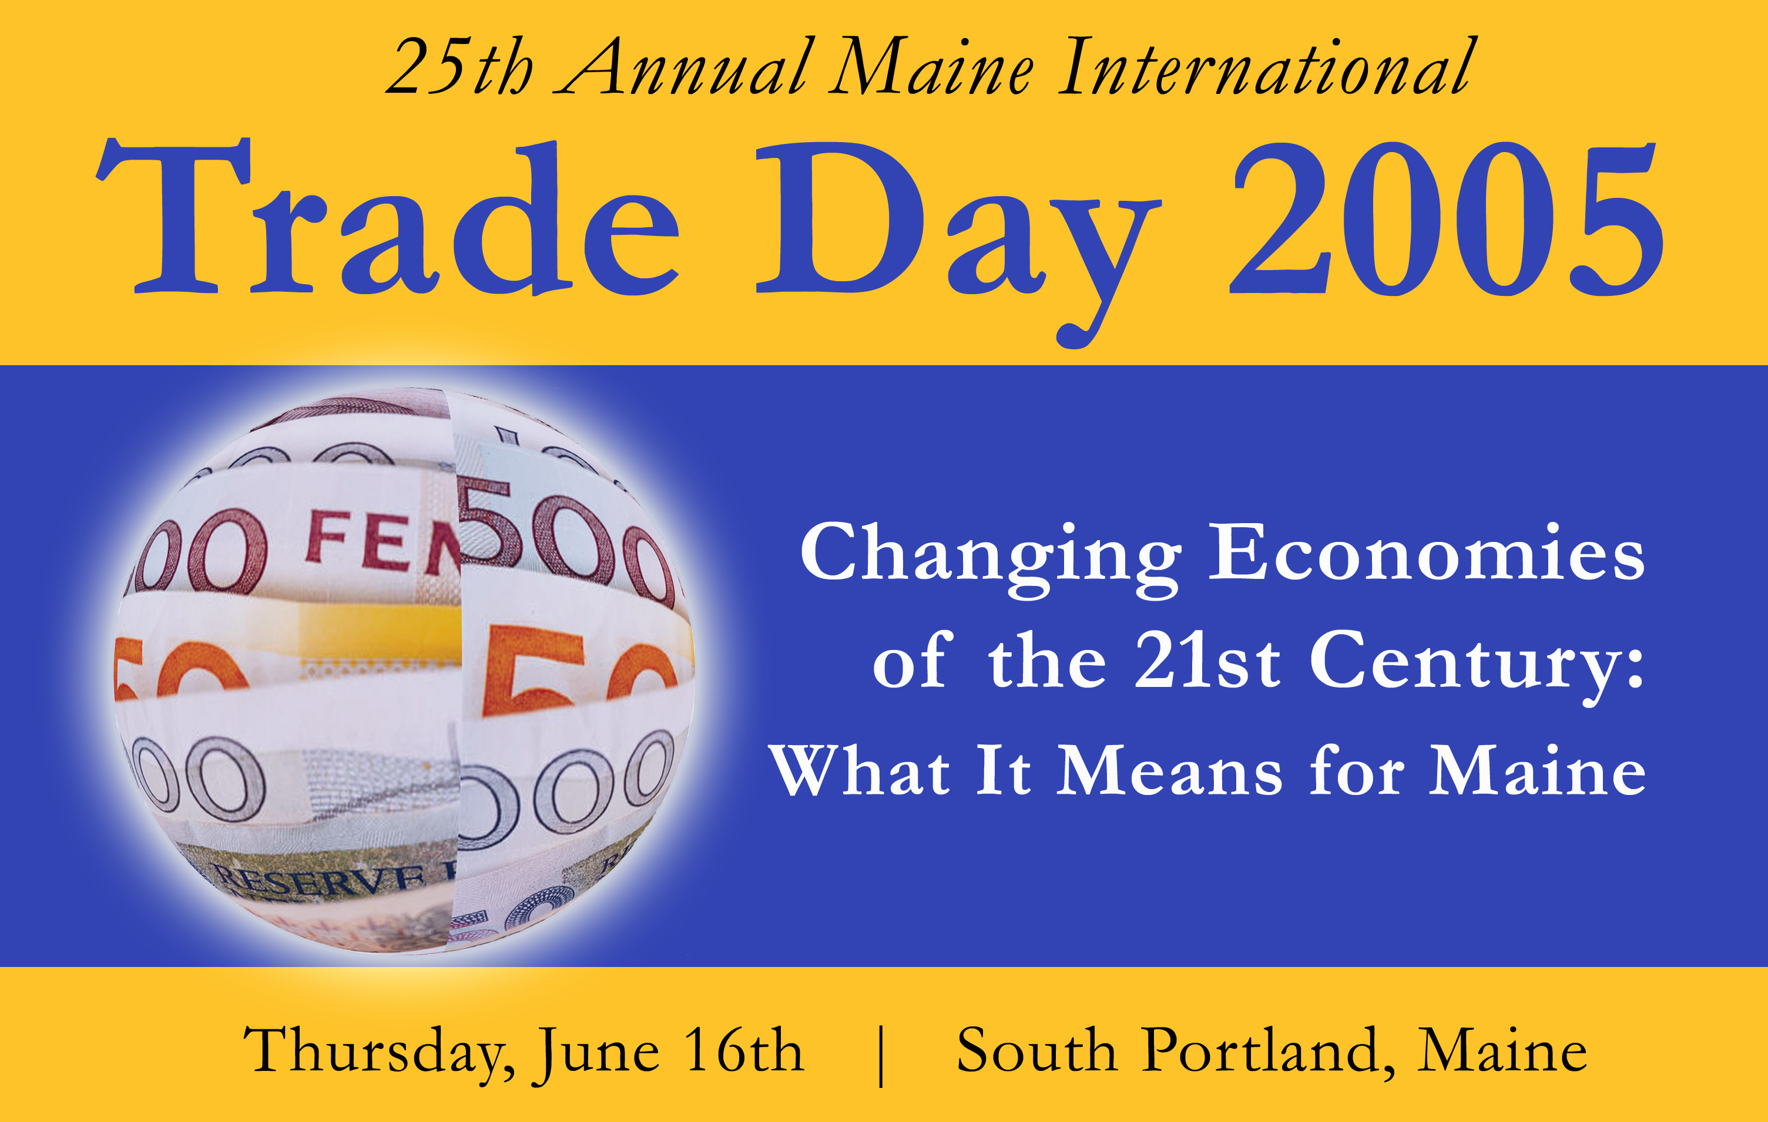

Panelists Agenda

11:30 Panelists check in with Trade Day Registration

11:45 – 12:45 Panelists Meet for Discussion Group and Box Lunch

1:00 Welcome & Introduction with a State of Trade Address
Richard J. Coyle, MITC

1:15 Overview of Major Economic Shifts in the 21st Century - Royal Bank of
Scotland Chief Economist, Ramachandra Bhagavatula

1:45 Break

2:00 International Panel Session
Challenges and Opportunities for U.S. Businesses in the Changing World Economies
Moderated by WMTW Channel 8 news anchor Tory Ryden

A short introduction will be given for each panelist prior to their speaking. Panelists will present for approximately 10 minutes, followed by questions from the moderator. Questions and Answers with the audience will be at the end of the program, once all panelists have presented.

- Asia Ms. Erin Sullivan, Senior International Trade Specialist at the U.S. Department of Commerce, U.S. and Foreign Commercial Service office of East Asia &Pacific in Washington, D.C.

- Americas Mr. Ricardo Amorim, Head of Latin America Research, WestLB in New York

- India Dr. Shashi Kumar, Associate Dean and Professor at the Loeb- Sullivan School at Maine Maritime Academy

- Europe Consul General John Rankin, UK Consul-General to New England. Former legal advisor to the UK Mission to the United Nations in New York and Geneva

- Canada Michel Tétu, Deputy Consul General, Senior Trade Commissioner for Canada in New England

4:00 Business Networking Reception in the Casco Bay Room

5:30- 8:30 International Trade Awards Dinner - featuring Governor John Baldacci and Michael Federle of Fortune Magazine

