AMEVIVE®

(alefacept)

BRIEFING DOCUMENT

AVAILABLE FOR PUBLIC DISCLOSURE WITHOUT REDACTION

Prepared by Biogen, Inc for the
Dermatologic and Ophthalmic Drugs
Advisory Committee Meeting
23 May 2002

EXECUTIVE SUMMARY

Proposed Indication and Dose

The data presented in this briefing document demonstrate that AMEVIVE® (alefacept) administered intramuscularly (IM) or intravenously (IV) has an acceptable benefit-risk profile to support the following proposed indication:

Alefacept is indicated for the treatment of patients with chronic plaque psoriasis who are candidates for phototherapy or systemic therapy.

The intended dose and dose regimen are:

- Alefacept administered as a once-weekly IM injection of 15 mg or as a once-weekly IV bolus dose of 7.5 mg for 12 weeks.
- Retreatment with alefacept may be initiated as needed provided that total lymphocyte and CD4+ T cell counts are within the normal range and a minimum of 12 weeks has passed between courses of treatment.

Major Findings

- In two pivotal studies, significantly more patients treated with a fixed dose of alefacept IM or IV weekly for 12 weeks achieved clinical response than those who received placebo, as measured by multiple outcome measures of efficacy, including

- a 75% or greater improvement in the Psoriasis Area and Severity Index (PASI 75),
- a 50% or greater improvement in the Psoriasis Area and Severity Index (PASI 50),
- a Physician’s Global Assessment of “almost clear” or “clear” (PGA AC/C), and
- quality of life as measured by the Dermatology Life Quality Index (DLQI).

- The clinical response following treatment with alefacept is durable. Repeat administration of alefacept provides cumulative efficacy such that some patients who did not demonstrate clinical response after one course respond to treatment with a second course.

- Alefacept targets the reduction of CD4+ and CD8+ memory T cells. These memory cells play a critical role in the pathogenesis of chronic plaque psoriasis.

- The clinical response seen with alefacept treatment is related to its pharmacodynamic effect on lymphocytes. The maximum reduction in T cells and their subsets typically occurs within 6 weeks of initiation of treatment with alefacept, at which time the rate of reduction decreases and T cell counts stabilize. Recovery of T cells occurs after withdrawal of treatment. A second course of alefacept showed no cumulative reduction in T cells.

- Treatment with alefacept is well-tolerated. Over 1350 patients have received a course of alefacept in clinical trials. The incidence of adverse events, including serious adverse events, was comparable in patients receiving alefacept or placebo. Despite the effect of alefacept on T cell counts, the incidence of infections, including serious infections, was low and comparable to that in placebo-treated patients. No patient experienced an opportunistic infection. Patients responding to alefacept therapy do not experience rebound of disease requiring hospitalization.

- The safety profile over multiple courses of alefacept therapy was similar to that defined for the first course.

- The combined data validate memory T cells as a novel pharmacologic target in the treatment of chronic plaque psoriasis.

Unmet Need

Patients with moderate to severe psoriasis have a chronic disease that results in severe social and physical disabilities associated with major deficits in quality of life including depression and suicide. Since topical therapies are rarely adequate, patients generally require treatment with phototherapy (e.g., PUVA and UVB) or systemic immunosuppressant therapy (e.g., methotrexate and cyclosporine). Patients respond to these therapies, but all of the therapies have limitations. Treatment with phototherapy is associated with an increased risk for skin cancers. The systemic immunomodulatory therapies are limited by their organ system toxicities such as hepatotoxicity or renal toxicity. Withdrawal of these drugs is often associated with flare or rebound of disease activity. These factors determine that no single long-term therapies exist, so patients are required to undergo sequential or rotational treatment. Thus, new therapies for the treatment of patients with psoriasis are needed.

Scientific Rationale for Alefacept

T cells, particularly the memory T cells (CD45RO+), have a central role in the pathogenesis of psoriasis. Immunohistochemical staining of psoriatic lesions demonstrate the predominance of activated memory T cells in the dermis and epidermis. The ligand, CD2, is upregulated in CD4+ and CD8+ memory T cells. Alefacept is a fully-human dimeric protein with the extra-cellular domain of lymphocyte functional antigen 3 (LFA-3) fused to the hinge and constant regions of the human IgG₁ heavy chain. Alefacept has two mechanisms of action. Firstly, binding of LFA-3 to its ligand, CD2, prevents binding of antigen-presenting cells (APC) and activation of T cells. Secondly, the Fc domain of alefacept binds to a receptor on natural killer (NK) cells and macrophages. The release of pro-apoptotic mediators by these cells results in targeted cell apoptosis of CD2-bearing cells, especially memory T cells.

Summary of Efficacy

The efficacy of alefacept has been demonstrated in two pivotal, Phase 3, placebo-controlled studies in 1060 patients with chronic plaque psoriasis.

Study 712 evaluated a single course of 10 and 15 mg alefacept IM compared to placebo. A course comprised 12 weeks of once weekly dosing with a minimum of 12 weeks of follow-up. Of the 507 patients enrolled, 168, 173, and 166 patients received placebo, 10 mg alefacept IM, and 15 mg alefacept IM, respectively.

Study 711 evaluated the efficacy of a single and repeat course of 7.5 mg alefacept IV in 553 patients randomized to, and dosed in, three treatment cohorts:

- two courses of alefacept (183 patients),
- one course of alefacept followed by one course of placebo (184 patients),
- one course of placebo followed by one course of alefacept (186 patients).

Compared to patients who received placebo, a greater proportion of patients treated with either 7.5 mg IV, 10 mg IM, or 15 mg IM alefacept experienced a clinical response as measured by PASI 75 two weeks after completion of treatment, the primary endpoint of each study. The differences between 7.5 mg IV and placebo IV, and between 15 mg IM and placebo IM were statistically significant (p < 0.001 in each case).

Support for clinical benefit is provided by other pre-specified assessments of clinical response at 2 weeks after treatment: a PGA AC/C and PASI 50 (Display 1). Both these analyses demonstrated significant benefit with either 7.5 mg IV or 15 mg IM alefacept treatment compared to placebo.

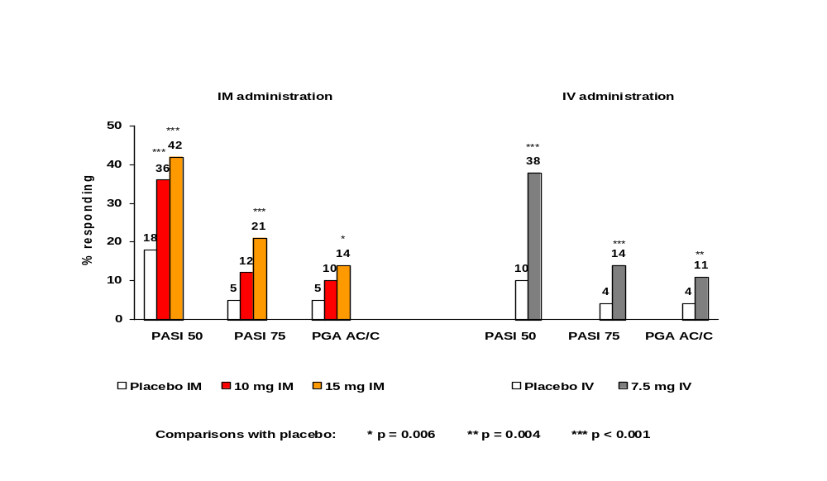Display 1 Response rates at 2 weeks after dosing in the first course of treatment

Further support for clinical benefit is provided by pre-specified assessments of clinical response at any time during a course of therapy (analogous to an overall response rate). These assessments include PASI 75, PASI 50, and PGA AC/C. All of these analyses demonstrated significant benefit with either 7.5 mg IV or 15 mg IM alefacept treatment compared to placebo (Display 2).

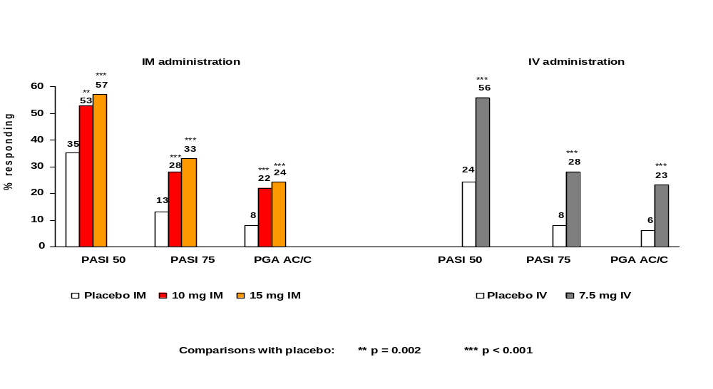Display 2 Overall response rates in the first course of treatment

In addition to the measurements of cutaneous responses, assessment of the patient’s quality of life using DLQI demonstrated significant improvement in the patients’ quality of life after treatment with alefacept. The improvement in quality of life as measured by DLQI correlates with clinical response as measured by PASI 75, PASI 50, and PGA AC/C.

Clinical response to treatment with alefacept is durable. Indeed, the median duration of response, defined as maintenance of at least a 50% reduction in baseline PASI in those patients who achieved PASI 75, was long: 216 days (more than 7 months). This result is in marked contrast to the clinical experience with cyclosporine or methotrexate where cessation of treatment is associated with disease flare or disease rebound.

Treatment with two courses of alefacept provides cumulative efficacy: patients who received a second course of alefacept continued to demonstrate clinical response, and some patients who did not achieve PASI 75 with a single course did so with a second course of alefacept.

The clinical response seen with alefacept correlated with its targeted reduction of CD4+ and CD8+ memory T cells. The maximum reduction of T cells typically occurred after approximately 6 weeks of treatment and corresponded to detection of clinical response. A second course of alefacept showed no cumulative reduction in T cells.
Summary of Safety

The consolidated safety database consists of 1357 patients with psoriasis who have received a course of alefacept. Safety extension studies are ongoing. Up to 46 patients have received 5 courses of treatment. Review of the safety database indicates that treatment with alefacept is well tolerated. The overall incidence of adverse events reported by alefacept- and placebo-treated patients was comparable.

The safety profiles of 7.5 mg alefacept IV and 15 mg alefacept IM were similar although patients who received 15 mg alefacept IM reported more pruritus, infections, asthenia, and injection site events than those who received 7.5 mg alefacept IV, while patients administered 7.5 mg alefacept IV experienced more rhinitis, chills, and accidental injuries than those who received 15 mg alefacept IM.

The rate of serious adverse events was comparable between alefacept- and placebo-treated patients (5%). No serious event was seen in 1% or more of alefacept-treated patients and the incidence of serious events did not increase with increased exposure to alefacept following multiple courses.

Despite the reduction in lymphocytes with alefacept treatment, a similar incidence of infections was observed between alefacept- and placebo-treated patients (45% vs 43%). The most frequently occurring infections in both treatment groups involved primarily the upper respiratory system, e.g., nasopharyngitis, pharyngitis, flu syndrome. In addition, the number of patients diagnosed with serious infections was low (8/876 (<1%) vs 2/413 (<1%), alefacept vs placebo, respectively) and the incidence did not increase with additional courses. Some patients treated with alefacept experienced CD4+ T cell counts <250 cells/μL, but there was no evidence that these patients were at greater risk for infection. No patient was diagnosed with an opportunistic infection. There was no impact of alefacept treatment on antibody responses following immunization.

The rate of malignancies in the safety database was low in both alefacept- and placebo-treated patients (10/876 (1%) vs 2/413 (<1%), alefacept vs placebo, respectively). The incidence of malignancies did not increase with repeat courses of alefacept. The incidence rate of malignancies was 20.8 per 1000 person-years and is consistent with that reported in the literature (29 per 1000 patient-years). In the first course of placebo-controlled studies, the incidence of squamous cell carcinoma of the skin was slightly higher in alefacept-treated patients compared to placebo (4/876 (<1%) vs 0/413 (0%), respectively). However, the observed rate per person-years exposure is consistent with the rate expected in this population.

Many of the current immunosuppressant therapies are associated with disease flare or rebound after cessation of treatment that sometimes requires hospitalization. The most common serious adverse event was hospitalization for psoriasis with an incidence rate higher in placebo-treated patients (6/413 (1%)) than those treated with alefacept (2/876 (<1%)). No patient who responded to alefacept experienced rebound of disease requiring hospitalization.

TABLE OF CONTENTS
PAGE
1 INTRODUCTION 13
1.1 Clinical Background 13
1.2 Pathophysiology of Psoriasis: The Role of T cells 16
1.3 Alefacept – Mechanism of Action 16
1.4 Intended Use of Alefacept 17
2 NONCLINICAL PHARMACOLOGY AND TOXICOLOGY 19
2.1 Nonclinical Pharmacokinetics 19
2.2 Toxicology 19
3 OVERVIEW OF CLINICAL EXPERIENCE and design of phase 3 studies 21
3.1 Phase 2, Dose-response Study and the Rationale for Fixed Dosing 23 Designs of the Phase 3 Studies and Their Extensions 23
3.2.1 Placebo-controlled Study of IM Administration of Alefacept (Study 712) and Extension Study (Study 717) 25
3.2.2 Placebo-controlled Study of Two Courses of IV Administration of Alefacept (Study 711) and Extension Study (Study 724) 27
4 CLINICAL EFFICACY 29
4.1 Measurement of Disease Activity in Chronic Plaque Psoriasis 29
4.2 Endpoints in Phase 3 Studies 30
4.3 Statistical Methods 31
4.4 Study Populations in Phase 3 31
4.4.1 Accounting of Patients 31
4.4.2 Demographic and Baseline Disease Characteristics 32
4.5 Modification of Exposure to Alefacept 34
4.6 Clinical Response following One Course of Alefacept 34
4.6.1 Analyses of Response by PASI 75, PASI 50, and PGA AC/C 35
4.6.2 Analysis of Clinical Effect by Subgroups 39
4.6.3 Analysis of Quality of Life 41
4.7 Duration of Clinical Response Following One Course of Alefacept 42
4.8 Clinical Response with Two Courses of Alefacept 44
4.9 Preliminary Findings in Psoriatic Arthritis 48
4.10 Summary of Clinical Efficacy 50
PAGE
5 CLINICAL PHARMACOLOGY 51
5.1 Pharmacokinetics 51
5.2 Pharmacodynamic Effects on Peripheral T Cell Counts 51
5.2.1 Pharmacodynamics following One Course of Treatment in Patients with Chronic Plaque Psoriasis 51
5.2.2 Pharmacodynamic Effects following Additional Courses of Therapy 55
5.3 Correlations between Reductions in T Cells and Efficacy 57
5.4 Action of Alefacept on Cutaneous T Cells 59
5.5 Implications of Reductions in T Cells on Immune Function 59
5.6 Summary of Clinical Pharmacology 62
6 CLINICAL SAFETY 63
6.1 Non-serious Adverse Events 64
6.2 Deaths, Serious Adverse Events, and Adverse Events Leading to Discontinuation of Study Drug 67
6.2.1 Deaths 67
6.2.2 Serious Adverse Events 67
6.2.3 Discontinuations from Study Drug due to Adverse Events 71
6.3 Infections 72
6.3.1 All Infections 72
6.3.2 Serious Infections 74
6.3.3 The Lack of Relationship between Infections and Low T Cell Counts 75
6.4 Malignancies 76
6.5 Immunogenicity 78
6.6 Laboratory Test Abnormalities 79
6.7 Summary of Clinical Safety 79
7 BENEFITS AND RISKS 80
7.1 Benefits 80
7.2 Risks 80
7.3 Conclusion 82
8 REFERENCES 83
APPENDIX 1: PASI, PGA, and DLQI 86
APPENDIX 2: Calculation of E_{AUC} 88
appendix 3: publication of phase 2 dose-response study (708): Ellis CN, Krueger GG. Treatment of chronic plaque psoriasis by selective targeting of memory effector t lymphocytes. N Engl J Med 2001; 345(4):248-255 89

List of Displays
Page
Display 1-1 Limitations of major treatments for moderate to severe psoriasis 15
Display 1-2 Alefacept: a fully human fusion protein 18
Display 1-3 Mechanism of action of alefacept 18
Display 3-1 Alefacept clinical trial program in psoriasis 22
Display 3-2 Exclusion criteria based on prior treatment in the Phase 3 studies 24
Display 3-3 Dosing algorithm used in Phase 3 Studies 25
Display 3-4 Overview of Studies 712 and 717 26
Display 3-5 Overview of Studies 711 and 724 27
Display 4-1 Therapies that disqualified patients as responders 30
Display 4-2 Accounting of patients in Studies 711 and 712 32
Display 4-3 Demographics, baseline disease characteristics, and most common prior therapies for psoriasis in Phase 3 studies 33
Display 4-4 Placebo substitution rates in alefacept-treated patients in Phase 3 studies 34
Display 4-5 Proportions of patients responding in the first course of treatment in Phase 3
Studies 711 and 712 36
Display 4-6 Proportion of patients achieving PASI 75 in the first course of treatment 37
Display 4-7 Odds ratios of responding 2 weeks post-treatment in Study 711 Course 1 and
Study 712 39
Display 4-8 PASI 75 2 weeks post-treatment − percentage responding by age, gender,
and baseline disease characteristics 40
Display 4-9 PASI 75 2 weeks post-treatment − percentage responding by response to prior phototherapy, prior systemic therapy, or no therapy 40
Display 4-10 Overall DLQI score in Studies 711 and 712 41
Display 4-11 Mean change in DLQI Overall Score by responder status at 2 weeks after the last dose 42
Display 4-12 Duration of a 50% reduction from baseline PASI in those who achieved PASI 75 in Cohort 2 of Study 711 43
Display 4-13 Duration of a 50% reduction from baseline PASI in those who achieved PGA AC/C in Cohort 2 of Study 711 44
Display 4-14 Proportions of patients responding in Courses 1 and 2 of Study 711 45
Display 4-15 Study 711: proportion of patients achieving PASI 75 by course 46
Display 4-16 Endpoints based on proportions of patients responding over the entire span of Study 711 47
Display 4-17 Endpoints based on proportions of patients responding over the entire span of Studies 712 and 717 47
Page
Display 4-18 Overall DLQI score in the second course of Study 711 48
Display 4-19 Swollen joint count and tender joint count 49
Display 4-20 Mean C-reactive protein by time 49
Display 5-1 Study 712: mean lymphocyte count by treatment and time 52
Display 5-2 Study 712: mean percentage change from baseline in total lymphocyte count and lymphocyte subsets at 2 weeks post-dosing 53
Display 5-3 Numbers of patients with counts <LLN: 15 mg IM and 7.5 mg IV 53
Display 5-4 Study 711 Cohort 2 (alefacept/placebo): percentage of patients above 75% of baseline for total lymphocytes 54
Display 5-5 Study 711 Cohort 2 (alefacept/placebo): percentage of patients with CD4+ T cell count >LLN 55
Display 5-6 Study 711: mean percentage change from baseline in total lymphocyte count and lymphocyte subsets at 2 weeks post-dosing in each course 56
Display 5-7 Study 711: numbers of patients with counts <LLN in one and two courses of 7.5 mg alefacept IV 56
Display 5-8 PASI 75 response rates at 2 weeks post-dosing by E_{AUC} quartiles of memory T cells in Course 1 of Study 711 and Study 712 58
Display 5-9 Design of Study 718 60
Display 5-10 Total anti-ϕX174 antibody titers 61
Display 6-1 Number of patients in analyses of safety 63
Display 6-2 Incidence of adverse events in the first course of placebo-controlled studies experienced by at least 5% of patients who received alefacept 65
Display 6-3 Incidence of adverse events experienced by at least 5% of patients by course of alefacept 65
Display 6-4 Adverse events with an incidence of 5% or more in the first course of phase 3 studies (by route of administration) 66
Display 6-5 Incidence of serious adverse events in the first course of placebo-controlled studies 68
Display 6-6 Incidence of serious adverse events by course of alefacept 69
Display 6-7 Incidence of adverse events leading to discontinuation of study drug in the first course of placebo- controlled studies 71
Display 6-8 Incidence of adverse events leading to discontinuation of study drug by course of alefacept 72
Display 6-9 Incidence of infections in the first course of placebo-controlled studies experienced by at least 5% of patients who received alefacept 73
Display 6-10 Incidence of infections experienced by at least 5% of patients by course of alefacept 73
Page
Display 6-11 Incidence of serious infections in the first course of placebo-controlled studies 74
Display 6-12 Incidence of serious infections by course of alefacept 75
Display 6-13 Incidence of malignancies experienced in the first course of placebo-controlled studies 76
Display 6-14 Incidence of malignancies by course of alefacept 76
Display 6-15 Observed and expected rates of non-melanoma skin cancer 77
Display 6-16 Incidence of malignancies in psoriasis and control populations 78
Display 6-17 Incidence of antibodies to alefacept by course of alefacept 78
Display A2-1 Calculation of E_{AUC} 88
Display A2-2 Calculation of E_{AUC} when counts are greater than baseline 88

LIST OF ABBREVIATIONS

ACR American College of Rheumatology
ALT Alanine transaminase
APC Antigen-presenting cells
AST Aspartate transaminase

CD Clusters of differentiation
CI Confidence interval
CLA Cutaneous lymphocyte antigen
CRP C-reactive protein

DAS Disease activity score
DLQI Dermatology Life Quality Index
DTH Delayed-type hypersensitivity

IM Intramuscular
IV Intravenous

LCV Lymphocryptovirus
LFA Lymphocyte functional antigen
LLN Lower limit of normal

MHC Major histocompatibility complex

NK Natural killer

PASI Psoriasis Area and Severity Index
PASI 75 75% or greater reduction from baseline PASI
PASI 50 50% or greater reduction from baseline PASI
PGA Physician’s Global Assessment
PGA AC/C Physician’s Global Assessment of “almost clear” or “clear”
PUVA Psoralen plus ultraviolet A light

ST Synovial tissue

TCR T cell receptor

UVB Ultraviolet B light

INTRODUCTION

Clinical Background

Plaque psoriasis, henceforth referred to as psoriasis, is a chronic, persistent inflammatory skin disease that affects 1 to 2% of the US and European populations and accounts for 85 to 95% of all forms of psoriasis (Nall and Farber, 1977; Griffiths and Voorhees, 1996). Women and men are affected equally. Although the disease may present at any age, the median age of diagnosis is 28 years. Approximately one-third of patients have a family history of psoriasis suggesting a role for genetic factors.

Clinically, patients present with well-demarcated, raised, scaly, thickened erythematous plaques. The most common sites involved are the extensor aspects of the elbows and knees, the scalp, and the lumbosacral area. Plaques can vary in size from “guttate” lesions (about 2 to 3 mm in diameter) to those covering the entire trunk (>20 cm). Eighty to ninety percent of patients have very itchy lesions, impacting quality of life (Yosipovitch et al, 2000; Rapp et al, 1997; Krueger et al, 2001). The clinical course of psoriasis is variable. Although some patients may experience spontaneous remission of variable duration, most patients require chronic treatment.

Approximately 50% of psoriasis patients have nail involvement and about 10% have associated arthritis. Patients with psoriasis are more likely to have hypertension, diabetes mellitus, inflammatory bowel disease, or obesity as co-morbidities (Henseler and Christophers, 1995). Although psoriasis is rarely a direct cause of death, its chronic, persistent clinical course starting in young adults has associated morbidity. Psoriasis is associated with an increased risk of substance abuse, psychological illness, suicidal ideation, and suicide (Gupta and Gupta, 1998; Devrimci-Ozguven et al, 2000). Because of the sensitivity associated with any cutaneous disease, the patient’s quality of life is compromised, and many patients will avoid social situations with potential for comment or judgment due to their disease. The impact of psoriasis on quality of life has been studied in both the United States and Europe and is comparable to other serious medical conditions such as diabetes, myocardial infarction, and depression (Rapp et al, 1999; O’Neill and Kelly, 1996; Lundberg et al, 2000). It is important for clinicians to be aware that there is little correlation between the extent of skin involvement and the patient’s sense of disability (Kirby et al, 2001).

The first-line therapies for treatment of mild plaque psoriasis are topical agents such as corticosteroids, coal tar, or vitamin D analogs (Lebwohl and Ali, 2001a). Patients who use topical agents are inconvenienced by the daily time commitment (typically 30 minutes or more) which leads to poor compliance (van de Kerkhof et al, 1998). In clinical practice, there are no strict cutoffs for defining moderate to severe disease, but it generally involves psoriasis lesions that either cover more than 10% of the body surface area or that are otherwise disabling (Krueger et al, 2000). Patients with moderate to severe psoriasis generally require treatment with phototherapy or systemic therapy (Feldman, 1998; Lebwohl and Ali, 2001b). The most commonly used agents are psoralen plus ultraviolet A light (PUVA), ultraviolet B light (UVB), methotrexate, retinoids, and cyclosporine (Lebwohl and Ali, 2001b). Retinoids, such as acitretin, are rarely adequate as monotherapy but have benefit in conjunction with PUVA and UVB (Lebwohl and Ali, 2001b). UVB alone is less effective than PUVA, though a new form of UVB, narrow-band UVB, appears to be nearly as effective as PUVA (Coven et al, 1997; Gordon et al, 1999).

Display 1-1 compares the limitations of PUVA, UVB, and the systemic immunomodulatory therapies, methotrexate and cyclosporine. These agents vary in efficacy, onset of activity, durability of remission, and the potential for rebound of disease activity with discontinuation. As different efficacy outcome measures were used to assess clinical benefit, an accurate comparison of the effectiveness of these treatments is difficult. PUVA has good clinical effect but its use, in terms of the number of treatments, is limited because of the risk for cutaneous malignancies with increasing exposure (Stern et al, 1997; Morison et al, 1998; Stern and Lunder, 1998). Patients also find phototherapy extremely inconvenient with its requirement for visits to the physician’s office 3 to 5 times per week. Methotrexate has associated liver, bone marrow, and pulmonary toxicities and a potential increased risk of lymphoproliferative disease (Kanik and Cash, 1997). Since monitoring of liver function tests is not indicative of the development of liver fibrosis, in addition to blood test monitoring, liver biopsies are recommended after each 1.5 g of methotrexate (Roenigk et al, 1998). PUVA, acitretin, and methotrexate are known teratogens. The clinical effectiveness of low dose cyclosporine is limited by its side effects, predominantly hypertension and cumulative renal toxicity (Lebwohl et al, 1998; Lowe et al, 1996; Zachariae et al, 1997). The latter limits the amount of time that patients can be treated with cyclosporine. In order to help reduce the known side effects associated with any one of these agents, rotation between these agents has been recommended although the long-term risk and benefit of such an approach has not been studied (Menter et al, 1996). For patients who do not respond to these standard agents alone, combinations of these therapies may be used (Menter et al, 1996).

Other agents that have been used to treat severe psoriasis in patients who did not respond to, or are not candidates for traditional therapies include hydroxyurea, 6-thioguanine, mycophenolate mofetil, and systemic tacrolimus, each of which is associated with potentially severe side effects (Zackheim et al, 1994; Mason and Krueger, 2001; Boyd and Neldner, 1991; Jegasothy et al, 1992; Lebwohl and Ali, 2001b). The decision to use potentially toxic systemic therapy for psoriasis requires physician judgement. Despite the use of these potent agents in the treatment of psoriasis, few patients actually achieve long-term clearing of their disease (Al Suwaidan and Feldman, 2000). Moreover, 30 to 40% of patients feel that current therapies are neither sufficiently aggressive nor effective for their disease (Krueger et al, 2001). There is clearly a need for new treatments that target psoriasis effectively that are not associated with collateral organ damage. Agents that offer significant relief from disease even after cessation of treatment, i.e., are disease-remittive, are also highly desirable.

Display 1-1 Limitations of major treatments for moderate to severe psoriasis

 | PUVA | UVB | Methotrexate | Cyclosporine | Acitretin
Duration of effect | 6 months | 5 months | 1-5 months. Risk of disease rebound after abrupt withdrawal | Recurrence in 2-12 weeks. Risk of disease rebound after abrupt withdrawal | Recurrence after 12 weeks
Major toxicities | Nausea 10-25%  Burns 5-10%  Increased risk of non-melanoma skin cancer (8-10 fold for squamous cell carcinoma)  Increased risk of melanoma reported.  Accelerated photoaging, PUVA lentignes | Burns, pruritus, and/or erythema  Photoaging, small increased risk of non-melanoma skin cancer | Abnormal liver tests 33%  Nausea 32%  Fatigue 13%  Gastrointestinal 18%  Leucopenia 9%  Headache 6%  Thombocytopenia 5%  Hepatic fibrosis in 13% and cirrhosis in 4%  Pneumonisis  Risk of lymphoma  Acute hematologic toxicity, can be fatal | >80% with adverse event, 10% severe  Hypertension 9%  Increased creatinine  ≥30% 40-50%  ≥50% 18-20%  Hypertrichosis 10-27%  Headache 15%  Parasthesia 14-40%  Gum hypertrophy 5%  Enhances risk of skin cancer in PUVA-exposed patients | Elevated triglycerides 40%  Elevated cholesterol 10%  Elevated AST 20%  Chelitis 100%  Alopecia 25%  Dry eyes 50-100%  Peeling palms & soles 50%  Chills 25%  Pruritus 50%  Muscle pain 25%  Xerosis 25%  Skeletal changes
Limit on treatment duration | 150-250 treatments | No limit | Liver biopsy every 1.5 g cumulative dose, typically every 2 to 3 years | Typically <1 year due to cumulative renal toxicity | Calcification of ligaments and tendons
Monitoring requirements | Annual skin examinations for life | Annual skin examinations | Blood counts and liver function tests every 1-2 months | Blood pressure  Creatinine  Magnesium | Liver function tests and serum triglycerides every 3-4 months
Comments | Requires treatment 3-5 times per week.  Teratogen | Requires treatment 3-5 times per week | Bone marrow toxicity most common cause of death. Many drug interactions.  Potent teratogen | Multiple drug interactions | Potent teratogen  Usually insufficient as monotherapy  Multiple drug interactions

The Medical Advisory Board of the National Psoriasis Foundation has published a consensus describing the minimal characteristics that new agents should meet (Krueger et al, 2000). These include:

- consistently clears disease activity, even if it occurs in only 5% of subjects,
- provides consistent, predictable, and statistically significant responses, short of complete clearing with minimal or no side effects, and
- predictably enhances quality of life in a statistically significant fashion.

These guidelines stress the importance of developing new treatments that do not have the organ toxicity associated with current therapies, even if the therapy does not consistently result in complete clearance of the disease. As advances are made in understanding the pathogenesis of psoriasis development of therapies with more specific targeting of the disease becomes possible.

Pathophysiology of Psoriasis: The Role of T cells

A growing body of research has characterized the central role of T cells in the pathogenesis of psoriasis. Inflammation in psoriasis is initiated by the interaction between dermal antigen-presenting cells (APC) carrying a putative autoantigen and T cells in regional lymph nodes (Robert and Kupper, 1999). APC-T cell interactions involve binding between many different cell surface receptors and their ligands. In this context, the binding of lymphocyte functional antigen 3 (LFA-3) on the APC to CD2 on the T cell has been shown to be important. It results in T cell activation, upregulation of CD2, and de novo expression of two cell surface molecules: CD45RO and cutaneous lymphocyte antigen (CLA) (Fuhlbrigge et al, 1997; Robert and Kupper, 1999). These lymphocytes are now termed CD4+ and CD8+ memory T cells (CD45RO is a “memory” marker). The memory T cells infiltrate skin because CLA expression confers skin-homing capability. Immunohistochemical staining of the psoriatic plaque demonstrates that more than 75% of the infiltrating lymphocytes are CD4+ and CD8+ memory T cells (Friedrich et al, 2000). The T cell infiltrate expresses high levels of CD2, which facilitates further interaction with LFA-3 on APC in the skin. Thus LFA-3/CD2 interactions are important in T cell activation both in the lymphoid tissues and after infiltration into the skin. The exact mechanism(s) by which infiltrating T cells accelerate keratinocyte proliferation is unknown. However, in situ APC-T cell interactions result in the production of a cytokine, IFNγ, which may be an important factor in inducing plaque formation. IFNγ has been shown to induce psoriatic keratinocyte stem cells to enter the cell cycle and proliferate (Bata-Csorgo et al, 1995; Szabo et al, 1998).

Alefacept – Mechanism of Action

AMEVIVE® (Alefacept, human LFA-3/IgG₁ fusion protein, LFA3TIP) is a fully-human, disulfide-linked, glycosylated, dimeric protein consisting of the first extra-cellular domain of human LFA-3, fused to the hinge and constant regions of the human immunoglobulin IgG₁ heavy chain (Display 1-2). Alefacept can inhibit T cell activation by blocking APC-T cell LFA-3/CD2 interactions. In addition, alefacept has been shown to bind to an immunoglobulin receptor (FcγRIII or CD16) via its IgG₁ domain. The FcγRIII immunoglobulin receptor is expressed by cytotoxic cells such as natural killer (NK) cells and macrophages. Binding of the alefacept IgG₁ domain to FcγRIII leads to the release of pro-apoptotic mediators such as granzyme. In turn, granzyme release leads to programmed cell death or apoptosis of the target bound via the alefacept LFA-3 domain (Display 1-3) (Majeau et al, 1994; daSilva et al; 2002). Comparing the various T cell subsets, memory T cells have higher levels of CD2 expression so that they are preferentially targeted by the alefacept pro-apoptotic mechanism. In summary, alefacept inhibits both T cell activation and can cause apoptosis of the CD4+ and CD8+ memory T cells. Because a significant proportion of the T cell infiltrate is comprised of CD4+ and CD8+ memory T cells, alefacept has a robust therapeutic rationale in psoriasis.

In the clinical setting, a number of changes in lymphocyte counts are predicted by the mechanism of action. The apoptotic effects on CD4+ and CD8+ memory T cells are detectable as a change in the total CD4+ and CD8+ T cell counts. Since CD4+ and CD8+ T cells themselves contribute to the total lymphocyte count, a reduction in this quantity is also predicted.

Intended Use of Alefacept

The proposed indication for alefacept is for the treatment of patients with chronic plaque psoriasis who are candidates for phototherapy or systemic therapy.

The intended doses and dose regimens are as a once-weekly IM injection of 15 mg or as a once-weekly IV bolus dose of 7.5 mg for 12 weeks. Re-treatment with alefacept may be initiated as needed provided that total lymphocyte and CD4+ T cell counts are within the normal range and a minimum of 12 weeks has passed between courses of treatment.

Display 1-2 Alefacept: a fully human fusion protein

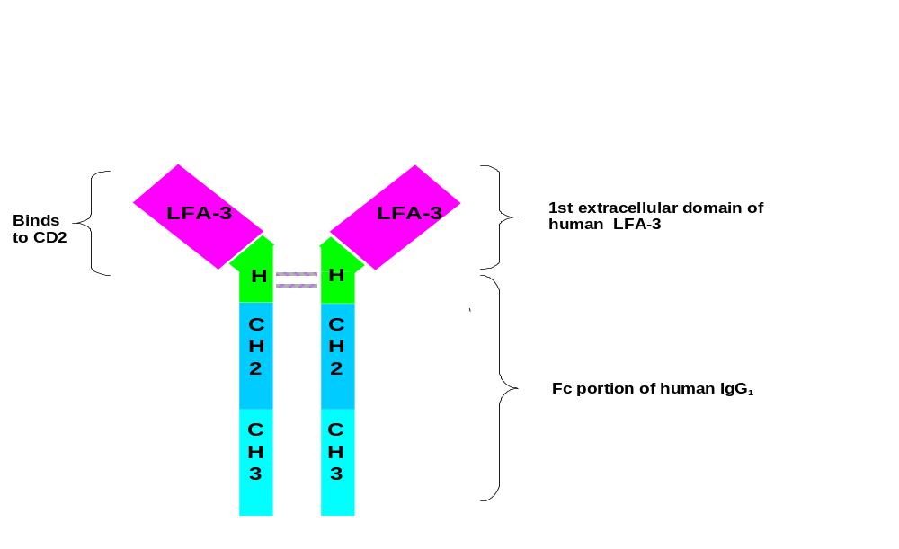

Display 1-3 Mechanism of action of alefacept

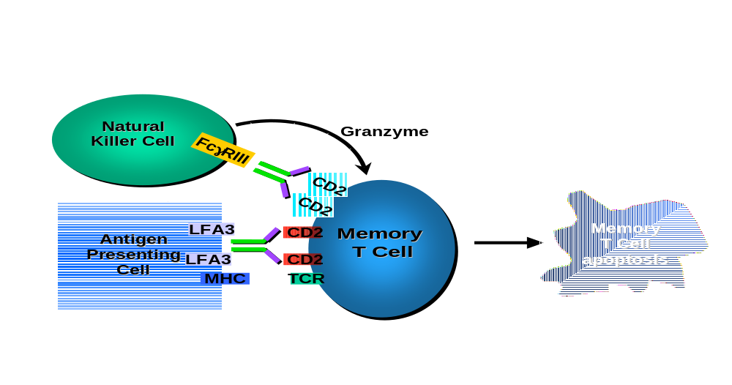

NONCLINICAL PHARMACOLOGY AND TOXICOLOGY

Nonclinical safety studies with alefacept were conducted in nonhuman primates. All pivotal studies were conducted with representative clinical grade material in compliance with FDA and international regulatory guidelines. To achieve maximal exposure, alefacept was administered IV in the majority of the nonclinical studies.

Nonclinical Pharmacokinetics

The pharmacokinetic profile of alefacept was evaluated in baboons and cynomolgus monkeys. Administration of alefacept demonstrated predictable and consistent serum concentrations following single- and repeat-dose administration. Alefacept serum concentrations were proportional to the dose administered, and clearance and elimination half-life were approximately 0.41 mL/h/kg and 150 hours, respectively. No apparent gender differences in the pharmacokinetics of alefacept were observed. Following IM administration, the elimination half-life was similar to that observed following IV administration. The bioavailability of alefacept following IM administration was approximately 58%.

Toxicology

A comprehensive toxicologic assessment of alefacept was performed in baboons and cynomolgus monkeys following single- and repeat-dose administration at doses in excess of 100 times the clinical dose.

The following is a brief summary of the findings from those studies:

- Single-dose administration through 10 mg/kg and weekly repeat-dose administration through 40 mg/kg was well-tolerated and no clinical signs of toxicity were observed during dosing or post-dose recovery periods.

- No occurrence of opportunistic infections was observed.

- Treatment-related changes included a reversible, dose-dependent reduction in absolute lymphocyte counts and T lymphocyte subsets including CD2+ T cells, CD3+ T cells, CD4+ T cells, and CD8+ T cells.

- Histologic evaluations revealed a consistent, reversible, mild/moderate decrease in the number of small lymphocytes in the spleen and lymph nodes. No changes were observed in the thymus.

- Immunohistochemical analysis revealed that the histologic findings were consistent with a reduction in CD2+, CD4+, and CD8+ T cells in the peri-arteriolar lymphoid sheath of the spleen and in the paracortex of the lymph nodes.

- The observed changes in T cell populations were accompanied by mild/moderate hyperplasia of CD20+ centroblasts within germinal centers (follicular hyperplasia). The morphology of CD20+ centroblast hyperplasia was consistent with modestly exaggerated clonal responses to normal antigenic stimulation. Normal follicular architecture was preserved.

- In a 52-week toxicology study, a single case of an acute B cell lymphoma was observed during week 28 in one of twelve non-human primates administered 20 mg/kg alefacept once weekly. At the time of diagnosis, this animal was receiving approximately 260 times a single IV dose for humans on a weight adjusted basis, and was exposed to a cumulative dose equivalent to 622 12-week courses of therapy. All animals in the study were positive for an endemic primate gamma herpesvirus known as lymphocryptovirus which has been associated with B cell lymphomas under certain circumstances.

- No adverse effects of alefacept administration were noted in reproductive toxicity studies in primates at weekly doses up to 20 mg/kg.

- No teratogenicity has been observed.

- No evidence of genotoxicity was observed in mutagenicity studies.

OVERVIEW OF CLINICAL EXPERIENCE and design of phase 3 studies

Alefacept has been administered to 240 healthy volunteers and 1357 patients with psoriasis for a total of 18 clinical studies that comprise the clinical program. Six studies were conducted in healthy volunteers and 12 in patients with psoriasis, as shown in Display 3-1.

In this section, the following are discussed:

- results from the placebo-controlled, dose-response study (Study 708) that provided data on the choice of doses, and a rationale for fixed dosing to be used for the Phase 3 studies (see Section 3.1),
- the designs of the two pivotal, placebo-controlled, Phase 3 studies (Studies 711 and 712), from which most of the discussion on efficacy in Section 4 and clinical pharmacology in Section 5 is derived (see Section 3.2), and
- the designs of the extension studies (Studies 717 and 724) conducted to obtain more data on the experience with multiple courses of alefacept (see Section 3.2).

In addition to the psoriasis program, Biogen is studying alefacept in three other indications: rheumatoid arthritis, scleroderma, and psoriatic arthritis. Studies in the former two indications are ongoing, and the study in psoriatic arthritis has recently completed (preliminary findings are given in Section 4.9).

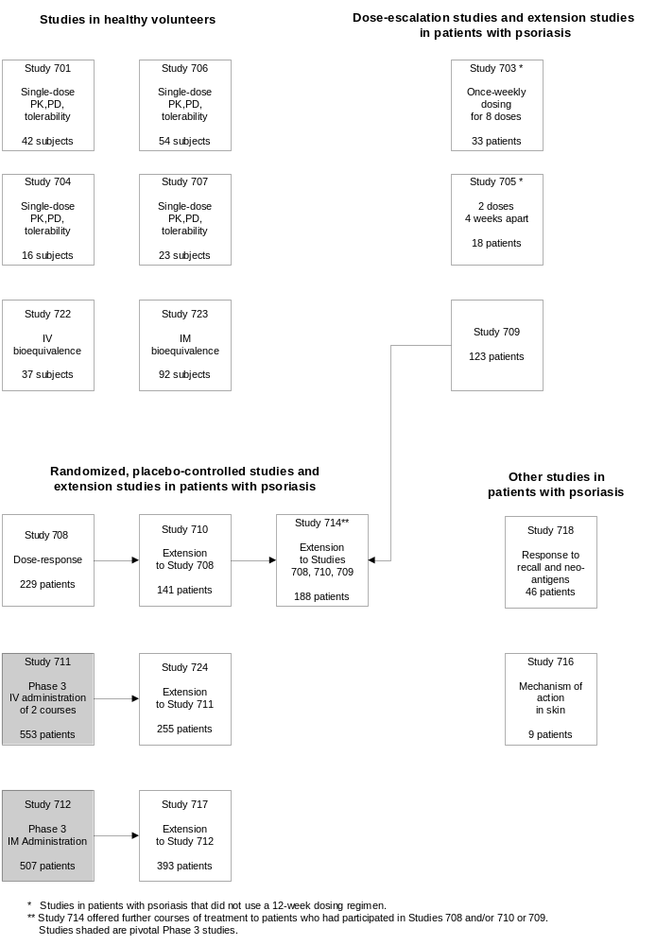Display 3-1 Alefacept clinical trial program in psoriasis

Phase 2, Dose-response Study and the Rationale for Fixed Dosing

Study 708 was a randomized, double-blind, placebo-controlled, parallel-group, dose-response study comparing the efficacy and safety of 0.025, 0.075, and 0.15 mg/kg alefacept in 229 patients with moderate to severe psoriasis. Each patient was to receive an IV bolus every week for a total of 12 weeks and be followed for efficacy and safety for 12 weeks after the last dose of study drug. This study was the first placebo-controlled study to examine the relationship between response and dose.

The degree of reduction in total lymphocytes, peripheral CD4+ and CD8+ T cells was dose-dependent and occurred during the treatment period. Selectivity in reduction of the CD4+ and CD8+ memory T cell populations over the CD4+ and CD8+ naïve T cell populations was observed in alefacept-treated patients.

The proportion of patients achieving a reduction of 75% or more from their baseline Psoriasis Area and Severity Index (PASI) at 2 weeks following the last dose was 10% in the placebo group compared with 21, 33, and 31% in the 0.025, 0.075, and 0.15 mg/kg groups, respectively (p = 0.021 for the test of treatment differences and p = 0.018 for the test of linear dose-response). This study provided strong evidence of efficacy with a long duration of response, e.g., the median time to further treatment in an extension study was 306 days (Ellis and Krueger, 2001, a copy of this publication is provided in Appendix 3). Importantly, efficacy outcomes correlated with changes in memory T cell subsets.

In this study and in earlier Phase 1 and Phase 2 studies, alefacept dosing was based on body weight. Analysis of the pharmacokinetic data from these studies showed no correlation between absolute dose and either central or peripheral distribution volumes. Study 707 showed that the disposition of alefacept was similar in lean and obese volunteers, i.e., disposition was unaffected by total body weight. These results provided the support for the evaluation of fixed dosing in the pivotal Phase 3 clinical studies, 711 and 712.

Based upon the analysis of data from Study 708, 0.075 mg/kg was selected as the optimal dose for further evaluation in Phase 3. Since the median body weight of patients in Study 708 was 98 kg, a total fixed dose of 7.5 mg IV was used in the Phase 3 IV study, 711. The fixed IM doses evaluated in Study 712 were based on the 7.5 mg IV dose. Based on the expected bioavailability of approximately 60% when administered IM, doses of 10 and 15 mg were chosen to bracket the corresponding equivalent IV dose.

Designs of the Phase 3 Studies and Their Extensions

Two placebo-controlled, Phase 3 studies were conducted: Study 712, in which alefacept was administered IM for one course, and Study 711, in which alefacept was administered IV for a maximum of two courses.

Both Phase 3 studies had a number of common design features that are described below.
Inclusion/exclusion Criteria
Men and women with chronic plaque psoriasis for at least 12 months, with a body surface area involvement of at least 10%, were eligible for entry into the phase 3 studies. Patients also had to have CD4+ T cell counts above the lower limit of normal (LLN).

Patients were to be excluded if any of the following criteria existed:

- erythrodermic, guttate, palmar, or generalized pustular forms of psoriasis;
- a serious local or systemic infection;
- a history of malignancy (patients with a history of basal cell carcinoma or <3 squamous cell carcinomas were eligible)
- HIV, or hepatitis B or hepatitis C with ALT or AST greater than three times the upper limit of normal.

In addition, patients had to have discontinued certain prior therapies as shown in Display 3-2.

Display 3-2 Exclusion criteria based on prior treatment in the Phase 3 studies

Required washout period | Therapy
Within 4 weeks of the first dose of study drug | Any investigational drug or approved therapy for investigational use
 | Systemic retinoids
 | Systemic immunosuppressant agents, e.g., methotrexate, cyclosporine, azathioprine, thioguanine, prednisone
 | Phototherapy
 | High potency topical corticosteroids
Within 2 weeks of the first dose of study drug | Moderate potency topical corticosteroids (other than on the scalp, palms, groin, and/or soles)
 | Vitamin D analogues and topical retinoids (other than on the scalp, palms, groin, and/or soles)
 | Keratolytics and coal tar (other than on the scalp, palms, groin, and/or soles)

Randomization
In both Phase 3 studies, randomization to treatment group (Study 712) or cohort (Study 711) was stratified by screening PASI and prior systemic therapy as follows:

- PASI >20 and never received phototherapy or systemic therapy,
- PASI >20 and previously received phototherapy or systemic therapy,
- PASI ≤20 and never received phototherapy or systemic therapy, and
- PASI ≤20 and previously received phototherapy or systemic therapy.
Dosing
A course of therapy comprised 12 weekly doses of study drug with at least 12 weeks of follow-up. Study drug was administered by the investigator or his/her designee at each site. Following the first dose, patients had blood drawn for determination of complete blood and lymphocyte counts. Further dosing was based upon an algorithm specifying the need for patients to be within specific limits for lymphocyte counts; otherwise placebo (saline) was substituted if counts fell outside those limits. The algorithm is presented in Display 3-3.

Display 3-3 Dosing algorithm used in Phase 3 Studies

- Each dose of study drug was to be separated by an interval of 5 to 9 days.

- Study drug was to be given if no clinical evidence of significant viral, bacterial, or fungal infection.

- Study drug was to be withheld for 2 weeks if the patient had a fever (body temperature >38°C) or if there was evidence of a clinically significant infection (including upper respiratory infection).

- Study drug was to be substituted with placebo if the CD4+ count from the previous week was <250 cells/μL. If CD4+ counts were <250 cells/μL for ≥4 consecutive visits, study drug was to be permanently substituted with placebo.

Blinding
All conventional precautions to maintain study blind were used in Studies 711 and 712. In addition, to prevent potential unblinding based on laboratory results (lymphocyte counts), the studies were conducted with an examining dermatologist and a laboratory physician at each site. The examining dermatologists remained blinded to laboratory results as they documented patients’ clinical response to study drug. The laboratory physician received all laboratory data and monitored lymphocyte results, and communicated changes in the dosing regimen to the study pharmacist. When necessary, the study pharmacist substituted an injection of placebo (saline) with similar appearance to, and same volume as study drug. All other safety issues relating to lymphocytes and lymphocyte subsets were handled by unblinded physicians at the Sponsor’s Contract Research Organization. Using these safeguards, all patients were assessed for clinical response in a blinded fashion.

Placebo-controlled Study of IM Administration of Alefacept (Study 712) and Extension Study (Study 717)

Study 712 was a randomized, double-blind, placebo-controlled, safety, and efficacy study involving 507 patients with moderate to severe psoriasis. Patients were randomized to receive 12 once-weekly IM injections of placebo, or 10 or 15 mg alefacept, with 12 weeks of follow-up (Display 3-4). Patients were seen weekly during the dosing period, and at 2, 4, 6, 8, and 12 weeks after the last dose.

The study was conducted at 64 centers in the United States, Canada, and Europe.

After completion of Study 712, patients were allowed to enter a double-blind extension study, Study 717, that has recently completed. The goal of Study 717 was to evaluate the safety and efficacy of a second 12-week course of alefacept when given IM to patients who received alefacept in Study 712. It also offered a course of alefacept to those who received placebo in Study 712. Patients who received placebo or 10 mg alefacept in Study 712 received a course of 10 mg in Study 717, and those who received 15 mg alefacept in Study 712 received a further course of 15 mg in Study 717.

To be eligible, patients had to have received at least eight injections in Study 712, and had to have completed all post-dosing visits in Study 712. Patients were required to enroll into Study 717 within 14 days of completing the last visit in Study 712. Patients who initiated alternative systemic therapy, phototherapy, or disallowed therapy prior to Week 8 in Study 712 were excluded from entry.

In order to receive a course of alefacept in Study 717, a patient’s disease severity had to be “mild” or worse by Physician’s Global Assessment (Appendix 1), and CD4+ T cell counts had to be at or above the LLN. Patients not satisfying these two criteria were followed at “interim visits” until they were eligible to be dosed.

Display 3-4 Overview of Studies 712 and 717
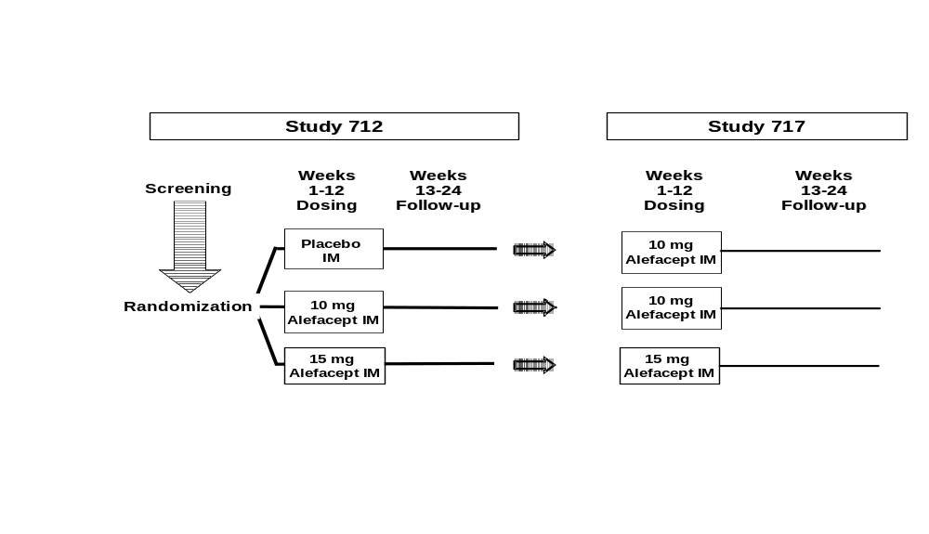

Placebo-controlled Study of Two Courses of IV Administration of Alefacept (Study 711) and Extension Study (Study 724)

Study 711 was a randomized, double-blind, placebo-controlled study involving 553 patients with moderate to severe psoriasis conducted at 51 sites in the United States and Canada. This study evaluated the safety and efficacy of two courses of alefacept. Each course consisted of 12 once-weekly IV injections followed by at least 12 weeks of follow-up (Display 3-5). Patients were randomized to one of three cohorts:

- Cohort 1: two courses of 7.5 mg alefacept,
- Cohort 2: a course of 7.5 mg alefacept followed by a course of placebo, or
- Cohort 3: a course of placebo followed by a course of 7.5 mg alefacept.

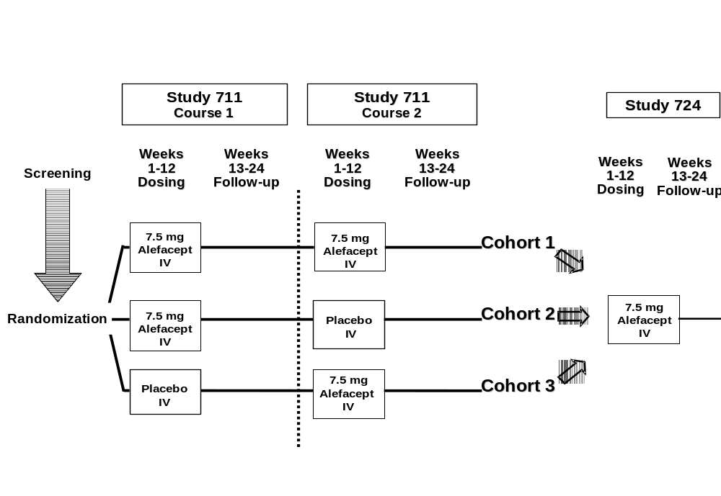Display 3-5 Overview of Studies 711 and 724

In Course 1, patients were seen weekly during the dosing period, and at 2, 4, 6, 8, and 12 weeks after the last dose. To be eligible for a second course, patients had to have

- a disease severity worse than “clear” by Physician’s Global Assessment,
- a CD4+ T cell count greater than or equal to the LLN, and
- not received disallowed medications, principally phototherapy or systemic therapies, in the time frames specified for the first course (Display 3-2).

Patients who did not satisfy these criteria were followed at “interim visits” until they met the conditions for a second course. As in the first course, patients were seen weekly during the dosing period of Course 2, and at 2, 4, 6, 8, and 12 weeks after the last dose.

In addition to demonstrating the effectiveness and safety of a second course of alefacept, the extensive 36-week period of follow-up for Cohort 2 (a course of alefacept followed by a course of placebo) allowed a more precise determination of safety, pharmacodynamic, and efficacy outcomes after one 12-week dosing period of 7.5 mg alefacept IV.

After completion of Study 711, eligible patients were allowed to enter Study 724, an open-label extension study to determine the safety and efficacy of further courses of alefacept (Display 3-5). Study 724 is ongoing. All patients receive 12 once-weekly injections of 7.5 mg alefacept IV when their disease has progressed to warrant systemic therapy or phototherapy. Patients are required to have a CD4+ T cell count at or above the LLN prior to their first dose.

CLINICAL EFFICACY

The following review of the efficacy of alefacept focuses on the two Phase 3 studies, 711 and 712, the designs of which are described in Section 3.2. Studies 711 and 712 support the efficacy of alefacept administered either IV or IM, respectively. In addition, data from Studies 711 and 717 (the extension to Study 712) support the efficacy of repeat courses of alefacept.

Measurement of Disease Activity in Chronic Plaque Psoriasis

Three measures of efficacy were used in the Phase 3 studies, the Psoriasis Area and Severity Index (PASI), a Physician’s Global Assessment (PGA), and the Dermatology Life Quality Index (DLQI).

The primary endpoint in both Phase 3 studies was based on PASI. This index was developed by Fredriksson and Pettersson (1978) in an effort to establish a standardized and reproducible clinical rating system that assesses the body area affected by psoriasis and the intensity of main symptoms on a scale ranging from 0 to 72. The PASI quantifies the severity and extent of disease by measuring the sum of the redness, thickness, and scale of the lesions, and weights these by the extent of body surface area involved (Appendix 1). A 75% or greater improvement in PASI (PASI 75) is accepted as the most stringent outcome measure demonstrating clinical benefit. Supportive evidence of clinical benefit is provided by the assessment of a 50% or greater reduction in PASI (PASI 50) and by the PGA. PGA is relevant to clinical practice because many physicians rate disease activity on a scale ranging from “severe” to “clear” (Appendix 1).

All physicians received instructions on the application of PASI and PGA prior to study initiation. In addition, the protocol specified that patients were to be examined by the same physician throughout the study. Sites were monitored for their consistency.

One of the critical assessments of clinical benefit in trials evaluating new therapies for patients with psoriasis is the demonstration of improvement in quality of life. In the Phase 3 studies, the DLQI was used to measure the effect of alefacept treatment on a patient’s quality of life. DLQI is a validated assessment of the impact of skin disease on patients’ lives (Finlay and Khan, 1994). Patients were asked to consider the previous 7 days and answer questions on an ordinal scale (Appendix 1). DLQI includes assessment of skin disease symptoms (such as itching and pain), patient feelings, daily activities, leisure activities, work/school function, personal relationships, and the negative aspects of treatment (for example, odor and mess). A reduction in DLQI score with treatment demonstrates improvement in a patient’s quality of life.

Endpoints in Phase 3 Studies

For both pivotal Phase 3 studies, the primary endpoint was the proportion of patients who achieved PASI 75 2 weeks after administration of the final dose.

Other pre-specified endpoints for both studies included the proportion of patients achieving, at 2 weeks after the last dose,

- a PGA of “almost clear” or “clear” (PGA AC/C), and
- PASI 50;

the proportion of patients achieving, at any time after the first dose (equivalent to an overall response rate),

- PASI 75,
- a PGA AC/C, and
- PASI 50;

and the mean DLQI score, 2 and 12 weeks after the last dose.

The clinical endpoints specified stringent criteria to ensure that clinical benefit was attributable to treatment with alefacept. Patients were considered treatment failures if they received phototherapy or any of the medications shown in Display 4-1 prior to reaching the specified efficacy endpoint. Use of moderately potent topical corticosteroids, keratolytics, coal tar, or vitamin D analogs was permitted on the groin, anal fold region, scalp, palms, and soles of the feet. However, application of these therapies to other regions of the body was considered a protocol violation and the patient was considered a treatment failure from the time of the violation onward.

Display 4-1 Therapies that disqualified patients as responders

- Phototherapy (PUVA, UVB)
- Systemic retinoids
- High potency topical corticosteroids
- Systemic corticosteroids
- Fumarates
- Methotrexate, cyclosporine, azathioprine, or other systemic immunosuppressant and immunomodulatory agents
- Another investigational drug or approved therapy for investigational use
- Inappropriate use of moderate potency topical corticosteroids, keratolytics, coal tar, or vitamin D analogs

Furthermore, patients who discontinued the study prior to the assessment at 2 weeks post-dosing, or failed to present for that visit, or did not have an efficacy assessment at that visit were also categorized as treatment failures.

Given these stringent criteria, the analyses underestimate the true proportion of patients responding to alefacept treatment. Analyses of the endpoints are based, therefore, on an intent-to-treat approach.

Statistical Methods

In the Phase 3 studies, sites were grouped into regions based on latitude to account for the varying amount of ultraviolet exposure from the sun. The choice of regions was pre-determined and specified in either the study protocol or study Statistical Analysis Plan. At randomization, patients were stratified by disease severity and by prior use of systemic therapy for psoriasis (Section 3.2).

For PASI 75, PASI 50, and PGA AC/C, the probability of responding was analyzed by fitting logistic regression models that included terms for geographic region, stratum, and treatment. For the overall DLQI score, analysis of variance was used with geographic region, stratum, baseline DLQI, the usage of phototherapy or other systemic therapies, and treatment terms in the model.

In Study 712, two comparisons were to be made, 10 mg alefacept IM vs placebo IM and 15 mg alefacept IM vs placebo IM. To preserve an overall Type I error of 0.050, each comparison with placebo used a Type I error of 0.025.

Study Populations in Phase 3

Accounting of Patients

A total of 1060 patients were dosed in the two Phase 3 studies, 553 in Study 711, and 507 in Study 712. Display 4-2 shows the numbers of patients dosed by treatment cohort (Study 711) and treatment group (Study 712). Withdrawal rates in each study were low but slightly higher during a course of placebo than during a course of alefacept.

Display 4-2 Accounting of patients in Studies 711 and 712

 | Study 711 |  |  |  | Study 712
 | Cohort 1 | Cohort 2 | Cohort 3
Course 1 | 7.5 mg  alefacept IV | 7.5 mg  alefacept IV | Placebo IV |  | Placebo IM | 10 mg  alefacept IM | 15 mg  alefacept IM
Number dosed  in Course 1 | 183 (100) | 184 (100) | 186 (100) |  | 168 (100) | 173 (100) | 166 (100)
Number withdrawn | 16 ( 9) | 26 ( 14) | 29 ( 16) |  | 16 ( 10) | 6 ( 3) | 14 ( 8)
Adverse event | 1 ( <1) | 5 ( 3) | 1 ( <1) |  | 3 ( 2) | 0 | 0
Worsening of  disease | 3 ( 2) | 6 ( 3) | 2 ( 1) |  | 0 | 0 | 3 ( 2)
Other | 12 ( 7) | 15 ( 8) | 26 ( 14) |  | 13 ( 8) | 6 ( 3) | 11 ( 7)
Course 2 | 7.5 mg  alefacept IV | Placebo IV | 7.5 mg  alefacept IV |  | Only 1 course administered in Study 712
Number dosed  in Course 2 | 154 (100) | 142 (100) | 153 (100)
Number withdrawn | 11 ( 7) | 24 ( 17) | 13 ( 8)
Adverse event | 0 | 0 | 0
Worsening of  disease | 2 ( 1) | 3 ( 2) | 1 ( <1)
Other | 9 ( 6) | 21 ( 15) | 12 ( 8)
NOTE: Numbers in parentheses are percentages.

Demographic and Baseline Disease Characteristics

In Phase 3, demographic characteristics were similar across treatment groups across studies (Display 4-3). Median age ranged from 44 to 46 years with the youngest patient aged 16 and the oldest 84. Approximately 75% of patients were aged between 30 and 59 years. The male to female ratio was approximately 2:1. Approximately 90% of the patients were Caucasian.

The median duration of disease across treatment groups ranged from 17 to 20 years. Median body surface area involvement ranged from 20 to 24% across all treatment groups. Approximately 90% of patients were considered to have “moderate” to “severe” disease as measured by PGA. Baseline PASI ranged from 3.4 to 58.8, with the median ranging from 13.2 to 15.2 across treatment groups. Approximately 17% of patients had a PASI in the range 5.0 to 9.9, 51% were in the 10.0 to 19.9 range, and 19% were in the 20.0 to 29.9 range.

Consistent with baseline disease characteristics, data regarding prior treatment suggest a disease severity suitable for management with systemic- and/or phototherapy-based approaches. The most common prior treatments were UVB therapy (43 to 54%), PUVA (30 to 42%), methotrexate (28 to 36%), retinoids (15 to 31%, with greater usage in Study 712), and cyclosporine (8 to 17%). The percentage of patients who reported no improvement or a worsening of disease with prior agents ranged from 30 to 47% for UVB, 23 to 36% for PUVA, 17 to 36% for methotrexate, 41 to 50% for retinoids, and 22 to 29% for cyclosporine. Thus, many patients enrolled in the Phase 3 studies had experienced an incomplete response or failed to respond to commonly used therapies.

Review of Display 4-3 leads to the conclusion that patients with moderate to severe psoriasis undergo treatment with many different modalities, i.e., no single agent predominates because of its risk-benefit profile, and that many patients are refractory to existing approaches.

Treatment groups were well balanced with respect to demographic and baseline disease characteristics.

Display 4-3 Demographics, baseline disease characteristics, and most common prior therapies for psoriasis in Phase 3 studies

 | Study 711 Course 1 |  |  | Study 712
 | Placebo IV  (N=186) | 7.5 mg  alefacept IV  (N=367) |  | Placebo IM  (N=168) | 10 mg  alefacept IM  (N=173) | 15 mg  alefacept IM  (N=166)
Demographics  Median (min, max) age (years)  Gender (%M: %F)  Race (% Caucasian: % Other)  Median (min, max) weight (kg) | 44 (18, 76)  68:32  87:13  91 (54, 170) | 45 (16, 84)  71:29  90:10  90 (46, 206) |  | 46 (20, 80)  65:35  88:12  86 (45, 144) | 45 (18, 72)  69:31  92: 8  84 (40, 170) | 45 (19, 78)  62:38  90:10  83 (43, 142)
Baseline disease characteristics  Median (min, max) duration of  disease (years)  Median (min, max) body surface  area involvement (%)  PGA: % who were  Severe  Moderate to severe  Moderate  Mild to moderate  Mild  Almost clear  Clear | 17 (2, 55)  22 (10, 85)  17  35  41  4  2  0  0 | 19 (2, 60)  22 (10, 98)  18  42  33  7  0  0  0 |  | 20 (3, 77)  24 (7, 90)  10  39  37  13  1  0  0 | 19 (4, 50)  22 (9, 95)  10  37  40  10  2  0  0 | 19 (2, 70)  20 (6, 85)  12  32  39  15  2  0  0
Median (min, max) PASI | 15.1 (4.2, 51.5) | 15.2 (4.3, 56.4) |  | 14.3 (5.3, 44.8) | 15.1 (3.4, 58.8) | 13.2 (3.7, 52.8)
Most common prior treatments  % who had prior treatment with  UVB  PUVA  Methotrexate  Retinoids  Cyclosporine | 54  30  30  15  8 | 49  36  36  17  12 |  | 49  40  28  27  14 | 45  40  31  31  17 | 43  42  30  30  17

Modification of Exposure to Alefacept

As described earlier, in the clinical trials evaluating alefacept, CD4+ T cell counts were monitored and the exposure to alefacept adjusted according to a protocol-defined algorithm (Display 3-3). Placebo was substituted for alefacept when a patient’s CD4+ T cell counts were ≤250 cells/μL the week prior to dosing. Alefacept was permanently discontinued if the CD4+ T cell count was <250 cells/μL for four or more consecutive visits.

As shown in Display 4-4, the number of patients with one or more placebo substitutions was greater with IV alefacept compared to either dose of IM alefacept. However, the proportion did not increase with the second course of alefacept in Study 711. None of the patients treated with either the 10 or 15 mg dose of alefacept IM had permanent substitution of study drug with placebo. Seven patients, all of whom had received 7.5 mg alefacept IV, received placebo through the remainder of Study 711. Following withdrawal of alefacept, the CD4+ T cell counts for these 7 patients began to recover.

Display 4-4 Placebo substitution rates in alefacept-treated patients in Phase 3 studies

 | Study 711 (7.5 mg IV) |  |  | Study 712
 | Course 1 (a) | Course 2 (b) |  | 10 mg IM | 15 mg IM
Number of patients dosed  Number of patients with ≥1 placebo substitution  Number of patients with permanent placebo substitutions | 367 (100)  38 ( 10)  7 ( 2) | 154 (100)  14 ( 9)  0 |  | 173 (100)  5 ( 3)  0 | 166 (100)  9 ( 5)  0
NOTE: Numbers in parentheses are percentages.
(a) Number of patients who received alefacept in Course 1 (Cohorts 1 and 2 combined).
(b) Number of patients who received two courses of alefacept (Cohort 1).

Clinical Response following One Course of Alefacept

Analysis of the proportions of patients achieving clinical response following one course of therapy is based on 507 patients in Study 712 for IM administration and 553 patients in the first course of Study 711. For Study 711, the comparison between alefacept and placebo for the first course of therapy is between Cohort 3 (placebo treatment during Course 1) and Cohorts 1 and 2 combined since both received alefacept during the first course.

Analyses of Response by PASI 75, PASI 50, and PGA AC/C

As shown in Display 4-5, a greater proportion of patients treated with either IV or IM alefacept than placebo achieved PASI 75 two weeks after the last dose, the primary endpoint of each study. In Study 711, 14% of patients treated with alefacept, compared to 4% who received placebo, responded 2 weeks after the last dose of Course 1 (p < 0.001). In Study 712, the proportions responding in the placebo, 10 and 15 mg alefacept IM groups were 5%, 12% (p = 0.041), and 21% (p < 0.001), respectively. Thus, the 7.5 mg IV and 15 mg IM groups were statistically significantly superior to placebo. Although the proportion of patients treated with 10 mg alefacept IM was higher than placebo, it was not statistically significant.

It is also worth noting that the effects of alefacept on the components of the PASI score, i.e., erythema, induration, and desquamation, were of similar magnitude.

Analysis of the secondary endpoint, PGA AC/C 2 weeks after the last dose, supports the primary outcome measure. In Study 711, 4% of those who received placebo compared to 11% of alefacept-treated patients improved by PGA AC/C assessment (p = 0.004). In Study 712, the response rates were 5, 10, and 14% in the placebo, 10 and 15 mg treatment groups, respectively, with a statistically significantly greater proportion in the 15 mg group compared to placebo (p = 0.006).

Analysis of the other efficacy endpoints of PASI 75 and PGA AC/C at any time, PASI 50 at 2 weeks after the last dose and at any time are consistent in demonstrating the efficacy of alefacept compared to placebo.

While statistically and clinically significant treatment benefit with alefacept has been shown in both pivotal studies at the time of the primary endpoint, the true magnitude of clinical benefit is underestimated at that time point. Results of the efficacy analyses suggest that the assessment of clinical response “at any time” during the course of treatment is a more relevant measure of clinical benefit. For all three alefacept treatment groups, the greatest response rate occurred after completion of dosing (Display 4-6). In Study 711, 21% of patients achieved PASI 75 6 weeks after alefacept treatment compared to 14% at 2 weeks after dosing. Similarly, in Study 712, 17% of patients treated with 10 mg IM alefacept had a PASI 75 at 4 weeks after treatment and 21% of the 15 mg treatment group achieved PASI 75 2 weeks after treatment. The occurrence of clinical benefit later in the dosing interval for some patients is consistent with the pharmacodynamic effect of alefacept. Maximum T cell reductions occurred later in the alefacept dosing interval in some patients. Consequently, maximum clinical benefit would be predicted to occur after completion of treatment.

Display 4-5 Proportions of patients responding in the first course of treatment in Phase 3 Studies 711 and 712

 | Study 711 Course 1 |  |  | Study 712
 | Placebo IV | 7.5 mg  alefacept IV |  | Placebo IM | 10 mg  alefacept IM | 15 mg  alefacept IM
Number of patients dosed | 186 (100) | 367 (100) |  | 168 (100) | 173 (100) | 166 (100)
PASI 75  - 2 weeks post-treatment (a)  - at any time (overall response) | 7 ( 4)  15 ( 8) | 53 ( 14)  p < 0.001  102 ( 28)  p < 0.001 |  | 9 ( 5)  21 ( 13) | 21 ( 12)  p = 0.041  48 ( 28)  p < 0.001 | 35 ( 21)  p < 0.001  54 ( 33)  p < 0.001
PGA AC/C  - 2 weeks post-treatment  - at any time (overall response) | 7 ( 4)  11 ( 6) | 42 ( 11)  p = 0.004  83 ( 23)  p < 0.001 |  | 8 ( 5)  14 ( 8) | 18 ( 10)  p = 0.065  38 ( 22)  p < 0.001 | 23 ( 14)  p = 0.006  40 ( 24)  p < 0.001
PASI 50  - 2 weeks post-treatment  - at any time (overall response) | 18 ( 10)  44 ( 24) | 139 ( 38)  p < 0.001  204 ( 56)  p < 0.001 |  | 30 ( 18)  59 ( 35) | 62 ( 36)  p < 0.001  91 ( 53)  p = 0.002 | 69 ( 42)  p < 0.001  94 ( 57)  p < 0.001
NOTE: Numbers in parentheses are percentages.
PASI 75 and PASI 50 represent 75% or greater and 50% or greater reductions from baseline PASI, respectively;
PGA AC/C is a PGA of “almost clear” or “clear”, each without the concomitant use of phototherapy or other systemic
therapies.
(a) Primary endpoint.
P-values for comparisons with placebo are considered statistically significant if <0.050 for Study 711 Course 1,
if <0.025 for each dose group in Study 712.

Display 4-6 Proportion of patients achieving PASI 75 in the first course of treatment

IV administration (Study 711 Course 1)
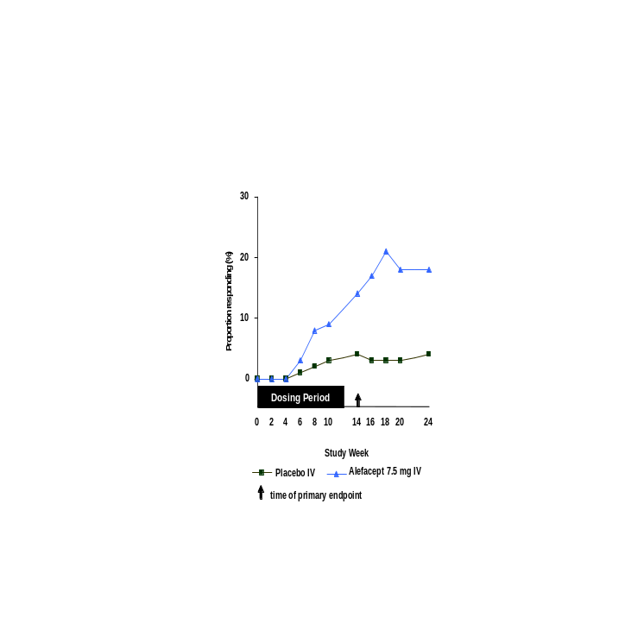
IM administration (Study 712)

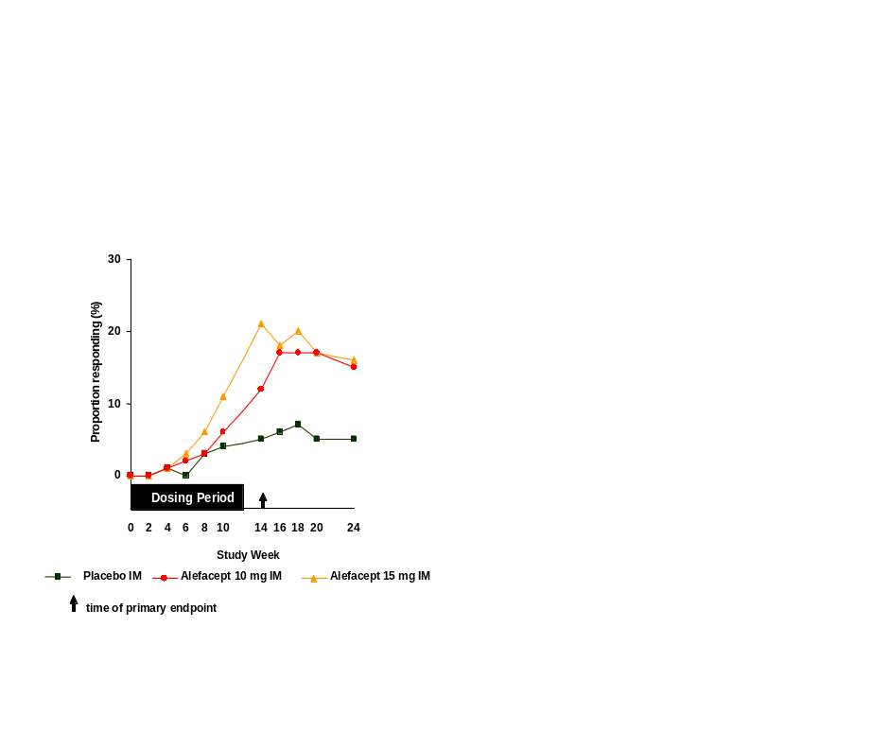
The efficacy results described above characterize three unique features of alefacept therapy:

- The clinical response with alefacept treatment is seen within 6 to 8 weeks of the initiation of dosing and corresponds to the reductions in memory T cells (Section 5.2).

- Continued improvement is observed following cessation of dosing in the face of increasing T cell counts.

- Treatment with alefacept provides a durable response. During the follow-up period, clinical response was maintained.

All efficacy evaluations consistently demonstrate these three characteristics of alefacept activity.

While minor differences in the response rates of the primary endpoint were observed in the two pivotal studies, a comparison of the two studies can be done by calculating the odds ratio of responding. If the odds of responding in each treatment group are the same, then the odds ratio will be 1. If alefacept is better than placebo, the odds ratio will be greater than 1, and if placebo is better than alefacept then the odds ratio will be less than 1. To compare the alefacept response to the placebo response across studies, the odds ratios of responding at 2 weeks after the last dose have been calculated for:

- the 7.5 mg IV group relative to the placebo IV group in the first course of Study 711,
- the 10 mg IM group relative to the placebo IM group in Study 712, and
- the 15 mg IM group relative to the placebo IM group in Study 712.

The odds ratios are based on the models fitted to the data that generated the p-values in Display 4-5 for treatment comparisons, and are thus adjusted for geographic region and stratum.

Display 4-7 presents the estimated odds ratios, and confidence intervals (CIs) for these estimates (95% intervals for Study 711 and 97.5% intervals for Study 712). CIs are determined according to the p-value used to determine statistical significance in the study protocol. Confidence intervals that do not contain 1 are statistically significant.

As can be seen from Display 4-7, the magnitude of benefit of alefacept administration was consistent across the 7.5 mg IV and 15 mg IM treatments. The odds ratio of responding to 10 mg alefacept IM is lower than that of 15 mg alefacept IM and 7.5 mg alefacept IV.

Display 4-7 Odds ratios of responding 2 weeks post-treatment in Study 711 Course 1 and Study 712

5
10
1
Favors alefacept
Favors
placebo
Response
Study
Dose and route
PASI 75
Study 711 Course 1
7.5 mg IV
Study 712
10 mg IM
Study 712
15 mg IM
PGA AC/C
Study 711 Course 1
7.5 mg IV
Study 712
10 mg IM
Study 712
15 mg IM
PASI 50
Study 711 Course 1
7.5 mg IV
Study 712
10 mg IM
Study 712
15 mg IM
Odds Ratio (CI)
4.32 (1.92, 9.76)
2.34 (0.92, 5.97)
4.69 (1.93, 11.41)
3.39 (1.47, 7.83)
2.27 (0.84, 6.13)
3.28 (1.25, 8.63)
5.84 (3.42, 9.99)
2.60 (1.45, 4.66)
3.31 (1.85, 5.93)

Analysis of Clinical Effect by Subgroups

Display 4-8 shows PASI 75 response rates 2 weeks following treatment by age, gender, and baseline disease characteristics. Display 4-9 shows PASI 75 response rates 2 weeks following treatment according to whether or not a patient had an improvement in disease with prior phototherapy or systemic therapy. For example, in Study 712, 127 patients in the 15 mg alefacept IM group had received prior therapy, of whom 99 reported improvement with that prior therapy. Of these 99, 17% achieved PASI 75 2 weeks post-dosing vs 3% in the comparable group who received placebo.

Despite the low numbers of patients in some categories,

- treatment with 7.5 mg alefacept IV and 15 mg alefacept IM results in greater response rates than placebo regardless of age, gender, and baseline disease characteristics,
- treatment with 7.5 mg alefacept IV and 15 mg alefacept IM results in greater response rates than placebo regardless of exposure to or improvement with prior therapy, and
- patients who had never been exposed to prior therapy tended to have a greater response rate than those who improved with a prior therapy.

Display 4-8 PASI 75 2 weeks post-treatment − percentage responding by age, gender, and baseline disease characteristics

 |  | Study 711 Course 1 |  |  | Study 712
 |  | Placebo IV | 7.5 mg alefacept IV |  | Placebo IM | 10 mg alefacept IM | 15 mg alefacept IM
Age (years) | <40  ≥40 but <60  ≥60 | 3/ 68 ( 4)  4/ 89 ( 4)  0/ 29 | 20/131 (15)  26/186 (14)  7/ 50 (14) |  | 5/ 57 ( 9)  2/ 82 ( 2)  2/ 29 ( 7) | 11/ 61 (18)  7/ 95 ( 7)  3/ 17 (18) | 17/ 63 (27)  10/ 73 (14)  8/ 30 (27)
Gender | Male  Female | 3/127 ( 2)  4/ 59 ( 7) | 33/260 (13)  20/107 (19) |  | 6/110 ( 5)  3/ 58 ( 5) | 14/120 (12)  7/ 53 (13) | 20/103 (19)  15/ 63 (24)
BSA involvement (%) | ≤30  >30 | 5/129 ( 4)  2/ 57 ( 4) | 39/250 (16)  14/117 (12) |  | 5/117 ( 4)  4/ 51 ( 8) | 17/112 (15)  4/ 61 ( 7) | 22/119 (18)  13/ 47 (28)
PASI | ≤10  >10 but ≤20  >20 | 1/ 32 ( 3)  5/ 91 ( 5)  1/ 63 ( 2) | 15/ 67 (22)  25/190 (13)  13/110 (12) |  | 0/ 32  6/ 95 ( 6)  3/ 41 ( 7) | 6/ 33 (18)  10/ 86 (12)  5/ 54 ( 9) | 7/ 39 (18)  15/ 84 (18)  13/ 43 (30)
PGA | “Severe” or “Moderate to severe”  “Moderate”  “Mild to moderate” or “Mild” | 3/ 98 ( 3)  4/ 78 ( 5)  0/ 10 | 29/220 (13)  17/122 (14)  7/ 25 (28) |  | 6/ 82 ( 7)  2/ 62 ( 3)  1/ 24 ( 4) | 11/ 81 (14)  5/ 70 ( 7)  5/ 22 (23) | 15/ 73 (21)  15/ 65 (23)  5/ 28 (18)
NOTE: Entries are number responding/number in category (percentage).

Display 4-9 PASI 75 2 weeks post-treatment − percentage responding by response to prior phototherapy, prior systemic therapy, or no therapy

 | Response to prior therapy | Study 711 Course 1 |  |  | Study 712
 | Response to prior therapy | Placebo IV | 7.5 mg alefacept IV |  | Placebo IM | 10 mg alefacept IM | 15 mg alefacept IM
Any prior therapy | No change or worsened  Improved  Never exposed | 0/ 41  6/106 ( 6)  1/ 39 ( 3) | 12/ 59 (20)  28/223 (13)  13/ 85 (15) |  | 2/ 24 ( 8)  3/107 ( 3)  4/ 37 (11) | 3/ 22 (14)  13/112 (12)  5/ 39 (13) | 7/ 28 (25)  17/ 99 (17)  11/ 39 (28)
UVB | No change or worsened  Improved  Never exposed | 0/ 47  3/ 54 ( 6)  4/ 85 ( 5) | 14/ 76 (18)  14/101 (14)  25/189 (13) |  | 2/ 25 ( 8)  1/ 56 ( 2)  6/ 87 ( 7) | 3/ 29 (10)  7/ 48 (15)  11/ 96 (11) | 8/ 28 (29)  7/ 43 (16)  20/ 95 (21)
PUVA | No change or worsened  Improved  Never exposed | 0/ 20  2/ 36 ( 6)  5/130 ( 4) | 6/ 47 (13)  8/ 84 (10)  39/236 (17) |  | 0/ 18  1/ 48 ( 2)  8/102 ( 8) | 3/ 21 (14)  5/ 46 (11)  13/106 (12) | 2/ 16 (13)  10/ 52 (19)  23/ 98 (23)
Methotrexate | No change or worsened  Improved  Never exposed | 0/ 17  0/ 38  7/131 ( 5) | 6/ 48 (13)  11/ 85 (13)  36/233 (15) |  | 0/ 13  2/ 34 ( 6)  7/121 ( 6) | 4/ 9 (44)  2/ 44 ( 5)  15/120 (13) | 2/ 17 (12)  4/ 32 (13)  29/117 (25)
Retinoids | No change or worsened  Improved  Never exposed | 1/ 14 ( 7)  0/ 14  6/158 ( 4) | 2/ 32 ( 6)  4/ 31 (13)  47/304 (15) |  | 0/ 19  1/ 27 ( 4)  8/122 ( 7) | 3/ 24 (13)  0/ 29  18/120 (15) | 4/ 23 (17)  7/ 27 (26)  24/116 (21)
Cyclosporine | No change or worsened  Improved  Never exposed | 0/ 4  1/ 10 (10)  6/172 ( 3) | 3/ 12 (25)  3/ 33 ( 9)  47/321 (15) |  | 0/ 5  1/ 17 ( 6)  8/146 ( 5) | 0/ 6  5/ 23 (22)  16/144 (11) | 0/ 8  2/ 20 (10)  33/138 (24)
NOTE: Entries are number responding/number in category (percentage).

Analysis of Quality of Life

Display 4-10 shows the mean DLQI scores at 2 and 12 weeks after the last dose of study drug in Studies 711 and 712. A reduction in DLQI score reflects improvement in quality of life. In Study 711, a statistically significant difference in mean DLQI between alefacept- and placebo-treated patients was apparent at 2 weeks (p < 0.001) and 12 weeks (p = 0.002) following treatment. In Study 712, benefit was seen 2 weeks following treatment with 15 mg alefacept IM (p < 0.001). Although the scores in quality of life at 12 weeks after dosing showed improvement for both the 10 and 15 mg alefacept IM groups, the differences from placebo were not statistically significant.

Display 4-10 Overall DLQI score in Studies 711 and 712
 | Study 711  Course 1 |  | Study 712
 | Placebo IV | 7.5 mg  alefacept IV | Placebo IM | 10 mg  alefacept IM | 15 mg  alefacept IM
No. of patients dosed | 186 (100) | 367 (100) | 168 (100) | 173 (100) | 166 (100)

At 2 weeks post-treatment

No. of evaluable patients (a) | 158 ( 85) | 314 ( 86) | 150 ( 89) | 152 ( 88) | 141 ( 85)
Mean DLQI at baseline | 11.0 | 11.0 | 10.7 | 11.1 | 12.1
Adjusted mean DLQI  2 weeks post-treatment (b) | 9.9 | 7.6 | 9.1 | 7.8 | 6.7
 |  | p < 0.001 |  | p = 0.049 | p < 0.001

At 12 weeks post-treatment

No. of evaluable patients (a) | 172 ( 92) | 332 ( 90) | 156 ( 93) | 157 (91) | 149 ( 90)
Mean DLQI at baseline | 10.8 | 11.0 | 10.8 | 11.1 | 12.2
Adjusted mean DLQI  12 weeks post-treatment (b) | 9.8 | 8.1 | 8.6 | 7.5 | 7.4
 |  | p = 0.002 |  | p = 0.079 | p = 0.060
NOTE: Numbers in parentheses are percentages.
A reduction in score reflects improvement in quality of life.
P-values for comparisons with placebo are considered statistically significant if <0.050 for Study 711 Course 1, if <0.025
for each dose group in Study 712.
(a) Number who completed questionnaire and respective visit.
(b) Mean is adjusted for geographic region, stratum, baseline DLQI score, and disallowed concomitant therapy.

In order to correlate the changes in quality-of-life scores with clinical response, treatment groups within each study were combined. Patients were classified as responders or non-responders according to their PASI 75, PGA AC/C, and PASI 50 responses irrespective of their treatment group. As shown in Display 4-11, the decrease in DLQI correlated significantly with improvement in the clinical assessment scores.

Display 4-11 Mean change in DLQI Overall Score by responder status at 2 weeks after the last dose

 | Responder |  |  | Non-responder |  |  | p-value  (a)
 | Baseline | Mean change from baseline |  | Baseline | Mean change from baseline
PASI 75  Study 711 Course 1  Study 712 | 10.95  10.51 | -8.60  -7.18 |  | 10.83  11.51 | -2.83  -2.92 |  | <0.001  <0.001
PASI 50  Study 711 Course 1  Study 712 | 11.57  10.81 | -7.36  -5.97 |  | 10.52  11.23 | -1.81  -2.24 |  | <0.001  <0.001
PGA AC/C  Study 711 Course 1  Study 712 | 10.44  9.63 | -8.06  -7.12 |  | 10.89  11.26 | -3.02  -3.09 |  | <0.001  <0.001
NOTE: A reduction in score reflects improvement in quality of life.
(a) Comparison of responders vs non-responders using one-way analysis of variance.

Duration of Clinical Response Following One Course of Alefacept

Systemic agents used in the treatment of moderate to severe psoriasis include cyclosporine the effects of which last for approximately 2 to 12 weeks, etretinate for 8 weeks, methotrexate for 1 to 5 months, and PUVA for approximately 6 months (Ellis et al, 1991; Ellis et al, 1995; Kaplan et al, 1983; Dooren-Greebe et al, 1994; Dooren-Greebe et al, 1995; Hesse et al, 1987). However, these therapies are associated with toxicity (Display 1-1). The need exists, therefore, for a safe and effective therapy that will give a durable response greater than that of existing systemic agents.

Currently, no consensus exists on the quantification of duration of response. However, in other published studies, duration has been defined as the time in which a patient has an increase to no more than 50% of the pre-study baseline PASI score and an increase to no more than 50% of the pre-study baseline body surface area affected (Ozawa et al, 1999; Shupack et al, 1997).

For alefacept, the best estimate of duration of response comes from patients who received a course of alefacept followed by a course of placebo, namely Cohort 2, in Study 711. In Study 711, duration of clinical response was defined in two ways:

- the maintenance of PASI 50 or better in patients who achieved a best observed response of PASI 75 at any time, and
- the maintenance of PASI 50 or better in patients who achieved a best observed response of PGA AC/C at any time.

Duration of response has been estimated using Kaplan-Meier methodology. This methodology takes into account the fact that the measurement of duration times may be right-censored due to a patient’s participation in the study being cut short due to, for example, voluntary withdrawal, an adverse event, termination of the study.

As shown in Displays 4-12 and 4-13, duration of response according to the two definitions above was long: for those who achieved PASI 75, the median duration of response at PASI 50 was 216 days (almost 31 weeks), and for those who achieved a PGA AC/C, 241 days (approximately 34 weeks). Unlike current systemic treatments including cyclosporine and methotrexate, treatment with alefacept provides a markedly durable clinical response.

Display 4-12 Duration of a 50% reduction from baseline PASI in those who achieved PASI 75 in Cohort 2 of Study 711
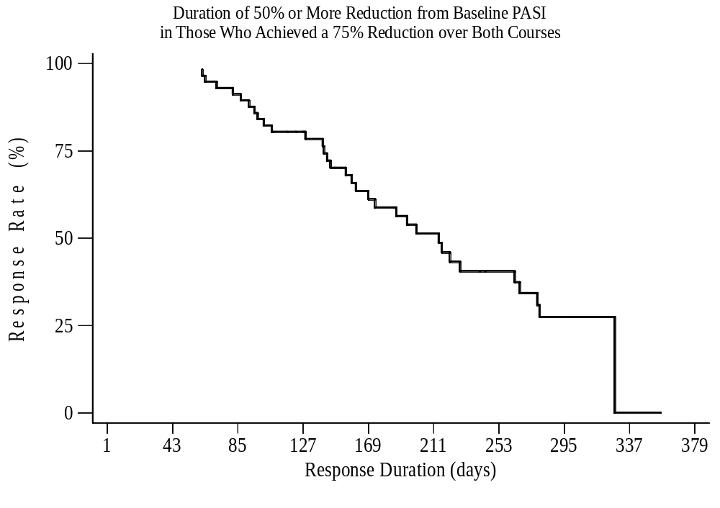

Display 4-13 Duration of a 50% reduction from baseline PASI in those who achieved PGA AC/C in Cohort 2 of Study 711
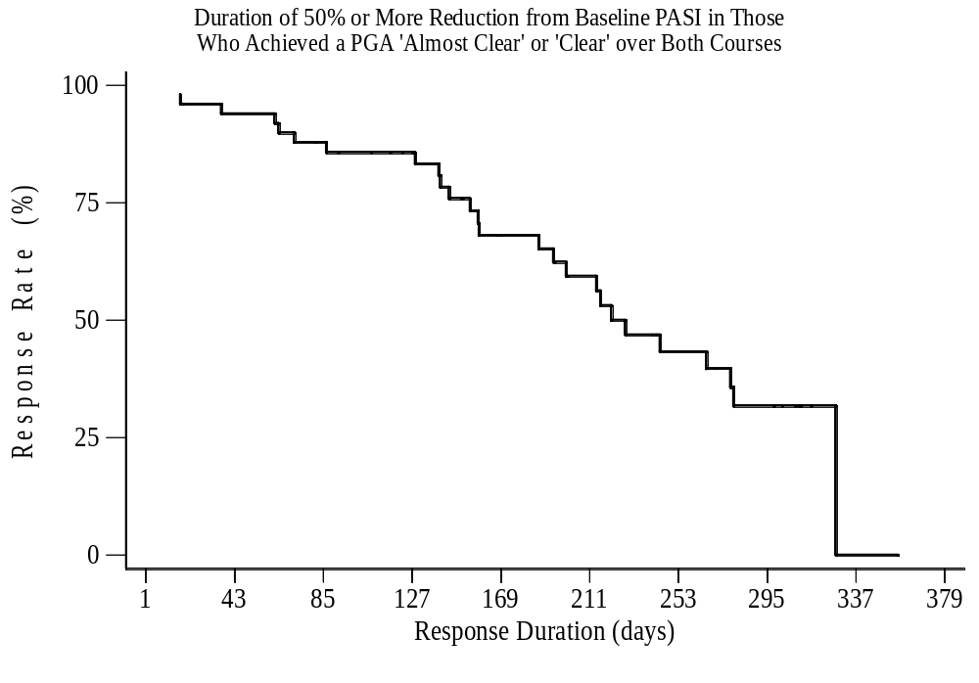

Clinical Response with Two Courses of Alefacept

The efficacy of two courses of alefacept was evaluated in the Study 711. In Study 711, patients were eligible to receive a second course of study drug if, at 12 weeks post-treatment in Course 1:

- their disease severity was worse than “clear” by PGA,
- their CD4+ T cell count was greater than or equal to the LLN, and
- they had not received disallowed concomitant medications, principally systemic or phototherapy within the same time frame as that for the first course (Display 3-2).

Patients who were not eligible to start dosing in Course 2 were followed at “interim visits” until they were eligible for a second course of treatment. Twenty-three of the 367 patients who received alefacept during the first course were never dosed during the second course. Of these 23 patients, 6 were in remission, i.e., had PGA ratings of “clear.”

Assessment of clinical response with a second course of alefacept is based upon the comparison between the 154 patients in Cohort 1 and the 142 patients in Cohort 2 of Study 711. Patients in Cohort 1 received alefacept during both courses of treatment while patients in Cohort 2 received placebo during the second course (this cohort had received alefacept during the first course).

At 2 weeks after the last dose of the second dosing period, a greater proportion of patients treated with a second course of 7.5 mg alefacept IV compared to placebo had a clinical response as measured by PASI 75 and PGA AC/C (Display 4-14). Twenty-three percent of alefacept-treated patients achieved PASI 75 compared to 7% who received placebo (p<0.001); and 20% of alefacept-treated patients achieved PGA AC/C compared to 6% who received placebo (p<0.001).

Patients treated with a second course of alefacept also demonstrated a clinical response compared to placebo as measured by PASI 50 at 2 weeks after treatment and at any time, PGA AC/C at any time, and PASI 75 at any time.

Note that the higher response rates for placebo in Course 2 may be due to the long duration of improvement following the first course of alefacept, and the higher response rates for alefacept in Course 2 suggest a cumulative benefit in efficacy (Display 4-15). Overall, patients who responded in Course 1 also responded in Course 2. Also, some patients who did not respond in Course 1 achieved response in Course 2.

Display 4-14 Proportions of patients responding in Courses 1 and 2 of Study 711

 | Study 711 Course 1 (a) |  |  | Study 711 Course 2
 | Placebo IV  (Cohort 3) | 7.5 mg  alefacept IV  (Cohorts 1 and 2) |  | Placebo IV  (Cohort 2) | 7.5 mg  alefacept IV  (Cohort 1)
Number of patients dosed | 186 (100) | 367 (100) |  | 142 (100) | 154 (100)
PASI 75  - 2 weeks post-treatment  - at any time (overall response) | 7 ( 4)  15 ( 8) | 53 ( 14)  p < 0.001  102 ( 28)  p < 0.001 |  | 10 ( 7)  27 ( 19) | 36 ( 23)  p < 0.001  57 ( 37)  p < 0.001
PGA AC/C  - 2 weeks post-treatment  - at any time (overall response) | 7 ( 4)  11 ( 6) | 42 ( 11)  p = 0.004  83 ( 23)  p < 0.001 |  | 8 ( 6)  25 ( 18) | 31 ( 20)  p < 0.001  46 ( 30)  p = 0.011
PASI 50  - 2 weeks post-treatment  - at any time (overall response) | 18 ( 10)  44 ( 24) | 139 ( 38)  p < 0.001  204 ( 56)  p < 0.001 |  | 35 ( 25)  70 ( 49) | 74 ( 48)  p < 0.001  99 ( 64)  p = 0.002
NOTE: Numbers in parentheses are percentages.
P-values for comparisons with placebo.
(a) From Display 4-5.
Display 4-15 shows the proportion of patients achieving PASI 75 in Course 1 and those achieving PASI 75 in Course 2. As described earlier, all patients are included in the analysis of Course 1, but only those who received alefacept in Course 1, i.e., Cohorts 1 and 2, are included in the analysis of Course 2.

Patients in Cohort 2 (alefacept/placebo) have a long lasting benefit from the first course which declines slowly during the second course when they received placebo. In contrast, the proportion of patients treated with a second course of alefacept (Cohort 1) who achieved PASI 75 was initially stable but increased to a maximum of 27% at 6 weeks after treatment. Results were similar for PASI 50 and PGA AC/C. It should also be borne in mind that the total benefit of receiving alefacept is underestimated since 23 patients who achieved optimal levels of clinical response or had CD4+ T cell counts below the LLN were not dosed during the second course.

Display 4-15 Study 711: proportion of patients achieving PASI 75 by course

Course 1 (all patients) Course 2 (patients who
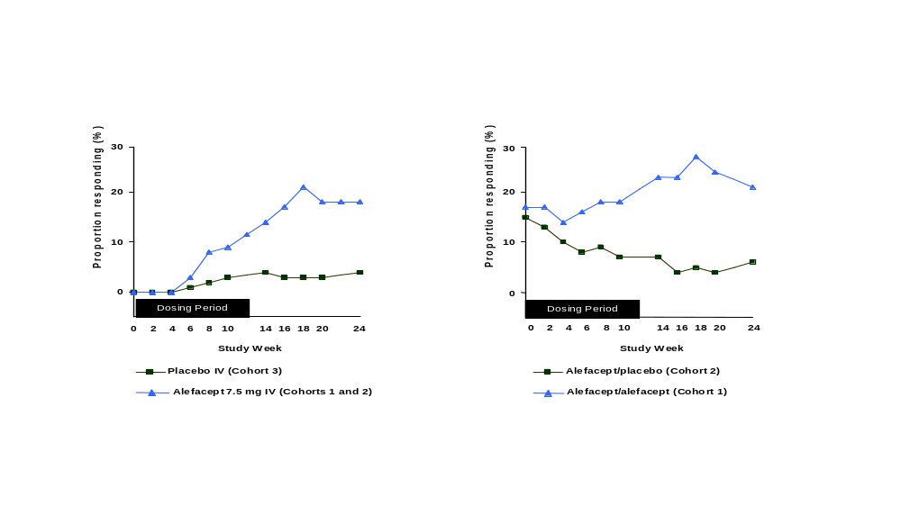 received alefacept in Course 1)

In clinical terms, the best approximation of benefit from two courses is gauged by comparing the response rates over two courses versus one. The greatest proportion of patients achieving clinical response was seen in Cohort 1, the cohort that received two courses of alefacept (Display 4-16). For Cohorts 1, 2 and 3, the proportions achieving PASI 75 were 40, 31, and 28%, achieving PGA AC/C were 32, 27, and 22%, and achieving PASI 50 were 71, 63, and 52%, respectively.

Display 4-16 Endpoints based on proportions of patients responding over the entire span of Study 711
 | 7.5 mg alefacept IV then  7.5 mg alefacept IV  (Cohort 1) | 7.5 mg alefacept IV then  placebo IV  (Cohort 2) | Placebo IV  then  7.5 mg alefacept IV  (Cohort 3)
Number of patients dosed | 183 (100) | 184 (100) | 186 (100)
PASI 75 | 73 ( 40) | 57 ( 31) | 53 ( 28)
PGA AC/C | 58 ( 32) | 50 ( 27) | 40 ( 22)
PASI 50 | 130 ( 71) | 116 ( 63) | 97 ( 52)
NOTE: Numbers in parentheses are percentages.

Display 4-17 presents the preliminary findings for response rates when the IM administration study, 712, and its extension, 717, are combined. For the placebo/10 mg cohort, the 10 mg/10 mg cohort, and the 15 mg/15 mg cohort, the proportions achieving PASI 75 were 23, 37, and 43%, achieving PGA AC/C were 17, 29, and 31%, and achieving PASI 50 were 57, 64, and 69%, respectively.

Display 4-17 Endpoints based on proportions of patients responding over the entire span of Studies 712 and 717
 | Placebo  then  10 mg alefacept IM | 10 mg alefacept IM  then  10 mg alefacept IM | 15 mg alefacept IM  then  15 mg alefacept IM
Number of patients dosed | 168 (100) | 173 (100) | 166 (100)
PASI 75 | 38 ( 23) | 64 ( 37) | 71 ( 43)
PGA AC/C | 29 ( 17) | 51 ( 29) | 51 ( 31)
PASI 50 | 95 ( 57) | 111 ( 64) | 114 ( 69)
NOTE: Numbers in parentheses are percentages.

In Study 711, patients’ quality of life was assessed using the DLQI at 2 and 12 weeks following treatment during the second course. Compared to placebo, alefacept-treated patients had a statistically significant improvement in their quality of life at both time points (Display 4-18).

Display 4-18 Overall DLQI score in the second course of Study 711

 | Study 711 Course 2
 | Placebo IV | 7.5 mg  alefacept IV | p-value
Number of patients dosed | 142 (100) | 154 (100)
At 2 weeks post-treatment

No. of evaluable patients (a) | 117 ( 82) | 138 ( 90)
Mean DLQI at baseline | 10.0 | 11.1
Adjusted mean DLQI 2 weeks post-treatment (b) | 8.0 | 6.5 | 0.026
At 12 weeks post-treatment

No. of evaluable patients (a) | 135 ( 95) | 149 ( 97)
Mean DLQI at baseline | 10.0 | 11.4
Adjusted mean DLQI 12 weeks post-treatment (b) | 8.8 | 6.9 | 0.007
NOTE: Numbers in parentheses are percentages.
A reduction in score reflects improvement in quality of life.
(a) Number who completed questionnaire and respective visit.
(b) Mean is adjusted for geographic region, stratum, baseline DLQI score, and disallowed concomitant therapy.

Preliminary Findings in Psoriatic Arthritis

Like psoriasis, psoriatic arthritis is a T-cell-mediated disorder. The LFA-3/CD2 interaction plays a significant role in the T-cell activation involved in both conditions.

Eleven patients with active psoriatic arthritis were treated with alefacept 7.5 mg IV for 12 weeks in an open-label study. Clinical joint assessment and laboratory assessments were performed at baseline, and after 4, 9, 12, and 16 weeks of treatment. Serial synovial tissue (ST) biopsies of an inflamed index joint (knee, ankle, wrist, or metacarpophalangeal joint) were obtained by arthroscopy at baseline, and after 4 and 12 weeks of treatment. At baseline, the mean swollen and tender joint count were both 7.

At completion of treatment, 6 of 11 patients (56%) fulfilled the disease activity score (DAS) response criteria (Display 4-19). Nine patients (82%) fulfilled the DAS response criteria at any point during the study. Using the American College of Rheumatology (ACR) scoring criteria, 7 of the 11 patients (64%) fulfilled the ACR 20 response of whom 3 (27%) also fulfilled ACR 50. Improvement in disease activity was associated with statistically significant reduction in C-reactive protein (CRP) (Display 4-20). There was also a statistically significant reduction in CD4+ T cells (p < 0.05), CD8+ T cells (p = 0.05), and CD68+ macrophages (p < 0.02) in the ST after 12 weeks of treatment compared to baseline. The ST and peripheral blood of those patients fulfilling the DAS response criteria contained more memory T cells at baseline and displayed a significant reduction in these cells compared to non-responding patients. It was concluded that the changes in ST, together with the improvement in clinical joint scores and CRP, after treatment with alefacept support the hypothesis that T-cell activation plays an important role in this chronic inflammatory disease. Further investigation of alefacept in psoriatic arthritis is warranted.
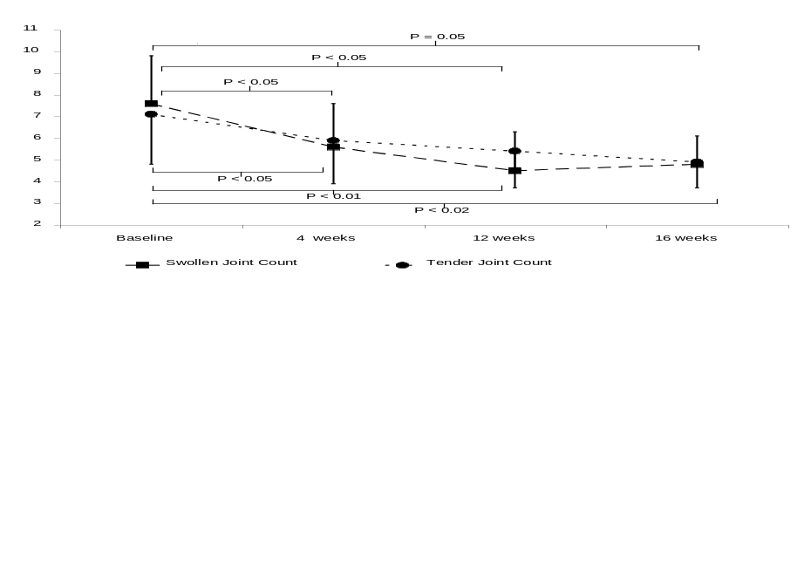

Display 4-19 Swollen joint count and tender joint count

Display 4-20 Mean C-reactive protein by time
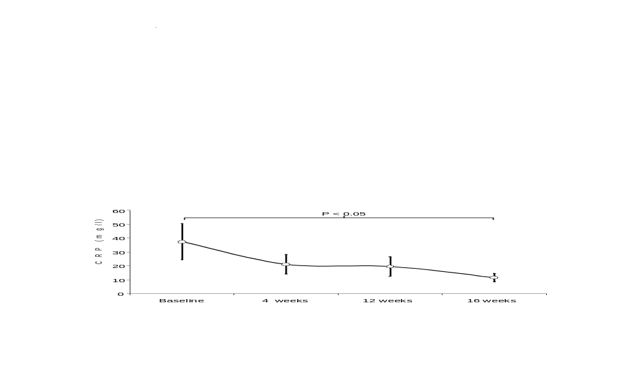

Summary of Clinical Efficacy

The clinical efficacy data from the two pivotal Phase 3 studies evaluating alefacept in patients with chronic plaque psoriasis demonstrate:

- Compared to placebo treated patients, a greater proportion of patients treated with either 7.5 mg IV, 10 mg IM, or 15 mg IM alefacept experienced a clinical response as measured by PASI 75 two weeks after completion of treatment. The differences between 7.5 mg IV and placebo, and between 15 mg IM and placebo were statistically significant.

- Support for clinical benefit is provided by all other pre-specified assessments of clinical response. These assessments include PGA AC/C at 2 weeks after treatment and at any time, PASI 50 at 2 weeks after treatment and at any time, and PASI 75 at any time. All of these analyses demonstrated significant benefit with either 7.5 mg IV or 15 mg IM alefacept treatment compared to placebo.

- In addition to these measurements of cutaneous responses, assessment of the patient’s quality of life using DLQI demonstrates significant improvement in the patients’ quality of life after treatment with alefacept. The improvement in quality of life as measured by DLQI correlates with clinical response as measured by PASI 75, PASI 50, and PGA AC/C.

- The onset of clinical response is seen at 6 weeks after initiation of alefacept in most patients. This timing of onset of activity corresponds with the maximal reduction in the memory T cells associated with alefacept treatment.

- In the clinical studies, the greatest response rate as measured by PASI 75 occurred between 2 to 6 weeks after completion of dosing for the three alefacept treatment groups.

- Clinical response to treatment with alefacept is durable and duration of response increases following a second course of treatment. These results contrast markedly with the clinical experience with cyclosporine or methotrexate where cessation of treatment is associated with disease activation.

- Treatment with two courses of alefacept provides cumulative efficacy, i.e., some patients who failed to respond to one course experienced a clinical response with a second course.

- Preliminary results from a study in psoriatic arthritis show alefacept to be a promising agent for this indication.

CLINICAL PHARMACOLOGY

Pharmacokinetics

The pharmacokinetics of alefacept were characterized in healthy volunteers and in patients with chronic plaque psoriasis.

In healthy-volunteer studies, single-dose IV administration of alefacept at doses ranging from 0.005 to 0.225 mg/kg showed that serum alefacept concentrations were proportional to the dose administered. Clearance, half-life, and volume of distribution were independent of absolute dose. In studies of patients with chronic plaque psoriasis, repeat-dose IV administration at doses ranging from 0.005 to 0.15 mg/kg showed that steady-state serum alefacept concentrations were proportional to dose.

When administered as a fixed dose of 7.5 mg IV, the half-life of alefacept was estimated as 267 hours (approximately 11 days), the clearance as 0.25 mL/h/kg, and the volume of distribution as 94 mL/kg.

Pharmacodynamic Effects on Peripheral T Cell Counts

Based on the mechanism of action described in Section 1.3, the pharmacodynamic effects of alefacept on

- total lymphocyte counts,
- total CD4+ and CD8+ T cells,
- memory T cells (CD4+CD45RO+ and CD8+CD45RO+),
- naïve T cells (CD4+CD45RA+ and CD8+CD45RA+),
- NK cells, and
- B cells

were monitored in the two pivotal studies, 711 and 712. Quantification of counts was conducted at a central laboratory.

Pharmacodynamics following One Course of Treatment in Patients with Chronic Plaque Psoriasis

The placebo groups in both pivotal studies showed a stable T cell profile over time. Compared to placebo, treatment with alefacept resulted in reductions in total lymphocytes (Display 5-1 shows total lymphocyte counts over time for Study 712), CD4+ and CD8+ T cells, and in CD4+ and CD8+ memory T cells. For the 10 and 15 mg alefacept IM doses in Study 712 and the three IV doses evaluated in Study 708, the Phase 2, dose-response study, the reduction in T cells was dose-dependent.

Consistent with its mechanism of action, treatment with alefacept resulted in a markedly greater reduction in CD4+ and CD8+ memory T cells compared to the reduction in CD4+ and CD8+ naïve T cells (Display 5-2). For both routes of administration, the degree of T cell reduction was greatest during the first 6 weeks of treatment, after which the rate of reduction slowed and the T cell count gradually started to increase after completion of the treatment course. Changes in CD4+ and CD8+ memory T cells are detectable as reductions in total CD4+ and total CD8+ T cells, which together cause reductions in total lymphocyte counts. As measured by mean percentage change from baseline at 2 weeks post-dosing, the greatest effects were evident in CD8+ and CD4+ T cells, followed by total lymphocyte counts (Display 5-2). There was no significant effect on NK cells or on B cells.

Display 5-1 Study 712: mean lymphocyte count by treatment and time
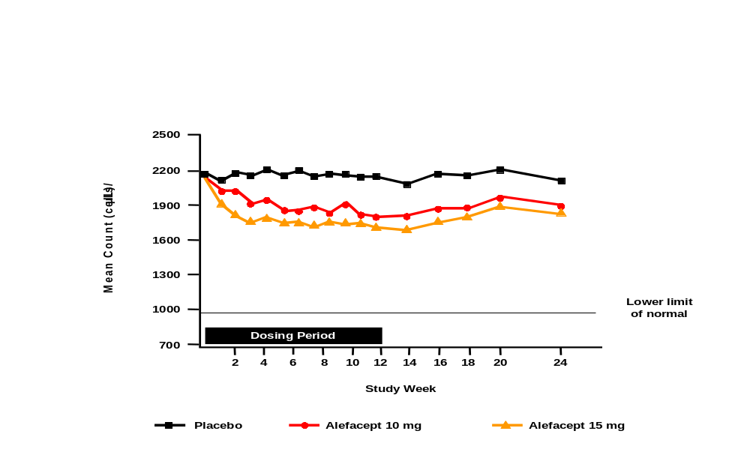

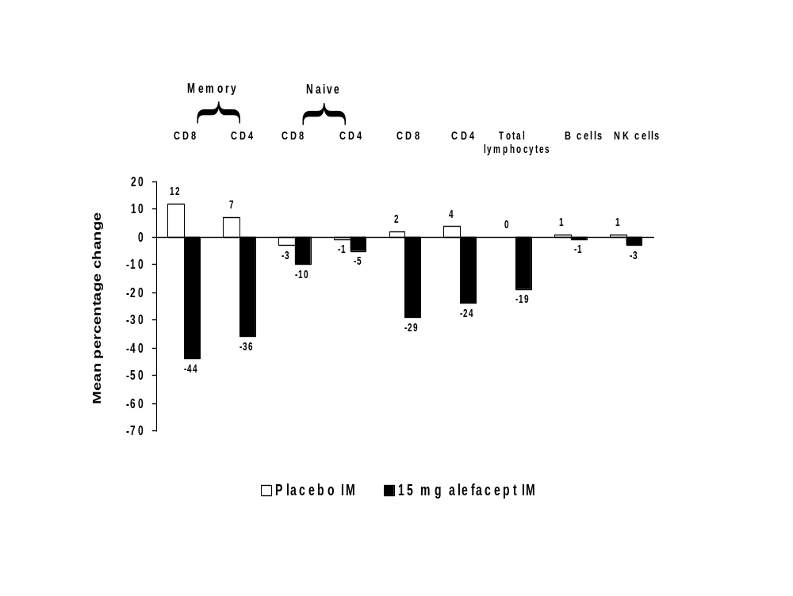Display 5-2 Study 712: mean percentage change from baseline in total lymphocyte count and lymphocyte subsets at 2 weeks post-dosing

The mean counts for total lymphocytes and T cell subsets were within normal limits during a course of alefacept. However, it is important to examine if any patients had one or more counts below the lower limit of normal (LLN). Display 5-3 shows the number of patients who had a total lymphocyte count, a CD4+ count, or a CD8+ count less than the LLN.

Display 5-3 Numbers of patients with counts <LLN: 15 mg IM and 7.5 mg IV

 | 15 mg IM  (n=166) | 7.5 mg IV  (n=366)
Number (percentage) of patients with

total lymphocytes <910 cells/uL (LLN) | 17 (10) | 80 (22)
total lymphocytes <500 cells/uL | 1 (<1) | 2 ( 1)
CD4+ count <404 cells/uL (LLN) | 52 (31) | 176 (48)
CD4+ count <200 cells/uL | 4 ( 2) | 11 ( 3)
CD8+ count <220 cells/uL (LLN) | 78 (47) | 217 (59)
CD8+ count <50 cells/uL | 3 ( 2) | 16 ( 4)
LLN: lower limit of normal.

Recovery of T Cells upon Completion of a Course of Alefacept
In Studies 711 and 712, lymphocytes and T cells were monitored for at least 12 weeks after treatment. The longest follow-up time after completion of a single course of treatment with alefacept is provided by patients in Cohort 2 of Study 711. Patients in this cohort received placebo as study drug during the second course, enabling the monitoring of recovery of T cells for a period of 36 weeks following the last dose of 7.5 mg alefacept IV. If a patient enrolled into Study 724, the extension to Study 711 described in Section 3.2.2, and participated in “interim visits” prior to dosing in Study 724, the period of follow-up is even longer.

The percentage of patients who attained a total lymphocyte count greater than 75% of baseline at all time points after the last alefacept dose in Course 1 can be quantified. Display 5-4 shows that 90% of patients had achieved a lymphocyte count greater than 75% of baseline by 162 days relative to the visit at 2 weeks post-doing (the first visit after the last dose). The count does not reach 100% because 8 patients were lost to follow-up, and although 3 patients have not as yet achieved a count greater than 75% of baseline, their counts are above the LLN.

As for total lymphocytes, detailed characterization of the rate of return of the CD4+ T cell count during the follow-up period has also been performed, in this case, to greater than the LLN (404 cells/μL). Display 5-5 shows that almost 90% of patients had CD4+ T cell counts at or above the LLN at 99 days relative to the visit at 2 weeks post-dosing. Again, the count does not reach 100% because 9 patients withdrew from the study and 5 patients have yet to reach the LLN.

Display 5-4 Study 711 Cohort 2 (alefacept/placebo): percentage of patients above 75% of baseline for total lymphocytes
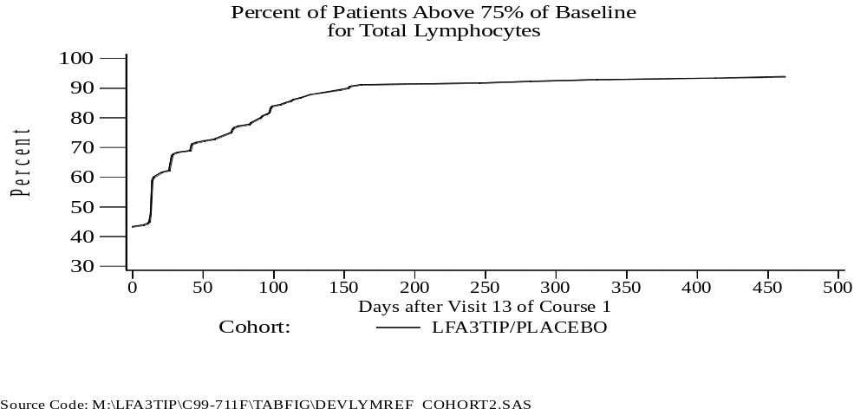
Days after the 2-week post-dosing visit in Course 1

Display 5-5 Study 711 Cohort 2 (alefacept/placebo): percentage of patients with CD4+ T cell count >LLN
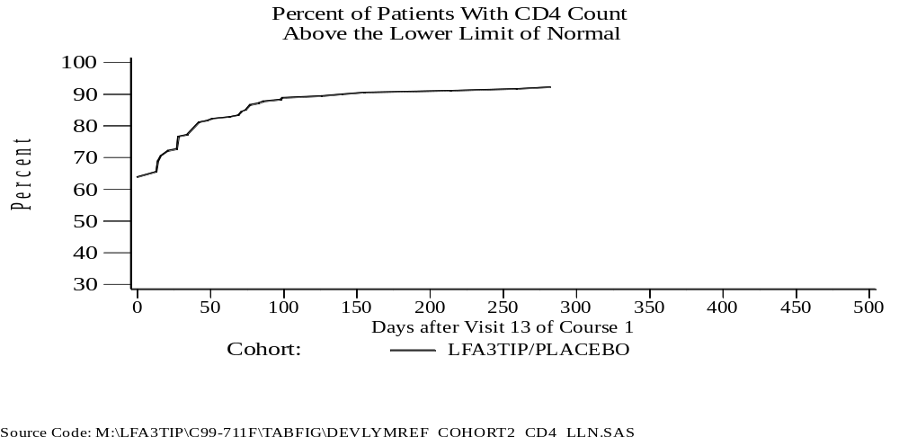
Days after the 2-week post-dosing visit in Course 1

Pharmacodynamic Effects following Additional Courses of Therapy

The effects of alefacept on T cell subsets during the second course were similar to those seen in the first course. Display 5-6 shows the mean percentage change from baseline at 2 weeks post-treatment for each course.

A second course of treatment with alefacept did not demonstrate a cumulative decrease in total lymphocytes, CD4+ and CD8+ T cell counts. This stabilization in T cell count is consistent with the more selective reduction of the memory T cells by alefacept.

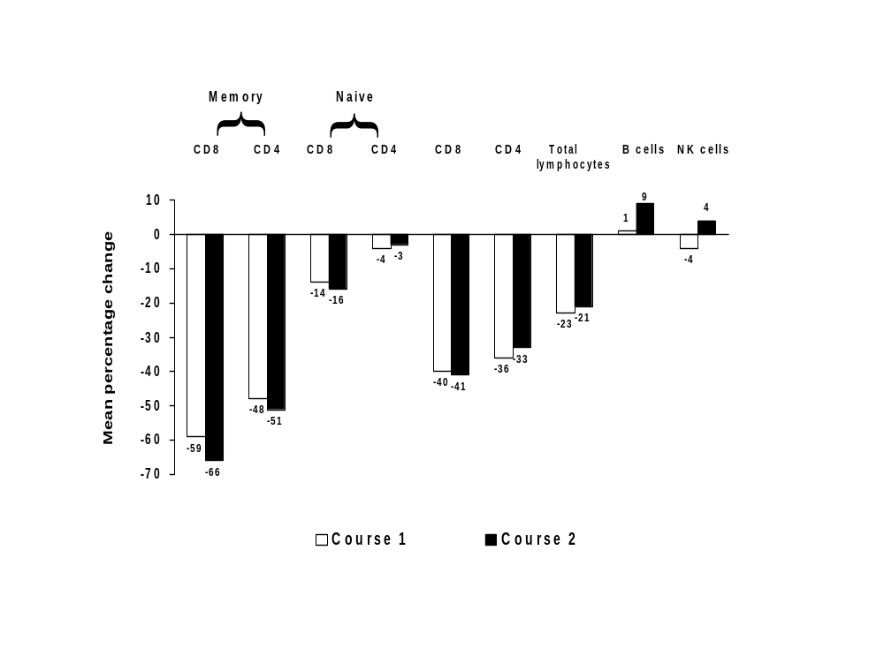Display 5-6 Study 711: mean percentage change from baseline in total lymphocyte count and lymphocyte subsets at 2 weeks post-dosing in each course

Further evidence of a lack of cumulative effect on lymphocytes and T cells is provided by the numbers of patients with counts less than the LLN. Display 5-7 shows these data for Courses 1 and 2 in Study 711. No increase in the number of patients with counts less than the LLN is apparent. Also, no evidence of cumulative pharmacodynamic effects after three courses of 7.5 mg alefacept IV has been seen in an ongoing Phase 2 study (Study 714, Display 3-1).

Display 5-7 Study 711: numbers of patients with counts <LLN in one and two courses of 7.5 mg alefacept IV

 | First course  (n=366) | Second course  (n=154)
Number (percentage) of patients with

total lymphocytes <910 cells/uL (LLN) | 80 (22) | 26 (17)
total lymphocytes <500 cells/uL | 2 ( 1) | 1 ( 1)
CD4+ count <404 cells/uL (LLN) | 176 (48) | 68 (44)
CD4+ count <200 cells/uL | 11 ( 3) | 4 ( 3)
CD8+ count <220 cells/uL (LLN) | 217 (59) | 86 (56)
CD8+ count <50 cells/uL | 16 ( 4) | 5 ( 3)
LLN: lower limit of normal.

Correlations between Reductions in T Cells and Efficacy

The relationship between reductions in T cell subsets and clinical response was analyzed. For these analyses, the area-under-the-effect curve, E_{AUC}, based on the percentage change from baseline, was used (further details are provided in Appendix 2). E_{AUC} represents the cumulative attrition of cells during the dosing period.

As shown in Display 5-8, an increase in response was seen for each increasing quartile of E_{AUC} for both subsets of memory T cells. (Q1 denotes the least reduction in T cells while Q4 denotes the greatest reduction). A similar correlation between E_{AUC} quartiles of memory T cells and the other clinical outcome measures, i.e., PASI 50 and PGA AC/C, was also demonstrated.

This correlation between the E_{AUC} of the memory T cells and clinical response corresponds to that seen between intra-lesional IFNγ+T cells and clinical response in Study 716 (Section 5.3). These observations are the first time that targeted reduction of a T cell subset has been correlated with clinical benefit in an autoimmune disease.

Display 5-8 PASI 75 response rates at 2 weeks post-dosing by E_{AUC} quartiles of memory T cells in Course 1 of Study 711 and Study 712

CD4+ memory cells

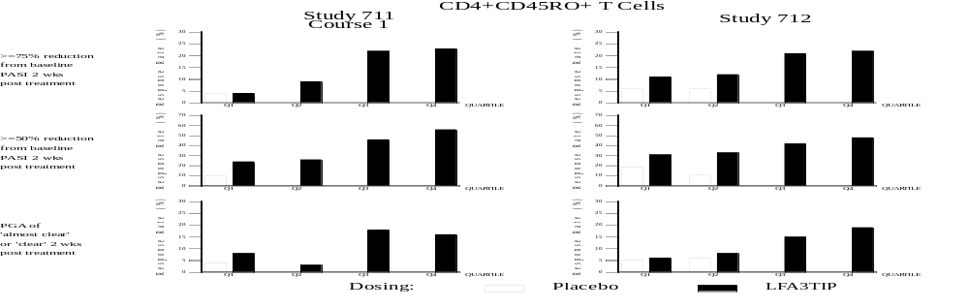

CD8+ memory cells

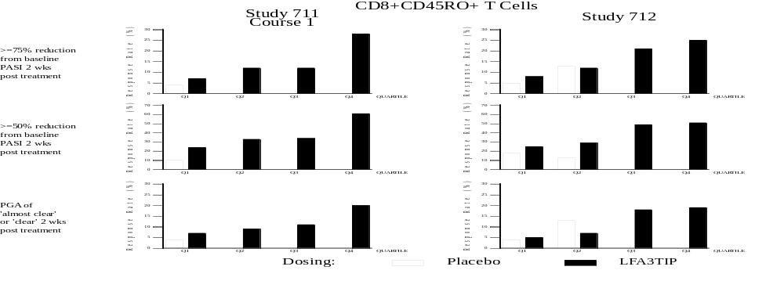

Solid bar represents alefacept; open bar represents placebo

E_{AUC} represents the cumulative attrition of cells. E_{AUC} is calculated for each patient. Those receiving alefacept (irrespective of dose) are grouped into four “bins” defined by the quartiles. Q1, Q2, Q3, and Q4 represent these “bins” in each study, with Q1 the lowest quartile, and Q4 the highest. Patients who received placebo are grouped according to the quartiles of the alefacept-treated patients.

Action of Alefacept on Cutaneous T Cells

Study 716 evaluated the effect of alefacept on T cells in the skin and correlated these changes with those in the periphery. Four patients in this study had punch and keratome biopsies before and after a course of 7.5 mg alefacept IV. All 4 patients demonstrated a relative reduction of in situ and circulating CD4+ and CD8+ T cells. In all 4 patients, the percentage change in baseline PASI correlated with the percentage change in the intra-lesional CD4+ and CD8+ T cells which expressed IFNγ+ (correlation coefficient of 0.68). Patients could be ranked in parallel by percentage reduction in PASI score, intra-lesional IFNγ+ T cells, and circulating CD8+ memory T cells. The three patients who had maintained the greatest reductions in PASI scores had significant reductions in IFNγ+ T cells at the end of treatment. The down-regulation of IFNγ+ secreting T cells corresponds with data suggesting a critical role of the Th1 inflammatory cytokine in the keratinocyte hyperproliferation (Bata-Csorgo et al, 1995, Austin et al, 1999, Friedrich et al, 2000). These data demonstrate that the peripheral lymphocyte reductions induced by alefacept are associated with T cell reductions in psoriatic plaques.

Implications of Reductions in T Cells on Immune Function

While alefacept-mediated lymphocyte effects are predictable and measurable, it is important to understand safety outcomes based upon current knowledge of memory T cell function. The primary role of memory T cells is preventing infections, especially opportunistic infections. Infections such as pneumocystis carinii pneumonia, toxoplasmosis, reactivation of herpetic infections, CMV infections, cryptosporidial infections and a range of candidal disorders are very typically seen in the context of memory T cell reduction. As described in Section 6, the risk of infection was thoroughly explored in the alefacept program. The data indicate no enhanced risk of infection nor a predisposition to opportunistic infection. To date, no opportunistic infections have been observed.

The major mechanism by which memory T cells protect from infection is to amplify and increase the speed of an immune response after re-exposure to a bacterial or viral antigen. This function was explored in two ways in the alefacept program: (i) assessment of delayed-type hypersensitivity (DTH) responses and, (ii) response to immunization in alefacept-treated patients. In Study 708, the Phase 2, dose-response study, DTH testing was performed for a range of antigens including tuberculin, tetanus, and diptheria. Although many patients treated with placebo exhibited loss of DTH response to one or more of the test antigens, there was a trend towards a higher proportion losing response in those treated with alefacept. The ability of patients to mount humoral immune responses in the face of reductions in T cells was assayed in Study 718.

Study 718 was conducted to evaluate humoral responses to a neo-antigen (φX174) and a recall antigen (tetanus toxoid) in patients with chronic plaque psoriasis treated with 7.5 mg alefacept IV for 12 weeks. Note that memory T cell function is critical for responses to both antigens. Patients were randomized to receive either alefacept or no treatment, the latter group serving as a control (Display 5-9). Alefacept-treated patients were immunized with φX174 at 6 and 12 weeks during dosing, and at 8 and 14 weeks after the final dose. Patients were immunized with tetanus toxoid 9 weeks after the final dose of alefacept. Patients in the control group received φX174 immunization 6 and 12 weeks after randomization and a tetanus toxoid immunization at 10 weeks after randomization. After the vaccination period, patients in the control group were offered treatment with alefacept.

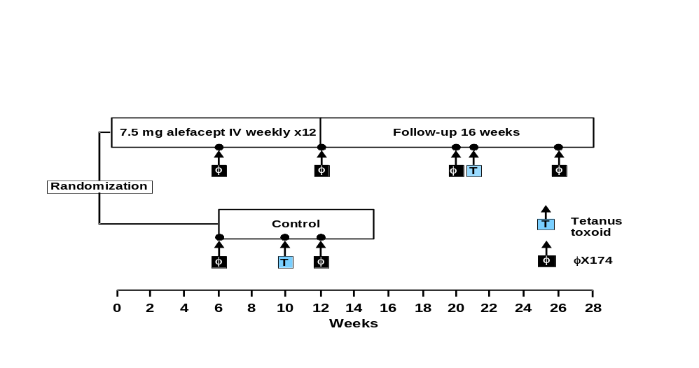Display 5-9 Design of Study 718

The peak antibody responses following the primary and secondary φX174 immunizations were similar for the control group and the group treated with alefacept. No patient in either treatment group failed to generate an IgG anti-φX174 response. The percentage IgG fraction of the anti-φX174 response after the secondary immunization was comparable between the groups. The anti-φX174 responses in the alefacept-treated group were durable as evidenced by a further rise in titer and percentage IgG fraction following the tertiary immunization (Display 5-10).

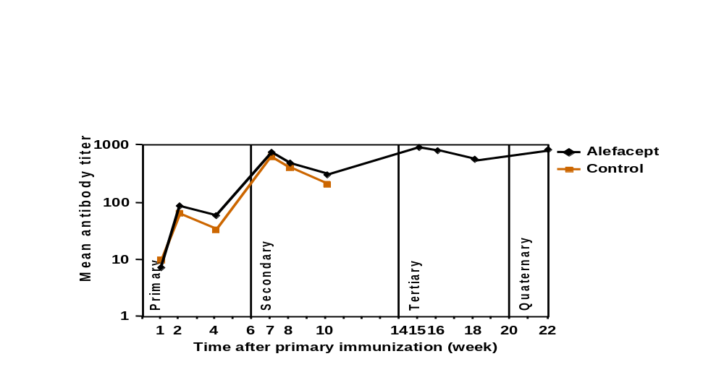Display 5-10 Total anti-ϕX174 antibody titers

Baseline titers for anti-tetanus toxoid antibodies were measured both at the first study visit for each group (study baseline) and immediately prior to immunization with the tetanus toxoid (pre-immunization baseline). A two-fold or greater rise in anti-tetanus toxoid response in relation to the study baseline was demonstrated by 91% and 89% in the control and alefacept-treated groups, respectively (p = 0.80).

These data demonstrate that immune function as assayed by the ability to

- mount antibody responses to a new antigen,
- mount IgG responses despite reductions in memory T cells, and
- respond to a physiologically relevant antigen, such as tetanus toxoid

are preserved during alefacept therapy.

Summary of Clinical Pharmacology

In summary, the clinical pharmacology data demonstrate the following:

- Serum concentrations of alefacept are proportional to dose. Following IM administration, dose-adjusted bioavailability is approximately 70%. The disposition of alefacept is consistent and independent of dose. The elimination half-life of alefacept is approximately 11 days following IV and IM administration.

- Treatment with alefacept results in a predictable, dose-dependent, mechanism-based reduction in total lymphocyte, CD4+ T cells, CD8+ T cells, and CD4+ and CD8+ memory T cells.

- The maximum effect of alefacept is approximately 6 weeks, after which the rate of T cell reduction decreases and T cell counts stabilize.

- There is no cumulative pharmacodynamic effect of alefacept with repeat courses of therapy.

- Recovery of T cells occurs with withdrawal of alefacept treatment.

- Recovery of T cells is similar with repeat administration of alefacept.

- Treatment with alefacept does not interfere with the immune response to recall or neo-antigens.

- The degree of T cell reduction, as measured by E_{AUC}, is correlated with clinical efficacy. This correlation supports the hypothesis that clinical response results from targeted reduction of the CD4+ and CD8+ memory T cells by alefacept.

CLINICAL SAFETY

This section presents an integrated analysis of the safety profile of alefacept in psoriasis following single and multiple courses of therapy. The integrated database is comprised of data from ten clinical studies of patients with psoriasis:

- three Phase 2 dose-escalation studies, Studies 703, 705, and 709;
- three double-blind, placebo-controlled studies: the Phase 2 dose-response study (708), and the two Phase 3 studies, 711 and 712;
- two extension studies, 710 and 714, where patients who had participated in the Phase 2 studies received additional courses of therapy; and
- two extension studies, 717 and 724, where patients who had participated in the two Phase 3 studies received additional courses of therapy.

With the exception of Studies 703 and 705 where a total of 51 patients were enrolled and received one infusion, one course of alefacept is comprised of 12 weeks of once-weekly dosing and a minimum of 12 weeks of follow-up. Since the duration of effect of alefacept is long, safety events reported during the 12 weeks of follow-up are included. In total, the safety profile of alefacept is based on 1056 patient-years of exposure.

Safety data have been analyzed in two ways:

- a comparison of the safety profile of alefacept with that of placebo from the placebo-controlled, single-course experience (413 patients received placebo and 876 received alefacept; Display 6-1), and
- a comparison of the safety profiles of multiple courses of alefacept to allow an understanding of the long-term adverse event profile (Display 6-1).

In addition, the incidence of infections and the incidence of malignancies, events of particular concern with products that affect the immune system, are presented.

Display 6-1 Number of patients in analyses of safety

 | Placebo | Alefacept
First-course exposure in placebo-controlled studies  Number of patients who have received at least  1 course of alefacept  2 courses of alefacept  3 courses of alefacept  4 courses of alefacept  5 courses of alefacept  6 courses of alefacept | 413 (a)  NA  NA  NA  NA  NA  NA | 876 (b)  1357 (c)  756  199  81  46  13
NA: Not applicable. Patients in (a) and (b) are distinct. Patients in (c) include those in (b),
and those in (a) who received alefacept for the first time in a subsequent course.

Non-serious Adverse Events

The most common adverse events reported by patients receiving alefacept in placebo-controlled studies were headache (18% placebo vs 17% alefacept), accidental injury (13% vs 15%), pharyngitis (13% vs 15%), infection (11% vs 11%), pruritus (8% vs 11%), and rhinitis (10% vs 11%). The incidence of adverse events with the first course of study drug was similar between alefacept and placebo in the controlled studies (Display 6-2). The only adverse event that occurred at least 5% higher in incidence among alefacept-treated patients compared to placebo-treated patients in the first course was chills (1% placebo vs 6% alefacept). Episodes of chills were reported within 24 hours of study drug infusion but their incidence did not increase with subsequent courses of treatment (Display 6-3).

The incidence of adverse events did not increase with subsequent courses of alefacept treatment: 83%, 74%, 64%, 72%, and 61% of patients had at least one adverse event in the first, second, third, fourth and fifth courses of alefacept, respectively (Display 6-3).

Display 6-2 Incidence of adverse events in the first course of placebo-controlled studies experienced by at least 5% of patients who received alefacept

 | Placebo-controlled studies
 | Placebo | Alefacept
No. of patients dosed | 413 (100) | 876 (100)
No. with an event | 327 ( 79) | 730 ( 83)
Event  Headache  Accidental injury  Pharyngitis  Infection  Pruritus  Rhinitis  Flu syndrome  Viral infection  Asthenia  Chills  Pain  Diarrhea  Dizziness  Arthralgia  Nausea | 74 ( 18)  52 ( 13)  55 ( 13)  45 ( 11)  34 ( 8)  40 ( 10)  36 ( 9)  28 ( 7)  28 ( 7)  5 ( 1)  21 ( 5)  22 ( 5)  13 ( 3)  24 ( 6)  14 ( 3) | 151 ( 17)  134 ( 15)  130 ( 15)  98 ( 11)  97 ( 11)  92 ( 11)  80 ( 9)  52 ( 6)  51 ( 6)  50 ( 6)  50 ( 6)  48 ( 5)  44 ( 5)  42 ( 5)  42 ( 5)
NOTE: Numbers in parentheses are percentages.
Events are listed by decreasing incidence in those who received alefacept.

Display 6-3 Incidence of adverse events experienced by at least 5% of patients by course of alefacept

 | Course of alefacept
 | First | Second | Third | Fourth | Fifth
No. of patients dosed | 1357 (100) | 756 (100) | 199 (100) | 81 (100) | 46 (100)
No. with an event | 1121 ( 83) | 560 ( 74) | 128 ( 64) | 58 ( 72) | 28 ( 61)
Event  Headache  Accidental injury  Pharyngitis  Infection  Rhinitis  Flu syndrome  Pruritus  Viral infection  Pain  Asthenia  Chills  Diarrhea  Nausea  Arthralgia  Sinusitis  Dyspepsia | 219 ( 16)  218 ( 16)  205 ( 15)  151 ( 11)  145 ( 11)  133 ( 10)  116 ( 9)  79 ( 6)  78 ( 6)  74 ( 5)  73 ( 5)  71 ( 5)  68 ( 5)  65 ( 5)  56 ( 4)  19 ( 1) | 71 ( 9)  130 ( 17)  92 ( 12)  76 ( 10)  66 ( 9)  55 ( 7)  41 ( 5)  51 ( 7)  38 ( 5)  23 ( 3)  11 ( 1)  16 ( 2)  20 ( 3)  15 ( 2)  29 ( 4)  14 ( 2) | 15 ( 8)  18 ( 9)  15 ( 8)  15 ( 8)  14 ( 7)  7 ( 4)  5 ( 3)  13 ( 7)  15 ( 8)  5 ( 3)  1 ( <1)  2 ( 1)  6 ( 3)  3 ( 2)  11 ( 6)  0 | 5 ( 6)  11 ( 14)  6 ( 7)  12 ( 15)  4 ( 5)  8 ( 10)  4 ( 5)  7 ( 9)  5 ( 6)  0  0  0  1 ( 1)  1 ( 1)  0  1 ( 1) | 2 ( 4)  4 ( 9)  1 ( 2)  3 ( 7)  1 ( 2)  2 ( 4)  3 ( 7)  1 ( 2)  3 ( 7)  1 ( 2)  0  0  0  0  1 ( 2)  3 ( 7)
NOTE: Numbers in parentheses are percentages.
Events are listed by decreasing incidence in the first course.
Display 6-4 shows the incidence of common adverse events by route of administration for the Phase 3 studies.

Of the events with an incidence of 5% or more, those that occurred more frequently in patients receiving 7.5 mg alefacept IV compared to those receiving 15 mg alefacept IM include accidental injury (7.5 mg alefacept IV vs 15 mg alefacept IM: 20% vs 10%), rhinitis (12% vs 5%), and chills (10% vs 2%).

Adverse events that occurred more frequently in patients receiving 15 mg alefacept IM compared to those receiving 7.5 mg alefacept IV include pruritus (15 mg alefacept IM vs 7.5 mg alefacept IV: 18% vs 11%), infection (16% vs 10%), asthenia (11% vs 4%), injection site pain (9% vs <1%), injection site reaction (5% vs 0%), and injection site inflammation (5% vs 0%). Injection site reactions were generally mild in severity.

Display 6-4 Adverse events with an incidence of 5% or more in the first course of phase 3 studies (by route of administration)

 | Phase 3 studies
 | Placebo |  |  | Alefacept
 | IV | IM |  | 7.5 mg IV | 10 mg IM | 15 mg IM
No. of patients dosed | 186 (100) | 168 (100) |  | 367 (100) | 173 (100) | 166 (100)
No. with an event | 143 ( 77) | 139 ( 83) |  | 310 ( 84) | 139 ( 80) | 145 ( 87)
Event  Accidental injury  Headache  Pharyngitis  Rhinitis  Pruritus  Chills  Flu syndrome  Infection  Viral infection  Pain  Back pain  Myalgia  Sinusitis  Arthralgia  Diarrhea  Arthritis  Dizziness  Asthenia  Nausea  Hypertension  Tooth disorder  Peripheral edema  Gastroenteritis  Injection site pain  Injection site reaction  Injection site inflammation  Injection site hemorrhage | 30 ( 16)  38 ( 20)  23 ( 12)  21 ( 11)  16 ( 9)  2 ( 1)  15 ( 8)  20 ( 11)  12 ( 6)  11 ( 6)  5 ( 3)  3 ( 2)  10 ( 5)  6 ( 3)  9 ( 5)  5 ( 3)  6 ( 3)  9 ( 5)  8 ( 4)  6 ( 3)  4 ( 2)  3 ( 2)  6 ( 3)  0  0  0  0 | 19 ( 11)  26 ( 15)  15 ( 9)  11 ( 7)  16 ( 10)  3 ( 2)  18 ( 11)  19 ( 11)  16 ( 10)  8 ( 5)  8 ( 5)  4 ( 2)  5 ( 3)  16 ( 10)  12 ( 7)  4 ( 2)  6 ( 4)  18 ( 11)  6 ( 4)  3 ( 2)  2 ( 1)  8 ( 5)  2 ( 1)  4 ( 2)  1 ( <1)  0  10 ( 6) |  | 73 ( 20)  62 ( 17)  52 ( 14)  43 ( 12)  40 ( 11)  37 ( 10)  37 ( 10)  35 ( 10)  29 ( 8)  26 ( 7)  20 ( 5)  20 ( 5)  19 ( 5)  18 ( 5)  18 ( 5)  17 ( 5)  17 ( 5)  16 ( 4)  13 ( 4)  11 ( 3)  9 ( 2)  8 ( 2)  6 ( 2)  1 ( <1)  0  0  0 | 22 ( 13)  34 ( 20)  20 ( 12)  24 ( 14)  24 ( 14)  1 ( <1)  14 ( 8)  25 ( 14)  13 ( 8)  8 ( 5)  4 ( 2)  3 ( 2)  6 ( 3)  8 ( 5)  11 ( 6)  4 ( 2)  6 ( 3)  10 ( 6)  13 ( 8)  8 ( 5)  5 ( 3)  6 ( 3)  8 ( 5)  8 ( 5)  1 ( <1)  5 ( 3)  11 ( 6) | 16 ( 10)  30 ( 18)  20 ( 12)  9 ( 5)  30 ( 18)  4 ( 2)  14 ( 8)  26 ( 16)  10 ( 6)  11 ( 7)  4 ( 2)  5 ( 3)  4 ( 2)  10 ( 6)  8 ( 5)  7 ( 4)  6 ( 4)  18 ( 11)  6 ( 4)  7 ( 4)  8 ( 5)  2 ( 1)  1 ( <1)  15 ( 9)  9 ( 5)  8 ( 5)  5 ( 3)
NOTE: Numbers in parentheses are percentages.
Events are listed by decreasing incidence in those who received 7.5 mg alefacept IV.

Deaths, Serious Adverse Events, and Adverse Events Leading to Discontinuation of Study Drug

Deaths

Three deaths following treatment with alefacept have been reported. All were considered by the principal investigator to be unrelated to study drug.

- A 34-year old man enrolled in Study 711 had a 26-year history of psoriasis with no known history of depression, psychiatric illness, or other chronic diseases, although there was a family history of suicide. The patient received 11 doses of 7.5 mg alefacept IV in Course 1 and withdrew from the study due to worsening of disease. Eleven weeks after his last dose of alefacept, the patient committed suicide.

- A 47-year old man with a past history of coronary artery disease, hypertension, obesity (111 kg), smoking, and gout was enrolled into Study 714 and died due to myocardial infarction 6 weeks after his last dose of 7.5 mg alefacept IV.

- A 53-year old man with a past history of diaphragmatic hernia and Barrett’s esophagus received a course of 15 mg alefacept IM in Study 712 and a further course of 15 mg IM in Study 717. He was diagnosed with an 8.5 cm poorly differentiated esophageal carcinoma 1 week after his last dose in Study 717. An abdominal CT scan was negative for metastatic disease. He was treated with palliative radiation therapy and stent placement. He was prematurely withdrawn from the study due to the event. The patient died 9 months after diagnosis due to esophageal adenocarcinoma.

One patient died of a myocardial infarction after being enrolled into, and randomized in Study 712, but prior to receiving any study drug.

Serious Adverse Events

The proportion of patients who experienced a serious adverse event was similar between the placebo and alefacept treatment groups (Display 6-5). In placebo-controlled studies, 19 patients (5%) who received placebo and 42 patients (5%) who received alefacept in the first course experienced at least one serious adverse event.

Many of the current immunosuppressant therapies are associated with disease flare or rebound after treatment is stopped that sometimes necessitates hospitalization. The most common serious adverse event was hospitalization for psoriasis experienced by 6 patients (1%) who received placebo and by 2 alefacept-treated patients (<1%). This difference is important since the period of reporting serious adverse events includes the 12 weeks of dosing and the 12 weeks of follow-up. No patient who responded to alefacept experienced rebound of disease requiring hospitalization.

The most frequently reported serious adverse events among alefacept-treated patients were coronary artery disorder (4 patients), cellulitis (3 patients), and myocardial infarction (3 patients). Each of these serious adverse events were observed at a rate of <1% in alefacept-treated patients and were not observed in placebo-treated patients. However, the number of patients exposed to placebo is less than half of those treated with alefacept. No events in either the alefacept or placebo groups were observed at an incidence of 1% or more. The risk of serious adverse events did not increase with multiple courses (Display 6-6).

Display 6-5 Incidence of serious adverse events in the first course of placebo-controlled studies

 | Placebo-controlled studies
 | Placebo | Alefacept
No. of patients dosed | 413 (100) | 876 (100)
No. with a serious event | 19 ( 5) | 42 ( 5)
Event  Coronary artery disorder  Cellulitis  Myocardial infarct  Accidental injury  Carcinoma  Chest pain  Diabetes mellitus  Gastroenteritis  Pancreatitis  Psoriasis  Abscess  Angioedema  Arthritis  Asthma  Atrial fibrillation  AV block complete  Back pain  Bursitis  Cholelithiasis  Congestive heart failure  Infection  Kidney calculus  Menorrhagia  Pleural effusion  Prostatic carcinoma  Skin carcinoma  Skin melanoma  Suicide attempt  Angina pectoris  Arthralgia  Bronchitis  Gastrointestinal disorder  Gum hemorrhage  Hernia  Pain  Rectal hemorrhage  Syncope | 0  0  0  0  0  1 ( <1)  0  0  1 ( <1)  6 ( 1)  0  0  1 ( <1)  0  0  0  0  0  2 ( <1)  0  1 ( <1)  1 ( <1)  0  0  1 ( <1)  0  0  0  1 ( <1)  1 ( <1)  1 ( <1)  1 ( <1)  1 ( <1)  2 ( <1)  1 ( <1)  1 ( <1)  1 ( <1) | 4 ( <1)  3 ( <1)  3 ( <1)  2 ( <1)  2 ( <1)  2 ( <1)  2 ( <1)  2 ( <1)  2 ( <1)  2 ( <1)  1 ( <1)  1 ( <1)  1 ( <1)  1 ( <1)  1 ( <1)  1 ( <1)  1 ( <1)  1 ( <1)  1 ( <1)  1 ( <1)  1 ( <1)  1 ( <1)  1 ( <1)  1 ( <1)  1 ( <1)  1 ( <1)  1 ( <1)  1 ( <1)  0  0  0  0  0  0  0  0  0
NOTE: Numbers in parentheses are percentages.
Events are listed by decreasing incidence in those who received alefacept.

Display 6-6 Incidence of serious adverse events by course of alefacept

 | Course of alefacept
 | First | Second | Third | Fourth | Fifth
No. of patients dosed | 1357 (100) | 756 (100) | 199 (100) | 81 (100) | 46 (100)
No. with a serious event | 67 ( 5) | 30 ( 4) | 9 ( 5) | 0 | 1 ( 2)
Event  Accidental injury  Psoriasis  Cellulitis  Coronary artery disorder  Skin carcinoma  Chest pain  Cholelithiasis  Diabetes mellitus  Myocardial infarct  Asthma  Carcinoma  Gastroenteritis  Hernia  Infection  Infection bacterial  Pancreatitis  Suicide attempt  Abscess  Acute kidney failure  Angioedema  Arthritis  Atrial fibrillation  AV block complete  Back pain  Bursitis  Cerebrovascular accident  Cholecystitis  Congestive heart failure  Duodenal ulcer hemorrhage  Dysuria  Gastrointestinal disorder  Kidney calculus  Menorrhagia  Obesity  Ovarian disorder  Pain  Pleural effusion  Prostatic carcinoma  Pruritus  Rectal hemorrhage  Scleritis  Shock  Skin melanoma  Angina pectoris  Bone disorder  Bronchitis  Carcinoma of lung  Coronary occlusion  Drug dependence  Gastrointestinal carcinoma  Hemorrhage  Hemorrhage of colon  Herpes simplex | 5 ( <1)  5 ( <1)  4 ( <1)  4 ( <1)  4 ( <1)  3 ( <1)  3 ( <1)  3 ( <1)  3 ( <1)  2 ( <1)  2 ( <1)  2 ( <1)  2 ( <1)  2 ( <1)  2 ( <1)  2 ( <1)  2 ( <1)  1 ( <1)  1 ( <1)  1 ( <1)  1 ( <1)  1 ( <1)  1 ( <1)  1 ( <1)  1 ( <1)  1 ( <1)  1 ( <1)  1 ( <1)  1 ( <1)  1 ( <1)  1 ( <1)  1 ( <1)  1 ( <1)  1 ( <1)  1 ( <1)  1 ( <1)  1 ( <1)  1 ( <1)  1 ( <1)  1 ( <1)  1 ( <1)  1 ( <1)  1 ( <1)  0  0  0  0  0  0  0  0  0  0 | 5 ( <1)  0  0  0  1 ( <1)  0  4 ( <1)  0  0  0  1 ( <1)  1 ( <1)  0  2 ( <1)  0  0  0  0  0  0  1 ( <1)  0  0  0  0  0  2 ( <1)  0  0  0  1 ( <1)  0  0  2 ( <1)  0  0  0  0  0  0  0  0  0  1 ( <1)  1 ( <1)  0  0  1 ( <1)  1 ( <1)  1 ( <1)  1 ( <1)  0  1 ( <1) | 1 ( <1)  0  0  0  0  0  0  0  1 ( <1)  1 ( <1)  0  0  0  1 ( <1)  0  0  0  0  0  0  0  0  0  0  0  0  0  0  0  0  1 ( <1)  0  0  0  0  0  0  0  0  0  0  0  0  0  0  1 ( <1)  1 ( <1)  0  0  0  0  1 ( <1)  0 | 0  0  0  0  0  0  0  0  0  0  0  0  0  0  0  0  0  0  0  0  0  0  0  0  0  0  0  0  0  0  0  0  0  0  0  0  0  0  0  0  0  0  0  0  0  0  0  0  0  0  0  0  0 | 0  0  0  0  0  0  0  0  1 ( 2)  0  0  0  0  0  0  0  0  0  0  0  0  0  0  0  0  0  0  0  0  0  0  0  0  0  0  0  0  0  0  0  0  0  0  0  0  0  0  0  0  0  0  0  0
NOTE: Numbers in parentheses are percentages.
Events are listed by decreasing incidence in the first course.
Display 6-6 Incidence of serious adverse events by course of alefacept (continued)

 | Course of alefacept
 | First | Second | Third | Fourth | Fifth
No. of patients dosed | 1357 (100) | 756 (100) | 199 (100) | 81 (100) | 46 (100)
No. with a serious event | 67 ( 5) | 30 ( 4) | 9 ( 5) | 0 | 1 ( 2)
Event  Hyperglycemia  Lung fibrosis  Nasal septum disorder  Peripheral vascular disorder  Peritonitis  Pneumonia  Pulmonary hypertension  Skin disorder  Thrombophlebitis  Urinary incontinence | 0  0  0  0  0  0  0  0  0  0 | 1 ( <1)  0  1 ( <1)  1 ( <1)  1 ( <1)  2 ( <1)  1 ( <1)  1 ( <1)  1 ( <1)  1 ( <1) | 0  1 ( <1)  0  0  0  1 ( <1)  0  0  0  0 | 0  0  0  0  0  0  0  0  0  0 | 0  0  0  0  0  0  0  0  0  0
NOTE: Numbers in parentheses are percentages.
Events are listed by decreasing incidence in the first course.

In the first course of placebo-controlled studies, more cardiovascular events were reported in the alefacept-treated group than in the group who received placebo. Specifically, there were three episodes of myocardial infarction and four episodes of coronary artery disease in the alefacept group, but none in placebo patients. There was one report of angina pectoris in the placebo group but none in the alefacept group. Review of these cardiovascular events did not reveal any unusual presentations. The majority of these events occurred in men 51 years of age or older, and each had one or more classical risk factors associated with ischemic heart disease.

In all studies, a total of five patients were diagnosed with a total of five myocardial infarctions. The incidence rate per person-years treated with alefacept was 5 events per 1056 person-years, or 4.7 per 1000 person-years with a 95% confidence interval (CI) of 1.6 to 11.7 per 1000 person-years. In the first course of placebo-controlled studies, the corresponding rates were 7.5 per 1000 person-years (3 events per 401 person-years; 95% CI: 3.5 to 15.8) for the alefacept-treated patients, and 0 per 1000 person-years (0 event per 178 person-years; 95% CI: 0 to 20.7) for the placebo-treated patients. The background rates for first myocardial infarction in white men in the 45-54 year age range has been estimated as 4 per 1000 person-years (Centers for Disease Control and Prevention, 2001). Thus, in an analysis by person-years exposure, the incidence was consistent with the rate expected in the study population.

One patient who was enrolled into Study 708 experienced a serious adverse event of angioedema. The patient’s symptoms occurred 1 week after his last dose of alefacept and responded to IV steroids. He had two additional minor recurrences at 2 and 8 weeks after the initial presentation and again he responded promptly to therapy. The patient had a past history of allergies.

Discontinuations from Study Drug due to Adverse Events

Overall, very few patients discontinued study drug due to an adverse event. In placebo-controlled studies, 6 (1%) patients who received placebo and 17 (2%) alefacept-treated patients discontinued study drug due to an adverse event (Display 6-7). From multiple-course exposure (Display 6-8), events accounting for discontinuation of treatment in more than one patient in the first course were headache (3 patients), nausea (3 patients), cholecystitis (2 patients), dizziness (2 patients), and psoriasis (2 patients). Single occurrences of events led to discontinuation in subsequent courses. There was no single adverse event consistently accounting for discontinuation of study drug. The spectrum of adverse events leading to treatment discontinuation was diverse, and the proportion of patients who discontinued study drug during subsequent courses did not increase.

Display 6-7 Incidence of adverse events leading to discontinuation of study drug in the first course of placebo-controlled studies

 | Placebo-controlled studies
 | Placebo | Alefacept
No. of patients dosed | 413 (100) | 876 (100)
No. with an adverse event leading to discontinuation of study drug | 6 ( 1) | 17 ( 2)
Event  Headache  Nausea  Angioedema  Arthritis  Bronchitis  Cholecystitis  Cholelithiasis  Coronary artery disorder  Dehydration  Dizziness  Flu syndrome  GI neoplasia  Infection  Nausea and vomiting  Pancreatitis  Pleural effusion  Prostatic carcinoma  Psoriasis  Syncope  Urticaria  Accidental injury  Asthenia  Fever  Neoplasm  Rash  Skin benign neoplasm | 0  1 ( <1)  0  0  0  0  0  0  0  0  0  0  0  0  1 ( <1)  0  0  1 ( <1)  0  0  1 ( <1)  1 ( <1)  1 ( <1)  1 ( <1)  1 ( <1)  1 ( <1) | 3 ( <1)  2 ( <1)  1 ( <1)  1 ( <1)  1 ( <1)  1 ( <1)  1 ( <1)  1 ( <1)  1 ( <1)  1 ( <1)  1 ( <1)  1 ( <1)  1 ( <1)  1 ( <1)  1 ( <1)  1 ( <1)  1 ( <1)  1 ( <1)  1 ( <1)  1 ( <1)  0  0  0  0  0  0
NOTE: Numbers in parentheses are percentages.
Events are listed by decreasing incidence in those who received alefacept.

Display 6-8 Incidence of adverse events leading to discontinuation of study drug by course of alefacept

 | Course of alefacept
 | First | Second | Third | Fourth | Fifth
No. of patients dosed | 1357 (100) | 756 (100) | 199 (100) | 81 (100) | 46 (100)
No. with an adverse event leading to discontinuation of study drug | 24 ( 2) | 5 ( <1) | 2 ( 1) | 1 ( 1) | 0
Event  Headache  Nausea  Cholecystitis  Dizziness  Psoriasis  Angioedema  Arthralgia  Arthritis  Asthenia  Bronchitis  Chills  Cholelithiasis  Coronary artery disorder  Dehydration  Flu syndrome  GI neoplasia  Herpes zoster  Infection  Injection site reaction  Nausea and vomiting  Pancreatitis  Pleural effusion  Prostatic carcinoma  Scleritis  Syncope  Urticaria  Vertigo  Allergic reaction  Carcinoma of lung  Conjunctivitis  Infection bacterial  Lung fibrosis  Pneumonia  Pulmonary hypertension | 3 ( <1)  3 ( <1)  2 ( <1)  2 ( <1)  2 ( <1)  1 ( <1)  1 ( <1)  1 ( <1)  1 ( <1)  1 ( <1)  1 ( <1)  1 ( <1)  1 ( <1)  1 ( <1)  1 ( <1)  1 ( <1)  1 ( <1)  1 ( <1)  1 ( <1)  1 ( <1)  1 ( <1)  1 ( <1)  1 ( <1)  1 ( <1)  1 ( <1)  1 ( <1)  1 ( <1)  0  0  0  0  0  0  0 | 0  0  0  0  0  0  0  0  0  0  0  0  0  0  0  0  0  0  0  0  0  0  0  0  0  0  0  1 ( <1)  0  1 ( <1)  1 ( <1)  0  1 ( <1)  1 ( <1) | 0  0  0  0  0  0  0  0  0  0  0  0  0  0  0  0  0  0  0  0  0  0  0  0  0  0  0  0  1 ( <1)  0  0  1 ( <1)  0  0 | 0  0  0  0  0  0  0  0  0  0  0  0  0  0  0  0  1 ( 1)  0  0  0  0  0  0  0  0  0  0  0  0  0  0  0  0  0 | 0  0  0  0  0  0  0  0  0  0  0  0  0  0  0  0  0  0  0  0  0  0  0  0  0  0  0  0  0  0  0  0  0  0
NOTE: Numbers in parentheses are percentages.
Events are listed by decreasing incidence in the first course.

Infections

All Infections

Because alefacept targets T cells, the frequency and severity of infections in the safety database were analyzed. Investigators recorded whether or not each adverse event represented a new or ongoing infection. The COSTART dictionary used to code adverse events throughout this Briefing Document allows for specific terms such as “viral infection” and “infection bacterial,” provided that investigators give sufficient information. However, the COSTART term “infection” is a more general term and so can include different types of infections without a great degree of specificity. To better clinically evaluate and interpret the nature of all infections, all events that were coded to the non-specific COSTART term “infection” have also been coded using the MedDRA dictionary.

The proportion of patients who reported infections was similar between the placebo- and alefacept-treated patients in the placebo-controlled studies: 43% and 45%, respectively (Display 6-9). In both treatment groups, the most frequently reported infections, i.e., with an incidence of 5% or more, were pharyngitis, nasopharyngitis (cold), flu syndrome, and viral infection. With additional courses of alefacept, the proportion of patients with these types of infections was similar although there appears to be a slight increase in viral infections. The incidence of infection did not increase during subsequent courses with alefacept (Display 6-10).

Display 6-9 Incidence of infections in the first course of placebo-controlled studies experienced by at least 5% of patients who received alefacept

 | Placebo-controlled studies
 | Placebo | Alefacept
No. of patients dosed | 413 (100) | 876 (100)
No. with an infection | 176 ( 43) | 393 ( 45)
Event  Infection  Nasopharyngitis (a)  Pharyngitis  Flu syndrome  Viral infection | 44 ( 11)  28 ( 7)  42 ( 10)  21 ( 5)  27 ( 7) | 95 ( 11)  66 ( 8)  89 ( 10)  64 ( 7)  52 ( 6)
NOTE: Numbers in parentheses are percentages.
Events are listed by decreasing incidence in those who received alefacept.
(a) MedDRA term.

Display 6-10 Incidence of infections experienced by at least 5% of patients by course of alefacept

 | Course of alefacept
 | First | Second | Third | Fourth | Fifth
No. of patients dosed | 1357 (100) | 756 (100) | 199 (100) | 81 (100) | 46 (100)
No. with an infection | 633 ( 47) | 327 ( 43) | 63 ( 32) | 33 ( 41) | 12 ( 26)
Event  Infection  Nasopharyngitis (a)  Tooth infection (a)  Skin infection NOS (a)  Pharyngitis  Flu syndrome  Viral infection  Sinusitis | 147 ( 11)  103 ( 8)  8 ( <1)  6 ( <1)  144 ( 11)  107 ( 8)  79 ( 6)  47 ( 3) | 76 ( 10)  57 ( 8)  2 ( <1)  2 ( <1)  62 ( 8)  44 ( 6)  51 ( 7)  26 ( 3) | 15 ( 8)  9 ( 5)  2 ( 1)  2 ( 1)  10 ( 5)  3 ( 2)  12 ( 6)  10 ( 5) | 12 ( 15)  6 ( 7)  2 ( 2)  2 ( 2)  4 ( 5)  6 ( 7)  7 ( 9)  0 | 3 ( 7)  3 ( 7)  0  0  1 ( 2)  1 ( 2)  1 ( 2)  1 ( 2)
NOTE: Numbers in parentheses are percentages.
NOS: Not otherwise specified.
(a) MedDRA term.

Serious Infections

The proportion of patients with serious infections was <1% for both the alefacept- and placebo-treated patients during the first course of therapy in the placebo-controlled studies (Display 6-11).

Display 6-11 Incidence of serious infections in the first course of placebo-controlled studies

 | Placebo-controlled studies
 | Placebo | Alefacept
No. of patients dosed | 413 (100) | 876 (100)
No. with a serious infection | 2 ( <1) | 8 ( <1)
Body as a whole  Cellulitis  Abscess  Infection  Wound infection NEC (a)  Digestive System  Gastroenteritis  Pancreatitis  Respiratory System  Asthma  Pneumonia | 0  0  0  0  0  1 ( <1)  0  1 ( <1)  1 ( <1)  0  1 ( <1) | 5 ( <1)  3 ( <1)  1 ( <1)  1 ( <1)  1 ( <1)  2 ( <1)  2 ( <1)  0  1 ( <1)  1 ( <1)  0
NOTE: Numbers in parentheses are percentages.
NEC: Not elsewhere classified.
(a) MedDRA term.

Serious infections occurring in more than one patient in the first course of alefacept include cellulitis (3 patients), bacterial infection (2 patients), and gastroenteritis (2 patients). In subsequent courses, 5 patients (<1%) in the second course, 3 patients (2%) in the third course, and none in the fourth and fifth courses experienced a serious infection (Display 6-12). Pneumonia was observed in three patients. There is no suggestion that multi-course exposure to alefacept increased the risk of experiencing a serious infection.

All serious infections were typical in the population studied in terms of presentation, course, and outcome. No unusual or opportunistic infections were observed. No deaths occurred due to an infection.

Display 6-12 Incidence of serious infections by course of alefacept

 | Course of alefacept
 | First | Second | Third | Fourth | Fifth
No. of patients dosed | 1357 (100) | 756 (100) | 199 (100) | 81 (100) | 46 (100)
No. with a serious infection | 10 ( <1) | 5 ( <1) | 3 ( 2) | 0 | 0
Body as a whole  Cellulitis  Infection bacterial  Abscess  Infection  Burn infection (a)  Appendicitis (a)  Postoperative wound infection (a)  Wound infection NEC (a)  Digestive system  Gastroenteritis  Respiratory System  Asthma  Bronchitis  Pneumonia  Skin and appendages  Herpes simplex | 7 ( <1)  3 ( <1)  2 ( <1)  1 ( <1)  1 ( <1)  1 ( <1)  0  0  0  2 ( <1)  2 ( <1)  1 ( <1)  1 ( <1)  0  0  0  0 | 2 ( <1)  0  0  0  2 ( <1)  0  0  1 ( <1)  1 ( <1)  0  0  2 ( <1)  0  0  2 ( <1)  1 ( <1)  1 ( <1) | 1 ( <1)  0  0  0  1 ( <1)  0  1 ( <1)  0  0  0  0  2 ( 1)  0  1 ( <1)  1 ( <1)  0  0 | 0  0  0  0  0  0  0  0  0  0  0  0  0  0  0  0  0 | 0  0  0  0  0  0  0  0  0  0  0  0  0  0  0  0  0
NOTE: Numbers in parentheses are percentages.
NEC: Not elsewhere classified.
(a) MedDRA term.

The Lack of Relationship between Infections and Low T Cell Counts

The occurrence of infections relative to the degree of reduction in T cell counts was evaluated in several ways. In the first analysis, the cumulative depression in lymphocytes was measured as a function of the total lymphocyte count area under the effect curve (E_{AUC}) (Appendix 2). Overall, the rate of infections did not increase by E_{AUC} quartile in the Phase 3 studies. When analyzed by each type of infection, there were slightly more cases of pharyngitis in the highest quartile in alefacept-treated patients during the second course in Study 711. The majority of these cases were mild to moderate in severity.

The incidence of infections was also analyzed in patients with CD4+ T cell counts <250 cells/μL or ≥250 cells/μL. In this analysis, comparison to placebo is difficult because only 2 patients treated with placebo had CD4+ T cell counts <250 cells/μL. Among patients treated with alefacept in the placebo-controlled trials, there was no difference in the occurrence of infections between patients with CD4+ T cell counts <250 cells/μL and those with counts ≥250 cells/μL. The incidence of infection did not increase in patients who developed CD4+ T cell counts <250 cells/μL with continued exposure to alefacept. It is important to note that no patient in the safety database, regardless of CD4+ T cell count, experienced an opportunistic infection. A similar analysis investigating the incidence of infection and CD8+ T cell counts did not reveal a relationship.

Malignancies

The rate of malignancies in the alefacept safety database was low. Two patients (<1%) in the placebo group and 10 patients (1%) in the alefacept group had malignancies diagnosed during the first course of study drug in placebo-controlled studies (Display 6-13). The incidence of malignancies did not increase with repeat courses of alefacept (Display 6-14). The incidence rate of malignancies per person-years is 20.8 per 1000 person-years (95% CI: 13.0 to 32.1), a rate that is consistent with that reported by Margolis et al (2001)(29 per 1000 person-years).

Display 6-13 Incidence of malignancies experienced in the first course of placebo-controlled studies

 | Placebo-controlled studies
 | Placebo | Alefacept
No. of patients dosed | 413 (100) | 876 (100)
No. with a malignancy | 2 ( <1) | 10 ( 1)
Event  Skin carcinoma  Carcinoma (a)  Prostatic carcinoma  Skin melanoma | 1 ( <1)  0  1 ( <1)  0 | 6 ( <1)  2 ( <1)  1 ( <1)  1 ( <1)
NOTE: Numbers in parentheses are percentages.
Events are listed by decreasing incidence in those who received alefacept.
(a) Includes one case of testicular cancer and one case of renal cell cancer.

Display 6-14 Incidence of malignancies by course of alefacept

 | Course of alefacept
 | First | Second | Third | Fourth | Fifth
No. of patients dosed | 1357 (100) | 756 (100) | 199 (100) | 81 (100) | 46 (100)
No. with a malignancy | 16 ( 1) | 4 ( <1) | 4 ( 2) | 1 ( 1) | 1 ( 2)
Event  Skin carcinoma  Carcinoma (a)  Skin melanoma  Prostatic carcinoma  Carcinoma of lung  Gastrointestinal carcinoma  GI neoplasia (b) | 11 ( <1)  2 ( <1)  2 ( <1)  1 ( <1)  0  0  0 | 2 ( <1)  1 ( <1)  0  0  0  1 ( <1)  0 | 2 ( 1)  0  0  0  1 ( <1)  1 ( <1)  1 ( <1) | 1 ( 1)  0  0  0  0  0  0 | 1 ( 2)  0  0  0  0  0  0
NOTE: Numbers in parentheses are percentages.
Events are listed by decreasing incidence in the first course.
(a) Includes one case of testicular cancer, one case of renal cell cancer, and one case of optic nerve melanoma.
(b) One patient with colonic adenomas.
The most common malignancy was skin carcinoma that occurred in 6 alefacept-treated patients (<1%) compared to 1 patient (<1%) who received placebo. The term “skin carcinoma” included both squamous cell and basal cell carcinoma. Patients with psoriasis are known to be at an increased risk for skin cancers. Examination of medical histories revealed that greater proportions of alefacept-treated patients relative to those who received placebo had prior histories of squamous cell skin cancer (11/876 (1%) vs 1/413 (<1%)) and basal cell carcinoma (13/876 (1%) vs 6/413 (1%)).

Data collected between 1976 and 1985 have shown that the rate of invasive squamous cell skin carcinomas in patients with low exposure to PUVA is 10 per 1000 person-years, and for those with high exposure to PUVA the rate is 38 per 1000 person-years (Display 6-15). Current rates are believed to be higher. In the first course of placebo-controlled studies, the corresponding rates for alefacept- and placebo-treated patients were 12.5 per 1000 person-years (95% CI: 6.9 to 22.2) and 0 per 1000 person-years (95% CI: 0 to 20.7), respectively. For total alefacept exposure, the rate was 13.3 per 1000 person-years (95% CI: 6.9 to 22.2). The observed rates, therefore, are consistent with the rate expected in this patient population.

With respect to basal cell carcinoma, in the first course of placebo-controlled studies, the rate in the alefacept-treated patients was 5.0 per 1000 patient years (95% CI: 1.6 to 11.7) and that for placebo-treated patients was 5.6 per 1000 patient years (95% CI: 2.2 to 13.1). No information on background rates is available.

Display 6-15 Observed and expected rates of non-melanoma skin cancer

 | Observed rate  (/1000 person-years) | Expected rate  in psoriasis patients  (/1000 person-years)
Squamous cell cancer | 13.3 | 10 to 38 (a)
Basal cell cancer | 5 | Not available
(a) From Stern et al (1997); Marcil and Stern (2001).

Two patients were diagnosed with melanoma (Display 6-14). One patient had significant prior treatment with PUVA/UVB and the second patient had the lesion noted at screening. One case was minimally invasive to 0.25 mm and the other was melanoma in situ. Each was less than 1 cm in greatest dimension. Both were treated successfully with local excision without sequelae.

The types and incidence of malignancies observed in the alefacept database are consistent with what would be expected in this patient population.

At the time of writing, a 68 year-old patient in an alefacept re-treatment study had a presumptive diagnosis of B cell non-Hodgkins lymphoma. Definitive immunohistological and molecular classifications are pending. The expected rate of lymphoma in the adult population is 0.2 to 0.3 per 1000 person-years. Given the elevated incidence cited by Margolis et al (2001), the expected rate would be 1.4 to 2.1 per 1000 person-years. Thus, with the size of the alefacept safety database, the observation is likely within expected limits.

As recently demonstrated by Margolis et al, patients with moderate to severe psoriasis are at increased risk of developing malignancies (Display 6-16). Indeed, relative to a group of patients with hypertension, patients with severe psoriasis are 1.78 times more likely to develop any type of malignancy (95% CI: 1.32 to 2.40), and 7.95 times more likely to develop a lymphoproliferative malignancy (95% CI: 4.94 to 12.79).

Display 6-16 Incidence of malignancies in psoriasis and control populations

 | Relative rate ratio (95% CI)  for all malignancies | Relative rate ratio (95% CI)  for lymphoproliferative malignancies
Hypertension  Severe psoriasis  Less severe psoriasis  Severe eczema  Organ transplant (heart, liver, or kidney) | 1.00 (reference)  1.78 (1.32 – 2.40)  1.13 (1.03 – 1.25)  1.04 (0.85 – 1.28)  2.12 (1.80 – 2.50) | 1.00 (reference)  7.95 (4.94 – 12.79)  2.11 (1.63 – 2.74)  1.70 (0.99 – 2.95)  3.35 (2.23 – 5.03)
From Margolis et al (2001).
Rate ratios are adjusted for age, state of origin, and sex.

Immunogenicity

Antibodies to alefacept were measured at baseline and in the follow-up period of each course. The proportion of patients testing positive for anti-alefacept antibodies at baseline and post-baseline during each course of treatment was low (0 to 2%), and the proportion of patients with detectable antibody did not increase with repeat courses of alefacept (Display 6-17).

A total of 35 patients have tested positive for anti-alefacept antibody in an alefacept course, of whom 6 remained positive during subsequent courses.

No safety issues associated with antibody development were identified.

Display 6-17 Incidence of antibodies to alefacept by course of alefacept

 | Course of alefacept
 | First | Second | Third | Fourth | Fifth
Number of patients dosed | 1306 | 756 | 199 | 81 | 46
Baseline  During course | 4/1289 (<1)  31/1269 ( 2) | 7/756 (<1)  10/663 ( 2) | 3/199 ( 2)  1/152 (<1) | 0/81  0/68 | 0/46  0/46
NOTE: Entries are number of patients testing positive/number evaluated (percentage).

Laboratory Test Abnormalities

During the clinical development of alefacept, the hematology and chemistry values were monitored. Extensive analyses of chemistry values showed no significant effects of alefacept treatment compared to placebo. The effect of alefacept upon lymphocytes is discussed in Section 5.2. A greater proportion of alefacept-treated patients had a decrease in the total white blood cell count after treatment compared to placebo (2% placebo vs 7% alefacept) that can be attributed to the reduction in lymphocyte counts. There were no differences in the other hematologic cell lines, (i.e., red blood cell count, neutrophils, eosinophils, basophils, monocytes, and platelets) between alefacept- and placebo-treated patients.

In placebo-controlled studies, 10% and 11% of patients in the placebo and alefacept groups, respectively, had elevations in aspartate aminotransferase (AST) at baseline, and 15% and 18% respectively, had baseline elevations in alanine aminotransferase (ALT). The incidence of shifts from baseline to high in transaminases were similar in alefacept and placebo groups. More than 90% of the elevations in liver function tests in the alefacept-treated patients ranged from 1 to 3 times the upper limit of normal. Isolated elevations to 5 times the upper limit of normal were observed in the context of baseline elevations. Only one patient discontinued due to liver function test abnormalities. No patient developed overt clinical hepatitis.

Summary of Clinical Safety

- During clinical development, over 1350 patients with chronic plaque psoriasis have received a course of treatment with alefacept. Analysis of the clinical safety database demonstrates that alefacept treatment is well-tolerated. Overall, the proportions of patients with adverse events or serious adverse events were low and comparable between alefacept and placebo in the controlled clinical trials. Among the serious adverse events, more patients treated with alefacept experienced a cardiovascular event. These events occurred in patients with one or more risk factors for heart disease. In particular, the rate of myocardial infarctions is consistent with that expected in the study population.

- Despite the effect of alefacept on T cell counts, the incidence of infections, including serious infections, was comparable between alefacept- and placebo-treated patients. The occurrence of infections, including serious infections, did not increase in patients with low CD4+ T cell counts. No patient experienced an opportunistic infection.

- In the clinical studies, the incidence of squamous cell skin carcinoma was slightly higher in alefacept- compared to placebo-treated patients but the numbers are too low to allow definite conclusions. Patients with psoriasis are known to be at risk for squamous cell skin carcinoma. It is possible that increased clearance of the skin lesions may allow easier and earlier detection of carcinoma. Furthermore, the incidence rate of squamous cell skin carcinoma is consistent with that expected in the study population.

- There is no suggestion of increased risk with multiple-course exposure to alefacept.

BENEFITS AND RISKS

Benefits

The clearest demonstration of a need for new treatment of moderate to severe psoriasis is the current treatment pattern of the disease: the use of agents with collateral organ toxicities as primary therapy for psoriasis. These current therapies may cause severe short-term adverse events in some patients, and all cause significant morbidity with long-term use. Even with the use of these treatments, psoriasis is rarely cleared. Patients with psoriasis and their physicians seek new, more targeted, safer yet effective approaches to treat the disease. In the meantime, because of the tremendous impact of psoriasis on patients’ lives, patients and their physicians choose to use potential toxic treatments for this disorder.

Alefacept is designed to target the reduction of the memory T cells by binding to CD2 and causing apoptosis of the activated memory T cell. This targeted reduction in the memory T cells results in suppression of the inflammatory process in psoriatic lesions.

The clinical benefit of alefacept was demonstrated in two pivotal trials, each supporting either an IV or IM route of administration. In these trials, a significantly greater proportion of patients treated with alefacept compared to placebo experienced clinical benefit as measured by PASI 75. Demonstration of clinical response by PASI 75 was supported by clinical response as measured by PGA AC/C and PASI 50 both at 2 weeks after treatment or at any time during a course of alefacept treatment. In conjunction with the improvement of the signs and symptoms of disease activity, the clinical significance to patients was confirmed by the patients’ improved quality of life as measured by the validated DLQI. Clinical response was consistent across demographic and baseline disease characteristics.

The clinical response following treatment with alefacept is durable. Most currently available systemic agents have associated rebound or flare of psoriasis with discontinuation of treatment. The long remission of disease activity associated with elimination of activated memory dermal T cells defines alefacept as the first remittive systemic therapy for treatment of chronic plaque psoriasis.

The efficacy data also demonstrate that patients have additional clinical benefit with subsequent courses of alefacept. A greater proportion of patients experience significant clinical response with a second course of alefacept.

Risks

Treatment with alefacept is well-tolerated. The most common adverse events were headache, pharyngitis, injury, infection, rhinitis, and pruritus. The majority of these events were mild and all occurred with similar frequency in both alefacept- and placebo-treated patients. The only difference in adverse events between the IM and IV routes of administration was an increased number of chills with the IV route and an increased number of injection site reactions with the IM route. In addition, there were few serious adverse events reported and the reporting rates of specific serious adverse events were similar between alefacept- and placebo-treated patients.

Because of its mechanism of action, patients treated with alefacept have a decrease in their total lymphocyte count, CD4+ and CD8+ T cell counts. Despite the reduction in lymphocytes with treatment with alefacept, the proportion of patients who experienced infections, including serious infections, was similar between the alefacept- and placebo-treated groups. The types of infections reported were comparable and included upper respiratory, i.e., pharyngitis, flu syndrome, and nasopharyngitis. Most of these infections were mild. Serious infections occurred in <1% of patients treated with alefacept. The occurrence of infections, including serious infections, was no higher in patients with low CD4+ T cell counts and did not increase with repeat courses of alefacept. No patient developed an opportunistic infection.

The overall low incidence of infections, including serious infections, in patients treated with alefacept may be related to its targeted reduction of memory T cells and the redundancy of the immune system. Treatment with alefacept causes greater reduction in the memory T cells compared to the naïve T cells, thereby leaving intact the immunological response to new antigens. The ability of the immune system to maintain its functionality is reflected by the results of Study 718 where alefacept-treated patients demonstrated normal primary antibody response and memory response. In addition, the reduction in the CD4+ and CD8+ memory T cells in the circulation may not correlate to the population of these cells in the lymphoid and non-lymphoid tissues where the majority of memory T cells reside. Lymph node biopsy of non-human primates exposed to alefacept demonstrated follicular hyperplasia with normal lymph node architecture. Thus, sufficient memory T cells may be available to respond to immunological challenge in patients treated with alefacept.

The long-term risks of targeting the activated memory T cells involved in the pathogenesis of psoriasis are not yet known. Current therapies, such as methotrexate and cyclosporine, also work through immune inhibition and both are less specific inhibitors of immune function and are associated with collateral organ toxicity. As such, the long-term toxicity of the more targeted approach is expected to be less than that of currently used treatments. Moreover, the lack of both opportunistic infections and detectable effects on the immune response to antigens supports the safety of alefacept. Finally, effects of alefacept on T cells can be monitored and are reversible. The ability to monitor T cell counts and to stop treatment provides a degree of safety not seen with other immune inhibitors.

To definitively address the issue of long-term risk, Biogen Inc. envisages a robust and well-powered approach to detect potentially important safety issues. The existing database will be supplemented with data from:

- safety extension trials - Phase 2 and Phase 3 re-treatment studies are ongoing in approximately over 800 patients;
- a safety surveillance study (500 patient open-label study) that will be initiated in 2002 in order to enhance the total number of patients exposed to alefacept; and
- a safety registry study proposed to evaluate long-term outcomes (e.g. serious infection, malignancy) in patients with any prior or ongoing exposure to alefacept. Detailed prior treatment histories will allow for more precise evaluation of the contribution of alefacept to the risk of events.

A specific goal of any post-approval evaluation of safety will be to develop enhanced data collection methodologies that specifically identify detailed information for adverse events of interest reported to Biogen Inc., e.g. collection of skin type, past medical history, histologic type, anatomical location, exposure to other carcinogenic agents for patients reported to have developed skin cancer.

Conclusion

Chronic plaque psoriasis is a life-long inflammatory disorder of the skin. It is associated with significant physical, psychological, and social morbidity. Although existing systemic therapies and phototherapy are fairly effective, they are associated with poor tolerability and significant short- and long-term organ-system toxicities. Treatment with alefacept is a more targeted approach aimed at the memory T cells involved in the pathogenesis of psoriasis. The reduction in these memory T cells provides improvement in the signs and symptoms of psoriasis. The clinical benefit with alefacept treatment is prolonged and associated with improvement in quality of life. Alefacept is well-tolerated. Despite the reduction in T cells, the incidence of infections, including serious infections, was low. Overall, the rate of occurrence of malignancies was low and consistent with the rate expected in this patient population. Thus, the benefit to risk assessment favors the use of alefacept in the treatment of chronic plaque psoriasis.

REFERENCES

Al Suwaidan SN, Feldman SR. Clearance is not a realistic expectation of psoriasis treatment. J Am Acad Dermatol 2000; 42(5):796-802.

Austin LM, Ozawa M, Kikuchi T, et al. The majority of epidermal T cells in Psoriasis vulgaris lesions can produce type 1 cytokines, interferon-gamma, interleukin-2, and tumor necrosis factor-alpha, defining TC1 (cytotoxic T lymphocyte) and TH1 effector populations: a type 1 differentiation bias is also measured in circulating blood T cells in psoriatic patients. J Invest Dermatol 1999; 113(5):752-759.

Bata-Csorgo Z, Hammerberg C, Voorhees JJ, et al. Kinetics and regulation of human keratinocyte stem cell growth in short-term primary ex vivo culture. Cooperative growth factors from psoriatic lesional T lymphocytes stimulate proliferation among psoriatic uninvolved, but not normal, stem keratinocytes. J Clin Invest 1995; 95(1):317-327.

Boyd AS, Neldner KH. Hydroxyurea therapy. J Am Acad Dermatol 1991; 25(3):518-524.

Centers for Disease Control and Prevention. Mortality from coronary heart disease and acute myocardial infarction – United States, 1998. Morbidity and Mortality Weekly Report 2001; 50(6):90-93.

Coven TR, Burack LH, Gilleaudeau R, et al. Narrowband UV-B produces superior clinical and histopathological resolution of moderate to severe psoriasis in patients compared with broadband UV-B. Arch Dermatol 1997; 133(12):1514-1522.

daSilva AJ, Brickelmaier M, Majeau GR, et al. Alefacept, an immunomodulatory recombinant LFA-3/IgG1 fusion protein, induces CD16 signaling and CD2/CD16-dependent apoptosis of CD2+ cells. In press.

Devrimci-Ozguven H, Kundakci TN, Kumbasar H, et al. The depression, anxiety, life satisfaction and affective expression levels in psoriasis patients. J Eur Acad Dermatol Venereol 2000; 14(4):267-271.

Dooren-Greebe RJ, Kuijpers AL, Mulder J, et al. Methotrexate revisited: effects of long-term treatment in psoriasis. Br J Dermatol 1994; 130(2):204-210.

Dooren-Greebe RJ, Kuijpers AL, Termorshuizen F, et al. Interruption of long-term methotrexate treatment in psoriasis. Evaluation of clinical course and laboratory parameters after discontinuation and reintroduction of weekly oral methotrexate. Acta Derm Venereol 1995; 75(5):393-396.

Ellis CN, Fradin MS, Hamilton TA, et al. Duration of remission during maintenance cyclosporine therapy for psoriasis. Relationship to maintenance dose and degree of improvement during initial therapy. Arch Dermatol 1995; 131(7):791-795.

Ellis CN, Fradin MS, Messana JM, et al. Cyclosporine for plaque-type psoriasis. Results of a multidose, double-blind trial. N Engl J Med 1991; 324(5):277-284.

Ellis CN, Krueger GG. Treatment of chronic plaque psoriasis by selective targeting of memory effector T lymphocytes. N Engl J Med 2001; 345(4):248-255.

Feldman SR. Psoriasis treatment. Curr Prob Dermatol 1998; 10:1-40.

Finlay AY, Khan GK. Dermatology Life Quality Index (DLQI)--a simple practical measure for routine clinical use. Clin Exp Dermatol 1994; 19(3):210-216.

Fredriksson T, Pettersson U. Severe psoriasis - oral therapy with a new retinoid. Dermatologica 1978; 157(4):238-244.

Friedrich M, Krammig S, Henze M, et al. Flow cytometric characterization of lesional T cells in psoriasis: intracellular cytokine and surface antigen expression indicates an activated, memory/effector type 1 immunophenotype. Arch Dermatol Res 2000; 292(10):519-521.

Fuhlbrigge RC, Kieffer JD, Armerding D, et al. Cutaneous lymphocyte antigen is a specialized form of PSGL-1 expressed on skin-homing T cells. Nature 1997; 389(6654):978-981.

Gordon PM, Diffey BL, Matthews JN, Farr PM. A randomized comparison of narrow-band TL-01 phototherapy and PUVA photochemotherapy for psoriasis. J Am Acad Dermatol 1999; 41(5 pt 1):728-732.

Griffiths CE, Voorhees JJ. Psoriasis, T cells and autoimmunity. J R Soc Med 1996; 89(6):315-319.

Gupta MA, Gupta AK. Depression and suicidal ideation in dermatology patients with acne, alopecia areata, atopic dermatitis and psoriasis. Br J Dermatol 1998; 139(5):846-850.

Henseler T, Christophers E. Disease concomitance in psoriasis. J Am Acad Dermatol 1995; 32(6):982-986.

Hesse G, Wichmann-Hesse AC, Bercher M. PUVA--therapy with low UV-A dose. Z Hautkr 1987; 62(12):927-6.

Jegasothy BV, Ackerman CD, Todo S, et al. Tacrolimus (FK 506) – a new therapeutic agent for severe recalcitrant psoriasis. Arch Dermatol 1992; 128(6):781-785.

Kanik KS, Cash JM. Does methotrexate increase the risk of infection or malignancy? Rheum Dis Clin Morth Am 1997; 23(4):955-967.

Kaplan RP, Russell DH, Lowe NJ. Etretinate therapy for psoriasis: clinical responses, remission times, epidermal DNA and polyamine responses. J Am Acad Dermatol 1983; 8(1):95-102.

Kirby B, Richards HL, Woo P, et al. Physical and psychologic measures are necessary to assess overall psoriasis severity. J Am Acad Dermatol 2001; 45(1):72-76.

Krueger G, Koo J, Lebwohl M, et al. The impact of psoriasis on quality of life: results of a 1998 National Psoriasis Foundation patient-membership survey. Arch Dermatol 2001; 137(3):280-284.

Krueger GG, Feldman SR, Camisa C, et al. Two considerations for patients with psoriasis and their clinicians: What defines mild, moderate, and severe psoriasis? What constitutes a clinically significant improvement when treating psoriasis? J Am Acad Dermatol 2000; 43:281-285.

Lebwohl M, Ali S. Treatment of psoriasis. Part 1: topical therapy and phototherapy. J Am Acad Dermatol 2001; 45(4):487-498.

Lebwohl M, Ali S. Treatment of psoriasis. Part 2: systemic therapies. J Am Acad Dermatol 2001; 45(5):649-661.

Lebwohl M, Ellis C, Gottlieb A, et al. Cyclosporine consensus conference with emphasis on the treatment of psoriasis. J Am Acad Dermatol 1998; 39(3):464-475.

Lowe NJ, Wieder JM, Rosenbach A, et al. Long-term low-dose cyclosporine therapy for severe psoriasis: effects on renal function and structure. J Am Acad Dermatol 1996; 35 (5 Pt 1):710-719.

Lundberg L, Johannesson M, Silverdahl M, et al. Health-related quality of life in patients with psoriasis and atopic dermatitis measured with SF-36, DLQI and a subjective measure of disease activity. Acta Derm Venereol 2000; 80(6):430-434.

Majeau GR, Meier W, Jimmo B, et al. Mechanism of lymphocyte function-associated molecule 3-Ig fusion proteins inhibition of T cell responses. Structure/function analysis in vitro and in human CD2 transgenic mice. J Immunol 1994; 152(6):2753-2767.

Marcil I, Stern RS. Squamous-cell cancer of the skin in patients given PUVA and ciclosporin: nested cohort crossover study. Lancet 2001; 358:1042-1045.

Margolis D, Bilker W, Hennessy S, et al. The risk of malignancy associated with psoriasis. Arch Dermatol 2001; 137(6):778-783.

Mason C, Krueger GG. Thioguanine for refractory psoriasis: a 4-year experience. J Am Acad Dermatol 2001; 44(1):67-72.

Menter MA, See JA, Amend WJ, et al. Proceedings of the psoriasis combination and rotation therapy conference. Deer Valley, Utah, Oct 7-9, 1994. J Am Acad Dermatol 1996; 34(2 Pt 1):315-321.

Morison WL, Baughman RD, Day RM, et al. Consensus workshop on the toxic effects of long-term PUVA therapy. Arch Dermatol 1998; 134(5):595-598.

Nall M, Farber E. World epidemiology of psoriasis. Psoriasis: proceedings of the second International Symposium. New York: Yorke Medical Books, 1977.

O'Neill P, Kelly P. Postal questionnaire study of disability in the community associated with psoriasis. BMJ 1996; 313(7062):919-921.

Ozawa A, Sugai J, Ohkido M, et al. Cyclosporin in psoriasis: continuous monotherapy versus intermittent long-term therapy. Eur J Dermatol 1999; 9(3):218-223.

Rapp SR, Exum ML, Reboussin DM, et al. The physical, psychological and social impact of psoriasis. J Health Psychol 1997; 2:525-537.

Rapp SR, Feldman SR, Exum ML, et al. Psoriasis causes as much disability as other major medical diseases. J Am Acad Dermatol 1999; 41(3 Pt 1):401-407.

Robert C, Kupper TS. Inflammatory skin diseases, T cells, and immune surveillance. N Engl J Med 1999; 341(24):1817-1828.

Roenigk HH, Auerbach R, Maibach H, et al. Methotrexate in psoriasis: consensus conference. J Am Acad Dermatol 1998; 38(3):478-485.

Shupack J, Abel E, Bauer E, et al. Cyclosporine as maintenance therapy in patients with severe psoriasis. J Am Acad Dermatol 1997; 36(3 Pt 1):423-432.

Stern RS, Lunder EJ. Risk of squamous cell carcinoma and methoxsalen (psoralen) and UV-A radiation (PUVA). A meta-analysis. Arch Dermatol 1998; 134 (12):1582-1585.

Stern RS, Nichols KT, Vakeva LH. Malignant melanoma in patients treated for psoriasis with methoxsalen (psoralen) and ultraviolet A radiation (PUVA). The PUVA Follow-Up Study. N Engl J Med 1997; 336(15):1041-1045.

Szabo SK, Hammerberg C, Yoshida Y, et al. Identification and quantitation of interferon-gamma producing T cells in psoriatic lesions: localization to both CD4+ and CD8+ subsets. J Invest Dermatol 1998; 111(6):1072-1078.

van de Kerkhof PC, Steegers-Theunissen RP, Kuipers MV. Evaluation of topical drug treatment in psoriasis. Dermatology 1998; 197(1):31-36.

Yosipovitch G, Goon A, Wee J, et al. The prevalence and clinical characteristics of pruritus among patients with extensive psoriasis. Br J Dermatol 2000; 143 (5):969-973.

Zachariae H, Kragballe K, Hansen HE, et al. Renal biopsy findings in long-term cyclosporine treatment of psoriasis. Br J Dermatol 1997; 136(4):531-535.

Zackheim HS, Glogau RG, Fisher DA, Maibach HI. 6-thioguanine treatment and psoriasis: experience in 81 patients. J Am Acad Dermatol 1994; 30(3):452-458.

APPENDIX 1: PASI, PGA, and DLQI

The calculation of the Psoriasis Area and Severity Index (PASI), the seven-point Physician’s Global Assessment (PGA), and the Dermatology Life Quality Index (DLQI) are described.

PASI

Four anatomic sites − head, upper extremities, trunk, and lower extremities − are assessed for erythema, induration, and desquamation using a 5-point scale:

- 0 = no symptoms
- 1 = slight
- 2 = moderate
- 3 = marked
- 4 = very marked.

Based on the extent of lesions in a given anatomic site, the area affected is assigned a numerical value:

- 1 = <10%
- 2 = 10-29%
- 3 = 30-49%
- 4 = 50-69%
- 5 = 70-89%
- 6 = 90-100%.

Since the head, upper extremities, trunk, and lower extremities correspond to approximately 10, 20, 30, and 40% of body surface area, respectively, the PASI score is calculated using the formula

PASI = 0.1(E_{h} + I_{h} +D_{h})A_{h} + 0.2(E_{u} + I_{u} + D_{u})A_{u} + 0.3(E_{t} + I_{t} + D_{t})A_{t} + 0.4(E_{l} +I_{l} +D_{l})A_{l}

where E, I, D, and A denote erythema, induration, desquamation, and area, respectively, and h, u, t, and l denote head, upper extremities, trunk, and lower extremities, respectively. PASI ranges from 0.0 to 72.0, with the highest score representing complete erythroderma of the severest possible degree. Typically, scores of 3 or less represent mild disease, scores over 3 and up to and including 15 represent moderate disease, and scores over 15 are considered to be associated with severe disease (Fleischer et al, 1996).

PGA

The PGA is a 7-point scale used to measure the severity of disease at the time of the physician’s evaluation:

- severe: very marked plaque elevation, scaling, and/or erythema
- moderate to severe: marked plaque elevation, scaling, and/or erythema
- moderate: moderate plaque elevation, scaling, and/or erythema
- mild to moderate: intermediate between moderate and mild
- mild: slight plaque elevation, scaling, and/or erythema
- almost clear: intermediate between mild and clear
- clear: no signs of psoriasis (post-inflammatory hypopigmentation or hyperpigmentation could be present).

DLQI

DLQI is captured on a patient questionnaire as shown below.

Question | Response
Over the last week, how itchy, sore, painful or stinging has your skin been? | Very much  A lot  A little  Not at all
Over the last week, how embarrassed or self-conscious have you been because of your skin? | Very much  A lot  A little  Not at all
Over the last week, how much has your skin interfered with you going shopping or looking after your home or garden? | Very much  A lot  A little  Not at all  Not relevant
Over the last week, how much has your skin influenced the clothes you wear? | Very much  A lot  A little  Not at all  Not relevant
Over the last week, how much has your skin affected any social or leisure activities? | Very much  A lot  A little  Not at all  Not relevant
Over the last week, how much has your skin made it difficult for you to do any sport? | Very much  A lot  A little  Not at all  Not relevant
Over the last week, has your skin prevented you from working or studying? | Yes  No  Not relevant
If “no”, over the last week how much has your skin been a problem at work or studying? | A lot  A little  Not at all
Over the last week, how much has your skin created problems with your partner or any of your close friends or relatives? | Very much  A lot  A little  Not at all  Not relevant
Over the last week, how much has your skin caused any sexual difficulties? | Very much  A lot  A little  Not at all  Not relevant
Over the last week, how much of a problem has the treatment for your skin been, for example by making your home messy, or by taking up time? | Very much  A lot  A little  Not at all  Not relevant

APPENDIX 2: Calculation of E_{AUC}

To provide a summary measure of the magnitude of change in lymphocyte counts and the duration of such an effect, the area-under-the-effect curve, E_{AUC}, was calculated for each patient and each cell type as described below.

For each patient, the percentage change from baseline count at each time point during the period after the first injection to 2 weeks after the last injection in each treatment course is calculated. The percentage change can be plotted against the actual time the sample was drawn and the points joined to form a polygon. The area between the resulting polygon and the line of no change (the zero percent line) can then be calculated using the trapezoidal rule (Display A2-1). The E_{AUC} can be thought as representing the “cumulative attrition” of counts.

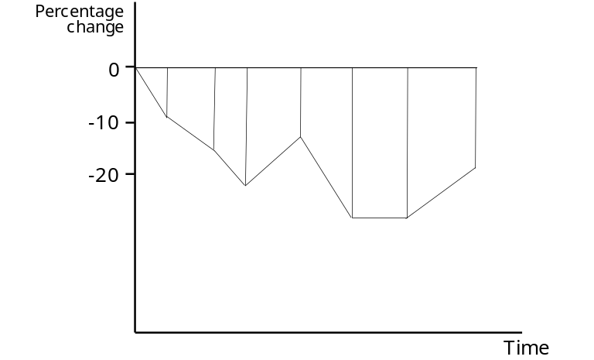
Display A2-1 Calculation of E_{AUC}

For a patient whose count is greater than baseline, the area above the line of no change is not included in the calculation. For instance, in Display A2-2, the second sample after baseline provided a count above baseline. The area above the line of no change is not included in the calculation, but the two triangles (shaded) are counted in the calculation of the E_{AUC}. The intersections with the line of no change are calculated by interpolation.

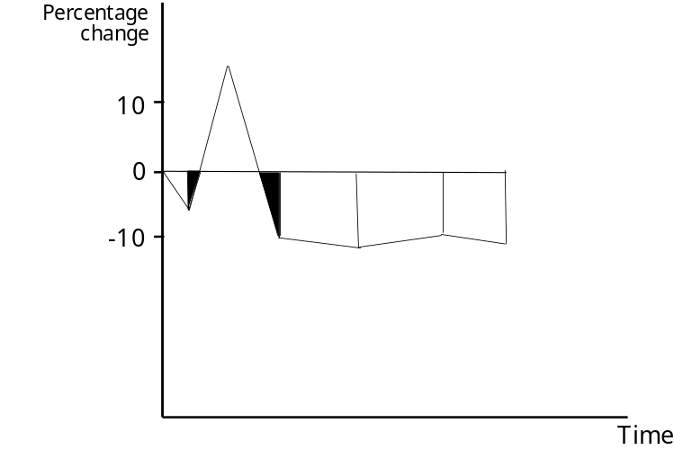
Display A2-2 Calculation of E_{AUC} when counts are greater than baseline

appendix 3: publication of phase 2 dose-response study (708): Ellis CN, Krueger GG. Treatment of chronic plaque psoriasis by selective targeting of memory effector t lymphocytes. N Engl J Med 2001; 345(4):248-255



