

RURAL DEVELOPMENT
Vermont/New Hampshire

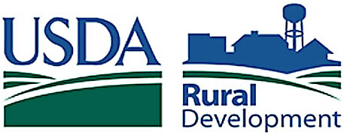

Volume 2004 May Issue

Committed to the future of rural communities

STATE DIRECTOR'S MESSAGE: A new logo, a new tag line – an enhanced image. Why the change? Because rural communities are the lifeblood of the American dream and the American economy. USDA Rural Development has the programs to help those dreams come true, to help rural economies flourish. The unexpected challenge when an agency has so much to offer is the task of reaching all of those who can use our products. We have stepped up to that challenge. On February 25, 2004, Department of Agriculture Secretary Ann Veneman announced a new initiative to better communicate Rural Development’s mission and goals. The new logo depicts a typical rural landscape, complete with a water tower and mix of buildings, all nestled in a rolling green hillside. The new tagline, Committed to the Future of Rural Communities, will help the agency reinforce our mission: Increasing Economic Opportunity and Improving the Quality of Life in Rural America. Last year, Rural Development invested almost $113 million in Vermont and New Hampshire. Emphasizing customer service and enhancing our efforts to be recognized as the ‛go to’ agency for economic and technical resources, we hope to exceed last year’s investment! Happy Spring!

Sincerely,
Jolinda H. LaClair

FEATURE PROGRAMS

ATTENTION LENDERS!

ATTENTION COMMUNITY LENDERS!

Community Facility Guaranteed Loans are an excellent way for you, as a lender, to finance and facilitate essential community facilities such as health care clinics, police and fire stations, schools and child care centers. Lenders: USDA RD guarantees 90% of your loan and you have an added opportunity to meet your Community Reinvestment Act requirements.

Communities and non-profits: A Rural Development guarantee increases your chances of obtaining the financing you need to provide services to your community members.

As part of President Bush’s faith-based and community initiative, and to provide more information about the Community
Facility Guaranteed Program to both lenders and community organizations, Rural Development will hold several educational workshops throughout Vermont and New Hampshire. To get information on locations and dates of the workshops, please contact Bill Konrad at 603-223-6045 or william.konrad@nh.usda.gov.

FIRST RESPONDER INITIATIVE

Rural Development salutes the job performed by the nation’s emergency response providers. We are also aware that urban residents may have to be served by rural First Responder’s services during times of a national crisis. To ensure that the resources to respond to future emergencies in America’s communities are readily available, Rural Development has made First Responders projects a top priority for funds available through the Community Facility and Economic Impact Initiative Grants National Office reserves. In cases of emergency conditions caused by economic problems or natural disasters, grants will receive 30 additional Administrator points and loans will receive 15 additional Administrator points.

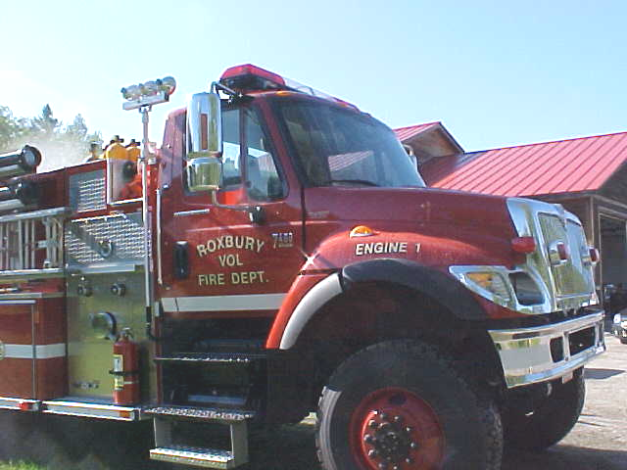
The following types of projects will be emphasized: health care facilities, communication centers, Civil Defense buildings, fire/police/rescue vehicles, equipment and buildings, early storm warning systems, food preparation distribution centers, animal shelters, and education facilities for response provider training.
The Town of Roxbury received a $33,750 USDA Rural Development Economic Impact Initiative Grant to help with the purchase of a new fire truck.

AVAILABLE FUNDING

Community Facility Economic Initiative Grant Fund

In addition to our regular grant allocation, the Community Facility Economic Initiative Grant program is funded again this year. $23.7 million will be available for the nation. Applications must be received by June 20th. In our experience, applications from the lowest income, most rural communities, compete particularly well for this funding. This includes most communities in the Northeast Kingdom and eastern Franklin County in Vermont, as well as select communities across Vermont and New Hampshire. Also, applications of $50,000 or less tend to be more competitive.

If you have a building improvement or equipment need for your essential community facility, please contact our Community Facility Specialists at the following locations:
For Chittenden, Franklin, Grand Isle, Lamoille, Orange and Washington Counties in VT, contact Naomi Hatch at 802-828-6032 or naomi.hatch@vt.usda.gov.
For Caledonia, Orleans, and Essex Counties in VT, contact Mark Koprowski at 603-747-2777 or mark.koprowski@nh.usda.gov.
For Addison, Bennington, Rutland, Windsor and Windham Counties, contact Andrea Ansevin-Allen at 603-756-3230 or andrea.ansevin-allen@nh.usda.gov.
For all New Hampshire counties, contact Scott Johnson at 603-223-6045 or scott.johnson@nh.usda.gov or Gregg MacPherson at 603-223-6045 or gregg.macpherson@nh.usda.gov
Farm bill clean energy funds available
Deadline for submitting applications is July 19.
Montpelier, VT: USDA Rural Development will make available $22.8 million in grants to jump start renewable energy and energy efficiency projects at farms, ranches and rural small businesses. Funds may be used to purchase renewable energy systems or to make energy efficiency improvements. Applicants must demonstrate financial need and the grant request must not exceed 25% of the total eligible project costs. These funds are being made available through Section 9006, Renewable Energy and Energy Efficiency Assistance program, of the 2002 farm bill. The Notice of Funds Availability (NOFA) inviting applications, was published in the May 5, 2004 Federal Register. You can read the NOFA online at http://www.rurdev.usda.gov/rd/nofas/2004/energy050504.pdf. Additional information is available at the website for the USDA Farm Bill Section 9006 at www.rurdev.usda.gov/rbs/farmbill.
"This year's program includes several changes in response to customer feedback," said USDA Rural Development State Director Jolinda LaClair. "We welcome these improvements and look forward to receiving some very competitive applications.”
FY 2004 Program Highlights Include:

*Renewable Energy grant maximum is $500,000
*Energy Efficiency grant maximum is $250,000
*Grant request minimum is $2,500
*75% non-federal match is required
*3rd party in-kind contributions can be counted toward the 75% match, limited to 10% of the 75% match requirement
*A project-specific feasibility study is required for renewable energy grant requests over $50,000
*A professional energy audit is required for energy efficiency projects costs exceeding $50,000
*Professional engineering services will be required for project costs exceeding $50,000
*Technology-specific guidance available for technical requirements, including energy efficiency
*Applicants must own the project and control the operation and maintenance of the project
*Special consideration is given to smaller agricultural producers with less than $1 million in gross receipts in the preceding year.
Deadline: The deadline for submitting applications for this year's funding cycle is July 19, 2004. Since there are a large number of application requirements, interested applicants are urged to review program details and begin work on their applications soon.

For Vermont and New Hampshire applicants, an original and one copy of the completed application must be delivered to the USDA Rural Development office at 3rd Floor, City Center, 89 Main Street, Montpelier, VT 05602 by the deadline of July 19, 2004. Only completed applications will be accepted. Incomplete, ineligible, or late applications will not compete for funding.

For more information, or if you intend to apply, please contact Lyn Millhiser, USDA Rural Development Business and Cooperative Programs Specialist at 802-828-6069 or lyn.millhiser@vt.usda.gov.

Value-Added PRODUCER GRANT PROGRAM

USDA Rural Development is expected to announce the availability of funding for the Value-Added Producer's Grant Program in early June. Competitive grant funds will be available to help independent agricultural producers, agricultural producer groups, farmer or rancher cooperatives, and majority-controlled producer-based business ventures to enter into value-added activities that will increase revenue to producers. Funds may be used for planning activities to establish a viable value-added marketing opportunity for an agricultural product, or working capital activities to operate a value-added business venture that will allow producers to better compete in domestic and international markets.

In the last funding cycle, Vermont applicants received three grants totaling $165,738. Northeast Organic Farming Association in Richmond received a grant for planning activities to create juice products from local fruits, vegetables and herbs. Thistle Hill Farm in North Pomfret will conduct feasibility, business operation and market planning activities for the development of Tarentaise Cheese from dairy milk. The third grant was awarded to AP-GARM SC, LLC from Burlington to evaluate the revenue potential from the sale of renewable energy green tags and greenhouse gas emission reduction credits, independent from the sale of the energy/electricity produced by the renewable energy project.

Complete program information will be available when the Final Rule is published in the Federal Register. For more information please contact Lyn Millhiser, Business and Cooperative Programs Specialist, at 802-828-6069 or lyn.millhiser@vt.usda.gov

Home Ownership Programs

In March 2004 there was an increase in loan and income limits for our Direct Loan program. Maximum purchase prices range from $160,100 to $290,100. In Vermont, the income eligibility for a family of four ranges from $44,550 to $57,500 depending on the county or area. In New Hampshire the income range for a family is $48,250 to $66,150. Funds for the Direct program are plentiful this year and we do not anticipate any shortages before the end of our fiscal year, September 30, 2004.

In the Single Family Guarantee program, the income eligibility standards are generally 50% higher than the Direct programs. There are no purchase price limits under this program, and all loans are originated by approved lenders. The agency has increased the guarantee loan fee from 1.5% to 1.75% effective June 1, 2004 to increase the availability of funding under this program. All lenders with existing reservations are encouraged to process loans for approval as soon as possible to avoid the rate increase.

If you would like more information about any of our programs, contact Housing Program Director, Robert McDonald at 802-828-6010, robert.mcdonald@vt.usda.gov or any of our local representatives.

EARTH DAY CELEBRATIONS - 2004

SWANZEY, NEW HAMPSHIRE

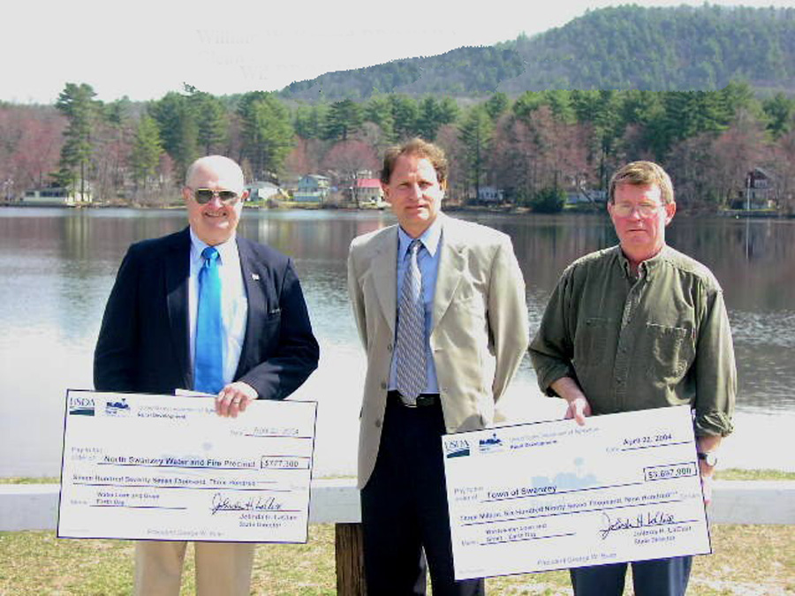
At a ground breaking celebrating Earth Day, the North Swanzey Water and Fire Precinct received a $607,300 loan and a $170,000 grant to replace asbestos cement water pipes in the area around Wilson Pond. The Town of Swanzey received a $1,863,950 loan and a $1,833,950 grant to bring municipal sewer to 243 homes in the same area.

Pictured left to right: Robert Beuregard, Chairman of the North Swanzey Water and Fire Precinct, Bill Konrad, Community Programs Director for USDA Rural Development and Glenn Page, Sewer Commissioner for the Town of Swanzey.

DUXBURY, VT
Last year, the Association of Vermont Recyclers received a $75,000 SWMG from RD. They used the grant to establish and work with High School Environmental Clubs across VT.
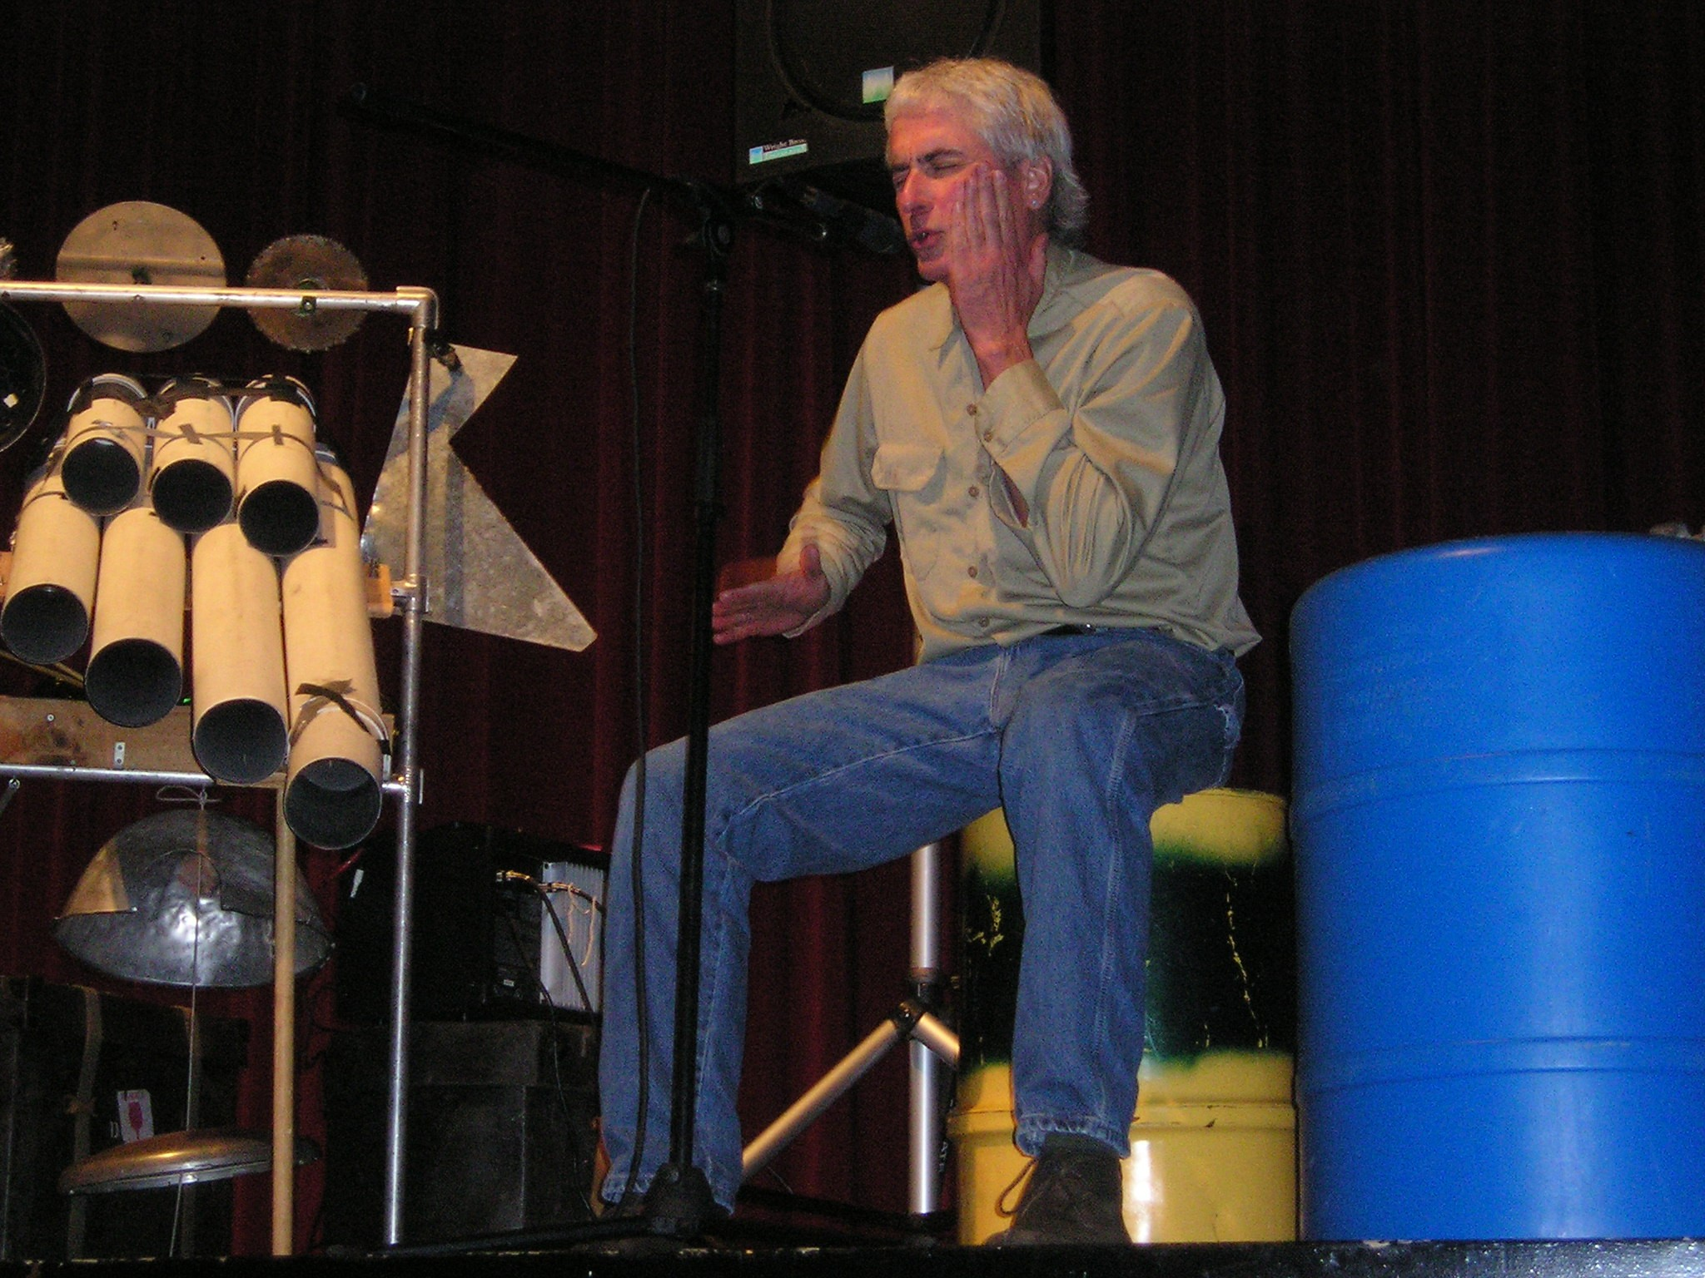
The Environmental Club of Harwood High School, in Duxbury, VT, was extremely active and, as a result, was rewarded with a presentation by the "Junkman” to celebrate Earth Day. Using old brake drums, a window screen, bottles, signs, clay pots, body parts and rocks, the Junkman, a professional percussionist, practices his art using recycled goods to connect music to our earth. Thirty-six Harwood students joined him using plastic, wood and metal recyclables to "jam". This Earth Day celebration made an impact.

STAFF NEWS

WELCOME

While we were sad to bid farewell to two of our very dedicated staff upon their retirement, Single Family Housing Specialists Nancy Domina from our Conway and Berlin, NH offices and James Clary of our Concord, NH office, we are pleased to welcome on board five new additions to our team.

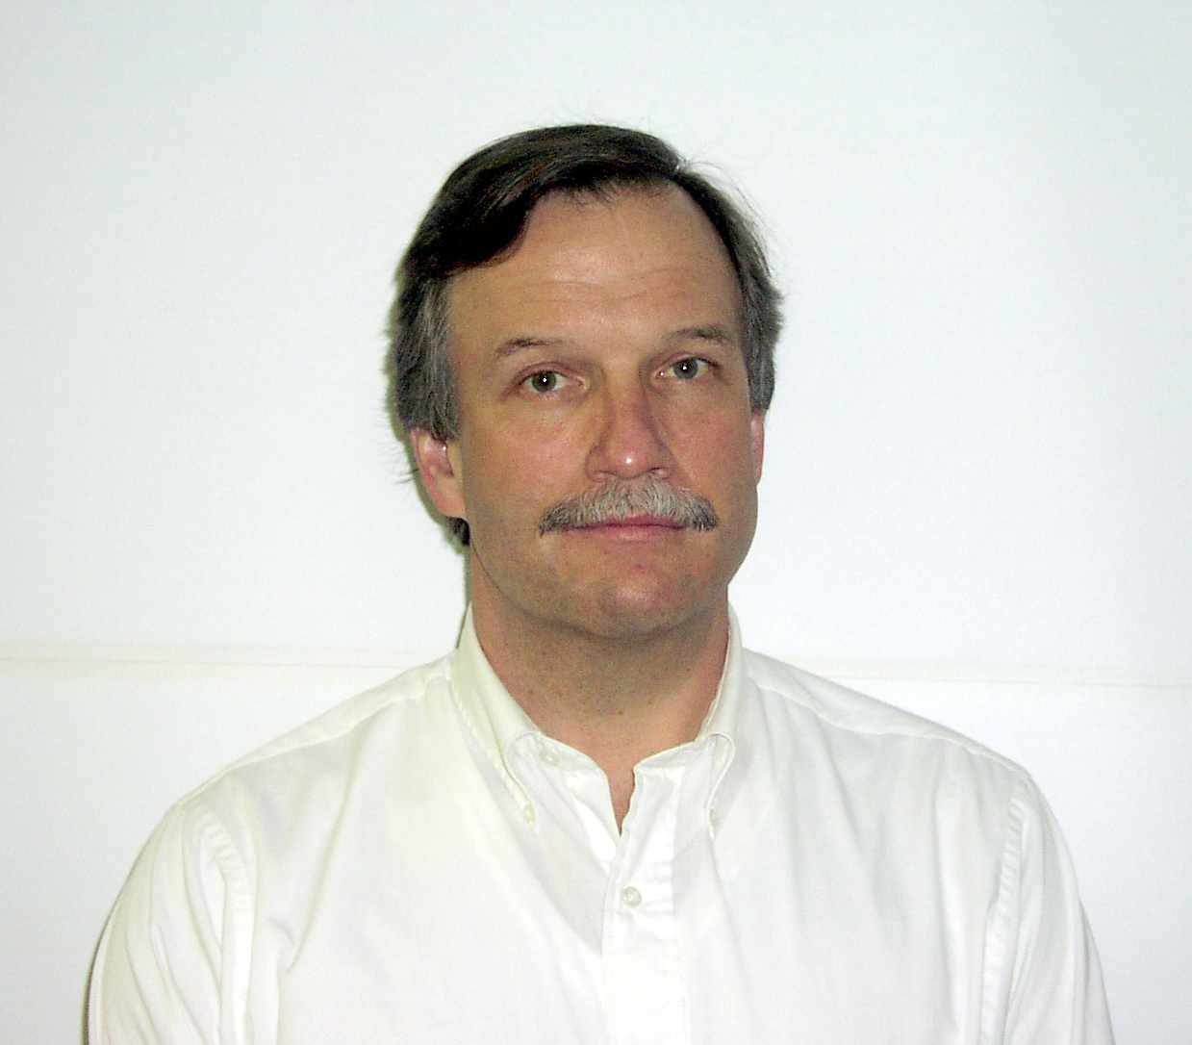
Paul Hill joined our Montpelier, VT office as our new Guaranteed Rural Housing Specialist for Vermont. Hill will be working with local lenders, to provide mortgage loan guarantees. Prior to joining Rural Development, Hill was the Director of the Housing and Community Facility Program for the Vermont Community Loan Fund in Montpelier. Hill studied Business at Towson State University in Maryland and brings 25 years of banking experience to his position with RD. You can reach Paul at 802-828-6016 or paul.hill@vt.usda.gov


Claire Bailey is the new Human Resource Manager in the State Office in Montpelier, VT. Claire is a native Vermonter and used to work for the Vermont Department of Employment and Training as the Chief Financial Officer. Most recently she was a Workforce Development Specialist for the U.S. Department of Labor, in Boston, MA. Contact Claire at Rural Development 802-828-6041 or claire.bailey@vt.usda.gov


Sue Hayes accepted the position of Area Director in the Montpelier Office, where she will oversee all program areas and staff in the Montpelier, St. Albans, Brattleboro and Rutland Offices. Most recently, Sue was the Integrated Support Manager at the Indian Head Naval Station in Maryland. She holds a degree in Engineering from Clarkson University and is a native of St. Johnsbury, VT. Sue can be reached at 802-828-6053 or susan.hayes@vt.usda.gov.

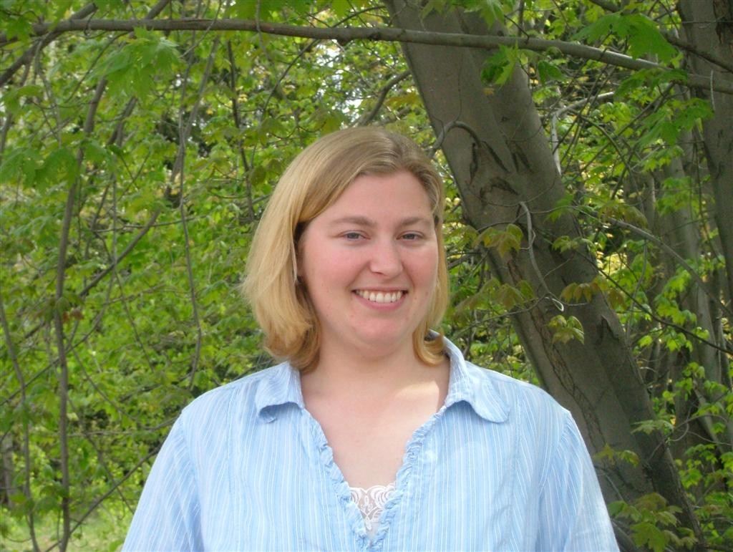
Angela Francesco, the new Technician in the Conway, NH office, previously worked in Washington, DC at the United States Holocaust Museum. When you call the Conway office, it is likely that it will be Angi you will speak to first and Angi who will answer your questions and refer you to other appropriate staff. Angela can be reached at 603-447-3318 or angela.francesco@nh.usda.gov

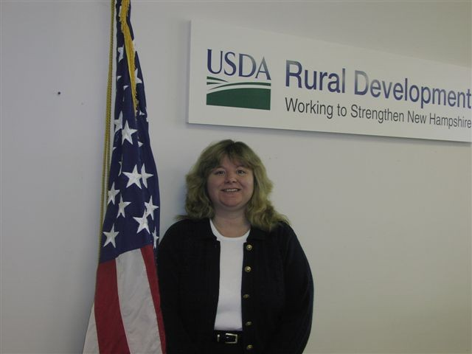
Daphne Feeney has joined our Concord, NH team as a Housing Specialist. Prior to joining the RD staff in Concord, Feeney was the Senior Single Family Housing Guaranteed Specialist for USDA Rural Development in Scarborough, ME. She brings twenty years of experience with Rural Development and five years as an employee at the Portsmouth, NH Naval Shipyard to her new position. Ms. Feeney will be working with families who want to purchase a home in Belknap, Hillsborough, Merrimack and Rockingham Counties. You can contact Daphne at 603-223-6040 or daphne.feeney@nh.usda.gov

CONGRATULATIONS

Congratulations to four of our Vermont employees who, nominated by their co-workers, received 2004 Distinguished Government Service Awards from the Vermont Federal Executive Association. Rhonda Shippee, Director of Business and Cooperative Programs, received a Supervisor/Manager Award. Sharon Lafley, Rural Housing Technician and Donna Montgomery, Business Technician, each received Administrative /Administrative Support Awards and Ed Plourde, Computer Specialist, received a Technical Trades Award.

CORPORATE CHALLENGE

Nine RD employees participated in this year’s Corporate Challenge, held annually to benefit the Governor’s Council on Physical Fitness. Two teams of runners included Paul Hill, Jolinda LaClair, Naomi Hatch, Rhonda Shippee, Robert McDonald, and Jonathan Harries. The team of walkers included Heidi Setien, Sherri Austin and Paula Higgins.

ANNUAL REPORT

Our Fiscal Year 2003 Annual Report is almost finished. We think you will find the report concise and informative. To receive a copy of the report, please contact Carolyn Lawrence at 802-828-6002 or carolyn.lawrence@vt.usda.gov

LEARN ABOUT RURAL DEVELOPMENT

We have developed several new outreach tools to share with you and your staff.
1) A power point presentation: an overview of RD’s loan, grant and technical assistance programs.
2) A 10 minute CD movie: the story that shows how RD’s various programs worked to improve the quality of life for residents of two communities; one in VT and one in NH.
3) A Program Guide: general information about all of RD’s programs in one publication.
4) County By County Breakdown: depicts all of RD’s loan and grant activities in VT and NH for the last three years, by town.
Our staff is always available to meet with your employees to discuss RD’s many programs. To arrange a presentation for your staff or to receive our outreach material, please contact Carolyn Lawrence at 802-828-6002 or carolyn.lawrence@vt.usda.gov

USDA Rural Development is an Equal Opportunity lender, provider and employer. Federal law prohibits discrimination. Complaints of discrimination may be filed with the Secretary of Agriculture or the USDA Director, Office of Civil Rights, Washington, DC 20250-9410



