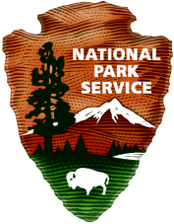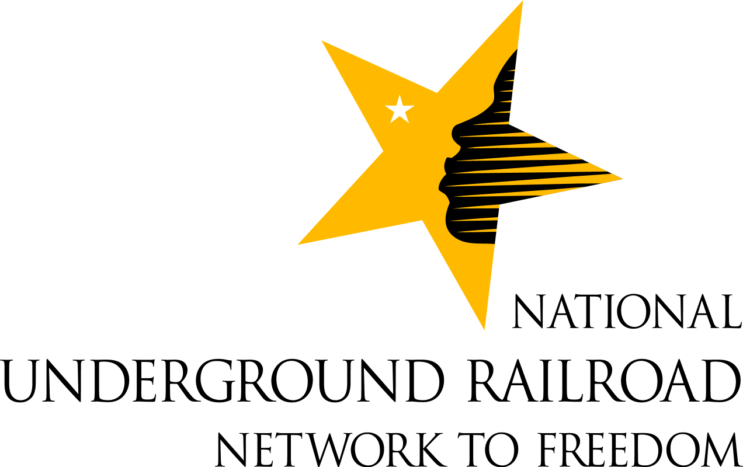

National Underground Railroad Network to Freedom Listings

California
California State Library [facility]
Footsteps to Freedom Study Tour [program]
Mary Ellen Pleasant Burial Site [site]
Meet Mary Pleasant/Oh Freedom (chautauqua) [program]
Reclaiming the Past Juneteenth Celebration [program]
“Straight From Tha Underground” [program]

Delaware
Delaware State House [site]
Historic Society of Delaware [facility]
Long Road to Freedom: UGRR in Delaware [program]
New Castle Courthouse [site]
The Rocks—Fort Christina State Park [site]
Star Hill Historical Society [program]
Thomas Garrett Home Site [site]
Tubman—Garrett Riverfront Park & Market St. Bridge [site]
Wilmington Friends Meeting House and Cemetery [site]

District of Columbia
African American Civil War Memorial [site]
Asbury United Methodist Church [site]
Blanche K. Bruce House [site]
Burial Site of Blanche K. Bruce [site]
Camp Greene and Contraband Camp [site] (NPS, George Washington Memorial Parkway)
Frederick Douglass National Historic Site [site] (NPS)
“From Slavery to Freedom” [program]
Mary Ann Shadd Cary House [site]
Moorland Spingarn Research Center, Howard
University [facility]
Site of Pearl Affair [site]
Slavery and the UGRR with a Focus on the Nation’s Capital [program]
Washingtoniana Division., Martin Luther King
Library [facility]

Florida
Bill Baggs Cape Florida State Park [site]
Family Heritage House Museum [facility]

Florida (continued)
Fort Jefferson, [site] (NPS, Dry Tortugas National
Park)
Southeast Archeological Center [facility] (NPS)

Georgia
Auburn Avenue Research Library [facility]
Fort Pulaski National Monument [site] (NPS)
From Africa to Eternity (traveling exhibit) [program]
“Mattie, Johnny and Smooth White Stones” [program]
“Mattie, Johnny and Smooth White Stones: Part II” [program]

Illinois
Congregational Church (Jacksonville) [site]
Dr. Hiram Rutherford Home [site]
Dr. Richard Eells House [site]
Galesburg Colony UGRR Freedom Station-Knox College [program]

Illinois College—Beecher Hall (Chapel) and the site of the College Building (1832-1852) [site]
Kimzey Crossing /Locust Hill [site]
Lucius Read House [site]
Old Slave House (reverse UGRR) [site]
Owen Lovejoy Homestead [site]
Pettengill Home Site [site]
Rocky Fork [site]
UGRR in Illinois [program]

Indiana
Bethel African Methodist Episcopal Church [site]
Decatur County Courthouse [site]
Dr. Samuel Tibbets Home Site [site]
“Freedom is My Home” [program]
Georgetown Historic District [site]
Historic Eleutherian College [site]
Indiana Freedom Trails Educational and Research Program [program]
Indiana Supreme Court—Courts in the Classroom [program]
Isaiah Walton Home Site [site]
John Gill and Martha Wilson Craven Home [site]
Levi Coffin House State Historic Site [site]
Lyman Hoyt House [site]
Tibbets House [site]

Indiana (continued)
“The Underground Railroad in Floyd County, Indiana” [program]
Underground Railroad Initiative, Department of Natural Resources, Division of Historic Preservation and Archeology [program]
William and Margaret Hicklin Home [site]
Seymour Train Station [site]

Iowa
Denmark Congregational Church [site]
Hitchcock House [site]
Ira Blanchard Home Site and Cemetery [site]
J.H.B. Armstrong House [site]
James C. Jordan House [site]
Lewelling-Gibbs House [site]
Nishnabotna Ferry House [site]
Todd House [site]

Kansas
Captain William Mitchell Homestead [site]
Clinton Lake Museum [facility]
Constitution Hall—Topeka [site]
Henry and Ann Harvey Farmstead [site]
Dr. John Doy Home Site (ruins) [site]
Quindaro Ruins [site]
Underground Railroad in Douglas County, Kansas [program]
Watkins Community Museum of History [facility]
Wabaunsee Cemetery [site]

Kentucky
Institute for Freedom Studies [program]
Fee Land: The Story of Juliet Miles [site]
Long Walk Home: From Slavery to Freedom [program]
White Hall [site]

Louisiana
River Road African American Museum and Gallery [facility]

Maryland
Adventures of Harriet Tubman & UGRR in Dorchester County [program]
Arrest Site of William Chaplin [site]
Banneker-Douglass Museum [program]
Belair Mansion [site]
Berry Farm [site] (NPS, National Capital Parks-East)
Camp Stanton, USCT [site]
Catoctin Center for Regional Studies [facility]
Catoctin Iron Furnace and Manor House Ruins [site]
Dorchester County Courthouse [site]
Experience Harriet Tubman & the UGRR by Sea 1 [program]

Maryland (continued)
Experience Harriet Tubman & the UGRR by Sea 2 [program]
Experience Harriet Tubman & the UGRR by Land [program]
Ferry Hill [site] (NPS, Chesapeake & Ohio Canal National Historical Park)
Finding a Way to Freedom Driving Tour [program]
Frederick Douglass Freedom & Heritage Trail &
Tour of Underground Railroad Sites in the City of
Baltimore, MD [program]
Gorsuch Tavern [site]
Hampton National Historic Site [site] (NPS)
In Their Steps [program]
Jacob Leverton Dwelling [site]
Jane C. Sween Library, Montgomery County Historical Society [facility]
Jefferson Patterson Park and Museum [site]
Marietta House [site]
Maryland State Archives [facility]
Mount Clare [site]
Old Jail of St. Mary’s County [site]
Point Lookout State Park [site]
Port Tobacco Courthouse [site]
President Street Station [site]
Reginald F. Lewis Museum [program]
Riley Farm [site]
Rockland [site]
Roedown Farm [site]
Rural Legacy Trail: UGRR Experience [program]
Shawnee Old Fields Village Site [site]
Sotterley Plantation [site]
Southern Maryland Studies Center [facility]
The Maryland State House [site]
The Underground Railroad Experience in Maryland [program]
Thornton Poole House [site]

Massachusetts
An Impressive Lesson for My Children [program] (NPS, Minute Man National Historical Park)
Discovering New Bedford’s Underground Railroad
History [program] (NPS, New Bedford
Whaling National Historical Park)
Hart and Mary Leavitt House [site]
Jackson Homestead [site]
Joshua Bowen Smith House [site]
Longfellow NHS [facility] (NPS)
Mount Auburn Cemetery [site]
Nathan and Polly Johnson House [site]
Roger Hooker and Keziah Leavitt House [site]
Ross Homestead [site]
Resisting for Justice-The African Meeting House & the
Rescue of Shadrack Minkins [program] (NPS,
Boston African American National Historic
Site)

Massachusetts (continued)
Tappan-Philbrick House [site]
The Wayside [site] (NPS, Minute Man National Historical Park)
William Ingersoll Bowditch House [site]

Michigan
Caroline Quarlls: A Family Legacy of Freedom
[program]
“Flight to Freedom” at Historic First Congregational Church of Detroit [program]
Free Soil Underground Railroad Sightseeing Bus Tour (tour) [program]
Guy Beckley House [site]
International Underground Railroad Heritage Program [program]
Jonathan Walker Grave and Marker [site]
Journey to Freedom Underground Railroad Tours
[program]
Underground Railroad Monument (Battle Creek) [site]
W.W. Harwood Farmstead [site]

Mississippi
Forks of the Road Enslavement Market Terminus [site]

Missouri
Mary Meachum Freedom Crossing [site]
Old Courthouse [site] (NPS, Jefferson National Expansion Memorial)

Nebraska
Mayhew Cabin [site]

New Hampshire
Cartland House [site]

New Mexico
Harriet’s Return [program]

New York
1816 Farmington Quaker [Friends] Meetinghouse [site]
Asa Wing [site]
Bristol Hill Church (First Congregational Church and Society of Volney) [site]
Buckhout-Jones Building [site]
Cayuga County Historian’s Office [facility]
Cayuga Courthouse [site]
Edwin W. Clarke House [site]
First Baptist Church of Elmira—Homesite of John W. Jones [site]
Gerrit Smith Estate [site]
Hamilton and Rhoda Littlefield House [site]
Harriet Tubman Home [site]

New York (continued)
Herman and Hannah Phillips House [site]
Howland Stone Store [site]
Hunt House [site] (NPS, Women’s Rights National Historical Park)
James Canning & Lydia Fuller House [site]
Jervis Langdon Home [site]
John B. and Lydia Edwards House [site]
Joshua W. and Samantha Wright House [site]
M’Clintock House [site] (NPS, Women’s Rights National Historical Park)
Matilda Joslyn Gage House [site]
Mexico Museum [facility]
Murphy Orchards [program]
North Street Meeting House, Scipio Preparative Meeting of Friends [site]
Onondaga Historical Association Museum & Research Center [facility]
Orson Ames House [site]
Oswego Market House [site]
Oswego School District Public Library [facility]
Park Church [site]
Richardson-Bates House Museum [facility]
Seward House [site]
Seymour Library [facility]
Site of Martha & David Wright House [site]
Slocum and Hannah Howland House [site]
Starr Clark Tin Shop [site]
Stephen and Harriet Myers Residence [site]
Thomas and Elizabeth James House [site]
Thomas Elliott and Ann Marie Stewart Elliott House [site]
Tudor E. Grant: From Fugitive Slave to Oswego Businessman [program]

North Carolina
Burial Sites of Henry Sr., and Dorothy Copeland [site]
Colonial Park [site]
Great Dismal Swamp [site]**
Orange Street Landing on Cape Fear [site]
Pasquotank River [site]
Roanoke Island Freedom Colony [site] (NPS, Fort Raleigh National Historic Site)
Roanoke Island Freedom Colony Memorial Garden [site]
Somerset Place [site]

Ohio
Bloomingburg Presbyterian Church [site]
Boyhood Home of Dr. William Thompson [site]
Bunker Hill House [site]
Burial Site of US Senator Thomas Morris [site]
Clermont County Courthouse [site]
Clermont County Underground Railroad Public Education Program [program]
Clermont County Trail Tour [program]
Charles B. Huber Homesite [site]
Charles B. Huber Farm [site]

Ohio (continued)
Dr. L.T. Pease Homesite [site]
Experience the Underground Railroad [program]
(NPS, Cuyahoga Valley National Park)
Felicity Weslyan Church [site]
A Forge for Freedom [program]
“A Fugitive’s Path-Escape on the Underground Railroad” [program]
Gus West Site/Abolition Lane [site]
Haines House [site]
Homesite of Dr. William E. Thompson [site]
James & Sophia Clemens Farmstead [site]
John P. Parker House [site]
John Rankin House [site]
King Family Cemetery [site]
Lindale Baptist Church and Cemetery [site]
Marcus Sims-Charles Huber Tannery [site]
Nelson T. Gant Homestead [site]
New Richmond, Ohio, Waterfront [site]
Oberlin Heritage Center/O.H.I.O. [facility]
Oberlin-Wellington Rescue Monument [site]
Office of the Philanthropist Newspaper [site]
Old Calvary Methodist Church [site]
On the Trail to Freedom in Lorain County, Ohio [program]
Robert Fee Burial Site [site]
Robert Fee Homesite [site]
Spring Hill Historic Home [site]
Spring Hill Historic Home (tour) [program]
The Sugar Tree Wesleyan Church Cemetery [site]
Tate Township Cemetery [site]
The Underground Railroad & Its Connection to the Ohio River [program]
Voices of Freedom [program]
Westwood Cemetery [site]
Williamsburg Cemetery [site]
Will Sleet Homesite [site]

Pennsylvania
Belmont Mansion [site]
Blairsville Passport to Freedom UGRR Experience [program]
Burial Site of William & Phoebe Wright (Huntington Friends meeting) [site]
Burial Site of Cyrus Griest (Menallen Friends Meeting) [site]
Burial Ground at Yellow Hill [site]
Chester County Historical Society [facility]
Cumberland County Historical Society [facility]
Fair Hill Burial Ground [site]
First National Bank Museum [facility]
Grave of U.S. Congressman Thaddeus Stevens [site]
Heinz History Center [facility]
Historical Society of Pennsylvania [facility]
Independence National Historical Park [site] (NPS)
Johnson House [site]
Kennett Underground Railroad Center [facility]

Pennsylvania (continued)
Library and Archives, Erie County Historical Society [facility]
"Living the Experience" [program]
Mother Bethel African Methodist Episcopal Church [site]
Pennsylvania State Archives [facility]
Place I Call Home Tour [program]
Quest for Freedom: The UGRR in Philadelphia [program] (NPS, Independence National Historic Site)
State Library of Pennsylvania [facility]
William C. Goodridge House [site]
Willis House [site]
Zercher’s Hotel [site]

Tennessee
Fort Donelson National Battlefield [site] (NPS)
Stones River National Battlefield [site] (NPS)

Texas
Blazing Trails to Freedom: The Underground Railroad in Texas [program]
The Resurrection of Harriet Tubman: Escape to
Freedom [program]
Seminole Indian Scouts Cemetery [site]

Vermont
Rokeby Museum [site]

Virginia
Afro-American Historical Association of Fauquier County [facility]
Alexandria Archaeology Museum [facility]
Alexandria Freedmen’s Cemetery [site]
Arlington House, The Robert E. Lee Memorial [site] (NPS, George Washington Memorial Parkway)
Bruin’s Slave Jail [site]
Birch Slave Pen [site]
Downtown Norfolk Waterfront [site]
Gadsby’s Tavern [site]
Great Dismal Swamp [site]**
The Library of Virginia [facility]
Leesylvania [site]
Loudoun County Courthouse [site]
Moncure Conway House [site]
Oatlands Plantation [site]
Petersburg Courthouse [site]
Sully Historic Site [site]
Thomas Balch Library [facility]

West Virginia
Harpers Ferry National Historical Park [site] (NPS)

West Virginia State Archives [facility]

Wisconsin
A.P. Dutton Warehouse [site]
Caroline Quarles: She’s Got a Story to Tell [program]
Jonathan Walker’s Homesite [site]
Milton House Museum [site]
Milton House Museum (tour) [program]
Monument Square, Racine [site]
Racine Heritage Museum [facility]
Site of the Rescue of Joshua Glover [site]

** Great Dismal Swamp is located in both North Carolina and Virginia

