Cabin Names and Cabin Activities

Each cabin is named for a special animal found in Redwood National and Sate Parks. Teachers often create cabin group activities based on each animal. Some ask their students to make murals or signs for their cabins. Others have the students create skits for the campfire program that relate to their animals/cabins. Some teachers have their students make labels for their gear with the animals’ name or body shape.

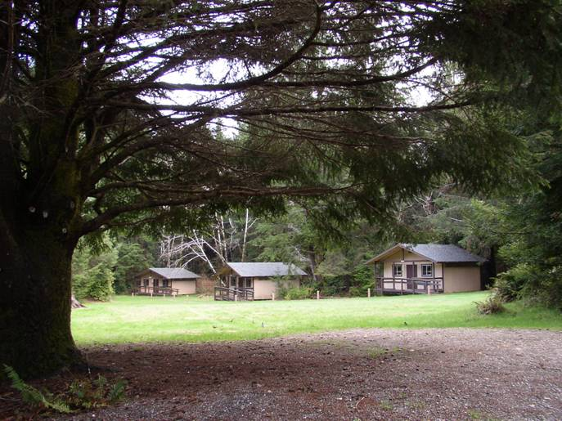

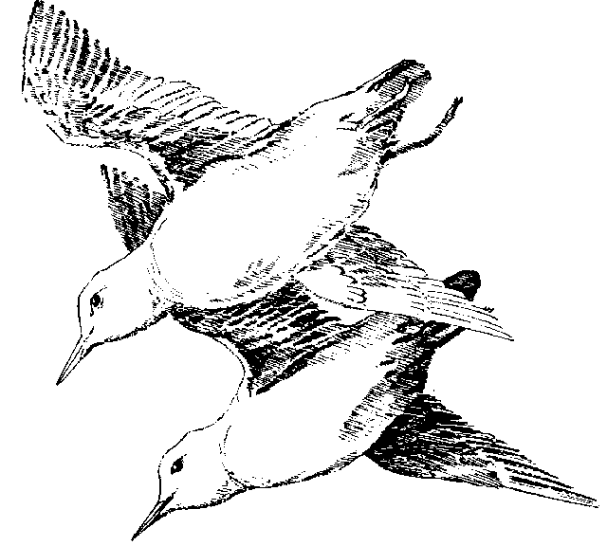
Marbled Murrelet

Who Am I?
My Common name: Marbled Murrelet
My scientific name: Brachyramphus marmoratus

What Do I Look Like?
In the summer my back is mostly dark brown, and my belly is white, but mottled with dark splotches that make me look like a marble. In the winter my back turns dark grey and my belly loses the dark splotches and is pure white.

Where Do I Live?
I spend most of my life out at sea, but I nest in places like the old-growth at WCEC. My range is between the Aleutian Islands in Alaska and Monterey Bay in central California.

What Kind of a Nest?
No one knew where we nested prior to August 5, 1974, when by accident someone found a nest at Big Basin State Park. As parents, we require a big limb carpeted with moss to lay our single (chicken size) egg. Usually, only trees older than 175 years have limbs large enough for us to build our nest. Our chick spends most of the day by itself. Twice a day, we bring it food from the ocean. We Murrelets can fly up to 60 miles per hour and that helps when you go from old-growth to the ocean twice a day, but things are not to easy for our chicks. From high up in the forest, they only have one chance to learn how to fly or else they will fall to the forest floor.

Limiting factors that affect marbled murrelets today:
On the land: Other birds eat our chicks, cutting down our homes in the old-growth forests, and noisy human activity near our nests all make it hard for us to survive.
In the ocean: When I can’t find fish…I’m in trouble! Over fishing, gill netting, bad storms and pollution, like oil spills, all make it hard for me to live.

Life as Endangered Species:
Before the old-growth became like little islands, we weren’t bothered so often by ravens, crows, and jays. This was because ravens, crows, and jays liked to live on the edges of the forest. But, now with more open space, more edges, and more people leaving garbage around attracting those kinds of birds, we’re in trouble. Ravens, crows, and jays (also known as Corvids) have followed people into the old growth for dropped food and handouts, these birds now stand a better chance at finding where our egg or chick may be hidden. If the Corvids find the egg or chick, they will eat it.

What Can You Do?
- Please help your parents clean up around camp so that you are not feeding any crows, ravens, or jays. “Don’t help a good bird go bad.”
- Support local fishermen who follow the law and treat us with compassion.
- Support the preservation of old-growth redwood forests. Without these forests, I cannot survive.
- Volunteer for organized clean-up days or start your own.
- Pick up old fishing line and garbage; it may save my life, I can get tangled up in it out at sea.
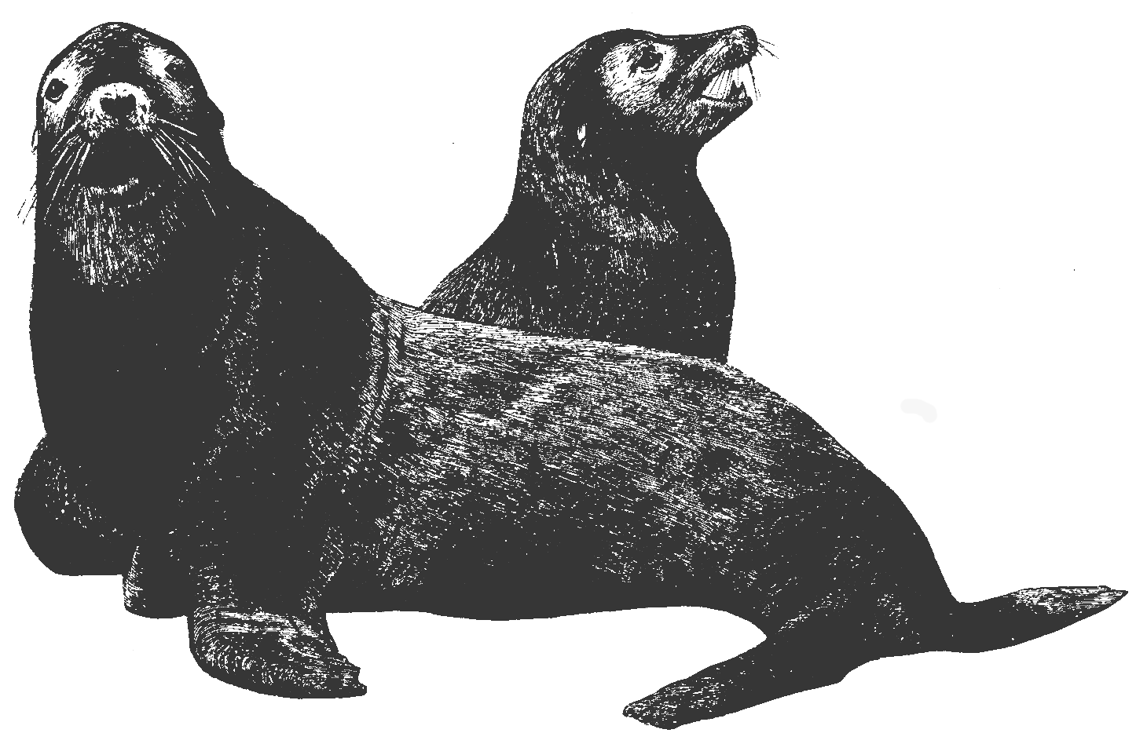
Sea Lion

Who Am I?
My common name: Steller’s Sea Lion
My scientific name: Eumetopias jubatus

Lion of the Sea?
I was named for Wilhelm Steller who noticed me in 1741. Mr. Steller called me a “Sea Lion” because of my lion-like roar and lion-like mane.

Have You Seen Me?
Well, I’m pretty hard to miss!! Female Steller’s sea-lions can be up to seven feet long and weigh up to 790 pounds while males can be as long as 11 feet and weigh up to 2,200 pounds! That’s a lot bigger than a black bear. My fur can be cream colored to reddish brown, like a lion.

See-food? Nope! Hear-food!
I am the fastest aquatic carnivore, swimming up to 25 mph! At these speeds, I have trouble seeing my seafood. Instead of seeing, I use sonar (kind of like a bat) to hunt for fish. Herring and rockfish are some of my favorites. I am a mammal and that means I have lungs….and do I ever! I can chase my prey underwater at depths of up to 450 feet and for as long as 20 minutes. You can find me sunning myself on rocks and swimming in the ocean. I have even been seen in rivers looking for another favorite food of mine…salmon.

Back Home in the Rookery:
During the summer months, we return to the rookeries (beach birthing places) where we were born. Here, males fight for the best spaces on the rocks. After the dust settles, females show up, ready to have our babies. Usually in a rookery, the females outnumber the males 10 to 1. We give birth to one lucky pup, which can usually walk and swim within days. Normally, junior will stick with mom for about a year. If you see a small pup on the beach, tell an adult or find a ranger station and report it. Most of all…never touch a pup! The pup will not smell right, and the mom will abandon it.

Declining Populations:
In the 1800s we were an important source of food, oil, and clothing for native people like the Aleut Indians in Alaska. When European hunters began to hunt us in large numbers, we were threatened, almost to extinction. Even after we became a protected species in the 1970s, our numbers continued to decline, mostly because we eat the same kinds of fish that humans like to catch. Water pollution, poaching, and disease may also be responsible for the deaths of many of us.

What Can You Do?
- Help keep the ocean and beaches clean. Volunteer for or organize beach clean-up days.
- Support local fishermen who follow the law and treat us with compassion.
- Report any pups you find on the beach, and tell others not to touch it! You could save a life.

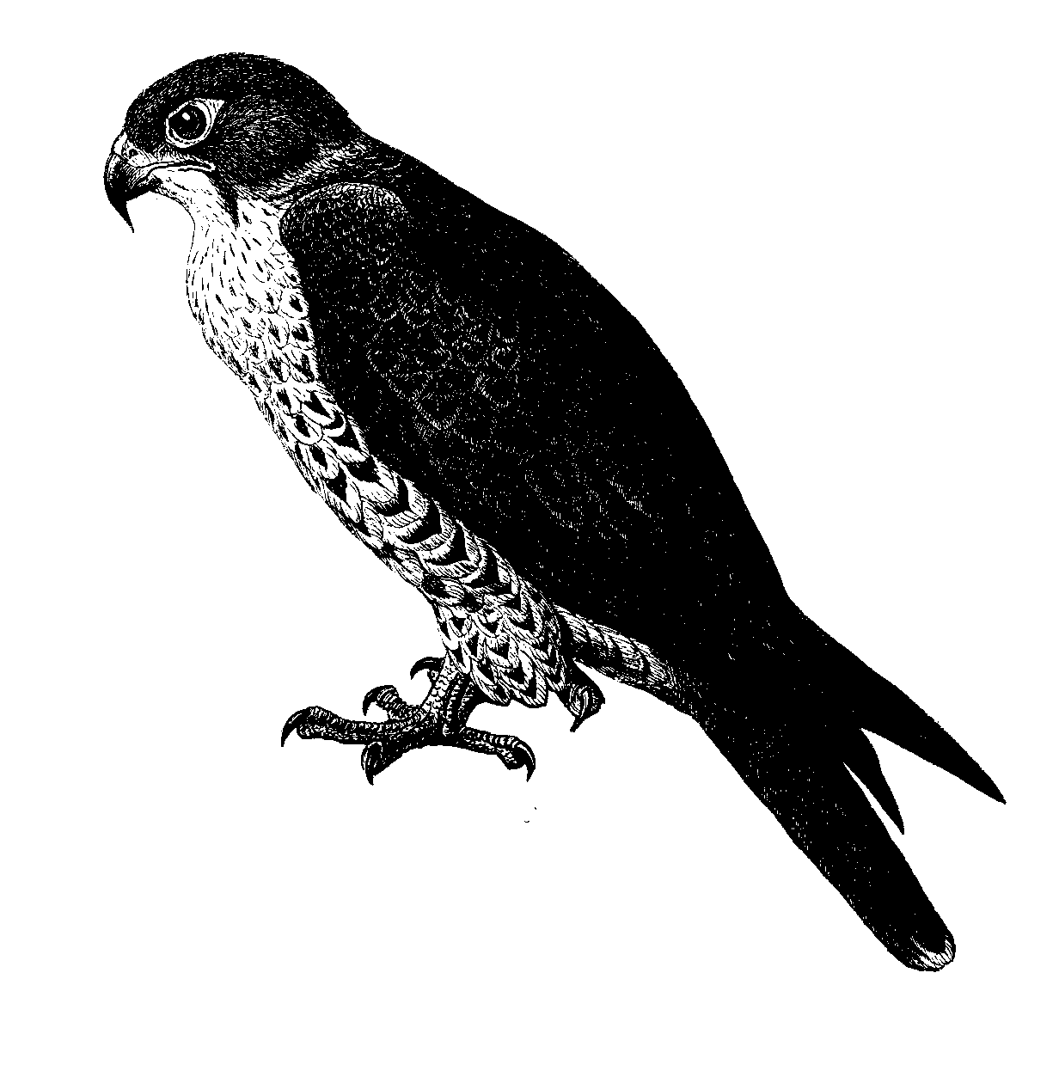
Peregrine

Who Am I?
My common name: American Peregrine Falcon.
My scientific name: Falco peregrinus anatum

One Big Backyard:
“Peregrine” means wanderer, and my friends and I wander around most of California. I am usually spotted in the Coast Ranges and in the Central Valley. In the summer, I can be seen as far north as Alaska, and in the winter sometimes as far south as Central and South America.

Have You Seen Me?
I am about 15-21 inches long, and have a wingspan of about 40 inches. My back is grey and my belly is white with dark bars. I may appear a solid dark color when I am young.

Fast Food!
I like eating other birds, such as sparrows and pigeons. I can catch my prey in mid-air, swooping down on a small bird at up to 200 mph. Most of the time, they never saw me coming. Talk about fast food!

Room with a View:
I build my nest on steep, rocky cliffs near the coast. Usually, you can find three or four eggs in my nest. My mate and I take turns watching the eggs and feeding the fledglings (baby birds).

Saved from Extinction!
In the early 1970s, scientists discovered that there were only four of us left in California! Lucky for us, we were put on the Endangered Species List. Thanks to concerned humans, we have almost recovered.

What Happened?
It turns out…the small birds that we love to eat were eating bugs that they loved to eat. Some of those bugs were from fields that had been sprayed with a pesticide called DDT. Pesticides are chemicals that people put on their crops to kill insects that might eat their crops. We ate the small birds that ate the bugs that had the pesticide DDT in their bodies (there’s that old food chain again). This hurt us, especially our eggs. Farmers didn’t know it, but the DDT had a bad side effect…it made our eggs shells so weak that almost all of them would break.

DDT is illegal to spray in the United States and that has helped us survive. But DDT can still be manufactured here and is still in use in other countries. I travel a lot, and so do the small birds I eat and because of this, DDT is still a threat to me.

What Can You Do?
- Find out where your food comes from. Ask your grocer; they should know!
- Support farmers who don’t put DDT on their crops. Not only does buying local produce keep our population from dipping dangerously low, it’s also a good way to support your community and country.
- Plant your own garden and practice good pest management (like lady bugs).
Wapiti

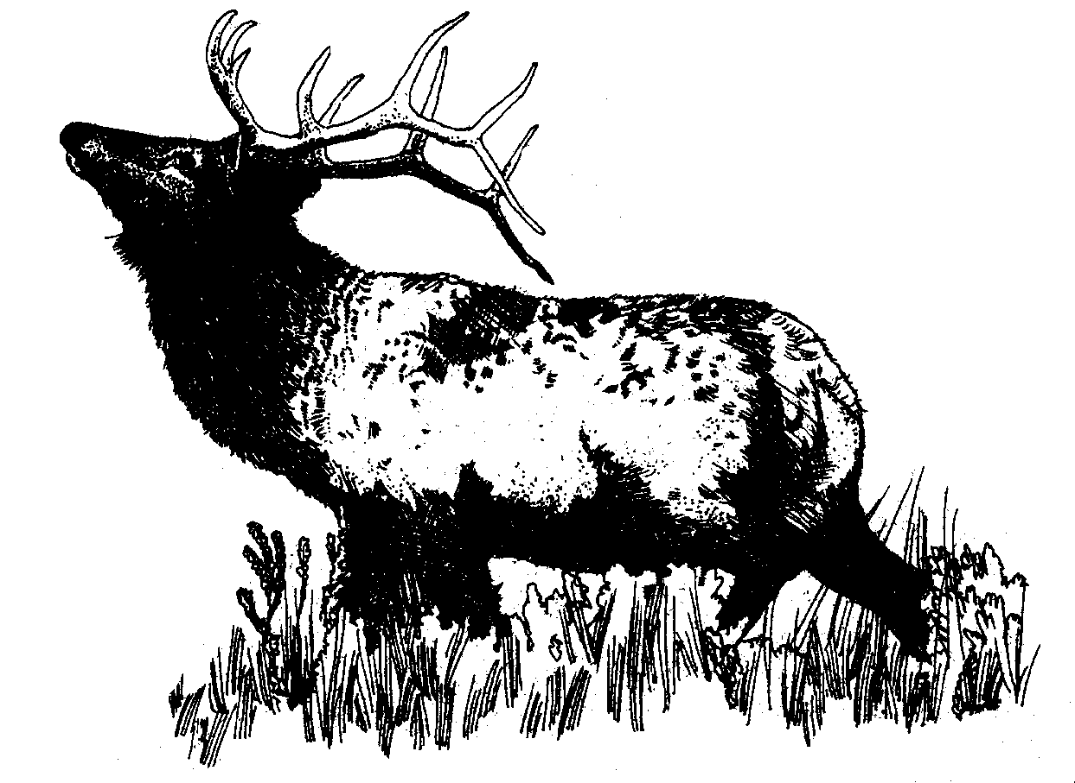
Who Am I?
My common name: Roosevelt Elk
My scientific name: Cervus elaphus

No Home on the Range:
Before the 19th century, elk were everywhere! Ten elk species roamed throughout the United States, from Massachusetts to California. However, too much hunting and loss of habitat seriously decreased our population. Now there are only three species in North America—Rocky Mountain elk, Tule elk, and Roosevelt elk. Roosevelt elk live along the coastal mountains of California, Oregon, Washington, and Canada. We can be seen in both the prairies and forests in Redwood National and State Parks.

Have You Seen Me?
I am a BIG member of the deer family, with a thick neck and slender legs. I stand about 4 ½ feet tall at the shoulder and can weigh over 1000 pounds! I am light brown on my back and darker brown underneath. Male elk grow a set of antlers every year, called a rack. They grow and shed these antlers every year. The antlers of a large bull (male) elk can weight over 30 pounds!

Liken’ Lichen!
YUM! Among other things, we eat lichen (pronounced “like-en”). Lichen is really two organisms, algae and a fungus, growing together. We usually find it on trees and rocks and start lick’in our lichens. We love lichen but we also eat grass, shrubs, and woody vegetation.

Life in the Harem:
Bulls (male elk) have a pretty rough job. Every fall they fight each other, hoofing at the ground and clashing antlers to establish who will be the bull who gets to hang out with the female elk herd (called a harem). Usually the strongest adult bull wins this privilege, but that isn’t always a prize worth winning! Sure, it means you get to mate with all the females, but what a responsibility! There can be up to 40 cows (female elk). The bull barely has time to eat and he doesn’t sleep much because he always has to keep an eye open for predators, as well as other bulls that might steal his cows! Cows have their calves in May through early June. Each cow usually has only one calf, but sometimes she has two. The calves will stay with their mother and continue to nurse for up to nine months. Eventually, a bull will run off the juvenile male elk.

Success Story:
We Roosevelt elk were in serious trouble in the early 1900s. Too many of us were killed by hunters for our meat and for our ivory teeth, which were made into jewelry. Livestock owners killed us because we competed with their herds for grazing space. Human development and agricultural land reduced our habitat size until we were almost wiped out. In the early 1900s there were less than two dozen of us in northern California. In 1948, the Save-the-Redwoods League came to the rescue, establishing an elk refuge and reserving 1600 acres for us at Prairie Creek Redwoods State Park. Efforts like these have helped to stabilize our population. There are now, an estimated 2000 Roosevelt elk in northwestern California.

What Can You Do?
- Support the continued protection of elk habitat.
- Respect ethical hunting practices and educated hunters.
- Learn more about us at school, at home, and in your parks.
Coho
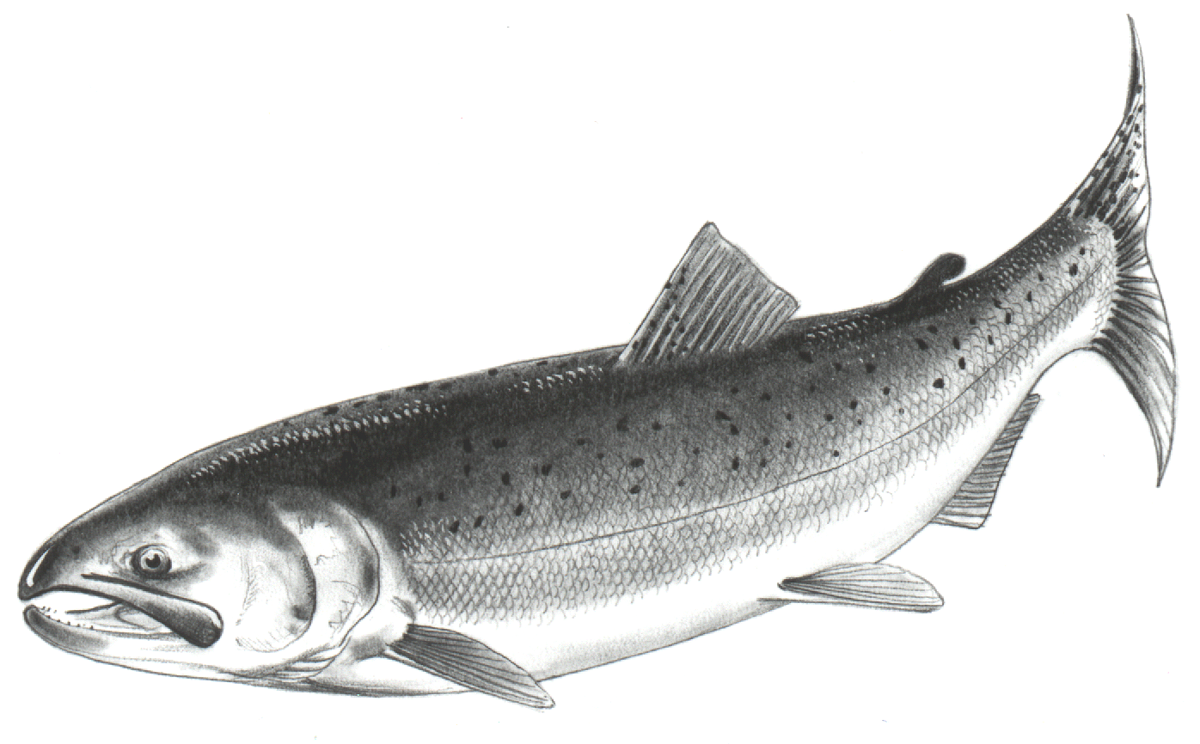

Who Am I?
My common name: Silver, blue-back, jack salmon.
My scientific name: Oncorhynchus kisutch.

Have You Seen Me?
Guess what color we are? Our sides are shiny silver, while our bellies are dark blue or green. Sometimes we have black spots on the upper parts of our tail fins. We are, on average, 24 inches long and weigh about 10 pounds. The largest recorded coho salmon measured 38.5 inches and weighed over 30 pounds!

Smell You Later!
You can find us hanging out anywhere from Alaska to Mexico, but I am usually seen north of Santa Cruz, California. Like all types of salmon, we are anadromous. That means we are born in freshwater rivers, spend most of our lives in the ocean, and return to our home river to spawn. After about three years at sea, it is time for us to return to the rivers of our birth and spawn. How do we find my way back to our home river? We can recognize our home river by smell. Even after three years at sea and sometimes over a thousand-mile journey, we smell our way back within 100 yards of the exact place we were born! I don’t know about you…but something smells fishy to me.

The Ultimate Sacrifice:
Spawning females lay around 2,500 eggs! Spawning males follow the females around and try to fertilize as many eggs as they can. After spawning, almost all the adults will die! After we die, thousand of little bugs will munch on our bodies for weeks. By the time those little bugs are finished eating us, they’re not so little anymore…in fact, they’re nice are juicy. And just about that time, our little eggs aren’t little eggs anymore…they are fry (baby salmon) with a big appetite for fat juicy bugs! Wow! It’s like we planned it or something.

Suffocating Eggs!
We coho can lay up to 5,000 eggs! Even with that many eggs, worldwide, coho salmon populations have decreased. Too much timber harvesting along the river banks has caused erosion. Erosion (when water carries dirt downstream) can cause eggs to suffocate as the dirt fills in the gravel in the bottom of the stream. Over fishing has also decreased our numbers. In the United States, from 1989 to1993 about 50 million pounds of my friends were caught every year! At that rate, you can see why there aren’t a lot of us left. Fortunately, the U.S. Fish and Wildlife, National Park Service, California Fish and Game, fisherman, and whole bunch of people just like you have begun programs to save us!

What Can You Do?
- Learn about us. Fishing is fun! Get to know your fish and practice proper catch and release techniques. This allows many people to enjoy fishing for years to come.
- Be a salmon detective! When you walk along streams, look for a pool of rocks that have been turned over in a stream, it is probably our nest or “redds.” Take care of these places.
- Always remember that storm drains often lead to streams and the ocean. Don’t poor oil or other waste products down storm drains; it can really hurt us.

