THREE-YEAR PLAN FOR ASSISTANCE TO TRIBAL COLLEGES AND UNIVERSITIES, FY 2006-2008

WHITCU, in accordance with EO 13270, compiled responses received from federal agencies on three-year plans that projected their efforts to fulfill the purposes of the EO. Pursuant to the EO, federal agencies are to address how they intend to increase the capacity of TCUs to compete effectively for available grants, contracts, cooperative agreements, and other federal resources; and to encourage TCUs to participate in such federal programs.

In 2003, WHITCU requested three-year plans from 40 federal agencies. These plans were for the FY 2004-2006 time period. Eighteen (18) agencies responded to the request but much of the information provided was not responsive to long-term planning. During 2006, WHITCU again requested three-year plans from 29 federal agencies for the FY 2006-2008 time period. All 15 federal departments representing the president’s Cabinet and 14 other federal agencies responded to the request for information. Three of the 14 federal agencies could not respond with data based on current programmatic activity.

The agencies completed the three-year plan for FY 2006-2008 in an electronic format, providing FY 2006 funding estimates and then projecting increased, decreased, or stable funding for the fiscal out-years of FY 2007 and FY 2008. Agencies also
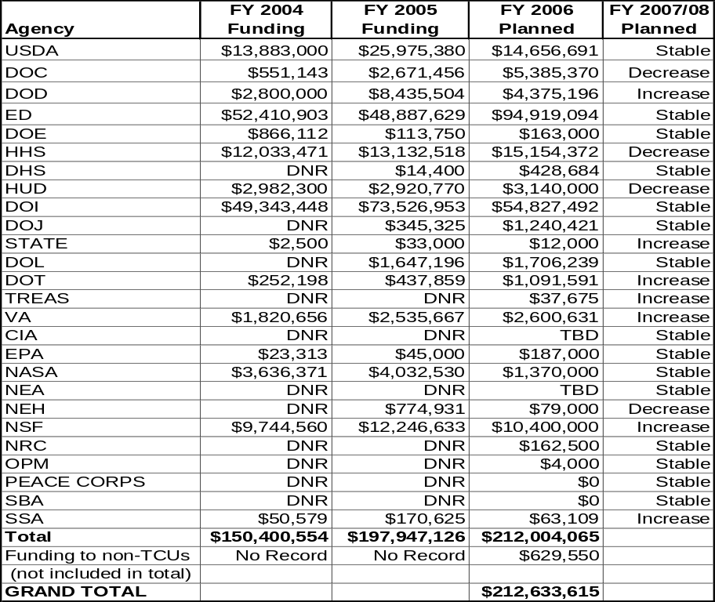
matched their programmatic activities to one of the areas of support designated in the EO: 1) long-term development,
Table C.1. Funding Trends Across Agencies.

2) financial management,
3) institutional capacity development,
4) physical infrastructure, and 5) educational achievement.

Table C.1 shows estimated agency funding for

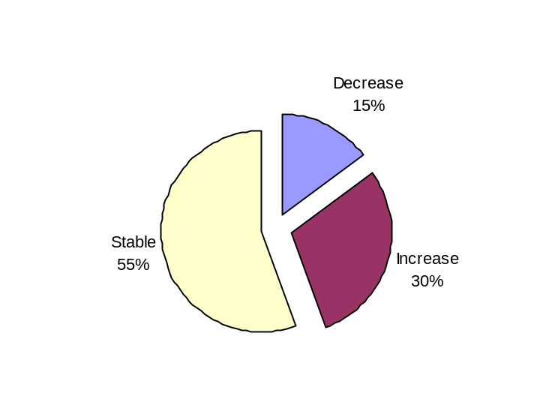
Figure C.1. FY 2006 Planned Funding by Agency.

Figure C.2. FY 2007/08 Agency Funding
Trends.

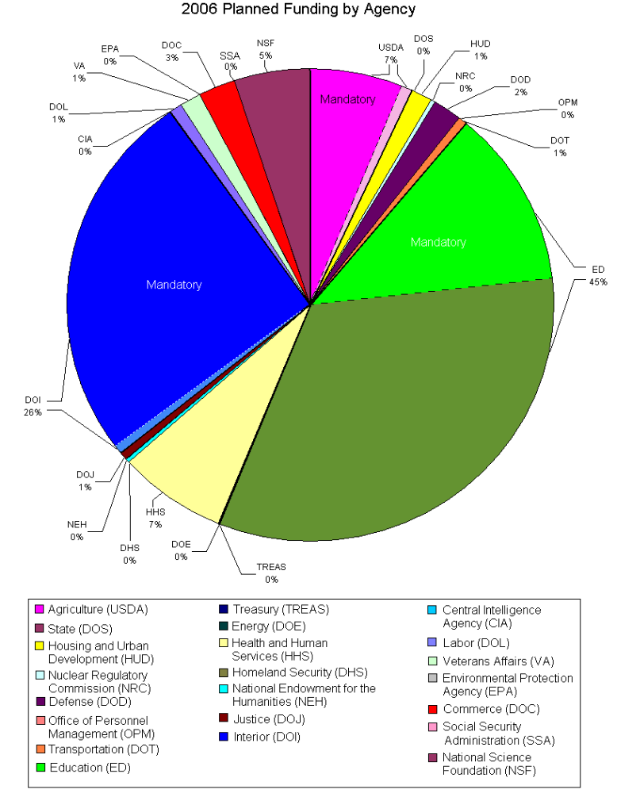

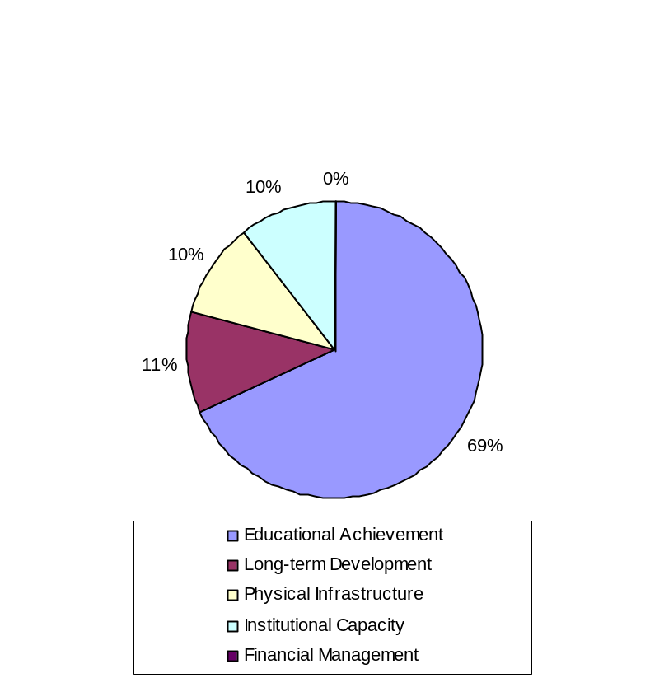

Figure C.3. FY 2006 Planned Funding
by EO Area of Support.

FY 2006 at $212,633,515. ED projected the largest amount of funding support for TCUs at $94,919,094, followed by DOI at $54,827,492, and HHS at $15,154,372. Figure C.1 represents the percentage of FY 2006 planned agency-reported funding to TCUs. Figure C.2 reflects the FY 2007/08 funding trends to be relatively stable at 55 percent, with a projection of 30 percent of the programs providing increased support to TCUs, while 15 percent of the federal programs will be reduced.

Relating the FY 2006 estimates to the areas of support in the EO, Figure C.3 indicates that 69 percent of the support from federal agencies would be provided in the area of educational achievement, 11 percent for long-term development, while 10 percent of the funds would be provided to both enhance physical infrastructure and build institutional capacity. No agency support was projected to help improve financial management and security at the TCUs.
To encourage leveraging of resources for greater impact and cost-efficiencies, while strengthening relationships within the federal agencies, agency objectives for the FY 2006-2008 plan were also grouped into three major thematic areas. These three themes were first identified in the 2004-2005 Annual Report to the President: academic programming, outreach, and institutional capacity building. Academic programming includes curriculum development, distance education delivery methods, and student preparation and success. Outreach includes agency efforts to raise the awareness among TCUs of agency programs and services, as well as to increase participation in grants, contracts, cooperative agreements and other programs. Institutional capacity building includes delivering technical assistance, providing resources for basic operations, and building supportive partnerships. Figure C.4 illustrates that 93 percent ($198,452,917) of federal monies for FY 2006 were projected to support institutional capacity building, 5 percent ($9,986,652) supported academic programming, and the remaining 2 percent ($4,194,046) were projected to support outreach.

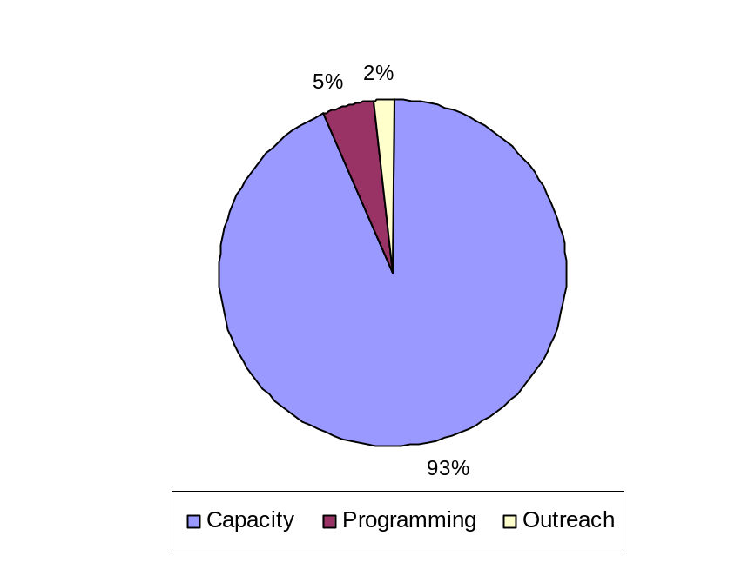The relationship between the US and Indian tribes remains one based on treaty rights and legal precedent, establishing Indian tribes as sovereign nations with which the federal government has a unique trust responsibility. In the broadest sense, this trust relationship views the federal government as trustee and Indian tribes as beneficiaries where responsibilities are derived from legal duties, moral obligations, understandings and expectations that have been established throughout the history of the federal government's dealings with Indian tribes. The federal government's trust responsibility includes the provision of educational opportunity. EO 13270 affirms the policy of the federal
Figure C.4. FY 2006 Planned Funding
by Theme.

government that this nation's commitment to educational excellence and opportunity extends to TCUs.

In recognition of this trust responsibility Congress has enacted legislation to designate specific funding to assist in the growth of the TCU community. The agencies carrying out these authorized programs include DOI, ED, and the USDA. These specific monies serve as the lifeblood for the colleges—ensuring that operational expenses are met, academic capacity is enhanced, faculty members are developed and retained, and facilities are constructed that will meet the institutions’ needs. A review of Figure C.5 indicates that 46 percent of support planned for FY 2006 would come from the mandatory funding authorized through the appropriations process.
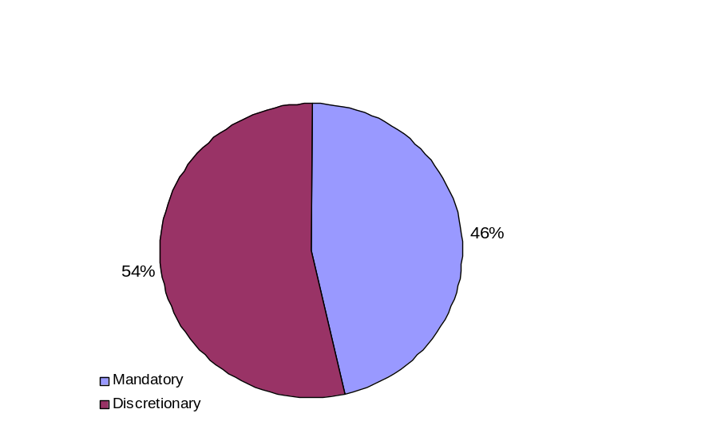
Agencies were projecting to spend $113,926,841 for program support through other, non-mandatory funding.
Figure C.5. FY 2006 Planned Funding,
Mandatory vs. Discretionary.

For FY 2006, DOI estimated providing a total of $55,443,392 to the TCUs. However, 97.6 percent of this total is mandatory funding, leaving only $1,353,992 to be provided at the discretion of agency heads. ED will provide 32.6 percent mandatory funds, and USDA estimates providing 93.3 percent of its funding through direct legislative authorities.

A review of mandatory funding indicates the corresponding areas of support in the EO, as follows: 1) educational attainment 66.3 percent of mandatory funding ($65,447,263), 2) long-term development 18.6 percent ($18,390,579), 3) physical infrastructure 13.6 percent ($13,440,000), and 4) institutional capacity building 1.5 percent ($1,468,932). No mandatory funds will be directed toward improvement of financial management systems and security. Regarding the three thematic areas, the total amount (100 percent) of mandatory funds for FY 2006 is estimated for use in institutional capacity building.

In compliance with the EO, WHITCU makes the following recommendations on the integrated agency three-year plan to enhance opportunities for the TCUs:

- Improve financial security of TCUs by providing consistent federal funding and technical assistance to ensure institutional viability.

As indicated in this report, nearly 50 percent of the federal funds that support TCUs come from legislative mandates. To appropriately fulfill the direction of the EO, federal agencies need to focus on providing consistent discretionary resource support to the TCUs.

Emphasis should be given to involving TCUs in federal programs for which they are eligible, providing technical assistance workshops to ensure that the institutions have the capability to compete for the grants, and providing training and support to the TCUs as small or disadvantaged businesses, where appropriate.

Agencies with legislated authorities to support the TCUs should conduct an annual review and assessment of the programs to evaluate the effectiveness of program delivery. If programs fail to meet program assessment guidelines, agencies should insure site visits and communication occurs to regain the effectiveness of the program for the TCUs.

A large disparity exists between the budget allocations of several agencies in the funding to all IHEs compared to the small percentage provided as support for the TCUs. This disparity must be recognized and corrected in programmatic mission areas. Technical assistance, such as indicated above, should be provided to insure that TCUs can compete for federal funds.

- Improve agency reporting processes.

For the FY 2006-2008 three-year plan, all agencies responded to the request to submit plans. Although an electronic format and significant direction was provided for the preparation of the document, there were still significant discrepancies in data received by the WHITCU office.

Long-term progress for assisting the TCUs can only be effective if the tools are available to determine data accuracy and consistency over time. Strong baseline data have been gathered from the FY 2004-2005 report and the FY 2006-2008 Three-Year Plans. Communications need to be streamlined to ensure clarity of support for the TCUs—by assigning a senior-level official to coordinate administrative responsibilities for collecting, reviewing, and reporting data from each agency in a timely manner; by providing training where appropriate; and by converting all reporting of data into an electronic format.

- Enhance Student Success.

Many federal agencies indicated they plan to offer internships and fellowships to students at the TCUs. While this activity accounts for only 1.5 percent of the discretionary funding planned for FY 2006 activities, many agencies find recruiting, selection, and mentoring of interns to be a time-consuming process. Additional factors that affect a lower success rate of internships for TCU students are their needs to remain in the immediate community for their extended family, cultural events, and connection to the land.

In addition to opportunities available through grants programs, several agencies provide summer research opportunities that involve not only students, but also faculty members. These programs allow faculty and students to select topics of interest and conduct the accompanying research at the agency’s facility, and then to return to the TCU campus and continue the work. Programs such as these provide a greater opportunity for more students to be involved in experiential learning opportunities, to gain a better understanding of the opportunities and challenges of the project by learning from a familiar instructor, and to pursue additional knowledge that may lead to desired career opportunities.

Another key factor in student success are TCU faculty members. Most faculty members hold untenured positions and endure heavy teaching loads and lower pay than other postsecondary institutions. A key recommendation of the Carnegie Foundation for the Advancement of Teaching was a comprehensive faculty development program for TCUs. The type of programs referenced above encourages professional growth through summer research programs and can lead to faculty exchanges, release time for research and other development, and advancement of academic credentials. An energized, effective faculty body brings strong support for student development. For example, the Packard Foundation’s Tribal Scholars Program found that often just the help of a single faculty member made the difference in a TCU student’s success.

In conclusion, the three recommendations in this report are cost-effective methods, and with the inclusion of quality baseline data, will help build agency program activity that effectively supports EO 13270. Agency ongoing resource support and continued cooperation with WHITCU will help accomplish the Administration’s direction to ensure educational excellence and opportunity to the TCUs.
The data file associated wirh figures c2, c3, and c4 contain all data displayed in this document, including table c1 and figure c1.

Departments of Agriculture, Commerce, Defense, Education, Energy, Health and Human Services, Homeland Security, Housing and Urban Development, Interior, Justice, Labor, State, Transportation, Treasury, and Veterans Affairs.
Central Intelligence Agency, Environmental Protection Agency, General Services Administration, Institute of Museum and Library Services, National Aeronautics and Space Administration, National Endowment for the Arts, National Endowment on the Humanities, National Science Foundation, Nuclear Regulatory Commission, Office of Personnel Management, Peace Corps, Small Business Administration, Social Security Administration, and the U.S. Agency for International Development.
Canby, Jr., W.C. 1998. American Indian Law in a Nutshell. St. Paul, MN: West Group.
P.L. 95-471, P.L. 105-244, and P.L. 103-382 and 7 USC 301 note.
Agency examples from FY 2005 and FY 2006 Reports indicate the Department of Defense provided 0.3 percent to the TCUs in FY 2005 and 0.1 percent in FY2006; Department of Homeland Security provided 0.1 percent of all funds to TCUs in both fiscal years, and Department of Energy reported 0.0 percent in both fiscal years.
For example, the National Aeronautics and Space Administration’s “AIHEC-NASA Enrichment Grants” established in FY 2005 and the Department of Energy’s Faculty and Student Teams (FaST) Program.
Boyer, P. 1997. Native American Colleges: Progress and Prospects. Princeton, NJ: Carnegie Foundation for the Advancement of Teaching.
Lee, Tiffany. 2007. Success and Challenges in Higher Education Transitions. Tribal College Journal, 19(1): 30-35.

