DOE/SC-ARM/TR-076

183-GHz Radiometer (GVR) Handbook

November 2006

MP Cadeddu

Work supported by the U.S. Department of Energy,
Office of Science, Office of Biological and Environmental Research

Contents

1 General Overview 1
2 Contacts 1
3 Deployment Locations and History 1
4 Near-Real-Time Data Plots 1
5 Data Description and Examples 2
6 Data Quality 5
7 Instrument Details 6

Figures

1 Examples of GVR Unfiltered and Filtered Brightness temperatures. 4
2 GVR Simplified Component Level Block Diagram 7
3 GVR-Measured Brightness Temperatures as a Function of PWV Retrieved from the
Co-Located MWR 8

Tables

1 Status and Location of the GVR 1
2 Primary Variables 2
3 Secondary Variables 2
4 Diagnostic Variables 3
5 Data Quality Thresholds 3
6 Dimension Variables 3
7 Instrument Specifications 7

General Overview

The G-Band Vapor Radiometer (GVR) provides time-series measurements of brightness temperatures from four double sideband channels centered at ± 1, ± 3, ± 7, and ± 14 GHz around the 183.31-GHz water vapor line. Atmospheric emission in this spectral region is primarily due to water vapor, with some influence from liquid water. The 183.31 ± 14-GHz channel is particularly sensitive to the presence of liquid water. The sensitivity to water vapor of the 183.31-GHz line is approximately 30 times higher than at the frequencies of the two-channel microwave radiometer (MWR) for a precipitable water vapor (PWV) amount of less than 2.5 mm. Measurements from this instrument are therefore especially useful during low-humidity conditions (PWV < 5 mm).

Contacts

Mentor

Maria Cadeddu
Decision and Information Sciences Division
Argonne National Laboratory, Bldg. 900
Argonne, Illinois 60439
630.252.7408
mcadeddu@anl.gov

Vendor/Instrument Developer

ProSensing, Inc.
107 Sunderland Road
Amherst, Massachusetts 01002
413.549.4402
info@prosensing.com

Deployment Locations and History

Table 1. Status and Location of the GVR

Serial  Number | Property  Number | Location | Date  Installed | Date  Removed | Status
001 |  | NSA/C1 | 2006/09/1 |  | Operational

Near-Real-Time Data Plots

Plots of near-real-time data can be viewed at the DQHands (Data Quality Health and Status) system accessible through the web site: http://dq.arm.gov/. Click on “QC Metrics and Plots” and select the desired site and data stream. The GVR is located at the site “North Slope of Alaska” (NSA), the data stream is “nsagvrC1.b1” or “nsagvrC1.a0” and the facility is “C1.”

Data Description and Examples

Data File Contents

Data streams available from the Atmospheric Radiation Measurement Program Archives are:

- nsagvrC1.a0: Raw signal counts at all frequencies
- nsagvrC1.b1: Calibrated, unfiltered and filtered brightness temperatures

Primary Variables and Expected Uncertainty

The primary variables measured by the GVR are brightness temperatures at 183.31 ± 1, 183.31 ± 3, 183.31 ± 7, and 183.31 ± 14-GHz. Because of some interference caused by a near-by U.S. Air Force radar a filter is routinely applied to all data. In the nsagvrC1.b1 datastream there are two sets of brightness temperatures one is the original time-series with interference spikes and the second one is the filtered time series.

Table 2. Primary Variables

Variable Name | Quantity Measured | Unit | Uncertainty
tbsky1 | 183.3 ± 1 GHz sky brightness temperature (filtered) | K | 2 K
tbsky3 | 183.3 ± 3 GHz sky brightness temperature (filtered) | K | 2 K
tbsky7 | 183.3 ± 7 GHz sky brightness temperature (filtered) | K | 2 K
tbsky14 | 183.3 ± 14 GHz sky brightness temperature (filtered) | K | 2 K
tbsky1u | 183.3 ± 1 GHz sky brightness temperature (unfiltered) | K | 2 K
tbsky3u | 183.3 ± 3 GHz sky brightness temperature (unfiltered) | K | 2 K
tbsky7u | 183.3 ± 7 GHz sky brightness temperature (unfiltered) | K | 2 K
tbsky14u | 183.3 ± 14 GHz sky brightness temperature (unfiltered) | K | 2 K

Secondary/Underlaying Variables

Table 3. Secondary Variables

Variable Name | Quantity Measured | Unit | Uncertainty
time | Time offset from midnight | s
warm1 | 183.3 ± 1 GHz warm load signal | count
warm3 | 183.3 ± 3 GHz warm load signal | count
warm7 | 183.3 ± 7 GHz warm load signal | count
warm14 | 183.3 ± 14 GHz warm load signal | count
hot1 | 183.3 ± 1 GHz hot load signal | count
hot3 | 183.3 ± 3 GHz hot load signal | count
hot7 | 183.3 ± 7 GHz hot load signal | count
sky1 | 183.3 ± 1 GHz sky signal | Count
sky3 | 183.3 ± 3 GHz sky signal | Count

Diagnostic Variables

Table 4. Diagnostic Variables

Variable Name | Quantity Measured | Unit | Uncertainty
temp_hot1 | Temperature of the hot absorber at the tip | C | 0.2 C
temp_hot2 | Temperature of the hot absorber at the center | C | 0.2 C
temp_warm | Temperature of the warm absorber | C | 0.2 C
temp_ext | Temperature of external sensor | C | 0.5 C
temp_component_plate | Physical temperature of component plate | C
temp_antenna_feed_horn | Physical temperature of antenna feed horn | C
temp_thermoelectric_cooling_plate | Physical temperature of thermoelectric cooling plate | C

Data Quality Flags

Data quality flags are named qc_‘fieldname’ (i.e. qc_tbsky1). Possible values for qc_flags are: 0 (value is within the specified range), 1 (missing value), 2 (value is less than the specified minimum), 4 (value is greater than the specified maximum), and 8 (value failed the valid “delta” check). Specified maximum and minimum values are shown in Table 5.

Table 5. Data Quality Thresholds

Field Name | Min | Max
tbsky1 | 3 | 310
tbsky3 | 3 | 310
tbsky7 | 3 | 310
tbsky14 | 3 | 310
temp_hot1 | 45 | 75
temp_hot2 | 45 | 75
temp_warm | 10 | 20

Dimension Variables

Table 6. Dimension Variables

Field Name | Min | Max
base_time | Base time in Epoch | seconds since 1970-1-1 0:00:00 0:00
time_offset | Time offset from base_time | s
lat | north latitude | degrees
lon | east longitude | degrees
alt | altitude | meters above Mean Sea Level

Some additional variables defined in the global fields are:

- delta_time_warm = time difference between the observation of the sky and the warm target = 4 s
- delta_time_hot = time difference between the observation of the sky and the hot target = 2 s

Annotated Examples

In this section we show an example of unfiltered and filtered data the user should expect. In Figure 1 we show unfiltered (black line) and filtered (red line) brightness temperatures at the four GVR channels (± 1, ± 3, ± 7, and ± 14-GHz from top to bottom). Data were collected on September 23, 2006.

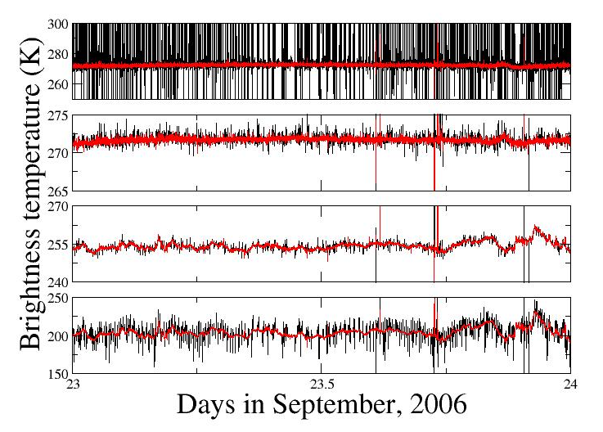
Figure 1. Examples of GVR Unfiltered (black line) and Filtered (red line) Brightness Temperatures

User Notes and Known Problems

Between 4/12/2004 and 9/1/2006 the instrument was working as a prototype. Data collected during this time have segments of elevated noise due to a slowly varying reduction of receiver sensitivity. This effect was dependent on the system temperature and it is noticeable during warmer days (surface temperatures >~ 255 K).

Frequently Asked Questions

This section is not yet available.

Data Quality

Data Quality Health and Status

Daily quality check on this data stream can be found at the DQHands page: http://dq.arm.gov/. Click on “QC Metrics and Plots” and select the desired site and data stream. The GVR is located at the site “NSA,” the data stream is “nsagvrC1.b1” or “nsagvrC1.a0” and the facility is “C1.”

Data Reviews by Instrument Mentor

The instrument mentor submits a monthly summary report IMMS accessible from the instrument web page. Some of the general checks performed by the instrument mentor are shown below.

1. In general the filtered brightness temperature time series should be smooth and with low noise levels.

2. Brightness temperatures should be greater than 2.75 K and less than approximately 310 K (We do not expect the ambient temperature in Barrow to be significantly higher than 30 C).

3. External temperature readings (ext_temp) can be compared to tower measurements. The agreement should be +/- 2 K.

4. The difference between the tip and the center of the hot absorbet (t_hot1-t_hot2) should be less than 2 C.

5. The temperature of the hot target (temp_hot1 and T_hot2) should be greater than 45 C and less than 75 C.

6. The temperature of the warm target should be greater than 10 C and less than 20 C.

7. Measured brightness temperatures are also compared with model computations as a general quality check.

Data Assessments by Site Scientist/Data Quality Office

The Data Quality office daily data assessment can be view at the DQHands web page.

Value-Added Procedures and Quality Measurement Experiments

No Value-Added Procedures are available at this stage.

Instrument Details

Detailed Description

List of Components

- RF section: white plastic box with rectangular Mylar window on top.

- Desktop PC host computer with monitor, keybord and mouse, and National Instrument break-out box mounted on top pf PC enclosure.

- Temperature control box.

- Radiometer cart with industrial blower on bottom shelf.

- Cables.

System Configuration and Measurement Methods

In this section we give a brief description of the GVR hardware configuration. The material in this section can be found in [1]. Refer to the same reference for further details on this instrument. A simplified block diagram of the GVR receiver is shown in Figure 2. The down-welling atmospheric radiation is captured by a 10 cm diameter, 1.7° beam-width, 90-degree parabolic metal mirror and focused to a corrugated feed horn. A sub-harmonically pumped mixer, using a 91.655 GHz LO signal, down-converts the upper and lower sidebands to base-band, where a broad-band low-noise amplifier increases the noise signal power and sets the receiver noise temperature. A broadband power splitter divides the amplified signal between four channels before filtering. The center frequency and bandwidth of the filters are 1/0.5, 3/1, 7/1.4 and 14/2 GHz respectively. The band-limited noise signals are square-law detected, converted to a TTL pulse-train using highly linear Analog Devices AD650 voltage-to-frequency converters (20 ppm nonlinearity and less than 0.3 ms response time to a step input as configured), and frequency-counted using an FPGA processor. This frequency counting effectively integrates and measures the square-law detector voltage, or equivalently the noise power. The measured noise power from the four channels together with the instrument temperature readings are time stamped and transmitted to a data logger PC via an RS232 (or optional RS422) bus.
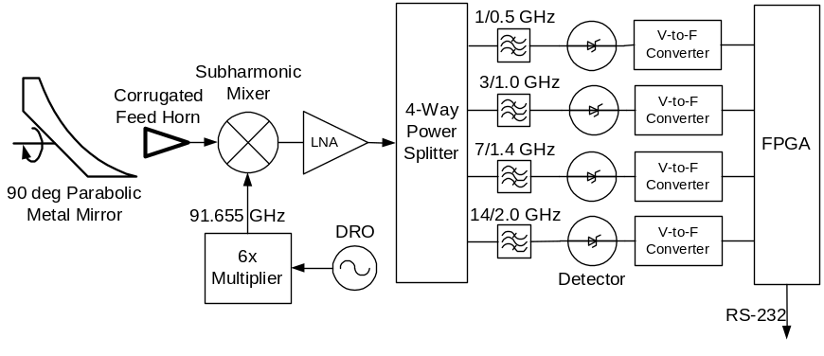

Figure 2. GVR Simplified Component Level Block Diagram

To stabilize the temperature of the receiver components, a packaging technique described in was employed, consisting of an insulated cold-plate in a box, in a temperature controlled enclosure. The resulting component plate temperature stability limited the effect of receiver-gain rate-of-change to below 100 K/Hr, requiring system gain and offset calibrations only a few times a minute to achieve a sub-K measurement precision.

Since neither noise sources nor low-loss fast switches are readily available at G-band, external (to the antenna horn) hot and warm calibration absorbers are required to track the receiver gain and offset. The metal mirror of the GVR is rotated with a stepper motor to point the radiometer antenna beam to the calibration loads. The hot and warm calibration absorbers are constructed using the Firam-160 absorber, with the hot load packed in an insulated box covered with a 1 mil Mylar window (~0.03 dB loss factor) tilted by 4°. The Mylar window is tilted by about twice the antenna beam-width to minimize the reflection of the receiver emitted radiation back to the receiver. The hot load is convection heated to a uniform temperature of 343 +/– 0.5 K, while the warm load is left to soak to the temperature of the outer enclosure, which is heated with a PID controller to 293 K. The temperature of the absorbers is monitored with Resistance Temperature Detectors (RTD) temperature sensors and the readings are recorded along with the receiver noise power data.

Specifications

Table 7. Instrument Specifications

Parameter | Value
Receiver noise temperature 1 GHz | 1750 K
Receiver noise temperature 3 GHz | 1610 K
Receiver noise temperature 7 GHz | 1600 K
Receiver noise temperature 14 GHz | 2170 K
Measurement precision, NEDT (Noise Equivalent Delta-T) | 0.2 K (200 ms averaging time)
Measurement Stability (Allan STD) | < 0.05 K over 1000 s
Measurement rate | 10/min with continuous calibration
Antenna aperture | 4”
Antenna beamwidth | 1.5°
Temperature range | -40 to 10 C (Environmental Chamber tested)
Output | ASCII data files

Theory of Operation

The GVR measures brightness temperatures from four double sideband channels centered at ± 1, ± 3, ± 7, and ± 14 GHz around the 183.31-GHz water-vapor line. Atmospheric emission in this spectral region is primarily due to water vapor, with some influence from liquid water. The 183.31 ± 3 and 183.31 ± 14-GHz channels are particularly sensitive to the presence of liquid water.

The sensitivity of the GVR channels to the presence of water vapor is much stronger than that of the 22-GHz water vapor line. In Figure 3 the dependence of GVR-measured clear-sky brightness temperatures on PWV is shown [2]. The PWV is retrieved from the MWR measurements. The circles, diamonds, triangles, and squares are model computations from one year of radiosonde data. Figure 3 shows the nonlinear response of the GVR to water vapor as well as the saturation of the channels close to the line center. These results are consistent with those of [3] who estimated the sensitivity to PWV at these frequencies to be approximately 30 times higher than at the frequencies of the MWR for PWV less than 2.5 mm. The 183.31 ± 14 GHz channel sensitivity to liquid water path is about 3.5 times greater than the sensitivity of the 31.4-GHz channel of the MWR [2].

The sensitivity of this channel to ice scattering was estimated by [4] and found to be negligible (< 0.6 K) at the GVR frequencies for typical winter ice clouds. Since the presence of Ice Water Path will increase the brightness temperature observed by the 183.3 ± 14 GHz channel, the presence of Ice Water Path would be interpreted as a contribution from liquid clouds.

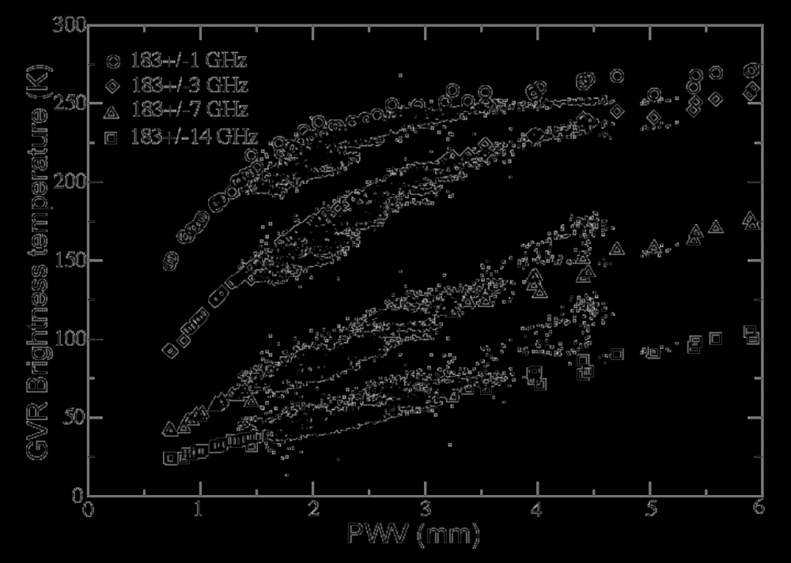
Figure 3. GVR-measured brightness temperatures as a function of PWV retrieved from the co-located MWR. Data are for non-cloudy conditions only. The circles, diamonds, triangles, and squares are model computations from one year of radiosonde data. The nonlinear response to PWV is evident in the ± 1 and ± 3 channels [2].

Calibration

Theory

The GVR is calibrated using a warm (~293 K) and a hot (~333 K) FIRAM-160 absorber. The absorbers are tilted by about 10 deg to ensure better than -60 dB reflectivity or 0.999999 emissivity. The resulting absorber brightness temperatures are taken to be equal to their physical temperature. The warm load “floats” at the internal temperature of the GVR enclosure. The hot load, packaged in an insulated box with a Mylar window, is convection heated: behind the absorber (opposite of the Mylar window) is a heated metal plate and a row of fans. The fans circulate the air around the load indirectly heating it. RTD placed at several locations in and around the hot load indicate that the maximum temperature differences are less than 0.5 K. The average temperature reported by sensors is used as the hot load equivalent brightness temperature. The accuracy of the temperature sensors is approximately 0.2 K, making them the most significant source of calibration error. This is because a + 0.2 K error at the 333 K hot load temperature and a – 0.2 K error at the 293 K warm load temperature will amplify to a – 2.8 K error at a 33 K sky brightness temperature. The metal mirror of the radiometer continuously cycles between the warm load, hot load and the sky, calibrating the instrument once every 10 seconds. This calibration is sufficiently frequent as the Allan Deviation stability of the GVR receiver was measured to be less than 0.05 K at a ΔT of 1000 sec. The operational calibration of the GVR was independently verified in the spring of 2006 with an external calibration load. A larger insulated hot load convection chamber was constructed with a higher precision temperature meter and sensors, calibrated with a NIST-traceable voltmeter and temperature probe with a 0.05 K absolute accuracy. The measured absolute error was less than 2 K in the four receiver channels over the brightness temperature measurement range. The brightness temperatures used in this paper are the ones originally obtained from the instrument. The revised calibration produced a slight (~ 1 K) increase in the brightness temperatures of the ±1 and ±3-GHz channel slightly improving the agreement with the model. In the next section we will apply the calibration correction to a few cases to determine the possible contribution of calibration uncertainties to the measurement.

Procedures

Brightness temperatures 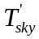 are produced for each channel according to:

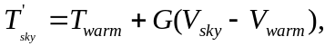 (1)

where V_{sky} is the signal recorded when the reflector is oriented towards the sky and V_{warm} is the signal recorded from the warm target at temperature T_{warm}. G is the gain computed as:

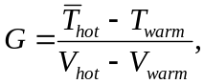 (2)

where V_{hot} is the signal recorded from the hot target and 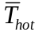 is computed by averaging the temperature of the hot target at the tip (T_{hot1}) and at the center (T_{hot2}).

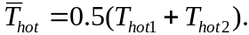 (3)

Keeping into account the Mylar loss factor L = 1.0116, the final brightness temperature is computed as:

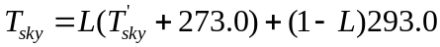. (4)

A filter is applied to the raw data (counts) as well as to the final brightness temperatures to produce the final brightness temperatures. The filter acts to ensure that each data point is bounded within the range of intensities defined by its neighbors. For each data point, the maximum and minimum values of the first four neighbors are determined. If the difference between the point and the maximum (or the minimum) is greater than a fixed threshold (in this case set to 3 K) the point is replaced with the average of the four neighbors. This filter is less smoothing than a traditional median filter as it trades noise suppression for temporal resolution.

History

- Deployed as SBIR prototype in Barrow, Alaska on April 14, 2005
- Calibration verified with external calibration box on April 19, 2006
- Factory hardware upgrades on May–August 2006
- Reinstallation in Barrow on September 1, 2006

Operation and Maintenance

User Manual

Not available.

Routine and Corrective Maintenance Documentation

Not available.

Software Documentation

Not available.

Additional Documentation

Not available.

Glossary

Uncertainty: We define uncertainty as the range of probable maximum deviation of a measured value from the true value within a 95% confidence interval. Given a bias (mean) error B and uncorrelated random errors characterized by a variance σ², the root-mean-square error (RMSE) is defined as the vector sum of these,

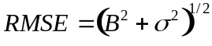.

(B may be generalized to be the sum of the various contributors to the bias and σ² the sum of the variances of the contributors to the random errors). To determine the 95% confidence interval we use the Student’s t distribution: t_{n;0.025} ≈ 2, assuming the RMSE was computed for a reasonably large ensemble. Then the uncertainty is calculated as twice the RMSE.

See the ARM Glossary (http://www.arm.gov/about/glossary.stm)

Acronyms

See the ARM Acronyms and Abbreviations. (http://www.arm.gov/about/aconyms.stm)

Citable References

[1] AL Pazmany. 2006. “Compact 183- GHz radiometer for water vapor and liquid water sensing.” Submitted to IEEE Transactions of the Geosciences Remote Sensing, June.

[2] MP Cadeddu, JC Liljegren, and A Pazmany. 2006. “Measurements and retrievals from a new183-GHz water-vapor radiometer in the Arctic.” accepted by IEEE Transactions of the Geosciences Remote Sensing, September.

[3] PE Racette, ER Westwater, Y Han, AJ Gasiewski, M Klein, D Cimini, DC Jones, W Manning, EJ Kim, JR Wang, V Leuski, and P Kiedron. 2005. “Measurements of low amounts of precipitable water vapor using ground-based millimeterwave radiometry.” Journal of Atmospheric and Oceanic Technology, Vol. 22, no. 4, pp. 317-333, April.

[4] D Cimini, ER Westwater, AJ Gasiewski, M Klein, V Leuski, and J Liljegren. 2006. “Ground-based millimeter- and submillimeter-wave observations of low vapor and liquid water contents.” Submitted to IEEE Transactions of the Geosciences Remote Sensing, June.

See section (6.5) for a definition of uncertainty.

