4.4 DECAY REGION AND HADRON ABSORBER (WBS 1.1.4)

Introduction

The neutrino beam requires a region where secondary particles (produced by the interaction of the incoming protons on the production target) can decay to produce neutrinos. This region is usually under vacuum (see section 4.7) to avoid particle loss through interaction with air molecules. In addition, the beam needs a hadron absorber at the end of the decay volume. At this absorber, non-interacting primary protons and remaining secondary hadrons interact and deposit their energy in the form of heat. The particles that are not stopped by the absorber consist mainly of muons, neutrinos and a small fraction of neutrons.

System Description: Decay Region

The parameters of the decay region are summarized in Table 4.4–1.

length | thickness
(meters) | (inches)
50 | 72
150 | 84
350 | 66
125 | 56

Decay Pipe Shielding Concrete
Specification from Mars runs

diameter | 1.98 | meters
length | 677.1 | meters
minimum wall thickness | 0.375 | inch
vacuum | <1 | torr

Table 4.4–1 Decay Region General Specifications

A significant element of this region is the decay pipe, under vacuum as described in section 4.7, which will be made up of steel pipe sections of inner radius 39 in and with wall thickness 3/8 in. Pipe sections will be fabricated in 40-ft lengths; each will have five stiffener-rings 3/8” thick, 5” in the radial dimension. Special end sections will be shorter in length; these will have two stiffener rings and one thrust ring. The upstream and downstream end caps (or windows) of the decay pipe are quite different from each other; the characteristics of each are summarized in Table 4.4–2. Note that neither of the End Caps is designed to be removable.

 | Upstream End Cap | Downstream End Cap
Nominal Window Thickness at r=0” | 0.062” | .25”
Nominal Window Thickness at r=38” | 0.375” | .25”
Material at r=0” | Aluminum | Carbon steel
Material at r=38” | Carbon steel | Carbon steel

Table 4.4-2: Properties of Decay Pipe End Caps
To reduce the number of particles interacting in the upstream window (thereby increasing the flux of neutrinos) the thickness has been minimized in the central region. This serves to minimize the effects of both absorption and multiple scattering. A sketch of the upstream window is shown in Figure 4.4-1a. Figure 4.4-1b is taken from an assembly drawing for the upstream window.

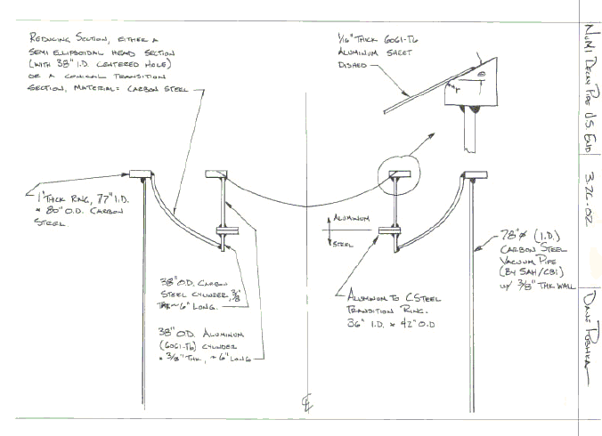
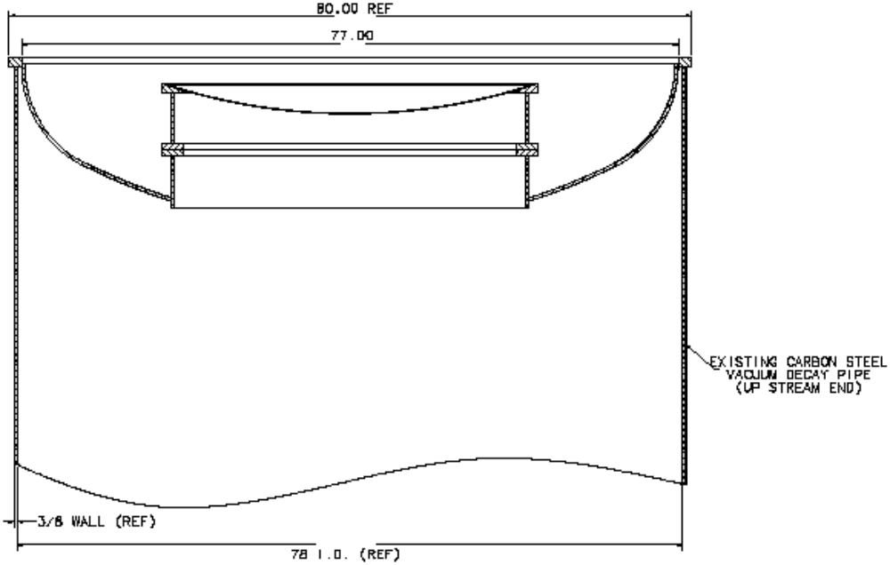
Figure 4.4-1a: Sketch of Upstream Window – Inner Window is 1/16” aluminum, Outer Window is carbon steel, Transition Piece employs an Explosion bonded pair of rings. Transition piece lengths are not to scale.

Figure 4.4-1b: Drawing of Upstream Window – To Scale, Shown Mounted

The inner portion of the window is aluminum 1/16” in thickness. It is joined to a steel outer portion by a transition section utilizing an explosion bonded bi-metal pair of rings. An ANSYS analysis of dynamic thermal stress due to an accident condition with full intensity beam missing the target and impinging on the window with a small size (resulting from missing the target) indicated that aluminum 6061-T6 was an acceptable material for the inner region; this was not the case for stainless steel. The diameter of the aluminum inner portion is determined by the largest diameter commercially available for the explosion bonded bi-metal rings. Shown in Figure 4.4-1a & b are bi-metal rings that have an outside diameter of 42” and an inside diameter of 36”. The radius of 18” where there is only 1/16” of aluminum in the path of the particles exiting horn #2 compares favorably with the distance of 14” from the beam centerline to the steel forming the top edge of the target chase.

The design of the downstream decay pipe window has a full-diameter semi-ellipsoidal window made of carbon steel 1/4 inches thick. A layout drawing is shown in Figure 4.4-1c.

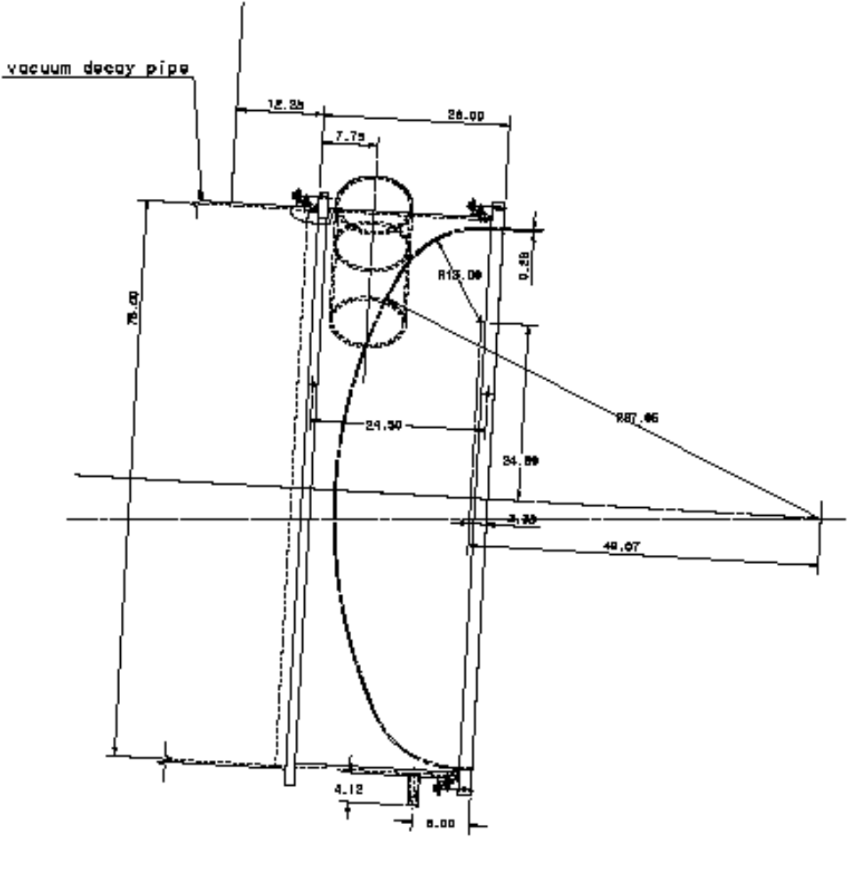
Figure 4.4-1c: Layout Drawing for downstream window. The diameter is 78”, length is 26”

The downstream End Cap is where the pump-out port is located. Also shown in Figure 4.4-1c is a drain stub—which would serve to allow drainage of water or oil that manages to collect at the downstream end of the decay pipe.

The decay pipe is surrounded in radius by ~5 feet of concrete (see Table 4.4-1). This concrete absorbs radiation escaping the decay pipe and constitutes the groundwater shield. The concrete shielding surrounding the pipe is poured in place. The energy deposited in the steel walls of the decay pipe and in the surrounding concrete is summarized in Table 4.4–3 (values from table 3, NuMI-B-610). and shown in Figure 4.4-2 (adapted from Figures 15 and 17 of NuMI-B-610)

 | Steel |  | Concrete
 |  |  | (0-30 cm) |  | (30-60 cm) |  | (>60 cm)
 | value | error | value | error | value | error | value | error
PH2L | 62.7 | 0.5 | 42.9 | 0.2 | 6.14 | 0.01 | 2.89 | 0
PH2M | 65.3 | 0.5 | 46.2 | 0.3 | 6.99 | 0.01 | 3.26 | 0

Table 4.4-3 Total energy deposition in kW in the decay pipe steel and the concrete surrounding the decay pipe. Results are shown for simulations of: (1) the baseline low energy beam (PH2L), (2) baseline medium-energy beam (PH2M),

.

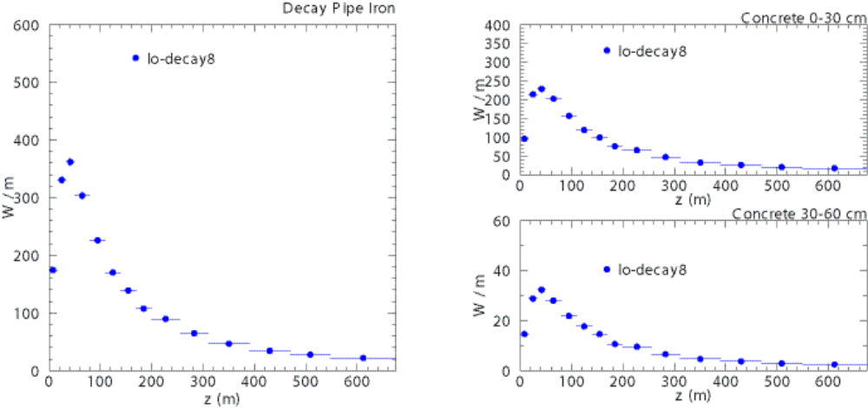

Fig. 4.4-2a: Energy deposition distribution for low-energy configuration of target and horns
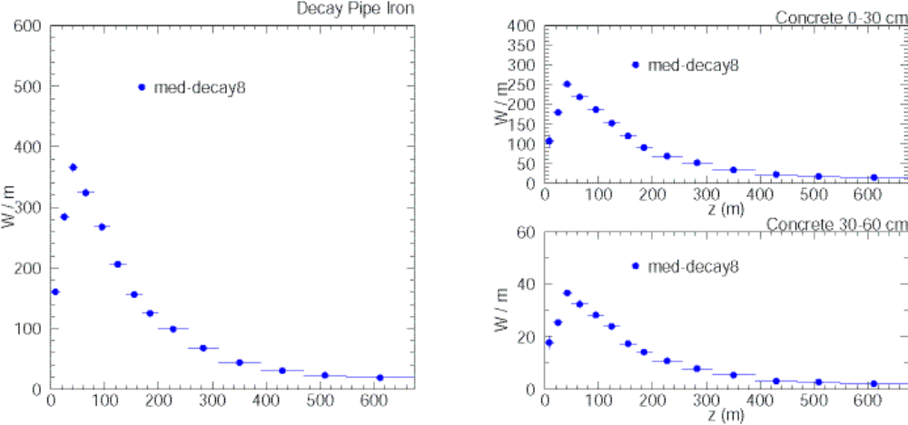
Fig. 4.4-2b: Energy deposition distribution for medium-energy configuration of target and horns

Twelve cooling pipes are placed at 30° intervals of azimuth around the decay pipe--in order to remove the heat generated in that region. The effectiveness of the concrete shielding in protecting the groundwater is discussed in Chapter 5. At its downstream end the decay pipe will be followed by instrumentation (Downstream Hadron Monitors – see section 4.5) whose primary purpose is to measure the proton beam position during low intensity commissioning and later special runs, with the target removed from the beam’s path. Following this instrumentation will be the Hadron absorber.

4.4.3 System Description: Hadron Absorber

As mentioned, the function of the hadron absorber is to absorb the energy of all remaining hadrons in the beam at the end of the decay pipe. The absorber design has a water-cooled core surrounded on five sides by steel shielding. On the beam east side, and at the downstream end, there is an additional layer of shielding concrete, three feet in thickness. The specifications of the steel in the hadron absorber are summarized in Table 4.4–5.

Position | # steel blocks | steel dimensions
 | 52" x 52" x 26" | W x H x L (inches)
bottom center | 16 | 52 by (4 x 26+ 2) by 4 x 52
bottom BE | 16 | 52 by (2 x 26 + 9.125 + 2 x 26) by 4 x 52
bottom BW inner | 16 | 52 by (2 x 26 + 9.125 + 2 x 26) by 4 x 52
bottom BW outer | 12 | 26 by (52 + 9.125 + 2 x 52) x 4 x 52
BE side | 8 | 52 by 2 x 26 by 4 x 52
BW side | 8 | 52 by 2 x 26 by 4 x 52
top | 24 | 3 x 52 by (1 + 2 x 26) by 4 x 52
total | 100

Table 4.4-5 Location and Size of Steel shielding in absorber

The entire absorber resides in the absorber cavern as shown in Figure 4.4-4.

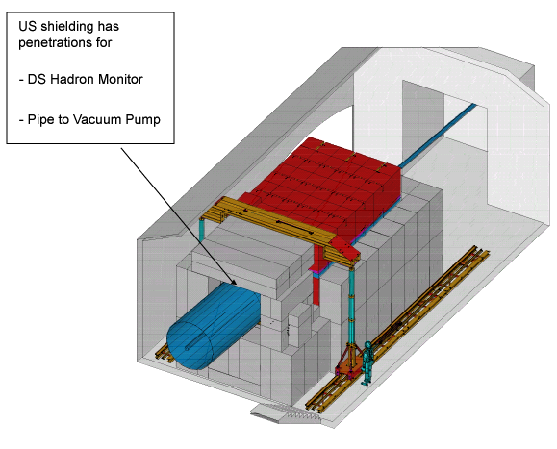

Fig. 4.4-4: absorber in cavern (some elements are outdated)
Another view, showing partial assembly, is given in Figure 4.4-5.
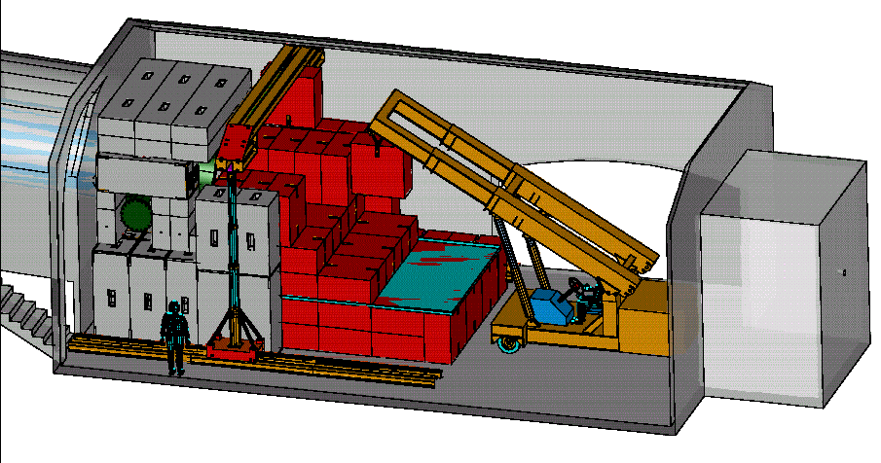
Fig. 4.4-5: View of absorber in cavern (several items shown are out of date)

Based on the expected beam energy deposition shown in Table 4.4–6, a water-cooled Al core has been designed as shown in Figure 4.4-6.

Total energy in the beam | 121.2 kJ
Energy of primary protons | 99.7 kJ
Energy of secondaries: pi; p | 16.1 kJ
n; e; gamma | 5.4 kJ
Average beam power | 64 kW

Table 4.4-6a Beam parameters in front of the absorber for the ME beam in normal operation mode (from Table 2.1 of NuMI-B-652).

Part of the absorber | 0<Z <2.4 m | 2.4 < Z <3.7 m
Core and subsequent steel | 41.0 (Al) | 5.7 (Fe)
Surrounding steel shielding | 10.2 | 0.14

Table 4.4-6b The average power (kW) deposited in the absorber for the ME beam. The total deposited power is equal to 57 kW. (from Table 2.2 of NuMI-B-652)

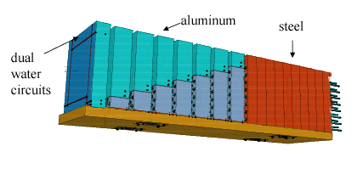

Fig. 4.4-6: Absorber Core arrangement (some items shown are outdated)

The design incorporates a Radioactive Water (RAW) system for cooling the core of the absorber that is described in section 4.7. The current design has a core with transverse dimensions 51” x 51”, with eight water-cooled aluminum modules each 12” thick, followed by 10 layers of CCS steel each 9.1 inches thick. Each aluminum module has two water circuits.

Table 4.4–7 shows peak temperatures in different locations in the absorber (taken from NuMI-B-652).

Location | reference temperature (°C) | temperature (°C) | reference
Al module #3 | 37 | 60 | RAW water
Al module #4 | 37 | 60 | RAW water
US face of steel | 20 | 85 | ambient
US steel in core | 20 | 270 | ambient

Table 4.4-7 Peak Temperatures in absorber (normal operation)

Figure 4.4-7 shows the temperature rise in module #4 if 4x10¹³ protons / 1.9 sec miss the target and reach the absorber with cooling water flowing. This is taken from a study by Bob Wands. The first part of the curve is less sensitive to the assumptions made about the rate of cooling water flow & is therefore more reliable.

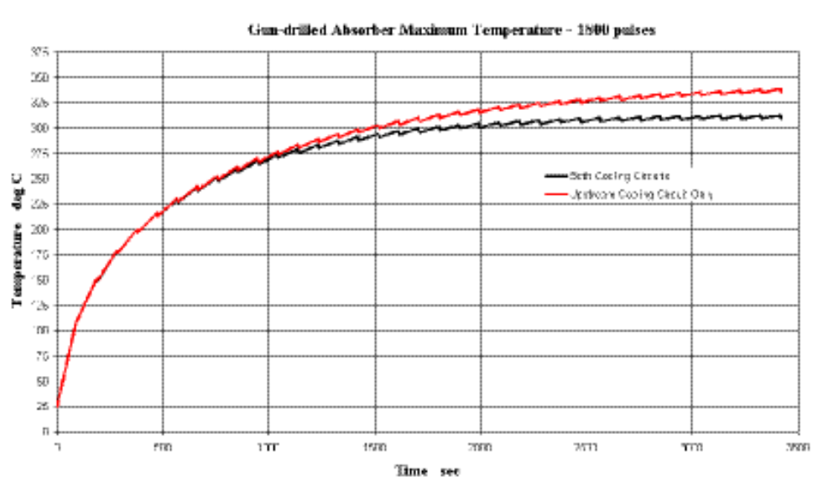
Fig. 4.4-7: Temperature Rise in Aluminum Module #3 or 4 versus time, beam missing target

In the unlikely event of a water leak in one of the two circuits in a module, that particular circuit could be shut off since the remaining circuit would provide sufficient cooling. Even in the more unlikely case of a failure also in the second circuit of a module, there is sufficient heat transfer to the two adjacent, water-cooled modules such that the temperature in the aluminum module with no water-cooling will not become high enough for structural damage. This is shown in Figure 4.4-8. Since modules #3 and #4 both receive 8 KW of power from energy deposition during normal operation, this figure indicates that the temperature would rise to 450 °F if there were no water flow in that one module.

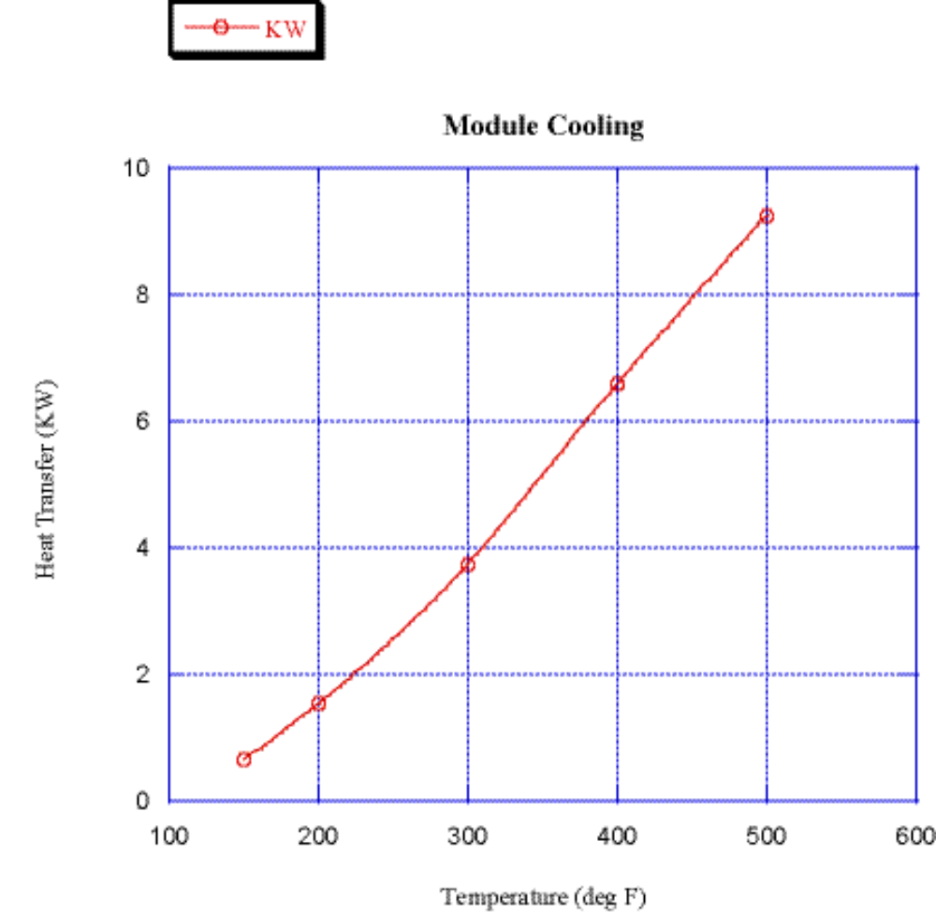

Fig. 4.4-8: Module cooling by convection to adjacent modules (no water flow)

The temperature of the core will be monitored by strategically mounted thermocouples. The full design of the thermocouple system has not started.

