4.4 DECAY TUNNEL AND HADRON ABSORBER (WBS 1.1.4)
4.4.1 Introduction
Producing a neutrino beam requires a region where the secondary beam pions, produced by primary beam protons hitting the target in the Target Hall, can decay to muons and neutrinos. After some distance, when a sufficient quantity of the pions have decayed, the pions need to be stopped so they do not contaminate the neutrino beam. So any general neutrino beam design needs a decay region followed by a beam absorber.
In the NuMI facility, the Target Hall is followed by the 675m long Decay Tunnel which holds this decay region. The Decay Tunnel holds the Decay Pipe which the particle beam passes through. To avoid a reduction of pions due to interactions in air, the Decay Pipe is a vacuum vessel. The Decay Pipe begins at the downstream end of the Target Hall, runs the entire length of the Decay Tunnel, and terminates in the Absorber Enclosure.

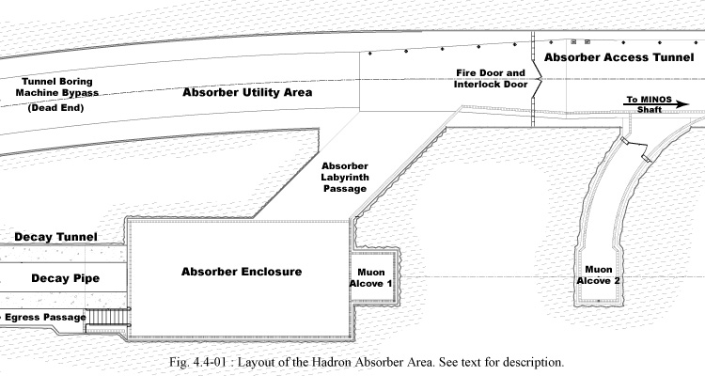
The Absorber Enclosure holds the Hadron Absorber, a beam dump made from a pile of aluminum, steel and concrete. All particles remaining in the beam at the downstream end of the Decay Pipe pass into the Absorber: primary protons which did not interact in the target, secondary pions which have not yet decayed, other secondary hadrons, and the muons and neutrinos which result from pion decay. All the protons, pions and other hadrons interact in the material of the Absorber and their energy is deposited there as heat. The muons and neutrinos pass through the Absorber and continue on into rock. The muons range out in the rock and stop. To measure the decreasing numbers of muons, detectors are placed in muon alcoves – passages cut into the rock along the beamline. After some distance of rock, only the neutrinos remain, and these pass into the MINOS Hall at the very end of the tunnel excavation.
Figure 4.4-01 shows a layout of the Absorber area. The Absorber Enclosure a ~20-ft wide ~50-ft long ~40-ft high room; it is accessed from the MINOS Shaft elevator via the Absorber Access Tunnel. The tunneling machine which dug the Decay Tunnel was turned off the beam centerline upstream of the Absorber Enclosure, so as to allow the beam to pass through rock downstream of the Absorber Enclosure. This bypass tunnel was sealed with concrete when the Decay Tunnel shielding was poured, and is now a dead-end. The floor space in the bypass is used as utility area for the Decay and Absorber water pump and vacuum systems. A Labyrinth Passage connects the Access Tunnel to the Absorber Enclosure. The Labyrinth Passage is named for the concrete blocks placed there, which shield the Access Tunnel from slow neutrons which are emitted from the Absorber as a result of the beam deposited in it. A Controlled Access Interlock door is located at the fire door in the Absorber Access Tunnel, just downstream of the Absorber Enclosure.
4.4.2 System Description: Decay Tunnel and Decay Pipe
The decay tunnel is an approximately 22ft diameter excavation created by the tunnel-boring machine during the facility construction. The only beamline component within the tunnel is the Decay Pipe, a vacuum region where the produced pions decay to muons and neutrinos. The Decay Pipe is a 6-ft diameter steel pipe which runs the entire length of the tunnel, centered on the neutrino beam centerline; its basic parameters are given in Table 4.4-01. The pipe was made from sections 40-ft long, each with five stiffener-rings 3/8” wide and 5” tall in the radial dimension. Each pipe section was surveyed into place, held up by a supporting structure since it was positioned above the tunnel floor, and welded to its neighbors.

Inner Diameter | Wall Thickness | Length | Vacuum
1.98 meters | 0.375 inch | 677.1 meters | <1 torr
Table 4.4-01: Parameters describing the Decay Pipe

Once the pipe sections were in place, the Decay Tunnel was backfilled with concrete to shield groundwater from the particles which impact the walls of the pipe. Figure 4.4-02 shows a sample cross-section diagram of the Decay Tunnel. As shown, the tunnel was excavated and the concrete was formed so that a ~50-in wide egress passage remained along the east side of the original excavation; this passage provides emergency access between the upstream Target Hall areas and the downstream MINOS areas.
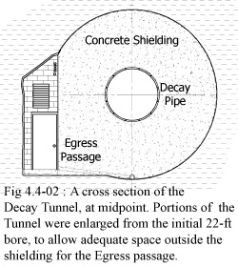
The concrete shielding is not of a uniform radial thickness; it is thicker at the upstream end than at the downstream end, because more particles impact the sides of the Decay Pipe along the upstream end and more shielding was required there. See Table 4.4-02 for the shield thickness versus length down the tunnel. The effectiveness of the concrete shielding in protecting the groundwater is discussed in Chapter 5.
The particles which impact the sides of the pipe interact and create particle showers in the steel and the surrounding concrete. Heat is deposited as those particles are absorbed by these materials. An excessive amount of heat in the steel pipe might cause it to expand enough to crack the concrete shielding, and so copper cooling lines were installed along the length of the Decay Pipe, before the concrete was poured. Twelve lines were placed at 30° intervals of azimuth around the decay pipe. To prevent any chemistry between the steel pipe and copper lines, a thin insulator was placed between them. The cooling lines exit at each end of the Decay Pipe and are connected to a RAW circulating and heat exchanger system.

Length in meters along the Decay Pipe | 50 | 150 | 350 | 425
Thickness of Shielding in inches | 72 | 84 | 66 | 55
Table 4.4-02: Thickness of Decay Region Shielding versus location along the tunnel

The total energy deposited in the steel walls of the decay pipe and in the surrounding concrete was modeled using the MARS program, which simulates particle interactions in matter and is used to evaluate shielding designs. The MARS results are summarized in Table 4.4-03. Figure 4.4-03 shows the distribution of the energy deposition along the length of the decay pipe.

 | Steel Decay Pipe | Concrete shielding
 |  | 0-30 cm radius | 30-60 cm radius | >60 cm radius
Low Energy Beam Configuration | kW | kW | kW | kW
Low Energy Beam Configuration | 62.7 | 42.9 | 6.14 | 2.89
Table 4.4-03 Total energy deposition in kW in the decay pipe steel and the concrete surrounding the decay pipe, from MARS simulations of the NuMI beamline in low energy neutrino beam configuration.

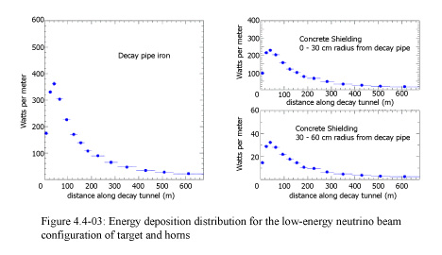
All of the decay pipe installation described above was part of the underground construction, and additional details may be found in the NuMI Facility TDR. Figure 4.4-04 shows photos of the decay pipe installation in progress. The only items remaining after the construction period were to attach end caps onto the Decay Pipe and then install the water and vacuum utilities; these tasks were performed as part of the NuMI Technical Components installation.
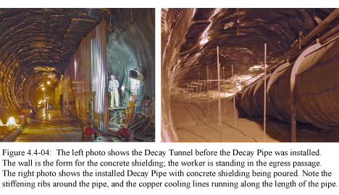
The decay pipe ends were sealed by end caps, concave in shape to minimize stress due to the vacuum inside the decay pipe. At the upstream end, one wishes to preserve as many of the secondary pions as possible in order to maximize the final flux of neutrinos. In general this means making a thin vacuum window, although in this case thin was a relative term. At the downstream end all pions of interest have decayed and there are no concerns about preserving particle flux; the Downstream End Cap can be made as thick as necessary to achieve straight-forward structural integrity.
Vacuum windows tens of mils in thickness and 6-ft diameter have been engineered and used. However, due to damage caused by a large particle flux, any such window will have a limited lifetime. This might not be an issue in some applications, but in the NuMI beamline, the Upstream End Cap is located at the downstream end of the Target Hall, under many feet of shielding blocks, and is quite inaccessible for repair or replacement. So the window thickness had to be sufficient to withstand the normal beam flux indefinitely and any possible accident conditions, yet be as thin as possible so as to minimize the window’s effect on that same beam flux. These criteria were tempered by the fact that the window did not have to be the full 6-ft diameter. The particles exiting the Target Hall do not extend out to a 6-ft radius, but instead fill the space defined by the Target Hall cave, which is approximately 3-ft diameter. The resulting design is a thinner window embedded within a thicker end cap. Figure 4.4-05 shows the Upstream End Cap. The inner window material is specifically aluminum 6061-T6, selected as having the best performance among various types of aluminum or steel. The worst condition the material must withstand is the dynamic thermal stress due to an accident condition where the full intensity primary proton beam misses the target and impacts the window with a small spot size. An ANSYS analysis of the Upstream End Cap under these conditions is reported in MSG-EAR-02317, Thermal and Stress Analysis of Numi Decay Pipe Thin Head, by Bob Wands, July 16, 2002.
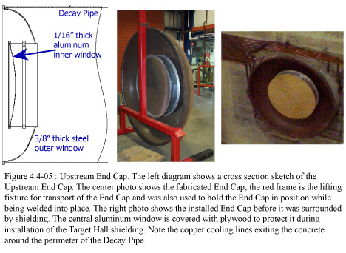
The Downstream End Cap is a full 6-ft diameter semi-ellipsoidal concave sheet made of carbon steel 1/4-in thick attached to a short section of pipe, and is shown in Figure 4.4-06. The vacuum pump-out port is located on the upper part of the End Cap pipe, and at the base is a line to allow for drainage of water that may collect in the Decay Pipe before the End Caps were installed.
Both End Caps were constructed with an integrated carbon steel rim the same diameter as the Decay Pipe, which allowed them to be welded directly to the Pipe. The root weld is GTAW (a.k.a. TIG), the remaining passes are SMAW (a.k.a stick) using 7018 filler metal. The final fillet weld is 5/16” wide.
The Decay Pipe and End Caps have been designed to withstand the pressures of normal operation in the NuMI beam environment, indefinitely. The design meets the ASME pressure vessel code for allowable stress (both primary and secondary), and the details are described in the Decay Pipe Engineering Notes. End Cap failure, while remote, is a hazard which must be examined, and a hazard analysis can be found in NuMI Note 0977.
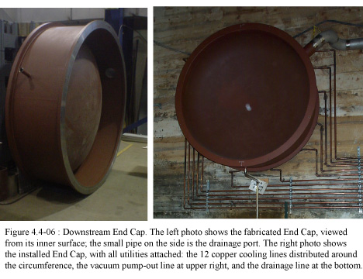
4.4.3 System Description: Hadron Absorber
The function of the Hadron Absorber is to stop most beam particles which remain at the end of the Decay Pipe and absorb their energy. The vast majority of these particles are hadrons, protons, pions and kaons, and essentially all of them are stopped by the Absorber. A relatively low rate of thermal neutrons are emitted from the Absorber as a by-product of the stopped hadrons. The muons in the beam are ranged out in rock downstream of the Absorber Enclosure. The neutrinos of course pass through all of this material and are the resulting product of the NuMI beam.
The Absorber must be able to easily handle the energy deposited by the beam, under all expected operating conditions and under all accident conditions which have any reasonable probability of occurring. The basic design of any such beam dump is a central core of metal surrounded by additional steel shielding and by an outer layer of concrete. The metal serves to both create and contain the particle showers. The outer steel and concrete layers provide additional containment; the concrete also acts to absorb thermal neutrons, those with energies of 847 keV and below, as these are not stopped by iron.
4.4.3.1 Absorber Core
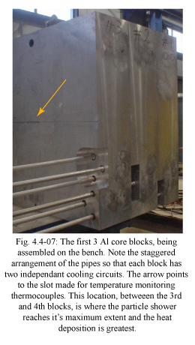
The detailed design for the Absorber core depends upon the size, energy and intensity of the entering hadron beam. A simulation of the NuMI beam impacting on a beam dump was used to define the basic design parameters of the Hadron Absorber; this work is reported in NuMI-B-652, Advanced Conceptual Design of the NuMI Hadron Beam Absorber Core, by A. Abramov, et. al. In summary, the Absorber consists of a core made from both aluminum and steel, surrounded by steel shielding blocks and an outer layer of concrete shielding blocks. The core is 51-in square transverse to the beam; this dimension was determined both by the beam size and by the availability of specific steel blocks for the surrounding shielding – a core made of a size similar to these blocks resulted in an easily stacked pile of material. The aluminum portion of the core is 8-ft deep, longitudinal to the beam, followed by a ~7.5-ft steel portion of the core. The aluminum portion is actively cooled by a circulating water system, described in more detail in Chapter 4.7. The temperature of the metal is monitored using thermocouples. An analysis of the water-cooled aluminum blocks subjected to the expected beam energy deposition is summarized in MSG-EAR-01-289, Thermal Stress Analysis of Gun-drilled NuMI Absorber Core, by Bob Wands.
The core is built up from smaller sections. The aluminum core is made from 8 blocks each 51” x 51” x 12”. Round channels were drilled within each block so that each of the 8 blocks has two independent water cooling circuits. The entrances and exits to these channels are set in a vertically staggered pattern along the sides, so that the water supply lines to each block do not interfere with each other in the final assembly. For ease of installation, the aluminum blocks and their piping were assembled into two sections of 4 blocks each; this minimized the number of delivery trips of materials to the Absorber Enclosure, and minimized the amount of welding performed underground in the Enclosure, where working space was tight. Figure 4.4-07 shows the three upstream aluminum core blocks on the bench, being assembled into one of the sections. The pipes for each Al core block are routed through the core blocks from back to front; thus the number of pipes increases from upstream to downstream.
The steel part of the core is made from 10 blocks each 51” x 51” x 9.1”. The steel core blocks were likewise assembled on the bench into 4 sections, of 3, 3, 2 & 2 blocks. The cooling water pipes for the aluminum core blocks pass through the steel sections, and so the steel blocks are machined with holes for the pipes. During installation the pipes were carefully “threaded” through the steel core sections.
Each cooling pipe is a single continuous length through the core blocks, not from welded sections, so as to minimize the probability of leaks. Each pipe runs from where it is attached to its core block, through holes in the aluminum and steel core blocks downstream, ending several inches past the last steel core block which sits at the back face of the Absorber. At the rear of the Absorber, additional piping was installed to connect the core cooling pipes to a Radioactive Water (RAW) system. Each core block has two water circuits. The two circuits are each joined at two manifolds, so that the entire core can be cooled by one or both of these water circuits. The report MSG-EAR-01-289 calculates that one water circuit provides sufficient cooling. In the case of a water leak in one circuit in any given module, the entire circuit can be removed from the system, manually, at the manifold location outside of the Absorber. In the more unlikely case of a failure in the second circuit, then the piping to the particular leaking core block (on either circuit) can be physically disconnected from the manifolds, halting water flow in that particular block but no others; again, report MSG-EAR-01-289 shows there is sufficient heat transfer to the adjacent blocks under this condition that the temperature in the disconnected block would not become high enough for structural damage. The Absorber RAW system is described in more detail in Section 4.7.
4.4.3.2 Absorber Layout & Installation
The Hadron Absorber was constructed by a stacking of steel and concrete shielding blocks, and this Section describes the stacking in the order in which the parts were installed. Please refer to the diagrams in Figure 4.4-08 throughout the stacking description; a list at the end of this section gives the FNAL PPD Mechanical Dept. drawing numbers for the main parts and overall assembly. Also refer to the photos in Figures 4.4-09 through 4.4-17 for views of the Absorber
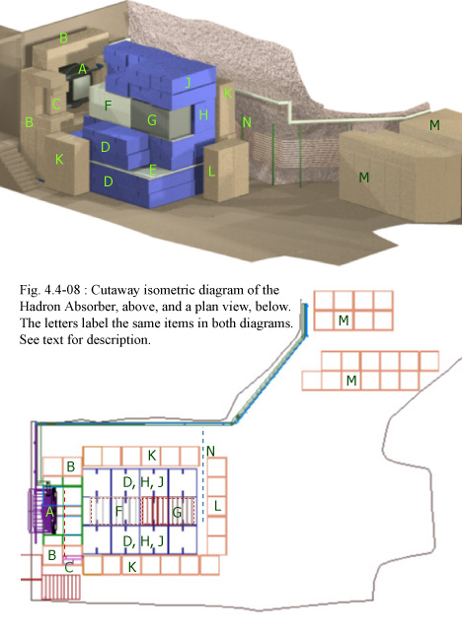
during installation. Installation started with stacked concrete shield blocks around the Decay Pipe and the Hadron Monitor. The
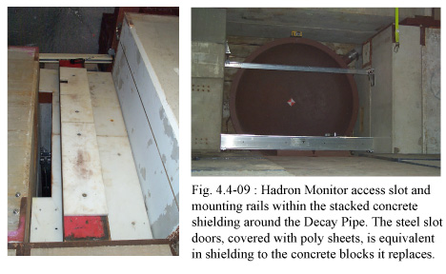
Monitor is located just a few inches downstream of the decay pipe Endcap, and both are labeled (A) in Figure 4.4-08. The concrete blocks, labeled (B) in Figure 4.4-08, can be considered an extension of the concrete shielding poured around the Pipe in the Decay Tunnel. The blocks sit flush against the base of the south wall of the Absorber enclosure, and extend 6-ft into the enclosure. The stacked blocks provide 3-ft of shielding around the top and sides of the decay pipe where the beam exits. The block base is built up about 7-ft high because of the elevation of the beam centerline and Decay Pipe in the Enclosure. On the upper east (beam-right) side, smaller blocks were stacked in a way to create an access slot, labeled (C) in the diagrams, for the installation of the Hadron Monitor. A sliding steel door covers the slot, and is shown in Figure 4.4-09. Also in that figure is a view of the Monitor support rails, showing it’s location in relation to the decay pipe and shielding. Figure 4.4-10 shows the completed Decay Pipe concrete block shielding, before any further Absorber installation occurred.
As mentioned, specific steel blocks were obtained for use as the main stacking element for the Absorber shielding; these steel blocks were 52" x 52" x 26", and are the blue items labeled (D),(H) and (J) in Figure 4.4-09. The Absorber base was stacked up in four layers of 12 steel blocks each, laid out 3 blocks wide transverse to the beam and 4 blocks deep longitudinal to the beam, labeled (D).
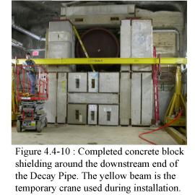
Between base layers 2 and 3 is a shallow steel pan which acts as a catch-basin for any cooling water leaking from the Absorber core, labeled (E). The pan drains to a tank, which has sufficient capacity for the entire volume of the Absorber primary RAW system. This tank can be seen at the back of the completed Absorber in Figure 4.4-16. Figure 4.4-11 shows two views of the base layers: the first two layers, and all four base layers. Each layer was shimmed to be level. Cracks between blocks were filled with grout. Note the edge of the water containment pan between layers 2 and 3. Note also that the middle row blocks in layers 3 and 4 sits lower than the outer rows. This is because the Absorber core carrier plate, a 1-in thick steel plate, sits on the middle row of blocks. The core carrier plate is machined level and provides a level base on which to set the core block sections. To compensate for the core carrier’s extra inch of elevation, 1-in thick steel plates lie on the steel containment pan beneath the outer rows of layer 3 blocks, raising them relative to the middle row. In the end, the Absorber base, with the core carrier plate, sits at a level elevation.Installation of the Absorber Core came next. The upstream face of the core is inset from the upstream faces of the blue steel shield blocks which surround it, by 12-in. Combined with space downstream of the Hadron Monitor and inside the concrete blocks, this makes for a volume of approximately 130-ft³ of air space which the beam travels through. Concerns about the release of excess activated air, discussed in Section 4.4.3.3, led to the filling of this volume by a box. The box is made from sheet aluminum, welded along all edges, and is filled with air at atmospheric pressure. The purpose of the box is simply to isolate the most intensely activated air within the box from any air in the nooks and crannies within the shield blocks which will eventually leak and mix with outside air. The box was set in position just before the first half-section of the aluminum core. Figure 4.4-12 shows the box, and then the first half-section of the core, with its long pipes supported behind it.
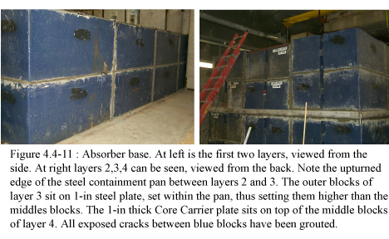
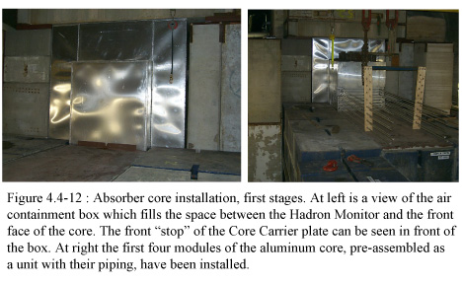
The second half-section of the aluminum core came next. The steel core sections were installed after the aluminum, and the steel sections were carefully threaded through the pipes from the aluminum core section. Figure 4.4-13 shows this installation process. A few inches of pipe extend beyond the last steel core block for attaching connections to the water system; this piping work was done later in the installation process after most of the heavy rigging was completed.
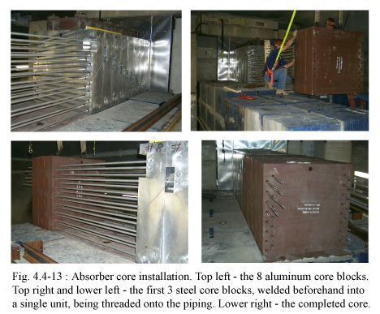
The side steel shield blocks were installed next, labeled (H) in the diagrams in Fig. 4.4-08. These are the same blocks as used for the base layers, but rotated so their 52-in length sits alongside the core. Two rows of steel blocks were placed on each side of the core. These blocks did not sit flush to the sides of the core but left an inch or so of space on each side. The side blocks were slightly higher than the core, so that when steel plates set on the side blocks bridged over the core about an inch of gap existed also above the core. These gaps were measured and steel plates fabricated to fill these small volumes, so as to exclude air which would otherwise add to the air activation issues. The readout cables for the core thermocouples were carefully run through the steel filler plates out to the rear of the core.
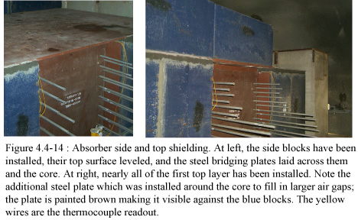
Steel bridge plates spanning the entire width of the Absorber steel shield blocks were laid on the side blocks so that no weight from the top layers of shielding rest upon the core. Two more layers of steel blocks, laid in the same way as the base layers, were set on the bridge plates, and are labeled (J) in the diagrams. At this time, the side concrete blocks, labeled (K) were set in place, one row down each side, 3-ft x 3-ft x 7-ft tall, stacked two blocks high. A small air gap exists between the side concrete blocks and the steel shield blocks. A similar wall of concrete blocks were set across the back of the Absorber steel pile, labeled (L) in the diagrams, but only the bottom level at this point. Figure 4.4-14 shows the core with side shield blocks and steel bridge plate, and the first layer of top shield blocks.
At this point, the space remaining between the ceiling of the Enclosure and the top of the blue shield blocks did not allow for the installation of more blocks of that size, yet more shielding was required to satisfy groundwater activation levels. Nor was there space left for the usual 3-ft of outer concrete shielding on the top of the pile, which meant more thermal neutrons would escape along the top than on all other sides. It was determined that 18-in more steel would satisfy the shielding needs, and the absence of concrete would be tolerated – if too many thermal neutrons escaped through the top and into the enclosure, then more concrete could be added to the Absorber Labyrinth to block them there.
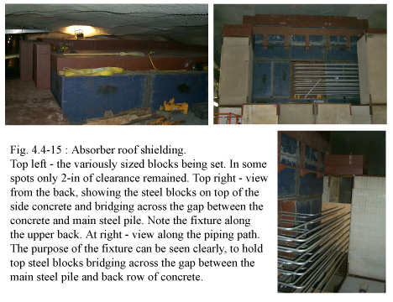
In some areas on the top of the Absorber there was barely sufficient space for this 18-in of steel, and because of the lack of overhead space the gantry crane could no longer be used to position blocks. This meant using more basic rigging techniques and these techniques would be made easier if each block were relatively small. A total of 88 blue shield blocks had been used to this point. The final 18-in layer was made of 78 steel blocks of various sizes. This top layer of steel blocks was set on the side concrete blocks and on the main pile, and bridged across all gaps along the sides and along the boundary between the front concrete shielding and the main pile. A large gap exists at the back, between the main pile and the outer concrete, where the core cooling pipes are routed. A fixture was designed to support steel blocks across the top of this gap. The top steel layer is not shown in the diagrams. Fig. 4.4-15 shows the top steel layer during installation, from different viewpoints.
The core piping was routed along the back of the Absorber pile toward the west wall of the enclosure; the path is labeled (N) in the diagrams. Before the final piping connections were made, a plywood box was constructed which filled the gap in the outer concrete shielding where the pipes were routed. Holes drilled in the box allowed the pipes to pass through. Once in place, the box was filled with polyethelene beads, which are similar in shielding value to the concrete.
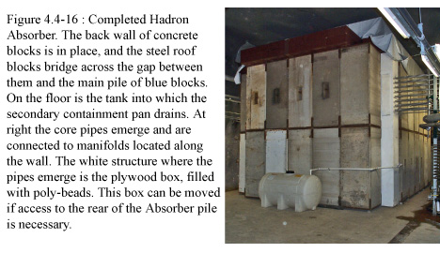
The completed Absorber is shown in Fig. 4.4-16. All of the outer concrete is in place. The piping emerges from the (painted) white bead-filled box. All the top steel is in place. The drain line from the metal containment pan, set in the base steel layers, is routed to a holding tank at the back of the Absorber. A heculite tarp is laid across the top, so that water from any drips in the enclosure roof runs off down the sides, and not down into cracks between the steel blocks. The worst (and only significant) ceiling drip in the enclosure is caught by a pan and drained into the gutters; however over time other drips may develop.
Once the Absorber was completed, the Absorber Labyrinth was installed in the passage between the Absorber enclosure and the Absorber utility area. The Labyrinth, labeled (M) in the diagrams, is simple, made from two rows of shield blocks, each row being 6-ft thick and running between floor and ceiling. Figure 4.4-17 shows the Labyrinth from each side. Also in that Figure is a view of the Absorber water and vacuum utility skids.

List of PPD Mechanical Dept drawing numbers for the main parts and overall assembly
427776 Overall Assembly, listing all sub-drawings
427334 Concrete block stacking, around DK pipe and along sides of Absorber
433146 Air containment box
431534 Hadron Monitor access slot shield door assembly
427127 Al core modules assembly – 427130:135+427620+427622 individual modules
427159 Core carrier plate assembly – 427160, 427162, 427164 individual plates
427154 Steel core blocks
406519, 433158, 431468, 431467 Core cooling pipes assembly
427337, 427376 Steel Blu block base assembly
427383 Containment pan assembly
427379 Steel Blu block side and top assembly

4.4.3.3 Control of Activated Air
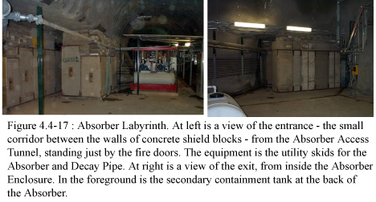
The Absorber shielding was primarily designed to protect the groundwater in the surrounding rock from activation by particle showers, a requirement which the Absorber satisfies. The shielding is also sufficiently thick that residual activation rates on the outer surface of the surrounding concrete are reasonable for an enclosure locked off during beam and otherwise infrequently accessed. A third radiological concern is the release of activated air, and here some steps had to be taken.
Any stacked construction of slightly uneven blocks, such as used for the Absorber, will create variously sized gaps and cracks. The air within these gaps and cracks becomes activated by the particle showers created in the Absorber material; the closer the gap or crack is to the beam centerline the more activated the air will become. If no effort is made to seal up the Absorber, the activated air will leak out of these gaps and cracks, and mix with un-activated air which is flowing through the Enclosure. The underground air flow pulls air from the Absorber Enclosure, up the decay egress passage, and out a ventilation stack halfway along the length of the decay tunnel. The time it takes for air to flow along this route is too short for all activated elements to decay, and some activated air will be released. There is an overall budget for released activated air, and so efforts were made to predict the contribution coming from the Absorber, which meant understanding all the volumes of air within the Absorber pile.
And there turned out to be significant volumes, not mere cracks, located in or near the beam center, where activation would be highest. The largest volume was the space between the Decay Pipe Endcap and the front face of the Absorber. The Hadron Monitor is located here, and because “backsplash” from beam hitting the front face of the core could affect the efficiency of the detector, by design there was some distance of open space between the two. The full beam intensity at the end of the decay pipe passes through this large volume of air. The next largest volume is the gaps between the core modules and the surrounding blue steel shield blocks. While only about an inch in thickness, the gaps exist on the top and two sides, and extend for the entire length of the core. Since these gaps surround the core, the air sees a large particle flux and becomes quite activated. The third main volume is around the upper portion of the south wall of the Enclosure, where the Decay Pipe exits. The shielding stacking plan assumed this wall was flat, but in fact it is not. The lower 5-ft of the wall extends 15-in further into the enclosure than the rest of the wall, above 5-ft. The shield blocks were placed where the wall met the floor, but that left a 15-in wide gap above the 5-ft level, all around the Decay Pipe. The actual particle flux passing through this volume is lower, because it is “behind” the poured Decay Pipe shielding and off the beam axis. However, this large gap is contiguous with the two other, more activated, air volumes mentioned above, inside the stacked shielding, giving a clear and easy path for the activated air inside the shielding to be pulled out and mix with the air in the Enclosure.
The amount and activation level of air from these volumes was calculated, and if the large gap around the Decay Pipe in the south wall was left as is, then all the activated air would mix freely with the air in the enclosure. From this, the predicted quantity of activated air released to the surface could be calculated, and that quantity was deemed to be too large a portion of the allowed fraction. But it was not necessary to make the Absorber air-tight – a small amount of activated air could be allowed to escape on a continuous basis. So, during Absorber installation, attention was paid to the particular large volumes mentioned, to minimize or eliminate them, and to cracks between stacked blocks, with the goal of an overall “leakage” of a few percent of the total activated air through such cracks.
As blocks were set and leveled, cracks along the floor and between blocks were filled with grout. Typically only the cracks along the outer sides were filled. Certain layers were covered with grout to create a level surface, sealing all cracks on that layer’s surface: the layer on which the core sits, and the top layer of blue shield blocks, were treated in this way. Figure 4.4-11 shows this crack filling, and it can be seen in other photos as well.
The first large volume, between the Decay Pipe Endcap and the front face of the core, was mostly filled by the aluminum box shown in Figure 4.4-12. The box simply prevents the air inside of it from freely mixing with air outside of it, removing the volume within the box from the equation for total activated air. The box fills the space between the Hadron Monitor and the front face of the core, which accounts for 55% of the total volume in this area. The remainder, between the Decay Endcap and the Hadron Monitor, cannot be similarly filled, as a box in this
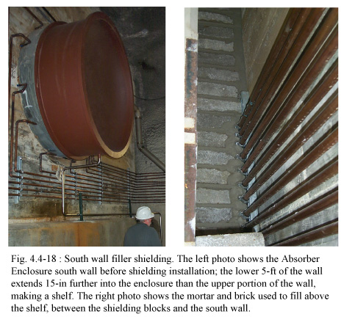

location would interfere with the installation of the Monitor. As long as the remaining free volume of air can be held within the Absorber and have a low leak rate into the Enclosure, then it can be tolerated.
The second main activated volume is the one around the core. The strategy again was to mostly eliminate the volume of air from the equation by filling the space with something else. In this case thin steel plates were fabricated to fit as closely as possible between the core and the steel blocks. One of the plates can be seen in Figure 4.4-14, extending beyond the end of the core block. These plates reduced the volume of air in this space to 10% of the former amount.
The third area of attention was the 15-in gap around the Decay Pipe on the south wall. This gap provided a large escape route for all the activated air within the Absorber. Figure 4.4-18 shows two views of the south wall. The first view before any shielding was installed; the 15-in change in wall position can be seen at the level of the person’s white hard hat. The second view is a close-up of the bricked-in gap after installation was completed. A protective foam wrap was placed around the piping before the mortar was applied. The brick wall is not air-tight, and was not required to be, as long as the leak rate was reduced to a few percent of what it would be if the wall was absent.

