Final Report for SOW-536-20060721-JOHNSON-1

“Review of the ITER Residual Gas Analysis (RGA) System”

Submitted by

Walter L. Gardner
Fusion Energy Division
Oak Ridge National Laboratory

March 2007

Introduction

One of the diagnostics tasks for which the US is responsible is residual gas analysis for determining gas composition. Gas composition (especially in the divertor and pumping duct regions) is considered to be an essential measurement parameter as put forth in Table 4.22-1 [group 1a] of the ITER Project Integration Document (PID) [ref 1]. In addition the PID sets forth measurement requirements in Table 4.22-2. A subset of these for gas composition is shown in Table 1 below.

Table 1
To better reflect the column headings the data in the columns was rearranged and some information added as shown in Table 2.

Table 2
The remainder of discussion of the Residual Gas Analyzers (RGA’s) in the PID as well as in the Design Description Document for Plasma Facing Components and Operational Diagnostics [ref 2] appears to refer to standard quadrupole mass spectrometer-based RGA’s. The drawback to these is that one cannot resolve He from D₂ unless a specially designed quadrupole with limited mass range is used. Furthermore, resolution of the hydrogenic (H, D, T) mass peaks is poor. To offset these drawbacks it has been recommended that a Penning Gauge Diagnostic [ref 3] be incorporated as part of the RGA system. Such a diagnostic cannot be used alone because it can only respond to species with optical emission lines. Hence, one should assume that the quadrupole mass spectrometer (QMS) and Penning Gauge Diagnostic (PGD) are complementary sensors.

Based on manufacturers’ specifications for QMS’s and operational experience with PGD’s Table 3 shows the expected measurement capabilities for each sensor type.

Table 3
Impact of ITER Environment on Design

Pressure
The operating pressures to be sampled in the pumping ducts by the RGAs are expected to range from a few Pa up to 20 Pa. This pressure range is greater than can be tolerated by QMS (few x 10⁻² Pa) or PGD (few x 10⁻¹ Pa) sensors. Hence, the RGAs must be differentially pumped. A preliminary design exists for a Type 2 Diagnostic Vacuum Pumping System [ref 4]. Since that design, the output of the cryopump was changed to exhaust into the torus service vacuum ring rather than the main cryopump foreline [ref 5]. A further recommended change to the design is to add a second cryopump. The problem with having only one cryopump of the size being considered [ref 6] is that it would reach its hydrogen capacity in ≈9 hrs [pump capacity (~2000 Pa-m³) ÷ {pressure (~0.01 Pa) * pumping speed (6 m³/s)*3600 s/hr}]. Fast regeneration takes ~1 hr, and full regeneration takes ~2.2 hrs. As stated in the PID, ITER will have a run schedule of two 8-hour shifts. Hence, to have the diagnostic RGA available for a full run day two cryopumps are required. To save cost and weight, two smaller capacity cryopumps such as the CTI-Cryogenics Model 8 should be considered. A schematic is shown in Fig. 1.

Radiation
Very high radiation fields can degrade ceramic insulators over time, which would affect both QMS and PGD sensors.
High radiation fields can degrade the electrical components of commercial QMS femtoamp high-gain amplifiers, which must be located near to the Faraday cup sensor. It is possible in moderate radiation fields to use vacuum tubes and other radiation resistant components [ref 7]. However, the current recommendation is to locate the diagnostic RGA’s outside the bioshield, so that the QMS should be able to tolerate the relatively low radiation field found there.
Tritium beta decay will cause a background shift in the QMS secondary electron multiplier (SEM). This shift will increase over time as tritium ions become buried in the target material until the SEM is no longer usable. Currently, the thought is to operate the system at a high enough pressure that the Faraday cup detector is the only one needed. If important the SEM could be brought online for limited operation.
The fiber optics that transmit the optical signal from a PGD are susceptible to the formation of color centers in a high radiation field, which degrades transmission. This can be ameliorated by continuously annealing the fiber at 250˚C [ref 3]. However, in high neutron flux areas annealing will not be fast enough to work. This is not a concern for the standard RGA’s, but would be a concern for the “advanced” RGA concept described later.

Magnetic Field
There is theoretical evidence that the sensitivity of QMS-based RGA’s begins to degrade significantly in magnetic fields greater than 0.05 T parallel to the mass filter axis [ref 8]. Instrument resolution becomes better with increasing field. Experimental results in this paper indicate a qualitative decrease in sensitivity and increase in resolution with applied magnetic field. For transverse fields [ref 9] an increase in resolution is observed for a field magnitude of 0.017 T, which is dependent on angular position (x-y direction). Enhanced sensitivity with applied field is attributed to flux leakage into the ionizer.
There appear to be no studies on the effects of magnetic fields on the Penning gauge diagnostic.
Locations
Specific locations for the RGA systems on ITER are being investigated. The PID has identified an RGA system sampling each pumping duct (four places). Other areas around the machine may be specified at a later date depending on perceived need and cost.
The proposed location for the RGA systems is currently just behind one of the main vessel cryopumps is shown in Fig. 2a. A pipe runs forward from this location to sample the pumping duct. This has the advantages of being behind the bioshield, and being in a lower magnetic field (≈0.1 T) that can be more easily fitted with magnetic shielding. From this position a pipe would run up to the pumping duct as shown in Fig. 2b. Though the diameter of the pipe shown is 30 cm (DN300) this was recently reduced by the ITER-IT to 20 cm (DN200). The length shown is ~5 m. Total length to the RGA, while every attempt will be made to minimize it, could be between 6-7 m. Time response as a function of length for various masses is shown in Fig. 3. Note that at six meters, masses less than 40 AMU have a time response less than 1 s, falling to masses less than 20 AMU at seven meters. It is not clear what drove the specification on time response. This should be revisited by the ITER-IT at a later time when the design and configuration are more mature.
An aperture or apertured valve located at the pumping duct of the pipe has not been factored into the layout at this point (see Design Concept section). It is highly recommended that the aperture or apertured valve, and pipe be considered as the “front end” for this diagnostic, and given sufficient design priority to be incorporated into the basic machine design early on. In addition, sufficient space behind the main cryopump (Fig. 2a) should be reserved for the diagnostic RGA system.
Design Concept
The design configuration currently being considered is shown schematically in Fig. 4. It is based on integrating the RGA sensors directly into the Type 2 Diagnostic Vacuum Pumping System (T2DVPS). In addition to the QMS and PGD sensors, a calibrated pressure gauge, a calibration gas system, an aperture or apertured valve to provide differential pumping, secondary containment, and the T2DVPS are shown.
RGA’s require periodic calibration. Once installed it is impractical to remove these systems to a central calibration facility. In-situ calibration to known gas mixtures and pressures is the preferred method. The calibration gas system is comprised of cylinders of pure and pre-mixed gases, regulators, a mixing volume with calibrated pressure gauge, a variable leak, and an isolation valve.
An apertured valve is recommended over a fixed aperture so that the RGA system is available to monitor vessel vacuum conditions where partial pressures may fall below ≈10⁻⁷ Pa. This decision rests with the ITER-IT. The aperture or apertured valve is not placed at the RGA end of the pipe because its conductance is low enough that the pressure over the length of the pipe from the duct to aperture would be nearly constant. Gas exchange would then be governed by diffusion. For deuterium in the pressure range of 5-20 Pa the diffusion time response (5-m length, D₂) ranges from >10 to >60 seconds.
A second configuration was briefly considered. In this configuration the pipe from the pumping duct would feed directly into the cryopumps, and the differentially pumped RGA section would be teed off the pipe near the cryopumps. If one could sustain the gas throughput, the time response would be excellent and there would be no need for an apertured valve at the pumping duct. However, the flow (of order 60 Pa-m³/s hydrogen) given the rated pumping speed and pressure near 20 Pa would quickly overload the cryopump thermally in a few seconds. Even if the pump could handle the thermal load the hydrogen capacity would also be reached in a matter of seconds. In order to reduce the flow to the point where the pump reaches its capacity in ~1hr (while the other pump regenerates) a ≈0.3-mm diameter aperture would be required. This aperture is only slightly larger than the aperture for the first configuration (≈0.1 mm). Hence, the pressure on the upstream side is of the same order as that at the duct, meaning that the diffusion time responses are applicable, and thus this configuration was dropped.
Development Needs
There are three areas where development is needed in order for the diagnostic RGA design to move forward. The information will also be needed to help generate better cost estimates as the design moves closer to the preliminary and final design phases.
Magnetic field measurements
The first development area has to do with the impact of magnetic field strength and direction on the RGA signal output, particularly the quadrupole mass analyzer portion of the RGA system. As pointed out previously, resolution generally improves with magnetic field. However, sensitivity can either decrease (as one would normally expect), or increase (as was actually observed due to field effects on the ionizer) depending on field direction. The effect on sensitivity is also mass dependent. At the level of field studied in reference 9 the change in sensitivity was much larger than the accuracy requirement shown in Table 3, and this was only for one mass (argon). The peak height change in reference 8, though in arbitrary units, appears to give a similar result.
In order to determine the minimum magnetic shielding requirements for the QMS, the minimum tolerable field and orientation need to be determined. [Note: The quadrupole electric fields are not axisymmetric, hence, orientation with respect to the transverse magnetic field is important.] This will allow determination of the best orientation of the quadrupole sensor, and the correct amount of shielding, given a good estimate of the maximum external field and its direction. While the PGD sensor head should be much easier to shield, because of its smaller size, as well as having its own permanent magnet field that will ameliorate the effects of an external field, measurements of minimum field and orientation are recommended to verify the level of shielding needed.
Calibration system conceptual design development
The second area needing development is the calibration gas system. As discussed previously a calibration gas system is needed, and a high-level hardware representation was shown. [Note: a calibration system was not considered in the original RGA package.] However, this representation is based solely on what has been used for PGD systems on JET and Tore Supra. A calibration gas system suitable for calibrating a QMS will undoubtedly be different though qualitatively similar. For instance, it will be desirable to calibrate the QMS with hydrocarbon (C_{x}H_{y}) and deuterated hydrocarbon (C_{x}D_{y}) gases. Contamination of either sensor type when using such gases will need to be researched to see if issues exist. Furthermore, whatever the final design of the calibration gas system it will be interfacing with a tritium handling system, i.e., the RGA. Thought must be given to how the interface will be made, which components need to be tritium compatible, and which parts of the system may see tritium under worst case scenarios, and, hence, need secondary containment.
Tritium containment, compatibility and operational concept development
It is recognized that the diagnostic RGA system will be exposed to tritium and, as such, will need secondary containment. However, the way in which this containment will be implemented has not yet been considered. Furthermore, all of the interfaces will have to be considered. Such interfaces would include, but not be limited to, electrical, He supply and return to the cryopumps, RGA input from the pumping duct, cryopump exhaust, and He vent.
Another thing to recognize in addition to containment is the tritium compatibility of components. As yet attention has not been paid to whether or not commercial parts exist in a tritium compatible form for all RGA related components.
Finally, the operational aspects of the RGA system have not been worked out. This is important to consider for tritium operations, not only because of the obvious safety and health implications, but also to make sure that all components needed for all operational scenarios (cold startup, standby, normal operations, calibration, troubleshooting, and shut down [including emergency]) have been identified.
Development needs outside the ITER project
While gathering information to develop the design specifications and concept for the DRGA’s it was discovered that there are only two RGA systems currently operating on tokamaks that measure during a discharge (Tore Supra and JET). These systems have significant issues. The JET RGA does not work in all types of discharges, and is only capable (it is unclear why) of free running mass scanning. The Tore Supra RGA has difficulty with RF noise when operating during RF heated discharges. The bottom line is that an RGA is not a mature diagnostic for tokamaks. More emphasis needs to be placed on getting an RGA system working reliably on a present day tokamak to study the problems that the ITER DRGA systems may face. To this end collaborative efforts will be pursued to gain experience and solve issues prior to delivery of the ITER DRGA systems.
An “advanced” RGA for in-divertor operation
Sampling the divertor gas composition directly through a long pipe (≈13-15 m) with the required time response of 1 s is unfeasible for a reasonable pipe diameter as shown in Fig.5. Ideally one would like to have a device located in the divertor that would locally measure the gas composition at pressures up to 20 Pa, in magnetic fields of several Tesla, and in high radiation fields and neutron doses. There has also been recent interest by the pellet fueling team in knowing the T:(D+T) ratio within ≤100 ms response times to control firing of T pellets vs. D pellets.
It has been determined that an RF glow discharge-based device could provide such a direct divertor gas composition measurement on the time scales needed. This RF Discharge-based Optical Gas Analyzer (RFD-OGA) uses a capacitive RF discharge to generate optical emission from various gas species of interest to ITER (H_{α}, D_{α}, T_{α}, He, [and perhaps] C₂, CD and CT). One might think of this system as having the same function as the Penning gauge diagnostic [ref 3], yet able to operate at substantially higher pressures (20 Pa), operate in very high magnetic fields [ref 10], and withstand significantly higher radiation doses. The system would be comprised of a discharge chamber, a low power (few tens of watts) 13.56 MHz generator, matching network, calibration gas system, optical system (mirrors, lenses, fiber), spectrometer, instrumentation and control electronics, and data acquisition system. A schematic of the RFD-OGA system is shown in Fig. 6. A 3D rendition of what the discharge chamber might look like is shown in Fig. 7.
It is proposed that the discharge chambers of the RFD-OGA’s be located at several toroidal locations under the dome in diagnostic divertor cassettes. Figure 8 shows a potential location. The optical output from the discharge would be relayed by mirrors back to the bioshield where collecting optics focus the light into a fiber optic that then feeds a high resolution spectrometer. The discharge is driven by an RF source and matching network located outside the bioshield. Connection to the discharge chamber is by an ITER approved coaxial cable with a diameter of perhaps twice that used for cable TV.
The calibration gas system, as for the standard RGA’s, is comprised primarily of bottles of pure and premixed gases, a suitable mixing volume, a calibrated pressure sensor, an isolation valve, and variable leak. The system will be located outside the bioshield and feed the discharge chamber through a long length of stainless steel tubing. Because of the long length of tubing needed and the fact that flow rates are mass dependent, the remotely operated isolation valve and variable leak would have to be located near the discharge chamber to keep gas ratios constant. An isolation valve will be used in conjunction with the leak valve. The gases (D₂, He, Ne/N₂) are assumed to be ejected into the torus vessel and pumped by the main cryopumps. Because there is not a suitable window material for in-vessel applications, the discharge chamber is open to the vessel to allow optical transmission. While this opening is suitable for letting gas into and out of the discharge chamber from the divertor region, it is not suitable for maintaining sufficiently high pressure in the chamber during calibration with reasonable gas throughput. Hence, a conductance limiting straight tube is attached to the chamber output.
The discharge chamber would be fabricated of ITER approved metal and ceramic components, and, as such, should be highly radiation resistant. The maximum voltage applied across the ceramic insulators should be of order 100V prior to discharge initiation.
Because the RFD-OGA concept is undeveloped and unproven, it is considered new scope, and will not be considered as a part of the ITER Diagnostic RGA package. If there were strong ITER interest, funding support would be needed for development, design and implementation.
References
- Project Integration Document, Version 3.0, IDM: ITER_D_2234RH, p. 291, (January 2007)
- Design Description Document WBS 5.5.G, Plasma Facing Components and Operational Diagnostics, G 55 DDD 38 01-07-17 W 0.1. (July 2001).
- Hillis, D. L., et al., Rev. Sci. Instrum. 70(1), 359-362 (1999).
- Design Description Document WBS 3.1J, Diagnostic Vacuum Pumping Systems, G 31 DDD 10 98-05-27 W 0.2 (May 1998).
- Design Description Document WBS 3.1, Vacuum Pumping and Fuelling Systems, G 31 DDD 14 01-07-19 W 0.1, page 31 (July 2001)
- Design Description Document WBS 3.1J, Diagnostic Vacuum Pumping Systems, G 31 DDD 10 98-05-27 W 0.2, page 11 (May 1998). (apparently same specifications as for CTI-Cryogenics Model 10F).
- Pearce, R., et al., Vacuum 44(5-7), 643-645 (1993).
- Tunstall, J. J., et al., Vacuum 53, 211-213 (1999).
- Srigengan, B., et al., IEE Proc.-Sci. Meas. Technol., 147(6), 274-278 (2000).
- Kaneko, T., et al., Jpn. J. Appl. Phys., 44(4A), 1543–1548 (2005).
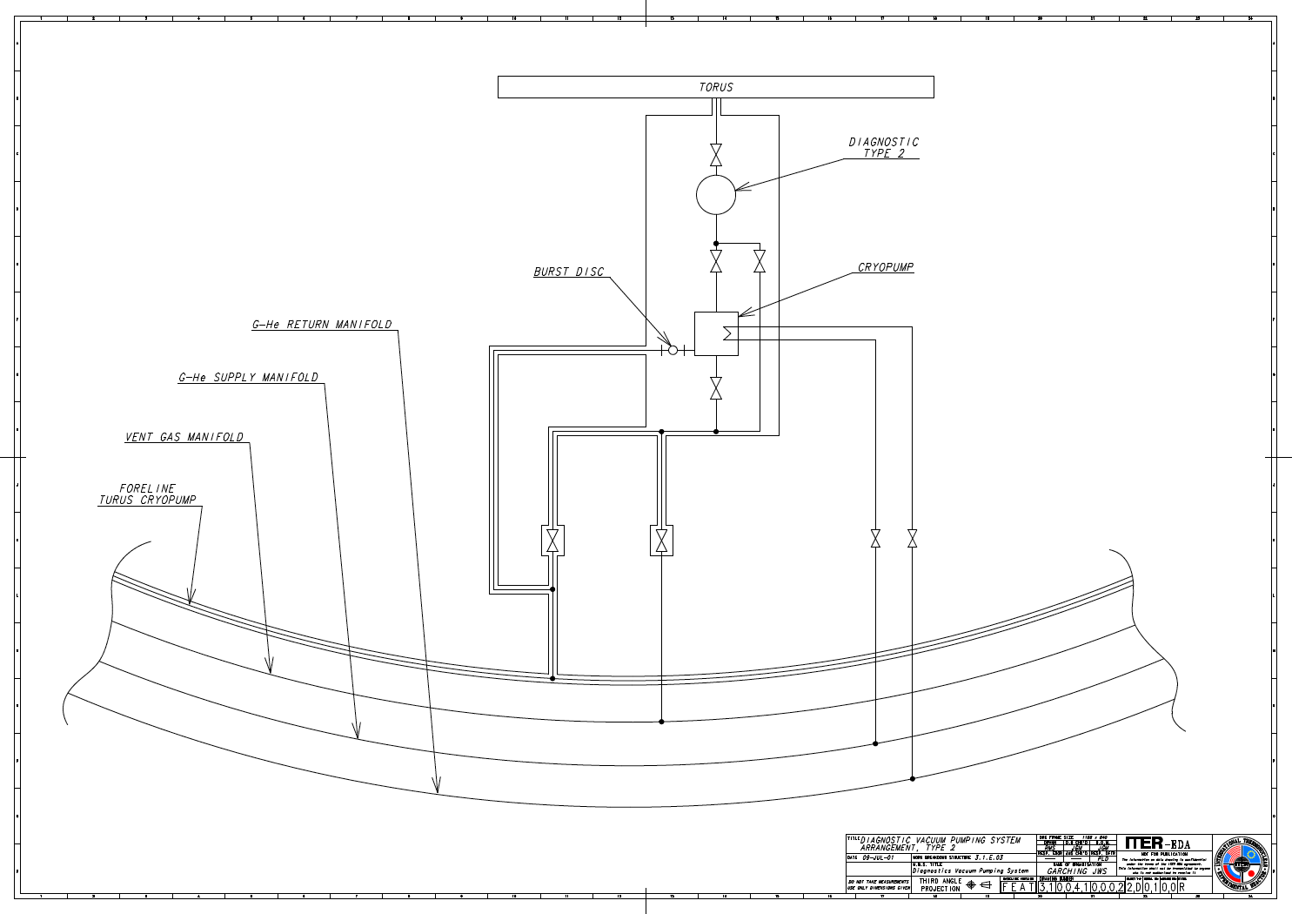
RGA system here
Torus service vacuum
Proposed 2nd cryopump system (w/containment)
.
.
.
.
.

Fig. 1. Schematic of the Type 2 Diagnostic Vacuum Pumping System. Modifications to the 1998 design include exhausting the cryopump to the torus service vacuum ring, and the addition of a second cryopump system (within tritium containment envelope).
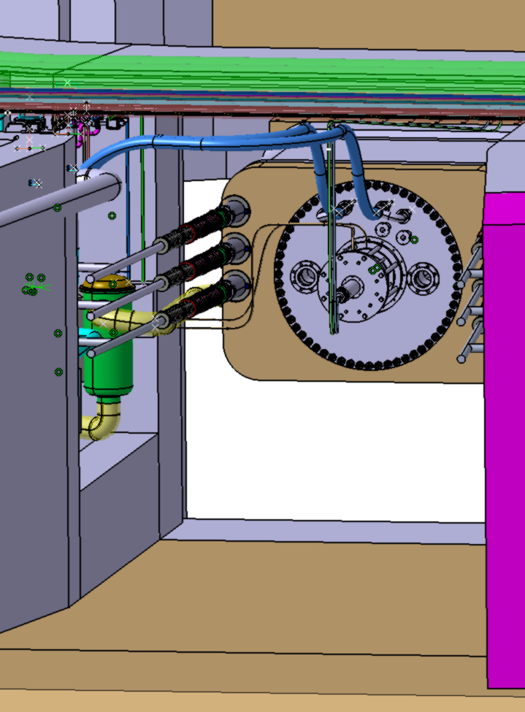
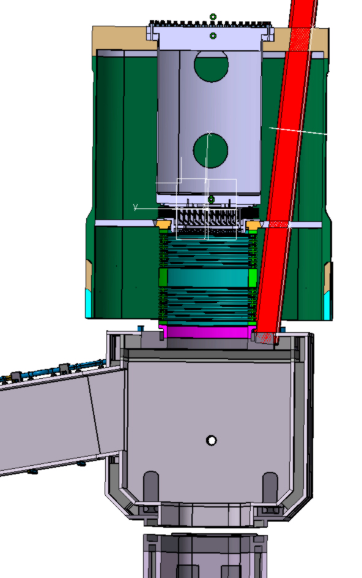
Cryopump
300-mm diameter pipe
●
Area proposed for RGA system (on skid or cart?)
(a)
(b)
Fig. 2. Proposed location of a diagnostic RGA system is shown in (a) behind a main divertor cryopump. (b) indicates the location of the pipe extension to the pumping duct.
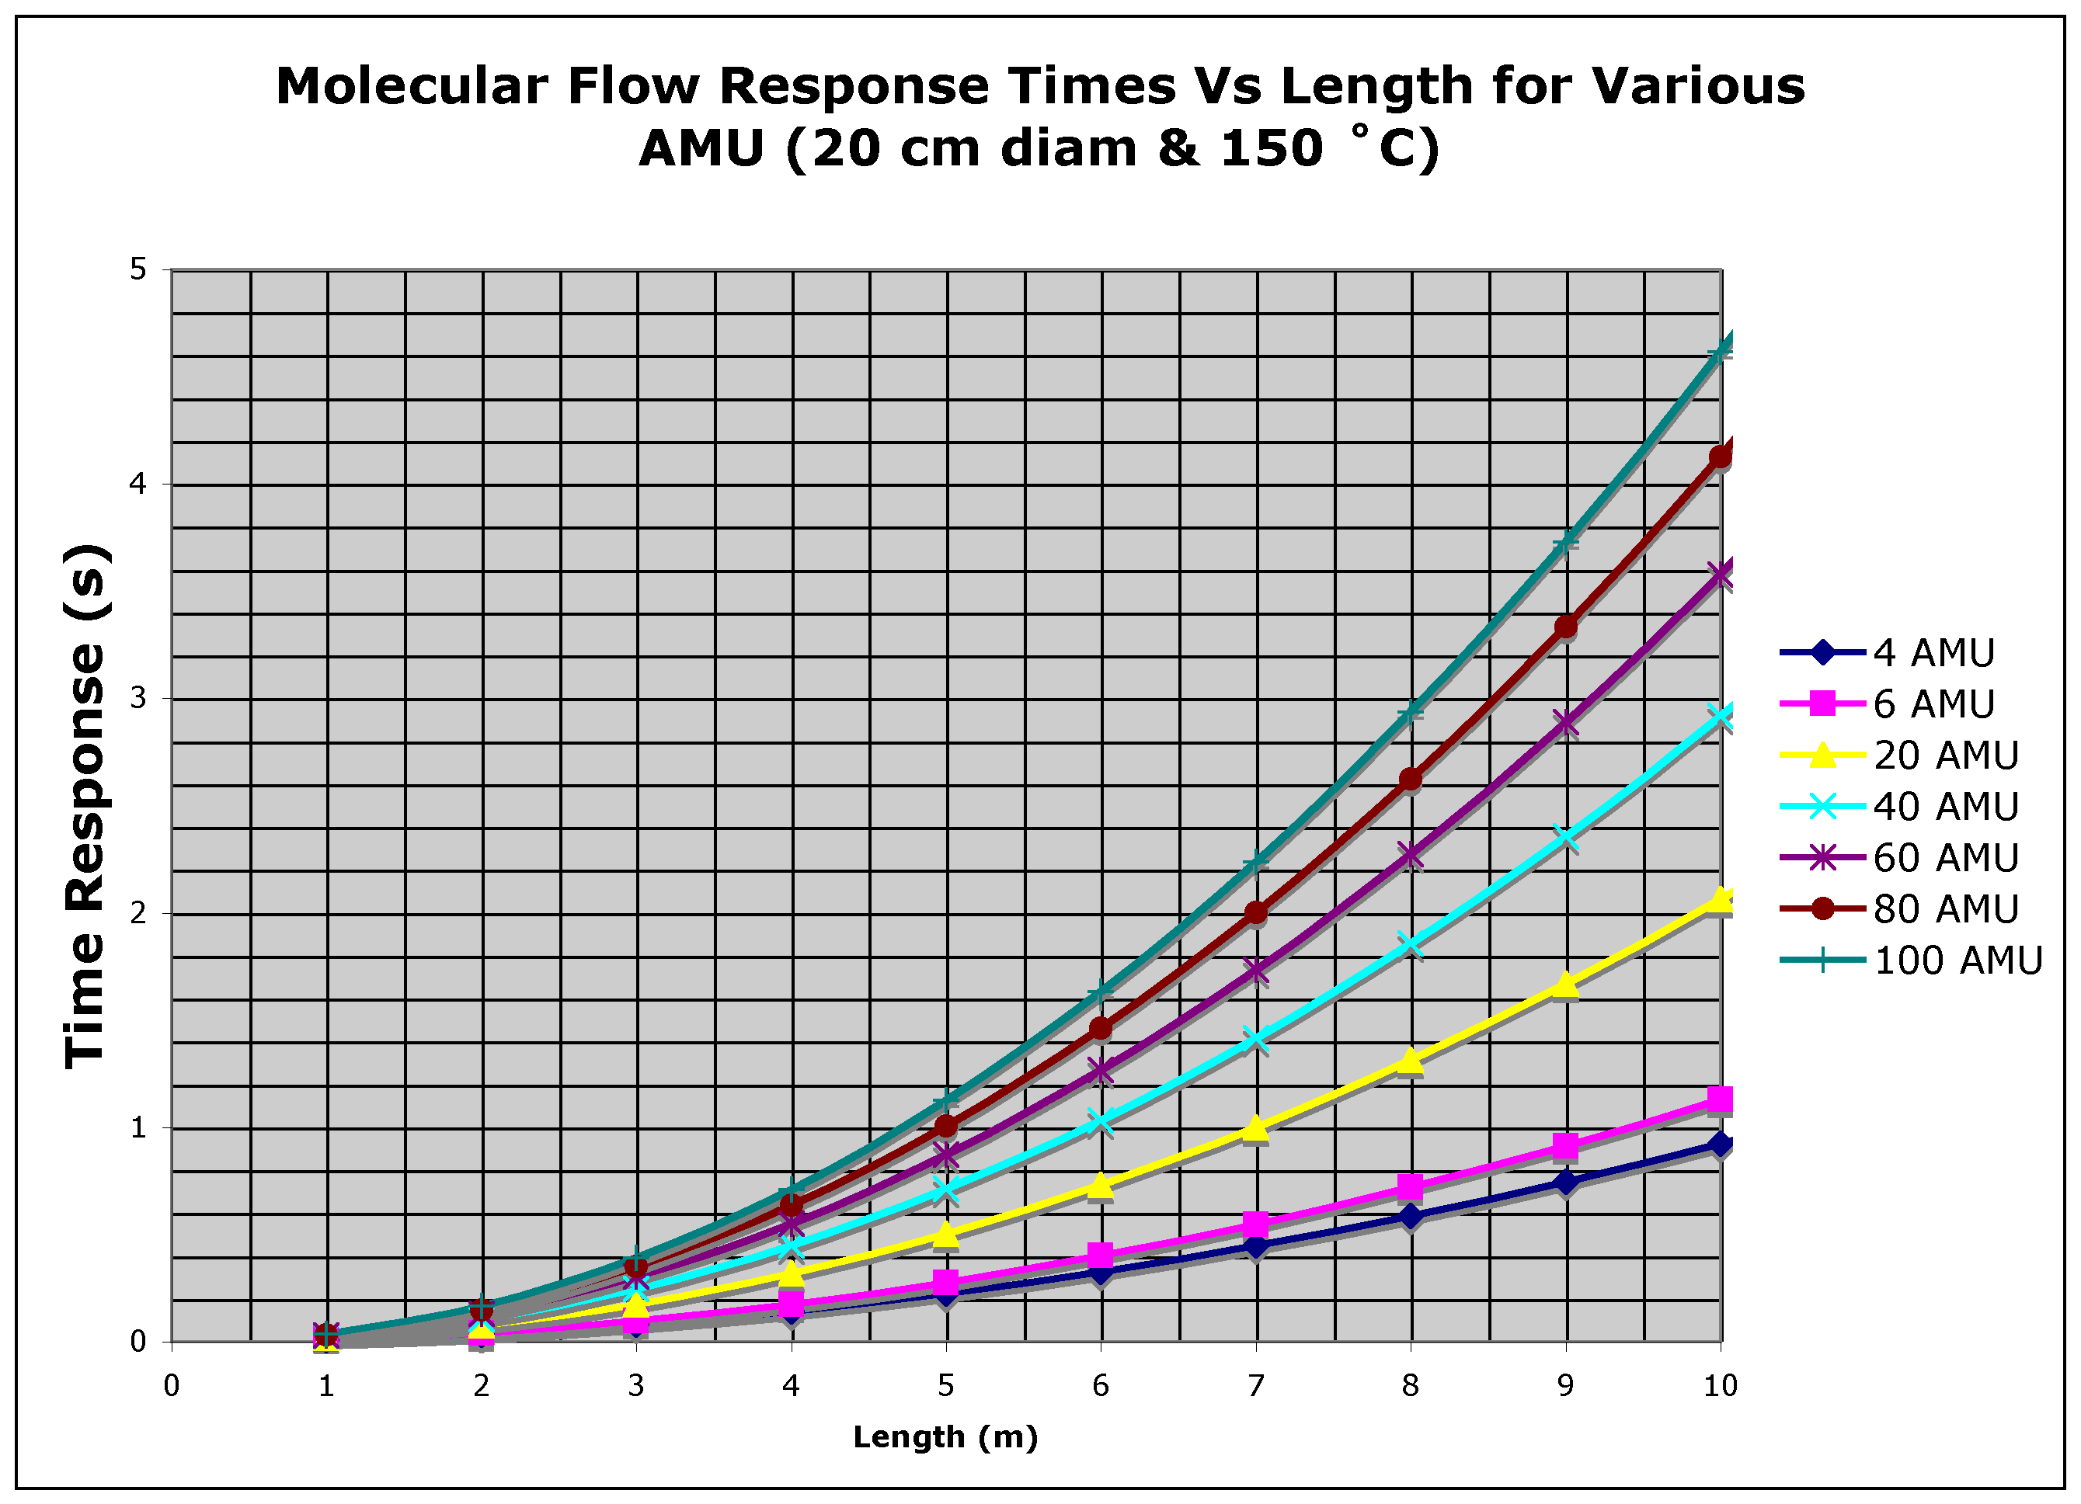
Fig. 3. A plot of molecular flow time response through 20-cm diameter pipe as a function of length for various molecular weights. Gas temperature is assumed to be 150 ˚C. [Time response = pipe volume (m³) ÷ conductance (m³/s)]
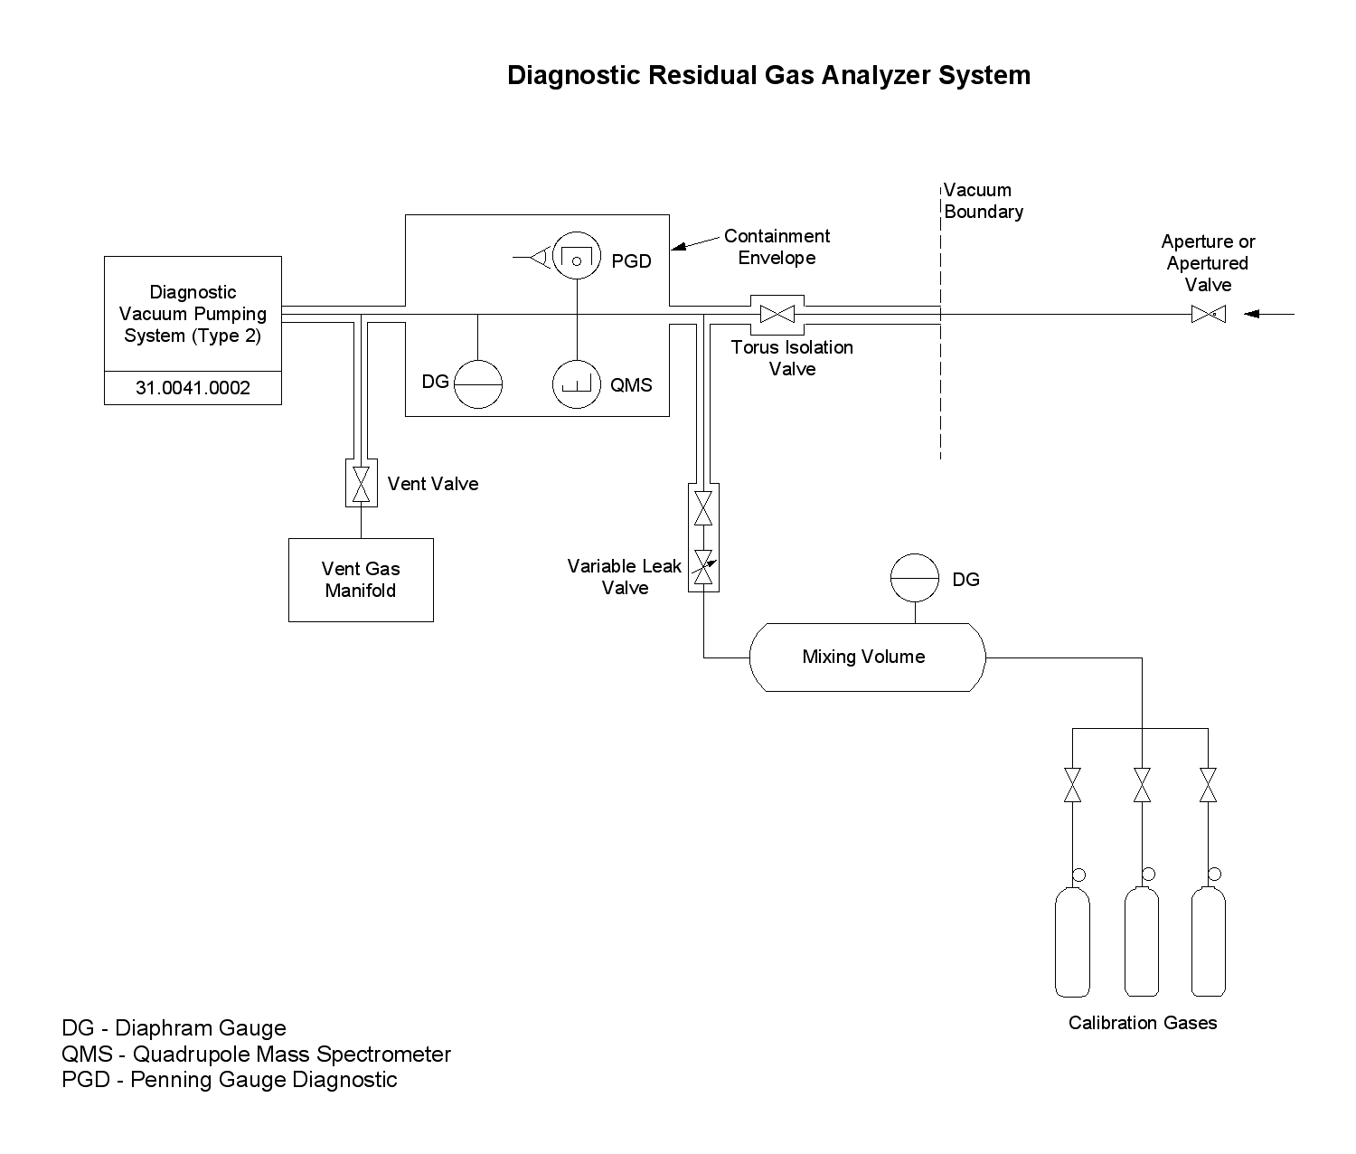
Fig. 4. Schematic of the Diagnostic RGA System.
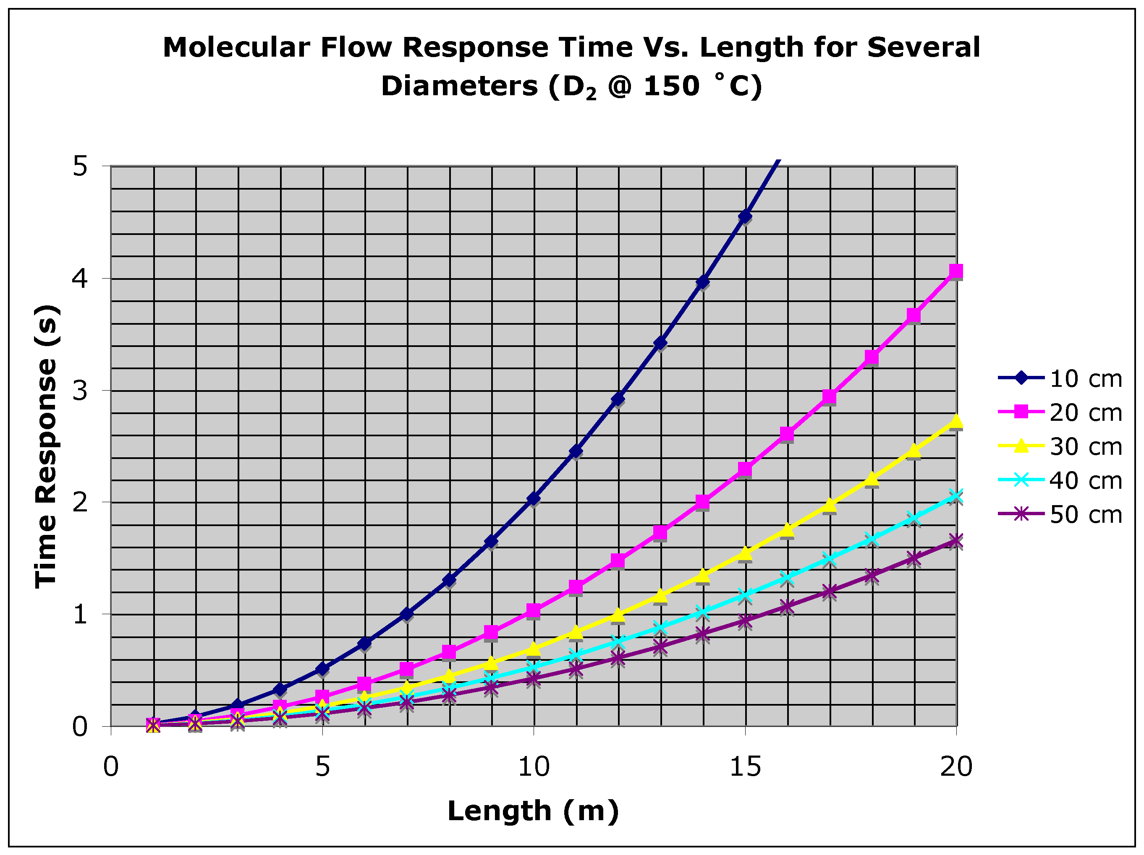
Fig. 5. Molecular flow time response for deuterium as a function of length for several pipe diameters. Gas temperature assumed to 150 ˚C.
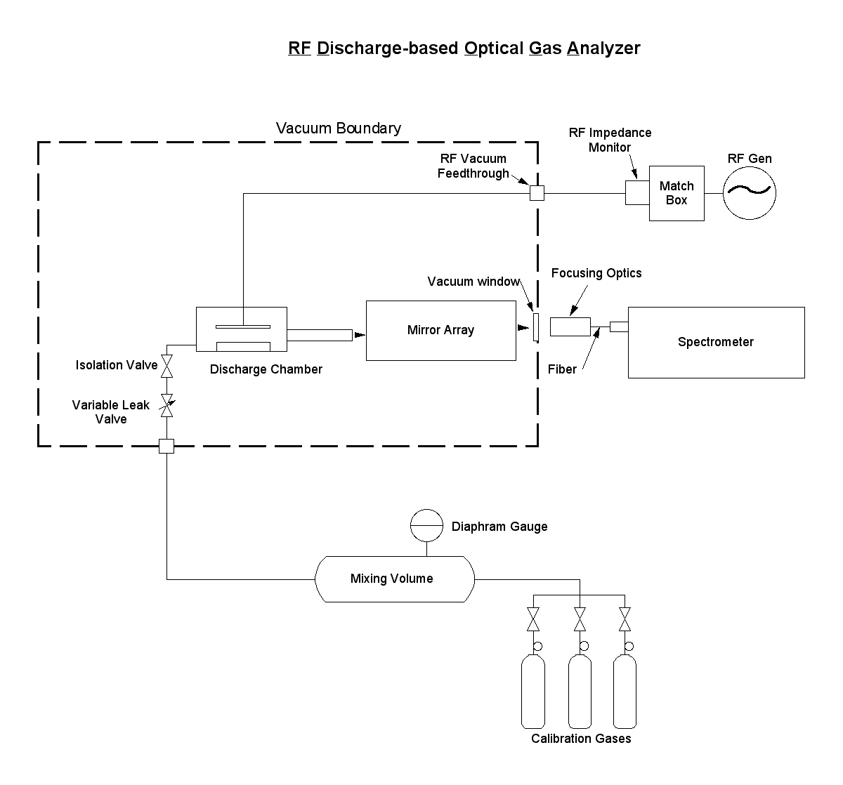
Fig. 6. Schematic of the “advanced” RGA also known as the RF Discharge-based Optical Gas Analyzer (RFD-OGA).
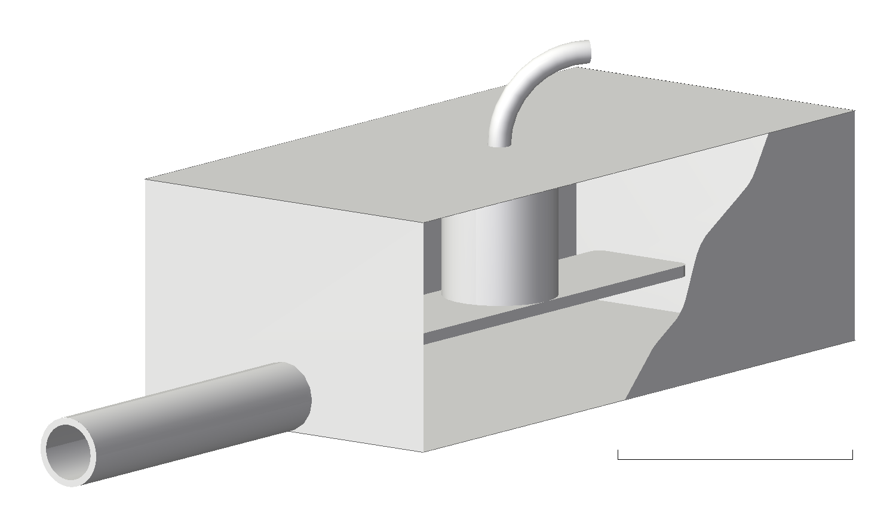
100 mm
RF Cable
Insulator
Powered Electrode
Tube for gas and light transmission
Fig. 7. 3D concept view of the RFD-OGA.
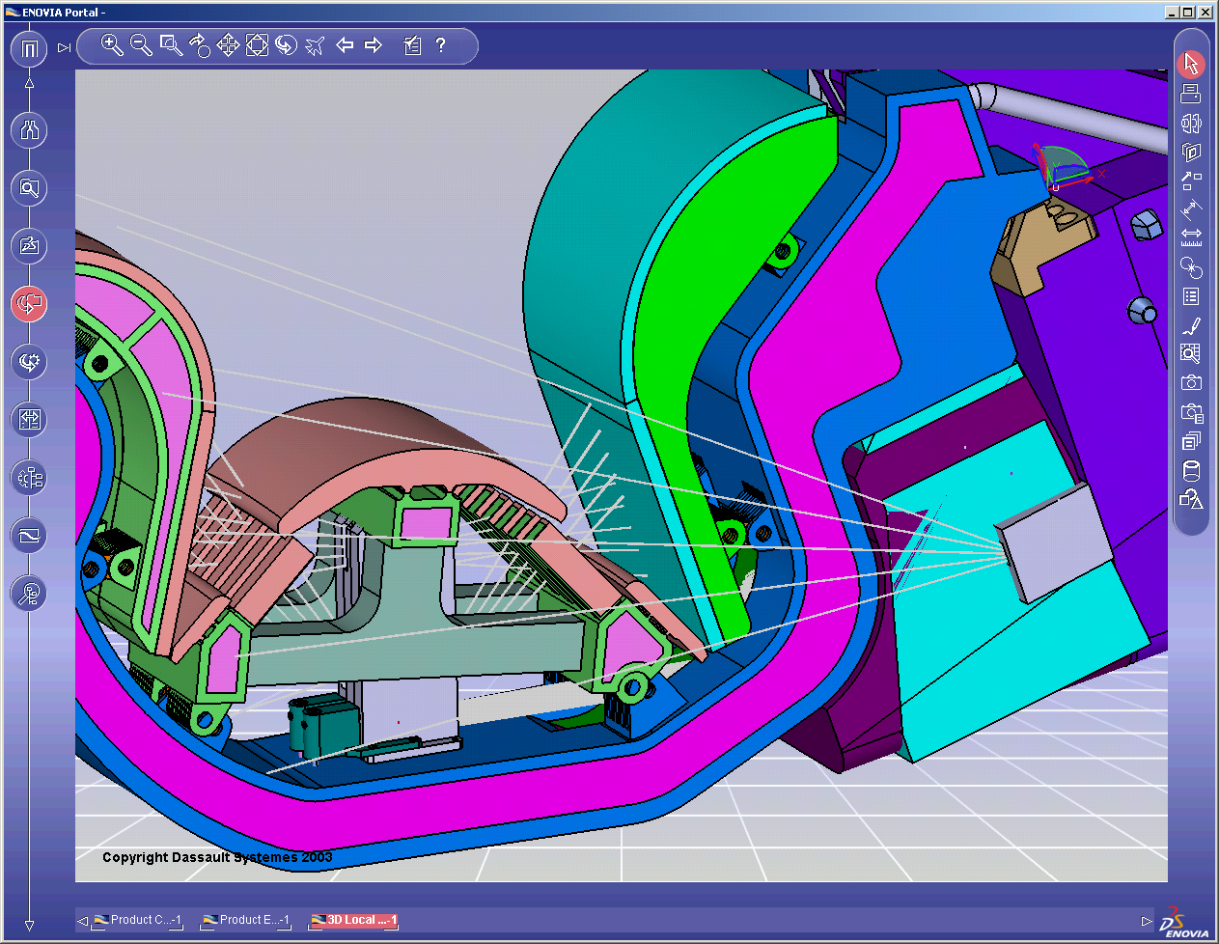
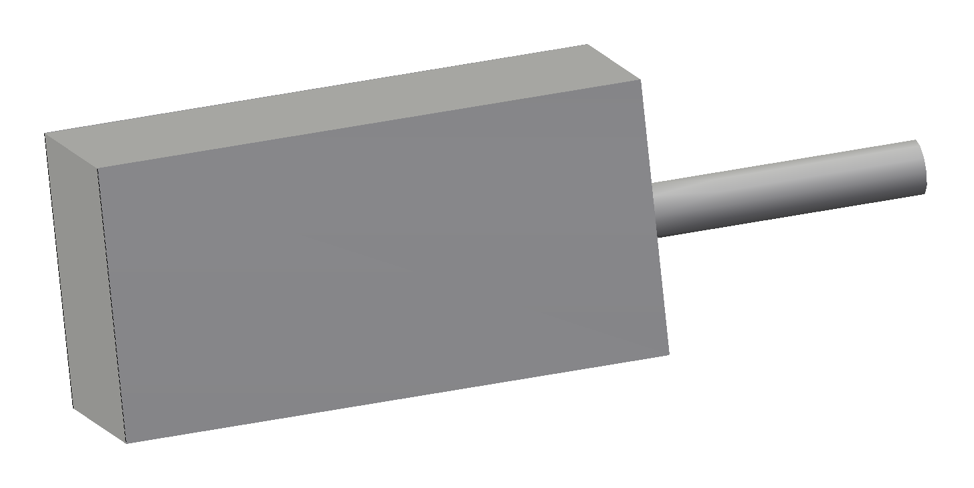
Locate RFD-OGA discharge chamber on shelf (200 mm wide x >450 mm long x >200 mm high)
RFD-OGA light output could piggyback on Impurity Monitor mirror system in this case
Fig. 8. Potential location of an RFD-OGA on a divertor cassette.

