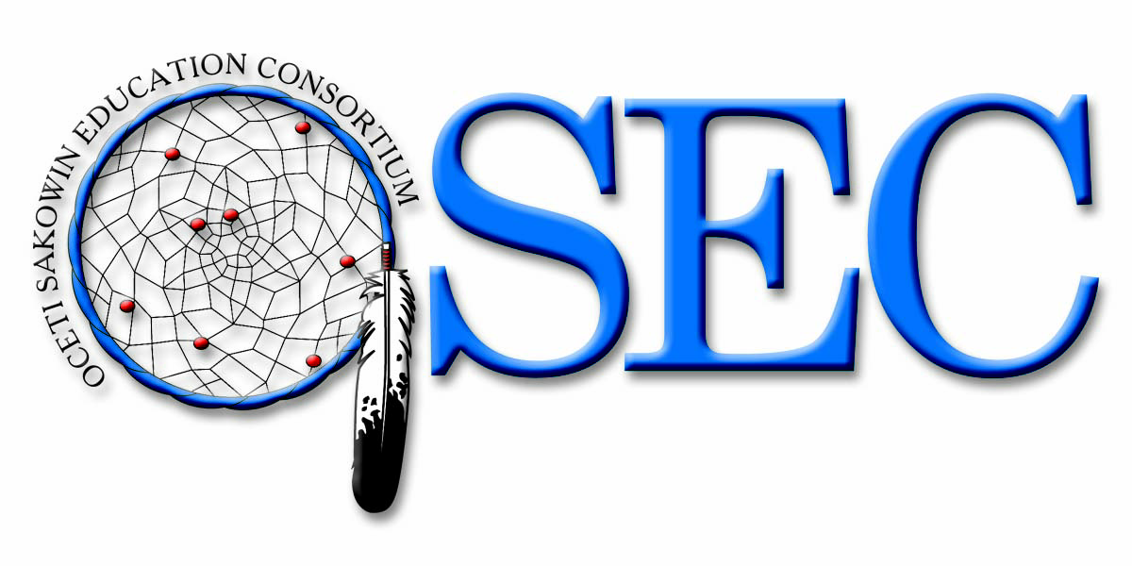

Committee on Education and Labor
U.S. House of Representatives

NCLB Testimony

September 9, 2008

Respectfully Submitted

Theodore L Hamilton
Executive Director
(605) 455-2678
Hamilton@gwtc.net

Introduction

Thank you, Chairman Kildee and Ranking Member Castle, for inviting me to testify today. My name is Ted Hamilton and I am the executive director of the Oceti Sakowin Education Consortium
The Oceti Sakowin Education Consortium is a consortium of fourteen tribal schools and four tribal colleges in South and North Dakota (see appendix 1). The Consortium provides a wide range of services to the schools including teacher professional development, school improvement planning, board training, special education technical assistance and collaborative hiring, early childhood programming and supplemental student service activities. (http://www.osdlc.org) The Consortium has been in existence since 2000, currently has a staff of 17 and has an annual operating budget of 2.4 million dollars.
In the past eight years, OSEC staff have provided services to schools at the request of school superintendents and principals through a cooperative like structure. Unlike a traditional educational cooperative model, OSEC maintains a school needs-based model that creates annually contracted projects specifically developed for each school's needs. This process is more time-consuming and less secure than tax-funded programs, but it does provide a clear picture of the needs of schools and our higher education partners. I want to stress that OSEC is not an advocacy or representative organization. The schools that are our members own us, and we believe that our school boards and tribal education departments should be heard in policy level discussions. We do provide technical support as requested relating to policy-level decisions.
I have been asked today to discuss the work our organization is doing related to the creation of a definition of Adequate Yearly Progress for some of our member schools, our reaction to the GAO study related to the Bureau of Indian Affairs Office of Indian Education Program's implementation of the alternative AYP process for tribes under NCLB and to also make some comments on other issues important to our membership.
I would like to focus my remarks on four areas:
No Child Left Behind Issues
Access to "qualified" teachers
Facilities and Transportation
BIE Restructuring/BIE and State Relationships
No Child Left Behind
The Government Accountability Office Report (GAO) concerning the alternative definition of adequate yearly progress is a good case to point out the more general difficulties our schools are having with the BIE system.
When No Child Left Behind was authorized there was a process defined in the Act for tribal input called Negotiated Rulemaking. During the Negotiated Rulemaking process which is designed to provide input into regulations, members of the rulemaking committee were assured that tribes would be provided support, both technical and fiscal, in development of alternative assessments and standards. As an interim step, schools would follow the accountability workbook of the states in which they reside. Two members of the Negotiated Rulemaking Committee, Dr. Roger Bordeaux of Tiospa Zina Tribal School and Deb Bordeaux of Loneman School, argued against the use of State workbooks and their associated standards, and finally, reluctantly, agreed to the State standards and assessment provisions provided the BIA provide support for the alternative adequate yearly progress process.
Upon returning home, Deb Bordeaux and Dr. Bordeaux contacted the schools in South Dakota. Dr. Bordeaux, who was serving a term on the Oceti Sakowin Education Consoritum board, asked OSEC help coordinate an initial meeting in Pierre, South Dakota at the Pierre Indian Learning Center to discuss No Child Left Behind and to explore the concept of an alternative definition of AYP. At the end of that meeting, eight schools had decided they would pursue an alternative definition by pooling $ 5,000.00 each to help defray the costs. OSEC was asked to manage the process and to act as a single point of contact with the BIA on the project. I am attaching to this document an appendix with a timeline of our work on the AYP issue and some of the hurdles placed in front of us by the Bureau.
The first year of our attempts to get this work done, we were told repeatedly by the Bureau that we could not apply as a group of schools for an alternative definition, were told that it would be too expensive and that there was no money for this type of work. We were required to have our school boards pass multiple resolutions agreeing to work together through the OSEC organizational structure and we generally did not receive any correspondence from the Bureau other than letters telling us they did not have to help us.
In reading the No Child Left Behind Act, Tribes and Tribal Schools that wish to waive the State definition for their own definition are required to submit an alternative definition within 60 days of alerting the Secretary of Interior of their intent to waive NCLB requirements. The Secretary of Interior is then required to give a written response either supporting or denying the waiver. This allows the Tribe or Tribes to begin a negotiation process with Interior. After four submissions beginning in 2005, the OSEC schools finally received their first written response to their proposed definition in August of 2008.
A significant aspect of developing an alternative definition of adequate yearly progress is the creation of educational standards and an assessment tool to assess if students have mastered the standards at the basic, proficient or advanced level. At the core of our concern about using State AYP definitions is the lack of culturally appropriate content standards. In the US Code of Federal Regulations (25CFR, CH 1, Subpart C 36.1, 2008 edition) it states:
(1) The school's language arts program shall assess the English and native language abilities of its students and provide instruction that teaches and/or maintains both the English and the primary native language of the school population. Programs shall meet local tribal approval.
(2) The school program shall include aspects of the native culture in all curriculum areas. Content shall meet local tribal approval.

The State of South Dakota does not develop its educational standards to meet the regulations above and is not bound by the regulations above. The purpose for development of an alternative definition of AYP is to ensure that the content being taught to our children is culturally-based and that native language is maintained.
Our organization has asked repeatedly for funding to develop assessment instruments for the standards we have created. We met with the BIE and DOE officials in late November of 2007 and were told funding would be available for assessment development. We were told to conduct a bidding process with companies for assessment development, create a plan and submit that plan. This was the third time we had completed this process. We also submitted our third accountability workbook for approval at that time. To help us, we were assigned a consultant from the Department of Education, Mr J.P. Boudain. Mr. Boudain helped us review the bids that we received and then helped create the final budget that we submitted on March 4th of 2008. The BIE sent Mr. Stan Holder to South Dakota on April 8th to tell us that the BIE was willing to fund the project but at 1/3 less the amount than was requested. He also indicated that we would have to have tribal council resolutions to proceed, once again delaying the process contrary to NCLB regulations. We were also left unsure of on-going funding for the project. We found this frustrating as this was our third time for bidding this project and we built the final budget based on the guidance from the consultant provided by the Government. We asked for a written response to our accountability workbook and for our request for assessment development funding.
In May 2008, we were informed that the BIE had hired a consultant to help us with development of the accountability workbook and the assessment development process. The person assigned this time was again Mr.Boudain. J.P. met with our development committee via phone conference and on June 11th we submitted our fourth accountability workbook with a request that we receive a response for each critical element in writing. Mr Boudain commented that the OSEC group had already done the work and that he would have to work with the BIE to help them with an approval process. Mr. Boudain has not met with our group again and when contacted has indicated he has been focused on working with the BIE staff. I find it ironic that the BIE hires a consultant to "help" our schools who then spends the bulk of his time helping the BIE. We received a response in August and have asked for a meeting on September 12th to discuss the BIE position on the workbook. We still have not heard anything about funding for the assessment development activities nor have we heard back about the September 12th meeting.
In reflecting on the GAO study, it is apparent that the BIE has not provided guidance to the tribes related to their rights under NCLB. When our group discussed the possibilities with Dr. Pat Abeyta and other BIE staff we were reminded that funding was not available, that it would be too much work, and that it was the BIE responsibility to act as the State Education Agency for the tribes. We question if tribes that chose to not pursue their own accountability workbook did so as a reaction to BIE staff not supporting tribal sovereignty.
We have tried to keep line officers informed of our progress and have found that they receive very little information or guidance related to the AYP process as the GAO study indicates. Our tribal education departments and tribal councils depend on the Line Offices to keep them informed of BIE policies and procedures.
We also noted the GAO study stated that there were no issues in establishing an MOU between the State of South Dakota and the BIE. The BIE approached the State through Bonnie Haines of the Lower Brule Line Office who informed the Secretary that the BIE represented all funded and operated schools. We found this to be a strange finding as the MOU was completed without the knowledge of our school administrators, tribal education departments and especially our tribal councils. Once the MOU was made public, the schools and tribal council representatives held meetings with Dr. Rick Melmer, the State Secretary of Education expressing concern for the process and asking him to consider rescinding the MOU.
The frustration with this situation is NCLB provides opportunities for tribes to have significant voice on assessing the quality of education for their children and making changes to their educational programs based on those assessments. The manner in which the BIE has chosen to implement NCLB has left tribes with no voice in educating their own children, evolved into a bloating of the bureaucracy in Albuquerque, and has bypassed the cornerstone of treaty-based obligations of the US Government to conduct business in a government-to-government basis with the tribes.
In general, NCLB has been poorly implemented by the BIE:
1. When NCLB started, many schools were placed immediately into Restructuring Status. The BIE guidance document for schools in restructuring was distributed in July of 2007, a full five years after the first schools were identified in that status, and in the 2008 school year, the BIE did not follow the 2007 guidance documentation regarding the development of restructuring plans.

2. Adequate Yearly Progress (AYP) determinations were made for South Dakota schools in April of 2008 for the 2006-2007 school year despite the requirements for a start-of-school deadline for this activity. The "plan" to fix this error continues to miss deadlines and not inform the communities of school progress.

3. A clear guidance process for waiving AYP provisions and establishing tribal provisions has not been created as has been documented by the recent GAO study.

4. A State Accountability Workbook has been created for the BIE without consultation with the tribes and without a well-documented peer review process that includes local input.

In the case of the BIE accountability workbook, it is unclear what Peer Review process was used to create the workbook. In talking with members of the Negotiated Rulemaking Committee, it was not their understanding that they had input into this process.

PL 107-110 NCLB
Title I, Part A, Subpart 1, Section 1111

‘‘(e) PEER REVIEW AND SECRETARIAL APPROVAL.—
‘‘(1) SECRETARIAL DUTIES.—The Secretary shall—
‘‘(A) establish a peer-review process to assist in the review of State plans;
‘‘(B) appoint individuals to the peer-review process who are representative of parents, teachers, State educational agencies, and local educational agencies, and who are familiar with educational standards, assessments, accountability, the needs of low-performing schools, and other educational needs of students;

The last issue, creation of an accountability workbook, places the BIE in the role of a State Education Agency; a clear violation of the government-to-government relationship between the US Government and the Tribes.
North Dakota and South Dakota tribes and schools successfully brought suit against the BIA concerning their restructuring consultation and the establishment of the SEA, yet despite the injunctions against them, the BIA continues to refer to themselves as the "51st" state, going so far as to create a State accountability workbook which is posted on the US Department of Education web site. The BIE has made a Memorandum of Agreement with the US Department of Education to act on behalf of the tribes as a State Education Agency. This means the Federal Government has agreed to work with itself to dictate services to the Tribes.
Finally, our frustration with NCLB requirements and the way the BIE has been implementing those requirements is the time-consuming nature of the processes. There are significant challenges with Indian Education right now that need to be addressed. The BIE is spending millions of dollars monitoring a fairly small part of the educational process rather than working with tribally-controlled schools at the school level. We have schools in our region that are in restructuring and corrective action status who receive little to no support from BIE while other schools receive dollars that require extensive travel of staff and use of time.
The insistence on centralization of activity is costing the US Government hundreds of thousands of dollars in travel because whole school staff and administrations are being flown to the Southwest or other locations to receive training that could and should happen at the school level. Implementations like this have been shown in the professional development literature to be very ineffective compared to on-site activities that can provide on-going support to the faculty and administrators.
Access to "Qualified" Teachers
One major area of work that needs attention is the critical shortage of qualified teachers. A study conducted by OSEC in fall of 2007 showed for every secondary opening there were .8 applicants. Principals at elementary schools had an average of 1.2 applicants for every opening. The end result of this shortage is that, for the most part, if a person is certified to teach and applies at a tribal school, they will get a job. The consequence for children is an end result of faculty who may not be prepared to teach in a reservation setting, or with Native students in off-reservation educational and/or residential settings. The schools have relied heavily on Teach for America as a stop-gap measure and, though the dedication of these young people should not be disregarded, greater effort must be made for development of a long-term (locally-based) teaching force.
Over 33% of our school administrator's are of retirement age and funding for training of new school principals has been awarded to State institutions of higher education rather than tribal colleges. This has meant that students are learning to administer State public schools, but are not learning to administer BIE operated or funded schools on reservations.
Facilities and Transportation
Funding for school maintenance has been restrained to a point where maintenance of facilities becomes a serious challenge. Add to this increased transportation costs, a lack of timely construction of new facilities and poor facilities development planning: we are looking at a system that has been consistently failing to meet the needs of our children. A case in point is the way in which facility square footage is planned. Schools are being built using a formula of failure. There is an expectation in the square footage formula that student enrollments will grow based on previous year enrollments. With the current drop out rate at 50%, schools face a very real problem of over-crowding if they are successful in improving attendance and retention. I was told by a counselor at Pine Ridge school that he was concerned that the school only had room for 350 students but due to reform processes, the school enrollment had reached 500 students. The implication of the conversation was that it was too inconvenient for the school to have these extra 150 students.
Funding for transportation is so constrained that money is expended prior to the school year and administrators are faced with spending Indian Student Equalization Program (ISEP) funding on transportation that is designed to pay for educational services to students. The schools must continue to transport students and end up being placed on "high risk" status with the BIE as a result of findings in their annual audits. In a 2007 survey of parents at one BIE funded school, 50% of parents indicated they did not have money to pay for gas to attend parent-teacher conferences. The school, in an attempt to increase parent involvement as recommended by the BIE, provided bus services to remote communities in the district for the conferences and then were challenged to pay for fuel due to rising fuel costs later in the year.
Restructuring
Administering schools is a time-consuming process. A school superintendent/principal on the Pine Ridge Reservation can fully expect to begin their working day at 7:00 in the morning and finish their day at 5:30 in the evening. Added to this 53 hour work-week are at least 2 monthly board meetings averaging 4 hours per week and a monthly two-day Oglala Nation Education Coalition meeting. Add to that schedule National and regional conferences, required trips to the Southwest and the average superintendent is getting two days off per month and works a 65 to 70 hour work week. It is little wonder that we have a high turnover rate among administrators.
In our discussions about restructuring the BIE, it has come to our attention that we have way too many bureaucracies to deal with. The diagram below is an example of the funding stream for a typical school on the Pine Ridge Reservation:

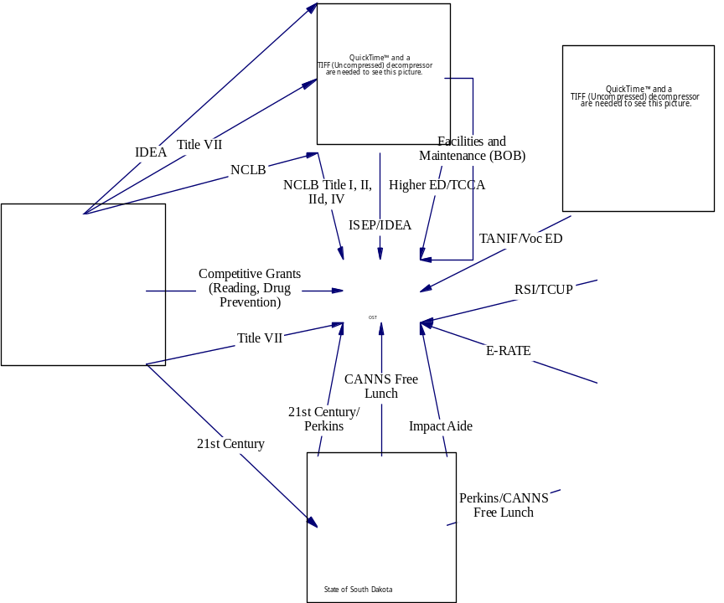

The school administration must be versed on all the Federal and State Programs, be aware of Federal legislative efforts of NIEA, NCAI, ACTS, as well as State organizations in addition to local tribal and family political and personal issues. This also means schools in the Dakotas must be accredited by the State to receive funding for lunch reimbursement which leads to a dual accreditation processes because schools want to be accredited through Regional systems that have created accreditation processes specifically for tribal schools and the State for meal funding.
In addition to the complexity of managing a tribal school setting, administrators are faced with watching large amounts of money heading to organizations who are there to "help" but who fall well short of meeting the needs of students because they are often managing grant based or contracted activities without direct input and support of tribal schools or colleges. In South Dakota we have seen millions of dollars heading to off-reservations organizations in forms of Federal grants and contracts that are supposed to assist Native students and teachers that end up providing very minimal support with very little tribal input.
This issue of how funding is sent to schools and reservations is critical as Congress sees expenditures and assumes that the money they are appropriating is getting to the people and agencies they are attempting to help. One example of a model that is being attempted in South Dakota is the Gear Up program. This program was developed as a partnership between the State of South Dakota and the OSEC schools. As is the case with all partnerships, we had challenges at the beginning but now have a solid program serving thousands of students across nine reservations. The key element to this program has been the care taken to assure that all the participating school boards were made aware of the grant requirements at the start of the grant, regular communications between the partners and the schools and a great deal of local control of grant activities. Unfortunately, this model is often the exception to the rule.
Recommendations
We would like Congress to do the following:
No Child Left Behind Issues:

1. Increase funding for development and maintenance of educational standards and associated assessment instruments for Tribally Controlled Schools as related to alternative AYP definitions.

2. Direct BIE and DOE to assure NCLB oversight to be managed at the Line Office level.

3. Direct BIE to fund OSEC Alternative Definition including development of all assessment instruments, management of AYP determination process maintenance of the assessment and determination process. BIE should provide a five (5) year plan for funding from 2008 - 2013, with budgeted amounts for subsequent 5 years (2013-2018).

4. Review and reverse unfair failing performance determinations based on a faulty BIE designed and implemented AYP determination process.

Access to Qualified Teachers

1. Fully fund Tribally Controlled College Act to ensure sufficient resources to Tribal Colleges in teacher development. The Act provided for an appropriation of 62.8 million dollars but final appropriate for this past year was 56 million dollars. This is a constant challenge for Tribal College funding.

2. Congress should create assurances that grants and contracts established to assist tribes in development of tribal faculty and administrators be given to tribal colleges, tribal organizations as a priority in funding and if given to off-reservation organizations that there is clear evidence that tribes to be impacted are involved in planning, implementation and evaluation of grant and contract activities.

Facilities and Transportation

1. Fully fund facilities maintenance so schools do not have to restrain their expenditures. Assure that Bureau facilities and maintenance appropriations are distributed to schools within 60 days of appropriation.

2. Increase appropriation for transportation to adjust to rising fuel costs and to address community transportation needs.

3. Direct the BIE to change construction requirements to reflect a 95% success rate with students and to adjust to the expanding populations of the reservations. Also, direct BIE to construct facilities that provide access to fine arts, sporting and culturally appropriate spaces.

4. Provide oversight to assure Negotiated Rulemaking process is followed for facilities and construction.

Restructuring

1. Appropriate funding for Tribal Education Departments as identified in the Tribally Controlled Schools Act and No Child Left Behind Act and to require the BIE to report regularly to Congressional Oversight Committee of their work to establish support Tribal Education Departments.

2. Provide oversight to this administration and the next administration to assure continued government to government relationships with tribes. The current BIE reorganization has created new levels of bureaucracy that impede tribes from timely access to decisions. It has also caused a near tripling in expenditures for administration of programs. Our schools are recommending removal of the Division of Performance and Accountability from the BIE organization chart and a streamlining of activity by strengthening the Education Line Offices on the Reservations. Ensure that all Education Line Officers have the proper credentials and experience in education paramount for an educational oversight position.

3. Funding for technical assistance should be kept at the level closest to tribal schools. Currently funding for assistance has been sent to the schools as part of NCLB and IDEA appropriations. This should remain as it is and tribal schools should be allowed to work with the Line Officers to determine appropriate assistance. BIE should be encouraged to allow schools to work collaboratively in their regions to establish cooperative ventures to meet technical assistance needs. Congress should provide oversight to assure wasteful programs that require extensive travel or large contracts to Universities in areas far removed from the reservations is stopped.

Appendix 1

Oceti Sakowin Education Consortium
School Membership, 2008
School | Reservation | Authority | Superintendent
Tiospa Zina Tribal School | Lake Traverse | Tribal Grant | Dr. Frank Paleria
Enemy Swim Day School | Lake Traverse | Tribal Grant | Dr. Sherry Johnson
Flandreau Indian School | Off Reservation Boarding School | BIA Operated | Betty Belkham
Marty Indian School | Yankton | Tribal Grant | Everdell Wright
St Francis Indian School | Rosebud | Tribal Grant | Larry Parker
Todd County School District | Rosebud | South Dakota Public | Dr. Margo Heinert
Crazy Horse School | Pine Ridge | Tribal Grant | (Currently Advertising)
Little Wound School | Pine Ridge | Tribal Grant | Linda Hunter
Wounded Knee District School | Pine Ridge | Tribal Grant | Marnee White Wolf
Isna Wica Owayawa | Pine Ridge | Tribal Grant | Deb Bordeaux
Porcupine School | Pine Ridge | Tribal Grant | Jerry Lessert
Takini School | Cheyenne River | Tribal Grant | Ted Roland
Eagle Butte School | Cheyenne River | BIA Operated | Sherry Farlee (ELO) / Nadine Eastman Principal
Little Eagle School | Standing Rock | Tribal Grant | Dave Archambault

The Oceti Sakowin Education Consortium also has tribal college members. These include:

Little Hoop College, Spirit Lake
Lower Brule Community College, Lower Brule
Sinte Gleska University, Rosebud
Oglala Lakota College, Pine Ridge
Appendix 2
Alternative AYP Timeline
2004
- March: Initial Meeting Pierre Indian Learning Center
- June 28: Video Conference, Standards Planning
- July: Initial Math and Reading Standards Drafted
  - Math: Dr. Eastman, Dr. Johnson
  - Reading; Chris McCoy, Rebecca Williams
- October: School boards approved OSEC AYP definition plans and authorize OSEC to negotiate with OIEP regarding adoption of alternative definition

2005

- January; 1st Draft Standards aligned and presented to OSEC membership
- January, Alert Pine Ridge Line Office of Alternative AYP definition activity
- February: Contract with Dr. Zalud and Reins from USD to provide external review of standards and to align to State and National Standards
- April Uploaded first draft to OSEC website
- May 9 Initial letter requesting technical support from OIEP
- June 27, Letter to Sharon Wells responding to letter regarding requirement for school board approval with board resolutions
- August 10 Letter to Ed Parisian
- October Ted Hamilton and Roger Bordeaux Travel to New Mexico
- November, Pat Abeyta contacts Wounded Knee District School to provide TA for alternative AYP without contacting other schools and ignoring OSEC.
- December Pat Abeyta scheduled to attend TA Meeting at LNI, does not make it to meeting. No reasons given.

2006

- January 23,Congressional Delegation Letter
- March 16 OIEP Reply to Congress indicating funds spent on NASIS system rather than assessment development
- March 28 Conference Call considering brining suit to OIEP over Safe harbor issues and discussed alternative AYP
- May School Boards send letters requesting waiver to OEIP.
- November 13, Correspondence with Pat Abeyta regarding alternative AYP thanks to interest from Tom Dowd

2007
- February 27 met with Pat Abeyta on AYP process
- May 7 Met with Tom Dowd regarding AYP agreed to submit TA request in two parts.
- June Submitted Part 1 AYP TA Request
- June 25-27 Wrote new accountability workbook with Pat Abeyta
- November 29 met with DOE/DPA/BIE staff regarding alternative AYP and was assigned JP Boudine as consultant. Requested development of a plan and budget for development of assessment

2008

- March, Submitted Assessment Development Proposal Per BIE Request
- April 8, Met with Stan Holder:
  - Told we needed tribal council resolutions to do the work
  - Proposed giving partial funding to proposal and asked that we seek money from Congress for future appropriations
  - Asked if we could combine work with Navajo Nation
  - Responded with letter to Mr. Holder April 11th
- May Informed BIE hired J.P. Boudain to provide consultation
- June Re-Submitted AYP accountability workbook (4th version)
- Aug First written response to workbook
Appendix #3
OSEC Teacher Recruitment Survey

In October of 2007 we created a simple survey to get an idea about how teacher recruiting was happening across the consortium and how many openings we were seeing. There were 13 respondents to the 18 surveys we sent out. We found some interesting things and opened up even more questions.
Two of our schools, Little Wound and Takini, are currently using an on-line service to identify potential teachers while the other schools are advertising locally in newspapers and through regional colleges. Table 1 indicates the number of opening by grade level across the schools surveyed and the number of applicants. The schools that did not use on-line recruitment had a rate of 1.2 applicants per open position.

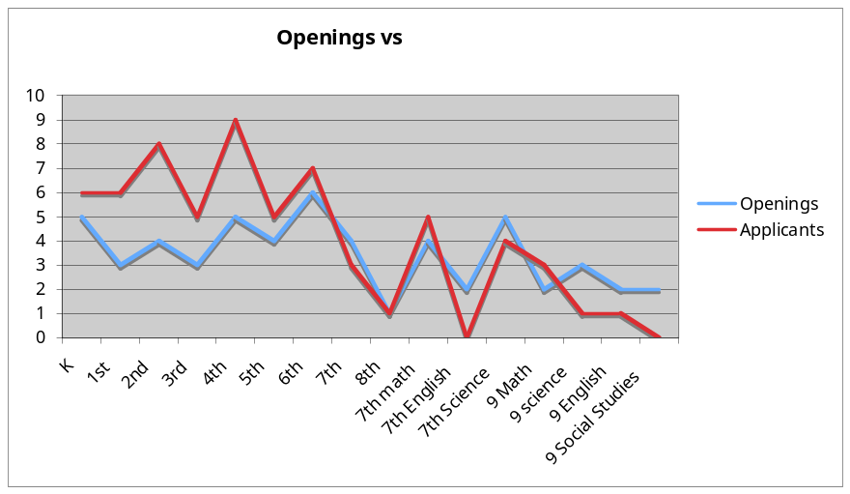

Table 1

Little Wound and Takini change the data to some degree as described in Table 2.
Takini had openings primarily in Elementary and Little Wound had High School positions. Even with on-line recruitment Little Wound was unable to fill all their positions at the High School level. On-line recruitment for two schools expanded the number of applicants to positions to 3.1. Not a large number but still larger than what we were seeing from more standard recruitment process.

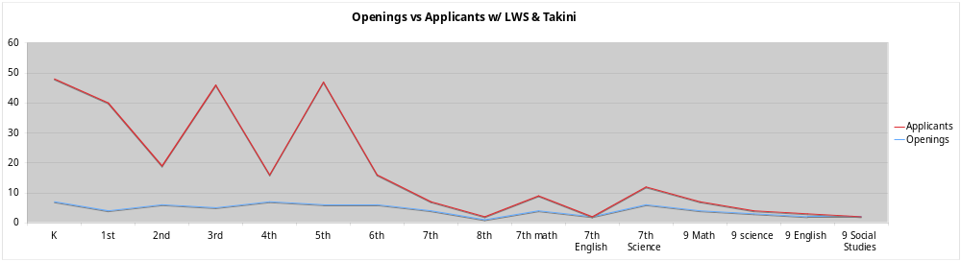
Table 2

A second issue we were looking at was who was from out-of-state and who was from in-state. With the exception of Little Wound and Takini, the rest of the schools had a rate of one out-of-state application per every 4 applications (see table 3).
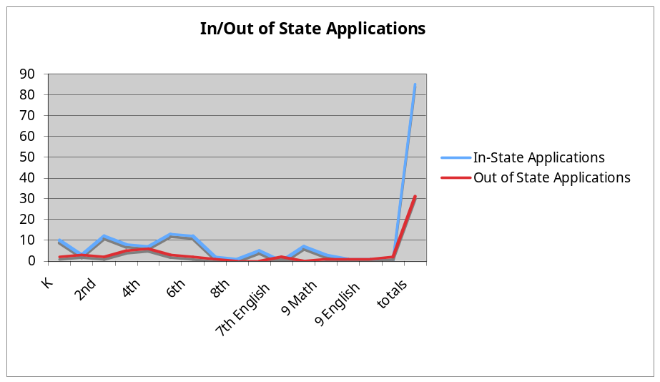
Table 3

Takini and Little Wound's data changed this figure dramatically as Takini had 30 out of state applications they found on-line and Little Wound had five or six per opening from on-line sources. Most of on-line sources are providing out-of-state placements.
We still have some questions that need to be addressed:

1. Why are some schools tracking this data and others are not? Since teacher quality is a significant issue with our schools, it would seem important to have the largest recruitment pool possible for each position.

2. We have a significant problem with secondary positions. Our colleges are not graduating sufficient secondary people, particularly in math and science, to fill the positions we have. Even positions that are traditionally easy to fill (History) are challenging on the reservations.

3. We did not ask, but one question that keeps coming up is how many applicants have already taught at a tribal school and are transferring to another tribal school?

4. Given the declining population in South Dakota and our perception that fewer and fewer students are selecting education as a career option, it seems that recruitment out of state and possibly the region is appropriate. What are the options for OSEC schools for out-of-state recruitment?

5. Given the needs for culturally based pedagogy, what will schools have to do to increase out-of-state teacher quality in the area of culturally based instruction?

Recommendations:

1. OSEC staff can conduct in-service training on on-line recruitment processes, emphasizing job boards.

2. Develop a joint openings board for the OSEC web-site to advertise openings.

3. Consider schools supporting joint recruitment efforts at job fairs

OSEC has received a bid for service from Teacher-Teacher.com. This bid would allow us to get discounts for their services. This is the service currently used by Little Wound and Takini for on-line searching.

Appendix 4

Ted Hamilton • Box 731 Kyle , SD 57772 • (605) 455-2678 • (605) 455-1659 fax • Hamilton@gwtc.net

April 10, 2008

Stan Holder, Acting Chief
Division of Performance and Accountability
1011 Indian School Road, NW (Suite 332)
P.O. Box 829
Albuquerque, New Mexico 87103

Dear Mr. Holder:

I am writing this letter under the direction of the OSEC Alternative Adequate Yearly Progress working team. As you are aware, you, Scott Westerhaus, Paula Pourier and I met on Tuesday, April 8th at the Prarie Winds Casino on the Pine Ridge Reservation to discuss the funding of development of an assessment instrument as described in the proposed alternative AYP determination accountability workbook submitted to the BIE in December of 2007. This letter is a response to the issues you brought to us through the meeting on April 8th. The composition of the working group is described in an attached attendance sheet to this letter.
In our discussion on the 8th, you began the meeting with a concern that your interpretation of the No Child Left Behind statute indicated that prior to the BIE providing funds to this process it would be necessary for the tribes involved to pass resolutions directing the BIE to authorize one tribe as the designee to receive the funding for this project. As we did not have the statute in front of us at the meeting, our group reviewed the statute on Wednesday and quote below:

Title I, Subpart 1
‘‘SEC. 1116. ACADEMIC ASSESSMENT AND LOCAL EDUCATIONAL AGENCY AND SCHOOL IMPROVEMENT.
‘‘(g) SCHOOLS FUNDED BY THE BUREAU OF INDIAN AFFAIRS.
‘‘(1) ADEQUATE YEARLY PROGRESS FOR BUREAU FUNDED
SCHOOLS.
‘‘(B) WAIVER.—The tribal governing body or school board of a school funded by the Bureau of Indian Affairs may waive, in part or in whole, the definition of adequate yearly progress established pursuant to paragraph (A) where such definition is determined by such body or school board to be inappropriate. If such definition is waived, the tribal governing body or school board shall, within 60 days thereafter, submit to the Secretary of Interior a proposal for an alternative definition of adequate yearly progress, consistent with section 1111

It is clear that our school boards have authority to waive the AYP definition and that development of the related assessment instruments under critical element 3.1 as defined in the proposed AYP Alternative definition under the guidance of Dr. Pat Abeyta from your office is a part of that process. The working group directed me to express the collective frustration and disappointment with the BIE in continuing to address this issue. Our schools sent Dr. Roger Bordeaux and myself to Albuquerque in October of 2005 to address this issue. We met with you, Dr. Abeyta, David Talayumpetwa, Lynn Lafferty and others in your office to discuss this issue. At that meeting it was decided that groups of schools could work on an alternative definition and that their school boards had the authority to do so under NCLB provisions. To now require the schools to go through the process of attaining tribal resolutions will unduly postpone the development of the assessment and is viewed by the group as a delaying action to keep the OSEC schools from completing this important work.
Based on our review of the statute, I have completed the Department of Education documentation for the process and am attaching it to this letter. We will be continuing to use Little Wound School as the fiscal agent and recipient of the funding per our discussion in December of 2007.
During our discussion of this issue and other issues on the 8th, you mentioned that you and Mr. Skenandore were supportive of this process but there were “other people” in the system who were not. Our group has directed me to ask you to provide a list of names of those who are not supportive of the development of the alternative definition and/or the associated assessment instruments. It is difficult to address concerns when we do not know who is bringing those concerns to the table and are unable to talk directly with them.
A second issue that you brought to our discussion on the 8th was a possible collaboration between the Navajo Nation and the OSEC schools in development of a combined assessment instrument. The OSEC schools do not find this an acceptable proposal and do not wish to pursue this type of collaboration for this issue. In our discussions we discussed your statements that acculturation of students has reached a point where cultural differences between tribes have been eroded and that there is a “Pan-Indian” culture developing among Native people. That because of this, the development of separate assessment instruments is not necessary and a combined instrument would allow for combined purchasing of teaching materials and testing materials.
Our group reached consensus that the concept of Pan-Indian is a result of assimilation. It is our belief that the Dakota, Lakota and Nakota speaking peoples are a unique and separate group of people in this world. We believe that the treaties with the US government recognize this uniqueness and that in keeping with the government-to-government relationship our work is to help educate our children and grandchildren to maintain this cultural perspective. It would be disrespectful on our part, and from our perspective the part of the BIE, to assume that the education of a child who is a member of the Oceti Sakowin is the same as a Dine child. We recognize and support the Navajo Nation’s right to determine their own educational standards and assessments of those standards while insisting that our communities have a right to the same. In passing the No Child Left Behind Act as it did, Congress reinforced the rights of tribes to self-determination of how their children are to be educated. It is our expectation that BIE and the Federal administration will fully fund all tribal efforts in the development of appropriate assessment instruments for those tribes that wish to do so, ours included. From our groups perspective, we see this as a closed option and direct the BIE to not pursue this line of thinking on our behalf again.
Regarding the funding amount you verbally offered us on the 8th of April. It was my understanding that we would receive 1.3 million dollars this year with subsequent funding of 1.1 million for the following two years. If I have misunderstood your offer I apologize but this is what Mr Westerhaus and Ms Pourier also wrote down. In discussing these figures with the group we found the BIE proposal to be unacceptable. I have been directed to inform the BIE that we want the full amount funded per our proposal. As you mentioned in our discussion, it is important for this project to be successful as a model for other tribes. Under-funding this process will be detrimental to its success. Our group reminded me that the BIE has been receiving 6111 funding for assessment development for at least four years. That it is our perspective that these funds have been misappropriated for use in funding the NASIS program and that the more than nine (9) million dollars spent in previous years should be made available to our group and other groups working on this issue. That the past practice of informing the Department of Education that these funds were not necessary for use in assessment development was incorrect and that BIE is responsible for correcting this error in judgment.
In the attached proposal and Federal Budget forms we are submitting we have done a slight adjustment to the funding proposal. We are planning a computer based assessment and want it clearly understood that the BIE is responsible for providing the equipment to deliver the assessment. The OSEC organization has been working with schools to improve their technology infrastructure and will continue to do so, but our schools need to have computers for students to use to take the assessment.
Our purpose for an on-line assessment is two-fold. First, the results of an on-line assessment are compiled faster. Our vendor pool indicated we could get results in less than 48 hours. This is a significant improvement over the past few years where Dakota Step results were not made available to the schools until five months after the assessment and AYP determinations were not available to schools until well into the school year. It is our perspective that BIE is out-of-compliance with NCLB due to reporting guidelines and we are hoping that a computer delivered system will help bring BIE back into compliance. Our second desire for a computer based assessment is very simply on-going cost. All three of our vendor bids indicated we would cut on-going costs by as much as 50% by using a computer delivered assessment.
One of the reasons our initial development costs are as high as they are is related to the validations necessary for a computer-assisted assessment. We will need to provide the Peer Review team the needed documentation to assure the validity, reliability and comparability of this assessment to the more cumbersome bubble sheet test process. Once we get this process started, we will create a savings for BIE in maintaining this assessment over time and should re-coop development costs in delivery savings in a three to five year period. I am placing the purchase of computer’s into the second year of the project. You indicated you would fund Year 1 out of this year’s money and Year 2 out of money allocated starting in July of 2008. We will need the computers in February of 2009 for professional development with faculty on the assessment pilots and then on-going in the process after that time. We should expect to replace the systems every 5 years.
During our group meeting, we discussed the Peer Review Process for approving our developed assessment. We are requesting that BIE work with us and the Department of Education to define our peer review team. In or initial discussions with Mr. Stevenson of DOE, we were informed that DOE selected the Peer Review team. When we discussed our desire that the Peers be Native people we were informed that DOE would select the team and that their backgrounds would not likely be Native backgrounds.
In reviewing the NCLB Act, we read the following related to the Peer Review process:

PL 107-110 NCLB
Title I, Part A, Subpart 1, Section 1111

‘‘(e) PEER REVIEW AND SECRETARIAL APPROVAL.—
‘‘(1) SECRETARIAL DUTIES.—The Secretary shall—
‘‘(A) establish a peer-review process to assist in the
review of State plans;
‘‘(B) appoint individuals to the peer-review process who
are representative of parents, teachers, State educational
agencies, and local educational agencies, and who are
familiar with educational standards, assessments, accountability,
the needs of low-performing schools, and other educational
needs of students;

In reading this section of NCLB it is our interpretation that the process would mean peer reviewers would reflect a Native American perspective. Our group will be building a list of people who we would like to have as peer reviewers. We would ask BIE to inform DOE and Mr. Stevenson that prior to the initiation of the Peer Review process we (BIE, OSEC and DOE) get together and go over a list of who will be reviewing the OSEC assessments. We will be particularly attentive to the credentials and experiences of those serving on the peer review team as they relate to familiarity with Dakota/Lakota/Nakota students.
I want to reinforce the importance of this work. As I described in our conversation on the 8th of April, the State of South Dakota has been funding the testing for BIE operated and funded schools for the past few years but is finding it more and more difficult to maintain that support. The development of this assessment and subsequent on-going maintenance will relieve the State of that responsibility and will create a process that is equitable to the State assessment for our students. It is our believe that it is the BIE’s responsibility to pay for the assessment of children in the schools funded through the BIE.
Finally, in our discussion the 8th of April, I requested a written response from the Secretary of Interior related to our accountability workbook. I have reviewed NCLB and there are not specific timelines defined in the tribal section related to this provision but in the section for state accountability workbooks it reads:

PL 107-110 NCLB
Title I, Part A, Subpart 1, Section 1111

‘‘(C) approve a State plan within 120 days of its submission
unless the Secretary determines that the plan does
not meet the requirements of this section;
‘‘(D) if the Secretary determines that the State plan
does not meet the requirements of subsection (a), (b), or
(c), immediately notify the State of such determination
and the reasons for such determination;

Since the related tribal process as defined by the law does not specify days, we are working under the interpretation that the 120 day window applies to the Secretary of Interior and his/her requirement to communicate with our organizations accountability workbook. As OSEC has been directed by BIE to submit a State Accountability Workbook and we have done so per BIE request, we will expect to hear from you in written form a response to each of the 10 sections of the workbook we have submitted.
The NCLB section that refers to the tribal process is as follows:

Title I, Subpart 1 ‘‘SEC. 1116. ACADEMIC ASSESSMENT AND LOCAL EDUCATIONAL
AGENCY AND SCHOOL IMPROVEMENT.
‘‘(g) SCHOOLS FUNDED BY THE BUREAU OF INDIAN AFFAIRS.
‘‘(1) ADEQUATE YEARLY PROGRESS FOR BUREAU FUNDED SCHOOLS.
‘‘(A) DEVELOPMENT OF DEFINITION.

. The Secretary of the Interior, in consultation with the Secretary [Education] if the Secretary
of Interior requests the consultation, shall approve such alternative definition unless the Secretary determines that the definition does not meet the requirements of section 1111(b), taking into account the unique circumstances and needs of such school or schools and the students served.

Our group would like a written response to the submitted accountability workbook by Friday, April 11th, 2008. If we must, we can wait into the following week, but will need to have a response as we are well past the 120-day response timeframe. Our group also is requesting that all proposals and counter-proposals related to funding the alternative AYP and the adoption of the alternative definition be done in writing so we can establish a proper paper trail. I appreciate your visit to Pine Ridge this week, but emphasize the importance of being able to document fully development and funding of this important work. It is an operating principle of OSEC to be transparent and open in all negotiations and I expect that we can continue in this fashion working with BIE on this project and other projects into the future.
It was good to see you this week.

Take Care,

Ted Hamilton
Executive Director

Cc: Gay Kingman, Aberdeen Area Tribal Chairman’s Association
Roger Bordeaux, ACTS President
Lesley Kandaras: Representative Stephanie Herseth
Elli Wicks: Senator Tim Johnson
John Thune
Mary Helen Kramer, Navajo Education Department of Education

