Bureau of Land Management
Nevada

Student Educational Employment Program

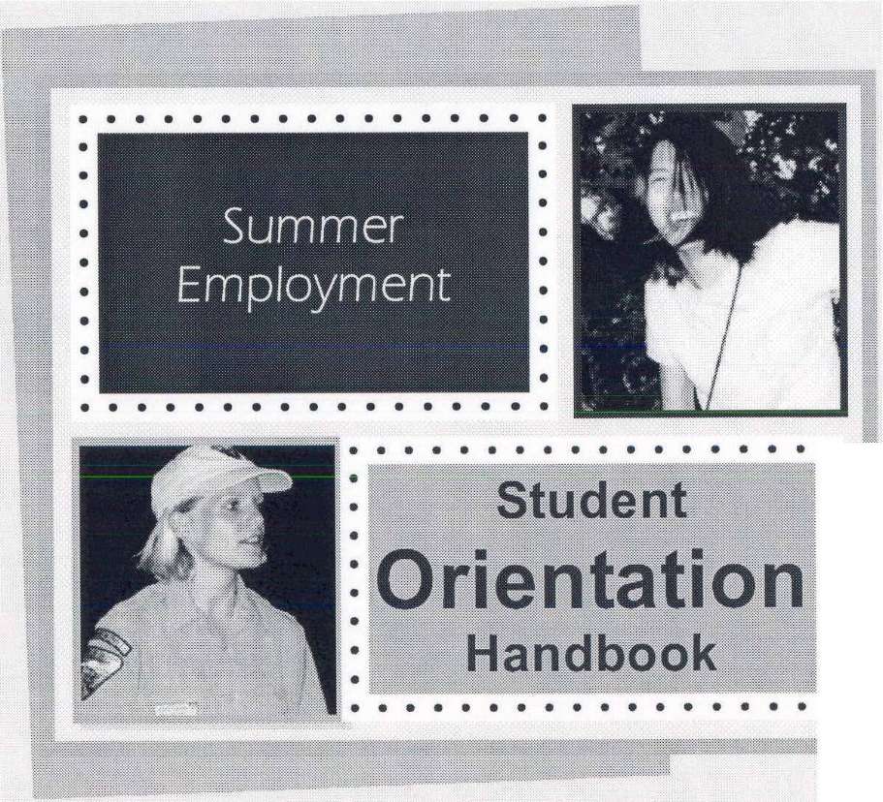
Branch of Human Resources


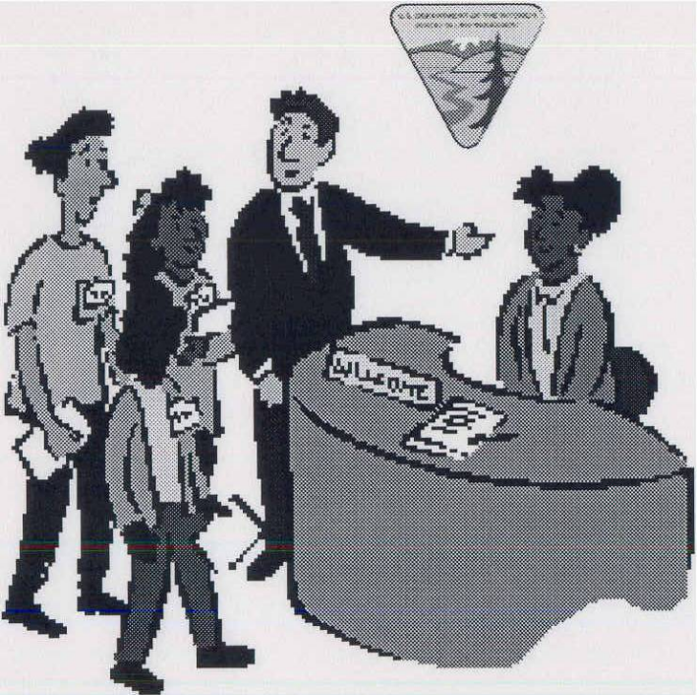

Welcome

to the

Bureau of Land Management in Nevada!
Table of Contents:
About BLM . . .
Your Employment . . .
Your Work Schedule
Showing up and Being at Work
Getting Paid
Leave Benefits
Holidays
In the Workplace . . .
What Should I Do?
Phone Etiquette
What to Wear
Surfing the Net
Sending Email
Important Things to Know
Program Evaluation
Equal Employment Opportunity
Student’s Evaluation
About BLM . . .

Check out the following internet and intranet sites to learn more about the Bureau of Land Management, its history, its mission, the organization, facts and figures and more.

  - www.nv.blm.gov - Internet

  - www.nv.blm.gov - Internet

  - web.nv.blm.gov – Intranet

NOTE: Before surfing the internet, be sure you read the section of this handbook on “Surfing the Net”. Discuss with your supervisor if you have any questions.
Your Employment . . .

Your Work Schedule

Showing Up and Being at Work

Getting Paid

Leave Benefits
- Annual Leave
- Sick Leave

Holidays
Your Work Schedule

BLM offers a flexible work schedule. Talk with your supervisor and set up a work schedule that accommodates the workplace and tasks you will be assigned, as well as your academic school schedule. Each office and supervisor has different needs; therefore students’ work schedules will also vary.

Starting Time: ____________________
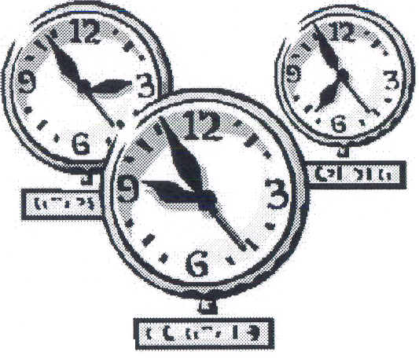

Morning Break*: 15 minutes

Lunch**: Varies (usually 30 minutes)

Afternoon Break*: 15 minutes

Quitting Time: ____________________

* Breaks: - You are entitled to one 0.15 minute morning and one 0.15 minute
afternoon break if you are working a traditional 8 hour shift.
- Breaks are paid time off.
- Be sure you notify the supervisor when you are leaving the workspace to

take a break.
- You may not save your break time to extend your lunch or leave earlier in
the day.

**Lunch: - You are required to take at least 30 minutes for lunch.
- Lunch breaks are unpaid time off.
- Be sure to discuss and arrange with the supervisor an
appropriate time for taking your lunch and for how long.
- Be sure to notify your supervisor when you are leaving for your
lunch break.

Showing Up and Being at Work

You are expected to be at work each day you are scheduled, and to arrive on time.


First thing in the morning:
- If you are running late for work, call your supervisor within one hour from when you are supposed to start work.
- If you are sick call your supervisor within one hour from when you are supposed to start work.
- If you have an unexpected emergency, call your supervisor within one hour from when you are supposed to start work or as soon as possible.

NOTE: Be sure you talk with a person – do not just leave a voice mail message.

During the day:
- If you are sick and must go home let your supervisor know.
- If you have an appointment (i.e. doctor) during the day, let your supervisor know as far in advance as possible.
- If you have an errand to do during lunch, and you expect to be gone longer than your usual lunch period, let your supervisor know. Discuss leave options to be taken during the lunch period with the supervisor.

One day, two days, weeks ahead of time:
- If you have a pre-arranged engagement, let your supervisor know as far in advance as possible. Discuss leave options to be taken for the engagement with the supervisor.
- See the section on Leave Benefits for more information.

Getting Paid

As an employee in the federal service, you are paid once every 2 weeks. This 2-week-period is referred to as a pay period, which begins on a Sunday and ends on a Saturday.


How much do I get paid per hour?
Generally, a high school student with no work experience is paid at the salary level equivalent to a GS-01. This year, in Nevada, the annual salary for a GS-01 is $17,328. The hourly rate is $8.30.

Time and attendance information:
At the end of every pay period, you must complete an electronic Time and Attendance Sheet (T&A) detailing the time you worked each day. Be sure to confirm with your supervisor how they want you to annotate your time.

When do I get paid?

It is important to know that before you receive your first pay check, you must first work one pay period; meaning you will receive the first pay check in the second pay period after your start date.

Thus, your first payday will be 14 days after the close of the first pay period in which you began work.

Your paycheck is directly deposited to your bank account. It should be posted to your account on the Tuesday after the end of the previous pay period. Contact the bank or make use of your banks online services to ensure that your paycheck was received.

Leave and earnings statement:
Each pay period you will receive in the mail a Leave and Earnings Statement (LES) showing your gross pay for the pay period, the amount of each kind of deduction, your net pay, your current year gross earning to date, and other important information. The LES also shows the amount of annual and sick leave earned, used, and available, as well as any other type of leave that you may have used. You are responsible for reviewing the LES to ensure the data is correct.

Contact your servicing Human Resources staff to correct any errors.

Deductions from your pay:
Some deductions are required by law and others are authorized by you. Common deductions include:
    - Taxes – Federal and State taxes are withheld from your gross pay. At the end of the year, you will receive a W-2 Statement of your earnings and the amount of taxes withheld for use in preparing your annual income tax return.
    - Social Security – required by law
    - Medicare – required by law
    - Health care insurance (if enrolled) – you authorize
    - Life insurance (if enrolled) – you authorize
    - Retirement / TSP (if enrolled) – you authorize

If any questions about deductions you observe from your pay, may be discussed with your supervisor, Field Office/Field Station administrative support assistant, or the Branch of Human Resources at (775) 861-6431.

Leave Benefits

Annual Leave:
Annual leave (also known as vacation) is provided for each BLM employee who has an established tour of duty or work schedule and whose appointment is for 90 days or longer. The use of annual leave is charged in increments of 15 minutes.

Full-time employees earn annual leave each pay period in increments of 4, 6, or 8 hours, depending upon the total years of federal service. With less than 3 years of federal or creditable military service, you will earn 4 hours of annual leave every pay period or every 2 weeks.

Part-time employees earn annual leave based on the number of hours worked. With less than 3 years of service, you will earn 1 hour of annual leave for every 20 hours you work in a pay period.

Annual leave may be used for:

- Coming to work late
- Running personal errands that can’t be done during lunch break
- Taking an extended lunch break
- Taking 1 or 2 hours off
- Taking a day-off
- Taking a vacation
- Non-medical appointments
- For supplementing sick leave as necessary

Simple rules for using annual leave:
- Request for leave must be submitted to and approved by your supervisor.
- If an emergency requires you to be away from work without prior approval, you must notify your supervisor as soon as possible on the first day of your absence.

If you have any unused annual leave, you will be paid a lump sum at your current hourly pay when your temporary job ends or upon resignation/termination.

Sick Leave:
Sick leave is provided for each BLM employee who has an established tour of duty or work schedule. The use of sick leave is charged in increments of 15 minutes.

Full-time employees earn 4 hours of sick leave every pay period.
Part-time employees earn 1 hour of sick leave for each 20 hours of duty.
Sick leave may be used for the following purposes:
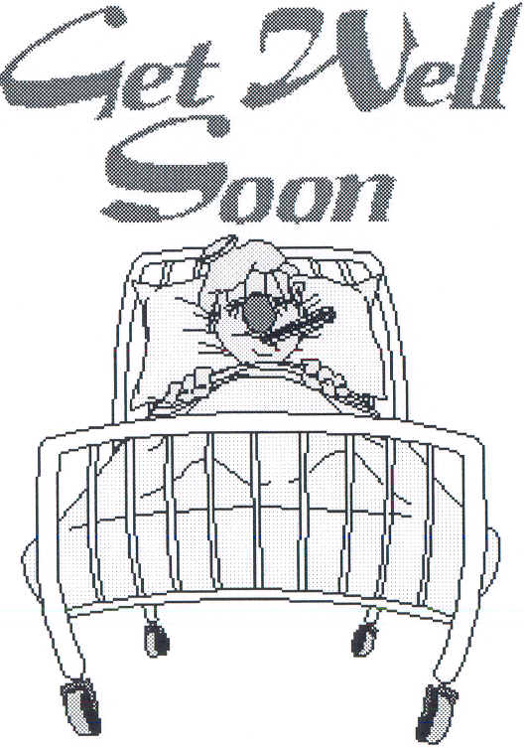
- You are sick.
- You are injured.
- You have a medical, dental or optical appointment.

Simple rules for using sick leave:
- Use sick leave for the proper reasons.
- Sick leave cannot be used to supplement annual leave.
- If you are too sick to work, notify your supervisor within 1 hour of the time you are scheduled to report for duty.
- Inform your supervisor in advance when you want to use sick leave for medical, dental or optical appointments.
- Submit a medical certificate signed by your doctor for a period of sick leave that last for more than 3 days, or if requested by your supervisor, for any sick leave.

If you violate any of these rules, you may be charged Absent Without Leave (AWOL) rather than sick leave and will not be paid for those hours.

Leave Without Pay:
Leave Without Pay (LWOP) may be granted under certain conditions when your annual leave or sick leave is used up and without undue interruption to the work of BLM. A request for LWOP must be for personal reasons, illness or for other reasons that are in the interest of the government such as for educational purposes and it must be in writing.

Absence Without Leave:
If you are absent from work without approved leave, (annual, sick or leave without pay) you are considered to be Absent Without Leave (AWOL). You receive no pay for this unauthorized absence. The AWOL may also result in a disciplinary action such as termination or suspension from your position.

Other types of leave:
Contact the Branch of Human Resources for more information, at 775-861-6431.
- Administrative Leave
- Family and Medical Leave Act (FMLA)
- Federal Employees Friendly Leave Act (FEFLA)
- Funeral Leave
- Court Leave

Holidays

The following holidays are observed in the federal service:

New Year’s Day January 1

Martin Luther King, Jr.’s Birthday 3rd Monday in January

Presidents’ Day 3rd Monday in February

Memorial Day Last Monday in May

Independence Day July 4

Labor Day 1st Monday in September

Columbus Day 2nd Monday in October

Veteran’s Day November 11

Thanksgiving Day 4th Thursday in November

Christmas Day December 25

When your regular tour of duty falls on a holiday, you will be paid at your regular pay rate, as long as you were in a pay status either the day before or the day after the holiday.
In the Workplace . . .

What Should I Do?

Phone Etiquette

What to Wear

Use of Government Equipment

Surfing the InterNet

Sending Email

Other Important Things to Know

Equal Employment Opportunity

What Should I Do?

- Take initiative
Ask what you can do.


- Ask for clarification of assigned tasks
Make sure you understand what is expected of you.
Make sure you understand the assignment.

- Be prompt
If you are unable to meet the deadline, discuss it with the supervisor or designated staff person who gave you the assignment.
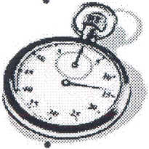

- Be thorough
Check and double-check your work.

- Be a self-starter
Don’t wait for an assignment.

- Show responsibility

- Act and conduct yourself professionally

- Dress professionally


Phone Etiquette

Ring-g-g-g
- Answer the work phone within 3 rings.
- When answering the work phone, be sure to identify your office, then identify yourself:
- “Human Resources, this is Sue.”
- “Human Resources, this is Sue. May I help you?”
- “Human Resources, this is Sue. How may I direct
your call?”
- Ask your supervisor how he/she would like the phone
answered in your office.

Taking messages:
- Who’s the phone call for?
- Name of caller – have caller spell name, if unsure
- Agency or company of the caller
- Phone number with area code – repeat it back to caller
- Brief message about the call
- Your name, date and time
- Promptly deliver messages

Calls forwarded to your phone:
Usually this happens when an employee is not at his/her desk to answer his/her call. The voice mail usually indicates for the caller to press zero if immediate assistance is required. So when this happens, the caller may say, “I was trying to get in touch with Joe but he’s not at his desk and I wonder if you can help me or if you could direct me to someone that could.”

- Assist the caller, if you can.
- If you are unable to assist the caller right away, get the caller’s name and phone number and have someone from your office/supervisor return the call.

Voice mail:
Most office phones are equipped with voice mail. If you have a voice mail, keep the message current:
    - “Hi, this is Jane. I am sorry I can’t take your call but please leave me a message and I will return your call as soon as possible. If you would like immediate assistance, please press zero. Thank you and have a great day!”

    - “Hi, this is Jane. I will be out of the office from Monday, April 12 returning on Wednesday, April 14. Please leave me a message and I will return your call when I get back. If you would like immediate assistance, please press zero. Thank you and have a great day!”

    - Hi, this is Jane. I’ will be out of the office from Monday, April 12 returning on Wednesday, April 14. If you have questions on _______, please contact Sue at extension ________ or leave me a message and I will return your call when I get back. If you would like immediate assistance, please press zero. Thank you and have a great day!”

* Voice mail is intended to take messages while you are away from your desk,
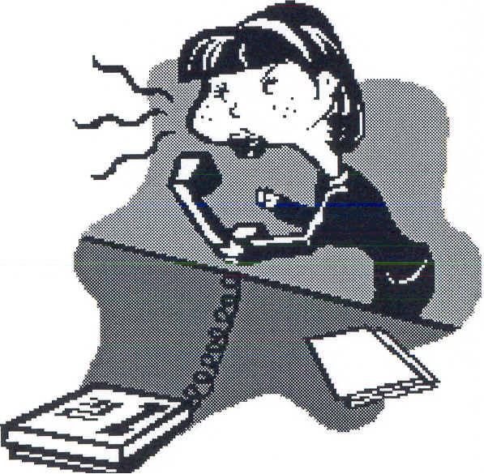
not for screening phone calls.
* These calls must be promptly returned, usually within 24 hours.
* Instruction Memorandum No. NV-2004-032 dated February 20, 2004.

Transferring phone calls:
When transferring a phone call, give the caller the extension of the
person/office you are transferring the call to in case the call is
disconnected in the process.

Putting calls on hold:
Do not leave any caller on hold longer than one minute. If you are not able to assist the caller right away, take the caller’s name and phone number and call them back as soon as possible.

Also, let the caller know that you or someone else will call back if you are not able to provide the assistance they need.

Rude phone calls:
Calmly ask the caller if he/she would like to speak to your supervisor. If so, let the caller know you are putting him/her on hold while you let your supervisor know or while you transfer the call.

Personal Calls:


Personal calls are allowed only on a limited basis.

Always be polite and courteous during any personal phone call. ☺

Instruction Memorandum No. 2001-093 dated 02/13/01 spells out the agency’s Policy on Limited Personal Use of Government Office Equipment and Telephone Use.

What message are you sending when . . .
- You answer the phone promptly? You make a favorable first impression.

- You say “BLM” or use office acronyms? You come across as cold and bureaucratic.

- You use your name? It makes the caller feel more relaxed.

- You add an appropriate greeting such as “good morning”? You send a cheerful message.

- You end your call by saying “goodbye” or “have a good day”? You make the last note of conversation cordial and pleasant.

- You let your caller know you were glad to be of service or that you are sorry you were unable to help? You convey willingness to serve.

- You use courteous phrases. You send a smile over the telephone. Phrases such as thank you; you’re welcome; I’d be glad to help you; or please call back if I can be of further assistance.

- You have sunshine in your voice? You send a positive impression of both you and the agency.
* Positive impressions lead to positive attitudes and a more positive work
environment.
* Attitudes are contagious.

* Little things make a BIG difference.
What To Wear

Summer is warm and a beautiful time of the year. However, keep in mind the following when preparing and dressing for the workplace environment:

The Overall expectation is . . .

You must be appropriately groomed and dressed for the office.

Check out the normal pattern of dress in your office by observing what your fellow co-workers are wearing.

Suggestions – DON’T Wear:
    - Cut offs
    - Short shorts

    - Clothing with messages about alcohol, tobacco, drugs or foul language printed on them.
    - Skimpy outfits
    - Short shirts where midriff is exposed
    - Flip flops or thongs

If and when in doubt, check with your supervisor!


Use of Government Equipment

Office equipment such as phones, fax machines, computers, copiers, scanners, and more are government properties.

- They are to be used for conducting government business.

- Use care when using them.

- Ask if unsure how to operate any equipment.


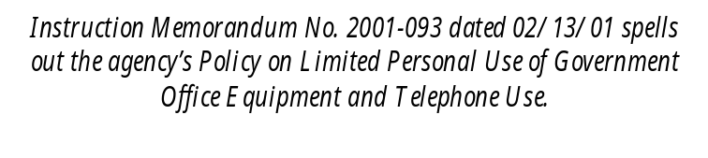
Surfing the InterNet

BLM has specific policies on the use of the Internet and electronic mail.
Please read it carefully and discuss it with your supervisor.

Instruction Memorandum No. 2002-224 dated
August 9, 2002 - Internet Use

Information Bulletin No. 1997-001 dated May 23, 1997 and June 13, 1997 – Internet Acceptable Use Policy

Sending Email

Important Things to Know

What Who to call, talk to, inform, etc.

Job Injuries Supervisor
Branch of Human Resources, 775-861-6605

Safety Concerns Supervisor
State Safety Officer, 775-861-6405

Building Security Supervisor

Building Evacuation Supervisor (ask to provide you a copy)

Employment Questions Supervisor
Branch of Human Resources, 775-861-6547

Discrimination State EEO Office, 775-861-6584

NOTES: Questions about the topics above should be discussed with your supervisor first. Your supervisor can assist and guide you in the appropriate process.

If you are unsure, do not understand, or do not know the office’s policy or BLM’s policy on issues, check with your supervisor or contact the additional resources provided by phone.

If you are unable to obtain information, guidance, or clarification to your questions or concerns, contact the State Recruitment Specialist / Student Educational Employment Program Coordinator at 775-861-6547.
Equal Employment Opportunity

The Equal Employment Opportunity (EEO) is an important goal of the Federal government, and a variety of laws and policies impact every Federal employee – regardless of grade, position, or how long you have been with the agency. The objectives of the EEO program are straightforward:

The first is to provide a full and fair opportunity for all employees, regardless of race, age, religion, sex, color, national origin, or handicap.

The second is to provide a non-discriminatory treatment of all employees carrying out their duties.

State EEO Office
Contact the EEO Office if you feel you have been discriminated against at
775-861-6584.

Branch of Human Resources
Contact the State Recruitment Specialist / Student Educational Employment Program Coordinator if you have other concerns that you are not able to discuss with your supervisor at 775-861-6547. The State Recruitment Specialist / Student Educational Employment Program Coordinator have all program responsibilities regarding any student employment.



BLM is an Equal Opportunity Employer

