

U.S. DEPARTMENT OF ENERGY
Energy Storage & Power Electronics
Systems Research Program
(DOE / ESPE)

DOE / ESPE
PROJECT REPORTS – FY2008
(Fourth Quarter)
Produced By:
Energy Storage & Power Electronics
Systems Research Program (SNL / ESPE)

Sandia National Laboratories
Albuquerque, NM

Table of Contents (Click on to return to this point)

Advanced Power Converter System Using High Temperature, High Power Density, SiC Devices 4
High Power Density (100KW), Silicon Carbide (SiC), Three-Phase Inverters 7
Development and Validation of Advanced Energy Management Control Algorithms for Short- or Long-Term Energy Storage 10
Advanced Power Devices and Converters 12
NMSU Capstone Senior Design Project 15
Scale Model Demonstration of Storage in Customer Driven Microgrids 17
East Coast Distributed Grid 19
Emerson Network Five-Tier Grid Stabilization 20
Emerson Network Power Fuel Cell Implementation 21
Emerson/Sprint Race to Failure Thermal Management 22
Emerson/Sprint Thin Film PV Project 24
Distributed Energy Systems 450 kW Ultracapacitor (EnergyBridge™) Demonstration at Palmdale CA Water Plant 25
EPRI and DUA Data Collection and Economic Analysis 27
Hydraulic Water System (Nereus) Generation Evaluation 28
PGE Sodium Sulfur Battery - Substation Upgrade Deferment 30
SMUD/RT Trackside – Ultracapacitor Energy Storage 31
SMUD/Sprint 20 kW Vanadium Redox Battery (VRB) 32
Zinc Bromine Battery (ZBB) 1 MWh Energy Storage Demonstration 33
20 MW FESS Facility Construction 35
Superconducting Flywheel Development 36
Development and Evaluation of Carbon-based Devices for Energy Storage Applications 38
Ni-MH Bipolar BESS Development 39
Dynamic Islanding for Improving Electric Service Reliability with Energy Storage 40
Project Pictures / Graphs / Tables: 41
Carbon-Enhanced Lead-Acid Battery and EC Testing 42
Iowa Stored Energy Park 44
NYSERDA / DOE – Joint Energy Storage Initiative: Advanced Sodium-Sulfur (NaS) Battery Energy Storage System (BESS) Project at MTA Long Island Bus 46
NYSERDA / DOE: Dispatchable Photovoltaic System with Electric Energy Storage for Commercial Buildings in NYC Area Network 49
NYSERDA / DOE: 300 kW / 900 kWh Gaia Power Technologies BESS for Peak Shaving and Substation Upgrade Deferral 50
NYSERDA / DOE: Long Island RR Trackside FESS 52
EPRI / DOE Energy Storage Handbook – Wind Applications Supplement 54

Advanced Power Converter System Using High Temperature, High Power Density, SiC Devices
Date Project Began: | FY2006
Date of This Project Report: | July – September 2008
Sandia Project Manager (PM): | Stan Atcitty
Contractor: | Aegis Technology Inc. (Aegis)
Partner(s): | University of Tennessee, Amerigon Inc., Hamilton Sundstrand, Ceradyne
Project Description
In this DOE STTR project, Aegis Technology is to design and demonstrate a SiC-based inverter system, addressing related technical issues and illustrating system benefits. The resulting SiC inverter will be capable of working at high power densities, high temperatures, and high frequencies; thus, achieving the advantages of high efficiency, small size, and light weight.
In Phase I, Aegis carried out the feasibility study of the proposed SiC inverter, including design, modeling, and prototyping. The modeling on one SiC inverter design for energy stoarge applications has shown dramatic reductions in power loss (2-3 times) and heatsink size (5-10 times), compared with a Si-based inverter. A six-packed, SiC power module (1200 V, 14 A), an AlN high-temperature package, a graphite foam heatsink, and a gate drive based on IXYS-chip were also demonstrated.
Currently, Phase II research is demonstating, modelling, and characterizing a scaled-up SiC inverter. The research work covers:
- Circuit design and modeling to evaluate the effects of SiC devices on the inverter system in both device-level (e.g. junction temepratures) and system-level (e.g. energy efficiency, size) configurations;
- Development of high temperature packaging, gate drive, and other ancillary devices;
- Construction and characterization of a SiC inverter; and
- Technical/economical analsyis of this system and technology transfer for commercial applications.
Key Project Events
Key project events or tasks in this Phase II project include:

- DC-AC inverter design.
- Power module design and prototype.
- Packaging and thermal management.
- Gate drive/control design and prototype.
- Modeling and characterization.
- Inverter prototype and testing.
- Commercialization.

Project Status
So far, in this ongoing project, we have accomplished the following tasks:
- DC-AC inverter design.
- Power module design/prototype.
- Packaging/Thermal management.
- Gate design/prototype.
- Modeling/characterization.
- Preliminary inverter prototype/testing.
- Preliminary commercialization.

Before constructing a full-size inverter, Aegis is first constructing and characterizing a 5 kVA DC-AC inverter, and then will sclae the design up for a 25 kVA SiC inverter. In this reporting period, the work accomplished includes: (1) testing and characterization of the inverter in a motor drive system; (2) design/fabrication of a second inverter prototype; and (3) design of a scaled-up inverter of 25 kVA DC-AC.

The work to be carried out in the next reporting period:

1) Continue test and characterize the inverter in a motor drive system;
2) Build and characterize the second inverter;
3) Design a scaled-up inverter of 25 kVA that can be interfaced with DC sources.

Project Pictures / Graphs / Tables
Fig. 1 shows the measured turn-on/off waveforms of he SiC JFET power modules (being used in the inverter prototype) with and without anti-parallel diode. The turn-on and turn-off time measured is approximately 80ns and 100ns, respectivley. It is found that the parasitic diode of SiC JFET has a very large reverse recovery current when no anti-parallel diodes are present. When an anti-parallel SiC diode was used, the reverse recovery characteristics were greatly improved. Therefore, it is necessary to incorporate a SiC, anti-parallel diode with SiC JFET for fast recovery.
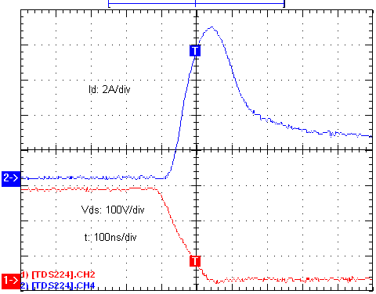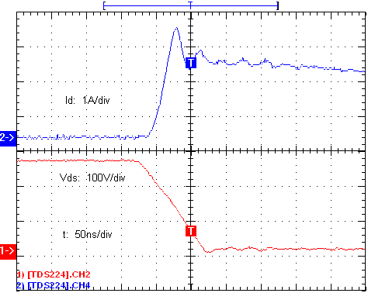
(a) (b)
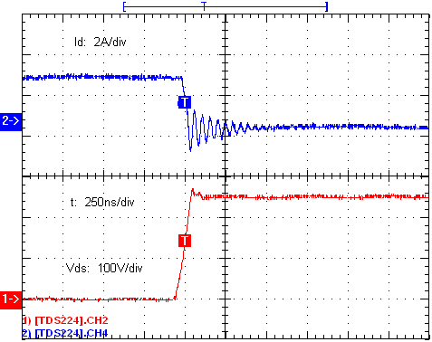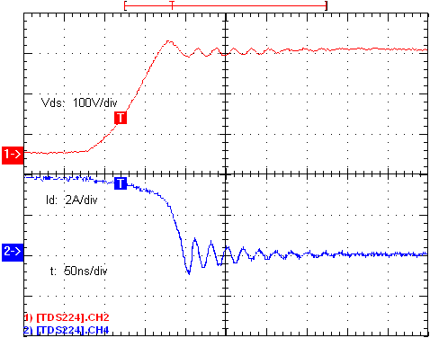
(c) (d)

Measured SiC JFET turn-on/off waveforms. (a) Turn-on waveforms without anti-parallel diode; (b) Turn-on waveforms with anti-parallel diode; (c) Turn-off waveforms without anti-parallel diode; (d) Turn-off waveforms with anti-parallel diode.

High Power Density (100KW), Silicon Carbide (SiC), Three-Phase Inverters
Date Project Began: | August 2006
Date of This Project Report: | July - September 2008
Sandia Project Manager (PM): | Stan Atcitty
Contractor: | Arkansas Power Electronics International, Inc. (APEI)
Partner(s): | GeneSiC Semiconductor, Inc. (GeneSiC)
Project Description:
With worldwide energy consumption becoming an epidemic and the future need for power conservation self evident, the improvement of power conversion systems and the reduction of energy waste has become a global priority. Silicon carbide (SiC) electronics have a wide range of advantages over standard silicon devices, including high temperature operation, increased efficiency, and increased frequency of operation. While silicon is limited to approximately 150 °C as the maximum operational junction temperature, SiC is, theoretically, operational to temperatures in excess of 600 °C.
The DOE Energy Storage System group awarded a Phase II SBIR to APEI on August 7, 2006. Phase II, scheduled to end on November 6, 2008, is a continuation of the Phase I work. The overall objective of Phase II is to develop high efficiency, compact, silicon carbide (SiC) power converters capable of operation at high junction temperatures. The “proof of feasibility” of such a power converter was demonstrated in Phase I by building and testing a single-phase 3kW SiC power inverter. In Phase II, APEI will take the concepts demonstrated in Phase I and develop a fully-functional, multi-purpose, three-phase, SiC-based, DC/AC power converter prototype for solar panel applications, which would significantly improve performance, efficiency, and reliability. This technology could be implemented in a wide range of power converter applications and has the potential to save billions of dollars annually in otherwise wasted energy.
Key Project Events:
APEI will present the project results and findings at the annual DOE peer review meeting on September 30, 2008, in Washington D.C.
Project Status:
During this quarter, APEI fabricated a 10 kVA, three phase, SiC inverter (Figure 1). After fabrication, the three phase, SiC inverter was fully characterized under various load conditions. Comparison studies between the SiC inverter and its Si counterpart developed in the previous quarter have been carried out. The power stage was fabricated using SiCED’s 1200V/15A 5 mm² VJFET’s. A key characteristic of this module is its high temperature operating capability (up to 300 °C).
After assembly, several tests were carried out aiming to confirm the theoretical electrical and thermal performance of the SiC inverter prototype. Figure 1 shows the fully assembled, three phase SiC inverter, including the filter components. Efficiency characterization studies and improvements were the main focus of the research effort during this quarter. The SiC inverter efficiency performance results were compared to the equivalent Si based inverter developed tested and characterized during the previous quarter.
Efficiency measurements were carried out under different loading conditions with a 600 VDC 10 kHz switching frequency for both the Si and SiC three phase inverters. Figure 2 shows the efficiency curves of the two modules. The SiC inverter showed a higher efficiency at higher power levels.
The efficiency results reflect the expected benefits of the more efficient SiC power devices when compared to similarly rated Si devices. Detailed comparisons between the 1200V Eupec BSM50GD120DN2 IGBT devices with the selected SiC JFETs was conducted to determine some of the contributing factors in the difference of efficiency between the two systems. The lower resistance and faster switching times of the SiC devices are factors that contribute to the overall high efficiency of the SiC based power inverter module.
Thermal characterization and model validation began this quarter. Thermal characterization of the SiC three phase inverter is crucial for future calculations of cooling requirements. APEI has begun a series of thermal characterization test to determine the thermal resistance from the die to the heat sink. The test results will be used to validate/calibrate existing thermal models developed by APEI. Figure 3 shows a thermal image of the three phase SiC inverter modules operating at 10 kW and at 600 VDC bus. As noted in Figure 3, there is approximately 28 °C difference between the top of the die and the heat sink. Preliminary comparisons to existing models show agreement within +/- 3 ˚C for the measured and simulated results. The simultaneous study of thermal phenomena and efficiency performance will provide vital design space constraints to determine optimal trade-offs between the two parameters. The final objective is to obtain the optimal power density and efficiency compromise.
Progress for Next Quarter
During the next quarter, thermal characterization and model validation will be completed. The thermal performance of the SiC inverter will be evaluated to determine the best efficiency and power density compromise. High power density studies will enable APEI to extend the technology-to-weight sensitive applications, such as hybrid electric and fully electric vehicles. Finally, advanced control strategies utilizing space vector modulation will be implemented to increase the overall efficiency of the SiC inverter module.
Project Pictures / Graphs / Tables:

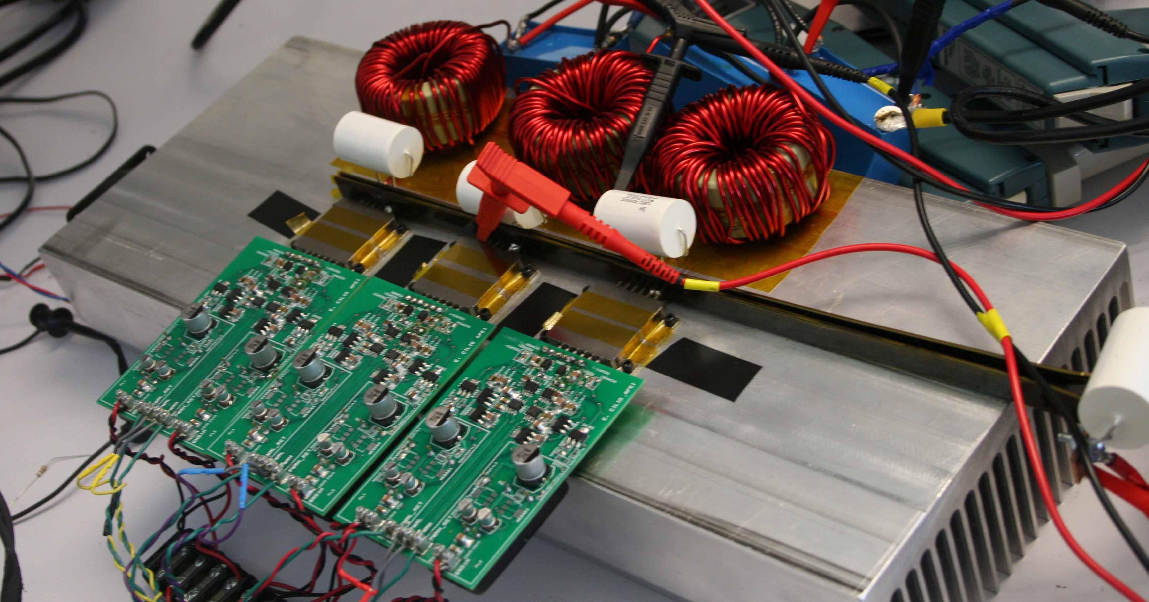
Figure 1. Fully assembled 10 kVA three phase SiC inverter.
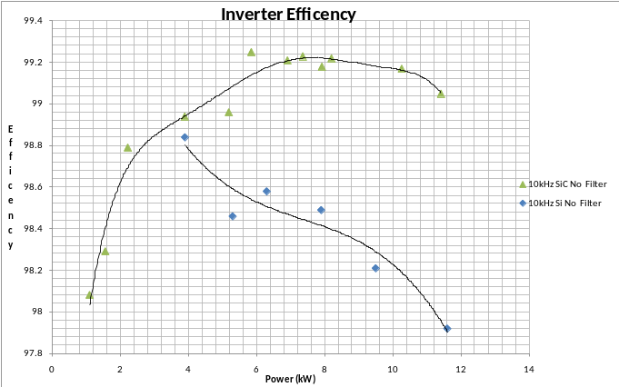
Figure 2. Si and SiC power stage efficiencies.
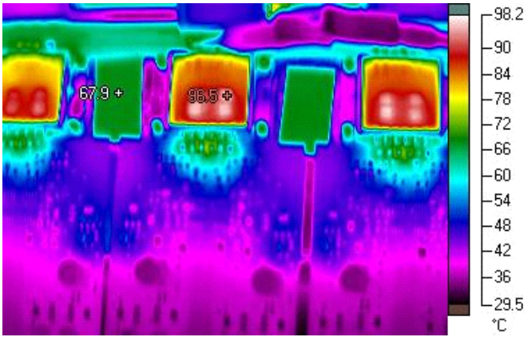

Figure 3. Thermal image of APEI, Inc.’s SiC three phase inverter operating at 600 VDC and 10 kW.

Development and Validation of Advanced Energy Management Control Algorithms for Short- or Long-Term Energy Storage
Date Project Began: | November 2007
Date of This Project Report: | July - September 2008
Sandia Project Manager (PM): | Stan Atcitty
Contractor: | Missouri University of Science & Technology
Partner(s): | North Carolina State University
Project Description:
From previous support, the Missouri University of Science & Technology (MST) has developed a Hardware-in-the-loop (HIL) test-bed that mimics the electric power grid. This laboratory will be used as a basis to develop the basis for a plug-and-play microgrid.

The current project focuses on characterizing different load types, resources, and configuration of a mid-sized distribution system, development of a computer model of a power-electronics-based microgrid, development of formal security models, superimposing the control nodes on a microgrid, developing theories and interface models for cooperating power electronics devices, and development and testing of distributed energy management strategies.
Key Project Events:
- Multiple FACTs device operation was successfully validated on the HIL test-bed.
- Open-loop offset time control for current management was experimentally validated on the proposed EC and battery converter topology
- The right-shunt UPQC converter design was completed
- An applicable ETO-based Distributed Power Flow Controller was first proposed and the pre-phase controller of DPFC will be designed and verified.

Project Status:
ongoing

Project Pictures / Graphs / Tables:
The proposed Distributed Power Flow Controller has an H-bridge based ETO light converter, modular controller, and communication links. Unlike conventional solutions, it connects to the power line directly (without transformer) because of its high voltage and current capability. The rating of the ETO light converter (1-2 MVA) is suitable for typical 138kV-500kV power transmission line applications. Fig. 1 shows the concept diagram of the Distributed Power Flow Controller.

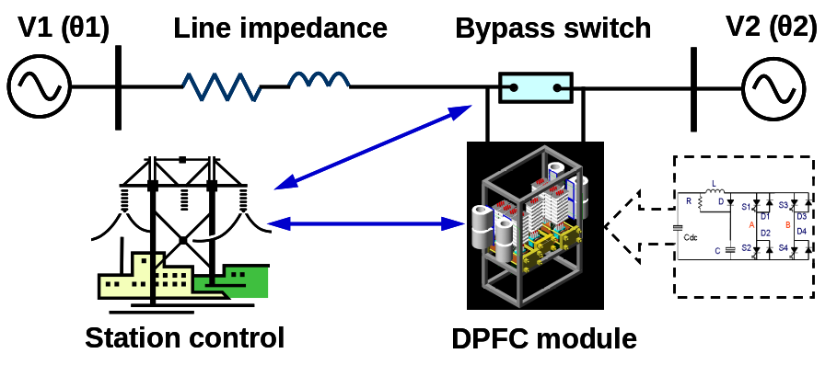

Fig.1 Proposed Distributed Power Flow Controller for transmission system

In order to verify the functions and operations of the Distributed Power Flow Controller, a two-machine one-bus system is introduced. The control diagram and specification are shown as Fig. 2.

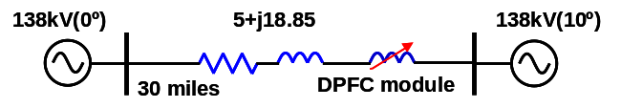
Line to line voltage of generator 1 (kV) | 138
Voltage phase of generator 1 | 0
Line to line voltage of generator 2 (kV) | 138
Voltage phase of generator 2 | 10
Line impedance of 30-mile line(ohm) | 5+j18.85
Line current (A) | 870
Switching frequency (Hz) | 1020
DC voltage of total converter (V) | 2500
Injection voltage | 2%
Simulation time (seconds) | 0.8
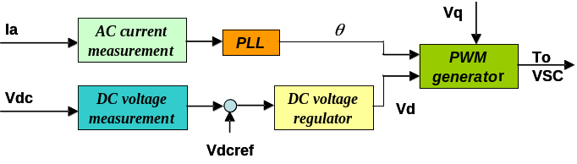

Fig.2 DPFC system simulations

Advanced Power Devices and Converters
Date Project Began: | November 2007
Date of This Project Report: | July - September 2008
Sandia Project Manager (PM): | Stan Atcitty
Contractor: | North Carolina State University (NCSU)
Partner(s): | Bonneville Power Administration, EPRI, TVA, Tri-City Electric Company, and Florida State University
Project Description:
With the support of DOE’s Energy Storage Program, the Gen-4 ETO (Light Triggered ETO) has been developed. Its application in DC applications, such as a VSC converter, has been studied in the previous quarters. ETO is also an excellent switch for AC applications; an example of this is the solid state circuit breaker (SSCB). FY07 4th quarter and future FY08 project support will focus on an SSCB application of the ETO. SSCB is also the key component used in a solid state fault current limiter (SSFCL)
Key Project Events:
For the first time, a 4.5 kV ETO AC switch has been tested.
Project Status:
On-going in FY08
Project Pictures / Graphs / Tables:

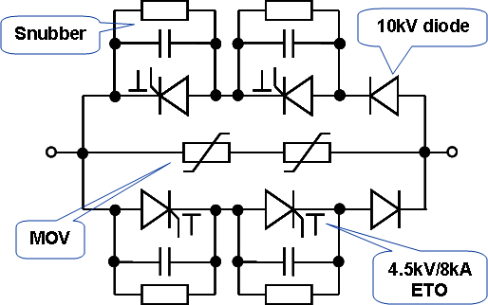

Fig.1 Proposed 9kV SSCB module diagram for 4160/2kA distribution line

Fig.2 shows the diagram and setup of half of a 4.5 kV SSCB module under test, where only one asymmetrical ETO in series with a reverse-blocking diode is sued, in parallel with an anti-parallel diode. The MOV and snubber capacitor are also included. A 7.5mH inductor is used as the load and AC 208 V is the input power grid.

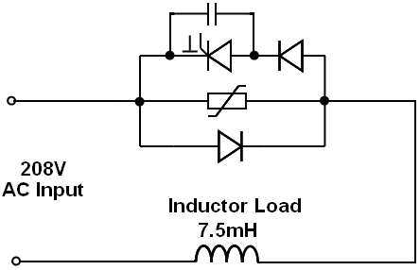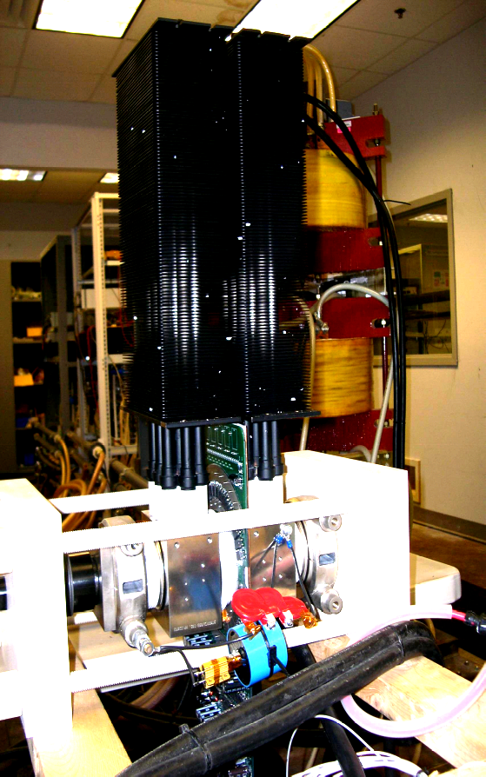
Fig.2 ETO based SSCB modular(half) diagram and setup

Fig.3 shows the load voltage and current during normal operation of the ETO-based SSCB. Fig. 4 shows the waveforms of SSCB when it cuts off the load current. At time t5, optical command-off is sent to the ETO. At time t6, the current through the ETO is decreased to zero. The voltage across the ETO increases rapidly and finally is clamped by the MOV.

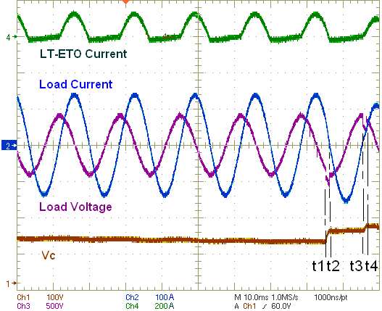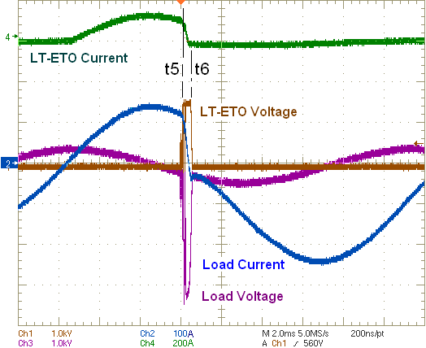
Fig.3 Load current and voltage Fig.4 Current cut-off

NMSU Capstone Senior Design Project
Date Project Began: | September 2007
Date of This Project Report: | July - September 2008
Sandia Project Manager (PM): | Stan Atcitty
Contractor: | New Mexico State University (NMSU)
Partner(s): | none
Project Description:
Technology development and deployment requires a simultaneous investment in education for sustainability. The goal of this project is to offer Senior Design Project classes in the areas of Energy Storage and Renewable Energy to undergraduate students in the Klipsch School of Engineering and the College of Engineering at New Mexico State University. The funding goes towards purchasing parts needed to prototype and demonstrate Energy Storage System concepts.

In consultation with DOE and Sandia National Laboratories, NMSU has developed six design project classes, each lasting an academic year, with thirty students completing these classes. The FY09 classes will deal with developing a photovoltaic system with storage that can operate in a grid-tied or stand alone mode. Further, based on an energy price signal from the electric utility, the system manages energy storage and energy sale/purchase.

This project provides significant visibility for the energy storage area and DOE programs amongst the undergraduate and graduate student body at NMSU. It introduces a group of students to this important area and trains them in the technologies that they will use in their careers.
Key Project Events:
- Five students completed their projects in May 2008 and presented subsystem prototypes. Stan Atcitty attended and served as an evaluator for the final presentation.
- Five students completed their project in August 2008 and demonstrated improved subsystem prototypes.
- A new student team for Fall 2008 presented a critical design review to Sandia
Project Status:
Project progress is consistent with schedule and budget. It is a ‘high visibility’ project in our undergraduate curriculum. A new design class has been designed and is being offered.

Project Pictures / Graphs / Tables:

μG Panel
Main Panel

μG
Meter

Controller
Utility
Meter

Loads

dc/ac

Photovoltaic
System
Photovoltaic
System
dc-dc peak power tracker
dc-dc constant voltage regulator

Storage

Figure 1 System Solution Developed by Design Class (μG symbolizes “microgrid)

Scale Model Demonstration of Storage in Customer Driven Microgrids
Date Project Began:
Date of This Project Report: | July - September 2008
Sandia Project Manager (PM): | Stan Atcitty
Contractor: | New Mexico State University, Las Cruces, NM
Partner(s):
Project Description
It has become abundantly clear that large-scale penetration of renewable-based distributed resources is impossible without attendant application of centralized and distributed storage. Therefore, it is important to examine the nature and application of small storage systems in so-called customer-driven microgrids. The customer-driven paradigm suggests that distribution microgrids with substantial penetration will evolve from the customer side. Small residential and commercial customers, who constitute as much as 35-50% of load, will invest in energy sources. The distribution utility services will now include network service and aggregation service for economic benefit, and reliability management through islanding for disturbances.

The El Paso Electric Power Laboratory at NMSU is an ideal environment to demonstrate the integration of storage-based or storage-supported distributed generation in distribution systems. The goals of this project are:

- The interconnection of sources to a distribution system and the steady state impact;
- The response of sources during disturbances;
- The role of storage in steady state feeder management and during disturbances; and
- The role of storage in supporting islanded operations.
Key Project Events:
The design of systems for allowing the implementation of a microgrid has progressed well through the fourth quarter and a presentation was made to Dr. Stan Atcitty of the Sandia National Laboratories.
Project Status:
It is expected that the requisite hardware will be in place by December 2008. Following this, we will set up demonstrations and system studies. Project progress is consistent with schedule and budget.

Project Pictures / Graphs / Tables:

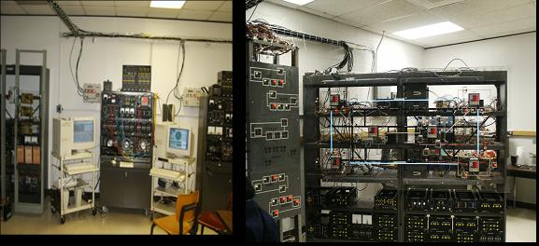
Laboratory Setup

East Coast Distributed Grid
Date Project Began: | November 2007
Date of This Project Report: | July – September 2008
Contractor: | Dan Borneo
Contractor: | Chesapeake Renewable Energy, LLC; Castlebridge Energy Group
Partner(s): | (TBD)
Project Description:
Chesapeake and Castlebridge, along with other partners, are interested in building a distributed energy grid (DG) on the east coast. One system suggested for a Maryland location would consist of:
- A 750 kW wind turbine,
- 30 kW of Solar PV,
- Two NGK 6,000 kWh energy storage units, and
- Two 500 kW biodiesel generators.

However, the group is looking at other sites with different needs that might require a different mix of generation and at different sizes.
Key Project Events:
- DOE/SNL Contacted by Castlebridge, FY07Qu4
- DOE/Sandia attended a meeting with Chesapeake in January, 2008.
- Follow-on meeting held May, 2008
Project Status:
Castlebridge continues to look for funding for a DG system that utilizes their algorithm to control a distributed energy system in such a way that they could utilize off-and-on peak energy rates to generate revenue. Of the initial two prospective sites, Washington High School in Maryland and Tangiers Island, Tangiers Island seem to have the most support. DOE/Sandia is lending support in evaluating various storage technologies that might be used in the system. A meeting was held in Virginia in August, 2008 to discuss installing a wind turbine on Tangier Island. Attendees included DOE wind representatives, the various environmental groups, and Tangier community leaders. The one major take away from this meeting is the number of permits needed, and the amount of time that might be required to procure them. Jon Miles has asked that Sandia stay involved as a disinterested third party to continue the efforts to make a wind turbine with storage a reality on Tangier Island.
Project Pictures / Graphs / Tables: none

Emerson Network Five-Tier Grid Stabilization
Date Project Began: | May 2007
Date of This Project Report: | July – September 2008
Sandia Project Manager (PM): | Dan Borneo
Contractor: | Emerson Network Power
Partner(s): | DOE
Project Description:
The Five-Tier Grid Stabilization Project will develop a hardware and software device that will efficiently and intelligently interact between the utility power generation system and connected loads and/or distributed energy systems. The device will discern the level of an overload by utilizing imbedded frequency signals, i.e. pricing signals, carried on the utility line, to either shed load or connect distributed energy sources. The device will incorporate five response levels; from slight overloads, during which non-essential loads are shed and/or distributed generation is brought on-line, to national security or natural disaster conditions, during which all but critical loads are shed. This interaction between the ISO and the loads can be utilized to keep the grid stable and/or to budget power consumption.
Key Project Events:
- Black Box Beta testing successfully completed November, 2007.
- Project final report delivered Q3, FY08
Project Status:
Project is complete and final payments issued.
Project Pictures / Graphs / Tables:
none

Emerson Network Power Fuel Cell Implementation
Date Project Began: | June 2007
Date of This Project Report: | July – September 2008
Sandia Project Manager: | Dan Borneo
Contractor: | Emerson
Partner(s): | DOE
Project Description:
This project will develop and test a fuel cell that will be utilized as the backup power source for an outdoor, remote telecom cabinet. The fuel cell is anticipated to be a rack-mounted unit that will be integrated into the telecom equipment cabinet.
Key Project Events:
- Scope submitted to Sandia Contracts in January 2008
Project Status:
A kickoff meeting was held in June, 2007, and the scope and deliverables were discussed. Scope was completed, reviewed by SNL, and submitted to SNL procurement to issue a contract. Emerson took exception to the DOE/Sandia contract patent clause, which states that DOE owns all patents developed as part of the project. This slowed down the contracting process. However, in August, Emerson agreed to the clause. SNL is now awaiting final signatures for the contract.
Project Pictures / Graphs / Tables:
none

Emerson/Sprint Race to Failure Thermal Management
Date Project Began: | January 2008
Date of This Project Report: | July – September 2008
Sandia Project Manager: | Dan Borneo
Contractor: | Sprint
Partner(s): | DOE
Project Description:
This project will design, manufacture and install a backup chiller system in a remote telecom equipment shelter. The shelter houses integrated Digital Enhanced Network (IDEN) as well as Code Division Multiple Access (CDMA) equipment. Anticipated heat load of the shelters will range from 10 kW - 20 kW.
Key Project Events:
- Contract Placed FY08Qu1
Project Status:
Contracts with Emerson and Sprint are in place and weekly meetings are being held. A project schedule is being developed and the project is estimated to be completed in FY09Qu2-Qu4. The team is working various solutions to provide low energy cooling in the event of a power outage. A cooling system designed by Schrofftech, estimated to be installed by FY09Qu2, was installed and evaluated this Quarter. The system performed well under adverse conditions. A final report is being written.
Project Pictures / Graphs / Tables:

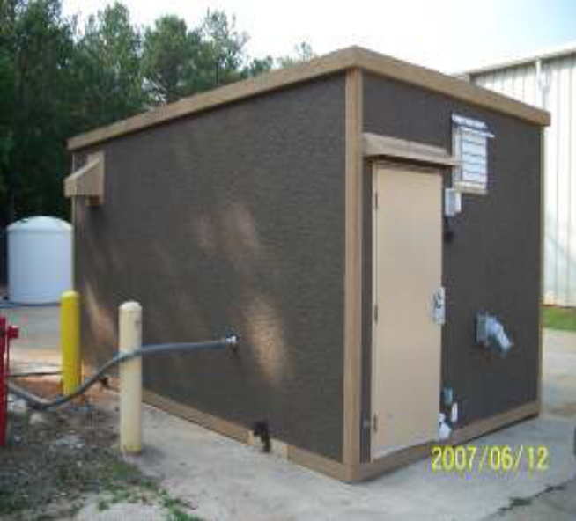
Pre-fabricated concrete wall construction, wall insulation R12, roof insulation R10.
Interior dimensions: 9 ft H x 19 ft D x 10.5 ft W
Equipped with:
− 2 5-ton Bard air conditioners, with economizer capability, Model WA602-A05EP.
− 15 inch diameter DC Vent Fan for emergency fresh air cooling, with dampers normally closed by gravity. The fan was disabled during these tests and the opening blocked with a sheet of cardboard.
Oldcastle outdoor telecom hut, Sprint
model RCS 11520-38U5-95
.

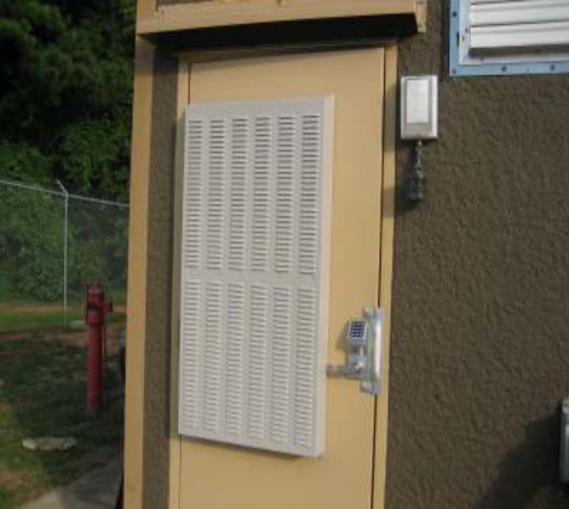

Door-mounted Schrofftech fan/filter unit.
Emerson/Sprint Thin Film PV Project

Date Project Began: | January 2008
Date of This Project Report: | July – September 2008
Sandia Project Manager: | Dan Borneo
Contractor: | Sprint
Partner(s): | DOE
Project Description:
This project will look at the implementation of thin film PV roofing systems on remote communication shelters. A contract with Sprint is in place and the kickoff was held in January 2008. The project is estimated to be completed in FY09Qu2. The team is looking at the feasibility and cost effectiveness of installing a thin film PV roofing system on remote communication shelters. Dan Borneo provided a cost estimate of a PV thin film installation at Sandia National Laboratories (Albuquerque, NM), which is summarized below.
Key Project Events:
- Contract Placed FY08Qu1.
Project Status:
The system was a Solar Integrated BIPV (3.264 kW DC STC), installed cost: $33,475 (includes PV material, inverters, meters, disconnects, installation, etc; does not include batteries or base roofing material, if needed.)

Figuring 80% output, given reductions for temperature, dirt, etc., it produces a system output of 3.264 kW*0.8 = 2.611 kW.
Albuquerque has an average of 6.4 hours of sun per day. At that rate (not taking into account that the intensity changes), the results would be:
- 2.611 kW * 6.4 hr/day = 16.7 kWhr/day.
- Assuming energy is valued at $0.15/kWhr, then 16.7 kWhr/day * 0.15/ kWhr = $2.50 energy saving per day.
- Per year: $2.5 energy savings/day *365 days/year = ~ $915 savings per year.
Assuming installed cost of $33K to figure payback: $33,000 installed cost/$915 savings/year = 36 year payback (not including any maintenance)
The roof is warranted for 20 years and the efficiency of the pv is ~4%
No updates to report for the FY08Qu4 period
Project Pictures / Graphs / Tables
none
Distributed Energy Systems 450 kW Ultracapacitor (EnergyBridge™) Demonstration at Palmdale CA Water Plant
Date Project Began: | 2004
Date of This Project Report: | July – September 2008
Sandia Project Manager: | Dan Borneo
Contractor: | Palmdale (Calif) Water District; Distributed Energy Systems (DES: formerly Northern Power)
Partner(s): | California Energy Commission (CEC) / Palmdale Water District / DOE
Project Description:
In support of distributed energy resources, this project demonstrates the use of a 450 kW, 30 second duration, ultra capacitor, energy storage module that could potentially be configured as an electric microgrid. The energy resources include a 950 kW wind turbine, a 200 kW natural gas generator, a 250 kW water turbine generator, and an 800 kW diesel generator.
Key Project Events:
- Commissioning completed September 2007
- Unit installed at Palmdale, December 2007
- Initial operational acceptance testing completed January 2008.
- Functional acceptance testing completed May 2008
Project Status:
The 450 kW EnergyBridge ultra capacitor is installed at the Palmdale site and the functional acceptance testing has been completed. The system is currently on line and data is being collected.

Project Pictures / Graphs / Tables:

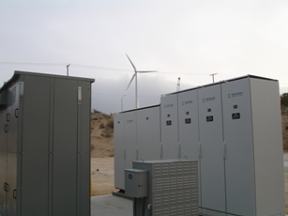
EnergyBridge System Installed at Palmdale (May 2008)
EPRI and DUA Data Collection and Economic Analysis

Date Project Began:
Date of This Project Report: | July – September 2008
Sandia Project Manager: | Dan Borneo
Contractor: | EPRI (Electric Power Research Institute) / DUA (Distributed Utility Associates)
Partner(s): | DOE
Project Description:
This project collects electrical data from demonstration electrical storage systems and analyzes the data to ensure that the technology is reliable and viable. The project also performs an economic analysis of the technologies to determine their cost effectiveness. This information is used to determine if the technology would be viable in the marketplace and to identify areas for improvement and possible deployment.
Key Project Events:
- New contract with EPRI placed FY08Qu1
- New contract with DUA placed FY08Qu2
- Palmdale data collection initiated FY08Qu3
Project Status:
Presently, EPRI and DUA are, or will be, performing analyses on these projects: 1) Palmdale EnergyBridge™, 2) Zinc Bromine Battery (ZBB), 3) SMUD/RT trackside SES, 4) PGE NaS battery, and 5) SMUD/SPRINT/VRB NaS battery.
Concerning the ZBB project, data collection will begin if and when a new contract between CEC and ZBB is placed and a utility agrees to place the battery at a substation. If ZBB can find a utility willing to install the battery, the most likely timeframe for this to occur would be FY08Qu1-Qu3. If this occurs, DOE/SNL will collect performance data and, upon conclusion of the testing, a final report on the technology and an economic analysis will be completed.

On the SMUD RT light rail project, due to funding issues, data collection has been pushed from FY08Qu3-Qu4 to FY09Qu3-Qu4 at the earliest, with the final report and economic analysis to follow. Preliminary economic data has been discussed in order to understand the baseline economics of the existing system and to be better able to evaluate any economic benefits that the new capacitor storage system might provide.

The California Energy Commission (CEC) has asked that we provide some preliminary economic guidance to PGE concerning the NaS battery project. Concerning the SMUD/SPRINT/VRB project, data collection is scheduled to begin FY09Qu3 with a12-15 month demonstration.
Project Pictures / Graphs / Tables:
none

Hydraulic Water System (Nereus) Generation Evaluation
Date Project Began: | July 2007
Date of This Project Report: | July – September 2008
Sandia Project Manager: | Dan Borneo
Contractor: | BlueWave Energy
Partner(s): | (TBD)
FY09 Funding: | (TBD)
FY08 Co-Funding (if applicable):
Project Description:
The Nereus system was developed by BlueWave Energy and is a method of storing energy in bulk that can then be discharged at a later time. By using a water tank and a buoyant mass, BlueWave Energy can lift heavy objects from ground level to a height above the ground to store energy. The heavy objects are stored at a height above the ground and released when the electricity is needed. As the masses are released and pulled down by gravity, they turn generators that produce electricity. This energy could be stored at a height necessary to produce the amount of energy an electric facility would require with no loss in energy from storing the energy over a long period of time. The system itself is completely “green” because there are no harmful elements used. Current trials have shown an efficiency of 90% and better. Sandia National Laboratories has been asked to lend support in the testing and evaluation of the system
Key Project Events:
- Contact with BlueWave initiated December 2007
- NDA with Sandia in place February, 2008.
- NDA between MSI and Bluewave signed Q3, FY08
Project Status:
BlueWave submitted a paper and revisions explaining their technology. While the idea is plausible, i.e. one can store compressed air using off peak (cheaper) power and use this compressed air to lift mass that will in turn generate electricity during on peak (expensive) power times, the efficiency is questionable; as well as the feasibility of building such a system in a cost effective, maintainable fashion. Sandia has recommended that they approach a local university to provide resources for further testing (It could be a potential project for college seniors). Sandia would be available to verify testing, if and when a demonstration phase is attained. A recommendation was made that Bluewave create a partnership with an Albuquerque firm, Mechtronics Solutions, Inc, (www.m-s-i.com), which might be able to help them in their work. An NDA has been signed by the two companies.
Project Pictures / Graphs / Tables:

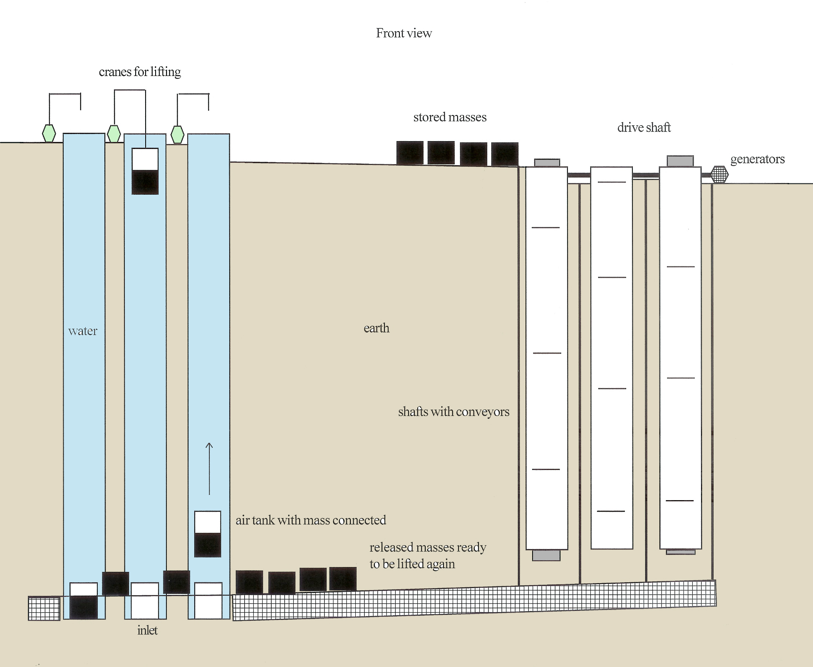

This is a diagram of a large Nereus system. There are multiple water columns as well as multiple conveyors (figure 4a will show the conveyors in use). The system is storing masses on the left side. The right side of the diagram shows the area for releasing energy (currently idle). The masses are lifted in the water columns on the left and stored on the top plateau. Not shown are the air tanks descending to be used again, which is shown on the side views.) 4/2008

PGE Sodium Sulfur Battery - Substation Upgrade Deferment
Date Project Began: | January 2008
Date of This Project Report: | July – September 2008
Sandia Project Manager: | Dan Borneo
Contractor: | California Energy Commission (CEC)
Partner(s): | CEC, PG&E (Pacific Gas & Electric), DOE
Project Description:
This project is to demonstrate a NaS battery utilized to defer upgrades of an overloaded transmission line. The system will be located near the load and provide peak shaving capability.
Key Project Events:
- DOE’s economic analyst performed preliminary evaluation of cost benefits during FY08Qu1.
Project Status:
Two informal meetings have been held between PG&E and DOE’s economic analyst to try to determine cost benefit criteria to help ensure an economic justification for this project. With this information, PG&E will go next to the Utility Commission and ask to include this project sometime between FY09Qu1and Qu3. Given the unknowns associated with the process of justifying the project to the PUC, no budget or schedule has been defined at this time.
Project Pictures / Graphs / Tables:
none

SMUD/RT Trackside – Ultracapacitor Energy Storage
Date Project Began: | 2005
Date of This Project Report: | July – September 2008
Sandia Project Manager: | Dan Borneo
Contractor: | Sacramento Municipal Utility District (SMUD)
Partner(s): | - Sacramento Regional Transit District (RT)  - Sacramento Municipal Utility District (SMUD)  - California Energy Commission (CEC)  - Siemens Transportation Systems (STS)  - U.S. Department of Energy (Sandia National Laboratories)
Project Description:
This project is to demonstrate a 1 MW, 20 second duration, static energy storage system (SES) on the Sacramento Rapid Transit (RT) light rail system. Utilizing Siemens ultracapacitors, the SES will provide a voltage boost to the rail distribution lines. This boost will allow faster acceleration out of the stations and the use of more locomotives. It will also help stabilize the rail power during peak demand periods, which will decrease the need for additional substations. Preliminary investigations illustrated that, at peak times, the operating voltage of the rail is less than the minimum operating voltage (600VDC). Calculations indicate that installation of the SES will increase the rail voltage above the minimum 600VDC level and shave 50kW of demand during peak hours of operation.
Key Project Events:
- Phase I: Study/Simulation began in 2005 and completed in 2007
- Phase 2: SES Demonstration Project began June 2007
- Contract between CEC and SMUD was in place by January 2008;
- System estimated to be on line during third quarter of FY09. (If adequate funding is secured in third quarter of FY08)
Project Status:
The project has been delayed due to an estimated $280K cost overrun of the existing budget. SMUD has received commitments from CEC, RT, and Siemens for the additional funding of $280K. SMUD will submit an additional funding request to CEC, and CEC commissioners will need to approve a change order before funding will be increased. DOE and Sandia National Laboratories have been working with SMUD to identify monitoring needs in order to be ready for testing when required, and to obtain preliminary “as is” data on the system. Monitoring needs have been identified and we are waiting on SMUD to put a contract in place with Siemens before continuing.

Project Pictures / Graphs / Tables

none

SMUD/Sprint 20 kW Vanadium Redox Battery (VRB)
Date Project Began: | June 2007
Date of This Project Report: | July – September 2008
Sandia Project Manager: | Dan Borneo
Contractor: | Sacramento Municipal Utility District (SMUD)
Partner(s): | - CEC (Calif. Energy Comm.)  - SMUD, Sprint  - VRB (VRB Power Systems)  - DOE
Project Description:
This project is to demonstrate a 20kW, 180 kWh, VRB battery system. The VRB battery will be designed to supply the required electrical energy at Sprint’s transmission equipment site located in Sacramento CA. The system will be used in a peak shaving mode and as a battery backup. The load on the system will be limited to a maximum of 20 kW, and the battery system will be designed to support up to six hours of operational run time in the peak shaving mode. Additionally, the system will be required to have an additional three hours of backup run-time to provide battery backup capability. VRB will design and install the system. Once the system is commissioned and operational, DOE and Sandia National Laboratories will collect the electrical data and perform a technical and economic analysis of the system.
Key Project Events:
- SMUD contract with VRB signed December 2007.
- VRB battery being manufactured FY08Qu3
- Kickoff meeting held January 2008.
Project Status:
The project has been delayed until a building permit is issued for the new building. The existing schedule, which had the installation of the VRB battery at the Sprint site beginning in FY08Qu4, has been pushed out. Installation will most likely not start until FY09Qu4. Commissioning is anticipated to be completed by FY09Qu4, with a one year demonstration to follow completion of commissioning. DOE/Sandia will collect and analyze the performance data.
Project Pictures / Graphs / Tables
none

Zinc Bromine Battery (ZBB) 1 MWh Energy Storage Demonstration
Date Project Began: | 2006
Date of This Project Report: | July – September 2008
Sandia Project Manager: | Dan Borneo
Contractor: | ZBB (ZBB Energy Corp.)
Partner(s): | - Calif. Energy Comm. (CEC)  - Electric Power Research Institute (EPRI)  - Distributed Utility Associates (DUA)  - DOE
Project Description:
This demonstration project utilizes a zinc bromine battery storage system installed at an electric utility test facility to reduce overloads during peak demand periods. The zinc bromine battery is discharged when the substation circuits exceed a predefined threshold. The objective is to defer a substation transformer upgrade until all associated planning and permitting can be accomplished. The initial design was for a 2 MWh system, but was subsequently reduced to a 500 kWh demonstration.
Key Project Events:
- 40-day test for a 500 kWh system completed October 2007.
Project Status:
ZBB’s original contract expired in March 2008. The original contract was to demonstrate a 2 MWh system. ZBB asked to extend the contract and change the scope of the original demonstration to a 1 MWh system. Since ZBB was never able to accomplish 2 MWh, CEC was not able to extend the contract with the new, reduced scope. However, a new contract is being drawn up that will allow ZBB to continue the demonstration of a 1 MWh system. The team is working with PG&E to identify a location to install the system once the new contract is in place. ZBB has one 500 kWh unit in California and is ready to ship the second 500 kWh unit. Once the new contract is in place, which is estimated by FY08Qu3-Qu4, DOE and Sandia National Laboratories will provide electrical monitoring and perform an analysis to determine if this system is cost effective as a means for energy storage.
Project Pictures / Graphs / Tables:

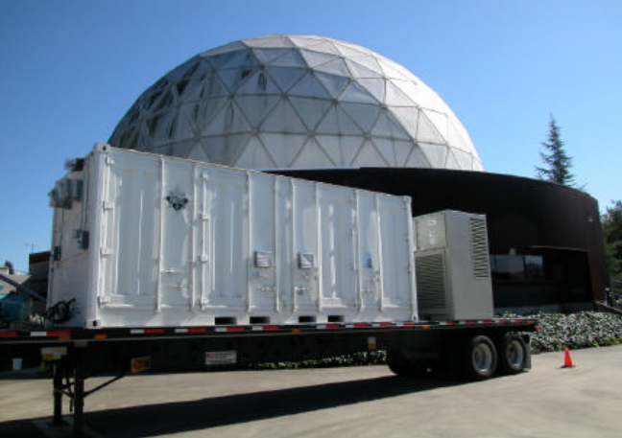
500Kw battery system on DUIT site, San Ramon Ca. 5/2007

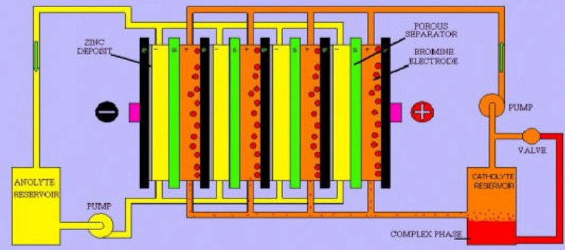
The Flowing Electrolyte System 2/2005

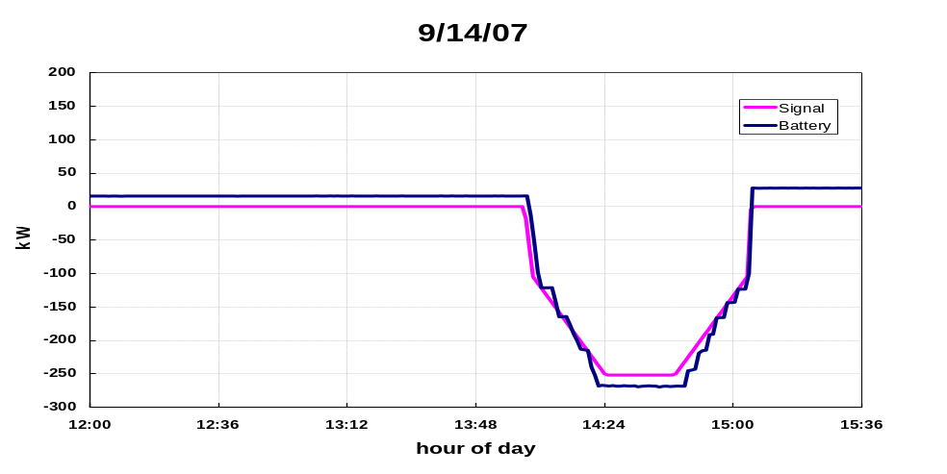
Load Following Discharge 9/14/0

20 MW FESS Facility Construction
Date Project Began: | 2007
Date of This Project Report: | July – September 2008
Sandia Project Manager: | Dan Borneo
Contractor: | Beacon Power Corp.
Partner(s): | DOE
Project Description: Build a 20 MW flywheel facility
Key Project Events:
- Design Closeout meeting conducted February 6, 2008
- Tyngsboro, NY selected as first 20 MW FESS site
- FESS under construction at Beacon’s Tyngsboro manufacturing facility. Work started FY08Qu2
Project Status:
A 1 MW FESS has been constructed at Beacon’s Tingsboro, MA plant. Another 1 MW plant is in construction. Beacon is planning to participate in Massachusetts’ non-generation based pilot program. They are continuing the permitting process to build a 20MW FESS in Stephentown, New York. Permitting includes construction and grid connection, and operation as a non-generation supplier.
Project Pictures / Graphs / Tables:

none

Superconducting Flywheel Development
Date Project Began:
Date of This Project Report: | July- September 2008
Sandia Project Manager: | Nancy Clark
Contractor: | Boeing
Partner(s): | None
Project Description:
This project continues an ongoing design and development effort between the ESS Program and Boeing to mature a new class of flywheel systems with multi-hour storage capabilities. The overall goal of this project is to produce a 3 – 5 kWh flywheel ESS for use in a hybrid wind/diesel generation application. This research offers significant potential benefits for future, large flywheel systems in terms of system efficiency, capital and operating costs.
Key Project Events:
- Prior to FY07 – Design, assembly & testing of three key components: the rim/hub ass’y, stability magnet ass’y (SMA), and the high-temperature, superconducting (HTS) bearing.
- By end of FY07 – Work completed on the 5 kWh rotor and successful testing of HTS bearing to approx. 15,000 rpm. Added additional capability to HTS bearing for passive damping of anticipated sub synchronous vibration, due to previous experience with the DOE SuperCon flywheel program.
Project Status:
Purchase Orders placed for FESS hardware with Lukas Machine Shop for the majority of the FESS hardware, including HTS damping hardware assembly, vacuum and containment chamber, touch down bearing frames, mounting hardware, motor / stator hardware, lift magnet hardware, cryogenic connections and sensor / diagnostic mounting.

Project Pictures / Graphs / Tables:

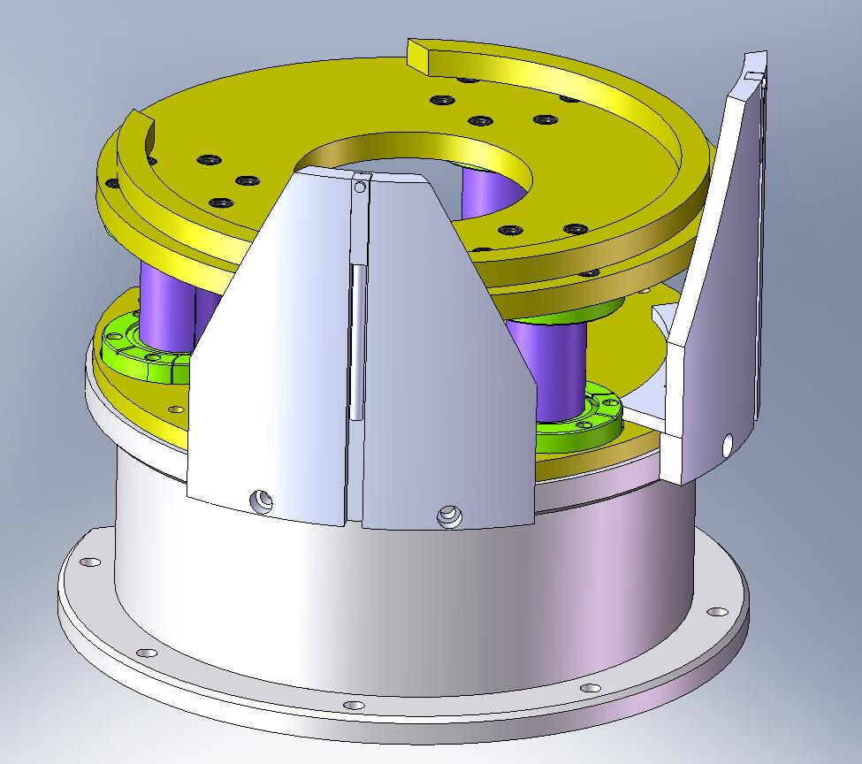
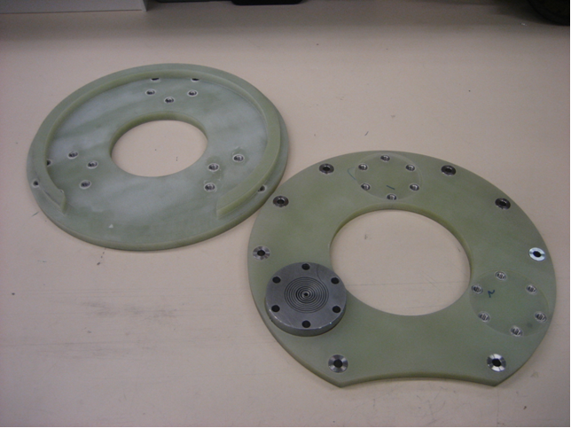
HTS Passive Damper System and Damper End Plates

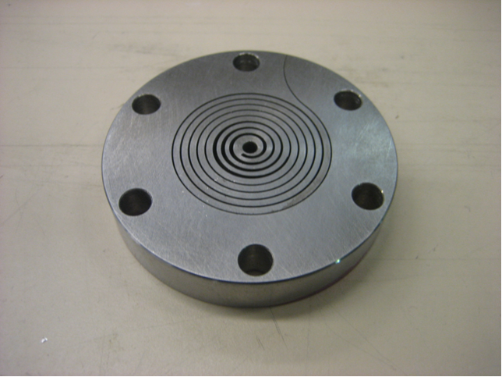

End Plate with Screen Manually Rolled
& Inserted

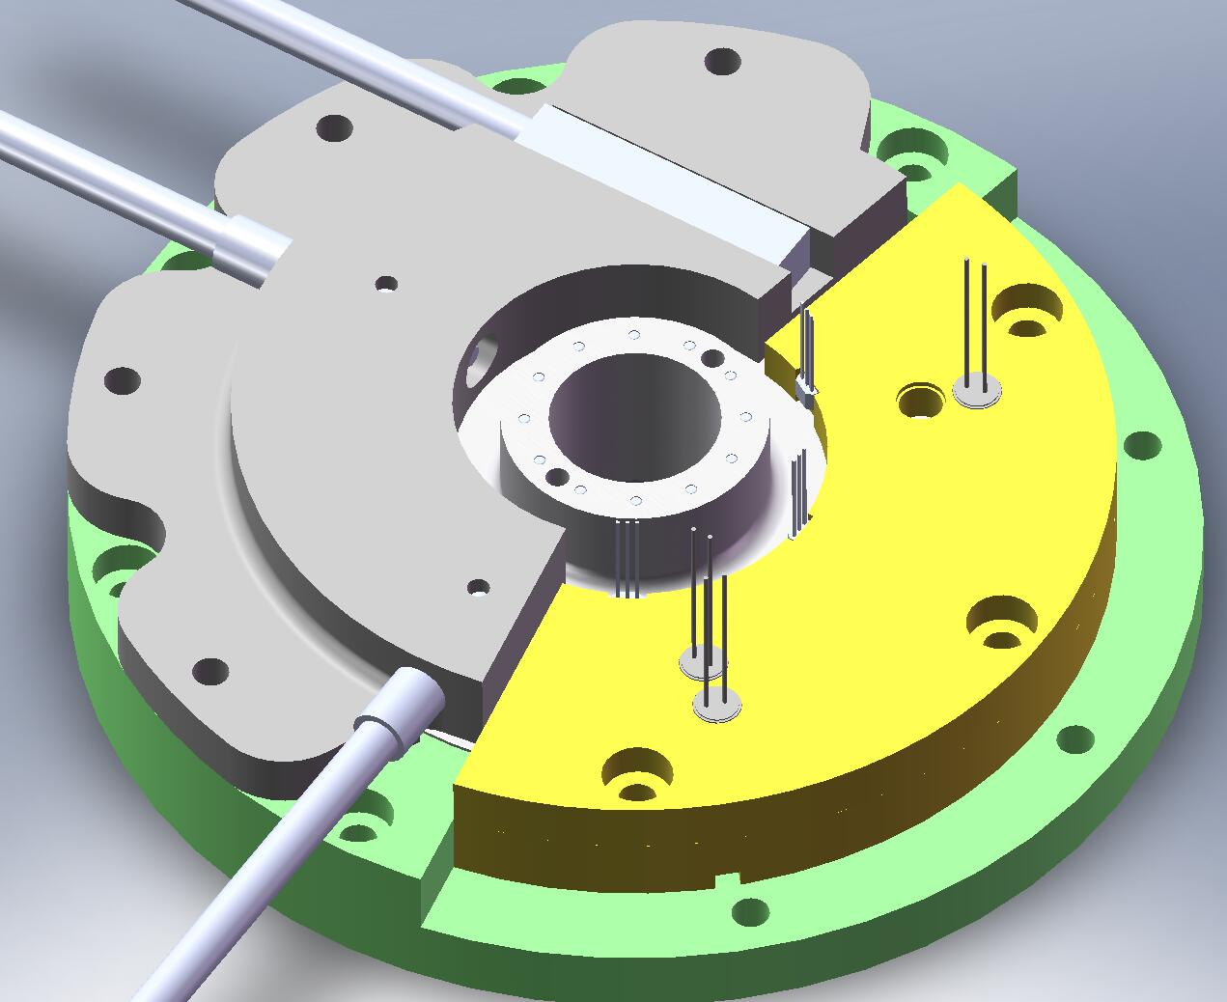
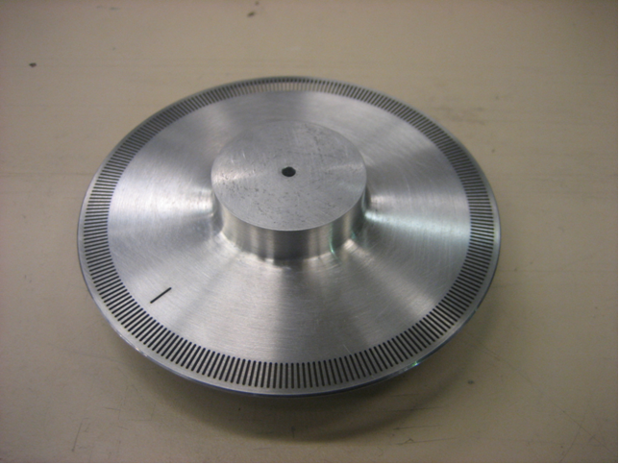
Encoder Wheel Designed by Boeing for High Speed Operation (test article shown in figure to the left, resides inside graphic on right).

Development and Evaluation of Carbon-based Devices for Energy Storage Applications
Date Project Began:
Date of This Project Report: | July - September 2008
Sandia Project Manager: | Nancy Clark
Contractor: | MeadWestvaco
Partner(s): | none
Project Description:
The focus of this project is to emphasize the development and testing of high-performance electrodes containing carbon to improve the performance of a hybrid energy storage (HES) device. In FY06, MeadWestvaco developed seven modified carbon types for use in high-performance electrodes. In FY07, NorthStar Battery built approximately 250 full-scale, sealed, lead-acid batteries, using both standard carbons and the newly developed carbons. Many of these carbon additives, as well as some additional types, were built into test cells by Hammond Expanders. Finally, Battery Energy also built approximately100 gel batteries containing a number of these carbons.
Key Project Events:
- In FY06, MeadWestvaco developed seven modified carbon types for use in high-performance electrodes.
- In FY07, NorthStar Battery built approximately 250 full-scale, sealed, lead-acid batteries using both standard carbons and the newly developed carbons.
- Battery Energy built approximately 100 gel batteries containing a number of these carbons.
- Final Presentation done at PEER review FY08 in September.
Project Status:
Final Report in process and will be submitted in FY09Qu1.
Project Pictures / Graphs / Tables:
none

Ni-MH Bipolar BESS Development
Date Project Began: | Late FY02
Date of This Project Report: | July – September 2008
Sandia Project Manager: | Nancy Clark / David Ingersoll
Contractor: | Electro Energy, Inc. (EEI)
Partner(s): | none
Project Description:
EEI has developed a bipolar, nickel-metal hydride (Ni-MH) battery whose performance characteristics meet a variety of energy storage application needs, including high-voltage/high-power modules with high cycle life. From FY02 through FY07, various bipolar Ni-MH cells, stacks, modules, and systems were developed and tested. In FY07, battery technology development work was successfully completed and the focus of the work shifted to building and testing complete NiMH-based systems, including:
- Liebert 100-kVA UPS integrated with Ballard System Batteries, and
- 600-V, 17-kWh, 6.5-kW BESS.
In FY08 it was found that insufficient funding remained to do upgrades required by utility for these systems to be useful, so the only activity this year is a final report.
Key Project Events:
- Joint decision by ESS program, utility partners, and EEI not to go forward with this technology in FY08.
- Project Status: Final Report sent to Technical Writer and will be finalized first quarter of FY09. EEI declared bankruptcy on September 20, 2008; therefore, work will cease.
Project Pictures / Graphs / Tables:
none

Dynamic Islanding for Improving Electric Service Reliability with Energy Storage
Date Project Began: | August 2008
Date of This Project Report: | July – September 2008
Sandia Project Manager: | Nancy Clark
Contractor: | American Electric Power
Partner(s): | None
Project Description:
One way to improve reliability of electrical service is to island as many customers as possible on a problematic feeder and service them with stored battery energy until the original service is restored. Because the power of each battery storage system is only a fraction of the feeder power capability, each battery might be able to serve only a fraction of the customers on that feeder. However, because the customer load varies significantly from peak to off-peak hours, a sophisticated control scheme is needed to serve the maximum number of customers for a given load and a battery's state of charge. This scheme for minimizing the interruption of a customer’s service is known as Dynamic Islanding.

In addition to making the economics more attractive, the energy storage system must also be able to perform peak shaving and defer upgrade capital. One way to do this, in addition to Dynamic Islanding, is to develop a control scheme that is capable not only of performing peak shaving but also incorporates the features of a NAS battery and the family of IntelliTeam switches and reclosers that are used on utility feeders. AEP has engaged in planning, designing, and implementing the installation of storage systems composed of a 2 MW, NaS battery-based system with a control scheme that allows the optimum use of the battery's stored energy to serve the maximum number of customers for a given load and battery's state of charge.

The three sites are all 2MW, 14.4 MWh and are located at Bluffton Ohio, East Busco, Indiana and Balls Gap, West Virginia. Installation at the three sites will be completed in FY09. After installation, the performance of each site will be monitored for one year. Sandia National Laboratories will publish the results in a SAND report.
Key Project Events:
- Contract placed August 2008.
- Project reported on at annual DOE Peer Review Meeting in September 2008.
- First system to be completed in December 2008.
Project Status:
All Systems are in process of installation.

Project Pictures / Graphs / Tables:

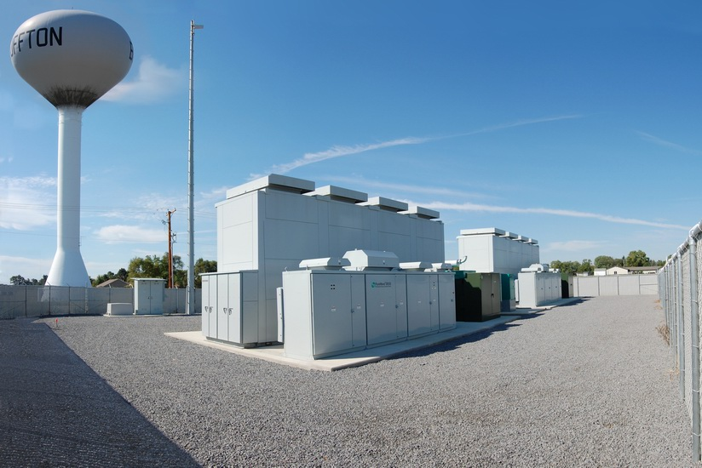

2MW, 14.4 MWh in Bluffton, Ohio
Back view showing PCS and transformers in front of NAS battery system

Carbon-Enhanced Lead-Acid Battery and EC Testing
Date Project Began: | December 2005
Date of This Project Report: | July – September 2008
Sandia Project Manager: | Tom Hund
Contractor: | (SNL In-house Project)
Partner(s): | none
Project Description:
In a cooperative effort with Mead-Westvaco, NorthStar Battery, and Battery Energy, the ESS Program is working to enhance the high-power cycle performance of valve-regulated, lead-acid (VRLA) batteries for utility cycling applications. The goal of this work is to evaluate the effect of different carbon formulations when used in the negative electrode of the battery. The carbon additions can significantly improve battery performance in high-power, partial-SOC cycling and prevent hard sulfation of the negative electrode, which can lead to capacity loss and premature battery failure. NorthStar Battery, Battery Energy, CSIRO/Furukawa, and East Penn Battery have produced a number of VRLA batteries containing carbon additives. All of the above batteries are under test at SNL. The goal of the current testing on the second series of carbon-enhanced VRLA batteries is to identify a carbon formulation and/or manufacturer that will maintain a low gassing current, while providing the high-power, intermediate-SOC cycle performance with a long cycle life, in utility applications.
Key Project Events:
- MeadWestvaco and NorthStar Battery team to evaluate carbon formulations in the negative electrode of NorthStar VRLA batteries for utility applications. Two series of MeadWestvaco carbon formulations have been evaluated to date. This battery is designed for telecommunications systems.
- MeadWestvaco includes Battery Energy SunGels in their carbon formulation testing. This battery is designed for motive power and remote area power supplies.
- CSIRO/Furukawa provides Sandia with an Ultrabattery for utility cycle testing. This battery is designed for hybrid electric vehicles (HEVs).
- Sandia purchases an East Penn carbon enhanced large format VRLA battery for testing. This battery is designed for utility cycling and wind farm power smoothing.
Project Status:
Testing for FY08Qu4 is currently focusing on the new East Penn carbon enhanced VRLA wind farm energy smoothing battery. The Ultrabattery asymmetric supercap/battery manufactured by Furukawa in Japan and East Penn in the US has completed testing. Also, the carbon enhanced Battery Energy SunGel and carbon enhanced NorthStar VRLA battery testing is complete. The testing on the East Penn large format carbon-enhanced VRLA for wind power smoothing is progressing well. This was the first large format battery designed for partial state of charge cycling. If successful, the East Penn VRLA battery could be used directly in multi-megawatt energy storage systems, such as wind farm energy smoothing and/or utility voltage support and frequency stabilization. Also, Furukawa Battery and East Penn Battery in the US are in the process of building large format 1,000 Ah Ultrabattery cells which could also be used in large mega-watt size energy storage systems.
Project Pictures / Graphs / Tables:
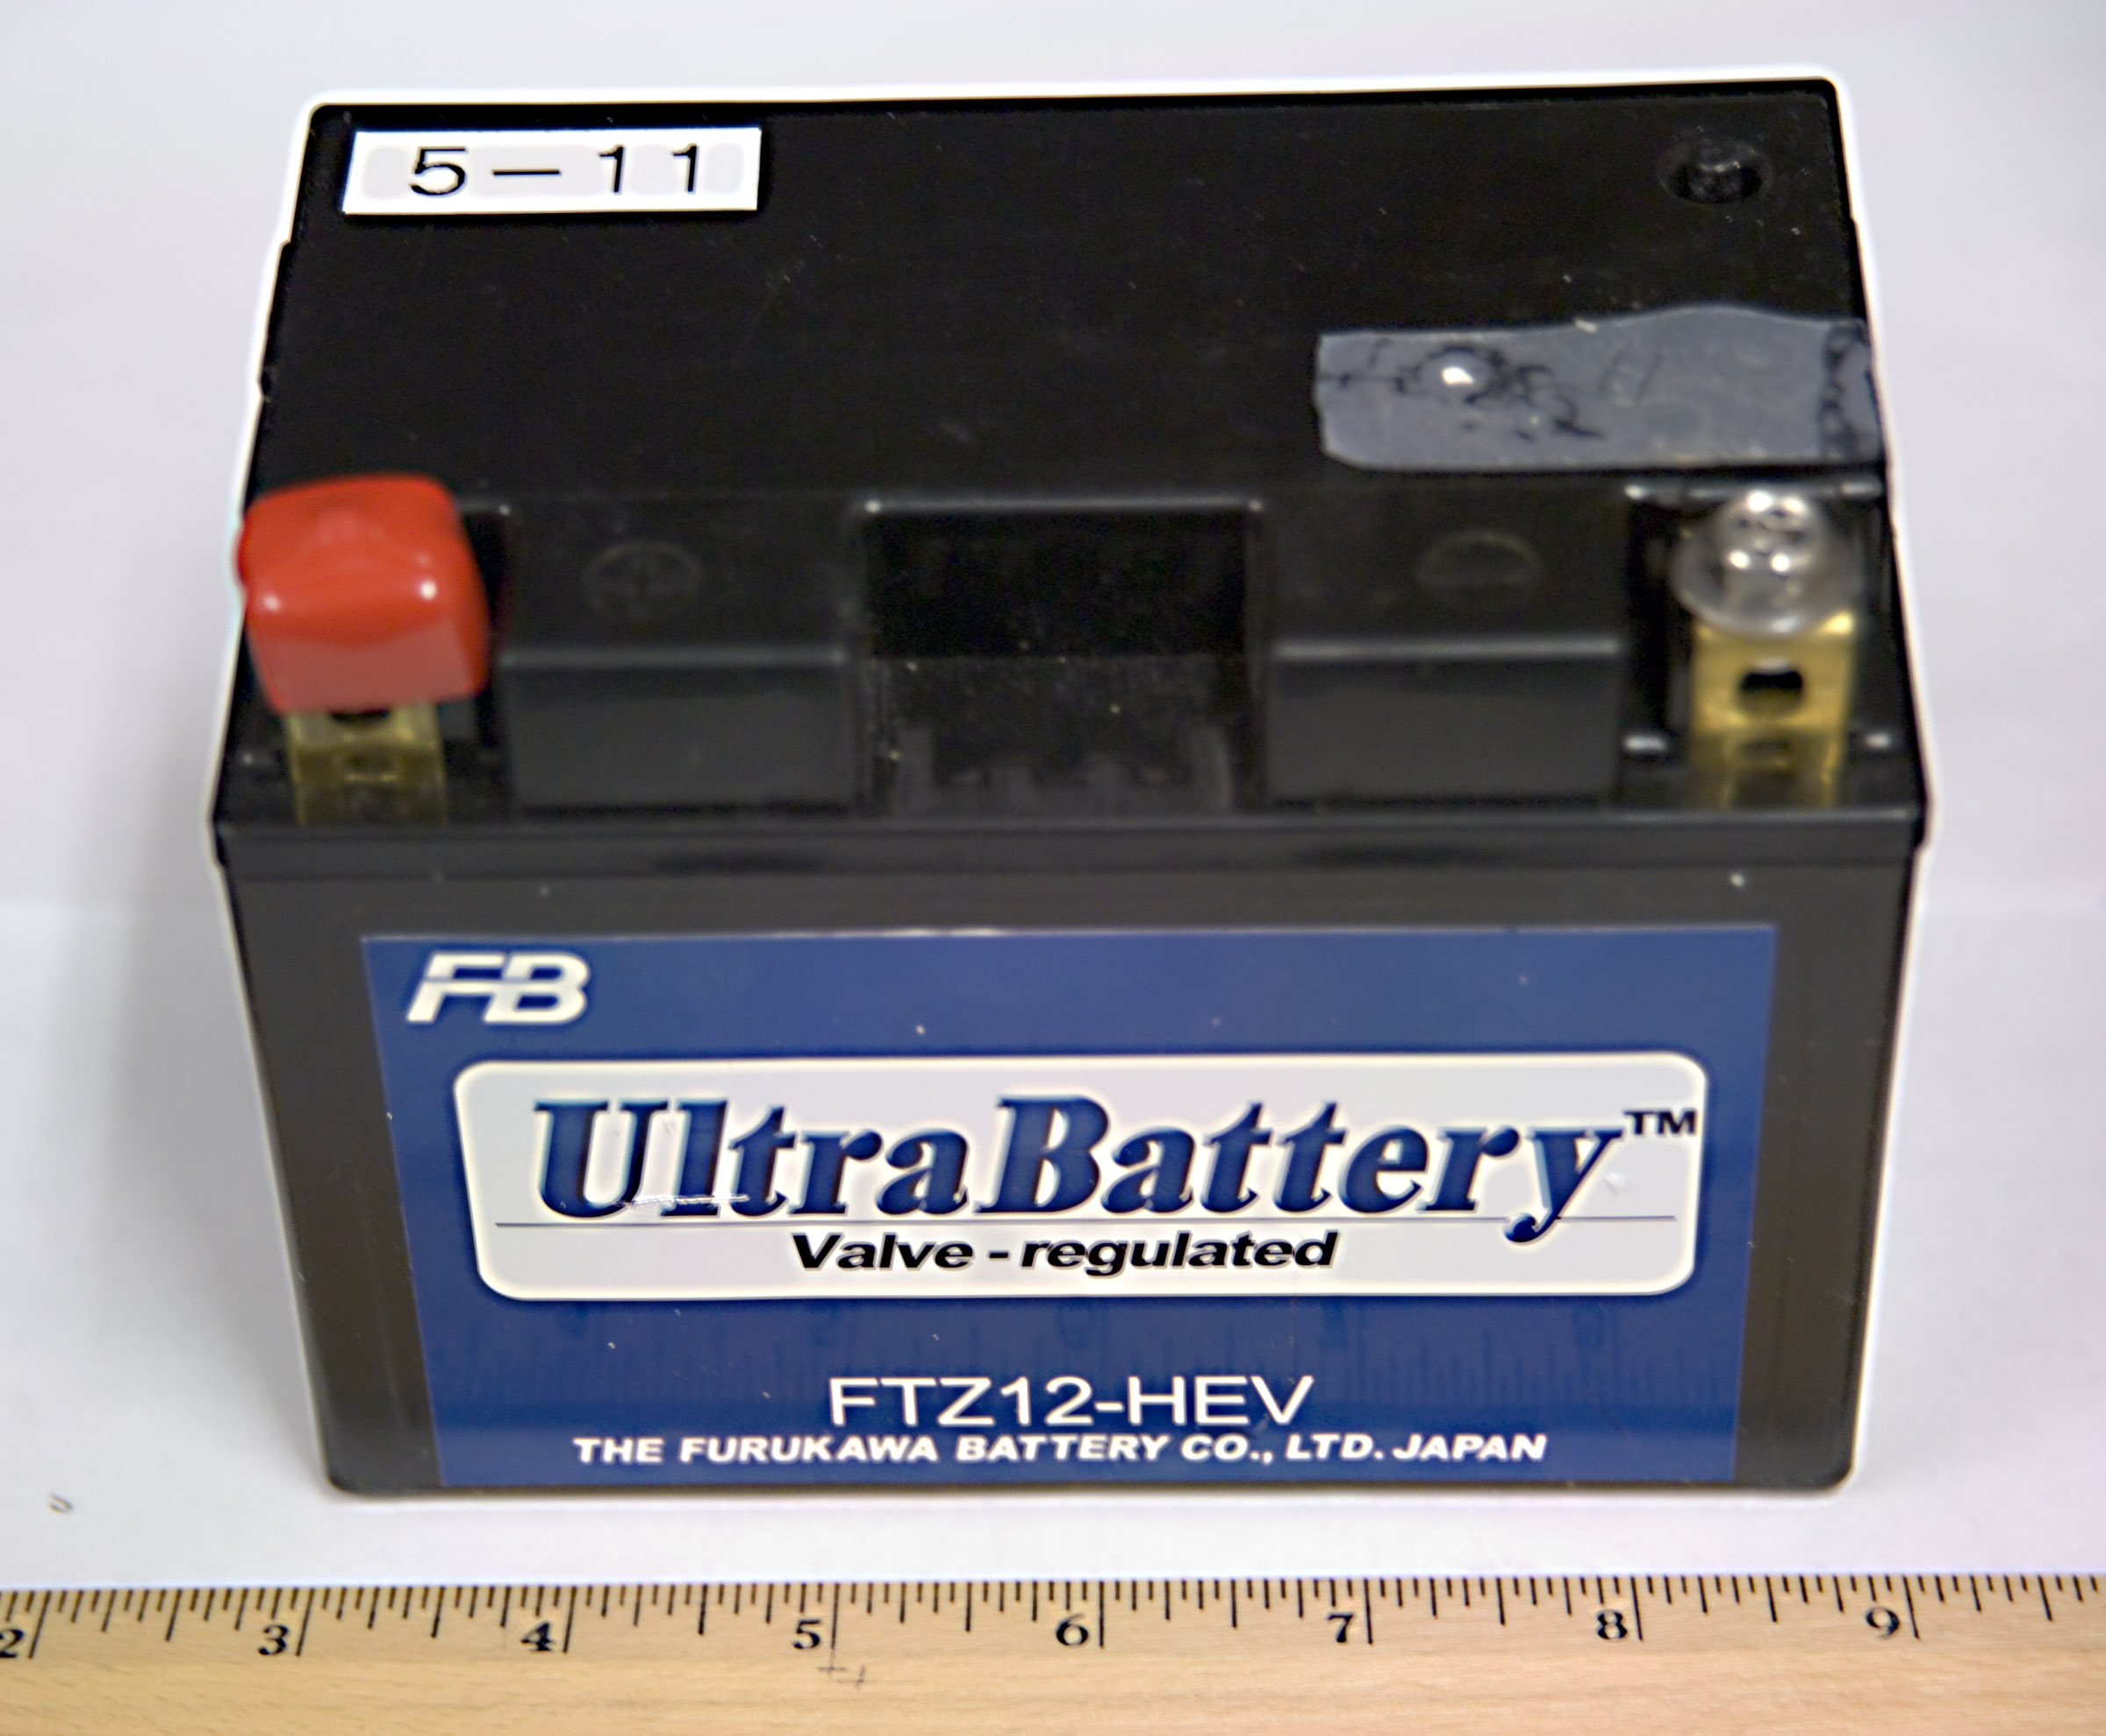
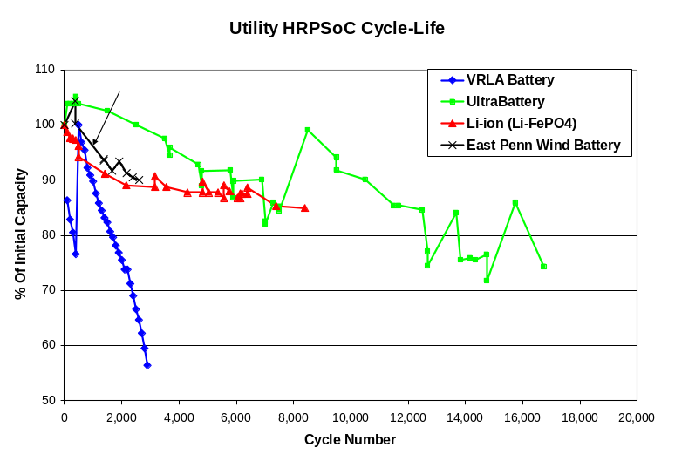

UltraBattery manufactured by Furukawa
(Japan) and designed by CSIRO (Australia).
Designed for hybrid electric vehicles (HEVs).

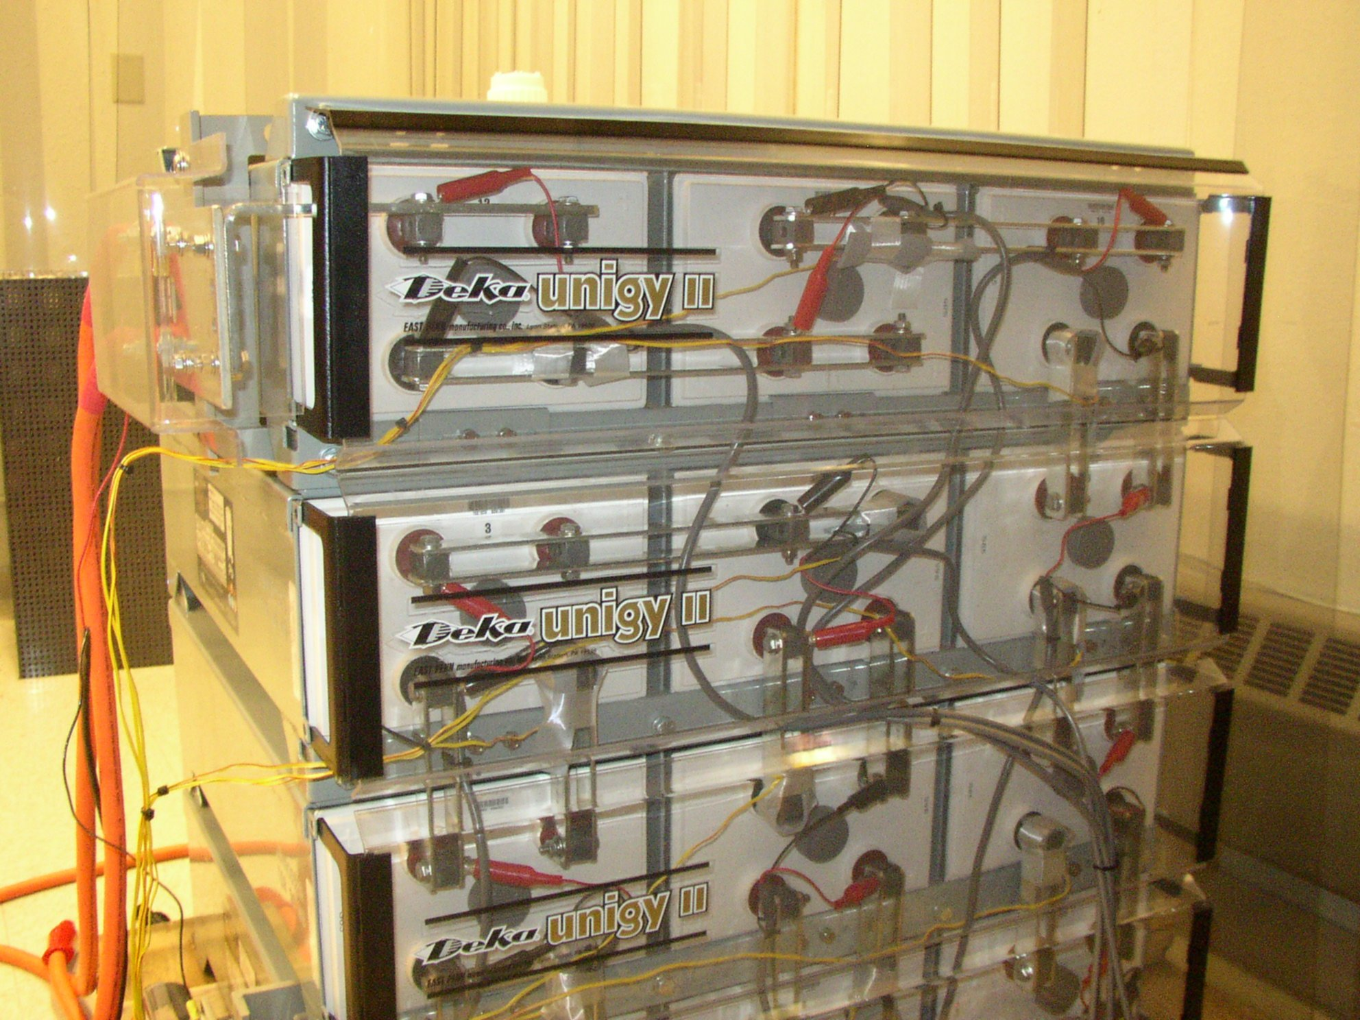

East Penn wind farm smoothing battery
carbon enhanced VRLA for high power
partial state of charge cycling (PSOC).

Iowa Stored Energy Park

Date Project Began: | FY05
Date of This Project Report: | July – Sept 2008
Sandia Project Manager (PM): | Georgianne Peek
Contractor: | Iowa Stored Energy Plant Agency (ISEPA)
Partner(s): | Iowa Association of Municipal Utilities (IAMU)

Project Description:
The Iowa Stored Energy Park (ISEP) is a DOE-supported effort of municipal utilities in Iowa, Minnesota, and the Dakotas to develop 13,400 MWh (268 MW for 50 hours continuous operation) of compressed air energy storage (CAES) that utilizes wind generation resources to the highest degree possible. ISEP will satisfy the municipal utilities’ need for intermediate generation and will support the development of wind energy by making it dispatchable, producing ancillary services to support the transmission grid, and encouraging further expansion of wind resources. In addition, ISEP will demonstrate the transferable processes of evaluating aquifer storage, site identification, CAES design, and operation for grid integration of wind.

Key Project Events:
- 2002 – IAMU study completed
- 2003 – Completed conceptual design; began search for geological sites
- 2005 – Conducted seismic surveys; completed feasibility analysis
- 2006 – Found suitable geologic formation
- 2007 – Public announcement of site; solicitation of municipal partners
- Jan. 2008 – Complete MISO market analysis
- May 23, 2008 – First modeling results of MRES

Project Status:
Preliminary modeling results of the Missouri River Energy Services’ (MRES) system show profitable results in the energy market. The current phase of the study is looking at the other value streams available in the market, such as capacity and ancillary service sales.

When reviewing model results of the MRES system with CAES, some key concerns about the dispatch and profitability of the CAES unit in the model were identified. It was suspected that the results could be caused by previously unidentified errors in the CAES algorithm. Ventyx (PROMOD IV) was contacted to find a solution to these issues.

The concerns are expected to be addressed and modeling completed in the 1st quarter of FY09.
In September 2008, the Iowa Power Fund, an agency set up in Iowa to foster energy efficiency and development efforts designed to make Iowa more energy independent, approved a forgivable loan of $3.2 million, to be combined with $1.5 million of DOE funds, for the drilling and pump testing phase of the project.

FY09 work will include determination of the best location to drill test wells, creation of a drilling schedule, management of the necessary land acquisition details, and drilling of the test wells.

Pictures / Tables / Graphs:

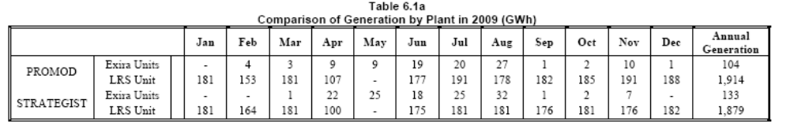
From May 23, 2008 modeling results report

NYSERDA / DOE – Joint Energy Storage Initiative: Advanced Sodium-Sulfur (NaS) Battery Energy Storage System (BESS) Project at MTA Long Island Bus
Date Project Began: | FY2006
Date of This Project Report: | July – Sept. 2008
Sandia Project Manager (PM): | Georgianne Peek
Contractor: | EnerNex
Partner(s): | NYSERDA, NYPA  NYPA negotiated cost share partners:  Metropolitan Transportation Authority Long Island Bus (LIB) (customer)  American Public Power Association’s DEED Program (APPA)  CEA Technologies, Inc. (CEATI)  Electric Power Research Institute (EPRI)  Natural Resources Canada (NRCan)  New York Independent System Operator (NYISO)  New York State Energy Research and Development Authority (NYSERDA)  United States Department of Energy (US DOE)  Consolidated Edison, Inc. (Con Ed)  FirstEnergy Corp.  Hydro One  Hydro-Québec  Long Island Power Authority (LIPA)  New York Power Authority (NYPA) (project developer)  Public Service Electric and Gas Company (PSE&G)  San Diego Gas & Electric (SDG&E)  Southern Company  Tennessee Valley Authority (TVA)

Project Description:
As part of the Joint NYSERDA/DOE Energy Storage Initiative, this project will demonstrate the ability to shift a compressor peak load to off-peak capacity and provide emergency backup power using a 1 MW, 7.2 MWh, NaS BESS at a major Long Island Bus (LIB) depot facility in Garden City, Long Island, NY. The LIB depot chosen as the site for this demonstration is a natural gas refueling station for 220 buses. Three 600 horsepower natural-gas compressors comprise the load that is served by a dedicated line from the Long Island Power Authority (LIPA). The load operates 24 hours a day, seven days a week over three shifts, and incurs high on-peak demand charges for four months of the year (approximately May 15 through September 15). The project will demonstrate the ability of a NaS battery system to enhance the reliability of the local grid by shifting load from on-peak to off-peak.

Key Project Events:
- NAS™ Battery (developed jointly by NGK and Tokyo Elec. Power Co., of Japan) modules arrived in New York on July 24, 2006.
- Battery module installation occurred over three days, August 3 – 7.
- LIPA confirmed on Feb 9, 2007 that they had accepted all of the mark-ups made by LIB on their 1/17 Interconnection Agreement (IA) submission
- The 1 MW, 7.2 MWh sodium-sulfur battery and PCS installation was completed on June 22, 2007.
- December 2007: NGK determines battery cycling will not restore batteries to full capacity and the batteries were returned to Japan for analysis.
- January 2008: NYPA and NGK meet to confirm a recovery plan and timeline.
- May 2008: New battery modules arrived and complete system restart was completed.
- June 2008: data acquisition system installed.
- Aug. 2008: Batteries have completed approximately 30 cycles

Project Status: The following was completed during this quarter:
The system is operational and the site operators are experiencing the benefits in fueling operations (schedule flexibility). Occasional nuisance trips due to control module communication failures and line over-voltage are being addressed by ABB. The data communication links are currently being established and verified. In addition, the data acquisition system operational issues are being addressed by ABB.
The compressor load analysis is underway by ABB to finalize black start design (will require new PCS to act as variable speed drive) – expected to be installed 2009.
The start of the 18 month operating test program to monitor performance of the system is scheduled to begin Dec. 2008. At that time, project background information and system monitoring data will be available at http://www.storagemonitoring.com/nyserdadoe/storage-home.shtml.

Pictures / Tables / Graphs:

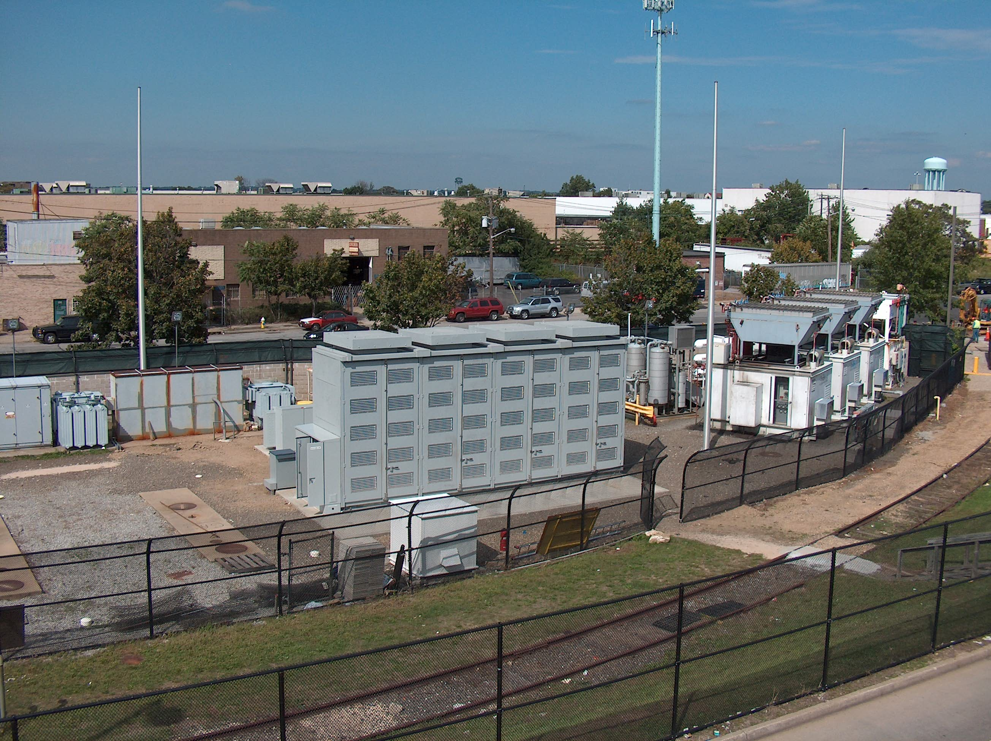
Completed installation - 2008

NYSERDA / DOE: Dispatchable Photovoltaic System with Electric Energy Storage for Commercial Buildings in NYC Area Network

Date Project Began: | FY2008
Date of This Project Report: | July – Sept. 2008
Sandia Project Manager (PM): | Georgianne Peek
Contractor: | EnerNex
Partner(s): | NYSERDA, CUNY, LGCC

Project Description:
This project will install a 100 kW PV system coupled with a 150 kW/ 150 kWh Gaia Power Technologies PowerTower storage system on the roof of LaGuardia Community College (LGCC) in Queens, NY. The storage system will provide the firming and dispatch capabilities for facility peak demand. The PV/ESS system will be modeled using “PV Planner” software developed by the University of Delaware with support from the National Renewable Energy Laboratory (NREL) for the purpose of analyzing dispatchable peak-shaving PV. The technical and economic performance will be monitored and analyzed for 18 months.

Specific project objectives are to:
• Demonstrate EES for firming electrical capacity of renewable energy;
• Demonstrate Dispatchable PV for managing demand charges;
• Evaluate grid reliability improvement through the commercialization and widespread deployment of dispatchable peak shaving PV; and
• Evaluate if dispatchable peak-shaving PV technology can be used to defer the need for a reverse power relay to interconnect with network electricity grids.

Key Project Events:
- Project kickoff meeting scheduled.

Project Status:
A project kick off meeting is scheduled for Oct. 2, 2008 at the project site on the LaGuardia Community College campus.

Pictures / Tables / Graphs:
none

NYSERDA / DOE: 300 kW / 900 kWh Gaia Power Technologies BESS for Peak Shaving and Substation Upgrade Deferral

Date Project Began: | FY2007
Date of This Project Report: | July – Sept. 2008
Sandia Project Manager (PM): | Georgianne Peek
Contractor: | EnerNex
Partner(s): | NYSERDA, Gaia Power Technologies, Delaware County Electric Coop

Project Description:
Demonstrate the performance of a 300 kW/900 kWh Battery Energy Storage System (BESS) consisting of four 75 kW/225 kWh PowerTower™ Modules (developed by Gaia Technologies) and utilizing Axion and Zebra batteries. The BESS will provide substation support and transmission and distribution upgrade deferral for Delaware County Electric Coop (DCEC) using dispatchable energy storage to provide peak power demand reduction.

Key Project Events:
- Kickoff meeting held June 26, 2007.

Project Status:
Project delayed partly due to the decision of performing an Environmental Health and Safety (EHS) assessment. The EHS assessment is driven by:
- No prior formal EHS assessments for BESS installations are available.
- Proposed site is in the middle of an industrial complex in order to fulfill secondary goal of providing backup power
The EHS Analysis has begun and will be conducted by City University New York Professor Dr. Sanjoy Banerjee, in 2 or 3 phases consisting of:
Phase A – Qualitative Risk Analysis
Phase B – Quantitative Preliminary Hazards Analysis (Only if warranted by Phase A analysis)
Phase C – Probabilistic Risk Assessment (Only if warranted by Phase B analysis):

The outcome of the EHS might impact BESS specifications and /or final location. All major components have been manufactured and are either ready for shipment to Gaia or are already at Gaia for testing and integration. Current plans are to install the BESS during the 1st half 2009 and commissioning in 2nd half. The demonstration will include two winter peak seasons.

Pictures / Tables / Graphs:

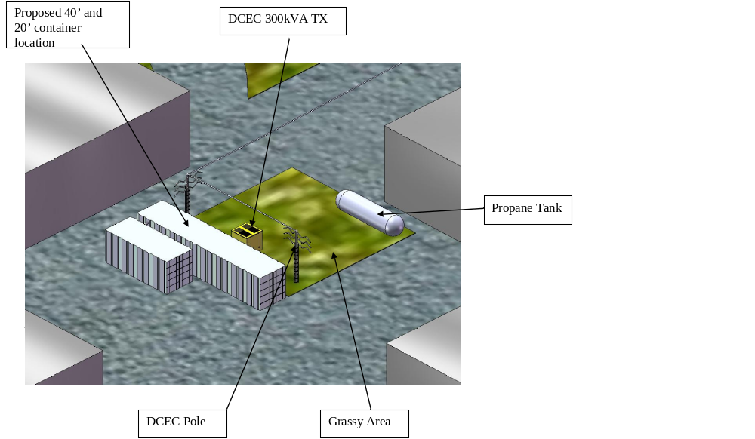
3D model of the demonstration site--- October 2008

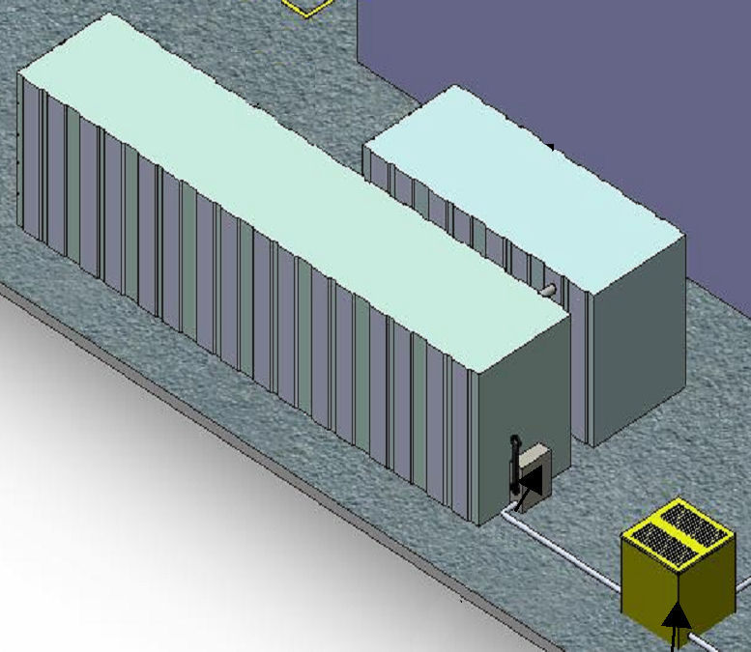
Standard enclosures include a 40ft shipping container contains all the power electronics, Zebra and lead acid batteries, and control equipment and a 20ft shipping container contains the Advanced lead acid carbon batteries.

NYSERDA / DOE: Long Island RR Trackside FESS

Date Project Began: | FY2008
Date of This Project Report: | July – Sept. 2008
Sandia Project Manager (PM): | Georgianne Peek
Contractor: | EnerNex
Partner(s): | NYSERDA, NYPA (NY Power Auth.), LIRR (Long Island Rail Road)

Project Description:
The New York Power Authority (NYPA) will install and demonstrate a high speed Flywheel Energy Storage System (FESS) at the Long Island Rail Road (LIRR) Deer Park station in Long Island NY. The scope of the project is a turn-key installation of a 2.5 MW FESS to provide traction power voltage support for LIRR to mitigate voltage sag problems, reduce power peak demand charges, and offset costly electric distribution upgrades.

Key Project Events:
- Project kick-off meeting January 8, 2008
- Turn-key FESS re-bid due July 11, 2008

Project Status:
On August 18, 2008, the two bid finalists presented their bids and Flywheel systems to the project team. After negotiations, a turnkey contractor has been selected. The contract documents are currently being processed. It is expected the contract award to be announced in the 1st Quarter FY09 and project initiated. The project design is expected to be kicked off in January 2009.

Pictures / Tables / Graphs:

Future FESS Site

EPRI / DOE Energy Storage Handbook – Wind Applications Supplement

Date Project Began: | FY2007
Date of This Project Report: | July – Sept. 2008
Sandia Project Manager (PM): | Georgianne Peek
Contractor: | Technology Insights
Partner(s): | EPRI

Project Description:
The initial edition of the EPRI/DOE Energy Storage Handbook for T&D Applications was completed in December 2003. A supplement to the Handbook for grid-connected wind applications was issued in December 2005. This project augments the Supplement by addressing concerns from technology updates and experts in the wind industry. Tasks include:
- Reviewing select utility wind penetration analyses and updating the models used in the supplement to improve the relevance of this work to system planners,
- Conducting a survey and reporting on the status of large (>10 MW), grid-connected wind/storage hybrid systems with emphasis on technical requirements for ESSs. The survey will include proposed programs in Japan, Hawaii, and Ireland, and
- Adapting the spreadsheet-based analytical methodology used in the current supplement to reflect the application duty cycles identified in the updated models and conducting value analyses for generic short-duration and generic long-duration energy storage technologies.

Key Project Events:
- November 2006 - Contract placed with Technology Insights

Project Status:
A draft report on Enhancing the Relevance of Energy Storage Performance and Assessment Models is expected in the 1st Quarter FY09. The report will draw extensively on the CEC IAP, CAISO Renewables Integration Study and on stakeholder exchanges (a first) to provide meaningful insights into storage opportunities, including any impediments to instituting them (e.g., FERC 2004).

Pictures / Tables / Graphs:
none

