PIPELINE

PRACTICE INTRODUCTION

USDA, Natural Resources Conservation Service—Practice Code 516

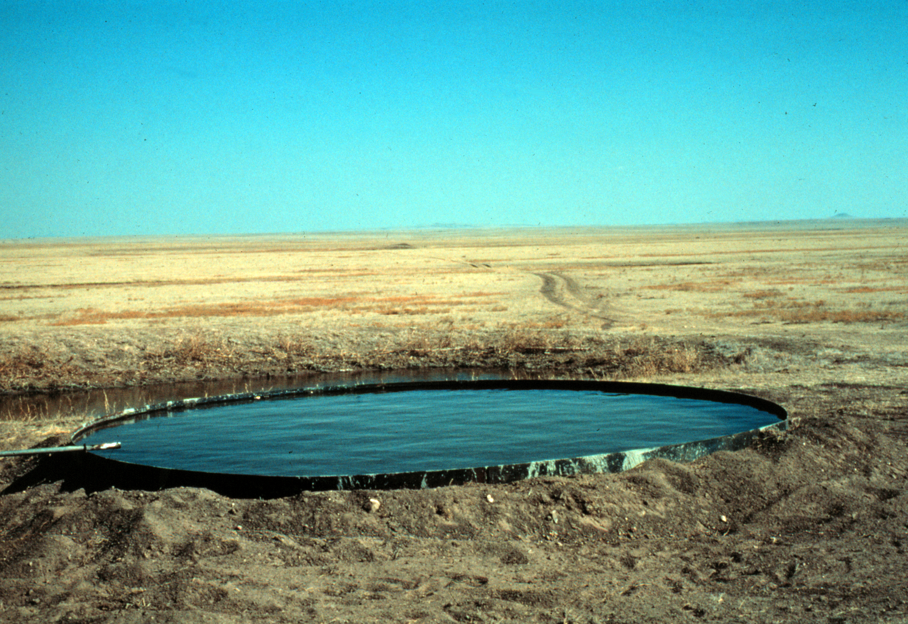

PIPELINE
The pipeline practice is used when a pipeline is needed to convey water for livestock, recreation or wildlife.

PRACTICE INFORMATION
The purpose of this practice is simply to convey water from the source of supply to the point(s) of use. The objective is usually to decentralize the location of drinking or water storage facilities. The practice is applicable where water needs to be piped to another location(s) for management purposes, to conserve the supply, or for reasons of sanitation.
Pipelines installed under this practice are generally for livestock management purposes. A single water source can provide livestock water to several locations and be very effective in improving management of a grazing unit.
Pipelines are also used on recreation and wildlife lands to provide or distribute drinking water facilities for humans as well as wildlife.

COMMON ASSOCIATED PRACTICES
Pipeline is commonly used as part of a Conservation Management System with watering practices such as Water Well (642), Spring Development (574), Pond (378), and Watering Facility (614).
For further information, refer to the practice standard in the local Field Office Technical Guide and associated specifications and job sheets.

Pipeline
5/2002
I.3 (+) Plant productivity and condition
Pipeline (516)
1. Install and reseed if necessary
Initial setting: Any area where conveyance of water from a source of supply is needed
C.2 (+) Income and
income stability
(individuals and
community)
I.4 (-) Cost for farmer (long term)
C.1 (+) Health of domestic and wild animals
C.1 (-) Health of domestic and wild animals
I.2 (+) Wildlife habitat
I.2 (-) Wildlife habitat
I.1 (-) Volume of downstream flow
Start
LEGEND
#. Created by practice
D. Direct effect
I. Indirect effect
C. Cumulative effect
Pathway
(+) increase; (-) decrease
D.1 (+) Provide and/or improve water quantity and quality
Note: Effects are qualified with a plus (+) or minus (-). These symbols indicate only an increase (+) or a decrease (-) in the effect upon the resource, not whether the effect is beneficial or adverse.

