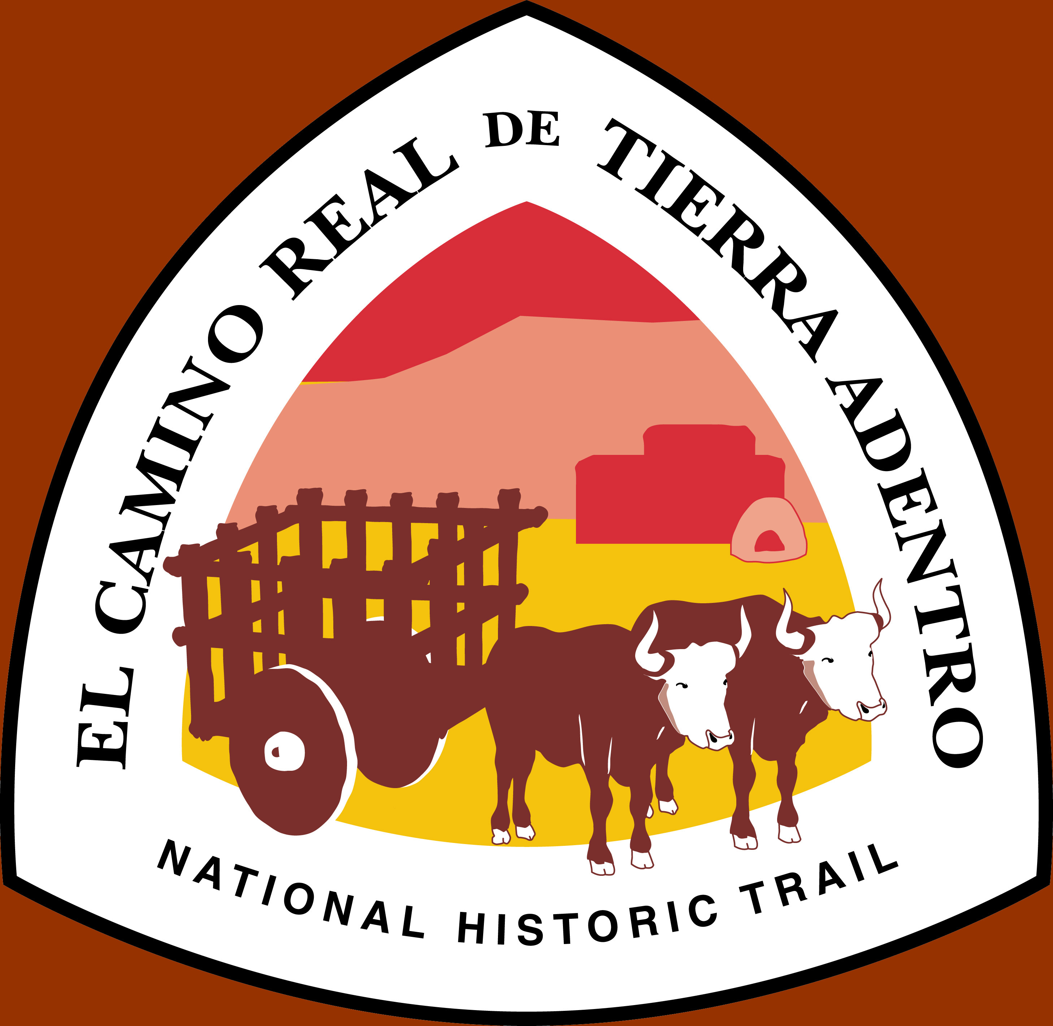

FY07 Trail Accomplishments
FY08 and Out-year Priorities
El Camino Real de Tierra AdentroBureau of Land Management
National Historic TrailNational Park Service
Department of the Interior

First Signs of El Camino Real de Tierra Adentro National Historic Trail
Tomé Hill, one of the major landmarks on the Camino Real, was the site of our first trail sign installation, June 30, 2007. Jacqueline Guilbault , Valley Improvement Association, Tomé, coordinated a morning-long event featuring more than two dozen speakers who shared their heartfelt connections to the trail with nearly 50 trail supporters.

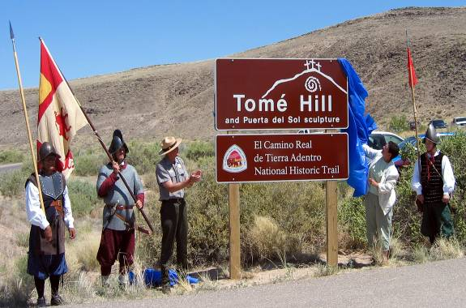
Also “signing on” in FY07 were El Rancho de Las Golondrinas, a not-for-profit living history museum, and Fort Selden, one of New Mexico’s State Monuments. Six additional sites have been certified, including The Palace of the Governors, El Camino Real de Tierra Adentro International Heritage Center, and Kuaua/Coronado, all part of New Mexico’s State Museums and Monuments; Keystone Heritage Park, an interpretive site and education center north of El Paso, Texas; the Plaza in Mesilla, New Mexico; and the Camino Real Site, south of Santa Fe, owned by the Archaeological Conservancy. Site signage is in development.

Other notable accomplishments in FY07:
- Interpretive signage development, Las Golondrinas
and El Paso Riverwalk (NPS Challenge/Cost Share [CCS])
- Conference (Camino Real de Tierra Adentro Trail Association [CARTA])
- Historic marker inventory and assessment (BLM CCS, CARTA)
- Trail corridor project consultations (BLM, NPS, CARTA)
- Conceptual development plan, Jornada del Muerto (NPS & BLM)

Priority Issues for FY08 and Beyond

National Register Nominations
Trail administration is partnering with the New Mexico State Historic Preservation Office to support a multiple property nomination for some two dozen of the Camino Real de Tierra Adentro’s most critical trail segments. The 404 miles of trail within the United States contain outstanding trail resources, including sections of the 400-year-old wagon road on the Jornada del Muerto, the “Journey of the Dead Man;” segments along the Río Grande through the Bosque del Apache and Sevilleta Wildlife Refuges; traces along the Santa Fe River canyon; and segments on La Bajada, the last long uphill on the road to Santa Fe. At present, no segments of the historic road are on the National Register or Register of Historic Properties in New Mexico. Funds for this project were garnered by the NPS.

World Heritage Nomination
In FY07, trail administration partnered with archaeological and historic consultants John Roney and Tom Merlan (former BLM archaeologist and State Historic Preservation Officer, New Mexico, respectively) and the owners and/or managers of nearly three dozen significant sites and trail segments on El Camino Real de Tierra Adentro to develop a nomination package for the NPS-managed US Tentative List for World Heritage. The package was substantially completed, but was held up prior to submission. Interest in developing what will be the first international nomination remains high on the Mexican and US sides of the trail. FY08 will bring new efforts on the part of Mexico to nominate El Camino Real de Tierra Adentro to the World Heritage List and NPS-International Affairs has indicated that it may be possible to add additional properties to the US Tentative List in coming years.

Site Protection and Preservation
This past year underscored the need for an agency-level coordinating group to share information on upcoming projects, coordinate responses, and carry out proactive trail resource protection and preservation measures. In FY07, trail administration and partners, including CARTA were involved in consultation regarding the development of the Río Grande Recreational Trail, the RailRunner commuter light-rail system, the Spaceport America proposal, land sales, roads improvements, utility corridors, pipelines, and commercial operations. Site and segment preservation and preservation of visitor opportunities are paramount concerns. BLM has initiated a Recreation Plan for public lands on Jornada del Muerto, and trail administration is pursuing development of similar management plans and actions elsewhere. In FY08, BLM, NPS, and CARTA will turn our conceptual development plan for the Jornada del Muerto into a series of wayside exhibits and trailheads to encourage public stewardship of this section of the trail.

Datasharing and Outreach Coordination
While trail administration is developing deep and effective ties to its traditional partner groups, especially CARTA, datasharing and outreach efforts are suffering from a lack of coordination. BLM and NPS are working to develop and manage cooperative trail resource databases and public web pages to address this issue. Trail administration envisions a shared data repository, primarily as an electronic GIS, which will allow BLM, NPS and their administrative partners fast, easy access to trail information. Outreach material and data developed for public consumption will be shared with CARTA and the public through web site links, publications, and other media.
Trail Contacts: Sarah_Schlanger@blm.gov, 505 438-7454 Michael_Taylor@nps.gov, 505 988-6742
National Historic Trails Lead National Trail System – Santa Fe
Bureau of Land Management, NM930 National Park Service
PO Box 27115 PO Box 728
Santa Fe, NM 87502-0115 Santa Fe, NM 87504

