Analysis of Tevatron 16 House Quench on December 5, 2003
D. Still, Fermi National Accelerator Laboratory*, Batavia, IL, 60510 USA

Introduction
On December 5, 2003 at 10:35:41 the Tevatron suffered a 16 house quench during the beginning of a Tevatron study period. In addition to the 16 house quench, the D49 collimator target and E03 1.5m collimator were damaged by proton beam Figure ## & ##. The C19 spool also suffered damage at the #1 pin of the conning tower as a result of larger cryogenic pressures induced from the quench Figure ##. The initial cause of the large quench was due to the CDF Roman Pot 3 reinserting itself back into the beam after it had been issued 2 retract commands from the Tevatron sequencer (C48). The pot has a control problem that if the limit switch is “hit” the pot frequently will spontaneously run itself back into the beam. This is exactly the scenario that initiated the 16 house quench on December 5, 2003. A detailed analysis of the quench, explanation for damaged components and recommendations for changes are discussed.

Detailed understanding of quench

Sequence of Events that Lead to Quench
1) When the pots were retracted, it appeared that not all of them had moved. Subsequent inspection showed that Pot #1 had an LVDT that occasionally would stick when moving in the OUT direction. It cannot be verified but it is suspected that this LVDT incorrectly reported that Pot #1 was not fully retracted, causing the file to be manually sent again in an attempt to move it.
2) Sending the retract file a second time caused the pots to move an additional distance past the desired park position until they contacted their limit switches. Pot #3 then entered its failure mode and ran back inward at high speed. (Later recreation of the failure suggests a velocity exceeding 1200mils/second or .03mm/msec).
3) Pot #3 encountered Proton beam halo first on the way into the even though Pot #3 comes the pbar side of the beam. Our only explanation for this is that the proton halo is bigger than the pbar beam plus halo at A48. From past history CDF and Pot colleagues have complained of proton halo swapping the pot detector from the pbar side. Evidence for pot #3 creating proton loss first can be deduced from the T44 loss plot Figure 1. D49 losses start to increase first due to the fact that this the location of the D49 proton collimator target which is the closest horizontal and vertical aperture to the beam. There are no F48 losses which would be consistence with pbars losses on the F49 pbar collimator target. This would be the closest aperture to the pbar beam.
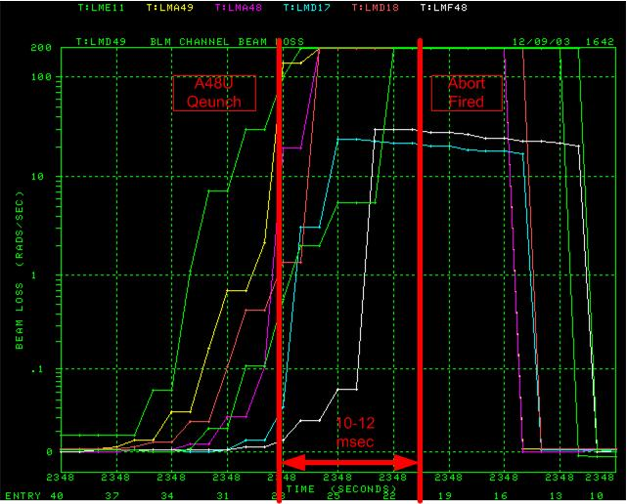
FIGURE 1. T44 loss buffer plot of losses at various locations during the 16 house quench.
4) The A48U cell quenches immediately roughly 16-14 msec before the Tevatron abort fired. This can be seen on Figure 2 which is a plot A4, D4, E1 and F1 QPM over sample buffer. The instant A48U quenches the 5 main bus dipoles in that quenching cell begin to loose current and field at a conservative estimated rate of
100Volts = L(DI/Dt)
where L = .232 H
DI/Dt = 500Amps/sec or .5Amps/msec.
5) Once the current began to decay in these 5 dipole magnets in the A48U cell Figure 3, the beam orbit began to change around the ring. Calculations in Table 1 and 2 estimates that the horizontal orbit at D49 would begin to move toward the D49 horizontal collimator target edge at a rate of -.36mm/msec or -3.92mm in 9 msec. The estimate is that the proton beam would be approximately 3mm from the target. Locally at A48 the beam would be moving to the radial outside away from the incoming pot 3.
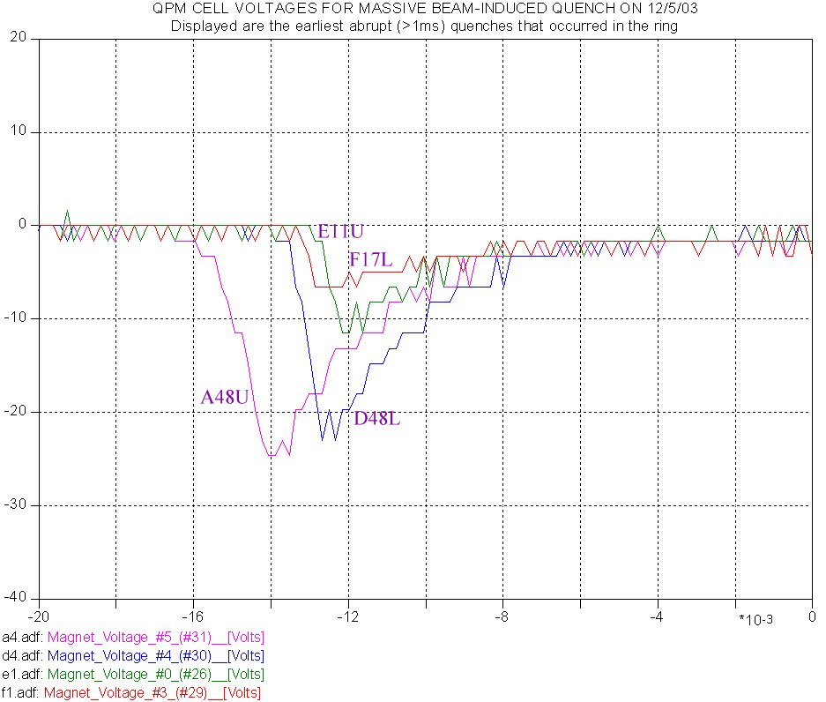
Quench A48 1st
Abort Fired
16msec
FIGURE 2. Voltage plots from QPM’s over sample buffer depicting quenches at A4, D4, E1 and F1. These quenches are very fast and quench a large portion of super conduction bus. A48U quenches approximately 10-12msecs before Tevatron abort loop is pulled. (Courtesy of D. Wolff and EE Support)
6) At the point when the primary proton beam reaches the D49 tungsten target edge, N. Mokhov estimates that in ~ 20-30 turns the beam would drill a hole in the 5mm tungsten wing and continue to circulate beam once a hole was created. Damage of the D49 target is shown in Figure 3.
7)Once the hole in the D49 target was created, proton beam could travel to the next limiting horizontal aperture which would be the E03 1.5 collimator. The beam then etched a horizontal line in the stainless steel collimator horizontal surface Figure 7.
8) The abort system then fired the A0 abort kickers some 12-16 msec after the quench of A48U at which time there is no evidence that any beam; proton or pbar went to the abort blocks at A0.
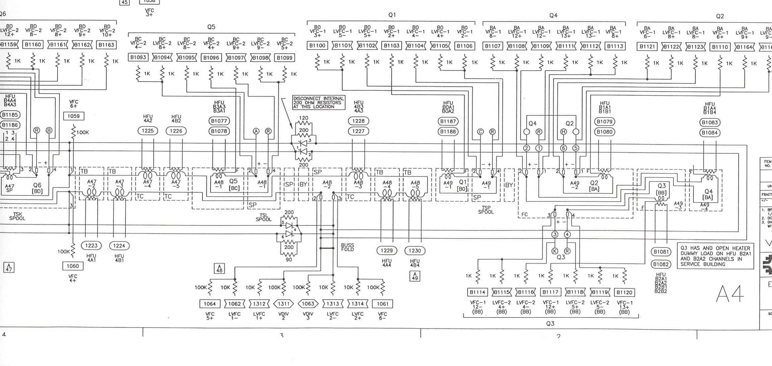
A48U quenching dipoles: Looses current
At .5A/msec
Pot 3 location
Protons
FIGURE 3. Drawing of the A4 Tevatron bus at the quenching cell A48U. Due to 5 dipoles quenching very fast the current is these dipoles is decreasing conservatively at 500Amps/sec creating a distortion in the Tevatron horizontal orbit.
9) The resulting quenches due to beam loss around the ring system then fired the A0 abort kickers some 12-16 msec after the quench of A48U at which time there is no evidence that any beam; proton or pbar went to the abort blocks at A0

Questions to Answer
- One question to answer is why there is proton halo bigger than the pbar beam and halo to the horizontal inside at A48. This may easily be explainable but there is some uncertainty at this point.

Table 2. Movement of beam at D49 target vs. time after A48U quench
Dx at D49 target (mm) | Time from A48U Quench
-0.36 | 1 msec
-0.72 | 2 msec
-1.09 | 3 msec
-1.45 | 4 msec
-1.81 | 5 msec
-2.17 | 6 msec
-2.54 | 7 msec
-2.90 | 8 msec
-3.26 | 9 msec

Common Quench Data
Table 1 provides conditions surrounding the quench. The houses that quenched during this event were A2, A4, B1, B2, B4, C1 ,C4 , D1, D4, E1 ,E2 ,E3 ,E4 ,F1 and lowbeta houses B0 and D0. Figure 4 provides a Tevatron ring wide loss profile from the beginning of the quench to the end. Table 2 provides the T67 abort input timestamps for events.

Table 3. Common facts about 16 house quench
Proton Intensity | 6600 E9
Pbar Intensity | 321 E9
Store number | 3083
Time of Quench | 10:35:41 Dec 5, 2003
Energy | 980gev
Lattice | Lowbeta at Collisions

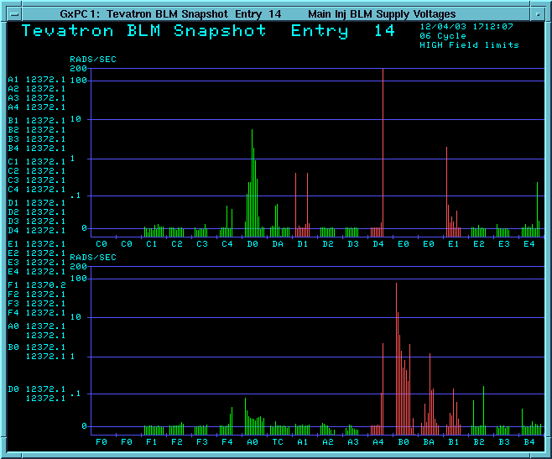
Table 1. Lattice parameters to calculate horizontal movement at D49 target due to massive quench at A48U with 5 main bus dipoles loosing current at .5A/msec
location | betaX | phase advance | phase from col | radians | Displacement at collimator (mm)
A47-4 | 61 | 20.3 | 10.933 | 68.69406 | -0.026792767
A47-5 | 95 | 20.313 | 10.92 | 68.61238 | -0.039417491
A48-3 | 215 | 20.324 | 10.909 | 68.54327 | -0.066606399
A48-4 | 335 | 20.327 | 10.906 | 68.52442 | -0.085562357
A48-5 | 480 | 20.33 | 10.903 | 68.50557 | -0.105280213
D49 col | 87 | 10.651 | 20.582 | 129.3205 | -0.038580551
Total move at D49 in first msec |  |  |  |  | -0.362239778
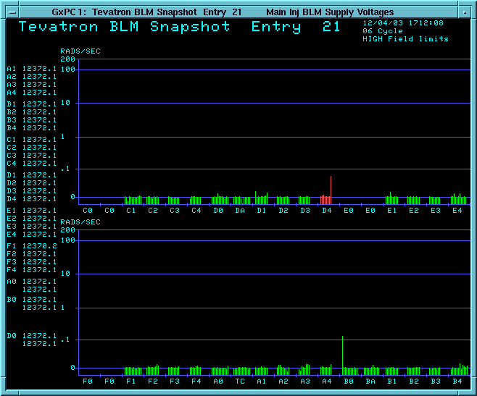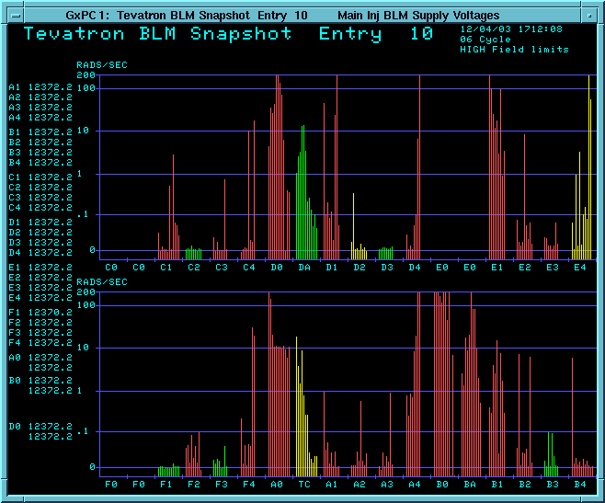
Figure 4. Progression of Tevatron ring wide losses during the quench. These are frames 21, 14 and 10 respectively. 1 frame is 2 msec. Frame 21 is before any loss.

T67 abort event | time stamp (secs) | delta time from first event (msec)
b0 blmba | 51.376 | 0
d1 blm | 51.376 | 0
f4 blm | 51.379 | 3
b2 blm | 51.379 | 3
b4 blm | 51.379 | 3
c1 blm | 51.379 | 3
d0 blm | 51.379 | 3
d4 dipole | 51.38 | 4
e2 blm | 51.38 | 4
e3 blm | 51.38 | 4
c1 blm | 51.38 | 4
e1 dipole | 51.381 | 5
a2 blm | 51.381 | 5
a4 dipole | 51.381 | 5
b0 dipole | 51.381 | 5
d0 qpm | 51.384 | 8
d4 qpm | 51.393 | 17
e1 qpm | 51.393 | 17
f1 qpm | 51.393 | 17
a4 qpm | 51.393 | 17
b4 qpm | 51.393 | 17
c4 qpm | 51.393 | 17
b0 qpm | 51.394 | 18
b1 qpm | 51.394 | 18
d0q2 | 51.394 | 18
a2 tecar | 51.402 | 26
e1 qfe1 | 51.403 | 27
e2 qde2 | 51.403 | 27
f4 qdf4 | 51.403 | 27
a4 qfa4 | 51.403 | 27
b2 dipole | 51.403 | 27
b0q2 | 51.404 | 28
b0q3 | 51.404 | 28
b0q5 | 51.404 | 28
e2 qpm | 51.41 | 34
e3 qpm | 51.41 | 34
a2 qpm | 51.41 | 34
b2 qpm | 51.41 | 34
c1 qpm | 51.41 | 34
d1 qpm | 51.41 | 34
d0q3 | 51.411 | 35
b4 dipole | 51.412 | 36
d1 dipole | 51.432 | 56
f1 dipole | 51.433 | 57
b1 dipole | 51.437 | 61
e3 dipole | 51.454 | 78
e2 dipole | 51.456 | 80
e4 qpm | 51.46 | 84

Damage to Accelerator Components

D49 Collimator Target Damage
The D49 collimator target is used as the primary beam scatter for conducting halo removal in the Tevatron. In order to provide reduction of halo losses at CDF and D0 detectors during a store this collimator is typically placed 5σ from the beam. It will be the closest device next to the beam horizontally and vertically during a store. The target has a 5mm tungsten wing that halo goes through in order to cause scattering of the halo. In this case, the tungsten wing was what was damaged (Figure ##). The wing is designed to replaced by unscrewing to bolts and replace with a new tungsten wing. Efforts were made to replace this wing but the wing developed a crack during installation and the unused target at D171 had to be removed from the beam line, replaced with a straight section of pipe and replaced at D49. The Tevatron will run with out the D171 target. Also 12 newly machined tungsten wings have been manufactured as replacements for future use.

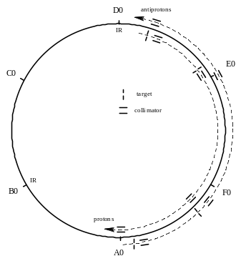
12 collimators total:
4 Targets
8 Secondary collimators

Arranged in 4 sets:
2 proton sets
2 pbar sets

Proton Set 1
D49 Tar, E03 & F172 2nd
Proton Set 2
D171Tar, D173 & A0
Pbar Set 1
F49 Tar, F48 & D172
Pbar Set 2
F173 Tar, F171 & E02

Figure 5. Tevatron collimator halo removal system. Red collimators indicate the primary proton set that were damaged.
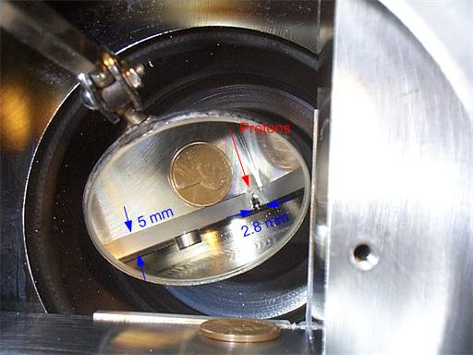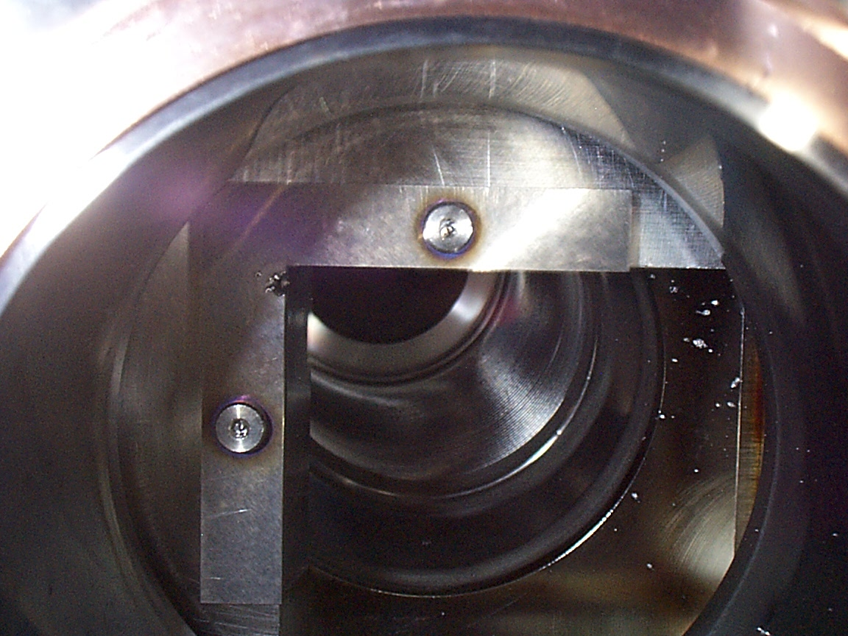
Figure 6. Damage to D49 collimator target during the 16 house quench. This is a tungsten wing used to scatter protons as part of a 2 stage collimator system for halo removal for CDF and D0 experiments. Tungsten melting point is 3400 C. Size of exit hole at maximum is 2.8mm. Size of Tungsten target is 5mm. This hole was created in 10-20 turns of 980gev proton beam after being mis-steered at A48 due to quenching magnets.

E03 1.5m Collimator Damage
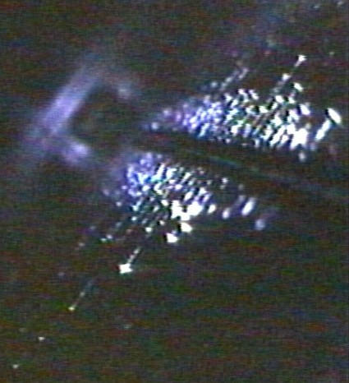
Figure 7. Damage to E03 1.5m collimator during the 16 house quench. This is a secondary collimator downstream of the D49 target the catches halo from the target. After 10-20 turns there was a hole drilled in the D49 target allowing proton beam to continue to next aperture restriction which is the E0e collimator. The length of damage is ~ 5-10 inches long at 1-2mm deep.

C19 Spool Conning Tower Damage
Damage to the C19 spool piece mainly involved a correction element feed through called the conning tower. This is where the warm correction element bus connects to the cold spool. The style that failed during the quench is of the “old” style and probably was already loose at the time of the quench. Large pressures induced by the quench resulted in 1 pin of 12 being pushed out of the conning tower. A couple of efforts to repair the pin while at 80K failed requiring the C1 house to be warmed up to room temperature to replace the conning tower.
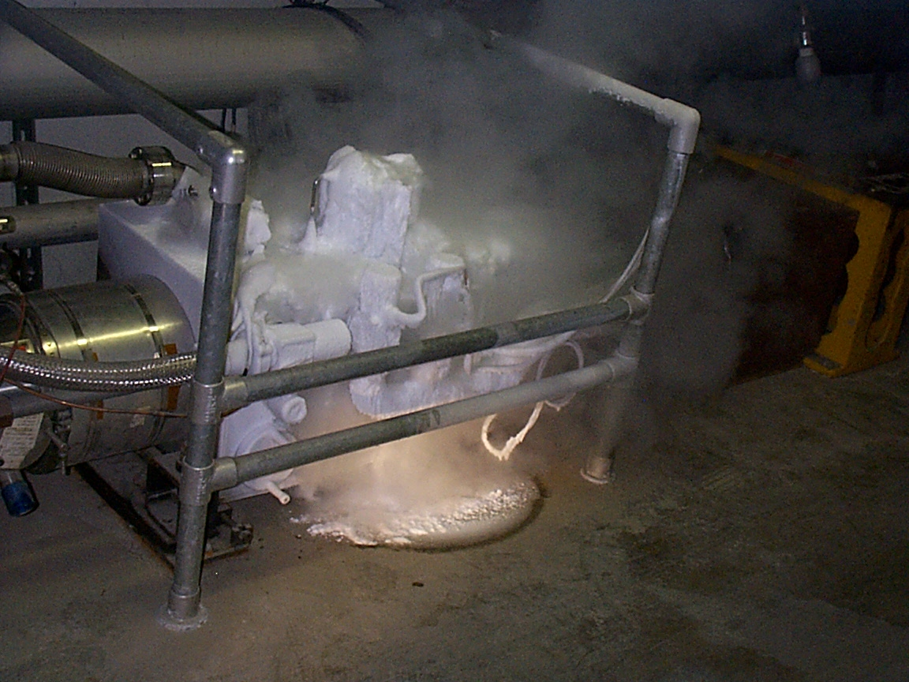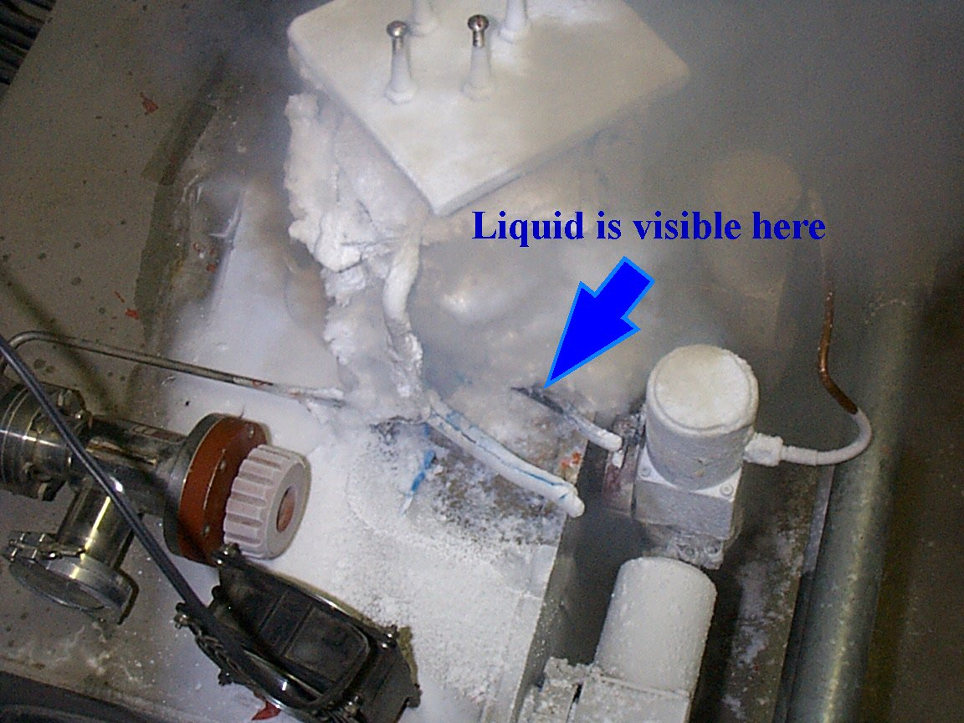
Figure 8. Picture of a helium leak on the C19 spool conning tower. The #1 pin and later more pins are leaking helium. After many efforts to repair the conning tower it was decided to warm up the C1 house and replace the C19 spool.

CDF Roman pot details
The B0 pots operate on a legacy motion control system originally used in a past incarnation of these detectors. Minimal documentation existed to allow understanding of the internal workings of the motor controllers. There had occasionally been problems with Pot #3 being found near its IN limit switch during shot setup (the sequencer checks to make sure they are out of the aperture before allowing beam injection.). On one occasion on 3/17/03, the pots were retracted for a study before beam was aborted and high losses were observed soon after. It was determined that pot #3 had run all the way to the IN limit as soon as it reached the OUT limit. The interface card was ultimately changed and the problem could no longer be intentionally reproduced, at least for some weeks. Pot #3 would still infrequently be found to have gone back in after store termination, and as a stopgap measure, the sequencer retract file was modified to park the pots at positions which were out of the aperture but short of the limit switches, since all observed instances of misbehavior appeared to be related to contacting the OUT limit switch. This change was made during the Fall shutdown and appeared to function as expected for two weeks prior to the quench.

Pot 3 Motion Test Following the Quench
Sequencer retract file was sent to retract the pot, and was then sent again after the pot had stopped. This should have closely duplicated the command sequence that occurred just prior to the quench. The pot continued to the outer limit switch and then rapidly ran back in. This failure could not be duplicated again to get a better idea of the speed or final position the pot attained, but from the plot it appears that the pot traversed an inch in under three seconds. (IN= +)

Pot 3 Damage
There was no damage viewed on the Pot 3 upon local investigation after the quench. Figures ## and ## are pictures of the Pot before the incident but would look similar at the time of investigation. There are still questions surrounding how far pot 3 went into the beam but there is much evidence and high confidence that pot interacted with proton beam halo and did not interact with core proton beam.
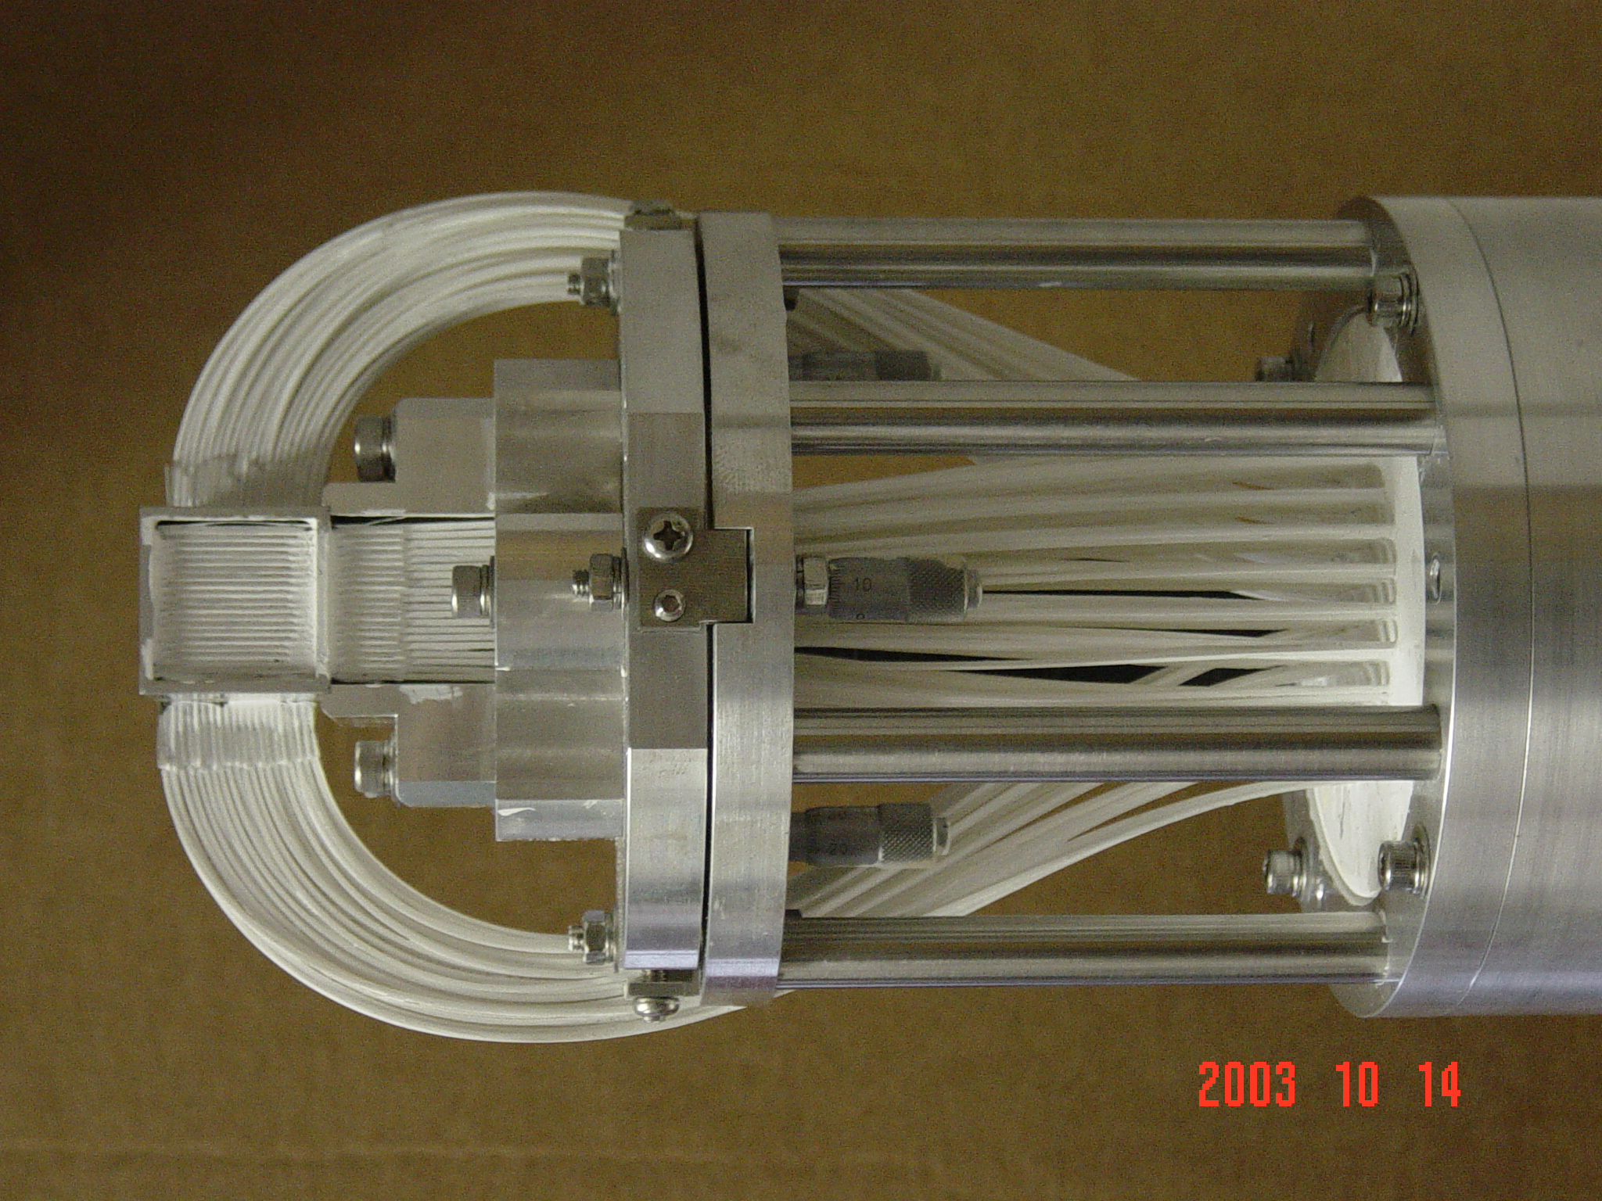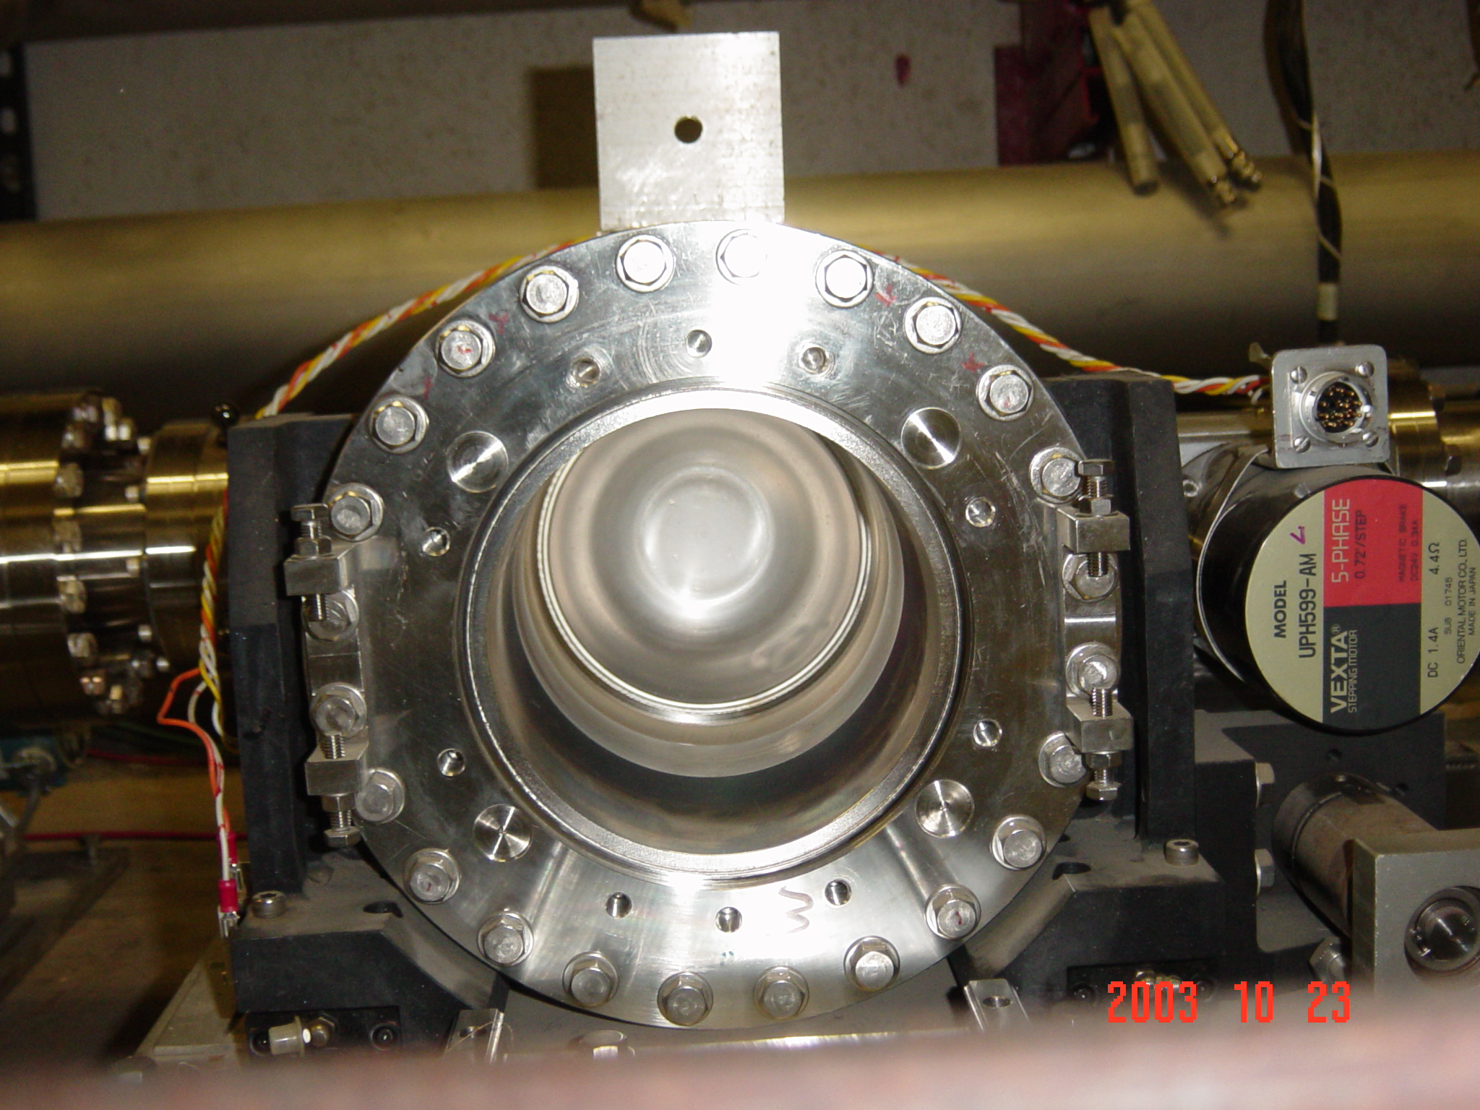

Figure 9. Picture of CDF Roman pot before Dec 5,2003. Top picture is detector that is inserted into beam; lower plot is housing that is perpendicular to beam pipe. The pot is inserted horizontally from the radial inside on the antiproton side of the helix. (Courtesy of CDF )
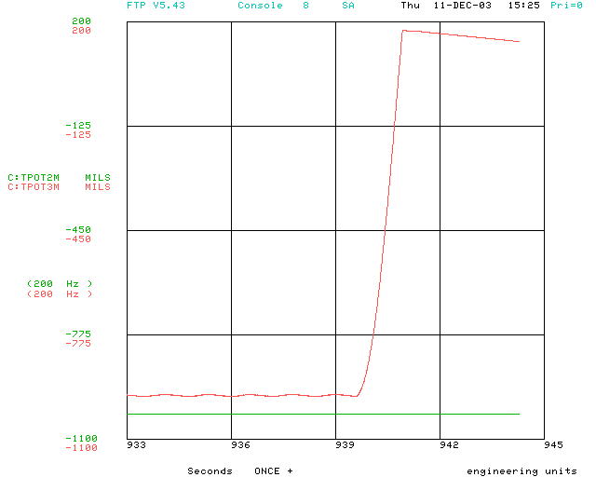
Figure 10. This is a plot of pot 3 upon recreation of the failure mode at the time the pot is driven back into the beam. This is on a fast time scale in order to estimate the speed driven back in. The speed is 1200 mils/sec
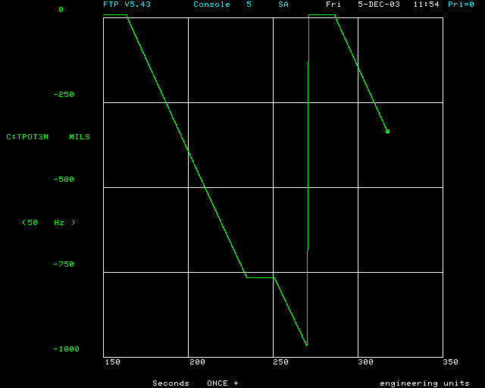
Figure 11. This is a plot of the motion of pot 3 in an attempt to recreate the failure of retracting the pot and then it inserting itself back into the beam.

Recommendation for changes
1) T44 and T67 ACNET applications have already been modified in order to provide better analysis tools to understand this type of event more clearly and accurately.
2) There were some initial thoughts that the dipole correction elements in the spools at D4, A4 and E1 were the first devices to quench causing the corrector outputs to begin to decay and move the orbits globally until the abort kickers would fire. Initial concerns centered on the fact that at collisions the dipole correctors are masked from pulling the abort on T67. This would mean that more time was given to orbit decay from dipoles tripping off and potentially causing more problems with beam loss, likely a quench , until the A0 abort kicker could fire. In this case, the unmasking of the dipole correction elements from the abort would not have helped since the quench at A48U developed so fast and involved a good portion of quenching superconductor changing the current in 5 main bus dipoles not correction elements. Discussions have taken place with in the Tevatron Department as to whether this would be better practice in the future of unmasking the dipole correction elements from the abort but no conclusion has been reached.
3) Having the QPM’S respond to faster quench from the over sample buffer could be an option but this would have to be discussed and implemented with the EE support department.
4) Better loss monitor protection could be another option for aborting fast quenches. Currently during stores the loss monitors are masked from the abort system due to the fact that there is only high field loss limit. It is know for sure that it would be impossible to ramp with these loss limits but a more complicated system could be proposed incorporating loss limits for different Tevatron states. This would need more planning and effort.

Conclusions
The CDF pot 3 reinserted itself back into the beam after it had been given commands to retract. This initiated large proton and pbar beam losses at A48. These losses produced a fast quench involving many superconducting magnets at the cell A48U. These magnets loosing field produced a horizontal orbit change at the D49 collimator target setting up conditions to damage this collimator and its corresponding secondary collimator E03 with beam. It is unfortunate that there was damage to the 2 collimators requiring replacement but on the other hand the collimators took the damage that potentially could have damaged another accelerator component.

acknowledments
The data, analysis and conclusions presented in this report come from many people and departments in order to carefully and accurately describe the events of the 16 house quench on December 5, 2003. I would like to thank and acknowledge all those who contributed. The list is of personnel is long but these are the main contributors: J. Annala, B. Hanna, T. Johnson, D. Wolff, B. Flora, N. Mohkov, S. Drozhdin, B. Hendricks, CDF Roman Pot personnel and Mechanical support.

