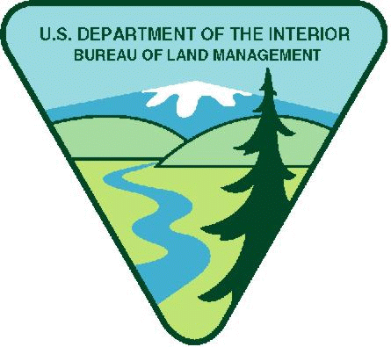

UNITED STATES

DEPARTMENT OF THE INTERIOR
BUREAU OF LAND MANAGEMENT

NOTICE OF INTENT TO AWARD

This Funding Announcement is not a request for applications. This announcement is to provide public notice of the Bureau of Land Management’s intention to fund the following project activities without full and open competition.

ABSTRACT
Funding Announcement | CA-NOI-08-0009
Project Title | CALIFORNIA BLM FIRE COMMUNITY PROTECTION/COMMUNITY ASSISTANCE
Recipient | California Fire Safe Council, Inc.
Principle Investigator / Program Manager | Jane Arteaga, California State Fire Mitigation and Education Specialist.
Total Anticipated Award Amount | Approximately $15 million over the life of the agreement.
Cost Share | 10%
New Award or Continuation? | Continuation
Anticipated Length of Agreement | 5 years
Anticipated Period of Performance | October 1st to September 30th Yearly
Award Instrument | Cooperative Agreement
Statutory Authority | The Federal Land Policy and Management Act of 1976, as amended. Public Law 94-579, Section 307 (b) states that the Secretary may enter into contracts and cooperative agreements for the management, protection, development, and sale of public lands.
CFDA # and Title | 15.228 Wildland Urban Interface Community Assistance
Single Source Justification Criteria Cited | #4 Unique Qualifications – The applicant is uniquely qualified to perform the activity based upon a variety of demonstrable factors such as location, property ownership, voluntary support capacity, cost-sharing ability if applicable, technical expertise, or other such unique qualifications;
BLM Point of Contact | Jane Arteaga, jarteaga@ca.blm.gov, Phone Number 916-978-4436

OVERVIEW
This agreement is made and entered into by the Department of the Interior, Bureau of Land Management, California State Office and the California Fire Safe Council, for the purpose of implementing the National Fire Plan for community assistance for protection from catastrophic wildland fires. This collaborative effort is a significant effort in implementing Community Protection/Community Assistance initiative through the appropriate operating principles of prevention through education, hazardous fuel reduction, collaborative stewardship, monitoring, creating jobs, and applied research. This effort to protect communities at risk from wildfire will be accomplished through projects in four areas; community wildfire protection planning, prevention/education program, hazardous fuel removal, and applied research.

RECIPIENT INVOLVEMENT

The CFSC agrees to provide supervision and oversight and to coordinate with other public and private organizations, agencies and individuals to accomplish the identified tasks.
- Operate grants Clearinghouse with funding from participating agencies.
- Fund projects when agencies want to pass funding through the FSC.
- Input and manage data entry for NFPORS data base.
- Provide Administrative Assistance for the California Fire Alliance

BLM INVOLVEMENT

Substantial involvement on the part BLM is anticipated for the successful completion of the objectives to be funded by this award. In particular, BLM will be responsible for the following:

- Actively participate in California Fire Alliance Clearinghouse workgroup
- Establish mutually agreeable deadlines for annual Clearinghouse
- Provide information on grant programs in Clearinghouse for inclusion on site
- Provide guidance and assistance to California Fire Safe Council in properly communicating about Clearinghouse with agency personnel at relevant levels, including headquarters and field offices
- Provide technical assistance to California Fire Safe Council on potential grants issues (issues usually relate to environmental compliance, federal forms and administrative issues)

SINGLE-SOURCE JUSTIFICATION

DEPARTMENT OF THE INTERIOR
SINGLE SOURCE POLICY REQUIREMENTS
Department of the Interior Policy (505 DM 2) requires a written justification which explains why competition is not practicable for each single-source award. The justification must address one or more of the following criteria as well as discussion of the program legislative history, unique capabilities of the proposed recipient, and cost-sharing contribution offered by the proposed recipient, as applicable.

In order for an assistance award to be made without competition, the award must satisfy one or more of the following criteria:

- Unsolicited Proposal – The proposed award is the result of an unsolicited assistance application which represents a unique or innovative idea, method, or approach which is not the subject of a current or planned contract or assistance award, but which is deemed advantageous to the program objectives;

- Continuation – The activity to be funded is necessary to the satisfactory completion of, or is a continuation of an activity presently being funded, and for which competition would have a significant adverse effect on the continuity or completion of the activity;

- Legislative intent – The language in the applicable authorizing legislation or legislative history clearly indicates Congress’ intent to restrict the award to a particular recipient of purpose;

- Unique Qualifications – The applicant is uniquely qualified to perform the activity based upon a variety of demonstrable factors such as location, property ownership, voluntary support capacity, cost-sharing ability if applicable, technical expertise, or other such unique qualifications;

- Emergencies – Program/award where there is insufficient time available (due to a compelling and unusual urgency, or substantial danger to health or safety) for adequate competitive procedures to be followed.

BLM did not solicit full and open competition for this award based the following criteria:

Single Source Justification Description:

(2) Continuation – This is a continuation of a current muli- agency agreement.

STATUTORY AUTHORITY

The Federal Land Policy and Management Act of 1976, as amended. Public Law 94-579, Section 307 (b) states that the Secretary may enter into contracts and cooperative agreements for the management, protection, development, and sale of public lands.

