

U. S. Department Publication No. FHWA-NHI-04-160
of Transportation April 2004
Federal Highway

Administration

NHI Course No. XXXXXX

Fundamentals of Road Weather Management

Appendix B: Participant Workbook




Table of Contents

I. Introduction 2
II. Executive Summary 2
III. Course Goal and Outcomes 3
Course Goal 3
Course Outcomes 3
IV. Course Agenda 4
V. Course Material 5
Exercise – Handout 5-1 17
Acronym List 18
Glossary 19

I. Introduction
The Fundamentals of Road Weather Management is a one-day course aimed at helping those involved in highway maintenance and operations develop techniques and strategies for tackling road weather problems. This course provides a basic knowledge of meteorology and addresses the technological resources available to support highway personnel in making effective road weather decisions.

II. Executive Summary
Over the past 20 years, improvements have been made in the areas of road sensors, anti-icing and information dissemination via tools such as Road Weather Information Systems (RWIS). However, concerns still remain regarding uniform standards and data sharing.

The Fundamentals of Road Weather Management is a one-day course aimed at transportation professionals involved in highway maintenance, highway safety, emergency management, and traffic management. The course provides techniques and strategies for tackling road weather problems, specifically designed for those individuals directly involved in the implementation of road weather solutions and allocation of resources. The course focuses heavily on resources and solutions, and how those solutions can reduce the impact of adverse weather on road users and highway personnel.

The following key points are covered in this course:

- Impact of weather on highway operations.
  - Discussion on the effects of weather on the traveling public and the impact of road weather on highway operation.

- Fundamentals of meteorology, including how it pertains to Road Weather Information Systems.
  - Includes discussion on the definitions of basic meteorology terms and the importance of climatology, tailored forecast and weather observations to roadway management.

- Technical and institutional resources available for implementing Road Weather Information Systems.
  - Key technological resources are identified for making road weather decisions, including challenges faced in implementing road weather technology.

- Range of effective and open solutions to the various types of weather conditions for various management practices.
  - Includes discussion on the importance of proactive planning and possible solutions to road weather challenges.
  - Various solutions to road weather problems are analyzed and applied to local environment.

In summary, the purpose of this course is not to make participants experts, but to provide them with the basic tools and resources needed for effective road weather decisions, and direction on where to go for more information.

III. Course Goal and Outcomes

Course Goal
The purpose of this course is to introduce the resources and basic information needed to effectively manage road weather issues. While some of this information may not be new to participants, this course will focus on using the presented KSA's (knowledge, skills and abilities) to effectively solve road weather issues. The goals of this course are to:
- Identify and discuss road weather problems.
- Discuss the resources available to support effective road weather decision-making.
- Enable participants to apply their knowledge, skills, and abilities to road weather management.

Course Outcomes
At the end of this course, participants will be able to:
1. Examine the impact of weather on highway operations.
2. Discuss the fundamentals of meteorology, including how it pertains to Road Weather Information Systems (RWIS).
3. Identify the technical and institutional resources for implementing Road Weather Information Systems (RWIS).
4. Examine the range of effective and open solutions to the various types of weather conditions for various management practices.

IV. Course Agenda
Length
Time Lesson Title (minutes)
8:30-9:00 Welcome 30
9:00-10:00 Lesson 1: The Road Weather Problem 60
10:00-10:10 Break 10
10:10- 11:10 Lesson 2: Meteorology for Non-meteorologists Part I 60
11:10-11:20 Break 10
11:20- 12:00 Lesson 3: Meteorology for Non-meteorologists Part II 40
12:00-1:00 Lunch 60
1:00-2:00 Lesson 4: Technology: Resources & Implementation 60
2:00-2:10 Break 10
2:10 - 3:00 Lesson 5: Solutions to RWP - Case Studies Part I 50
3:00-3:10 Break 10
3:10-4:00 Lesson 6: Solutions to RWP - Case Studies Part II 50
4:00-4:30 Wrap-up 30

V. Course Material

Lesson 4: Technology: Resources and Implementation
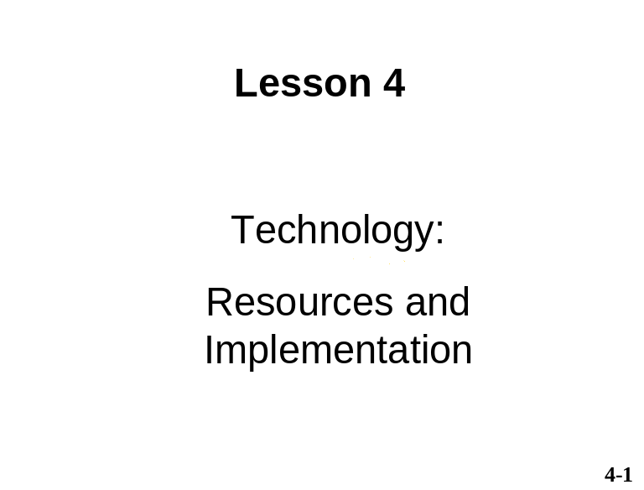 | __________________________  __________________________  __________________________  __________________________  __________________________  __________________________  __________________________  __________________________  __________________________  __________________________  __________________________
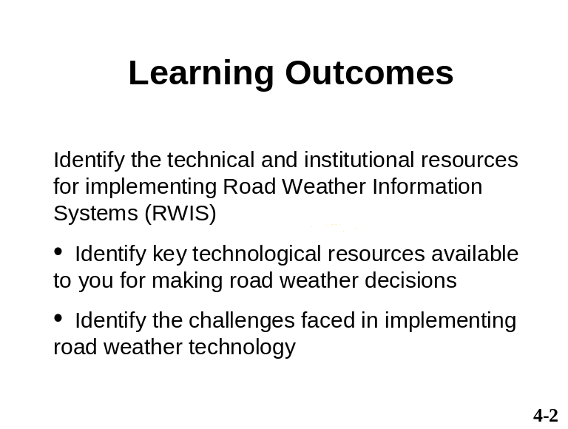 | __________________________  __________________________  __________________________  __________________________  __________________________  __________________________  __________________________  __________________________  __________________________  __________________________  __________________________
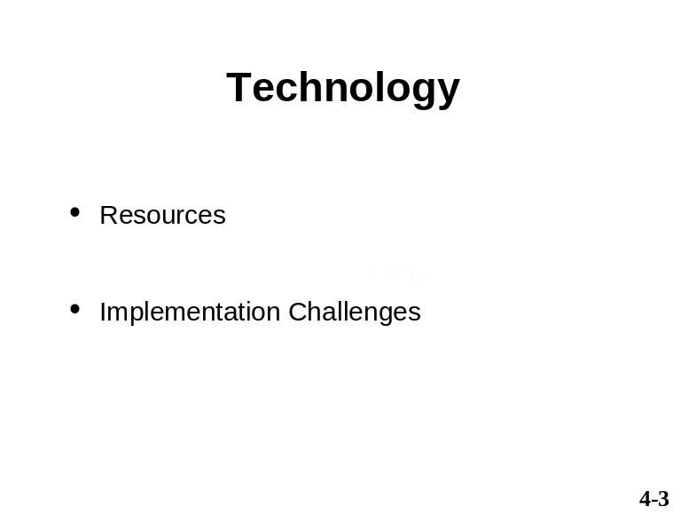 | __________________________  __________________________  __________________________  __________________________  __________________________  __________________________  __________________________  __________________________  __________________________  __________________________  __________________________
Why use technology:
- Make your operations more efficient and effective
- To provide a higher level of service
- Keep roads safer and keep traffic moving

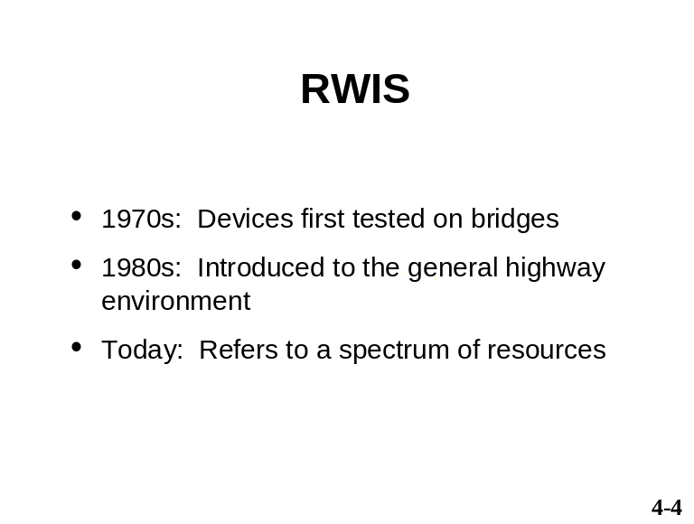 | __________________________  __________________________  __________________________  __________________________  __________________________  __________________________  __________________________  __________________________  __________________________  __________________________  __________________________
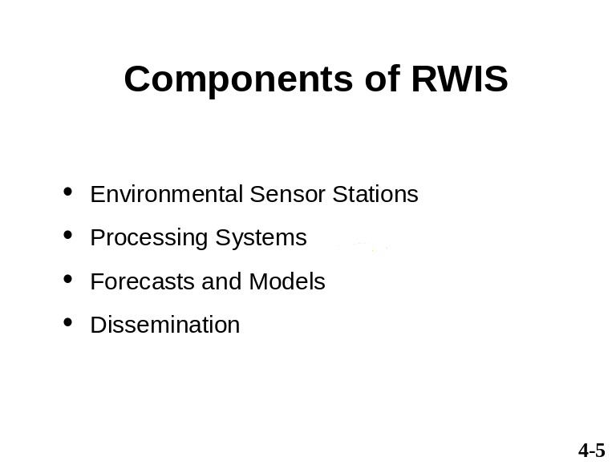 | __________________________  __________________________  __________________________  __________________________  __________________________  __________________________  __________________________  __________________________  __________________________  __________________________  __________________________
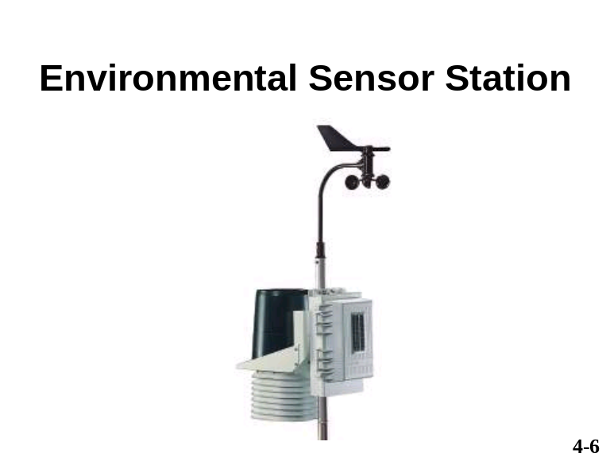 | __________________________  __________________________  __________________________  __________________________  __________________________  __________________________  __________________________  __________________________  __________________________  __________________________  __________________________
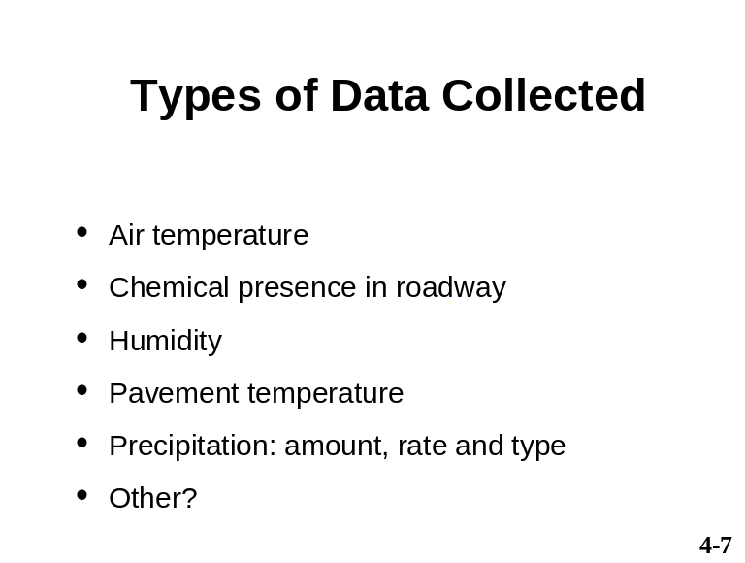 | __________________________  __________________________  __________________________  __________________________  __________________________  __________________________  __________________________  __________________________  __________________________  __________________________  __________________________
For more information on Environmental Sensor Stations please refer to Chapter 4: “Technology Resources” in the Fundamentals of Road Weather Management reference manual.
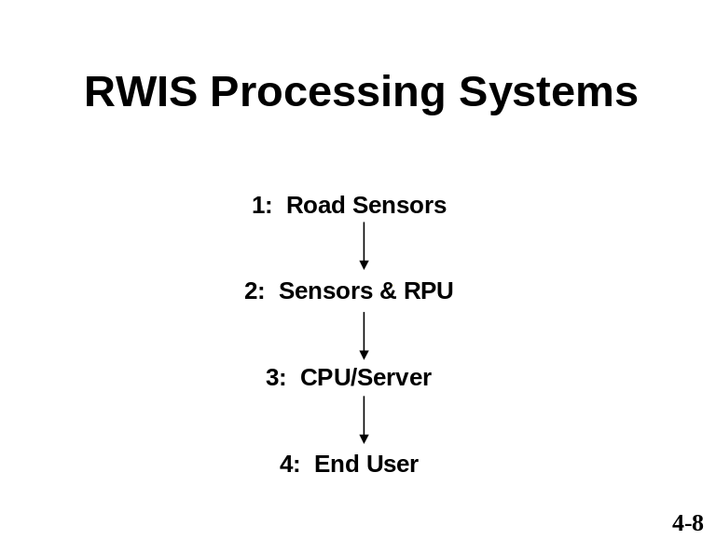 | __________________________  __________________________  __________________________  __________________________  __________________________  __________________________  __________________________  __________________________  __________________________  __________________________  __________________________
RPU: Remote Processing Unit CPU: Control Processing Unit
For more information on RWIS please refer to Chapter 4: “Technology Resources” in the Fundamentals of Road Weather Management reference manual.
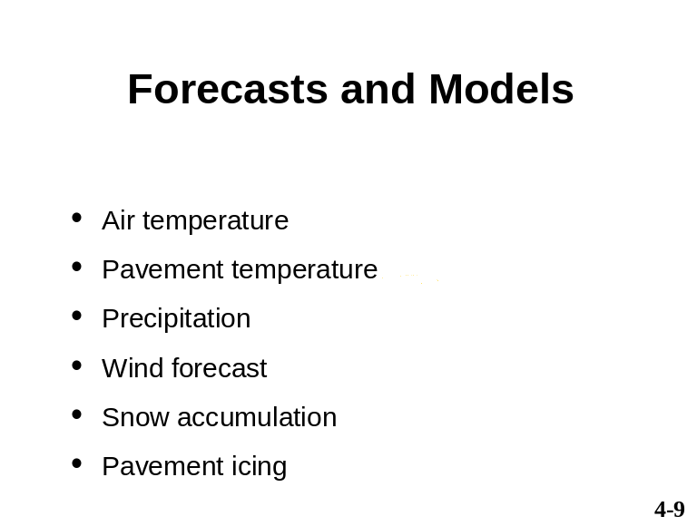 | __________________________  __________________________  __________________________  __________________________  __________________________  __________________________  __________________________  __________________________  __________________________  __________________________  __________________________
Weather forecasts are either provided by the ESS vendor or if a VAMS has been contracted, by the VAMS using sensor data from an ESS.
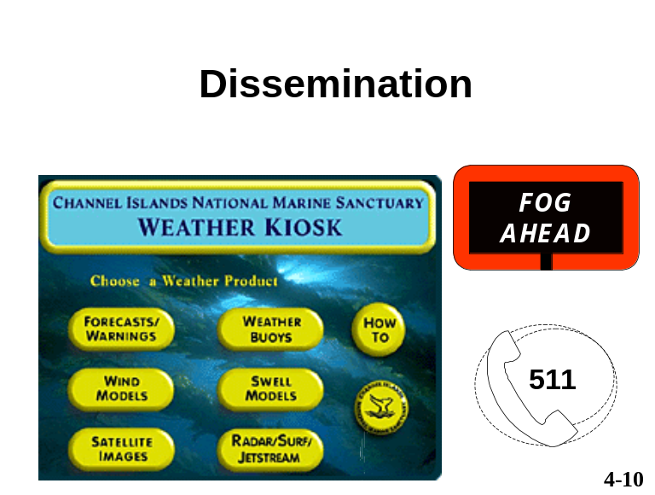 | __________________________  __________________________  __________________________  __________________________  __________________________  __________________________  __________________________  __________________________  __________________________  __________________________  __________________________
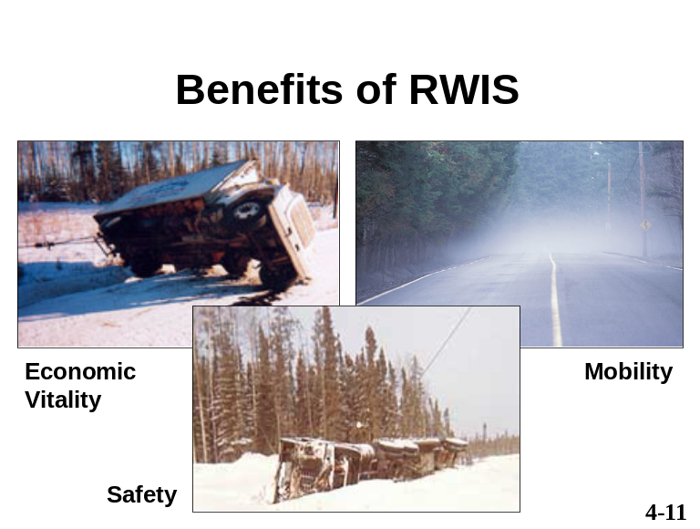 | __________________________  __________________________  __________________________  __________________________  __________________________  __________________________  __________________________  __________________________  __________________________  __________________________  __________________________
For more information on the benefits of using RWIS please refer to Chapter 4: “Technology Resources” in the Fundamentals of Road Weather Management reference manual.
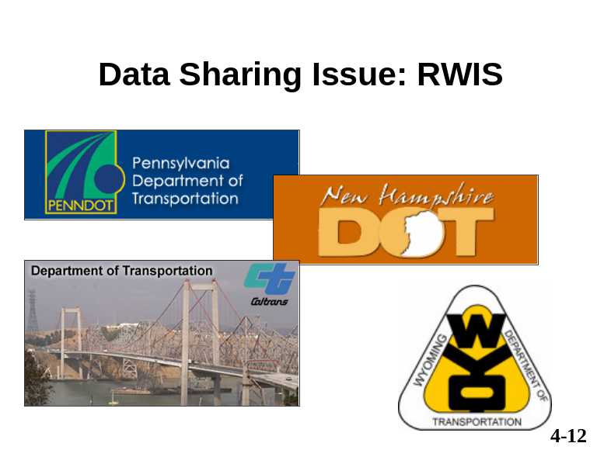 | __________________________  __________________________  __________________________  __________________________  __________________________  __________________________  __________________________  __________________________  __________________________  __________________________  __________________________
For more information on data sharing issues please refer to Chapter 4: “Technology Resources” in the Fundamentals of Road Weather Management reference manual.
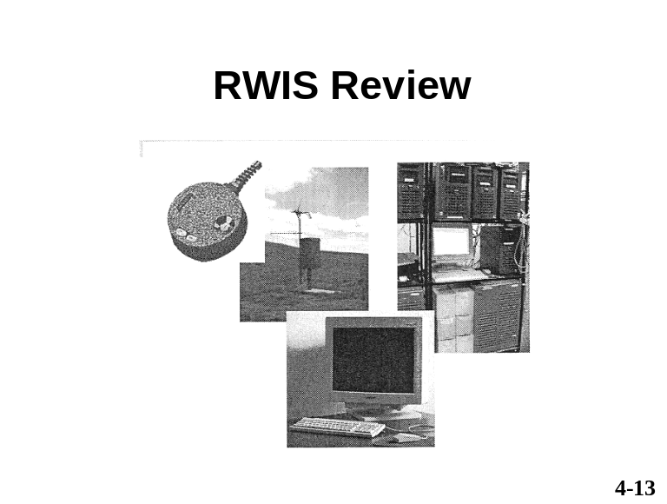 | __________________________  __________________________  __________________________  __________________________  __________________________  __________________________  __________________________  __________________________  __________________________  __________________________  __________________________
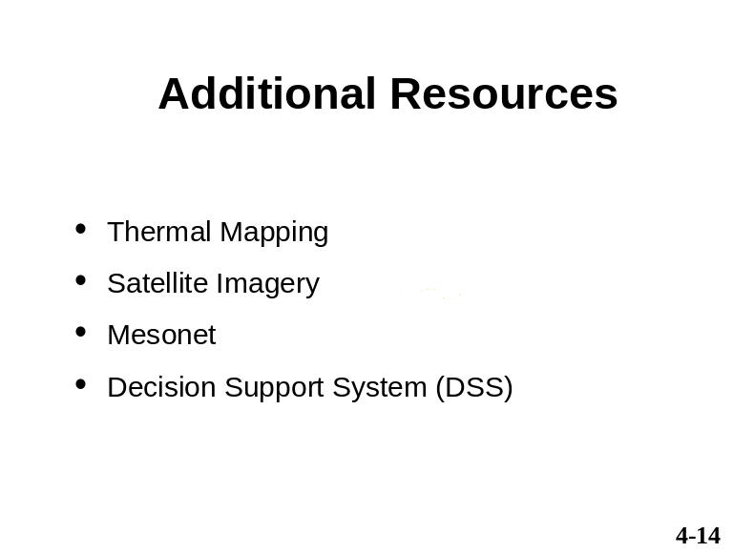 | __________________________  __________________________  __________________________  __________________________  __________________________  __________________________  __________________________  __________________________  __________________________  __________________________  __________________________
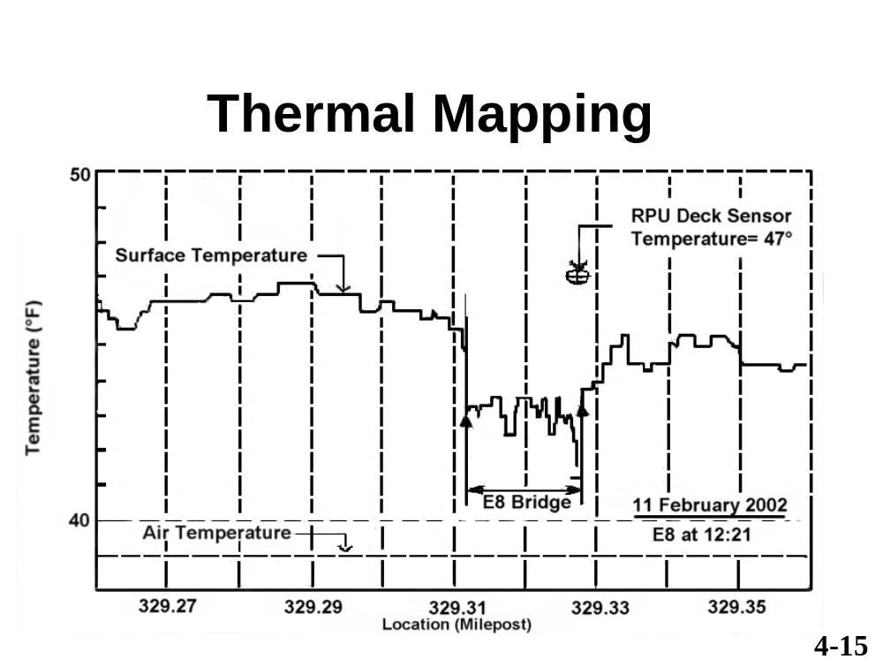

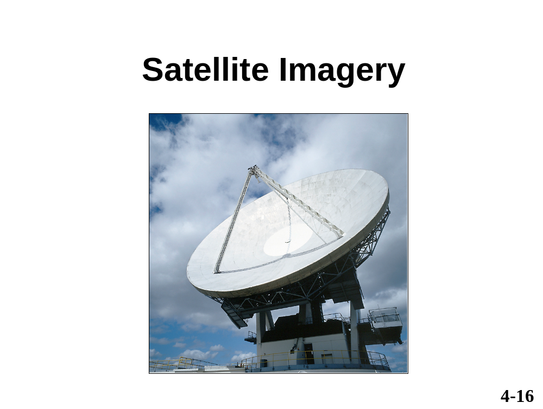

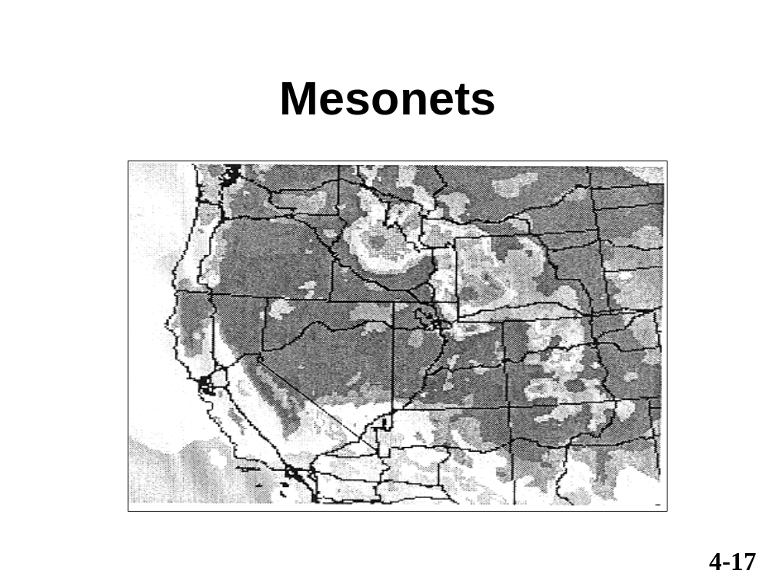

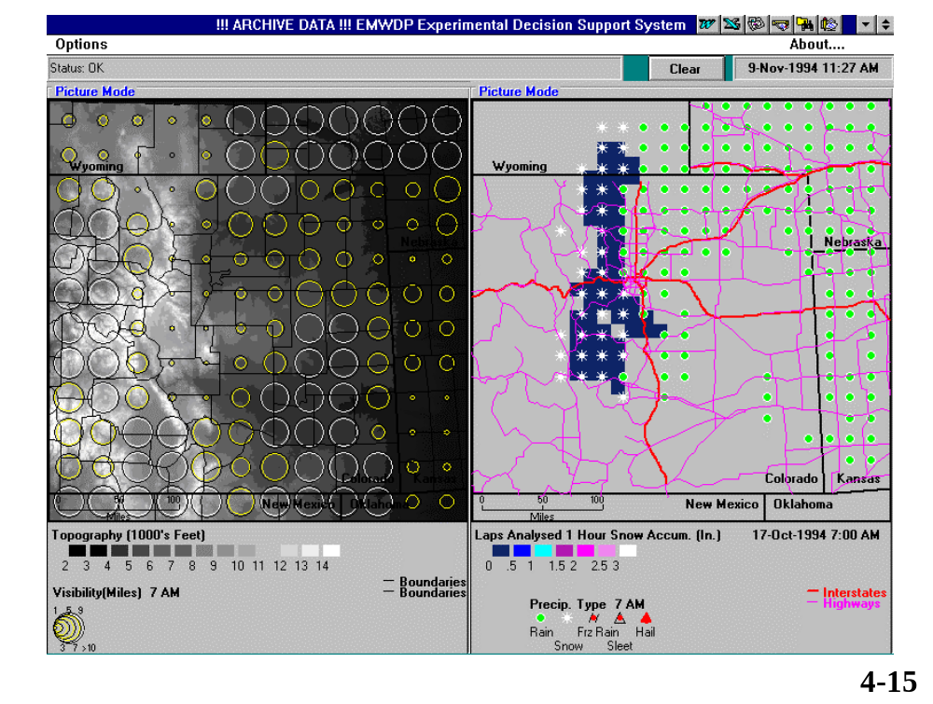

DECISION SUPPORT SYSTEM

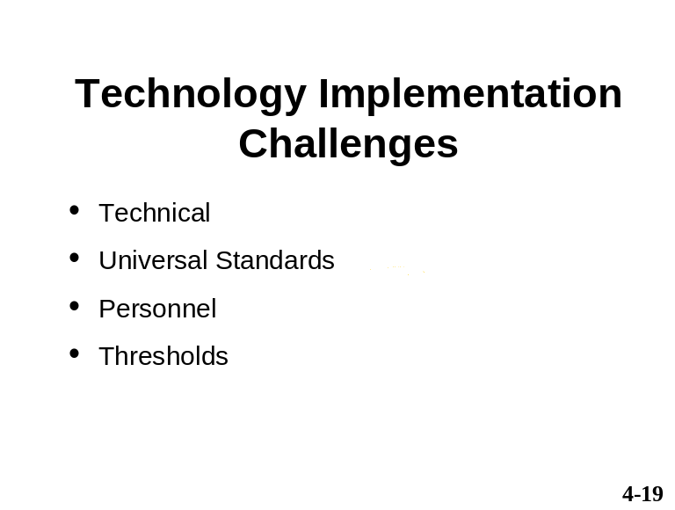 | __________________________  __________________________  __________________________  __________________________  __________________________  __________________________  __________________________  __________________________  __________________________  __________________________  __________________________
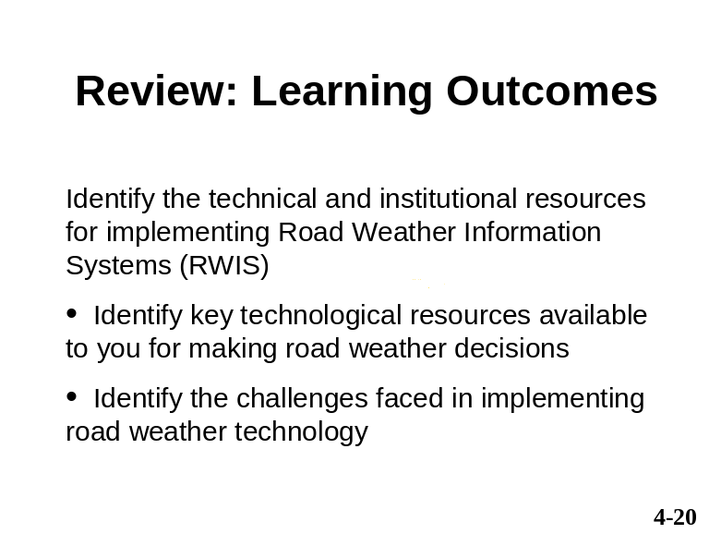 | __________________________  __________________________  __________________________  __________________________  __________________________  __________________________  __________________________  __________________________  __________________________  __________________________  __________________________

Exercise – Handout 5-1

Instructions: Match the technological resource or device on the right – with its RWIS component on the left. Write in the number of the resource or device in the space next to its related component.

Component of RWIS Resource/Device

ESS _____ 1. RPU

_____ 2. Value added Meteorological Services
(VAMS)

Processing Systems _____ 3. Kiosks

_____ 4. Pavement icing

Forecasts and Models _____ 5. Road sensors

_____ 6. Variable message boards

Dissemination _____ 7. Sensor stations

_____ 8. CPU

Acronym List

CPU Central Processing Unit

CVU Commercial Vehicle Operators

DSS Decision Support System

ESS Environmental Sensor Stations

Hazmat Hazardous Materials

MDSS Maintenance Decision Support System

NOAA National Oceanic and Atmospheric
Administration

NTCIP National Transportation Communications
for ITS Protocol

NWS National Weather Service

PMA Primary Market Area

RPU Remote Processing Unit

RWIS Road Weather Information Systems

TMC Traffic Management Center

VAMS Value-Added Meteorological Services

Glossary

Decision Support System  (DSS) | A system that integrates weather, road condition, and resource information to facilitate road weather information decision making.
Environmental Sensor  Station (ESS) | A suite of atmospheric and roadway sensors, plus a remote processing unit (RPU).
ENTERPRISE | A pool-fund organization, consisting of seven U.S. state Departments of Transportation, Canada, and the Netherlands, that has developed a set of standard test procedures for implementing road weather technology.
Humidity | The amount of moisture (e.g., water vapor) in the atmosphere.
Maintenance Decision  Support System (MDSS) | An FHWA initiative to develop a decision support system (DSS) for winter road maintenance.
Mesonet | A collection of weather observing stations typically combining data from multiple agencies and applications.
National Transportation  Communications for ITS  Protocol (NTCIP) | The generic name of standards that define how roadside services talk to a central road weather information system.
Road Weather Information  Systems (RWIS) | The main technological resource available for managing road weather issues. Refers to a coordinated system of data collection, analysis, dissemination, and display of road weather information.
Value added Meteorological  Services (VAMS) | A for-hire company which develops specific  weather planning programs for businesses and industries.

