 | Department of the Interior  Bureau of Land Management | 

ANTELOPE MOUNTAIN
COMMUNICATIONS SITE MANAGEMENT
PLAN

Prepared by the Bureau of Land Management
Eagle Lake Field Office, California

Approved by: _______Dayne Barron_________________________ __May 4, 2007____
Field Manager Date
ANTELOPE MOUNTAIN COMMUNICATIONS SITE MANAGEMENT PLAN

I. INTRODUCTION 3
A. Terms and Definitions 3
B. Purpose 4
C. Site Description 5
D. Area Served 5
E. Access 5
F. Site History and Development 6
G. Goals and Objectives of Site Management Plan 6
II. AUTHORITY AND DIRECTION 7
A. Authority 7
B. Relationship to Communications Site Leases/ROW Grants 8
III. GENERAL RESPONSIBILITIES 8
A. The Bureau of Land Management 8
B. Facility Owners and Facility Managers 8
C. FCC and NTIA/IRAC 10
IV. AUTHORIZED USES AND USERS WITHIN A FACILITY 10
Use by Multiple Users 10
V. FEES 11
VI. GENERAL OPERATION AND MAINTENANCE DIRECTION 11
A. Unique Resource Considerations at this Communication Site 11
B. Wiring and Grounding 11
C. Communications Equipment 12
D. Cables and Transmission Line (Wave Guides) 15
E. Radiation 15
F. Utilities-Availability of and Requirements for: 16
G. Sanitary Facilities 17
H. Security and Law Enforcement 17
I. Site Maintenance 18
J. Inspections 19
K. Fire Prevention and Hazard Reduction Requirements 19
L. Access Maintenance and Restrictions 20
VII. CONDITIONS FOR CONSTRUCTION, MODIFICATIONS OR EXPANSION 21
A. New Facility Owner Responsibilities 21
B. Construction Methods and Resource Protection 22
C. Construction Inspection 23
D. New or Remodeled/Expanded Buildings 23
E. New or Remodeled/Expanded Towers 25
VIII. SITE ASSOCIATION/ADVISORY GROUP 25
IX. APPENDICES 25
A. Location and Site Maps 25
B. Authorized Facilities 26
C. Site Photographs 26
D. Inspection Checklist and Sample User Association By-Laws 26
APPENDIX A 27
APPENDIX B 30
APPENDIX C 31
APPENDIX D 34

INTRODUCTION

Terms and Definitions
The terms used in this communications site management plan conform to the definitions listed in the April 22, 2005, Federal Register notice “Rights-of-Way, Principles and Procedures: Rights-of-Way under the Federal Land Policy and Management Act and the Mineral Leasing Act”, with further clarification provided in Bureau of Land Management (BLM) Handbook 2860-1 and the United States Code of Federal Regulations (CFR) 43 CFR 2800. In the event of a conflict, between the plan and these sources, the Federal Register notice and the BLM Handbook will govern.

The words “lease” and “lessee” as used in this plan refer to the relationship between the BLM and the communications use lease lessee, or right-of-way (ROW) holder. The words “customer” and “tenant” refer to the relationship between the lessee or holder and the occupants in the lessee’s facilities.
LEASE OR ROW – A use authorization issued to a communication Facility Owner or Facility Manager allowing for the use of public land to construct and or operate a communications facility and, unless specifically prohibited, to sublease to occupants in that facility.
LESSEE, LEASE HOLDER, OR ROW HOLDER – A Facility Owner or Facility Manager
CUSTOMER – A facility occupant who is paying a facility manager, facility owner, or tenant for using all or any part of the space in the facility, or for communication services, and is not selling communication services or broadcasting to others.
TENANT – A facility occupant who is paying a facility manager, facility owner, or other entity for occupying and using all or part of a facility. A tenant operates communication equipment in the facility for profit by broadcasting to others or selling communication services.
COMMUNICATIONS SITE – An area of BLM-managed public land designated through the land and resource management planning process as being used or is suitable for communications uses. A communications site may be limited to a single communications facility, but most often encompasses more than one. Each site is identified by name; usually a local prominent landmark, such as Antelope Mountain Communications Site.
FACILITY – The building, tower, and related incidental structures or improvements authorized under the terms of the grant or lease.
FACILITY MANAGER – The holder of a BLM communications use authorization who leases space for other communication users. A facility manager does not own or operate communications equipment in the facility for personal or commercial purposes.
FACILITY OWNER – Individuals, commercial entities, organizations, or agencies, that own a communications facility on Federal land; own and operate their own communications equipment; and hold a communications use authorization. Facility owners may or may not lease space in the facility to other communications users.
NON-BROADCAST – This category includes Commercial Mobile Radio Service (CMRS), Facility Managers, Cellular Telephone, Private Mobile Radio Service (PMRS), Microwave, Local Exchange Network, and Passive Reflector.
BROADCAST – This category includes Television Broadcast, AM and FM Radio Broadcast, Cable Television, Broadcast Translator, Low Power Television, and Low Power FM Radio.
RIGHT-OF-WAY (ROW) – The public land authorized to be used or occupied pursuant to a ROW grant.
RIGHT-OF-WAY GRANT – A use authorization issued pursuant to Title V of the Federal Land Policy and Management Act of October 21, 1976 (43 U.S.C. 1701 et seq.) or issued on or before October 21, 1976, pursuant to then existing statutory authority, authorizing the use of a ROW over, upon, under or through public land for construction, operation, maintenance and termination of a project.
HOLDER – Any applicant who has received a ROW grant, lease or temporary use permit.
USERS – All ROW and lease holders, lessees, customers, and tenants that own or operate a facility or communication equipment at the communication site.
SENIOR USE – Any use whose implementation date is prior to the implementation date of the use in question.
RANALLY METRO AREA (RMA) – A series of nine population zone areas, the highest of which is greater than 5 million and the lowest being 25,000 or less. These zones are determined annually and published in the Ranally Metro Area Population Ranking, an independent publication from Rand McNally.

Purpose
This plan will be used by BLM officials administering communications uses at Antelope Mountain, existing lessees, holders, and applicants desiring a lease, grant, or an amendment to an existing lease or ROW grant. The plan will be kept updated by amending pages or sections of the plan rather than issuing a revised edition of the plan. When a revision is necessary, a letter from the Eagle Lake Field Office enclosing a copy of revised pages or sections will amend the plan. The amendments will be consecutively numbered.
Overall management direction for the administration of communications sites is outlined in the CFR and the BLM Handbook and applicable BLM Instructional Memoranda. Specific direction for site management planning on designated communications sites is contained in BLM Handbook 2860-1. Primary regulations and policy pertaining to issuance of ROW authorizations by the BLM are found in Title 43 CFR Sections 2801- 2808 and BLM Handbook 2860-1.

This communications site will be managed under the direction of the Eagle Lake Resource Management Plan (RMP) Record of Decision which is scheduled to be finalized in 2006. The Draft Resource Management Plan states that the Eagle Lake Field Office will:

“Establish communication sites on Antelope, Shaffer, and Grasshopper Mountains. In reference to this:

- Develop plans for each site (and update when necessary).
- Designate rights-of-way for each location.
- Define site boundaries, require cadastral surveys, and develop a map showing the location of each facility and its legal access. Facilities must be located within designated sites.”

This Site Management Plan provides applicable guidance and adds current policy and technical standards for better management of the Antelope Mountain Communications Site. This plan governs development and management of Antelope Mountain and will be modified in the future as needs and conditions warrant. Any future such uses must be designed, installed, operated, and maintained to be compatible and not interfere with the senior uses as defined in Section A above. This site-specific plan is administrative in nature and is Categorically Excluded from further review under the National Environmental Policy Act (NEPA) in accordance with 516.DM 2, Appendix 1, item 1.10, which states “ – Policies, directives, regulations, and guidelines that are of an administrative, financial, legal, technical, or procedural in nature and whose environmental effects are too broad, speculative, or conjectural to lend themselves to meaningful analysis and will later be subject to the NEPA process, either collectively or case-by-case”. Any additional development of the site will be addressed in a site-specific NEPA document.

Site Description
The site is located approximately 7 miles north of Susanville, California and approximately 0.75 miles east of State Highway 139. It is on Antelope Mountain, a low-lying mountain above Susanville. The area is managed by the Eagle Lake Field Office. It is specifically located in the SW¼SW¼ of sec. 35, T. 34N., R. 11 E., Mt. Diablo Base and Meridian, Lassen County, California at approximately 40º 27’ 12” North Latitude and 120º 34’ 17” West Longitude. The elevation at the Antelope Mountain Communications Site is approximately 6,060 feet above mean sea level. A site map is provided as Appendix A.

Area Served
This site does not serve a Ranally Metro Area (RMA). The population zone served is less than 25,000. These zones may be adjusted in the future as population change. This information will be used for rental fee determination.

Access
From Susanville, travel north on Highway 139 approximately 6.8 miles to a gravel surfaced road to the south. Turn right (south) and travel 0.3 miles to an unnamed fork in the road. Turn right, go through a steel bar gate (which is normally locked), and travel an additional 0.5 miles to the Antelope communications site.

Site History and Development
There are currently four communications facilities at Antelope Mountain. The first site was authorized to the California Highway Patrol (CHP) in 1960 under BLM authorization number CAS-60734. Since that time, it has provided a base for a variety of other uses. Citizens Telcom was the second authorized user in April, 1961 for microwave uses under serial number CAS-66031. The authorization was assigned to Frontier, A Citizens Communication Co., in 2002. The third user on the site was Sierra Radio Network Group, who constructed a tower in 1976 under authorization CACA-3073. Sierra houses their FM broadcast operations in the CHP building, and operates three radio towers under their own lease. The USDA Forest Service was issued an authorization in 1988 to construct and operate a facility for their internal uses. US Cellular was issued a lease in 1991 for their cellular service under authorization number CACA-28975, and received permission to upgrade their facility in 2004. The last user to establish a facility on Antelope Mountain was Lassen Municipal Utility District, who established a small facility for their internal mobile communications under BLM serial number CACA-41854 in 2000. There is a new facility within the Frontier fence, owned by Edge Wireless, that currently does not have an authorization.
A list of all authorized facilities as of the date of this plan can be found in Appendix B. Any modifications to existing facilities or proposals for new facilities must be approved by the Eagle Lake Field Office according to the appropriate NEPA process and guidance described in this document.
There are problems at this site with radio interference. If it deteriorates based upon the impacts to the existing uses, additional studies, equipment upgrades, frequency isolation, and separation may be necessary in conjunction with any additional uses especially if they are continuously transmitting in nature or the increase in power from the private land uses.

Goals and Objectives of Site Management Plan
1. Manage the Antelope Mountain site for two-way radio, microwave, cellular, cable television receive and other low power broadcast uses. All uses must be designed, operated and maintained so as not to physically or electronically interfere with the senior uses. Due to the current problems with interference at the site, additional high power users shall not be allowed at this site. The existing high power uses, defined as those uses with an output of greater than 500 watts effective radiated power (ERP), shall be allowed as grandfathered uses (the current high power uses are two FM radio broadcasters). Facility owners/managers shall not add additional high power users within their facilities, and BLM will not authorize additional high power facilities at the site. BLM may, however, authorize modifications to existing facilities if it can be shown that the modification will lessen interference problems or is otherwise in the public interest.
2. Manage communication equipment on the Antelope Mountain site to maintain the radio frequency (RF) hazard to be within the Public Standard as defined by the Federal Communications Commission (FCC).
3. Systematically develop the site to maximize the number of compatible uses while ensuring safety and protection of resources. Development of new towers or buildings within each of the authorized owner’s facilities will be authorized only after their respective tower or building space area is filled to near capacity.
4. Help fulfill the public need for adequate communications sites.
5. Protect the interests of holders, lessees, tenants and customers, by preserving a safe and electronically “clean” environment.
6. Encourage the efficient development and use of space and facilities within the designated site, subject to the BLM’s goal to provide the best possible public service at reasonable cost.
7. Achieve visual quality objectives by requiring design standards that are unobtrusive and utilizing earth tone colors and non-reflective surface material and stringent site maintenance requirements.
8. Describe the BLM’s policy for road maintenance.
9. Develop new facilities only after the appropriate site-specific NEPA analysis and coordination with current lease or ROW holders and users. This future development must be consistent with the Eagle Lake RMP Record of Decision.
10. Amend this Communications Site Plan as necessary to be consistent with future RMPs.

AUTHORITY AND DIRECTION

Authority
BLM has authority to authorize communications uses on public land (administered by the BLM) is granted by the Federal Land Policy and Management Act of 1976, 90 Stat. 2776 (43 U.S. C. 1761-1771) and is reflected in Title 43, Code of Federal Regulations (CFR), Sections 2801- 2808 and various BLM Washington Office Information Bulletins and Instruction Memoranda.
BLM authority for communications site management planning is contained in BLM Handbook 2801-1, Plan of Development. Direction on and policy for communication use authorizations is contained in BLM Manual Section 2860.
Authority for the issuance of authorizations and/or licenses for the transmission and reception of electronic radiation for communication purposes is granted by Congress and administered by the FCC and/or the National Telecommunication and Information Administration – Interagency Radio Advisory Committee (NTIA/IRAC).

Relationship to Communications Site Leases/ROW Grants
This site plan will be incorporated into all leases and ROW grants issued (now and/or in the future) for this communications site and must be used in conjunction with the granting authorization. PROVISIONS OF THIS SITE PLAN ARE ENFORCED THROUGH THE GRANTING AUTHORIZATION (LEASE OR ROW GRANT). Each lessee or holder is expected to include the requirements of the authorization and this site plan into any documents, which describe the business relationship between the lessee and their tenants and customers. The lessee or holder is responsible for enforcing those provisions.

GENERAL RESPONSIBILITIES

The Bureau of Land Management
The Bureau of Land Management retains the responsibility for issuing and amending authorizing instruments to Facility Owners and Facility Managers, only for the areas actually occupied by the authorized improvements. The issuance of a FCC license (authorization), or frequency assignment, does not authorize occupancy of public land. Granting occupancy and use of public land rests exclusively with the BLM. This includes:

- Approving any new facility(ies) at the site.
- Approving amendments to existing facilities (i.e. additions to tower, antenna, equipment or building), and approving assignments of leases and ROW grants to qualified buyers of facilities on the site.
- Approving any modifications to existing facilities including the tower, antenna, equipment or building. Also, approving any changes to the existing FCC licenses, prior to the submission of an application to the FCC.
- Frequency Management. The BLM is not normally responsible for the resolution of conflicts when the licensees or agencies are operating within the limits of the FCC and NTIA/IRAC authorizations.

Facility Owners and Facility Managers
Facility owners and facility managers (or their designated representatives) are responsible for:

- Complying with their use authorization and all provisions of this site plan.
- Ensuring that all new facilities, expansions, or improvements are consistent with the Eagle Lake Field Office land use planning documents; any environmental document(s)/decisions for the site; and, this site plan.
- Ensuring facilities/equipment not complying with Federal/State/local laws/regulations/ ordinances will be removed or modified within one year of the approval of this plan. Any modification needs pre-approval by the BLM.
- Keeping all facilities within the established limits of their authorized area.
- Providing the BLM with the name, address and phone number for a local contact person. The Facility Owner and Facility Manager and the contact person may be the same individual. The contact person will be available for emergencies and will have the authority to make decisions about construction issues, facility maintenance and all equipment within the facility.
- Providing 30-day notice to all facility owners/facility managers at the site, as well as the BLM, of all new frequencies proposed for the site. A completed BLM technical data sheet or equivalent must be sent with the 30-day notice to allow for comment of potential interference. This notification requirement applies to new frequencies for facility owners/facility managers as well as their tenants and customers
- Adhering to the lease/ROW grant as follows:
  - Facility Owners and Facility Managers with Communications Use Leases are authorized to rent building/tower space to tenants and/or customers without prior written approval from the BLM.
  - Tenants and/or customers may not construct their own equipment shelter (building, shelter or cabinet) or antenna support structure (tower or mast). The facility owner must own all communication shelters and towers under their lease or grant. [If that is not possible, a separate SF-299 application, cost-recovery fees, analysis, and authorization are required. This may also result in the use being a tenant/customer of the original lease/ROW in addition to being a separate facility for billing purposes.]
  - Tenants and/or customers using a facility covered by a Facility lease/ROW will not have separate BLM leases/ROWs to authorize their use except in situations where regulations or policy require them.
  - Facility Owners and Facility Managers are responsible for complying with the terms and conditions of the facility lease/ROW. Facility Owners/Facility Managers are also responsible for ensuring that their tenants and customers are in compliance with the terms and conditions of the lease/ROW and applicable FCC or NTIA/IRAC license terms and conditions.
  - The Facility Owner and Facility Manager may not place any unreasonable restrictions nor any restriction restraining competition or trade practices on tenants and/or customers, or potential tenants and/or customers.
- Ensuring that all communications equipment is properly installed, operated, and maintained.
- Ensuring that all communication equipment meets ANSI, FCC and BLM regulations, guidelines and standards concerning radiation limitations by:
  - Monitoring radiation levels at their facility and;
  - Immediately correcting any radiation levels that are, or could be a hazard to human health. (FCC 47CFR sections 1.1307(b), 1.1310 and 2.1093) and FCC OET Bulletin 54, August 1999.
- Providing a certified copy of all uses and the correct category of uses within the facility, along with the current phone numbers and addresses of all tenants and customers as of September 30th each year. This report is due by October 15th each year.
- Keeping the premises around their buildings free of trash and debris.
- Placing the BLM lease/ROW serial number on the door of their communications site building.
- Correcting all interference problems. The users are normally responsible for the resolution of conflicts when the licensees or agencies are operating within the limits of the FCC and NTIA/IRAC authorizations.

FCC and NTIA/IRAC
The FCC and NTIA/IRAC are responsible for Frequency Management. The FCC and NTIA/IRAC are not normally responsible for the resolution of conflicts when the licensees or agencies are operating within the limits of the authorizations.

AUTHORIZED USES AND USERS WITHIN A FACILITY

Use by Multiple Users
Use of all facilities and improvements by more than one user will be required except where the facility owner is a government agency. Site applicants will take the lead in this area and design their proposals to accommodate multiple uses of facilities and improvements. This includes multiple uses of buildings, towers, back-up generators, grounding systems, fuel containers, access ways and parking areas.
Due to the availability of building and tower space at the site, new facilities or major modifications to existing facilities will generally not be approved until the empty space is utilized even if other users are, or could be, competitors.
Facility Owners and Facility Managers are not required to lease facility space to others if they can prove to the authorized BLM officer that:
- Space is not available;
- The use is incompatible with the existing facilities;
- Additional space is needed by the facility owner/manager;
- Additional users would violate system security needs; or,
- Potential interference is not resolvable.

FEES
The BLM will charge Facility Owners and Facility Managers annual rental fees pursuant to federal regulations contained in 43 CFR 2806. The fees are based on two factors- the type of communications use, and the population served by the use. These fees are considered fair market value for the use of public land. The population Zone 9 (less than 25,000) will be used for these calculations unless something else is specifically agreed to in writing by the authorizing officer or until populations change.
Fees that Facility Owners and Facility Managers may charge their tenants and customers are to be reasonable (consistent with, and not in excess of, other fees for similar facilities) and commensurate with the uses and occupancy of the facilities and services provided to tenants and customers.

GENERAL OPERATION AND MAINTENANCE DIRECTION

Unique Resource Considerations at this Communication Site
There are no currently identified special resource coordination considerations with on-site or adjacent resource values. Should special conditions arise through the revision process of the land use plan or other situations, this site plan will be amended accordingly.

Wiring and Grounding
1. All equipment is to be installed within existing buildings and in metal equipment racks or within metal equipment cabinets and in accordance with manufacturers’ specifications. All equipment, racks, cabinets and overhead ladder trays are to be grounded and shielded in compliance with National Electrical Code (NEC) and in accordance with accepted industry standards.
2. All electrical wiring and grounding must meet the NEC and applicable State/local codes. All permanent wiring shall be installed in metallic conduit. Surge protection shall be installed between the electric service meter and the first power distribution panel.
3. Lightning protection shall be in accordance with NEC part 810-20 Antenna Discharge Units and Part 810-21 Grounding Conductors. Periodic bonding of the down conductor to the tower (Galvanized) steel shall be made with proper bonding connectors that are tin plated or made of brass.
4. Each building is to have its own separate grounding system for all users in that structure. Wherever practical, interconnection of individual grids and/or the simultaneous placement of a large sized copper ground wire with any new grounding systems that are buried on the site will be required.
5. Site or facility grounding must be constructed of copper, with #2 AWG or larger wire or 2” or larger solid copper strap, connected to an adequate site/facility ground electrode system. The site/facility ground electrode system shall be bonded to the power service entrance grounding electrode conductor. Guy wires should also be grounded using manufacturers approved methods to preclude bi-metallic junction and corrosion. All equipment on the site (buildings, towers, power units, transmitters, receivers, antennas, combiners, telephone systems, power cabinets, HVAC units, etc) must be connected to the site/facility ground by direct connection. Electrical system ground wiring is required for electrical ground fault protection and circuit breaker coordination. The grounding systems shall comply with applicable laws, codes and in accordance with standard engineering practice. Below ground connections must use either an exothermic welding process (i.e. Cadweld, Thermoweld, etc.), copper wedge pressure devices (i.e. Ampact, Burndy, Wrench-lock, etc.), or brazed copper connections in conjunction with a mechanical UL listed connector (to be used as a physical strength enhancement component). Brazing by itself is not an acceptable method of bonding below earth grade (buried).

Communications Equipment
Equipment Ownership
All equipment shall be labeled (or the information available at the site, as applicable) with:
- The owner’s name;
- Transmitter frequency(ies);
- A valid FCC, or IRAF, authorization;
- Transmitting power output(s); and
- A current 24-hour phone contact number.
Transmitting Equipment
All transmitters will have protective devices (shields, filters, isolation components), designed into or externally installed, to prevent interference with other users. All transmitters will meet FCC licensing requirements. Two-way transmitters should have dual section isolators for a total of 60 db of isolation.
The re-radiation of intercepted signals from any unprotected transmitter and its associated antenna system will be prevented by the use of appropriate filters (wide band and narrow band broadcast transmitters).
The direct radiation of out-of-band emissions (i.e. noise or spurious harmonics) will be reduced to a level such that they may not be identified as a source of interference as defined in the FCC Rules and Regulations (e.g. Part 90.209(e)). If site noise (electromagnetic noise) becomes an issue, noise threshold limits will be established, and amended into the site plan, prior to authorizing any new uses.
Direct radiation of out-of-bound emissions, (i.e. transmitter wide band noise, spurious emissions, harmonics, etc.) shall be reduced to a noninterference level by using bandpass, lowpass, and/or harmonic filtering. Where duplexing is used, use of a notch type device should be avoided. In situations where a notch type or a hybrid device is used, a bandpass filter must be used with the transmitter.
Band-reject filtering may be required in certain applications.
Re-radiation of signals from a transmitter and its associated antenna system shall be prevented by installing appropriate devices (i.e. ferrite isolators), with minimum return loss of 25 db.
All transmitters not in immediate use and not specifically designated as standby equipment shall be removed. Loads connected to circulators are to be capable of dissipating the total power output of the transmitter.
Receiving Equipment
All receivers shall comply with all applicable parts of the FCC rules, including Parts 2 and 15.
All receivers shall have sufficient “front end” pre-selection to prevent receiver spurious response. The use of bandpass, band-reject cavity or crystal filters may be required to prevent receiver-produced intermodulation or adjacent-channel interference is recommended at the input of all receiving devices.
A bandpass device (cavity, crystal filter, etc.) is recommended at the input of all receiving devices. Cavity filters, or other protective device, may be used at receiver inputs to reduce interference.
Where duplexing is used, a bandpass cavity duplexer is required. Use of the notch-type device is not permitted.
Tower
Generally only one tower is authorized for each facility owner. Facility Owners and Facility Managers may obtain permission to construct the second tower only after submitting evidence that demonstrates that their existing tower is completely filled and full use has been made of combining systems.
- All towers will be left unpainted, if they are dull, galvanized steel. Paint is required only if the tower has a shiny (i.e., reflective) surface. If paint is required, the BLM will approve only non-reflective colors from the Munsell Soil Color Chart, Standard Environmental Colors or the equivalent.
- Maximum tower height for future towers at this site is 195 feet.
- Anti-climb devices, removable steps, or other means to discourage unauthorized climbing, are highly recommended to reduce or avoid liability claims.
- All new towers will be self supporting. No guy lines are permitted.
- To avoid possible impacts to birds or bats, follow the most current version of the U.S. Fish & Wildlife Service’s Interim Guidelines on the Siting, Construction, Operation and Decommissioning of Communication Towers, available at the following website: http://migratorybirds.fws.gov/issues/towers/comtow.html
Antennas
            - Microwave (dish) antennas (other than ground mounted satellite dishes) will be limited to a maximum of eight (8) feet in diameter. The smallest diameter dishes are preferred if technically feasible.
            - Dishes should be mounted as low as possible to reduce visual impacts.
            - All antennas must meet all OSHA safety standards. If an antenna exceeds FCC public or occupational radiation standards (see FCC OET Bulletin 57), it will be remedied within 24 hours after measurements are taken or isolated (e.g., fencing, signing, relocation, lowering power levels are all possible remedies). Ground measurements of radio frequency radiation (RFR) levels will be taken before mitigation measures are implemented.
            - Color(s) for dish antennas, or covers, must be pre-approved by the BLM. New white dish antennas and/or covers will not be approved. Existing white dishes and covers must be repainted or replaced with dishes of approved color (typically dark grey), as repairs or replacement become necessary.
            - Antennas will be purchased with or treated to have a non-reflective surface.
Interference
The responsibility for correcting interference problems is a matter for resolution between the lease/ROW holder of the facility(ies), the user causing the interference, and the affected party(ies). First users on a site have seniority with respect to the resolution of interference complaints. Senior holders have an obligation to maintain their equipment to industry standards, to operate their systems in accordance with the terms of both the FCC license and NTIA/IRAC frequency authorization, and to comply with the BLM authorization.
New users on a site must correct, at their expense, interference problems that they create. They may be required to furnish an intermodulation study, electromagnetic noise study, or other interference-related data and must agree to accept financial responsibility for elimination or prevention of any interference caused by the facility before their application can be evaluated. They must cease operation of the suspect equipment until the problem is corrected. If interference problems cannot be resolved or corrected within a reasonable time, the new use that is causing the interference may be terminated and the equipment removed.
All users shall cooperate with the Site Users Association, if one is formed, and the BLM in identification and correction of any interference. The BLM does not have authority for correcting interference problems, but can act as a mediator to help all affected parties. Interference problems must be coordinated with the FCC or NTIA/IRAC, whichever is appropriate.
Interference with law enforcement and/or emergency communications must be corrected immediately. The operation of equipment covered by this site plan shall not interfere with United States Government radio or electronic operations already in existence on public land within two (2) miles of this site. The user causing this interference, shall, at its own expense, take all action necessary to prevent or eliminate such interferences. If it does not eliminate such interference within ten (10) days after receipt of notice from the BLM to do so, this use will be terminated.
If electromagnetic noise becomes an issue, noise thresholds will be established and this site plan will be amended accordingly.

Cables and Transmission Line (Wave Guides)
All new cabling will be jacketed and shielded and shall either be flexible or semi-rigid type. Existing substandard cables will be upgraded as repairs or replacement become necessary.
Cables will be properly installed and will be strapped and fastened down. Use of ports at building entrance points will be kept to a minimum by use of combiners.
When attaching power cables onto a tower, conduits should be used. Coax and wave guides should be installed in a wave guide ladder or equally divided among all tower legs.
All transmission lines (wave guides) are to be supported in accordance with manufacturer’s specifications.
Unjacketed transmission line of any type is prohibited. No transmission line shall be left unterminated.
Double shielded braided or solid shielded cable will be used. No RG-8 type cable is permitted. No connector-type adapters will be used on transmission lines. Only correct connectors that will mate to connected devices are to be used.
Conduits will be shared when they service common areas and will be buried where possible.

Radiation
All communications uses must meet ANSI, FCC and BLM regulations guidelines and standards concerning radiation limitations. This site is considered uncontrolled for the purposes of compliance with RFR standards.

Monitoring radiation levels at the site is the responsibility of all site users and will occur at intervals to comply with FCC regulations and guidelines. A copy of these monitoring reports will be provided to the BLM upon request. The FCC is responsible for enforcement of the monitoring and standardization for compliance. The FCC could revoke the license and/or issue a fine for failure to comply. Additionally the BLM could terminate or suspend the use authorization for failure to comply.

Onsite RFR measurements will be taken using appropriate equipment that can adequately measure and record both on-tower and on-the-ground levels before mitigation measures related to RFR are implemented pursuant to FCC standards and requirements.

Security fences with RFR notice signs are required around areas that exceed public use levels including anchor points outside the primary facility compound fence, if necessary. Raising higher power transmitting antenna on the tower or modifying the antenna type to half wavelength may be necessary to eliminate RFR hazards. Reducing power may also be required if other alternatives are not feasible. All fencing location and design or new tower construction must be pre-approved by the BLM.
Warning signs will comply with ANSI C95.2 color, symbol, and content conventions. Contact information including name and telephone number will also be included on warning signs. Existing warning signs compliant with FCC 47 CFR 1.1307(b) which do not currently include name and telephone number will be accepted as long as the name and telephone number is clearly posted on other signage at the Lessee’s site.
Lowering power levels for on-tower access during maintenance will be coordinated between affected users.
Any identified RFR radiation problems that are, or could be, a human health hazard must be corrected within 24 hours after measurement tests have been completed or be removed from the site by the site user(s). If the proposed corrective action involves any new ground disturbance, it must be pre-approved by the BLM.

Utilities-Availability of and Requirements for:
Commercial Electrical Power
Commercial power is provided to the site under a separate ROW grant to Lassen Municipal Utility District (serial number CAS-66462). The current electrical service to the site has the capacity to service additional users at the site. Future upgrades of the electrical service will be part of the right-of-way to LMUD and may need to be paid for by the benefiting user(s).
Telephone Service
Commercial telephone lines are not currently available at this site.
If additional service is ever deemed necessary, a separate ROW grant will be issued or the existing grant will be amended. Site users will also pay for the cost of:
- The necessary resource surveys and reports for service connections; and
- The cost of constructing service connections.
For visual reasons, overhead utility poles may not be authorized.
Fuel Tanks
Facility owners and facility managers are responsible for providing fuel storage (propane and diesel) and emergency power for their tenants and customers. No tenants or customers will be authorized to have separate fuel tanks and/or generators. Each facility owner will preferably consolidate fuel storage into a tank large enough in size to accommodate all tenants and customers within their facility. At a minimum, tanks will be grouped together in a consolidated area adjacent to their facilities. All fuel, storage tanks (e.g. LPG, propane and diesel) must meet current fire department, Federal, State and local government safety and hazardous materials requirements. Propane is the preferred fuel for future generators.
- All tanks will be:
a. Signed in red letters, “SMOKING OR OPEN FLAME PROHIBITED WITHIN 20 FEET”;
b. In conformance with National Fire Protection Association (NFPA) requirements; and,
c. Painted an approved color, or screened by an enclosure to blend in with the natural environment. If an enclosure is used, it must be pre-approved and painted an approved color from the Munsell Soil Color Chart, Standard Environmental Colors.
2. Diesel tanks will also be:
a. Enclosed in BLM and fire department approved secondary containment vaults that are painted a BLM approved color from the Munsell Soil Color Chart, Standard Environmental Colors.
b. Constructed with underground fuel lines. Fuel line must be constructed of black, treated pipe and fittings, and must be posted.
c. A containment basin must be maintained below all diesel tanks which are not designed and approved to be self contained.

Sanitary Facilities
Plans for any sanitary facilities must be pre-approved by the BLM. If it is determined by the BLM that the users need such facilities, they will be provided by the lease/ROW holder in a manner and location satisfactory to the BLM and within the requirements of the Lassen County Health Department.

Security and Law Enforcement
The Lassen County Sheriff’s Department is the key law enforcement agency for the area. They are responsible for most civil and criminal matters. The BLM will be responsible for enforcing matters related to uses of BLM lands (e.g. resource protection issues). The security gate for the site, located 0.3 miles from Highway 139, is normally locked. BLM maintains a key to the gate and can facilitate access for visitors. BLM will not provide entry for facility owners, tenants, customers, or contractors working for them except in an emergency. Facility owners will maintain a maximum of one lock on the gate and be responsible for providing keys or access to tenants, customers, and contractors.
Patrolling and policing for security purposes is the user’s responsibility.
Most of the facilities on Antelope Mountain are currently fenced. If fencing is ever deemed necessary for security purposes at other facilities on the site, it must meet the following criteria:
1. All fences must meet health and safety requirements.
2. All fence locations and design require Bureau of Land Management pre-approval. The standard fencing type will be chain-link (i.e. cyclone).
3. The standard fence height will be eight (8) feet.
4. Fencing will be designed, maintained, and of a type to minimize interference issues.
5. Fences will be signed with RFR notices if RFR is above public levels.

Site Maintenance
The objective of maintenance activities is to present a clean, neat, and orderly appearance at the site and have all of the authorized improvements safe for workers and the public. All users will keep up the overall appearance of the site.
Miscellaneous debris remaining after any construction and/or equipment installation, removal or modification, is not only a hazard, but can cause interference or intermodulation problems. In particular, all loose wire or metal objects are to be removed from the site.
The users of the site will remove all graffiti within 10 working days of finding it, weather permitting.
Users will not be permitted to leave or dispose of trash, garbage or cut brush on public lands. No outside trash or litter containers will be provided. Site users will remove litter from the site as it is produced.
Policing of litter in common areas (i.e. areas between buildings and developed sites) is the shared responsibility of those holders bordering these areas.
During construction and/or maintenance, excess materials (e.g. cement, wire, metal, building materials) will be removed from public land.
Peeling paint on buildings and/or towers will be re-painted within thirty (30) days of discovery by the facility owner or facility manager and within 10 days of notification of the holder by the BLM, weather permitting.
The Lessee is responsible for the abatement and control of noxious weeds within the bounds of their lease site and common use areas. Abatement practices are to be implemented in accordance with the Eagle Lake Field Office weed abatement programs.

Inspections
Enforcement authority is vested in the BLM as the Communications Site Administrator for Antelope Mountain via 43 CFR 2800. The BLM may conduct an annual inspection of each user’s facility. This inspection will verify:
  - Compliance with technical standards.
  - Structural integrity.
  - As-built plan accuracy.
  - Electromagnetic compatibility.
  - General site health, safety, and cleanliness.
The BLM shall provide written notice of the scheduled inspection date at least 30 days in advance. Each user shall arrange to have personnel available at the site at the time of the inspection.
Any non-compliance found by a user shall be reported to the BLM. The BLM will conduct an inspection and a written copy of the inspection report shall be forwarded to the violating user within 30 working days following the inspection. The report shall include:
      - A description of the violation.
      - Corrective action required.
      - Name, address, and organization of the responsible party.
      - Time allowed for completion of corrective measures.
      - Anticipated action in the event of noncompliance with remedial instructions.

Fire Prevention and Hazard Reduction Requirements
Facility owners and facility managers will be required to control vegetation within the fenced area around their facilities. Gravel or mineral soil (i.e. bare ground) must be maintained to a minimum of (10) feet clearance around buildings and a minimum of (10) feet clearance around any propane tanks. Identified threatened, endangered, or sensitive plant species must remain within the minimum clearance areas.
Smoking is prohibited in flammable vegetation areas.
Roof structures shall be kept reasonably clear of debris at all times.
No explosives will be stored at this site. Flammable materials shall be stored in conformance with the requirements of local fire regulations. Flammables will be placed in closed containers and stored away from sources of ignition and combustible materials. If flammables are stored within a building, the building will be locked, properly signed and well ventilated.
Approved spark arresters will be required and maintained on all internal combustion engines.
At least one (1) U.L. rated 40 A:B:C dry chemical fire extinguisher is required inside each building. Prior to each June, fire extinguisher(s) shall be inspected by holders and refilled, if necessary.
Any fire will be immediately reported to “911”, the nearest BLM office and/or Lassen County Sheriff.
BLM Officers will make periodic fire prevention inspections. They will call to the holder’s attention any lack of compliance with the above regulations, plus any other existing hazards. Compliance with these inspections is required within the time limits specified in the inspection report.
All fire protection standards must be accomplished by the beginning of fire season unless otherwise agreed to, and then maintained throughout the fire season.

For new construction, the Bureau of Land Management will provide the Holder with a separate Construction Fire Plan which will be prepared at that time as applicable

Access Maintenance and Restrictions
Roads
The natural surface road to the site from the highway is only occasionally maintained by BLM. The road is in good condition. No maintenance agreement currently exists for the road. It is recommended that the site users contribute to better maintain this only access to the site. BLM is not responsible for maintaining access to the site.
Individual users who damage or disturb the access road, or any associated structures, such as ditches, culverts, roadside vegetation, signs and/or underground utilities or facilities, will be required to repair the road and/or associated structures, to conditions equal to or superior to those prior to any damage or disturbance. This work must be done according to applicable road maintenance standards and may require the appropriate NEPA analysis.
Interior Site Driveways/ Parking Areas
Interior site driveways within the communications site will be maintained by the site users. Interior roads will be planned and approved during establishment of new facilities. Interior roads will be maintained in a manner to allow only one entrance to the site. Off-road vehicle use by a user in and around the communication site will be avoided.
Road Closures
Native surface roads are subject to periodic closures to entry during periods of extreme fire danger, inclement weather, or wet conditions. Authorized site users may use the site during these periods, but should use judgment and may need to seek advance approval from the Bureau of Land Management.

CONDITIONS FOR CONSTRUCTION, MODIFICATIONS OR EXPANSION

New Facility Owner Responsibilities
In addition to the responsibilities listed in Section III, New Facility Owners and Facility Managers are responsible for:

1. Submitting a complete application to the Eagle Lake Field Office (ATTN: “Realty Specialist”) prior to any new construction, or modifications to existing improvements. The application must include:
- The appropriate cost recovery and application fees as determined by BLM.
b. A copy of the approved Site Plan Base Map showing all of the proposed (new) facilities including structures, towers, and auxiliary equipment;
c. Completed drawings/plans prepared by a registered engineer and Plan of Development approved by the BLM;
d. Identification of any microwave beam paths, a plot of their azimuth(s), and their proposed elevation(s) on the tower;
e. Documentation that shows that proposed facilities will not be obstructing, or interfering with, any existing fixed point to point antennas, omni-directional broadcast antennas, or microwave beam paths in the directions of primary population targets. Proposed beam path needs must be shown on Site Plan Base Map; and,
f. Any needed recommendations, changes or modifications to their original proposal, based on any required resource surveys and/or reports.
2. Demonstrating that their proposals will not cause undue interference with any existing uses before the BLM can approve new facilities. In addition, it is the applicant’s responsibility to show that any new facilities will make the most efficient use of the limited amount of space at the site.
3. Showing their proposals will provide for future users without additional construction.
4. Providing engineering and geotechnical investigations for development of specific foundation designs and grading plans.
5. Provide for erosion control as part of the Plan of Development prior to construction activities. At a minimum, erosion control must include: sediment control, stipulations that cut/fill slopes will be graded and contoured to prevent erosion and/or excessive runoff, and recommendations for temporary erosion control measures, (e.g. netting, silt fences, swales, and/or sediment collection areas).
6. Coordinating with other Federal (e.g., FCC and FAA), State and County agencies and obtain all required approvals and/or permits.
7. Providing 30-day notice to all facility owners/facility managers at the site, as well as the BLM, of all new frequencies proposed for the site. A completed BLM technical data sheet or equivalent must be sent with the 30-day notice to allow for comment of potential interference. This would be for new frequencies for themselves and their tenants and customers.
8. Insuring that all written approvals have been obtained from the BLM prior to construction. In addition:
a. Directional broadcast antennas (e.g. translators) will only be protected within the arch between their licensed 3 dB points.
b. New and/or modified facilities will not obstruct existing fixed point-to-point antennas or omni-directional broadcast antennas in directions of primary population targets.

Construction Methods and Resource Protection
Plans submitted by an applicant for any new construction or modifications shall specify provisions for soil rehabilitation measures including, but not limited to, soil replacement and stabilization and for proper handling of runoff from buildings, parking area, access roads, and undeveloped common areas.
The following methods and resource protection measures will be required to minimize impacts during construction:
1. Avoid and protect sensitive resource areas, as identified by the BLM.
2. Compliance with the Plan of Development and the Erosion Control Plan.
3. During construction and/or maintenance, no paint or paint thinners will be disposed of on site.
4. Minimize ground disturbance and vegetation removal as much as possible during construction activities. All ground-disturbing activities require BLM pre-approval.
5. Disturbed areas will be re-vegetated with native vegetation species pre-approved by BLM as soon as possible after construction. If necessary, reseeding will be required until vegetation is successfully established as determined by the BLM.
6. No grading material will be cast off during construction/reconstruction activities. Excess soil can be used for fill material on road and/or building/tower pads.
7. Temporary, on-site storage of construction materials will require pre-approval by the BLM.
8. Construction materials and supplies, except for hazardous materials (see number 10. below) may be left unattended at the construction site at the end of each workday, but at the owner’s risk.
9. Hazardous materials, including, but not limited to all fuels, oils, and lubricants are not to be left unattended at the site at any time. During construction, these materials are to be removed from the site at the end of each workday, or temporarily stored inside a locked and signed building until the following workday.
10. All surplus construction materials and/or waste debris must be removed from the site no later than thirty (30) days after construction has been completed.
11. Any earth moving or heavy equipment (e.g. dozers, graders, cranes, backhoes, etc.) leaving the designated roadway and/or approved parking area(s) to perform authorized activities at the site, will be washed off prior to being brought onto public lands to prevent the introduction and spread of noxious weeds into the area.

Construction Inspection
1. All new construction, reconstruction, or major modification shall conform to the established technical standards and accepted engineering practices (i.e., the Uniform Building Code).
2. Any construction inspections required by other applicable agencies are the responsibility of the lessee/holder. Copies of completed inspections are to be provided to the Eagle Lake Field Office, Authorized Officer, either as they occur or as part of the final as-built plan. Inspection information shall become a permanent part of the holder’s lease/ROW case file.
3. The Lessee/Holder agrees that corrective work detailed in BLM, or other agency required compliance inspections, would be completed by the scheduled completion date. If the Lessee/Holder disagrees or has questions about specific items, the Lessee/Holder must contact the BLM in order that the disagreement or item may be resolved.
4. A final set of as-built plans will be submitted to the Eagle Lake Field Office, Authorized Officer, within 90 days of acceptance of structure (if contracted) or of completion date.

New or Remodeled/Expanded Buildings
- Any new buildings must be designed to accommodate multiple users along with fitting into the physical environment as defined in a site-specific environmental analysis developed at the time of the proposal.
- Buildings are required to be one-story. The roof must be metal or covered with metal to be fire resistant. Roofs can be equipped with antenna support structures, such as poles and railings that can extend up to 25-feet above ground level.
- Facility Owners and Facility Managers are encouraged to construct the interior of their buildings in a modular fashion, so that they can:
a. Sublease sections to others;
b. Provide tenants and customers with internal separation and security;
c. Reduce physical interference; and
d. Increase management effectiveness.
- The following materials are approved for construction of new facilities (i.e. buildings)

a. Floors – Concrete slab with drainage.
b. Walls – Concrete block metal or pre-fabricated concrete.
c. Roof – Metal, or concrete, if painted to eliminate shiny surfaces, or other fireproof material as approved by the BLM. Proposals for wooden roofs will not be approved.
d. Partitions – If it is felt partitions are necessary in buildings, ensure they are constructed with fire resistant material (e.g., concrete block, reinforced concrete, or properly grounded fencing.
e. Color – Proposed color for use on all exterior building surfaces must be pre-approved by the BLM. The goal of the color selection for the facilities is to make the building as inconspicuous as possible and make buildings located on the skyline look inconspicuous when viewed from a distance. The intent is to reduce or eliminate glare from reflective and/or illuminated surfaces such as windowpanes, sheeting and reflective paints. Non-reflective, BLM approved colors will be used on equipment buildings.
- Building entry lights must:
a. Only light the immediate area in the vicinity of the door;
b. Be motion activated and have a limited time duration (e.g., 3-5 minutes); and
c. Have a shielded beam that is pointed at the building door.
Requests for all-night (i.e. “dusk-to-dawn”) lighting, or entry lighting that would be visible from outside of the site will not be approved. FAA required lighting would be the only exception.

New or Remodeled/Expanded Towers
- All new construction, reconstruction, and modifications to towers will be pre-approved by the BLM prior to implementation.
- It is the applicant/holder’s responsibility to assure that a new, or modified, structure will not unduly interfere electronically or physically with any existing equipment at the site. Towers must be spaced, so as to prevent ground level radiation and/or interference problems. This must be clearly demonstrated in writing to the BLM prior to issuance of a new lease/ROW or amendment.
- All new towers will comply with current structural and safety specifications and design standards, including safety-climbing devices. Towers should be as narrow and “open” as safety and structural integrity allow. New towers will be designed using maximum wind, snow, and/or tower loading anticipated for the site.

SITE ASSOCIATION/ADVISORY GROUP

A Site Users’ Association is recommended at this site. If formed in the future, all lease and ROW holders would be encouraged to join the association. The goal of the association would be to maximize the effective use of the site, coordinate access and maintenance. The objective of a sanctioned association would also be to represent all site users as a group when dealing with the BLM Eagle Lake Field Office on matters relating to the site administration. The association would be able to work in cooperation with the BLM to identify problems or opportunities and make recommendations to the BLM for any changes in management strategies at the site. The association could also provide input to the BLM regarding the future addition of equipment and facilities at the site. While the advice and recommendations of the association would not be binding on the BLM, the BLM could use the input for administration of the site. The BLM would be a member of such a group and would help jointly develop the charter (i.e., the ground rules). Sample by-laws are attached to the end of this document for reference.
In the absence of a formal Site Association, the BLM may utilize a Site Advisory Group that can make suggestions and/or recommendations to specific problems associated with the administration of the site.

APPENDICES

Location and Site Maps

Authorized Facilities

Site Photographs

Inspection Checklist

APPENDIX A
LOCATION MAP

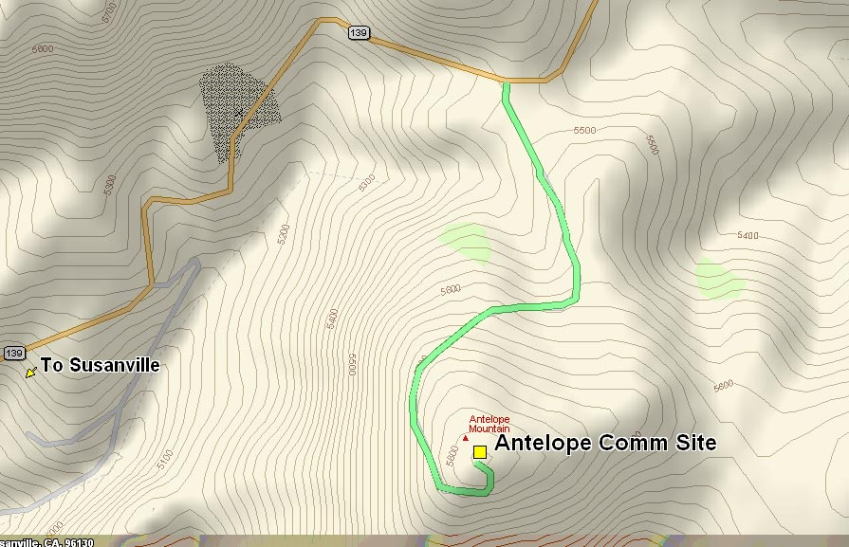
SITE MAP

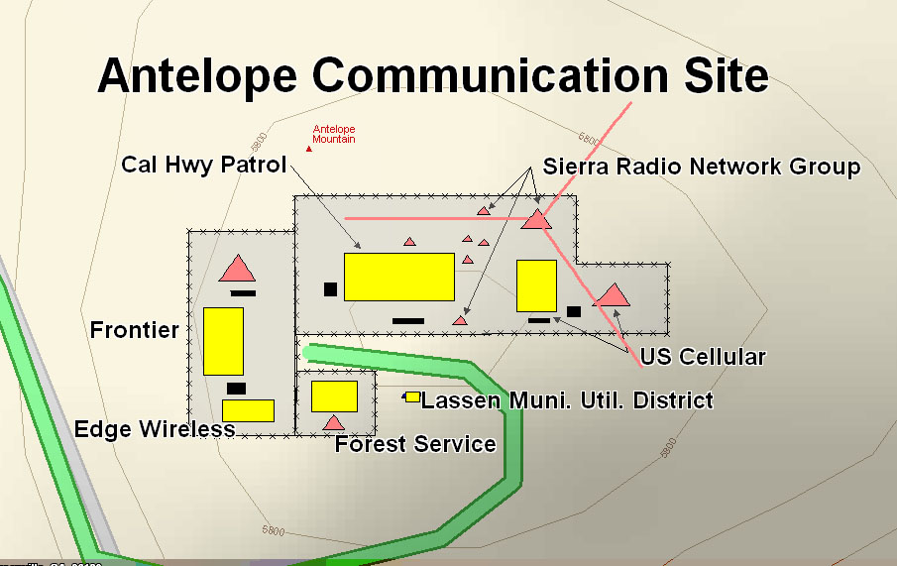

SKETCH DIAGRAM OF CALIFORNIA HIGHWAY PATROL FACILITY

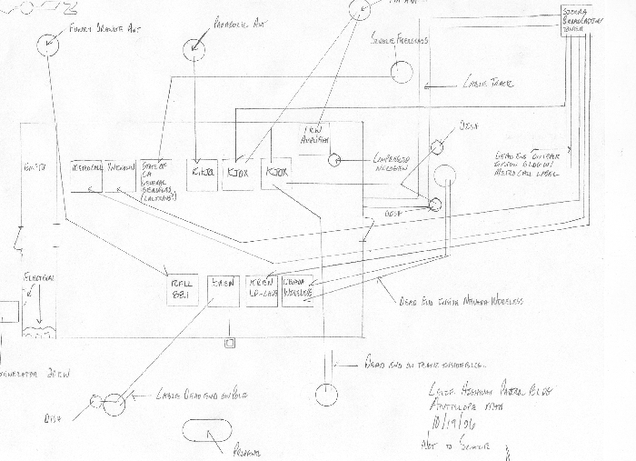

APPENDIX B
ANTELOPE MOUNTAIN COMMUNICATIONS SITE LESSEE/HOLDER FACILITY TABLE

(See associated User’s Table on the Website)
 | Auth # | Use | Building | Tower | Access/Parking | Other
Facility #1  Frontier, a Citizens Communication Co. | CAS-660317 | MIC | 24’ x 24’ concrete block,  12’ x 24’ aggregate wall | 150’ lattice self-supported | Access and parking | 85 kW generator, 500-gal propane tank, access road to site, 50’ x 60’ fence
Facility #2  USDA Forest Service | CACA-20889 | PMRS | 8’ x 8’ steel | 35’ lattice self- supported | Access and parking | 20’ x 30’ fence
Facility #3  Lassen Municipal Utility District | CACA-41854 | PMRS | (2) 3’ x 6’ steel cabinets | 32’ wood pole | Access and parking | none
Facility #4  California Highway Patrol | CAS-60734 | PMRS | 24’ x 40’ steel | 35’ wood pole, 40’ wood pole (for Nevada Wireless) | Access and parking | 120’ x 70’ fence,20 kW generator, 500 gal propane tank
Facility #5  US Cellular | CACA-28975 | CEL | 12’ x 26’ aggregate | 110’ monopole | Access and parking | 25kW generator, 500 gal propane tank, fence (with CHP)
Facility #6  Sierra Radio Network Group | CACA-3073 | FM | None (in CHP building) | 195’ guyed tower, (4) 35’ wood poles | Access and parking | none

APPENDIX C
SITE PHOTOGRAPHS

(See associated Facility Photos on the Website)

Facility 1, Frontier, a Citizens Communications Co.
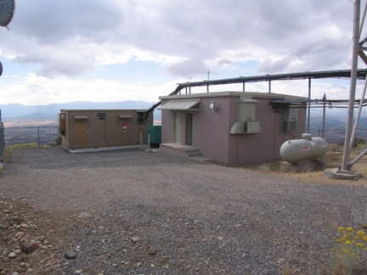

Facility 2, USDA Forest Service
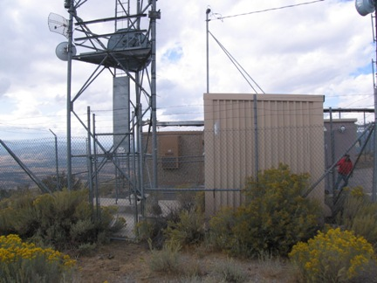

Facility 3, Lassen Municipal Utility District (LMUD)
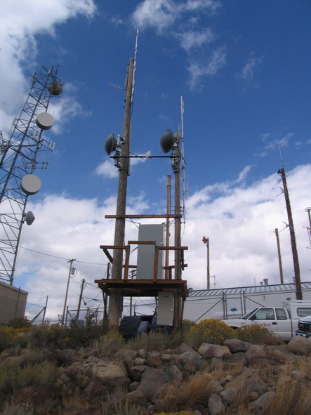

Facility 4, California Highway Patrol
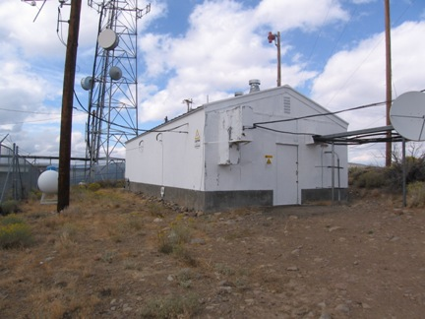

Facility 5, US Cellular
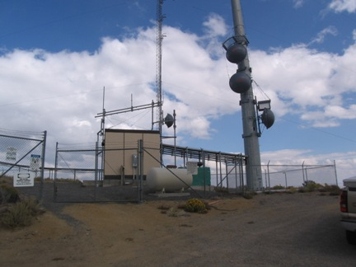

Facility 6, Sierra Radio (center tower only)
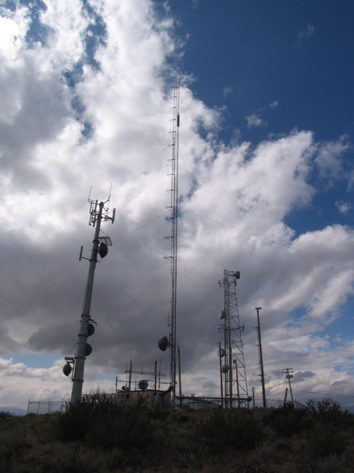

APPENDIX D
“Antelope Mountain Annual Technical Inspection”
Date Inspected: _____________________________ Time Inspection: ________________________________

Permit Holder: ______________________________ Authorization # _________________________________

Site Technician: ____________________________ Phone # _______________________________________

Number of Transmitters ______________________ License Posted _________________________________

Please mark the following Items as Acceptable (A) or Unacceptable (U).

Electrical Wiring ------------------- (A) (U) Grounding --------------------- (A) (U)

Equipment Installation ------------ (A) (U) Housekeeping ----------------- (A) (U)

Building Repair -------------------- (A) (U) Tower Repair ------------------ (A) (U)

Please mark the following Items as Yes (Y) or NO (N) or (NA)

Isolators ---------------------------- (Y) (N) (NA) Circulators --------------------- (Y) (N) (NA)

Cavities ----------------------------- (Y) (N) (NA) Terminators -------------------- (Y) (N) (NA)

Filters ------------------------------- (Y) (N) (NA) Lightning Protection ---------- (Y) (N) (NA)

Comments: __________________________________________________________________________________

____________________________________________________________________________________________

Recommended Corrective Action: ________________________________________________________________

_____________________________________________________________________________________________

_____________________________________________________________________________________________

Required Corrective Action to Be Taken: __________________________________________________________

_____________________________________________________________________________________________

_____________________________________________________________________________________________

_____________________________________________________________________________________________

_____________________________________________________________________________________________

Committee Representatives: _____________________________________________________________________

Bureau of Land Management Representatives: _______________________________________________________
Please make the required corrective action within the next 120 days. Please make a written report of corrective action taken and submit to the BLM. If you should have any questions, please call the BLM office.
APPENDIX D
SAMPLE USER ASSOCIATION BY-LAWS

XXXX MOUNTAIN COMMUNICATION SITE USER’S ASSOCIATION
CONSTITUTION

ARTICLE I

SECTION 1: The name of this Association will be the XXXX MOUNTAIN COMMUNICATION SITE USER'S ASSOCIATION, organized for the cooperative protection from physical and electromagnetic interference to existing radio facilities and ground and air access, protection of property and development of the area for the maximum compatible use commensurate with the adequate functioning of existing facilities, in accordance with pertinent regulations. The Association is an unincorporated nonprofit association formed solely for the purposes hereinafter set forth and will not directly or indirectly, as an association, engage in any business whatsoever for profit or otherwise. The signatories of this agreement are in no way deemed to be a partnership, joint venture, or association except for the purpose expressly herein set forth.

ARTICLE II

SECTION 1: The purpose of this association is to form an organization of present and future radio-electronic users under right-of-way on XXXX Mountain within the ABC Field Office, Vale District, Bureau of Land Management (BLM).

The XXXX Mountain Communication Site, which is located in:

Township 30 North, Range 12 East, Mount Diablo Meridian,
Lassen County, California, Section 13, E½

Containing approximately 2 acres

for the purpose of this agreement, will be defined as the area consisting of the present development on the peak and the land in a circle around it within a radius of 2,000 feet. The object is to properly manage future use and development of this communication site to minimize physical and electromagnetic interference for the authorized users of it.

The objectives of the association are:

A. To advise the BLM Field Manager on measures to manage the site to protect the rights and interests of its members, including protection from physical and electromagnetic interference.

B. To investigate allegations of physical and/or electromagnetic interference and recommend measurers for correction.

C. To review applications from prospective users and recommend to the BLM Field Manager measures which will adequately protect existing operations. A prompt report will be made of the recommended course of action with supporting rationale as each situation may require.

E. To recommend cooperative arrangements for financing the maintenance and upkeep of existing improvements, such as roads and other developments constructed for the common benefit of the site users.

F. To recommend a schedule of fees that will be applicable to all members of the Association for the maintenance of common use improvements benefiting all right-of-way holders.

G. To work in cooperation with the BLM in enforcement of all pertinent regulations of the Department of the Interior, and to do any and all things, lawful, just and necessary to further the interests of the users association.

ARTICLE III

SECTION 1: The Association will consist of the right-of-way grant holders on the XXXX Mountain Communication Site, or a representative for each holder as designated in writing to exercise its voting privilege, and a representative of the Bureau of Land Management. A right-of-way grant holder is defined as an individual, association, corporation or governmental entity holding a Bureau of Land Management right-of-way grant or reservation for a communication site. Notices delivered to the designated representative will be considered notice to the user itself.

SECTION 2: The Association will elect a Board consisting of a chairperson, vice-chairperson, secretary/treasurer, three financial committee members, technical review committee chairperson, site database manager, and three technical review committee members, from the right-of-way holders, who will hold office for one year. Election of officers will be determined by the drawing of lots. Members so elected will then serve their terms on a rotational basis. A reserve list will be maintained in the order of the drawing of lots. New users will be added to the reserve list to serve as officers in the group in the order they receive authorization to locate on the site. The first name so drawn will serve as chairperson and the other offices will be so filled in descending order as the names are drawn. At the end of the one-year term, all positions will shift upward on the list, the chairperson moving to last on the reserve list. As vacancies occur, due to turnover in a holder's internal organization, an authorized representative may serve out the remainder of the unexpired term.

For the purpose of this document, the term, "user group" and "user" will be used interchangeably to refer to those right-of-way grant holders who have entered into this Association and which have been authorized to occupy the XXXX Mountain Communication Site by receipt of a right-of-way or right-of-way reservation issued by BLM.

SECTION 3: The recommendation of the Association will be forwarded to the BLM Field Manager for action.

SECTION 4: Each new right-of-way holder on the XXXX Mountain Communication Site will be required to enter into the Association through stipulations included in its right-of-way grant from BLM.

SECTION 5: Members will be in good standing when all Association fees and assessments are paid, and when they are in compliance with the Association's constitution and bylaws.

ARTICLE IV

SECTION 1: Each party hereto will, during the existence of this Agreement and thereafter, severally release and indemnify each other from and against all liability, cost, expense and valid claims for injuries or deaths of persons and loss or damage to property arising out of use of the access road or electronic site by such party or the employees, agents, guests or assigns of such party.

SECTION 2: All users will agree to indemnify and hold harmless the United States, its successors and assigns, its officers, agents and employees, from any and all damages and claims for damages of every description or kind whatsoever, which may result from the exercise of any of the rights reserved herein.

XXXX MOUNTAIN COMMUNICATION SITE USER'S ASSOCIATION

BYLAWS
ARTICLE I

SECTION 1: Chairperson's Duties

A. Arrange for and preside at meetings of the Association.

B. Represent the Association in public meetings and meetings with the Bureau of Land Management.

C. Supervise the work of the other officers of the Association to assure coordination of efforts and on-time completion of necessary tasks.

D. Approve and sign all Association expenditures of Association funds.

SECTION 2: Vice-Chairperson's Duties

A. Assume any or all of the Chairperson's duties, given appropriate notice, if the Chairperson is not able to fulfill them.

B. Monitor site inspections to assure fair and impartial results.

C. Coordinate and direct committee work as needed.

D. Promote cooperation among site users.

SECTION 3: Secretary/Treasurer's Duties

A. Prepare outgoing Association correspondence and present to Chairperson for approval and distribution.

B. Disseminate incoming correspondence to directly affected site users.

C. Record minutes at meetings, and keep members apprised of meetings, agendas and planned activities which affect the Association, including meetings.

D. Maintain all Association files, records, and accounts to keep them current and accurate. This will include sending notices to the members of assessment payments due and making deposits into the appropriate account so that checks may be written to cover expenses of the Association. All Association documents will be open and available for inspection by any member, including the BLM.

E. Prepare all checks and payments of the Association members and present them to the chairperson for approval and signature. Maintain a record of all transactions, including date, amount received or disbursed, from or to whom, and for what purpose.

ARTICLE II

SECTION 1: The Financial Committee will be a standing committee consisting of at least three association members elected by the membership. The committee will set forth a procedure for determining a proper and fair sharing of cost and expense of use, maintenance and reconstruction of the access road and common use facilities directly related to the use of the site, such as road surface and foundation conditions, bridges, culverts, drains and the like, and any other activity which is directly related to maintain the site and related facilities in a useable condition. The committee is also responsible for maintenance and upkeep of gates and locks, and other common use facilities as may be appropriate for the site. The committee will audit the Treasurer's financial records just prior to the annual meeting, or on special request, and present a report of its findings to the Association. The committee will be responsible for preparation of the Association's annual budget. When the Association determines that road or site conditions warrant repair, the committee will research the work, exploring all cost, complexity, and contracting options, contract the work to be done and inspect it for acceptance upon completion.

SECTION 2: The Site Database Manager's duties will be to:

A. Develop and maintain a base of the technical data which concerns the users of the XXXX Mountain Communication Site. This database could be expected to include such things as receiver/transmitter frequencies, ERP output, a list of users, call signs, and a detailed site map. Other information may also be included as the need is identified by the Association.

B. Prepare and distribute the Association members a current listing of relevant site data on an annual basis. A convenient time for the distribution of this listing would be at the annual meeting or a special meeting.

ARTICLE III

SECTION 1: Interests

Right-of-way holders granted rights for common use facilities (access road) will assign those rights to the Association. By acceptance of the right-of-way grant, the Association accepts full responsibility for maintenance of those facilities.

SECTION 2: Assessments

An annual assessment will be made upon all right-of-way holders to provide funds for operational expenses of the Association. Association expenses are defined to include maintenance of common use facilities such as the access road as well as the incidental expenses of operation such as postal fees and cost of distributing notices of meetings and agendas. Special assessment may be made and apportioned as approved by the membership to cover unanticipated circumstances which may arise.

Initial fee: $ 50.00
Annual dues: $ 50.00
New applications: $150.00
Modifications: $ 50.00

SECTION 3: Proration, Late Payment Penalties, Enforcement and Collection

A. Proration of Assessments

Prorated fees will be paid in advance for a 12-month period. Those grantees receiving a BLM right-of-way grant after January 1 of each year will pay a prorated fee. Grants issued prior to the 15th of the month will pay for the full month. Proration will be based on the following factors:

12 months 1.0000 6 months 0.5000
11 months .9167 5 months 0.4167
10 months .8333 4 months 0.3333
9 months .7500 3 months 0.7500
8 months .6667 2 months 0.1667
7 months .5833 1 months 0.0833
All amounts will be rounded to the nearest dollar.

B. Late Payment Penalties

Grantees will be allowed 90 days after the assessment is determined to submit payment of fees. Fees not paid within the 90 days will be charged a late fee commensurate with the California State legal interest rate.

C. Enforcement

Failure to pay the annual assessment may result in cancellation of the holder's right-of-way grant for failure to comply with its terms and conditions.
D. Collection

Collection of assessments, including custody and disbursement of the money, will be made by the Secretary/Treasurer. Billings for assessments will be sent during January of each year or will be due for part of a year when the right-of-way grant is issued.

ARTICLE IV

SECTION 1: Technical Standards

All users on the site will adhere to the following technical standards. Adherence to these standards will minimize physical damage and RF interference, thus providing for improved electromagnetic compatibility of all users.

A. All radio-electronic type equipment, including associated cables, wiring and antenna systems, will be installed and maintained in a clean, neat and orderly manner, and be permanently secured. All such installations will be both electrically and mechanically sound.

B. All associated cabling must be designed to prevent interference.

C. All radio equipment will be anchored by applicable approved standards or approved rack mount (floor to ceiling). Each transmitter will be externally identified with a copy of the current FCC license, or IRAC authorization, name and telephone number of the person responsible for the equipment maintenance, the receiver frequency, transmit/receive tone frequencies, and transmit frequency and power.

D. All antenna cables entering and leaving will carry like identification tags entering and leaving building. The antenna will not be indiscriminately moved after initial mounting and tests.

E. When radio interference occurs, notch filters, crystal filters and dual ferrite isolators and/or band pass devices may be required. The need for additional filtering equipment will be determined on a case-by-case basis.

F. All transmitting/receiving equipment be in accordance with FCC rules and regulations.

G. All RF transmission line systems will be engineered, procured and installed with the intention of minimizing any effects upon the ambient RF noise floor environment.

H. Any receiver generating interference may need to be equipped with cavities, crystal filters, or to change their IF to eliminate interference.

I. Power output of any system on the low-power portion of the XXXX Mountain Communication Site will not exceed 500 watts ERP (Effective Radiated Power). Transmitter isolators will have a minimum of 65db of isolation in the output to the antenna. For the applicant that desires to exceed the 500 watt limitation, additional information may be requested. Such information may consist of a complete intermodulation study, field strength test, etc. The applicant may also be requested to make a formal presentation to the XXXX Mountain Communication Site Users Association, Technical Committee, and the BLM before the application will be approved. If the application for a transmitter exceeding 500 watts ERP is approved and this transmitter causes interference to another user that cannot be resolved by any known technical means, the new user will cease operation within 24 hours of notice by the BLM. Electromagnetic interference being defined as any radio frequency associated interaction that impedes or hinders another service. In the event that further negotiations cannot resolve the interference problem, the new station will not be permitted to resume transmitting.

J. System design must provide adequate isolation between antennas.

K. If harmful spurious emissions and harmonic content are shown to be causing interference, the responsible user will be required to use additional measures to suppress it.

L. Each microwave and point-to-point system change or addition will be addressed individually by the Technical Committee to provide advice to the Field Manager to take appropriate action.

M. Any miscellaneous equipment that cause harmful interference will not be used, or if installed, must be repaired, replaced or removed.

N. Systems must be grounded in a manner that is compatible with existing user's grounding so interference will not be compounded.

O. All antennas and signal transmission media must be terminated with its own characteristic impedance when not in use.

P. The noise floor contribution of any new equipment or changes to existing equipment must not cause the total noise floor to exceed the agreed upon maximum level.

Q. Housekeeping has environmental, visual and electromagnetic compatibility. Debris which is permitted to remain adrift raises the noise floor for all users and gives rise to intermodulation potential which often defies identification. Therefore, all debris will be cleaned up immediately and will not be allowed to accumulate on the site.

R. Guy wires, bonding across crevices, transmission lines, brackets, etc., will be insulated. Loose wire or metal objects must not be left on towers, or on site..

SECTION 2: Annual Inspection and Enforcement

The Bureau will provide written notice of the scheduled inspection date and time 30 days in advance, and each user may arrange personnel available at the site at the time of inspection.

SECTION 3: When Interference Occurs

A. All users will cooperate with this Association and the Bureau in identification and correction of any interference-related problems.

B. When a new user applies for a right-of-way to install a system, or an existing user applies for an amendment on the site, the BLM will advise all the existing users concerning the technical and physical parameters of the proposed system so that they may ascertain if the proposed installation is physically and electronically compatible to their frequency system(s).

C. The association members will be given a period not to exceed thirty (30) days from receipt of the Notice of Site Availability from the Bureau of Land Management in which to comment on it and to the applicant on probable interference.

D. If the technical evaluations reflect that there may be interference problems with other users, the applicant has up to thirty (30) days to respond to the Technical Committee on remedies for interference problems. These remedies may include engineering analysis and other pertinent information. A field test for compatibility may be request at the expense of the applicant.

ARTICLE V

SECTION 1: Meetings

A quorum will be present at any meeting to conduct any business of the XXXX Mountain Communication Site User's Association. A quorum will be defined as a simple majority of the members of the user's association which are in good standing.

A. Annual

An annual meeting will be held on a rotating basis at least once a year. Additional meetings may be scheduled at any time the Chairperson requests, to carry out the functions of the Association.

B. Special

Special meetings to consider specific new issues will be held at a time and place as may be designated by the Chairperson, a quorum (simple majority) of the user's group, or the BLM Field Manager. Notices for such meetings will state the purpose(s) for which the meeting is called, and will adhere to the advance notice requirement. No business will be transacted a special meetings except as stated in the notice unless the members at the meeting give their unanimous consent thereto.

SECTION 2: Advance Notice

All meeting notices will be distributed no less than 30 days before the scheduled date. Exceptions may be made to respond to an emergency. The notice will include the date, time, place, and agenda items for the meeting. If any guests are scheduled to attend, that information should also be included. At the discretion of the chairperson, the requester of a special meeting may be required to pay the publication cost of advance notice for the associated special meeting.

SECTION 3: Order of Business

Robert's Rules of Order will be followed in all procedural matters. Meetings will have the following general form:

A. Call to order.

B. Sign-in.

C. Reading of minutes of last meeting.

D. Report of financial committee.

E. Report of technical committee.

F. Determination of standing of members.

G. Old business.

H. New business.

I. Election of officers (annual meetings).

J. Appointment of committees (annual meetings).

K. Comments from members.

L. Adjournment.

ARTICLE VI

SECTION 1: The Association may amend or repeal bylaws if two-thirds of the voting members present favor such action. Proposed changes to the laws will be presented in writing at one meeting and appropriate action taken at a second meeting. Votes may be cast in person by the holder, an authorized representative, by written proxy carried by an attending member, or by a prewritten decision.

SECTION 2: The bylaws may also be amended by mail. The proposed amendment(s) will be mailed to all members in good standing with a 30-day response period from date of mailing. The amendments may be passed if two-thirds of all eligible members concur in writing to the amendment(s) as worded in the mailing.

SECTION 3: The Association may enact such necessary supplements and committees deemed appropriate to carry out its functions.

SECTION 4: The following members of the XXXX Mountain Communication Site User's Association hereby adopt the constitution and bylaws of the association. Execution of this constitution and bylaws will bind the signatories to abide by the terms of the XXXX Mountain Communication Management Site Plan of which this document is a part.

Implementation of this agreement will become effective upon execution by the BLM Field Manager after the signature of each of the existing right-of-way grant holders on the site.

The following members of the XXXX Mountain Communication Site User's Association hereby adopt the constitution and bylaws of the asociation and agrees to support them:

