Archived Information

Planning and Evaluation Service


Comprehensive Regional Assistance Centers Program:
Final Report on the Evaluation

Volume I

2000



U.S. Department of Education  Doc. #2000-19 | Office of the Under Secretary

COMPREHENSIVE REGIONAL ASSISTANCE CENTERS PROGRAM:

FINAL REPORT ON THE EVALUATION

Volume I

Katrina G. Laguarda
Jeanine L. Hildreth
Catherine T. Kelliher
Derek L. Riley
Karen P. Walking Eagle
Ellen M. Pechman
Policy Studies Associates
Washington, D.C.

Prepared for:

U.S. Department of Education
Office of the Under Secretary

2000

This report was prepared for the U.S. Department of Education under Contract Number EA94053010. The views expressed herein are those of the contractor. No official endorsement by the U.S. Department of Education is intended or should be inferred.

U.S. Department of Education
Richard W. Riley
Secretary

Office of the Under Secretary
Judith A. Winston
Under Secretary(A)

Planning and Evaluation Service
Alan L. Ginsburg
Director

Elementary and Secondary Education Division
Ricky T. Takai
Director

September 2000

This report is in the public domain. Authorization to reproduce it in whole or in part is granted. While permission to reprint this publication is not necessary, the citation should be: U.S. Department of Education, Office of the Under Secretary, Planning and Evaluation Service, Elementary and Secondary Education Division, Comprehensive Regional Assistance Centers Program: Final Report on the Evaluation. Volume I, Washington, D.C., 20202.

To order copies of this report, write:

ED Pubs
Education Publications Center
U. S. Department of Education
P. O. Box 1398
Jessup, MD 20794-1398;

via fax, dial (301) 470-1244;

or via electronic mail, send your request to: edpubs@inet.ed.gov.

You may also call toll-free: 1-877-433-7827 (1-877-4-ED-PUBS). If 877 service is not yet available in your area, call 1-800-872-5327 (1-800-USA-LEARN); Those who use a telecommunications device for the deaf (TDD) or a teletypewriter (TTY), should call 1-800-437-0833.

To order online, point your Internet browser to: www.ed.gov/pubs/edpubs.html.

This report is also available on the Department’s Web site at: www.ed.gov/offices/OUS/eval/.

On request, this publication is available in alternative formats, such as Braille, large print, audiotape, or computer diskette. For more information, please contact the Department’s Alternate Format Center (202) 260-9895 or (202) 205-8113.

ACKNOWLEDGMENTS

Many people contributed to the planning, development, and review of this report. We would like to express our appreciation to all of the Comprehensive Center customers and potential customers who participated in interviews and who responded to surveys. Without their cooperation, this evaluation would not have been possible.

We would also like to acknowledge the 15 Comprehensive Center directors and their staffs, who assisted in all phases of the data collection by providing Policy Studies Associates (PSA) with customer lists and activity registration lists, by helping PSA site visitors gain access to case study sites, and by hosting site visit teams at their centers.

We would like to thank the members of the technical working group for the evaluation, who reviewed preliminary findings from early phases of the project, as well as an early version of the final report, and made valuable suggestions for further analysis and reporting:

Joyce Benjamin, Oregon Department of Education
Ronn Friend, Maryland Department of Education
Patricia Gonzales, U.S. Department of Education
Mary Jean Haberman Lopez, New Mexico Department of Education
Trudy Hensley, Region XIV Comprehensive Center
Cheryl Kane, U.S. Department of Education
Diana Lam, Providence Public Schools
William Morrill, Caliber Associates
Mary Ramirez, School District of Philadelphia
Maris Vinovskis, University of Michigan

At the U.S. Department of Education, we would like to thank the study team who provided advice, critique, and practical help of various kinds through all phases of the evaluation, as well as a careful review of several drafts of this report. Susan Sanchez of the Planning and Evaluation Service served as project officer for the evaluation. Other present and former members of this team include: Patricia Gore, Milagros Lanauze, Joyce Murphy, and Sharon Saez of the Goals 2000 Office; Larry Cohen of the Budget Service; Mark Smith of the Office of General Counsel; and Art Cole and Edith Harvey of the School Improvement Programs Office.

Finally, we would like to thank our colleagues at PSA whose hard work and skill made this study possible. Brenda Turnbull served as an advisor to the evaluation through all stages of the project and reviewed the final report. In addition to the authors of this report, members of the study team at PSA included: Anne Castle, Lara Fabiano, Bruce Haslam, Mary Leighton, Michael Rubenstein, and Jessica Wodatch. They were assisted by Amy Hightower, David Kauffman, Dan Odenwald, Mari Parker, and Catherine Zudack. Dan Odenwald, Elizabeth Shinkman, and Dwayne Smith assisted with all phases of survey administration, follow-up, and coding. Leslie Anderson, Joelle Gruber, Jennifer Suh, and Megan Welsh assisted in the production of exhibits. Keon Ferguson, Benjamin Lagueruela, and Kimberly Thomas provided production support.

CONTENTS

Page

ACKNOWLEDGMENTS iii

CONTENTS v

EXHIBITS vii

THE COMPREHENSIVE REGIONAL ASSISTANCE CENTER PROGRAM AT A GLANCE xi

EXECUTIVE SUMMARY 1

I. INTRODUCTION 13

Program Mission and Goals 13
Overview of the Comprehensive Center Program 15
Evaluation Purposes and Methods 18
Overview of the Report 20

II. COMPREHENSIVE CENTER CUSTOMERS 23

Who Are the Comprehensive Centers’ Customers? 23
Are Centers Serving Their Highest-Priority School and District Customers? 29
Needs and Purposes: Why Do Customers Seek Assistance? 38
Summary 46

III. PORTFOLIO OF SERVICES 49

What Are the Centers Major Strategies for Organizing and Delivering Assistance? 49
What Services Do Customers Receive? 56
How Do Services to State and Local Customers Differ? 66
What Services Do the Centers Provide to the U.S. Department of Education? 71
Summary 72

IV. QUALITY OF COMPREHENSIVE CENTER SERVICES 74

Are Services Comprehensive? 75
Is the Content of the Assistance Reported to Be Accurate and Grounded in Research? 81
Are Centers Responsive to Customer Needs and Interests? 85
Are the Scope and Intensity of Services Adequate? 89
Do Center Staff Members Have Adequate Expertise? 90
Are Center Customers Satisfied with Comprehensive Center Services? 92
Summary 105
CONTENTS (Continued)

Page

V. EFFECTS 107

Effects on the Work of Individuals 107
Effects on the Work of Organizations 112
Assisting Customers to Respond to the Requirements of ESEA 129
Enhancing State Capacity to Deliver Technical Assistance in Support of ESEA 131
Effects on Teaching and Learning 131
Center Strategies for Assessing the Effects of Their Services 134
Summary 137

VI. COLLABORATION WITH COMPREHENSIVE CENTERS AND OTHER TECHNICAL
ASSISTANCE PROVIDERS 139

Collaboration within the Comprehensive Center Network 139
Collaboration with Other Technical Assistance Providers 141
Conditions that Encourage Collaboration 144
Conditions that Impede Collaboration 145
Summary 147

VII. CONCLUSIONS 149

Recommendations for Future Oversight of the Program 152

APPENDIX A: Comprehensive Center Mission Statements A-1

APPENDIX B: Comprehensive Centers, Grantee Organizations, and Partner Organizations B-1

APPENDIX C: Survey Methods C-1

APPENDIX D: Survey Instruments D-1

APPENDIX E: Matrix of Case Study Sites E-1

APPENDIX F: Semi-Annual Progress Reports: Aggregated Data Tables
(December-January, 1999) F-1

EXHIBITS

I.1 Timeline of Key Events 15

I.2 Budget Allocations and Demographic Data for the 15 Comprehensive Center Regions 17

II.1 Percent of Potential District Customers Nationwide Reporting That They Had Heard
Of the Comprehensive Center Serving their Region and That They Had Received
Services 25

II.2 Number of Organizations Receiving On-Site Professional Development or
Consultation in 1998, and Number of Gatekeepers at those Organizations,
as Reported by the Comprehensive Centers 26

II.3 Professional Responsibilities of Gatekeepers 27

II.4 ESEA Programs Administered by SEA, District, and School Gatekeepers 28

II.5 Professional Responsibilities of Participants in Center Activities 29

II.6 Percent of Students Eligible for Free and Reduced-Price Lunches in Districts
Served by Comprehensive Centers, as Reported by Gatekeepers 30

II.7 Percent of Target Student Populations in Districts Served by Comprehensive Centers,
as Reported by Gatekeepers 31

II.8 Percent of Potential District Customers Reporting that They Have Heard of the
Comprehensive Center Serving Their Region, by District-level Demographics 33

II.9 Percent of Potential District Customers Reporting that Someone in Their District
Had Received Technical Assistance from a Comprehensive Center Serving Their
Region, by District-level Demographics 34

II.10 Percent of Potential District Customers Reporting on the Types of Contact They Have
Had with a Comprehensive Center, by District Size 35

II.11 Percent of Students Eligible for Free and Reduced-Price Lunches in Schools Served
by Comprehensive Centers, as Reported by Gatekeepers 36

II.12 Percent of Target Student Populations in Schools Served by Comprehensive Centers,
as Reported by Gatekeepers 37

II.13 Percent of Participants Reporting Their Purposes in Participating in a Center-
sponsored Activity, by Type of Organization 39

II.14 Topics for Which Customers Have the Greatest Technical Assistance Needs 40

II.15 Reasons to Begin Using Comprehensive Center Products and Services 44
Exhibits (Continued)

II.16 Reasons Why Districts Have Not Made Use of Comprehensive Center Products
and Services 45

II.17 Percent of Gatekeepers Who Reported Turning to Various Sources of Assistance
“Always” or “Sometimes”, by Type of Organization 47

III.1 Percent of Gatekeepers Reporting That the Center’s Products and Services Addressed
Certain Topics 58

III.2 Percent of Gatekeepers Reporting That the Center’s Products and Services Addressed
Certain Categorical Topics 59

III.3 Percent of Gatekeepers Reporting on the Number of Times That Their Organization
Received Various Products or Services from a Comprehensive Center in a Year,
by Type of Product or Service 62

III.4 Percent of All Participants Reporting That They Received Center Follow-up
Assistance Once and More than Once 63

III.5 Other Sources of Assistance to Which Gatekeepers Were Referred by the Center,
by Type of Organization 64

III.6 Percent of Gatekeepers Who Received Various Center Products or Services Five or
More Times in a Year, by Type of Organization 68

III.7 Percent of Gatekeepers Who Were Very Satisfied with Their Access to Center
Products or Services, by Type of Organization 69

IV.1 Gatekeepers’ Ratings of the Quality and Utility of Comprehensive Center Products
and Services 83

IV.2 Participants’ Ratings of the Quality and Utility of Center-Sponsored Activities 84

IV.3 Percent of Gatekeepers Reporting That They Contributed to the Design or Planning
of Center Services Provided to Their Organization, by Type of Organization 88

IV.4 Comprehensive Center Staffing Patterns: Number of Regular Professional Staff and
Areas of Expertise 93

IV.5 Percent of Participants Rating the Quality and Utility of Center Assistance as
“Excellent,” by Type of Organization 97

IV.6 Percent of Gatekeepers Rating the Quality and Utility of Center Products and
Services as “Excellent,” by Volume of Services 99

Exhibits (Continued)

IV.7 Percent of Participants Rating the Quality and Utility of Center Activities as
“Excellent,” by Frequency of Telephone Follow-up 100

IV.8 Percent of Participants Rating the Quality and Utility of Center Activities as “Fair” or
“Poor,” by Frequency of Workplace Visits 102

IV.9 Bivariate Regression Analysis of the Relationship between Gatekeepers Ratings of
Center Services and Products 104

IV.10 Bivariate Regression Analysis of the Relationship between the Percentage of
Customers Receiving High-end Services and Size of Center Budget 105

V.1 Percent of Participants and Gatekeepers Reporting on Effects of Center Assistance
on Their Work 108

V.2 Percent of Participants Reporting Effects of Center Assistance on Their Work, by
Type of Organization 110

V.3 Percent of Participants Reporting That a Center-sponsored Activity Had an Effect
on Their Work, by Frequency of Follow-up with Additional Workshops, Training,
and Meetings 111

V.4 Percent of Participants Reporting That a Center-sponsored activity Had an Effect
on Their Work, by Whether They Were Required to Participate or Volunteered in
That Activity 113

V.5 Percent of Participants Reporting Effects on Their Own Work, by Number of
Purposes for Participation 114

V.6 Percent of Gatekeepers and Participants Reporting on Effects of Center Assistance on
the Way Their Organization Does Its Work 115

V.7 Percent of Gatekeepers Reporting the Types of Effects Center Assistance Had on
Their Organization’s Work, by Type of Organization 117

V.8 Percent of Participants Reporting the Types of Effects Center Assistance Had on
Their Organization’s Work, by Type of Organization 118

V.9 Percent of Gatekeepers Reporting Organizational Effects of Center Assistance by
Volume of Services 120

V.10 Percent of Participants Reporting That a Center-sponsored Activity Had an Effect on
Their Organization’s Work, by Frequency of Follow-Up with Additional Workshops,
Training, and Meetings 121
Exhibits (continued)

V.11 Percent of All Respondents Reporting Organizational Effects of Center Assistance,
by the Number of Topics on Which They Received Assistance 122

V.12 Percent of Participants Reporting That a Center-sponsored Activity Had an Effect on
Their Organization’s Work, by Whether They Participated in That Activity as a
Member of a Team or Group 123

V.13 Percent of Gatekeepers Reporting That Center Assistance Had an Effect on Their
Organization’s Work by Whether They Were Involved in the Design or Planning of
Center Services 125

V.14 Percent of Participants Reporting That a Center-sponsored Activity Had an Effect on
Their Organization’s Work, by Whether They Contributed to the Design of the
Activity 126

V.15 Percent of Participants Reporting Effects of the Work of Their Organizations, by
Number of Purposes 127

V.16 Percent of Participants Reporting That a Center-sponsored Activity Had an Effect on
Their Organization’s Work, by Their Purposes in Participating 128

Insert Map
The Comprehensive Regional Assistance Centers Program at a Glance

The Comprehensive Regional Assistance Centers help states, school districts, and schools meet the educational needs of children served under ESEA. As of September 2000, 15 regional centers are being operated under cooperative agreements by the following grantees. Telephone numbers and Web addresses follow their names and locations.

Region I (Connecticut, Maine, Massachusetts, New Hampshire, Rhode Island, and Vermont): New England Comprehensive Assistance Center, Education Development Center, Inc., Newton, Mass., (800) 332-0226, www.edc.org/NECAC/.

Region II (New York): New York Technical Assistance Center, the Metropolitan Center for Urban Education at New York University, New York, N.Y., (800) 4NYU-224 or (212) 998-5100, www.nyu.edu/education/metrocenter/nytac/nytac.html.

Region III (Delaware, District of Columbia, Maryland, New Jersey, Ohio, and Pennsylvania): Region III Comprehensive Center at the George Washington University, Center for Equity and Excellence in Education, George Washington University, Arlington, Va., (800) 925-3223 or (703) 528-3588, r3cc.ceee.gwu.edu.

Region IV (Kentucky, North Carolina, South Carolina, Tennessee, Virginia, and West Virginia): Region IV Comprehensive Center at AEL, Appalachia Educational Laboratory, Inc., Arlington, Va., (800) 755-3277, www.ael.org/cac/.

Region V (Alabama, Arkansas, Georgia, Louisiana, and Mississippi): Southeast Comprehensive Assistance Center, Southwest Educational Development Laboratory, Metairie, La., (504) 838-6861 or (800) 644-8671, www.sedl.org/secac/welcome.html.

Region VI (Iowa, Michigan, Minnesota, North Dakota, South Dakota, and Wisconsin): Region VI Comprehensive Assistance Center, University of Wisconsin-Madison, Madison, Wis., (888) 862-7763 or (608) 263-4220, www.wcer.wisc.edu/ccvi/.

Region VII (Illinois, Indiana, Kansas, Missouri, Nebraska, and Oklahoma): Region VII Comprehensive Center, University of Oklahoma, Norman, Okla., (800) 228-1766 or (405) 325-1729, region7.ou.edu.

Region VIII (Texas): STAR (Support for Texas Academic Renewal) Center, Intercultural Development Research Association, San Antonio, Tex., (888) FYI-STAR, www.starcenter.org/.

Region IX (Arizona, Colorado, Nevada, New Mexico, and Utah): Southwest Comprehensive Regional Assistance Center, New Mexico Highlands University, Rio Rancho, N.Mex., (505) 891-6111, www.cesdp.nmhu.edu/swcc/.

Region X (Idaho, Montana, Oregon, Washington, and Wyoming): Northwest Regional Educational Laboratory’s Comprehensive Center, Region X, Northwest Regional Educational Laboratory, Portland, Ore., (503) 275-9500, www.nwrac.org.

Region XI (Northern California): Region XI Comprehensive Assistance Center, WestEd, Oakland, Calif., (800) 645-3276, www.wested.org/cc/.

Region XII (Southern California): Southern California Comprehensive Assistance Center, Los Angeles County Office of Education, Downey, Calif., (562) 922-6343, sccac.lacoe.edu.

Region XIII (Alaska): Alaska Comprehensive Regional Assistance Center, Southeast Regional Resource Center, Juneau, Alaska, (888) 43-AKRAC or (907) 586-6806, www.akrac.k12.ak.us.

Region XIV (Florida, Puerto Rico, Virgin Islands): Region XIV Comprehensive Center, Educational Testing Service, Tampa, Fla., (800) 756-9003, www.ets.org/ccxiv.

Region XV (Hawaii, American Samoa, Federated States of Micronesia, Guam, Republic of the Marshall Islands, Commonwealth of the Northern Mariana Islands, and Republic of Palau): Pacific Comprehensive Regional Assistance Center, Pacific Resources for Education and Learning, Honolulu, Hawaii, (808) 441-1300, www.prel.org.

EXECUTIVE SUMMARY

Introduction

The Improving America’s Schools Act (IASA) of 1994, which amended the Elementary and Secondary Education Act (ESEA) of 1965, represents a departure in federal education policy. The categorical programs funded under the reauthorized ESEA are designed to work together to enable all students, especially those who live in areas of poverty and have special educational needs, to reach high and challenging academic standards. Instead of operating separate, categorical services to support students’ “regular” educational program, the U.S. Department of Education encourages states and districts to use ESEA programs to reinforce state and community reform efforts geared to challenging state standards.

To support this shift in the implementation of federal education programs, Congress replaced the U.S. Department of Education's existing network of 48 categorically based ESEA technical assistance centers with 15 Comprehensive Regional Assistance Centers. The new Comprehensive Centers were to pioneer a new form of comprehensive, cross-program assistance to support standards-based reform as envisioned in other sections of the law. This new vision of comprehensive assistance emphasizes the dissemination of new ideas and practices that strengthen teaching and learning for all children served under ESEA, over a more narrow focus on helping grantees respond to the administrative or programmatic requirements of a single categorical program.

As authorized under Title XIII of the ESEA, the Comprehensive Centers provide intensive professional development, training and technical assistance to states, local education agencies (LEAs), schools, American Indian tribes, community-based organizations, and other ESEA grantees in a long list of areas. They include: (1) improving the quality of instruction, curricula, assessments, and other aspects of school reform; (2) implementing effective schoolwide programs; and (3) meeting the needs of children, especially children in high-poverty areas, migrant children, immigrant children, limited English proficient (LEP) children, neglected or delinquent children, homeless children, American Indian children, and children with disabilities. Comprehensive Centers are required to assign highest priority to serving: (1) Title I schoolwide programs and (2) LEAs and Bureau of Indian Affairs (BIA)-funded schools with the highest percentage or numbers of poor children. This specific focus on high-poverty schools and districts is unique to the Comprehensive Centers among ED’s various technical assistance programs.

The U.S. Department of Education set regional boundaries and allocated funds for individual Comprehensive Centers based on the concentrations of Title I-eligible, limited English proficient, migrant, and American Indian children in the area. In creating the Comprehensive Centers program, Congress greatly expanded the range and scope of the centers' responsibilities relative to the work of the 48 categorically-organized technical assistance centers that had served ESEA grantees before 1994. At the same time, Congress drastically reduced the resources available to support the new program by funding the Comprehensive Centers at approximately half the level of the previous programs.

The evaluation of the Comprehensive Centers addressed two basic questions: (1) How are the Comprehensive Centers fulfilling their statutory mission, as embodied in Title XIII of the ESEA?; and (2) How does the centers’ work contribute to educational change and improvement in the states, districts, and schools that they serve? To ensure the quality of the Comprehensive Center program, Title XIII of ESEA requires the U.S. Department of Education to conduct regular surveys of customers to determine if they are satisfied with their access to and the quality of Comprehensive Center services. The evaluation was also designed to satisfy this requirement.

Data collection for the evaluation, conducted by Policy Studies Associates (PSA) of Washington D.C., was carried out in three phases:

- Phase 1 consisted of site visits to all 15 Comprehensive Centers, beginning in November 1998, interviews with professional staff at all of the organizations that contribute to the centers’ work, and a review of key center documents.

- Phase 2 consisted of three different surveys of customers and potential customers of the Comprehensive Centers, administered in spring and summer 1999. The first customer survey was directed to a random sample of 1,086 gatekeepers in states, districts, schools, and other organizations that received services from the Comprehensive Centers in 1998, drawn from customer lists compiled by the centers. (Gatekeepers are customers of the Comprehensive Centers who request or negotiate for services on behalf of the organizations they represent.) The second customer survey was directed to 1,123 participants in a sample of 30 major Comprehensive Center activities, such as intensive professional development and model schools initiatives. (These customers are the end-users of Comprehensive Center assistance.) The third survey was directed to potential customers of the Comprehensive Centers in a nationally representative sample of 1,122 districts with poverty rates above the national median. This survey was sent to the district-level staff member most directly responsible for the administration of ESEA programs.

- Phase 3 consisted of 15 case studies, conducted in spring and summer 1999, of center services to states and local sites (both districts and schools), and eight case studies of collaboration among Comprehensive Centers and between the centers and other technical assistance providers. We selected case study sites where the effects of the technical assistance provided could reasonably be observed by spring or summer 1999.

The final evaluation report consists of three volumes. Volume I: Comprehensive Regional Assistance Centers Program: Final Report on the Evaluation synthesizes the information gathered by the evaluation. Volume II: Case Studies of Center Services to State and Local Sites and Case Studies of Collaborative Activities contains case studies of center services to states, districts, and schools, and profiles of collaboration among centers and other technical assistance providers. Volume III: Comprehensive Center Profiles describes the mission and goals, organization and staffing, needs assessment strategies, portfolio of services, and collaboration activities with other technical assistance providers, for each of the 15 centers.

Comprehensive Center Customers

The Comprehensive Centers have reached a number of their potential customers at the school, district, and state levels. A review of the entire portfolio of Comprehensive Center activities shows that the centers, as a network, allocate resources in roughly equal proportions to the state, district, and school levels.

- Most end-users of Comprehensive Center training and technical assistance are based in schools. Two-thirds of all participants in a sample of 30 major Comprehensive Center initiatives were based in schools. Seventy percent of all school-based participants (accounting for half of all participants) reported that they were teachers.

- Sixteen percent of all districts with poverty rates above the national median received services from a Comprehensive Center in 1998-99, based on a nationally representative survey of 1,122 potential district customers. An additional 26 percent reported that they had heard of the Comprehensive Centers but had not received services or were not sure if they had received services.

- The Comprehensive Centers provide services to SEAs in all 50 states, the District of Columbia, the U.S. Virgin Islands, Puerto Rico, and nine Pacific entities. In 1998, two-thirds of all state-level federal program managers reported that they had received services from the Comprehensive Centers.

The Comprehensive Centers are more likely to serve their highest-priority school and district customers, targeting both high-poverty districts and schools, and districts and schools serving large numbers of English language learners, migrant students, and American Indian students:

- Nationwide, districts with high rates of poverty and districts with significant enrollments of LEP students, American Indian students, and migrant students were more likely to report that they had received services from the Comprehensive Center serving their region, compared with other potential district customers. For example, 40 percent of districts with LEP enrollments greater than 25 percent reported that they had received services, compared with 16 percent of all potential district customers.

- Almost two-thirds of gatekeepers who represent districts that received services and three-quarters of gatekeepers who represent schools that received services reported that the majority of their students were eligible for free- or reduced-price lunches. (These gatekeepers are customers of the Comprehensive Centers who negotiate for services on behalf of the organizations they represent.) Almost a third of district-level gatekeepers and 38 percent of school-level gatekeepers reported very high concentrations of poverty, with 75 percent or more of their students eligible.

- Sixty-nine percent of school-level gatekeepers reported that their school operated a Title I schoolwide program.

- Almost half of gatekeepers in schools served by the centers reported that their school enrolled a significant proportion of limited English proficient students (that is, more than 10 percent of their total enrollment). Similarly, almost a third of gatekeepers reported that their schools had a significant proportion of American Indian students (more than 10 percent of their total enrollment).

Gatekeepers seek out Comprehensive Center services because the services are free, and because they have reason to believe that they will be useful. The reasons most commonly cited for seeking out Comprehensive Center products and services were: (1) products and services are free of charge (with 87 percent of gatekeepers reporting that this was a "very important" or "moderately important" reason for seeking assistance); (2) the centers have a reputation for providing high-quality assistance (86 percent); and (3) products and services are easily accessible (85 percent).

Survey data from potential district customers suggest that increased marketing and outreach efforts would create additional demand for center services. Among high-poverty districts that knew about the centers but had not received services, the reasons most often cited for not making use of center products and services were: (1) not receiving information about center products or services (with 44 percent of districts reporting that this was a reason for not using center services); (2) not having time to learn about center products and services (36 percent); and (3) not knowing whom to contact at the center (31 percent). Few potential customers reported that they had avoided the centers because they did not need their assistance or because they had a negative impression of the centers' work. Only one percent of potential customers reported that they had requested assistance, but that the center had not been able to provide it. These findings suggest that many more districts would be interested in receiving center services, given additional outreach efforts.

Portfolio of Services

The Comprehensive Centers organize most of their work around a small group of key initiatives that engage the centers in long-term relationships with customers. They can be classified into three broad categories: (1) professional development initiatives, (2) model schools and partnership sites, and (3) continuing consultation with states, districts, and schools. These initiatives command most of the centers' staff time and other resources. In addition, most Comprehensive Centers operate a “dual track” of services that includes a set of much lower-intensity activities designed to reach a wider audience. These lower-intensity activities include single, "one-shot" workshops and dissemination of written materials.

The Comprehensive Centers are fulfilling the intent of their authorizing legislation to provide "comprehensive" assistance. As the reauthorized ESEA has sought to shift emphasis from the implementation of parallel programs for special populations of students to more comprehensive reforms, the aims of technical assistance have shifted from strengthening the performance of single categorical programs to supporting the work of entire schools or school support systems. On surveys, gatekeepers most commonly reported that their organization received assistance on topics usually associated with comprehensive, standards-based reform as envisioned in ESEA. According to gatekeepers who represent organizations that received services, the topics most commonly addressed by those services were: (1) student assessment (with 49 percent of all gatekeepers reporting that their organization received assistance on this topic); (2) improving curriculum and instruction in reading and language arts (49 percent); (3) implementing schoolwide programs (48 percent); (4) challenging standards and accountability (45 percent); and (5) analyzing student achievement data and interpreting the results (43 percent).

Categorical assistance—including help in carrying out the provisions of specific ESEA programs and addressing the needs of specific student populations—is also a major focus of center services. Almost half of gatekeepers reported that their organizations received assistance in serving special student populations, with almost one-quarter receiving assistance for LEP students. About one-third of gatekeepers reported that their organization received assistance in responding to the provisions of at least one ESEA program.

Customer Satisfaction with Comprehensive Center Services

Most Comprehensive Center customers gave the centers high ratings for the accessibility, quality, and utility of their services. This finding is true for both gatekeepers, who are responsible for requesting services from the Comprehensive Centers on behalf of their organizations, and participants in center activities, who are the end-users of Comprehensive Center assistance.

- Eighty-five percent of gatekeepers reported that they were “very satisfied” or “moderately satisfied” with the accessibility of center products and services. Gatekeepers gave similar ratings for all types of services (satisfaction was lower with regard to the accessibility of center Web pages and electronic products).

- Eighty-six percent of gatekeepers reported that they were “very satisfied” or “moderately satisfied” with the overall quality of the assistance they received. Gatekeeper ratings of quality were similar for all topics of assistance.

- More than 75 percent of gatekeepers and participants gave the centers ratings of “excellent” or “good” on various dimensions of quality and utility.

Gatekeepers in high-poverty schools and districts are as likely to be satisfied with center services as gatekeepers in lower-poverty schools and districts.

Some customers were less satisfied with the utility of Comprehensive Center services, as related to their specific needs. Both gatekeepers and participants gave Comprehensive Center services the lowest ratings for the extent to which their services responded to specific local conditions or their own needs and interests:

- 24 percent of participants and 16 percent of gatekeepers rated center services "fair" or "poor" on the extent to which they responded to local conditions

- 16 percent of participants and 14 percent of gatekeepers rated center services "fair" or "poor" on the extent to which they addressed their needs and interests

- 16 percent of gatekeepers and 13 percent of participants rated services "fair" or "poor" on their ability to respond in depth to all of their questions and interests

A small proportion of respondents in our case study sites expressed dissatisfaction that they were not receiving the same volume of services, nor the same degree of specialized expertise, as they had received from the categorical technical assistance centers operated by ED before 1994.

After their state education agency, gatekeepers report that they are more likely to consult the Comprehensive Centers than any other source of assistance. Approximately two-thirds of gatekeepers report that they "always" or "sometimes" turn to the Comprehensive Center for help in areas that are important to them.

On average, Comprehensive Centers with larger budgets generated higher levels of customer satisfaction. Customer satisfaction varied by individual Comprehensive Center, and in most cases these variations were quite pronounced. The study tested many possible hypotheses to explain this variation. Only one variable appears to be consistently related to various measures of customer satisfaction: the size of the center’s budget. Although it is not true that all large centers receive high ratings of customer satisfaction and all small centers receive low ratings, the relationship between size and satisfaction across the entire network of 15 centers is strong and statistically significant. Specifically, every $100,000 increase in center budget corresponds with a 2 percentage point increase in the number of gatekeepers reporting that they are “very satisfied” with the overall quality and accessibility of center services.

The explanation for this finding appears to be that larger centers, on average, provide a higher volume of higher-intensity, more expensive services to their customers. Centers with larger budgets tend to have more resources available for each of the customers they serve, and customers of larger centers do, in fact, report that they receive more services. It appears that customers of larger centers are more satisfied with the quality and accessibility of the services as a result.

Effects

Most Comprehensive Center customers report that the centers’ assistance has had an effect on their own work. This finding holds true for both gatekeepers, who are responsible for negotiating services with the Comprehensive Centers on behalf of their organizations, and participants, who are the end-users of Comprehensive Center assistance.

- Eighty percent of participants and 77 percent of gatekeepers reported that they had gained new information as a result of center assistance.

- Seventy-two percent of participants and 61 percent of gatekeepers reported that they had incorporated something they had learned from the center into their work.

Individual effects varied among different groups of customers:

- Participants in center activities were more likely to report that the activity had an effect on the way they do their job if they received follow-up services from the center.

- Participants who cited multiple purposes for participating in an activity were more likely to report that the activity had an effect on the way they do their job.

Comprehensive Center customers were more likely to report that assistance had generated awareness of new information within their organizations than they were to report that assistance had prompted changes in practice:

- More than three-quarters of participants and gatekeepers reported that center assistance generated awareness of new information within the organization.

- Almost half of participants and gatekeepers reported that center services helped their organization carry out a major, planned improvement effort.

- About a third of participants and gatekeepers reported that center services prompted their organization to initiate a new practice.

Organizational effects varied significantly by the characteristics of the service and the type of organization served:

- Gatekeepers whose organizations received a higher volume of services were more likely than those who received a lower volume of services to report all types of organizational effects.

- Schools were more likely than districts or states to report that Comprehensive Center services had changed teachers’ classroom practices, improved teaching and learning for all students, and increased student achievement. This finding is explained by the fact that services to schools are more likely to be designed to directly affect classroom practice.

- States were more likely than districts or schools to report that the centers’ assistance had enhanced their organization’s capacity to provide technical assistance in support of ESEA programs.

Among our case study sites, federal program administrators maintained that the Comprehensive Centers played a key role in assisting them to respond to the requirements of the reauthorized ESEA. In several states respondents explained that center staff members had helped to extend their capacity by filling in gaps left by the their own limited staffing and resources--by conducting training sessions on the state's behalf or by helping with grant applications. At the local level, Comprehensive Center assistance has supported schools throughout the schoolwide planning process and in the development of written plans; however, the assistance has had limited effect on the development of local capacity in schools for planning on their own.

Just over one-half of all center customers reported that the centers’ work had helped to increase teacher knowledge and skills, and just over one-third reported that the assistance had resulted in a change in classroom practices. End-user participants in activities directly targeted to
instruction were more likely to report effects on teaching and learning. Changes in teaching and learning were a specific goal of center services in only four of our local case study sites. In these sites, teachers reported making changes in their classroom practices, though these changes were limited in scope.

Increases in student achievement were the least commonly reported effect of Comprehensive Center services, with about one-quarter of both participants and gatekeepers reporting that the centers’ work had helped to improve student achievement. This finding is not surprising when we consider that technical assistance activities have, at best, an indirect effect on student learning. Indeed, participants in activities specifically designed to improve teachers' knowledge and skills were more likely to report effects on student achievement as a result of Comprehensive Center assistance. Among the four local case study sites where services were specifically targeted at schools and classrooms, one had data showing improvements in student outcomes. However, the Comprehensive Center network is currently conducting an extensive evaluation of the Reading Success Network (an intensive professional development initiative focused on the diagnosis of and interventions for reading difficulties in young children) across the 15 Comprehensive Center regions that includes an examination of student outcomes.

Conclusions

By the spring of 1999, the end of their third full year of operation, the Comprehensive Centers had achieved at least two important milestones. First, they had developed a fairly coherent portfolio of services that responded to the broad charge set out in their authorizing legislation. Second, the centers had succeeded, in a relatively short period of time, in cultivating a base of satisfied customers. A close examination of the effects of Comprehensive Center assistance, as they are reported by customers, confirms much of what we already know about high-quality technical assistance and professional development:

- Comprehensive Center technical assistance is more useful to customers if it is intensive and if it extends over time.

- Comprehensive Center technical assistance is more useful to customers if it is tailored to address their needs and interests.

- The effects of Comprehensive Center services are most apparent when services are intensive and targeted directly at the individuals and organizations expected to change.

The Comprehensive Centers face continuing challenges, however. The centers’ broad mandate and limited resources have forced them to make choices about whom they will serve and the breadth
and depth of services they will provide. Comprehensive Center services, at their present level of intensity, do not produce radical changes in the behavior of organizations and individuals in any but a few instances. Changes in teaching and learning are particularly limited. This dilemma is not unique to the Comprehensive Centers program. Instead, it reflects the great level of effort required to achieve ED’s goals for its technical assistance systems.

The key findings of this evaluation suggest that the operations of the Comprehensive Centers could be modified to build on their early work:

- The Comprehensive Centers could focus attention on developing their capacity to respond to customers' particular local conditions and customer needs and interests. Although customers are generally satisfied with the content and format of Comprehensive Center assistance, survey results suggest that services could be even more closely tailored to address their particular questions, needs, and interests and local conditions. The Comprehensive Centers could place special emphasis on learning even more about particular customers' needs and interests and fine-tuning their services to supply the support and expertise their customers require.

- The Comprehensive Centers could consider targeting their services even more carefully on organizations that can benefit most from their assistance. Surveys of potential customers suggest that there is a sizable market for Comprehensive Center services. By stepping up their marketing activities, the centers may be able to locate schools and districts that are best able to benefit from their particular expertise, achieving the best fit between their particular portfolio of services and expertise and the needs and interests of the customers they serve. This strategy would require that the centers turn down requests for assistance in some cases.

- The Comprehensive Centers could develop further strategies for capacity building in states and districts. Most Comprehensive Center services to states and districts aim to build their capacity to improve education programs in high-priority schools. In many cases, however, this capacity building consists of supplying additional staff to extend the state's or district's reach among schools, rather than adding knowledge or expertise not readily available within the organization. The Comprehensive Centers also need to consider ways that they can increase the knowledge and skills of SEA and LEA staff to enable them to serve schools more effectively.

- The Comprehensive Centers could build on opportunities to collaborate across the network on key initiatives like the Reading Success Network. When collaboration among technical assistance providers is successful, Comprehensive Center staff members report that it enhances the quality of their services to the field. The RSN is a good example of a case where collaboration on a joint effort has allowed the entire network to benefit from products and expertise developed by individual centers. The Comprehensive Centers should continue to pursue similar opportunities in the future, especially with regard to current efforts to develop strategies for assisting low-performing schools.

ED can also take steps to strengthen its oversight of the Comprehensive Center program:

- ED should continue to explore ways to build its capacity to provide effective assistance and support to the Comprehensive Centers. In the past year, ED managers of the Comprehensive Center program have taken steps to improve communications between the centers and various ED program offices by hosting meetings at ED on various high-priority topics. ED should continue to seek ways to provide the centers with the information and access to program managers that they need to be responsive to ED's needs and purposes.

- ED should continue to work with the Comprehensive Centers to develop standard annual procedures for monitoring their work and for evaluating its effects. The adoption of some standard annual evaluation procedures would allow the Comprehensive Centers to collect much better and more systematic data on the effects of their services on customers. ED should continue to work with the centers on refining and improving the uniform reporting format that they use in their semi-annual progress reports to ED. In addition, ED could work with the centers to develop standard instruments and data collection procedures for each of the 15 centers to use in assessing the impact of services on customers.

Although there are steps that the Comprehensive Centers and ED can both take to strengthen existing services, the findings of this evaluation indicate that, to have major effects on education change and improvement, the Comprehensive Centers would have to work on a much more intensive and costly scale. For the sake of refining the goals and objectives of the Comprehensive Centers program so that the centers can organize their work around objectives that are both important and feasible, we make the following recommendations:

- ED and the Comprehensive Centers should continue to work together to clarify and refine the mission and goals of the program, especially with regard to the content and purposes of services provided. As a new entity, each center has developed its own set of priorities and strategies for organizing services to its region. Now may be a good time for Comprehensive Center staff and ED managers to review those strategies with the aim of clarifying the nature and goals of “comprehensive” assistance.

- The Comprehensive Centers and ED should discuss goals for extending the centers’ reach among district and school customers, as well as reasonable goals for the effects expected as a result of this effort. There is a clear trade-off between the intensity and effectiveness of services and the extent of the centers’ reach.

- ED and the Comprehensive Centers should consider even stronger targeting of high-priority customers as a way of addressing the problem of reach. Now that the centers have succeeded in establishing themselves as a valuable source of assistance in the regions they serve, it may be time to consider targeting services even more closely on their highest priority customers--schoolwide programs, high-poverty schools and districts, or low-performing schools and districts.

I. INTRODUCTION

In 1994, as part of its reauthorization of the Elementary and Secondary Education Act (ESEA), Congress replaced the U.S. Department of Education’s (ED’s) existing network of 48 categorically based technical assistance centers with 15 Comprehensive Regional Assistance Centers. The Comprehensive Centers, as authorized under Title XIII of ESEA, are charged with delivering a new brand of “comprehensive” assistance to support standards-based reform as envisioned in other sections of the law. As envisioned in Title XIII, the Comprehensive Centers would become the cornerstone of a “national technical assistance and dissemination system” that would support states, districts, American Indian tribes, schools, and other ESEA grantees in administering and implementing ESEA programs and in implementing school reforms that improve teaching and learning for all students. This report examines the ways in which the Comprehensive Centers have responded to their statutory mission, and the ways in which they have contributed to educational reform in the states, districts, and schools they serve.

Program Mission and Goals

The Improving America’s Schools Act (IASA) of 1994, which amended ESEA, represents a departure in federal education policy. Instead of fostering separate, categorical programs in parallel to students’ “regular” instruction, ESEA provisions now encourage states and districts to use federal funds to reinforce state and local efforts geared to challenging state standards. In its reauthorization of ESEA, Congress found that:

Current technical assistance and dissemination efforts [those operating before 1994] are fragmented and categorical in nature, and thus fail to address adequately . . . integrating [various ESEA programs and state and local reforms] into a coherent strategy for improving teaching and learning [P.L.103-382, Section 13001(4)].

Rather than assisting ESEA grantees to implement the provisions of a single, narrowly-focused categorical program, the Comprehensive Centers were charged with pioneering a new form of comprehensive, cross-program assistance that would help states, schools, districts, and American Indian tribes help all students, particularly those who are poor, limited English proficient, migrant, or American Indian, to attain challenging new academic standards. More specifically, the Comprehensive Centers were charged with providing training and technical assistance in:

- Improving the quality of instruction, curricula, assessments, and other aspects of school reform, supported by funds under Title I.

- Implementing effective schoolwide programs.

- Meeting the needs of children, especially children in high-poverty areas, migrant children, immigrant children, limited English proficient (LEP) children, neglected or delinquent children, homeless children, American Indian children, and children with disabilities.

- Implementing high-quality professional development.

- Improving the quality of bilingual education.

- Creating safe and drug-free environments.

- Implementing educational applications of technology.

- Coordinating education services and programs to ensure the full participation of all students.

- Increasing parent involvement in education.

- Reforming schools and school systems, and the governance and management of schools.

- Evaluating programs.

- Meeting the special needs of students living in urban and rural areas [P.L.103-382, Section 13102 (a)(1)(A-L)].

In creating the Comprehensive Centers program, Congress greatly expanded the range and scope of the centers’ responsibilities relative to the work of the five technical assistance programs that had existed before 1994. At the same time, Congress drastically reduced the resources available to support the new program by funding the Comprehensive Centers at approximately half the level of the five previous categorical technical assistance programs. This combination of expanded mission and reduced funding has forced the Comprehensive Centers to make strategic choices about whom they will serve and how.

In the face of this ambitious legislative mandate, each Comprehensive Center has taken steps to formulate its own mission and core strategies for delivering assistance that will address the needs and interests of customers in its region. (A table displaying mission statements drawn from Comprehensive Center annual reports is attached in Appendix A.) Although each center's mission and goals varies slightly from the rest in content and focus, all reflect the charge to serve high-poverty schools and districts and to build the capacity of the SEAs and LEAs in their regions.

The Comprehensive Centers differ from other federally funded technical assistance programs in two ways. First, the Comprehensive Centers are required by their authorizing legislation to assign highest priority to serving: (1) schoolwide programs, and (2) LEAs and Bureau of Indian Affairs-(BIA-) funded schools with the highest percentage or numbers of poor children. This specific focus on high-poverty schools and districts is unique to the Comprehensive Centers program. Second, the Comprehensive Centers are the only technical assistance program charged with assisting states, schools, and districts in the implementation of ESEA programs.

Overview of the Comprehensive Centers Program

The 15 Comprehensive Centers signed cooperative agreements with ED in October 1995 and began operation in April 1996 after a six-month startup period. At the time of data collection for this evaluation, the Comprehensive Centers had been in operation for about three years.

Exhibit I.1

Timeline of Key Events
Comprehensive Center Grant Period Ends
ESEA Reauthorized; Title XIII Authorizes Comprehensive Center Program
September 30,
2000
Comprehensive Centers Begin Full Operation
Comprehensive Center Evaluation Data Collection
Cooperative Agreements Signed

April
1996
Spring-Summer
1999
October
1994
October 1,
1995
1997
1998

The "Comprehensive Centers at a Glance" exhibit at the beginning of this volume shows the 15 Comprehensive Center regions. ED set regional boundaries and allocated funds to individual Comprehensive Centers based on the concentrations of Title I-eligible children, limited English proficient children, migrant children, and American Indian children in each state. Although some of the organizations that operate regional educational laboratories also operate Comprehensive Centers, the boundaries of these regions do not match the boundaries of the regional educational laboratory program or any other ED technical assistance programs.

The Comprehensive Centers vary in size, with the budget of the largest center almost three times as large as the budget of the smallest center. Exhibit I.2 shows the size of these allocations and the numbers of states, districts, Title I schools, and eligible students served by each center. Each Comprehensive Center employs an average of 18 regular professional staff in 12 full-time-equivalent (FTE) positions, although staffing levels vary a great deal from center to center. With only one or two exceptions, all the Comprehensive centers employ at least some staff who worked for one of the technical assistance programs operated by ED before 1994.

Most Comprehensive Centers are made up of a primary grantee and several partner organizations (a list of grantees and partner organizations is included in Appendix B). Five of the 15 institutions that received grants to operate Comprehensive Centers also operate regional educational laboratories, five are universities, and the remaining five are educational service organizations of various kinds. Ten of the 15 Comprehensive centers are made up of one or more organizations that operated a grant or a contract under the old system of categorically-based technical assistance.

In most cases, partner organizations hold subcontracts to provide services on behalf of a Comprehensive Center and contribute some specialized expertise to the overall mix of center services. In most cases, primary grantees and their partner organizations are located in different cities or even states. Working relationships between primary grantees and partners vary from center to center, ranging from close collaboration to relatively independent activity.

Because the Comprehensive centers replaced technical assistance programs that were operated by both the Office of Elementary and Secondary Education (OESE) and the Office of Bilingual Education and Minority Languages Affairs (OBEMLA), senior staff from both of these offices jointly oversee the Comprehensive Centers program. Day-to-day management of the Comprehensive Centers program comes from the Goals 2000 Office within OESE.

Exhibit I.2

Budget Allocations and Demographic Data for the 15 Comprehensive Center Regions

Region | Comprehensive  Center  FY99 Budget | Total Professional FTEs | Number of  State  Education  Agencies | Number of Districts | Number of  Title I Schools | Number of Students  (rounded to the nearest thousand)
 |  |  |  |  |  | Title I  Eligible | Migrant | LEP | Indian
I | $1,260,615 | 4.55 | 6 | 1,302 | 2,256 | 380,000 | 17,000 | 79,000 | 2,000
II | $1,974,681 | 17.38 | 1 | 706 | 2,593 | 841,000 | 11,000 | 247,000 | 5,000
III | $2,320,022 | 17.28 | 7 | 1,814 | 5,175 | 1,183,000 | 19,000 | 85,000 | 1,000
IV | $2,145,861 | 16 | 6 | 726 | 3,715 | 1,059,000 | 32,000 | 39,000 | 18,000
V | $2,156,149 | 13 | 5 | 837 | 4,086 | 1,068,000 | 34,000 | 35,000 | 17,000
VI | $1,881,624 | 13.65 | 6 | 2,268 | 5,977 | 801,000 | 27,000 | 103,000 | 70,000
VII | $2,323,837 | 18.7 | 6 | 3,253 | 5,380 | 1,069,000 | 43,000 | 186,000 | 110,000
VIII | $2,385,538 | 17.63 | 1 | 1,043 | 3,923 | 979,000 | 97,000 | 514,000 | 1,000
IX | $1,618,371 | 13.1 | 6 | 624 | 2,160 | 496,000 | 30,000 | 260,000 | 121,000
X | $1,264,964 | 9.2 | 5 | 1,148 | 2,669 | 324,000 | 56,000 | 113,000 | 49,000
XI | $1,773,799 | 8.1 | 1 | 823 | N/A | 535,000 | 76,000 | 469,000 | 25,000
XII | $2,593,355 | 7.5 | 1 | 232 | N/A | 918,000 | 131,000 | 913,000 | 8,000
XIII | $849,294 | 5.5 | 1 | 53 | 205 | 18,000 | 12,000 | 35,000 | 31,000
XIV | $2,375,262 | 11.75 | 3 | 69 | 2,274 | 1,104,000 | 57,000 | 290,000 | 0
XV | $861,628 | 4.7 | 7 | 7 | 117 | 44,000 | 0 | 42,000 | 0

Sources: Budget Service, Office of the Under Secretary, U.S. Department of Education; Comprehensive Centers.

Evaluation Purposes and Methods

In September 1998, ED awarded a task order to Policy Studies Associates (PSA) of Washington, D.C., to conduct an evaluation of the Comprehensive Centers. The evaluation was designed to address two basic questions:

- How are the Comprehensive Centers fulfilling their statutory mission, as embodied in Title XIII of ESEA?

- How does the Comprehensive Centers’ work contribute to educational change and improvement in the states, districts, and schools they serve?

Data collection for the evaluation was carried out in three phases. Beginning in November 1998, PSA visited all 15 Comprehensive Centers and interviewed professional staff at all of the organizations that contribute to the centers’ work. PSA reviewed each center’s annual plan of operation or strategic plan, quarterly and annual progress reports to ED, a budget for the most recent fiscal year, and reports on any evaluation activities conducted by the centers. Profiles of each Comprehensive Center, based on information collected during these site visits, are collected in Volume III of this report.

In the second phase of data collection, PSA administered three different surveys to customers and potential customers of the Comprehensive Centers in spring and summer 1999:

- The Survey of Center Customers: State and Local Contacts was mailed to a random sample of 1,086 representatives of the states, districts, schools, and other organizations served by the Comprehensive Centers in 1998. Survey respondents were key contacts who had worked closely with the centers on the delivery of technical assistance to their organizations. To draw the sample, PSA worked from customer lists compiled by the Comprehensive Centers according to standard sampling criteria.

- The Survey of Center Customers: Participants in Center Activities was administered to participants in a sample of 30 Comprehensive Center initiatives. The activities included in the sample for this survey were relatively long-term and intensive, and represented a variety of major center initiatives (for example, model schools initiatives, teacher networks, or long-term professional development efforts). Working from registration or participant lists provided by the centers, PSA administered surveys to 1,123 teachers and administrators.

- The Survey of Potential Customers was administered to a nationally representative sample of 1,122 school districts. Surveys were sent to the administrator at each district office directly responsible for the implementation of federal programs.

In addition, two items in the Follow-Up Survey of State Implementation of the Elementary and Secondary Education Act, funded by ED under another contract, and fielded in the summer of 1998, asked federal programs administrators in all 50 state education agencies about their experiences with the Comprehensive Centers.

The purpose of these surveys was to collect information from customers about their interaction with the centers, to assess their satisfaction with the quality and utility of services, and to learn why some potential customers have not worked with the centers.

The third and final phase of data collection consisted of 15 case studies of center services to states and local sites (both districts and schools), and case studies of collaboration among Comprehensive Centers and between the centers and other technical assistance providers. The purpose of these case studies was to take a much more fine-grained look at the effects of Comprehensive Center services on individuals and organizations.

In consultation with Comprehensive Center staff, PSA identified state and local case study sites where the Comprehensive Centers had worked intensively and where effects could reasonably be observed by spring or summer 1999. Because PSA was interested in studying the effects of Comprehensive Center services on individuals and on organizations, PSA limited its sample to those cases where the centers had been working intensively enough and for long enough to produce observable effects. From a group of 34 nominations, PSA selected a sample of seven states and eight local sites, with attention given to variation in geographic and demographic characteristics, the content of the assistance, the kinds of assistance delivered, and the types of customers served. PSA chose one case study site from each Comprehensive Center region (see the table in Appendix C for a brief description of the case study sites). The results of these case studies are written up in Volume II of this report.

PSA also consulted with Comprehensive Center staff to identify eight examples of collaboration among the Comprehensive Centers or between Comprehensive Centers and other federally funded technical assistance providers for more in-depth study. In choosing subjects for these profiles of collaboration, we tried to identify the most extensive examples of collaboration in the Comprehensive Center network. The resulting profiles are also included in Volume II.

One final note on PSA's data collection methods: This evaluation was not designed to collect data on the experiences of the entire universe of center customers. Instead, we sampled customers—
both gatekeepers (those who arrange for services to their organizations) and participants—whose organizations had received professional development or consultation services directly from the centers. We did not sample participants in regional events; participants in one-time, short-term training

activities; or customers whose contact with the center was limited to receipt of written materials or information over the telephone. We did not attempt to collect data on these customers for two reasons: (1) the centers do not keep adequate records of all customers they reach through short-term training and other low-intensity activities, and it would not be reasonable to expect them to do so (for example, they do not collect names and contact information for every individual who participates in every one of their workshops or calls the center on the telephone); and (2) customers who have received a limited amount of service from the centers are unlikely to remember the service well enough to comment on it in a survey or in an interview.

Overview of the Report

Since 1996, when they began full operation, the Comprehensive Centers have succeeded in establishing themselves in the regions and developing an established customer base. As we will show in the following chapter, the Comprehensive Centers have reached a number of their potential customers at the state, district, and school levels, and they have targeted their services in response to the priorities established in their authorizing legislation. The Comprehensive Centers spend the majority of their staff time and other resources on a class of major initiatives and activities that they describe as high-intensity, high-impact assistance—professional development and consultation services designed to change the behavior of organizations and individuals. A review of the centers’ major initiatives indicates that most Comprehensive Center activities are indeed “comprehensive,” meaning that they support the vision of reform contained in other sections of ESEA. For these reasons, we would conclude that the Comprehensive Centers are responding in a credible way to their statutory mission, as embodied in Title XIII of ESEA.

Comprehensive Center customers give center services high ratings for their quality and usefulness. In fact, one of the most important accomplishments of the Comprehensive Centers program is that in a relatively short period of time (three years at the time the surveys were administered), the centers have been able to assemble a relatively large base of satisfied customers. Our review of the quality of center services along various dimensions suggests that, at least for their highest profile, highest intensity activities, the centers do deliver services of good quality.

The Comprehensive Centers program faces challenges, however. The centers’ broad mandate and limited resources have forced them to make choices about whom they will serve and the breadth and depth of services they will provide. Because the Comprehensive Centers have been at times unable to provide the volume of services that the antecedent centers had provided, some customers have been dissatisfied with the level and kinds of assistance they have received.

In addition, the Comprehensive Centers do not have the resources necessary to support the depth and breadth of change envisioned in Title XIII of ESEA in any but a handful of schools and districts. The preamble to Title XIII of ESEA describes the purpose of ED’s technical assistance as: (1) administering ESEA programs, (2) implementing school reforms to improve teaching and learning for all students, (3) coordinating those reforms with other federal, state, and local efforts to help all students meet challenging state standards, and (4) adopting, adapting, and implementing promising and proven practices for improving teaching and learning. Comprehensive Center customers report that their own work and the work of their organizations has changed as a result of Comprehensive Center services. Our observations of these effects in the case study sites reveal, however, that the centers have been most successful in disseminating new ideas related to school improvement, not in promoting the kind of whole-cloth reform that might plausibly lead to changes in teaching and learning for all students.

As a result of center services, states are running programs more effectively and providing new technical assistance services to the field, and school and district administrators have acquired new skills in program planning and needs assessment. However, Comprehensive Center services, at their present level of intensity, do not produce radical changes in the behavior of organizations and individuals in any but a few instances. This dilemma is not unique to the Comprehensive Centers program. Instead, it reflects the great level of effort required to achieve ED’s goals for its technical assistance systems. This report will explore some of these themes in greater depth.

The text that follows is divided into six sections. In Chapter II, we describe who the Comprehensive Centers’ customers are and their purposes in seeking out technical assistance. Chapter III describes the centers’ portfolio of services and the volume and content of services received by the Comprehensive Centers’ core customers. In Chapter IV, we assess the quality of Comprehensive Center services and examine how customer satisfaction with the quality and utility varies by the characteristics of the service as well as by center. In Chapter V we report on the effects of Comprehensive Center services, both as reported by customers on surveys and as observed in our case study sites. Chapter VI examines collaboration within the Comprehensive Center network and between the Comprehensive Centers and other federally funded technical assistance providers. Chapter VII presents our conclusions and some recommendations for the Comprehensive Centers and ED to consider in planning future technical assistance services. Appendices to this volume include the study’s customer surveys and information on survey sampling methods, brief descriptions of the case study sites, and a summary of the Comprehensive Centers’ progress report data.

Two additional volumes to this report contain additional descriptions of Comprehensive Center services and activities. Volume II contains case studies of Comprehensive Center services to states and
local sites, as well as profiles of Comprehensive Center collaborations with other technical assistance providers. Volume III contains profiles of each of the 15 Comprehensive Centers, which describe key features of the centers’ operations in 1998 and summarize each center’s portfolio of services at the time of PSA’s site visit.
II. COMPREHENSIVE CENTER CUSTOMERS

Title XIII of ESEA requires that the Comprehensive Centers provide training and assistance to “State educational agencies, tribal divisions of education, local educational agencies, schools, and other grant recipients under this Act” [P.L. 103-382, Section 13102 (a)(1)]. In addition, Title XIII directs the Comprehensive Centers to give priority to: (1) Title I schoolwide programs and (2) local educational agencies and Bureau of Indian Affairs (BIA) schools with the highest percentages or numbers of children in poverty. This evaluation examined the breadth of the Centers' reach among their potential customer base, assessed the Centers' success in targeting their services to high-priority customers, and described customers' purposes in seeking technical assistance.

Who Are the Comprehensive Centers’ Customers?

This evaluation drew on surveys of customers identified in the Comprehensive Centers' own records, as well as nationally representative surveys of state and district administrators who are potential users of center assistance, to describe the centers' existing customer base.

States, Districts, Schools, and Other Organizations Served

State Education Agencies. The Comprehensive Centers provide services to SEAs in all 50 states, the District of Columbia, the U.S. Virgin Islands, Puerto Rico, and nine Pacific entities. Within SEAs, the centers’ potential customers include managers of federal programs and staff responsible for school improvement programs. In 1998, 68 percent of all SEA staff responsible for the administration of nine different federal programs reported that they had received services from the Comprehensive Centers.

Districts. Not all districts are potential customers of the Comprehensive Centers. Because the Comprehensive Centers are required to assign priority to high-poverty districts, we considered all districts with poverty levels above the national median to be potential center customers of the centers.

Of this group of districts, 16 percent reported that they had received services from a Comprehensive Center in 1998-99 (Exhibit II.1). An additional 26 percent of potential district customers reported that they had heard of the Comprehensive Centers but had not received services or were not sure if they had received services. The remaining 58 percent of districts had not heard of the Comprehensive Center serving their region or didn’t remember if they had heard. As we discuss below, the figures are different for particular kinds of districts, such as those with very high poverty.

In 1998, the Comprehensive Centers’ own customer lists show that they served approximately 387 districts directly through professional development or consultations provided on-site (Exhibit II.2). This group of 387 districts represents the Comprehensive Centers’ “core” group of customers at the district level, a group that generally received a more intensive set of services than other district customers. It is a subset of the 16 percent of districts that reported that they had received services—any kind of services—in Exhibit II.1.

Schools. At the school level, the Comprehensive Centers define their potential customer base as all schoolwide program schools and all schools with poverty rates of 50 percent or more.

This evaluation did not conduct a survey of schools to determine, for example, the percentage of schoolwide program schools that have received services from the Comprehensive Centers. In 1998, the centers reported that they served 680 schools by providing professional development or consultation directly on-site, or by serving teams of teachers from the school in relatively long-term professional development activities offsite (Exhibit II.2).

Although the Comprehensive Centers work with gatekeepers at all levels of the educational system to gain entrée to sites and to plan services, the end users of training and technical assistance are based predominantly in schools. For example, two-thirds of all participants in our sample of Comprehensive Center activities were based in schools.

Other agencies. In addition to SEAs, districts, and schools, the Comprehensive Centers also serve a number of intermediate education agencies and other organizations. Intermediate education agencies serve groups of schools and districts in regions within states. Sometimes they are organized and funded by SEAs; sometimes they are cooperatives supported by member districts. Several Comprehensive Centers, especially those that operate in California, New York, and Texas, work closely with intermediate education agencies to deliver services to their region. In 1998, the Comprehensive Centers reported that they provided services to 124 intermediate education agencies
(Exhibit II.2).
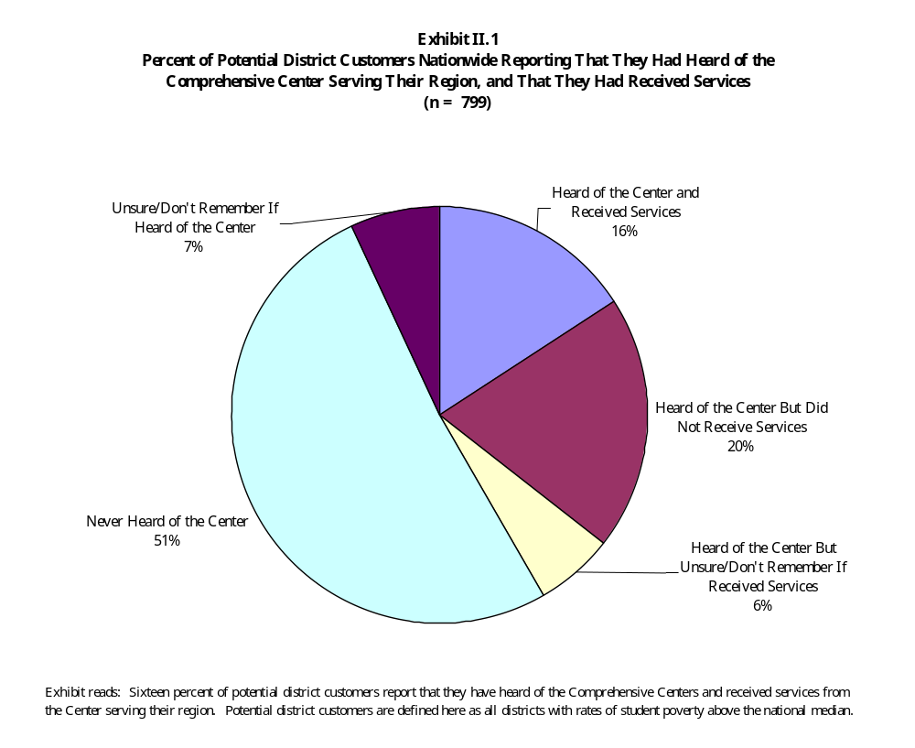

Exhibit II.2

Number of Organizations Receiving On-Site Professional Development
or Consultation in 1998, and Number of Gatekeepers at Those Organizations,
as Reported by the Comprehensive Centers

Type of Organization | Number of Organizations Served On-Site in 1998¹ | Number of Gatekeepers
State Education Agencies | 62² | 392
Districts | 387 | 592
Schools | 680 | 845
Intermediate Education Agencies | 124 | 187
Other Educational Organizations | 211 | 240
Total | 1,464 | 2,256

Exhibit reads: In 1998, 62 State Education Agencies received on-site professional development or consultation; 392 gatekeepers were located at the State Education Agencies.

- Includes organizations that received one or more days of professional development off-site for a team of representatives from the organization.
- Includes education agencies in the 50 states, the District of Columbia, Puerto Rico, the U.S. Virgin Islands, and entities in the Pacific region.

In 1998, the centers also reported that they served 211 other organizations, including American Indian tribes, colleges and universities, Title I Parent Advisory Councils, and various professional organizations.

Roles and Responsibilities of Individuals Served

Gatekeepers. Within organizations, there are two kinds of center customers. The first, whom we call the gatekeeper, is the Comprehensive Center’s primary point of contact with the organization being served. The gatekeeper (and, occasionally, his or her supervisors) makes the initial decision to engage the center’s services. The gatekeeper helps to plan activities and negotiates the terms of the center’s work on site. In large organizations, particularly SEAs and large school districts, Comprehensive Centers may work with multiple gatekeepers. As a group, gatekeepers are of particular interest to this evaluation because they decide how and when their organizations will seek out and use technical assistance resources.

In 1998, Comprehensive Center records show that they worked with nearly 400 gatekeepers to plan and deliver services to SEAs (Exhibit II.2). Exhibit II.3 shows that three-quarters of these SEA gatekeepers report that they administer a federal program of some kind. In addition, most gatekeepers (81 percent) are responsible for providing training, professional development, or technical assistance themselves.

Exhibit II.3

Professional Responsibilities of Gatekeepers

Which of the following activities are major parts of your professional responsibilities?

Percent of Gatekeepers Reporting,

by Type of Organization
Professional Responsibilities | State Education Agency  (n=129) | School District Central Office  (n=192) | School  (n=267) | Intermediate Education Agency  (n=59) | Other Organization  (n=73)
Administering an educational organization | 27 | 46 | 77 | 43 | 27
Administering a federally funded program | 74 | 68 | 42 | 55 | 42
Providing training, professional development, or technical assistance | 81 | 71 | 45 | 98 | 61

Exhibit reads: Twenty-seven percent of state education agency (SEA) gatekeepers administer an educational organization as part of their professional responsibilities.

Of all gatekeepers at the state level, about half help to administer Title I. About a quarter help to administer each of seven other programs, including Title I, Part C (Education of Migratory Children), Safe and Drug-Free Schools and Communities, and Title VII (Bilingual Education, Language Enhancement, and Language Acquisition) (Exhibit II.4).

Exhibit II.4

ESEA Programs Administered by SEA, District, and School Gatekeepers

Which of the following federal education programs, if any, do you help to administer?

Percent of Gatekeepers Reporting,

by Type of Organization
ESEA Programs | State Education Agency  (n=126) | School District Central Office  (n=189) | School  (n=258)
Title I, Part A | 48 | 65 | 63
Title I, Part B (Even Start) | 22 | 11 | 5
Title I, Part C (Education of Migratory Children) | 29 | 26 | 16
Title II, Eisenhower Professional Development | 24 | 48 | 28
Title IV, Safe and Drug-Free Schools and Communities | 23 | 38 | 44
Title VI, Innovative Education Program Strategies | 28 | 39 | 17
Title VII, Bilingual Education, Language Enhancement, and Language Acquisition | 24 | 28 | 39
Title IX, Indian, Native Hawaiian, and Alaska Native Education | 9 | 26 | 12
Goals 2000 | 28 | 34 | 23

Exhibit reads: Forty-eight percent of SEA gatekeepers help to administer Title I, Part A.

In 1998, the Comprehensive Centers worked with nearly 600 district-level gatekeepers. Almost two-thirds of these gatekeepers administer Title I programs, a little more than a third administer Safe and Drug-Free Schools and Communities, and roughly a quarter administer Title I, Part C (Education of Migratory Children), Title VII (Bilingual Education), and Title IX (Indian Education). Seventy-one percent also have responsibility for providing training, professional development, or technical assistance themselves.

In 1998, the Comprehensive Centers worked with almost 850 gatekeepers at the school level. More than three-quarters of school-level gatekeepers report that they administer an educational organization; the centers’ records tell us that most of these are principals.

Participants. The second kind of customer is the participant in center-sponsored training and technical assistance activities. Participants are the end-users of technical assistance services; they are expected to use the information they acquire from the centers in their daily work. They may or may not have been involved in the planning of services, and they usually do not help to decide whether their organizations will continue to use the Comprehensive Centers as a resource.

About two-thirds of all participants in our sample of 30 Comprehensive Center activities were based in schools. Exhibit II.5 shows that of all school-based participants in center activities, 70 percent (accounting for half of all participants in Comprehensive Center activities) reported that they teach elementary or secondary students as a major part of their professional responsibilities.

Exhibit II.5

Professional Responsibilities of Participants in Center Activities

Which of the following are major parts of your professional responsibilities?

Percent of Participants Reporting,
by Type of Organization
Professional Responsibilities | School  (n=513) | School District  Central Office  (n=132) | State Education Agency  (n=50)
Teaching elementary or secondary students | 70 | 5 | 2
Providing training, professional development, or technical assistance | 24 | 64 | 74
Administering an educational organization | 23 | 29 | 6
Administering a federally funded education program | 10 | 56 | 50
Parent or community representative | 5 | 6 | 0

Exhibit reads: Seventy percent of school-based participants in Center activities report that teaching elementary
or secondary students is a major part of their professional responsibilities.

Are Centers Serving Their Highest-Priority School and District Customers?

The Comprehensive Centers are targeting their highest-priority customers, at both the school and district levels, and this targeting appears to be reasonably effective. The centers are targeting both high-poverty districts and schools and districts and schools serving large numbers of students in the target populations named in the centers’ authorizing legislation, including limited English proficient students, migrant students, and Indian students.

High-Priority Districts

The majority of the centers’ existing district customers may be considered “high-priority” according to the criteria set in the centers’ authorizing legislation:

- Almost two-thirds of district-level gatekeepers report that more than 50 percent of their students were eligible for free or reduced-price lunches. (Exhibit II.6)

Exhibit II.6

Percent of Students Eligible for Free and Reduced-Price Lunches in Districts Served by Comprehensive Centers, as Reported by Gatekeepers
(n=139)

What percentage of students in your district are eligible to receive free or reduced-price lunches?
Percent of Students | Percent of Gatekeepers Reporting on the Percent of Students in Their District Who Are Eligible for Free and Reduced-Price Lunches
75 – 100% | 29
51 – 75% | 33
26 – 50% | 29
0 – 25% | 9

Exhibit reads: Twenty-nine percent of district-level gatekeepers reported that between 75 and 100 percent of the students in their district are eligible to receive free or reduced-price lunches.

- Almost a third of district-level customers reported very high concentrations of poverty, with 75 percent or more of their students eligible.

- More than half of district-level customers report that their districts enroll a significant proportion of limited English proficient students (that is, more than 10 percent of the total student population). (Exhibit II.7)

- About a fifth of district-level customers report that their districts enroll a significant proportion of Indian students.

Exhibit II.7

Percent of Target Student Populations in Districts Served by Comprehensive Centers,
as Reported by Gatekeepers
(n=137)

What percentage of children in your district belong to each of the following groups?
 | Percent of Gatekeepers Reporting on the Range of Students in Their District Who Belong to Target Populations
Target Student Populations | <1% | 2-10% | 11-25% | 26-50% | Over 50%
Children with limited English proficiency | 12 | 30 | 22 | 22 | 14
Indian, Native Hawaiian, or Alaska Native children | 52 | 27 | 8 | 3 | 8
Migratory children | 54 | 32 | 7 | 4 | 1
Immigrant children | 41 | 41 | 11 | 5 | 1
Neglected or delinquent children | 54 | 28 | 10 | 4 | 1
Homeless children | 70 | 22 | 3 | 2 | 3
Children with disabilities | 5 | 39 | 44 | 7 | 2

Exhibit reads: Twelve percent of district-level gatekeepers reported that less than 1 percent of students in their district are of limited English proficiency.

Note: Rows may not sum to 100 percent because some respondents reported that they did not know.

Among our nationally representative sample of potential district customers, high-priority districts are more likely to report that they have heard of the centers and that they have received services than other kinds of districts. For example, Exhibit II.8 shows that districts with high rates of poverty and districts with high enrollments of LEP students, Indian students, and migrant students were more likely to report that they had heard of the Comprehensive Center serving their region than were other districts in the sample. Among the 50 districts in the country with the largest numbers of children in poverty, 90 percent had heard about the Comprehensive Center serving their region.

High-priority districts are also more likely to report that they have actually received services from the centers. For example, Exhibit II.9 shows that 40 percent of districts with significant enrollments of limited English proficient students, 36 percent of districts with significant enrollments of Indian students, and 25 percent of districts with significant enrollments of migrant students reported that they had received services from a center, compared with just 16 percent of all districts with poverty rates over the median. Districts with the highest concentrations of poor children and districts with the largest numbers of poor children were also much more likely to report that they had received services from the Comprehensive Centers.

One final set of findings provides additional evidence that the Comprehensive Centers are effectively targeting high-priority customers at the district level. High-poverty districts and districts with significant enrollments of certain student populations are more likely to report that they receive high levels of center services than are other district customers. This is especially true for the centers’ higher-intensity, more expensive forms of service—on-site consultation and help convening special events. For example, high-poverty districts are more likely to report that they receive on-site consultation five or more times a year than are other districts; the same finding holds true for districts that enroll migrant students, Indian students, and limited English proficient students. Although the differences are not statistically significant for all center services and for all categories of high-priority districts, these findings do suggest that, even within their established customer base, the centers target higher levels of resources to higher-priority customers.

Large Districts

Large districts were more likely to report contact with the Comprehensive Centers than smaller districts. For example, Exhibit II.10 shows that 53 percent of districts with enrollments over 25,000 reported that someone in the district had received services from a center, compared with just 9 percent of districts with enrollments under 2,500. These varying rates of contact suggest that larger districts are more active consumers of technical assistance. However, they also suggest that the centers are targeting their services to reach large numbers of students efficiently.
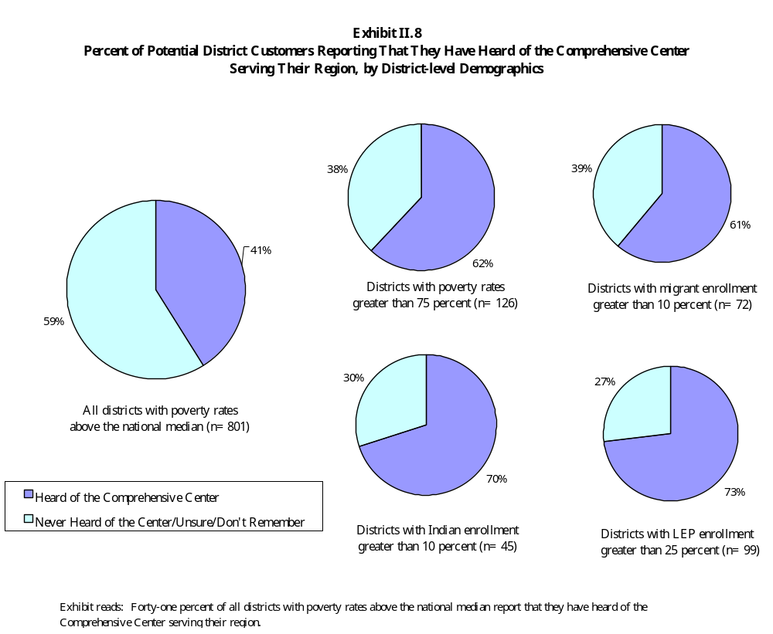

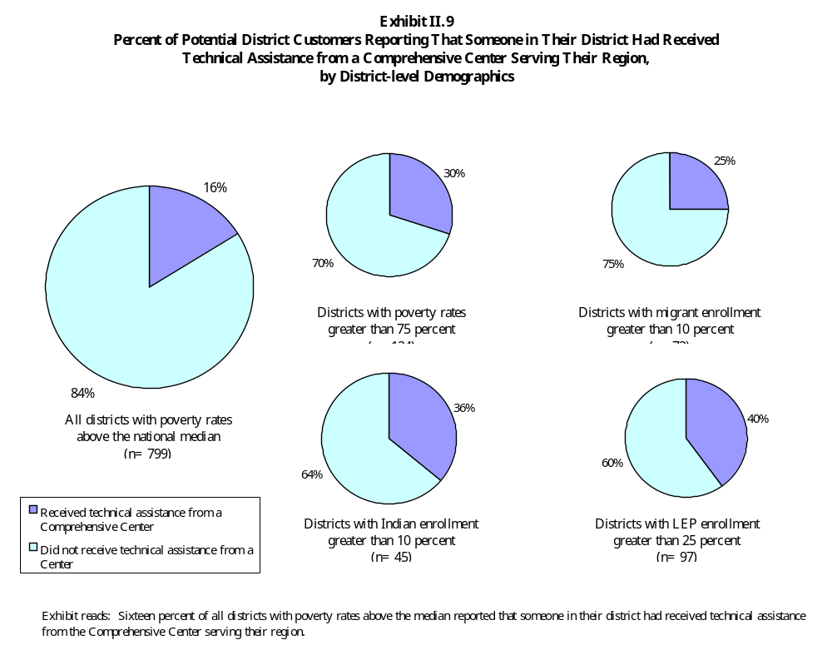
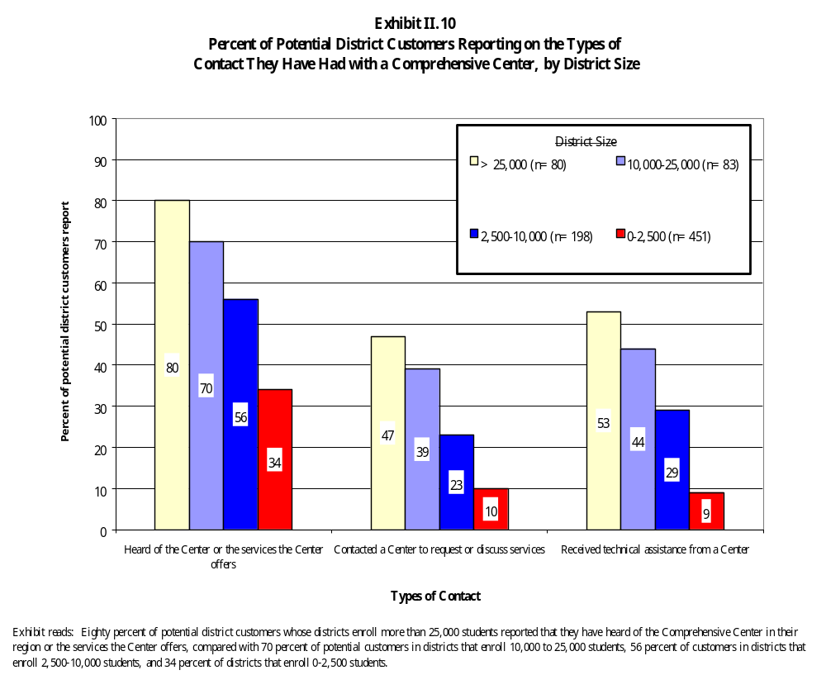

Schools

The Comprehensive Centers are also targeting high-priority schools, as defined by the centers' authorizing legislation:

- Sixty-nine percent of school-level gatekeepers report that their school operates a Title I schoolwide program.

- Almost three-quarters of school-level gatekeepers report that 50 percent or more of their students are eligible for free or reduced-price lunches. (Exhibit II.11)

- More than a third of school-level gatekeepers represent very high-poverty schools, where 75 percent or more of students are eligible.

- Almost half of the schools served by the centers reported that they had a significant proportion of limited English proficient students (that is, more than 10 percent of their total enrollment), with 13 percent reporting that half or more of the students they served were limited English proficient. (Exhibit II.12)

- Almost a third of schools served reported that they enroll a significant proportion of Indian students (more than 10 percent of their total enrollment), with 14 percent of schools reporting that half or more of their students were Indian.

Exhibit II.11

Percent of Students Eligible for Free and Reduced-Price Lunches in Schools Served by Comprehensive Centers, as Reported by Gatekeepers
(n=190)

What percentage of students in your school are eligible to receive free or reduced-price lunches?
Percent of Students | Percent of Gatekeepers Reporting on the Percent of Students in Their School Who Are Eligible for Free and Reduced Price Lunches
75 – 100% | 38
51 – 75% | 36
26 – 50% | 14
0 – 25% | 12

Exhibit reads: Thirty-eight percent of school-level gatekeepers reported that between 75 and 100 percent of the students in their school are eligible for free or reduced-price lunches.
Exhibit II.12

Percent of Target Student Populations in Schools Served by Comprehensive Centers,
as Reported by Gatekeepers
(n=193)

What percentage of children in your school belong to each of the following groups?
 | Percent of Gatekeepers Reporting on the Range of Students in Their Schools Who Belong to Target Populations
Target Student Populations | <1% | 2-10% | 11-25% | 26-50% | Over 50%
Children with limited English proficiency | 30 | 22 | 19 | 16 | 13
Indian, Native Hawaiian, or Alaska Native children | 49 | 19 | 9 | 8 | 14
Migratory children | 56 | 26 | 7 | 7 | 3
Immigrant children | 58 | 21 | 12 | 5 | 3
Neglected or delinquent children | 27 | 40 | 17 | 9 | 5
Homeless children | 68 | 24 | 4 | 1 | 2
Children with disabilities | 13 | 42 | 35 | 6 | 2

Exhibit reads: Thirty percent of school-level gatekeepers reported that less than 1 percent of the students in their school are of limited English proficiency.

Note: Rows may not sum to 100 percent because some respondents reported that they did not know.

Finally, the same pattern of providing higher levels of service to high-priority customers holds true for schools as well. High-poverty schools and schools with significant enrollments of migrant students, Indian students, and limited English proficient students were more likely to report that they got certain kinds of service five or more times a year than were other schools. Again, this pattern held true for the centers’ higher-intensity and more expensive kinds of services, although not every difference was statistically significant for every category of high-priority customers. These findings suggest that within the centers’ established customer base, high-priority schools are more likely to receive services than other kinds of schools.

Needs and Purposes: Why Do Customers Seek Assistance?

States, schools, and districts seek assistance for a variety of needs and purposes having to do with the specific local conditions they face, the overall policy context, and the availability of a resource that they view as likely to be useful. Despite the variety of purposes that spur customers to seek the centers' assistance, the centers have established themselves as a useful source of assistance among their existing customers.

Personal and Organizational Goals

On surveys, large numbers of participants in Comprehensive Center activities reported that they hoped to obtain new ideas and contacts for advancing their own work and the work of their organizations. About three-quarters of all respondents identified “keeping current professionally” and “obtaining ideas or contacts that would strengthen my work” as reasons for their participation in center-sponsored activities. Exhibit II.13 shows that school-based participants were slightly more likely to report that they hoped to benefit personally from center activities, suggesting that they were slightly more likely to see the Comprehensive Center as a source of new ideas for their own work.

About two-thirds of all participants in center activities reported that they hoped to obtain ideas or contacts that would strengthen their organization’s existing work or help their organization carry out an improvement effort. Exhibit II.13 shows that district-based participants were slightly more likely than others to report that they hoped to advance their organization’s work by participating in a center-sponsored activity. State-based participants were slightly more likely than others to report that they hoped to obtain new ideas that would help them be a resource to others, probably because they are most heavily engaged in providing training, professional development, and technical assistance themselves.

Comprehensive Reform and School Improvement

On surveys, gatekeepers were most likely to identify “core” issues associated with school improvement as areas where their organization had the greatest need for technical assistance services. Exhibit II.14 shows that the topics most commonly identified by Comprehensive Center customers were: (1) improving curriculum and instruction (29 percent); (2) analyzing student achievement data and interpreting results (28 percent); (3) expanding parent/family involvement (25 percent); and
(4) designing program evaluations (23 percent) (Exhibit II.14). Customers’ responses to this survey item suggest that they share an interest in comprehensive reform and data use that is central to the agenda of the Comprehensive Centers and to many ED programs.
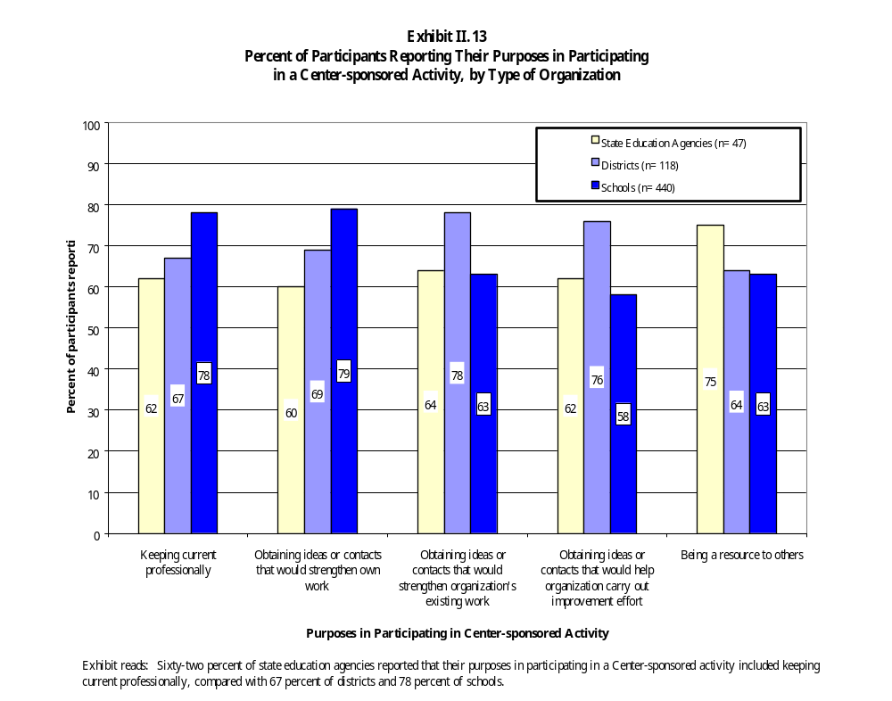

Exhibit II.14

Topics for Which Customers Have the Greatest Technical Assistance Needs
(n=529)

For which topics does your organization have the greatest need of technical assistance?
Topic | Percent of Gatekeepers Reporting
Improving curriculum and instruction | 29
Analyzing student achievement data and interpreting the results | 28
Expanding parent/family involvement | 25
Program evaluation | 23
Challenging standards; accountability | 21
Student assessment | 21
Improving the quality of bilingual education programs | 20
Addressing the needs of special populations | 16
Implementing schoolwide programs | 15
Adopting model programs or comprehensive school reforms | 15
Implementing educational applications of technology | 11
Creating safe and drug-free learning environments | 8
Consolidating or integrating federally funded programs | 7
Implementing ESEA programs | 5
Issues identified by ED Integrated Review Teams | 2

Exhibit reads: Twenty-nine percent of gatekeepers reported that improving curriculum and instruction is the topic for which they have the greatest technical assistance need.

Comprehensive Center customers were less likely to identify topics associated with specific ESEA provisions as areas where they had need of assistance. Topics identified least often included:
(1) addressing issues identified by ED Integrated Review Teams (2 percent); (2) implementing ESEA programs (5 percent); (3) consolidating or integrating federally funded education programs (7 percent); (4) creating safe and drug-free learning environments (8 percent); and (5) implementing the educational applications of technology (11 percent). Center customers in state departments of education were more likely to identify topics related to ESEA program administration as areas of need, although the percentage was still low compared with those identifying more “comprehensive” concerns. Other responses did not vary significantly among state, district, and school customers, nor did they vary between districts that were established customers of the centers and districts that had not yet received services.

These findings suggest that customers of the Comprehensive Centers are responding to the emphasis in the current policy context on accountability systems, using data to drive decision making, and comprehensive, rather than categorical, approaches to reform. Our interviews with Comprehensive Center staff also suggested that federal priorities and programs can drive demand for certain types of services. In the year after the Comprehensive Centers began operation, for example, many of their activities focused on helping schools that were newly eligible to run schoolwide programs under the 1994 law to develop schoolwide program plans. As most of the eligible schools have come on line, however, Comprehensive Center staff members report that calls for assistance with schoolwide program planning have been dwindling. By the time we fielded our survey, in spring 1999, “implementing schoolwide programs” ranked in the middle of the pack as a technical assistance need. On the other hand, “adopting model programs or comprehensive school reforms,” a topic related to the Comprehensive School Reform Demonstration (CSRD) Program, a newer federal initiative, ranked much higher as an expressed need than specific ESEA programs.

Responding to Specific Local Challenges

Our collection of 15 case studies suggests that states and local sites are likely to seek out or accept assistance for reasons that are quite specific to a site and to a particular task at hand. Customer purposes that were common across several case studies included:

Extending state or local capacity. At both the state and local level, some customers saw the centers as a way of extending the capacity of their own organizations to provide services to teachers and schools. In both Texas and Mississippi, for example, state administrators explained that lack of staff and legislative mandates prevented them from working with as many schools as they would like; they saw the Comprehensive Centers as a way to serve a larger number of schools on the state’s behalf. Several districts in California joined the Reading Success Network (RSN), a professional development initiative sponsored by the Southern California Comprehensive Assistance Center, in order to secure scarce professional development resources for teachers. In addition, several principals reported that an important benefit of the RSN was that it helped them to support a large number of new and provisionally certified teachers in their schools, who had been hired as a result of California’s class size reduction initiative.

Accountability pressures. In a few sites, accountability pressures created an important incentive for seeking out help or accepting help when offered. In North Carolina, for example, a new state requirement that LEP students be tested in English two years after arriving in the state prompted several districts to seek help with their English as a Second Language (ESL) programs. In the spring of 1999, the middle school at Mountainview was identified for Title I program improvement, and school staff turned to the Comprehensive Center for help with school improvement planning and related activity throughout the 1999-2000 school year.

Complying with ESEA and other program provisions. In several sites, state and local administrators requested help from the Comprehensive Centers in schoolwide program planning. For example, teachers from the Mountainview School began work with their Comprehensive Center because they were concerned about completing their schoolwide plan on time; the second year of their partnership with the Mountainview School focused on assembling data and preparing a report for their state accreditation review. At the state level, the New York State Department of Education turned to the Comprehensive Center for help in developing a statewide consolidated plan. Several other states, including New York and Texas, used the Comprehensive Centers early on to help train their Title I school support teams.

Responding to the needs of a particular student population. Several states and districts in our case study sample, including the North Carolina ESL clusters, Hawaii, and Riverside City Schools, sought help from the Comprehensive Centers because of recent increases in the numbers of LEP, migrant, and immigrant students in their schools. In all of these cases, state and district administrators wanted help in training teachers to address the special educational needs of these new students. Our case study site in Alaska decided to participate in Alaska Onward to Excellence because of a long-standing interest in including native culture and knowledge in the curriculum and a commitment to building a school culture that effectively engaged the native community.

Availability of Useful, Free Services

In addition to satisfying their own needs and purposes, customers seek out or accept Comprehensive Center services because the services are free, and because customers have reason to believe that they will be useful. For example, Exhibit II.15 shows that 87 percent of center customers reported that the fact that center services were free of charge was a “very important” or “moderately important” reason for using center services and products. In interviews at all of our case study sites, respondents commented that the fact that Comprehensive Center services were free was an important condition allowing them to avail themselves of those services.

Almost 90 percent of survey respondents identified the centers’ reputation for providing high-quality technical assistance as “very important” or “moderately important” in prompting their organization to begin using the services and products offered by the centers. This perception of quality appears to be shared by customers and noncustomers alike. Only 2 percent of districts that had not received services reported that they had avoided the Comprehensive Centers because they believed that they had a reputation for poor service.

An Untapped Market for Services

Survey data from a nationally representative survey of districts suggest that increased marketing and outreach efforts would create additional demand for center services. Potential district customers who had not made use of center products and services attributed their lack of contact with the centers to the fact that they did not have enough information about what the centers do and how they operate. For example, among high-poverty districts that knew about the centers but had not received services, the reasons most often cited for not making use of center products and services were: (1) not receiving information about center products or services (44 percent); (2) not having time to learn about center products and services (36 percent); (3) not knowing whom to contact at the center (31 percent); and
(4) not knowing if the center can address the district’s particular needs and interests (29 percent) (Exhibit II.16).

Few districts reported that they had avoided the centers because they did not need their assistance. Among districts that had heard of the centers but had not received services, only 27 percent said that they receive adequate assistance from other sources. In addition, very few districts reported that they had avoided the centers because they had a negative impression of the centers’ work. For example, very few reported that: (1) they have not been able to develop productive working relationship with center staff (9 percent); (2) center products and services do not address their needs
(2 percent); (3) the center does not have a reputation for providing high-quality products and services
(2 percent); or (4) they had requested assistance, but the center was unable to provide it (1 percent).
Exhibit II.15

Reasons to Begin Using Comprehensive Center Products and Services
(n= 554)

How important were the following factors in prompting you or your organization to begin using the products or services offered by the Comprehensive Center?

Percent of Gatekeepers Reporting on the
Importance of Various Factors in Prompting Them to Use Center Products or Services
Reasons to Begin Using  Comprehensive Center Products and Services | Very Important/  Moderately Important | Somewhat Important | Not at All Important
Center products and services were free of charge | 87 | 11 | 3
The Center had a reputation for providing high-quality technical assistance | 86 | 11 | 3
Center products and services were easily accessible | 85 | 13 | 3
Center products and services met the needs of our organization | 78 | 10 | 2
The Center provided products or services that were not available elsewhere | 77 | 17 | 7
Center services built on technical assistance we had received in the past | 76 | 13 | 11

Exhibit reads: Eighty-seven percent of gatekeepers thought that it was very important or moderately important to begin using Comprehensive Center products and services because they were free of charge.

Note: Rows may not sum to 100 because of rounding.

Exhibit II.16

Reasons Why Districts Have Not Made Use of
Comprehensive Center Products and Services
(n=213)

If your district has not made use of the products or services offered by the Comprehensive Center, what are the reasons?
Reasons for Not Using Center Products or Services | Percent of Potential District  Customers Reporting
We have not received any information about Center products or services | 44
We have not had time to learn about Center products or services | 36
We don’t know whom to contact at the Center | 31
We don’t know if the Center can address our particular needs and interests | 29
We receive adequate assistance from other sources | 27
We have not been able to develop productive working relationships with Center staff | 9
Center products and services do not address our needs | 2
The Center does not have a reputation for providing high-quality products and services | 2
We have requested assistance, but the Center was unable to provide it | 1

Exhibit reads: Forty-four percent of potential district customers reported that one reason their district has not made use of Center products or services is because they have not received any information about Center products or services.

These findings suggest that many more districts would be interested in receiving center services, given additional outreach efforts.

The Comprehensive Centers as a Regular Source of Assistance

Among their established customers, the Comprehensive Centers have managed to carve out a niche for themselves as a valuable source of technical assistance. Approximately two-thirds of all gatekeepers report that they “always” or “sometimes” turn to their Comprehensive Center for help in areas that are important to them. Established customers report that they are slightly more likely to consult the Comprehensive Centers than any other source of assistance, with the exception of their state education agency. These findings vary somewhat by type of customer, with school-level gatekeepers slightly less likely to report that they would consult the Comprehensive Centers than gatekeepers in districts or states (see Exhibit II.17). Among all types of customers, however, the Comprehensive Centers have established themselves as a credible source of assistance to which gatekeepers can turn on a regular basis.

Summary

Evidence from nationally representative surveys of school districts and state administrators of federal programs shows that the Comprehensive Centers have reached a number of their potential customers with some level of service. In addition, the centers are targeting their services to their highest priority customers, as defined in their authorizing legislation. Comprehensive Center customers engage in work with the Comprehensive Centers in the expectation that the centers’ assistance will be of high quality and will address their needs and purposes. In the next chapter, we describe the major categories of center services and describe the content and format of services received by individual customers.

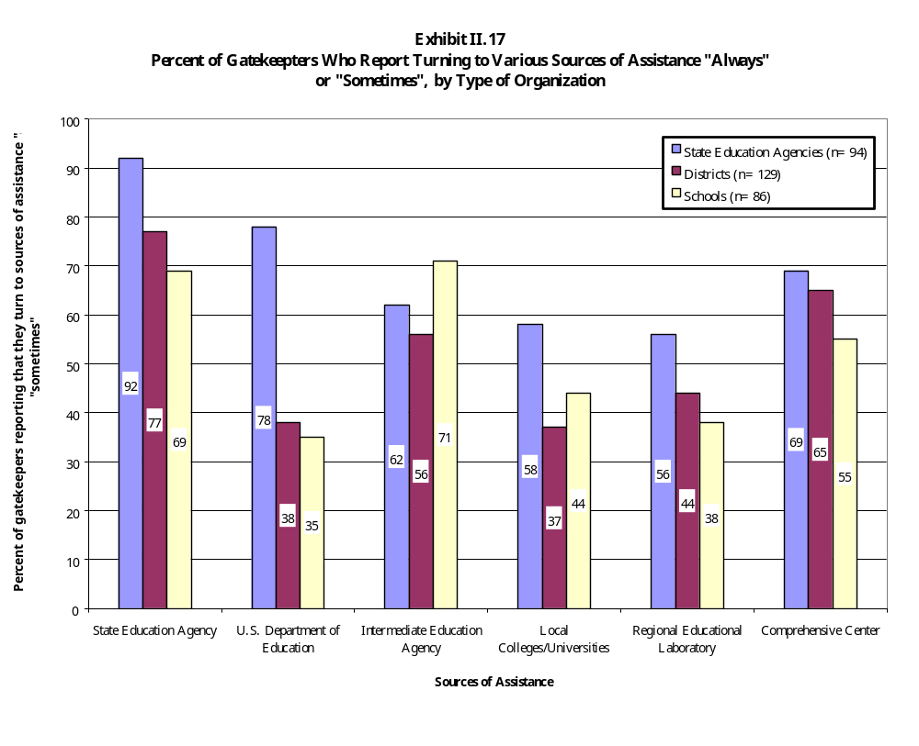

III. PORTFOLIO OF SERVICES

Title XIII of ESEA charges the Comprehensive Centers with providing training and technical assistance to customers on a long list of possible topics, from improving the quality of instruction, to implementing effective schoolwide programs, to meeting the needs of special populations of students. A central purpose of this evaluation is to describe the ways in which the centers have responded to their statutory mission, and in particular, the ways in which they have organized their portfolio of services. In this chapter we examine both center strategies for organizing and delivering assistance, and the content and format of services received by customers and the organizations they represent.

What Are the Centers’ Major Strategies for Organizing and Delivering Assistance?

Most center services can be classified into one of two categories: (1) “major” initiatives that consist of multiple contacts with an organization over a period of time, and (2) information dissemination activities and short-term training events that do not, on their own, involve a relationship with customers. In this section we describe both types of activities.

Major Center Initiatives

Many of the Comprehensive Centers organize a substantial portion of their activities around a small group of key initiatives. These initiatives generally engage the centers in long-term relationships with customers and are intended to create some kind of systematic change in the organizations served. In interviews, Comprehensive Center staff made it clear that they believe that these kinds of long-term services are their most valuable contribution to the regions they serve. One comment summarized the observations of many other center staff members:

One of the things we decided a while back is that one-time interventions don’t really have potential of creating systemic, comprehensive change. We shy away from this. Even in cases when we’re going into a district that’s in a crisis, we try to use it as an entree for sustained support.

The centers’ major initiatives, which represent their highest-intensity, most expensive set of services, can be classified into three broad categories: (1) professional development initiatives;
(2) services to model schools and partnership sites; and (3) consultation with states, districts, and schools.
Professional development initiatives. Most of the centers’ services to states and local sites involve some form of training and professional development. Among the centers’ major initiatives, training and other professional development provided is relatively intensive (meaning that the total package of training delivered amounts to five days or more) and is usually provided during a period of weeks or months. Typically, centers follow up the training with additional opportunities for networking, information dissemination, and over-the-shoulder consultation, although individual participation in these follow-up activities may vary. School and district administrators and teachers usually participate in center-sponsored professional development as members of a team representing their organization. Examples of major professional development initiatives in the Comprehensive Center network include the following:

- Reading Success Network (RSN): The goal of the RSN is to improve student achievement in reading in grades K-3 by training a cadre of school-level coaches to support classroom teachers’ efforts to improve instruction. The RSN was developed by the Southern California Comprehensive Assistance Center and has since been adopted by all 15 Comprehensive Centers as one of the network’s flagship professional development initiatives. The RSN provides professional development to classroom teachers and school-based literacy coordinators in the assessment of reading and the diagnosis of reading difficulties, the use of data to assess reading performance, intervention strategies, and peer coaching and cognitive coaching as strategies for working with colleagues. Coaches work with classroom teachers to incorporate new strategies in the diagnosis of reading difficulties and in early intervention into their existing repertoire of skills. The Comprehensive Center sponsors the initial training series and works with the county offices of education to provide follow-up training as needed.

- Cognitively Guided Instruction (CGI): The Region VI Comprehensive Center sponsors training in Cognitively Guided Instruction, a math program based on problem solving for students in kindergarten through third grades. Developed by researchers at the University of Wisconsin-Madison from a decade of research on the way that children reason mathematically, CGI helps teachers to observe student cognitive processes in order to tailor and individualize instruction. Two teachers and one resource specialist/trainer from each school attend a week-long summer institute sponsored by the Comprehensive Center that introduces them to the principles and practices of CGI. Teachers may return the following summer for an advanced CGI institute. The center expects that teachers who receive training will disseminate what they have learned in some way at their schools.

- Learning Facilitators’ Academy: The Region VII Comprehensive Center developed the Learning Facilitators’ Academy to help school staff in a large urban district think strategically about using categorical resources to help all children, especially limited English proficient children and those eligible for Title I, to reach local standards for student performance. The Learning Facilitators’ Academy provided training to teams from 12 schools, consisting of administrators; Title I, bilingual, and content area teachers; and guidance counselors. Five day-long Saturday training sessions focused on the change process, team building, student learning styles, curriculum alignment, and instructional strategies. Participants concluded each session with a service delivery plan that they tried in schools and classrooms between sessions and reported on at the following session.

- North Carolina ESL Clusters: The Region IV Comprehensive Center at the Appalachia Regional Educational Laboratory provides professional development and training to districts that are experiencing a sharp rise in the numbers of migrant students enrolled in their schools. The center sponsors a five-day summer “lab school,” where mainstream teachers learn both the theory of second language acquisition and the practice of developing lesson plans using effective strategies for limited English proficient students. Participating teachers observe other classes and pilot their lessons in a summer school setting. Center staff provided additional workshops as requested during the school year and conducted follow-up visits to teachers’ classrooms to provide feedback on the implementation of the strategies they learned over the summer.

- Schoolwide Programs Network. The New England Comprehensive Assistance Center sponsors a Schoolwide Programs Network for elementary schools that have a Title I schoolwide program or are planning one. The goal of the network is to develop schools’ capacity to plan and implement comprehensive school reforms. Participation in the Network has four components: (1) professional development opportunities, including an annual Schoolwide Congress, special topic workshops, Spring “Retooling” Meetings, and a Leadership Academy for principals and coaches; (2) a coach, generally an SEA staff member trained by the center, who provides follow-up, on-site consultation to assist with planning and implementation; (3) guided visits to schools that have raised student achievement; and (4) monthly mailings and on-line list serve discussions.

- Training for Schoolwide Program Planning Teams. The Region XI Comprehensive Assistance Center provides training to teams of administrators, principals, parents, and teachers between four and eight times over the course of a year. These full-day or half-day sessions address needs assessment, team building, data collection, data disaggregation, analysis, plan writing, and obstacles to implementation. Comprehensive Center staff members follow up with consultation to individual schools by telephone and in person when feasible.

Model schools and partnership sites. Of all the services provided to schools and districts by the Comprehensive Center network, services to model schools and partnership sites are by far the most intensive. Three Comprehensive Centers have made “model schools” initiatives a centerpiece of their portfolio of services. Typically, Comprehensive Center staff develop an agenda for service in consultation with individual schools. Although all model schools or partnership sites may receive some standardized services (attending a summer institute provided to all schools, for example), they also receive a fair number of services tailored to their specific needs. Model schools initiatives are among the few center-sponsored activities that include regular, on-site over-the-shoulder technical assistance in individual schools.

- Region XIV Model Schools. The Region XIV Comprehensive Center has provided services to eight schools with Title I schoolwide programs since 1996. These schools all share high rates of poverty, mobility, and disciplinary suspensions; high concentrations of targeted populations; and low achievement. Model schools set goals and priorities, develop and implement school improvement plans to meet these goals, evaluate results, periodically revise goals to incorporate challenges, and share experiences and expertise with other schools. Center staff, who function as coaches for school-level teams, help model schools plan their programs, provide information on research-based programs and professional development strategies, facilitate teacher collaboration, provide assistance with specific federal program provisions, assist with program evaluation, and document and disseminate the schools’ successes. Model school institutes, sponsored quarterly by the centers, provide a forum for staff from the Model Schools to share ideas and expertise. Each model school works with one or two primary contacts at the center.

- Region V Initiative Schools. Since early 1998, the Southeast Comprehensive Assistance Center (SECAC) has provided intensive, needs-based, sustained, comprehensive services in one or two schools in each of the states in its region (a total of 8 schools). In general, the state team leader has the primary relationship with the schools, although he or she typically brokers resources for the school, such as recruiting other center staff to fulfill special roles. Typical center services to initiative schools include a needs assessment, creation of an improvement plan, and assistance in implementing the plan. Professional development is often a substantial aspect of the plan and its implementation. In the first few months of their work with the initiative schools, state team leaders visited the school in person twice a month. After the initial planning period, center staff visits to the school range from one to several times a month, although telephone and electronic communications are more frequent.

- Region X Partnership Sites. The Northwest Regional Educational Laboratory’s (NWREL’s) Comprehensive Center in Region X has recruited one district in each of three states in its region to become a partnership site. These partnerships are intended to build capacity in one school and to develop approaches to comprehensive reform that can be applied in other schools. The center negotiates a Memorandum of Agreement with each site that specifies how the center will provide services to the site, and how the site will contribute to advancing the center’s work. Technical assistance is customized and includes such activities as developing culturally specific instruction; designing responsive programs; building interdisciplinary teams; and training staff to use data-based “profiling” to summarize, disaggregate, and analyze student assessment data for instruction. Partner sites have also participated in jointly sponsored center/NWREL conferences on integrating programs, gaining parent and community support, responding to cultural diversity, and using computers to profile and track schools’ achievements. State liaisons at the Comprehensive Center work with each of the partnership sites; center staff members visit each school an average of once a month.

Continuing consultation with states, districts, and schools. Many Comprehensive Centers provide continuing consultation and over-the-shoulder technical assistance to each of the states in their region. Some centers divide their staff into state-based teams; staff members spend all, or almost all, of their time providing services in their assigned states. The Southeast Comprehensive Assistance Center houses one staff member in each of the states in its region. Some centers also provide consultation and technical assistance services to groups of schools and districts in its region. Typically these consultation services extend over a period of years. At the state level, the assistance generally focuses on the implementation of ESEA and other federal programs; at the local level, the assistance usually focuses on needs assessment and schoolwide planning.

- Support to the Maryland State Department of Education: The Region III Comprehensive Center has provided various kinds of support to federal programs of the Maryland State Department of Education (MSDE). The center assisted in the development of a new Even Start application process, helped develop a manual for projects making the transition from federal to local funding support, and documented meetings of Even Start program directors. The center worked closely with Maryland’s Migrant Education Director to evaluate the effectiveness of the academic component of its migrant program, and to create a self-assessment tool for principals and teachers. Center staff attend MSDE’s Title I administrators’ meetings, and have conducted presentations on schoolwide programs and school reform, developed a scoring rubric for the Title I distinguished schools program, and assisted with consolidated planning efforts. Finally, the center helped Title IV staff to draft the program’s RFP, delivered a presentation on the principles of effectiveness and conducting needs assessments, and assisted in identifying Safe and Drug-Free Schools program experts, consultants, and materials in preparation for a state conference.

- Implementation of the Comprehensive School Reform Demonstration (CSRD) program in New York: The New York Technical Assistance Center (NYTAC) has assisted the New York State Education Department with the implementation of CSRD by helping to develop and refine its application for CSRD subgrants and reviewing incoming proposals for grants. During the planning stage, the center worked with SEA staff to ensure that the program would address the needs of migrant students; similarly, the center reviewed the approved CSRD models to determine how well each addresses the educational needs of LEP students. Recognizing the need for continuing and collaborative assistance to make the program a success, the center formed the CSRD Think Tank, made up of staff members from the center, the SEA, the Effective Schools Consortium Network, the Northeast and Islands Laboratory at Brown University, and the New York City Board of Education. The think tank meets quarterly to discuss how to coordinate technical assistance among these service providers. Currently, the group is revising a scoring rubric for CSRD applications and designing an evaluation of CSRD schools across the state.

- Support to critically low-performing schools in New Mexico: The Southwest Comprehensive Center provides technical assistance to 11 schools identified by the state’s accountability system as “critically low performing.” Center staff members meet with individual school teams to develop state-mandated Educational Plans for Student Success (EPSS), and provide training in leadership and comprehensive planning. With assistance from the center, the schools also convene meetings with external groups and community partners.

- Alaska Onward to Excellence (AOTE): Originally developed by the Northwest Regional Educational Laboratory (NWREL), AOTE trains leadership cadres made up of school and community members who set goals for student outcomes, gather data to assess progress toward those outcomes, and guide the development and adoption of educational programs. With the help of NWREL, the Alaska Comprehensive Regional Assistance Center (AKRAC) collaborates intensively over a period of at least two years with schools and districts selected because of their need for stable, effective support for educational improvement. During this period, staff help the communities set up broadly representative advisory groups that tackle the hard questions about what students should know and be able to do at the end of their elementary and secondary schooling and how to measure student progress. In the Snowbank School District, for example, certified teachers meet with village elders for several weeks in the summer, recording their ideas about curriculum goals and assessment strategies. AKRAC staff ran the initial training sessions for AOTE leadership cadres, and continues to provide consultation and support to local AOTE coordinators.

- Ebeye Public School Partnership. The Ebeye Public School Partnership is a comprehensive school improvement initiative at the Ebeye Public School in the Marshall Islands. Originally, the local government asked the Pacific Center, the organization that houses the Pacific Comprehensive Regional Assistance Center, to take over and administer the school; instead, the Pacific Center chose to work with school staff to develop capacity and work with the community to develop a sense of ownership and responsibility. Pacific Center staff, including staff from the Comprehensive Center, have helped convene community meetings to create a school plan; helped structure the school into clusters; and organized and facilitated a four-week summer academic improvement program for 120 students that also served as a teacher training institute.

Information Dissemination and Short-Term Training

Most Comprehensive Centers report that they operate a “dual track” of services—a group of high-intensity activities aimed at a relatively small group of schools and districts, and a set of much lower-intensity services that reach a wider audience. Comprehensive Centers engage in short-term training and information dissemination activities in order to establish a presence in the region and in order to reach a reasonable proportion of the schools and districts that are eligible to receive their services. As one center staff member described it:

We operate with dual streams—one that works more closely with a smaller number of schools and another that tries to work with as many schools in the region as possible. Reaching out to the large numbers involves conferences and workshops. The work in the individual schools involves more fine-grained work.

Many Comprehensive Center staff members reported that they feel a strong obligation to assist every customer who approaches them for help. As one center staff member put it, "We never turn anybody away, ever." Short-term activities allow the centers to be responsive to requests from the field and to market more intensive services.

Examples of “one-shot” workshops and information dissemination activities include the following:

- In the summer of 1998, SECAC provided the Regional Institute on Curriculum Integration, which focused on integrating math, science, reading, and technology curriculum. The institute was a two-day training for school teams of three—including a principal, a math or science teacher, and a reading or technology teacher.

- Working closely with two Education Service Centers in Texas, the STAR Center in Region VIII co-sponsored two schoolwide institutes for school improvement teams from approximately 25 school districts. The STAR Center’s A Toolkit for Assessing and Revising the Integrated Campus Improvement and Title I Schoolwide Plan was widely disseminated to help teams align their campus improvement and schoolwide plans.

- The Region VII Comprehensive Center has sponsored several planning meetings for administrators of Indian education programs, including a two-day training at the National Indian School Board (NISB) meeting. About 35 BIA representatives from inside and outside the region participated in the NISB training.

- The Northwest Regional Educational Laboratory’s Comprehensive Center, Region X, maintains a resource library of materials for teachers and administrators in the region. Educators can contact the center’s full-time information specialist by e-mail, Web site or over the telephone, and borrow resource materials for 21 days. Comprehensive Center staff members are available to answer questions. The center also distributes a monthly newsletter.

- The Region XI Comprehensive Assistance Center produces publications on numerous reform subjects, including standards-based accountability, parent education and multi-lingual communities, the special education needs of linguistically diverse students and communities, serving the region’s Indian populations, and schoolwide comprehensive reform programs. The center disseminates these publications throughout its region.

Allocating Resources among High-Intensity and Low-Intensity Activities

The Comprehensive Centers maintain that they assign highest priority in their work to their major initiatives and continuing work with customers. In order to estimate how much of the centers' work revolves around their major, continuing initiatives, we asked center directors to estimate how much of their staff time was allocated to this broad category of service. Because staff time is by far the largest expensive category for the Comprehensive Centers, estimating how centers allocate staff time provides us with a reasonable estimate of how the centers allocate their resources overall. In response, two-thirds of the centers reported that 75-90 percent of their staff time was spent on high-intensity assistance or major initiatives. The remaining third estimated that they invested 50-75 percent of their staff time in high-intensity service. Although it is possible that center directors' commitment to high-intensity service may have lead them to overestimate the amount of time their staffs spend on these activities, these estimates suggest that the centers are investing the majority of their resources, at the very least, in high-intensity activities that involve continuing contact with customers.

What Services Do Customers Receive?

Our survey and case study samples consist almost entirely of customers of the center’s major, high-intensity initiatives. Our survey data are based on a representative sample of gatekeepers whose organizations received a minimum level of service in 1998-99, and from a randomly selected sample of participants in 30 major professional development and consultation initiatives. Their experiences, coupled with our case study data, provide some insight into the content and format of the services received by the Comprehensive Centers’ most important customers.

Common Content Strands

Multiple topics. Most gatekeepers reported that the Comprehensive Centers provided their organizations with assistance on a range of different topics. The average gatekeeper reported that his or her organization had received assistance on six different topics over the course of the last year. As a result, the percentage of gatekeepers reporting that their organization received assistance on a topic is high for almost every topic we listed in the survey (despite the fact that we included instructions to check the topic only if the topic was a primary focus of the assistance received). Almost no Comprehensive Center gatekeepers reported that the Comprehensive Centers provided them with services on one topic alone.

“Comprehensive” topics. On surveys, gatekeepers most commonly report that their organization received assistance on topics usually associated with comprehensive, standards-based reform. According to gatekeepers, the topics most commonly addressed by Comprehensive Center assistance are: (1) student assessment (with 49 percent of all customers reporting that their organizations received assistance in this area); (2) improving curriculum and instruction in reading and language arts (49 percent); (3) implementing schoolwide programs (48 percent); (4) challenging standards and accountability (45 percent); and (5) analyzing student achievement data and interpreting results (43 percent) (Exhibit III.1). Other topics, such as using educational technology, creating safe and drug-free learning environments, and addressing issues raised by ED Integrated Review Teams, were much less common. The large number of gatekeepers reporting that their organization received assistance on topics related to the “core issues” of schooling, such as improving curriculum and instruction and student assessment, indicates that many of the centers’ services have indeed been comprehensive.

Categorical topics. Categorical assistance—which includes help in carrying out the provisions of specific ESEA programs and addressing the needs of specific student populations—is also a major focus of center services. Exhibit III.2 show that help in addressing the needs of special student populations was one of the most commonly reported topics of assistance, with almost half of the Comprehensive Centers’ customers reporting that their organizations received assistance in this area. Customers reported that they received help in serving LEP students more often than any other student population, with almost one-quarter of gatekeepers reporting that their organization received assistance with LEP students.

Examples of assistance designed to address the needs of special populations include the following:

- In both North Carolina and the Riverside City Schools, the Region IV Comprehensive Center at AEL and the Region VII Comprehensive Center delivered training to mainstream teachers coping for the first time with large numbers of limited English proficient students in their classrooms. In both regions, the training introduced teachers to research on language acquisition and provided them with techniques for integrating limited English proficient students into their regular classroom lessons.

- For the Hawaii Department of Education, the Pacific Comprehensive Regional Assistance Center has provided numerous services addressing the needs of limited English proficient children and their parents. The center has helped translate materials for non-English speaking parents; coordinated training for district and school staff in the state’s Language Assessment Scales, which determine English language proficiency as spoken and heard; hosted a teleconference for the state’s ESL teachers, specialists, resource teachers, and administrators; and connected the SEA with contacts throughout the Pacific who can facilitate the transition of immigrant children from the Pacific into Hawaiian schools.

Although one half of all the centers’ customers reported that they received help with serving special populations of students, this help was not necessarily targeted at districts and schools with high enrollments of LEP, Indian, or migrant students. In other words, districts that enroll high proportions of LEP, Indian, or migrant students were no more likely than other districts to report that they received assistance with serving special populations of students. In keeping with their mission, the centers do not appear to be seeking out districts and schools with large numbers of LEP, Indian, or migrant students simply to provide assistance with those populations.

Exhibit III.1

Percent of Gatekeepers Reporting That the Center’s Products and Services
Addressed Certain Topics
(n=577)

Since the beginning of 1998, has your organization received any products or services from the Comprehensive Center that addressed the following topics? (Check “yes” only if the topic was a primary focus of the products or services you received.)

Topics | Percent of Gatekeepers Reporting That the Centers’ Assistance Addressed Certain Topics
Improving curriculum and instruction in reading/language arts | 49
Student assessment | 49
Implementing schoolwide programs | 48
Addressing the needs of special student populations | 47
Challenging standards; accountability | 45
Analyzing student achievement data and interpreting results | 43
Program evaluation | 40
Adopting and implementing particular model programs | 39
Expanding parent/family involvement | 38
Implementing ESEA programs | 35
Improving the quality of bilingual education and ESL programs | 33
Consolidating or integrating federally funded education programs | 27
Improving curriculum and instruction in mathematics | 25
Implementing educational applications of technology | 21
Improving curriculum and instruction in other core academic areas | 20
Creating safe and drug-free learning environments | 17
Issues identified by ED Integrated Review Teams | 6

Exhibit reads: Forty-nine percent of gatekeepers reported that their organization received Center products or services that addressed improving curriculum and instruction in reading/language arts.

Exhibit III.2

Percent of Gatekeepers Reporting That the Center’s Products and Services Addressed Certain Categorical Topics
(n=577)

Since the beginning of 1998, has your organization received any products or services from the Comprehensive Center that addressed the following topics? (Check “yes” only if the topic was a primary focus of the products and services you received.)
Topics | Percent of Gatekeepers Reporting That  the Centers’ Assistance Addressed  Certain Categorical Topics
Addressing the needs of special student populations | 47
Limited English Proficient | 18
Migratory | 8
Indian | 7
High-poverty | 1
Special needs | 1
Other | 1
Unspecified | 19
Implementing ESEA programs | 35
Title I, Part A | 12
Title I, Part B (Even Start) | 1
Title I, Part C (Education of Migratory Children) | 1
Title II | 1
Title IV | 1
Title VI | 2
Title VII | 3
Title IX | 1
Other programs | 1
Unspecified ESEA | 18

Exhibit reads: Forty-seven percent of gatekeepers report that they received assistance that addressed the needs of special populations.

About a third of gatekeepers reported receiving assistance in implementing at least one ESEA program. Respondents most frequently identified Title I as the program for which they received assistance. About a third of gatekeepers also reported that they received assistance in improving the quality of bilingual education and ESL programs.

Many centers rely on staff from their partner organizations—many of which served as technical assistance centers under ED’s previous system—to provide categorical, program-specific services; staff from these partner organizations tend to specialize in programs for migrant, LEP, and American Indian children. Examples of categorical assistance include:

- The Southwest Comprehensive Center developed and disseminates A Guide for Planning Indian Education Programs: Meeting Federal Program Requirements. It has also successfully advocated for the establishment in one state’s education agency of a BIA staff position and the re-establishment of one state’s Indian Education Association.

- The Region IV Comprehensive Center at the Appalachia Education Laboratory (AEL) helped the state’s Title I office establish its measure of adequate yearly progress as required by the Title I legislation. It worked with state program staff to streamline the program’s process for evaluating progress made by Title I schools; subsequently, the center trained LEA Title I coordinators to use data to evaluate their progress and identify problem areas in their schools.

- The Region IV Center also developed a series of training sessions to provide local Safe and Drug-Free Schools subgrantees with guidance on implementing the program’s new principles of effectiveness.

Volume of Services

The Comprehensive Centers’ core customers—the states, districts, and schools that they identified on their customer lists—receive a relatively high volume of services. For example, Exhibit III.3 shows that 87 percent of gatekeepers reported that their organization had received professional development services in the last year; 22 percent of gatekeepers reported that they received professional development services five or more times. Almost two-thirds of gatekeepers reported that their organizations had received on-site consultations in the last year; 20 percent reported that they had received visits from center staff five or more times.

Most participants in center-sponsored activities also report that they receive some form of follow-up to the services they receive from the centers. Participants in center-sponsored activities reported, for example, that they received additional materials from the centers (67 percent); additional workshops, training, and meetings, beyond what was originally scheduled (62 percent); follow-up by telephone (45 percent); and visits on-site (42 percent) (Exhibit III.4). Because most participants in center-sponsored activities are based in schools, this finding is interesting because it suggests that the centers are investing a significant amount of effort in visiting individual schools and classrooms.

In addition to the centers’ own follow-up efforts, more than half of the participants reported that they received assistance on a topic related to the activity from another source. Participant reports on follow-up, combined with gatekeeper reports on the quantity of services received and the variety of topics addressed, demonstrate that the one-shot “parachute drop” is a relatively rare occurrence among established customers.

There were almost no statistically significant differences among state, district, and school participants in the amount of follow-up they received from the centers. The single exception was follow-up by telephone; not surprisingly, school participants, most of whom are teachers, were less likely to report that they received follow-up assistance in this way.

In addition to services they provide themselves, 59 percent of gatekeepers reported that the centers referred them to other sources of assistance as well. Gatekeepers reported that centers referred them most often to SEAs (with 51 percent of those who received referrals reporting that they were referred to an SEA); regional educational laboratories were another common object of referrals (45 percent). Exhibit III.5 shows that centers were more likely to refer state-level gatekeepers to regional laboratories than customers in other types of organizations; local-level customers were more likely to be referred to SEAs or intermediate education agencies than state-level customers.

Role of Technology in Delivery of Services

In general, the Comprehensive Centers do not yet rely heavily on advanced telecommunications or other forms of technology to deliver services. All 15 of the Comprehensive Centers maintain Web sites, some of which provide access to newsletters and center-developed products. Most centers also rely on e-mail to communicate with customers; 52 percent of state-, district-, and school-level gatekeepers reported that they had received technical assistance services via e-mail. Other modes of communication, however, were less common:

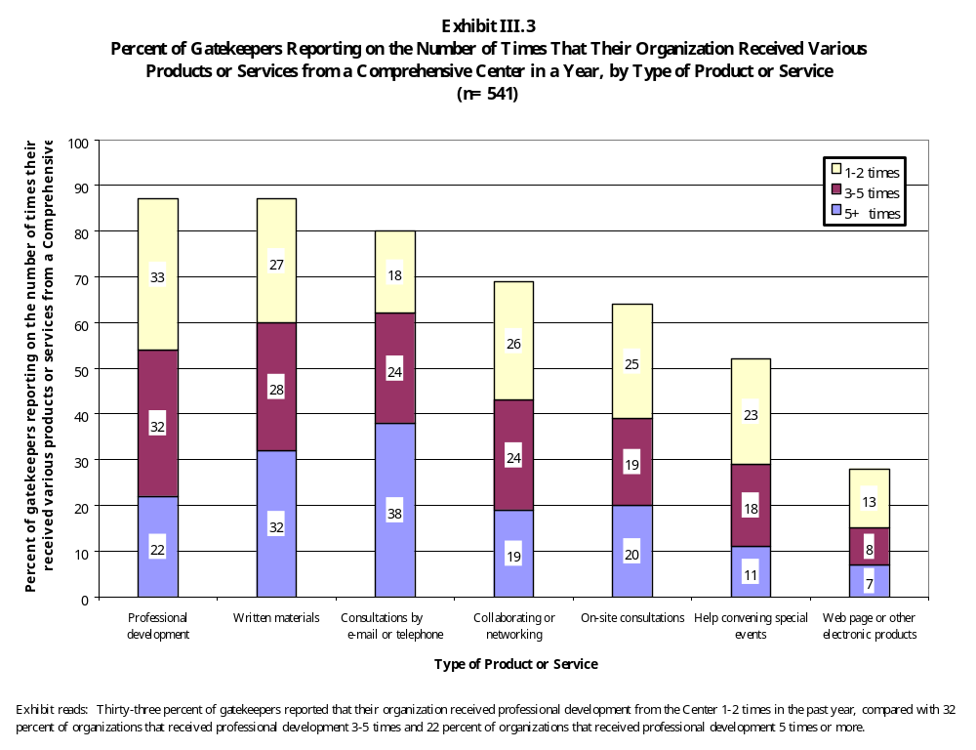

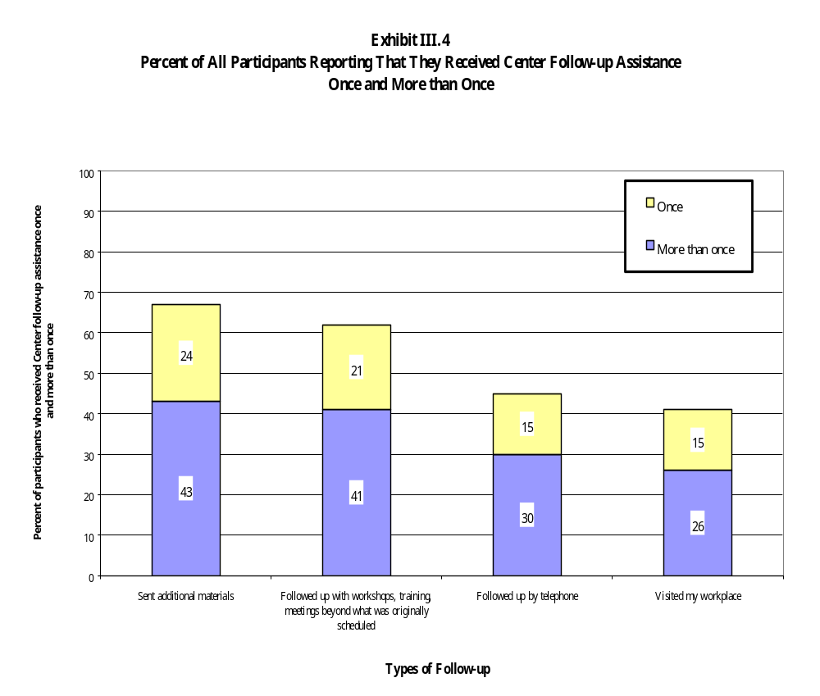

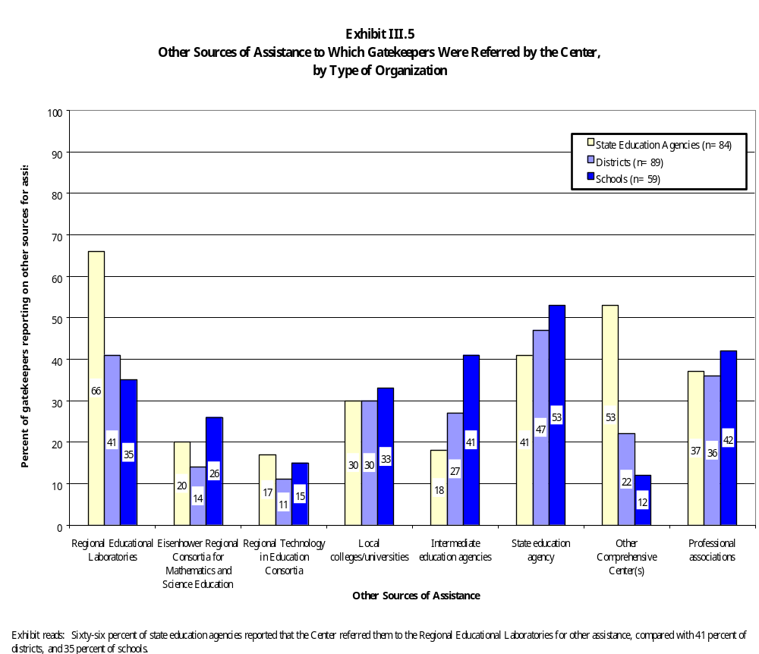

- About a quarter of center customers reported that they visited their center’s Web page or received other electronic products from the center. Only 7 percent of customers reported that they visited the Web page five or more times over the course of the year. The small number of repeat visitors suggests that the center Web pages are not yet used as a mechanism for communicating with established customers or for delivering services.

- Nineteen percent of center customers reported that their organizations have received services from the Comprehensive Center via teleconference. Five percent reported that their organizations have received services via videoconference.

- Nineteen percent reported that their organizations have received services via audio or videotaped presentations

Some examples of the ways in which the centers use technology to provide services to customers include the following:

- Under a Goals 2000 grant, the Southwest Comprehensive Center and its host organization have involved 20 New Mexico teachers in a “Standards Online Group.” Each teacher in the group received a laptop computer so that they can communicate with each other about the state’s standards and their implications for instruction.

- The New England Comprehensive Assistance Center maintains five listservs. They include a listserv for members of the centers’ schoolwide network, members of the Data Strategies Initiative, Safe and Drug-Free Schools Coordinators in the region, principals in the schoolwide network, and members of the Reading Success Network, in Region I and nationwide.

- The Region VII Comprehensive Center pilots several online products, including Profiler, a database software that school technology specialists can use to assess and prioritize internal technology needs and to build technology capacity among teachers. Another product is a language instruction CD-ROM that teaches the Choctaw language.

Of those customers who had received services via some form of advanced telecommunication, 60 percent said that the technology allowed the center to deliver the information more quickly and effectively. Some also said that the use of the technology enhanced the quality of the service by making new information easier to understand (48 percent), or by making presentations more interesting
(44 percent). Of all center products and services, customers were least likely to be satisfied with their access to center Web pages or other electronic products. Twenty-nine percent of center customers reported that they were “Somewhat satisfied” or “Not at all satisfied” with the accessibility of those services.

These examples suggest that the Comprehensive Centers have begun to explore some possible applications of technology for the purposes of disseminating information. Such examples are relatively rare across the Comprehensive Center network, however, and this fact, coupled with customers’ reporting of the level of technology used by the centers in delivering services, suggests that the centers are not likely to adopt wide-scale use of technology and advanced telecommunications as a substitute for face-to-face contact with customers any time in the near future.

How Do Services to State and Local Customers Differ?

Centers cultivate different kinds of customer relationships at the state level than they do at the local level. As a result, their portfolio of services to states differs from their portfolio of services to districts and schools.

Targeting

A key difference among state and local customers is that local contacts are more likely to be screened by the centers for their capacity to implement reform. Because the Comprehensive Centers are limited in their ability to serve all districts and schools within their regions, centers conduct both formal and informal screenings to determine districts’ and schools’ capacities to use technical assistance and to make changes. For example:

- Schools wishing to participate in the Region XII Comprehensive Center’s Reading Success Network (RSN) must submit an application. The application requires each school to (1) identify an RSN school team; (2) complete a site process data sheet describing the school’s schoolwide and classroom intervention strategies, assessment indicators, grade levels, and expectations of RSN; (3) submit a copy of the school’s accountability report and reading/literacy component plan; and (4) demonstrate school and district commitment to RSN.

- Similarly, to target its services in North Carolina, the Region IV Comprehensive Center asked districts to identify “focus schools,” schools with extensive needs for technical assistance that were prepared to receive intensive help. According to a center staff member, “Even if other schools are more needy, if they’re not ready, it’s a waste of our time. . . . Being ready for change is not a straight line; it’s a critical mass.”

In comparison, the expectation that the centers will serve every state in their region requires that the centers adapt to each state’s readiness for reform, rather than using readiness as a criterion for targeting services. A state’s capacity to use technical assistance, however, affects the level and types of services delivered by the center.

Volume of Services

State-level gatekeepers tend to have more frequent contact with the Comprehensive Centers than their local counterparts do. A major thrust of center services to states includes consultations with state liaisons, over-the-shoulder technical assistance, and other activities designed to build the capacity of SEA staff members, and which result in a fairly frequent contact with SEA staff. Many Comprehensive Centers assign individual staff members to a particular state to serve as liaison with the center and to broker services in that state.

Our survey data show that state gatekeepers are more likely to report that their agencies receive various types of assistance five or more times in a year than are gatekeepers at the district or local levels. For example, Exhibit III.6 shows that SEA gatekeepers were more likely to report that they received on-site consultations, consultations by e-mail or telephone, collaborating or networking with other programs, and help convening special events.

On a surprising note, however, state-level gatekeepers were somewhat less satisfied with their access to center products and services than were district-level gatekeepers. Exhibit III.7 shows that across all types of services, district-level gatekeepers were more likely to report that they were “very satisfied” with their access to the center’s products or services than were state-level gatekeepers or school-level gatekeepers. Although SEA gatekeepers receive higher levels of service, on average, they may have higher expectations for a particular level of services as well, because of their status as state-level customers and the way the centers market their services to states. District-level gatekeepers may experience a better fit between the services they do receive and their expectations of the centers.

Gatekeepers at various levels of the educational system reported relatively few differences in the topics of the assistance they received. Among the few significant differences in survey responses, state-level gatekeepers were more likely to report that they received assistance with the implementation of ESEA programs, while district- and school-level contacts are more likely to report that they received technical assistance related to comprehensive school improvement. Fifty-four percent of state gatekeepers, for example, reported that they received assistance with the implementation of ESEA programs, compared with 34 percent of district gatekeepers and 26 percent of school gatekeepers. By contrast, half or more of school- and district-level gatekeepers reported receiving assistance on improving curriculum and instruction in reading/language arts, compared with 36 percent of state-level gatekeepers.

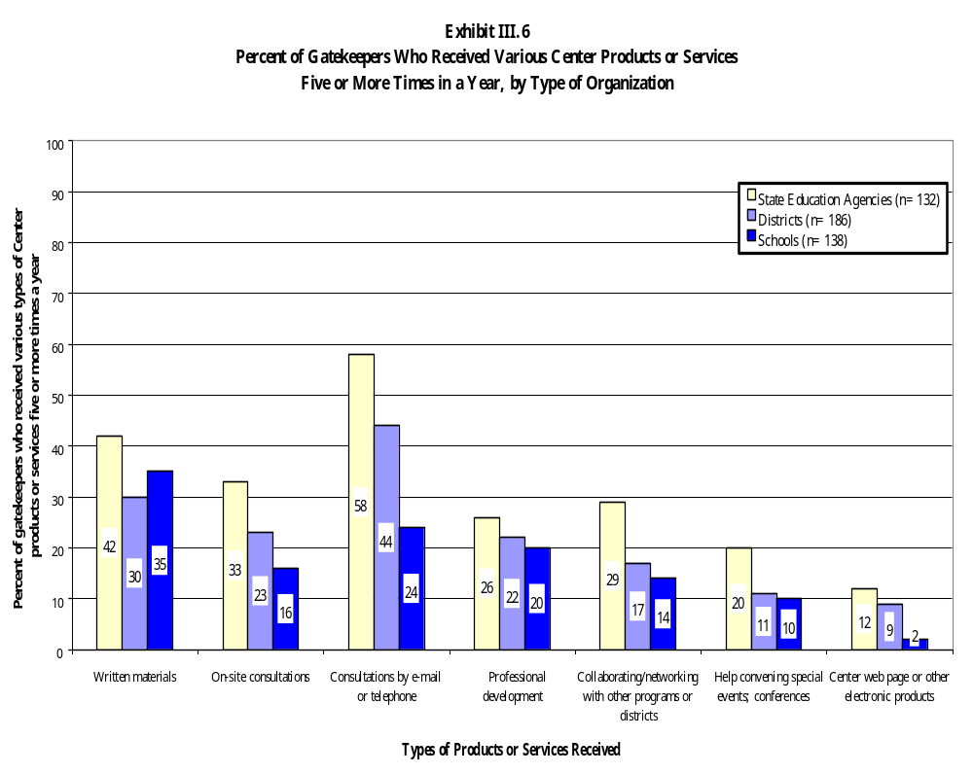

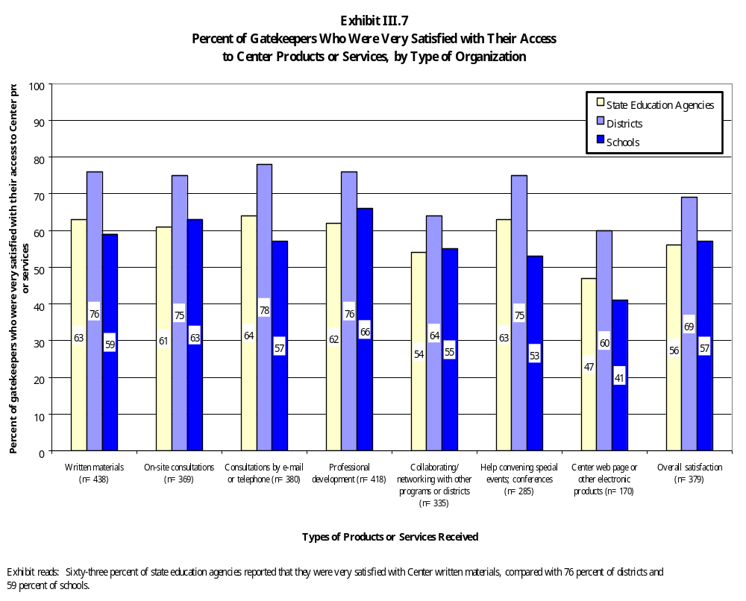

Content of Services

States are more likely than locals to set the direction of center services; in contrast, locals rely on centers to take the lead in providing services, often relying on centers’ expertise in specific content areas and with established reform models and strategies. In most places, SEA and center staff members spend considerable time developing workplans detailing the center’s portfolio of services to the state and establishing priorities for the center. This process takes place both formally and informally. For example, the Region V Comprehensive Center and the Mississippi Department of Education established a coordinating committee that meets several times each year to identify the state’s technical assistance needs and develop a service delivery plan for the state. Staff members from the various federal programs sit on the committee. A respondent from the NYSED described the Region II Comprehensive Center’s responsiveness to his state’s needs:

They [center staff members] were especially effective because they did not have a work plan when they came in. They didn’t say we had to work with standards and testing . . . the mandate. They asked us, ‘What are your needs?’ and we told them. They came back six weeks later with a plan. It’s an annual work plan, which they reviewed with us prior to it being established.

Unlike their state counterparts, local clients are more likely to seek the center’s assistance in content areas, reform models, and strategies in which the center has demonstrated expertise. Such activities enable centers to build on lessons learned elsewhere. For example:

- The Region XI Comprehensive Center tapped into its expertise in schoolwide programs to sponsor multi-session institutes on schoolwide program planning for school teams from the Monterey Peninsula Unified School District. The center had used a similar training strategy to host schoolwide institutes in other districts in northern California and had published a guide to schoolwide implementation, Schoolwide Reform: A New Outlook.

- In its services to three clusters of districts in North Carolina, the Region IV Comprehensive Center adapted its Lab School model, which (1) models the use of specific strategies; (2) provides opportunities for application and experimentation; and (3) offers follow-up support. The services focused on the special needs of LEP students and involved consciousness-raising activities and discussion related to theories of language acquisition and appropriate instructional activities for LEP students. The center worked with one cluster to deviate slightly from the model so that the districts were able to offer the Lab School in conjunction with a regular summer academy for ESL teachers.

Other examples of established programs adapted by centers to meet local needs include Alaska Onward to Excellence, Cognitively Guided Instruction, the Reading Success Network, and Continuous Progress/Model Schools.

Allocating Resources Among States, Districts, and Schools

Across the entire center network, Comprehensive Centers allocate their resources approximately equally among states, districts, and schools. As we have noted, most major center initiatives, which include both professional development activities and consultation, are designed for and targeted to school-level staff. In addition, the Comprehensive Centers work with larger numbers of gatekeepers in schools and districts than they do in states. On the other hand, our survey data and our observations in case study sites indicate that state-level gatekeepers have more frequent contact with center staff and command a slightly higher volume of services. Although it is impossible to make a precise estimate of the amount of staff time and other resources centers devote to serving each level of the system, the centers’ own descriptions of their work, our survey data, and our observations in case study sites suggest that all three major groups of customers—states, districts, and schools—command a significant portion of the centers’ time and resources.

Allocations of time and center resources among states, districts, and schools do vary by center, with some centers adopting a more state-intensive approach to serving their regions than others. However, these differences are not generally reflected in the customer lists that the centers compiled, or in the reports of center customers. In other words, SEA customers in regions where the center has adopted a strong state-focused approach to serving the region are no more likely to report frequent contact with the Comprehensive Center and a high volume of services than are SEA customers in regions where the center has not adopted a state-focused approach.

What Services Do the Centers Provide to the U.S. Department of Education?

Although they are not a central focus of this evaluation, the services provided by the 15 Comprehensive Centers to the U.S. Department of Education occupy a prominent place in their portfolio of activities. In fall 1998, for example, a memorandum from ED to center directors set out the expectation that the centers would devote up to 10 percent of their resources to carrying out ED projects. The centers are also available to take on supplemental contracts for additional projects from ED.

One of the most important examples of the service that the centers provide to ED is their role in planning and supporting three Improving America’s Schools (IAS) conferences each year. Each year one to three centers are responsible for some of the conferences; centers receive a supplement of $25,000 from ESEA Title XIII funds to cover the costs of staff time devoted to planning the event. By all accounts, however, this stipend does not cover all of the staff time spent on IAS-related activity. In addition to planning and supporting IAS conferences, some examples of the work that the centers do for ED include the following:

- The Comprehensive Centers work with the regional educational laboratories on the implementation of the Comprehensive School Reform Demonstration program (CSRD). To expand their work in supporting the implementation of CSRD in their regions, the centers receive an additional supplement of $50,000 from CSRD funds. The centers work with states on setting up an RFP process, organizing showcases of CSRD models, assessing districts’ capacity to support CSRD schools, and helping schools review data to select the most appropriate and effective reform model.

- The Southern California Comprehensive Assistance Center received a supplemental grant award of $60,000 from Safe and Drug-Free Schools funds to organize the School Security Chiefs forum. The three-day forum was attended by the heads of school security of large urban and suburban school districts across the United States and was also attended by representatives from the Departments of Justice and Education.

Summary

Although they provide one-shot services from time to time, the Comprehensive Centers generally concentrate their time and resources on providing long-term technical assistance to states, districts, and schools. In fact, two-thirds of centers reported that 75-90 percent of their staff time was spent on high-intensity services. The centers’ major initiatives are in the areas of professional development, services to model schools and partnership sites, and consultations with clients. Several centers targeted schools for intensive services based on narrow demographic or performance criteria, such as the list of low-performing schools identified by a state. Most gatekeepers reported that the centers provided organizations with assistance on a range of topics, including those associated with comprehensive, standards-based reform as well as those concerning categorical programs. State gatekeepers are more likely than their local counterparts to have more frequent contact with the centers and set the direction of center services. However, state-level customers were generally less satisfied with their access to center products and services than were local customers. centers may provide lower-intensity services, such as information dissemination and sort-term training, to establish a presence in a particular region or to reach a wider audience. In general, the Comprehensive Centers do not rely heavily on advanced telecommunications to deliver services, although they do maintain Web sites and use e-mail to communicate with customers.

IV. QUALITY OF COMPREHENSIVE CENTER SERVICES

In Title XIII of ESEA, Congress finds that “high-quality technical assistance can enhance the improvements in teaching and learning achieved through the implementation of programs under [ESEA]” and charges the Comprehensive Centers with providing technical assistance using “the highest quality strategies available” [P.L. 103-382, Section 13001(1), and Section 13102(3)]. This chapter of the report examines certain dimensions of quality in the work of the Comprehensive Centers. These dimensions of quality, which we have developed from the literature on professional development and technical assistance, from ED’s own expectations of the program, and from the experience of customers in the field, provide a framework for assessing Comprehensive Center services. They include:

- Comprehensiveness. The Comprehensive Centers’ particular mission as a federal technical assistance program is to provide assistance to states, districts, and schools in using federal programs to support comprehensive, standards-based reform. Consistent with the vision of standards-based reform contained in other parts of the law, Comprehensive Center assistance is intended to support the integration of categorical programs in the service of state and local goals for student achievement.

- Accurate content grounded in research. Information or assistance that is inaccurate or out of date is not helpful to customers. In addition, technical assistance services should be based on the best research and practitioner knowledge available on how students learn and how organizations change.

- Responsiveness to customer needs and interests. The literatures on both professional development and technical assistance maintain that individuals are much more likely to benefit from services that address a clearly defined local need or interest.

- Adequate scope and intensity. Changing the behavior of individuals and organizations is not a simple undertaking. Unless the goal of the assistance is to convey relatively simple information (like the timetable for implementing particular provisions of a new law), assistance must be relatively intensive and continuing.

- Adequate staff expertise. Individual technical assistance providers may have more or less relevant expertise, as well as interpersonal skills that enable them to work more or less effectively with particular customers. These variations in individual expertise make a difference to the quality of service.

Our findings on the quality of Comprehensive Center services are based on three sources of data: (1) our observations of the design and implementation of center services in the case study sites; (2) customers’ ratings of the quality and utility of the services they received; and (3) interviews with Comprehensive Center staff members.

Are Services Comprehensive?

As the reauthorized ESEA seeks to shift the emphasis from the implementation of parallel programs for target populations to comprehensive reforms that support improved teaching and learning for all students, especially those served under ESEA, the focus of technical assistance in support of ESEA has shifted from the performance of a single program to the work of the entire school or the system that supports the school.

In interviews, center staff maintained that the assistance provided the Comprehensive Center program is substantially different from the work done in the past under the Department’s older categorical system. This was especially true for staff members who had worked for one of the antecedent centers: they argued that the change in focus from categorical to comprehensive assistance has had a significant impact on their work. Center staff members described comprehensive assistance as training and consultation geared to whole school reform and systems reform, with special attention to the integration of programs and funding streams. One Comprehensive Center staff member summed up the transition to a new kind of comprehensive assistance in this way:

It’s been really quite dramatic to go from a categorical, narrow, “in-our-box” approach to very systemic, broad-based, whole school approach. This has resulted in a better approach for impacting schools, [but] it has also been a process, and a challenge, to have different federal program coordinators sit down together and work to realize that whether a child is Title I, LEP, or migrant, he or she is the same child.

In practice, the Comprehensive Centers have responded to this charge to provide comprehensive assistance in a variety of ways. From their entire portfolio of activities, the categories of services that most clearly advance “comprehensive” goals include the following: (1) assisting schools to develop Title I schoolwide programs; (2) assisting schools and districts to conduct needs assessments and use data to drive decision making; and (3) assisting states and districts to develop consolidated plans for ESEA programs.

Schoolwide Program Planning as a Comprehensive Strategy

Assisting schools in the planning and implementation of schoolwide programs is a natural fit for the Comprehensive Centers. The planning process, when implemented successfully, helps school staff to think comprehensively about the strengths and weaknesses of their existing programs and to improve learning for special populations of students by drawing on the resources of the entire school, not just categorical programs. In addition, many schools became eligible to operate schoolwide programs for the first time in 1994, thus creating a ready market for Comprehensive Center services.

All the Comprehensive Centers have provided some training and technical assistance to schools and districts planning schoolwide programs. Most of the centers’ activity has focused on raising awareness of the schoolwide program option, disseminating information about planning requirements, and supporting schools as they plan. Supporting the planning and implementation of schoolwide programs is a central focus of activities, consuming a significant proportion of staff time, for at least a third of the centers. Examples of this category of assistance include:

- The New England Comprehensive Assistance Center (NECAC) facilitates a network of Title I schoolwide program schools. The keystone event for the network is an annual Congress for teams from member schools. Teams come to this Congress with a school action or improvement plan on which to work, and NECAC provides facilitators to help them with the planning process and to provide follow-up coaching on implementation during the school year.

- The STAR Center co-sponsored two schoolwide institutes with the state Education Service Centers and developed A Toolkit for Assessing and Revising the Integrated Campus Improvement and Title I Schoolwide Plan, which assists schools in aligning their schoolwide program plans with the campus improvement plans required by the state of Texas. Additionally, the center worked closely with one large city district in the planning and implementation of schoolwide programs and in applying the lessons learned from center research on successful schoolwide programs in Texas.

- The Region XI Comprehensive Assistance Center has sponsored schoolwide institutes in which more than 250 schools have participated. The institutes are organized around a center product called Schoolwide Reform: A New Outlook. This product has also been sent to 1,600 individuals who have requested it. To improve parent involvement in schoolwide planning, the center has developed information for parents in five languages.

- The Southern California Comprehensive Assistance Center collaborates with the state’s own network for supporting schoolwide programs, called the Statewide System of School Support, to provide a program of coaching and technical assistance to the county’s schoolwide programs. The assistance focuses on standards and assessments, comprehensive school planning, governance, and student-centered decision making.

Needs Assessment, Strategic Planning, and Using Data

Comprehensive reform requires that districts and schools think more strategically about how they will use federal resources to improve the regular education of children served under ESEA. This emphasis on the integration of federal resources and whole school reform requires more sophisticated planning on the part of schools and districts. As a result, school-level and district-level needs assessment and planning are central components of many Comprehensive Center activities. One Comprehensive Center staff member summed up this approach to assistance in the following terms:

Comprehensiveness is about noticing what’s going on and not going on in terms of students’ achievement, focusing on resources inside and outside, and paying attention to the external environment.

Coupled with this new emphasis on strategic planning and needs assessment is a strong emphasis on analyzing and using student achievement and demographic data to drive decision making. Comprehensive Center staff point out that disaggregating data becomes especially important as a way to ensure that the students who are meant to be served under ESEA—poor children, LEP children, or American Indians, for example—benefit under whole school reform efforts. As a result, many Comprehensive Centers have incorporated training in the analysis and use of data into their repertoire of services.

Examples of training in needs assessment, data use, and setting benchmarks for tracking progress include the following:

- Alaska Onward to Excellence, sponsored by the Alaska Comprehensive Regional Assistance Center, trains leadership cadres of community members and school staff to evaluate student performance data, set goals for improvement, and monitor progress over time.

- The Northwest Regional Educational Laboratory’s Comprehensive Center, Region X, sponsored a summer institute for its partnership sites on the use of data to drive school decision making. School and district staff learned to use Excel spreadsheets and SPSS to summarize, disaggregate, and analyze student achievement data. During the school year, Comprehensive Center staff consulted with school team members on assembling elaborate “school profiles,” which one partnership site used in its state accreditation process. The center has modified school “profiling” tools, created by the regional educational laboratory’s School Improvement Program, to help schools and districts initiate schoolwide program needs assessment and implementation evaluation.

Consolidated Planning at the State and Local Levels

At the state level, a few centers worked with states in their region in the years immediately following reauthorization to help consolidate their federal programs. In these few states, the centers’ understanding of the reauthorized ESEA combined with their knowledge of school change provided states with “a guiding vision of what comprehensive” meant and of how comprehensive services could work. According to an SEA program director in a state where the Comprehensive Center had been particularly active in helping to implement the reauthorized ESEA:

The center served a pivotal role during the transition to comprehensive services. It was a dramatic change in all the subtitles. [The center’s] role was to bring information about this change to us. Instead of us taking our time and resources to learn all the information, he was here physically when we needed him. Technically, we could have done it for ourselves, but his involvement delivered the information in a more expedient and efficient way.

Several Comprehensive Centers convene meetings of state-level federal program administrators on a regular basis. For example, the New England Comprehensive Assistance Center convenes federal program directors from the six states in its region on a quarterly basis for a one-and-a-half-day meeting. The first day of the meeting is devoted to discussion of cross-program coordination; on the second day, participants split into role-alike groups.

At the local level, a few centers have also developed tools and training to assist in local consolidated planning:

- The Region III Comprehensive Center worked with the Delaware Department of Public Instruction to implement the quality review component of the local consolidated application and school improvement process. The center assisted in the design of questions for the SEA to use as part of the reviews, observed SEA staff interacting with LEA staff during pilot reviews, and gave feedback and recommendations to the SEA.

- The Region IV Comprehensive Center at the Appalachia Regional Educational Laboratory provided assistance to the Tennessee Department of Education in putting together a consolidated plan for Title I, Title II, and Title VI. The center and the SEA piloted the redesigned plan in five districts, with center staff providing training to district officials in developing effective consolidated applications. With assistance from the center, each site collected and analyzed data to identify district needs.

- The STAR Center developed the Resource Guide for Coordinating Funding and provided training to the state’s Education Service Center staff, district administrators, and school administrators. Also, in partnership with one of the Education Service Centers in its region, it created a simulation game, called Show Me the Money, that it uses in many of its training activities.

Limitations of “Comprehensive” Assistance

In interviews, several Comprehensive Center directors reported that their commitment to providing “comprehensive” services has led them to make concrete trade-offs in their capacity to provide categorical services as well. As we reported in Chapter III, Comprehensive Centers continue to provide, and their customers continue to request, assistance related to the implementation of specific categorical program provisions and to the needs of special populations of students. At least some of the Comprehensive Centers have found that it is impossible to maintain the specialized program expertise necessary to satisfy all of these requests for assistance. One experienced provider described this tension between categorical and comprehensive assistance as a “conundrum:”

Can you deal with these two pieces simultaneously? The problem is, when you are talking about categorical programs, you’re talking about taking an advocacy and protector role. For 20 years we have conditioned bureaucracies to advocate and protect . . . but comprehensive reform has to have a forward thrust, [and an assurance] that the system is in fact doing the right things vis  vis those designated groups.

These choices have not always been received well among the centers’ potential customers. Center staff members, especially those who work with schools serving Indian children, migrant children, and limited English proficient children, report that in the field they encounter some resistance to comprehensive approaches to assistance. Some customers strongly object to blurring the lines across traditional categorical programs, fearing that “their” students will fall through the cracks. In addition, as we will see later in this chapter, some customers have been severely critical of the limitations of the comprehensive approach and of the services they have received as a result. According to one center staff member:

We run into the barrier of categorical assistance. . . . Everyone’s open until you step on someone’s categorical toes. We run into the fear that somehow, if we do schoolwide program planning, [that] “These children won’t get serviced,” but it’s also saying, “My piece of the pie will disappear.”

In an attempt to balance their charge to provide comprehensive assistance with the demand for categorical services that continues to exist, most Comprehensive Centers have allocated at least a portion of their resources to meeting purely program-specific or population-specific needs.

Our review of the centers’ portfolio of services indicates, however, that the centers have made a credible effort to organize their services to the field around “comprehensive” initiatives—those that promote strategic planning, data-based needs assessment, and integration of program funds to support standards-based goals for student learning. Most services include some component designed to promote the goals of comprehensive, standards-based reform. As we have seen, most Comprehensive Center customers report receiving assistance on topics closely related to comprehensive reform as envisioned in ESEA, and to the activities that the centers themselves describe as comprehensive—student assessment, implementing schoolwide programs, challenging standards and accountability, and analyzing student achievement data and interpreting the results. For these reasons, we would argue that the Comprehensive Centers have responded effectively to the mandate contained in their authorizing legislation.

Is the Content of the Assistance Reported to Be Accurate and Grounded in Research?

This evaluation drew on two sources of data to examine the quality of the content of center services: (1) the centers’ own descriptions of the research base that underlies many of their products and services; and (2) customers’ ratings of the accuracy and quality of the products and services they receive from centers, compared with other products and services.

The Reported Research Base for Center Products and Services

Comprehensive Center staff are generally well-read and familiar with the research on their particular areas of expertise, and they can readily describe the research foundation for the services they deliver. The extent to which the Comprehensive Centers’ major initiatives are specifically grounded in research or in a well-developed theoretical framework varies considerably from activity to activity, however. A handful of Comprehensive Center activities are, in fact, the products of research and development efforts. In these cases, links to a research base are specific, and a key element of the product or service delivered to customers. The most prominent of center initiatives is Cognitively Guided Instruction (CGI), which is based on the work of a group of researchers at the University of Wisconsin on children’s cognitive development in mathematics. These researchers have developed a set of teacher materials and institutes that each Comprehensive Center then provides to its customers. The Region VI Comprehensive Center also sponsors a school leadership institute based on the work of another researcher at the University of Wisconsin. Other examples of research and development efforts adopted by the center network include Alaska Onward to Excellence, which is an adaptation of Onward to Excellence, a model of school reform based on effective schools research that was developed and piloted by the Northwest Regional Educational Laboratory. In the Houston Independent School District, the STAR Center has provided training to principals in the attributes of high-achieving, high-poverty schoolwides, based on research conducted by the Charles A. Dana Center at the University of Texas-Austin (a partner in the STAR Center).

For other Comprehensive Center activities, the theoretical framework supporting the activity is often based on more than one body of research, and the links to research are often less direct and less specific. Training and assistance provided by the Reading Success Network, for example, are based on research on both literature-based and phonetic approaches to reading instruction, as well as research on cognitive coaching and peer coaching. In describing the research foundation for the Learning Facilitator’s Academy in Riverside, the Comprehensive Center staff member who developed the activity cited specific pieces of literature in the effective schools research, research on second language acquisition and cross-cultural learning, and research on professional development.

For still other activities, center staff members report no specific links to published research. Instead, center staff rely on a well-developed “craft knowledge” of their areas of specialization, some of which is based on their own or their colleagues’ action research. In many areas, such as schoolwide program planning, or conducting needs assessments using student achievement data, this practitioner expertise is far more important than any related published research. As one center director expressed it, this strand of center activity is driven more by client needs and circumstances than by a particular set of research findings. As this director commented, the center is committed to providing “help of a practical nature. It is grounded in theory and research, and it is rich in content . . . [but] it is client driven.”

One final note on the links between center services and the research base: As part of their information dissemination activities, Comprehensive Center staff often provide summaries of research on topics of interest to schools, districts, and (most often) states. For example, the deputy commissioner in one of our case study states recalled that when his state faced potential challenges to its bilingual programs, the center provided summaries of research showing their effectiveness: “[The center] did the work researching it; they contacted national researchers; and we were able to avoid a ‘California crisis’ [as a result of their efforts].” Comprehensive Center staff prepared research summaries on school uniforms and block scheduling for the Mountainview School as it considered its options for the development of a Title I school improvement plan. The Comprehensive Centers regularly provide clients with bibliographies, information about researchers and product developers, and supplementary evidence for their work through newsletters, on their Web sites, and in project materials. Each center also disseminates the available research evidence for the CSRD models that are available for their customers; two centers distribute literature reviews on CSRD models through Web sites or written products.

Customer Ratings of Accuracy and Quality of Content

Customers give the Comprehensive Centers high marks for the accuracy and the quality of the information they provide. For example, Exhibit IV.1 shows that half of all gatekeepers rated the accuracy of the content and the extent to which it reflected sound research or the most current thinking in the field “excellent,” compared with similar products and services available from other sources; an additional third rated it “good.” Exhibit IV.2 shows that more than 90 percent of participants in center activities rated the centers “excellent” or “good” on these dimensions as well.

Exhibit IV.1

Gatekeepers’ Ratings of the Quality and Utility of Comprehensive Center
Products and Services
(n=542)

Compared with similar products and services available from other sources, how would you rate the quality of the products and services you received from the Comprehensive Center on each of the following dimensions?
Compared with similar products and services available from other sources, how would you rate the overall USEFULNESS of the products and services you received from the Comprehensive Center?
 | Percent of Gatekeepers Reporting
Dimensions of Quality and Utility | Excellent | Good | Fair | Poor | Not able to judge
Addressed our organization’s needs and interests | 52 | 29 | 11 | 3 | 6
Accuracy of content | 51 | 31 | 5 | 2 | 12
Timely | 50 | 32 | 8 | 5 | 6
Reflects sound research or the most current thinking in the field | 50 | 29 | 6 | 2 | 12
Useful and accessible format | 49 | 30 | 11 | 4 | 6
Useful for guiding improvement efforts | 48 | 31 | 10 | 4 | 7
Responsive to local conditions | 48 | 29 | 12 | 4 | 7
Presentation and format | 42 | 35 | 8 | 2 | 12
Extent to which the Center provided knowledge and expertise not available within your organization | 42 | 34 | 9 | 2 | 13
Ability to respond in depth to all of your questions and interests | 42 | 33 | 10 | 3 | 12

Exhibit reads: Fifty-two percent of gatekeepers rate Center services “excellent” for the extent to which they addressed their organization’s needs and interests.

Note: Rows may not sum to 100 because of rounding.

Exhibit IV.2

Participants’ Ratings of the Quality and Utility of Center-Sponsored Activities
(n = 675)

Compared with similar products and services available from other sources, how would you rate the quality of the Center’s assistance related to [the activity] in each of the following areas?
Compared with similar products and services available from other sources, how would you rate the overall USEFULNESS of [the activity] on each of the following dimensions?
 | Percent of Participants Reporting
Dimensions of Quality and Utility | Excellent | Good | Fair | Poor | Not able to judge
Reflects sound research or the most current thinking in the field | 54 | 37 | 6 | 1 | 3
Accuracy of content | 51 | 41 | 5 | 1 | 2
Presentation and format | 44 | 41 | 12 | 2 | 1
Accessibility to participants | 44 | 41 | 12 | 2 | 1
Timely | 43 | 39 | 12 | 3 | 3
Useful for guiding improvement efforts | 43 | 39 | 12 | 3 | 3
Opportunities for networking among participants | 41 | 38 | 13 | 5 | 3
Addressed my needs and interests | 38 | 44 | 13 | 3 | 2
Ability to respond in depth to all of your questions and interests | 36 | 46 | 14 | 2 | 2
Responsive to local conditions | 30 | 42 | 18 | 6 | 4

Exhibit reads: Fifty-four percent of participants in Center-sponsored activities rated as “excellent” the extent to which the activity reflected sound research or the most current thinking in the field.

Note: Rows may not sum to 100 because of rounding.

Customers in our case study sites gave similarly high ratings to the quality and accuracy of the information they had received from the Comprehensive Centers. Most gatekeepers in our case study sites reported that the accuracy and quality of the information they had received from the centers compared well with information they had received from other sources. As one customer noted, “There are other
free sources [of technical assistance] that we do not use because they do not do solid work. I would prefer to use the center more.”

These assessments of the quality of the centers’ assistance are subjective, of course. Although both case study respondents and survey respondents reported that the centers compared well with other sources of assistance, we have little information about the basis on which they made those comparisons. Some of the gatekeepers in our case study sites are sophisticated consumers of information and assistance who have worked in their areas of interest for many years and know the research literature well themselves. Others have had rather limited access to technical assistance resources and have had relatively little experience with other providers. It is even more difficult to assess the ratings of our survey respondents because we know little about their relevant experience.

Are Centers Responsive to Customer Needs and Interests?

This evaluation of Comprehensive Center services examined both the extent to which centers involved their customers in planning and designing services, and the extent to which customers said that the centers’ services addressed their purposes.

Customers’ Role in Planning Services

Our case study and survey data, taken together, suggest that the customer’s role in planning services can vary considerably. In most of our case study sites, where services were relatively intensive or sustained, Comprehensive Center staff worked closely with state and local gatekeepers to design services adapted to the particular needs and purposes of their customers. In the most successful working relationships, there was a symbiosis between the customer’s role in defining the services they desired and the center’s. The center would first elicit information about the customer’s needs and suggest several options. Together, center staff and customers would decide among the options.

In the Kingston Unified School District, for example, the Comprehensive Center staff met with principals and district staff for a full day to plan the center’s work in the district. They worked from a planning matrix that identified the center’s products and training activities related to schoolwide program planning and agreed upon ways these could be adapted to suit the purposes of the district. This pattern was typical among many of our local case study sites. Among states, SEA and center staff met regularly to identify needs and to discuss the state’s requests for service. Typically, SEA and center staff worked together to plan activities that address the state’s identified needs.

Among our local case study sites there were two examples of activities that had been designed with relatively little input from school or district contacts: Cognitively Guided Instruction (CGI), a professional development initiative developed by researchers at the University of Wisconsin, and the Reading Success Network (RSN), which was planned by staff from the eight county offices of education in Southern California. In both cases, schools and districts are invited to participate in the activities as conceived by the center. Including such “off the shelf,” research-based activities in their repertoire of services helps to conserve center resources by limiting the time needed for new product and service development.

Customers in case study sites generally praised the centers for their responsiveness during planning. The following is a typical comment from a satisfied customer:

They try to find out what our needs are. If it’s within their capacity to assist us, they always try to do so. They do have some packaged ideas—things that they feel will be helpful. . . . If we were to ask for specific things, I think they would try to address them as best they could.

Although most respondents in case study sites praised the centers for designing services that were useful and relevant to their daily work, some clients complained that center staff began work with their organization with a pre-determined agenda, and others complained that the centers were not sufficiently proactive in their outreach. These criticisms were relatively rare among all respondents, however.

Across all gatekeepers in our survey sample, about two-thirds reported that they take an active role in the design and planning of services. This percentage is not especially high, given that gatekeepers are generally responsible for working with center staff to plan services to their organizations. Organizations whose gatekeepers report that they played no role in designing or planning services probably have very little input into the content or format of the services they receive. Of the gatekeepers who did participate in planning or designing services, about half reported that they help to select and frame the content, half reported that they help to identify participants, and about 40 percent reported that they help to plan logistics.

Gatekeepers whose organizations received a high volume of services were almost twice as likely to report that they had been involved in selecting and framing the content of the activities and in designing the format of the activities than were gatekeepers whose organizations received a low volume of services. In addition, state-level gatekeepers were more likely to report that they were involved in designing activities than were local gatekeepers. For example, Exhibit IV.3 shows that 66 percent of state-level gatekeepers reported that they participated in selecting and framing the content of activities, compared with 51 percent of district-level gatekeepers and 33 percent of school-level gatekeepers. These differences probably reflect the variation in the types of relationships that centers develop with state staff and with gatekeepers in districts and schools; as we have noted, centers have much more frequent contact with SEA gatekeepers and tend to customize services for states more often. Center initiatives like the RSN and CGI, which are designed as a package of services by the centers, tend to be targeted at districts and schools. As a group, then, we would expect local sites to take a less active role in planning services.

As would be expected, end-user participants in center activities were less likely to report that they contributed to activity design than were gatekeepers. Among participants in center activities, 17 percent said they contributed to selecting and framing the content, 16 percent reported that they coordinated the activity with other assistance they receive, and 40 percent said they provided feedback to the provider or presenter. Among participants surveyed, more than half (53 percent) said they did not contribute at all to designing the activity. As we noted in an earlier chapter, most participants in center activities are based in schools, and most of those are teachers. Teachers who participate in center–sponsored professional development activities and other kinds of activities, then, report that they have relatively little opportunity to influence the content or format of those activities.

Customer Ratings of Responsiveness

End-user participants in Comprehensive Center activities reported that the activities generally served their purposes. Thirty percent reported that the activities “served my purposes completely,” and an additional 57 percent reported that the activity “was a good start.” Only 13 percent of participants reported that the activity did not serve their purposes or that it did not provide sufficient information or guidance to allow the participant to follow up.

Although they were generally satisfied with the extent to which center-sponsored activities addressed their purposes, end-user participants gave the Comprehensive Centers slightly lower ratings for the responsiveness and the utility of their services than for other dimensions of quality, such as accuracy of content. For example, Exhibit IV.2 shows that while more than half of participants rated the centers “excellent” for the extent to which their assistance reflected sound research, only about a third rated them “excellent” for their ability to respond in depth to all of their questions or for their responsiveness to local needs.

Centers also received their highest negative ratings from participants on items related to responsiveness. Almost a quarter of participants rated center services “fair” or “poor” for the extent to which they were responsive to local conditions, 16 percent rated them “fair” or “poor” for the extent to which they addressed participant’s needs and interests, and 16 percent rated them “fair” or “poor” for their ability to respond in depth to all the participant’s questions.
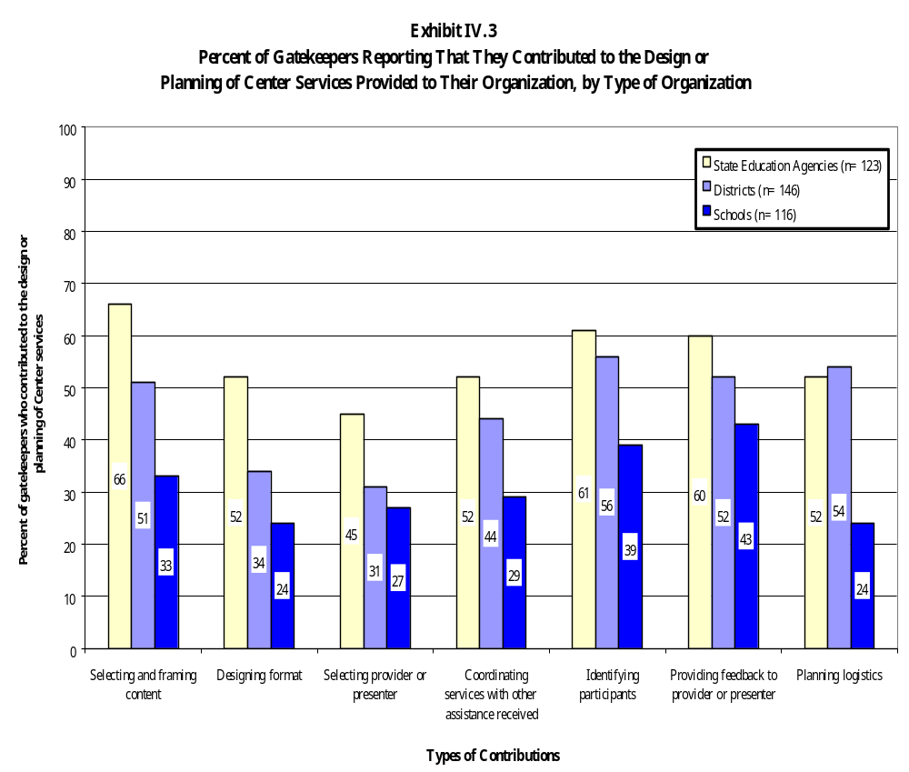

It is not surprising that both our case study and survey data yield somewhat mixed messages about customers’ satisfaction with the responsiveness of Comprehensive Center services, compared with their overall quality or their basis in research. Responsiveness is a much more difficult standard to achieve than basic accuracy of content; it requires that technical assistance providers understand specific local conditions and customize their services for each organization and individual served. In addition, dimensions of responsiveness that are related to the ability to provide in-depth answers to all questions and to address all needs and interests require a much deeper knowledge of the subject matter at hand. Customers may rate a superficial presentation of new ideas high for the accuracy of content, but they would almost surely rate such a presentation low for the extent to which it responded in depth to all of their questions and interests.

Are the Scope and Intensity of Services Adequate?

Survey data from participants show that Comprehensive Center services are at least designed to supply individual customers with assistance that is of adequate scope and intensity to produce intended effects. As we reported in Chapter III, most participants in center activities report receiving some form of follow-up assistance from the centers, in the form of additional materials; additional workshops, training, and meetings; and telephone follow-up. In addition, most participants report receiving some form of assistance on the same topic from another source.

Among our local case study sites, however, we observed a great deal of variation in the scope and intensity of center services, both in the way that services were designed and in the participation levels of individual participants. In schools that were part of intensive model schools initiatives or partnership sites, including the Mountainview School and Richmond Elementary, center services were very intensive, by almost any measure. Center staff members were in the school regularly, as often as once a month, and school staff members called on the center for help frequently in between visits. At both these schools, school-based customers saw their center contact as an adjunct member of the school community. In other cases, local contact with center staff members was much more limited.

In several sites where centers had provided services to schools through an initiative organized at the district level, for example, we found that school-level staff members were hesitant to follow through on offers from the center staff to provide additional assistance. Center staff members routinely provided information about reaching them for follow-up purposes, but some school-based customers reported that they “wouldn’t feel comfortable” calling them because they had first made contact with the center through a district-level gatekeeper and didn’t feel comfortable taking on that role; others reported they “just didn’t feel the need.” Despite one center’s repeated willingness to offer follow-up services, some principals still didn’t understand the parameters for continued consultation. One principal explained, “What we don’t know is if there is a time line, and if it stops now.” As a group, they were generally skeptical about the possibility of asking for more assistance on their own behalf.

In other cases, the services were not designed to be especially intensive over the long term. In the case of the CGI, for example, participants attended one five-day summer institute, followed by a second institute a year later. Although participants praised the initial institute for the quality of the training provided and believed that it had provided them with a very solid introduction to the theory and practice of CGI, many reported during the second summer institute that lack of follow-up and support during the school year had been a problem. As one participant noted, “I don’t want to wait a whole year to find out if I’m doing it right.”

Finally, in some cases we observed that the participation of individuals across a collection of center activities in a particular site can be uneven. For example, the Reading Success Network (RSN) sponsors regular network meetings and support activities for RSN coaches, but none of the coaches we interviewed as part of our case study of the RSN had actually participated in any of those meetings. In these cases, uneven participation rates dilute the scope and intensity of services for participants.

Comprehensive Center services are generally designed to provide adequate support and follow-up to individual participants. The Comprehensive Centers have organized their work in line with their commitment to provide intensive, continuing assistance that has a reasonable chance of producing change in the states, districts, and schools served. There are clear limitations to what the centers are able to do, however. Even among the centers’ most intensively served customers, moreover, we find that individual participation levels in center activities vary. Our evidence suggests that even the best intentions and the best-designed activities may not provide enough support to meet all needs.

Do Center Staff Members Have Adequate Expertise?

In our case study sites, customers praised individual center staff members for their knowledge and skill in delivering technical assistance. Customers praised center staff members, many of whom had worked in the more categorical centers under ED’s previous system, for their broad expertise, skill as facilitators, and flexibility. At the state level, customers appreciated center staff members’ range of talents—from planning a conference to assisting with a grant application to sponsoring schoolwide institutes—as well as their expertise in specific areas. Typical comments in praise of center staff members included:

[Our assigned center staff member] is very knowledgeable. Everyone here knew her. . . . She is competent and everyone trusts her. She never contradicts us as a state. She really works well with people, enhances everyone’s opinions, and is an outstanding facilitator.

We chose [to work with the center] because we value their expertise in terms of being able to do the work and in developing plans. They’ve had so much experience in school improvement. I felt that their contributions were very valuable.

At the leadership level what you experience with the center is more of an intangible . . . just knowing there is such a strong body of knowledge and expertise that you can rely on. I have confidence in the center . . . there's no question that whatever support they're [giving] is going to be appropriate. . . It's peace of mind, knowing that I trust these people.

In rare cases, customers described occasions when they were not pleased with the quality of center staff members. In one instance, an SEA staff member complained to us that his contact at the center knew less about analyzing data than he did. In another local site, turnover in center staff affected the center’s relationship with an individual school and therefore its progress in implementing reform. In this school, teachers were quite vocal about their dissatisfaction with the knowledge base and presentation skills of this particular center staff member. Another district worked for two years with the same two talented center staff members. When both consultants became unavailable during the final several months of their project in the district, some schools lost interest in doing further work with the center. In all cases when we heard about problems with individual center staff members, however, they had been replaced by the center leadership as soon as possible.

In interviews Comprehensive Center directors pointed out the importance of recruiting staff members who are both generalists and specialists. As one director explained, “In recruiting staff, the dilemma is: Do you hire specialists or generalists? In a sense the background needs to be generic and, having said that, we need someone who knows a lot about all these specific areas.” One strategy for responding to this challenge is to create cross-disciplinary teams that draw on the knowledge and skills of several staff members. Sharing staff with host institutions and partner organizations can enhance the knowledge and expertise available to individual centers. Comprehensive Centers often construct staffing plans in a puzzle-like fashion, drawing on specific areas of expertise in partner organizations to create a unified whole. These arrangements vary tremendously from host organization to host organization, however.

As Exhibit IV.4 shows, the centers rely heavily on part-time staff to carry out their work. These part-time staff usually divide their time between Comprehensive Center work and other projects--often other federally funded technical assistance contracts--at the host institution. In this way they can maximize the pool of expertise available to them. The number of full-time equivalent staff employed by a center correlates roughly with the size of a center’s budget (and probably would correlate more closely if we made adjustments for the cost of living and average salaries in the various regions). Centers with larger budgets were able to recruit more staff members, diversify the expertise available, and therefore better meet the needs of the customers in their regions.

Are Center Customers Satisfied with Comprehensive Center Services?

To ensure the quality of the Comprehensive Centers program, Title XIII of ESEA requires that the secretary of education conduct surveys of populations to be served under the act every two years to determine if they are satisfied with their access to and the quality of Comprehensive Center services [P.L.103-382, Section 13101(c)(2)]. This evaluation was designed, in part, to satisfy this requirement.

High Overall Customer Satisfaction Ratings

Most Comprehensive Center customers gave the centers high ratings for the accessibility, quality, and utility of their services. For example, 85 percent of gatekeepers reported that they were “very satisfied” or “moderately satisfied” with the accessibility of center products and services. Customers gave similar ratings for all types of center services, including on-site consultations, professional development, and help convening special events (satisfaction was slightly lower for accessibility of center Web pages and electronic products, as we have already noted). Eighty-six percent of gatekeepers reported that they were “very satisfied” or “moderately satisfied” with the overall quality of the assistance they received. Customer ratings of quality were similar for all topics of assistance. Finally, as we have already seen in Exhibits IV.1 and IV.2, both gatekeepers and participants also gave the centers high ratings for the quality and utility of their services, especially the extent to which they reflect sound research and accurate content.

Dissatisfaction with the Utility of Comprehensive Center Services

Although most customers are generally satisfied with the services they receive from the Comprehensive Centers, some are not. Fifteen 15 percent of gatekeepers reported that they were “somewhat satisfied” or “not at all satisfied” with the overall accessibility of center services, and 14 percent reported the same for the overall quality of services. Up to a quarter of respondents rated the centers “fair” or “poor” on some dimensions of quality and utility, with participants generally giving center services lower ratings than gatekeepers. For example, Exhibits IV.1 and IV.2 show that:

Exhibit IV.4

Comprehensive Center Staffing Patterns: Number of Regular

Professional Staff and Areas of Expertise

 | Total Number Of Regular Professional Staff |  | Number Of Regular Professional Staff with Expertise in the Following Areas
Region | Main  Organization | Partner  Organization(s) | Curriculum and Instruction | School Reform | Title I | ELL | Migrant | Reading/Literacy | Other
I | 7 | 2 | 2 | 3 | 4 | 1 | 1 | 1 | 6
II | 14 | 15 | 7 | 7 | 3 | 5 | 2 | 3 | 10
III | 13 | 16 | 17 | 13 | 16 | 17 | 17 | 16 | 6
IV | 15 | 9 | 2 | 3 | 1 | 2 | 2 | 5 | 12
V | 15 | 2 | 7 | 8 | 5 | 3 | 2 | 2 | 2
VI | 12 | 5 | 10 | 8 | 11 | 7 | 5 | 5 | 17
VII | 18 | 6 | 1 | 9 | 0 | 4 | 1 | 3 | 16
VIII | 7 | 17 | 23 | 21 | 21 | 7 | 4 | 16 | 2
IX | 10 | 9 | 17 | 17 | 14 | 16 | 5 | 13 | 8
X | 10 | 2 | 9 | 9 | 6 | 4 | 1 | 5 | 9
XI | 12 | 0 | 7 | 10 | 6 | 5 | 2 | 0 | 10
XII | 6 | 8 | 5 | 4 | 10 | 2 | 1 | 4 | 11
XIII | 8 | 3 | 2 | 4 | 4 | 2 | 2 | 1 | 11
XIV | 9 | 6 | 8 | 13 | 7 | 6 | 3 | 7 | 15
XV | 10 | 5 | 6 | 10 | 3 | 3 | 0 | 2 | 9

Source: Comprehensive Center Progress Reports

- Twenty-four percent of participants and 16 percent of gatekeepers rated center services "fair" or "poor" for their responsiveness to local conditions

- Sixteen percent of participants and 13 percent of gatekeepers rated center services "fair" or "poor" for their ability to respond in depth to all their questions

- Sixteen percent of participants and 14 percent of gatekeepers rated center services "fair" or "poor" for the extent to which they addressed their needs and interests

- Eighteen percent of participants rated center services "fair" or "poor" for the opportunities they provided for networking among participants

Some respondents in our case study sites also expressed dissatisfaction with center services, compared with the services they had received in the past from the categorically-based technical assistance centers that operated before 1994. Most of the customers we interviewed who had had some experience with the antecedent technical assistance centers maintained that the current Comprehensive Centers are unable to provide anything close to the level of service they had received in the past. Some maintained that the quality of assistance they received from the Comprehensive Centers was comparable to what they had received in the past, although they did not benefit from nearly the same quantity of service. Others maintained that both the quality and quantity suffered in comparison with what the antecedent centers had provided to them. Some typical comments included:

Through the current [comprehensive] method, we are not getting the same level or quality of services. There isn’t the same reaction time or time line for service delivery. There is nowhere near what we got when you had specific technical assistance centers. . . . With the current system, I have no idea who’s in charge and where they operate from.

They’re all knowledgeable but not for the particular things we need. There’s a big learning curve. I just don’t see the centers functioning the same way the [old] technical assistance centers did.

Respondents also pointed to shortcomings among center staff related to their areas of expertise. Because center staff are often called upon to be both generalists and specialists, many customers thought that the centers lacked the capacity to address special population needs as well as the antecedent centers did. In some states staff members said that they taught Comprehensive Center staff the nuts and bolts of specific ESEA programs provisions, rather than center staff teaching SEA staff. As one SEA staff member put it:

It’s been a constant struggle. . . . Those who should be receiving help from the center are actually giving the technical assistance. . . . They just haven’t hired the expertise. . . . We want our old centers back because we want that expertise. . . .

These comments come from a small number of respondents, almost all of whom have special responsibility for the administration of a particular categorical program, and almost all of whom were customers of the antecedent centers. Their dissatisfaction is explained, in part, by the expectations set by the work of the antecedent centers. Because the Comprehensive Centers operate under a different mission and with a much lower level of resources, it is not surprising that some customers would find they suffer by comparison with the older system of categorical centers.

Satisfaction with center services varies significantly by respondent, by the characteristics of the service, and by Comprehensive Center. In the remainder of this chapter we explore those variations.

Variation by Respondent

As we have noted, end-user participants gave the centers somewhat lower ratings for the utility of their assistance than did gatekeepers (see Exhibits IV.1 and IV.2). For example, 30 percent of participants rated center-sponsored activities “excellent” on the extent to which they were responsive to local conditions, compared with 48 percent of gatekeepers. Forty-three percent of participants reported that the assistance addressed the needs of their organization, compared with 52 percent of gatekeepers. It is not surprising that ratings of utility might be somewhat lower for participants than for gatekeepers. Center services are designed to benefit participants, and they are the ones who are expected to use center assistance in their daily work. As a result, participants would be inclined to set a higher standard for the utility of a service. In addition, gatekeepers are much more likely to be involved in the design of activities than are participants. As a result, they are probably disposed to believe that the activity is useful.

Among state, district, and school customers, there were some significant differences in customer satisfaction with the quality of services. District-level gatekeepers were most likely to report that they were “very satisfied” with the overall quality of center products and services. For example, 70 percent of district-level gatekeepers reported that they were “very satisfied” with the overall quality of services, compared with 63 percent of school gatekeepers and 56 percent of state-level gatekeepers. In an earlier chapter we observed that district-level respondents were also most likely to report that they were “very satisfied” with their access to Comprehensive Center services. As with our finding regarding access, we speculate that this pattern (higher satisfaction for districts than for either states or schools) reflects a better fit between district-level expectations and level of services provided. States have higher expectations and are more difficult to satisfy; schools receive fewer services and are somewhat less satisfied for that reason.

State-level gatekeepers also gave the Comprehensive Centers somewhat lower ratings for their utility of assistance in guiding improvements. Twenty-five percent of state gatekeepers rated the centers “fair” or “poor,” compared with 10 percent of district-level gatekeepers and 15 percent of school-level gatekeepers.

Among participants, there were a few significant differences in ratings by state, district, and school staff, with district-level participants giving the centers the highest ratings for the quality and utility of their services. For example, Exhibit IV.5 shows that district participants were more likely than state and school participants to rate the centers “excellent” for the presentation and format of their activities, for opportunities for networking, and addressing their needs and interests.

Variation by Characteristics of the Service

By topic of assistance. Comprehensive Center customers report that they are “very satisfied” with the quality of center services on all of the topics we addressed in survey items, with no significant variations in customer satisfaction across the topics of activity. However, several other characteristics of center services and activities are associated with customer ratings of quality and usefulness.

By volume of services. Gatekeepers whose organizations receive a higher volume of services are more likely to give the centers high ratings on the quality and utility of their services. To measure the volume of services received by organizations, we asked gatekeepers to report on the number of times their organization had received the following services: (1) written materials; (2) on-site consultations; (3) consultations by telephone or e-mail; (4) professional development activities;
(5) collaborating or networking with other programs or districts; (6) help convening special events;
(7) center homepage or other electronic products. We combined responses on each of these items to create a composite score across all delivery methods. We then sorted respondents’ scores, ranging them from highest to lowest in terms of the number of times their organization had received all of the services contained in the survey item. In the following analyses, we compared gatekeepers with composite scores in the top quartile (whom we describe as “high-volume” customers) with gatekeepers whose composite scores were in the bottom quartile (whom we describe as “low-volume” customers).

Seventy-four percent of high-volume customers reported that they were “very satisfied” with the overall quality of the services and products they received, compared with 48 percent of low-volume customers. In addition, 36 percent of low-volume customers were “somewhat satisfied” or “not at all satisfied” with the quality of assistance; compared with 7 percent of those with more frequent contact.
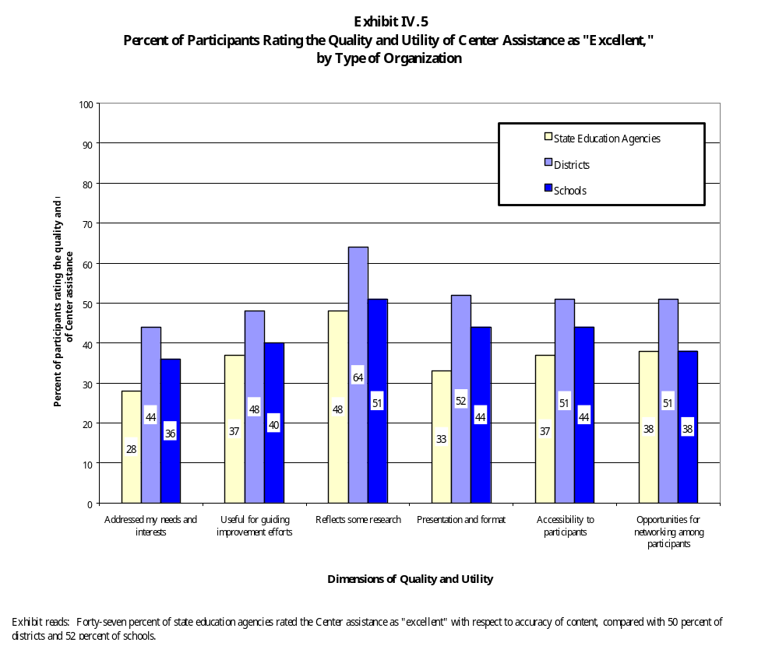

When comparing the assistance provided by the centers with assistance available from other sources, gatekeepers whose organizations received a higher volume of services also tended to give the centers higher ratings. For example, Exhibit IV.6 shows that 63 percent of high-volume customers rated the centers “excellent” in guiding improvement efforts, compared with 39 percent of respondents with less frequent contact. Sixty-one percent of high-volume customers rated the responsiveness of the assistance to local conditions “excellent,” compared with 40 percent of those with less frequent contact. Sixty-three percent of high-volume customers rated center services “excellent” for addressing their needs and interests, compared with 46 percent of low-volume customers.

Respondents who receive services frequently are more likely to (1) receive greater depth of information; (2) have more opportunities to work with centers to tailor services to meet their needs; and (3) have time to develop positive relationships with center staff. Such customers are more likely to have positive experiences and to perceive the quality and utility of service as better than those who receive services less frequently.

By level of follow-up. As we have noted in earlier sections of this chapter, high-quality technical assistance is intensive and is delivered over an extended period of time. Persons receiving more frequent services have more opportunities to receive in-depth information and are more likely to receive assistance that more directly meets their needs. They are also more likely to rate the quality of assistance higher. Data from our participant surveys further illustrate this relationship.

In general, customers who received follow-up assistance were more likely to rate the quality and utility of center activities “excellent” and less likely to rate them “fair” or “poor.” This finding holds true for most types of follow-up. As the frequency of additional assistance increases, from “never” to “once” and from “once” to “more than once,” positive ratings increase and negative ratings decrease. For example, Exhibit IV.7 shows that 61 percent of participants who received telephone follow-up more than once rated the centers’ activities “excellent” for the extent to which they proved useful for guiding improvement efforts, compared with 32 percent of participants who received no telephone follow-up. Similarly, 38 percent of participants who received no telephone follow-up rated the centers “fair” or “poor” for their responsiveness to local conditions, while only 17 percent of participants who received telephone follow-up more than once rated them “fair” or “poor.” These findings hold true for other types of follow-up, including additional materials and additional workshops and training, although Exhibits IV.7 reports on telephone follow-up only.

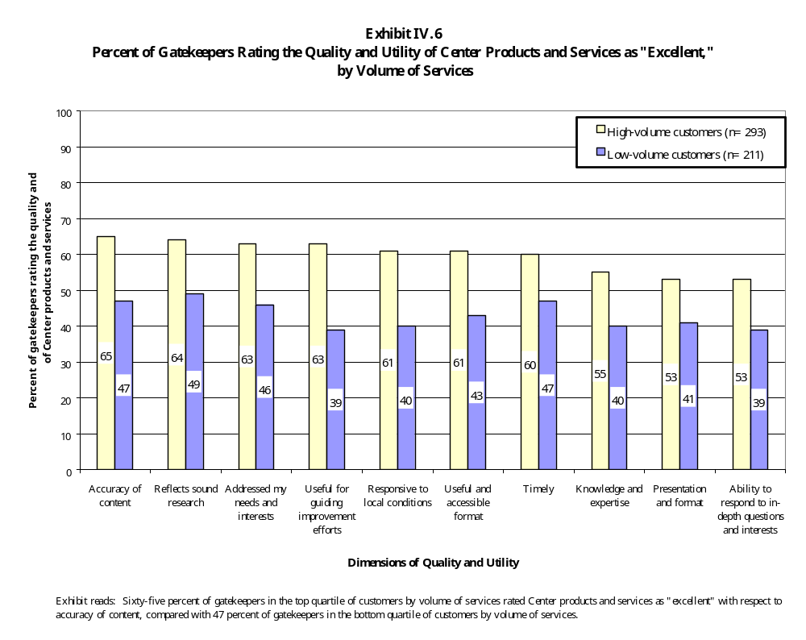

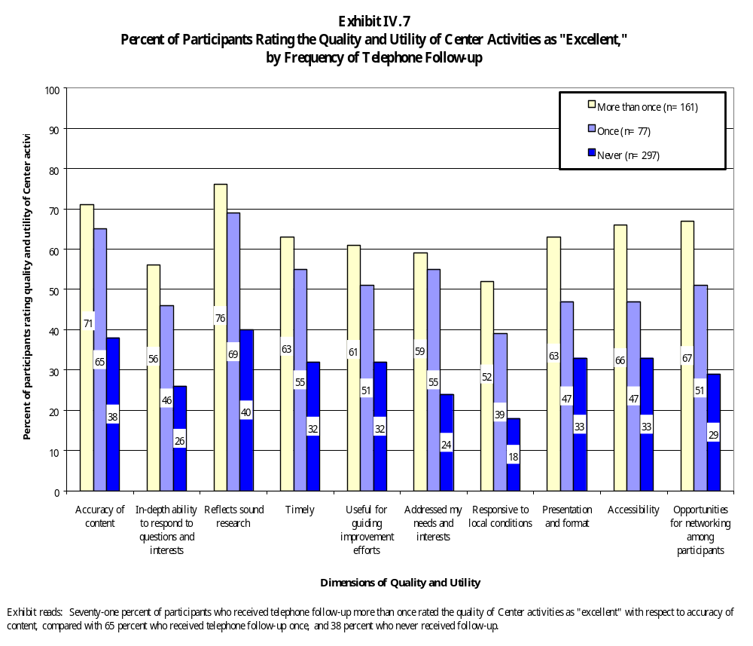

Response patterns do vary slightly for follow-up that includes visits to the workplace. In this category of follow-up, the percentage of participants giving the centers low ratings does not consistently decrease as the frequency of additional assistance increases. For example, Exhibit IV.8 shows that 35 percent of respondents who received no workplace visits gave the activities low ratings for the extent to which they were responsive to local conditions, compared with 11 percent of participants who received one visit to their workplace. The percentage of participants assigning center activities a negative rating increases for participants who received more than one workplace visit, to 19 percent. This pattern is consistent across many, though not all, dimensions of quality and utility addressed by our surveys.

Participants receiving frequent workplace visits may begin to perceive the centers as becoming overly intrusive in their professional lives and may consequently develop a more negative view of quality and usefulness of the assistance. This finding further demonstrates the importance of an continuing, collaborative relationship between providers and customers. Providers and customers should continually work together to assess whether or not the assistance continues to have desirable outcomes and continues to meet the needs of those served.

Variation by Center

Customer satisfaction with the accessibility, quality, and utility of center services varies by individual Comprehensive Center. On most of the customer satisfaction items on our survey of gatekeepers, these variations in satisfaction levels were quite pronounced. For example, the percent of gatekeepers reporting that they are very satisfied with the overall accessibility of Comprehensive Center products and services ranges from a high of 90 percent at one center to a low of 31 percent at another. The percent of gatekeepers reporting that they are very satisfied with the overall quality of center services ranges from a high of 89 percent at one center to a low of 35 percent at another. The percent of gatekeepers who rated the Comprehensive Centers “excellent” for the extent to which their assistance addressed their organizations’ needs and interests ranged from a high of 72 to a low of 31.

We tested many possible hypotheses to explain this variation in customer satisfaction by center. We were unable to detect any statistically significant relationship between Customer satisfaction and the following center characteristics:

- Type of host institution (that is, whether the center is based in a regional educational laboratory, a university, or some other type of organization)

- Number of customers served (from customer lists submitted by the centers)

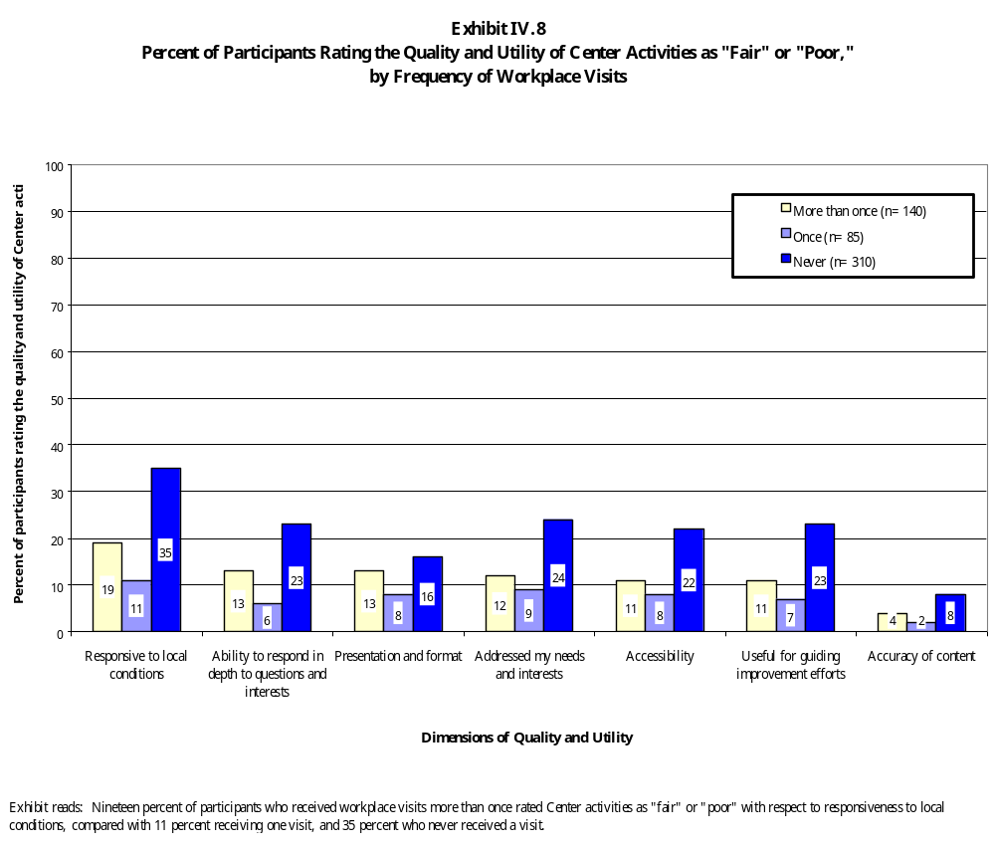

- Primary strategy for delivering assistance to the region (for example, whether centers with strong state-focused strategies for serving their regions received higher satisfaction ratings from their state-based customers than centers without strong state-focused strategies)

- Coherence of mission (we identified a small group of centers that, in our judgment, had adopted a particularly coherent mission and set of strategies for serving their region, and tested whether this group of centers received higher satisfaction ratings)

In other words, whether a center is based in a certain kind of host institution, whether it provides services in a certain kind of way, whether it has adopted a particularly coherent set of strategies for serving its region, or the number of customers it serves appears to have no relationship to customer satisfaction with the accessibility, quality, and utility of center services.

Only one variable is consistently and significantly related to various measures of customer satisfaction, and that is the size of the center’s budget. The size of center budgets varies widely among the 15 Comprehensive Centers, depending on the numbers of Title I-eligible, LEP, migrant, and Indian students in each region. The smallest center has an annual budget of $850,000, while the largest center has an annual budget of more than three times that size, at $2.6 million. We examined the relationship between size of center budget and various measures of satisfaction and found that there is indeed a strong relationship between the two, with large centers receiving, on average, higher ratings of customer satisfaction than smaller centers.

Although it is not true—and the reader should not infer—that all large centers receive high ratings of customer satisfaction and all small centers receive low ratings, the relationship between budget and customer satisfaction across the entire network of 15 centers is strong and statistically significant. Exhibit IV.9 shows, for example, that every $100,000 increase in center budget corresponds with a 2 percentage point increase in the number of gatekeepers reporting that they are “very satisfied” with the overall quality and accessibility of center services. Variation in the size of center budgets accounts for 84 percent of the variability in customers’ ratings of the accessibility of center services, and 77 percent of the variability in customers’ ratings of the quality of center services. Relationships of similar magnitude and strength also exist between the size of center budgets and the percentage of center gatekeepers rating the quality and utility of center services “excellent.”

The explanation for this finding appears to be that larger centers, on average, provide a higher volume of higher-intensity, more expensive services to their customers. Centers with larger budgets do not necessarily serve larger numbers of clients; size of a center's budget has no relationship with the
Exhibit IV.9

Bivariate Regression Analysis of the Relationship between Gatekeeper Ratings of Center Services and Products

 | Y intercept | Slope | T value | R² | Number of Observations
Percent of gatekeepers reporting that they are “very satisfied” with access to Center services by the size of budget (in hundred thousands) | 32.86 | 1.96 | (8.2)*** | .84 | 15
Percent of gatekeepers reporting that they are “very satisfied” with the quality of Center services by the size of budget (in hundred thousands) | 31.61 | 1.93 | (6.6)*** | .77 | 15
Percent of gatekeepers reporting that the quality of Center services is “excellent’ when compared with assistance provided by other sources (in hundred thousands) | 1.43 | 2.46 | (6.1)*** | .74 | 15
Percent of gatekeepers reporting that the utility of Center services is “excellent” when compared with assistance provided by other sources (in hundred thousands) | 15.09 | 1.97 | (6.1)*** | .74 | 15
*** p<.001

Exhibit reads: For every $100,000 difference in the budget, there is a 1.96 percent difference in the proportion of customers who are “very satisfied” with their access to Center services and products. Center budget explains 84 percent of the variance in high levels of satisfaction.

number of customers it served in 1998, as recorded on the centers' own customer lists. Instead, centers with larger budgets tend to have more resources available for each of the customers they do serve. In fact, customers of larger centers do report that they receive a higher volume of services, although the relationship is only significant for those services that are particularly resource intensive and expensive to provide—professional development, on-site consultations, and help convening special events (see Exhibit IV.10). Rather than using additional resources to reach a larger number of customers, then, it appears that larger centers use their resources to serve roughly the same number of customers with a higher volume of services.

As we discussed earlier in this chapter, volume of services and frequency of follow-up are associated with customer assessments of quality. Centers with larger budgets provide a larger volume of high-intensity, relatively expensive services, and customers appear to be more satisfied with services as a result.
Exhibit IV.10

Bivariate Regression Analysis of the Relationship between the Percentage of Customers Receiving High-end Services and Size of Center Budget

 | Y intercept | Slope | T value | R² | Number of Observations
Percentage of gatekeepers receiving professional development, on-site consultations, and convening assistance five or more times (in hundred thousands) | .61 | 9.76 | (2.9)* | .39 | 15
* p<.05

Exhibit reads: For every $100,000 difference in the budget, there is a 9.76 percent difference in the proportion of customers receiving professional development, on-site consultations, and convening assistance on five or more occasions. Center budget explains 39 percent of the variance, by Center, in percentage of customers receiving such assistance.

Summary

The Comprehensive Centers have made a credible effort to respond to their charge in Title XIII of ESEA to provide training and technical assistance “using the highest-quality . . . strategies possible” [P.L.103-382, Section 13102 (a)(3)]. The majority of Comprehensive Center activities are, in fact, comprehensive; most of the information and other content conveyed by the centers are reported to be accurate and grounded in research; most center activities are responsive to customer needs; most are sustained and intensive; and most customers are satisfied with the expertise of individual center staff. Nonetheless, not all activities meet all our criteria for quality equally well. Some activities have been planned without the active involvement of customers, some receive low ratings for responsiveness, and many are not intensive. However, most Comprehensive Center activities satisfy one or more of these criteria for high-quality assistance. In addition, Comprehensive Center customers give the centers high ratings for the quality and utility of their services. As one possible indicator of quality, customer satisfaction data indicate that the centers are providing a valuable set of services to their regions.

V. EFFECTS

This evaluation examined the effects of Comprehensive Center services in terms of the expectations set forth in their authorizing legislation. We asked customers about the effects of center services in both surveys and in visits to case study sites. We begin the chapter with customers’ reports of the general effects of the centers’ services on their own work and on the work of their organizations, and examine some of the factors associated with those effects. Next, we examine the extent to which center services have strengthened the implementation of ESEA provisions, enhanced states’ and districts’ capacity to provide technical assistance in support of ESEA, and improved teaching and learning in participating schools and classrooms. For data on these specific kinds of effects, we turn primarily to our case study sites.

Effects on the Work of Individuals

Comprehensive Center customers participated in a variety of technical assistance activities designed to enhance their knowledge and skills and build their capacity, both to deliver technical assistance and fulfill their job responsibilities. According to our survey and case study data, the centers were more likely to influence state, district, and local staff members’ individual work than the work of their organizations.

Participants and gatekeepers most frequently reported that they had gained new information as a result of center assistance (see Exhibit V.1). More than three-quarters of both groups of respondents reported this outcome. Respondents also frequently indicated that center assistance directly affected the way they did their jobs. Sixty-one percent of gatekeepers and 72 percent of participants reported that they incorporated something they had learned from the center into their work.

Survey data also show that center services and products frequently prompt participants and gatekeepers to share, formally and informally, what they have learned with others. Forty percent of gatekeepers reported that they have provided technical assistance in support of ESEA. Additionally, three-quarters of participants reported that they have informally shared new ideas with others, and 50 percent of participants reported formally providing training or technical assistance.
Exhibit V.1

Percent of Participants and Gatekeepers Reporting on Effects of Center Assistance
on Their Work

Overall, what effect, if any, has Comprehensive Center assistance had on your own work?
Effect | Percent of Participants  (n=669) | Percent of Gatekeepers  (n=573)
I have gained some new information | 80 | 77
I have informally shared ideas with colleagues | 74 | **
I have incorporated into my job something I learned from the Center | 72 | 61
It confirmed what I was already doing | 60 | 49
I have communicated the ideas to colleagues or others through training, technical assistance, or similar activities | 50 | **
I have provided technical assistance to others in support of federal programs | ** | 40
It has had little or no effect on how I do my job | 9 | 9
Other | 3 | 4

** Item not included in the survey instrument for this group of respondents.

Exhibit reads: Eighty percent of participants reported that Center assistance allowed them to gain new information and additional perspectives.

Variation by Type of Respondent

There is variation in the proportion of state, district, and school gatekeepers and participants reporting individual effects. School-level participants were more likely than state and district participants to report gaining new information and incorporating something learned into their job. Exhibit V.2 shows that 86 percent of school participants, 66 percent of district participants, and 55 percent of state participants reported gaining new information about a program or instructional practice. Seventy-six percent of school participants reported that they had incorporated something into their job, compared with 56 percent of state participants and 67 percent of district participants. There was, however, no such variation among gatekeepers along these dimensions. This is not surprising if we consider that gatekeepers typically work with centers to plan services for their organizations. Gatekeepers may or may not be end-user participants in the services. As a result, they may be less disposed to carry away lessons from the services that they can apply in their own work—the services may not be tailored to their particular purposes, or they may not be thinking of themselves as learners in their work with the center.

Among gatekeepers, district and state respondents were more likely than school respondents to report that they had provided technical assistance in support of federal programs. Overall, 57 percent of state gatekeepers and 46 percent of district gatekeepers reported this effect, compared with 23 percent of school gatekeepers. This difference is also likely attributable to the professional responsibilities of each respondent. District and state personnel have more direct responsibility for administering federal programs and are also responsible for providing assistance to schools. (Eighty-one percent of state gatekeepers and 74 percent of district gatekeepers identified providing technical assistance as a major professional responsibility, compared with 46 percent of school gatekeepers.)

Overall, 9 percent of gatekeepers reported that the assistance had little effect on how they did their jobs. State gatekeepers (16 percent) were more likely than both school (6 percent) and district gatekeepers (7 percent) to report that center services and products had little effect on how they did their jobs.

Variation by Level of Follow-Up

End-user participants in center activities were more likely to report that the activity had an effect on the way they do their job if they received follow-up services from the center. This pattern holds for all types of follow-up, including follow-up by telephone, additional training, written materials, and visits to the workplace. For example, Exhibit V.3 shows that 64 percent of participants who received additional training more than once, beyond what was originally scheduled, reported that they communicated the ideas learned to others via technical assistance activities, compared with 43 percent of those who participated in additional training only once, and 38 percent of those who never participated in additional training. Similarly, the percentage of participants reporting that they incorporated something new into their job increases from 63 percent to 83 percent as the frequency of telephone follow-up increases.

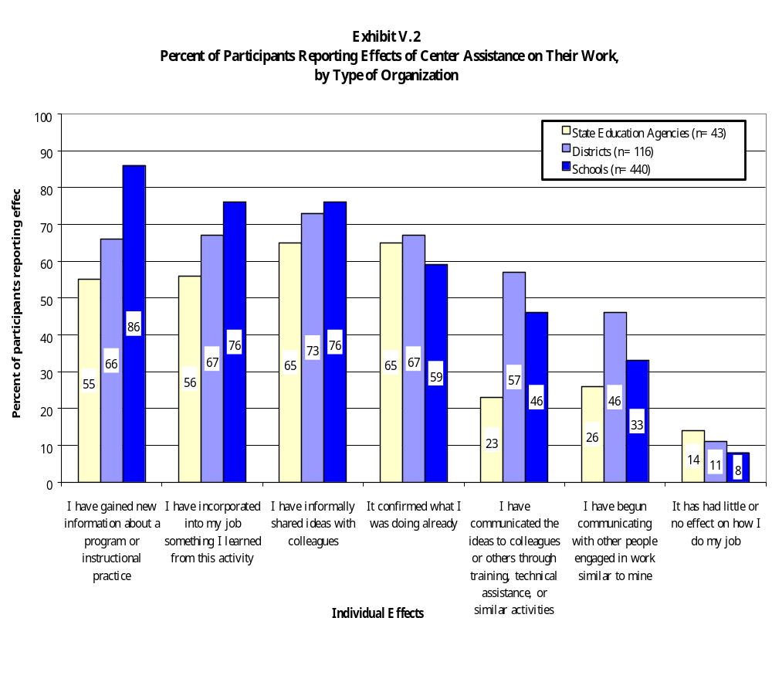

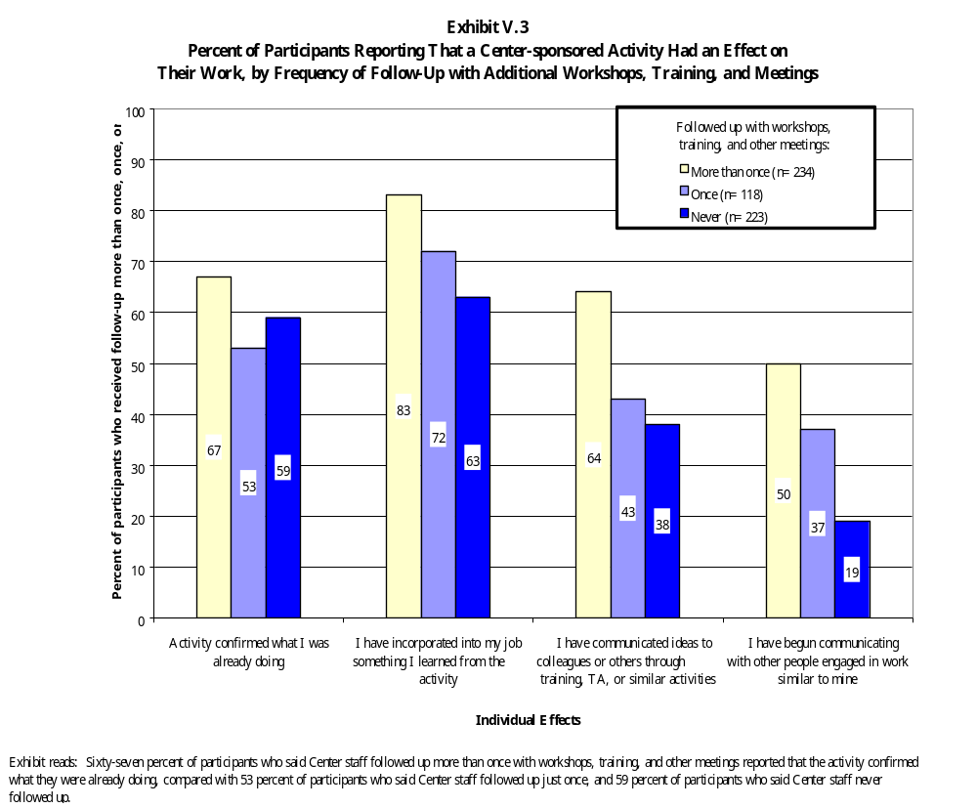

Variation by Participant Motivation

By whether participants were required to participate in the activity. Participants in center-sponsored activities who were required to participate are less likely to report that the activity had an effect on their work than participants who volunteered. For example, 80 percent of volunteers reported that they had informally shared ideas with colleagues as a result of the activity, compared with 62 percent of those who were required to participate (Exhibit V.4). This pattern repeats itself across all the individual effects identified in our survey item.

By participants’ purposes for participating. Participants’ goals and purposes are also important factors that affect the impact of a service or activity. Data from the participant survey indicate that persons with multiple reasons for participating in an activity are more likely to report that the activity had an effect on the way they do their job. Persons who have more interests in and goals for participation are more likely to be invested in the activity and are thus more likely to reap benefits from the activity. Exhibit V.5 shows that 53 percent of participants who identified just one of the purposes listed in our survey item as the reason for their participation reported that they had incorporated something they learned from the activity into their job. In contrast, 81 percent of participants identifying all five purposes listed in our survey item reported making changes in their jobs. This pattern holds true for all types of individual effects.

In addition to the general level of enthusiasm or engagement displayed by end-user participants, survey data show that specific purposes also have an impact on individual outcomes. For example, participants who reported that their purposes included “obtaining ideas or contacts that would strengthen my work” were more likely to report that they included something they had learned from the center into their job, compared with participants who did not identify that purpose as a reason for participating in the activity. This finding holds true for all kinds of individual effects identified in our survey item.

Effects on the Work of Organizations

Exhibit V.6 shows that for both participants and gatekeepers, the most commonly reported organizational effect was that center assistance helped generate awareness of new information within the organization. Both participants and gatekeepers were more likely to report that center assistance affected the existing work of their organization than it prompted their organization to undertake a new effort. Approximately half of both groups of customers reported that center assistance supported an established practice of their organization. Thirty-five percent of gatekeepers and 45 percent of participants indicated that center services prompted their organization to initiate a new practice.
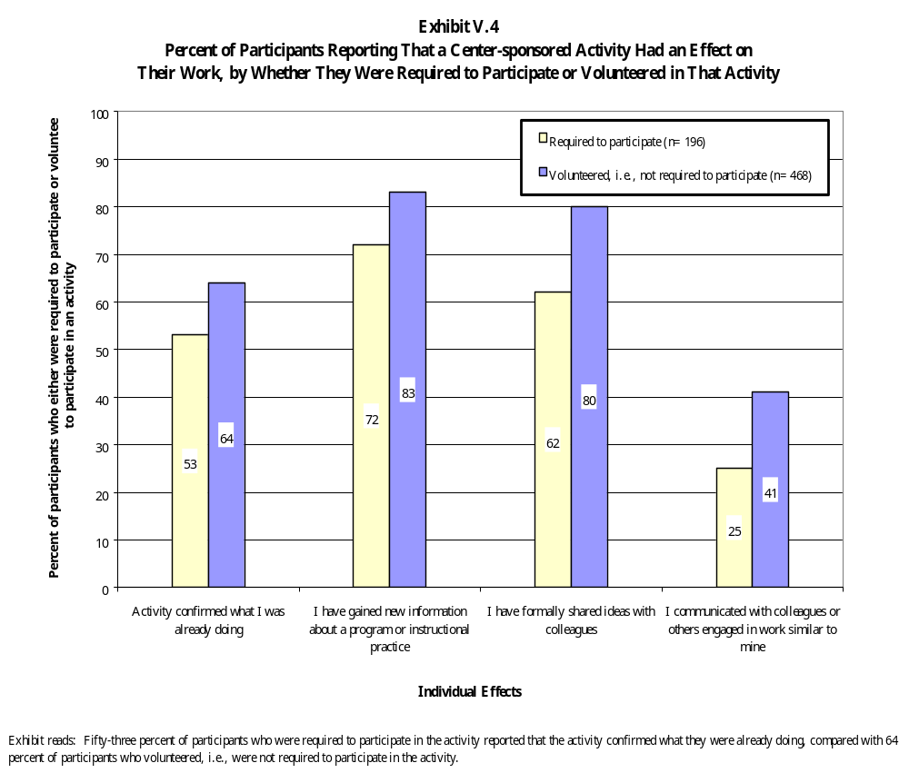

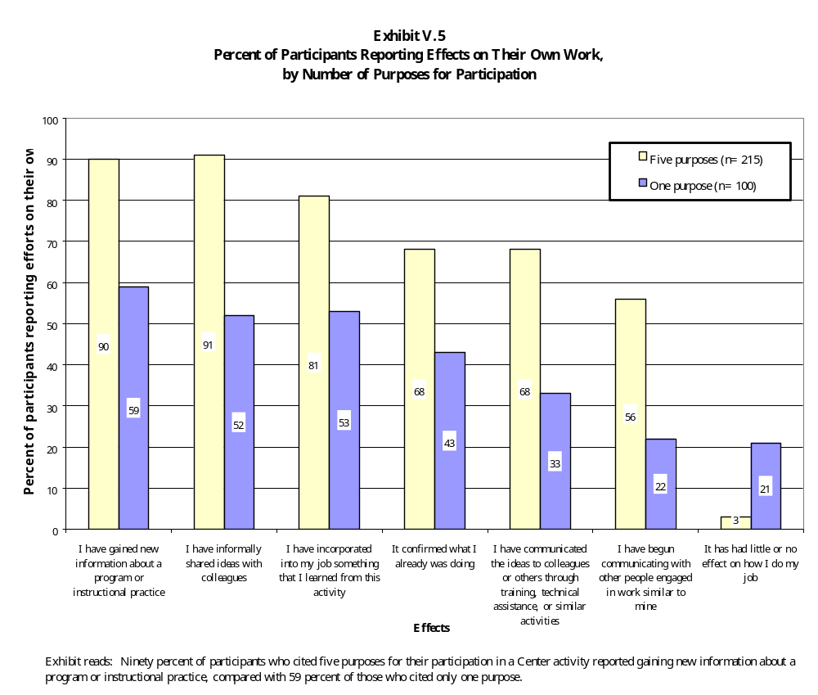

Exhibit V.6

Percent of Gatekeepers and Participants Reporting on Effects of Center Assistance
on the Way Their Organization Does Its Work

Effect | Percent of Participants  (n=668) | Percent of Gatekeepers  (n=552)
Helped generate awareness of new information | 77 | 80
Increased teachers’ knowledge and skills | 56 | 57
Supported an ongoing program, policy, or practice of the organization | 52 | 55
Helped the organization establish or  initiate a new program, policy, or practice | 35 | 45
Helped the organization take the next step in a reform effort | 46 | 45
Improved teaching and learning for a specific population of students | 38 | 42
Put the organization in touch with other organizations engaged in similar tasks | 29 | 38
Improved teaching and learning for all students | ** | 36
Enhanced the organization’s capacity to provide technical assistance in support of ESEA programs | ** | 36
Changed teachers’ classroom practices | 35 | 35
Increased student achievement | 28 | 24
It has had little or no effect on my organization’s work | 11 | **
Other | 2 | 4

** Item not included in survey instrument for this group of respondents.

Exhibit reads: Seventy-seven percent of participants reported that Center assistance generated awareness of new information within the organization.

Slightly less than half of participants (46 percent) and gatekeepers (45 percent) reported that center services helped their organization move forward in reform efforts. This finding makes sense, given that it is generally easier to make modifications to current activities than it is to enact new policies and procedures.

Variation by Organization Served

There were significant differences in the numbers of state, district, and school gatekeepers reporting effects for some types of organizational change. For example, Exhibit V.7 shows that 85 percent of school-level gatekeepers reported that the center’s services had helped generate awareness of new information, compared with 77 percent of districts and 71 percent of states. Predictably, schools were more likely than districts or states to report that Comprehensive Center services had changed teachers’ classroom practices, improved teaching and learning for all students, and increased student achievement. This finding is explained by the fact that services to schools are more likely to be designed to directly affect classroom practice.

Among participants in center activities, school-based respondents were more likely to report changes in teachers’ knowledge and skills, and improvements in teaching and learning. District-level end-users of assistance were more likely than school or state participants to report that the activity helped their district initiate a new practice or take the next step in a reform effort (Exhibit V.8).

Variation by Characteristics of the Assistance

By volume of services. Gatekeepers whose organizations received a higher volume of services were more likely than those who received a lower volume of services to report that the service affected the work of their organizations. This finding holds true for all types of services and kinds of organizational effects. To conduct the analyses we described below, we added up the number of times gatekeepers reported receiving all types of center services—written materials, professional development, on-site consultations, etc.—to produce a composite score reflecting the overall levels of service. We then divided gatekeepers into quartiles based on these composite scores and compared

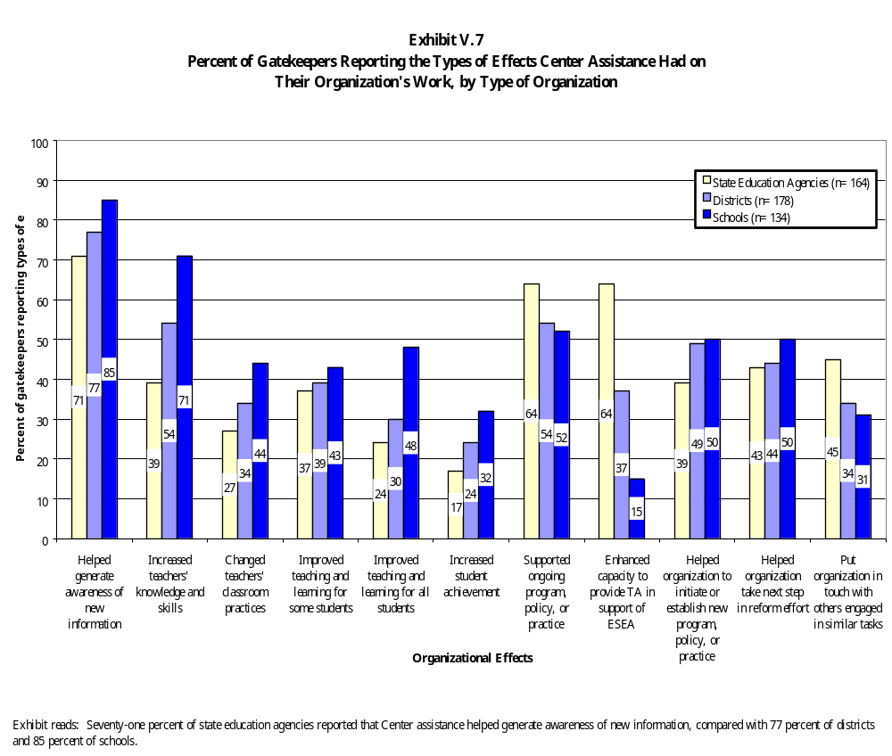

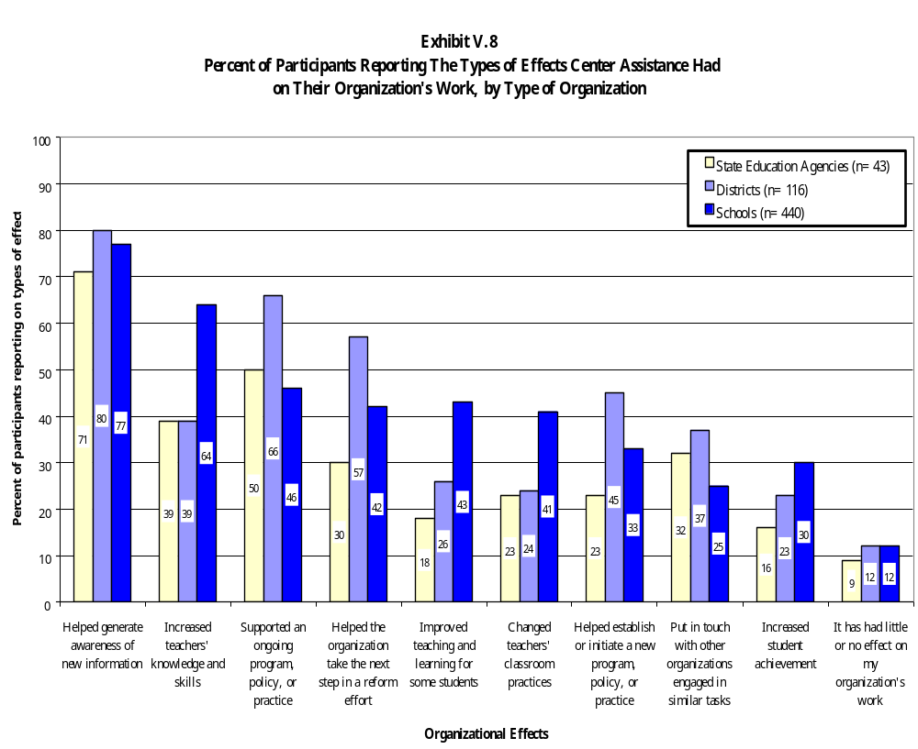

gatekeepers in the top quartile (who received what we call “high-volume” services) with gatekeepers in the bottom quartile (who received what we call “low-volume” services).

Exhibit V.9 shows that 94 percent of gatekeepers who received a high volume of services reported that the assistance generated awareness of new information within the organization, compared with 56 percent of those who received a lower volume of services. Fifty-four percent of those receiving a high volume of services noted a change in classroom practices, compared with 16 percent of those receiving a low volume of services. There are large differences for other kinds of organizational effects as well. Exhibit V.10 shows that end-user participants in center activities who received a high volume of follow-up services were more likely to report all types of organizational effects.

As discussed in the previous chapter, customers receiving services over an extended period of time have more opportunities to receive in-depth information and work with the centers to tailor services to meet their needs. Consequently, customers receiving high levels of service are more likely to develop the capacity to implement new ideas and practices.

Variation by number of topics addressed. The number of topics of assistance also affects gatekeeper reports of the impact of center services and products. Respondents receiving assistance on a greater number of topics were more likely to report that the assistance affected their work and the work of their organization (Exhibit V.11). Sixty-one percent of gatekeepers receiving assistance on six or more topics reported that center services helped their organization take the next step in a reform effort, compared with 33 percent of those receiving assistance for fewer topics. Significant relationships exist for all types of organizational effects.

Variation by Participation Patterns

By membership on a team. Participants in center-sponsored activities who came as members of a team representing their organization were more likely to report that the activity had an effect on their organization’s work. More than a third of respondents who participated as a member of a team representing their organization reported a change in teacher classroom practices and improved teaching and learning for a specific population of students (Exhibit V.12). In contrast, only a quarter of those who participated in activities as individuals reported these outcomes. Team members were also more likely to report that the center assistance had helped their organization take the next steps in a reform effort.
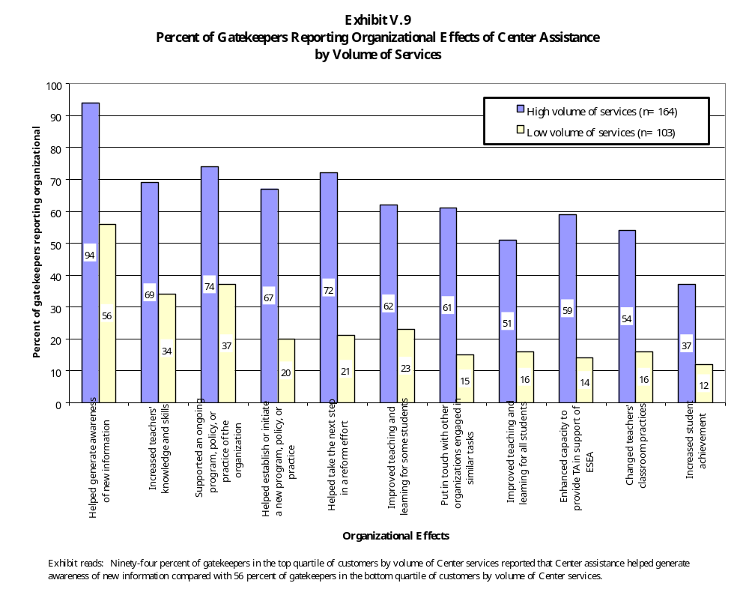

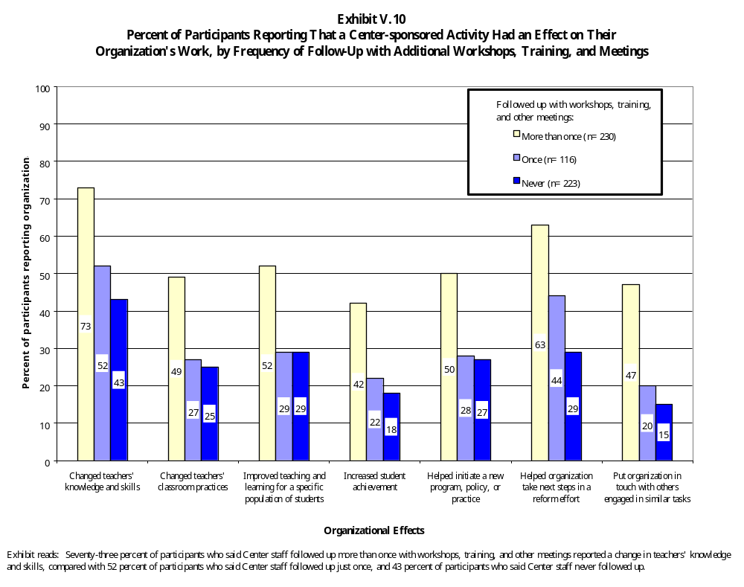

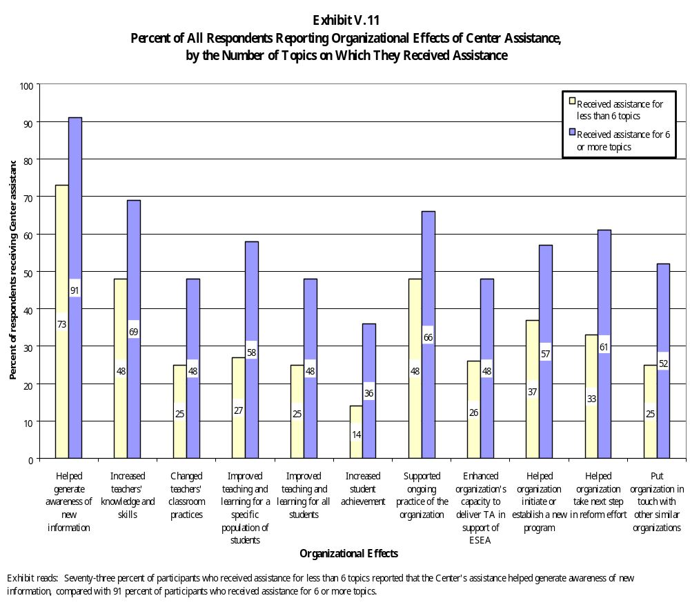

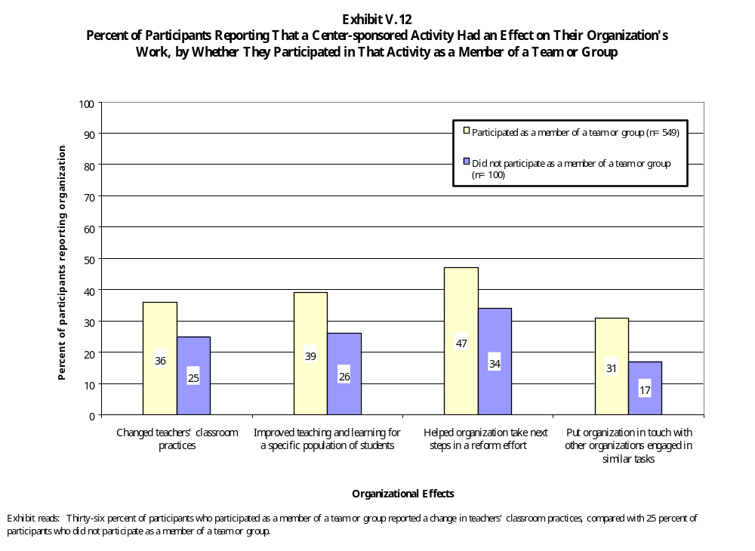

These results suggest that organizations that send teams of participants to an activity may be demonstrating greater levels of support for the activity, which translate into greater levels of support for implementing new ideas and skills. Participants themselves are more likely to perceive the activity as important to the overall goals of the organization. Both individual and organizational support are critical elements in the change process. Additionally, if a team of representatives from an organization receives training, there will simply be a greater number of trained individuals within the organization. Organizations with a “critical mass” of people with new knowledge and skills are more likely to produce change.

There were almost no significant differences between volunteers and those who were required to participate in center activities with regard to organizational effects.

By involvement in planning services. Both gatekeepers and participants who were involved in planning activities were more likely to report that the assistance had an effect on their organizations. Such involvement affords them the opportunity to actively work with the centers to tailor assistance to meet the needs of their organization and increases the likelihood that they will make changes as a result of the assistance. Exhibits V.13 and V.14 show that about two-thirds of participants and gatekeepers who were involved in activity design reported increased teacher knowledge and skills as a result of the center activity. In contrast, slightly less than half of participants and gatekeepers who were not involved reported the same outcome. There are similar differences in the proportions of respondents reporting effects for most organizational effects.

Variation by Purposes for Participation

As with individual effects, participants who had clear purposes for participating in an activity were more likely to report effects on their organizations as a result of center services. For example, Exhibit V.15 shows that 50 percent of respondents who identified all five purposes in our survey item as reasons for participating in an activity reported that classroom practices had changed as a result of the activity, compared with 18 percent of respondents who identified just one purpose. This finding holds for all types of organizational effects included in our survey item.

Individual purposes were also related to organizational effects, and some purposes are associated with greater organizational effects than others. For example, Exhibit V.16 shows that participants who reported that their purposes for participating in an activity included “obtaining ideas or contacts that would help my organization carry out a major, planned improvement,” as a purpose were more likely to report that the assistance helped the organization initiate changes or make progress in reform efforts than those who did not identify this purpose. By contrast, participants who identified
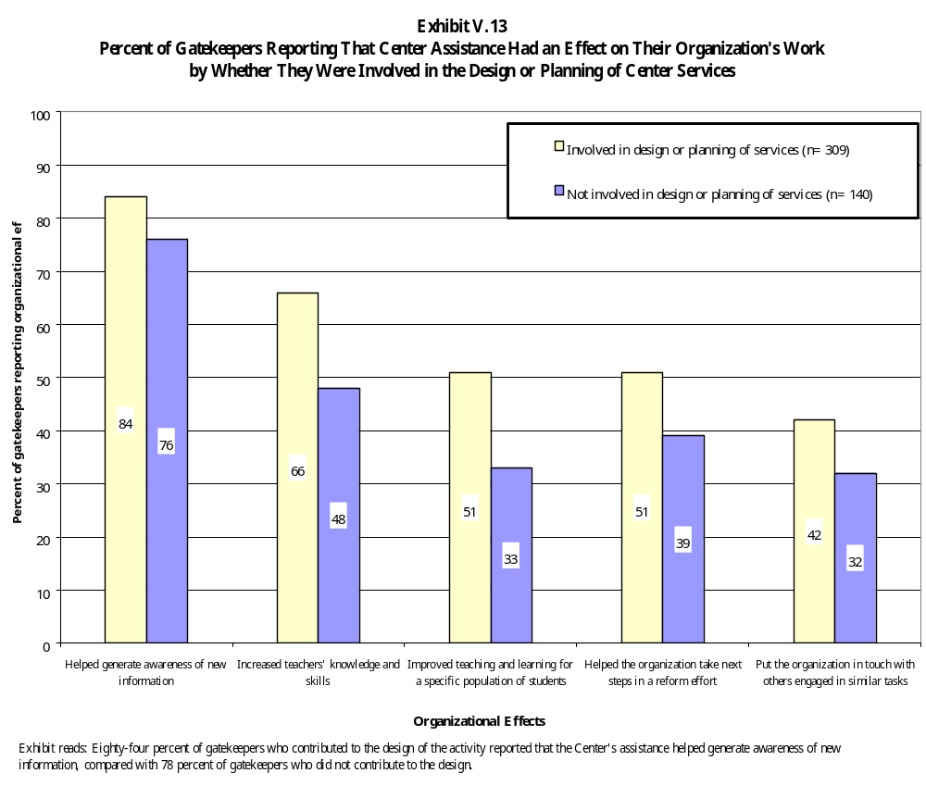

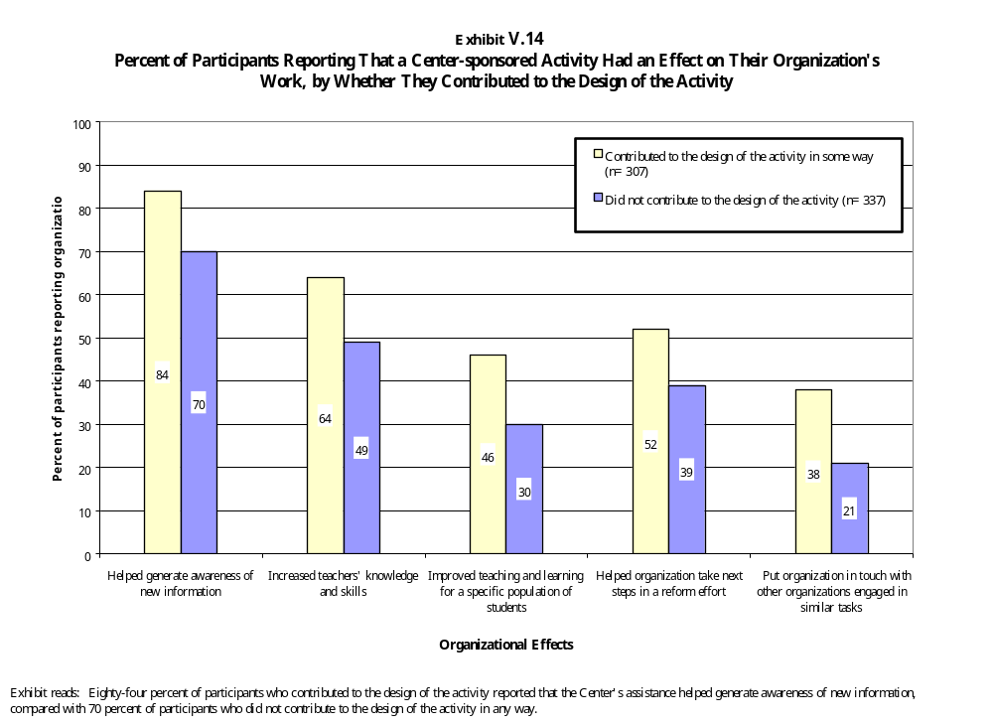

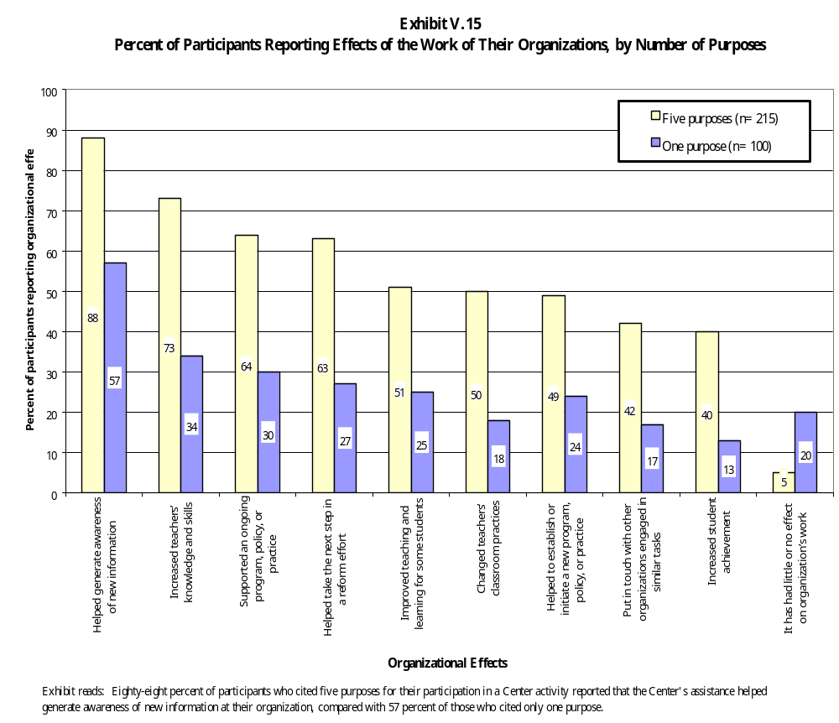

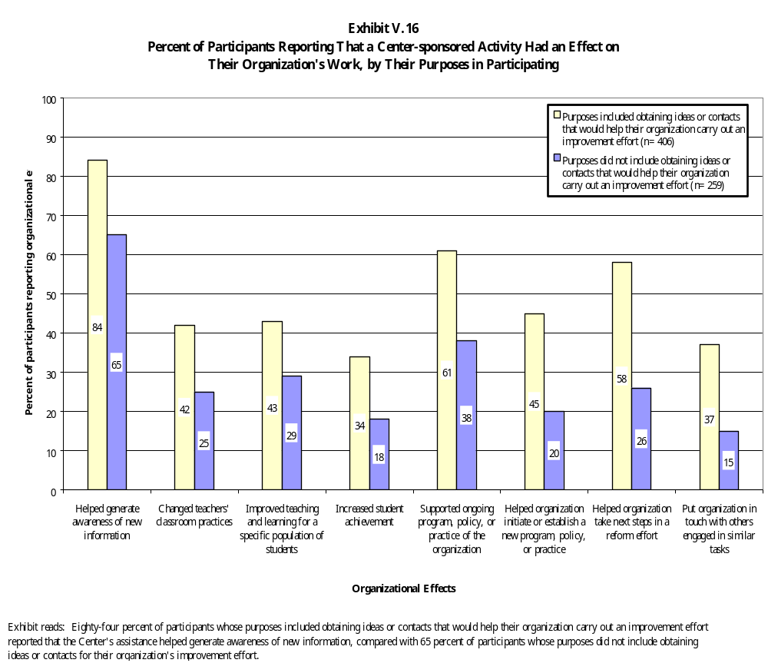

“keeping current professionally” as a purpose were no more likely to report that their organization initiated new changes or took the next step in its reform process than persons who did not identify this purpose (in other words, the difference in reporting by these two groups of participants was not statistically significant). Participants with goals that focus mostly on their own work appear to be less likely to make the connections between the assistance and the work of their organization.

Many of the characteristics we ascribe to high-quality assistance are in fact associated with desirable effects. Comprehensive Center services are more effective if they are intensive, if they are planned in consultation with the recipients of services, if they are responsive to customer needs, and if customers are motivated to participate in and benefit from the assistance. Our survey data confirm these findings on the general effects of center services on the work of individuals and organizations. We turn now to an examination of the specific effects of Comprehensive Center services.

Assisting Customers to Respond to the Requirements of ESEA

Among our state case study sites, federal program administrators maintained that the Comprehensive Centers played a key role in assisting them to respond to the provisions of the reauthorized ESEA. In a few of our case study states, SEA staff credited the centers with helping them through the early stages of planning new programs in response to the requirements of the reauthorized ESEA. In a closely related set of activities, several centers also worked closely with states to carry out the Comprehensive School Reform and Demonstration (CSRD) Program. One SEA administrator described the centers’ contribution this way:

[They] are always out in the front when a new initiative comes in. They set the parameters under which the SEA should be able to think about these things. When CSRD was introduced, for example, we engaged in many conversations about what it meant. What’s a program? What do the nine components mean? We were trying to make sense of the time line. They really helped us make critical decisions about how we’d approach the issue of getting out to the schools and districts. They helped provide the structure to make this thing happen at the beginning.

Other states we visited praised the centers’ willingness and ability to perform a variety of tasks—from editing reports to conducting training to helping with grant applications. Staff members credited the centers with filling in gaps left by limited staff, time, and resources. One SEA staff member explained, “[With their help, I can do] way more than I could have done by myself.” Similarly, staff members at another SEA maintain that their center “has made a difference in what we can offer districts. We personally and financially would have to do the job they are doing, which we just can’t do.”

There are many examples of the ways in which the Comprehensive Centers have extended states’ capacities to develop and carry out new ESEA programs. A few examples include:

- According to state staff, NYTAC was a vital collaborator and leader in New York’s efforts to write their ESEA consolidated plan and bring the entire department on board. One said, “As the ESEA plan was written and finalized, we knew [center staff] could help with implementation.” The center also assisted in providing training related to Title I School Support Teams and schoolwide planning and implementation.

- Beginning in 1996, the STAR center worked with one Education Service Center (ESC) to build the capacity of the ESC system to assist districts and schools in coordinating funding and programs. Together they sponsored a statewide summit, followed up with participants, and developed the Resource Guide for Coordinating Funding and Programs. A year later, the center and ESC held a training of trainers for the Texas Education Agency and other ESC staff. A state staffer said, “Even though I can’t [always provide assistance in fund coordination], I know it’s getting done [through the center].”

- In Region XV, one of the center’s partners, RMC Research Corporation, was particularly helpful in building Hawaii’s capacity to support and administer Title I schoolwide schools. A state staff member explained, "We had no schoolwides five years ago. At that point, we needed help. Our schoolwide planning model is based on RMC’s model. Then two years ago we needed help with School Support Teams, so Pacific Resources for Education and Learning (PREL) put us in touch with RMC in Denver.” Through its partners, the Comprehensive Center played a key role in building state capacity to implement these ESEA provisions.

- According to Maryland staff, the Region III Comprehensive Center contributed to state, district, and school efforts related to Title I and consolidated planning. The center has presented on schoolwide programs, developed a scoring rubric for the Title I Distinguished Schools Program, and helped the Baltimore City School District develop its consolidated application.

At the local level, Comprehensive Center assistance has supported schools throughout the schoolwide planning process and in the development of written plans; however, the assistance has had limited effect on the development of local capacity in schools for planning on their own. Approximately one-third of district-level gatekeepers reported that the centers’ assistance had enhanced their organization’s capacity to provide technical assistance in support of ESEA programs. In two of our local case study sites, support for Title I schoolwide program planning was the central focus of Comprehensive Center assistance. In each site, schools successfully completed their schoolwide plans; in interviews, staff members referred to them with pride (and relief) when they described the results of the centers’ work. In these same sites, however, school staff had mixed reactions when asked if they could now engage in a similar planning process on their own. Some respondents reported that they had learned skills in data analysis and needs assessment that they could now apply on their own; others insisted that they could not develop another plan without the help of the center.

Enhancing State Capacity to Deliver Technical Assistance in Support of ESEA

Overall, 40 percent of gatekeepers reported that center services improved the capacity of their organization to provide technical assistance in support of ESEA. There was, however, significant variation by type of respondent. State gatekeepers were most likely and school gatekeepers were least likely to report this effect. Sixty-four percent of state gatekeepers, 37 percent of district gatekeepers, and 15 percent of school gatekeepers reported that the centers’ assistance had increased their capacity to provide technical assistance in support of ESEA.

At the state level, center assistance has helped build the capacity of federal program administrators to deliver technical assistance related to ESEA programs. Almost two-thirds of state-level gatekeepers reported that the centers’ assistance had enhanced their organization’s capacity to provide technical assistance in support of ESEA programs. Some SEA staff reported that they “learn by watching” center staff during workshops, presentations, and consultations and often use the approaches to technical assistance the center uses with them. A couple of respondents—based in the Hawaii and Mississippi Departments of Education—noted that their own capacity for providing technical assistance has increased since they first began working with the centers. For example, a staff member from the Hawaii Department of Education explained:

In the past my needs were more obvious because I had less knowledge of schoolwide implementation. We had no schoolwides five years ago. . . . At that point I really needed help. PREL was helpful then. . . . Now I feel like I have greater expertise in schoolwides and managing Title I. The substance of efforts is located at the SEA, and [PREL] is more a supporter and helper. . . . Since then [two years ago], we took over and don’t rely on PREL in the same way.

Effects on Teaching and Learning

Changes in Teaching Practices

Survey data indicate that changes in teaching and learning are the least common effects of Comprehensive Center services. Respondents most frequently cited an increase in teacher knowledge and skills, with over half of all respondents reporting this outcome. It should come as no surprise that those closest to the classroom, school-based gatekeepers and participants, were more likely than district and state gatekeepers and participants to report such changes. Differences by respondent type were significant, with 71 percent of school gatekeepers reporting this effect, compared with 54 percent of district gatekeepers and 39 percent of state gatekeepers. A similar response pattern also exists for participants.

Fewer respondents reported that the increased knowledge of teachers actually resulted in a change in classroom practices. Overall, 35 percent of both participants and gatekeepers reported this effect. Again, school-based participants and gatekeepers were more likely than respondents based in other organizations to report this effect. Approximately 40 percent of school-based gatekeepers and participants reported a change in teacher practices. In contrast, approximately one-third of district and state gatekeepers and one-quarter of district and state participants cited the same change.

Respondents were least likely to report increased student achievement as a result of center
services, with one-quarter of all gatekeepers and participants identifying this impact. There were also significant differences by respondent for this effect, with one-third of school-based participants and gatekeepers and less than one-quarter of district and state participants and gatekeepers reporting this effect.

The relatively low percentage of gatekeepers and participants reporting effects on teaching and learning is most likely affected by the focus of center services. To conduct the analysis we describe here, we sorted the 30 activities in our survey sample into activities directly targeted to instruction and other activities. Participants who participated in activities directly targeted to instruction were more likely to report effects on teaching and learning. For example, approximately three-quarters of participants in instruction-focused activities reported a change in teachers’ skills and knowledge. By contrast, 53 percent of participants in noninstruction-focused activities reported this change.

Producing changes in teaching and learning is not often an specific goal of Comprehensive Center services. Among our seven state case study sites, SEA and center staff argued that changes in teaching and learning may not be appropriate outcomes for the centers’ work at the state level. Among our eight local case study sites, changes in teaching and learning were an specific goal of center services in only four of the sites.

Center assistance was more likely to increase teachers’ knowledge and skills than to result in actual changes in teaching practices. About 55 percent of survey respondents reported that Comprehensive Center services increased teachers’ knowledge and skills, and a little more than a third reported that Comprehensive Center assistance had changed teachers’ classroom practices. Respondents based in schools were more likely to report these findings than respondents based in districts and states. In the four local case study sites where center assistance had been designed to influence teaching and learning, teachers reported making changes in their practices, though these changes were limited. Examples of ways the centers increased teachers’ knowledge and skills and affected their practices are described below.

Cognitively Guided Instruction. Many of the teachers we interviewed reported that they had worked during the school year to align their instruction with the “CGI philosophy.” Teachers reported that they had incorporated the use of mathematics manipulatives into their teaching as well as group discussions of approaches to solving complex mathematical problems that are the hallmark of CGI. Among the classrooms we observed during mathematics instruction, teachers had implemented some of the new approaches to instruction to a greater or lesser degree, depending on their level of comfort with the new techniques and the particular circumstances of their classroom.

Reading Success Network. The Comprehensive Center that designed the RSN describes the initiative as a professional development activity, not a specific reading intervention. From the coaches, principals, and teachers we interviewed, we heard that the RSN coaching strategies have been effective at prompting teachers, particularly new or young teachers, to become more engaged in problem solving and trying new ideas in their classrooms. Teachers commented that the RSN “gives them tools,” “polishes existing skills,” and “serves as an impetus for institutionalizing analysis, reflection, and change.” These comments all point to changes in teachers—in their attitudes and perspectives—and to a lesser degree suggest examples of changes in teaching.

Training for teachers of limited English proficient (LEP) students. Teachers in both North Carolina and the Riverside City Schools reported that the training offered by their Comprehensive Center had provided them with a much better understanding of how language is acquired and had taught them some useful techniques for working with the LEP students in their classrooms. Several teachers in Riverside noted that they now assign limited English proficient students “Reading Buddies,” and teachers in North Carolina described how they had adopted more physical approaches to communication in the classroom.

Effects on Student Learning

Increases in student achievement were the least commonly reported effect of Comprehensive Center services, with only 28 percent of participants and 24 percent of gatekeepers reporting this as an effect of services. Not surprisingly, school-level gatekeepers and school-based participants (most of whom are teachers) were much more likely to report this effect than other types of center customers. Thirty-two percent of school-level gatekeepers reported that center services had increased student achievement, compared with 24 percent of district-level gatekeepers and 17 percent of state-level gatekeepers. Also, participants in center activities specifically targeted at instruction were more likely to report increased student achievement as an effect of the activity than were participants in other activities (33 percent of those in instruction-focused activities, compared with 11 percent of those in other activities).

Even among those participants receiving assistance specifically focused on instruction, the proportion of participants reporting increased student achievement as an effect of the assistance is relatively low. Similarly, there is little evidence that the Comprehensive Center assistance has improved student outcomes on a wide scale among our case study sites. Only one local case study site had assembled evidence of a center’s impact on student outcomes. In Alaska, staff at the Snowbank Village School reported that student absenteeism and tardiness decreased significantly since the school began the AOTE process; these changes are accompanied by much higher levels of parent involvement and collaboration between the village and the school. The Comprehensive Centers that sponsor CGI and RSN are currently collecting data on student outcomes as part of their evaluation of those programs; however, the results of those evaluations are not yet available. There are other sites that have outcome data that were not included in our case study sample. For example, the Comprehensive Center network is currently conducting an extensive evaluation of the Reading Success Network across the 15 Comprehensive Center regions. This evaluation includes an examination of student outcomes and should produce useful findings.

Center Strategies for Assessing the Effects of Their Services

The Comprehensive Centers invest large amounts of time and effort in compiling information on their activities and customers for reporting back to ED. However, the centers collect relatively little systematic information about the effects of their services (although the evaluation of the RSN described above is one notable exception).

Collecting Data on Activities and Customers

Every six months the Comprehensive Centers compile data on their activities and on the customers they have served and submit those data as part of semi-annual progress reports to ED. ED uses the data to report to inform its own oversight of the program, and to measure the Comprehensive Centers’ progress toward the following performance indicators developed under the Government Performance and Results Act (GPRA):

- 1.1 Addressing legislative priorities: An increasing percentage of Comprehensive Center customers will be schoolwide programs, high-poverty schools, and Bureau of Indian Affairs-funded schools.

- 1.2 Integrating technical assistance: An increasing percentage of Comprehensive Center activities will provide integrated, noncategorical technical assistance (such as focusing on standards, assessment of special populations, reading, other challenging curricula, and whole-school reform).

To ensure that the data can be aggregated in a standardized way across Comprehensive Centers, ED and the centers developed a uniform reporting format in early 1998. Each center has developed a fairly sophisticated database for recording basic information about each of its activities, including information about the content and format of each of its activities and about the customers and organizations served. A summary of progress report data for 1999 is attached in Appendix F. Examples of findings in this summary include the following:

- In 1999, the Comprehensive Centers reported 3,737 professional development events, 1,181 consultation events lasting one day or more, and 2,679 events that they convened or facilitated. These counts represent slight increases over activity in FY1998.

- The centers reported providing a larger proportion of high-intensity activities than in FY 1998. In 1999, for example, the centers reported that 58 percent of the professional development events they sponsored lasted for more than one day (up from 44 percent in FY 1998).

- The Comprehensive Centers had more contacts with teachers and schools than with other types of individuals or organizations.

- Almost 90 percent of all contacts with schools were with high-priority schools (Title I schoolwide programs, high-poverty schools, or BIA schools).

Collecting Data on the Effects of Comprehensive Center Activities

Although the Comprehensive Centers collect large amounts of data on the number of services they provide, the topics they address, the duration of their activities, and the customers they serve, most centers collect relatively little systematic information on the quality, cost-effectiveness, and impact of their services.

Most Comprehensive Centers rely primarily on informal feedback loops to assess their effectiveness. All centers pay close attention to verbal feedback from SEA and LEA customers. State liaisons frequently rely on their close relationships with SEA staff members to solicit feedback on center services, and center staff members observe district and school customers on follow-up visits to assess whether their work has had an impact. The Comprehensive Centers also consider requests for follow-up services and repeat business to be an important indicator of their effectiveness. As one staff member described it:

I am not doing a formal evaluation but always kind of scanning. . . . If we don’t meet the needs of the clients in the region, we won’t be refunded. This is the ultimate test. It is market-driven. Would they want us there again?

In addition to anecdotal information collected by the centers in various ways, most centers administer surveys to clients at the end of each professional development activity. These methods of self-evaluation are usually only useful in helping the centers weed out activities that have been seriously flawed or ineffective, however.

A few centers conduct random surveys of their customers some time after they have provided a service. For example, NWREL's Comprehensive Center administers a survey to a random sample of its clients that asks whether the customer has learned new skills and whether those skills have led to changes in practice. The New England Comprehensive Assistance Center commissions an external evaluation of its work each year that relies heavily on customer surveys.

In interviews, many center staff members discussed the need for more systematic and formal processes for evaluating the effects of their activities. As one center staff member noted, “We have happy customers, but we do not have hard data on this.” In addition, center staff members reported that it is difficult or impossible to assess the cost-effectiveness of particular center services, primarily because the Comprehensive Centers do not track staff members’ time or other expenses by activity or by category of service.

Two of the Comprehensive Centers GPRA indicators require some standardized data collection across centers on the effects of their services:

- 1.3 Addressing customer needs: An increasing percentage of state and local administrators served by the CCs will report satisfaction with the usefulness of technical assistance provided.

- 1.4 Showing impact with customers: Participants in center activities report that they have incorporated information or skills they have learned from the centers into their work.

The customer survey data generated by this evaluation was used to report on these two indicators in ED’s 1999 GPRA Performance Report.

Summary

Customer survey data collected in this evaluation show clear effects of Comprehensive Center services, especially as they are associated with various characteristics of high-quality assistance. Thus, we see that customers who receive a higher volume of services report a greater number of effects, customers who are involved in planning the service report a greater number of effects, and customers who are motivated to participate in center activities report a greater number of effects. When we examine the specific effects of Comprehensive Center services in greater detail in our case study sites, however, especially in light of the expectations set out in the centers’ authorizing legislation, we find that they are comparatively limited in scope. For example, the centers most often enhance states’ capacity to carry out ESEA programs by providing extra hands to accomplish the work involved; much more rarely do they enhance state capacity by increasing the knowledge and skills of regular SEA staff. The Comprehensive Centers have assisted many schools to develop Title I schoolwide program plans; after the plan is complete, however, staff in those schools remain unsure of their ability to undertake a similar needs assessment and strategic planning process on their own. Improvements in teaching practice that can be clearly attributed to the effects of Comprehensive Center assistance are limited to those activities that are targeted directly at classroom teachers.

Much of the centers’ work has produced desirable effects on the work of states, districts, and schools. It is not surprising that those effects are sometimes limited in scope and almost always limited to the centers’ highest intensity, most carefully targeted activities. Many studies have shown that the investment required to produce dramatic changes in the operation of schools and classrooms is considerable. In most cases it is beyond the capacity of the Comprehensive Centers to provide the required levels of support. As a result, it is important that both the Comprehensive Centers and their managers in the Department of Education set realistic goals for the centers’ work and set expectations for outcomes appropriately.

VI. COLLABORATION WITH COMPREHENSIVE CENTERS AND OTHER TECHNICAL ASSISTANCE PROVIDERS

Title XIII of ESEA requires the Comprehensive Centers to “coordinate services, work cooperatively, and regularly share information with, the regional educational laboratories, the Eisenhower regional consortia . . . research and development centers, State literacy centers . . . and other entities engaged in research, development, dissemination, and technical assistance activities which are supported by the [U.S. Department of Education] as part of a Federal technical assistance
system. . . .” [P.L.103-382, Section 13102 (a)(4)]. In response to this mandate to provide “coordinated assistance,” the Comprehensive Centers have engaged in a variety of collaborative activities with one another, and with other federal, state, and local organizations. These activities have varied not only in content and focus, but also in terms of the depth and intensity of inter-agency interaction that is required. As a group, they illustrate the extent to which the term “collaboration” has been broadly and diversely interpreted.

Collaboration within the Comprehensive Center Network

Since the centers’ inception, the 15 Comprehensive Center directors and staff from each of the centers have met quarterly for three days to discuss issues of common concern and to coordinate their work. These quarterly meetings have become important opportunities for the centers to showcase their work for one another, exchange ideas and resources, and to plan together on joint projects. In addition, as the Comprehensive Centers have matured, they have developed other mechanisms for collaborating within the network.

Reading Success Network

The most visible example of collaboration among the 15 Comprehensive Centers is the Reading Success Network (RSN), a professional development initiative designed to improve reading achievement among students in grades 1-3. The RSN trains coaches who support classroom teachers’ efforts to improve their reading instruction by strengthening their skills in the diagnosis of reading difficulties and early intervention efforts. The Southern California Regional Assistance Center developed the RSN in 1996 as one of its major professional development initiatives. In 1998, all 15 centers adopted the RSN in response to some prodding from ED to take on a project that would increase the centers’ visibility as a program and advance ED goals. Reading, one of ED’s top priorities, emerged as the topic of choice. The RSN initiative was described by one center director as “the most significant” collaboration among the centers because of the depth of their involvement.

Each center sends staff to network-sponsored RSN training sessions; at these meetings centers share information, materials, staff, and expertise to build their capacity to implement the RSN in their own regions. In addition to helping center staff improve their own knowledge and skills in this area, participation in RSN has also facilitated center efforts to share expertise and resources while providing direct services to clients in their regions who seek to introduce RSN in their schools and districts. In 1999, the Comprehensive Centers began work on a network-wide evaluation of the RSN and its effects on teaching and learning in the schools where it is being implemented. A committee of center staff members met several times to design the evaluation, and the network has hired two evaluators to oversee their data collection efforts and to analyze and report on the data.

Sharing Staff

We heard of a few instances where Comprehensive Centers “borrow” staff with specialized expertise from other centers. Staff at the Southwest Comprehensive Regional Assistance Center, for example, have special expertise in Title VII evaluation (because of their previous work at ED’s Title VII Evaluation Assistance Centers). These staff members have worked with other Comprehensive Centers to deliver training on program evaluation in bilingual education. In a similar vein, the Region VI Comprehensive Assistance Center has made the summer institutes of its major professional development initiative, Cognitively Guided Instruction, open to school teams from other Comprehensive Center regions. The Alaska Comprehensive Regional Assistance Center paid to send teams from some schools in its region to the CGI institute in summer 1999.

Some Comprehensive Center staff members see collaboration among Comprehensive Centers as an important strategy for extending the expertise available within their own center, acknowledging that some centers are better equipped than others to respond to certain client needs.

Coordinating Council and Other Special Interest Groups

The Comprehensive Center network has developed several mechanisms for sharing information and pooling resources. A “Coordinating Council” of five center directors facilitates communication between ED and the center network. The Coordinating Council meets with ED staff four times a year, in the months between center directors’ meetings, and disseminates information and decisions from those meetings to the rest of the network. The Coordinating Council has allowed the centers to remain in closer contact with their own program officers at ED and with OESE and OBEMLA senior managers. A publicity committee made up of center directors works on developing marketing materials that all of the centers can use. Finally, the centers have some resource dissemination groups, such as a school climate specialty group that was convened by the Region XI Comprehensive Assistance Center to study how to integrate school climate issues into the schoolwide program planning process.

Collaboration with Other Technical Assistance Providers

The Comprehensive Centers collaborate with organizations outside their network to accomplish a range of objectives that ultimately shape the duration, nature, and content of the collaborative relationships, and help to account for wide variations in the interactions that take place among and between staff from different collaborating organizations. The collaborations that we studied can be divided into two groups: (1) those with a single objective or focus, and (2) those that address multiple topics, issues, and concerns.

Collaborations with a Single Objective

In these initiatives, the centers and their partners work closely together over several months or years to provide direct assistance to clients on a specific topic or narrow range of issues. Often the Comprehensive Centers and their partners share resources, and jointly provide services such as on-site consultations or hosting training events. The close working relationship sometimes creates the impression among service recipients of a single technical assistance entity.

Examples of activities in this first category include the following:

- Comprehensive School Reform Demonstration program (CSRD): Enacted in 1997 under the Department of Education Appropriations Act, CSRD provides funding for schools to implement comprehensive, research-based school reform programs. Since 1996 all of the centers have provided technical assistance related to the implementation of CSRD in their respective regions. PSA examined the CSRD-related activities of four centers: (1) the New York Technical Assistance Center, (2) the Southeast Comprehensive Assistance Center, (3) the Northwest Regional Educational Laboratory’s Comprehensive Center, and (4) the Region XIV Comprehensive Center. These centers all collaborate with regional educational laboratories to: (1) host model showcases to introduce the CSRD program and reform models to LEAs; (2) sponsor conferences that address CSRD implementation and evaluation issues; (3) assist SEA personnel in completing their applications for CSRD funding; (5) review CSRD subgrantee applications and help SEA staff to identify and select the most promising applicants; and (4) provide materials and training to CSRD subgrantees.

- Data Strategies Initiative (DSI): Since the early 1990s, federally funded technical assistance providers in New England have met regularly to share expertise, resources, and information, and to discuss projects and activities of mutual interest. The New England Technical Assistance Collaborative, as it is known, includes the regional educational laboratory, the Comprehensive Center, and the Eisenhower regional mathematics and science consortium serving New England. One of the most recent initiatives to come out of these regular meetings is the Data Strategies Initiative, a joint project of the New England Comprehensive Assistance Center; the Eisenhower Regional Alliance for Mathematics, Science, and Technology Education Reform (the Regional Alliance); and the Northeast Regional Resource Center (NERRC). The DSI involves a group of states and 11 districts in an effort to enhance the capacity of program administrators to use data to drive decision making and to upgrade state and local accountability systems.

- Civil Rights Project: The Region IV Comprehensive Center at AEL, ED’s Office for Civil Rights (OCR), and the Southeastern Equity Center, an equity assistance center based in Miami, Florida, are collaborating to help school districts in North Carolina comply with civil rights laws regarding the education of limited English proficient students. OCR initiated the collaboration in an effort to bring the resources of all three organizations to bear on the districts’ legal and educational problems. The Comprehensive Center and the Southeastern Equity Center combine their knowledge and expertise in designing and developing educational programs for LEP students, and in providing training and professional development to help teachers meet these students’ academic needs more effectively. This support, coupled with legal guidance from OCR, has been invaluable to the resource-strapped, noncompliant school districts.

- Self-Assessment Guide for Excellent Services (SAGES) for Children and Youth in Homeless Situations: The New York Technical Assistance Center, Support for Texas Academic Renewal (STAR) Center, Alaska Comprehensive Regional Assistance Center, and the Region XIV Comprehensive Center worked together on a collaborative research project with the Texas Office for the Education of Homeless Children and Youth. The goal of the project was to identify factors that contribute to academic success for homeless students and to develop a tool for assessing the impact of academic programs on homeless students. In order to broaden the scope of the project and increase its national significance, approximately two staff members from each of the participating organizations interviewed classroom teachers, homeless liaisons, school and district administrators, and homeless services providers in 25 school districts around the nation. The project team then analyzed the data and developed a self-assessment tool for educators and service providers.

- Superintendents Policy Institute: The Region III Comprehensive Center, together with Southeastern Regional Vision for Education (SERVE)—a regional education laboratory based in Georgia—and superintendents from two school districts, organized and led a working group in examining issues pertaining to accountability, language minority students, education reform, and school improvement. The goals of the Institute, which brought together approximately 30 superintendents from school districts with high concentrations of poor students, were to: (1) generate cutting edge thinking about education reform and school improvement, and (2) disseminate new knowledge developed through collaborative inquiry among the participants. In addition, as part of the collaboration, one of the superintendents has allowed staff from the center to field-test in his school district some of the theories and ideas that emerged from the Institute.

Open-Ended Collaborations

Other collaborations consist of partnerships between technical assistance providers to deliver services to a common customer base. In both cases, the collaborating partners are housed in the same host organization, and their collaboration takes the form of an institutional partnership. Examples of these collaborations include:

- Services to rural areas in Comprehensive Center Region IX: The Southwest Comprehensive Regional Assistance Center (SWCC) and the Utah, Colorado, Arizona, and New Mexico Rural Systemic Initiative (UCAN-RSI) are both located at New Mexico Highlands University. UCAN-RSI is a National Science Foundation initiative that is designed to involve community members in efforts to improve science, mathematics, and technology education in selected rural school districts in the four-corner states. In partnership with UCAN-RSI, SWCC has endeavored to expand its services to American Indian communities, help reform education through professional development, and improve science, mathematics, and technology education in rural communities.

- Services to the Pacific region: The Pacific Comprehensive Regional Assistance Center is one of several organizations located within Pacific Resources for Education and Learning (PREL), a nonprofit corporation that serves Hawaii and other entities throughout the Pacific. In addition to operating the Comprehensive Center, PREL operates the regional educational laboratory and the Eisenhower mathematics and science consortium that serve the Pacific region. Since the early 1980s, PREL (in both its current and previous capacities) has hosted the Pacific Education Conference, a three-day meeting for teachers, administrators, and other stakeholders in the Pacific region. Within PREL, the Comprehensive Center collaborates with the regional educational laboratory, the STAR Program, and the Pacific Math and Science Regional Consortium to host the conference. In addition, the Comprehensive Center and other technical assistance organizations within PREL have sponsored a leadership academy for school and district administrators, and provided intensive technical assistance to a local public school on a small Pacific island that enrolls 1,200 students in the first through eighth grades. Collaboration between the center and other PREL organizations is facilitated by the fact that PREL leadership and staff members share a common mission and service region.

Conditions that Encourage Collaboration

Participants in the collaborative activities we studied in depth identified a common set of conditions that help to ensure the success of a collaboration.

Clear Benefits for Both Partners

Our respondents agreed that collaboration will only occur if the parties involved are able to identify how they and their customers will benefit. When collaboration works well, collaborating organizations are able to extend their reach and influence in their service areas, and customers receive better services that draw upon a wider range of resources and expertise. Staff from the Region IV Comprehensive Center at AEL and the Southeastern Equity Center observed that their collaborative efforts facilitated the delivery of a “double dose of expertise [because] instead of one resource, [clients] have two. . . .” The two providers maintained that they were able to reach more customers than would have been possible otherwise. Collaborating partners in the Data Strategies Initiative (DSI) expressed similar sentiments, saying that the collaborative effort “enabled us to do something that we could not have afforded to do on our own, and to do it the way we really wanted to do it.”

Participants in the SAGES research project argued that their collaboration resulted in a “more comprehensive, meaningful, and validated product” than would have been developed without the input and perspectives of staff from several Comprehensive Centers around the country. Similarly, Comprehensive Center staff members credited the UCAN-RSI collaboration with improving their work in Indian education, and encouraging them to look beyond the elementary grades in the course of their work.

Staff in collaborating organizations also reported that the collaboration had enhanced their own knowledge, skills, and capabilities. For example, Comprehensive Center staff members described the SAGES project as an “enlightening process” that increased awareness among the participants of the expertise that exists in other Comprehensive Centers. Staff members from collaborating organizations reported that they had also enhanced their personal and organizational knowledge and capacity by: (1) reviewing materials developed by others, such as surveys, training manuals, and research instruments; (2) learning how to create a Web site and use other technology to improve services to clients; and (3) listening to their partners discuss unfamiliar topics such as schoolwide change, education for the homeless, and mathematics and science education.

Mutual Trust and Respect

Collaborating partners report that they are much more likely to form partnerships when they know about and respect the knowledge and expertise of their potential partners. In several of the collaborations that we studied in detail, center staff had prior working relationships with individuals in their partner organizations, or had first-hand knowledge of relevant work they had done. For example, a staff member from the Office for Civil Rights (OCR) reported that she had invited the Region IV Comprehensive Center and the Southeastern Equity Assistance Center to work with her office on a project because she was aware of the Comprehensive Center director’s knowledge and capabilities, and knew that staff in both organizations had complementary expertise.

Mutual trust is also a key ingredient in a successful collaboration. A staff member from one of the regional educational laboratories noted that her collaboration with the Comprehensive Center in her region had worked well because her counterpart at the Comprehensive Center did not “jockey for position” with her. Rather, they shared responsibilities and were supportive of each other to the extent that clients were not aware that they were employed by separate institutions.

Economic Efficiency

Center staff members reported that working together can sometimes save money. Several interviewees from the centers and the regional educational laboratories pointed out that it was much more efficient for the two organizations to host a single CSRD model showcase together than for them to sponsor separate events on their own. Staff members at PREL explained that collaboration among organizations that serve the Pacific region is motivated by a desire to reduce travel costs. When one staff member travels to a distant island and provides technical assistance services on behalf of the Comprehensive Center and other technical assistance organizations housed at PREL, all of the partners save time and money.

Conditions That Impede Collaboration

Nearly everyone with whom we spoke identified the following obstacles to collaboration: (1) time and other costs associated with collaboration; (2) competition among technical assistance providers; and (3) differences among technical assistance providers in terms of their mission, agenda, philosophy, and geographical boundaries. Several Comprehensive Center staff members reported that, without the legislative requirement to do so, they would probably spend less time and fewer resources collaborating with other organizations.

Costs of Collaboration

Comprehensive Center staff members and their counterparts in other organizations also maintained that collaboration carries significant costs that sometimes outweigh the benefits to customers and to collaborating organizations.

Nearly everyone we interviewed commented on how time consuming and expensive collaboration can be. Collaboration requires that partners invest time in planning projects that will advance the interests of both organizations, dividing responsibilities in a way that makes the most sense for the work at hand, and maintaining close communication between partners. The fact that the Comprehensive Centers operate on a very limited budget has led to frustration and the feeling among some that the true “cost” of collaboration will be a reduction in the quantity or quality of services to clients. One respondent effectively summarized the sentiments of several people by stating: “We are under-funded and over-promised. We have a press to have impact, satisfy clients, and get new work. [This] doesn’t make a lot of time to collaborate and leverage resources.” Another complained that “Collaboration often looks like we are taking money away from direct services.”

Several respondents who are involved in the CSRD-related collaboration questioned the wisdom of ED’s decision to fund two different technical assistance programs to do the same work with essentially the same clientele. They assert that it might have been more cost effective if all of the funding had gone to either the regional educational laboratories or the Comprehensive Centers, rather than to both. This would have eliminated the significant amount of time and other resources that were spent by both organizations in communicating, coordinating, and planning with partners that were not always close by.

Competition Among Collaborators

Comprehensive Center staff and their potential partners acknowledge that mistrust, suspicion, and the desire to protect their organizations from competition have impeded collaborative efforts. Several respondents attributed concerns about protecting “turf” to the fact that the Comprehensive Centers and other federally funded technical assistance providers know that organizations that are partners now might become competitors in future rounds of competition for ED contracts and grants. In at least three Comprehensive Center regions, Comprehensive Centers are now collaborating with organizations that had competed against them for the original Comprehensive Center grant in 1995, and that they have every reason to believe will compete against them for ED grants in the future. One Comprehensive Center director explained that the fact that the regional educational laboratory in her region had competed for, and lost, the Comprehensive Center grant hindered collaboration in the first year or two of the Comprehensive Center’s existence.

Differences in Mission, Philosophy, or Service Area

Finally, several interviewees noted differences in the organizations’ mission, agenda, philosophy, and or geographic boundaries that affect their ability to collaborate. Respondents involved in several different projects observed that when regional borders do not overlap completely, as is the case with the Comprehensive Centers and the regional educational laboratories, it is difficult to assign responsibilities equitably. Furthermore, the amount of resources that each organization will be able to commit to a specific state or sub-area will vary based on the total size of their respective service areas.

Several respondents noted that collaboration can be difficult because technical assistance providers often have different missions and concepts of technical assistance. One Comprehensive Center staff member argued that because the laboratories have “a research agenda,” and the centers have “a service agenda,” the two are often involved in very different activities and this makes collaboration difficult. Another Comprehensive Center staff member explained that because individuals who are employed in organizations that provide technical assistance are trained differently from those in research and development and those in advocacy organizations, they emerge with different “values.” These values in turn shape goals, objectives, and activities.

Summary

In response to a mandate in their authorizing legislation to collaborate with one another and with other technical assistance providers as part of a "federal technical assistance system," the Comprehensive Centers collaborate among themselves and with others on a somewhat limited basis. Their experience shows that collaboration can have important benefits and allow the Comprehensive Centers to extend their reach and their influence within their regions. Because collaboration gives centers access to a wider range of expertise, information, and other resources for serving customers, it can also improve the quality and effectiveness of their services. However, nearly every respondent interviewed--both Comprehensive Center staff and staff of collaborating organizations--also reported that collaboration is both time consuming and expensive. In addition, differences in mission and goals among potential partners, as well as past and future competition for the same customers and funding sources, make collaboration more difficult. As a result, the Comprehensive Centers maintain that collaboration is only worthwhile if it advances the interests of each of the partners involved, and if the potential benefits of the collaboration outweigh the costs. The experience of the Comprehensive Centers to date suggests that these conditions are met in a relatively limited number of cases.

VII. CONCLUSIONS

This evaluation of the Comprehensive Centers program was designed to address two basic questions:

- How are the Comprehensive Centers fulfilling their statutory mission, as embodied in Title XIII of the Elementary and Secondary Education Act (ESEA)?

- How does the Comprehensive Centers’ work contribute to educational change and improvement in the states, districts, and schools they serve?

Because the Comprehensive Centers are a new program, and because the work they do represents a significant departure from ED’s past programs of technical assistance in support of ESEA, this evaluation set out to describe in some detail the portfolio of services provided by the centers, as well as the effect of those services on the individuals and organizations served.

As we have described, the Comprehensive Centers’ mission and goals were far broader than those of the five categorical technical assistance programs they had replaced. For the first time, technical assistance in support of ESEA programs was meant to support comprehensive, schoolwide reform, integrating federal programs and funding streams to support the attainment of ambitious goals for student performance. In comparison with the work of the antecedent technical assistance programs, a substantial portion of which had focused on helping ESEA grantees with the nuts and bolts issues of administering programs—such as developing applications, conducting evaluations, coordinating with other programs—the Comprehensive Centers’ aims of technical assistance had now become significantly more ambitious, much closer to changing the core of schooling itself.

By the end of their third full year of operation, the Comprehensive Centers had achieved at least two important milestones. First, they developed a fairly coherent portfolio of services that responded to the broad charge set out in their authorizing legislation. The Comprehensive Centers spend the majority of their staff time and other resources on a class of major initiatives and activities that they describe as high-intensity, high-impact assistance—professional development and consultation services designed to change the behavior of organizations and individuals. A review of the centers’ major initiatives and of the way center staff describe their work suggests that most Comprehensive Center activities are indeed “comprehensive,” meaning that they support the vision of reform contained in other sections of ESEA.

Second, the centers have succeeded, in a relatively short period of time, in cultivating a relatively large base of satisfied customers. In nationally representative surveys of state and district federal programs administrators, we found that the centers had provided services to a significant proportion of their potential customers at each of these levels. The centers had targeted their services appropriately in response to the priorities established in their authorizing legislation. As a result, the centers’ reach has been considerably broader among their highest priority customers.

In general, the Comprehensive Centers’ customers are satisfied with the services they receive and find them useful. Most established customers value Comprehensive Center services enough to return for additional assistance. Among potential district customers who have heard of the centers but have not received services, the reasons given for not seeking out assistance include not having either enough information about the centers or enough time to get that information, rather than reservations about the quality of Comprehensive Center services. These findings suggest that the centers have been successful in establishing a reputation in their regions as a useful source of technical assistance.

A close examination of the effects of Comprehensive Center assistance, as they are reported by customers, demonstrates anew the importance of intensity, duration, and customer focus in high-quality technical assistance and professional development. If the centers are to contribute to educational change and improvement, their services require more funding.

The Comprehensive Centers’ technical assistance is more useful to customers when it is intensive and when it extends over time. The volume and intensity of center services are good predictors of both customer satisfaction and the reported effects of center services. Gatekeepers are more likely to report that center services result in improvements in their organization’s work if their organizations receive a large volume of different kinds of services (professional development, on-site consultation, help convening special events) and if their organizations receive services on multiple topics. Participants are more likely to report effects if they receive follow-up services. In addition, participant satisfaction with center services increases as the number of follow-up activities increases.

The fact that larger centers, on average, receive higher ratings for the quality and usefulness of their services also illustrates the importance of volume and intensity of services as predictors of customer satisfaction. On average, larger centers provide a larger volume of services to their customers than smaller centers. Larger centers do not serve proportionately larger numbers of customers than smaller centers; given the choice, larger Comprehensive Centers appear to allocate additional resources to serving individual customers more intensively, rather than to extend their reach. Our findings suggest that serving a fixed number of customers more intensively with additional resources may be a reasonable choice.

The Comprehensive Centers’ technical assistance is more useful to customers when it is tailored to address their needs and interests. Both gatekeepers and participants who participate in the design and planning of Comprehensive Center services are more likely to report that those services had an effect on their own work or the work of their organizations. End-user participants who report that an activity served their purposes are more likely to report that it also had an effect on their work. Those who are committed to benefiting from Comprehensive Center services are more likely to do so; thus we find that teachers and administrators who volunteer to participate in center activities are more likely to benefit from those activities than those who are required to attend, and those who bring a clear sense of purpose to the activity are also more likely to benefit. These patterns are not surprising. However, it is probably also true that centers that seek out motivated customers and tailor their services to address their particular needs and interests are likely to produce greater effects on the individuals and organizations served.

The effects of Comprehensive Center services are most apparent when services are intensive and targeted directly at the individuals and organizations expected to change. Gatekeepers based in schools are much more likely to report changes in teaching practices and student learning as a result of Comprehensive Center services than state-level or district-level gatekeepers. For these gatekeepers, the link between center services and the intended effects (in this case, improvements in teaching and learning) is direct, and it is relatively easy to trace the effects back to the influence of the centers’ work. Similarly, end-user participants in center activities are much more likely to report changes in teaching practices and student learning if the activities in which they participated are designed to address instruction.

Among our case study sites, we found that changes in the ways schools organize to serve students and changes in teaching and learning were easiest to detect in local sites where customers had received intensive assistance specifically designed to produce intended effects. Cognitively Guided Instruction teachers reported experimenting with new teaching strategies in their mathematics classrooms, for example, and schoolwide planning teams completed new plans in schools that had received coaching on the schoolwide planning process. In our case study sites at the state level, Comprehensive Center staff members maintained that their goal was to build state capacity to support change in schools and changes in teaching and learning. Not surprisingly, in these cases it was much more difficult to track the influence of the centers’ work through to its intended effects on schools and classrooms. This was especially true with effects on teaching and learning. In fact, most of our state-level respondents argued that it was inappropriate to expect Comprehensive Center services to produce measurable effects in schools and classrooms.

The centers’ goals for their own work have always been ambitious. A quick reading of mission statements prepared by the 15 Comprehensive Centers in Appendix A shows that the centers are firmly committed to bringing about fundamental change in the way schools operate and to improving teaching and learning for the students served under ESEA. The centers did not create these lofty goals in a vacuum. The preamble to Title XIII of ESEA describes the purpose of ED’s technical assistance as: (1) administering ESEA programs; (2) implementing school reforms to improve teaching and learning for all students; (3) coordinating those reforms with other federal, state, and local efforts to help all students meet challenging state standards; and (4) adopting, adapting, and implementing promising and proven practices for improving teaching and learning. ED has reinforced the notion that the Comprehensive Centers’ work should produce change in classrooms and schools. ED’s encouragement and support of the Reading Success Network as a programwide initiative is a good illustration of its belief that the centers should be able to demonstrate some positive effects on teaching and learning.

In the face of these ambitious goals, the Comprehensive Centers program faces continuing challenges. The centers’ broad mandate and limited resources have forced them to make choices about whom they will serve and the breadth and depth of services that they will provide. Because the Comprehensive Centers have been at times unable to provide the volume of services that the antecedent centers had provided, some customers have been dissatisfied with the level and kinds of assistance they have received.

Comprehensive Center customers report that their own work and the work of their organizations has changed as a result of Comprehensive Center services. Our observations of these effects in our case study sites suggest, however, that the centers have been most successful in disseminating new ideas related to school improvement, not in promoting the kind of whole cloth reform that might plausibly lead to changes in teaching and learning for all students. As a result of center services, states are running programs more effectively and providing new technical assistance services to the field, and school and district administrators have acquired new skills in program planning and needs assessment. However, Comprehensive Center services, at their present level of intensity, do not produce radical changes in the behavior of organizations and individuals in any but a few instances. This dilemma is not unique to the Comprehensive Centers program. Instead, it reflects the great level of effort required to achieve ED’s goals for its technical assistance systems.

Recommendations for Future Oversight of the Program

The vision for the Comprehensive Centers program set forth in Title XIII of ESEA is an appealing one. Title XIII charges the Comprehensive Centers with encouraging and supporting education reform and improvement that will benefit those students who most need improved education opportunities. In response to this charge, the centers have engaged in work designed to produce a host of important outcomes. In response to this charge, the centers have engaged in work designed to produce a host of important outcomes. The key findings of this evaluation suggest that the operations of the Comprehensive Centers could be modified to build on their early work:
The Comprehensive Centers could focus attention on developing their capacity to respond to customers' particular local conditions and customer needs and interests. Customers are generally satisfied with the content and the format of Comprehensive Center assistance they receive. The dissatisfaction that exists hinges on customers' perception that the assistance could be even more closely tailored to address their particular questions, needs, and interests and the local conditions they face. In response, the Comprehensive Centers could place special emphasis on learning even more about particular customers' needs and interests and fine-tuning their services to supply the support and expertise their customers require. This approach would probably require even more intensive services for most customers, however, so it would have serious implications for the breadth and reach of the Comprehensive Centers in the future.

The Comprehensive Centers could consider targeting their services even more carefully on organizations that can benefit most from their assistance. Surveys of potential customers suggest that there is a sizable market for Comprehensive Center services. The Comprehensive Centers have been cautious to date about marketing their services in a way that would create more demand than they can satisfy. However, the centers could consider stepping up their marketing activities in order to locate schools and districts that are best able to benefit from their particular expertise. In this way they could achieve the best fit between their particular portfolio of services and expertise and the needs and interests of the customers they serve. This strategy would require that the centers turn down requests for assistance in some cases. In these cases, they would need ED's support in responding to potential customers who are unhappy about not receiving services.

The Comprehensive Centers could develop further strategies for capacity building in states and districts. Most Comprehensive Center services to states and districts aim to build their capacity to improve education programs in high-priority schools. In many cases, however, this capacity building consists of supplying additional staff to extend the state's or district's reach among schools, rather than adding knowledge or expertise not readily available within the organization. The Comprehensive Centers also need to consider ways that they can increase the knowledge and skills of SEA and LEA staff to enable them to serve schools more effectively.

The Comprehensive Centers could build on opportunities to collaborate across the network on key initiatives like the Reading Success Network. When collaboration among technical assistance providers is successful, Comprehensive Center staff members report that it enhances the quality of their services to the field. The RSN is a good example of a case where collaboration on a joint effort has allowed the entire network to benefit from products and expertise developed by individual centers. The Comprehensive Centers should continue to pursue similar opportunities in the future, especially with regard to current efforts to develop strategies for assisting low-performing schools.

ED can also take steps in the next phase of the centers' operations to strengthen its oversight of the program:

ED should continue to explore ways to build its capacity to provide effective assistance and support to the Comprehensive Centers. In the past year, ED program managers of the Comprehensive Center program have taken steps to improve communications between the centers and various ED program offices by hosting meetings at ED on various high-priority topics. ED should continue to seek ways to provide centers with the information and access to program managers that they need to be responsive to ED’s needs and purposes.

ED should continue to work with the Comprehensive Centers to develop standard procedures for monitoring their own work and for evaluating its effects on an annual basis. The adoption of some standard annual evaluation procedures would allow the Comprehensive Centers to collect much better and more systematic data on the effects of their services on customers. Because the uniform reporting format used by the Comprehensive Centers in their semi-annual progress reports to ED is the primary source of data for reporting on the program’s Government Performance Results Act (GPRA) indicators, ED should continue to work with the centers on refining and improving that reporting format. In addition, ED could work with the centers on developing standard instruments and data collection procedures for each of the 15 centers to use in assessing the effect of their services on customers. ED may also want to consider commissioning regular independent evaluations of the centers’ highest profile activities. The centers’ evaluation of the Reading Success Network (which was designed by a group of center staff members from across the 15 centers and is being conducted by an outside evaluator) may be a useful model for future efforts in this regard.

Although there are steps that the Comprehensive Centers and ED can both take to strengthen existing services, the findings of this evaluation indicate that, to have major effects on education change the Comprehensive Centers would have to work on a more intensive and costly scale. Their statutory mission is far broader than their resources can support, and this suggests that ED and Congress should revisit the whole subject of the program’s purpose, aspirations, and scope. For the sake of refining the goals and objectives of the Comprehensive Center program so that the centers can organize their work around objectives that are both important and feasible, we make the following recommendations:

The Comprehensive Centers and ED should continue to work together to clarify and refine the mission and goals of the program, especially with regard to the content and purposes of services provided. In developing new forms of “comprehensive” assistance to respond to the mandate in their authorizing legislation, and in the absence of clear guidance from ED about what “comprehensive” might mean, each center developed its own set of priorities and strategies for organizing its portfolio of services to its region. Now may be a good time for Comprehensive Center staff and ED managers to review those strategies with the aim of clarifying the nature and goals of “comprehensive” assistance. The Comprehensive Centers have focused a great deal of their time and attention on providing support to the schoolwide planning process, and they have also worked on improving needs assessment and strategic planning among schools and districts. Are these still the best strategies for promoting comprehensive school reform, as envisioned by ESEA? Are there other ways through which the Comprehensive Centers might support the implementation of strong comprehensive programs that promote student learning? After three years of operation, the Comprehensive Centers have made a good start at developing a portfolio of services that could legitimately be characterized as comprehensive. Now may be a good time to consider whether those strategies can be refined.

In addition, we have seen that the Comprehensive Centers provide a considerable amount of support to customers specifically designed to address the needs of special populations, and that customers find the Comprehensive Centers a particularly useful source of assistance in this area. Providing technical assistance on the needs of special populations, including limited English proficient students, American Indian students including Native Alaskan and Hawaiian children, and migrant students, is clearly a central component of the centers’ mission. Comprehensive Center staff and ED managers might review the current level of effort expended on addressing customers’ needs related to special populations, and consider whether the balance between these services and more comprehensive services is appropriate.

The Comprehensive Centers and ED should discuss goals for extending the Centers’ reach among district and school customers, as well as reasonable goals for the effects expected as a result of this effort. The centers have succeeded in reaching a number of their potential customers at the state, district, and school levels. As we have seen, however, there is a clear trade-off between the intensity and effectiveness of services and the extent of the centers’ reach. Comprehensive Center directors and ED managers who oversee the program should discuss these trade-offs between depth and breadth of services.

This evaluation also found that, across the Comprehensive Center network, the centers allocate their resources roughly equally among states, districts, and schools. Working with and through states is an important strategy for strengthening ESEA programs and building capacity to use ESEA to serve target populations more effectively. As we have seen, however, it is difficult to trace the effects of services to states on districts and schools. Working directly with districts and schools produces desirable effects but consumes a large proportion of center resources. ED should also attempt to clarify priorities for allocating technical assistance resources to various levels of the education system, and modify expectations for effects accordingly.

The Comprehensive Centers and ED should consider even stronger targeting of high-priority customers as a way of addressing the problem of reach. The Comprehensive Centers have been responsive to their charge to target their services on high-priority school and district customers, including schoolwide program schools and high-poverty districts and Bureau of Indian Affairs (BIA) schools. As a new program, however, the centers needed to develop a customer base quickly, and they served almost everyone who asked for help. Now that the centers have succeeded in establishing themselves as a valuable source of assistance in the regions they serve, it may be time to consider targeting services even more closely on their highest priority customers. Targeting services even more closely—perhaps, for example, by serving only schoolwide program schools, schools in need of improvement, or very high-poverty schools—would have the effect of limiting the program’s potential customer base, and hence some of the pressures related to extending the reach of Comprehensive Center services.

APPENDICES
APPENDIX A

Comprehensive Center Mission Statements

Region I—New England Comprehensive Assistance Center
To create sustainable structures that promote achievement of all students to high standards; to enhance the capacity of the region’s six state education agencies as technical assistance providers to help children achieve high standards; and to enhance the capacity of school districts’ administration, parents, and teachers to help children to achieve high standards.

Region II—New York Technical Assistance Center
To promote an understanding of, and provide services and assistance to, underserved populations and the education, government, and community agencies that serve them, which will result in ensuring equity and achieving excellence in the educational experiences of children and youth.

Region III Comprehensive Center at the George Washington University
To provide high-quality technical assistance and service to state and local education agencies and schools to facilitate the success of comprehensive education reform and school improvement initiatives. The Center collaborates with their clients and partners to focus on improving teaching and learning and ensuring equitable opportunities for all students to achieve challenging content and performance standards. The Center is committed to building strong working partnerships with other service providers and educators to bring coordinated assistance to educational systems throughout the region.

Region IV Comprehensive Center at Appalachia Regional Educational Laboratory (AEL)
To help schools realize the goal of the 1994 Improving America's Schools Act—that all children achieve high standards, particularly those students with special needs.

Region V—Southeast Comprehensive Assistance Center
To provide comprehensive training and technical assistance related to the administration and implementation of programs under the Improving America’s School Act of 1994.

Region VI Comprehensive Assistance Center
To promote excellence in education through provision of quality services based on research and proven practices and that are targeted to the needs of clients to improve instruction and learning for all children.

Region VII Comprehensive Center
The Center provides technical assistance to local education agencies, schools, tribes, state education agencies, and community-based organizations that build capacity, improve teaching, promote school reform, assist with the development of state performance and content standards, and facilitate the federal education priorities in the Improving America's Schools Act to benefit all schools. The Center also ensures that the students most at risk of failure are supported through networking, coordination, and collaboration with other entities that share this mission.

Region VIII—Support for Texas Academic Renewal (STAR) Center
To focus energy, expertise, and commitment to prepare our children for the 21st century by providing support and technical assistance services to the Texas Education Agency, Education Service Centers, and local school districts that implement state and local education reform efforts funded under the Improving America's Schools Act.

Region IX—Southwest Comprehensive Regional Assistance Center
To provide training and technical assistance to programs funded under the Improving America's Schools Act.

Northwest Regional Educational Laboratory’s Comprehensive Center, Region X
To help ensure that all students are provided opportunities to meet challenging state content and performance challenges.

Region XI Comprehensive Assistance Center
To support schools as they engage in comprehensive school change and efforts to continuously improve teaching, learning, and student achievement.

Region XII—Southern California Comprehensive Assistance Center
To improve teaching and learning for all children including those who live in poverty; are migratory; are immigrants; have limited English proficiency; are neglected, delinquent, or homeless; or have disabilities.

Region XIII—Alaska Comprehensive Regional Assistance Center
To provide comprehensive training and technical assistance to teachers and school administrators, to improve the teaching and learning of all students in Alaska, and to help schools meet the goals of Alaska 2000.

Region XIV Comprehensive Center

To develop comprehensive schoolwide programs to meet the needs of all children and to
deliver effective instructional strategies to local educational agencies and Bureau of Indian Affairs schools that have the highest percentages or numbers of children in poverty.

Region XV—Pacific Comprehensive Regional Assistance Center
To provide ongoing training and assistance to educators in the region and to collaborate with technical assistance providers to deliver coordinated services.

Appendix B

Comprehensive Centers, Grantee Organizations, and Partner Organizations

Region | Name of  Comprehensive Center | Grantee | Partner Organizations
I | New England Comprehensive Assistance Center | Education Development Center, Inc. | The Council of Chief State School Officers  Learning Innovations  The Urban Institute
II | New York Technical Assistance Center (NYTAC) | Metropolitan Center for Urban Education School of Education, New York University | ESCORT of the State University of New York at Oneonta  Hunter College of the City University of New York  ORBIS Associates of Washington, D.C.  RMC Research Corporation
III | Region III Comprehensive Center at The George Washington University | The George Washington University | RMC Research Corporation  Research for Better Schools  ESCORT of the State University of New York at Oneonta
IV | Region IV Comprehensive Center at Appalachia Educational Laboratory (AEL) | Appalachia Educational Laboratory, Inc. | ESCORT of the State University of New York at Oneonta  ORBIS Associates of Washington, D.C.  MaiTran Associates  SERVE Regional Education Laboratory
V | Southeast Comprehensive Assistance Center (SECAC) | Southwest Educational Development Laboratory | Northwestern State University of Louisiana  Texas A&M University-Kingsville  American Indian Research and Development, Inc.
VI | Comprehensive Center at The University of Wisconsin-Madison | University of Wisconsin-Madison | Eastern Michigan University  United Tribes Technical College  Hamline University
VII | Region VII Comprehensive Center | University of Oklahoma | PRC, Inc./Educational and Evaluation Services  Texas A&M University-Kingsville  Phi Delta Kappa International  Inter-Tribal Associates, Inc.
VIII | Star Center (Support for Texas Academic Renewal) | Intercultural Development Research Association (IDRA) | Charles A. Dana Center at the University of Texas at Austin  RMC Research Corporation
IX | Southwest Comprehensive Regional Assistance Center | New Mexico Highlands University | Midcontinent Regional Educational Laboratory  WestEd  Indigenous Institute for Educational Excellence
X | Northwest Regional Educational Laboratorys Comprehensive Center, Region X | Northwest Regional Educational Laboratory | Affiliated Tribes of Northwest Indians  Salish Kootenai College

XI | Region XI Comprehensive Assistance Center | WestEd | Chicago State University/Education for the Future  San Jose State University, Division of Teacher Education, Special Education-Rehabilitative Services  MaiTran Associates  Win Visions
XII | Southern California Comprehensive Assistance Center | Los Angeles County Office of Education | Imperial County Office of Education  Inyo County Office of Education  Los Angeles County Office of Education  Office of the Mono County Superintendent of Schools  Orange County Office of Education  Riverside County Office of Education  San Diego County Department of Education  San Bernardino County Superintendent of Schools
XIII | Alaska Comprehensive Regional Assistance Center (AKRAC) | South East Regional Resource Center | Alaska State Department of Education  Northwest Regional Education Laboratory
XIV | Region XIV Comprehensive Center | Educational Testing Service | Center for Applied Linguistics, Sunbelt Office  David Anchin Center at University of South Florida  Developing Resources for Education in America, Inc.  ESCORT of the State University of New York at Oneonta  Litton/PRC, Inc.
XV | Region XV Pacific Comprehensive Assistance Center | Pacific Resources for Education and Learning | University of Guam-Multicultural Education Resource Center (MERC)  WestEd  RMC Research Corporation of Portland, Oregon
Total |  | 15 | 53 (41 unduplicated count)

APPENDIX C

Survey Procedures

Survey of Center Customers: State and Local Contacts

Survey Administration and Response Rate

In January 1999, the Centers submitted lists of all customers served during the 1998 calendar year. Customers were defined as key contacts who had worked closely with the Centers on the design and delivery of technical assistance. Since the focus of analysis was the organization and not the individual, we categorized key contacts according to the type of organization they represented. The organization served as the basis for sampling.

A random sample of key contacts representing states, districts, schools, and other organizations was drawn using the proportional sample technique. This technique ensured that the proportion of sampled customers would represent the proportion of all customers served by each Center.

We administered surveys between April and July 1999. We sent surveys to 1,086 key contacts; 762 respondents completed and returned the survey for an overall response rate of 70 percent. To adjust for differential response patterns by Center, we assigned weights to again reflect the proportion of all customers served by each Center.

Follow-up Procedures

We mailed reminder postcards to all non-respondents three weeks after the initial mailing to encourage them to complete and return the survey as soon as possible. We mailed or faxed additional surveys to respondents who had not received the survey or had misplaced it. Additionally, approximately six weeks after the initial mailing we contacted non-respondents by telephone and mailed additional surveys on two other occasions. We also updated the center's list to replace contacts who were no longer with the organization.

Survey of Center Customers: Participants in Center Activities

Survey Administration and Response Rate

During the late winter and early spring of 1999 the Comprehensive Centers submitted registration or participant lists for a sample of 30 Center-sponsored activities. The activities included in the sample were relatively long-term and intensive and represented a variety of major Center initiatives. These lists served as the basis for sampling. We administered surveys to all participants for activities with less than 50 participants. We administered surveys to a random sample of participants for activities with more than 50 participants.

We administered surveys between April and July 1999, on a staggered schedule based on the availability of participant lists. We tailored the survey for each activity, identifying the name of the activity; the dates the activity occurred; the Center and, where applicable, any collaborating organizations sponsoring the activity. In all, we sent surveys to 1,132 teachers and administrators; 795 participants completed and returned the survey for an overall response rate of 70 percent.

Follow-up Procedures

We mailed reminder postcards to non-respondents approximately two weeks after the initial mailing and conducted a second mailing four weeks after the initial mailing. We mailed a final round of surveys to non-responders in July.

Survey of Potential Customers

Survey Administration and Response Rate

Using the Common Core of Data – 1995, we calculated the median percentage of students living below the poverty line for all districts, 14.1 percent. We selected all districts with higher proportion of poor students than the median, yielding 6,295 districts. We then drew a random sample using the proportional sampling technique for the following for strata: (1) 0-2,500 students; (2) 2,501-10,000 students; (3) 10,001-25,000 students; and (4) greater than 25,000 students. This technique ensured that the proportion of sampled public school districts within each of the strata would represent the proportion of districts within the entire population of poor school districts. In addition, we sent surveys to the 50 school districts serving the largest numbers of poor students and to the 50 districts serving the largest concentration of poor students.
We administered surveys between June and August 1999. In all, we sent surveys to 1,122 federal program directors; 838 respondents completed and returned the survey, yielding a response rate of 76 percent. However, 13 surveys were returned without the identifying information that would have allowed us to link the survey with a particular district. Therefore, these surveys were not included in any of the analyses. We weighted the data to adjust for oversampling large school districts and differing response rates among the different strata.

Follow-up Procedures

We mailed reminder postcards to non-respondents approximately three weeks after the initial mailing. Approximately four weeks after the first mailing we contacted non-responding districts by telephone to ask for a specific person to whom we could send additional correspondence. The initial survey was directed to the Director of Federal Programs. We sent a second mailing of surveys approximately five weeks after the first mailing and a third mailing in late July.

Exhibit C.1
Survey of Center Customers: State and Local Contacts from Organizations Served in 1998

Survey Sample

Type of Organization | Number of Organizations | Number of Primary Contacts¹ | Sample Size² | Number of Completed Surveys - Unweighted Sample | Number of Completed Surveys – Weighted Sample
State Education Agencies | 62 | 392 | 188 | 154 | 102
Districts | 387 | 592 | 284 | 211 | 156
Schools | 680 | 845 | 409 | 234 | 223
Intermediate Agencies | 124 | 187 | 90 | 76 | 47
Other Organizations | 211 | 240 | 115 | 87 | 53
Total | 1464 | 2256 | 1086 | 762³ | 581⁴
_________________________
¹ Primary contacts are defined as key persons with whom the centers have worked in designing and delivering services and products.
² The sample is stratified by type of respondent and is designed to be representative at the state, district, and school levels.
³ Includes those reporting that they did not receive services from a center.
⁴ Includes only those reporting that they received services from a center.

Exhibit C.2
Description of Activities Included in Survey of Participants in Center Activities

 | Region | Name of Activity | Description | Participant Characteristics | Number of Participants | Intensity
1. | I | Data Strategies Initiative | Training for districts and technical assistance providers (SEA staff) to learn to interpret student achievement data and use it in decision making. | Open to all high- poverty districts; seven currently participating. | 46 | Two three-day institutes; follow-up varies by district. Last institute fall 1998.
2. | I | Schoolwide Network (SWN): Core Member Schools | Network of elementary schools planning or operating schoolwide programs. Provides ongoing professional development and support to school improvement teams. | Nine school-level teams of teachers and principals. | 94 | Annual two-day schoolwide congress; optional follow-up workshops; spring follow-up meeting; follow-up by a coach; a list-serve; and Principals Academy. Last Congress October 1998.
3. | II | ACT: Aligning Curriculum with Technology | Training for teams of teachers from schools and districts in such areas as digital libraries, digital learning, and local area networks. | Interdisciplinary teams of up to five teachers. | 206 | A two-day workshop held in May 1998. Additional activities with the district included planning for a second conference in May 1999 and widening the focus to include smaller schools.
4. | II | Parent Training in Low-Performing Schools | Introduce parents to the district’s system for identifying low-performing schools and propose strategies for increasing parental involvement. | Parents | 75 | A series of two-day workshops held throughout the district over the course of a year; follow-up activities are ongoing.
5. | III | Retreat for a District’s Compensatory Education Staff | Assist district staff in shifting from compliance monitoring to providing technical assistance and support to schools. | District staff | 23 | One-day workshop in August 1998 and four days of planning and follow-up.
6. | III | Pennsylvania Big Cities Consortium | Assisted SEA with the planning and implementation of school improvement activities for member schools and districts. Topics included assessment, school improvement, student diversity and learning, and improving mathematics performance. | SEA and district staff | 19 | Varies according to the needs of schools and districts; most ongoing work is done at the state level (few sustained activities with district reps).
7. | IV | North Carolina ESL Clusters | A train-the-trainer model for three clusters of schools and districts to help mainstream teachers work with ESL students. There are four categories of services: training in assessment; regional/statewide training; model schools; and lab schools. | LEA and SEA administrators, principals, teachers, ESL coordinators | 33 | Activities vary by cluster; On average, six days of training during the academic year and five days in the summer for teachers and administrators.
8. | IV | Tennessee Local Consolidated Planning | Develop a process for local districts to complete consolidated applications for Titles I, II, and IV. | Staff from five LEAs, SEA staff, administrators, teachers, and parents | 34 | Two one-day meetings with SEA staff and six days of training for school representatives (February-June 1998).
9. | V | Initiative Schools | Assist schools in conducting a needs assessment and creating and implementing an improvement plan. | Staff in eight schools | Exact number unknown | Two face-to-face contacts per month in the beginning; then at least one visit per month (more if needed); ongoing telephone calls; follow-up based on needs of the school
10. | V | Regional Institute | “Foundations of Teaching and Learning: Integration of Reading, Math, and Technology.” Training focused on integrating math, science, reading, and technology in the curriculum. | School teams consisting of principal, math or science teacher, and reading or technology teacher | 148 | Two-day institute in summer 1998.
11. | VI | Cognitively Guided Instruction | A problem-solving math program for K-3 teachers based on developmental stages and individualized assessment. | Teams of two teachers and one resource specialist/trainer | 42 | Five-day training in summer 1998 and telephone/survey follow-up throughout the year.
12. | VI | Principal Leadership Institute | A workshop for school administrators on how to build a positive school culture. | Principals and some district administrators | 30 | 2 days in summer 1998 with limited follow-up in areas with a concentration of participants and some e-mail follow-up. Follow-up planned for summer 2000 in all three institutes.
13. | VII | Learning Facilitators Academy | Preparing school staff to develop consolidated plans for federal grants by training teams in the change process, team building, student learning styles, curriculum alignment, and instructional strategies. | Staff from eight elementary and four middle schools | 77 | Five weekend sessions in a three-month period (six hours per session) in spring 1998 and a six-hour follow-up session in fall 1998; on-site observations.
14. | VII | Schoolwide Showcase | An initial three-day schoolwide showcase with SEA staff demonstrated what the Center could do to help support state and local implementation of schoolwide programs. This initial meeting resulted in follow-up assistance to Kansas, Nebraska, and Missouri. | SEA federal program directors from four states | 18 | Three-day meeting (early 1998) with follow-up telephone consultations for those interested; activities with three states are ongoing.
15. | VIII | Excellence and Equity Through Technology Network Institutes (EETNet) | Assisting campus improvement teams to develop and implement technology plans. Focused on conducting on-line needs assessments and engaging in long-range technology planning. | Campus improvement teams from 32 schools in 23 districts | 62 | Two-day institutes with additional assistance from the Center including a two-day follow-up institute within a year. Initial institute in Fall 1997; follow-up in early 1998.
16. | VIII | Leadership Institute for Bilingual Directors | Topics include research on bilingual education, leadership skills, and the Title VII evaluation. Institute designed to allow participants to share successes and work collaboratively to overcome barriers to success. | Bilingual directors, principals, and Title I staff | 84 | Three-day institute in fall 1998.
17. | IX | Reading Success Network in One District | Training coaches who assist teachers in diagnosing students' reading problems in K-3 and in supplying appropriate interventions. | Teachers and key administrators from 8 schools | 17 | Participants receive coaching, materials, and attend workshops; began fall 1998.
18. | IX | Outstanding Nevada Educators Cadre School Support Team | Worked with a state Title I school support team on assisting troubled schools. Designed a plan for needs assessment, Terra Nova administration, and training. | School support team members | 24 | Ongoing activities as negotiated with NDE, level of assistance varies.
19. | X | Partner Sites | Center works with three partner sites in such areas as analyzing, disaggregating, and using student performance data in decisionmaking. | School-based teams from three partner sites | 19 | Summer institutes and on-site consultations every other month; intensity varies by site.
20. | X | Support for State Level Distinguished Educators | Training and technical assistance to the regions distinguished educators. | Distinguished educators from each of five states in the region | 53 | Intensity varies by state with a common symposium held each year; a total of two to three activities each year. The common symposium was held in March 1998.

 | Region | Name of Activity | Description | Participant Characteristics | Number of Participants | Intensity
21. | XI | Principals Institute | Supplements ongoing assistance to school teams by providing intensive professional development support to principals whose schools are beginning the schoolwide process. | Principals and administrators from 50-80 schools in two regions | 34 | Half-day sessions; number of activities varies by site; ongoing with activities beginning as a pilot in 1997-98 and other schools added in 1998-99.
22. | XI | Proposition 227 Collaborative Initiative | Collaborative efforts with the SEA, regional networks, and schools and districts to help meet the requirements of Proposition 227 legislation. Activities include involvement in the state taskforce, hosting and presenting at statewide networks, assisting schools and districts, and field-initiated research. | SEA staff and informal consortiums of schools and districts | 26 | Varies by activity; efforts are long-term and ongoing.
23. | XII | Reading Success Network | Network of Title I schoolwide and targeted assistance schools that have identified reading as a focus for school reform. The Center trains coaches who assist teachers in diagnosing reading problems in K-3 students and in supplying appropriate interventions. | School coaches | 383 | Five-day training (two counties provide additional days of training);  day follow-up; activities are ongoing.

 | Region | Name of Activity | Description | Participant Characteristics | Number of Participants | Intensity
24. | XII | Regional Institute | “Creating a Standards-based Assessment Program: Making the Connection Between Standards, Assessment, and Student Learning.” Assisted nine districts in developing an assessment program that meets state and federal mandates; provides an accurate picture of student achievement; and is used to make informed instructional decisions. | District trainers | 48 | Three-day training in spring 1998.
25. | XIII | Alaska Onward to Excellence (AOTE) | An Effective Schools development program in which the community is extensively involved in setting performance and content standards, assessing progress, and nurturing the school’s mission. | Teachers, administrators, parents, and community members | 154 | Eight days of training for team leaders and four meetings per year for faculty; activities ongoing. Most recent activity in fall 1998.
26. | XIII | Integrating the Internet into the Curriculum | Assists teachers in meeting the Alaska Technology Content Standards by providing training on using the Internet as an educational research tool and providing a guided practice approach to teaching technology. | Teachers and students | 82 | Faculty received two days of training; students one-day with telephone and other distance follow-up. Last session fall 1998.

 | Region | Name of Activity | Description | Participant Characteristics | Number of Participants | Intensity
27. | XIV | Reading Success Network | Training coaches who assist teachers in diagnosing reading problems in K-3 students and in supplying appropriate interventions. | K-3 teachers from six schools in Hillsborough County, FL | 31 | Three days of initial training in fall 1998 with follow-up at monthly RSN meetings.
28. | XIV | Model Schools Project | Assists eight low-performing, high-poverty schools in developing school improvement plans, and evaluating results. | Staff in eight schools | 27 | Three-year project beginning in 1996.
29. | XV | Pohnpei Five-Year Plan for Education | Provides assistance to Pohnpei in developing its first five-year plan. | State staff | 14 | A year-long activity with plans to provide technical assistance for implementation.
30. | XV | Expanding Classroom Assessment Literacy | Using a toolkit on alternative assessment developed by the Regional Educational Laboratories to train a statewide cadre of assessment trainers. Topics include embedding standards-based assessment into classroom instruction and assessing Adequate Yearly Progress in schools. | Educators from all areas in the regions | 63 | Initial three-day institute in May 1998 with additional institutes to be conducted yearly; list-serve follow-up.

Exhibit C.3
Survey of Potential Customers
Survey Sample

District Size | Number of Districts Above Median Poverty¹ | Number in Sample | Number of Completed Surveys Unweighted Sample | Number of Completed Surveys Weighted Sample
0-2500 | 4634 | 638 | 451 | 598
2501-10000 | 1263 | 250 | 198 | 163
10001-25000 | 263 | 114 | 83 | 34
>25000 | 135 | 120 | 80 | 17
Total | 6295 | 1122 | 825 | 812²
____________________
¹ Using data from the Common Core of Data—1995, the median poverty level for all school districts is 14.1 percent.
² Thirteen surveys are not included in the weighted sample because they did not include information necessary for identifying the district size.

APPENDIX D

Survey Instruments

EVALUATION OF THE COMPREHENSIVE CENTERS
SURVEY OF CENTER CUSTOMERS: STATE AND LOCAL CONTACTS

The official name of the Comprehensive Center that serves your region is the:

[NAME OF CENTER]

This Comprehensive Center is operated by

[NAME OF PRIMARY GRANTEE]

in partnership with

[NAME OF PARTNERS]

[Center] is directed by [Name of Director] and is located in [City].

Please answer the following questions based on your experiences with the [Center], whether you worked primarily with [Center] or its partner organization.

. Please indicate the type of agency for which you work. (CIRCLE ONE)

a. School 1
b. School district central office 2
c. Intermediate education agency or BOCES 3
d. State education agency 4
e. Other (Specify): ________________________________________________________ 5

. Which of the following activities are major parts of your professional responsibilities? (CIRCLE ALL THAT APPLY)

a. Administering an educational organization 1
b. Administering a federally funded education program 1
c. Providing training, professional development, or technical assistance 1
d. Other (Specify): ________________________________________________________ 1

. Which of the following federal education programs, if any, do you help to administer? (CIRCLE ALL THAT APPLY)

a. Title I, Part A 1
b. Title I, Part B (Even Start) 1
c. Title I, Part C (Education of Migratory Children) 1
d. Title II, Eisenhower Professional Development Program 1
e. Title IV, Safe and Drug-Free Schools and Communities 1
f. Title VI, Innovative Education Program Strategies 1
g. Title VII, Bilingual Education, Language Enhancement, and
Language Acquisition Programs 1
h. Title IX, Indian, Native Hawaiian, and Alaska Native Education 1
i. Goals 2000 1
j. Other (SPECIFY) 1
k. I do not help to administer federal programs 1

. Since the beginning of 1998, have you communicated with Comprehensive Center staff (i.e., by telephone, mail, e-mail, or through a survey or other means) to request help or to discuss Center services to your organization?

a. Yes 1
b. No 2
c. Not sure 3

. Since the beginning of 1998, have you or anyone in your organization received training, technical assistance (i.e., by telephone, fax, e-mail, through Center-sponsored conferences, workshops, etc.), or written products from the Comprehensive Center?

a. Yes 1
b. No (SKIP TO END) 2
c. Not sure (SKIP TO END) 3

. How important were the following factors in prompting you or your organization to begin using the products or services offered by the Comprehensive Center?
 | Very important | Moderately important | Somewhat important | Not at all important
a. Center products or services met the needs of our organization | 1 | 2 | 3 | 4
b. The Center provided products or services that were not available elsewhere | 1 | 2 | 3 | 4
c. Center products and services were easily accessible | 1 | 2 | 3 | 4
d. Center products and services were free of charge | 1 | 2 | 3 | 4
e. Center services built on the technical assistance we had received in the past | 1 | 2 | 3 | 4
f. The Center had a reputation for providing high-quality technical assistance | 1 | 2 | 3 | 4
g. Other (Specify)____________________________ | 1 | 2 | 3 | 4

. If you have been involved in designing or planning the services that the Comprehensive Center provides to your organization, in what ways do you usually contribute? (CIRCLE ALL THAT APPLY)

 I rarely contribute to the design or planning of services (SKIP TO QUESTION 8)

a. Selecting and framing the content 1
b. Designing the format 1
c. Selecting the provider or presenter(s) 1
d. Coordinating the services with other assistance we receive 1
e. Identifying participants 1
f. Providing feedback to the provider or presenter(s) 1
g. Planning logistics 1
h. Other (Specify): _________________________________________________________ 1

. Since the beginning of 1998, how many times have you or your organization received the following products or services from the Comprehensive Center? How satisfied are you with the ACCESSIBILITY of the Centers products and services (i.e., how easily can you obtain the following products and services from the Center)?

 | A. How many times since the end of last school year? |  |  |  | B. Satisfaction with your ACCESS to the Centers products or services?
 | 0 | 1-2 | 3-5 | 5+ | Very satisfied | Moderately satisfied | Somewhat satisfied | Not at all satisfied
a. Written materials | 0 | 1 | 2 | 3 | 4 | 3 | 2 | 1
b. On-site consultations | 0 | 1 | 2 | 3 | 4 | 3 | 2 | 1
c. Consultations by e-mail or telephone | 0 | 1 | 2 | 3 | 4 | 3 | 2 | 1
d. Professional development (e.g., workshops, institutes) | 0 | 1 | 2 | 3 | 4 | 3 | 2 | 1
e. Collaborating/networking with other programs or districts | 0 | 1 | 2 | 3 | 4 | 3 | 2 | 1
f. Help convening special events; conferences | 0 | 1 | 2 | 3 | 4 | 3 | 2 | 1
g. Center home page or other electronic products | 0 | 1 | 2 | 3 | 4 | 3 | 2 | 1
h. Other (Specify) ______________________ | 0 | 1 | 2 | 3 | 4 | 3 | 2 | 1
i. Your satisfaction with the OVERALL accessibility of Center products and services? |  |  |  |  | 4 | 3 | 2 | 1

. What kind of technology, if any, has the Comprehensive Center used to provide your organization with technical assistance? (CIRCLE ALL THAT APPLY)

 The Center has not used any of the technologies listed below to provide our organization with technical assistance (SKIP TO QUESTION 11)

a. E-mail 1
b. The Centers own Website 1
c. Some other Website 1
d. Teleconferencing 1
e. Videoconferencing 1
f. Audio or videotaped presentations 1
g. Other (Specify): _________________________________________________________ 1

. What effect, if any, did the Comprehensive Centers use of technology have on the services your organization received? (CIRCLE ALL THAT APPLY)

a. The volume of information provided was more than expected 1
b. Information/training was delivered more quickly and efficiently 1
c. The use of technology enhanced the ability of service recipients to understand what was
presented (e.g., new concepts, materials, skills) 1
d. The use of technology made the presentation/training more interesting 1
e. The use of technology had no effect on the quality or efficiency of Center services 1
f. Other________________________________________________________________ 1

. Since the beginning of 1998, has your organization received any products or services from the Comprehensive Center that addressed the following topics? (Check Yes only if the topic was a primary focus of the products or services you received). How satisfied are you with the QUALITY of the products and services you have received from the Comprehensive Center? (CIRCLE YES OR NO IN EACH ROW IN COLUMN A; CIRCLE ONE RESPONSE IN COLUMN B ONLY IF YOU MARKED YES IN COLUMN A).

 | A. Received assistance?  YES / NO | B. If you received assistance, satisfaction with the QUALITY of Center products and services?
 | A. Received assistance?  YES / NO | Very satisfied | Moderately satisfied | Somewhat satisfied | Not at all satisfied
a. Implementing schoolwide programs | Y / N | 4 | 3 | 2 | 1
b. Implementing other ESEA programs (e.g., Title I, Title VII)  (Specify ESEA program)  __________________________ | Y / N | 4 | 3 | 2 | 1
(Specify ESEA program)  __________________________ | Y / N | 4 | 3 | 2 | 1
c. Consolidating or integrating federally funded education programs | Y / N | 4 | 3 | 2 | 1
d. Addressing the needs of special student populations (e.g., LEP, migratory, Indian)  (Specify population)  __________________________ | Y / N | 4 | 3 | 2 | 1
(Specify population)  __________________________ | Y / N | 4 | 3 | 2 | 1
e. Improving curriculum and instruction in:  Reading/language arts | Y / N | 4 | 3 | 2 | 1
Mathematics | Y / N | 4 | 3 | 2 | 1
Other core academic areas | Y / N | 4 | 3 | 2 | 1
f. Challenging standards; accountability | Y / N | 4 | 3 | 2 | 1
g. Student assessment | Y / N | 4 | 3 | 2 | 1
h. Analyzing student achievement data and interpreting results | Y / N | 4 | 3 | 2 | 1
i. Improving the quality of bilingual education and ESL programs | Y / N | 4 | 3 | 2 | 1
j. Creating safe and drug-free learning environments | Y / N | 4 | 3 | 2 | 1
k. Implementing educational applications of technology | Y / N | 4 | 3 | 2 | 1
l. Expanding parent/family involvement | Y / N | 4 | 3 | 2 | 1
m. Program evaluation | Y / N | 4 | 3 | 2 | 1
n. Adopting and implementing particular model programs or comprehensive school reforms | Y / N | 4 | 3 | 2 | 1
o. Issues identified by ED Integrated Review Teams | Y / N | 4 | 3 | 2 | 1
p. Other (SPECIFY)  __________________________ | Y / N | 4 | 3 | 2 | 1
q. Your satisfaction with the OVERALL quality of the Centers products and services |  | 4 | 3 | 2 | 1

. Of the topics listed in question 11 (rows a-p), for which three does your organization have the greatest need of technical assistance? (WRITE UP TO THREE TOPICS ON THE LINES BELOW)

a. ______________________

b. ______________________

c. ______________________

. When you are seeking assistance on each of the topics listed in question 12, how often do you usually turn to each of the following sources?
 | Always | Sometimes | Seldom | Never | N/A
a. Topic (a)_____________________
U.S. Department of Education | 4 | 3 | 2 | 1 | 0
State education agency | 4 | 3 | 2 | 1 | 0
Intermediate education agency (e.g, regional service center, county office of education, area educational agency) | 4 | 3 | 2 | 1 | 0
Local college/university | 4 | 3 | 2 | 1 | 0
Regional Educational Laboratory | 4 | 3 | 2 | 1 | 0
Comprehensive Center | 4 | 3 | 2 | 1 | 0

 | Always | Sometimes | Seldom | Never | N/A
b. Topic (b)_____________________
U.S. Department of Education | 4 | 3 | 2 | 1 | 0
State education agency | 4 | 3 | 2 | 1 | 0
Intermediate education agency (e.g, regional service center, county office of education, area educational agency) | 4 | 3 | 2 | 1 | 0
Local college/university | 4 | 3 | 2 | 1 | 0
Regional Educational Laboratory | 4 | 3 | 2 | 1 | 0
Comprehensive Center | 4 | 3 | 2 | 1 | 0

 | Always | Sometimes | Seldom | Never | N/A
c. Topic (c)_____________________
U.S. Department of Education | 4 | 3 | 2 | 1 | 0
State education agency | 4 | 3 | 2 | 1 | 0
Intermediate education agency (e.g, regional service center, county office of education, area educational agency) | 4 | 3 | 2 | 1 | 0
Local college/university | 4 | 3 | 2 | 1 | 0
Regional Educational Laboratory | 4 | 3 | 2 | 1 | 0
Comprehensive Center | 4 | 3 | 2 | 1 | 0
. Compared with similar products and services available from other sources, how would you rate the quality of the products and services you received from the Comprehensive Center on each of the following dimensions?

a. Implementing schoolwide programs

 We did not receive any assistance on this topic (SKIP TO QUESTION 14b)
 | Excellent | Good | Fair | Poor | Not able to judge
Accuracy of content | 4 | 3 | 2 | 1 | 0
Ability to respond in depth to all of your questions and interests | 4 | 3 | 2 | 1 | 0
Extent to which the assistance reflected sound research or the most current thinking in the field | 4 | 3 | 2 | 1 | 0
Extent to which the Center provided knowledge and expertise not available within your organization | 4 | 3 | 2 | 1 | 0
Presentation and format | 4 | 3 | 2 | 1 | 0

b. Improving curriculum and instruction in reading/language arts, mathematics, or other core academic areas

 We did not receive any products or services on this topic (SKIP TO QUESTION 14c)
 | Excellent | Good | Fair | Poor | Not able to judge
Accuracy of content | 4 | 3 | 2 | 1 | 0
Ability to respond in depth to all of your questions and interests | 4 | 3 | 2 | 1 | 0
Extent to which the assistance reflected sound research or the most current thinking in the field | 4 | 3 | 2 | 1 | 0
Extent to which the Center provided knowledge and expertise not available within your organization | 4 | 3 | 2 | 1 | 0
Presentation and format | 4 | 3 | 2 | 1 | 0

c. Products and services on all other topic areas
 | Excellent | Good | Fair | Poor | Not able to judge
Accuracy of content | 4 | 3 | 2 | 1 | 0
Ability to respond in depth to all of your questions and interests | 4 | 3 | 2 | 1 | 0
Extent to which the assistance reflected sound research or the most current thinking in the field | 4 | 3 | 2 | 1 | 0
Extent to which the Center provided knowledge and expertise not available within your organization | 4 | 3 | 2 | 1 | 0
Presentation and format | 4 | 3 | 2 | 1 | 0

. Compared with similar products and services available from other sources, how would you rate the overall USEFULNESS of the products and services you received from the Comprehensive Center? (CIRCLE ONE IN EACH ROW)
 | Excellent | Good | Fair | Poor | Not able to judge
Addressed our organizations needs and interests | 4 | 3 | 2 | 1 | 0
Responsive to specific local conditions our organization faces | 4 | 3 | 2 | 1 | 0
Timely | 4 | 3 | 2 | 1 | 0
Useful for guiding improvement efforts | 4 | 3 | 2 | 1 | 0
Useful and accessible format | 4 | 3 | 2 | 1 | 0

. Has your organization contributed any of its own resources (e.g., release time, materials, building space, etc.) in order to expand or otherwise enhance Comprehensive Center services?

a. Yes 1
b. No 2

. Has the Comprehensive Center ever referred you to other sources for assistance, or has your contact with the Center ever introduced you to other sources of technical assistance? (CIRCLE ONE)

a. Yes 1
b. No (SKIP TO QUESTION 19) 2

. If so, to whom? (CIRCLE ALL THAT APPLY)

a. Regional Educational Laboratories 1
b. Eisenhower Mathematics and Science Education Regional Consortia 1
c. Regional Technology in Education Consortia 1
d. Local colleges/universities 1
e. Intermediate education agencies (e.g., county offices of education, BOCES,
regional service centers) 1
f. State education agency 1
g. Other Comprehensive Center(s) 1
h. Professional associations 1
i. Other (Specify): _________________________________________________________ 1

. Overall, what effect, if any, has Comprehensive Center assistance had on your own work? (CIRCLE ALL THAT APPLY)

 Not applicable; I did not benefit directly from the services

a. It confirmed what I was already doing 1
b. I have gained some new information and additional perspectives 1
c. I have incorporated into my job something I learned from the Center 1
d. I have provided technical assistance to others in support of federal programs 1
e. It has had little or no effect on how I do my job 1
g. Other (Specify): _________________________________________________________ 1

. What, if anything, do you do differently in your job as a result of your experience with the Comprehensive Center?

 Not applicable; I did not benefit directly from the services

___________________________________________________________________________________

___________________________________________________________________________________

___________________________________________________________________________________

___________________________________________________________________________________

. What effect, if any, has Comprehensive Center assistance had on the way your organization does its work? (CIRCLE ALL THAT APPLY)

a. Helped generate awareness of new information 1
b. Increased teachers knowledge and skills 1
c. Changed teachers classroom practices 1
d. Improved teaching and learning for a specific population of students 1
e. Improved teaching and learning for all students 1
f. Increased student achievement 1
g. Supported an ongoing program, policy, or practice of the organization 1
h. Enhanced the organizations capacity to provide technical assistance in support of
ESEA programs 1
i. Helped the organization initiate or establish a new program, policy, or practice 1
j. Helped the organization take the next step in a reform effort 1
k. Put the organization in touch with other organizations engaged in similar tasks 1
l. Other (Specify): _________________________________________________________ 1

. What, if anything, is different about the way your organization operates as a result of its contact with Comprehensive Center?

____________________________________________________________________________________

____________________________________________________________________________________

____________________________________________________________________________________

____________________________________________________________________________________

____________________________________________________________________________________

Note: The following items should be completed by school or district staff only. All other respondents may skip to the end of the survey.

. What percentage of students in your school or district are eligible to receive free- or reduced-price lunches? (CIRCLE ONE)

 Does not apply; I am not based in a school or district

a. 0-25% 1
b. 26-50% 2
c. 51-75% 3
d. 76-100% 4

. What percentage of students in your school or district belong each of the following groups? (CIRCLE ONE IN EACH ROW)

 Does not apply; I am not based in a school or district

 | <1% | 2-10% | 11-25% | 26-50% | Over 50%
a. Children with limited English proficiency | 5 | 4 | 3 | 2 | 1
b. Indian, Native Hawaiian, or Alaska Native children | 5 | 4 | 3 | 2 | 1
c. Migratory children | 5 | 4 | 3 | 2 | 1
d. Immigrant children | 5 | 4 | 3 | 2 | 1
e. Neglected or delinquent children | 5 | 4 | 3 | 2 | 1
f. Homeless children | 5 | 4 | 3 | 2 | 1
g. Children with disabilities | 5 | 4 | 3 | 2 | 1
h. Other (SPECIFY) ____________________ | 5 | 4 | 3 | 2 | 1

. Does your school operate a Title I schoolwide program?

 Does not apply; I am not based in a school

a. Yes 1
b. No 2

Thank you!
EVALUATION OF THE COMPREHENSIVE CENTERS
SURVEY OF CENTER CUSTOMERS: PARTICIPANTS IN CENTER ACTIVITIES

This survey is designed to gather data regarding the activity named

[NAME OF ACTIVITY]

which is an ongoing activity that began in [DATE].

This activity was provided by your regions Comprehensive Center, which is officially named

[NAME OF CENTER]

and operated by the [NAME OF PRIMARY GRANTEE].

. Please indicate the type of agency for which you work: (CIRCLE ONE)

a. School 1
b. School district central office 2
c. Intermediate education agency or BOCES 3
d. State education agency 4
e. Institutes of higher education 5
f. Other (Specify): ____________________________ 6

. Which of the following activities are major parts of your professional responsibilities?
(CIRCLE ALL THAT APPLY)

a. Teaching elementary or secondary students 1
b. Administering an educational organization 1
c. Administering a federally funded education program 1
d. Providing training, professional development, or technical assistance 1
e. Other (Specify): __________________________ 1
f. I am a parent or a representative of a community organization 1

. Did you participate in [Center initiative] provided by the Comprehensive Center?

a. Yes 1
b. No (STOP HERE) 2
c. Unsure/Dont remember (STOP HERE) 3
. What was the extent of your involvement in the activity? (CIRCLE ONE)

a. Attended everything that was offered 1
b. Attended more than half of what was offered 2
c. Attended less than half of what was offered 3
d. Attended very little of the activity 4

. Were you required to participate in this activity?

a. Yes 1
b. No 2

If you answered Yes, by whom? _____________________________________

. Did you receive a stipend, professional development credit, or some other payment for participating in this activity?

a. Yes 1
b. No 2

. Did you participate in this activity as a member of a team or group representing your agency, organization, or program?

a. Yes 1
b. No 2

. Were you involved at all in designing the format or the content of this activity? In what ways?
(CIRCLE ALL THAT APPLY)

a. Selecting and framing the content 1
b. Designing the format 1
c. Selecting the provider or presenter(s) 1
d. Coordinating this activity with other assistance we receive 1
e. Identifying participants 1
f. Providing feedback to the provider or presenter(s) 1
g. Planning logistics 1
h. Other (Specify): ___________________________________________ 1
i. I did not contribute at all to the design of this activity 1

. What were your purposes in participating in this activity? (CIRCLE ALL THAT APPLY)

a. Keeping current professionally 1
b. Obtaining ideas or contacts that would strengthen my work 1
c. Obtaining ideas or contacts that would strengthen my organizations
existing work 1
d. Obtaining ideas or contacts that would help my organization carry out a major,
planned improvement effort 1
e. Being a resource to others 1
f. Other (Specify): ___________________________________ 1

. How fully did the activity serve your purposes? (CIRCLE ONE)

a. It served my purposes completely 1
b. It was a good start 2
c. It was a start, but it did not provide sufficient information or guidance to enable
me to follow up 3
d. It did not serve my purposes 4

. To what extent, if at all, did staff from the Comprehensive Center provide you with the following kinds of assistance directly related to this activity? (CIRCLE ONE RESPONSE IN EACH ROW)

 | More than  once | Once | Never
a. Followed up by phone | 3 | 2 | 1
b. Followed up with workshops, training, meetings beyond what was originally scheduled | 3 | 2 | 1
c. Sent additional materials | 3 | 2 | 1
d. Visited my workplace | 3 | 2 | 1
e. Other (Specify): __________________________________ | 3 | 2 | 1

. Have you received additional assistance on a topic related to this activity from another source (e.g., school district office, state education agency)?

a. Yes 1
b. No (SKIP TO Q 14) 2
c. Not sure (SKIP TO Q 14) 3

. What assistance did you receive? (CIRCLE ALL THAT APPLY)

a. Additional workshops, training, meetings 1
b. Additional materials 1
c. Financial or other material support for implementation 1
d. Individual consultation 1
e. Networking opportunities 1
f. Other (Specify): __________________________ 1

. Compared with other similar activities available from other sources, how would you rate the quality of [ACTIVITY] in each of the following areas? (CIRCLE ONE RESPONSE IN EACH ROW)

 | Excellent | Good | Fair | Poor | Not able to judge
a. Accuracy of content | 4 | 3 | 2 | 1 | 0
b. Ability to respond in depth to all of your questions and interests | 4 | 3 | 2 | 1 | 0
c. Extent to which the assistance reflected sound research or the most current thinking in the field | 4 | 3 | 2 | 1 | 0
d. Presentation and format | 4 | 3 | 2 | 1 | 0
e. Accessibility to participants | 4 | 3 | 2 | 1 | 0
f. Opportunities for networking among participants | 4 | 3 | 2 | 1 | 0

. Compared with similar products and services available from other sources, how would you rate the overall USEFULNESS of the products and services you received from the Comprehensive Center on each of the following dimensions? (CIRCLE ONE RESPONSE IN EACH ROW)

 | Excellent | Good | Fair | Poor | Not able to judge
a. Fit with your needs and interests | 4 | 3 | 2 | 1 | 0
b. Responsiveness to the specific local conditions you face | 4 | 3 | 2 | 1 | 0
c. Timeliness in serving your purposes | 4 | 3 | 2 | 1 | 0
d. Extent to which you were able to use the assistance to guide improvement efforts | 4 | 3 | 2 | 1 | 0

. Overall, what effect, if any, has your participation in [ACTIVITY] had on your work?
(CIRCLE ALL THAT APPLY)

a. It confirmed what I was already doing 1
b. I have some new information about a program or an instructional practice 1
c. I have incorporated into my job something I learned from this activity 1
d. I have informally shared the ideas with a colleague(s) 1
e. I have communicated the ideas to colleagues or others through training,
technical assistance, or similar activities 1
f. I have begun communicating with other people engaged in work similar to mine 1
g. Other (Specify): ____________________________________ 1
h. It has had little or no effect on how I do my job 1

. What, if anything, do you do differently in your job as a result of your experience with the Comprehensive Center?

___________________________________________________________________________________

___________________________________________________________________________________

___________________________________________________________________________________

___________________________________________________________________________________

. What effect, if any, has this [ACTIVITY] had on the way your organization does its work?
(CIRCLE ALL THAT APPLY)

a. Helped generate awareness of new information 1
b. Supported an ongoing program, policy, or practice of the organization 1
c. Helped the organization initiate or establish a new program, policy, or practice 1
d. Helped the organization take the next step(s) in a reform effort 1
e. Put the organization in touch with other organizations engaged in similar tasks 1
f. Other (Specify): __________________________________________ 1
g. It has had little or no effect on my organizations work 1

. What, if anything, is different about the way your organization operates as a result of its experience with the Comprehensive Center?

____________________________________________________________________________________

____________________________________________________________________________________

____________________________________________________________________________________

____________________________________________________________________________________

. Which of the following kinds of additional assistance, if any, you have sought from the Comprehensive Center as a result of your participation in this activity? (CIRCLE ALL THAT APPLY)

a. Additional materials on the topic covered in the activity 1
b. Materials on other topics 1
c. Advice on other resources that might be available to you and your colleagues 1
d. Answers to questions about the topics covered in the activity 1
e. Answers to questions about other topics 1
f. Additional training and/or technical assistance in testing or
implementing ideas presented in the activity 1
g. Additional information available on the Centers Web site 1
h. Other (Specify): ________________________________________ 1
i. I have not sought any additional assistance 1

Thank you!

EVALUATION OF THE COMPREHENSIVE REGIONAL ASSISTANCE CENTERS
SURVEY OF POTENTIAL CUSTOMERS

The official name of the Comprehensive Center that serves your region is the:

[NAME OF CENTER]

This Center is operated by

[NAME OF PRIMARY GRANTEE]

in partnership with

[NAME OF PARTNERS]

[Center] is directed by [NAME OF CENTER DIRECTOR] and located in [CITY].

Directions: Please answer the following questions based on your experiences with the [Center]. As you complete this survey, please consult with other federal programs administrators or district staff who may have had contact with the Center.

. What is your title? ____________________________

. Have you heard of the [Center] or services the Center offers?

a. Yes 1
b. No (SKIP TO Q6) 2
c. Not sure (SKIP TO Q6) 3

. Since the end of last school year, have you or anyone in your district communicated with [Center] staff (i.e., by telephone, mail, e-mail, or through a survey or other means) to request help or to discuss Center services in your district?

a. Yes (SPECIFY) ______________________________ 1
b. No 2
c. Not sure 3

. Since the end of last school year, have you or anyone in your district received technical assistance (i.e., by telephone, fax, e-mail, through Center-sponsored conferences, workshops, etc.) from the Center?

a. Yes (SKIP TO Q6) 1
b. No 2
c. Not sure 3

. If your district has not made use of the products or services offered by the Comprehensive Center, what are the reasons? (CIRCLE ALL THAT APPLY)

a. We have not received any information about Center products
or services 1
b. We receive adequate assistance from other sources
(SPECIFY) ______________________ 1
c. We dont know if the Center can address our particular needs
and interests 1
d. We dont know whom to contact at the Center 1
e. We have not been able to develop productive working relationships
with Center staff 1
f. We have not had the time to learn about Center products and services 1
g. Center products and services do not address our needs 1
h. The Center does not have a reputation for providing high-quality
products and services 1
i. We have requested assistance, but the Center was unable to provide it 1
j. Other (SPECIFY)_____________________________________________

____________________________________________________________

____________________________________________________________ 1
k. Dont know 1

. For which THREE of the topics listed below would your district be most likely to seek technical assistance or other help from sources outside the district? (CHECK UP TO THREE)

a. Implementing schoolwide programs ______
b. Implementing other ESEA programs
(e.g., Title I, Title VII)
(SPECIFY)___________________ ______

(SPECIFY)___________________ ______
c. Integrating federally funded education programs ______
d. Addressing the needs of special student
populations (e.g., LEP, migratory, Indian)
(SPECIFY)______________________ ______

(SPECIFY)________________________ ______
e. Improving curriculum and instruction in:
Reading/language arts ______
Mathematics ______
Other core academic areas ______
f. Challenging standards; accountability ______
g. Student assessment ______
h. Analyzing student achievement data and
interpreting results ______
i. Improving the quality of bilingual
education and ESL programs ______
j. Creating safe and drug-free learning
environments ______
k. Implementing educational applications of
technology ______
l. Expanding parent/family involvement ______
m. Program evaluation ______
n. Adopting and implementing particular model
programs or comprehensive school reforms ______
o. Issues identified by ED Integrated Review Teams ______
p. Other (SPECIFY)_________________________ ______

(SPECIFY)______________________ ______
. For each of the topics you checked in question 6, how often do you usually turn to each of the following sources for information and assistance?
 | Always | Sometimes | Seldom | Never
a. Topic (a)_____________________
U.S. Department of Education | 4 | 3 | 2 | 1
State education agency | 4 | 3 | 2 | 1
Intermediate education agency (e.g, regional service center, county office of education, area educational agency) | 4 | 3 | 2 | 1
Local college/university | 4 | 3 | 2 | 1
Regional Educational Laboratory | 4 | 3 | 2 | 1
Comprehensive Center | 4 | 3 | 2 | 1

 | Always | Sometimes | Seldom | Never
b. Topic (b)_____________________
U.S. Department of Education | 4 | 3 | 2 | 1
State education agency | 4 | 3 | 2 | 1
Intermediate education agency (e.g, regional service center, county office of education, area educational agency) | 4 | 3 | 2 | 1
Local college/university | 4 | 3 | 2 | 1
Regional Educational Laboratory | 4 | 3 | 2 | 1
Comprehensive Center | 4 | 3 | 2 | 1

 | Always | Sometimes | Seldom | Never
c. Topic (c)_____________________
U.S. Department of Education | 4 | 3 | 2 | 1
State education agency | 4 | 3 | 2 | 1
Intermediate education agency (e.g, regional service center, county office of education, area educational agency) | 4 | 3 | 2 | 1
Local college/university | 4 | 3 | 2 | 1
Regional Educational Laboratory | 4 | 3 | 2 | 1
Comprehensive Center | 4 | 3 | 2 | 1

. What percentage of students in your district are eligible to receive free- or reduced-price lunches? (CIRCLE ONE)

a. 0-25% 1
b. 26-50% 2
c. 51-75% 3
d. 76-100% 4

. What percentage of students in your district belong each of the following groups? (CIRCLE ONE IN EACH ROW)

 | <1% | 2-10% | 11-25% | 26-50% | Over 50%
a. Children with limited English proficiency | 5 | 4 | 3 | 2 | 1
b. Indian, Native Hawaiian, or Alaska Native children | 5 | 4 | 3 | 2 | 1
c. Migratory children | 5 | 4 | 3 | 2 | 1
d. Immigrant children | 5 | 4 | 3 | 2 | 1
e. Neglected or delinquent children | 5 | 4 | 3 | 2 | 1
f. Homeless children | 5 | 4 | 3 | 2 | 1
g. Children with disabilities | 5 | 4 | 3 | 2 | 1
h. Other (SPECIFY) ____________ | 5 | 4 | 3 | 2 | 1

. From which of the following federal education programs, if any, does your district receive funding?

 We do not receive any federal funding

a. Title I, Part A 1
b. Title I, Part B (Even Start) 1
c. Title I, Part C (Education of Migratory Children) 1
d. Title II, Eisenhower Professional Development Program 1
e. Title IV, Safe and Drug-Free Schools and Communities 1
f. Title VI, Innovative Education Program Strategies 1
g. Title VII, Bilingual Education, Language Enhancement, and
Language Acquisition Programs 1
h. Title IX, Indian, Native Hawaiian, and Alaska Native Education 1
i. Goals 2000 1

Thank you!

APPENDIX E

Case Studies of Center Services to States

Region | State | SEA Offices | Activities
I | Massachusetts | Regional service providers; Early Literacy Office | Staff from the Massachusetts SEA help to facilitate the New England Comprehensive Assistance Center's Schoolwide Network and its Data Strategies Initiative. Massachusetts is a focus state for the Centers Reading Success Network activities, and SEA staff have participated in the network-wide training activities. The Center works closely with the states regional service providers in planning and implementing technical assistance activities in the state. The Center also provides technical assistance related to Title I and Title IV to the Massachusetts SEA.
II | New York | Office of the Deputy Commissioner; Office of Curriculum and Instruction;  Office of Federal Programs | The New York Technical Assistance Center (NYTAC) assisted the New York State Education Department in the development of its consolidated plan, provided training to its Title I School Support Teams, and works extensively with the state’s regional technical assistance network, including the BOCES, the Effective Schools Consortia Network, and the state’s regional bilingual education and migrant education centers. In addition, NYTAC created a CSRD think tank to support implementation of that program. In addition to advising the state, the think tank helped design the application process, review applications, and hold workshops and model showcases.
III | Maryland | Office of Comprehensive Planning and School Support | The Center worked with the SEA to develop a network of exemplary schools that can share best practices with low-performing Title I schools. The state partnered 10 schools from the Maryland Blue Ribbon Schools Consortium with 10 Title I schools. The Center also assisted the SEA with its CSRD application and helped it develop a rubric for evaluating local applications. It is working with the Maryland Even Start Think Tank to develop a manual to assist programs become more self-sufficient at the end of their funding cycle.
V | Mississippi | Regional Service Centers; Office of Innovative Services; Bureau of Instructional Development | Through its state liaison, SECAC has built an onoing relationship with the Mississippi Department of Education and the five Regional Service Centers (RSCs) it created as a technical assistance arm in 1997. SECAC has provided training to the RSCs in needs assessment and service planning, facilitated communication among them, and helped them become operational in their beginning stages. The Center has contributed to the development of the state reading initiative and assisted in training pilot districts, and it has partnered to provide a series of events to assist Mississippi schools choose, implement, and evaluate CSR models.
VIII | Texas | Education Service Centers; Technology Office; Office for the Education of Special Populations | The STAR Center provides ongoing training for staff from the state’s Education Service Centers (ESCs), the technical assistance arm of the Texas Educational Agency. The Center also works with and through the ESCs to assist schools and districts in aligning schoolwide plans with campus improvement plans, integrating technology, and coordinating funding. The Center collaborates directly with the ESCs and also models for the ESCs, building their capacity to provide high-quality technical assistance.
IX | New Mexico | Division of Learning Services; Management Support and Intervention | The Southwest Comprehensive Regional Assistance Center has helped the New Mexico SEA develop long-range goals and has worked with other technical assistance providers in the state to determine how to support those goals. The Center’s own technical assistance services are related to the goals, including work with low-performing schools, training for School Support Teams, and assistance with standards implementation.
XV | Hawaii | Office of Accountability and School Instruction Support, School Renewal Group, Special Programs Management Section | The Pacific Comprehensive Assistance Center works with the Hawaii SEA to provide assistance regarding Title I issues. Pacific Center staff maintain an ongoing relationship with the state’s Title I linkers and have trained and assisted them in assessment, workshop planning and presentation, supporting schools, and school monitoring. It has also assisted the state in training school support teams and developing the state’s Title I schoolwide planning system. The Pacific Center uses its expertise in Pacific cultures and languages to provide consultation and create useful products for Hawaii. Through teleconferences and training, the Pacific Center has helped build the knowledge and skills of ESL and special education practitioners. Lastly, it has assisted the state in developing an evaluation system for the Even Start program

Case Studies of Center Services to Local Sites

Region | Name | Focus of Case Study | Activities | Demographic Characteristics
IV | Tyson and Gardner Counties | Three districts and six schools | Ongoing, intensive assistance to three clusters of approximately seven districts each, which are experiencing rapid growth in the number of LEP students. Assistance includes district-level help in planning services for LEP students and professional development for ESL and classroom teachers. The focus of the professional development has been on assessing the educational needs of LEP students, using effective pedagogical strategies with them, and involving LEP parents in school activities and affairs. Week-long “lab” schools during the summer and shorter training sessions during the school year are used. | Rural; high poverty; high concentrations of ESL and migrant populations
VI | Cognitively Guided Instruction  (CGI) | Two Title I schools; CGI Institutes attended by school teams from six districts (both within and outside the Center’s region) | Cognitively Guided Instruction is a problem-solving math program for students in K-3. Teachers observe the cognitive process to tailor instruction to the child's ability. The program is based on developmental stages and individualized assessments and is grounded in research. The Center holds five-day initial and advanced institutes during the summer, which are attended by teams from schools. Program participants receive surveys and telephone call follow-ups. | Industrial and agricultural communities; high poverty; concentrations of ESL students in some districts and schools; American Indian populations in some districts and schools
VII | Riverside Public Schools | District; four schools | Riverside City Schools’ Learning Facilitator’s Academy—The Region VII Center, working with the schools, designed the academy to increase the use of consolidated planning for all federal programs, including Gifted and Talented, Bilingual, and ESEA programs. Participants—grouped in six-person, cross-disciplinary teams—met for five weekend sessions over three months. Session topics included: the change process, team building, student learning styles, curriculum alignment, and instructional strategies. The district is now preparing to join the Reading Success Network. | Large, Midwestern, urban district; high poverty
X | Mountainview School District | District; One school | One of the Northwest Center’s three intensive partnership sites. The Center provides technical assistance to administrators, staff, and parents. Activities include work on a data-based needs assessment/profile system, schoolwide program planning, and community involvement. | Rural; high poverty; 98 percent American Indian
XI | Kingston Unified School District | District; seven schools | The Region XI Comprehensive Assistance Center provides the Kingston Unified School District continuing technical assistance in the implementation of schoolwide programs. The Center designed and conducted the districts planning for the transition to schoolwides and continues to offer services to eight school teams and principals as they implement their plans. The collaboration involves teachers and other district personnel in 8-12 days of on-site assistance annually and through various Center-sponsored activities. | Mid-size urban district; high poverty; ESL populations
XII | Reading Success Network (RSN) in Orange and San Bernardino Counties, CA | Five schools in four districts in two counties | The RSN is made up of Title I schoolwide and targeted assistance schools that have identified reading as a focus for school reform. The Center trains coaches and others who assist teachers in diagnosing reading problems in K-3 students and in choosing appropriate interventions. At present, RSN includes 211 schools and 329 coaches as active participants in the network, which is being implemented in all eight counties in the Center’s region. | Suburban; high poverty
XIII | Snowbank School District | Two schools | An example of AKRAC's innovative Alaska Onward to Excellence program, where members of the community come together to set the school system's goals and establish benchmarks and standards within and beyond the state’s standards. Because of high turnover in school staff, non-transient staff develop and maintain school programs. The district’s approach to school reform relies on building a strong community investment in defining success and evaluating whether or not it is achieved. | Rural; high poverty; low achievement; high concentration of ESL populations
XIV | Richmond Elementary School | One School | Richmond participates in two initiatives of the Region XIV Comprehensive Center: the Model Schools/Continuous Progress Program and the Reading Success Network. The Center has included the school in a series of activities and events designed to promote an effective and comprehensive whole school program. Richmond also seeks assistance from the Center to help it target services to migrant students, involve parents, train ESL/bilingual teachers, and organize America Reads tutoring services. | Rural; high poverty; high concentration of ESL populations; low achievement; high mobility

APPENDIX F

Semi-Annual Progress Reports From the Comprehensive Centers: Aggregated Data Tables

January – December, 1999

As part of its evaluation of the Comprehensive Regional Assistance Centers (Comprehensive Centers), the U.S. Department of Education (ED) has asked Policy Studies Associates (PSA) to aggregate and report on data elements submitted by the Comprehensive Centers in their semi-annual progress reports. This report contains aggregated data tables for the year 1999, beginning January 1 and ending December 31. It follows a similar report, completed in March 1999, that aggregated data elements in Center progress reports for the 1998 fiscal year (October 1, 1997 to September 30,1998). Findings from an analysis of these aggregated semi-annual reports are presented below. Unless otherwise noted, findings are based on data for the entire year 1999.

Beginning in January 1999, ED made changes to Comprehensive Center reporting. Since then, Comprehensive Centers are required to submit semi-annual reports instead of the quarterly reports they submitted in prior years. Whereas Center reporting was previously based on a fiscal year reporting schedule, it is now based on the calendar year. The progress reports are due to ED following the end of each semi-annual period—January 1 through June 30 and July 1 through December 31. For this reason, analysis and aggregation of 1999 Center data must also follow the calendar year, rather than the fiscal year as in 1998.

Number, Type, and Duration of Technical Assistance Events (Tables 1 and 2)

The Comprehensive Centers reported high levels of activity in 1999, with slight increases over activity reported for FY 1998.

- In 1999, the Comprehensive Centers reported 3,737 professional development events for the year, an average of 21 events per month per Center (up from 18 events in FY 98).

- The Centers convened or facilitated 2,679 events, an average of 15 events per month per Center (up from 14 events in FY 98).

- The Centers reported 1,181 consultation events that lasted one day or more, an average of 7 events per month per Center (up from 4 events in FY 98).

Centers continue to report providing a large proportion of high-intensity activities, and do so to a greater degree than in FY 1998.

- In 1999, Centers reported that 58 percent of the professional development events they sponsored lasted for more than one day (up from 44 percent in FY 1998).

- Centers reported that 17 percent of their consultation events lasted for more than one day (up from 12 percent in FY 1998). Although we have no data about where these consultations took place, it is likely that many took place at the customers’ sites.

- From July to December 1999, Centers reported that 64 percent of their professional development events and 54 percent of their consultation events took place as part of a series. This suggests that the majority of Center services are provided in the context of an established relationship with customers in which there was ongoing or follow-up assistance.

Note: Information about continuity (that is, whether professional development and consultation events took place as stand-alone events or as part of a series) is only available for the July to December 1999 reporting period.

Compared with FY 1998 reports, information dissemination figured less prominently in the Centers’ portfolio of services, though it still accounts for a substantial bulk of all services.

- In 1999, information dissemination made up 27 percent of all reported technical assistance events (down from 57 percent in FY 1998).

Note: The decrease in the percent of information dissemination events can be accounted for in part by a change in reporting instructions from ED. Beginning in July 1999, Centers were asked to report mass mailings as a single event, rather than counting each mailed document as a separate event.

- For the period July to December 1999, Centers reported that 81 percent of all their information dissemination services were customized responses to individual requests for information; the remainder were mass mailings and broadcasts.

Topics Addressed by Technical Assistance (Table 3)

Most often, Comprehensive Center services addressed topics that were “integrated” or crosscutting, rather than topics that focused on specific ESEA program categories. For instance, the most prominent topics of Center services were reading, Title I schoolwide programs, standards and accountability, and well-prepared teachers.

- The greatest number of Center events addressed reading (27 percent of the total number of events). Other topics commonly addressed by the Centers included: implementing Title I schoolwide programs (23 percent of the total number of events), standards and accountability (21 percent), well-prepared teachers (19 percent), curriculum and instruction (18 percent), and assessment (18 percent). Findings from the customer surveys administered by PSA as part of the Comprehensive Center evaluation confirm the Center’s own data.

- Centers reported 4,095 events, or 21 percent of the total number of events, in the category “integrated, non-categorical technical assistance.”

Note: The number of events in this category is underreported because many Centers did not use this line in the table shells to report their activities. Between January and June 1999, 6 of the 15 Centers reported a figure on this line, and between July and December 1999, 13 Centers reported a figure.

- In contrast, Center services focused less often on ESEA program-specific topics, such as Title VII (12 percent of the total number of events), Title IX (10 percent), and Title IV (7 percent).

- In their professional development services, Centers focused most on reading (34 percent of the total number of professional development events), followed by assessment (25 percent), standards and accountability (25 percent), and curriculum and instruction (24 percent).

- In their consultation services, Centers focused most on reading (26 percent of the total number of consultation events) and Title I schoolwide programs (25 percent).

Note: The numbers reported in Table 3 are all duplicated counts. Most Centers reported that single events addressed more than one topic. For instance, it is plausible that a single professional development event could address the needs of limited English proficiency students, reading, standards, and assessment. Thus, the column totals in this table are far greater than the total number of events reported in Table 1a. To calculate the percent of all events that addressed a specific topic, we used the unduplicated total reported in Table 1a as the denominator.

Note: The sum across each row does not always equal the reported count in the “Total Number of Events” column. This is a result of inaccurate reporting by individual Centers. For the purpose of aggregating across Centers, we consistently followed the rule of entering counts as the Centers reported them.

Recipients of Technical Assistance Services (Tables 5 and 6)

The Comprehensive Centers reported a large volume of contacts with individual customers during 1999.

- During 1999, the Centers reported 519,051 contacts with educators and administrators at all levels of the education system (up from 279,821 in FY 98). Additionally, they reported 88,817 contacts with parents, community members, and other customers. Each Center reported an average of 3,377 service contacts with individual customers per month.

Contacts with first-time customers are a small percentage of all Comprehensive Center contacts with individual customers, suggesting that Centers establish ongoing relationships with customers that consist of multiple contacts.

- From January to June 1999, Centers reported 5 percent (9,366) of all contacts were with first-time customers.

- From July to December 1999, Centers reported that they gave assistance for the first time to 10 percent of all institutions they served.

Note: Due to ED’s mid-year change in reporting instructions, Centers reported first-time assistance to individual customers in the January to June 1999 report and first-time assistance to institutions in the July to December 1999 report.

The Comprehensive Centers had more contacts with teachers than with any other type of service recipient. Paraprofessionals, LEA administrators, and principals had the next greatest number of contacts with Centers, though they had substantially fewer than did teachers.

- The Centers reported that 48 percent of all Center service contacts were with teachers. Specifically, teachers had about half of all Center consultation (53 percent), information dissemination (52 percent), and professional development (49 percent) contacts. They accounted for about a third of contacts in activities that the Center convened or facilitated (37 percent).

Note: It is not surprising that Comprehensive Centers reach more teachers, because there are more teachers to serve than any other customer type and teachers are more likely to participate in large-group activities.

- The Centers reported that they had a smaller number of service contacts with paraprofessionals (12 percent), LEA administrators (11 percent), and principals (11 percent).

The Centers had more contact with schools than with any other type of institution. Most school-level contacts were with high-priority schools, as defined in the Centers’ authorizing legislation.

- From January to June 1999, 54 percent of all Center contacts with institutions were with schools. From July to December 1999, 45 percent of all institutions receiving Center services were schools.

- From January to June 1999, 88 percent of all Center contacts with schools were with high-priority schools—48 percent with high poverty, schoolwide program schools, 36 percent with high poverty, non-schoolwide program schools, and 4 percent with Bureau of Indian Affair (BIA) schools. Eleven percent of contacts with schools were with schools that were not high-priority schools, and 9 percent contacts with schools were unaccounted for in Center reports.

- From July to December 1999, 89 percent of all schools receiving services were high-priority schools—58 percent were high poverty, schoolwide program schools, 29 percent were high poverty, non-schoolwide program schools, and 2 percent were BIA schools. Nine percent of schools receiving services were not high-priority schools, and 2 percent were unaccounted for in Center reports.

- For ED’s reporting under the Government Performance Results Act (GPRA), PSA reported that an average of 77 percent of Center contacts with schools in 1999 were with schoolwide, high-poverty, or BIA schools. In order to prevent one Center’s data (which are currently being retabulated) from skewing aggregate data, we calculated the percent of contacts with high-priority schools for each Center and averaged that percent across Centers. This method was used to calculate the percent of contacts with all types of institutions in 1999 reported under Indicator 1.1 in ED’s GPRA report.

Comprehensive Centers also had many contacts with districts, and to a lesser extent, with SEAs and other institutions.

- From January to June 1999, 26 percent of all Center contacts with institutions were with LEAs. In the second half of the year, July to December 1999, the Centers reported that LEAs made up 31 percent of all institutions served.

- After schools and districts, SEAs received the next greatest number of Center contacts. From January to June 1999, 8 percent of all Center contacts with institutions were with SEAs, and from July to December 1999, 11 percent of all contacts were with them.

- From January to June 1999, 11 percent of all Center contacts with institutions were with institutions categorized as “other,” and from July to December 1999, 10 percent of contacts were with “other” institutions. For both reporting periods, less than 2 percent of Center contacts were with either community-based organizations or intermediate units.

Note: The Centers received a new set of reporting instruction for Table 6 in June 1999. From January to June 1999, the Centers reported duplicated counts of contacts with institutions. Thus, an institution that received more than one service would be counted more than once. For the July through December 1999 reporting period, the Centers were directed to report unduplicated counts of institutions. In other words, an institution that receives Center services would only be counted once. The fact that Center reports of total contacts with institutions dropped by two-thirds over the two periods suggests that they are increasingly reporting unduplicated counts. Nevertheless, based on counts of SEAs that received Center services, it appears that only 4 of the 15 Centers reported unduplicated counts of institutions (see Tables 6a and 6c).

Collaboration with Other Agencies (Tables 1 and 4)

Compared with FY 1998, Comprehensive Centers reported an increase in their collaborations with other agencies to provide technical assistance in 1999.

- In Table 1a, Centers reported that 18 percent of all technical assistance activities involved collaboration with a partner (up from 8 percent in FY 98).

- Of the total number of events that involved collaboration in 1999, 68 percent involved collaboration with non-federally funded technical assistance providers, which consisted mostly of SEAs (see next bullet and note). Also, 34 percent involved “other” providers.

- For the July through December 1999 period, of the total number of events that involved collaboration, 61 percent involved collaboration with state education agencies,

- 26 percent with “other” organizations, 21 percent with institutions of higher education, 21 percent with intermediate units, and 10 percent with community based organizations.

Note: Beginning with the July through December 1999 period, the Center reports were reformatted to clarify categories of collaborative agencies (contrast Tables 4a and 4b). Most importantly, the category “non-federally funded technical assistance provider” was replaced with specific categories, such as “institutions of higher education,” “state education agencies,” and “intermediate units.” As a result, counts for the new categories are only available for the second half of 1999.

- In many instances, Comprehensive Centers collaborated with other federally funded technical assistance providers. Of the total number of events that involved collaboration in 1999, 38 percent involved collaboration with Regional Educational Laboratories, 14 percent with another Comprehensive Center, 6 percent with Eisenhower Consortia, and 24 percent with other federally funded providers.

Note: Figures in Table 4a may be duplicated in both FY 1998 and 1999. A single event may be counted more than once if it involved collaboration with more than one type of collaborating agency. For instance, one event that involved collaboration between a regional educational laboratory, second Comprehensive Center, and state department of education could be reported six times in this table (assuming both centers reported the event). This would inflate the total number of events involving collaboration as reported in Table 4a, as well as explain why the Table 4a total is much larger than the Table 1a collaboration total. Above, to avoid duplication of counts, events by type of collaborating agency reported in Table 4 are divided by the collaboration total reported in Table 1a.

Web Site Hits (Table 7)

Compared with FY 1998, Comprehensive Centers are receiving an increasing number of Web site hits, although there continues to be great variation among Centers.

- Comprehensive Centers received a total of 690,690 Web site hits, an average of 3,837 per month per Center. This is a substantial increase from FY 1998’s total of 218,001.

- The number of Web site hits continues to vary greatly from Center to Center, ranging from 2,580 to 323,384. The Region III Comprehensive Center and the Northwest Regional Educational Laboratory’s Comprehensive Center, whose Web sites are hosted by a university and a regional educational laboratory, account for 65 percent of the total hits.

The Comprehensive Regional Assistance Centers program replaced five technical assistance programs that had previously served grantees of the Bilingual Education, Chapter 1, Drug-Free Schools and Communities, Indian Education, and Migrant Education programs.
Title XIII, Part A of the Elementary and Secondary Education Act, refers to this network as the "Comprehensive Regional Assistance Centers." We use the name “Comprehensive Centers,” which is commonly in use among the Comprehensive Centers themselves and within ED, for the remainder of this report.
The names of this school and all the other schools and districts in our case study sample have been changed.
Because the format of the tables was revised mid-year, some data from January 1 to June 30 could not be combined with data from July 1 to December 31. This is true in the case of Table 6, where counts were duplicated for the first half of the year but not the second half. In these cases, our tables aggregate data for each half of the year separately. Also, some of the revised tables gained and lost row and column categories (Tables 1, 3, and 4). In these cases, we provide an aggregate table that reports the data that could be combined for the entire year 1999, as well as an aggregate table that reports only on July to December.

