

inside this issue:
HSPD-12 MATTERS
page 2

PDSD STAFF CHANGES
FACTS ON AGROTERRORISM
REPORT ON ESPIONAGE
page 3

E-VERIFY
NEED TO KNOW
WEBSETS UPDATE
page 4

NO CLEARANCE, NO DEBRIEFING
PDSD SECURITY CONFERENCE
page 5

FUN! RECYCLE MAZE
page 6

issue 21 spring 2008

personnel & document
security division

Pdsd News



EARTH DAY, APRIL 22, 2008
http://www.epa.gov/earthday/

Implementation of e-Clearance

To meet the milestones of the e-Government initiative e-Clearance, USDA agencies were to begin submitting all background investigation forms electronically to OPM as of April 14, 2008.
Assistant Secretary for Administration, Boyd Rutherford, released a memo on March 13, 2008 titled “Implementation of e-Clearance Initiative.” This memo announced that all USDA agencies will begin submitting all background investigation forms (SF85, SF85P, and SF86) via the electronic questionnaire for investigations processing (e-QIP) system as of April 14, 2008.

USDA began implementing e-Clearance in 2004. One of the three main components of e-Clearance is e-QIP, which allows the electronic submission of investigative forms via a secure web-based server.
The edit checks in e-QIP greatly reduce the number of errors associated with the paper process. This reduces the need to return forms to the applicant for rework and corrections, which in turn facilitates faster processing of forms and improves investigation timeliness. The e-Clearance initiative will save time and resources, and it will save the taxpayers about $260 million over 10 years.

Since February 2006, USDA has fully implemented the electronic submission of public trust (SF85P) and national security (SF86) requests. USDA’s implementation of standard form (SF) 85, “Questionnaire for Non-Sensitive Positions” in e-QIP remains much lower than desired.

The SF85 is currently being submitted via e-QIP on a limited basis within Marketing and Regulatory Programs (MRP), Research, Education, and Economics (REE), Food Safety, Forest Service (FS), National Finance Center (NFC), and Departmental Administration (DA). Food, Nutrition, and Consumer Services (FNS) and the Office of the Chief Information Officer (OCIO) have achieved 100% SF-85 e-QIP submission!

OPM’s e-Clearance milestones require the submission of no less than 95% of SF85 investigations in e-QIP by the first quarter of FY09.

If you have any questions concerning e-QIP use or training, contact Vet Thorpe at 202/ 720-4390.


Kathy Dillaman, Associate Director of the Federal Investigative Services Division (FISD) with the Office of Personnel Management (OPM), testified before the Committee on Oversight and Government Reform with the United States House of Representatives on April 9, 2008 on the implementation of Homeland Security Presidential Directive 12 (HSPD-12) and the status of the background investigation process.

Dillaman stated “In fiscal year 2007, OPM received 285,000 requests for NACI level investigations – an increase of 40% from fiscal year 2006 levels, primarily attributed to implementation of HSPD-12. Given the automated nature of the NACI level investigation, the overall impact to OPM’s investigations program has been minimal and we have successfully expanded our Federal and contractor workforce to process the additional workloads generated by HSPD-12 without negatively impacting our other national security workloads. On December 18, 2007, OPM issued interim credentialing standards for Federal departments and agencies to use when determining whether to issue or revoke personnel identity verification (PIV) cards to their employees or contractor personnel. An interagency working group will be established to address agencies’ concerns prior to issuing final standards.”

“As of the beginning of fiscal year 2008, 83 percent of the submissions for national security investigations were made through e-QIP, with 14 agencies submitting all requests electronically. In February 2008, agencies submissions for initial security investigations through e-QIP averaged 14 days meeting the performance goal for this process. In addition, the rejection rate for electronic submissions is currently 7 percent, close to the performance goal of less than 5 percent.” Dillaman stated OPM has exceeded their initial security clearance investigation processing goal (80% completed within 90 days) with an average timeframe of 67 days.

Visit http://www.opm.gov/news_events/congress/testimony/index.asp to read the entire testimony.

HSPD-12 and Background Checks
HSPD-12 DASO Contractor Implementation Project
PDSD continues working with OPPM’s Procurement Policy Division and Communications Resources, Inc. (CRI) on procedures for implementing the requirements of HSPD-12 as it pertains to contractor employees. The DASO Contractor Implementation Project team completed Phase 1 of the project, with more than 40 contractor employees having a completed and favorably adjudicated background investigation.

In late March 2008, data entry into NEIS (Non-Employee Identification System), a USDA software program designed for maintaining contractor company identifiers and contractor employee data, was initiated by CRI. NEIS will ultimately link to the General Services Administration database.

The DASO Contractor Implementation Project continues into FY 2008 with contractor employees in Phase 2 at various steps in the process (including e-QIP initiation and completion, background investigations being conducted by OPM and adjudication by PDSD).

If you would like additional information about this Project, HSPD-12 requirements for contractor employees, or NEIS, please contact Eileen Gibbons at (202) 720-7373 or by email at Eileen.Gibbons@usda.gov.








PDSD bids farewell to Diane Dixon, Chief of Information Security, in March 2008. Diane accepted a position at the Environmental Protection Agency (EPA). Her former position has not been filled.

PDSD also bids farewell to Monique Hall, Personnel Security Assistant (USIS contractor) handling our e-QIP submissions to OPM, who left PDSD in early April 2008. We welcome Sara Ball, Personnel Security Assistant (USIS contractor), who brings 2 ½ years of personnel security experience from DOJ as a federal contractor and the Secret Service as a federal employee. With her experience in initiating background investigations, Sara will take over the e-QIP submissions to OPM for PDSD. Sara can be reached at 202/720-0017 or sara.ball@usda.gov.

Spotlight! Lucy Lew, Personnel Security Assistant, will be celebrating her 36th year at USDA this June! Lucy started with USDA as a Summer Aide in June 1972 and joined Personnel Security in 1976. We want to thank her for her years of service and continued contribution to Personnel Security. Congrats Lucy!
PDSD Staff News
Chinese Spying on the Rise
Facts on Agroterrorism
What is Agriculture? Livestock, Crops, and Food Processing Systems.
Agroterrorism is the unlawful use of force and violence against some component of agriculture to intimidate or coerce a government, the civilian population, or any segment thereof, in furtherance of political or social objectives in such a way as to adversely impact the agriculture industry, any component thereof, the economy, or the consuming public.
Agroterrorism targets: livestock, crops, water supplies, food in grocery stores, farm workers, food processors, restaurants… just to name a few.
Biological weapons have been called “the poor man’s atom bomb” because the capacity to produce and spread them requires relatively little in the way of sophisticated technology.
Sources: FEMA; The Ultimate Terrorist, Jessica Stern, 1999; “30 Years of Terrorism: A Special Report,” FBI, 1999; CNN; New York Times

Food Defense: Guarding against the intentional contamination of food.

Food Security: This term is sometimes used interchangeably with food defense. However, the traditional definition of food security in the world of public health refers to the implication that “all people at all times have both physical and economic access to enough food for an active, healthy life.” (WHO, 2002)

Food Terrorism: “An act or threat of deliberate contamination of food for human consumption with chemical, biological or radio nuclear agents for the purpose of causing injury or death to civilian populations or disrupting social, economic, or political stability.” (WHO, 2002)

For two decades, Chi Mak, a Chinese born engineer, lived quietly with his wife in a Los Angeles suburb. He held a job with a U.S. defense contractor where he held a security clearance. He had access to sensitive plans for Navy ships, submarines, and weapons. He secretly copied this sensitive information and sent it via courier by his in-laws to China. Mak was sentenced in late March 2008 to 24 ½ years in prison.

Officials state the Chinese government has deployed a diverse network of professional spies, students, scientists, and others to systematically collect U.S. know-how. Mak acknowledged that he had been placed in the U.S. more than 20 years ago to steal secrets. “It speaks of deep patience” said an ODNI head of counterintelligence.

Full story: http://www.washingtonpost.com
Changes in Espionage
By Americans: 1947-2007
In March 2008, a report titled “Changes in Espionage by Americans: 1947-2007” was released by Katherine L. Herbig of Northrop Grumman Technical Services based, in part, on the Defense Personnel Security Research Center (PERSEREC) database on espionage by American citizens. It documents changes and trends in American espionage since 1990.

The report outlines the following findings: “Since 1990 offenders are more likely to be naturalized citizens, and to have foreign attachments, connections, and ties. Their espionage is more likely to be motivated by divided loyalties. Twice as many American espionage offenders since 1990 have been civilians than members of the military, fewer held Top Secret while more held Secret clearances, and 37% had no security clearance giving them access to classified information. Two thirds of American spies since 1990 have volunteered.”

Read the full report at http://www.fas.org/sgp/library/changes.pdf.


Need to Know

Your security clearance does not give you approved access to all classified information. It gives you access only to information at the same or lower level of classification as the level of the clearance granted; AND that you have a "need-to-know" in order to perform your work.
Need-to-know is one of the most fundamental security principles. The practice of need-to-know limits the damage that can be done by a trusted insider who goes bad. Failures in implementing the need-to-know principle have contributed greatly to the damage caused by a number of recent espionage cases. Need-to-know imposes a dual responsibility on you and all other authorized holders of classified information:

- When doing your job, you are expected to limit your requests for information to that which you have a genuine need-to-know. Under some circumstances, you may be expected to explain and justify your need-to-know when asking others for information.

- Conversely, you are expected to ensure that anyone to whom you give classified information has a legitimate need to know that information. You are obliged to ask the other person for sufficient information to enable you to make an informed decision about their need-to-know, and the other person is obliged to justify their need-to-know.

- You are expected to refrain from discussing classified information in hallways, cafeterias, elevators, rest rooms or smoking areas where the discussion may be overheard by persons who do not have a need-to-know the subject of conversation.
You are also obliged to report to your security office any co-worker who repeatedly violates the need-to-know principle.
Need-to-know is difficult to implement as it conflicts with our natural desire to be friendly and helpful. It also requires a level of personal responsibility that many of us find difficult to accept. The importance of limiting sensitive information to those who have a need to know is underscored, however, every time a trusted insider is found to have betrayed that trust. Here are some specific circumstances when you need to be particularly careful:
- An individual from another organization may contact you and ask for information about your classified project. Even though you may have reason to believe this person has the appropriate clearance, you are also obliged to confirm the individual’s need-to-know before providing information. If you have any doubt, consult your supervisor or security officer.

- Difficult situations sometimes arise when talking with friends who used to be assigned to the same classified program where you are now working. The fact that a colleague formerly had a need-to-know about this program does not mean he or she may have access to the information. There is no "need" to keep up to date on sensitive developments after being transferred to a different assignment.

webSETS Update
e-Verify

The Employment Eligibility Verification Program (E-Verify), previously known as the Basic Pilot Program, allows U.S. employers to verify name, DOB, and SSN, along with immigration information for non-citizens, against Federal databases in order to verify the employment eligibility of both citizen and non-citizen new hires.

By October 1, 2007, all Federal departments and agencies were required to begin verifying their new hires through E-Verify in accordance with OMB memo dated August 10, 2007 (see link below). This process complements agencies existing implementation plans in support of Homeland Security Presidential Directive 12 (HSPD-12).

E-Verify greatly limits subjectivity otherwise required in employer review during the Form I-9 process, virtually eliminates Social Security mismatch letters, improves the accuracy of wage and tax reporting, protects jobs for authorized U.S. workers, and helps U.S employers maintain a legal workforce.

Agencies are encouraged by OMB to request their existing and future contractors to use E-Verify. OMB sent a letter to its major contractors encouraging their use of E-Verify and emphasizing its ability to help comply with immigration law.

PDSD Adjudicators may contact e-Verify POC’s at USDA to confirm an employee’s legal status in the U.S. if the check was not completed in their background investigation by OPM.

http://www.whitehouse.gov/omb/memoranda/fy2007/m07-21.pdf

As many of you are aware, we planned on releasing the new web-based Security Entry Tracking System, referred to as webSETS, in March. Regrettably, we had to delay the release due to some outstanding issues that need to be addressed to ensure the system is fully tested, certified, and compliant with PII concerns.

We are working with Communications Resource, Inc (CRI) and the National Finance Center (NFC) to finalize these requirements and hope to have the system launched in the coming weeks.

We are pleased that so many of you have successfully completed the webSETS training in AgLearn! If you have not completed your training and your 30-day deadline has passed, please contact Carrie Moore. Please remember to fax in your certificates to 202/720-1689. If you are experiencing any problems obtaining your certificate in AgLearn, please contact Carrie for assistance.

New employees requiring access to webSETS as a part of their official duties with USDA must complete the “webSETS User Request & Acknowledgement” form. Once received and approved, PDSD will contact AgLearn to get the training module added to their lesson plan.

Please remember to notify PDSD whenever an authorized SETS user leaves USDA so their access can be properly terminated.

We appreciate your continued patience during this process!

Carrie Moore, 202/720-3487
carrie.moore@usda.gov






NO SECURITY CLEARANCE, NO DEBRIEFING
SECURITY CLEARANCE REFORM UPDATE
PDSD SECURITY CONFERENCE
USDA/DA/OSS/PDSD
1400 Independence Ave, SW
Room S-310
Washington, DC 20250
(202) 720-7373 (phone)
(202) 720-1689 (fax)
pdsd@usda.gov
http://www.usda.gov/da/pdsd/

PDSD often receives phone calls from employees that do not hold a security clearance who are departing from USDA and are looking to receive a security clearance debriefing. Security debriefings are for cleared employees/contractors only.

Employees/contractors who have been found Suitable for a Public Trust position (a position that does not require a security clearance) are not required to contact PDSD prior to leaving USDA. If your HR office is requiring PDSD’s sign off on a final departure form for collateral or SCI clearance, simply write “N/A” (not applicable) as this section does not pertain to your position. If you have any questions about debriefings, please contact Joy Assent at 202/720-0791.
PDSD is in the planning stages of our first Personnel and Information Security Conference to be held at USDA Headquarters in Washington, DC later this year. We look forward to gathering all of our security point-of-contacts in the field along with Human Resources personnel involved in personnel security matters such as HSPD-12.

This conference will hold sessions on webSETS, processing investigation forms in e-QIP, the adjudication process, and requesting SCI access to name a few. We welcome your input in the coming weeks on topics you would like more training or guidance on. Please submit your suggestions to Susan Gulbranson at susan.gulbranson@usda.gov by May 31st.
Proposed Position Designation System: In January 2008, the Office Personnel Management (OPM) introduced a proposed revision to the current position designation system that has been in draft for several years. OPM requested that agencies test the system and conduct an impact assessment over a period of 90 days, to include a test of an automated tool. User comments were generally favorable, particularly regarding the automated tool. PDSD provided USDA’s response with input from Marketing and Regulatory Programs; Research, Education, and Economics; Farm and Foreign Agricultural Services; Food Safety, and the Food and Nutrition Service. We thank those Human Resource professionals who took time to test this important tool!

Proposed Model for Tiered Investigations: OPM, in collaboration with the personnel security community, has introduced a proposed model of tiered investigations to complement the proposed position designation system. The intent is to create a more simplified process for Security Clearance and Suitability Investigation standards. USDA agencies have been requested to provide feedback concerning the proposed model to susan.gulbranson@usda.gov by April 28, 2008. Questions concerning the model may be directed to Susan Gulbranson on (202) 720-7373.

participating with perserec: measuring the quality of personnel security investigations
The quality and efficiency of personnel security clearance programs across the federal government have recently received a great deal of attention following the terrorist attacks of September 11, 2001, the increase in positions requiring security clearances, and the release of the Intelligence Authorization Act of 2004. To help address concerns surrounding the quality of personnel security investigations (PSI), the Defense Personnel Security Research Center (PERSEREC) has developed a set of rating scales called the Background Investigation Quality Rating Form (BI-QRF) that can be used to get feedback from adjudiators about their level of satisfaction with the quality of investigations. PERSEREC hopes to identify problematic aspects of investigative reports for adjudication, document investigation strenghts and weaknesses, address reciprocity concerns, supplement traning efforts, and monitor PSI service contracts.

The Personnel Security Branch (PSB) is in the process of joining this study and we look forward to finding ways to improve the adjudication process.
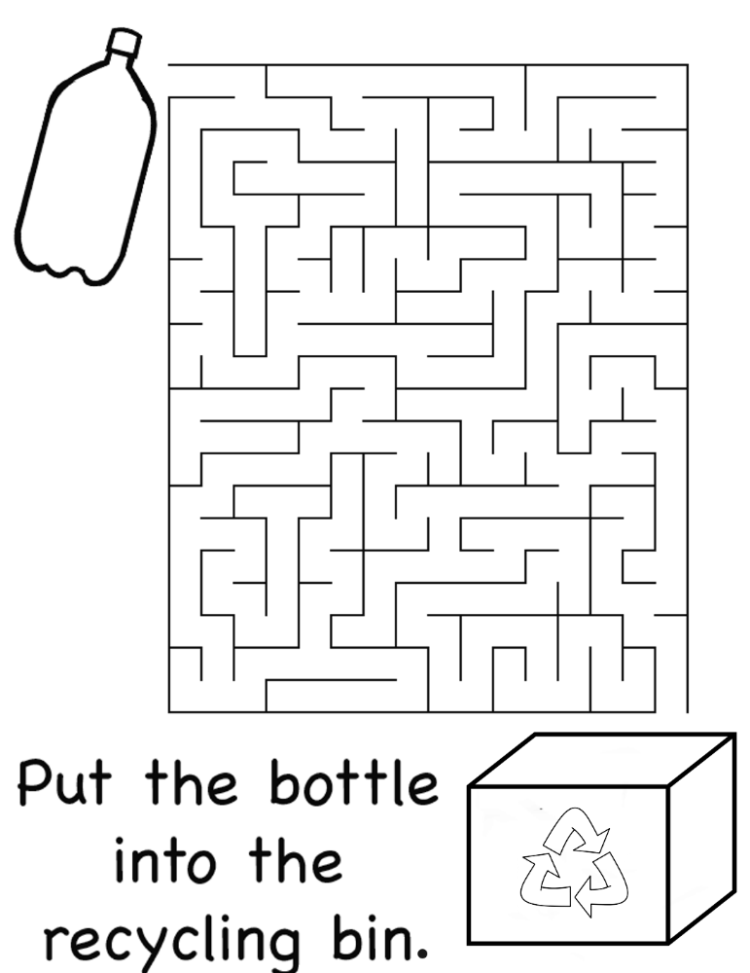
+
New Guidance for Contracting Classified Work

