

GEORGE WASHINGTON BIRTHPLACE
NATIONAL MONUMENT

PRESENTS
How Most of the Plantation Lived: Slavery on the Washington’s Farm
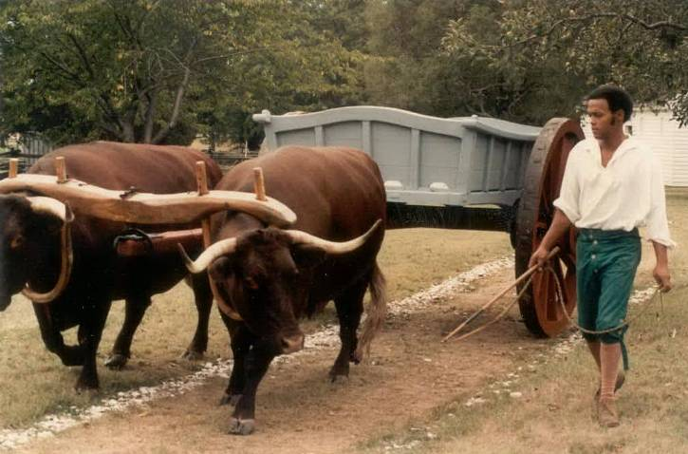

CURRICULUM MATERIALS

Dear Teacher,

Thank you for participating in the educational program, “How Most of the Plantation Lived: Slavery on the Washington’s Farm.” The George Washington Birthplace National Monument developed this special program for 3rd through 5th grade students to meet the Virginia Standards Of Learning and the Maryland Voluntary State Curriculum content standards.

In this program, students will experience the institution of slavery, its social and economic influence on colonial Chesapeake culture, and George Washington’s relationship with slavery through hands-on activities at the park.

Students will explore daily life on a tobacco plantation for a slave by contrasting Master’s and Slave’s time, and investigating slave family and community life through hands-on cultural expression such as music, tobacco field tasks and tools; and the Washingtons’ role as a slave holding family in context of colonial Chesapeake culture.

The pre- and post-visit activities in this teacher guide include math exercises for the planting and economics of tobacco growing; foodways and dietary differences between household slaves, field slaves, and the Washingtons; and comparisons between conditions and seasons for household and field slaves.

We are proud to offer “How Most of the Plantation Lived: Slavery on the Washington’s Farm” to assist teachers in conveying the importance of understanding our history.

George Washington Birthplace National Monument

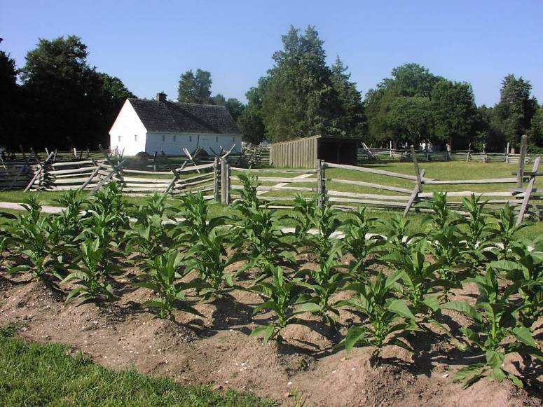

Table of Contents
Preparation Activities
Using This Guide and Student Workbook

- The teacher guide is intended to support the Foundations of Slavery program at the park. It is structured with a sequence of learning activities including pre-visit exercises and follow-up activities.

- The pre-visit activities should be completed in order for the students to better comprehend the Foundations of Slavery program presented at the park.

- Follow-up activities allow students to complete the objectives for the Standards of Learning and to demonstrate their learning.

Park Background 4

A. The Institution of Slavery and Influence
On Colonial Chesapeake Culture 5

B. Slavery in Early VA and MD Colonies 13

C. Tobacco Economy and Triangular Trade 21

Follow-up Activities
D. I’m a Slave! 37

E. Reflections on Slavery 41

F. Interpreting Artifacts 42

Grade 3 – 5 Curriculum Standards Addressed

Virginia Maryland
History and Social Science Social Studies
- 3.2, 3.4, 3.7, 3.8, 3.12 - Grade 3-5: 3.0, 4.0, 5.0, 6.0
- VS.1, VS.3, VS.4, VS.6 Music
English - Grade 3-5: 1.0 1, 2, 3; 2.0 1,2; 3.0 1
- 3.1, 4.1, 5.1 Theater
Music - Grade 3-5: 1.0 2, 2.0 1
- 3.1, 3.4, 3.8, 3.11, 3.14
- 4.4, 4.7, 4.10, 4.14
- 5.4, 5.6, 5.9, 5.12
- MS.3, MS.5, MS.6, MS.8
- IB.1, IB.4, IB.14, IB.15, IB.21

Making Reservations to Visit the Park for the in-park portion of the program

- Please call George Washington Birthplace National Monument, 804-224-1732, x.227, as early as possible and at least a month in advance to make reservations for your class to visit the park for the Foundations of Slavery program.

- The Foundations of Slavery program at the park is 1 ½ hours long. The program accommodates up to 35 students.

- The program is normally available in fall (Sept – Nov) and spring (March – June).

- Please plan to prepare your students for their park visit by using the pre-visit activities.

- Picnic grounds, orientation video, visitor center, bookstore, beach and burial ground areas are also available.

Park Background

Is your mother or father keeping something valuable for you until you are older? Maybe it is your grandfather’s pocket watch that he wanted you to have. It could be your grandmother's necklace or photograph. Your family "safekeeps" this item until you can understand its importance for you and your family. These items tell a story about your family. You will want to keep these "special" family items to pass down to your children.

The National Park Service has the same role your parents do in safekeeping your "special" family items. The National Park Service protects places that have a story to tell about the land, wildlife, or history. These sites are protected because they are “special places” for the people of the United States. The role of the National Park Service has been to protect and preserve (safekeep) these places for the future.

Where George Washington was born is a "special place” for the people of the United States. The birthplace is important because George Washington was the “Father of Our Country.” Visitors have traveled to the birthplace of George Washington since 1815. George Washington Birthplace National Monument became a part of the National Park Service in 1930. Across the United States, almost 400 places that tell a story are in safekeeping by the National Park Service. This means that your children and your children’s children will be able to visit these sites just as you can.

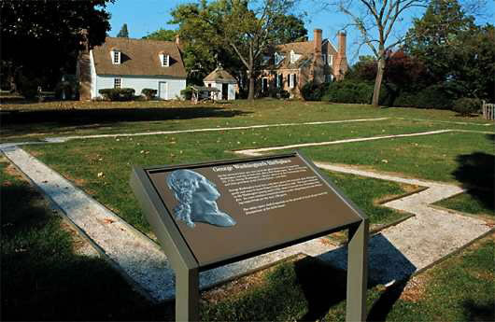

Pre-Visit Preparatory Lessons to be completed before the park visit

Pre-Visit Lesson “A”

Subject: The Institution of Slavery and Influence on Colonial Chesapeake Culture
Time: 1-2 class periods

Objectives: students will be able:
- To describe the institution of slavery and its influence on Colonial Virginia culture.
- To correctly use vocabulary that the students should know prior to their visit to George Washington’s Birthplace, and from the SOLs.

Purpose: To prepare the students for a visit to George Washington’s birthplace and give the students a basis of understanding of what they will see and do during their field trip.

Materials:
Pre-visit lesson plan
Large piece of paper
KWL chart
Vocabulary sheet
Highlighters for each child
Index cards (set for each student)
Introduction to Slavery reading
Classroom Map

Procedure:
Opening - KWL chart
- Preparation. Tell the children you are going on an exciting field trip to George Washington’s Birthplace in Westmoreland County, Virginia. Ask the students to locate Westmoreland County on a Virginia Map and review north, south, east, and west.
- KWL Chart. Create a KWL chart. Ask the students to list what they know about slavery and what they want to know. Organize their knowledge on a large sheet of paper. Also provide the students with individual student KWL charts. Students fill their KWL charts in with your guidance. Students keep the KWL charts in their folders to use for the post-lesson.
- After the class completes the appropriate sections of their KWL chart, distribute the vocabulary sheets. Review the vocabulary and the definitions with the class.
Introduction to Slavery Reading
- Reading. Distribute the reading and ask students to use a highlighter to pick out key words from the SOLs that have been covered, and vocabulary words. As you read to the class, pause at key ideas or key words and ask students to highlight those items. Pause and discuss the items as appropriate.
- Discussion Questions. Discuss the questions at the end of the reading as a whole class.
- Guide students in adding any new information learned from the reading to the KWL chart.
Vocabulary Flash Card Game
- Vocabulary flash card preparation. Give the children index cards to make vocabulary flash cards. On one card write the word and on the other card write the definition. Write the number of the definition in the top right hand corner of both the word and the definition card. For example:
1

Slave
1.
A person forced to work for another: in former times, one person who was forced to work for another person for no payment and was regarded as property.

NOTE: You can choose to do all cards or can choose to do a few at a time. The recommendation is to take a few definitions at a time and gradually add to the game.
- Vocabulary game. When the children have completed the cards divide the class into teams of four and play a game with the vocabulary. Students may use the vocabulary sheet with the definitions to assist them in the game. There should be one set of cards for each group. Turn all cards facedown and each child turns over a card. The child turns the card back over and tries to remember where the card is located. This continues until the child can match the word with the definition. The child with the most card sets is the winner of the game. This game is based on the idea of the Memory Game, but uses the vocabulary presented in the lesson.
Closure
- Review concepts of the day. Go back to the KWL chart and ask the children to remember what they will be looking for on their field trip and a question they would like to ask when they visit the site. Tell the children they will soon visit the George Washington Birthplace.

George Washington Birthplace Foundations of Slavery KWL Chart

K W L

What I know What I want to know What I have learned

Directions: Use your vocabulary sheet to highlight key ideas and key words as you are reading with the class. Raise your hand if you have any questions about the information you are reading. Remember to look for information to add to your KWL chart!
Introduction to Slavery
Imagine what it would be like to lose your freedom. The first Africans in the Chesapeake colonies were brought to Jamestown in 1619. These Africans were probably servants, and worked in the tobacco fields along with white servants.
Work was hard for servants, but at the end of a period of years, they could become free and work for themselves. Even so, the white servants came by choice. The black servants were most likely forced into servitude and into coming to the colony.
At that time, slavery already was well established throughout the Caribbean and Central and South America. The loss of freedom often started when Africans were kidnapped and sent by ship across the Atlantic Ocean to the Americas. Latitudes are the lines going horizontally across maps and globes that divide them into equal divisions. Because slave ships sailed in the middle latitudes, the Africans’ long, terrifying journey was called the Middle Passage.
Slavery was when someone else had control over a person’s life without their consent, and they were held against their will for their whole life. It was when someone owned another person, as if they were property. A slave was made to work, did not have a choice and their freedom was taken against their wishes.
As time passed, less white people agreed to be servants, but the planters still needed human resources to work in the fields and produce goods. The laws changed to limit the freedoms and choices of African servants. Rules were made so Africans could not carry guns, marry who they wanted, or do business, whether they were free, servant, or slave.
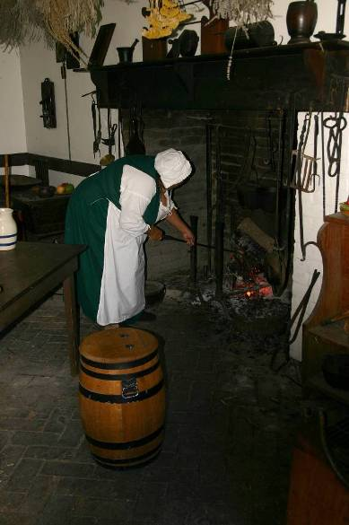
Some people began to think all people with dark colored skin were slaves. Sometimes, Native Americans were kidnapped and forced to work because they had dark colored skin. The tribes the Native Americans belonged to would rescue them and it was hard to keep Native Americans in slavery. Africans were a long way from their homeland and any potential rescuers, so it was easier to keep them enslaved.

Slaves’ loss of freedom provided the labor for plantations. Slaves were human resources because they were used to do work or make a product. Slaves did many kinds of work on plantations, such as working in the house of a wealthy person, cooking, weaving, or working in the fields. Some were skilled craftsmen who made tools, barrels, shoes, bricks or other products needed on the plantation. Others were employed as lumberjacks, dockworkers, and ironworkers. The tools and workshops needed to perform these crafts are known as capital resources.
Planters who owned slaves made an economic choice to pay money to buy a slave instead of using their money for other things they needed or wanted. This is called opportunity cost. Planters counted on the value of the slave’s labor to make up for the money they had to pay to buy the slave.
Plantations owners in southern colonies especially turned to slaves as the human resources they needed to work their plantations. There were also slaves in the northern colonies, but not as many.
Different areas specialized in different natural resources to grow to trade or sell. People who grow crops are called producers. They focused on growing one crop to sell, often using the labor of slaves, who did not have a choice. In the Caribbean, slaves were used to grow sugarcane. In the Carolina colonies, slaves grew rice, indigo (a plant used for blue dye) and sea-isle cotton.
The Chesapeake colonies of Virginia and Maryland specialized in growing tobacco to sell and trade. Later, they grew more grain, hemp (plant used for rope), and flax (plant used to make linen cloth) and raised animals. Because there are so many tasks involved in growing tobacco, there was a greater need for labor. The slavery system became entrenched by the late 1600s when more and more colonists were growing tobacco.
Not all white people who lived in the south owned slaves or thought slavery was acceptable. Slaves cost a lot of money and many poor people could not afford to buy slaves. Wealthier colonists had enough money, or capital resources, to buy slaves. The wealthy people who owned slaves said that equality was based on the color of a person’s skin. We know that this is not true today, but in the 1700’s people had different beliefs.
Profits for some meant loss of liberty for others. There were not as many slaves in the northern colonies as there were in southern colonies. However, some Northern businessmen still profited from slavery. Some made money building the ships that carried kidnapped Africans across the Atlantic Ocean or by supplying the rough cloth that slaves wore. In New England, businessmen made rum to trade for Africans to be brought to this country to be sold as slaves.
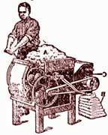
Even if African Americans lived in the North they did not always have an easy life. African Americans, whether free or slave, were segregated and were could not go to the schools, churches, or neighborhoods they wanted. African Americans could not vote or in some places, own property. In both the North and South, Africans had limited freedom.
The Fugitive Slave Act of 1793 was a law that said slaves were the property of the men that owned them. Today we own property such as a car, house, land, clothes, or toys. This law said that the slave was the property of another person.
In 1794, Eli Whitney invented a machine called the cotton gin. This machine separated the cotton fiber from the seeds much faster than it could be done by hand. Southern plantations specialized in growing cotton and when the cotton gin was invented there was a need for more people to pick cotton. The invention of the cotton gin meant the slavery system that had become so widespread when tobacco growing increased would not stop: now the plantation owners needed even more human resources to pick cotton.

Today George Washington is a symbol of our country’s freedom from England, but he lived with slavery from his youngest years. The Washingtons were slaveholders, so young George was raised around slaves. At first he seemed to think about slaves as property, like most white people did at that time. As an adult, when his slaves ran away, Washington advertised and tried hard to get them back. Washington’s views toward his slaves may have changed throughout his life. During the Revolutionary War, his trusted slave William Lee fought by Washington’s side. When he died, Washington left instructions in his will for his own slaves to be freed after his wife Martha died. Very few of the founding fathers or other people of his time did this.

Choices and freedoms are something we value in America today. Slavery ended in this country during the Civil War in the 1860s. There was dishonor in the system, but it’s part of our country’s past, and shaped our country’s development.

Questions for class discussion:

- If you were to lose your freedom, what would you miss the most?

- How did slavery affect the opportunities that George Washington had in life?

- George Washington was trying to set an example by freeing his slaves when he died. What do you think people of his time thought of his example and why?

Slaves George Washington inherited
George inherited 10 of the following 15 slaves when he was 11 years old:
Ned Dick Toney Steven Jo London Hannah
George Jcumy Jack Judy Nan Betty Jenny
Phillis

From George Washington’s Will, 1799

“Upon the decease of my wife, it is my Will & desire that all the Slaves which I hold in my own right, shall receive their freedom.”

Vocabulary Sheet
- Banjar: African banjo-type instrument made from gourd, with wooden neck and strings added.

- Bell: African percussion instrument, often played with a stick. May be a double or single bell.

- Capital Resources: machines, tools, and buildings used to produce goods and services. The hoes the slaves used to work in the fields are examples of capital resources.

- Colony: a country or area that is ruled by another country

- Cotton: a bush producing soft white downy fibers and oil-rich seeds.

- Cotton gin: machine invented by Eli Whitney in 1793 to separate cotton fibers from the seeds. It was an important machine in the history of slavery because it increased the production of cotton and which increased the need for slave labor.

- Craftsman: a person who makes decorative or practical objects skillfully by hand. An example of a craftsman is an ironworker.

- Djembe: West African drum, hour-glass shaped, played with the hands.

- Economic Choice: how a person chooses to spend his or her money or resources. Some men made an economic choice to buy a slave.

- Fiddle: wooden stringed instrument, descended from African banjar instruments. Today some versions are called violins.

- Flax: the plant that is used to make the fiber cloth called linen.

- Foodways: Foods from a particular culture. Includes ways that certain foods are traditionally made or served, and foods that are traditionally served at special times.

- Hoe: garden tool used for weeding or turning over soil. It is a compound machine that has a long pole (lever) and a small flat metal blade (wedge) set into one end of the pole.

- Human Resources: human resources are people at work. The slaves were human resources because they worked and produced a good or service.

- Interdependence: depending on others in the production of goods and services. The colonies were dependent on England for refined goods such as spices, fine clothing, glass and medicines. England depended on the colonies for raw materials such as tobacco, and further south, rice, indigo (a dye) and cotton.

- Master: boss or person in a position of authority, for example, over a business, slave, servants, or an animal.

- Master’s Time: the time of the slave’s day when he or she worked for the master.

- Middle Passage: journey across the Atlantic Ocean from Africa in slave ships.

- Natural resources: things found in nature such as water, soil, wood, and coal. Slaves used their knowledge of natural resources such as soil and land to produce crops.

- Negro: the term used for a black person in historical times.

- Okra: a vegetable from Africa that is used in soups and stews to make it thicker.

- Opportunity Cost: something given up when making a choice of what to buy. Money masters paid to buy slaves couldn’t be spent on other items the planter needed or wanted. So the opportunity cost was the other items the planter couldn’t buy because they bought slaves.

- Plantation: a large estate or farm where crops such as tobacco, rice, cotton, coffee, or tea are grown.

- Producer: a person, company, or country that produces goods or services for sale.

- Quarters: a living space: a building or rooms where people live, especially military personnel or servants.

- Shekere: African percussion instrument made from gourd with a net of beads strung over it.

- Slave: a person forced to work for another: in former times, one person who was forced to work for another person for no payment and was regarded as property.

- Slave’s Time: the time of the day when the slave was not doing work for the master.

- Specialization: being an expert in one job. Could also mean a plantation that grows only one cash crop, such as tobacco.

- Tobacco: a plant grown for its leaves for smoking. It was used as money in colonial days.

- Yams: vegetable that resembles a large white potato and is the root of a tropical vine.

- Wool: yarn spun from the short curly hair of sheep or other mammals, used in knitting or weaving. Sometimes the sheep are killed to get the wool, other times it’s shorn off while they’re alive.

Pre-Visit Lesson “B”

Subject: Slavery in Early Virginia and Maryland Colonies
Time: 1 class period

Objectives: students will be able to:
- Complete a sequence chart for the beginnings of slavery in America.
- Compare and contrast the life and lifeways of slaves and planters.
- Identify the importance of the arrival of Africans to early Jamestown

Purpose: To introduce students to the beginnings and defining characteristics of slavery. To help students gain a rudimentary understanding of the life of a slave and planter in early Virginia. To help students understand the relationship of the colonial tobacco economy and slavery.

Materials:
Sequence chart
Venn Diagram
Colonial Slave Life and Colonial Slave Housing and Community Life readings
Planter Life and Colonial Planter Housing and Community Life readings

Procedure:
Opening - Sequence Chart
1. Preparation. Explain the following reasons for English colonization in America:
- England wanted to establish an American colony to increase her wealth and power,
- England hoped to find silver and gold, and
- An American settlement would furnish raw materials that could not be grown or obtained in
England, while opening new markets for trade.
As a result, explain that the first permanent English settlement in America was Jamestown, founded
in 1607 as an economic venture.
- Colony: a settlement ruled by a distant country
- Raw materials: resource in its natural state, such as wood, that can be used to manufacture a product.
- Trade: the buying or selling of goods.
- Economic: of or relating to money matters or concerns.

2. Tobacco: John Rolfe, a colonist, began to grow a new kind of tobacco that proved to be very popular in
England. Consequently, tobacco soon became a valuable cash crop.
  - Cash Crop: a crop people grow to sell rather than to use themselves.

3. Slavery: Explain that Africans arrived in Jamestown against their will in 1619. It is believed that they
were taken forcibly from their homes in Africa, and arrived as baptized Christians and therefore were labeled indentured servants. In reality, their servitude closely resembled slavery. The popular conception of a race-based slave system did not fully develop until the 1680's.
  - Indentured Servants: a person who agrees to work without pay for a certain length of time in
exchange for some benefit.

4. Explain: The success of tobacco as a cash crop transformed life in the Virginia colony and encouraged
slavery. In 1661, the Virginia General Assembly legalized slavery.

5. Explain how the successful planting of tobacco depended on a reliable and inexpensive source of labor.
As a result, large numbers of Africans were brought to the colony against their will to work as slaves
on the plantations. Furthermore, the Chesapeake colonies became dependent on slave labor, and the
dependence lasted a long time.
  - Plantation: a large farm.

6. Sequence Chart. Distribute the sequence chart. Ask students to complete the sequence chart using the
following events:

John Rolfe begins to grow a new kind of tobacco in Virginia.

England wants to establish an American colony to increase her wealth and power.

The Virginia General Assembly legalizes slavery.

Africans arrived in Jamestown against their will.

The first permanent English settlement in America is founded at Jamestown.

Slave Life Comparison
7. Read Colonial Slave, Colonial Slaves’ Housing and Community Life, Planter Life, and Colonial
Planter Housing and Community Life readings to or with your students.

Venn Diagram
8. Venn Diagram. Ask students to complete the Venn Diagram comparing and contrasting the life and
housing of slaves and planters.

9. Ask students to share their Venn Diagram with the class. Optional- while the students are sharing,
incorporate some of their elements into a larger Venn Diagram or chart on the board or overhead transparency.

Closure
- Review concepts of the day. Looking at the Venn Diagram, ask the children to remember what
differences they will be looking for in slaves’ and planters’ lives on their field trip.
Sequence Chart

1.

2.
3.

4.
5.

Colonial Slave Life
Work is a relentless part of life if you are a slave. The daily life of colonial slaves was usually hard. Slaves were often only given the bare essentials for life: a place to sleep, basic clothing, and enough food to keep them healthy enough for work. They worked six or seven days a week from sun-up to sun-down, from "can see to can't see" in slave's lingo. Slaves were worked as hard as a body can physically tolerate to ensure a good crop.

Being a slave does not mean you had no skills. Slaves on plantations such as the one at Popes Creek where George Washington was born, were agricultural and skilled workers. Africans brought numerous skills from their native lands, including agricultural experience. In the Chesapeake colonies, most new African slaves arrived between June and August when tobacco plants had been moved from the seedbeds and were growing in the fields. The slaves’ first task was to weed between the tobacco rows, using their hands, axes, or hoes. Field laborers’ daily lives were determined by agricultural rhythms. On large plantations, slaves were divided into groups depending on their abilities. Tobacco, however, could be grown profitably on smaller plantations, where an overseer directed small groups of slaves.

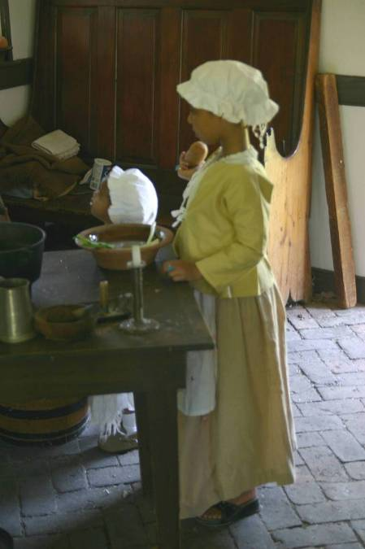
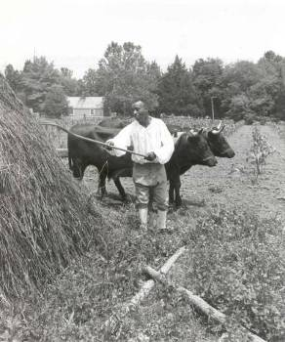
When George Washington was a boy, in addition to agricultural workers, plantations had many skilled workers. Although most black women were field hands, by the 1770's a small but growing number were employed in weaving, making clothes, dairying, and household and child care. Black men had already become more diversified, joining white artisans as skilled craftsmen. Initially, many of these Africans had learned their trade through an apprenticeship. As the number of African blacksmiths, carpenters, coopers, shoemakers, tanners, spinners, weavers and other artisans grew on the plantations, these slaves were increasingly able to train their fellow slaves, often passing along skills to their children or kinsmen. These slaves’ skills and talents made the plantation economically self-sufficient.

Today we try to make things fair for everyone, but in colonial times opportunities were limited for slaves. Slave children did not attend school because of special laws in the colonies that outlawed slaves from being taught to read and write. Instead, the slave children usually began to work part-time in the tobacco fields around the age of seven. Tasks for children varied greatly from plantation to plantation; often, they spent the rest of their day running errands, watching the younger children, doing odd jobs, or playing.
Colonial Slave Housing and Community Life
How do you feel when you’re treated differently than someone else? In colonial times, slaves were not always treated the same. Even on the same plantation, slave quarters varied considerably. Separate quarters were a luxury generally enjoyed only by favored house slaves or those with special skills or duties. Household and skilled slaves often lived in a quarter near the main house complex, generally in better constructed dwellings than those provided for the average slave. As a boy, George Washington probably was cared for by the household slaves and knew them well. Other slaves lived in quarters out of sight of the main house. Although their dwellings were usually more primitive, field slaves at least enjoyed a certain measure of privacy from the constant intrusion of their master and his family.

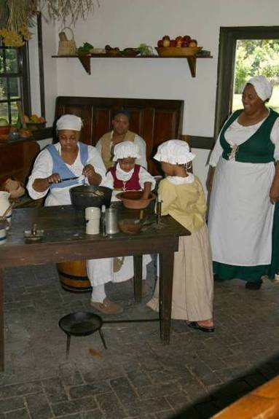
Family is something we’re all born with. For most of the colonial period, slaves increased in number by having children at about the same rate as whites. Relationships between male and female slaves were encouraged and something resembling marriage or a family unit was occasionally recognized; however, masters could choose to sever marriages because of economic and other conditions. Splitting up and selling partners and children away from the plantation to another location was common. As an adult, George Washington determined that he would not split up slave families.

Family units generally occupied slave quarters, although this was not always the case. The houses in a typical quarter formed what sometimes appeared to be a small village. Most slave houses were very small, with one room and possibly a loft above. There was usually a wooden chimney lined with clay and a dirt floor. The slave holder spent little time or expense outfitting these dwellings. A built-in bed was common, and sometimes the only, comfort provided.

Every cultural group has customs. When African slaves first arrived in the colonies, their customs often clashed with those of the planters. Slaves’ religion, foods, weaving, arts, medicine and speech was different than that of their masters’ families. By maintaining elements of African culture and customs, slaves built a sense of community and self worth. By using their skills, some slaves developed a spirit of self-reliance and a measure of autonomy. Eventually, the different cultures adapted to each other. Slaves often picked up colonial speech, manners and lifeways, while elements of slaves’ traditional African crafts, skills, speech, superstitions and ideas became part of colonial culture. When George Washington was young, slave culture in the Chesapeake region still had many elements of African culture and customs.

Slaves knew how to make musical instruments from materials found in nature in Africa, such as gourds and logs. Slaves were able to continue their traditions by making similar instruments with materials found in the colonies. Call and response songs, intricate rhythms, dancing and group participation were popular. Storytelling, legends, folklore and songs helped slaves remember their history and culture, and songs set the pace of field work.

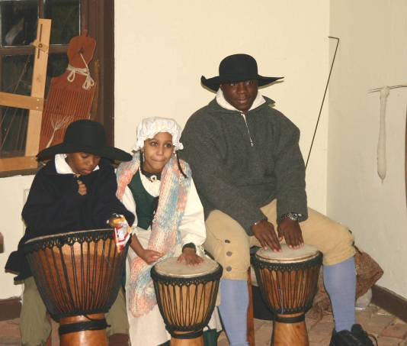
How do you learn the skills to survive? African agricultural techniques that slaves taught planters helped planters survive in the colonies. Slaves taught planters how to grow foods grown in Africa, such as rice, yams, beans, peanuts and millet. One-pot meals such as stews that could simmer over a low fire all day and be eaten after the day’s work was done were common. Eventually these elements of African and slave culture influenced the culture of the colonies. For example, today peanut soup, roasted sugared yams and sweet potato pie are popular southern foods. These influences became part of who we are today.

Colonial Planter Life
What responsibilities do you have today? George Washington’s family were planters. The main responsibilities of the planter's family was to watch over the work of the servants and slaves, to make sure the plantation was run well, and to serve in public service positions such as the House of Burgesses. The planter saw that crops were planted, harvested, stored, and shipped. He kept records in order to run the plantation like a successful business.

The planter's wife had the same responsibilities as other colonial women. She ran the household and supervised the care of the plantation's slaves. It was up to the planter’s wife to see that everyone had food, clothing and medical care. Sometimes a plantations slaves numbered in the hundreds. When George Washington was a boy, his father owned 20-25 slaves at the Popes Creek plantation. George inherited 10-11 slaves when he was just 11 years old. As an adult, George Washington owned over 300 slaves, more than anyone in his county.
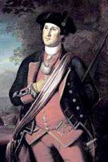
An important responsibility for children today is to study hard to get a good education. In colonial times, there were few schools in the southern colonies because people lived so far apart. As a result, large plantations had their own small schools. The planter's children were taught basic reading and writing. Planters often hired teachers from Europe to teach their children. When children were about 12 or 13 years old, they attended special town schools. After that, wealthier boys such as George Washington’s older half-brothers often went to college in Britain or in the colonies. The planter's daughters were taught basic reading and math, and how to take care of a plantation household. By age 12 or 13, girls stopped going to school.
Colonial Planter Housing and Community Life
What symbols of wealth and prestige do you wish for today? A nice car, big house, distinguished career? In colonial days, plantations were laid out with formal gardens and landscape designs borrowed from English manorial estates. Planters aspired to the gracious lifestyle of landed British gentry, and gleaned ideas from English country estates and architectural books as they designed their houses. Mansion houses were typically surrounded by gardens and landscaped grounds that heightened the visual effect of their elegance and importance. Most had several service buildings close by. These included barns, stables, workshops, and dwellings and gardens for slaves who worked in the mansion and on the grounds surrounding it. From the big house, masters and mistresses kept watch over the plantation to ensure that everything ran smoothly.

The big house, usually a two or three-storied mansion, was a visible symbol of the planter’s wealth. A wide entrance hall might lead into a dining room, a parlor, a library, and one or more sitting rooms. Here a planter could display wealth with European furnishings and imported artwork. On upper floors, bedrooms for family members and guests contained the most comfortable and luxurious decor available. Nurseries for planters’ children were on the uppermost floors, reached by the servant’s stairs at the back of the house. In addition to providing housing, plantation houses also reflected colonists’ difference in status.

The Memorial House at George Washington Birthplace was built to look like a typical planter’s mansion. When George Washington was born at Popes Creek, his family lived in a smaller plantation house. You will see the foundation of this house when you visit the park.

In colonial days, many aspects of daily life and culture provided opportunities to display your status. The planter’s family ate fancier foods than the slaves, and larger portions. The planter’s wife kept expensive items like sugar and spices locked up until the cook needed them, to make sure no one took extra. The musical instruments that the planter’s family played, such as expensive harpsichords and violins, were often brought by ship from England. By not allowing such refined goods to be made in the colonies, England was able to keep the profit from producing the goods for themselves. George Washington did not play an instrument, but he loved music and dancing, which he did often. Classical music, and Virginia reels (line dances) were popular with planters in his time.
Questions for class discussion:

1. What makes up someone’s culture?

2. How did slaves affect the culture of the colonies?

3. How did the culture of the colonies affect slaves’ culture?

Venn Diagram

Slaves
Planters

Pre-Visit Lesson “C”

Subject: Tobacco Economy and Triangular Trade
Time: 1 – 2 class periods

Objectives: students will be able:
- To analyze and interpret maps of the Triangular Trade routes, West Africa and the Chesapeake to explain the importance of shipping and trading to economies of the Chesapeake colonies.
- To draw conclusions about advantages and disadvantages to economic specialization and interdependence as they relate to tobacco as a cash crop.
- To draw conclusions about cause and effect relationships among the tobacco economy and slavery.

Purpose: To introduce and help students understand concepts of economic specialization and interdependence, triangular trade and the kingdom of West Mali, and the relationship of the colonial tobacco economy and slavery.

Materials:
Map of Africa
Map of West African Slave Trading Ports
West African Slave Trading Regions Fill-In Story – teacher and student versions
Highlighters
Map of the Original 13 Colonies
Map of the Chesapeake
Chesapeake Colonies Mapping Worksheet – teacher and student versions
World Map
Triangular Trade Activity
George Washington and Plantation Economy Worksheet - teacher and student versions
Classroom atlas (not provided)
Virginia and Maryland state highway maps, or other maps showing Northern Neck, Potomac River,
Chesapeake Bay and state names (not provided)

Procedure:

Opening - West Africa Slave Trading Regions
- Slave Trading Regions Fill-In Story: Explain that slaves in the colonies came from West Africa. Pass out the Map of Africa, the Map of West African Slave Ports, and the West African Slave Trading Regions Fill-In Story activity. The maps will be used during the story activity. Ask students to work in pairs or complete the activity as a class, reading the story and filling in the blanks as you come to them with words from the Word Bank.

Triangular Trade
3. Discuss why map reading skills were important in colonial times and why they are important today.

4. Mapping: Distribute copies of the Map of the Original 13 Colonies, the Map of the Chesapeake
Colonies and the Chesapeake Colonies Mapping Worksheet. Students may work individually or in pairs to complete them. Discuss answers as a class before continuing.

5. Drawing triangular trade routes: Distribute copies of the World Map and Triangular Trade Activity
sheet. Students may work individually or in pairs to complete them. Discuss answers as a class before continuing.

6. Classroom discussion: Discuss these questions as a class.
  - Why was shipping and trading, such as the Triangular Trade, so important to the colonies’ economic development?
  - What role did tobacco and the Triangular Trade have in the development of the slavery system in the American colonies?
  - Just like tobacco in the North American colonies, the sugar industry was critical to developing the slavery system in the Caribbean islands. Both required a lot of labor.
    - Was it possible for the colonial tobacco and sugar industries to survive without slave labor?
    - Was it possible for the Triangular Trade to survive without tobacco and sugar?

Tobacco Economy, Economic Specialization and Interdependence
7. Explain specialization and interdependence.
- Economic specialization: Growing only one cash crop for sale, such as tobacco.
- Interdependence: depending on others in the production of goods and services. The colonies were dependent on England for refined goods such as spices, fine clothing, glass and medicines. England depended on the colonies for raw materials such as tobacco, and further south, rice, indigo (a dye) and cotton.

8. Ask students to look at the triangular trade routes they drew on their World Maps. Ask them to explain
how the different countries involved in the triangular trade were interdependent – which countries were dependent on which other countries for what products or services?

9. Expansion of slavery in the colonies: Explain that growing tobacco is very labor intensive, requiring a
great deal of hand labor every month of the year. The increase in growing of tobacco in the Chesapeake colonies in the late 1600s increased the need for a cheap source of human capital or labor, which greatly expanded the slavery system in the colonies.

10. George Washington and Plantation Economy worksheet: Distribute copies of the worksheet for
students to complete in pairs. After they finish, discuss the answers with the class.

Closure
- Review concepts of the day. Looking at the worksheets and maps, ask students to think about the
relationships among triangular trade, tobacco economy and slavery. Ask students:
  - What evidence they think they might see of these relationships on their field trip
  - How they think George Washington and his society fit into these relationships

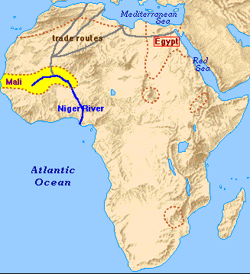
Map of Africa
Map of West African Slave Ports

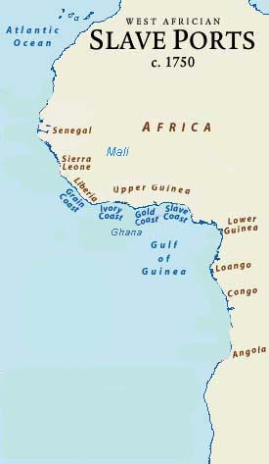

West African Slave Trading Regions Fill-In Story – Teacher’s Answers
Colonial slavery was tied to West Africa through trade. Slaves were brought to the Caribbean Islands from West Africa to work on sugar plantations by the 1500s. As tobacco production in the Chesapeake colonies of North America expanded in the late 1600s, the need for an inexpensive human resource for labor also expanded. To fill this need, colonists turned to West Africa.

Using your Map of West African Slave Ports, find and highlight the name of each of these kingdoms and countries where slaves came from:
Ghana Mali Ivory Coast Gold Coast
Guinea Slave Coast Senegambia Sierra Leone
During and before the colonial times, some of these areas such as Ghana and Mali were kingdoms run by kings that later became modern countries.

West Africa had its own cultures. Storytelling was part of West African culture. It was a way of sharing information, entertainment and passing history from one generation to another. “Griots” is the term used even today in Mali for storytellers, musicians and historians who retold their country’s history. It means “Keeper of Memories.” Our current knowledge of the history of this region comes largely from such storytellers.

Just as trading became important to the economy of North American colonies, trading was also important to the economy of West Africa. Each country had resources, such as salt, gold or human labor. They usually had plenty of some resources and not enough of others, so they traded. Many West African counties that had gold were on trade routes that ran north across the Sahara desert to the salt mines and Mediterranean Sea, and east to Egypt. The kingdom of Mali had gold, but not much salt to preserve their food. Salt was needed in days before refrigerators to make food last longer. It could be traded for gold. Look at your Map of Africa: the trade routes from Mali could be traveled by camel across the desert, or by boat on rivers to the ocean.

The slavery that already existed in Africa became an object of trade in colonial times. In West Africa people were often captured in wars and made to be slaves. The Caribbean sugar trade in the 1500s and the Chesapeake colonies’ tobacco trade in the 1600s created a market for selling and buying of slaves. Slaves were traded to the slave ships for tools, guns and manufactured products that were in short supply in most West African countries. Trading in slaves was an economic choice for the countries involved.

It was time for change. By 1808, the colonies in North America stopped importing slaves from Africa. Britain and other countries had banned slave trade. Slavery still existed in the colonies, but it was not legal to import slaves from other countries. The slave trade ended, but slavery continued until the Civil War.
Word Bank
Trade Routes Slaves Kings Sahara Importing
Storytelling Trading Tobacco Civil War Caribbean
Mediterranean West Africa War Musicians Salt
Economic Choice Gold Importing Camel Rivers
Manufactured Products Human
West African Slave Trading Regions Fill-In Story
Colonial slavery was tied to West Africa through trade. Slaves were brought to the _________ Islands from West Africa to work on sugar plantations by the 1500s. As _______ production in the Chesapeake colonies of North America expanded in the late 1600s, the need for an inexpensive _____ resource for labor also expanded. To fill this need, colonists turned to ____ ______.

Using your Map of West African Slave Ports, find and highlight the name of each of these kingdoms and countries where slaves came from:
Ghana Mali Ivory Coast Gold Coast
Guinea Slave Coast Senegambia Sierra Leone
During and before the colonial times, some of these areas such as Ghana and Mali were kingdoms run by _____ that later became modern countries.

West Africa had its own cultures. ____________ was part of West African culture. It was a way of sharing information, entertainment and passing history from one generation to another. “Griots” is the term used even today in Mali for storytellers, _________ and historians who retold their country’s history. It means “Keeper of Memories.” Our current knowledge of the history of this region comes largely from such storytellers.

Just as trading became important to the economy of North American colonies, _______ was also important to the economy of West Africa. Each country had resources, such as ____, ____ or human labor. They usually had plenty of some resources and not enough of others, so they traded. Many West African counties that had gold were on _____ _____ that ran north across the _______ desert to the salt mines and _____________ Sea, and east to Egypt. The kingdom of Mali had gold, but not much salt to preserve their food. Salt was needed in days before refrigerators to make food last longer. It could be traded for gold. Look at your Map of Africa: the trade routes from Mali could be traveled by _____ across the desert, or by boat on ______ to the ocean.

The slavery that already existed in Africa became an object of trade in colonial times. In West Africa people were often captured in ____ and made to be slaves. The Caribbean sugar trade in the 1500s and the Chesapeake colonies’ tobacco trade in the 1600s created a market for selling and buying of ______. Slaves were traded to the slave ships for tools, guns and ___________ _______ that were in short supply in most West African countries. Trading in slaves was an ________ _____ for the countries involved.

It was time for change. By 1808, the colonies in North America stopped _________ slaves from Africa. Britain and other countries had banned slave trade. Slavery still existed in the colonies, but it was not legal to import slaves from other countries. The slave trade ended, but slavery continued until the _____ ___.
Word Bank
Trade Routes Slaves Kings Sahara Importing
Storytelling Trading Tobacco Civil War Caribbean
Mediterranean West Africa War Musicians Salt
Economic Choice Gold Importing Camel Rivers
Manufactured Products Human
Map of Original 13 Colonies
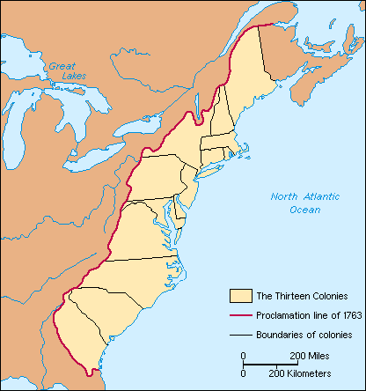

Map of Chesapeake Colonies
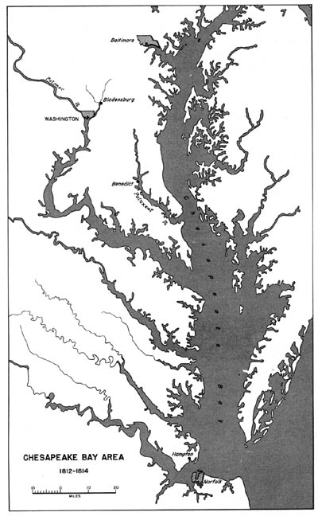

Chesapeake Colonies Mapping Worksheet – Teacher’s Answers
You should have 2 maps.
Look at the Map of the Original 13 Colonies.
1. Label each of original 13 colonies. You may use a classroom atlas if needed.

Look at the Map of the Chesapeake Colonies. This map is from the year 1812.
The map was drawn after the city of Washington D.C. was built.

2. Who is Washington D.C. named for? (George Washington)

3. Find Washington D.C. on the map. What river is the city beside?
(labeled on the map – Potomac River)
4. Find the body of water that the Potomac River flows into. What’s its name?
(Chesapeake Bay, labeled)
5. Find the Northern Neck of Virginia. This is where George Washington was born.
The Northern Neck is the peninsula just south of the Potomac River. It’s not labeled on your map, so write it in. (May or may not be labeled on modern highway maps).
6. Use a modern highway map to find and mark the location of George Washington
Birthplace National Monument.

7. Use a modern highway map to find and mark the location of your own town.

8. What was the advantage was of living along a waterway? (Hint: think about how
people traveled in colonial times). (easy transportation access, shipping and trading).

9. Use a modern highway maps to label the states of Virginia and Maryland.

10. What river separates Virginia from Maryland?
(Potomac River – it was a very important shipping lane in colonial times. Ships from England came
up the river to plantations like the one where George Washington was born, loaded with goods that
colonists bought with the credit they got from their tobacco crops).
Shipping and trading were important to the economic development of the colonies.
Triangular Trade between the American colonies, Africa and Europe was a significant
example.
Each country has different natural resources. Countries often have more of a particular
product than they need, but don’t have enough of other products.
By shipping and trading each country can get items they need: they sell some goods so they
have the money or credit to buy other types of resources and goods they don’t have.

11. What are some resources and goods that countries ship and trade today?
Chesapeake Colonies Mapping Worksheet
You should have 2 maps.
Look at the Map of the Original 13 Colonies.
1. Label each of original 13 colonies. You may use a classroom atlas if needed.

Look at the Map of the Chesapeake Colonies. This map is from the year 1812.
The map was drawn after the city of Washington D.C. was built.

2. Who is Washington D.C. named for?

3. Find Washington D.C. on the map. What river is the city beside?

4. Find the body of water that the Potomac River flows into. What’s its name?

5. Find the Northern Neck of Virginia. This is where George Washington was born.
The Northern Neck is the peninsula just south of the Potomac River. It’s not labeled on your map, so write it in.

6. Use a modern highway map to find and mark the location of George Washington
Birthplace National Monument.

7. Use a modern highway map to find and mark the location of your own town.

8. What was the advantage was of living along a waterway? (Hint: think about how
people traveled in colonial times)

9. Use a modern highway maps to label the states of Virginia and Maryland.

10. What river separates Virginia from Maryland?

Shipping and trading were important to the economic development of the colonies.
Triangular Trade between the American colonies, Africa and Europe was a significant
example.
Each country has different natural resources. Countries often have more of a particular
product than they need, but don’t have enough of other products.
By shipping and trading each country can get items they need: they sell some goods so they
have the money or credit to buy other types of resources and goods they don’t have.

11. What are some resources and goods that countries ship and trade today?
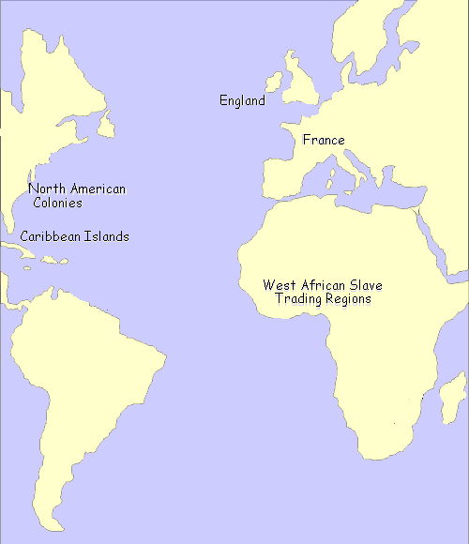
World Map

Triangular Trade Activity
1. Find these triangular trade points on the World Map:
England Caribbean Islands West African slave trading region
France North American colonies

2. Below is a list of resources and the countries or colonies where they were found or produced in large supply. Mark the names of these resources on their corresponding countries or colonies on the World Map:
Resource Country or Colony
Tobacco Virginia and Maryland colonies
Sugar, Molasses Caribbean Islands
Rice, Indigo (dye) Carolina and Georgia colonies
Rum, Iron New England colonies
Slaves West coast of Africa
Manufactured goods, tools & guns England, France

3. Today we know that people should not be treated like products. In colonial times some people thought it was ok to treat slaves that way, but today we know that is not acceptable.

Draw arrows on your World Map to show where countries that needed the resources below could get them shipped from:
England needs sugar. France needs tobacco.
France needs iron. England needs rum. France needs molasses. France needs rice. England needs tobacco. England needs indigo.
West Africa needs guns and tools. West Africa needs manufactured goods.
Virginia and Maryland need manufactured goods and tools.
The Caribbean Islands need people to work on sugar plantations.
Virginia and Maryland need people to work on tobacco plantations.
The Carolinas and Georgia need people to work on rice and indigo plantations.
The Caribbean Islands need tools.

You have now mapped out the shipping routes of the triangular trade.

Can you see the problem with the triangular trade system? We do trading like this today with non-human products, but the slaves didn’t have any choice. Slaves were taken forcibly from their home countries.

People have always moved around to where there is a need for labor, but it’s different if they are slaves and don’t have a choice.
George Washington and Plantation Economy – Teacher’s Answers
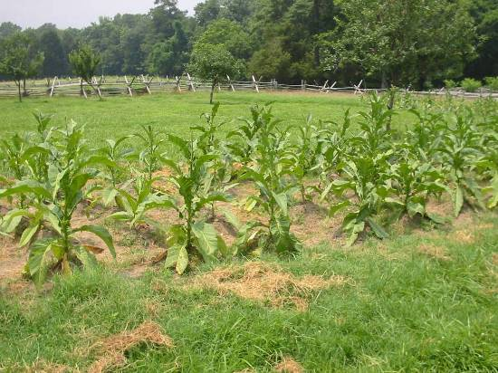
Like any planter, George Washington had to learn math to run a plantation. He became very good at math. Tobacco was the Washingtons’ only cash crop. When only one product or service is produced to sell, it is called economic specialization.

Economic Specialization
There are about 1000 pound of tobacco in a barrel. Tobacco is a natural resource. If 1 pound of tobacco sells for 1 pound of British sterling (money, something like our dollars), how many pounds of British sterling would you get for a barrel of tobacco?
1 pound sterling x 1000 pounds tobacco = 1000 pound British sterling

You won’t know what price you got until the ship returns from England the next year. What if the price drops (and this is your only cash crop)?
You’ll earn less than you thought you would, you’ll go into debt.

What options did the colonists have if they didn’t like the price they got for their tobacco?
Write a letter to complain, protest, eventually they started a revolution (American Revolution)

Describe one problem with economic specialization:
If anything goes wrong with the one crop (low prices, insects, disease, poor growing year, drought, etc), you’ll lose money/have nothing to fall back on.

Diversification
Colonists like the Washingtons sent along a list on the ship to England, of things they wanted to buy. What happens if the total cost of the goods you requested from England cost more than you earn from the tobacco for the year?
You’ll go into debt.
As an adult, George Washington eventually decided to diversify his crops. He grew corn, wheat and other grains to sell, in addition to tobacco. Why would it be better to grow several different crops to sell?
If anything goes wrong with the one crop, you’ll have the others to fall back on (example: an insect or disease might strike one crop, but not the others).
Economic Interdependence
England depended on the colonies for raw materials and goods like tobacco, iron, indigo for dye-making, and cotton for cloth. The colonies depended on England for finished goods like glass, medicines, tools, spices and clothes. Depending on each other is called economic interdependence. What problems can you think of with this system of economic interdependence? England could take advantage of the colonies. Colonies were dependent on England, did not have freedom to determine their own destiny. Economic dependence solidified political dependence. This was one cause of the American Revolution.
Human Resources
Growing tobacco required lots of hand labor every month of the year. The plantation economy depended on the labor of slaves. Slaves were a human resource. Eventually George Washington decided he didn’t like this system, and provided for many of his slaves to be freed after he and Martha Washington died. Throughout his life though, George Washington, like his neighbors, used slaves to work his plantations.
What type of work do you think the plantation owners did?
Oversaw things, managed the work, kept track of the finances, made decisions
What type of work do you think the slaves did?
Physical labor, working in tobacco fields or other physical tasks on the plantation
When slaves were working on plantations, who got the profit from their labor?
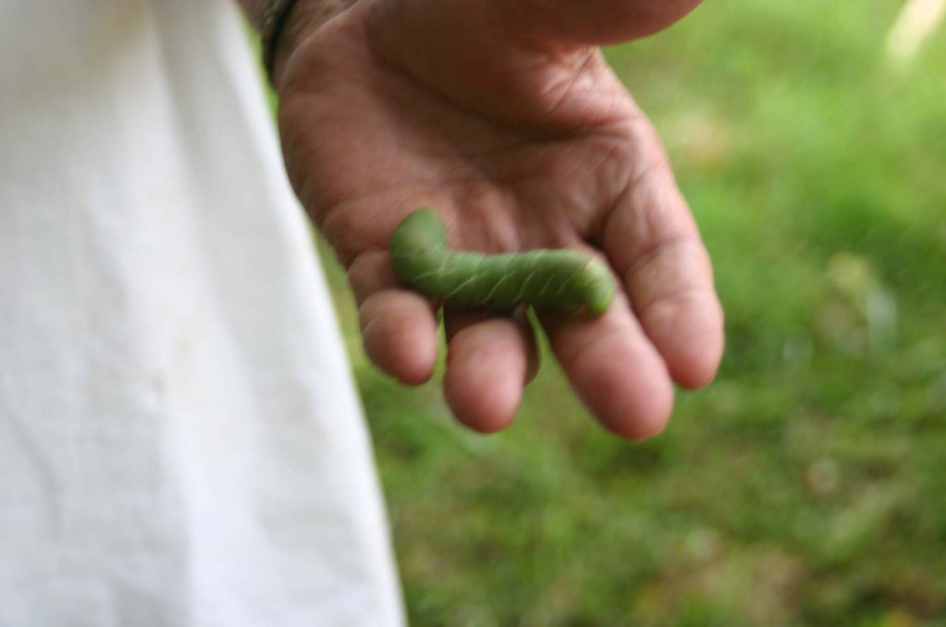
Plantation owners
Was it fair?
No, but that is the social system in which George Washington lived.
Why do you think the slavery system expanded so much when tobacco became the primary cash crop in the Chesapeake colonies? Growing tobacco required a great deal of inexpensive labor by hand, every month of the year.
George Washington and Plantation Economy
Like any planter, George Washington had to learn math to run a plantation. He became very good at math. Tobacco was the Washingtons’ only cash crop. When only one product or service is produced to sell, it is called economic specialization.

Economic Specialization
There are about 1000 pound of tobacco in a barrel. Tobacco is a natural resource. If 1 pound of tobacco sells for 1 pound of British sterling (money, something like our dollars), how many pounds of British sterling would you get for a barrel of tobacco?

You won’t know what price you got until the ship returns from England the next year. What if the price drops (and this is your only cash crop)?

What options did the colonists have if they didn’t like the price they got for their tobacco?

Describe one problem with economic specialization:

Diversification
Colonists like the Washingtons sent along a list on the ship to England, of things they wanted to buy. What happens if the total cost of the goods you requested from England cost more than you earn from the tobacco for the year?

As an adult, George Washington eventually decided to diversify his crops. He grew corn, wheat and other grains to sell, in addition to tobacco. Why would it be better to grow several different crops to sell?

Economic Interdependence
England depended on the colonies for raw materials and goods like tobacco, iron, indigo for dye-making, and cotton for cloth. The colonies depended on England for finished goods like glass, medicines, tools, spices and clothes. Depending on each other is called economic interdependence. What problems can you think of with this system of economic interdependence?

Human Resources
Growing tobacco required lots of hand labor every month of the year. The plantation economy depended on the labor of slaves. Slaves were a human resource. Eventually George Washington decided he didn’t like this system, and provided for many of his slaves to be freed after he and Martha Washington died. Throughout his life though, George Washington, like his neighbors, used slaves to work his plantations.
What type of work do you think the plantation owners did?

What type of work do you think the slaves did?

When slaves were working on plantations, who got the profit from their labor?

Was it fair?

Why do you think the slavery system expanded so much when tobacco became the primary cash crop in the Chesapeake colonies?

Post-Visit Followup Lessons to be completed after the park visit

Post-Visit Lesson “D”

Subject: I’m a Slave!
Time: 1 class period

Objective: students will be able:
- To complete a word search in order to view and review some of the vocabulary used at George Washington Birthplace National Monument.
- To write a fictional, personal narrative based on their experience as a slave in colonial times at George Washington Birthplace National Monument, evaluating and discussing issues in writing.
- To compare and contrast their life as a slave and their lives in the present.

Purpose: To help students reflect on their experience at George Washington Birthplace National Monument and make connections to the present.
To help students interpret ideas and lifestyles from the historical perspective of a slave.

Materials:
Word Find (provided), Paper, and Pencil
Vocabulary sheet from pre-visit lessons

Procedure:

Opening - Word Find
1. Distribute copies of the Word Find to your students.

2. Review the Vocabulary Words from the pre-visit lesson with your students and discuss how they relate to what was observed at George Washington Birthplace National Monument.

3. Allow students to complete the word find.

Writing “I Was a Slave” Narrative
4. Discuss with students the difference between writing a story from a 1st person point of view and a 3rd
person point of view. A first person story is told by a character in the story and uses the words I and me. A third person story is told by someone outside of the story.

5. Ask students to write a paper from a 1st person point of view completing the following writing prompt:
One day, I woke up, and I was a slave in Virginia. I…

6. A well-written personal narrative:
  - Is written in the first person,
  - Contains descriptive details that tell about the significance of the event, and
  - Has an ending to make it feel complete.

Ask students write for 20-25 minutes. Remind students to:
  - Use as many descriptive words as possible to describe their experience as a slave
  - Include details based on their experience at George Washington Birthplace National Monument
  - Use some of the vocabulary in the word find.

7. Ask for volunteers to share their writings orally with the class.

Compare and Contrast: Slaves Lives vs. Our Lives
8. Make a two-column chart on the board. Label the columns Alike and Different.

9. Discuss and list with your students ways in which the lives of slaves were alike and different to our
lives today.

Closure
- Ask students what they learned about slavery and the Washington’s time (colonial time) that was
different than they thought it would be. Post the Alike and Different Chart in your classroom.

Slave Life!
Teacher’s Answers

N F T M Y C B S Y E S H C N O
H O P O I N Y B O O F G R E D
X D I U B A O E E H J E K M E
J W U T W A R L B L T J X S S
D W I D A W C U O S L F S T R
L G O Y G T A C A C X L S F H
P O H Z K B N M O I E A H A F
F E Y W A W O A I E L X E R C
I D O N V H N J L B D F K C A
E O J E B M E J D P D A E V K
L A S L A V E J U G I S R X Z
R J J B J B B X L H F G E K A
Q U A R T E R S G M X P I J O
S E G A S S A P E L D D I M Q
P L X W N X C B D S M A Y Y N

BANJAR BELL COLONY CRAFTSMEN
DJEMBE FIDDLE FLAX FOODWAYS
HOE MASTER MIDDLE PASSAGE OKRA PLANTATION QUARTERS SHEKERE SLAVE
TOBACCO WOOL YAMS

Slave Life!

N F T M Y C B S Y E S H C N O
H O P O I N Y B O O F G R E D
X D I U B A O E E H J E K M E
J W U T W A R L B L T J X S S
D W I D A W C U O S L F S T R
L G O Y G T A C A C X L S F H
P O H Z K B N M O I E A H A F
F E Y W A W O A I E L X E R C
I D O N V H N J L B D F K C A
E O J E B M E J D P D A E V K
L A S L A V E J U G I S R X Z
R J J B J B B X L H F G E K A
Q U A R T E R S G M X P I J O
S E G A S S A P E L D D I M Q
P L X W N X C B D S M A Y Y N

BANJAR BELL COLONY CRAFTSMEN
DJEMBE FIDDLE FLAX FOODWAYS
HOE MASTER MIDDLE PASSAGE OKRA PLANTATION QUARTERS SHEKERE SLAVE
TOBACCO WOOL YAMS

Post-Visit Lesson “E”

Subject: Reflections on Slavery
Time: 1-2 class periods

Objective: students will be able:
- To demonstrate what they have learned from their visit to George Washington’s Birthplace.

Purpose: To reflect on their visit to George Washington’s birthplace and the information they learned from the visit.

Materials:
KWL chart created in pre-visit lesson
Each child should have their individual KWL chart
Paper and pencils for students
Long paper to create a mural
Markers, paint, crayons for the mural

Procedure:
Opening - Writing Activity
- Reflect on the trip to George Washington’s Birthplace. Ask the children what the term hard labor
means to them after the visit to the Birthplace. Ask the children:
  - To give examples of what the slaves did during “Master’s Time” and how this was hard labor.
  - How they would feel if they were slaves?
  - Why they would or would not have wanted to live during this time?
  - What would they change? What would they keep the same? Allow time for discussion.

2. Writing Teams. Divide the class into teams. A suggestion for the teams would be as follows:
  - Slave time
  - Master’s time (hard labor)
  - Economic specialization
  - Economic interdependence

Ask each team to brainstorm as a group about their topic and what they learned at George Washington’s Birthplace. Give teams time to brainstorm, discuss, and write in their own words what they learned. Then ask teams to share what they learned with the class.

Mural
- Ask the students to use what they wrote to create a mural of their trip. The mural should “go back in
time” to show how the slaves lived. Divide the mural into the same number of sections as the writing teams. Label the paper at the top with the same headings (slave time, master’s time (hard labor), economic specialization, economic interdependence.) Ask the teams to create a picture based on what they wrote. The mural can be displayed in the classroom with the writings or in a central location of the school to share what they learned on their trip to George Washington’s Birthplace.

Closure
- Add information to the class KWL chart and guide students in completing their individual charts.
Answer the student questions and reflect on what has been learned from the visit and how it relates to the Virginia Standards of Learning. Share the mural with the class or the school.

Post-Visit Lesson “E”

Subject: Interpreting Slave Artifacts and Lifeways
Time: 1 class period

Objective: students will be able:
- To discuss and predict how groups share and borrow from other cultures, in relation to Africans’ forcible immigration to the east coast of America as slaves.
- To identify and interpret artifacts and lifeways related to colonial slavery.

Purpose: To help students apply what they have learned on their park visit, to better understand the influences of African slaves on Virginia and Maryland culture.

Materials:
Artifacts and Lifeways worksheets

Procedure:
Opening - Discussion

1. Discussion: As a class, discuss how the forced immigration of slaves and their lifeways affected the

VA and MD colonial culture. Ask students if and how they think the slaves’ culture was affected by colonial culture.

Writing Paragraphs
- Artifacts and Lifeways worksheets: Ask students to follow the instructions on the worksheets to write
paragraphs about slave tools, artifacts and lifeways and their cultural influence.
  - You can choose whether to have each child write each of the four paragraphs, or only distribute one worksheet / paragraph assignment per student. (For example, one row or group could each be assigned the plow paragraph, one row or group each assigned the tobacco paragraph, and so on). Or students could be given a choice of which paragraphs to write.

- After students have written their paragraphs, ask for volunteers to share their writings by reading their
paragraph aloud.

Closure
4. Discuss as a class what students liked best about their slavery studies and the national park visit.

Artifacts and Lifeways Worksheet - Hoe
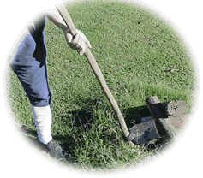
This is a hoe used to chop weeds, to hill up dirt around crops, and to cook.

Write a paragraph about this tool.
Include details such as:

- the main crops hilled up with this tool
- who used it
- who supervised the people using this tool
- how do we use this tool today
- do you think this tool was originally an African tool or a colonial tool? Why?

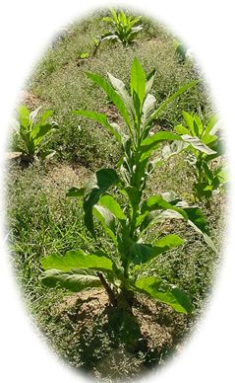
Artifacts and Lifeways Worksheet - Tobacco

This is a tobacco plant. See how the dirt is “hilled up” around the plant to keep moisture near the roots.

Write a paragraph about tobacco. Include details such as:
- why the colonists raised tobacco,
- who worked the tobacco in the fields
- who sold the tobacco
- who bought the tobacco
- how the growing popularity of tobacco affected the number of slaves in the colonies

Artifacts and Lifeways Worksheet – Slaves’ Music
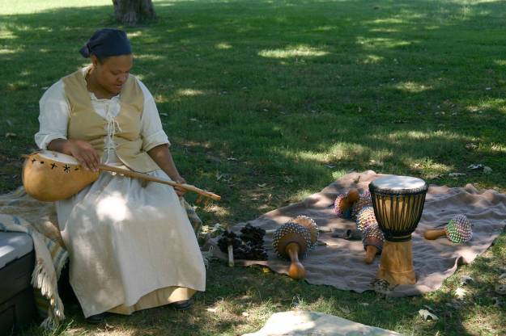
This woman is playing African percussion instruments. She is holding a banjar, and has a djembe drum, shekeres, rattles, and other percussion on the blanket. Slaves played instruments like these when they were not on Master’s time.

Write a paragraph about slaves’ music.
Include details such as:

- how did music help slaves maintain their African culture
- why were slaves’ instruments made from materials like gourds and logs
- how were African instruments different from the planter family’s instruments
- which of our instruments today are similar to the slaves’ instruments
- what other types of things do you think slaves did on Slaves’ time, when they were not on Master’s time

Artifacts and Lifeways Worksheet –
Slaves’ Foodways

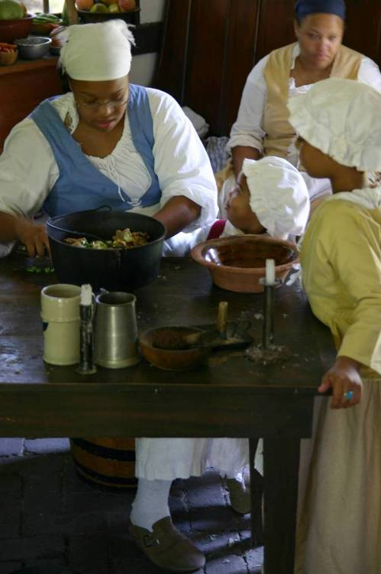
This woman is teaching her daughters to cook African foods, such as black-eyed peas, yams and okra. Slaves were given a ration of foods to cook for themselves. They were often allowed to grow vegetables and herbs for their own use as well. Slaves’ foods often were a mixture of extras or leftovers, such as extra animal parts, food scraps, and leftover spices. Some slaves also had to cook meals of usually fancier foods for the planter’s family.

Write a paragraph about slaves’ foodways.
Include details such as:

- describe your favorite ethnic foods – where do you think they come from
- how were slaves’ foods different from the planter family’s foods
- how did foods help slaves maintain their African culture
- besides foods, what other ways did slaves keep their African culture
- which of our foods today are similar to the slaves’ foods

