Report on the Roll Tests of Connected Tevatron Dipoles

At the Magnet Test Facility

Tom Peterson
Updated August 13, 2003

INTRODUCTION

Technical Division was asked by Beams Division to assess whether realignment of magnets in the tunnel can be done safely without warming up the magnets and disconnecting them from each other. Realignment involves both transverse movement and roll, but concerns mostly involved rolls and included the following:
- the coil might not move with the iron due to end constraints on the cryostat
- a leak from air to insulating vacuum could develop
- the cryostat (as opposed to interconnect) might be twisted
- the beam tube bellows might be damaged
- a leak from helium or nitrogen to vacuum could develop
- adjacent magnets could move
Also, perhaps a test would reveal some surprises

TEST PROCEDURE

Location.
Stand 6 at MTF. In addition to cryogenic supply, it has an existing vacuum system for pump down, access to a helium purge for continuous leak checking during rolling, and access to magnet bus via current leads for warm or cold powering. Stand 6 required some preparatory work, as did the magnet supports.

Preparations.
A few more MTF-style Tevatron magnet supports were fabricated and installed. The Stand 6 extension was aligned and bolted in place. In order to help us understand Kaiser coil measurements, changes in a Kaiser coil signal were compared with mechanical and stretched wire measurements of actual cryostat/coil rotations in a yoke assembly, using partially disassembled TB0334 in IB2.

Procedure.
- We placed 66” quad TQ223F, and dipoles TC0443 and TC0504 in that order on test stand 6 at MTF. The quad was connected to the test stand power leads; dipoles were electrically isolated and powered via the voltage taps.
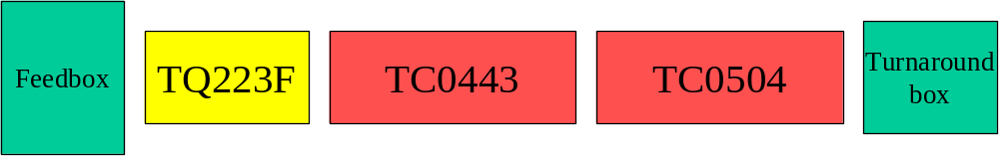
Figure 1. Magnet arrangement on Stand 6 in Industrial Building 1.

- Each dipole was supported at four points using MTF dipole supports, but in a manner identical to the tunnel 4-point supports. (The quad was supported like the dipoles, thus not as firmly locked in position as in the tunnel.)
- The magnets were mechanically aligned and leveled. Connections were made using tunnel-style seals by a BD technician. A tilt meter and dial indicators were used to measure roll and offsets. Dial indicators were set in position on each magnet and zeroed. A dial indicator also measured cryostat box to yoke motion. We set the tilt meter on TC0443 above the supports nearest TC-0504. The photos below show the interconnect (open in the first photo, then closed) with dial indicators.

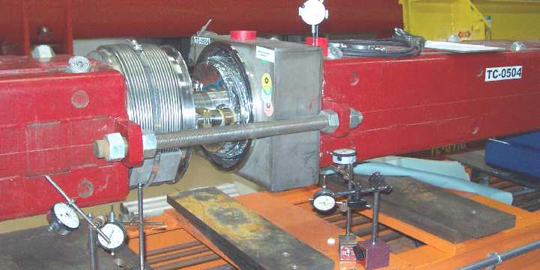

Figure 2. TC0443-to TC0504 interconnect open, showing dial indicators including one on top to check for cryostat-to-yoke motion.
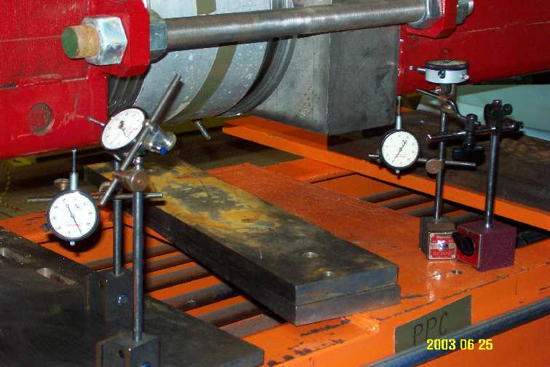

Figure 3. TC0443-to TC0504 interconnect closed, showing dial indicators.

- We zeroed the tilt meter and checked that all dial indicators were zeroed.
- A pen mark across the vacuum flanges at the gap between clamp sections served to check for slip of vacuum flanges relative to one another.
- Baseline (before rolling) stretched wire and Kaiser coil measurements were made. Smart bolt depths were measured and recorded.
- We rolled TC0443 four milliradians by means of the 1” vertical support nuts. Four milliradians = 14 arc-minutes = 0.23 degrees. The vertical jacks are 4.5” off center, so 18 mils vertical motion is required, about 1/8 of a turn. We lowered the two jacks on the east (Stand 4) side by approximately equal amounts, to get 4 mr roll toward Stand 4. There was some lateral motion as a result of these adjustments which we did not try to correct.
- Dial indicators at each end of the magnet were used to confirm approximately the same amount of motion at each end, but we were concerned primarily with the dipole-dipole interconnect and did not try to perfectly match the position changes at the two ends.
- We recorded all dial indicator readings, including dial indicators on the magnets looking at cryostat end box position relative to the iron yoke, and we recorded tilt meter readings.
- We took stretched wire readings to measure magnetic field roll. (We powered each dipole separately via the voltage taps and powered the quad via the test stand power leads.)
- We took Kaiser coil readings. (We powered each dipole separately via the voltage taps.) The Kaiser coil allowed us to monitor potential rotation of a dipole's collared coil relative to its yoke.

After the first set of roll data were taken:
- Repeated steps 4 through 11 for another 4 mr roll in the same direction another set of readings. (Yes, first rezeroed the dial indicators and tilt meter.)

Cold roll test after we finished with stretched wire tests:
- We did a 4 milliradian cold roll test to check mechanical integrity (leak tightness) of joints between rolled magnets. Kaiser coil provided indication of coil positional change. (Stretched wire had to be done only with magnets warm and open to air, since we have no warm bore for a string of Tevatron magnets.)

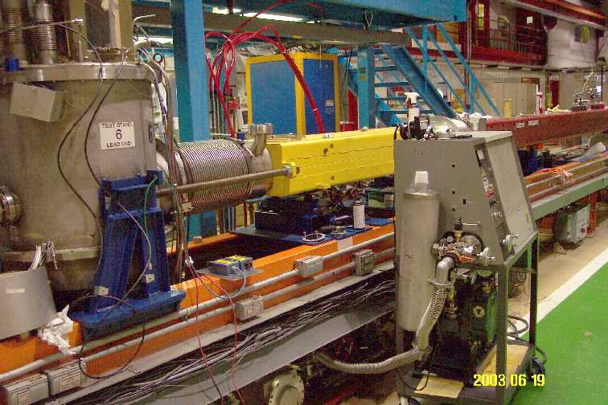

Figure 5. View from feedbox end.

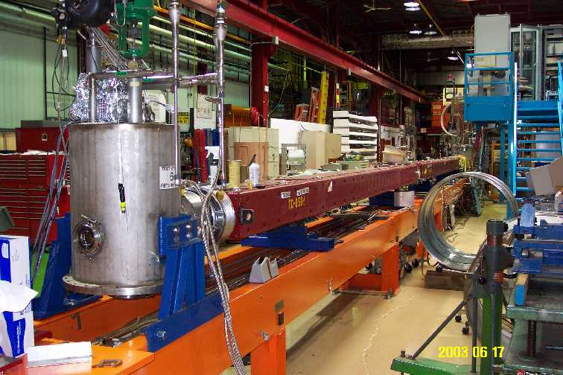

Figure 6. View from turnaround box end.

RESULTS

The following three figures were created by Joe DiMarco from magnetic measurement data.

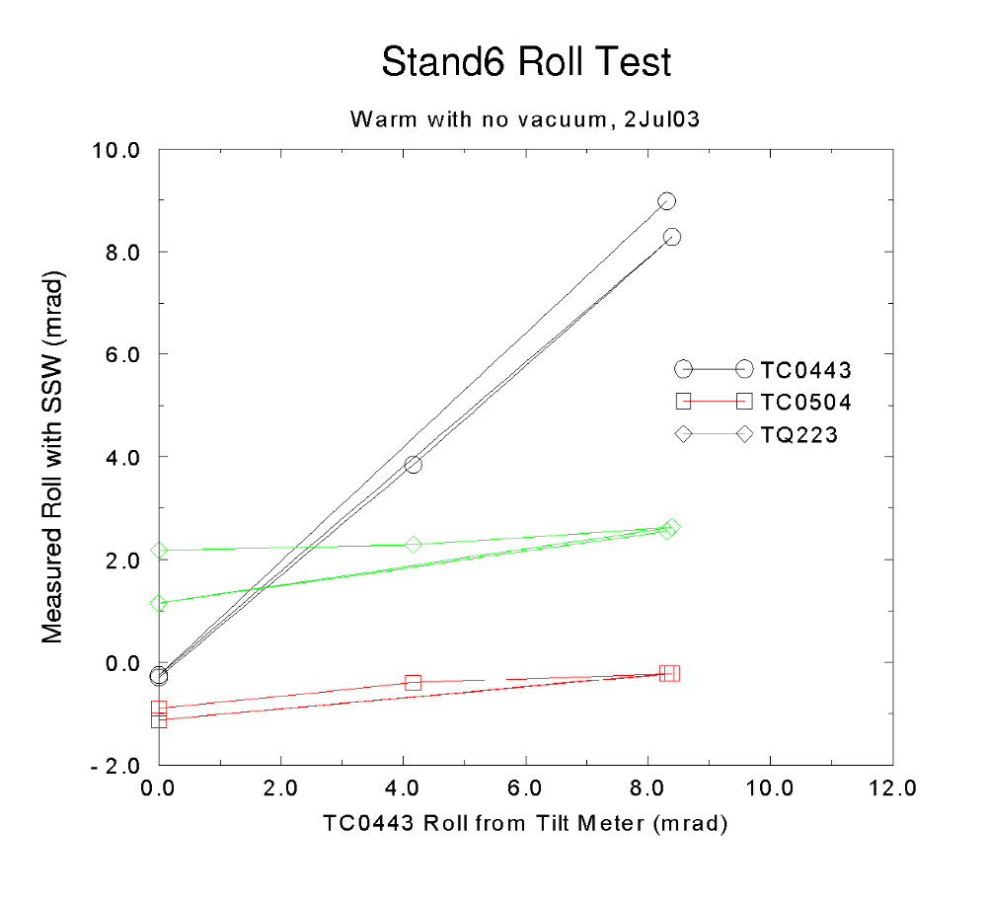
Figure 7. Warm roll tests to 8 mr and back show (by means of single stretched wire) that the coil of TC0443 followed the yoke to less than 0.2 mr in one test. (We do not know why the coil seemed to move more than the yoke in the other test, but we suspect that the measurement of the mechanical roll of the yoke was slightly in error.)

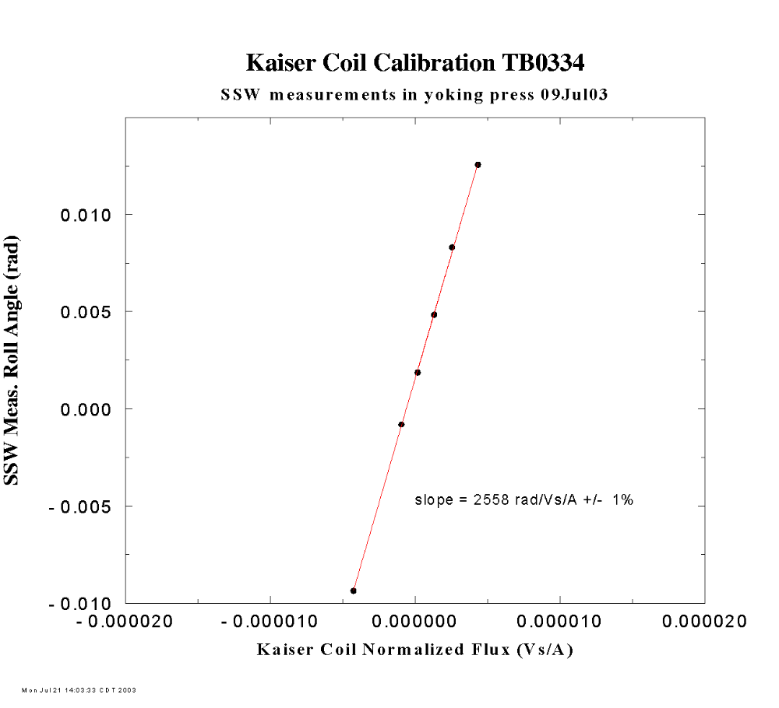
Figure 8. The coil of TB0334 was rolled relative to its yoke by a known amount in a test in IB2 in order to obtain a set of calibration data for a Kaiser Coil. Two more dipoles will be similarly tested in IB2 to confirm that the Kaiser coil calibration is representative.

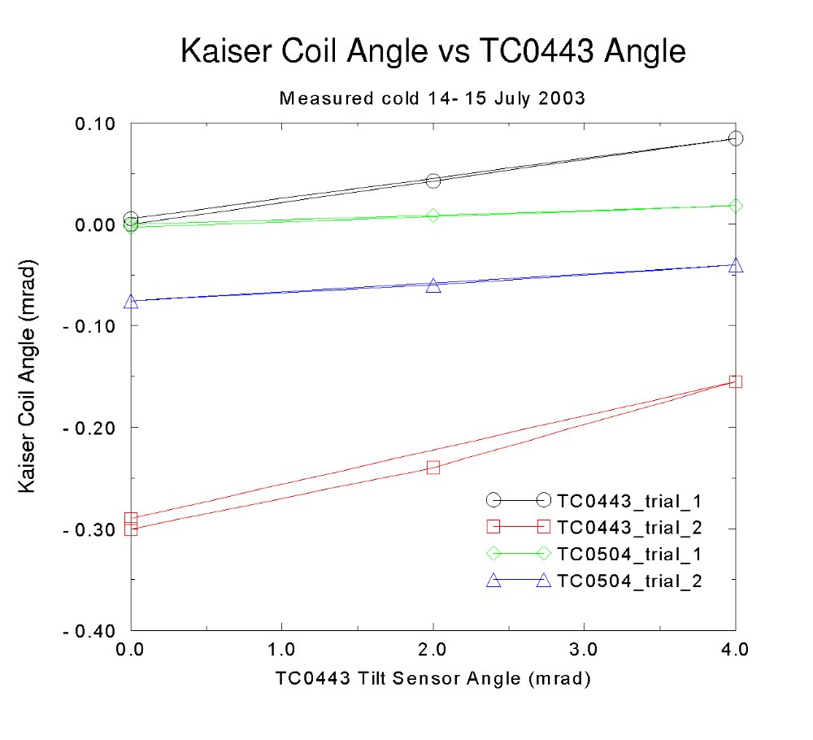
Figure 9. Kaiser coil follows the yoke to less than 0.2 mr. We do not understand the change in initial offset in TC0443 from trial 1 to trial 2, but the initial offset does not change our conclusion that the coil follows the yoke.

Mechanical measurement results.
- A pen mark on the vacuum flanges indicated varying amounts of relative slip during both warm rolling and cold rolling.
- A dial indicator on the cryostat box showed less than 1 mil movement relative to yoke even at 8 mr of roll
- A leak detector on the assembly showed no increase of vacuum pressure or helium background during cold rolling.
- Following cold roll tests, inspection of the beam tube bellows indicated some permanent deformation.
- Follow-up warm roll tests with only the internal lines (cryo lines and beam vacuum) connected showed the nature of the beam tube bellows deformation. (See photos below.)
- Other internal bellows showed less apparent strain, as one would expect since they are longer and smaller in diameter.

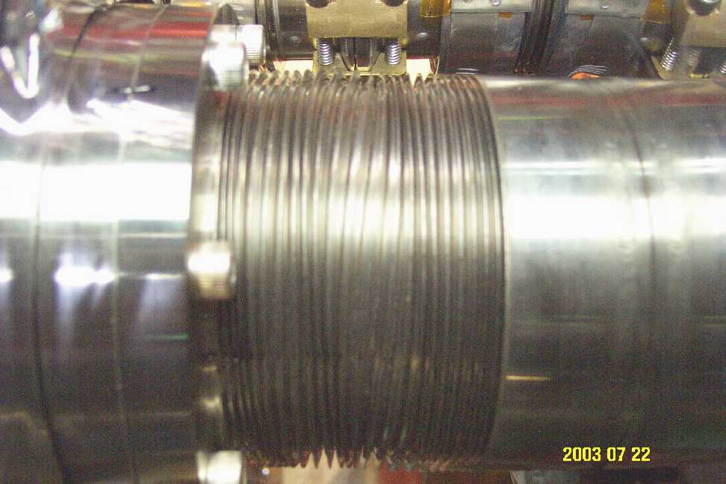

Figure 10. Beam tube bellows strained due to 8 mr of twist

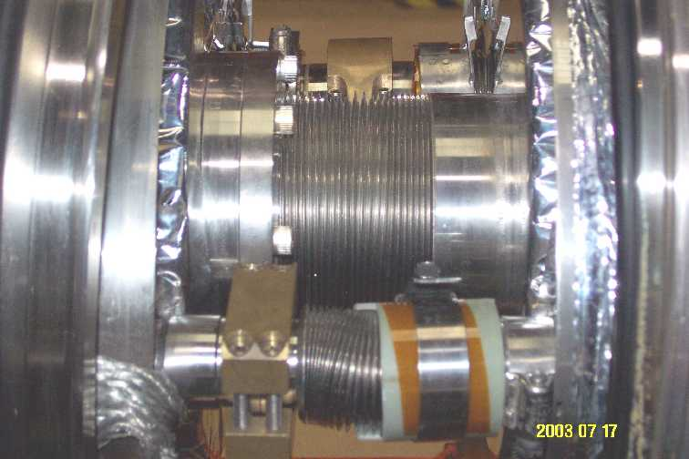

Figure 11. Beam tube bellows following tests, back at zero roll position.

Answers to the list of initial concerns.
- Coil might not move with the iron due to end constraints on the cryostat.
Test result--not a problem; the coil moved with the yoke.
- A leak from air to insulating vacuum could open up.
Test result--no leaks with this test.
- The cryostat (as opposed to interconnect) might be twisted.
Test result--not a problem; the cryostat was not twisted.
- The beam tube bellows might be damaged.
Test result--it was, but not catastrophically. It is a matter of amount of roll and deformation.
- A leak from helium or nitrogen to vacuum could open up.
Test result--no leaks in this test.
- Adjacent magnets could move.
Test result--no significant motion.
We thought that perhaps a test would reveal some surprises. Yes, the vacuum flanges slipped! This was a key mechanical result.

Summary of results.
- In warm roll tests, the collared coil does track the motion of the yoke. The yoke of TC0443 was rolled in steps of 4 milliradians to 8 mrad and back to zero. Stretched wire measurements indicated that the coil followed the yoke to within the accuracy of the measurements, about +/- 0.1 mrad. Kaiser coil measurements and smart bolt depth measurements confirm little coil-to-yoke relative motion.
- The magnets connected on either end, TC0504 and TQ223 (note: quad not supported like in the tunnel), moved a little, but less than 0.4 mrad with TC0443 at 8 mrad.
- The system remained leak tight. However, a line across the vacuum flange joint showed that the pairs of vacuum flanges slipped relative to one another in a similar way at each end of the magnet, about 30 mils, or about 5 milliradians. Thus, there is some risk of opening an insulating vacuum-to-air leak with the roll.

Comments and recommendations.
- On the positive side
  - The coil followed the iron yoke.
  - The system remained leak tight during a cold roll up to 4 mr.
  - The adjacent dipole was not too much affected by the roll.
- Reservations
  - Vacuum flanges slipping (for example, at an old joint where the o-ring has dried or sticks to the flanges) could produce an air-to-cryostat vacuum leak. Vacuum flanges not slipping could result in relative coil motion.
  - Beam tube bellows look permanently deformed.
  - This was a sample of one, and the issue may be more statistical in nature. Maybe not all magnets behave like these have on the MTF test stand in terms of vacuum flange slip or even coil-yoke motion.
  - Initial roll conditions in the tunnel may not be neutral.
- Recommendation based on these tests (as of July 23)
  - Cold rolling carries definite risks, but so does a thermal cycle. Tests at MTF indicate that small cold rolls (< 2 mr) may work.
  - The above conclusion is extremely conservative, based on the limitations and uncertainties in the studies so far. Tests will be done to clarify the twist limits of the beam tube bellows and also to explore the issue to vacuum flanges slipping with a dry O-ring.

