National Aeronautics and Space Administration

A Generational Investigation to Increase Langley’s Insight about Today’s and Tomorrow’s Young Professionals (AGI²LIT²Y)

Melissa Carter
Jennifer P. Keyes
Robin W. Schlecht
Katrina L. Young

www.nasa.gov

Acknowledgments
As Langley’s 2007 NASA FIRST pilot class, we would like to express sincere appreciation to the following individuals for their support, advice, patience, and encouragement as we completed our year long duties which included training modules, shadowing experiences, a center project, and related NASA FIRST activities. These individuals include: Richard Antcliff, Linda Bangert, Brian Baxley, Leslie Beimler, Laura Brewer, Michael Finneran, Stephanie Hahn, Roger Hathaway, Laurence Leavitt, Cynthia Lee, Thomas Moul, Laura O’Connor, Donna Speller Turner, Martin Waszak, and Risé Williams. We also would like to thank the many NASA Langley employees who offered their personal and professional experiences and opinions to aid in our effort to understand what is necessary to attract and retain the next generation of NASA’s workforce. You know who you are…

Table of Contents
Abstract 1
Introduction 2
Center Project 3
Data Collection 3
Incentives and Motivators 4
De-Motivators 6
Employment and Hiring Practices 7
Generational Workforce Perceptions 10
Senior Leader Perceptions 12
Recommendations 13
Future Work Recommendations 15
Center Project Lessons Learned 16
Conclusions 18
Appendix A – NASA FIRST Focus Group Meeting Notes 20
Appendix B – NASA FIRST Focus Group Question List 55
Appendix C – Additional Questions Created by NASA FIRST 56
Appendix D – NASA FIRST Survey 57
Appendix E – Focus Group Invitation Letters 59
Appendix F – Presentation Slides to NASA Langley Center Leadership Council 61
Appendix G – Center Project Handout for Center Leadership Council Presentation 70
Appendix H – Research Reading Summaries and Notes 72
Appendix I – Presentation Slides to NASA Marshall Senior Leadership 90
Appendix J – About the NASA FIRST Pilot Program 95
Appendix K – NASA FIRST Lessons Learned 97
Appendix L – Recommendations for Selecting a Mentor 99
Appendix M – Recommendations for Success for NASA FIRST 101
Appendix N – Additional Information about NASA FIRST and 102

Abstract
The National Aeronautics and Space Administration (NASA) Foundations of Influence, Relationships, Success, and Teamwork (FIRST) program is designed to provide employees in science, engineering, and professional administrative positions with the foundational skills necessary for their future success within the Agency. One of the major assignments for each NASA FIRST team representing each NASA center is to complete a center level project. NASA Langley’s NASA FIRST Team selected a project that correlates to the Langley Strategic Planning Framework Increase Workforce Adaptability Objective. Martin Waszak, Deputy Director with the Advanced Planning and Partnership Office served as the project’s champion and the team’s senior advisor. Between February 2007 and October 2007, Langley’s NASA FIRST team conducted focus groups, collected and analyzed data, and researched workforce literature to understand the generational characteristics of Langley employees currently aged 35 years old and younger (as of June 2007) as well as to (1) identify what motivates and de-motivates Langley employees 35 years of age and younger, (2) define Langley employees’ career goals pertaining to stability (retention at NASA) and adaptability (workforce agility), (3) investigate if there are perceived differences between permanent and term employees, and (4) investigate perceptions of Langley’s Senior Leaders. As a result of the NASA FIRST team’s center project entitled: A Generational Investigation to Increase Langley’s Insight about Today’s and Tomorrow’s Young Professionals (AGI²LIT²Y), Langley senior leadership was provided with clarity into what attracts and retains its current and future workforce, its workforces’ needs, in addition to recommendations to remain an agile Center – now and into the future.

Introduction
The American workplace constitutes an environment of growing change and the demographics of today’s workforce are vastly different from the workforce of just a few years ago. NASA Langley Research Center’s senior leadership recognizes the value in understanding these changes in order to ensure that Langley remains a healthy aerospace center - one with a culture of enhanced creativity and productivity; and one that is capable and readily able to respond to the needs of the Agency and Country.
One of the major assignments for each Center’s NASA FIRST team is to complete a center level project. The project for Langley’s 2007 NASA FIRST class directly ties to the Langley Strategic Planning Framework through the Realignment of Incentives Initiative within the Increase Workforce Adaptability Objective. Martin Waszak, Deputy Director, with the Advanced Planning and Partnership Office serves as the team’s senior advisor. The main goals of the project are to research the generational characteristics of Langley employees currently aged 35 years old and younger (as of June 2007) and provide insight into what attracts and retains this next generation of NASA’s workforce. The project’s areas of focus, developed in conjunction with the team’s senior advisor and main stakeholders, are to (1) identify what motivates and de-motivates Langley employees 35 years of age and younger, (2) define Langley employees’ career goals pertaining to stability (retention at NASA) and adaptability (workforce agility), (3) investigate if there are perceived differences between permanent and term employees, and (4) investigate perceptions of Langley’s Senior Leaders. Therefore, the Langley center project is titled: A Generational Investigation to Increase Langley’s Insight about Today’s and Tomorrow’s Young Professionals (AGI²LIT²Y).
The methodology, results, and recommendations presented in this report are the culmination of this work by the Langley NASA FIRST team.

Center Project

Data Collection
The focus of this study was to gain insight into what Langley’s employees 35 years of age and younger think when asked to discuss specific topic areas of interest to Langley senior leadership. We directed our communications to this subgroup after consulting with Charles “Pete” Polen from Langley’s Office of Chief Counsel. We requested the contact information for any current employee 35 years of age and younger as well as any employee who both was 35 years of age and younger and had resigned between June 2004 and June 2007. As of June 2007, when we requested the data, there were 122 employees, 35 years of age and younger on Center. The list of employees who resigned from the Agency was edited to remove co-ops/students whose allotted time had expired. After removing the names of these individuals, the total number of employees to contact was 16.
The team decided to have a trained facilitator to conduct several focus groups in order to allow a discussion of issues rather than to solely elicit feedback through one line questions and answers from a survey. Moreover, if necessary, the facilitator would also be capable of handling any Equal Employment Office issues that might arise. Donna Speller Turner from the Advanced Planning and Partnerships Office’s Navigation (NAV) Center was selected to facilitate all four focus groups. Three dates were chosen to conduct three onsite focus groups: July 9, 13, and 18, 2007. A call-in focus group, which allowed anonymity, was scheduled for July 10, 2007.
Following the selection of focus group dates and a location, our next step was to create letters of invitation to be e-mailed to the on-site employees and post mailed to those who had left. Before being distributed, they were reviewed by the Office of Equal Employment Opportunity, the appropriate union(s), and Langley senior management.
While awaiting response from the e-mailed and post mailed invitations, the team researched workforce and generational diversity issues; and communicated with the major stakeholders for the project. As a result of this effort, a list of questions to ask was developed by a subgroup of the NASA FIRST team and then agreed upon by the entire team. The list of questions was narrowed into five categories with a maximum of two questions per category based on the consultation of Langley’s NAV Center personnel. The categories were: (1) Incentives/Motivators; (2) De-motivators, (3) Employment and Hiring Practices; (4) Generational Workforce Perceptions, and (5) Senior Leader Perceptions.
Once confirmation of attendees was received, Donna Speller Turner facilitated three on-center focus groups in the NAV Center. These sessions were well attended with between five to ten people per group. The call-in focus group for people who had resigned from NASA Langley had one participant. Participants were receptive, attentive, and their responses were sincere. There was a common interest in attending and staying longer if necessary. The participants expressed real appreciation for having the opportunity to share and to have their voices heard. Overall, the participants’ energy in the room was good, and people candidly volunteered information. After the focus groups were conducted, ten questions representing the categories listed above were e-mailed to Langley’s current employees aged 35 and younger in order to allow those unable to attend an ability to participate. The feedback from their e-mails was combined into an additional group listed as e-mail responses. Donna Speller Turner combined the notes from each on-site focus group, and Melissa Carter added the e-mail responses to create a master document. These notes are attached to this report as Appendix B. It is important to note that the responses compiled by the NAV Center did not capture how many persons in the group made the same comment. Therefore, comments made by one person appear right next to comments agreed by the entire room. However, with the e-mail responses, each individual response is listed; therefore, it is possible to determine how common an issue was among that group. After the data was received, each member of the NASA FIRST group was assigned a specific section to analyze and on which to report.
An overview of the statistical information of each focus group and the e-mails about the focus group participants’ average age, years of service, and position type is listed below. This gives an overview of the composition of the respondents. It should be further noted that the overall permanent and term employee percentages of those responding is fairly close to the percentages for all those aged 35 and under on center (70% permanent and 30% term). Presently, the center as a whole is comprised of a workforce that is 96% permanent and 4% term.

 | Average Age | Average Years in Service (Federal) | Percent Perm. Hires | Percent Term Hires
Group 1 (10) | 30 | 8 | 60 | 40
Group 2 (7) | 32 | 6 | 57 | 43
Group 3 (5) | 28 | 3 | 40 | 60
Emails (12) | 29 | 5 | 75 | 25
Overall (34) | 30 | 6 | 62 | 38

Table 1. Composition of the focus group respondents

Incentives and Motivators
Research on Generation X (born between 1963 – 1981) and Generation Y (born between 1981 – Present) has shown many options of what incentives and motivators are effective, and therefore the de-motivators than can negatively impact these age groups. Bruce Tulgan in “Managing Generation X” claims that “no news does not mean good news” and that “Members of Generation X and Y need continuous feedback as it relates to job performance.” In addition, USA Today has reported that “work life balance is not just a buzz word … younger workers are interested in having employers accommodate both professional and personal lives.” For clarity, people born between 1963 and 1981 are considered part of Generation X and people born between 1981 and the present are considered part of Generation Y.
To identify what motivates and de-motivates these generations of employees at NASA Langley, the question asked at the NASA FIRST focus groups was: “What drives you to perform well on the job?” The focus group sessions offered significant insight into what these generations think and how they feel when asked this question. To obtain specifics about employee preferences for desiring to continue to work here, the follow-on question was asked, “Which benefits are most important to you?”
The participants asserted that having the responsibility for and the ability to engage in interesting and more challenging work as clearly the primary motivator to perform well on the job. This may imply that trusting employees to deliver and pushing responsibility down the chain-of-command as low as possible is an appropriate motivator because it develops ownership and a sense of worth in the accomplishment. For most, accomplishments are worthy of recognition, which is the next exceedingly important motivator.
Recognition for a job well done is extremely important and was likened to interesting and challenging work, which was one of the first responses in all three focus group sessions. It was expressed that when recognizing an employee’s accomplishment, the employee’s superiors should be informed; this was considered good and appreciated. Interestingly, the general consensus of the groups was that an e-mail is a preferred method of conveying formal recognition, especially with carbon copying (cc’s) superiors. This form of recognition is preferred over verbal recognition. Furthermore, it was clear that although supervisor recognition doesn’t have to be monetary, monetary awards are still effective motivators for a job well done. In general, it is simply important to frequently acknowledge employees for their contributions, skills, and work ethic. In short, a little encouragement goes a long way.
A follow-on form of recognition is support form supervisors, staff, and peers. Obvious as it may be, making sure employees have the physical support (e.g., computer hardware and software) and personal support (e.g., acknowledgement of an expressed family need(s)) needed in order to do their jobs can overtime be overlooked or assumed.
In addition, work/life balance was a particularly energized topic. This includes incentive areas such as flexible work schedules, vacation/credit hours, and telecommuting. It was voiced that telecommuting is “extremely valued.” Flexibility is a huge incentive in terms of when and how to fulfill the “forty-hour” work week. Flexibility was noted as being important for alleviating stress during the “life happens” scenarios. When considering the “forty-hour” work week it is important to note that the focus group participants saw working forty hours as fully meeting the requirements of their jobs. Some meaningful comments were, “It’s forty hours, not JUST forty hours” and that one participant was incredibly thankful to have the supervisor she did as he was obviously so dedicated; however, she also readily said that she did not want her supervisor’s life or lack there of. It was repeatedly mentioned that the participants had lives outside of work and that if a strong need for extra hours was explained then they would be here, otherwise they were going home. The groups did not want repercussions, such as lack of promotions or recognition, due to not working hours beyond the standard 40-hour week when no clear reason why that was needed had been brought forth and explained.
Job security and employee benefits were additional passionate topics and are motivators which will continue to work at NASA Langley. Employee benefits include salary, health insurance, retirement planning, educational opportunities, on-site day care center, etc. These incentives were cited as the ones that “…keep us here!” and as one of the “…only reasons to become or switch to civil service.” It was clear that many people in the focus groups were willing to accept less pay for more health benefits. In general, it was evident that people who apply to work here tend to want to stay employed here.
There were several other motivators that included mission and environment. As another motivator, the “sense of mission,” knowing you are “making a difference,” and knowing how employees “fit in and are contributing” to Agency goals shows how important it is for Senior Leadership to continually convey vision, direction, and the sense of mission our personal impact makes on the Agency and the World. A good work environment, which includes “the people” and positive attitudes, was also mentioned in two of the focus groups. This is important because it inform us that people can play the major role in making up the environment. Poor understanding of our impact upon each other in the work environment can easily make a situation quickly unpleasant.
Lastly, there were a number of other comments that although not unanimously addressing the questions the FIRST team asked, do fall within the overall category of incentives and motivators. Several of these comments referred to aspects of working at NASA Langley that make life less enjoyable: working with people who have a realistic view of daily work, tools and procedures that don’t hinder work (e.g., seemingly convoluted procurement regulations) and in general less “red tape.” Other comments include preferences, likes, or perks regarding working with NASA as an agency. Examples include the reputation/prestige of working with NASA, clearly stated goals, direction, honesty, and the opportunity to work in or around unique facilities.

De-Motivators
The NASA FIRST team also looked to identify what were "de-motivators." De-motivators are considered anything in the work environment that can reduce the satisfaction working in and desire to perform in the work place. The goal was to learn what caused employees 35 years old and younger to be less satisfied with their job and in worst case instances, cause them to leave. It is important to note that the first part of the “question” (i.e. “satisfied with their job”) had the most responses. Due to the participants’ primary focus on the first part of the question, the remaining portion of the question (i.e. “cause you to leave”) was practically ignored by the participants in most of the three, on-site focus groups.
The most common de-motivator identified by the participants was "red tape." For the purpose of clarity during our focus groups, "red tape" was defined as anything that either prevented an employee from doing his/her job or took him/her away from doing the job. Focus group participants asserted examples of red tape as Travel Manager, lengthy publication reviews, yearly property loan agreements, and the purchase process. Also, as it relates to technology and work, ODIN and NOMAD were discussed as examples of what was described as the "one-size-fits-all" mentality. Both of these programs present a lack of flexibility which forces employees to have to change how they do their work. In general, employees felt that the amount of their time spent on administrative work took time away from their ability to produce engineering or other professional results.
The next most common participant’s response was the different interpretations of Agency and Center policies and practices. A very common example given was training in terms of being allowed to sign up for training, and even after signing up for training being allowed to attend. Employees see others taking classes, or even pursuing college degrees, and wonder why they are not permitted to do the same. Another example was telecommuting. It appeared that different management groups had different requirements for being able to telecommute. Finally, policies concerning government travel and attending conferences seemed to vary from organization to organization.
The last common response was the lack of a formal new hire training or mentoring program. Employees feel that they were just thrown into work without getting the necessary training about the center, its policies, and even the job they are expected to do. Along with this concern, is the fact that most people are over-booked (have been assigned to work on more projects than for which they have time). This prevents the more senior members of the Langley workforce from having the time to mentor or even take a younger employee under their wing.
The answers to why would you consider leaving NASA mainly came from the e-mail responses received. The most frequent response was lack of interesting work. Young NASA employees enjoy the work they do here, and recognize the unique opportunities for research that LaRC offers. If the work was no longer interesting, they feel they would look elsewhere. The other common response was family needs. This included the need for a higher income, if travel requirements became too much, a forced move away from LaRC, and the fact that Hampton Roads was not the most desirable location for some to live.

Employment and Hiring Practices
Many sources of research, such as Bruce Tulgan’s Managing the Generation Mix, state Generations X and Y seek diverse opportunities. [They] will change jobs every five years.” This finding dominates many of the messages about these generations that Langley’s senior leaders have heard, read, and question. Likewise, their interest in this subject area is also a result of alleged reports of instances where potential employees did not want or prefer a term civil service position at NASA Langley. To seek clarity about employment types for senior leadership, the NASA FIRST team investigated the reasoning for the possible lack of interest, or lack of preference to accept a term position in contrast to a permanent position. This may be case as a result of differential treatment of term employees when compared to permanent employees. Therefore, the focus group participants and e-mail respondents were asked the following question: “Do you feel that permanent and term employees are treated differently? If so, how?”
During the focus group sessions, this question was indirectly answered. The lack of distinct “no” or “yes, because” comments recorded by the facilitator may be inferred to mean that the focus group participants did not feel that there were treatment differences between term and permanent employees. On the other hand, the e-mail responses did directly address this question, and there were a variety of answers. By far, the most common answer was that there is no difference in treatment. One e-mail response even mentioned that it is difficult to determine an employee’s position type without having reviewed the position posting and description for which the employee applied. Two responders also didn’t feel that they knew or were in a position to answer the question concerning whether or not terms were treated any differently. Another respondent said he/she couldn’t speak about term employees being treated differently by his/her management although he/she did say he/she had a strong impression that a term employee’s management does treat him/her differently. There was only one person who felt that term employees are treated differently. This responder said that he/she felt that term employees are expendable. This person felt that fewer resources are given to term employees who have to prove their worth in order to obtain a possible permanent position. Although this was the only response of this type, there was far greater concern regarding the potential to be treated differently in the future. One respondent’s reasoning for this position was “terms may start getting treated differently if the negative feelings and impressions about term hires are true or even if they are false if they are allowed to persist.”
Other concerns shared were that there are potentially damaging “facts” about term hires that could affect future term employee treatment, regardless of the facts’ veracity. They suggested that the “intentions at the highest level of the Center and/or Agency need to be clarified and distributed so all know the truth.” The NASA FIRST team has found that amongst our own team what we know and have been told about terms (i.e., definitions, conversion, intentions, etc.) are not consistent; therefore, we also support (1) the Center using term hiring to maintain its workforce and (2) the need for both current employees and potential employees to have term hiring and employment practices explained and communicated consistently and clearly. From two of the focus groups and some of the e-mail responses, a picture of what is believed about term employees and positions emerged. Therefore, it is important to make Langley senior leaders aware of what our participants feel is true about terms. It was understood that hiring terms does give the center greater flexibility with the workforce. However, it was mentioned that this may be seen as one possible or even the only method of achieving workforce flexibility due to Office of Personnel Management’s regulations that ineffectively address issues of “poor performance, disability, etc.” The participants also emphasized the importance of job security to them by responding that the security of a permanent position is best and the lower job security of having term status was inhibiting. It was added that the job security of a term position was better than the job security of a position in the private sector. Some expressed concerned that the only time a term employee would be different than a permanent employee would be during a Reduction in Force (RIF); thus, despite this aforementioned situation, a term’s position description is the same as a permanent’s, and funding certainly wouldn’t be a problem.
Furthermore, some participants mentioned that there was speculation of converting all terms working on projects with possible future funding. Other participant speculations included that if a term employee works hard, then being a term is just a “technicality.” Likewise, another participant’s response was that if someone has been doing good work, he/she does not want to be “pushed out at the end of his/her term.” An additional concern raised was that giving term employees a deadline as to when their job was “over” might cause them to seek other employment opportunities. This uncertainty of continued employment with NASA and the unfulfilled investments made in a term employee in regards to training, mentoring, etc. may not provide a return on investment for the center. It is also important to note that all of the term employees participating in the focus groups with the NASA FIRST team either intended, planned, or hoped to be converted to permanent employee status.
In addition, participants interjected two questions during the data collection for the Employment and Hiring Practices category. The first question was “What is a term employee in regards to the requirements?” To answer this question, the FIRST team would suggest that details of a term position including definition, a list of position similarities and differences between term and permanent positions, benefits, etc. be published and available to all current and potential employees. Secondly, the participants asserted that they would like to have the center publicize the conversion rate for terms employees to permanent positions. Therefore, the FIRST team would suggest that if this data is not currently available that it should start being collected and published.
Aside from the differential treatment discussion and types of positions, the FIRST team also addressed the Center’s agility and adaptability as it related to the employment and hiring. Its findings directly relate to the Center’s Increase Workforce Adaptability Objective which is a part of the Center’s the Realignment of Incentives Initiative. A key characteristic of an adaptable workforce is the willingness of employees to move to new work as it comes to the center. To investigate this willingness in Langley’s population of employees aged 35 years and younger, the NASA FIRST team asked the focus group participants and e-mail respondents the following question: “Are you willing to change your research/career focus?” Only one of the focus groups directly addressed this question. The group’s consensus was that willingness to change job or research focus would depend on answers to several questions. Examples of these questions include:
- Do I have to change or loose my job?
- Change to where? Am I interested in the new work?
- Does the change provide an opportunity for more responsibility?
Several of the e-mail responses echoed these first two questions - “Is the change required to keep my job?” and “Am I interested in the new work?” To add to this point, one responder said that if he/she was “faced with job elimination or switching to an area that I dislike, then I would leave.” Additional comments emphasized that it is important for leaders and managers to realize that people are not “plug and play;” therefore, employees can not be indiscriminately moved around at will. Several other reasons for changing were mentioned as well:
- “To stay competitive and a player in the future of NASA;”
- “To try to find ways to apply past experience to new tasks, where appropriate;”
- “Because we must avoid the idea of becoming "stove-piped" and narrow minded in regards to our work; Especially now with the exploration initiative, we must be willing to work outside of our area of expertise and learn new trick;”
- “It helps to zoom out and see the big picture;”
- Changing “allows me to be more flexible. This way I can be adaptable during the uncertain times of budget constraints, competitive funds, and possible RIFs;”
- “I don’t feel I’ve completely found my niche yet so who is to say it doesn’t exist somewhere else;”
- “As long as there was adequate on the job support and training in this new role;” and,
- “As long as I am motivated and inspired by the work.”
Two other participants responded that they are not willing to change. Both asserted that they have no desire to leave their current areas. The comments included one claiming that he/she had “no desire to pursue a different area” other than aviation, and the other commenter claimed that he/she wanted to stay “focused on space” only to continue to “develop in [their] career in astronautical engineering.” These differing opinions are important to note because increased or targeted incentive plans may not be enough to convince certain employees to change their jobs. Yet, one responder did suggest that “as engineers we need to be open to new concepts and ideas (and should not only be encouraged, but forced to do so in some cases).”
On the other hand, there were a number of other comments that were not applicable to the questions the FIRST team asked; however, the comments were be recognized and are applicable within the overall category of employment and hiring practices. Several of these comments referred to aspects of Langley’s hiring process. The participants, understanding that the general process is complex, described several key points about the process such as (1) “the required application paperwork can be daunting” and (2) the "firm Office of Personnel Management (OPM) regulations inhibit” this complexity from changing. Likewise, participants offered insight about the hiring cycle. As some explained, Langley’s hiring cycle is also not aligned with major events in a standard college school year such as graduation and the ends of semesters. Because of these misalignments, Langley could experience difficulties when hiring undergraduates and graduate students. Another effect of this misalignment, in some cases, has been that NASA job offers occurred before a standard job search began; therefore, potential employee’s decisions about whether or not to accept a NASA job had to be made without knowing what other options were available. Consequently, the comment was made: “communication during the hiring process needs improvement.” Such improvement may be the dissemination of more information with increased frequency. This being said the “transition from the co-op [program] to a term [position] was easy.” A further suggestion for the hiring process would be to have “potential hires meet with current staff (preferably some close in age)” to provide more information about potential work locations and the overall hiring process. The participants felt that “many choose the federal route because of passion about the work,” and that they were “willing to accept [a] lower salary to get better benefits.” The benefits provided by NASA were identified several times as being exceptional, and described as one of the factors that “helps to retain the employees.” Benefits specifically mentioned were: health benefits, life benefits, pay benefits, Thrift Saving Plan, telecommuting, on-site day care, educational opportunities, clubs & sports, and leave (amount/policy).
In addition to benefits, participants generally agreed that once employed more mentoring and coaching would be appreciated. The NASA Contracting Intern Program was used as an example of a program with a strong mentoring program. Lastly, other employment topics of concern that were identified included (1) the employment hiring [3:1] ratio, (2) the “one deep” problem, and (3) the concern surrounding these problems as well as the importance of retaining experienced technicians and others whose knowledge and skills aide administration, engineering, safety, and technical areas.

Generational Workforce Perceptions
The demographic of today’s workforce is vastly different from the workforce of just a few years ago. The American workplace now constitutes an environment of growing change – a shift of persons leaving and entering the workforce. According to Generations at Work: Boomers, GenXers, & Nexters: “Never before in the history of the American workplace are so many different age groups working together in such tight quarters. Veterans, Baby Boomers, GenXers and now the Nexters (also known as Generation Y) are working shoulder to shoulder, cubicle to cubicle.”
As a result of such difference in the workforce, it is advantageous for industry, academia, and the government to recognize the impact of generational diversity. By doing so, these entities will be able to enhance their creativity and productivity because of (1) the formation of diverse teams who possess different knowledge, skills, experiences, and approaches related to work and, (2) the team’s ability to approach simple and complex problems and challenges using a variety of vantage points and a broader breadth of work experience. NASA Langley Research Center’s senior leadership also recognizes the value in understanding and enhancing the importance of generational blending. Therefore, it instructed the NASA FIRST team to analyze the Center’s generational workforce issues in order to clarify some common misconceptions and understand the importance of workforce issues such as job security, job flexibility, and peer relationships.
Presently, some common misconceptions about members of Generation X and Generation Y range from individuals who are “slackers wasting their lives in low-pay, low-status, short-term jobs” to other individuals who are “technologically savvy” focused individuals who only prefer to work in fast paced environments with limited human interactions. Based on NASA FIRST findings, both Generation X and Y Langley employees seek to work at NASA because of (1) its interesting and challenging work assignments; (2) their passion about the work; and (3) monetary and non-monetary incentives such as health care benefits, flexible work schedules, retirement and thrift savings benefits, etc. This was reiterated during our focus groups. For example, participants of focus group session three reported that they would be willing to accept a lower salary in order to receive better benefits. Moreover, these generations of workers also seek the opportunity to work on more important technical projects. Langley’s Generation Xers and Nexters aspire to be self-sufficient through traditional and on-the-job learning and increased opportunities for growth – and making a contribution. Langley’s young workforce views its assignment as a learning experience and a way to gain skills to become more marketable. “If managed effectively, they can be a wonderful source of creative productivity” (Tulgan, 1996).
Furthermore, research states, “Most [Gen-Xers] don’t expect to stay in the same job, or even work for the same company, for more than a few years” (Meredith, et al). However, the majority of our focus group participants proclaimed that job security and stability is important to them. For example, although the majority of the focus group participants agreed that permanent employment is the “best” option, these employees would be willing to accept a temporary work assignment because it offers more “security” than the private sector (i.e., industry). Also, the temporary employment opportunity could lead to future permanent employment opportunities. And when asked, “Why would you consider leaving NASA?” the respondents answered that their departure would mainly be the result of a lack of interesting work, appreciation, professional development, and/or growth opportunities. Both Generation X and Y employees are interested in seeking opportunities for professional advancement. Employers who quickly offer these opportunities should also note improved retention rates. Lancaster and Stillman claim in When Generations Collide, “If Xers feel they are being coached and trained, and that they are building a career portfolio, then they are much more likely to stay. We really do believe this a generation searching for a place to call home. ‘The goal is to show them a place that is willing to invest in them as a person. In return, they give you their all” (59).
Therefore, it is important to understand what drives members of Generations X and Y to be both hired at NASA and remain employed with the Agency. It has been reported in Generation Y: The Millenials, Ready or Not, Here They Come that some common elements important to Generation Y in the workplace are: good relationships with boss and co-workers, income, opportunity for growth, opportunity to showcase skills and receive recognition of a job well done, challenging daily work; flexible schedule for social and personal time, and a casual dress environment.
Similar to the NAS Recruitment Commission’s findings, the NASA FIRST Focus Groups one through three found the following incentives as important to NASA employees, ages 35 years old and younger:
- Work assignments that are meaningful, exciting, and interesting;
- Employee recognition for job well done (i.e., verbal and non-verbal; monetary and non-monetary awards);
- Flexible work schedules (i.e. telecommuting, annual leave, credit/compensatory hours);
- Personal satisfaction/Work Ethic;
- Supportive work environment (people, training, and nature of work assignments);
- Salary plus health care benefits, life insurance, and retirement, and
- Educational opportunities and benefits.
Hence, communications in the form of feedback is critical to the success and retention of today’s younger workforce. They will not assume that “no news is good news” in the workplace. Regular constructive feedback from NASA peers, mentors, supervisors, and others will confirm and/or reaffirm an employee’s value and successful performance as well help to correct, mitigate, and where possible, eliminate costly mistakes. Bruce Tulgan asserts, “When younger employees see that their work is paying off and receive continuous feedback on how to achieve even more success, they become more confident, more productive, and more willing to use their creative talents”
Melissa Nicefaro, of the Business New Haven, has stated that “to become the next great generation we need to [sic] take them under our wing and really help them to develop rather than penalizing them for what they don’t know.” Therefore, in addition to testing this premise and clarifying some of the generational workforce misconceptions, the NASA FIRST focus groups provided further insight into the working relationship among the various age groups. Overall, the generational blending of ideas and work is well received by this younger workforce. The feedback from the three focus groups illustrated that the Gen Xers and Gen Yers generally have a respectful, jovial relationship with the older workforce. Some of the comments from the focus groups included the following assertions:
- We appreciate/encourage the “mix” of senior and junior staff members (NASA FIRST Focus Group 1);
- We like the mix of senior, post-doctorates, co-ops, etc. (NASA FIRST Focus Group 2), and
- We, generally, have same work ethic as older workforce (NASA FIRST Focus Group 3).
Moreover, NASA employees 35 years of age and younger feel accepted by the older members of the workforce (i.e., the Baby Boomers, Traditionalists, etc.) if and when they work hard. Also, it is generally perceived that one’s on-the-job treatment is directly tied to his/her knowledge and not necessarily his/her age. For NASA, this amicable working relationship is beneficial not only to grow future leaders, but also to recruit and retain top talent of all ages and backgrounds.
While the world faces extreme shortages of persons entering academia and industry related to science and engineering, the world’s leading organization for aeronautical and space research, NASA continues to attract some of the best and brightest scientist and engineers despite this shrinking pool of professionals. As a result of its focus on enhancing its own generational blend of workers, recognizing the diversity of needs among its workforce, and understanding how each generation of workers can uniquely and cohesively work together, NASA Langley Research Center will continue to strengthen and increase the number of persons entering the pipeline of science, technology, engineering, and mathematics.

Senior Leader Perceptions
According to the three focus groups, it appears that Langley’s senior leadership is taking the correct approaches to ensure that Langley remains a healthy aerospace center. The data collected supports this finding because the focus group participants had an opportunity to discuss openly their response to the following question: “What are your thoughts about senior leadership?” It is important to clarify that the majority of the responses focused on Langley’s senior management and its current Center Director, Lesa Roe.
It was very apparent from the consistent responses that Langley’s senior management is open to communicating directly with its employees. This communication is evident through Lesa Roe’s open door policy, town meetings, etc. In order to continue to have productive, well-received Open Door sessions, one participant recommended that follow-up actions be identified as well as posted for current members of the workforce to review. Overall, Roe was described as being “down-to-Earth” and effective. Moreover, the members of senior leadership were also described as more approachable than previous administrations. These results are important since they match the research which says that employers of generations X and Y need to allow them access to decision makers.
Furthermore, to continuously improve Langley’s senior leadership’s commitment to open dialogues with its Center workforce, it was suggested that additional methods of communication be established such as blogging and a feedback mechanism to (1) ensure that a duplication of efforts is not occurring and (2) issues are being acted upon. Also, the respondents would prefer communications that was more consolidated such as an abstract with links to websites containing more detailed information versus a 60-slide PowerPoint presentation. This method satisfies both those that want short concise communications and others who would like to have the longer more in-depth versions of presentations, e-mails, or proceedings. In addition to how information is transferred or communicated from management to the workforce, the respondents also recommended that the clearer language be used; therefore, it would be best to use common language rather than acronyms that may not be universally understood.
Contrary to the positive feedback, a few responders described how senior staff appears “disconnected” from the technical information. Often times, it appears that most of the senior staff’s communication is managerial or administrative in nature. Furthermore, there was a general understanding that the Center’s management is motivated to make changes despite not always being able to do so. The respondents recognized their participation in the AGI²LI²TY focus group and the collection of their thoughts and feedback as an example of positive change from the senior leaders. Moreover, it is important to note that there was little to no discussion focusing on the communications and management at the organizational or directorate level.

Recommendations
From the results of the focus groups, the call-in session, and participants’ e-mail responses, the NASA FIRST team has analyzed the data outlined in detail in the preceding sections and would like to offer several actionable recommendations. The top five recommendations are summarized below:
- Frequently acknowledge employees for their contributions through recognition;
- Re-establish a more formal mentoring and/or a new hire program;
- Post data on term hires (definitions, conversion rates) to help offer a more complete and accurate picture of hiring and employment at Langley;
- Continue to disseminate information to employees using multiple methods of communication, and
- Enhance/Extend communications from the Center Director to include a blog concerning issues addressed during open door sessions.
One of the first responses in all three focus group sessions when asked, “What drives you to perform well on the job?” was regarding employee recognition for a job well done. Participants recommended that management ensure that recognition efforts correlate to the type, duration, and level of the work effort required. For most, this recognition was critical. It was found that forwarding praise to superiors is valued, and the general consensus was that e-mail is a more preferred method of conveying formal recognition. Sending carbon copies (i.e. cc’s) to superiors is especially preferred over verbal recognition. Additionally, it was clear that although supervisor recognition doesn’t have to be monetary, monetary awards are still effective motivators for a job well done. In general, it is simply important to frequently acknowledge employees for their contributions, skills, and work ethic
A common de-motivator response was the lack of a formal new hire training or mentoring program. Employees feel that they were just thrown into work without getting the necessary training about the Center, its policies, and even the job that they are expected to do. Along with this concern is the fact that most people are over-booked (i.e., have been assigned to work on more projects than for which they have time). This prevents the more senior members of the workforce from having the time to formally mentor or even take a younger employee under their wing.
Furthermore, the focus groups and the e-mail responses painted a picture of what is believed about term and permanent positions, and it is important to make Langley senior leaders aware of these believed truths. In general, it was understood that hiring terms does give the center greater flexibility with the workforce. It was recommended that the definition of a term position be published and available to all current and potential employees. Another important message derived from the focus groups was that all of the term employees participating intended, planned, or hoped to be converted to permanent employee status. Therefore, it is recommended that the Center’s rate of term employees being converted into permanent positions be publicized. If such a statistic does not exist today, then it should start being collected and released. This information should help inform potential and new term employees of the actual potential for permanent opportunities.
Likewise, consensus among the focus group shows Langley’s senior management is approachable and open to communicating directly with its employees. This was a positive finding, and it is recommended that information continue to be disseminated to employees using the multiple methods of communication discussed earlier. To enable additional open dialogue with the Center workforce, it was suggested that a feedback mechanism, such as a blog, relaying issues addressed during open door sessions be added to the communication mechanisms currently in place.

Future Work Recommendations
As the NASA FIRST team concluded its time working on its center project, recommendations for future work on these topics were generated. These points should allow for the continued progression of this effort towards a final result of adjusting the incentives and value systems of the Langley Research Center to better align with the goals of the Strategic Planning Framework. The team therefore recommends that Langley Senior Leaders and any future selected team:
- Expand this work to include all ages, directorates, job classifications (engineer, technician, administrative, business, co-ops, students, etc.;
- Follow up with all groups on a regular interval to track changes in opinions and develop trend information;
- Provide detailed research of LaRC’s current rewards/recognition and value systems, and
- Post the Initiative’s results of both NASA FIRST work and additional follow-ups (i.e., wiki, blog).
The expansion of the work is encouraged to broaden the scope of such research to the center at large. Changes to the incentives and value systems need to be prefaced with data from all segments of the NASA Langley population; hence, the team’s recommendation is to collect similar types of data as was collected during this project from all age groups, directorates, and job classifications. A distinction about this last grouping is that the team would suggest every type of employee on center, including students, be queried. The student population is of importance as they will become the next group of Langley employees.
As someone’s life progresses their needs and wants may change. During the focus groups, it was mentioned that the importance of job security increases as family obligations (spouse, children) change and increase. Therefore, it is important to continue to check in with the Langley population at regular intervals to see if the motivational, de-motivational, and perceptions have changed over time. Hence, it is recommended that trending data be developed to determine when incentives may need to be changed or altered based on the life changes of the employees.
It is important to know how a system works before trying to change it. Therefore, it is recommended that to augment the aforementioned research into the needs and desires of the employees of Langley, that the incentives and value systems themselves be researched. The existence of an award that should directly meet the motivational needs of employees is not enough if the award nominating process is too difficult and/or not being used by supervisors. Both the types of awards and recognition options that exist and how they are or are not being utilized should be investigated.
Finally, all of the research conducted by both the NASA FIRST team and other groups in the future should be made available to the employees. With so many competing priorities for an employee’s time, it is important to show that participation in surveys and focus groups to aid this cause are valued and opinions are being heard. The NASA FIRST team has asked who among the population aged 35 and younger at Langley would like copies of our results and the team’s final report and presentation slides will be sent to all who responded. Feedback helps promote buy-in for results, and give employees a sense of ownership and of contributing to the outcome.

Center Project Lessons Learned
Lesson I: “Learning how to negotiate and influence people when there are diverse personal & professional opinions and beliefs.”

As with any group, there is going to be a wide variety of opinions and beliefs. The hard, yet important, part of being a leader and/or team member is being able to (1) work with all persons despite their unique points of view and (2) get the job done. In our normal work life, we work with people who share similar jobs or skills: engineers with engineers, scientists with scientists, public relations people with public relations people; therefore, we learned that when you are working with an interdisciplinary group, you must be mindful of each other's personal and professional background, beliefs, and values.

Lesson II: “There are a lot of hidden tasks to leadership (meeting agendas, providing stakeholder’s status updates, and taking care of your teammates).”

As a future leader, we recognize that there are a lot of hidden tasks and challenges when serving in leadership roles. While these tasks and challenges that include everyday tasks and team member contributions, the biggest task and challenge for a leader is the end result of the project; the success of the project depends in part on the leader in charge. This knowledge was gained when each NASA FIRST member participated as the team leader for our center project. Following these individual time periods of leadership, we identified several hidden leadership responsibilities and learned several important lessons. For our group, the hidden responsibilities of leadership (i.e., these burdens) fall into three categories: maintaining meeting agendas, providing stakeholder’s status updates, and taking care of your teammates.
One responsibility of a leader is to maintain meeting agendas which requires planning and preparation for meetings so that time can be used efficiently and a goal(s) of the meeting is/are reached. This planning and preparation includes coordinating room locations, meeting times, and developing an outline of topics that needs to be addressed as task manager. This helps to avoid the “having a meeting for meeting sake” scenario. Keeping track of individual schedules, compiling information and organization of materials is critical as the project evolves. Lastly, but not conclusively, it is import to maintain critical contacts and keep stakeholders in the communication loop and up-to-date as necessary to gain support and to plan milestones and project scope.
Furthermore, when providing stakeholders status updates, the leader acts as the primary point of contact (POC). This position requires passing along and disseminating information accurately and timely. The leader should work to make sure everyone shares the same mental model of what the current project tasks, status, and vision are as things change. With out proper communication it is easy to potentially proceed down paths that are not necessarily consistent with stakeholder vision and needs.
Moreover, taking care of your teammates can be challenging as a result of individual personalities, needs, and capabilities. Investing in your teammates requires time and energy, and it is difficult to isolate all of the ways that energy is used. As leaders, there are several key lessons to be remembered. Maintaining face and a positive attitude can be challenging at times. Sharing and discussing problems or issues that get in the way of work performance is necessary in addition to being patient, flexible, and adaptable. When appropriate, it is important to allow teammates to work tasks out according to how they are most comfortable and best capable. Lastly, but not conclusively, inwardly motivating and encouraging teammates is critical as things can sometimes wind down over the duration of the project.
In essence, leadership is so much more than setting vision, making decisions, and giving direction to your team. Some of the seemingly small tasks build up and take a considerable amount of time. Everything from status reports and key activities to meeting agendas and final integration of products falls to the lead. These are all activities that make a team successful and efficient both internally and externally. It is important to realize and recognize that our leaders are legitimately working and working hard, even if we don’t see them doing activities that we as team members are used to or comfortable calling “work.”

Lesson III: “The Navigation Center (NAV) and its employees are valuable resources.”

Originally, we thought that we would need to do a lot of researching on how to conduct an effective focus group including how to ask the right questions. However, the professionals at the NAV Center provide this information and service. Donna Speller Turner with the NAV Center communicated and met with us regularly to instruct us on how to properly conduct focus groups; ensure that our questions were valid and reliable; inform us of registered participants; and facilitate the sessions as well as transcribe our collected data. She truly involved herself in the endeavor and provided us the needed guidance and feedback.

Lesson IV: “Proper use of delegation and trusting in ability and capability of team members.”

As a team of future leaders, it was essential that as individuals we learn not to try to do everything ourselves but share the responsibilities and trust our team members. We are all highly independent, hard working individuals so being able to trust that the job would get done and to the exacting standards we would impose ourselves was a challenge we all faced.

Lesson V: “Accept the fact that your original project plan, however well thought out, may require multiple revisions. Remember, change is inevitable.”

During our training experience and the on-the-job training, we learned the various components to project planning and how to create a project plan. While it was stressed that a project plan is dynamic and subject to change, it was extremely valuable to learn this first hand. What we, as a team ,learned was the importance of being flexible and willing to accept change because there will be times and situations which are out of one’s control despite the level of preparation, one’s skills, the number of individuals working, etc.

Lesson VI: “There are many steps between an idea and data when you are planning to get information and opinions from employees.”

The process of preparing to collect information such as for our project requires consultation with and/or providing information to: General Council, Office of Human Capital Management, Office of Equal Opportunity, and the appropriate union(s).

Lesson VII: “Planning takes time.”

Four iterations of our project plan were required before the team was able to find a schedule and series of activities that would get us to our desired final goal and fine-tuning is always occurring.

Lesson VIII: “Reviews of materials take time and much iteration.”

Gathering suggestions, edits, and comments on our proposed invitation letters and focus group questions took much longer and required more iterations than expected. It is important to remember that as the number of reviewers and the rigidity of their schedules increases, more time needs to be allotted for comments and approvals. One to two weeks is not adequate.

Conclusions
NASA Langley Research Center’s senior leadership recognizes the value in understanding the environment of growing change and the demographics of today’s workforce. The NASA FIRST project for Langley Research Center served to offer insight into what attracts and retains the next generation of NASA’s workforce in order to help ensure that Langley remains a healthy aerospace center. From our discussion with a subset of Langley’s workforce, it is promising that the Center will continue to foster and promote a culture of enhanced creativity and productivity as well as be a Center capable and readily able to respond to the needs of the Agency and the World.
The project’s areas of focus, served to (1) identify what motivates and de-motivates Langley employees 35 years of age and younger, (2) define Langley employees’ career goals pertaining to stability (retention at NASA) and adaptability (workforce agility), (3) investigate if there are perceived differences between permanent and term employees, and (4) investigate perceptions of Langley’s Senior Leaders.
Overall, feedback and appropriate recognition drive Langley employees to perform well on the job. Additionally, it is useful to be aware that “no news does not necessarily mean good news” for Generation X and Generation Y employees. “This is useful when conveying vision, direction, and sense of mission. Sense of mission meaning, knowing how and where one fits in, and what impact is being made was shown to be an important inward motivator. In closing, the importance of frequently acknowledging employees for their contributions through recognition bubbled to the surface.
Overall, there are several key topics that can cause employees 35 years old and younger to be less satisfied with their job. Examples included the amount of administrative tasks, "red tape," and anything that prevented an employee from doing his/her job. Other areas included different interpretations of Agency and Center policies and practices and the lack of a formal new hire training or mentoring program. Employees feel that they were just thrown into work without getting the necessary training about the center, its policies, and even the job they are expected to do. In closing, a need to re-establish a formal mentoring and/or a new hire program has been identified.
Overall, physical benefits that help attract and retain Langley employees 35 and under include job flexibility and job security. According to the focus group participants the desire for job security and its importance increases as personal / family responsibility increases. Other benefits of significant interest identified by Langley employees include the work environment, the physical job benefits, and the work life balance.
Overall, employees agree that the open door policy is one example that illustrates management’s emphasis on approachability; and that often times senior management exhibits motivation for change despite not always being empowered to make changes. One area includes coming to a common understanding regarding the differences and intentions between term and permanent employees. In closing, employees desire this data on term hires (e.g., definitions, conversion rates, etc.) to be made available in order to help offer a more complete and accurate picture of hiring and employment here at Langley. In general, it has been shown that continued communication by dissemination of information to employees using multiple methods of communication to enhance/extend communications is critical to this generation.

Appendix A – NASA FIRST Focus Group Meeting Notes
NASA FIRST Focus Group Meeting Notes for

July 09, 2007
July 13, 2007
July 18, 2007
E-mail Responses

Facilitator: Donna Speller Turner
LaRC Navigation Center
757-864-9209 (donna.s.turner@nasa.gov)

Documentation prepared by: Sandra J. Harrell
LaRC Navigation Center
757-864-9586 (sandra.j.harrell@nasa.gov)

Documentation edited by: Melissa B. Carter
LaRC's NASA FIRST TEAM
757-864-8606 (Melissa.B.Carter@nasa.gov)
PLEASE NOTE: FOR THE FOCUS GROUPS, SIMILAR ITEMS WERE LISTED ONCE (AND COMBINED). THE E-MAIL RESPONSES ARE THE RAW DATA (NO COMBINATION)

Incentives/Motivators

What drives you to perform well on the job? And Which benefits are most important? Least important?

July 9, 2007 NASA FOCUS GROUP

- Recognition for job well done
Observer 2: Nodding heads
- Interesting and more challenging work
- verbal accolades from boss (e-mails with cc’s are a plus)
- knowledge that work is useful
- matched to output
Observer 1: email w/cc > Verbal > $
Observer 2: Want people to be aware of the long time and effort behind final product that may appear simple.
Verbal recognition is important
Want to know how work is useful and that its not just someone's errand (lots of agreement)
Try to match the type of recognition to the type, duration, and effort of the work
Passing praise to higher ups (superiors) is good (agreement here)
General consensus that email is a more preferred method of conveying recognition, especially with cc's to superiors is preferred to verbal recognition to just employee
- Support from staff
Observer 1: Good work environment (branch & branch leadership)
Observer 2: Help with administrative duties such as travel arrangements
People, the safety office for example, that truly are doing things to make life better, not to just improve something on paper
- Working w/people who have a realistic view of daily work
- Flexible work schedule + vacation/credit hours + telecommuting
Observer 1: Work hour flexibility/telecommuting
Observer 2: Flexibility is huge (big response)
Being able to leave for a few hours and get time in later important
Time off: annual leave and credit hours systems (agree)
- Educational benefits
Observer 2: Educational programs
Pipeline mentioned positively
- Salary, job security and health benefits
Observer 1: Health care & retirement
Observer 2: Telecommuting!
Salary, Job Security, and Health Insurance are all things that employees have in good amounts
Least important benefit is life insurance since it can be bought cheaper elsewhere (some agreement)
- On-site childcare
Observer 2: Child care center onsite is very important (verbal agreement)
- More work on important technical projects
Observer 1: Interesting work - knowing that work mattered
Observer 2: Upward mobility is important to some (one that didn't work in engineering area)

July 13, 2007 NASA FOCUS GROUP

- Supervisor recognition for job well done (written or verbal) -- $$ rewards are okay also.
Observer 4: Money is not necessary, but it is okay too
Written or verbal recognition
Sometimes work output does not appear hard, but still want it
What is recognition? Boss saying "good job;" knowing that work is meaningful. Recognition depends on the output. Ex cc supervisor about a good job via email.
- Personal satisfaction- interesting work/passion
- what I do matters
Observer 2: Enjoy what you do
The job is interesting
Get up in the morning and want to come to work
Passion
Sense of accomplishment (what I do matters)
Observer 4: Interesting work, enjoying what you do, feeling what I do contributes to the agency mission.
Trying new things- having an opportunity to try interesting, more challenging work. Good work = New Challenging Work = Promotion
- Supervisor “support”- personal & professional
- for training
- informing
- “plum” assignments
Observer 2: This means:
Be an advocate, go to bat for you
Look out for you with training and other opportunities
Encourage / allow you to try new things
Advocacy takes the form of:
Informing when see opportunities
Giving plum assignments
Observer 4: Supervisors support personal growth and advocates what we do
Look out for areas of interest and training
- Tools + procedures that don’t hinder work (i.e., convoluted procurement regulations) – generally, less red tape
Observer 2: Having tools and processes that don’t hinder
Get stuff when you need it
Less red tape on procurement (agreement)
Not just on procurements -- OHCM
Resources management
Financial management
Some of this is just not knowing what do or who to go to as a new person
Observer 4: Simplification of rules
Having tools and procedures that do not hinder job (i.e.: software needed but there is a lot of red tape; less red tape with procurement, human resources; varies depending on the job)
- Travel opportunity (the “right” amount as in not too much travel, not too little travel)
Observer 2: Some travel can be nice -- change of venue
- Clearly stated goals + direction (honesty)
Observer 2: "I don't know" is okay if it's honest
- Good work environment (the people)
Observer 2: Great retirement, benefits, health insurance
These keep us here
There are mothers of 2 or 3 kids that are out here because of these benefits being so good they can’t pass them up to stay home with their kids
Managers are supportive of life balance

July 18, 2007 NASA FOCUS GROUP

- Health/life insurance + retirement + TSP
Observer 2: Benefits make up for lack in pay
Health insurance, benefits paid by government, retirement, TSP, health insurance after retirement
- Work is exciting, meaningful, “cool”
- Environment, support from peers
- Individual positive attitudes + personal motto
Observer 2: Attitude – yours and that of the organization
Your attitude makes a big difference
This is from your background
Peers being excited about what they do – it’s infectious
Have a personally motivational saying. It picks you up at hard times
Ex.: It’s a good day to work at NASA
This could be described as a personal credo or motto or affirmation
- (If I do a) Good job, convert me to permanent
Observer 2: If you don’t do a good job you won’t be converted
- External people are excited & impressed (that I work at NASA)
Observer 2: Talking to others about what we do and they get excited and impressed. It’s a nice reminder
- Salary increase
Observer 2: Good salary and pay increases (some and not all agreed here)
- Flexible schedules (to enhance my quality of life)
- Telecommuting
- Unique facilities
Observer 2: we have more toys that others, wind tunnels are an example
- Training/education opportunities
Observer 2: Training is good to help get ready for new work
Opportunity for further education and to get grad school paid for

E-mail Responses

- Challenging work, opportunity to make a difference, being entrusted with responsibility, being able to represent NASA externally
- Being able to compete with others in government and industry and know that I have unique skills, resources and experience to do a job right and ensure mission success. Maintaining that distinction drives me to perform well.
- We are a busy branch with a lot of work coming in. Our teams are stretched thin and I know that doing my part will aid my fellow workers. I don't want to let them down.
- I have a strong desire to become a great researcher that is well known and respected in the industry. This obviously takes decades of strong work to accomplish.
- I have a strong desire to understand our work and do it better. The field of Aeroelasticity is incredibly complicated and diverse. There are so many topics to delve into that I haven't brushed the surfaces of yet. I want to understand at least most of it.
- Producing results that are acted upon.
- Basically if you can make a difference - you essentially have to. It's actually a nice state to be in. You are always floored ;).
- The knowledge that well performed work aids in having a successful performance review
- Personal satisfaction in solving difficult problems
- Knowledge that our research may make a difference in peoples lives
- Peer recognition, respect
- Monetary compensation
- I think I am most motivated when I can see the impact, or anticipate the potential impact, that my work has had. Nothing is more frustrating than working on a project for an extended period of time only to feel in the end that it was for nothing. It is gratifying to see when work I have performed has had an impact on the successes and future plans of the Agency.
- Knowing that I am appreciated. This comes in several forms. Being verbally thanked is very important. The trick with this is that the person saying thanks needs to really seem like they mean it. Written appreciation is even better. It can be revisited reread, saved. It is especially nice the few times that someone has pointed out to my project leads or supervisors that I did a good job. I like those e-mails and do print and save every one of them.
- Monetary awards are nice. The downfall of them is that it seems like everyone gets one so getting even $500 for some project doesn’t mean as much as a personal thank you for the word that I DID since all of the 30 people that worked on it are going to get some monetary award. I want to know that I did good, not just get some random “yeah the team did something.”
  - I was recently told that not everyone gets something, this would have been nice to know since it would have given me some of the individual praise that I know I thrive on.
- Getting to go do public outreach events and still be able to represent NASA is a driver. There is almost nothing more inspiring than standing in front of a room of elementary school kids and just have them be completely silent while you talk and then have hand shoot up with questions!
- There is a certain feel in my gut when I see the meatball or a piece of NASA history that just makes me smile and feel good. I always want to feel that!
- I do feel that I will always have a job. I have been fortunate enough to work and have been given opportunities in a wide variety of areas with a great number of people and I feel that even if I was to need to leave where I am now I would be able to find a spot somewhere else on the field or at worst case in the agency.
- Job satisfaction – knowing that I did my best to contribute to something worthwhile – as well as personal satisfaction.
- Recognition from peers and supervisors – money is welcomed, but verbal and written is truly welcomed as well as certificates and time off.
- The opportunity to be selected or given something more challenging to do based on previous performance.
- Recognition
- Getting support and resources that I need in order to do my job
- Monetary awards
- Exciting work

Most important:
- Training courses
- Accessibility to learning materials
- Fitness center
- Flexible work schedule
- Health benefits
- Getting to work on REALLY cool projects (robotic and human missions to other planets and moons) that are not done anywhere else.
- The opportunity to work on exciting programs and increase my overall knowledge and skills is probably the most important work-benefit to me.
- I also enjoy the time off and flexibility with the military (I’m also an Army Reservist) that comes with a government job.
- Education benefits
- Flexible Schedules
- Liberty to make decisions at the time I believe they must be made. We can get hardware (computer, test equipment) as needed. The Branch is great about this. Basically we can do what's needed. If the question is about compensatory benefits - I tend to think that as a government employee, I have what I need to be comfortable and focus on the work at hand.
- health benefits Most:
- Flexible work schedules
- Ample time off (note this is meaningless if we are not able to use it because of over tasking)
- Salary
- Retirement benefit
- By far, the most important benefit to me is the flexibility I am granted in getting my job done. I know what is expected of me and my coworkers know they can depend on me to perform. As long as I stay on top of my work and maintain close contact with the people I'm directly working with, what difference does it make if I come into the office at 7am or 9am or leave at 3pm or 6pm? Also, being able to use sick leave to take care of family members is a very nice benefit. Actually, even having additional sick leave in the first place is a very nice benefit. But, when my mother was diagnosed with cancer several years ago I was very grateful that I could use sick leave to attend to the matter.
- Flexible hours are probably most important. With a new puppy it has been really nice to be able to get in at 8:15 or 8 or 8:30 or what I need based on what has gone on that morning.
- Along with the flexible hours, credit hours and comp time are two other benefits that I really value. Credit hours have allowed me to take time off on multiple occasions. Comp time is nice since maxing out the 24-hour limit on credit hours is easy when you’re on any project within two weeks of a major meeting. That you can send off the e-mail requesting comp time right from WebTADs is really nice. I do also recognize that I am fortunate to have a branch head that allows us to accrue comp time.
- My salary! I make a really good salary! I had more than doubled my starting salary in the first 3.5 years as a full time employee. I couldn’t possibly ask for more than to have had increases that fast. I started higher than the teachers in my family, some of which had been working for more than 30 years! I was extremely happy to start at $36K as a GS 7-1 and now to be at $75 as a GS 13-1! Between my salary and my husband’s we can quite comfortably pay for our house mortgage, car payment, and expenses as well as save both in our TSP/401K funds and in savings. I can’t ask for more than that!
- I appreciate the health insurance and since my Dad is a government employee I was able to get coverage equivalent to what I’ve had my whole life.
- I like TSP since it does give me some control over where my retirement money goes. And it is also set up so that there are funds that will do the gradual changes from more risky to more safe automatically so that if I don’t want to directly deal with it, my investments are being taken care of.
- I appreciate the onsite day care since I see it as a great benefit for several of my co-workers even if I don’t use it.
- Interesting and enjoyable experiences. Like to have freedom to choose how I complete the project as long as objective and results are valid and replicable.
- New challenging work that allows me to think outside of the box or try new things.
- Flexible work schedule – ability to use leave and sick leave as need is important as a parent; - as well as comp and credit hours.
- Bi-weekly payment
- Investment Options
- Working with and meeting interesting people, NASA and non-NASA.
- Telecommuting
- Access information from off-site Work/life balance is most important to me.

Least Important
- Would say my least important would be the educational benefits. (this will go to de-motivators too.) The fact that NASA will pay for me to get an advanced degree has only caused me to get pressure from my peers and supervisors to get an advanced degree that will not get me one penny more money nor one bit more responsibility or more plum assignments. Yet it would cause me to further ignore my family, beyond what the hours of my job seem to be requiring, and to put me in another situation like undergrad when I was verbally abused by professors. I don’t care if NASA pays for it or not, I will not let anyone force me to go to school and I certainly not ready to give anyone, professor or otherwise, the power to mess up my self confidence and self worth so badly that it takes me years to recover again. NO silly masters degree would worth the years of effort, work, and depression I’ve gone through to get past what happened in my undergrad years.
- Life insurance
- To me, at this point child care is pretty redundant, but who knows, things change ;)
- The least important to me retirement. Not because it is not important, but rather the fed government retirement package for younger works is not as competitive as some private sector retirement packages.
- yearly branch level awards that are given out (everyone gets them)
- Annual Leave. I feel that annual leave is my least important benefit, because the annual leave provided pales in comparison to the comp / credit time I earn. As I can't take enough leave to use up all of my comp / credit time, the annual leave gets ignored & never used.

De-Motivators

What Center and/or organizational behaviors (policies, practices, etc.) cause you to be less satisfied with your job?

July 9, 2007 NASA FOCUS GROUP

- No recognition
Observer 2: No Thank you
- Lack of path/opportunity for upward mobility
- Increase in “RED TAPE” / “ADMINISTRIVIA” (full cost charging, etc)
Observer 2: Three instant yeses, in general agreement
More and more administrative work being passed to engineers
Illogical practices
- Required systems (travel manager, others) -- take more time away from work
Observer 2: PRs or Travel manger
Systems to prevent fraud, waste, and abuse that cost and waste more than the fraud, waste and abuse would have
- Different “INTERPRETATIONS” of policies + practices (training, telecommuting, travel, and other)
Observer 2: Classes, telecommuting, travel
Telecommuting being strict
Full Cost accounting -- charging administrative tasks, training, etc to project. Just doesn’t seem right
- Ability to actually attend training
Observer 2: When you sign up for classes because they want you to take it and then when the time comes to leave they won’t let you go (big agree here)
- Being over-subscribed/over-committed
Observer 2: Being booked over 100% of time and expect to agree to take on all projects and work hard on all of them (lots of agreement and laughter on this one)
One person deep in a lot of areas both technical and business sides
All need to be wary of looking more efficient at agency level due to costing less even though now it take longer here so costs more in other areas. Is it really cheaper?
Example of removing capability to calibrate measuring equipment from center. Yes now it appears cheaper since don’t have calibration people “just sitting around”. However, now when want to do test or realize that need to add something to test have to have all engineers and test personnel sit and wait for equipment to be shipped out and back for calibration. Which is more expensive to have calibrators waiting or engineers?
Analogy: Fire Departments. Wouldn’t it at least appear more efficient if the number of fire stations was reduced so that the fire fighters were always fighting a fire? This may also appear cheaper at a high level as there would be less fire fighters and fire stations.
The resenting look of folks that seems to say “Why weren’t you here when we were here?” is a de-motivator (copied from the generational perceptions section)

Why would you consider leaving NASA?

  - Lack of appreciation
  - Lack of opportunity for growth/movement
  - Pay

July 13, 2007 NASA FOCUS GROUP

- “Red tape” and not knowing/not enough people to train newbies
Observer 4: Having to navigate through required systems like Travel Manager, etc
Different interpretations of policies, courses, travel, telecommuting
Full Cost accounting- having to charge time to project for something like training
- NO clear “newbie” orientation/not enough
Observer 4: No clear assimilation into organization
Nor orientation about the chain of command, policies, and procedures
- Lack of advance planning = extra/uncoordinated work, i.e., knee-jerk reaction
Observer 2: Management planning
A large amount of stuff doesn’t get done due to running around doing last minute “oh I have to have this” stuff -- knee jerk reactions
Everything is urgent these days
Observer 4: too much time spent on last minute work; not well coordinated work creates extra work; lack of clear planning.
- Multiple task assignments creates uncomfortable feeling of being a team player
Observer 2: Don't like multitasking
Observer 4: Major misconceptions: multitasking too many projects (one person deep experience); not enough people qualified to do task
- Lots of “ONE DEEP” work assignments
Observer 2: Mentioned multiple times
Observer 4: inability to take course work when there are others who are back-ups
Oversubscribed using of WBS
- Limited career/educational development
Observer 2: Academics, salary, career and educational development
- Too much/not enough travel
Observer 2: There needs to be balance
Observer 4: Could interfere with personal life (work/life balance)
- Good ol’boy system can be an inhibitor
Observer 2: Some agreement-mostly from the order folks
Still is and always will be here
All about who you know
This is the culture
Observer 3: stereotypes arise "the old boy network" center culture
Observer 4: Varies based on who you know and who knows you, really inhibits growth
- Negative people
Observer 2: Haters, negative people

Why would you consider leaving NASA?

- None

July 18, 2007 NASA FOCUS GROUP

- Difficulties + complexities w/publishing and attending conferences
- (legal, web, travel $$, management site, # of attendees allowed to attend, foreign conference.)
Observer 2: Red tape around publishing papers and going to conferences. Especially irritating to new PhDs here on the center since the biggest most important thing for them to do is to get published and known in their field. NASA is making this very hard to do since can’t just go to conferences so how going to get known when all the members of your field go to this conference and you’re told you can’t go.
- Starting salaries lag behind private + mid-level
- Poor attitudes among co-workers + less motivated co-workers
Observer 2: May see this as younger employees more from others
People being asleep in their offices given as an example
- Uncertain/cancelled projects- wasted time/energy
Observer 2: Work on projects for a long time and nothing ever gets built or flown and the project gets canceled and feel like time was wasted (big one – agreement)
- Metal desks, lack of ergonomic furnishings
- Offices are not cleaned enough (dusty, etc)
Observer 2: Work environment
Hard to be motivated when you have a metal desk with two drawers that have been broken and a metal chair and you can’t get a new one because you don’t have a back problem / injury and yet these chairs will cause back problems
Would like furniture that works
Offices are dusty – maybe cleaned once a year, it should be more frequent
When walk into one of the buildings it feels like you stepped back in time 50 years and yet we’re supposed to be the leading edge of the industry. Hard to make a good impression on visitors with these conditions
- IT equipment/ODIN catalog not state-of-the-art
Observer 2: Home computers can smoke the ones here
ODIN can help with getting some new equipment
ODIN locking down boxes makes development impossible
IT blocking of some websites is annoying since when did Google image search for space shuttle pictures several of the sites were blocked
Websites are locked that have screen savers and no one pointed the person to the proper / NASA sponsored site that was a way to get pictures
ODIN requirements are restrictive since can’t put things on your computer that are needed to do your job

Why would you consider leaving NASA?

- Feel “locked in the cubicle” – Technicians get to do more fun stuff

E-mail Responses
What Center and/or organizational behaviors (policies, practices, etc.) cause you to be less satisfied with your job?

- Paper reviews are too drawn out (responsibility for reviewing papers falls on a few individuals who are busy) - would recommend more emphasis on peer review
- Travel office is reticent to consider less common options that would save money (i.e. buying non-reimbursable tickets for non code-share flights in order to save $1000's, full reimbursement for general aviation flights when the total cost (considering all passengers) is less than commercial airfare)
- Overly protective property policies cost time (i.e. getting signatures every year to take a laptop home) - do the necessary investigation to make sure people are trustworthy and then trust them
- The one-size-fits-all mentality (i.e. new ODIN and NOMAD requirements) Not everyone does all their work using e-mail, power point and excel. When mandates come down from the upper management of NASA that everyone shall do/use the same thing, it appears that little attempt was made to find out how work really gets accomplished. The lack of flexibility which forces us to constantly work around mandates is a big de-motivator. Time spent setting up a system or process today knowing that it will have to be reworked in the future is a big de-motivator. And a help desk supported by people who do not use the systems is not helpful.
- Threats of RIF that never happen…it just scares away the really good people who were highly employable and looking for an excuse to do something different. It hurts moral.
- The safety culture is one that annoys me and I feel is less safe than it can be. It seems that the safety culture is one where the safety personnel are out to see what is going wrong to therefore shut down operations. The culture should instead be one where the safety personnel are out to assist and make things safer by working with people and then gradually implement a solution. This can be accomplished by NOT shutting down operations every time a concern is raised, and offer perhaps a moderate response to a concern. Because what happens now is that many people are afraid to point anything out because the safety "sheriff" will stop your project in its tracks for unlimited time to enact a series of over-restrictive rules that sometimes do not even address the real problem. The safety office needs to be understanding, workable, and helpful; and be less of an enforcer. The idea of safe or not safe does NOT exist. Nothing can ever be truly safe (i.e. the absence of all risk). We need to mitigate our risks rather than pretend we eliminated all risk only when the sheriff deems it to be safe. By instilling a mentality that everyone needs to mitigate these risks and accept that some things are risky will be way safer than stamping everything as either safe or unsafe. This is one area where Army Aviation is more advanced than NASA (and probably the only area).
- Outsourcing at all cost has got to go. The good news is that it appears that this train has just about stopped. We should learn from our past here and realize that the idea of outsourcing our core capabilities does not open the government up to competition as originally desired. Once we spend a decade training the folks to run a one-of-a-kind facility, there will never be anyone else able to replace this work force at a moments notice. So by outsourcing these positions we have gained No flexibility, but rather another series of management levels to deal with on a daily basis that often have competing agendas.
- Poor personnel management. I think that the center could better manage its time requirements on its personnel to perform administration tasks. Having worked as a contractor out of the same office, I can say that the magnitude of time spent filling out administrative paperwork has increased by an order of magnitude since I became a civil service (to do roughly the same job). It would be nice if the center would create a administrative portal that we could login into using our NASA LaRC accounts that would allow us to fill in paperwork for network connections, security paperwork, travel, time-keeping, loan agreements, VPN requests, LARA accounts, financial disclosure forms, personal development plans, and training plans (just to name a few), where the software would pre-fill out all applicable fields (since the information is already in the center's IT system). If the site was structured appropriately, it should allow people to more easily find the forms they need (and know that they are the latest form) and dramatically reduce the time required to fill the information in. In addition, by having it in a web form, the system would also be able to pull of previous form submissions, so users wouldn't have to fill out every form from scratch. I find this "organizational behavior" particularly irritating because I feel that the government pays me to produce engineering analysis, and these distractions (necessary, but not at the current time requirements) impact my ability to produce in that capacity.
- I don't get dissatisfied. I do get frustrated. I can get frustrated with things like NOMAD, when a working system is replaced with a lesser performing system. I find this to be counter-intuitive, but perhaps I don't see something.
- There seems to be ageism. There seems to be an inherent distrust of younger, fresh out employees. Also, there is not enough mentorship opportunities to train new employees, thus it's a vicious cycle of more experienced people not trusting younger less experienced people due to their lack of knowledge.
- Resistance to change
- Averse to high-risk (bleeding edge) research
- Lack of support for research facilities
- Obsolete buildings and facilities
- Not being able to tell what is appreciation and what is rude behavior (this ties into my responses to question 1 too)
  - I can get used to people showing appreciation in ways I wouldn’t normally think of. Being made fun of or being the focus of demeaning jokes in group situations is really hard to take as appreciation even if the folks making fun wouldn’t have bothered to even acknowledge my presence if they didn’t respect me. I would have preferred not have their respect and to just have been ignored. I really am not motivated by rude remarks about my clothes or what I’m eating for lunch.
  - Getting some new assignment as a reward for doing well on other assignments is great and when it’s mentioned to others in my presence as “oh we’ll stick Joe with it” (and especially when this is accompanied by laughter - which it normally is), it just demeans what was meant as a reward. It really makes me not only NOT want the new work it makes me want to leave my branch.
- Talking about people behind their backs. The rude and uncalled for comments said during telecons while the mute is on is de-motivating. These are not going to help the work get finished or help in building better relations with our teammates at our center or others. It is hard to sit there, mention that you don’t feel that was called for, get a rude remark directed to me in response and know that outside the room this behavior may be attributed to me purely through being in the same branch or on the same project is not motivating to want to work in that organization or project.
- It is demotivating that behaviors such as these situations is rewarded through rewarding the people that do them through verbal praise, written acknowledgement, monetary rewards, and awards (yes even honor medals). Someone may be technically brilliant and put out good work, I just really am dismayed and de-motivated to see the people with these behaviors constantly rewarded and when the behaviors are brought up to leaders the comments I have gotten are “well they bring in work” or “oh that’s just how they are, you should get used to it.”
- Don’t say thank you and have a tone of voice or body language that gives off the feeling that you’re only saying it because you have to. That’s de-motivating not motivating like it was intended to be.
- The pressure that I get to go to grad school is yet another thing that makes me what to leave the organization I am in. (See question 2 for more details on this one)
- Another huge de-motivator is what seems to be valued and perceived as you’re working hard and contributing. I do not feel I should have to sit in a conference room all day long, especially when I’m only needed to say “yes that’s correct” once in all the hours that I’m there. Nor do I feel that hours of 7 or 8 in the morning until 6 or 8 at night should be required. If a TRUE need is there I would be there. I cannot do this on a regular basis and stay healthy, un-stressed, and not burnt out. This is the norm (as well as working on weekends) for several of the members of the branch and I feel the impression is that they are the most contributing members of the branch. Well just because I have be working on a separate project that doesn’t require that lifestyle doesn’t mean that I am not working, not putting in my time, producing great products, and making my customers happy. I feel there is a reason a week of work for the government has been defined as 40 hours and anything beyond that requires approval once you hit a pretty small limit of 24 hours cumulatively over the 40. This to me means that someone, likely a smart person with knowledge of what stress and hours in front of a computer screen can do to a person, set 40 hours as a limit for a reason! Why is it considered that I’m only working or contributing if I put in at least 45-50 hours and really need to hit 55-60? This is certainly demotivating. Further so since at kick-off meetings for projects the project lead will say “and I want to keep the pace reasonable and don’t want anyone working late nights, holidays, and weekends”, and to immediately have a local team lead laughingly say “oh well already broke that rule” and have other local leadership laugh and agree. I have not seen a project since 2005 where the pace was reasonable and excessive extra hours were not deemed required all the time. I have even had disparaging remarks made to others in my branch about me when I was on leave around Christmas for a couple of weeks using use-or-lose leave! (A couple of folks told me parts of what was said when I returned) This is ridiculous to me and extremely demotivating!
- Don’t insist that I sign up for training when there isn’t anything that will actually benefit what I do in our branch and for my projects and then further when it comes up find some reason why I can’t go. Don’t expect me to sign up for 3 day or week long training classes when I’m on a project that requires travel one of over 3 weeks! Timing on training is as important as timing on other projects.
- Lack of information shared about how to move upward through the management system.
- Bad attitudes, lack of personality types, and lack of diversity
- Old, un-inspiring work environment, not high-tech or creative encouraging environment at all
- The time it takes, red tape, etc. for paperwork to go through
- The purchase process, etc.
- Bad attitudes, resistance to change
- Budgetary shifts.
- Lack of information and discussion about policies, rules, and employee rights and responsibilities.

Why would you consider leaving NASA?

- Only if the work were no longer challenging or meaningful I'm really happy with my job.
- Growing family and other responsibilities that make it impossible to maintain the level of quality required to do a task right or maintain my own personal standards. Or if travel becomes to frequent that I do not get to spend what I consider is enough time with my family.
- The only thing that I can see now that would make me consider leaving NASA would be my wife and/or future family wanting to move to a different location for professional or personal reasons.
- I consider leaving if the agency shut down or became stagnated for an extended period of time.
- ...If I ever found that I can no longer contribute to meaningful work, which I strongly doubt will happen at NASA. In such an event I would question my usefulness. Before leaving I'd make every attempt to refocus/repair things.
- Other agencies have a better new hire orientation, mentorship program than does NASA. Lack of opportunities for advancement or gaining new skills. Also, pay is an issue. In some cases, private sector jobs have more competitive pay than does NASA and the fed government as a whole. There is not much focus upon career development for younger employees. Additionally, the threat of a RIF (reduction in force) has been hanging over LaRC's head for the past 3 years. It's not very comforting to know that it is a last in, first out mechanism that would help drive that process. It makes one's outlook shaky to say the least.
- Poor pay. Compensation is considerable higher in the private sector, especially for entry-level engineers.
- Lack of support for aeronautics research.
- Location. Hampton Roads is not a desirable locale for me.
- I would potentially leave for a job in a different field, if I decided that I was no longer interested in engineering and research. But, for engineering and research (especially aerospace) I believe NASA is the pinnacle and I don't see any reason to leave if I am going to stay in those fields. To elaborate on why I might choose to leave... sometimes I don't feel that the average American cares about what NASA does. I don't think NASA does a good enough job of "selling itself" to the American people. Consequently, I think we are more of a political football then we might otherwise be if Joe Public knew more about how NASA could benefit him (commercially through technology, personally through education, and emotionally through exploration). I think if the public had more of a vested interest in what NASA does then I think the Agency would be more politically stable and better able to handle projects that last for several Presidential Administrations.
- If I had to. (fired, RIF, NASA as a agency shut down, etc)
- I would also leave if I was forced to compromise my personal values and ethics. So far this hasn’t happened. I have become much more aware of what my values and personal limits are in the past year so I hope this new awareness doesn’t make me realize that where I am is worse than I thought it was. I value my family and know that for me to be healthy I have to leave work and have time at home to relax and spend time with my family and doing the other things that are meaningful to me (the hobbies that reduce my stress and keep me refreshed). If this became an issue I would be inclined to switch projects or branches or directorates before leaving NASA since I do love the agency and I’m guessing that it would not be an agency position / policy that would push me too far.
- A forced move or detail would be a distinct item that might push me over the edge as I see no good reason to be separated from my family and am not going to uproot them either.
- Reduction in Force due to budget or lack of promotion, stagnant career potential – no growth opportunities or ability to try something new.
- One reason, the cultural demographics and logistics of the Peninsula. I feel like I have a dream job, yet I don’t like living here.
- Poor pay. Compensation is considerable higher in the private sector, especially for entry-level engineers.
- Lack of support for aeronautics research.
- Location. Hampton Roads is not a desirable locale for me.

- Senior Leader Perceptions

Your thoughts about LaRC senior leaders?

July 9, 2007 NASA FOCUS GROUP

- Appreciate Lesa Roe
- branch-level discussion
- meetings w/newbies
- she is down to earth
- open-door approach
Observer 2: Haven’t been here long so not as much knowledge of senior leaders
All impressed with small town meetings and said they were very helpful
I was surprised by comments about the administration prior to Lesa
Like that Lesa’s trying to meet with new people / hires
Lesa’s down to earth so that helps with perceptions of her
Like the open door sessions
Makes her more approachable
Lessens the divide between her and the employees

- Mike Griffin – is a plus that he manages as a scientist and seems more focused on relevant science issues
Observer 1: He (Mike) is not trying to run a business.
Previous admin (O'Keefe) had disconnect between HQ & Centers
Felt Bridges handled RIF scare wrong
Observer 2: Feel that Mike appreciates technical work and makes it feel more like a technical place and less like running a business
Examples given were Mike’s choices to re-look at the Hubble servicing mission and that he acknowledges that we have a talented workforce
Feels like Mike is at least using logical processes to make decisions even if all the decisions haven't been good for Langley

July 13, 2007 NASA FOCUS GROUP

- Seem to be motivated for change, but not always able (for events, this forum)
Observer 2: Perception is that they want to do good and their hands are tied
The fact we have this forum is an indication they want to change and example of their hands being tied is that they want more flexibility with hiring and have to just deal with the option being term hires
Observer 4: Example they are holding this focus group (exp of wanting change)
- Clearly trying to communicate (Lesa Roe open door, branch forums, advocacy, etc)
Observer 2: Open doors, mini town meetings, branch level openness
They take our inputs / ideas
Observer 4: Appreciate Lesa's brand
Trying to meet with new employees
Down to earth
More approachable and open door policy
- Lately, more approachable (different senior leaders)
Observer 2: We aren’t scared to go higher up with ideas
What has changed to make this so is that we’ve switched people
(lots of negative emotions and words about Bridges)
Observer 4: Not scared to listen because some people have left
Doing a better job than director before
Surprised by "everyone for self" mentality with prior administration"
- Seem to be more committed to “Center” good
Observer 2: More concern for center and having a job well done
See leaders wearing a “center” hat more than just “org” hat
Administration changed which led to environment changing which led to attitude changing
Observer 3: OVERALL, people were intimidated by the senior leader question
Observer 4: More concerned about center; wearing an integrated center hat
Change in administration; change in culture
Mike Griffin: (1) understand the technical and importance of research, looking back to Hubble; (2) makes choices that makes work more meaningful and relevant
Switch to NASA to work on technical expertise and that it maters.

July 18, 2007 NASA FOCUS GROUP

- Would prefer a more consolidated approach to meeting outcomes (abstract + link vs. 60-chart PPT package)
- Use common language (fewer acronyms)
- Others prefer long/complete e-mails/power point charts
Observer 2: Get tons of emails about all senior leader activities, they need to be consolidated
We don’t have the context, being younger and new, to understand what the topics are and why they are important
One email every (1, 2, 4) weeks with just a few bullets saying only the high points would be preferred
Essentially an abstract
Someone else says he does like the verbose emails since allows you to see and learn about people and to know exactly what’s gong on and to get ideas of what’s important to specific individuals in case you ever work with them.
Discussion about emails resulted in some agreement for a bulleted/abstract-like email with links to the full documents so that if you want the summary you got it and if you want to do more reading you can do that too
- Appreciate Lesa Roe open door, not sure there’s any follow-up to issues raised during the meetings
Observer 2: Open doors are neat
Most hadn’t gone since hadn’t had a need
One person had gone to one with a problem, an administrative/policy issue. Lesa was nice and seemed receptive and then nothing happened. No follow up ever happened and nothing got fixed.
Didn’t get any indication of “okay we’ll fix” or “no it stands because …”
Wanted this regardless of answer
Observer 3: want feed back loop
- Appear to be disconnected from technical “stuff” (because most communication is managerial or administrative in nature)
Observer 2: Get the feeling that the leaders are all administrative and management and that they are not involved in the technical work at all. The impression is that they’ve lost touch with the technical work. They are just doing human resources and administrative and management stuff
Get this impression because:
All communications deal with administrative and management things (General agreement in room on this, no question that communication topics were reason)
One person scans the key activities, the rest don’t even look at them

E-mail Responses

- I highly respect LaRC's senior leaders. Lesa Roe does an excellent job communicating the senior leadership's activities to the employees. She's articulate and visionary. Her leadership qualities provide a solid example to other aspiring leaders.
- I have very little contact with senior leaders, but from what I have seen of Lesa Roe, she certainly seems more capable and open minded than others who have been in her position.
- As for the branch management, I am very happy with their performance and support. They always seem willing to stick their neck out for us and push for what we need/want.
- I am not all that familiar with center leadership, mainly because I haven't seen the leadership positively impact my ability to produce analysis. I appreciate the leadership resolving the funding issues that allowed the hiring freeze to be lifted (allowing me to get hired), and hope to see more actions coming out of center leadership that positively impact my ability to get my work done, which I think is the principal function of center leadership within NASA's management structure.
- The ones I've met I hold in high regard.
- I think that they could do more to make the work environment more inviting and engaging for younger workers. It is very easy to feel like an outsider when you are 10 -20 years younger than your co-workers. Senior leadership I think should take a more active role in retaining the young talent that they have.
- Honestly? I know they are there, but I don't know much else about them. Although, I admit I could do more to stay in tune with what's going on at the Center level. Working primarily on Exploration, I have a tendency (as I'm sure many of the people in my branch do) to be focused mostly on the space side of things at the Agency level.
- They intend for Langley to be here and prosperous in the future. They really are trying to do what is best to have the center meet the needs of the agency while keeping as many of us employed and working on good, important stuff. Lesa, Steve, Cindy, and Laura all seem to genuinely care about the center and the employees. They want to do what’s best for us and although this means accepting that change has to occur they do seem to want to hear feedback and to change for the better and to keep all of us who are willing to adapt.
- The problem I see is that I don’t feel the center at large knows how good the senior leadership is and how hard they are trying on such a large number of fronts. Course their efforts make them so busy that they don’t have time to tell the employees at large how much they are involved in and working on. I have had the chance to spend time with several members of the senior leadership team and have no doubt that I trust them completely! Not everyone will have the chance to have a similar level of close contact and yet I want them to have the same level of trust I do.
- I wonder if the Office of the Director needs to add a position, or add the job duties to someone who isn’t already overwhelmed, to get out the word better. To go out around the field and find out how the employees need to receive information (type of communication format, volume of information, frequency of communication), and what they really want to know about and make sure they know what’s really going on. I know some things can’t be discussed others I imagine can (such as workforce pipeline).
- I have favorable opinions and hopes for the current senior leaders. They appear to be more open to new ideas and ways to disseminate information and the type of information. Appreciate the e-mails, the CD-COMMs, open door policy, future open house, etc. They are morale boosting.
- I think that as a whole, they are trying to ensure that the right people have the right job experiences and being used to further the center and the agency along.
- It also appears that Lesa and others are trying to incorporate new strategies for the future to keep the center alive and healthy.
- Personally I feel they are finally on the right track to repairing a big problem. I hope they have the stamina and vigilance to see the problem through.
- Senior leadership needs to continually convey the sense of mission and our personal impact on serving America.
Employment & Hiring Practices

Do you feel that permanent and term employees are treated differently? If so, how?

July 9, 2007 NASA FOCUS GROUP

- Term offers more security than private sectors
Observer 2: 6 years of job security is better than private sector
Sure could terminate, still better than private sector. At least there is weeks of paperwork even to terminate a term
- But, perm is best
Observer 2: Job security of a permanent position is best (lots of nodding heads)
- Term does offer w/f adjustments opportunity
Observer 1: Sees term/perm as a stepping stone
Wants Perm for stability
Observer 2: The understanding is that as long as there is funding terms will have jobs.
Funding going away is an issue for all employees not just terms.
Terms are a good practice and makes sense. Gives more flexibility to change the workforce as the work changes.
If you are hard working than being a term is just a technicality
- Transition co-op (term was easy)
Observer 2: The co-op application process was awful, and the conversion process from co-op was easy.
When getting NASA job the salary was even upped to match an offer from the Navy
- Required application paperwork can be daunting (pushed some to other companies) and “FIRM” OPM regulations inhibit
Observer 2: Do know some LARSS Students that don’t come here to work due to the paperwork of the application and they can get a job that pays just as well and gives a good experience without all the paperwork
Do realize that paperwork is a government thing not necessarily a Langley thing
Do need to pay attention to when the co-op post-graduation-can-be-hired time is up since there were two examples given of people that got hired and ended up not being brought on due to being days past their limit.
Understand that the limit is an OPM firm regulation, just wish it was paid closer attention to

Changes?
  - It depends - DO OR NO JOB?
    - TO WHERE? AM I INTERESTED?
    - OPPORTUNITY FOR MORE RESPONSIBILITY?
    - PEOPLE ARE NOT PLUG-AND-PLAY
Observer 1: Change focus only if interesting or required to keep job
Would try to continue some work that had interest to you (compromise)
Observer 2: If will let me keep my job I’ll do it
Depends on what is it being changed to. Am I interested in the other area?
Will following interesting problems and challenges
Guess this is why they hire terms! (Laughter)
Try to find opportunities to keep skills from previous job or training and/or getting to work on things of interest while working on some new topic or focus
Promotions are seemed to be based on responsibility not on having one focus and being world renowned now so it’s okay to change research focuses now since can still get promoted even if switch
Observer 3: People seemed to want to do what protects their jobs.

  - Should be more/high value placed on experienced staff
    - prefer more personal approach (names on functions)
    - Important to retain experienced technicians, others (vis-à-vis safety administration knowledge, and technical expertise
Observer 2: Do need to acknowledge that people are plug and play
Don’t just fire one group and hire a new group due to new work
This would lead to permanent brain drain
People that have been around have valuable knowledge
There is definite concern over the technician workforce leaving
Assuming people being plug and play seen as an issue with the technicians
Veteran techs being let go in favor of contractors that don’t KNOW facilities
Causes safety issues
The stand downs, caused by safety issues and unknowledgeable technicians brought in to just do this one test, may be more expensive than keeping veteran technicians that are knowledgeable about one specific facility
Common skills between jobs need to be highlighted

July 13, 2007 NASA FOCUS GROUP

- “Term” status inhibits (less job security) is important to me
-would help to publicize conversion rate
Observer 2: Didn’t understand what the question meant
Wanted job security so terms are scary (agreement)
Would like to see stats on terms -- # that stayed on as terms, left, were let go, converted to perms, etc
Someone mentioned that senior leaders might not have released these since worried about misconceptions about terms due to data on these things being old
Comment made that could start putting these together based on this round of term hiring
“conventional wisdom” (that Gen X and Yers don’t want to stay in a job more than 4-5 years) may apply to more private sector since job hopping is the way to get salary increases
Yeah, could have done the job hopping things and instead choose to work for the government
If reason for term hiring is to let people go who don’t fit or aren’t working, than tell folks that so that that’s why hiring terms rather than perms so don’t think it’s because want to fire everyone at end of the term
And so hard to fire a perm due to OPM regulations and paper work so not surprising that hiring went to terms
Even promotions are terms in the project world and that’s scaring people
“What do I do when the money goes away?”
An issue with hiring terms is hiring younger people and then training them and then giving them a deadline like the end of their term. This arbitrary deadline may make them more likely to leave even if NASA has full intentions of keeping them. Since they don’t know for certain they’re likely to look for a new job which is something we never would have thought of doing as a perm. So even if we don’t kick them out the gate they may go since we provided the seed to start them thinking of going elsewhere even without a RIF scare or something.
Observer 3: Term position- no understanding of job security. Passionate topic! Group worked through this topic.
Observer 4: Sounded as if would not last forever; as if someone who wants job security, it's a scary thing; show stats of how term hires are hired to permanent CS positions; are terms the same as five years ago?
At least you have 6 years, in the public sector, you have no security
Job security- permanent is best
Understanding that as long as funding is okay, then you are "okay to work" as work changes, you can adapt workforce
- Many choose the federal route because of passion about the work
Observer 4: Private versus public:
Job hopping in government is not like in the private sector where job hop is about money
Chose government because we want to be here
Flexibility is for government to rid self of employees
If you are term, you will perform to get the job
If you do not do the job, fire them
Government problem (OPM) does not address poor performance
Term appointment is NASA’s response to hiring and firing
Term promotion – people are really scared as it relates to project world
- If I want/need to leave, I will consider it
-but, if I do good work, I don’t want to be pushed out at end of my term
Observer 4: Job security is important
- OPM doesn’t effectively address poor performance or disability or other issues
- Benefits are great (helps to retain the employees)
-Health -On-Site day care
-Life -Education Opportunity
-Pay -Clubs, Sports
-TSP -Leave (amt/policy)
-Telecommuting
- Hiring cycle not strategic, not aligned w/various school year events (such as graduation, etc.)
Observer 2: Except when it happens to work on occasion, and even then there is poor communication with what was going on
We don’t recruit at colleges
Used to, and now we’re still under a “freeze”
Observer 4: Transition from co-op to term was "smooth, really good" LARSS program (i.e. student) - a lot of paperwork
- Communication during hiring process need improvement (need more, frequent)
Observer 2: Would be nice to sit down and understand what options are for placement
Had several branches that wanted to hire a coop and got hired and didn’t know where would be working
Observer 4: Should be open door to speak with management
Brief new staff from different branches
More formal coaching and mentoring for new hires – should be clearer
- “Potential hires” should meet w/current staff (preferably some close in age). Would appreciate more mentoring and coaching
Observer 2: Mentoring would be nice (agreement)
Now there is training for mentors. It’s just starting now, and is still lacking, and besides finding one (a mentor) is the catch
Observer 4: training of mentors versus catch a mentor
- NASA contracting Intern Programs (has strong + formal mentoring program)
Observer 2: Group hiring like the “Contracting Intern Program” was a good experience with getting to move to several centers and then pick your top one to get to stay at.
- Term employees = investment in training and mentoring (may not provide ROI to the Center)

July 18, 2007 NASA FOCUS GROUP

- Willing to accept lower salary to get better benefits.
Observer 2: Health insurance mentioned twice
- Hiring process is complex -- but do-able.
Observer 2: Agree that there is paperwork and convoluted hiring process; it’s just not enough so to be off putting
The group was willing to spend a day filling out forms
- In some cases, job offers came before job searching began
Observer 2: Offers came really early before graduation and have only 2-3 weeks to respond so it was impossible to look elsewhere for a job
Understand why, just felt odd at the time
As part of hiring – the moving process: Didn’t get paperwork in time (same day as leaving to move here) so paid for own transfer / move and then had to fight to get back the money after was already here and found out that NASA would have paid for the move.

E-mail Responses
Do you feel that permanent and term employees are treated differently? If so, how?

- no basis for judgment
- I do not think that term employees are treated differently by other employees. We all have to work together as a team and we put our titles and CS or non-CS etc. behind us. However, I cannot answer as to whether or not management treats them differently, because I get the strong impression that their management does.
- No, but I think there is potential for it in the long run.
- I don't know. I am not a permanent employee, so I can't really compare.
- Yes, I feel that term employees are expendable. Fewer resources are given to term employees to prove their worth in order to obtain a possible permanent position.
- Not that I'm aware of.
- In my experience, I don't think they are treated differently.
- No absolutely not. The only time they would be is under a RIF and even them I’m not so sure. The term employees that I know have Position Descriptions that are essentially no different than mine and are all written so broadly that if one pot of funding went away they would just go work on something else, the same as would happen with me. There is already talk of converting all of the terms in the future since the work doesn’t appear to be going away and in fact seems to be growing. So I’d have to say a resounding no for them being treated differently. If I hadn’t been around to see the postings they applied to I wouldn’t even know they were terms!
- Terms may start getting treated differently if the negative feelings and impressions about term hires are true or even if they are false if they are allowed to persist. If “facts” about term hires (whether they are true or especially if they are false) like “they can be fired at any time regardless of if their term duration is up,” and “even if they do great work the center doesn’t intend to renew any terms so they’ll all be let go,” or “terms will never be converted to perms even if there is work for them in the future and they have done a spectacular job during their term,” then terms may get treated differently in the future. Why bother to give a plum assignment or special treatment or bonuses or training when they are going to be gone in 4-6 years. Why give them more than the minimal office space since they are just slightly glorified students. They certainly couldn’t have duties with a high level of responsibility since they won’t be around for the next study, etc. So I feel intentions at the highest level of the center and / or agency need to be clarified and distributed so all know the truth!
- I do not think that they are treated differently. The main focus I believe is on the work and getting it done correctly, on time, and within budget. However, I would be honest, and say that I do not know a great deal about what a term employee is in regards to the requirements and who are term employees. This is probably due to the “hush nature” about job positions, GS-levels, etc.
- I don’t think they are treated differently. However, it is my experience that the employees do feel differently and that there is not enough awareness of the difference between the two.
- I am very concerned about the “one deep” problem and technology transfer.

Changes?
  - No - Aviation has been a passion since ~8th grade and I have no desire to pursue a different area.
  - If I had to change my research focus to stay competitive and a player in the future of NASA then yes. I would certainly try to find ways to apply past experience to new tasks where appropriate but if that is where the center and the agency wanted to go I would adapt…to a point.
  - Absolutely. We positively must be flexible and willing to do the work/research that is needed. We must avoid the idea of becoming "stove-piped" and narrow minded in regards to our work. Especially now with the exploration initiative, we must be willing to work outside of our area of expertise and learn new tricks. That being said, however, I have watched over a century of experience walk out of the door of our branch over the last couple of years. We are no longer as capable as we used to be. There is a real need to retain this ability and provide this particular support to the industry. I certainly do not measure up to those who have left, but somebody will have to carry this responsibility in the future. There is a real danger to the aeronautical world if we loose this capability.
  - Yes, I would be willing to change my research focus as long as it was still focused on space (I would not be willing to work for aeronautics). I think that as engineers we need to be open to new concepts and ideas (and should not only be encouraged, but forced to do so in some cases), and therefore I would be willing to shift to learn new things. As to not being willing to work for aeronautics, my interest lies in space, and don't feel that working for aeronautics would allow me to continue develop in my career in astronautical engineering.
  - Yes. It helps to zoom out and see the big picture.
  - Yes, by being willing to change my focus that allows me to be more flexible. This way I can be adaptable during the uncertain times of budget constraints, competitive funds and possible RIFs.
  - Yes, if the new area is of interest to me. If I was faced with job elimination or switching to an area I dislike, I would leave.
  - I think I might, if something came along that I was interested in more than what I am currently working.
  - Sure, why not. I want to keep my job (which would be one reason to move), and there are lots of other areas and projects on the center that sound interesting so why not switch. I don’t feel I’ve completely found my niche yet so who is to say it doesn’t exist somewhere else.
  - Of course when asking about a detail and if it was something I should look into I was told it would be a really bad idea especially this early in my career so that was discouraging to hear that from someone I trusted. If there was a good opportunity or a job that I could do and was needed to do I would hope that folks in my current organization would be supportive.
  - Yes, I would be willing to change my focus if there was a need as long as there was adequate on the job support and training in this new role.
  - Yes, as long as I am motivated and inspired by the work. I like trying new things.
Generational Workforce Perceptions

How important is “job security” to you? Job Flexibility?” Do you feel accepted by older members of the workforce? Why?

July 9, 2007 NASA FOCUS GROUP

- Job security + flexibility ( very to extremely for most)
Observer 1: Job security is extremely important
Work/Life Balance is EXTREMLEY important
Observer 2: Both security and flexibility very to extremely important (consensus of group)
One alternate to this was interesting work
Security
This means that you can’t be handed a box on Tuesday due to the paperwork required to let someone go so you will have at least some advanced notice and multiple weeks to find something new
Flexibility pertains to hours, leave, telecommuting (extremely agree with telecommuting)
Observer 3: Work/Life balance was an energized topic.
- Internet-based work feels more natural
    - but IT security inhibits/requires workarounds
Observer 2: Used to internet, IMing so telecommuting is quite natural (all agree)
Have an expectation to be able to get to everything online. So limits on emails and such due to security is frustrating
Understand need for security. Just seems like really should be able to transfer data around for example to both within center and to other centers and groups being worked with
(No one at focus groups had heard of “Nike-net”)
- Compared to Army, NASA seniors are more flexible
Observer 2: Army experience with older generation worse than here at NASA. NASA older workers are more flexible and willing to try new things, comparatively
- Ideas are heard, doors are open
- Feel respected, treated like a peer
- Treatment tied to knowledge, not age
Observer 3: Experience is very valuable
- Appreciate/encourage the “mix” of senior and junior staff members
Observer 2: Older workers seem enthusiastically to welcome and listen to students when they are here
Older researchers take you under their wing, offices are always open (agreement)
Get respect and given real responsibility, treated like a peer even as a student
People come to us for advice even though younger so how long in the job important more than age
Treatment is tied to knowledge
Respect goes with working hard. People will respect you if you’re working hard
Hope the center will keep putting efforts in all levels of students (undergrads, grads, post docs, etc) since the mix is felt to be important.
Need to be conscious to not cut out a group just due to a funding rationale only
We are not married to the job! Balance is important
We are going home. Many have young kids
Do have work life balance, we have a life
Feeling, seen, and heard people, older people, say that they have no life.
We do have life
Several folks get into work early in the morning so can leave early
If there isn’t REALLY a need than not going in over the weekend
Emails sent to the whole group thanking those that came in over weekend when it was voluntary since there didn’t seem to be any urgent need so didn’t go in yourself feels like a stab in the back
There is half of myself that’s not here
If there is a need we’ll be here, this can’t be the expectation and can’t be needed to get promotion potential or recognition
No ill will toward working 40 hours a week
It’s “40 hours” not “just 40 hours”
Seems there are pockets of the balance working
Don’t call us on vacation! When on vacation I’m away from the office
The resenting look of folks that seems to say “Why weren’t you here when we were here?” is a de-motivator (copied into de-motivator section too)
It’s not a goal to work ourselves to death
We also don’t let the resentment from others bother us as much
Job doesn’t define us. Older workers have appearance that work is their life.
Or they don’t need as much sleep (laughter)

July 13, 2007 NASA FOCUS GROUP

- Feel encouraged (validated)
Observer 2: Senior members of workforce really very positive towards younger ones.
“They have more confidence in my than I do”
There are a few folks that react negatively to younger ones, and don’t feel this is unusual
Observer 4: Embraced, respected, well treated, open to new ideas
Taken under the wing = great learning experience
Like the open door and treated like a peer
Come to even younger person for some advice
In private sector, not respected
Treatment is tied to knowledge, not age
If you work hard, you are respected
- A few have Civil Servant vs. Contractors mindset
- Think senior workforce likes our energy
Observer 4: breadth of age group - "freshness" is refreshing
- Like the mix of senior, post-docs, co-ops, etc.
Observer 2: “Center has a huge problem” with an average age of 48. Need to be careful since the large number of students can make the place feel younger than it really is and it’s NOT
Observer 4: Average age of NASA employee is 48 - there is a serious problem
The perception is that there is a young workforce due to high school, college and graduate programs
- Think that management appreciates our willingness to change, adapt, and embrace technology
Observer 2: Younger folks are:
More likely to change
Haven’t seen so many things so aren’t as jaded
Observer 4: We are more open-minded because we haven't been jaded by time
- Might be some resistance to knowledge transfer from younger to older (like child to parent)
- Mindset is sometimes old-fashioned or too conservative (i.e., for example, NASA Watch link is not on @LaRC page)
Observer 4: Embrace technology - "second life being blocked"
No fun @ NASA - work, work vs. come to work-to-work attitude & belief
Management aspects that we will abide by rules and regulations
If important to them, the person would seek out what makes them happy
Instant messaging – Has IT moved out with this?
Older generation may embrace it but does not want to understand it (analogy – parent to child)
“NASA Watch” – do not want to condone certain websites, will not put it on @LARC as a link – should change
- Private companies also have (IT) access limits
Observer 2: Technological change welcome too
We make use of all technology
This goes to being likely to change again
In terms of restrictions on use of technology …
Some say that the regulations are fine and everyone needs to abide by them and just deal with it.
Discussion of IM and regulations and if someone should just accept regulations
Some say that should have known they’d exist when signed up for a government job. You agreed to be here so you signed up to agree with the regulations.
Have run into some resistance with “reverse mentoring” when it comes to technology
Can go to a lot of websites and the center is moving out on IM and such (agree)
Observer 4: Our generation is used to instant messaging, more comfortable with internet-based applications
Being able to get on-line easier, but limit by file capacity due to security over the net is an issue
Being able to work remotely using data is a plus

July 18, 2007 NASA FOCUS GROUP

- Feel accepted when/if I work hard
Observer 2: Do feel accepted by older members of workforce. The catch is that you have to be working hard and have enthusiasm since if you’re not they will question you before questioning someone who has been here longer
In industry they will fire anyone that's not working hard
- For some, job security is not as important
Observer 2: Not true for all
Security nice though
Once have kids will want it more
- Generally, have same work ethic as older workers
Observer 2: Don’t know if this is different in industry
- Life choices/desires are the same (family, home, etc) so job stability is important
Observer 2: Two reasons that became a civil servant:
Health benefits
Job security, which is very important
Job security means:
That when funds dry up, you don’t need to find a whole new job that could potentially not even be in your field just to have something (since have family so have to have something to support them)
Steady income, You know it’ll be there in 2 weeks
- Occasionally feel age-isolated (i.e., when working on a team)
Observer 2: Do notice that people we work with are all ~50
So don’t have the same relationship with team members since these people are all in a different stage of life. So younger folks have to take the lead in helping make these contacts and creating those relationships
- Center should update Cafeteria menu, sports gym, team & club organizations, etc., to appeal to younger employees
Observer 2: Only 3 reasons to switch to civil servant
Health insurance
Job security
Educational benefits

E-mail Responses

How important is “job security” to you? Job Flexibility?”
- I think job security in the federal government is as good as it can be anywhere. It's important to a degree, but I'm always confident of finding another good job if the need were to arise.
- Job security is very important. As I mentioned above, when there was rumors that there was going to be a RIF, productivity dropped, good people left, workloads got heavier and moral was at an all time low…at least in our branch…because we were the youngest and supposedly the first to go…regardless of experience.
- Job flexibility is also VERY important and here I think NASA does an excellent job. My personal situation goes like this. I had been working at NASA Langley for 5 years when my husband got transferred to Missouri. Knowing that there were not a lot of aerospace jobs in MO, I approached my branch head about the possibility of teleworking. The branch had a lot of work to do and I was already trained to do it. He agreed. This is not the best solution for everyone especially very new people where the interaction with senior engineers is essential to ones development. And it also does not always work with different personalities. It does require discipline, structure, a willingness to learn new software and hardware to make a different location appear seamless. One has to be willing to travel. It is clearly not for everyone but for those who have limited options but still want to work on inspiring projects like those done at NASA it is a wonderful option and has worked great for me.
- Job flexibility is certainly more important to me than job security. Over-secure jobs are damaging to the agency. The government should have the capability to remove or re-assign someone when needed and warranted. We should not be that different from our commercial counterparts with regard to this. I believe that if we made civil servant positions a little more "flexible" then there would be less need to sub-contract positions out and we would function better as an organization.
- Job security: Important, I would like to work for NASA for the remainder of my career, but I am not concerned about finding a job elsewhere.
- Job flexibility: Very Important, makes it easier to get the work done
- Job Security: It allows persons to not worry as much about funding. Seems like a good thing. You tend to see things on a different plane of priorities and responsibility. Its great to ask "what's important?" and not "what's important for me?"
- Job Security: It is very important. Leaving college and facing the challenges associated with making the change requires a certain amount of stability that comes from knowing that your job is secure.
- Job security: Not that important at this point. I feel I have the ability to find another job in short order if necessary.
- Job flexibility is very important, I don't want to do the same thing over and over for my whole career.
- Job security is very important to me, it is one of the main reasons I chose to become a civil servant. As for job flexibility, see my response to Q2.
- Job security and flexibility are both vital to me.
- I don’t want to look for another job. This is the only “real” (not coaching sports at a summer camp or scooping ice cream) job I’ve ever had and I’m quite happy with that. To some extent I’ve been with NASA long enough now that I wouldn’t know what else I could do or where else even to go look.
- In terms of flexibility I do enjoy the flexible workday as I mentioned in question 2. I do not know much about job flexibility. I have done several different jobs on lots of different projects. I have not switched organizations so I don’t know how well that works.
- Too much flexibility in projects and assignments (although always keeping you employed) can lead to burn out (due to not getting down time when projects stack up one next to another), and not finding a niche or what you’re really good at (since you never get to do anything more than once, and are always so busy that you don’t get to try something that you may really want to try due to not having any free time).
- Job security is very important and highly valued; this is one reason why I chose to work for the government. Job security and stability go hand in hand. I want a job where I know that as long as I do a good job and my performance is acceptable that I am employed and I will have growth potential.
- Flexibility is important as it relates to the type of job that I am doing. I would like the flexibility move around the Center or the Agency to tackle new roles and responsibilities so that I am contributing to the Vision and Mission as well as learning and continuing to grow in the process.
- Job security is important to me. Doing the exciting work is more important to me.

Do you feel accepted by older members of the workforce? Why?

- Yes
- Yes, but you have to earn their respect. It does not come cheep. And it has been my experience that most senior members realize that we are the next generation and are very willing to help us become the very best at what we do. They let us learn from our own mistakes. We have to remember that we are the same to the new engineers enter the workforce as well.
- Yes, I am becoming more and more useful within my branch and the others are always willing to help and instruct me when needed. Also, my opinions and thoughts are well received and respected when I have an idea.
- Yes, I feel accepted by older members of the workforce. They are willing to listen to my ideas and respect my inputs.
- Yes. those I know and have worked with.
- No. It is difficult to find co-workers who are willing to give younger people the opportunity to prove themselves and their knowledge. It is a lack of trust, yet rarely are there opportunities for mentorship and other things that would build the trust the older members would have in younger workers. They don't trust younger workers to handle portions of work they could maybe use help upon. This serves no one, because in this instance the work still needs to get done, yet the younger person is not gaining any experience, and another trust building opportunity is missed.
- Yes. I have always felt welcomed and that my opinion is valuable.
- Most of the time, yes. Earlier in my career (I've been here at NASA LaRC for 5 years now), especially during my initial mentorship time for the first year or two, I did kind of feel like I was on my own. At the time, I was one of only two "fresh out" of college people that had been hired by the branch in a very long time. I think the next youngest person in the branch was still 15 years older than us. Consequently, I don't think they really knew what to do with us at first, the older branch members didn't have a lot of experience serving as mentors. Now, in my branch, I see young people come in and they seem to have better mentor relationships than I did, which is good. In the past 5 years my branch has brought on quite a few more young folks, so I think the older folks are getting more used to having less experienced people around, and mentoring them along the way. However, with NASA being so lopsided towards the more experienced age spectrum I think this probably still happens where young folks are kind of left to fumble around on their own for a while.
- Sometimes yes, sometimes no. I have felt that my want to be involved in everything so early in my career is looked down on since older members of the workforce had to wait longer to get some of the same opportunities I’ve had early in mine. I don’t care for the resentment.
- Other times I must say that the older members of the workforce that I work with have more confidence in what I can do than I do and know I have gotten some great opportunities! So I guess it’s person to person dependent.
- The older workforce (i.e.), the baby boomers, have been really great in terms of my NASA career. For the most part, they have provided guidance to complete the job or tasks at hand as well as shown a genuine, caring attitude towards me.
- Older workforce has been gracious to give me opportunities to grow and change directions when the need arose.
- Yes I do, however, I would prefer to work with more balanced workforce. I find a lot of resistance to change.

Other Issues

July 9, 2007 NASA FOCUS GROUP

Wants?
- Sabbatical + detail opportunities (at other gov't agencies outside of NASA or w/private sector)
- Opportunity to teach at local public schools (adjunct teachers???)
- Should be able to earn 8 hours of AL now vs. after 15 years of service
- Part-time work options
- Students loan repayment option (could be part of the new-hire compensation package)
Observer 2: Chances to go other places and work such as other centers or overseas
Teaching opportunities (group attentive and not tons of interest, mentoring students was mentioned to speaker)
For websites or tutorials to say “contact Joe Smith” not say “Contact the facility lighting coordinator” since how are you supposed to know who that person is
Do recognize that this would require considerable upkeep
Other:
When participants were thanked for coming and providing their opinions, one reaction was “It’s really nice to be asked!”

July 13, 2007 NASA FOCUS GROUP

Wants?

- Re-strengthening of the co-op program
- Increase educational programs (SHARP, LARSS, post-docs, etc.)
Observer 4: “Hope that NASA continues to invest in education so that there is a mix of high school students, college students, researchers, post-docs, etc.”
“You learn as you teach” – having to explain it helps to have it funded
- More options for flexible work arrangements

July 18, 2007 NASA FOCUS GROUP

Wants?
- none

E-mail Responses
Anything Else?
- Would be interesting for someone to look through all of the LMS procedures from a researcher perspective and determine the time burden. When considered individually, the time seems insignificant, but it can be overwhelming when taken together.
- I am concerned about reprisals for bringing up some of these issues. It could look poorly upon workers who complain; nevertheless, I am glad to see that the center is starting to explore these issues.
- If NASA wants to regain and maintain its reputation as a leading aeronautics research institution, it needs to attract the best and brightest. Right now, the attractiveness is wanting: low pay, minimal budgetary support for research and facilities, and a poor research process (i.e., programs, milestones, metrics, etc.)

Appendix B – NASA FIRST Focus Group Question List

Incentives/Motivators

Q1: What drives you to perform well on the job?

Q2: Which benefits are most important? Least important?

De-Motivators

Q3: What Center and/or organizational behaviors (e.g., policies, practices, etc.) cause you to be less satisfied with your job?

Q4: Why would you consider leaving NASA?

Senior Leader Perceptions

Q5: Your thoughts about LaRC senior leaders?

Employment and Hiring Practices

Q6: Do you feel that permanent and term employees are treated differently? If so, how?

Q7: For Engineers: Are you willing to change your research focus? Why?
Q7: For Non-Engineers: Are you willing to change your career focus? Why?

Generational Workforce Perceptions

Q8: How important is "job security" to you? Job flexibility?

Q9: Do you feel accepted by older members of the workforce? Why?

Other issues for your thoughts and input

Appendix C – Additional Questions Created by NASA FIRST

Appendix D – NASA FIRST Survey

NASA FIRST Survey and Interview Talking Points:

Using the NASA Annual Human Capital Survey and Office of Management and Budget Statistical Survey Guidelines, we have generated some talking points to address the following objectives:

- To define Langley employees’ career goals;
- To clarify the perceptions about Langley hiring practices – PERM vs. TERM, and
- To identify what motivates and de-motivates Langley employees.

Objective I: CAREER GOALS

1. Do you wish to have a long-term NASA career?

2. Do you wish to work for outside organizations in future? If yes, please check one or more:

Industry other Federal Agency

Academia Self-employment

3. Do you plan to remain in your current field of expertise?

4. Do you plan to pursue a profession in management?

5. Will you like to pursue a job transition opportunity?

6. Do you plan to further your education? If so, what type of education do you wish to pursue? Check one or more:

Undergraduate Certificate Graduate Certificate

Executive Leadership Training Agency Leadership Training

Masters Degree Doctorate Degree

7. Am I given an opportunity to improve my skills in my organization?

8. Do my supervisors/ team leader(s) in my work unit support employee development?

9. Does your supervisor recommend and help to develop an individual training plan?

10. Does your supervisor support any training opportunities that you present?

OBJECTIVE II: Motivators

These are three core questions to be answered and explored.
- Why did you pursue employee with NASA Langley?

Salary Insurance

Flexibility Education and Training Opportunities

Work Schedule Job Security

NASA (name recognition) Type of Job (i.e., research)

- Why did you continue to work at NASA Langley?

Family Work Environment Security

Promotion Flexibility Job Security

Salary Job Satisfaction

Education and Training Opportunities

- What drives you to perform well on the job?

Professional Recognition Personal ethics

Salary Work Environment

Flexibility Promotion

Security

- What de-motivates you on the job? What causes you to consider leaving or your resignation?

Reduction in Force threat Lack of job-related resources

Lack of promotion Lack of support for professional growth

Lack of peer appreciation Lack of supervisors/team leaders appreciation

Lack of work-life balance Unrealistic job expectations (i.e., deadlines)

Lack of funding

Appendix E – Focus Group Invitation Letters

Onsite Letter:

Good Afternoon,
As you may be aware, the number of NASA Langley Research Center's (LaRC) employees eligible for retirement is steadily growing. Presently, you are one of approximately 122 civil servants aged 35 or younger at LaRC. This is a great concern of Langley’s senior leaders, and everyone working here today.
Langley’s senior leadership has read studies and reports about our generation that do not seem to reflect this generation here at LaRC. Therefore, they would like to know what you want as employees, what motivates and de-motivates you. As a result, they have asked Langley’s NASA FIRST participants (see below for more information on FIRST) to help them understand our generation.
We have a unique opportunity to directly affect how center management views and works with the age 35 and under generation. In order to give them the understanding they are seeking, we need to study our generation. We will not be hiring consultants. We will not be talking to your managers. We would like to speak with YOU!!!
We will be hosting 3 open discussion sessions located at the Navigation Center (Bldg. 1212, Second Floor): July 9, 2007 at 9 – 10 AM EST; July 13, 2007 at 9 – 10 AM EST; and July 18, 2007 at 1:30 – 2:30 PM EST. To register to attend one of these sessions please e-mail Donna Turner (Donna.S.Turner@nasa.gov), and mention the NASA FIRST Focus Group and your choice of sessions. There will be 20 slots available for each focus group session and a waiting list will be kept. We will not be taking attendance. We are just asking that you show up to one of them and give us your honest input. If you are wondering what we may ask, our questions are simple:

What motivates and de-motivates you?
Are you looking for job flexibility?
Does the Center have the best incentives in place for the next generation of NASA employees?
We value you and your opinions, and we definitely would like to learn from you. Please take advantage of this opportunity and plan to attend one of these sessions. Light snacks and beverages will be served with an honor system for payment.
Thank you for your help.
Melissa Carter, Jennifer Keyes, Robin Schlecht, and Katrina Young
Langley's NASA FIRST Team
NASA FIRST (Foundations of Influence, Respect, Success and Teamwork) is a one-year developmental opportunity for GS-11’s and 12's. This program is designed to help develop skills required of tomorrow’s future leaders.

Offsite letter:

Greetings,

As you may be aware, the number of NASA Langley Research Center's (LaRC) employees eligible for retirement is quickly growing. Presently, there are only 122 civil servants aged 35 or younger at LaRC. This is a concern of Langley’s senior leaders, and everyone working here today.

Langley’s senior leadership has read studies and reports about our generation that do not seem to reflect what they see at LaRC. Therefore, they would like to know what you want as employees, what motivates and de-motivates you. As a result, they have asked Langley’s NASA FIRST participants (see below for more information on FIRST) to help them understand our generation.

We have a unique opportunity to directly affect how Langley’s center management views and works with our generation. In order to give them the understanding they are seeking, we need to study our generation. We will not be hiring consultants. We will not be talking to managers. We would like to speak with YOU!!! As a former NASA Langley employee, you have a perspective that is not available here at LaRC. We are looking to understand more by asking questions like:

- What motivated you while at Langley?
- What de-motivated you?
- Why did you leave?
- What would you recommend Senior Leadership use as the best incentives for the next generation of NASA employees?

We will be hosting a conference call on July 10, 2007 at 7 PM EST if you are interested. For the voice portion of the telecon, all you have to do is call 866-875-7443 and type in 4166523 as the passcode (which is the same code for everyone) on July 10th at 7 PM EST. Due to limitations, we will accept the first 19 callers to dial-in. The conference call should last no longer than one hour. Please make plans to call in.

Again, we value your opinions and input. We look forward to hearing from you soon.

Thank you for your help.

Melissa Carter, Jennifer Keyes, Robin Schlecht, and Katrina L. Young
Langley's NASA FIRST Team

NASA FIRST (Foundations of Influence, Respect, Success and Teamwork) is a one-year developmental opportunity for GS-11’s and 12's. This program is designed to help develop skills required of tomorrow’s future leaders.

Appendix F – Presentation Slides to NASA Langley Center Leadership Council

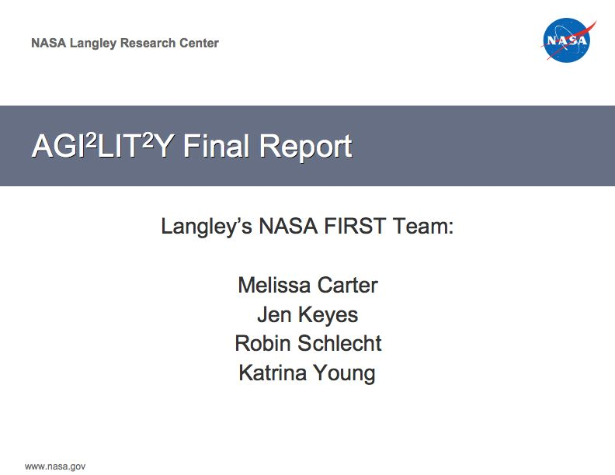
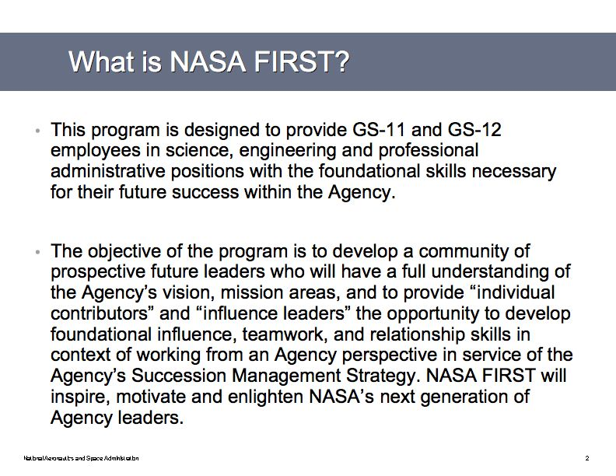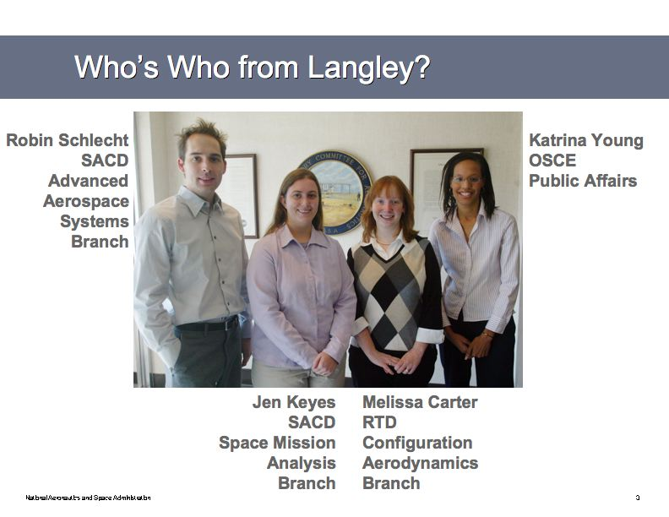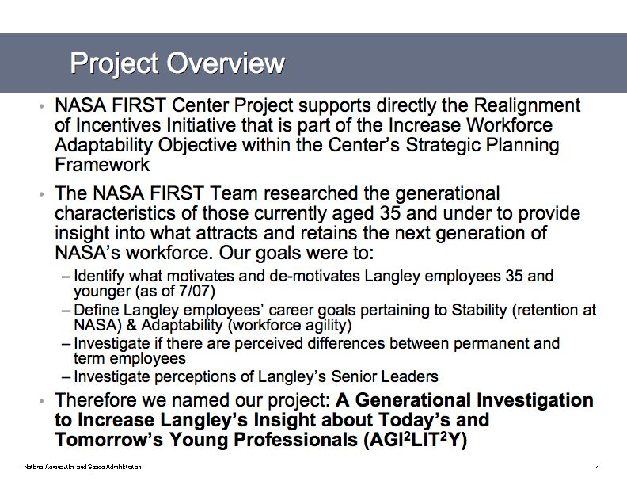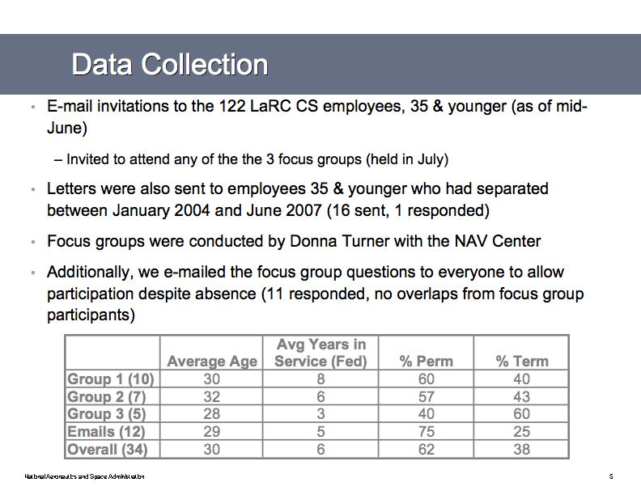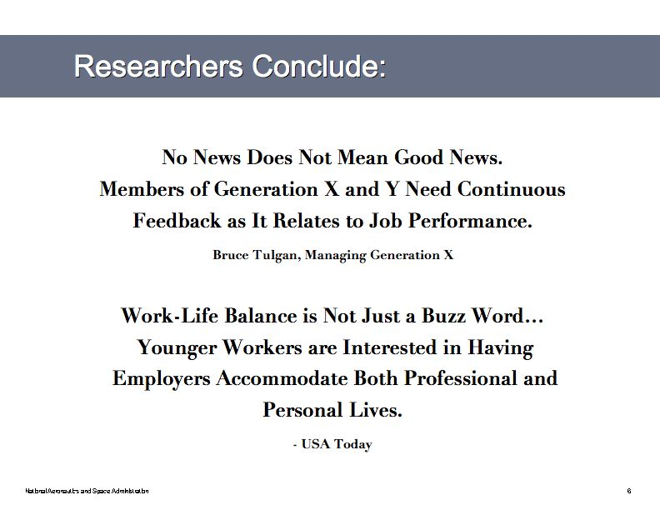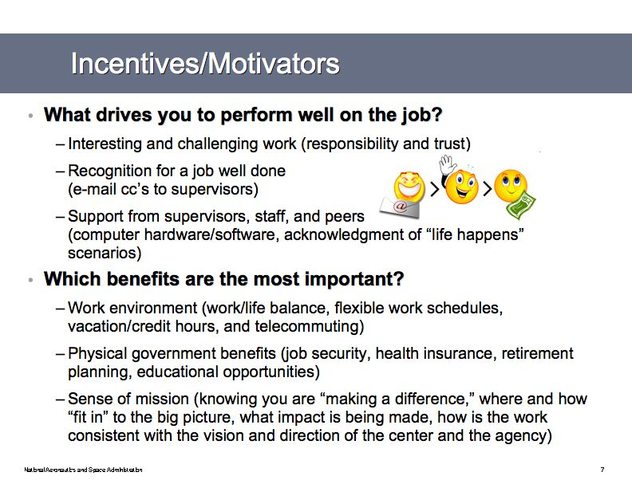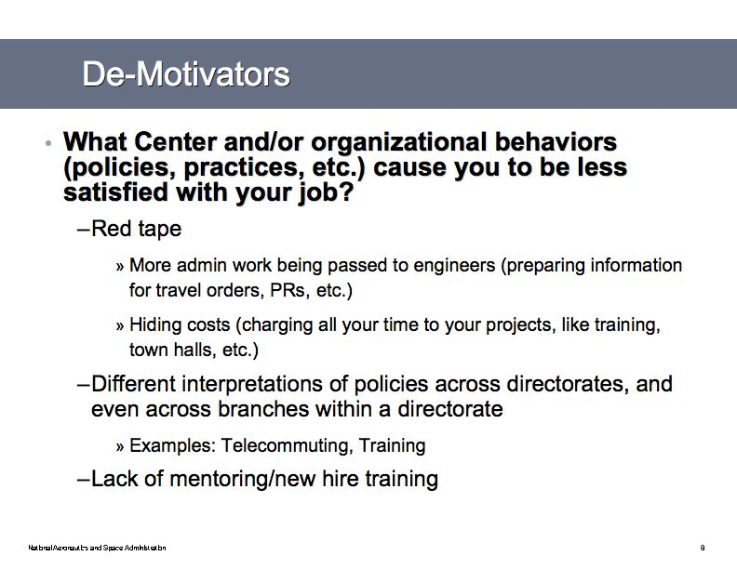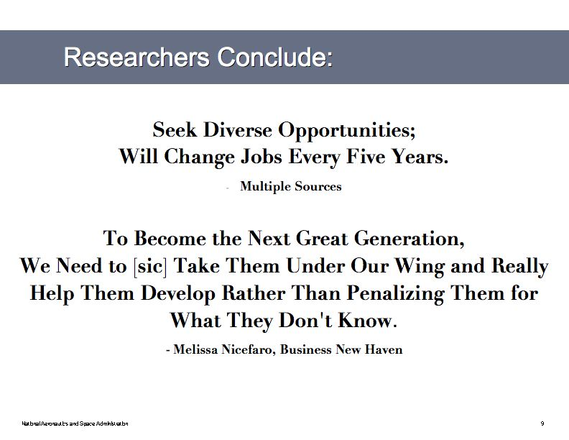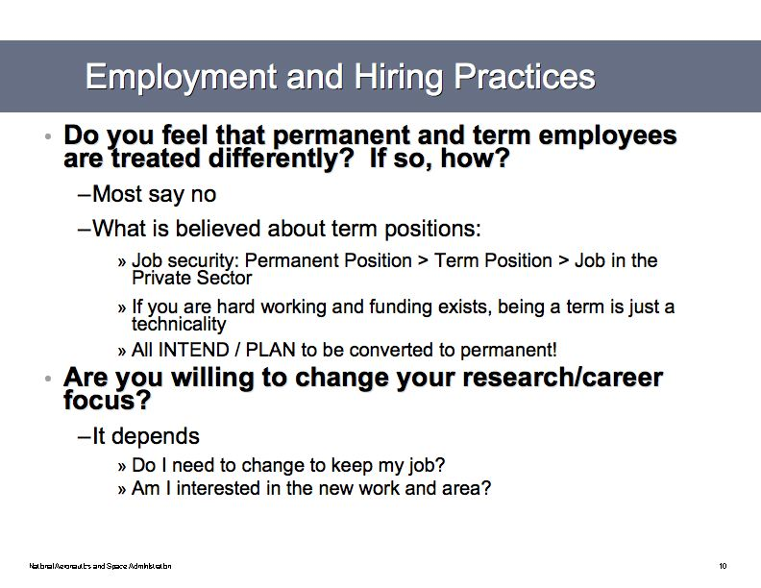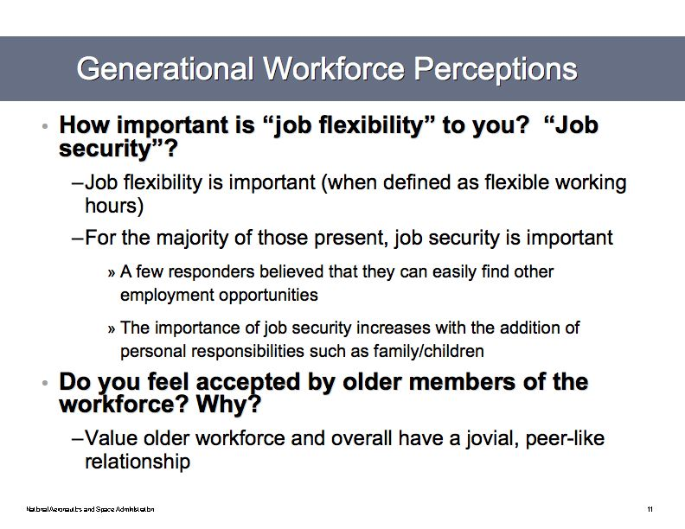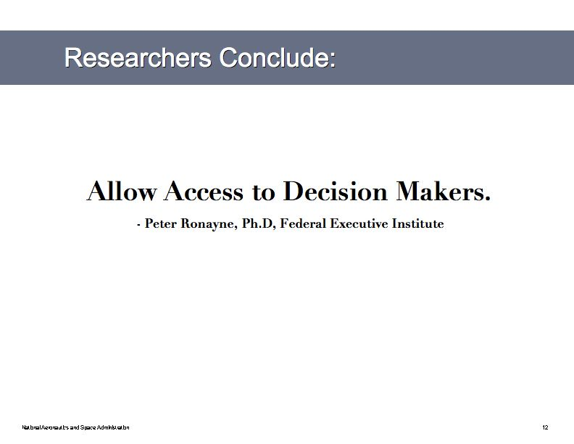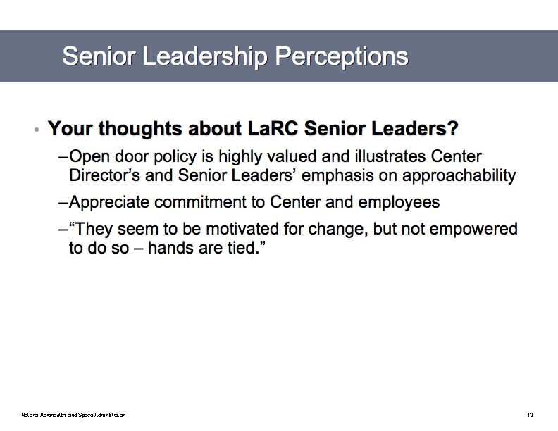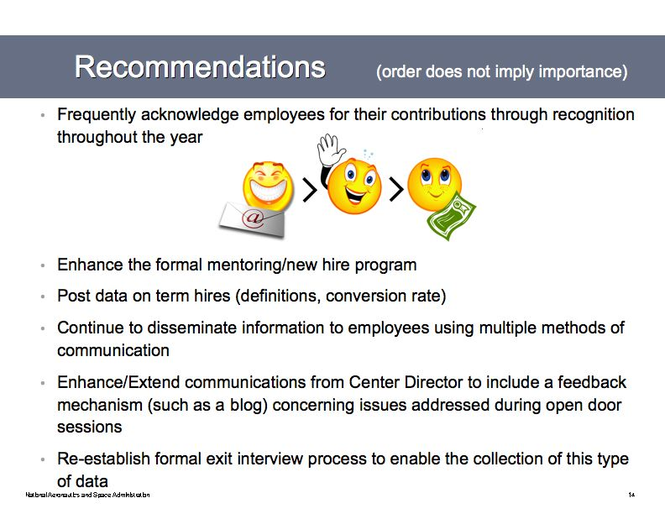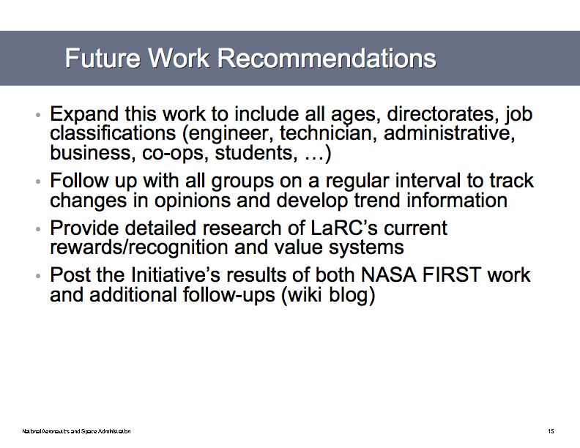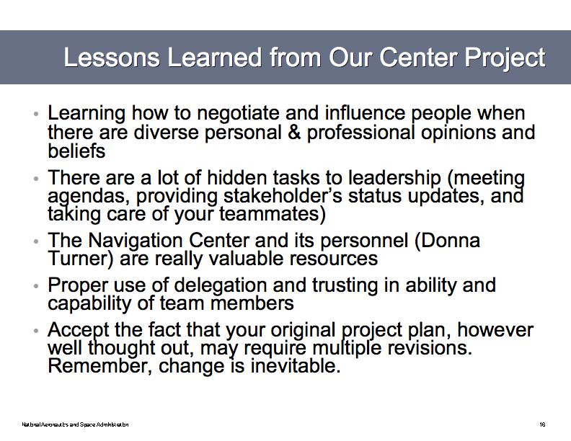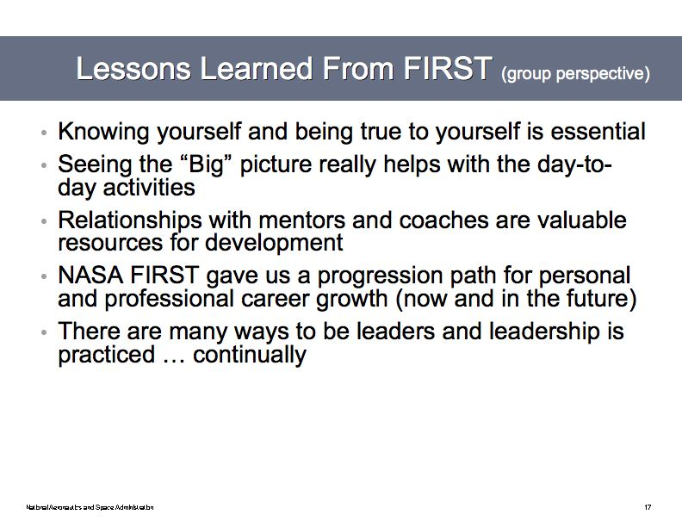

Appendix G – Center Project Handout for Center Leadership Council Presentation

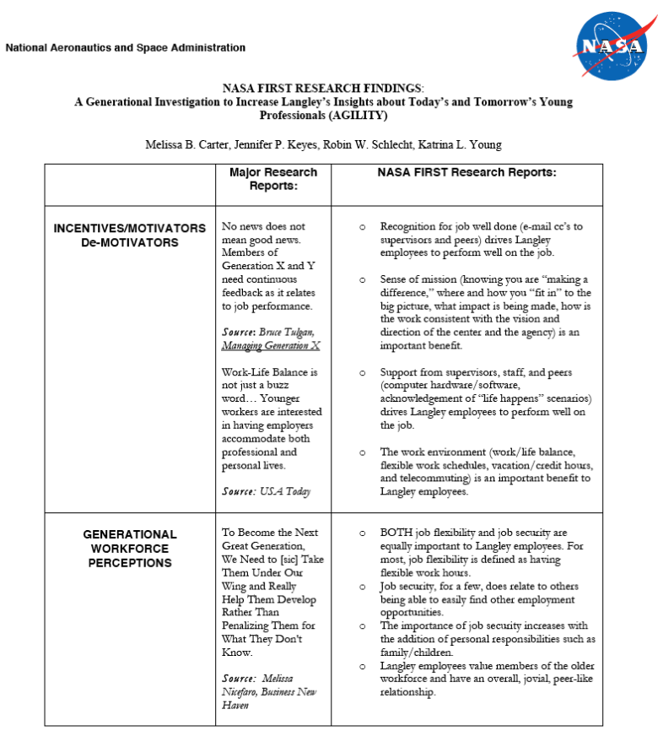
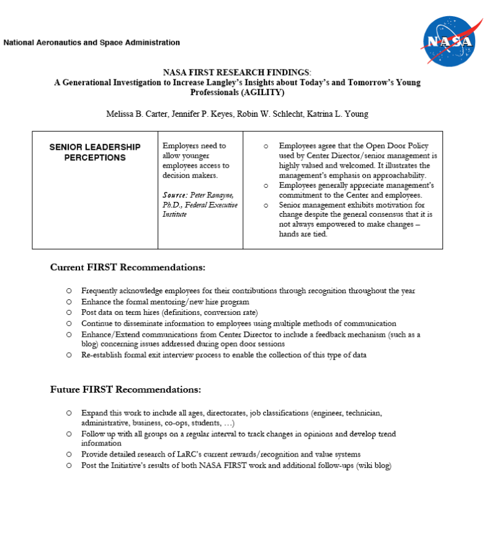

Appendix H – Research Reading Summaries and Notes

"Attitudinal Differences Between Generation-X and Older Employees"
Authors: Natalie Ferres, Anthony Travalione, and Ian Firms
Source: International Journal of Organizational Behaviour, Volume 6 (3), 320-333
www.usq.edu.au/extrafiles/business/journals/HRMJournal/IJOBVolume6/FerresTravaglioneFirnsPaper3.pdf

“Call Them Gen Y or Millennials: They Deserve Our Attention”
Source: Merrill Associates
Topic of the Month: May 2005
(Topic of the Month articles of interest for volunteer resource managers and nonprofit leaders)
http://www.merrillassociates.com/topic/2005/05/call-them-gen-y-or-millennials-they-deserve-our-attention/
Accessed on 03/20/2007

Generation Y were born into the world when children and family were fashionable. Other world facts and happenings included Las Vegas as a “family destination” and “Baby on Board” signs were the trend. Generation Y “children have been wanted, valued, and coddled from birth.”

Another interesting fact about Generation Y is that this generation seems to conform to traditional values, rules, and standards. However, they are very open and liberal about differences. Generation Y are tolerant of difference. This generation is the product of the Civil Rights Movement and the children of Baby Boomers. Therefore, they reject prejudice and are incredibly tolerant of older people (i.e., looks, experiences, preferences, etc.) This group is very open-minded.

Also, this is the generation on the go. Gen Y likes to have things happen quickly. They prefer fast checkout, self-checkout, and quick, conveniences. “They are the 24/7 generation, used to shopping online at 2 a.m. or researching a product on the net so they can be prepared, informed buyers.”

“Variety and stimulation are the norm for Generation Y. Life is full of experiences and they want to live a life filled with endless variety and change.”

Generation Y is a group of multi-taskers who never live according to the status quo.

"Federal Human Capital Survey- NASA"
2006
http://www.fhcs2006.opm.gov/
"Generational Diversity"
Cari Dominguez, Chair of the US EEOC
Copyright 2003
http://www.mcca.com/site/data/magazine/coverstory/0803/perspectiv…

Summary: Organizations typically overlook the significant impact of generational diversity. As a result, 81 percent of such organizations do not include cross-generational issues in their diversity training. Generational blending requires attention for several reasons including:

1. In today’s American workforce, there are four different generations at work.
- The Silent Generation: ages 59 and older
- The Baby Boomers: ages 41 to 48
- Generation X: ages 24 to 40
- Generation Y: ages 23 and younger

2. Each generation has been shaped by different world views and historic events. Therefore, they approach work and career in different ways.

3. “Generational blending can enhance creativity and productivity, as age-diverse work teams are able to approach problems and challenges from a variety of vantage points and draw from greater breadth of experience.”

4. If organizations understand generational differences, this may help with organizations’ to recruit, develop, and retain top talent, regardless of age.

5.Organizations that understand the significance of generational diversity have an edge over competition and other organizations as they attract talent.

6. Intergenerational conflict can also counter effective because it can affect morale and productivity of an organization. In many cases, it can lead to EEO complaints and lawsuits.

Interesting Fact: “Although workers under the age of 40 are not protected by the federal age anti-discrimination law, younger workers also can be the targets of age-based stereotyping, particularly as they move into positions of greater responsibility.

7. The size of Generations X and Y combined is still not large enough to replace the number of older workers leaving the workforce.

"Generation X Speaks Out on Civic Engagement and the Decennial Census: an Ethnographic Approach"
Author: Melinda Crowley
Source: US Census Bureau
www.census.gov/pred/www/rpts/Generation%20X%20Final%20Report.pdf

"Generation Y" – From Wikipedia
http://en.wikipedia.org/wiki/Generation_Y
Accessed on 03/20/2007

Generation Y is a term used to describe a cohort of people born after Generation X. In terms of specific dates of inclusion into Generation Y, there are many speculations. The mostly widely perceived date of inclusion, based on market research, is from 1978 – 2000. If the years 1978 – 200 are used, then the size of Generation Y in the United States is approximately 76 million.

Other common monikers used for Generation Y is:

- The Net Generation
- iGeneration
- MySpace Generation
- Reagan Babies
- Second Baby Boom
- MyPod Generation
- Millennials
- The D.A.R.E Generation
- Generation Next
- Echo Boomers
- Google Generation
- Grand Theft Auto Generation
- Nintendo Generation
- Halo Generation
- Me Generation
- Cynical Generation

A defining event for Generation Y is the Challenger explosion on January 28, 1986. This event separates Generation X from Generation Y, as most members of Generation Y were either not yet born or too young to remember this major national event. Also, other cultural events include The Space Shuttle Columbia disaster and the X Prize and beginning of personal spaceflight.

Generational Demographics
Many Generation Y children are the offspring of Baby Boomers; therefore, “there is a perceived tendency to share social views with the Boomers and culture with Generation X, who serve chiefly as their ‘older cousins’ or even older siblings.

However, some recent market research contradicts this theory, and asserts: “The generation of today’s young adults under 35 and teenagers most resemble are the dying GI generation, the people who are the foot soldiers in World War II and the Rosie the Riveters. That was the generation known for its civic purpose and teamwork and upbeat attitudes and institutional trust…”

Generation Y is the first group to witness to experience technologically firsts such as:
- The Internet
- Camera phones
- Sophisticated computer graphics
- GUISs
- Digital cable
- Social Networking
- Cellular phones
- Instant messaging
- DVDs
- Digital audio players (iPod, MP3 players)
- HDTV
- DVR and TiVo devices
- GPS
- Text Messaging
- Satellite Radio
- PCs with modern operating systems and mouse-based point and click

"Generation Y: The Millennials, Ready or Not, Here They Come"
NAS Recruitment Communications
Copyright 2006

Three Major Characteristics of Millennial Group
- They are racially and ethnically diverse;
- They are extremely independent because of family/parenting;
- The feel empowered. – They feel a sense of security and are optimistic about the future.

Who is Generation Y?

Description

- Generation Y is composed of people born between 1977 to 1994;
- Presently, there are over 70 million people who are members of Generation Y; and,
- Generation Y population is more than three times the size of Generation X population.

Home Life

Generation Y is being raised in the age of the “active parent.” More time has been spent with children as a result of divorce. Child is the focus of Generation Y parents. Parents of Generation Y are very hands-on. Businesses have recognized that fathers are important to child rearing and are making accommodations. As a result of the focus on the family, Generation Y “believe that they can accomplish most anything, and if they don’t, they can always go back home and get help and support” (2). Lastly, they have a strong sense of entitlement.

Technology

* Generation Y grew in the advancement of personal computing power. Three out of four teenagers are on-line, and 93% of those ages 15 – 17 are computer users. The majority of children eight years of age and older online are into E-mailing, gaming, and instant messaging.
* Source: The Millennials: Americans Born 1977 to 1994; National Center for Health Statistics.

Generation is very used to receiving information from multiple sources in a matter of seconds. Therefore, if they do not receive information in a timely fashion, this generation will immediately choose another source. This directly relates to employment and regulations. For example, if Generation Y will question such things as uniform requirements and schedules, and if they are not pleased with the answers, then they will look for other sources.

Population

Generation Y is a diverse group of individuals. They are also very tolerant with the diversity around them. “One to every three Caucasian people is a member of a minority group.” Working and interacting with people from other ethnic group is normal and acceptable.
Source: The Millennials: Americans Born 1977 to 1994; Bureau of Census, 2000.

Characteristics of Generation Y

Pros:
- Adaptability: comfortable to adapt to situations.
- Technologically Savy: grew up with tech advances and comfortable with it and taking advantage of them.
- Ability to grasp new concepts: learning-oriented generation.
- Efficient multi-taskers: Do it fast and better than competition.
- Tolerant: Try to make diverse workforce feel at home as well as comfortable.

Cons
- Impatient: Raised in technological, fast-paced world and like instant gratification;
- Skeptical: Question the truth as a result of culture of deceit (i.e., political cheating, lying, and corrupt business leaders, etc.)
- Blunt and expressive: Favor self-expression over self-control. Making a point is most important.
- Still Young: Because of lack of experience, there are willing to ask questions. It is better for them to ask questions because it saves time. No need to waste time to figure it out.
- Image Driven: Make personal statements with image. This very important

Education

Millennials are one of the most educated generations. They love to learn. College attendance is the norm. Based on 2002 Census data, 64% of women and 60% of men attend college after graduating from high school and 85% attend college full time.

Asian-American women are the most educated group of Generation Y. They are most likely to attend and obtain a degree from a University. 56% have college experience and 16% have a bachelor’s degree.

Source: The Millennials: Americans Born 1977 to 1994; Bureau of Census: Educational Attainment, 2002.

Interesting perspective about job market:

- 51% do not expect job offers upon graduation
- 16% are headed to graduate school
- 57% are moving home after graduation
- 56% are willing to relocate for a job
- 34% are concerned that off-shoring (i.e., out-sourcing) will affect them
- 74% think that relevant work experience is more important in getting a job
- The national average for expected first year salaries is $39,500

Source: monstertrack.com, Entry-Level Job Market Outlook, Spring 2004.

Employment

Attitude about Work

They do not plan on being at the same location for an extended period of time.
They want to be at the top of the chain right away.
The Generation Y employee wants to the work better and faster than their co-workers. (Being competitive with themselves and other is their nature).

Impact on the Workforce

Shortage of workers as Baby Boomers retire and Gen Y enters the workforce.
Clash of the generations because grandparent-aged worker will work along side much younger workers. Gen. Y does not want to be “seen” as the “child.”

According to survey by Lee Hecht Harrison, 60% of employers are already experiencing intergenerational tensions at work. (Source: Generation Y: They’ve Arrived at Work with a New Attitude, 2005).

Generation Y is expected to get along with Baby Boomers better than those who belong to Generation X.
Generation X and Y difference/obstacle: The feeling of “I had to work to work to get here, why don’t they?” Gen. Xers do not think that Y wants to do menial tasks,

By 2012, Generation Y will have filled the 18 – 34 age group. Younger employee will increase by 10% between 2003 – 2012, according to Bureau of Labor Statistics.

At the same time, workers aged 35 – 44 will decrease by 6%.

Most Commonly Used Media of Generation Y for Career Opportunities:

MonsterTrack.com, Career Fairs, and Personal Networking.
(Source: Understanding Generation Y: Student Monitor-Media and Lifestyle, Spring 2004)

Position selection is behavior driven, not monetarily. Gen Y want to work “there” because they want to, not because they have to.

Appreciate technology only when useful to them. E-mail and Internet have made communication very impersonal; this is acceptable most of the time, but not during the application process.

To catch their attention – use colorful, upbeat, and modern campaign. Be different from the rest.

Want the personal touch. Will fill out the application on-line but this is about it. Want the interaction with the recruiter as well as the basic information about the company, the possibilities, and the opportunities.

THE BEST PEOPLE TO CONNECT WITH GENERATION Y ARE GENERATION Y.

Generation Y heavily influenced by the parents.

Use personality profiles to hire people with similar work habits and views will reduce the tension and turnover in the workplace.

Elements Important to Workplace:

- Good Relationships with boss and co-workers;
- Income;
- Opportunity for growth;
- Opportunity to showcase skills and receive recognition of a job well done;
- Challenging daily work;
- Flexible schedules for social and personal time; and
- Casual dress environment.

Ways to Retain Generation Y Employee

- Encourage their values. (show them their value and worth. Let them express themselves and have input into decision making process)
- Train them. If you want the job done right, tell them how to do it.
- Mentor them.
- Show them how their work will contribute to the bottom line. Need to know their impact.
- Provide full disclosure. Be honest.
- Create customized career paths.
- Provide access to technology. Have the latest and best technology at their fingertips to attract and retain them.

"Getting to Know Generation X"
Source: NAS Insights
Date: 2006
www.nasrecruitment.com/TalentTips/NASinsights/GettingtoKnowGenerationX.pdf

"Helping Employers Secure Advantages in a Shifting Labor Market: Five Ways to Connect with Generation X and Y Workers"
Source: Kelly Services
Date: April 2005
www.smartmanager.us/eprise/main/web/us/hr_manager/document_center/genxy_whitepaper.pdf
"The Labor Force Experience of Women from 'Generation X'"
Author: Marlsa DiNatale and Stephanie Boraas
Source: Monthly Labor Review
Date: March, 2002
www.bls.gov/opub/mlr/2002/03/art1full.pdf

"Leading the Multi-Generational Workforce"
Source: Outsource Training.biz LLC
www.outsourcetraining.biz/pdf/Leading%20the%20Multi-generational%20Workforce%20(sample).pdf

“Managing by Defining Moments”
Authors: Geoffrey E. Meredith, Charles D. Schewe, PhD, and Alexander Hiam
Date: Copyright 2002
Publisher: Hungry Minds, Inc; New York, New York
ISBN: 0-7645-5412-3

Incentives/Motivators
- Q1: What drives you to perform well on the job?
  - Exciting, creative, fun work environment (aka Pike Place Fish in Seattle, WA) (26)
  - Gen-Xers probably respond well to work assignments that allow him/her to be in touch with his/her friends (34)
  - Gen-Xers would like assignments presented “as a wild adventure, an exciting opportunity to do something unexpected and fun” (35)
  - For N-Gens explain implications of not fixing a problem right away (rationale) since they want to understand the big picture before making a commitment. (35)
  - N-Gens like to work in a team setting (35)
  - After a job, make sure you thank N-Gens and recognize their effort in a very personal and meaningful way (35)
  - Use technology (35)
  - Gen-Xers tend to “crave lots of feedback” and “want to know how they are doing at all times. So don’t wait until a project is done to offer praise or share information on performance.” Reinforce what they are doing right. (129)
  - Challenges (Gen-Xers) (129)
  - Gen-Xers “prefer straightforward internal communications that focus on how changes or new initiatives will affect them personally. Focus on communicating openly and honestly and without a lot of corporate positioning.” (129)
  - Gen-Xers are looking for “a balance between work and private life, a chance to work independently, opportunities to use new technology, and workplaces that are more like communities.” (130)
  - Gen-Xers should be rewarded with things such as extra vacation days and the freedom to spend time with their family, pursue a hobby, or do absolutely nothing. (131)
  - Gen-Xers expect work to be fun. Do “fun and spontaneous things like bring in ice cream, party hats, and noise makers when an important milestone is met.” (131)
  - “The easiest way to nurture a desired behavior among Gen-Xers is to encourage it when you see it.” (131)
  - “What Gen-Xers Want: Challenge, Excitement, Feedback, Recognition, Time Office, Training, Fun at work, Meaningful work, An end to politicking” (135)
  - Managers should check in with their Gen-X employees once a month about their short-term performance and development goals. “Most managers don’t check in with their Gen-X employees nearly that often, and that is why the employees feel ignored, under-appreciated, and out of the information loop.” (138)
  - “Make sure that employees understand what the priorities are, and why they are priorities.” (138)
  - Gen-Xers “crave meaningful feedback, participation in the decision-making process, the knowledge that their work is making an impact, and recognition for a job well done.” (141)
  - “Companies should think of low-cost rewards to compensate and motivate N-Gens -- allowing them more flex time in their work schedules, opportunities for enhancing their social interactions with other workers, and greater leeway in designing their work environment, for example. But in the end, money talks for this cohort.” (149)
  - N-Gens are “very comfortable with new technology and see embracing it as part of being on the cutting edge.” (150)
  - N-Gens are expected to have a very high debt ration when they get out of school and therefore “are very focused on getting high-paying jobs and starting out on a career path as soon as possible. … Cash awards are likely to be highly motivational for this cohort” (154)
  - N-Gens “want their work to be meaningful, and they want it to foster relationships that extend beyond the workplace.” (159)
  - N-Gens “want to be able to feel that their work is meaningful, and that they are contributing toward the accomplishment of a large goal, be it corporate or societal.” (159)
  - “Another way to keep N-Gens engaged is for managers to do things like take younger employees to high-level meetings, not as participants, per se, but as spectators. Doing so exposes employees to interesting discussions about the company and gives them a taste of what they could be doing in the future.” (160)
  - “How to keep younger [N-Gen] workers happy: give them opportunities to work in small peer-related teams, turn projects into entrepreneurial endeavors, let them choose their own hours, find out their skills and interests and help them become self-fulfilled, find ways to make work meaningful beyond just a paycheck, create ways for them to spend time with upper managers, have them work for ethical leaders, set up a mentoring program, be generous with rewards and recognition.” (161)
  - “Use recognition to help scratch N-Gens’ itch for success and progress. … Formal award ceremonies with public recognition of achievements are often a good thing. Certificates of appreciation can work wonders too.” (170)
  - “When it comes to feedback, Gen-X employees do much better with informative feedback than with controlling feedback.” (173)
  - Work motives that cross both Gen-X and N-Gen employees are: Self-Expression, Status, Recognition, Rewards, and Personal Needs. (187)
  - Other work motives for Gen-Xers are: Excitement, and Control (187)
  - Other work motives for N-Gens are: Affiliation, Purpose, Consideration, and Responsibility (187)
  - Incentives that fit the Gen-X Cohort well: (191)
    - Anything fun, such as travel, a night on the town, a change of location, or a temporary posting to a new area
    - Tickets to entertainment events
    - Things they think are fun – let them design the activity
    - Travel options in which the employee chooses when and where to go and whom to go with
    - Flexibility to select next assignment or co-workers
  - Incentives that fit the N-Gen Cohort well: (193)
    - Recognition through gifts of useful items for the work environment that employees can place and control the use of (such as a swing-arm lamp with dinner or a CD player with headphones)
    - Job rotations or short-term assignments that prevent boredom
    - Entertainment 9tickets or events, but make sure they are of their choice, not yours)
    - Advancement to positions of greater responsibility
    - Becoming members of a micro-team than can bond to accomplish specific tasks and goals
  - “A simple but powerful motivator [for N-Gens]: Thank you notes and frequent verbal recognition and encouragement. N-Gens want to be noticed and appreciated and often feel like they’re not getting enough attention.” (193)
  - What N-Gens want in a job: Respect (92.9%), Fair Treatment (92.3%), Flexible schedule (91.2%), Money (88.1%), and Fun (87.2%) (193)
- Q2: Which benefits are most important? Least important?
  - MOST IMPORTANT:
    - Gen-Xers embrace efforts to improve their quality of life such as flex time, telecommuting, casual dress, and unpaid time off. (131)
    - “Learning new skills through training” is high on the motivator list for Gen-Xers (133)
    - For Gen-Xers both Moms and Dads will need to take time off work to care for sick children (133)
    - Gen-Xers want a family-friendly boss / company (133)
    - “On-site childcare centers or childcare referral programs help to attract and retain” Gen-Xers (133)
    - In the face of tragedy, due to event such as September 11th, provide employees, especially N-Gens, “a chance to express their feelings and admit their fears.” (150)
    - N-Gens “are more likely to respond to such perks as flexible scheduling, the ability to take unpaid leave, and permission to work from home -- perks typically not offered to entry-level employees.” (154)
    - Tuition reimbursement is particularly valued by N-Gens
    - “N-Gens are looking to settle down. Early marriage is one way for them to find stability in an uncertain world.” May “start families early” and therefore “be attracted by flexible work options, such as job-sharing, telecommuting, and part time opportunities.” (156)
    - “Most young people are interested in the transferability of pensions and 401(k) savings.” (156)
    - N-Gens “prefer honesty and authenticity” … “corporate communications must be simple and straightforward and without a lot of public relations spin.” (157)
    - “Companies that have on-site workout facilities or that offer free or reduced rates at an off-site gym can use those perks to help attract and retain fitness-conscious N-Gens” (158)
    - N-Gens will find “cafeteria-style health plans that offer flexibility and a wide range of coverage” the most appealing (158)
  - LEAST IMPORTANT:
    - “N-Gens don’t see the need for company health plans that have low deductibles” (158)

De-Motivators
- Q3: What Center and/or organizational behaviors (e.g., policies, practices, etc.) cause you to be less satisfied with your job?
  - Work that isn’t interesting enough to hold attention (boring project) (34)
  - Gen-Xers distain long hours, office politics, and time away from family (122)
  - Gen-Xers hate being told “I’m the boss, and you do as your told” (123)
  - Don’t expect Gen-Xers to be dedicated to their work to the exclusion of all else (123)
  - Don’t assign Gen-Xers to traditional teams and expect them to thrive (127)
  - Gen-Xers do not want to be told directly what to do by supervisors (129)
  - Gen-Xers are quickly turned off by phony managers and corporate game playing (129)
  - Due to events such as September 11th, N-Gens are more fearful for their personal safety. As a result they may be fearful about getting on airplanes for business trips too often. “Teleconference, faxing, e-mailing, and phoning will be preferred to having face-to-face meetings.” (150)
  - “1 or 2 weeks off and a standard benefits package are not going to wow many in this cohort” (154)
  - “N-Gens see working in cubicles as akin to solitary confinement.” (155)
  - The Internet plays a prominent role in the lives of N-Gens. As a result “they will abide by restrictions that put limits on racially, sexually, or religiously sensitive material, but see other restrictions as overly totalitarian.” (155)
  - N-Gens are “probably the most marketed to [cohort] of all time … so they are very aware of hype. … They are turned off by extravagant exaggerations of reality. … Corporate communications must be simple, straightforward, and without a lot of public relations spin. Otherwise this cohort will lose their belief in management, and motivating them will become even more of a challenge.” (157)
  - N-Gens “expect to have the fastest, sleekest equipment available to them. They consider having up-to-date computer equipment, along with high-speed access to the internet, as one of life’s necessities.” (158)
  - N-Gens “will fight the system if they think leaders are not acting fairly or are lacking in integrity.” (159)
  - “N-Gens are likely to resent impersonal management more keenly than other employees” due to their reaction to events such as September 11th causing this cohort to have a “need for genuine caring and consideration in the workplace.” (171)
  - “Managers and organizations may not be bale to get away with the insensitive behavior they’ve gotten away with in the past – at least not without risking the dissatisfaction, de-motivation, and possible defection of the important new [N-Gen] cohort.” (171)
  - Be careful “about turning Gen-Xers off accidentally by using any motivators or incentives that seem overly cheerleader-like and awaken their cynicism. Be careful of assumptions with this cohort.” (191)
  - When Gen-Xers “resent the time spent at the motivational event – it can become de-motivating instead.” (191)
- Q4: Why would you consider leaving NASA?
  - Gen-Xers are impatient. They don’t want to wait around for 10 years for a good assignment, they want one now or they will leave to try to find it somewhere else. (124)
  - Gen-Xers are more likely to jump from one job to another, piecing together marketable skills that they can sell down the line to the next employer (125)
  - N-Gens “expect to be paid for performance, so seniority-based advancement will not motivate them to stick around. Rather, it is more likely to drive them away.” (155)
  - “In providing [N-Gens] with technology training, make sure the material you are offering is absolutely the most up-to-date technology around. If it is outdated, N-Gens will start looking elsewhere for work that is a little more challenging and cutting-edge.” (159)
  - “Managers and organizations may not be bale to get away with the insensitive behavior they’ve gotten away with in the past – at least not without risking the dissatisfaction, de-motivation, and possible defection of the important new [N-Gen] cohort.” (171)

Senior Leader Perceptions
- Q5: Your thoughts about LaRC senior leaders?
  - “I’m the boss, and you do as you’re told” won’t work with Gen-Xers (123)
  - Gen-Xers don’t expect a company to look out for them very carefully so they better do it themselves (124)
  - Managers need to articulate honestly and clearly what Gen-Xers employees can and cannot expect from their employer / boss / lead / project / position / … (125)
  - Gen-Xers are impatient. They don’t want to wait around for 10 years for a good assignment, they want one now or they will leave to try to find it somewhere else. (124)
  - Gen-Xers in survey after survey report that they don’t trust their managers, don’t think their employers trust them, and want much better more open, and more honest communication with their employers (125)
  - Gen-Xers do not want to be told directly what to do by supervisors (129)
  - Gen-Xers “prefer bosses who take a personal interest in them to bosses who keep things on a purely professional level.” But only take the time to get to know your Gen-X employees “if you are genuinely interested in them.” (129)
  - Gen-Xers tend to distrust anyone in a position of authority due to dire events from their coming of age years (129)
  - N-Gens “will fight the system if they think leaders are not acting fairly or are lacking in integrity.” (159)
  - “Another way to keep N-Gens engaged is for managers to do things like take younger employees to high-level meetings, not as participants, per se, but as spectators. Doing so exposes employees to interesting discussions about the company and gives them a taste of what they could be doing in the future.” (160)
  - “Gen-Xers’ communications with their managers are usually quite poor.” (172)
  - “Managers often misread the independence value as indicating that Gen-X employees resent direction and do not want attention.” (172)
Employment and Hiring Practices
- Q6: Do you feel that permanent and term employees are treated differently? If so, how?

- Q7: For Engineers: Are you willing to change your research focus? Why?
- Q7: For Non-Engineers: Are you willing to change your career focus? Why?
  - N-Gens are open to change (33)
  - “Gen-Xers are always on the lookout for a bigger and better opportunity. Rather than staying with one company for life, many Xers are looking to build marketable job skills quickly, then move on to the next opportunity. During their coming of age years, they saw their parents downsized after years of being loyal to the company, and Xers are not about to let that happen to themselves.” (132)
  - N-Gens respect institutions and therefore are much more likely to remain loyal to the company. (149)
  - N-Gens see “change as something positive and beneficial.” (150)
- Other
  - Gen-Xers are “the first cohort for whom the career search may never be completely over.” (132)
Generational Workforce Perceptions
- Q8: How important is "job security" to you? Job flexibility?
  - A Gen-Xers sees themselves as an independent free agent in the world of work (33)
  - N-Gens are open to change (33)
  - Gen-Xers are “the first cohort for whom the career search may never be completely over.” (132)
  - “Gen-Xers are always on the lookout for a bigger and better opportunity. Rather than staying with one company for life, many Xers are looking to build marketable job skills quickly, then move on to the next opportunity. During their coming of age years, they saw their parents downsized after years of being loyal to the company, and Xers are not about to let that happen to themselves.” (132)
  - Gen-Xers “realize that corporate loyalty will get them no where” (132)
  - After children Gen-Xers are more stable (133)
  - “Most [Gen-Xers] don’t expect to stay in the same job, or even work for the same company, for more than a few years. Their whole career is built around being flexible enough to seize new opportunities when they come along.” (136)
  - N-Gens respect institutions and therefore are much more likely to remain loyal to the company. (149)
  - “N-Gens respect institutions, but they don’t have the same feeling of absolute, unquestioning deference to the company, the family, … or the government that the ghost cohorts did.” (149)
- Q9: Do you feel accepted by older members of the workforce? Why?
  - Gen-Xers lack the optimism and idealism that bonds other cohorts together (125)
  - “The difference in values between the Baby Boomers (both sets) and Gen-Xers is so pronounced that it’s no wonder these groups have trouble getting along in the workplace.” (127)
  - Gen-Xers “free agency and independence tends to get them in trouble with Boomer managers and supervisors” (127)
  - N-Gens have values of “respect for institutional values, conservatism, and the feeling of having been unified by a national crisis” in common with the World War II cohort
  - “Make room in the monthly schedule for at least one casual get-together” as this provides for the face-to-face interactions that don’t happen as often due to e-mail and telecons and telecommuting (168)
  - N-Gens’ expectation of quick success can often be frustrating to “older managers who had to pay their dues along the way.” (169)
  - “The Gen-X mentality may offend older supervisors, leading to accusations of poor attitude and insubordination, which employees feel are unjustified.” (172)
- Other
  - N-Gens have an expectation for immediate success (21)
  - Gen-Xers value informality, cynicism, and street smarts (21)
  - Gen-Xers have needs for emotional and financial security and desire for independence (21)
  - Gen-Xers value friendship highly (33)
  - Gen-Xers take a cynical view of the future (33)
  - Gen-Xers seek to improve own quality of life (33)
  - N-Gens are anxious about safety and security issues (33)
  - N-Gens view diversity as a highly positive thing (33)
  - N-Gens want to understand the big picture before committing (35)
  - Gen-Xers have a slacker image (124)
  - Gen-Xers see their interested outside of work as being more important than their work (124)
  - Gen-Xers are impatient. They don’t want to wait around for 10 years for a good assignment, they want one now or they will leave to try to find it somewhere else. (124)
  - Gen-Xers are more self-reliant than members of other cohorts (125)
  - Tragic events such as Challenger and September 11th have made Gen-Xers take a “no guarantees” mentality (126)
  - Gen-Xers learned early on to be independent (127)
  - Gen-Xers tend to “crave lots of feedback” and “want to know how they are doing at all times. So don’t wait until a project is done to offer praise or share information on performance.” Reinforce what they are doing right (129)
  - Gen-Xers put a lot of importance on friendships (129)
  - Gen-Xers “want to enjoy life.” They “learned long ago than work is just a paycheck, and that the things that really matter is life (family, friends, hobbies) are much more fun than work.” (130-131)
  - Gen-Xers “expect work to be fun” (131)
  - Gen-Xers are likely to remain more loyal to a company that shows concern for the environment (134)
  - Gen-Xers and N-Gens think of ethnic and social diversity as no big deal (134)
  - Gen-Xers have always been ahead of the technology curve (136)
  - Both Gen-Xers and N-Gens are good at multitasking (136)
  - N-Gens “have learned self-sufficiency and self-reliance from an early age” just as Gen-Xers did (144)
  - N-Gens have never known life without CDs, computers, answering machines, or cell phones. As employees they are truly wired and technologically savvy.” (145)
  - N-Gens “have a strong sense of entitlement, and many carry unrealistic expectations about how fast they will advance in the workplace.” (145)
  - N-Gens are more fearful for their personal safety than people of older cohorts (146)
  - N-Gens “tend to be less cynical, more idealistic and altruistic, and far more optimistic than Gen-Xers. (148)
  - N-Gens do consistently reject “their Boomer parents’ liberal and anti-establishment values” (148)
  - N-Gens respect institutions and therefore are much more likely to remain loyal to the company. (149)
  - N-Gens are more likely than Gen-Xers to be team players
  - N-Gens like Gen-Xers are “not interested in letting work consume them and define who they are. They are looking for a balance between work and life right from the start.” (154)
  - For N-Gens “the internet has become a way of life and using it for practical purposes is second nature to them. Cell phones, pagers, instant messaging, and more have also become a way to communicate with people in far-flung locations in real time.” (159)
  - “Gen-X employees do not know how to elicit the desired emotional support and reassurance / security from their supervisors.” (172)

"Managing the Generation Mix 2007"
Source: Managing the Generation Mix, 2nd Ed
Authors: Carolyn Martin, Bruce Tulgan
Date: 2006
www.rainmakerthinking.com/mix2007.doc

"Managing Generation X: How to Bring Out the Best in Young Talent"
Author: Bruce Tulgan
Capstone Publishing Limited, 1996
Source: US Office of Personnel Management

Some common misconceptions about members of Generation X (born between 1963 – 1981) are that these individuals are “slackers wasting their lives in low-pay, low-status, short-term jobs.” Other stereotypes include that they are disloyal employees who wish to move from job-to-job without paying their dues. Contrary to these misconceptions, Generation Xers aspire to be self-sufficient through “learning and increased opportunities for growth – and making a contribution. Generation X employees view each assignment as a learning experience and a way to gain skills to make themselves more marketable. If managed effectively, they can be a wonderful source of creative productivity.”

One recommendation to get “the best out” of Generation employees is communication through feedback. This generation needs regular constructive feedback that will aid in success as well as reduce future mistakes. Younger workers can then see that the work is paying off and can also learn how to achieve more success. This will lead to more confident workers who are productive and willing to use creative talents.

This generation needs a constant feedback loop. The model according to Tulgan should be FAST… Feedback that is Accurate, Specific, and Timely.

Constructive feedback fosters learning and growth opportunity. Gen Xers often “grow anxious without any reliable status reports on their job performance.”

Therefore, the best work environment for this demographic is one where they are given total responsibility for a specific project along with the tools, information, support, and freedom they need to focus on accomplishing it.

In conclusion, managing Generation X employees requires ridding oneself of preconceived notions about this group and providing them with the environment, information, and freedom to perform their best.

"Why employee surveys fail… and how to achieve success"
Source: MERCER Human Resources Consulting
Date: December 20, 2005
www.mercerHR.com

When surveys are poorly designed and implemented, and when there is no follow-up action, the can have negative impacts and do not gain intended results.

Not only is a failed survey a waste of time, it can also lead to employee disengagement.

When an organization conducts a survey with follow-up actions, most employees have an 84% engagement rate versus only 39% when there are no follow-up actions.

Why Surveys Fail?

Here are 10 key areas that could be potential stumbling blocks; however, these are suggestions of how to improve them or avoid them.

10 Key Areas include:

1. Project Planning
- Define long-term project goals and establish Key Performance Indicators (KPIs)
- Integrate with business strategies and change initiatives
- Estimate time and resources requirements
- Obtain input from representatives of major parts of the organizations
- Develop a network of champions who support the survey
- Create a project management infrastructure

2. Communications
- Develop an end-to-end communication plan
- Establish a clear schedule and responsibilities for communication “events”
- Create a survey brand to establish coherence and continuity

3. Questionnaire design: Make the Survey Relevant
- Begin with a tested theoretical model for the questionnaire design, focused on business performance
- Gather employee input on key areas of concern
- Gather manager and other stakeholder, input on key areas of interest
- Include questions that allow for organization-wide and local follow-up action

4. Timing
Ensure the survey results are available in time to provide input
Schedule data collection to avoid disruptions to work and to reach a maximum number of employees

5. Prioritization of issues
- Use norm comparison to identify areas of strength and weakness
- Make historical comparisons to monitor trends
- Use key driver analysis to identify the areas that have the greatest impact on performance
- Focus on vital issues for follow-up action

6. Engaging senior management
- Ensure rapid review of survey results by senior management after data collection
- Allocate sufficient time for a full, interactive senior management review of results and to reach consensus on issues and priorities

7. Data delivery
- Design data delivery with the end user in mind
- Ensure that results are presented in an engaging and easy-to-understand manner (keep simple)

8. Follow-up support
- Provide follow-up training for managers and or survey champions
- Continue to involve the survey champion network to support managers in developing action plans
- Identify and document best practices
- Create a library or database of best practices

9. Monitoring and accountability
- Define clear management responsibilities for survey activities
- Establish follow-up goals on the basis of actions, rather than on improvement in survey scores
- Conduct a regular monitoring of survey follow-up action
- Regularly review survey activities at management meetings

10. Linking survey results to business outcomes
- Integrate survey results with the business planning process
- Use survey results to guide and evaluate the success of change initiatives
- Integrate survey data with human capital metrics
- Establish the linkage of survey results with measures of organizational performance

"Within Reach ... But Out of Synch: The Possibilities and Challenges of Shaping Tomorrow's Government Workforce"
Source: The Council for Excellence in Government & The Gallup Organization
Date: December 5, 2006
www.excelgov.org/UserFiles/File/Within%20Reach%20But%20Out%20of%20Synch.pdf

Appendix I – Presentation Slides to NASA Marshall Senior Leadership

NASA Marshall Space Flight Center's NASA FIRST team investigated recruiting and retention in a multi-generational environment. We have included their presentation to MSFC's senior leaders so that future work can use these results.

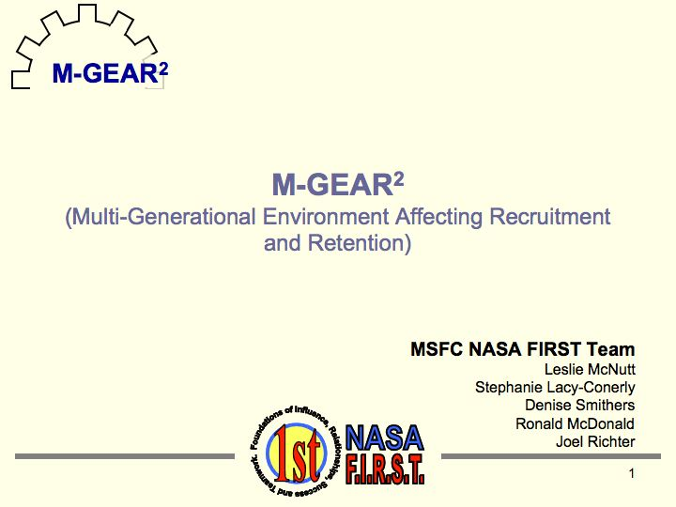
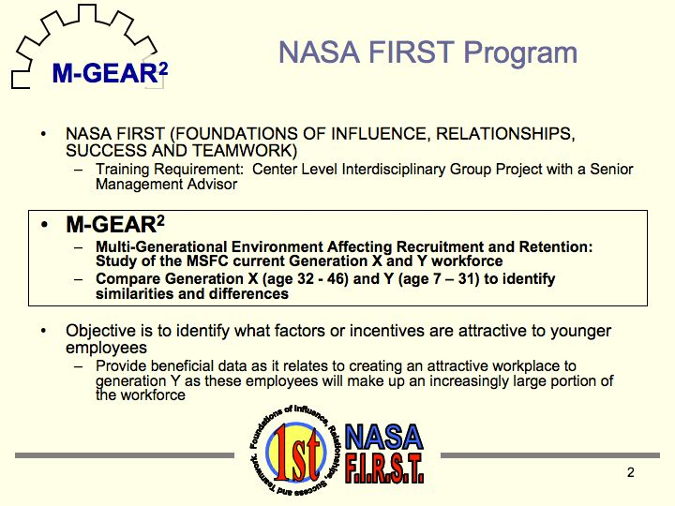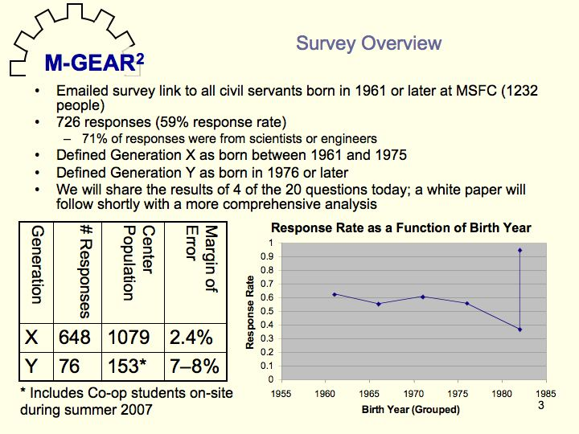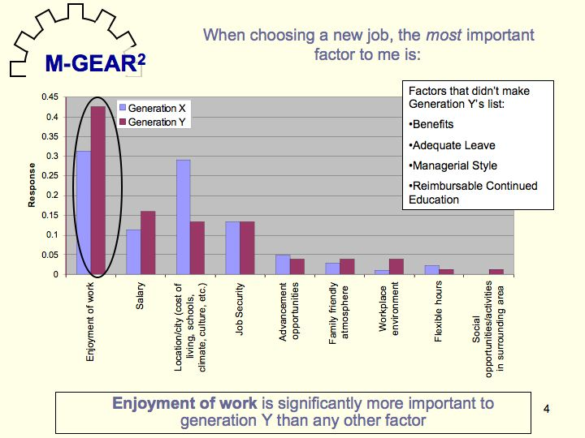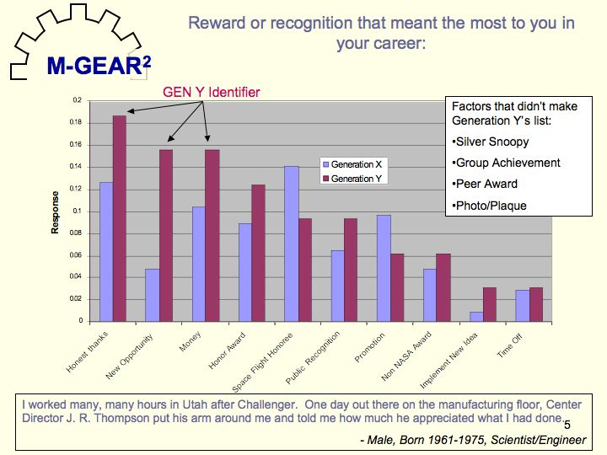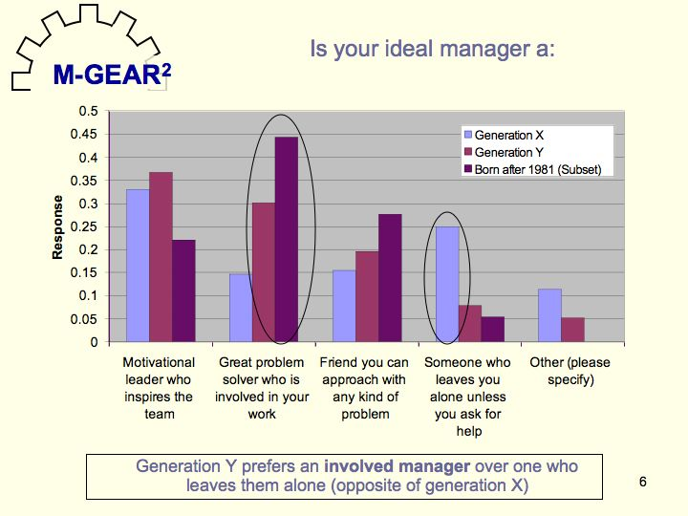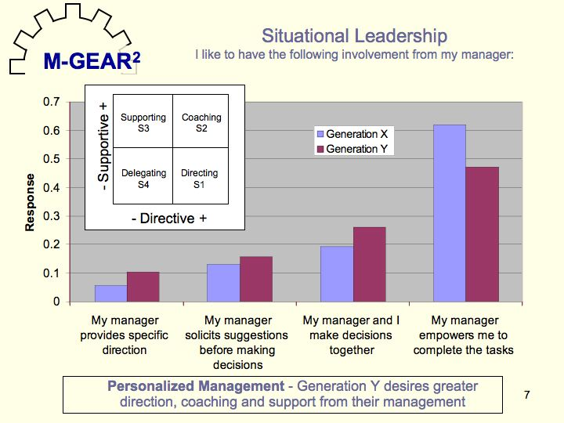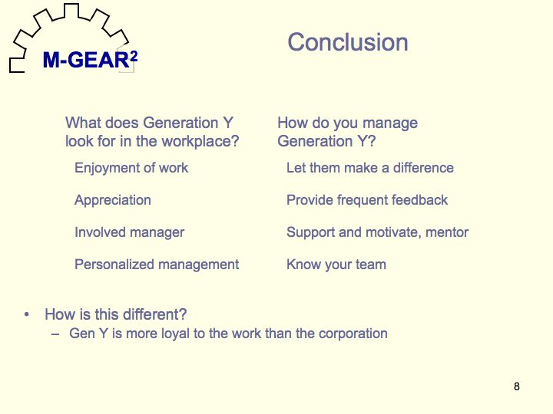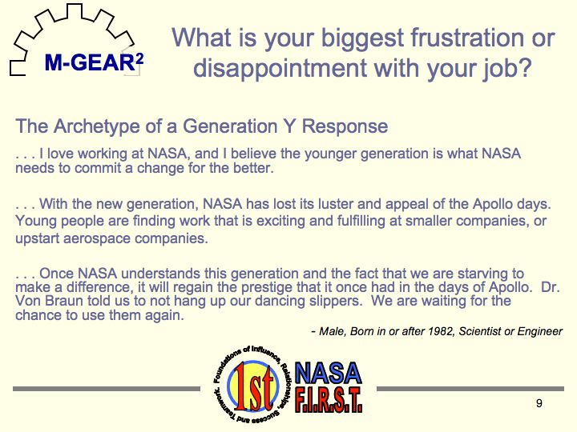

Appendix J – About the NASA FIRST Pilot Program
The National Aeronautics and Space Administration (NASA) Foundations of Influence, Relationships, Success, and Teamwork (FIRST) is a program designed to provide Grade Schedule (GS) GS-11 and GS-12 employees in science, engineering, and professional administrative positions with the foundational skills necessary for their future success within the Agency. The objective of the program is to (1) develop a community of prospective future leaders who will have a full understanding of the Agency’s vision, mission areas, and (2) provide “individual contributors” and “influence leaders” the opportunity to develop foundational influence, teamwork, and relationship skills in context of working from an Agency perspective in service of the Agency’s Succession Management Strategy. As a result of their experiences, NASA FIRST participants will become inspired, motivated, and enlightened as NASA’s next generation of Agency leaders. This year-long, part-time program, including four training modules, shadowing, group projects, individual assessments, and activities, is the foundational development program in NASA’s overall succession management strategy. According to NASA, this strategy is designed to provide leadership skills and knowledge of the Agency’s vision and mission to the Center’s “best and brightest”—NASA’s future leaders. Therefore, the NASA FIRST program is designed for high-potential civil servants who are committed to serving NASA, and are seen as future leaders by their supervisor, manager, and Center Director.
The 2007 pilot class of NASA FIRST includes 41 participants from all ten NASA centers, including White Sands Test Facility, and the NASA Shared Services Center. The four Langley participants represent diverse backgrounds and current assignments. Robin Schlecht joined NASA Langley as a Langley Aerospace Research Summer Scholar (LARSS) student in the summer of 2002 and as an engineering co-op in 2003. Now, Robin is an aerospace engineer in the Advanced Aerospace Systems Branch in the Systems Analysis and Concepts Directorate. Robin is responsible for designing and developing state-of-the-art technologies that will enhance the performance of advanced aircraft. Jen Keyes joined NASA Langley in the summer of 1999 as an Advanced Undergraduate Research using Optical Radiation in the Atmosphere (AURORA) Program Intern and then as an engineering co-op in the fall of 1999. Now, Jen is an aerospace engineer in the Space Mission Analysis Branch in the Systems Analysis and Concepts Directorate. Jen’s latest work has involved the development and analysis of the Exploration Objectives for the Moon and Mars. Melissa Carter joined NASA Langley in 1998 as an engineering co-op. Melissa is an aerospace engineer in the Configuration Aerodynamics Branch in the Research and Technology Directorate. Melissa’s current research includes the Blended Wing Body, sonic boom prediction and mitigation, and jet noise. Katrina Young joined NASA Langley as a LARSS student in 1998 and began as an education co-op student in 2000. Katrina is a program analyst in the Office of Strategic Communications and Education assigned to Public Affairs. Katrina’s duties include communicating the NASA Vision and Mission as well as research to NASA employees, stakeholders, and members of the general public through media, exhibits, and community outreach activities.

Appendix K – NASA FIRST Lessons Learned

Lesson I: “Knowing yourself and being true to yourself is essential”

Knowing yourself and being true to yourself is one of the greatest challenges that was faced during this program. As highly driven people, sometimes it is easy to get caught up in competition with other people. However, it is essential to step back and really consider what makes you happy. Instead of seeing that you have to continue up the ladder of command, it is important to realize at what point would you not be enjoying the job but simply doing it to continue up. Money and power are constantly portrayed as the way to happiness. However, it is important that as individuals we discover what truly makes us happy and not allow other influences to sway us to go against our beliefs.

Lesson II: “Seeing the “Big” picture really helps with the day-to-day activities”

It can be really easy to simply focus on only the work we are currently doing. However, NASA FIRST gave us the opportunity to step outside our work and see all that NASA does, and everything that influences our goals. Being able to talk to senior leaders and see all the different research the centers are doing gave us a better appreciation for the overall mission of NASA and where we fit in. This understanding helps when we return to our day-to-day activities by providing the broader context for the work we as individuals, a center, and an agency do.

Lesson III: “Relationships with mentors and coaches are valuable resources for development”

Through NASA FIRST each of us has had the opportunity to have a mentor and some one-on-one coaching. These relationships have provided insight into our work, our place within our branches, and possible options for our futures. The individuals we have been fortunate enough to have assist us during this year have been an invaluable sounding board for new ideas, inspirations, and discoveries.

Lesson IV: “NASA FIRST gave us a progression path for personal and professional career growth (now and in the future)”

Each of us on the Langley team entered the NASA FIRST Program for different reasons and with different expectations. We are all leaving the program with more knowledge about NASA, leadership, and ourselves. NASA FIRST has in that way provided each of us with opportunities to grow and to map out paths for our futures.

Lesson V: “There are many ways to be leaders and leadership is practiced … continually”

Leadership is not only about becoming the NASA Administrator or a member of the Senior Executive Service. You can be a leader at many levels from the senior leadership at the agency or a center to a team or group lead position for a project within a branch. All of these levels will benefit from great leadership!

Lesson VI: “Knowing what you value is important”

Knowing what your personal values are, how they drive you, and affect the way you make decisions are important as they affect every aspect of your life both at work and at home. Your values affect what motivates and de-motivates you.
The other centers do some incredible things and play integral roles for agency and mission success.

Lesson VII: “The other centers do some incredible things and play integral roles for agency and mission success”

Having had the opportunity to learn about the other centers’ histories and current work as well as meet people from each location has greatly enhanced our understanding of the agency and our networks of personal connections that we can continue to make use of in the future.

Appendix L – Recommendations for Selecting a Mentor

Characteristics of a Good Mentor:
- Understands the need for work-life balance
- Can serve as a neutral listener and sounding board and ensure that information discussed will remain confidential where needed
- Explains how an organization works, who the key players are, and can also elaborate on the overall vision/mission of the organization
- Has a winning attitude and personality that works well with mentee (does not always bring personal negative viewpoints into the mentoring relationship)
- Understands and demonstrates flexibility as mentor (work schedule, meeting times, etc.)
- Offers personal and professional advice that is applicable to mentee’s work and life situations
- Willing to introduce mentee to new individuals, experiences, etc. to help set and accomplish goals
- Provides open, honest, and relative advice
- Demonstrates a desire to be a mentor and clearly wants to be a mentor
- Willing to listen
- Willing and available to get together (in person, on phone, over email, instant messenger)
- Knowledgeable of the people, environment, and areas I work with/in, without having direct conflicts of interest if I need to discuss specific situations or behaviors or examples or hypotheticals that I need advice on
- Offers stories from their own career/life of relevant situations
- Looks out for the mentee in terms of opportunities that would be good fits (work, life, …)
- Both the mentor and mentee need to be flexible since “life happens” and plans may need to change
- Mentors should not assume anything regarding the mentee. Mentees can surprise with regard to what they both know and do not know. There are several categories of needs where the mentor can offer:
The enthusiastic beginner = needs direction
The disillusioned learner = needs coaching
The cautious completer = needs support
The self-reliant achiever = needs responsibility
- Where projects for mentees are involved, clearly defined boundaries are required.
- Mentors need to offer continual feedback regarding expectations, performance and success criteria.

When Selecting a Mentor:

- Make the mentee interview (at least 3) potential mentors

  - Enables the best fit since every mentee will likely need something a little different
  - Good experience interacting with others (both the interviews and the process of asking someone to be your mentor and then having to tell the others you interviewed that you didn’t feel they were the best fit. Although this was tough, looking back it was valuable)
- Have a relationship agreement to help set/limit expectations (how often to meet, where, how, how long, how to refer to each other, etc.)
- Seek a mentor who has completed NASA leadership courses such as Leadership Development Program, Senior Executive Service
- If applicable and of interest, choose a mentor who is outside of your organization or not someone to whom you report directly
- Choose an individual who wants to be a mentor rather than someone who sees it as another duty or requirement
- Keep an open mind about expectations for you and the mentor

Appendix M – Recommendations for Success for NASA FIRST
Class of 2008

To ensure that Langley’s 2008 NASA FIRST class successful completes its leadership training, we recommend the following actions continue and/or be added:
- Allow the participants access to the Center Leadership Council to aid in their understanding of NASA’s policy and directives as well as to interface with senior leaders;
- Ensure that they understand early the proper procedures and policies when collecting data and who appropriate persons are and/or what channels of communications are recommended;
- Have the Center Point of Contact meet with them at least monthly to gauge needs, offer advice, and provide directions
- Allow participants the ability to choose their center project from multiple choices

Appendix N – Additional Information about NASA FIRST and
Contact Information

For additional information on NASA FIRST please visit:
http://www.leadership.nasa.gov/nasa_first/home.htm
http://www.nasa.gov/centers/langley/news/researchernews/rn_nasafirst_120806.html

For write-ups on the different training modules please visit:
http://www.nasa.gov/centers/langley/news/researchernews/rn_nasafirstKatrina.html
http://www.nasa.gov/centers/langley/news/researchernews/rn_nasafirstKeyes.html
http://www.nasa.gov/centers/langley/news/researchernews/rn_nasafirst_schlecht.html
http://www.nasa.gov/centers/langley/news/researchernews/rn_nasafirst_carter.html

Contact Information for the Langley's NASA FIRST Class 2006-2007
Melissa Carter: Melissa.B.Carter@nasa.gov (757) 864-8606
Jennifer Keyes: Jennifer.P.Keyes@nasa.gov (757) 864-1958
Robin Schlecht: Robin.W.Schlecht@nasa.gov (757) 864-9615
Katrina Young: Katrina.L.Young@nasas.gov (757) 864-3868

Project Sponsors
Cindy Lee: Cynthia.C.Lee@nasa.gov (757) 864-6114
Marty Waszak: Martin.R.Waszak@nasa.gov (757) 864-4015

