




FedTraveler.com
Data Exchange Specifications
Version 1.1
Submitted by EDS
April 23, 2004


Revision Chart
Version | Primary Author(s) | Description of Version | Date Completed
1.0 | Ken Sivaraman, Michael Starban | Initial Submission | 26 February 2004
1.1 | Ken Sivaraman | Modified Submission, conforming to comments from original submission | 23 April 2004

Approvals
We, the undersigned, accept this document as a stable work product to be placed under formal change control as described by the Configuration Management document.
Sponsor |  | Date
Project Manager |  | Date
Leadership Team |  | Date
Stakeholder(s) |  | Date

Table of Contents
Revision Chart i
1.0 Introduction 1
1.1 Purpose 1
1.2 Scope 1
1.3 Intended Audience 1
2.0 FedTraveler.com EAI Framework Logical Architecture 2
2.1 FedTraveler.com Integration Framework 2
2.2 Conceptual Architecture 3
2.2.1 Business Process Management 3
2.2.2 Content and Rules-Based Routing 4
2.2.3 Data Translation and Transformation 4
2.2.4 Collaborations 4
2.2.5 Adapters 4
2.2.6 Messaging Middleware 5
2.2.6.1 Publish and Subscribe Messaging 5
2.2.6.2 Queues 5
2.2.6.3 Topics 6
2.3 Scheduling 6
2.3.1 Defining Schedules 6
2.3.2 Collaboration Scheduling 6
2.4 Security 6
2.4.1 Encryption capabilities 7
2.4.2 Access Control 7
2.4.3 Internet Protocol (IP) address filtering 7
2.5 FedTraveler.com XML Schema 7
2.6 FedTraveler.com XML Data Dictionary 7
2.7 FedTraveler.com Standard Data Input and Output 8
2.8 FedTraveler.com Data Exchange Procedures 8
2.9 FedTraveler.com Travel Report Elements 8
2.10 FedTraveler.com Invitational Travel Support 8
2.11 FedTraveler.com Data Validation and Verification 8
3.0 Appendix A 10
3.1 SeeBeyond eGate Integrator 10
3.1.1 SeeBeyond Integration Server 10
3.1.2 SeeBeyond Message Server 11
4.0 Appendix B 12
4.1 SeeBeyond eInsight Business Process Manager 12
4.1.1 SeeBeyond eInsight Overview 12
4.1.2 SeeBeyond eInsight Architecture 12
5.0 Appendix C 14
5.1 SeeBeyond ICAN 5.0 Adapters List 14
6.0 Appendix D 20
6.1 SeeBeyond eXchange Integrator 20

Introduction

Purpose
The document defines the requirements for data exchange to establish enterprise-wide Interface Agreements using the FedTraveler.com Enterprise Application Integration (EAI) Framework.

Scope
The scope of this document describes the processes and procedures for data exchange (inbound and outbound), data transmissions and scheduling options, security and access requirements and options and format translation capabilities of the FedTraveler.com EAI Framework.

Intended Audience
This document is intended for the following audience:

- eTS Engineering Community
- Application Integration Subject Matter Experts (SMEs)
- General Community

All information contained in this document should be carefully reviewed. Any concerns, comments, and/or questions should be directed to the individuals identified in the table below.
Name | Mail | Phone | Organization
Ken Sivaraman | ken.sivaraman@eds.com | (703) 733-3052 | EDS Business Acceleration Services
Michael Starban | michael.starban@eds.com | (703) 742-1980 | EDS Business Acceleration Services
Darren Collins | Darren.collins@eds.com | (703)742-1444 | EDS eTravel Services

FedTraveler.com EAI Framework Logical Architecture
This section describes the FedTraveler.com Enterprise Application Integration (EAI) Framework from which the data exchange processes and procedures are defined and data flow is executed.

For the FedTraveler.com EAI Framework, EDS has teamed with SeeBeyond Technology Corporation to leverage its best of breed enterprise application integration platform known as the ICAN 5.0 Suite. EDS plans to leverage several of the core products within this suite, including:
- eGate Integrator - for application to application integration
- eInsight Business Process Manager - to leverage business processes and workflow across the enterprise
- eXchange Integrator - for inter/intra agency integration as well as for support for the many common business to business protocols such as Electronic Data Interface (EDI)
- a combination of the adapters listed in Appendix C, as required by the target environment.

It should, however, be noted that the ICAN 5.0 Suite is comprised of more products than what EDS has chosen to use for the FedTraveler.com Integration Framework. The capabilities and functionalities conveyed in this document pertain strictly to those parts of the ICAN 5.0 Suite that EDS has determined to be pertinent to future FedTraveler.com implementations from an Enterprise Application Integration perspective. For more product-specific information on the ICAN 5.0 Suite components chosen for the FedTraveler.com Integration Framework, please refer to Appendices A-D, found at the end of this document.

FedTraveler.com Integration Framework
An Integration Framework is the digital glue that binds business processes with application logic, data, and platforms across the virtual enterprise and positions an organization to achieve maximum Return On Investment (ROI) on its IT infrastructure.

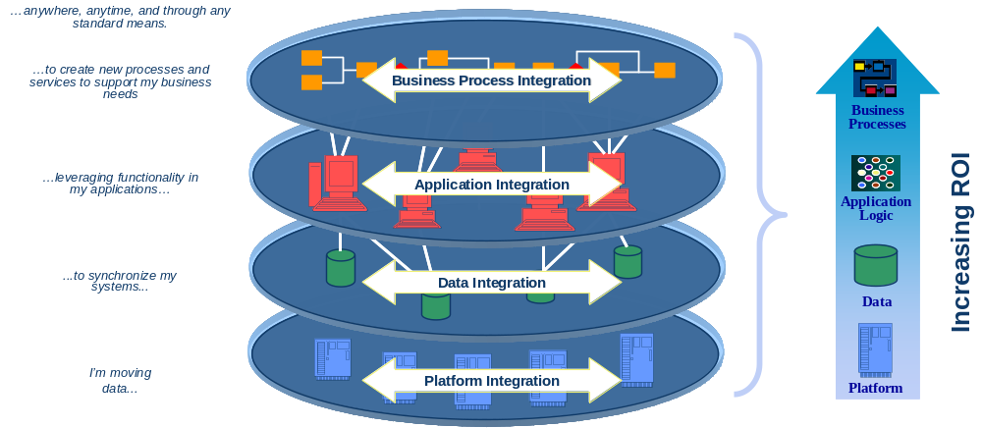

An Integration Framework is a complex middleware suite that includes, at a minimum, graphical message transformation and intelligent routing services. Integration Frameworks (also commonly referred to as integration brokers) typically provide pre-built adapters for communication with most common, off-the-shelf applications, databases and communications protocols, as well as generic adapters or adapter development kits for integrating custom applications. Most leading integration brokers also include some form of Message-Oriented Middleware; Business Process Automation tools; and graphical management and administration utilities.
Since integration brokers use messaging systems to move information between applications, the message transport layer supported by the message broker is of a great importance. A message-oriented transport middleware infrastructure facilitates communication between points of integration in a distributed environment by allowing applications to exchange messages through an intermediary system of service components. These messages may encapsulate any type of application-specific protocols that support services such as process a request on the target system as well as to transfer data associated with the request. The messages can also encapsulate a simple notification of an event that will be handled by one or more recipients in a predetermined manner. All of these capabilities are available within the FedTraveler.com Integration Framework (herein referred to simply as the Integration Framework).

Conceptual Architecture
The following diagram identifies the key service layers provided by the Integration Framework.

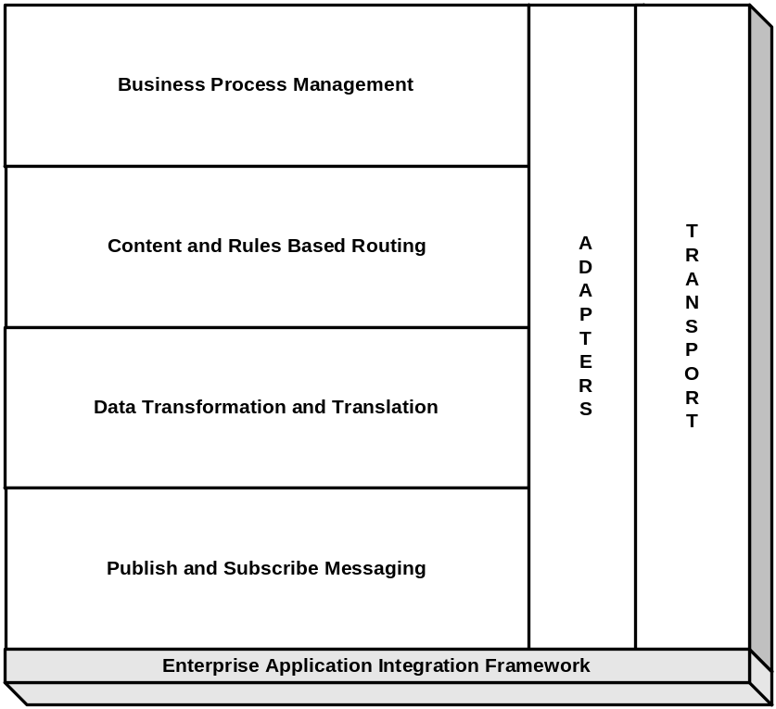

Business Process Management
Business Process Management (BPM) defines, directs, and tracks the execution of manual and system-related business processes. Automated business processes accommodate roles (work force definitions), rules (business logic that drives processes), and routing (delivering work and information resources). Manual processes provide human workflow capabilities so that people can interact with running business processes, for example as part of an approval process. Process logic and business rules needed to drive processes are captured and automated as part of the BPM solution.
For more information on the SeeBeyond Business Process Manager software tool please refer to the Appendix B of this document.

Content and Rules-Based Routing
Content and Rules-Based Routing capabilities allow the Integration Framework to define business rules to evaluate the content of a message, and to intelligently direct the flow of information based on that content.

Data Translation and Transformation
The BPM layer provides the capability to graphically transform input messages into one or more output messages. Data translation and transformation capabilities allow for both the semantic and syntactic transformation of data.
Transformation is a high level service that goes beyond the translation capabilities. It may include:

- Basic data-field translations between data types (e.g. EBCDIC to ASCII), format (e.g. decimal to binary), alignment and lengths
- Sophisticated message modifications, such as reformatting of data structures (e.g. omitting or reordering fields), value mapping using table look-ups (e.g. change 1, 2 and 3 to F, M and U) or more complex logical transformation according to user defined algorithms
- Validation and filtering (e.g. returning, rejecting incorrect messages or dropping them completely)
- Dividing one message into several messages or combining multiple message into one

The rules for message transformation and translation can be defined by both developers and business analysts.

Collaborations
Collaborations, otherwise known as business rules, graphically define how data should be transformed and routed (content and rules-based routing) between components. Collaborations also define how databases should be queried in response to requests and how interfaces to 3rd-party applications should be invoked. Loosely translated, collaborations define data translation and data transformation logic between applications and across the enterprise.

Adapters
Adapters provide the connection between the 3rd-party applications and the Integration Framework. Pre-built adapters are available for common off-the-shelf applications (i.e. Enterprise Resource Planning, Customer Relationship Management, Sales Force Automation), databases, middleware, and communications protocols. Custom adapters may be developed using pre-existing adapter templates or Adapter Development Kits.
The adapter provides a high-level interface to back-end applications and communicates to the Integration Framework using the underlying messaging middleware. It typically hides the specific EAI implementation details from both the application and the developer. The adapter also contains the necessary business logic to understand complex integration scenarios, such as a request to “find a consumer” for a particular message, and to perform the necessary message flow management to transmit that request to the appropriate back-end applications and coordinate their responses. Any required data translation or transformation is also performed within the adapter.
See Appendix C of this document for a complete list of SeeBeyond adapters, some combination of which will be used in each target environment.

Messaging Middleware
The messaging middleware capabilities provide a mechanism for moving information from one location to another. This messaging sub-system supports guaranteed, reliable and one-time delivery of messages, including both asynchronous “fire and forget” and synchronous request and reply forms of communication.
The Integration Framework acts as an intelligent intermediary that directs the flow of messages between applications inside this messaging middleware. When a business event takes place, a source application “publishes” the messages corresponding to that business event within the messaging middleware. The messaging middleware then reviews the messages and the embedded business logic. It delivers the messages to one or more consumer applications using the message routing rules defined within the embedded business logic. The consumer applications receive only the messages to which they are entitled. As mission-critical messages travel over the network, the Integration Framework ensures that messages are never lost or duplicated in the event of network failure. The messaging middleware delivery capability uses a store and forward message queuing mechanism between integrated applications. The source-application-to-queue-to-consumer-application transfer takes place in real time when the consumer application is available. If the consumer application is unavailable, the message is persisted within a queue for later delivery.

Publish and Subscribe Messaging
Publish and Subscribe Messaging provides a further abstraction of the underlying messaging middleware infrastructure, eliminating the need for sending and receiving systems to maintain any knowledge of source and consumer applications, respectively. Publishers supply information based on a specific subject or topic, but maintain no knowledge of the consumer application. Subscribers receive information based on a specific subject or topic, but maintain no knowledge of the source application.

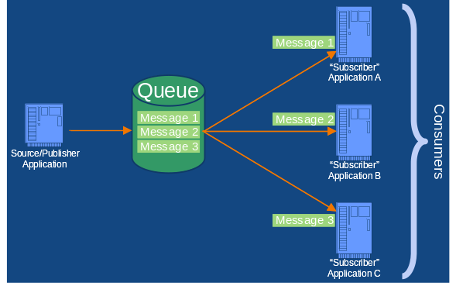
Queues
A queue is a shareable object within the messaging middleware that provides point-to-point (p2p or PTP) publish and subscribe capability. Point-to-point messaging can be explained as an environment where individual messages from a publisher are intended to be delivered to a single, unique subscriber. A queue can, however, have many subscribers. In such an environment where a source application generates 3 messages, Message 1 is delivered to Subscriber Application A, Message 2 is delivered to Subscriber Application B and Message 3 is delivered to Subscriber Application 3. In the event that one of the consumer applications goes down, the messages continue to flow to the remaining consumer applications.
If for instance, in the environment depicted by the graphic above, Subscriber Application A were to go down, Message 1 would be delivered to Subscriber Application B, Message 2 would be delivered to Subscriber Application C, and Message 3 would be delivered to Subscriber Application B, and so on.
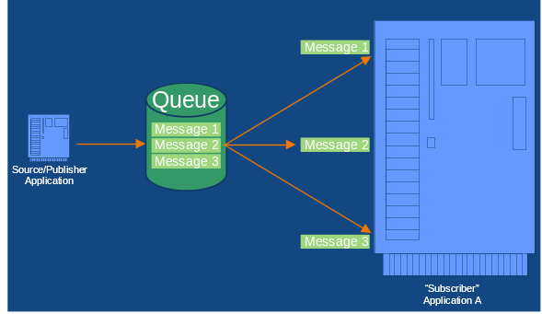
This functionality is essential in mission-critical environments because it allows consumer applications to get information using more than one pathway. If one were to think of a single subscriber application that required fault-tolerance, an environment could easily be designed where that single subscriber would actually act as if it were 3 disparate subscribers within in the messaging middleware. In this fashion, if one of the subscriber processes were to go down, the application would continue to function because the remaining 2 subscribers would continue to function and deliver messages.

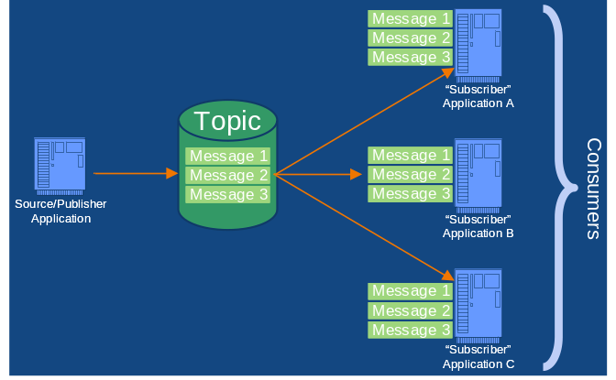
Topics
A topic is a shareable object within the messaging middleware that provides universal publish-and-subscribe messaging capability. This means that a single publisher can generate messages which can then be delivered by the messaging middleware to any set of subscribers, ensuring that all subscribers receive a copy of each message.

Scheduling
Integration Frameworks provide scheduling capabilities to start and stop services for individual integration modules, i.e. Collaborations, Adapters, etc.. They usually also provided system administration scheduling capabilities used during system maintenance, but those activities are not associated with the data exchange or data/application integration. These are capabilities inherently available within the FedTraveler.com Integration Framework.

Defining Schedules
Schedules can be established to execute Collaborations or Adapters one time every:
- n seconds, minutes, hours, or days
- day, day of the week, or day of the month, at a specified time
- year, at a specified day and time

However, when a schedule is defined for Collaborations or Adapters, the scheduling feature automatically:
- Overrides any triggering features of the component (typically applicable for database Adapters)—they are effectively turned off.
- Executes the component once—one time only—at the specified schedule time.

Collaboration Scheduling
Collaborations normally execute when they are “triggered” by messages. Though the Adapters themselves can be scheduled to execute at a specific time, they may have multiple Collaborations, and there might be a need to schedule the Collaborations to execute at different times. This is capability inherent to the Integration Framework.

Security
The Integration Framework provides a public key infrastructure (PKI X.509) with an S/MIME (Secure Multipurpose Internet Mail Extensions) and SSL (Secure Sockets Layer) -based security solution for ensuring data privacy, data integrity, trading partner authorization and transaction non-repudiation. The framework supports digital certificates from VeriSign, Entrust, Baltimore Technologies, and all others that are X.509 compliant. Certificates made available by an organization can be stored within the Integration Framework environment for use by whatever components require it.

The Integration Framework can be configured to securely receive inbound traffic from the Internet. A staging server is typically setup within the DMZ (De-Militarized Zone) to intercept messages from the public Internet. Upon receipt, the Integration Framework can validate the transaction for content and routing information, and then forward the transaction to the appropriate application(s) within the trusted network. Using this method, the internal Integration Framework servers can be insulated from the public Internet. Another technique that can be used is to utilize client- and server-side X.509 certificates for HTTP (Hyper-Text Transfer Protocol) transaction authorization/authentication to further prevent unauthorized entry into the trusted environment. The Integration Framework can also leverage the capabilities provided by 3rd-party firewalls and proxy servers.

Encryption capabilities
The Integration Framework provides the following encryption capabilities:
- Transport = HTTP:
HTTPS SSLv2, SSLv3, TLSv1 (DES, 56-bit key; RC2, 128-bit key; RC2, 40-bit key; 3DES, 168-bit key; RC4, 128-bit key; RSA 1024+-bit key).
- Transport = E-Mail (SMTP/POP):
DES, 56-bit key; RC2, 128-bit key; RC2, 40-bit key; 3DES, 168-bit key; RC4 128-bit key; RSA 1024+-bit key (when S/MIMEv3 used).
- Transport = FTP:
DES, 56-bit key; RC2, 128-bit key; RC2, 40-bit key; 3DES, 168-bit key; RC4 128-bit key; RSA 1024+-bit key (when S/MIMEv3 used).
- Transport = others:
DES, 56-bit key; RC2, 128-bit key; RC2, 40-bit key; 3DES, 168-bit key; RC4 128-bit key; RSA 1024+-bit key (when S/MIMEv3 used).
Cryptographic module is RSA.

Access Control
The Integration Framework provides for access control lists to be defined to restrict the level of information available to external trading partners (for more information on trading partners, please refer to Appendix D for more information on the SeeBeyond eXchange Integrator tool). The following categories are provided to manage user access of those who interact with the trading partner information: None, read-only, add, edit, or full control access rights. Agencies have the ability to fully control and protect information not only when it is transmitted between trading partners, but also while it is stored within the Integration Framework.

Internet Protocol (IP) address filtering
The Integration Framework does not provide out-of-the-box IP address filtering functionality, as this is typically performed by either a firewall or by the security functionality built into most web servers. IP address filtering can, however, be realized by writing code within the Integration Framework to receive and validate transactions before forwarding them to a back-end system.

FedTraveler.com XML Schema
The XML Schema is a separate deliverable from this document.

FedTraveler.com XML Data Dictionary
The data elements available for exchange and integration within the business data warehouse (or other eTS data source), including the functional data element descriptions, field characteristics, and data types are available within the XML Data Dictionary. The XML Data Dictionary is a separate deliverable from this document.
A representation of these data elements in XML format is available within the Data Management Plan. However, due to the inordinate number of ways in which data can be represented in EDI or other industry standard Internet-enabled data formats, this document speaks to the numerous types of data formats that can be recognized and easily translated by the FedTraveler.com EAI Framework instead of providing examples of this data in each of those data format variants.

FedTraveler.com Standard Data Input and Output
The standard data input and output from the FedTraveler.com environment will initially, for IOC, conform to the XML Schema, XML Data Dictionary, and the specifications of the web service defined within the Data Management Plan. It should be understood by all parties that these data formats will likely be augmented during the transition from IOC to FOC.

FedTraveler.com Data Exchange Procedures
The process and procedures by which data can be exchanged inbound and outbound between the FedTraveler.com EAI Framework and other applications, systems, or resources are implementation details that will vary with each individual agency. However, the standard way in which this functionality will be presented for IOC is via the Web Service defined within the Data Management Plan.
This Web Service can incorporate any combination of the data transmission options, scheduling options, security and access control capabilities, as well as data format translation capabilities that are available as standard features within the EAI Framework.

FedTraveler.com Travel Report Elements
Pursuant to the observations received by EDS from our original submission of this document, we have included a 15th XML schema to our library of XML Schemas which contains the elements required by the reports identified in Attachment 7 of the RFP. This XML Schema is called EDSTravelManagementReports.xsd. In addition, FedTraveler.com can output these reports from within the GUI in Microsoft Excel format, as required in the RFP.

FedTraveler.com Invitational Travel Support
FedTraveler.com is unique in that it does not treat invitational travel any differently than any other type of travel. As such, the FedTraveler.com Integration Framework uses a data element already defined by GSA called TravelPurposeCode within the section of elements titled TravelPlanningAuthorization to indicate that the travel being defined is invitational, versus any other type.

FedTraveler.com Data Validation and Verification
The FedTraveler.com Integration Framework integrates at the application level with the host application. This effectively means that to any given application, the FedTraveler.com Integration Frameworks’ adapter simply behaves as if it were a native client of that application.
An example of this might be integration with an Oracle Financial Management System, in that once it has been integrated, the Oracle Financial Management System cannot tell the difference between a user sitting in front of a keyboard using its native GUI and the FedTraveler.com Integration Framework adapter. This is the key differentiator of the technology being used by FedTraveler.com. Integrations are tightly bound, yet non-intrusive. Applications do not have to be modified or re-architected in order to be integrated with the rest of the enterprise.
Leveraging this type of integration, the need for data validation and verification is virtually nullified. This is because the data validations and verifications defined within the host applications continue to be leveraged within the Integration Framework. It is not necessary or required to add additional data validation and verification rules to the FedTraveler.com Integration Framework unless required by some external data manipulation needs.

Appendix A

SeeBeyond eGate Integrator
The SeeBeyond ICAN Suite is based on eGate Integrator EAI platform. eGate solves complex connectivity issues and enables the dynamic delivery of information across applications and systems to partners and customers. It is a flexible integration platform open to legacy, existing and future standards, platforms, languages, and technologies. eGate is based on a distributed and open architecture that supports portability of integration logic across common integration servers. eGate components can reside on different workstations within a global network.
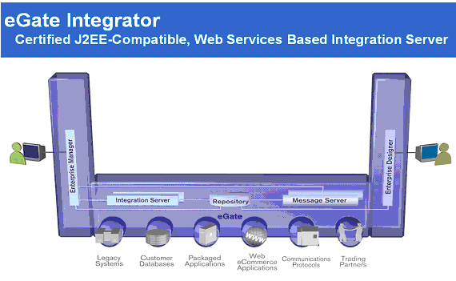
Using communication protocols and adapters, eGate can communicate with and link multiple applications and databases across a variety of different operating systems. eGate can work with a wide variety of hardware, message standards, operating systems, databases, and communication protocols in both real-time and batch/scheduled modes.
eGate bridges older and newer systems, resulting in a centrally managed, intelligent, unified enterprise. This provides the capability to incorporate best-of-breed technology into enterprise strategy, without any need to uproot older IT investments.
The eGate platform implements a transparent architecture that is well suited for distributed computing environments. This means that the various components of an eGate system do not have to reside on the same machine. Instead, they can be distributed across several different machines within the network.
The eGate platform includes a number of back-end components such as the SeeBeyond Integration Server, and the SeeBeyond Message Server.

SeeBeyond Integration Server
The SeeBeyond Integration Server is based on the Java 2 Enterprise Edition (J2EE) platform. The Integration Server provides services for security, transactions, business rules execution, and connectivity management. The Integration Server is the engine that runs Collaborations for processing business logic and Adapters that communicate with external applications.
The Integration Server typically implements Adapters as J2EE Connector Architecture (JCA) adapters. However, for HTTP/HTTPS protocols, the Integration Server uses servlets running in the Web container to provide J2EE HTTP facilities.
Collaborations are implemented as Message Driven Enterprise Java Beans (EJBs)—triggered by messages from external systems via message-based adapters, HTTP adapters, or inbound messages.
The Integration Server also provides Java Management Extension (JMX) monitoring, Transaction Coordination, and Security Realm Management (using either Lightweight Directory Access Protocol (LDAP) or a local file to store user names and passwords).

SeeBeyond Message Server
eGate Integrator includes the SeeBeyond Message Server as its Java Messaging Service (JMS) implementation.
In addition to the SeeBeyond Message Server, eGate includes support for 3rd-party messaging middleware such as HP NonStop JMS on HP NonStop Server platforms, IBM MQ Series, and others.

Appendix B

SeeBeyond eInsight Business Process Manager
eInsight Business Process Manager (eInsight) is part of the SeeBeyond ICAN Suite of products. eInsight delivers business process management features and functions to the ICAN Suite.
Business process management is the strategic orchestration of the movement of information and the flow of complex processes between participants (systems, users, and organizations) to accomplish larger business objectives.
eInsight is tightly integrated with the ICAN Suite and runs as a component within the ICAN Suite environment.
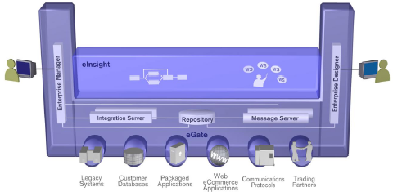
- The eInsight Business Process Designer runs as a component within the eGate development environment.
- Business process definitions, components and deployment profiles are stored in a common Universal Description, Discovery, and Integration (UDDI) Repository.
- The eInsight Engine, which coordinates all business process-related activity of a deployed project, runs within a SeeBeyond Integration Server.
- Web-based business process monitoring is provided by an eInsight plug-in to eGate’s JMX framework, which connects to eInsight’s Monitoring Manager to access current instance data.

SeeBeyond eInsight Overview
eInsight provides a clear view into the internal and external processes of an organization. These processes may be executed by computer systems or employees.

SeeBeyond eInsight Architecture
eInsight is wholly-based on well-known, existing industry standards such as:
- Web Services Business Process Execution Language (WSBPEL) - the underlying code generated when creating a business process.
- Universal Description, Discovery, and Integration (UDDI) protocol - allows access to business processes and systems as Web Services.
- Web Services Description Language (WSDL) - defines an interface to the business process.
- Business Process Markup Notation (BPMN) - provides a standard graphical view for WSBPEL.
- J2EE Connector Architecture (JCA) - provides a mechanism to access external applications and data.

The figure below depicts how the different eInsight components interact:
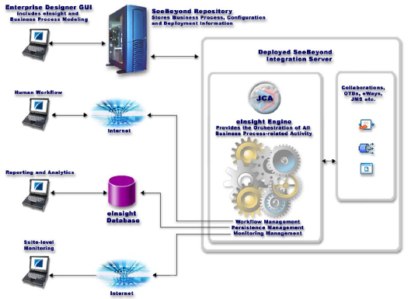

Appendix C

SeeBeyond ICAN 5.0 Adapters List
The following tables, organized by categories, give a comprehensive list of the Adapters used in the SeeBeyond ICAN 5.0 Suite. SeeBeyond also refers to its adapter components as eWays.
Category: Application SeeBeyond eWay™ Adapter Connections | Description
BroadVision eWay V. 5.0 | The eWay Intelligent Adapter for BroadVision enables the eGate system to exchange data with BroadVision One-To-One business applications. The eWay can operate in either inbound-to or outbound-from-BroadVision mode, at near-real-time speed.
Bloomberg Portfolio Management eWay V. 5.0 | The Bloomberg eWay provides a means for obtaining data from a Bloomberg Portfolio Trading System in near real-time.
Blue Martini eWay V. 5.0 | The eWay Intelligent Adapter for Blue Martini enables the eGate system to exchange data with Blue Martini. The Blue Martini eWay provides both synchronous and asynchronous message exchange.
Clarify eWay V. 5.0 | The eWay Intelligent Adapter for Clarify enables eGate Integrator to exchange data with Clarify eFrontOffice applications.
Commerce One MarketSite eWay V. 5.0 | The eWay Intelligent Adapter for Clarify enables eGate Integrator to exchange data with Commerce One™ MarketSite™ (Commerce One MarketSite eWay) using the XML Portal Connector (XPC) framework.
J. D. Edwards OneWorld GenJava eWay V. 5.0 | The JDE OneWorld GenJava eWay allows the eGate system to exchange data with an OneWorld server by using GenJava generated Java wrapped classes.
Oracle Financials eWay V. 5.0 | The Oracle Financials eWay enables the eGate system to exchange data with external financial databases through the use of the Java library and issued SQL statements.
Oracle Manufacturing eWay V. 5.0 | The Oracle Manufacturing eWay enables the eGate system to exchange data with the Oracle E-Business Suite 11i, a comprehensive enterprise resource planning (ERP) software package
PeopleSoft Batch eWay V. 5.0 | The PeopleSoft Batch eWay allows the eGate system to exchange data with PeopleSoft. The PeopleSoft Batch eWay uses selected features of the SeeBeyond Batch eWay to handle batch data via FTP.
PeopleSoft HTTP eWay (INTL) V. 5.0 | The PeopleSoft HTTP eWay supports all PeopleSoft 8 modules that use underlying XML messaging exposed by PeopleTools. This eWay also provides the means to exchange data with PeopleSoft 8 by utilizing PeopleTool’s Third Party integration technology. This integration is accomplished by using PeopleSoft 8 Application Messaging technology. Application Messaging uses a Publish/Subscribe architecture.
PeopleSoft Message Agent eWay V. 5.0 | The PeopleSoft Message Agent eWay enables the eGate system to exchange data with PeopleSoft applications. It connects to the PeopleSoft Application Server as a client, and communicates with the Message Agent using PeopleSoft Message Agent APIs.
PKMS eWay V. 5.0 | The PKMS eWay enabled the eGate system to exchange data with the PKMS Shop Floor Management System.
Portal Infranet eWay V. 5.0 | The Portal Infranet eWay allows the eGate system to exchange data with Portal’s Infranet software. The eWay supports two messaging modes: inbound to eGate using publication via Portal’s EAI Manager, and outbound from eGate following the Request/Reply scenarios via OPCODEs.
Remedy eWay V. 5.0 | The eWay Intelligent Adapter for Remedy EIE (Remedy eWay) provides a way to communicate the Remedy AR system by using Remedy’s Enterprise Integration Engine (EIE).
SAP-ALE eWay V. 5.0  SAP-BAPI eWay V. 5.0  SAP-BDC eWay V. 5.0  SAP-EDI eWay V. 5.0 | The eWay Intelligent Adapters for SAP has been designed specifically to connect eGate to SAP enterprise-management software within a network of diverse hardware and software systems. Using one or more SAP eWays, eGate can act as a bus, linking SAP applications and other software systems, or differently-configured SAP systems. The SAP-ALE eWay allows bi-directional data exchange between eGate and an SAP system via SAP’s Application Link Enabling (ALE) interface method, which employs SAP’s Intermediate Document (IDoc) Format. The SAP-BAPI *Way allows bi-directional data exchange between eGate and an SAP system via SAP’s Business Application Programming Interface (BAPI). The SAP-BDC eWay allows bi-directional data exchange between eGate and an SAP R/3 system via BDC (Batch Data Communications). The SAP EDI eWay controls the communication protocol layer between the SAP R/3 host and eGate, and can be configured to process data in either direction.
Siebel EAI eWay V. 5.0 | The Java eWay Intelligent Adapter for Siebel EAI is a software interface that enables the eGate system to exchange Events (messages) with Siebel EAI via a Web server. The eWay communicates with Siebel via open standards such as HTTP and XML.
Siebel EIM eWay V. 5.0  Siebel Event-Driven eWay V. 5.0 | The Java eWay Intelligent Adapter for Siebel EIM provides bi-directional communications between eGate Integrator and the Siebel Enterprise Integration Manager (EIM). The eWay provides an execution environment that oversees Siebel’s EIM processes and dynamically creates Siebel IFB files (it also provides the option of generating IFB files manually).
Siebel Event-Driven eWay V. 5.0 | The eWay Intelligent Adapter for Siebel (Event-Driven) provides connectivity between eGate and Siebel 99 Front Office using COM/DCOM connectivity. It provides an inbound and outbound event-driven interface option to or from another system, through eGate.
Siebel UAN eWay V. 5.0 | The eWay Intelligent Adapter for Siebel UAN provides connectivity between eGate and Siebel using Siebel’s Universal Application Network.
SOAP eWay V. 5.0 | The Simple Object Access Protocol (SOAP) eWay enables the eGate system to exchange data with Internet and Web Services applications that exchange information using SOAP.
SWIFT ADK eWay V. 5.0 | The SWIFT ADK eWay is designed specifically to interface with the SWIFTAlliance, and enables the SeeBeyond eGate system to exchange data with SWIFTAlliance The SWIFT ADK eWay provides secure messaging services (both receiving and transmitting) between SWIFT financial institutions.

Category: Tool Kits and Web SeeBeyond eWay™ Adapter Connections | Description
Apache Web Server eWay  V. 5.0 | The Apache Web Server eWay extends the functionality of the Apache Web Server by making external data sources available to calls from within a Perl CGI script. Normally, the web server would be limited to sharing local resources only. By using the Apache Web Server eWay, the web server can access remote data sources. The eWay also makes it possible to use a wider range of data sources that would not normally reside on the web server such as SAP, PeopleSoft, Oracle, Lotus Notes, Excel, Access, and more.
ATG Dynamo eWay  V. 5.0 | The ATG Dynamo eWay extends the functionality of the ATG (Art Technology Group) Dynamo Application server by making external data sources available to calls from within Java servlets and Java Server Pages (JSP files).
C Generic eWay™ Extension Kit  V. 5.0 | The C Generic eWay Extension Kit enables the developer to extend the client side of eGate Integrator by using standard C DLLs.
CGI Web Server eWay V. 5.0 | The CGI Web Server eWay acts as a gateway to the eGate system for a Web server. The CGI Web Server eWay allows the Web server to access remote data sources which would otherwise be unavailable.
DataChannel eWay V. 5.0 | The DataChannel eWay extends the functionality of the DataChannel Server application server by making external data sources available to calls from within Java servlets and Java Server Pages (JSP files).
eGate™ API Kit V. 5.0 | The eGate API Kit enables to create custom applications or modify existing external applications to interface with the eGate system. The API Kit provides the following interfaces:  - SeeBeyond Java Message Service (JMS) for Java; COM +; C/C++; RPG  - SeeBeyond Multiplexer (MUX) eWay for ActiveX; C/C++; COBOL; Java Perl
Generic Multi-Mode eWay™ Extension Kit V. 5.0 | The Generic Multi-Mode eWay Extension Kit allows you to develop custom Multi-Mode eWays and eWay Connections using Java.
iPlanet Application Server eWay V. 5.0 | The iPlanet eWay extends the functionality of the web server by making external data sources available to calls from within Java servlets and Java Server Pages (JSP files).
iPlanet Web Server eWay V. 5.0 | The iPlanet eWay extends the functionality of the web server by making external data sources available to calls from within a Java servlets and JavaServer pages (JSP files).
Java Generic eWay™ Extension Kit V. 5.0 | The Java Generic eWay Extension Kit Developer’s Guide enables you to develop eWays or other eGate applications using Java.
MS IIS eWay V. 5.0 | The MS IIS eWay is a gateway to the eGate Integrator system for the Microsoft Internet Information Server (IIS) Web server. The eWay primarily uses the following components:  - A .dll file on the Web server  - SeeBeyond Java Messaging Service (JMS)
WebLogic eWay V. 5.0 | The Intelligent Adapter for WebLogic eWay (WebLogic eWay) facilitates integration between applications built on the WebLogic platform and eGate, using J2EE’s component model (EJB).
WebSphere Application Server eWay V. 5.0 | The WebSphere eWay facilitates integration between applications built on the WebSphere platform and eGate, using J2EE’s component model (EJB).
WebSphere eWay V. 5.0 | The WebSphere eWay extends the functionality of the application server by making external data sources available to calls from within Java servlets and JavaServer pages (JSP files).

Category: Database SeeBeyond eWay™ Adapter Connections | Description
DB2 Universal Database eWay V. 5.0 | The DB2 Universal Database eWay uses the Java library to issue SQL statements to interact with DB2 databases.
JDBC/ODBC eWay V. 5.0 | The JDBC/ODBC eWay enables the eGate system to exchange data with external databases.
Lotus Notes ODBC eWay V. 5.0 | The Lotus Notes eWay enables the eGate system to access data from a Lotus Notes, database. The eWay can act as an inbound or outbound eWay depending on its configuration.
ODBC eWay V. 5.0 | The ODBC eWay implements the logic that sends Events (data) to eGate and queues the next Event for processing and transport to the database.
Oracle eWay V. 5.0 | The Oracle eWay enables the eGate system to exchange data with external Oracle databases.
SQL Server eWay V. 5.0 | The SQL Server eWay enables the eGate system to exchange data with external SQL Server databases.
Sybase eWay V. 5.0 | The Sybase eWay enables the eGate system to exchange data with external Sybase databases.
Teradata eWay V.5.0 | The Teradata eWay enables the eGate system to exchange data with external Teradata databases.

Category: Legacy/ Mainframe SeeBeyond eWay™ Adapter Connections | Description
ADABAS/ Natural eWay V. 5.0 | The ADABAS Natural eWay provides an interface to Software AG’s ADABAS Natural language which allows for a generic mechanism to call Natural or Natural batch programs or to allow Natural programs to pass data to eGate in a reliable and efficient manner.
CICS eWay V. 5.0 | The eWay Intelligent Adapter for CICS is an interface that enables remote bi-directional calls to CICS transactional programs.
IMS eWay V. 5.0 | The IMS eWay enables the eGate Integrator to connect with IBM’s IMS/TM mainframe applications through IBM’s IMS Connect, or its predecessor, IMS TCP/IP OTMA Connection (ITOC).

Category: Communication SeeBeyond eWay™ Adapter Connections | Description
Batch eWay V. 5.0 | The Batch eWay enables the eGate system to use an FTP connection to exchange data with other network hosts, for the purpose of receiving and delivering Events stored in files.
COM/DCOM eWay V. 5.0 | The eWay Intelligent Adapter for COM/DCOM enables the eGate system to exchange data with server side COM/DCOM-enabled applications and components.
CORBA Client eWay V. 5.0 | The CORBA Client eWay allows to integrate non-CORBA systems with CORBA server applications without the need for custom coding. The eWay enables eGate to make requests to a CORBA-compliant object from within a Collaboration.
CORBA VisiBroker Client eWay V. 5.0 | The CORBA-VisiBroker Client eWay provides a Monk programming language interface to external applications that have CORBA interfaces. This allows access to CORBA objects via the Monk scripting language.
CORBA VisiBroker Server eWay V. 5.0 | The CORBA-VisiBroker Server eWay enables CORBA-VisiBroker applications to exchange data with non-CORBA systems.
Dial-Up eWay V. 5.0 | The Dial-up eWay provides the user of eGate Integrator to dial out to a remote server and perform the following functionality:  - Support a variety of protocols, such as Kermit, x-modem, y-modem, and z-modem  - Support parameter based configuration of a connection  - Support identification of duplicate upload/download of files  - Support multiple upload/download over a single connection  - Support for monitoring the results of file upload/download, connection attempts, such as session logging
e-Mail eWay (INTL) V. 5.0 | The e-Mail eWay allow eGate users to automate many of the typically manual email operations and allows email to be sent and received programmatically without human intervention.
HTTPS (SSL) eWay V. 5.0 | The HTTP(S) eWay allows eGate Integrator to communicate with client applications over the Internet using the HyperText Transfer Protocol (HTTP) and HTTP over Secure Sockets Layer (SSL), that is, HTTP(S). The HTTP(S) eWay supports both the GET and POST methods.
Jacada Enterprise/Access eWay V. 5.0 | The Jacada Enterprise/Access eWay provides data translation and manipulation of a binary stream intended to interact with a person, in the form of a monitor screen and keyboard, and matches the data content to the screen order.
LDAP eWay V. 5.0 | The LDAP eWay enables eGate to exchange data with an LDAP directory.
MQSeries eWay V. 5.0 | The MQSeries eWay allows the eGate system to exchange data with IBM’s MQSeries.
MSMQ eWay V. 5.0 | The MSMQ eWay enables the eGate system to exchange data with Microsoft Message Queue (MSMQ) Service.
Odette FTP eWay V. 5.0 | The Odette FTP eWay enables the eGate system to exchange data with any system using the Odette FTP (OFTP) communication protocol.
SNA eWay V. 5.0 | The SNA eWay enables the SeeBeyond eGate Integrator system to access an SNA network environment to drive entire transactions, including conversational transactions. The SNA eWay is an interface that makes uni-directional calls to an SNA Server.
TCP/IP eWay V. 5.0 | The TCP/IP eWay provides real-time, reliable data transfer for systems that support TCP/IP.
TCP/IP HL7 eWay V. 5.0 | The TCP/IP HL7 eWay Intelligent Adapter enables the eGate Integrator system to exchange data with an external TCP/IP backend, using the HL7 data protocol.
WAP eWay V. 5.0 | The WAP eWay Intelligent Adapter enables the eGate system to exchange data with mobile devices that are WAP 1.1 enabled via Phone.com’s UP.browser.

Appendix D

SeeBeyond eXchange Integrator
eXchange Integrator is an enterprise module for defining trading partner profiles and protocol management for inter/intra agency (B2B) interoperability. eXchange provides B2B choreography and allows business processes to use eInsight to monitor and manage B2B conversations. It provides packaged B2B protocol support including ebXML, EDI (X.12 & EDIFACT) with AS2, RosettaNet, BizTalk, CIDX and NCPDP. In addition it provides:
- Open Protocol Extensibility
- Users can define support for any open or proprietary protocol through easy graphical user interface (GUI) configuration to handle enveloping, acknowledgements/negative-acknowledgements and message tracking
- SWIFT, UCCnet, cXML, xCBL, ISO 15022, HIPAA X12, ODETTE, UCS, VICS, ACORD and others supported via eGate and the extensibility framework
- Trading Partner Management
- Provides an easy-to-use graphical interface for managing trading relationships with thousands of trading partners.
- Transaction Security, Auditing & Non-Repudiation
- AS2 Compliant Security



