The Third


MicroArray Quality Control

Project Meeting

December 1-2, 2005

Palo Alto, California

http://edkb.fda.gov/MAQC/

Co-sponsored by:


Contents of the Meeting Handout:

- Meeting Agenda
- Introduction to the MAQC Project
  - Overview
  - Implementation and progress
  - Participating organizations
  - Publication plan
  - Timeline
- List of Registered Meeting Participants

Notes:

- The results to be presented at the MAQC project meeting should be considered preliminary and do not necessarily represent the final conclusions of the MAQC project.
- The main objectives of the MAQC project meeting are:
  - To allow participants an opportunity to review the datasets, exchange ideas about data analysis and QC metrics/thresholds based on the preliminary analysis results;
  - To decide on the next phase of the MAQC project (rat or mouse);
  - To discuss the proposed publication plan and to decide additional analyses that need to be performed for each manuscript.
- The entire MAQC project meeting (including discussion sessions) will be recorded.
- Information presented at the MAQC meeting should be considered confidential and should not be distributed beyond participants of the MAQC meeting.

The MAQC Project Meeting Agenda
December 1-2, 2005, Cyprus Room, Crowne Plaza Cabana, Palo Alto, CA
Day One: Thursday, December 1, 2005
Chair: Yvonne Dragan (FDA/NCTR)
8:00 am | Chair’s remarks | Yvonne Dragan
8:05 am | Welcome | Ronald Davis (Stanford)
8:10 am | Overview of the MAQC project | Leming Shi (FDA/NCTR)
8:20 am | MAQC reference RNA samples | James Fuscoe (FDA/NCTR)
Seven Microarray Platforms* Co-chairs: Mike Wilson (Ambion)/Federico Goodsaid (CDER)
8:30 am | Inter-site reproducibility | Xu Guo (Affymetrix)
8:45 am | Cross-site performance of one- and two-color platforms | Jim Collins (Agilent)
9:00 am | ABI expression array data comparison | Yongming Sun (Applied Biosystems)
9:15 am | DualChip platform: concept | Francoise de Longueville (Eppendorf)
9:30 am | GEH: | Richard Shippy (GE Healthcare)
9:45 am | Performance metrics for cross-platform studies | Eugene Chudin (Illumina)
10:00 am | Analysis of NCI home brew 70mer arrays | Ernest Kawasaki (NCI)
10:15 am | Break
Three Alternative Technology Platforms* Co-chairs: Federico Goodsaid/Mike Wilson
10:30 am | TaqMan® gene expression assays for microarray validation | Kathy Lee (Applied Biosystems)
10:45 am | Cross-platform comparison based on 245 genes | Yuling Luo (Genospectra)
11:00 am | Numerical calibration of 205 genes | James Willey (Gene Express)
11:15 am Discussion (10 platform providers) | - Quality of data from your test sites  - Lessons learned: challenges & pitfalls  - Cost ($ & time) and value to your org.  - Suggestions for the MAQC project  - Comments from external test sites | Panel: Shawn Baker, Jim Collins, Francoise de Longueville, Xu Guo, Ernest Kawasaki, Kathy Lee, Yuling Luo, Richard Shippy, Yongming Sun, James Willey
12:00 pm | Lunch (on your own)
Ten Data Analysis Sites (I)* Co-chairs: Roderick Jensen (UMB)/Marc Salit (NIST)
1:15 pm | Intra-platform, inter-laboratory variation | Walter Liggett (NIST)
1:30 pm | Correlation estimation from a random effects model | Sheng Zhong (UIUC)
1:45 pm | Assessing consistency of the MAQC platforms | Wenjun Bao/Tzu-Ming Chu (SAS)
2:00 pm | Repeatability, reproducibility, and inter-platform consistency | Wendell Jones (Expr. Analysis)
2:15 pm | Integrating the MAQC project into clinical diagnostic applications: Lessons from the clinical laboratories | Hanlee Ji (Stanford)
2:30 pm | QRI image analysis of Affymetrix GeneChip .DAT files | Cecilie Boysen (ViaLogy)
2:45 pm | An extensive survey of analysis methods | Lisa Croner (Biogen Idec)
3:00 pm | QC metrics/thresholds & analysis methods | Leming Shi/Weida Tong (FDA/NCTR)
3:15 pm | Break
Ten Data Analysis Sites (II)* Co-chairs: Marc Salit/Roderick Jensen/
3:30 pm | Cross-platform probe mapping and quality metrics for the 1000 chosen genes | Roderick Jensen (UMB)
3:45 pm | Mapping probes to RefSeq transcripts | Damir Herman (NCBI)
4:00 pm | Probe design and alternative splicing on data consistency | Jean Thierry-Mieg (NCBI)
4:15 pm Discussion (10 analysis sites) | - Probe-target mapping & master indices  - Performance metrics and thresholds  - Normalization & gene selection methods  - Flagged spots and outlier arrays  - Future directions of data analysis  - Biogen Idec’s request for data access | Panel: Wenjun Bao, Cecilie Boysen, Lisa Croner, Damir Herman, Walter Liggett, Roderick Jensen, Hanlee Ji, Wendel Jones, Jean Thierry-Mieg, Weida Tong, Chunlin Xiao, Sheng Zhong
5:00 pm | Adjourn
*Each speaker has 10 minutes for presentation and 5 minutes for questions/discussion.

Day Two: Friday, December 2, 2005
Chair: William Slikker, Jr. (FDA/NCTR)
8:00 am | Chair’s remarks | William Slikker, Jr.
8:10 am | Keynote address: Data quality in genomics | Ronald Davis
Invited Presentations Chair: William Slikker, Jr.
8:50 am | ERCC: The External RNA Controls Consortium | Janet Warrington (Affymetrix)
9:00 am | The Metrology for Gene Expression Program | Marc Salit (NIST)
9:10 am | Array standardization and the MfB Programme | Carole Foy (LGC, UK)
9:20 am | Rat reference RNAs for proficiency testing | Karol Thompson (FDA/CDER)
9:30 am | Study design and analysis of multiple platforms (mouse) | Winston Kuo (Harvard)
9:40 am | Proficiency testing using MTRRM and MAQC samples | Laura Reid (Expr. Analysis)
9:50 am | 10th Anniversary of Science 95’ paper | Mark Schena (TeleChem ArrayIt)
10:00 am | MAQC rat mini pilot project: preliminary data | Hongzhu Ren (EPA)
10:05 am | Preliminary results using rat RNA samples | James Fuscoe (FDA)
10:10 am | MAQC for rat and/or mouse?  - Survey of interest: platform providers, test sites  - RNA samples  - Experimental design  - Timeline | Federico Goodsaid
10:30 am | Break
Regulatory Perspectives: Co-chairs: Yvonne Dragan/Federico Goodsaid
10:45 am | Hybridization standards for regulatory review | Federico Goodsaid
10:55 am | - Expected uses of the MAQC datasets  - Proficiency tests  - External spike-in controls  - Remaining challenges (prior to RNA)  - Guidance on QC and data analysis | Panel:  Yvonne Dragan, Federico Goodsaid, Francis Kalush, Scott Pine, Hongzhu Ren, Weida Tong
Planning for MAQC Manuscripts Chair: Leming Shi
11:30 am | - Editorial  - FDA’s VGDS and IPRG  - MAQC main manuscript  - Reference RNA samples  - Sequence-based cross-platform mapping  - Normalization & gene selection methods  - Validation by alternative technologies  - Titration datasets  - Inter-laboratory variations  - Cross-hybridization  - One-color versus two-color platforms  - Informatics tools for regulatory review  - Other topics to be suggested  Manuscript-drafting teams  Timeline  Journal | Janet Woodcock/Dan Casciano  Felix Frueh/Federico/Sponsors  Leming Shi (MAQC Team)  James Fuscoe/Mike Wilson  Damir Herman/Roderick Jensen  Leming Shi/Jim Chen  Federico Goodsaid  Richard Shippy  Walter Liggett/Marc Salit  Zoltan Szallasi/Roderick Jensen  Tucker Patterson/Jim Collins  Weida Tong  Participants
12:55 pm | Concluding remarks | Leming Shi
1:00 pm | Adjourn
The Cyprus conference room will be available until 4:00 pm for participants to continue discussion.
Location:
The meeting will be held on December 1-2, 2005 at the Cyprus Room, Crowne Plaza Cabana, 4290 El Camino Real, Palo Alto, CA 94306. Telephone: 650-857-0787; FAX: 650-496-1939; Website: http://www.cppaloalto.crowneplaza.com/. Please note the change of meeting venue.

Registration:
Registration is free but required. Contact Leming Shi, National Center for Toxicological Research, US FDA, 3900 NCTR Road, Jefferson, AR 72079. Tel: 870-543-7387; leming.shi@fda.hhs.gov.

Conference Call:
A conference call has been set up to allow interested people to join the meeting by telephone throughout the entire MAQC meeting. Dial-in number: 888-566-5020 (international: +1-210-795-9594), Passcode: 33297. In fairness to the expected large audience in the Palo Alto conference room, callers are asked to minimize the number and length of their questions/comments because the audio quality may be less than satisfactory. However, callers are encouraged to send their questions/comments by e-mailing weida.tong@fda.hhs.gov and leming.shi@fda.hhs.gov. We reserve the right to disconnect the conference call if the audience in the Palo Alto conference room decides that there is too much disruption by the calls. Thanks in advance for your understanding.

MAQC:
http://edkb.fda.gov/MAQC/ or
http://www.fda.gov/nctr/science/centers/toxicoinformatics/maqc/.

ArrayTrack:
http://www.fda.gov/nctr/science/centers/toxicoinformatics/ArrayTrack/

Genomics @FDA:
http://www.fda.gov/cder/genomics/

Stanford Genome Technology Center (SGTC):
http://med.stanford.edu/sgtc/

ERRC (The External RNA Controls Consortium):
http://www.cstl.nist.gov/biotech/ERCC/testplan.htm

NIST’s Metrology for Gene Expression Program:
http://www.cstl.nist.gov/biotech/Cell&TissueMeasurements/GeneExpression.htm

Co-sponsors: The MAQC (MicroArray Quality Control) project meeting is co-sponsored by the US Food and Drug Administration and Stanford Genome Technology Center of Stanford University.

The MAQC Project: Establishing Calibrated RNA Samples, Reference Datasets, and QC Metrics/Thresholds for Microarray Quality Control

FDA’s Critical Path Initiative (http://www.fda.gov/oc/initiatives/criticalpath/) identifies pharmacogenomics as a key opportunity in advancing medical product development and personalized medicine. FDA issued the “Guidance for Industry: Pharmacogenomic Data Submissions” (http://www.fda.gov/cder/guidance/6400fnl.pdf) to facilitate scientific progress in the field of pharmacogenomics and to facilitate the use of pharmacogenomic data in drug development and medical diagnostics. Microarrays represent a core technology in pharmacogenomics; however, before this technology can successfully and reliably be applied in clinical practice and regulatory decision-making, standards and quality measures need to be developed.

The MicroArray Quality Control (MAQC) project involves six FDA Centers, major providers of microarray platforms and RNA samples, government agencies, academic laboratories, and other stakeholders. The MAQC project (Figure 1) aims to evaluate QC metrics and thresholds for objectively assessing the performance achievable by various microarray platforms and evaluating the advantages and disadvantages of various data analysis methods. Two RNA samples will be selected for three species (i.e., human, rat, and mouse), and differential gene expression levels between the two samples will be calibrated with microarrays and other technologies (e.g., QRT-PCR). The resulting microarray datasets will be used for assessing the precision and cross-platform/laboratory comparability of microarrays, and the QRT-PCR datasets will enable evaluation of the nature and magnitude of any systematic biases that may exist between microarrays and QRT-PCR. The availability of the calibrated RNA samples and the resulting microarray and QRT-PCR datasets, which will be made readily accessible to the microarray community, will allow individual laboratories to more easily identify and correct procedural failures. The implementation and progress of the MAQC project is shown in Figure 2. The MAQC project will help improve the microarray technology and foster its proper applications in discovery, development and review of FDA regulated products.
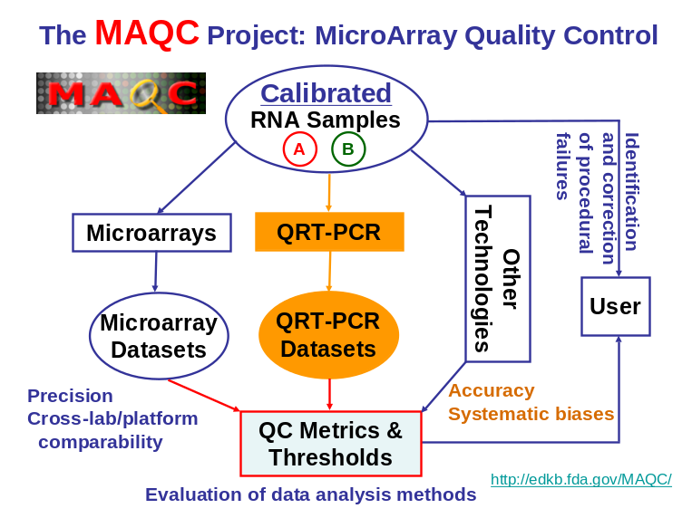
Figure 1: An overview of the MAQC project.
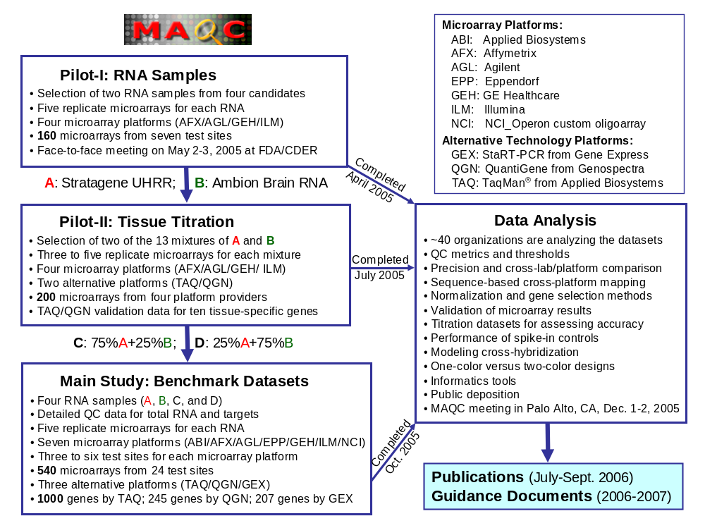
Figure 2: The implementation and progress of the MAQC project.
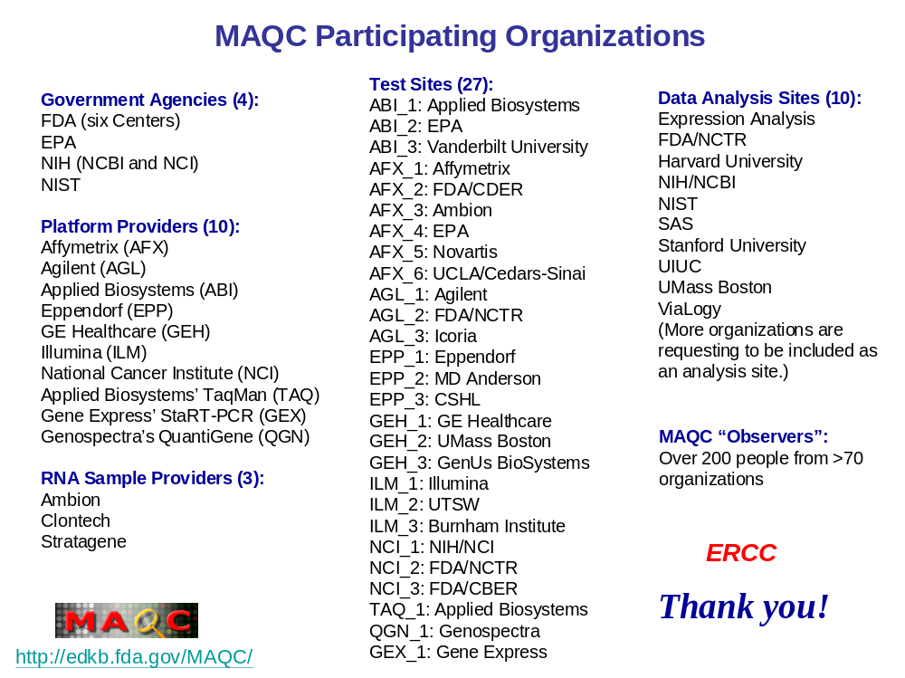
Figure 3: Participants in the MAQC project.
Table 1. An outline of manuscripts proposed as a special journal issue on Microarray Quality Control (draft; for discussion only)
No. | Tentative Title | Contents | Manuscript Team
1 | Pharmacogenomics and the US FDA’s Critical Path Initiative to Medical Product Development: Technology-driven Innovations | - Editorial to this Special Issue on microarray quality control;  - The importance of pharmacogenomics in medical product development and personalized medicine (as stated in the FDA’s Critical Path Initiative);  - The reliability of technologies is essential to realize the promises of pharmacogenomics. | Janet Woodcock (Deputy Commissioner, FDA)  Dan Casciano (Director, FDA/NCTR)
2 | Implementation of the FDA’s Voluntary Genomic Data Submissions (VGDS) Mechanism: Guidelines on microarray quality control and data analysis are essential | - Implementation of the VGDS mechanism at the FDA for sponsors to voluntarily submit genomic data (including data management, analysis, visualization, and interpretation; training of FDA reviewers; interactions between FDA and sponsors);  - Lessens learned from several VGDS case studies;  - Illustration of the challenges in the regulatory review of pharmacogenomic data: quality control of microarray experiments and guidance on data analysis. | Felix Frueh  Federico Goodsaid  Weida Tong  Sponsors
3 | The MAQC Project: Establishing Calibrated RNA Samples, Reference Datasets, and QC Metrics/Threshold for MicroArray Quality Control  (“MAQC Main Manuscript”) | - Overview of the MAQC project: Pilot-I; Pilot-II; Main Study (~1000 arrays);  - Uniqueness and deliverables of the MAQC project;  - Quality control metrics and thresholds for assessing the performance of each platform;  - Microarray cross-platform comparability;  - Concordance with alternative technologies (TaqMan, QuantiGene, and StaRT-PCR);  - Correlation of step-by-step QC data with overall quality of microarray data;  - Relative accuracy based on titration datasets;  - Next steps for the MAQC project: mouse and rat; beyond total RNA. | Leming Shi  Mike Wilson  Uwe Scherf  Laura Reid
4 | Establishing Well-calibrated Reference RNA Samples as an Efficient Quality Control Tool for Quantitative Gene Expression Profiling | - MAQC Pilot-I: Selection of two RNA samples as the reference materials using six objective criteria (based on data from 160 arrays on four microarray platforms): (A) Stratagene Universal Human Reference RNA and (B) Ambion Human Brain Reference RNA were selected;  - Characteristics of the two RNAs: quality, purity, stability, availability, and reproducibility;  - Characterization by microarray gene expression profiling;  - Protocols on the applications of the reference RNA samples. | Jim Fuscoe  Mike Wilson  Gavin Fischer
5 | Probe Sequence Based Mapping across Microarray Platforms: “Are they measuring the same things?” | - Mapping probe sequences of each platform to the 9/26/2005 release of RefSeq database;  - Statistics on the probe-target mapping;  - Handling different mapping scenarios: (A) one probe – one target; (B) multiple probes – one target; (C) one probe – multiple targets; and (D) multiple probes – multiple targets;  - Relationship between proximity of probes from different platforms and cross-platform consistency;  - Web access to probe sequences and cross-platform mapping indices. | Damir Herman  Rick Jensen  Scott Pine  Zoltan Szallasi
6 | Impact of Normalization and Gene Selection Methods on Microarray Studies | - Normalization methods: raw; total (mean) intensity; median intensity; quantile; Affymetrix specific – MAS5, dCHIP, RMA, PLIER, and their variants;  - Gene selection methods: fold change, p-value, fold change + p-value, SAM, FDR, Others;  - Impact of the different combinations of normalization and gene selection methods on the stability of the “significant gene list” from the same platform;  - Impact on microarray cross-platform comparability;  - Identification of a reliable/stable “significant gene list”;  - Impact of different ways of handling background and offset values. | Leming Shi  Xu Guo  Wenjun Bao  Rick Jensen  Lisa Croner  Rafael Irizarry  Jim Chen
7 | Validation of Microarray Results with Alternative Technologies | - Unbiased selection of 1000 genes for TaqMan validation;  - Unbiased selection of 200 genes for QuantiGene and StaRT-PCR validation;  - Consistency across technology platforms;  - Identification of the most discordant genes across platforms;  - Design of new assays for explaining the discrepancies. | Federico Goodsaid  Kathy Lee  Yuling Luo  Jim Willey
8 | The Use of Titration Datasets to Assess the Accuracy of Microarray Platforms | - MAQC Pilot-II: Selecting two of the 13 titration points for the main study (200 arrays plus TaqMan and QuantiGene assays for 10 genes);  - MAQC Main Study: Two titration points (75:25 and 25:75, SUHRR:ABHRR);  - Expected versus observed fold changes (including mathematical formulas);  - The use of titration data to evaluate normalization methods. | Rich Shippy  Shawn Baker  Paul Wolber  Yuling Luo  Rick Jensen
9 | Characterization of Intra-platform, Inter-laboratory Variability | - Sources of technical variation that affect many genes;  - Inter-laboratory comparison approaches that encompass many genes;  - Surprising aspects of inter-laboratory differences;  - Confirmation by manufacturer spike-ins (if this contributes to the characterization). | Walter Liggett  David Duewer  Marc Salit
10 | Modeling Cross-hybridization of Microarray Experiments | - Probe sequence based models to estimate the affinity between probe and target;  - Probe sequence based models to estimate the level of tendency of cross hybridization;  - Target sequence based methods to estimate the effect of secondary structure of microarray hybridization. | Zoltan Szallasi  Rick Jensen
11 | One-color versus Two-color Designs in Microarray Experiments | - Philosophical considerations on microarray experimental designs: two-color vs one-color;  - Common reference design vs sample-pairing design;  - Dye biases and dye-swaps;  - One-color hybridizations run on a two-color platform;  - Ratio- and intensity-based data analysis for two-color design. | Tucker Patterson  Jim Collins  Francoise de Longueville  Hong Fang  Tao Han  Jing Han  Ernie Kawasaki
12 | Informatics Tools for Utilizing the MAQC Datasets for Microarray Quality Control | - ArrayTrack as a tool for regulatory review of pharmacogenomic data submissions;  - Assessing laboratory proficiency by comparing its data against the MAQC benchmark datasets;  - Assessing the quality of individual arrays by examining the performance of spike-in controls. | Weida Tong  Hong Fang  Federico Goodsaid

Timeline:
- May 31, 2006: Submission of MAQC manuscripts; Public release of MAQC datasets.
- July-September 2006: Publication of MAQC manuscripts.

MAQC Timeline

- April 28, 2004: Leming Shi submitted a Concept Paper (brief proposal) to FDA/NCTR director on “Establishing Quality Assurance and Quality Control (QA/QC) Criteria for DNA Microarray Measurements”. Multiple FDA Centers were invited to participate.
- June 10, 2004: The Microarray QC concept paper was approved (project#: E0720701).
- September 24, 2004: Felix Frueh and Federico Goodsaid (FDA/CDER) were invited to visit FDA/NCTR. A wide range of issues and challenges regarding the use of genomic data in regulatory review were extensively discussed.
- October 2004: Major microarray platform providers and RNA companies were invited.
- October 22, 2004: Science published “Getting the noise out of gene arrays”, raising concerns about the reliability of microarray data.
- February 11, 2005: The first face-to-face meeting was held at FDA/NCTR, Jefferson, Arkansas. In the meeting summary (dated February 16, 2005), Leming Shi named the project as “MAQC” (MicroArray Quality Control). Regular biweekly teleconferences have been set up to keep track of the MAQC project.
- March 22, 2005: FDA released the final version the “Guidance for Industry: Pharmacogenomic Data Submissions” (http://www.fda.gov/cder/guidance/6400fnl.pdf) to facilitate scientific progress in the field of pharmacogenomics and to facilitate the use of pharmacogenomic data in drug development and medical diagnostics.
- March 27, 2005: Full proposal under the title “The MAQC (Microarray Quality Control) Project” was submitted to FDA/NCTR director.
- April 2005: Pilot-I (RNA Sample Selection) data generation was completed.
- May 2-3, 2005: The second face-to-face meeting was held at FDA/CDER, Rockville, MD. Decisions were made on RNA sample selection and the design of the main study.
- May 3, 2005: The full MAQC protocol was approved by FDA/NCTR director.
- June 2005: The MAQC website was set up: http://edkb.fda.gov/MAQC/.
- July 2005: Pilot-II (Tissue Titration) data generation was completed.
- July 15, 2005: “Cross-platform comparability of microarray technology: intra-platform consistency and appropriate data analysis procedures are essential” (Shi L. et al.) was published in BMC Bioinformatics, illustrating the importance of the MAQC project on quality control and data analysis.
- August 22, 2005: Main study RNA samples were shipped to test sites.
- October 21, 2005: Main study data were generated and submitted to FDA/NCTR.
- October 25, 2005: Data from AFX, AGL, ABI, GEH, and ILM were distributed to 27 test sites and 10 data analysis sites.
- November 4, 2005: Data from EPP, NCI, TAQ, QGN, and GEX were distributed.
- November 28, 2005: Agilent one-color data (AG1) were distributed.
- December 1-2, 2005: The third face-to-face meeting will be held in Palo Alto, CA to discuss results on the analysis of the MAQC datasets and plans for publications.
- May 31, 2006: Submission of MAQC manuscripts; Public release of the datasets.
- July-September 2006: Publication of MAQC manuscripts.
- December 2006: Public meeting on microarray quality control and data analysis.
- December 2007: Guidance on microarray quality control and data analysis.
Table 2. List of Registered MAQC Meeting Participants

As of 7:00 AM PST, November-29-2005, 100 people have registered to attend the MAQC project meeting in Palo Alto, CA. For those who plan to attend the meeting via conference call, please contact Leming.Shi@fda.hhs.gov so that your name will be added to the list of participants in the meeting summary.

No. | Name | Organization | E-mail
1 | Aschheim, Kathy | Nature Biotechnology | k.aschheim@natureny.com
2 | Austermiller, Bradley | Ohio Medical University
3 | Baker, Shawn C. | Illumina | scbaker@illumina.com
4 | Bao, Wenjun | SAS | wenjun.bao@sas.com
5 | Beneke, Ralph | Tecan | ralph.beneke@tecan.com
6 | Bertholet, Vincent | Eppendorf | bertholet.v@eppendorf.be
7 | Bjeldanes, Erik | Agilent | erik_bjeldanes@agilent.com
8 | Boysen, Cecilie | ViaLogy | cecilie.boysen@vialogy.com
9 | Bremer, Eric | Northwestern University | egbremer@northwestern.edu
10 | Bromley, Bud | ViaLogy | bud.bromley@vialogy.com
11 | Broudy, Thomas | Affymetrix | thomas_broudy@affymetrix.com
12 | Chen, Luke | PhalanxBio
13 | Chen, Michelle | Agilent
14 | Chen, Rong | Stanford University | rchen1@stanford.edu
15 | Chu, Tzu-Ming | SAS | tzu-ming.chu@sas.com
16 | Chudin, Eugene | Illumina | echudin@illumina.com
17 | Coleman, Jeannette F. | FDA/NCTR | jcoleman@nctr.fda.gov
18 | Collins, Jim | Agilent | jim_collins@agilent.com
19 | Conard, Wes | Affymetrix | wes_conard@affymetrix.com
20 | Croner, Lisa J. | Biogen Idec | lisa.croner@biogenidec.com
21 | Davies, Christopher | Affymetrix | christopher_davies@affymetrix.com
22 | Davis, Ronald W. | Stanford University | dbowe@stanford.edu
23 | de Longueville, Francoise | Eppendorf | delongueville.f@eppendorf.be
24 | DeSesa, Catherine | Northwestern University | cdesesa@luc.edu
25 | Dick, Daren | TeleChem ArrayIt | daren@biosearchtech.com
26 | Dragan, Yvonne P. | FDA/NCTR | yvonne.dragan@fda.hhs.gov
27 | Falduto, Mike | GenUs BioSystems | mfalduto@genusbiosystems.com
28 | Fischer, Gavin M. | Stratagene | gavin.fischer@stratagene.com
29 | Friedman, Milt | TeleChem ArrayIt | miltfriedman@earthlink.net
30 | Fulmer-Smentek, Stephanie | Agilent
31 | Fuscoe, James C. | FDA/NCTR | james.fuscoe@fda.hhs.gov
32 | Goodsaid, Federico M. | FDA/CDER | federico.goodsaid@fda.hhs.gov
33 | Guo, Xu | Affymetrix | xu_guo@affymetrix.com
34 | Hager, Janet | Yale University | janet.hager@yale.edu
35 | Haje, Paul K. | TeleChem ArrayIt | paul@arrayit.com
36 | Herman, Damir | NIH/NCBI | herman@ncbi.nlm.nih.gov
37 | Jacobson, James W. | Luminex | daves@luminexcorp.com
38 | Jensen, Roderick V. | UMass Boston | roderick.jensen@umb.edu
39 | Ji, Hanlee | Stanford University | hanleeji@stanford.edu
40 | Jokhadze, George | PhalanxBio
41 | Jones, Wendell | Expression Analysis | wjones@expressionanalysis.com
42 | Kalush, Francis | FDA/CDRH | fxk@cdrh.fda.gov
43 | Kao, Pail | PhalanxBio
44 | Kawasaki, Ernest S. | NIH/NCI | kawasake@mail.nih.gov
45 | Knight, Charles | Ohio Medical University
46 | Kohne, Connie | Jaden BioScience | ckohne@san.rr.com
47 | Kohne, David | Jaden BioScience | drkohne@gmail.com
48 | Kumm, Jochen | Stanford University | Jochen.kumm@stanford.edu
49 | Kuo, Winston | Harvard University | wkuo@genetics.med.harvard.edu
50 | Lee, Kathy Y. | Applied Biosystems | kathy.y.lee@appliedbiosystems.com
51 | Li, Li | Stanford University | l3li@stanford.edu
52 | Li, Quan | UT Southwestern | quan.li@utsouthwestern.edu
53 | Liggett, Walter | NIST | walter.liggett@nist.gov
54 | Liu, Chunmei | Affymetrix | chunmei_liu@affymetrix.com
55 | Liu, Wei-min | Roche | wei-min.liu@roche.com
56 | Lobenhofer, Edward K. | Icoria | elobenhofer@icoria.com
57 | Lucas, Anne | Agilent
58 | Luo, Yuling | Genospectra | yluo@genospectra.com
59 | Ma, Charles | PhalanxBio | charlesma@phalanxbiotech.com
60 | Ma, Yunqing | Genospectra | yma@genospectra.com
61 | Magnuson, Scott R. | GenUs BioSystems | smagnuson@genusbiosystems.com
62 | Mansfield, Elaine | Stanford University | elainems@stanford.edu
63 | Martinsky, Todd J. | TeleChem ArrayIt | todd@arrayit.com
64 | Mehta, Kshama | Agilent
65 | O'Leary, Dan | Nichols Institute Diagnostics | olearyd@nicholsdiag.com
66 | Peters, Elizabeth H. | Gene Express | ehpeters@gmail.com
67 | Peterson, Ron | Novartis | ron.peterson@novartis.com
68 | Pine, Scott | FDA/CDER | patrick.pine@fda.hhs.gov
69 | Reid, Laura | Expression Analysis | lreid@expressionanalysis.com
70 | Ren, Hongzu | EPA | ren.hongzu@epamail.epa.gov
71 | Salit, Marc | NIST | salit@nist.gov
72 | Samaha, Ray R. | Applied Biosystems | raymond.samaha@appliedbiosystems.com
73 | Schena, Mark | TeleChem ArrayIt | mark@arrayit.com
74 | Schroth, Gary P | Solexa | gschroth@solexa.com
75 | Setterquist, Robert A. | Ambion | bsetterquist@ambion.com
76 | Shchegrova, Svetlana | Agilent | svetlana_shchegrova@agilent.com
77 | Shi, Leming | FDA/NCTR | leming.shi@fda.hhs.gov
78 | Shippy, Richard | GE Healthcare | richard.shippy@ge.com
79 | Slikker, Jr., William | FDA/NCTR | william.slikker@fda.hhs.gov
80 | Smith, Dave D. | Luminex | daves@luminexcorp.com
81 | Sun, Yongming | Applied Biosystems | sunya@appliedbiosystems.com
82 | Suzuki, Greg | TeleChem ArrayIt | greg@arrayit.com
83 | Thierry-Mieg, Danielle | NIH/NCBI | dthierre@ncbi.nlm.nih.gov
84 | Thierry-Mieg, Jean | NIH/NCBI | mieg@ncbi.nlm.nih.gov
85 | Thompson, Karol L. | FDA/CDER | karol.thompson@fda.hhs.gov
86 | Tong, Weida | FDA/NCTR | weida.tong@fda.hhs.gov
87 | Turpaz, Yaron | Affymetrix | yaron_turpaz@affymetrix.com
88 | Walker, Stephen J. | Wake Forest University | swalker@wfubmc.edu
89 | Wang, Charles | UCLA/Cedars-Sinai | charles.wang@cshs.org
90 | Warrington, Janet A. | Affymetrix | janet_warrington@affymetrix.com
91 | Wicki, Roland | Applied Biosystems | roland.wicki@appliedbiosystems.com
92 | Willey, James C. | Gene Express (Ohio Medical Univ.) | jwilley@meduohio.edu
93 | Williams, Alan | Affymetrix | alan_williams@affymetrix.com
94 | Wilson, Mike | Ambion | mwilson@ambion.com
95 | Wolber, Paul K. | Agilent | paul_wolber@agilent.com
96 | Xiao, Chunlin | Applied Biosystems | chunlin.xiao@celera.com
97 | Yang, Jingping | SuperArray | jpyang@superarray.net
98 | Zhai, Jack | Applied Biosystems | jack.y.zhai@appliedbiosystems.com
99 | Zhang, Lu | Solexa | lzhang@solexa.com
100 | Zong, Sheng | UIUC | szhong@uiuc.edu
101
102
103
104
105

