 | Federal Aviation Administration  National Aeronautics and Space Administration | 

Integrated Plan For
Air Traffic Management
Research and Technology Development

Version 3.0
January 1999

Volume 2 : Area Work Team Plans and
Joint Research Project Descriptions

A Product of the
FAA/NASA
Interagency Air Traffic Management (ATM) Integrated Product Team (IPT)



For further information or questions concerning the
Integrated Plan for Air Traffic Management Research and Technology
Development, Version 3.0, please contact:

Federal Aviation Administration
FAA/NASA Integrated NAS Research
AAR-700
800 Independence Avenue, S.W.
Washington, D.C. 20591
(Telephone: 202-267-7316)

Or

National Aeronautics and Space Administration
Advance Air Transportation Technologies Project Office
Ames Research Center
Mail Stop 262-5
Moffett Field, CA. 94035
(Telephone: 650-604-5132)

The Plan is available on the Internet IAIPT FTP site.

TABLE OF CONTENTS

Page
Overview of Research Areas
1. System/Cross-Cutting Area 1-
1.1 Goals 1-1
1.2 NAS 2005 Environment 1-4
1.3 Operations and Services 1-4
1.4 Needs and Joint Research Projects 1-
1.5 Mature Free Flight Environment 1-5
1.6 Project Summaries 1-
1.6.1 JRPD J11 - ATM Advanced Concept Studies and Exploration 1-
1.6.2 JRPD J12 - Human Factors For Evolving Environments 1-6
1.6.3 JRPD J13 - System Performance Assessment and Investment Analysis 1-
1.6.4 JRPD J14 - Air Traffic Management Operational, Engineering, and
Safety Methods and Analysis 1-
1.6.5 JRPD J16 - Application of Aircraft Capabilities to ATM Advanced Concepts 1-
1.7 Integration and Risk Management 1-
2. Traffic Flow Management Area 2-
2.1 Goals 2-1
2.2 NAS 2005 Environment 2-4
2.3 Operations and Services 2-4
2.4 Needs and Joint Research Projects 2-5
2.5 Mature Free Flight Environment 2-6
2.6 Project Summaries 2-
2.6.1 JRPD J21 - Collaborative Decision Making 2-
2.7 Integration and Risk Management 2-8
3. Surface Area 3-1
3.1 Goals 3-1
3.2 NAS 2005 Environment 3-3
3.3 Operations and Service 3-
3.4 Needs and Joint Research Projects 3-3
3.5 Mature Free Flight Environment 3-4
3.6 Project Summaries 3-4
3.6.1 JRPD J31 - Airport Surface Management Technologies 3-5
3.7 Integration and Risk Management 3-6
4. Terminal Area 4-1
4.1 Goals 4-1
4.2 NAS 2005 Environment 4-5
4.3 Operations and Services 4-5
4.4 Needs and Joint Research Projects 4-5
4.5 Mature Free Flight Environment 4-6
4.6 Project Summaries 4-7
4.6.1 JRPD J41 - Final Approach Spacing Tool (FAST) 4-7
4.6.2 JRPD J42 - Dynamic Final Approach Spacing 4-7
4.6.3 JRPD J43 - Parallel Runway Spacing Reduction 4-8
4.6.4 JRPD J45 - CTAS Adaptation/Implementation in Complex Airspace 4-8
4.6.5 JRPD J46 - Collaborative Arrival Planning 4-9
4.6.6 JRPD J47 - RNAV/FMS Terminal Routing 4-10
4.6.8 JRPD J48 - Arrival/Departure Management Integration 4-10
4.7 Integration and Risk Management 4-11
5. En Route Area 5-1
5.1 Goals 5-1
5.2 NAS 2005 Environment 5-7
5.3 Operations and Services 5-7
5.4 Needs and Joint Research Projects 5-8
5.5 Mature Free Flight Environment 5-10
5.6 Project Summaries 5-10
5.6.1 JRPD J51 - Controller Capabilities to Manage Traffic in Transition Airspace 5-10
5.6.2 JRPD J54 - Controller Capabilities for Improved Problem Prediction 5-10
5.6.3 JRPD J55 - Controller Capabilities for Improved Problem Resolution 5-11
5.6.4 JRPD J56 - Integration with Other Technologies and Domains 5-11
5.6.5 JRPD J57 - Other Initiatives to Enhance Decision Support Systems 5-12
5.6.6 JRPD J58 - Integration and Application of Decision Support Tools at Sector 5-12
5.7 Integration and Risk Management 5-14
6. Oceanic Area 6-1
6.1 Goals 6-1
6.2 NAS 2005 Environment 6-3
6.3 Operations and Services 6-3
6.4 Needs and Joint Research Projects 6-4
6.5 Mature Free Flight Environment 6-4
6.6 Project Summaries 6-5
6.6.1 JRPD J61 - Advanced Oceanic Automation System Development 6-5
6.6.2 JRPD J62 - Common Separation Methods and Standards 6-5
6.7 Integration and Risk Management 6-6
7. Acronyms and Abbreviations 7-

APPENDICES

Appendix A - ATM Performance Outcomes and Outputs for ATM Research and Technology Development
Appendix B - Definition of an IAIPT Key Milestone for ATM Research and Technology Development
Appendix C - Joint Research Project Descriptions (JRPDs) for ATM Research and Technology Development

LIST OF SCHEDULES

Page
1-1 System/Cross-Cutting ATM Performance Goals/Key Milestones 1-2
2-1 Traffic Flow Management ATM Performance Goals/Key Milestones 2-2
3-1 Surface ATM Performance Goals/Key Milestones 3-1
4-1 Terminal ATM Performance Goals/Key Milestones 4-1
5-1 En Route ATM Performance Goals/Key Milestones 5-2
6-1 Oceanic ATM Performance Goals/Key Milestone 6-1

{This Page Intentionally Blank.}

Overview of Research Areas
In its role as manager of the NAS, the FAA supports NAS users by providing system-wide services that enable and enhance the operations of the aviation community. FAA services consist of information and instructions that ensure the safe and efficient planning and operation of flights within the NAS.
The types of services available in the 2005 and Free Flight NAS will probably remain constant; however, the allocation of who provides the service will change. With increased information sharing, users can play an active role in NAS decision making and resource management. Furthermore, avionics enhancements will allow users to accept some aircraft separation responsibilities.
A NAS where users not only receive but provide many of their own services will require many new technologies and procedural changes. To develop capabilities, systems, and procedures that satisfy future needs, there are 22 FAA and NASA joint research projects. Although many of the projects target the same or similar needs, comparable requirements may dictate separate initiatives. For example, the need for real time updating of trajectory predictions for aircraft operating in oceanic airspace, where domestic line-of-site communications are not available, will probably necessitate the use of communications satellites. Providing this capability for real time updating of trajectory predictions for aircraft operating over the U.S. will not be necessary. Consequently, this Integrated Plan correlates each research project with one of six domains to which the project applies: System/Cross-Cutting, Traffic Flow Management, Surface, Terminal, En Route, and Oceanic.
The following sub-sections provide detailed information about each domain. Each includes: 1) a description of domain goals; 2) a domain specific vision that describes the NAS 2005 environment; 3) operations, and services; 4) a correlation between domain needs and joint research projects (see note below); 5) a domain specific vision that describes the Mature Free Flight environment; 6) joint research project summaries; and 7) integration/risk management assessments. Individual project summaries identify the milestone years for each initiative.
Note: In each table that correlates domain needs to research projects, the needs were extracted from the bullet statements that describe how each of the 2005 domains are characterized in A Concept of Operations for the National Airspace System in 2005, dated September 30, 1997. Research projects are identified by number, product name, and product identification (ID) number. Further work is planned by the IAIPT to ensure there has been a complete identification of all needs, and to correlate any remaining needs with joint research projects. The IAIPT will continue to assess the priority and direction of each research project, and take the appropriate actions if revisions are determined to be necessary.

{This Page Intentionally Blank.}

1. System/Cross-Cutting Area
The FAA and the aviation community are jointly making recommendations and decisions about how the ATM system should evolve in accomplishing the goals of free flight. For example, the RTCA Free Flight Steering Committee is leading an on-going effort to ensure that the recommendations of Task Force 3 are carried out in a manner that meets user needs and priorities. A number of technical and operational issues exist that must be addressed in deciding whether and how the recommendations can be accomplished. Also as free fight objectives and principles mature, there will be a continuing need for research to address additional recommendations and changes in user needs/priorities. The primary purpose therefore of this area is to support decision making on how the ATM system should evolve by assessing system-level issues and developing promising operational concepts for further research at the domain level. Additionally, this area covers three major system level activities that span the other work areas: 1) Airframe systems and operations; 2) a demonstration of distributed air/ground air traffic management; and 3) a task to evaluate the introduction of en route, terminal, and surface automation decision support systems into the North East Corridor.

1.1 Goals
The first goal of the System/Cross-Cutting Area is to explore alternative, advanced ATM concepts as a means of achieving the operational goal of “free flight”. This includes performing related human factors and ATM system-impact studies throughout the concept life cycle in support of cost-effective and well-prioritized decisions to pursue concept prototyping and/or development. Activities in the System/Cross-Cutting area support the efforts of the FAA/user community to define an evolutionary path to free flight principles that deliver benefits as early as possible. In particular, the activities are coordinated with the on-going Free Flight Select Committee and the FAA’s companion Free Flight Action Plan in directing ATM evolution.
The second goal of the System/Cross-Cutting Area is to develop measures and metrics, analysis methodologies, integrated supporting databases, models, and tools required to assess and evaluate advanced ATM concepts and to manage ATM projects which explore and demonstrate those concepts. Alternative ATM concepts will be assessed using models of the current and anticipated NAS architecture, extended to include the new functional and performance capabilities.

Schedule 1-1 System/Cross-Cutting ATM Performance Goals/Key Milestones

ATM Advanced Concept Studies and Exploration
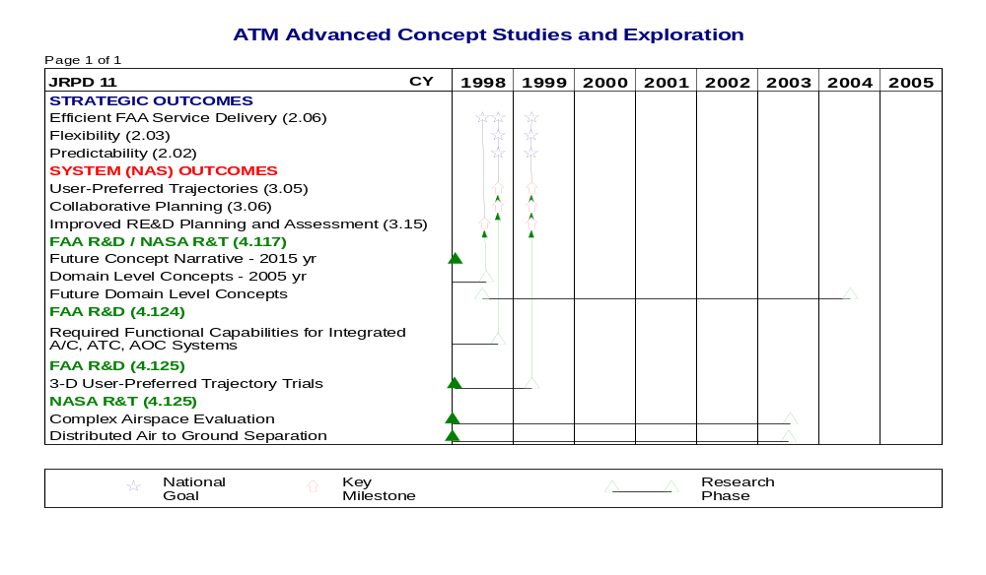

Human Factors for Evolving Environments
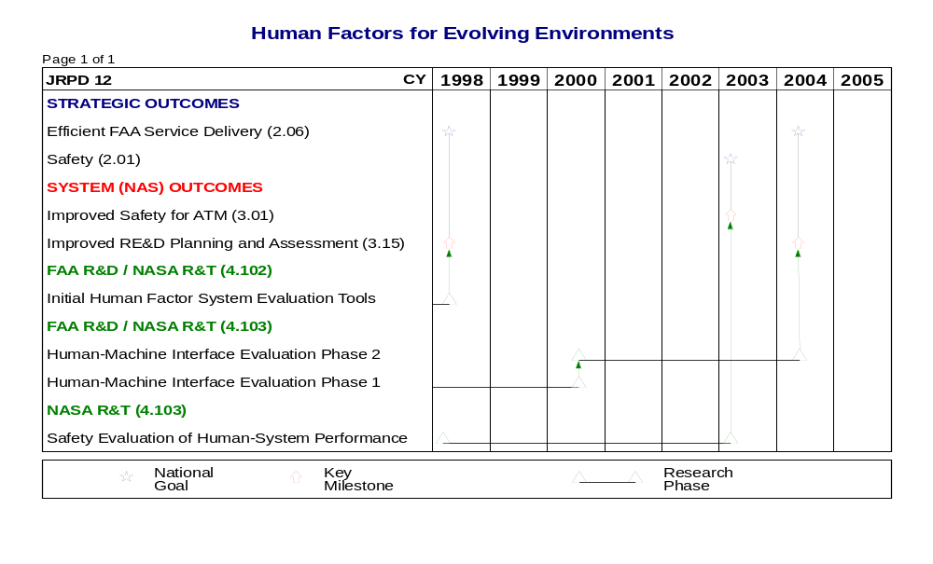

Schedule 1-1 System/Cross-Cutting ATM Performance Goals/Key Milestones, Cont.

System Performance Assessment and Investment Analysis
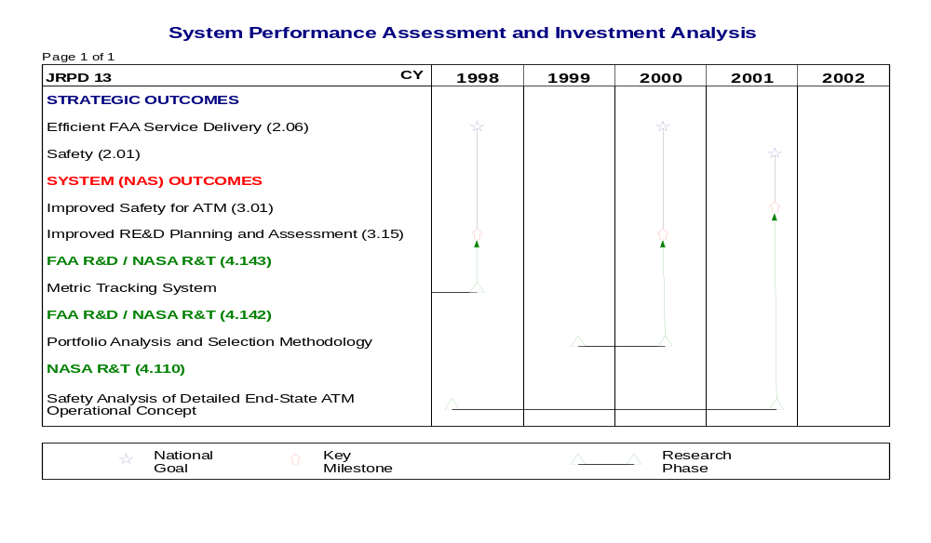

ATM Operational, Engineering, and Safety Methods and Analysis
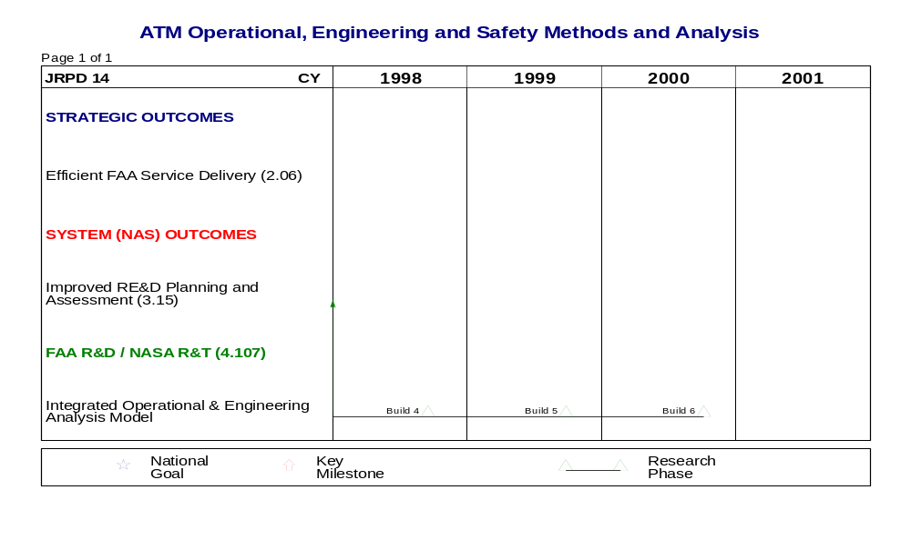

Schedule 1-1 System/Cross-Cutting ATM Performance Goals/Key Milestones, Cont.

Application of Aircraft Capabilities to ATM Advanced Concepts
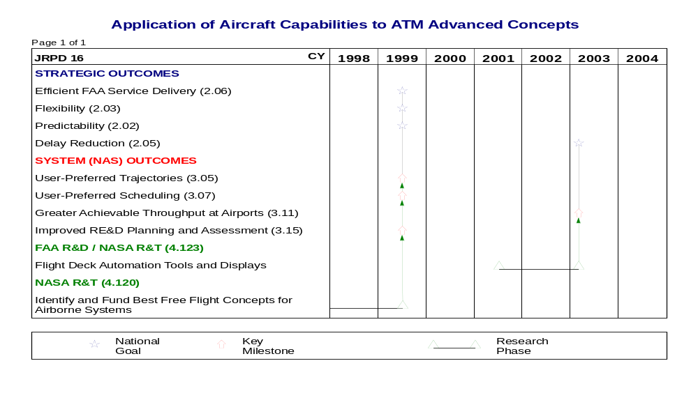

1.2 NAS 2005 Environment
The System/Cross-Cutting Area represents activities that define and mark the boundaries of the future environment of the NAS. The operational concepts define the manner in which the users and service providers would like to perform their evolving roles and responsibilities. The human centered limits and strategies to realizing these goals are established by evaluating the capabilities and limitations of the human to operate in this environment. The capability to identify the limits imposed by schedule, geographic distribution of travel, and the current and future infrastructure is also provided through these activities.
This area also represents the activities which are either common to all domains or require integration across domains. The communication, surveillance, navigation, and flight deck capabilities to support ATM are common and should remain common across domains. The databases to support performance prediction and measurement should be common across domains and are therefore included in this environment. Finally, the ultimate benefit of the systems and procedures developed within this program can be achieved only if the movement of information and the tactical decisions the information supports are integrated, real-time, across the domain boundaries. Thus, efforts to integrate and demonstrate the seamless nature of the future ATM system are truly crosscutting, system activities.

1.3 Operations and Services
The NAS as described above has one key characteristic which cuts across domain and phase of flight – the future NAS is characterized by an increasing dependency on a shared infrastructure. The flight deck and ground are coupled for navigation, surveillance, and communications; but, even more important the automation and decision support systems are also a shared environment. The question in alternatives for the future is not in whether the infrastructure is shared, but to what degree. This changing philosophy reflects both the fiscal advantages as well as the operational performance that can be achieved when the flight deck is an active participant in the development of information, planning, and tactical strategies.

1.4 Needs and Joint Research Projects
The following table correlates System/Cross-Cutting Area needs, extracted from A Concept of Operations for the National Airspace System in 2005, dated September 30, 1997, and identified in Volume 1, Section 4, of the Integrated Plan, with individual joint research projects. The JRPD information includes the project number, the specific product that addresses the need, and the product identification number. Appendix C contains additional JRPD information.
2005 Needs | JRPD#/Product/Product ID#
Technology to improve the efficiency of human performance | J11/Operational Capability & Performance Requirements/4.127
Decision support systems to improve performance measurement | J12/System Evaluation Tools/4.102  J13/Portfolio Analysis & Selection Methodology/4.142  J14/Integrated Operational & Engineering Analysis Model/4.107
Avionics to improve pilot situational awareness  GPS Navigation Systems  Automatic Dependent Surveillance Systems | J16/Flight Deck Automation Tools & Displays/4.123

1.5 Mature Free Flight Environment
In the mature state, cross cutting systems (integrated en route, terminal, and surface tool packages which evolve into NAS packages) will continue to evolve, providing greater flexibility to system users. Improved avionics will allow users to undertake greater self-separation responsibilities. In addition, NAS performance measurement systems will provide better information that service providers and users can use to collaboratively manage operations. (See JRPDs J11, J12, J16)

1.6 Project Summaries
1.6.1 JRPD J11 - ATM Advanced Concept Studies and Exploration
Technical Overview/Abstract
The specific research issues to be addressed will be decided by the Interagency IPT in concert with the Free Flight Steering Committee and the aviation community in general. The results of the research activities, in turn, will support the Free Flight Steering Committee’s planning efforts on the evolution of ATM capabilities. The research results will include proposed operational concepts including user and service provider roles and responsibilities, system functional needs and domain allocations, NAS architectural impacts, and candidate decision support capabilities and technologies required to implement new concepts. Most importantly, recommendations will be made to the IAIMT about whether the issue or concept merits more detailed evaluation at the domain-level. Such explicit decision making will help the FAA and the user community to channel research resources toward the highest payoff concepts.
- Develop a draft system level operational concept, including projected roles and responsibilities for all affected users and service providers, and assumptions related to evolving technologies (e.g., CNS capabilities available by time frame).
- An operational concept to a level of detail to support more detailed analysis (e.g., identification of issues for assessment).
- Summary of ROM benefits and costs.
- Initial assessment of NAS architecture/infrastructure impact (if any).
- A report out to the IAIPT to aid decision on further development and assignment of that development to area JRPDs.
Note: Additionally, this JRPD will include the planning and concept exploration studies leading to two major technology validation efforts within the NASA Advanced Air Transportation Technology program scheduled to begin in 2001. Candidate technology validation efforts include an adaptation of decision support tools to a complex airspace such as the North East corridor, and the demonstration of distributed air/ground air traffic management. The funding for these technology validation efforts is also included in this JRPD to assure that the activities are based on NAS-wide issues. A more detailed description of these plans is contained in the AATT element of the NASA Aviation System Capacity Program. Complete project descriptions will be developed by the 4th quarter of 1999. The fiscal resources to be allocated to the technology validation efforts are explicitly identified in the Resource Summary table in Section 5.1.7, as well as the resource analyses in Section 6.

Program Responsibilities
The FAA, working in concert with the RTCA Free Flight Steering Committee and other user organizations, has primary responsibility for leading the evaluation of advanced concepts for ATM decision support capabilities and planning the evolution of NAS capabilities. NASA has the responsibility for leading the evaluation of advanced concepts for flight deck capabilities. The IAIPT will support those efforts by conducting research in accordance with the above approach and by providing research products that will aid in decision on the evolution of the NAS. Both the FAA/CAASD and NASA will be responsible for conducting advanced ATM concept research, including laboratory and field evaluations where necessary to fully evaluate the issue at hand. The ATM research efforts will be conducted in close coordination with other FAA IPTs. Those FAA IPTs will provide support for research, development and demonstration of other capabilities (e.g., CNS, aircraft avionics) necessary to the candidate ATM concept. Results of these multiple efforts will, of necessity, be integrated to formulate the total system answer to the particular research question.

For the complete Joint Research Project Description, see page C-1 in Appendix C.

1.6.2 JRPD J12 - Human Factors For Evolving Environments
Technical Overview/Abstract
This project is a complement to the modeling and simulation project J14. It is based on the advanced concepts scenarios developed through J11. Other individual programs within the FAA’s Air Traffic Management IPT are mandated to address human factors issues specific to their particular implementation. The bases for these specific human factors decisions are provided by research in this element. However, there are complex underlying human factors issues such as air/ground integration, distributed control modes, team decision making, and display and procedures for flight operations and in support of user-preferred routing.
- Design Guidance and Design Support Tools: Provide validated human factors guidelines and design-aid tools to assure development of human-centered aiding systems for flight deck and ATC.
- Evaluation Methodologies: Provide validated analytic and model-based tools to evaluate system-level human performance and integrated decision-aiding systems.
- Safety and Reliability: Provide validated safety and reliability metrics to evaluate human-machine interface
- Operations Procedures and Communications: Provide procedures and human-machine interfaces for the flight deck and ground operations in a dynamic distributed control and decision-making system. Establish roles and responsibilities within and across system elements.

Program Responsibilities
The FAA, working in concert with the RTCA Free Flight Steering Committee and other user organizations, has primary responsibility for leading the evaluation of advanced concepts for ATM decision support capabilities and planning the evolution of NAS capabilities. NASA has the responsibility for leading the evaluation of advanced concepts for flight deck capabilities. The Interagency IPT will support those efforts by conducting research in accordance with the above approach and by providing research products that will aid in decision on the evolution of the NAS. Both the FAA/CAASD and NASA will be responsible for conducting advanced ATM concept research, including laboratory and field evaluations where necessary to fully evaluate the issue at hand. The ATM research efforts will be conducted in close coordination with other FAA IPTs. Those FAA IPTs will provide support for research, development, and demonstration of other capabilities (e.g., CNS, aircraft avionics) necessary to the candidate ATM concept. Results of these multiple efforts will, out of necessity, be integrated to formulate the total system answer to the particular research question.

For the complete Joint Research Project Description, see C-9 in Appendix C.

1.6.3 JRPD J13 - System Performance Assessment and Investment Analysis
Technical Overview/Abstract
To provide tools for concept evaluation, prototype development, and full-scale development efforts with a comprehensive system performance (cost/benefit/risk) assessment and investment portfolio analysis. These tools will support the choice of strategies and technologies which ensure the continued technological leadership and productivity of the NAS and its users.
- Cost/Performance/Risk assessments and methodology development
- Life Cycle Cost Realism
- Benefits Baseline to Domain
- Portfolio Analysis and Selection Methodology
- Project Performance Prediction and Tracking Process
- System performance databases (Weather, NAS Demand, Aircraft Performance, ATC Infrastructure, Economics)
- Operational scenario database for life cycle assessment
- Airspace User Behavior Assessments
- Gaming, Scheduling, Equipment Investments

Program Responsibilities
The FAA and NASA will manage and perform the following tasks:
- Research, develop, select and implement the investment model;
- Establish a benefits baseline for the NAS;
- Develop a project performance tracking methodology and the supporting database;
- Research, determine, and implement the ATM IPT investment analysis strategy;
- Perform system studies;
- Perform the AATT system studies; and
- Develop all or part of supporting databases and conduct analyses on user equipage and aircraft performance.

For the complete Joint Research Project Description, see page C-13 in Appendix C.

1.6.4 JRPD J14 - Air Traffic Management Operational, Engineering, and Safety Methods and Analysis
Technical Overview/Abstract
To provide operational, engineering and safety analyses to support National Airspace System concept exploration, research issue investigations and to determine predicted NAS-wide benefits and safety impacts of advanced technological and procedural improvements to the air transportation system.
- Integrated Operational and Engineering Analysis Models of the National Airspace System and its subsystems for use by the FAA/NASA, industry and other organizations to improve operational and engineering analysis.
- Operational information to provide input for cost/benefit studies of new concepts, technologies, and procedures.
- Safety assessment methodology for determining hazards, developing mitigation strategies and conducting operational assessment of the hazards and mitigation strategies.

Program Responsibilities
The AWT will co-lead a government-sponsored team to collaborate in developing a comprehensive modeling effort that covers U.S. domestic NAS modeling needs. The team will develop the necessary databases, methodologies, and models. The team will also conduct validation of these databases, methodologies, and models through their application to critical assessments of ATM IPT technology and procedural development.

For the complete Joint Research Project Description, see page C-19 in Appendix C.

1.6.5 JRPD J16 - Application of Aircraft Capabilities to ATM Advanced Concepts
Technical Overview/Abstract
To evaluate and develop aircraft systems and operational procedures that will enhance the efficiency, flexibility, and safety of the ATM system in the evolution towards achieving free flight operations for all NAS users. This effort will evaluate existing and future aircraft systems to determine their operational impact when integrated with the evolving free flight environment. New technologies for the aircraft flight deck will also be developed to enhance efficient and safe free flight operations.
- Develop, evaluate, and demonstrate concepts to provide flight deck crews the information to dynamically plan and re-plan routes for maximum efficiency.
- Develop airborne automation tools (e.g., conflict resolution), flight data and situation displays (e.g., 3-D view of airspace) which can be used to assure safe and further reduced separation.
- Assess the airborne implications of the application of new technologies (e.g., GPS/ADS-B, advanced FMS) to support free flight operations.
- Develop NAS 2005 application of datalink avionics (e.g., current applications and digital delivery of taxi clearances (DDTC)).

Program Responsibilities
The FAA, NASA, and CAASD are working together to develop an integrated approach to research involving ATM-compatible flight deck systems and procedures. The Interagency IPT, NASA, and the FAA will work collaboratively to assure that operational concepts, demonstrations, validations, and procedures are developed in a integrated manner to best achieve national goals.

For the complete Joint Research Project Description, see page C-25 in Appendix C.

1.7 Integration and Risk Management

Products | Risks | Mitigation Strategy
(J11) Future Ops Concept | Lack of acceptance  Uncertainties of future technologies | Interface with user via Free Flight Select Committee and Field Controllers  Multiple alternatives  Work with NEXTOR to identify potential operational environment
(J11) Complex Airspace | Adaptation of automation to complex airspace  Full realization of benefits due to air space constraints | Parallel airspace design studies with benefit assessment
(J11) Distributed air/ground air traffic management | Controller/pilot acceptance due to difficulties in managing roles and responsibilities | Conduct fundamental human factors assessments to define procedures for shared tasking between air and ground
(J12) Design Guidance Operations Procedure and Communication | Lack of acceptance  Not aligned with future operations | Work with users, service providers, and IPTs  Use Ops Concept as basis for the development
(J13) Cost Performance/ Risk methodology | Lack of acceptance  Changing investment environment – future funding of aviation | Align with GPRA process  Evaluate NCAR recommendations  Work with internal cost/pricing group to understand FAA future funding
(J13) Portfolio Analysis and Selection Methodology | Limited funding | Demonstrate through prototype – decision support on architecture
(J14) Operational models | Limited funding  Incompatible data requirements  Fidelity for future operations | Joint development – NASA and European partners  RTCA 192 recommendations  Inter-process for plug and play  Developers participate in Ops Concept development and National Airspace Review
(J14) Infrastructure Model | Fidelity of workload and controller activity modeling | Tie development closely to FAA air traffic, NASA MIDAS development, and European partner
(J16) Flight deck capabilities for situational awareness and safety | Uncertainty of technology integration | Use FAA Safe Flight 21 to refine requirements and guidance  APATH research

2. Traffic Flow Management Area
Today, when demand is expected to exceed capacity, traffic flow managers at the national and local levels consider various flow strategies to resolve the expected congestion. These strategies are typically selected with limited information or consultation with NAS users, and without complete knowledge of the implications on other airspace resources. This lack of information may result in restrictions that are too restrictive. Furthermore, since NAS users are unaware of the constraints in the system, they are unable to plan the most efficient operations, and are unable to take actions to resolve the problem.
In the NAS 2005 environment, managing NAS resources will continue to be the responsibility of traffic flow service providers at the national and local level. They will ensure that use of resources will not exceed safe and acceptable levels. However, the environment will be based on information sharing and collaboration resulting in better decisions and more efficient operations for the NAS and its users. NAS users will be responsible for managing their operations to meet their objectives, while complying with selected strategies.

2.1 Goals
The goal of the Traffic Flow Management (TFM) Area is to provide a TFM capability that enables enhanced flexibility, access, and collaboration for all categories of airspace users. In addition, it explores enhancements to Decision Support System (DSS) capabilities and FAA/industry data exchange to support a more collaborative TFM decision-making environment. Finally, it develops concepts and prototype capabilities that move TFM operations closer to free scheduling and free routing in the Free Flight environment.

Schedule 2-1 Traffic Flow Management ATM Performance Goals/Key Milestones

Collaborative Decision Making
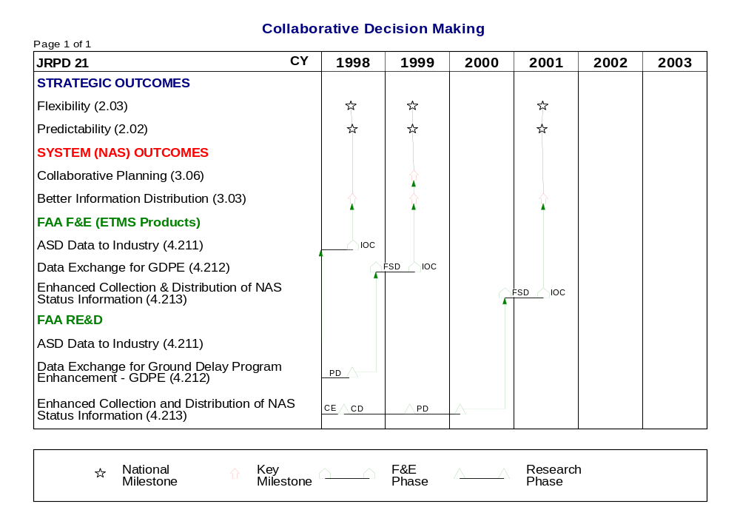

Schedule 2-1 Traffic Flow Management ATM Performance Goals/Key Milestones, Cont.

Collaborative Decision Making, cont.
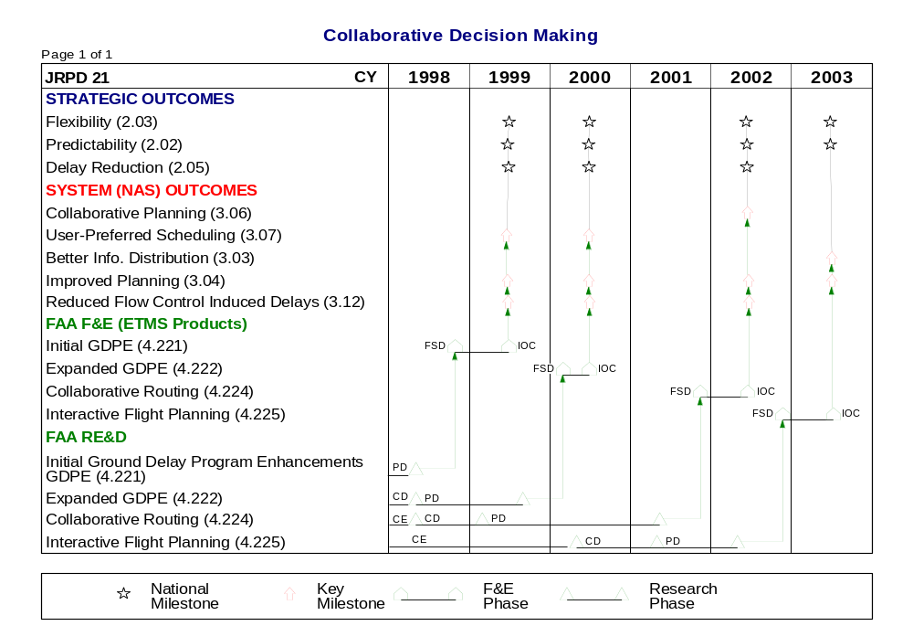

Schedule 2-1 Traffic Flow Management ATM Performance Goals/Key Milestones, Cont.

Collaborative Decision Making, cont.
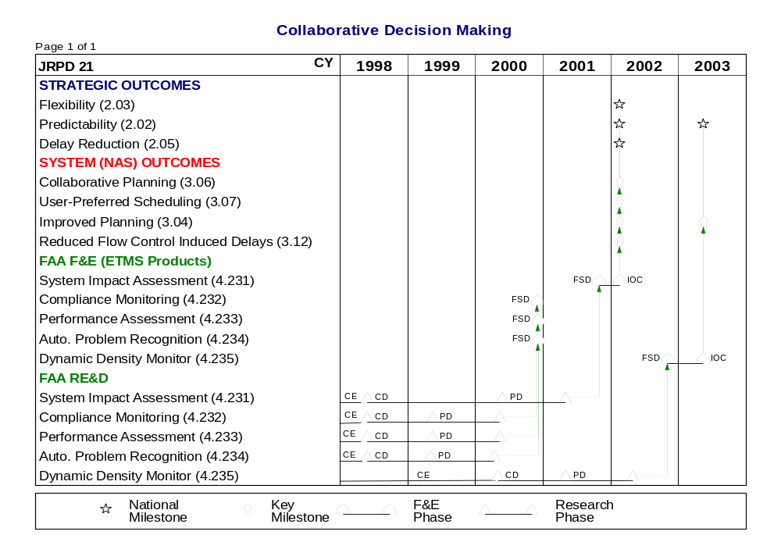

2.2 NAS 2005 Environment
TFM in the NAS 2005 environment will be characterized by an environment of collaborative partnership and information sharing among service providers, and between the service providers and the NAS users. Increased user flexibility will be achieved because of this new environment, enabling NAS users to plan their operations based on the most updated and accurate information regarding NAS status. Information sharing will also improve decision by traffic flow service providers. Furthermore, when users receive accurate information on expected congestion, they may take actions to reduce their demand, hence reducing that congestion. Another aspect of the NAS 2005 environment is that traffic flow management will be more collaboration between traffic flow service providers and NAS users. Given the magnitude of the problem, lead time, and expected impact on each operator, NAS users may decide to participate in the strategy selection process. This participation may result in decisions that are more acceptable to NAS users and at the same time improves the overall system effectiveness.

2.3 Operations and Services
In the NAS 2005 environment, national service providers monitor NAS conditions and capacity, and serve as a central point-of-contact for NAS users and local service providers. When required, the national service providers initiate and coordinate traffic management initiatives of a broad scope. They play a lead role in improving overall NAS service by managing national programs that modify national procedures and techniques governing daily operations. In the NAS 2005 environment, local service providers resolve traffic flow problems expected to impact local airspace. These local problems will be handled more efficiently at the local level, exploring alternatives for managing potential problems with other service providers as well as with the users; alternatives for managing potential flow problems typically take an aggregate approach (such as specifying the number of flights into an airport during a specified time interval) and have a more equitable distribution of impact on the users.
Users are better able to plan their operations in anticipation of NAS capacity and traffic conditions and are better able to minimize congestion or possible delays due to the comprehensive information made available. NAS users represented by AOCs will be participants in the selection of the flow initiatives and assume responsibility for adhering to selected strategies.

2.4 Needs and Joint Research Projects
The following table correlates Traffic Flow Management Area needs, extracted from A Concept of Operations for the National Airspace System in 2005, dated September 30, 1997, and identified in Volume 1, Section 4, of the Integrated Plan, with individual joint research projects. The JRPD information includes the project number, the specific product that addresses the need, and the product identification number. Appendix C contains additional JRPD information.
2005 Needs | JRPD#/Product/Product ID#
Route conflict probe for use prior to filing | J21/Interactive Flight Planning/4.225
AOC probes proposed route changes | J21/Collaborative Routing/4.224
Probe flight plans against system constraints for General Aviation | J21/Interactive Flight Planning/4.225
Automatic checking of flight profile against conditions and constraints | J21/Interactive Flight Planning/4.225
Automatic display of flight profile problems to user | J21/Interactive Flight Planning/4.225
Electronic availability of flight plan for all service providers
Enhanced flight plan for all users that includes preferred trajectory, aircraft weight, runway preference for departure/arrival, gate assignment, and cross border issues
User provided profile automatically generates flight plans
Interactive flight planning | J21/Interactive Flight Planning/4.225
Time based metering to maximize airspace and airport capacity | J46/Initial Collaborative Planner Tool/4.410
Common enhanced DSS for both local and national TFM | J21/Collaborative Routing/4.224
DSS to help service providers visualize demand and manage complex traffic flows | J21/Collaborative Routing/4.224
Databases and DSS that use databases to enable shared view of traffic and weather among all parties | J21/Collaborative Routing/4.224
Databases and DSS that use databases to enable shared view of traffic and weather among all parties with "what-if" tools to evaluate proposed strategies | J21/Collaborative Routing/4.224
Increased automated information exchange | J21/ASD Data to Industry/4.211  J21/Data Exchange for Ground Delay Program Enhancements/4.212  J21/Enhance Collection and Distribution of NAS Status Information/4.213
DSS to improve NAS monitoring, performance measurements, and strategic development | J21/Performanc Assessment/4.233  J21/Automated Problem Recognition/4.234
DSS for ATCSCC to provide global perspective and facilitate coordination among national and local flow managers | J21/System Impact Assessment/4.231

2.5 Mature Free Flight Environment
Although most TFM improvements are expected to take place by the 2005 time frame, enhancements to NAS 2005 capabilities will improve the resolution of flow problems. Refined capabilities will improve NAS users’ ability to collaborate with traffic management to reduce the demand for constrained resources. Traffic flow managers will have better capabilities to predict the time and location of congestion and will use this information when collaborating with NAS users to determine the most effective flow strategies. Traffic management personnel will also receive improved predictions of hazardous weather locations so they can assess the weather’s impact and provide options to system users. Finally, traffic management personnel and NAS users will continue to develop strategies to minimize constraints on users in the use of their share of capacity at constrained resources.

2.6 Project Summaries
2.6.1 JRPD J21 - Collaborative Decision Making
Technical Overview/Abstract
Near-Term TFM Capabilities:
- Initial FAA/Industry Data Exchange: Provide TFM and user community with information necessary to support Ground Delay Program Enhancements (GDPE) e.g., schedules, schedule changes, airport acceptance rates, arrival rates, etc. This capability will build upon current Aircraft Situation Display (ASD) Data to industry capability.
- Collaborative Decision Making (CDM) GDPE: Provide for enhanced procedures and automation capabilities (e.g., Flight Schedule Monitor, Ration by Schedule, Schedule Compression, etc.) to make the GDP more efficient and to better accommodate user preferences in dealing with constraints.
NAS 2005 Capabilities:
- Enhanced FAA/Industry Data Exchange: Provide for the exchange of information (e.g., user preferences, NAS status, sector loading, constraints, dynamic SUA) necessary to enable more advanced collaborative decision making, including capabilities for users to display this information.
- Expanded GDPE: Provides Flight Substitution Process Simplification, Control by Time of Arrival, and Daily Download capabilities.
- Collaborative Routing: Apply current technologies to achieve collaborative objective routing between TFM facilities, and between TFM and the users including routing changes due to severe weather and traffic congestion (e.g., Collaborative Routing Coordination Tools (CRCT)).
- Interactive Flight Planning: Provide feedback on submitted flight plan at time of flight plan filing instead of at clearance delivery.
- Performance Assessment: Determine performance standards for TFM operations in collaboration with TFM operators and NAS users; develop metrics for these standards to be used to analyze performance; these metrics will be used to help determine strategy for similar situations that may develop in the future.
- Automated Problem Recognition: Develop capability that could recognize and measure projected demand on a NAS resource.
- Compliance Monitor: Define compliance in the context of collaborative decision making; determine methods for measuring compliance, and ways to ensure that the system is as fair as possible to all users.
- Dynamic Density Monitor: Determine if and how sector boundaries can be changed dynamically; determine which traffic features and factors are useful to the traffic manager for prediction; explore how to express them in a meaningful fashion.
- System Impact Assessment: Develop a simulation capability to assess the impact of schedule changes, routing changes, miles-in-trail restrictions.
Advanced TFM Concept Exploration:
- Assess alternative roles/responsibilities (ATCSCC, TMU, pilots, AOC) to enable TFM evolution toward free flight; includes workload assessments.
- Evaluate automation capabilities needed to support enhanced concepts and roles/responsibilities.
- Evaluate the application of new technologies (e.g., aircraft avionics, information sharing tools) to support TFM concepts.
- Assess impact on TFM infrastructure of advanced ATM concepts; plan for evolution of system design/components.
CDM Packages:
The TFM capabilities are grouped together as builds or “CDM Packages” and integrated into the TFM infrastructure. The Pre-CDM Package consists of HARS/R, ASDI and the CDMNet network infrastructure. CDM Package #1 includes the basic CDM capabilities and will be integrated into ETMS by the end of 1999. CDM Package #2 includes enhancements to the basic CDM capabilities and the rudiments of Collaborative routing and NAS Status information. Successive builds have increased functionality in these areas and also have performance evaluation and enhancement elements.

Program Responsibilities
The FAA sponsors the research and development activities. CAASD performs concept exploration and concept development. The FAA will implement the developed functionalities.

For the complete Joint Research Project Description, see page C-29 in Appendix C.

2.7 Integration and Risk Management

Products | Risks | Mitigation Strategy
(J21) Collaborative Decision Making | Dependency on airline participation and cooperation | Provide a product that the airlines want and need
(J21) Collaborative Decision Making | Inadequate funding and funding shortfalls | RTCA support; generate detailed benefit assessments
(J21) Collaborative Decision Making | Integration of CDM into TFM Infrastructure | Close coordination with Volpe NTSC  FAA must define the CDM/ETMS architecture
(J21) Collaborative Decision Making | Time to develop R&D products | Investigate applicability of COTS products

3.0 Surface Area
The surface movement operations in the NAS time frame will provide an ability to increase the traffic throughput for all weather conditions, and to minimize ground delay of departing and arriving aircraft; i.e., from time of push-back to the runway, and from the runway to the gate. The NAS 2005 time frame is an evolutionary step to the “mature state” which is characterized by the implementation of the NAS 2005 system capabilities at more airports and for a larger aircraft population with advanced avionics.

3.1 Goals
The goals of the Surface Area are to: 1) reduce taxi delays, 2) design and develop prototype automation infrastructure, algorithms, and controller interfaces that will allow the tower controller to efficiently control surface traffic in instances where visual contact is severely restricted or precluded, and 3) functionally evaluate future tower automation capabilities in a full-scale simulation of a major airport tower cab.

Schedule 3-1 Surface ATM Performance Goals/Key Milestones

Airport Surface Management Technologies
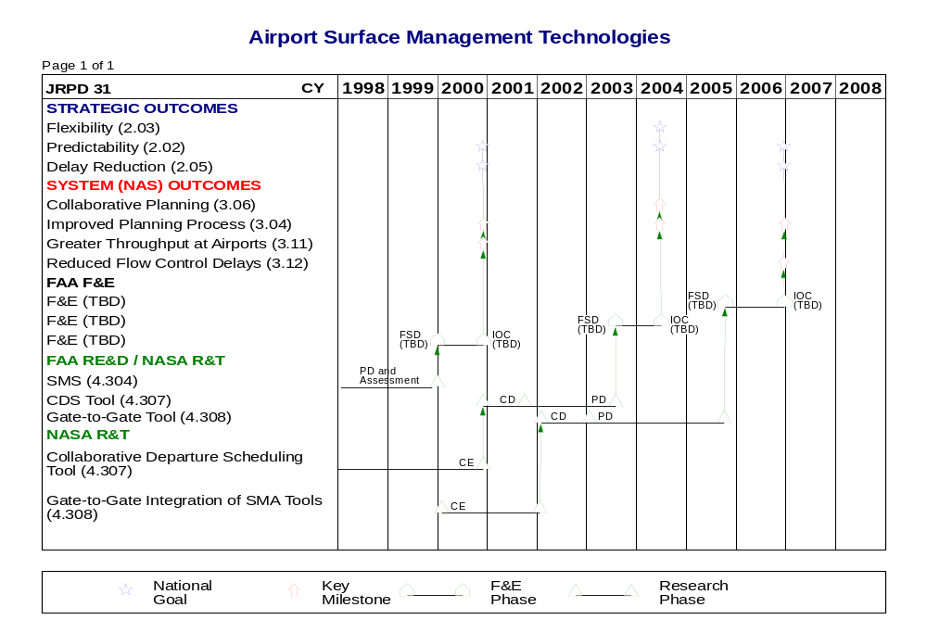
Schedule 3-1 Surface ATM Performance Goals/Key Milestones, Cont.

Airport Surface Management Technologies, cont.
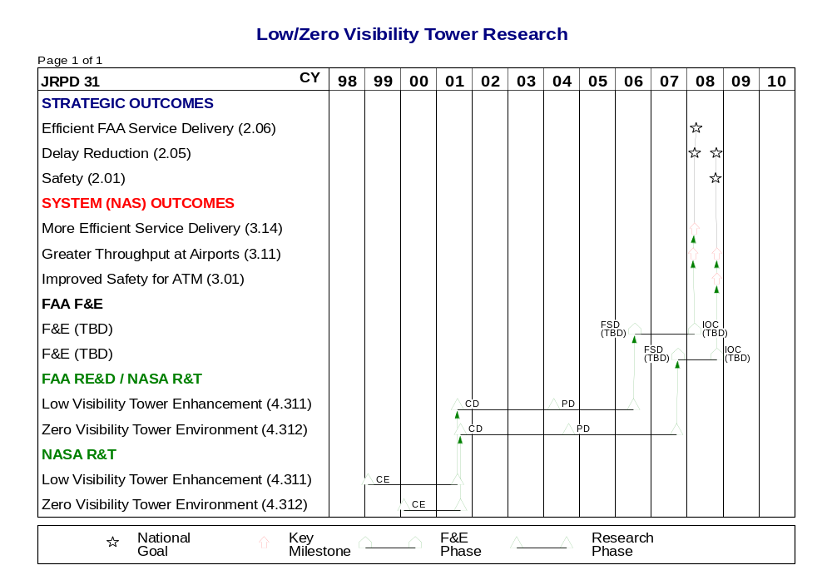

3.2 NAS 2005 Environment
The NAS 2005 environment for Surface is characterized by the availability of much more accurate information on aircraft and surface vehicle positions that will improve safety. This is enabled by the use of satellite-based position information augmented by local area corrections providing very accurate positional information. This accurate positional information, when added in the cockpit with information on other aircraft positions and real time weather information (via datalink), will allow airport operations to continue at near normal operations in near zero visibility conditions.
In the NAS 2005 environment, there will be complete integration of all systems related to airport surface movements (of all vehicles) and facility use planning. This system integration will allow for optimum planning by integration of information concerning flight plans, airborne and surface surveillance information, departures, arrivals, gate assignments, taxiway and runway assignments and schedules, crew assignments (both flight and ground) weather, noise abatement procedures, traffic management plans, and dynamically changing user needs.

3.3 Operations and Services
The integration of systems and information sharing will allow for reduced taxi times and takeoff delays, and more efficient sequencing of surface traffic. The system integration will link together the service providers, flight decks, Airline Operations Centers (AOCs) ramp staff, airport operator, and airport emergency centers. The services provided include aviation information, separation assurance, and traffic management .

3.4 Needs and Joint Research Projects
The following table correlates Surface Area needs, extracted from A Concept of Operations for the National Airspace System in 2005, dated September 30, 1997, and identified in Volume1, Section 4, of the Integrated Plan, with individual joint research projects. The JRPD information includes the project number, the specific product that addresses the need, and the product identification number. Appendix C contains additional JRPD information.
2005 Needs | JRPD#/Product/Product ID#
Obstructions marked with broadcast transmitters
ATCT automation enhancements including satellite based surveillance info for conflict detection
Automation aids for dynamic planning of surface movements | J31/Surface Movement Advisor/4.304  J31/Collaborative Departure Scheduling Tool/4.307
Automation to monitor and predict the movement of ground vehicles
Display satellite derived position data for selected flights to service provider
DSS for departures incorporating departure time, aircraft type, wake turbulence criteria, and route | J31/Surface Movement Advisor/4.304  J31/Gate-to-Gate Integration of SMA Tools/4.308
Integration of service provider automation with departure and arrival information | J31/Gate-to-Gate Integration of SMA Tools/4.308
Ramp service providers have displays used to sequence and meter aircraft movement | J31/Gate-to-Gate Integration of SMA Tools/4.308
Service provider DSS for arrivals that considers assigned gate | J31/Surface Movement Advisor/4.304  J31/Gate-to-Gate Integration of SMA Tools/4.308
Service provider DSS to determine taxi sequencing, conformance monitoring, and conflict checking. | J31/Surface Movement Advisor/4.304  J31/Gate-to-Gate Integration of SMA Tools/4.308
Surface situation displays for airborne and surface traffic and with data tags for all flights and vehicles
Tower automation conformance monitoring to detect runway encroachments
Tower automation to detect conflicts between aircraft as well as between aircraft and vehicles | J31/Surface Movement Advisor/4.304  J31/Gate-to-Gate Integration of SMA Tools/4.308
Accurate display of weather for service provider and user with automatic simultaneous broadcast of hazardous weather alerts
Surface management information system with complete data connectivity between service providers, flight deck, AOC, ramp, airport operator, and airport emergency centers | J31/Gate-to-Gate Integration of SMA Tools/4.308

3.5 Mature Free Flight Environment
Building on the foundation established in 2005, surface operations and capabilities are expanded to more airports. In addition to the receipt of the Automatic Terminal Information Service (ATIS)-type message transmitted via datalink, real time updates of ATIS message components are transmitted via datalink. There will be accurate displays of weather for both system users and service providers with automatic simultaneous broadcasts of weather alerts. Using satellite-based position information, airport operations can continue at a near normal pace during near zero visibility conditions. In addition, air traffic control tower automation can detect conflicts between aircraft and vehicles. Tower automation will also perform conformance monitoring of an aircraft’s taxi route to ensure that aircraft do not enter active runways without clearance.

3.6 Project Summaries
The outcomes for the Surface Area work team is to enable new collaborative surface/airfield management technologies that will offer predictive capabilities (e.g., planning, scheduling, and advisories) to augment the users operational decision-making process. In addition, it provides a Surface Development and Test Facility (SDTF) that enhances planning, assessment and evaluation of Surface outcomes by using a full-scale (Level V Tower/Major Airfield Level V ATCT) simulator. Finally, it enhances and provides new functionality to increase safety by improving situational awareness at night and for Low/Zero visibility conditions.
All of these three areas are defined as Airport Surface Management Technologies (J31) meet national strategic and NAS level goals in the areas of productivity, flexibility, predictability, delay reduction, and improved planning/assessment capabilities.

3.6.1 JRPD J31 - Airport Surface Management Technologies
Technical Overview/Abstract
Research, development, and evaluation of future management technologies that will reduce surface delays and optimize airport capacity. New surface/tower management technologies will offer predictive capabilities and augment the airport users’ operational decision making process regarding the surface movement of aircraft. Also, the study and development of augmentations to the air traffic tower environment that can provide an operationally useful enhanced or synthetic view of the airport surface during periods of low or zero visibility. The goal is to maintain the safety and efficiency of surface operations under adverse visibility conditions.
Near-Term Surface Capabilities:
- The Surface Movement Advisor (SMA) is an airport automation system that facilitates the sharing of information among air traffic control, airline, and airport operations communities.
- Collaborative Departure Scheduling provides improvements to joint airline/airport/ATC taxi procedures to reduce departure taxi delays and airport congestion.
- Investigate new collaborative surface user-preferred procedures (e.g., market based dynamic slot allocations, etc.).
- Investigate integration of surveillance and surface automation functionalities.
NAS 2005 Surface Capabilities:
- Gate-to-Gate planning, investigate user-preferred procedural integration of SMA with all other automation/traffic management tools (TMA, FAST, arrival/departure scheduling, ATIDS, and Aeronautical Datalink) with user participation.

NAS 2005 and Mature Free Flight Low/Zero Visibility Outputs
- Low/Obstructed Visibility Enhancement: This is the development of a prototype that provides a synthetic view over a limited area of the airport surface and which functions under most low visibility conditions.
- Zero Visibility Tower Environment: This is the development of a full-scale “virtual tower cab” system that covers the entire airport surface and meets requirements for continuous operational use under severe IMC.

Program Responsibilities
The FAA is responsible for airport surface management technologies operational inputs, prototype development, and full-scale development. NASA Ames Research Center is responsible for automation concept exploration/development. FAA and NASA are responsible for associated field tests. NASA Langley Research Center is responsible for surveillance integration concept exploration/development and associated field tests.
NASA is responsible for low/zero visibility tower research concept development, concept exploration, and prototype of the automation and computer-human interface (CHI) in close coordination with users, particularly air traffic controllers. The FAA is responsible for requirements analysis, user liaison, and implementation issues.

For the complete Joint Research Project Description, see page C-37 in Appendix C.

3.7 Integration and Risk Management
The following table identifies primary risk areas and mitigation strategies for product and interface development associated with Surface DSS tools. More detailed risk identification, risk assessment, and risk abatement can be found in the Surface Area Risk Management Plan.

Products | Risks | Mitigation Strategy
(J31) SMA  (J31) Collaborative Departure Scheduling Tool  (J31) Gate-to-Gate Integration | 1. Resources/Joint development  2. Schedule  3. Requirements  4. NAS prototype interface development  5. Site adaptation  6. Hardware/Software  7. NAS integration  8. Tower automation platform | 1. Budget and planning of resources  2. Phased development and implementation  3. User defined and prototyping in operational environment  4. TNCPs, IRDs & ICDs of NAS interfaces  5. Parceling of functions and SDTF validation  6. Use of COTS & open systems architecture  7. Dedicated resources & SDTF pre-integration  8. ARTS/STARS compatibility of 1-way/2-way interfaces
(J31) NAS Deployment of SMA Product | 1. No F&E funds available for deployment  2. No tower automation infrastructure to support SMA | 1. None planned  2. Not funded and requirements not defined
(J31) Low Visibility Tower  (J31) Zero Visibility Tower | 1. Resources/Joint Development  2. Schedule  3. Requirements  4. NAS Interface Development. | 1. Budget and planning of resources.  2. Phased development and implementation  3. User defined and prototyping in operational environment, and virtual prototyping development  4. SDTF Pre-validation of requirements

4. Terminal Area
Today’s busy terminal areas are characterized by rigid routing and airspace constraints. Furthermore, terminal areas have historically been major bottlenecks in the NAS because of these constraints. Lack of decision support capabilities, older generation of displays and automation, minimal or no information on user intent and preferences, and limited arrival and departure routes result in airspace resources not being utilized to the maximum extent. Service providers must manually maintain separation based on rigid routes and separation procedures. Although service providers do try to grant users’ request to the extent possible, they cannot accommodate them as often as necessary. These preferences can range from a preferred arrival sequence to an airport to a preferred departure route that allows the aircraft to fly faster for a longer period of time. The NAS 2005 goals for terminal area environment are the following:
- Allow visual flight separation in all-weather conditions, thereby increasing capacity;
- Increase throughput, thus reducing delays, while maintaining safety; and
- Increase users’ flexibility, improving efficiency of users’ operations.

4.1 Goals
The goal of the Terminal Area is to develop ATM decision support tools (DSTs) and procedures based on human factors and engineering design principles to assist controllers, pilots, and airline operators in improving the efficiency and flexibility of operation in high density airspace.

Schedule 4-1 Terminal ATM Performance Goals/Key Milestones

Final Approach Spacing Tool
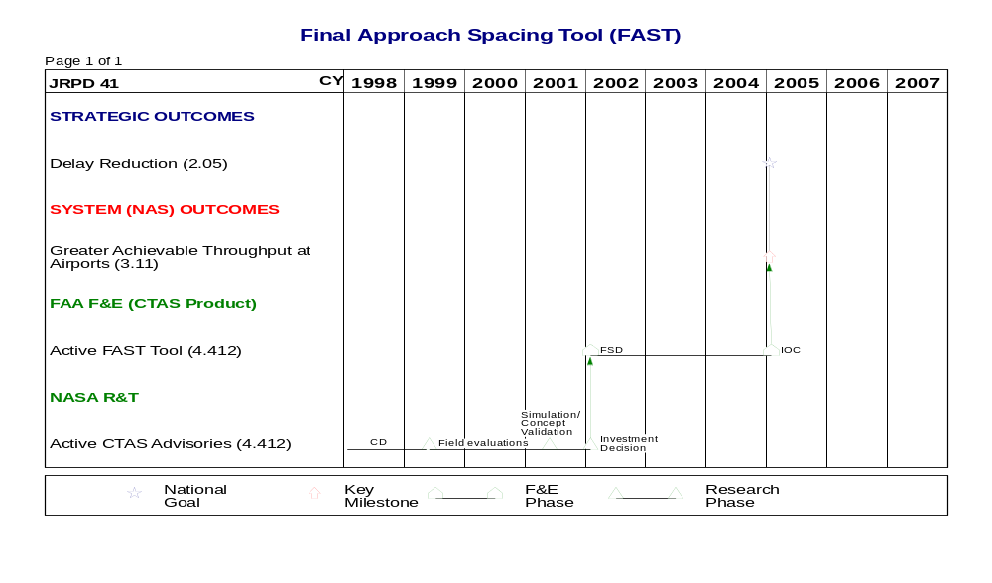

Schedule 4-1 Terminal ATM Performance Goals/Key Milestones, Cont.

Dynamic Final Approach Spacing
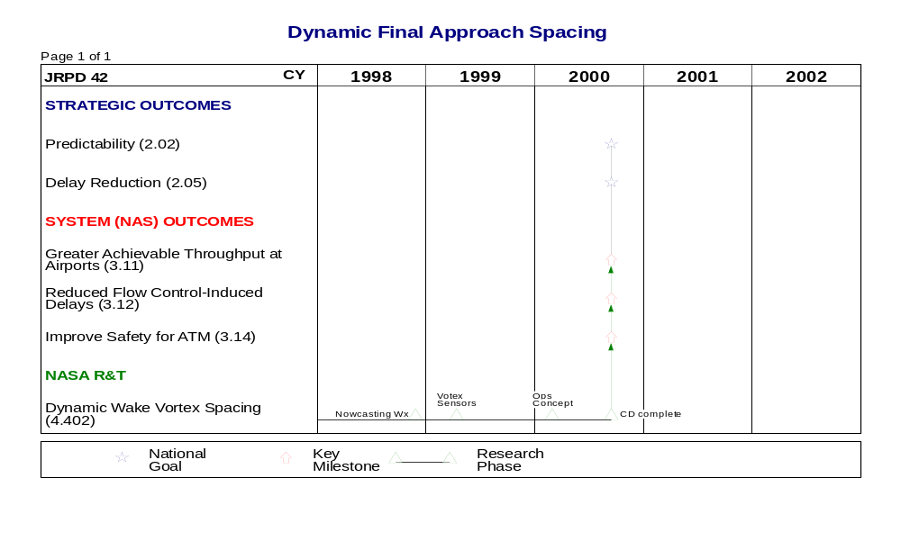

Parallel Runway Spacing Reduction
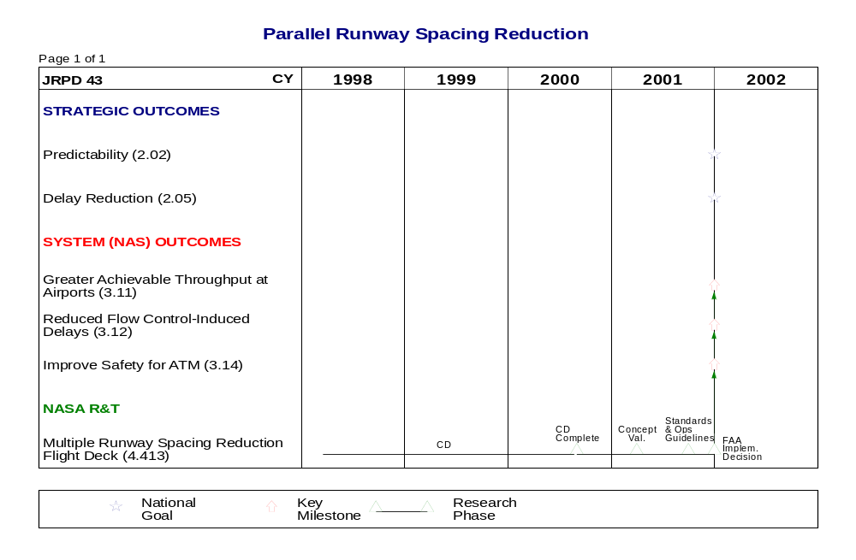
Schedule 4-1 Terminal ATM Performance Goals/Key Milestones, Cont.

CTAS Adaptation/Implementation in Complex Airspace
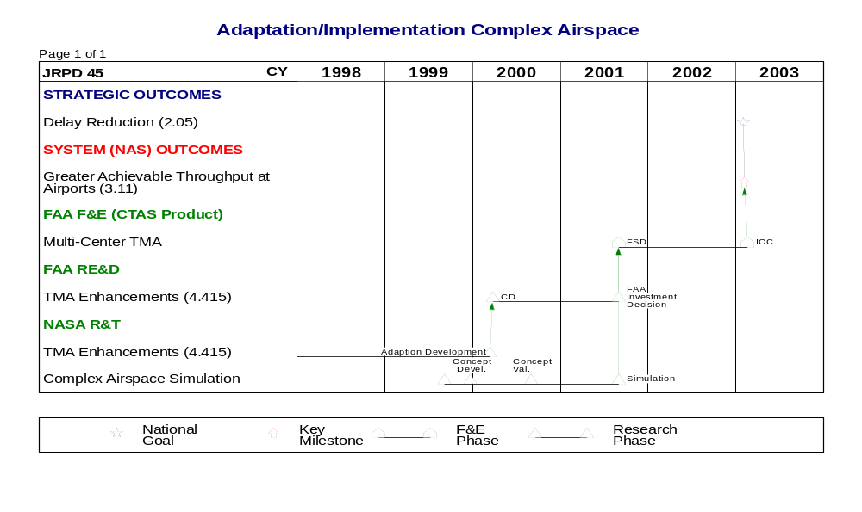

Collaborative Arrival Planning
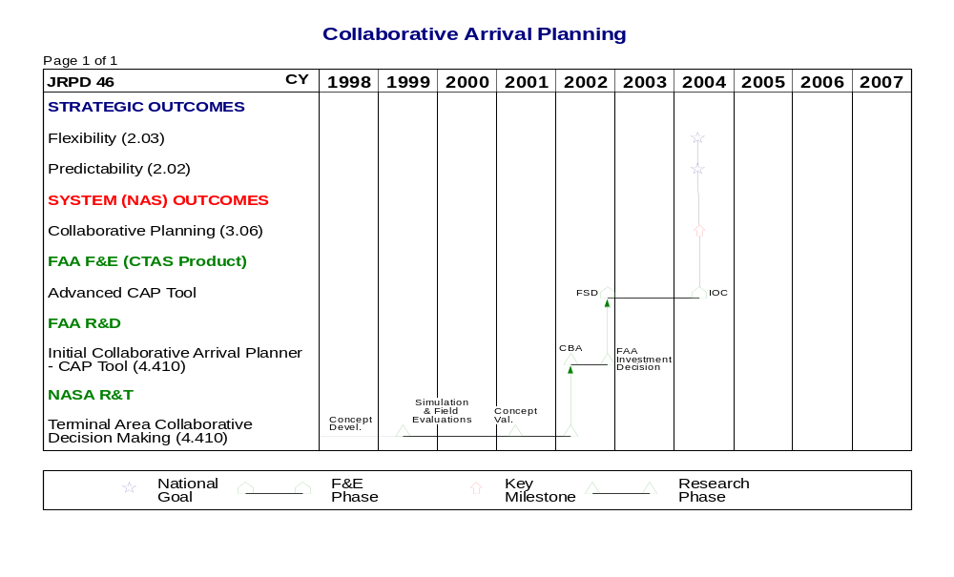
Schedule 4-1 Terminal ATM Performance Goals/Key Milestones, Cont.

RNAV/FMS Terminal Routing
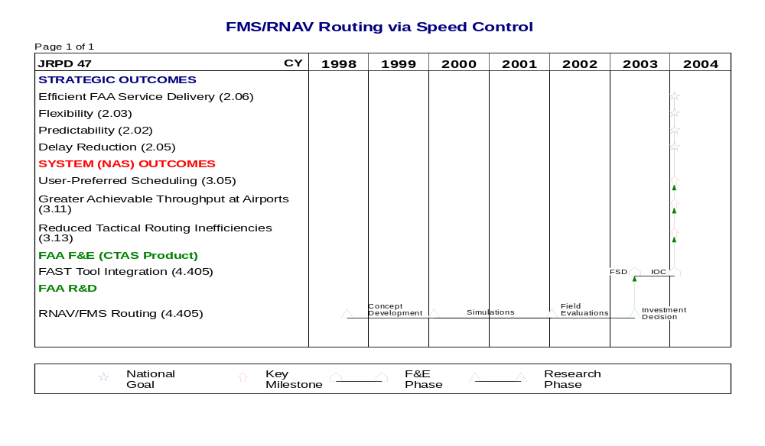

Arrival/Departure Management Integration
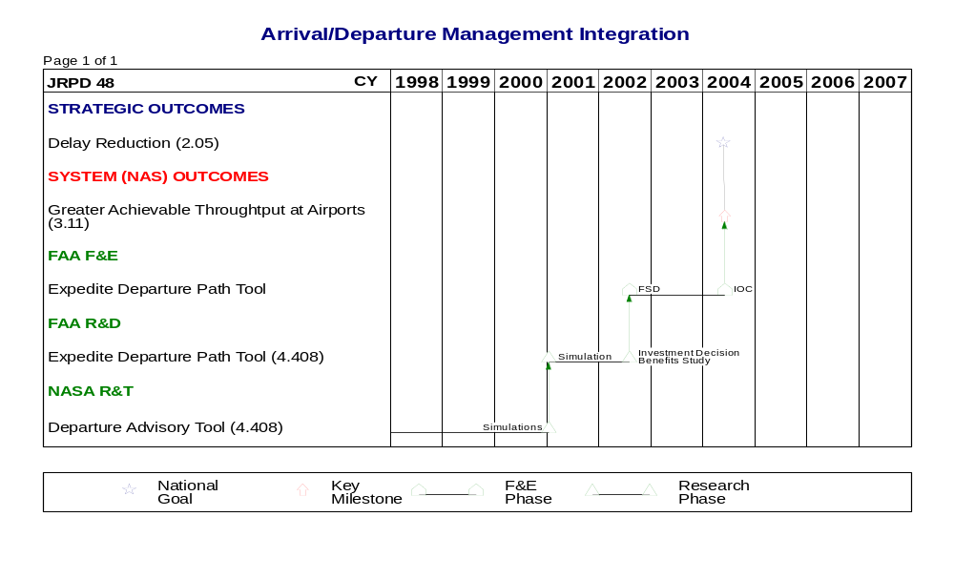
4.2 NAS 2005 Environment
Decision support capabilities with improved trajectory modeling will help service providers maintain separation by identifying and resolving conflicts earlier, and sequencing and metering (spacing) arrival traffic efficiently and based on users’ preferences. Accurate position and intent information will be important elements for achieving these improvements.
Accurate position information will be feasible because of availability and greater use of satellite-based navigation. This position information will be available to service providers on improved displays, and to the decision support capabilities available in the terminal area. These capabilities will use the position and intent information to predict potential conflicts and resolutions, and to notify the service provider of the expected conflicts and its resolution strategies. Accurate position information is also significant to pilots as their situational awareness is improved. Properly equipped aircraft will be able to broadcast their positions to other aircraft to be displayed on their cockpit traffic display. Pilots will be able to use the information displayed in their cockpit to maintain electronic visual separation from other aircraft on the same arrival or departure paths. Since pilots and service providers will receive the same position information for other aircraft, a shared common view of traffic will exist.

4.3 Operations and Services
A primary improvement in the Terminal Area will be the ability of service providers to accommodate users’ preferences more often. This will be achieved for two reasons. First, users will be able to communicate their preferences earlier than today through various means. For example, sequence preferences may be communicated through enhanced flight plans or ground-to-ground communication links. Second, decision support capabilities will assist service providers in evaluating and implementing users’ requests. These preferences will be available to decision support capabilities early enough to be used in assigning runways, arrival sequencing, and arrival spacing. Service providers will be supported by decision support capabilities for maneuvering aircraft onto the final approach in accordance with planned traffic sequence.
Additionally, because of satellite-based navigation and ground-based augmentations, more airports will have precision instrument approaches available to pilots. Additional ground-based augmentations will be available for busy airports with higher availability requirements.
Pre-defined datalink messages will be available to an increasing number of equipped aircraft. Use of datalink for routine messages will reduce voice communication between service provider and pilot, giving the service provider the opportunity to handle more traffic.
Accurate weather will be displayed to service providers. Weather will also be uplinked to the cockpit and displayed on a traffic display system, providing a common view of the weather to pilot and service provider. Current hazardous weather and the predicted movement information will be available to decision support capabilities to notify service providers of any potential conflicts with airborne aircraft.

4.4 Needs and Joint Research Projects
The following table correlates Terminal Area needs, extracted from A Concept of Operations for the National Airspace System in 2005, dated September 30, 1997, and identified in Volume 1, Section 4, of the Integrated Plan, with individual joint research projects. The JRPD information includes the project number, the specific product that addresses the need, and the product identification number. Appendix C contains additional JRPD information.

2005 Needs | JRPD#/Product/Product ID#
User preferred climb/descent profiles and runway assignments | J41/Active CTAS Advisories/4.412  J48/Expedite Departure Path/4.408
Highly accurate conflict detection and reliable conflict resolutions from improved trajectory modeling modeling | J41/Active CTAS Advisories/4.412  J45/TMA Enhancements/4.415  J48/Expedite Departure Path/4.408
Automated safe-altitude warning function for service provider
Greater than 250 K in Class B airspace below 10K
Improved identification of traffic using electronic flight ID
Specific parallel approach collision avoidance and escape guidance logic | J43/Multiple Runway Spacing Reduction - Flight Deck/4.413
Aircraft position broadcast to other aircraft and ATC
RNAV departure and arrival routes | J47/RNAV/FMS Terminal Routing Procedures/4.405
Reduced visual approach and departure minima using specific point in space geometries | J43/Multiple Runway Spacing Reduction -Flight Deck/4.413
Automated exchange of gate and runway preference between aircraft, AOC, and flight object | J46/Initial Collaborative Arrival Planner/ 4.410
Automatic exchange of information between flight deck and ground DSS to improve accuracy and coordination of arrival trajectories | J41/Active CTAS Advisories/4.412
Reduced or time-based separation standards in terminal area | J42/Dynamic Wake Vortex Spacing/4.402
Service provider tools to enhance final approach spacing and runway assignment | J41/Active CTAS Advisories/4.412
Distant weather conditions available to service provider | J41/Active CTAS Advisories/4.412
Increasingly accurate weather displays to service providers | J41/Active CTAS Advisories/4.412
Greater than 250 K in Class B airspace below 10K

4.5 Mature Free Flight Environment
Datalink is available to handle routine pilot and service provider communications. However, some time critical communications such as windshear alerts, airborne collision resolution advisories, etc., occur automatically. Equipage with ADS-B is fundamentally complete and all aircraft broadcast their position to ATC and other system users. Using cockpit displays of traffic information, ATC decision support systems, and datalink new procedures exist to reduce congestion. In addition, pilots can select their routes. In high-density areas, airspace design allows for multiple arrival and departure paths based on area navigation. Routes in use are transmitted via datalink to properly equipped aircraft. This flexibility allows pilots to meet required times of arrival thus improving the utilization of airport assets.

4.6 Project Summaries
4.6.1 JRPD J41 - Final Approach Spacing Tool (FAST)
Technical Overview/Abstract
This project will develop active advisory tools that assist TRACON controllers in efficiently spacing arrival aircraft on final approach in order to maximize arrival runway utilization. Active FAST (aFAST) provides heading and speed advisories to TRACON arrival controllers in order to achieve efficient, conflict-free trajectories. These advisories are in addition to the sequence number and runway assignment provided by Passive FAST (pFAST). Weather data provided by the Integrated Terminal Weather System (ITWS) will also be incorporated into aFAST. The human-computer interface issues (physical characteristics, implementation, user interface) will be examined in a series of real time simulation studies beginning in FY 1998. The algorithmic and procedural issues will be examined in simulations prior to a field site evaluation. These simulations will be initially conducted at NASA Ames, with validation occurring at the William J. Hughes Technical Center. Pending results of these simulations, a prototype will be developed for evaluation at a field site. Based on the field site evaluation and a cost benefit analysis, a decision will be made as to whether this is suitable for full-scale development (FSD).

Program Responsibilities
aFAST will first be developed for Dallas/Ft. Worth (DFW) TRACON, with NASA taking the lead for concept development and exploration, as well as prototype development, if undertaken. NASA is also responsible for an initial benefits study (for entering the prototype development phase.) FAA is responsible for providing expertise on ATM, operational users’ needs and operational environment requirements, prototype non-interference testing with the NAS, and support to prototype system laboratory and operational assessment. The FAA is also responsible for coordinating this program with the appropriate FAA related programs such as the Standard Terminal Automation Replacement System (STARS). NASA and the FAA are jointly responsible for a cost/benefits analysis. Based on this information, a risk assessment, and the recommendations offered to the FAA Joint Resource Committee (JRC), an investment decision will be made by the FAA for further development and implementation. A draft A-level specification and technology transfer materials will also be produced as part of the transition package.

For the complete Joint Research Project Description, see page C-43 in Appendix C.

4.6.2 JRPD J42 - Dynamic Final Approach Spacing
Technical Overview/Abstract
Terminal Area Productivity (TAP) ATM Team, TAP RSO Team, and TAP LVLASO Team are working together to develop and evaluate the dynamic spacing concept. The benefits of this concept will depend on 1) the Aircraft Vortex-Spacing System (AVOSS) that is being developed by the TAP RSO Team to provide dynamic separation requirements based on vortex persistence predictions validated by sensor measurements, and 2) the Dynamic Runway Occupancy Management (DROM) system being developed by the TAP LVLASO Program for determining a lower bound on separation requirements based on runway occupancy time.
This project will determine controller operational parameters for a dynamic spacing requirement, analyze the impact of dynamic spacing on traffic stability, and develop ATC procedures and advisories for effecting dynamic spacing based on the Center TRACON Automation System (CTAS) Final Approach Spacing Tool (FAST). The effectiveness of the technique will be evaluated through full-mission simulations.

Program Responsibilities
NASA Ames and NASA Langley are jointly responsible for all aspects of concept exploration and concept development. The FAA is responsible for all aspects of pre-production prototype development, full-scale development, and deployment. NASA and the FAA are jointly responsible for a cost/benefits analysis. Based on this information, a risk assessment, and the recommendations offered to the FAA Joint Resource Committee (JRC), an investment decision will be made by the FAA for further development and implementation. A draft A-level specification and technology transfer materials will also be produced as part of the transition package.

For the complete Joint Research Project Description, see page C-47 in Appendix C.

4.6.3 JRPD J43 - Parallel Runway Spacing Reduction
Technical Overview/Abstract
The objective of this project is to develop and demonstrate flight deck based situational awareness tools which will allow independent parallel runway operations to runways spaced more closely than the current standard. The goal is to allow operations to runways spaced as close as 1700 feet apart. The methodology will be to:
- Develop, test, and demonstrate techniques to improve navigation precision, of aircraft on closely spaced parallel approaches, so the probability of an intrusion is reduced.
- Develop, test, and demonstrate conflict detection, alerting, and appropriate displays necessary to prevent a near miss in the event that an intrusion from an adjacent parallel approach were to occur.
- Define and demonstrate airborne and air/ground information technologies that utilize improved navigation and conflict detection capability to enable lateral spacing for non-visual approaches to be reduced, as much as possible, below PRM standards while preserving current levels of safety.

Program Responsibilities
NASA Langley is responsible for all aspects of concept exploration and concept development. MIT Lincoln Laboratory is responsible for data collection, data analysis, and model validation. NASA and the FAA are jointly responsible for a cost/benefits analysis. Based on this information, a risk assessment, and the recommendations offered to the FAA Joint Resource Committee (JRC), an investment decision will be made by the FAA for further development and implementation. A draft runway separation standards, operating procedures, specification and any technology transfer materials, as appropriate, will also be delivered.

For the complete Joint Research Project Description, see page C-51 in Appendix C.

4.6.4 JRPD J45 - CTAS Adaptation/Implementation in Complex Airspace
Technical Overview/Abstract
This project will develop procedures and automation tools built upon CTAS tools to create efficient planning aids for the most congested, complex regions of airspace. While CTAS can be adapted to some sites with only minor or routine software changes, the most congested airspace regions, with additional complexities of operation, will require special consideration. The extensions of Traffic Management Advisor (TMA) to multi-facility operations will be developed. Algorithms for workload-impacted planning and for multi-center scheduling will be added to TMA and the resultant tool will be tested in a series of simulations and in live traffic operations. These constitute the completion of CTAS Build 2 functionalities. Issues of data acquisition and the allocation of delays across facilities will then be addressed. The revised algorithms will then be tested in simulations at NASA and at the William J. Hughes Technical Center prior to a field site evaluation. If these require significant algorithm changes from the original TMA, a cost benefits study will be conducted, and a decision will be made as to whether or not to pursue FSD for the enhanced TMA.

Program Responsibilities
The extensions of TMA to multi-facility operations (without the airspace redesign) will first be investigated at PHL, with NASA taking the lead for concept development and exploration. The FAA is responsible for: 1) providing expertise on ATM, operational users’ needs and operational environment requirements, 2) performing prototype non-interference testing with the NAS, and 3) supporting prototype system laboratory and operational assessment. NASA and the FAA are jointly responsible for a cost/benefits analysis. Based on this information, a risk assessment, and the recommendations offered to the FAA Joint Resource Committee (JRC), an investment decision will be made by the FAA for further development and implementation. A draft A-Level specification and technology transfer materials will also be produced as part of the transition package.

For the complete Joint Research Project Description, see page C-55 in Appendix C.

4.6.5 JRPD J46 - Collaborative Arrival Planning
Technical Overview/Abstract
Collaborative arrival planning automation tools will allow the user to request and influence intra-airline arrival characteristics from ATC via CTAS. The tactical Collaborative Arrival Planner (CAP) tool will assist and improve the handling of individual aircraft arrival preferences, allowing the user to better manage off-schedule aircraft or aircraft facing possible airport diversion. The strategic CAP tool will alter CTAS arrival sequence within a carrier’s aircraft given an arrival preference order or relative priority ranking.

Program Responsibilities
The CTAS (Build 2) TMA “repeater” and CAP tools will first be developed for the Ft. Worth ARTCC and DFW TRACON airspace for airlines with substantial hub operations at DFW airport, i.e., American Airlines and Delta Airlines. NASA will take the lead for concept development and exploration, in collaboration with airline users and FAA controller personnel. NASA will also investigate the potential of CDMNet in collaborative arrival planning. The FAA is responsible for providing expertise on ATM, operational environment requirements, prototype non-interference testing with the NAS, and support to prototype system laboratory and operational assessment. NASA and the FAA are jointly responsible for a cost/benefits analysis. Based on this information, a risk assessment, and the recommendations offered to the FAA Joint Resources Council (JRC), an investment decision will be made by the FAA for further development and implementation. A draft A-level specification and technology transfer materials will also be produced as part of the transition package.

For the complete Joint Research Project Description, see page C-59 in Appendix C.

4.6.6 JRPD J47 - RNAV/FMS Terminal Routing
Technical Overview/Abstract
This project will explore procedures and develop controller aids to increase usage of Area Navigation (RNAV)/Flight Management System (FMS) routes using speed control in the TRACON environment. Human-in-the-loop simulation will be used to determine speed control viability and to explore computer display aids to assist the controller in maintaining inter-arrival spacing between aircraft with varied navigation performance. This would involve re-defining FMS routes at a chosen facility, creating a front of the panel simulation to reflect the facility operations, developing an operational concept using newly developed procedures and aids, and conducting experiments with the facility controllers to determine viability. If the concept proves viable, assess the impact on passive FAST to integrate the operational concept.

Program Responsibilities
The FAA and MITRE CAASD are jointly responsible for concept exploration and demonstration, validation, and conducting a cost/benefits analysis. Based on this information, a risk assessment, and the recommendations offered to the FAA Joint Resource Committee (JRC), an investment decision will be made by the FAA for further development and implementation. A draft A-level specification and technology transfer materials will also be produced as part of the transition package.

For the complete Joint Research Project Description, see page C-63 in Appendix C.

4.6.7 JRPD J48 - Arrival/Departure Management Integration
Technical Overview/Abstract
This project will develop integrated planning and advisory decision support tools for efficient management of airborne traffic from take-off through climb-out in TRACON airspace to insertion into en route traffic streams. The Expedite Departure Path (EDP) tool will focus on traffic management and control of both arrival and departure traffic as being interdependent. Decision support tools will be developed for sequencing, scheduling, and route planning of departure traffic from take-off until the aircraft is merged into the en route traffic stream or is established on its preferred route. Algorithms developed for FAST (J41) may be modified where appropriate. Conflict-free four-dimensional trajectories will be generated for each aircraft included in the planning. The EDP tool will provide controllers with speed, heading, and altitude advisories that depict the results of the planning and trajectory calculations.

Program Responsibilities
The EDP tool will first be developed for DFW TRACON, with NASA taking the lead for concept development and exploration, as well as prototype development, if undertaken. NASA is also responsible for an initial benefits study (for entering the prototype development phase). The FAA is responsible for providing expertise on ATM, operational users’ needs and operational environment requirements, prototype non-interference testing with the NAS, and support to prototype system laboratory and operational assessment. The FAA is also responsible for coordinating this program with the appropriate FAA related programs such as the Standard Terminal Automation Replacement System (STARS), Departure Sequencing Engineering Development Model (DSEDM), and Surface Movement Advisor (SMA). NASA and the FAA are jointly responsible for a cost/benefits analysis. Based on this information, a risk assessment, and the recommendations offered to the FAA Joint Resource Committee (JRC), an investment decision will be made by the FAA for further development and implementation. A draft A-level specification and technology transfer materials will also be produced as part of the transition package.

For the complete Joint Research Project Description, see page C-67 in Appendix C.

4.7 Integration and Risk Management

Products | Risks | Mitigation Strategy
(J41, J42, J43, J45, J46, J47, J48) All DSTs | Access is required to FAA facilities and personnel for development and field testing but facilities have operational issues that may significantly impact schedules for these activities | Limit major validation activities to a single site and participate in planning meetings for that site. Keep testing schedule sufficiently flexible to accommodate facility requirements
(J41) FAST | Active FAST depends on availability of STARS’ color display and delays in introduction could delay field test and deployment schedule | Examine use of alternative color displays for FAST field testing
(J42) Dynamic Final Approach Spacing | The Dynamic Final Approach Spacing concepts are dependent on the Aircraft Vortex-Spacing (AVOSS) algorithms and the Dynamic Runway Occupancy Management (DROM) System R&D program. | Dynamic Final Approach Spacing research is being coordinated with the AVOSS and DROM work.
(J43) Parallel Runway Spacing Reduction | Parallel Runway Spacing Reduction is dependent on future Controller-Pilot Data Link Capabilities. | Coordinate with CPDLC development team.
(J45) CTAS Adaptation/ Planner for Complex Airspace | The dependencies of complex airspace operation (multi-facility coordination, arrival/departure dependencies) mandate a dynamic, integrated operation of multiple decision aiding systems | Early identification of system interdependencies provide for common framework for multiple tool development
(J46) CAP | CAP must create an acceptable controller/AOC interactive communication and negotiation process, i.e., CAP is dependent upon ATC/multi-airline agreement of process | Development of CAP will be supported by a team of ATCs and airline users in planning analysis and simulation
(J47) RNAV/FMS Terminal Routing | Research is dependent on airspace redesign activities. | Working with airspace redesign committee through ASD and MITRE CAASD. NASA also has member on committee.
(J48)  Expedite Departure Path (EDP) tool | EDP tool utilizes the aFAST algorithms. | Evaluate aFAST trajectory algorithm performance for arrivals.

5. En Route Area
The En Route capabilities in the NAS 2005 environment are characterized by having an ability to respond to user preferences while handling increased traffic loads and maintaining safety. User flexibility, predictability, and efficiency are enhanced by increased accommodation of user preferences and the reduction of restrictions. The NAS 2005 time frame is a transition period to the mature state which is characterized by providing free maneuvering operations in low density. However, high density areas still require the oversight from ATC for sequencing and primary separation assurance. The NAS 2005 time frame is also a period of transition for service providers from only performing tactical aircraft separation to performing strategic planning of trajectories through the en route airspace.

5.1 Goals
The goal of the En Route Area is to develop and implement an integrated set of decision support capabilities and procedures that will help enable free flight. This integrated set of en route air traffic decision support tools will enhance user flexibility and predictability, reduce the ATC system’s dependence on the structured route system, and increase efficiency in managing traffic entering and leaving constrained Terminal airspace.
In the NAS 2005 time frame, enhanced capabilities will be oriented toward providing en route controllers with automated conflict detection capabilities and trial planning/problem resolution tools. Initial integration with the DSTs fielded as part of Free Flight Phase 1 will also be completed. Capabilities will be provided to controllers and traffic flow management personnel to improve the efficiency of delivery of en route aircraft to constrained Terminal airspace. Finally, the NAS 2005 capabilities will include initial use of datalink for aircraft intent information to the DST tool set. Enhanced NAS 2005 capabilities will include augmented conflict detection (e.g., weather, special use airspace, sector density, flow restrictions), automated conflict resolution, and other improvements to the initial NAS 2005 capabilities.
For Mature Free Flight, exploration of improvements to en route (cruise and transition) operations and concept development for capabilities that move en route operations closer to free flight will be performed. These capabilities will include increased use of aircraft intent information (e.g., FMS integration), advanced conflict detection (e.g., use of dynamic weather and airspace information), and coordination between ATC and the flight deck in selecting conflict resolution options.

Schedule 5-1 En Route ATM Performance Goals/Key Milestones

Controller Capabilities to Manage Traffic in Transition Airspace
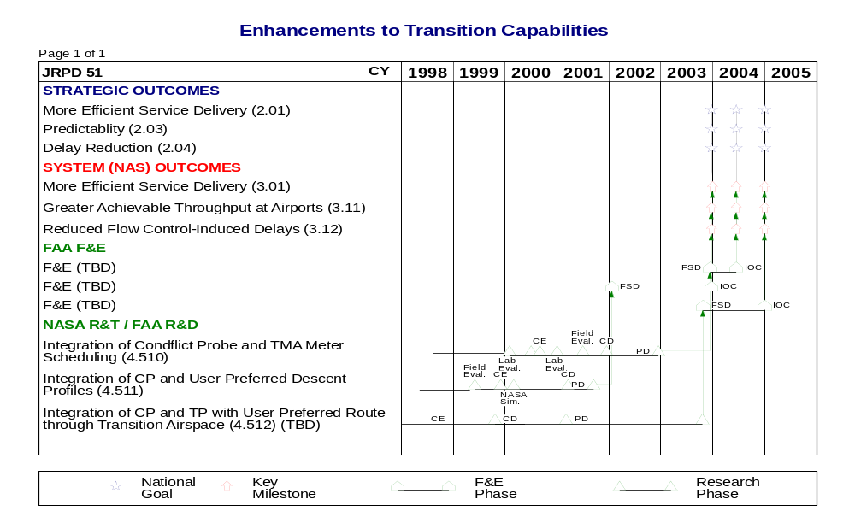

Schedule 5-1 En Route ATM Performance Goals/Key Milestones, Cont.

Controller Capabilities for Improved Problem Prediction
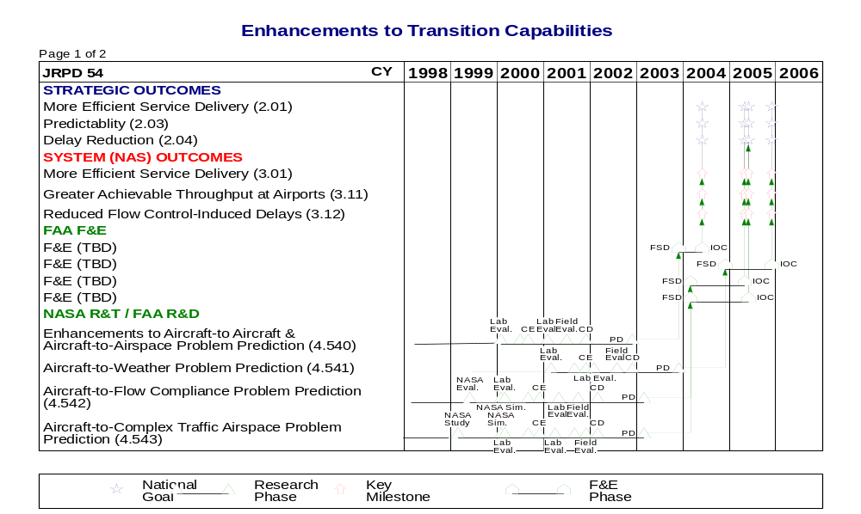

Schedule 5-1 En Route ATM Performance Goals/Key Milestones, Cont.

Controller Capabilities for Improved Problem Resolution
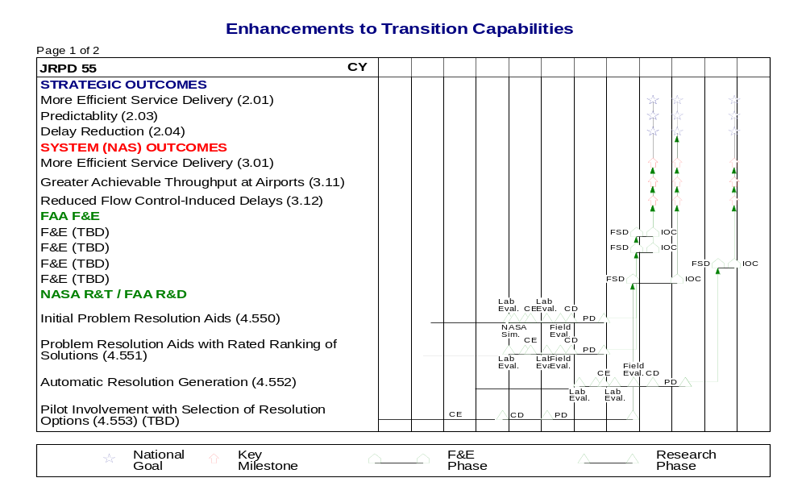

Schedule 5-1 En Route ATM Performance Goals/Key Milestones, Cont.

Integration with Other Technologies and Domains
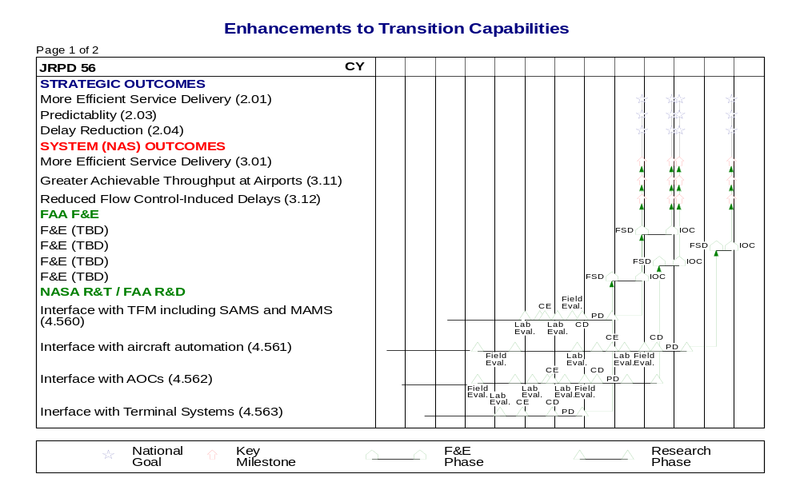

Schedule 5-1 En Route ATM Performance Goals/Key Milestones, Cont.

Other Initiatives to Enhance Decision Support Systems
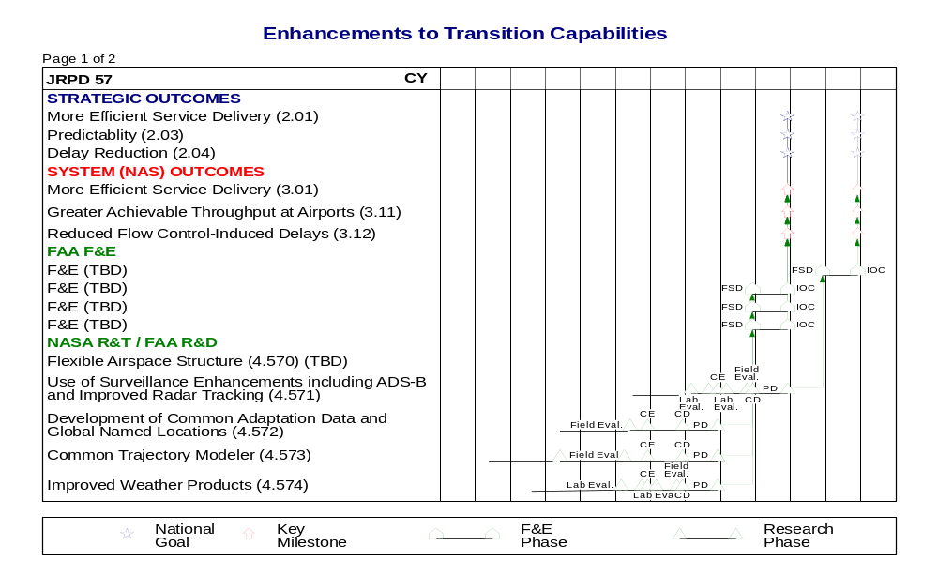

Schedule 5-1 En Route ATM Performance Goals/Key Milestones, Cont.

Integration and Application of Decision Support Tools at Sector
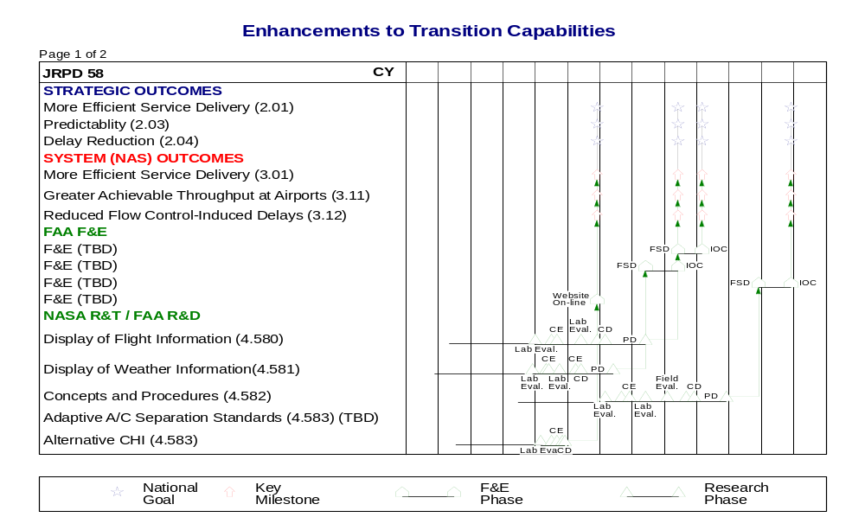

5.2 NAS 2005 Environment
The NAS 2005 environment for En Route will be characterized by the following: 1) improved decision support tools for conflict detection, resolution and flow management will allow for increased accommodation of user-preferred trajectories (UPTs) and for handling of increased traffic volume, 2) aircraft will fly optimum altitudes during cruise to take advantage of favorable winds and avoid hazardous weather and turbulence, 3) aircraft will also fly fuel-efficient descent profiles during the arrival phase of flight, 4) collaborative decision making between ATC and users will allow increased accommodation of pilot requests and facilitates more efficient tactical routing around weather, special use airspace and traffic bottlenecks, 5) seamless communication and coordination between and within facilities will decrease controller workload and enable increased airspace flexibility, 6) airspace structure will be dynamically adjusted to accommodate traffic flows and optimize air traffic service provider productivity, 7) increased use of datalink will allow ADS-equipped aircraft to fly in areas lacking in radar surveillance and allow air-ground exchange of aircraft intent information, and 8) as better aircraft intent data is provided to the DST toolset, the more accurate the trajectory will become, resulting in more accurate conflict predictions.

5.3 Operations and Services
The services provided in the En Route Area in the NAS 2005 environment include: 1) separation assurance, 2) traffic management, and 3) airspace management. Air traffic service providers will remain responsible for aircraft-to-aircraft separation and maintaining separation between aircraft and airspace. Improved conflict detection and resolution tools will allow service providers to maintain aircraft separation assurance despite less structured routes and increased traffic volume. Integration of selected DSS tools will begin movement toward a seamless toolset in which conflict predictions can accommodate sequencing constraints and/or assure conflict free descent profiles. Access to common sources for weather information, special use airspace status and flow control restrictions allows service providers to provide efficient tactical avoidance of adverse weather, restricted airspace, and flow restrictions. Improved air-to-ground communications allows improved coordination between air traffic service providers and the flight deck to accommodate user requests.
The role of traffic flow service providers will change to include more strategic traffic management, coordination of user-preferred trajectories and flexible airspace structuring. The traffic flow service provider tools will provide strategic conflict probing against traffic, weather, restricted airspace, sector density and flow restrictions. The traffic flow service provider will also be involved with negotiation of user-preferred trajectories with national traffic flow service providers, adjacent facility traffic flow service providers, and users (such as airlines).
In order to provide efficient utilization of air traffic and traffic flow service providers, airspace will be managed flexibly by changing airspace boundaries and service provider roles dynamically to accommodate changes in traffic load. Airspace boundaries will be adjusted in anticipation of expected traffic flows or in response to weather and special use airspace changes. Both sector and facility boundaries will be adjusted to meet these requirements. In addition, a common set of tools available to all service providers in a facility will allow roles to be adjusted to meet the current traffic load.

5.4 Needs and Joint Research Projects
The following table correlates En Route Area needs, extracted from the ATS Concept of Operations for the National Airspace System in 2005, dated September 30, 1997, and identified in Volume 1, Section 4, of the Integrated Plan, with individual joint research projects. The JRPD information includes the project number, the specific product that addresses the need, and the product identification number. Appendix C contains additional JRPD information.

2005 Needs | JRPD#/Product/Product ID#
Global grid of named locations for coordination, transition points for flow initiatives, and backup | J57/Other Initiatives to Enhance DSS/4.572 (Development of common adaptation data and global named locations)
Optimum descent profiles | J51/Controller Capabilities to Manage Traffic in Transition Airspace/4.511 (Integration of conflict probe and user preferred descent profiles)
Flexible airspace structure and reduced boundary restrictions | J57/Other Initiatives to Enhance DSS/4.570 (Flexible Airspace Structure)
SUA status changes linked to DSS for automatic re-evaluation of trajectories | J56/Integration with Other Technologies and Domains/4.560 (Interface with TFM including SAMS and MAMS)
Increased collaboration between AOCs and ATM | J56/Integration with Other Technologies and Domains/4.562 (Interface with AOCs)
Datalink for frequency changes, transfer of communications, and faster clearance delivery | J56/Integration with Other Technologies and Domains/4.561 (Interface with Aircraft Automation)
Datalink to provide aircrews and service providers with same weather information | J56/Integration with Other Technologies and Domains/4.561 (Interface with Aircraft Automation)  J57/Other Initiatives to Enhance DSS/4.574 (Improved Weather Products)
Distribute weather data to DSS for processing and presentation to service providers | J58/Integration and Application of DSTs at Sector/4.581 (Display of Weather Information)
Modified routes datalinked to cockpit and to downstream ATC facilities | J56/Integration with Other Technologies and Domains/4.561 (Interface with Aircraft Automation) &4.563 (Interface with Terminal Systems)
DSS assist with conflict detection | J54/Controller Capabilities for Improved Problem Prediction/4.540 thru 4.543 (Problem Prediction Enhancements)
DSS assist with development of conflict resolutions | J55/Controller Capabilities for Improved Problem Resolution/4.550 thru 4.553 (Problem Resolution Enhancements)
Satellite based navigation and surveillance data used for enhanced conflict probe and alerting | J57/Other Initiatives to Enhance DSS/4.571 (Use of Surveillance Enhancements Including ADS-B & Improved Radar Tracking)
Direct VFR/IFR routing through Class B and C airspace for GA | J51/Controller Capabilities to Manage Traffic in Transition Airspace/4.512 (Integration of Conflict Probe with User Preferred Routes through Terminal Airspace)
Paper flight strips eliminated (DSS display necessary information) | J58/Integration and Application of DSTs at Sector/4.580 (Display of Flight Information)
Different separation standards depending on equipage and the quality of position data | J58/Integration and Application of DSTs at Sector/4.583 (Adaptive Aircraft Separation Standards)
Reduced or time-based separation standards en route | J58/Integration and Application of DSTs at Sector/4. 583 (Adaptive Aircraft Separation Standards)
Service provider displays indicate quality of aircraft position information | J58/Integration and Application of DSTs at Sector/4.580 (Display of Flight Information)
Surveillance of all positively controlled aircraft using radar and satellite derived position information | J57/Other Initiatives to Enhance DSS/4.571 (Use of Surveillance Enhancements Including ADS-B & Improved Radar Tracking)
Standardized trajectory information | J51/Controller Capabilities to Manage Traffic in Transition Airspace/4.510 (Integration of URET CCLD and CTAS TMA)  J57/Other Initiatives to Enhance DSS/4.573 (Common Trajectory Modeler)

5.5 Mature Free Flight Environment
Airlines and high-end general aviation users perform free maneuvering operations in low density areas. With datalink communications and the implementation of new traffic management procedures and technology, dynamic re-sectorization allows fewer communications frequency changes. Procedural changes allow low altitude direct routes. The ATM conflict probe resolves most conflicts allowing maximum routing flexibility with a minimum of restrictions.

5.6 Project Summaries
5.6.1 JRPD J51 – Controller Capabilities to Manage Traffic in Transition Airspace
Technical Overview/Abstract
To better manage traffic in transition airspace, this project integrates FFP1 Conflict Probe with the Traffic Management Advisor metering scheduling capability. This integrated capability will provide conflict free and fuel-efficient paths to the Terminal Radar Approach Control boundary enabling the maximum use of terminal airspace and airport capacity.
The approach employed will be to conduct lab evaluations of URET CCLD and CTAS Traffic Management Advisor (TMA) adapted to a common site, and to develop decision support software, display formats and operational procedures in cooperation with controllers and pilots through a combination of fast-time simulation, real-time simulation, shadow testing, and possible live traffic tests.

Program Responsibilities
The FAA will develop an initial capability to exchange messages between conflict probe and traffic management advisor. The FAA and NASA will conduct research to identify appropriate ways to provide for fuel-efficient descents. The FAA and NASA will also investigate ways to provide TMA and CP capabilities from a common architecture.

For the complete Joint Research Project Description, see page C-71 in Appendix C.

5.6.2 JRPD J54 – Controller Capabilities for Improved Problem Prediction
Technical Overview/Abstract
Capabilities will be in place prior to the NAS 2005 environment and represent a first step in facilitating user-preferred routing. These capabilities, which include automated conflict detection, will be augmented with enhancements to aircraft-to-aircraft and aircraft-to-airspace problem prediction, and by enabling the detection of potential aircraft conflicts with hazardous weather and complex traffic airspace, and non-compliance with flow constraints.
Building on concepts and capabilities developed under the URET and CTAS programs, further research using laboratory and possible field demonstrations will be performed to revise and validate the following:
- The controller team operational concept for conflict detection involving aircraft-to-aircraft and aircraft- to-airspace conflicts and adherence to flow instructions including meter fix/arrival times, altitude and speed constraints, and other dynamic or routine constraints
- Operational and functional performance requirements and updated algorithms with evaluation and development of aspects such as: trajectory prediction, advisory timing, false and missed advisory rate, controller computer-human interface, conflict probabilities, and traffic management advisories
- Investigating a common HCI for controller advisories
- Inter-facility operations
- Benefits to be used for investment decisions

Program Responsibilities
The FAA and NASA will perform experiments leading to validation of an operational concept and definition of operational and functional requirements for a single integrated set of capabilities for the En Route environment. The FAA will develop and implement enhancements to the Free Flight Phase 1 conflict probe capabilities. NASA will conduct further research into the en route/descent advisor and will develop dynamic density indicators for workload prediction (in coordination with JRPD 21).

For the complete Joint Research Project Description, see page C-75 in Appendix C.

5.6.3 JRPD J55 – Controller Capabilities for Improved Problem Resolution
Technical Overview/Abstract
Conflict resolution capabilities will be in place prior to the NAS 2005 environment and represent a first step in facilitating user-preferred routing. These capabilities, which include trial planning and auto coordination, will be augmented by automated problem resolution and en route clearance advisories.
Building on concepts and capabilities developed under the URET and CTAS programs, further research using laboratory and field demonstrations will be performed to revise and validate operational and functional performance requirements and updated algorithms with evaluation and development of aspects such as controller computer-human interface and automated resolution advisories.

Program Responsibilities
The FAA will develop additional conflict resolution capabilities to enhance the FFP1 conflict resolution capability. The FAA and NASA will perform experiments leading to validation of an operational concept and definition of operational and functional requirements for a single integrated set of capabilities for the En Route environment based on the results of the ongoing research. NASA will conduct conflict resolution research using the en route/descent advisor capability.

For the complete Joint Research Project Description, see page C-81 in Appendix C.

5.6.4 JRPD J56 – Integration with Other Technologies and Domains
Technical Overview/Abstract
Problem prediction and resolution will be in place in the NAS 2005 environment and represent a first step in facilitating user-preferred routing. These initial capabilities will be augmented through their integration with other NAS 2005 systems. In coordination with System/Cross-Cutting, Traffic Flow Management, and Terminal Area Work Teams, this project will design a software interface with:
- Traffic Flow Management (TFM) allowing the efficient dissemination of: 1) real-time special use airspace information, and 2) Traffic Management Unit (TMU) defined reroutes to the sector team;
- Controller-to-pilot datalink capabilities;
- Aircraft automation to obtain and use current aircraft (weight) and environment (wind) information for trajectory prediction;
- Airline Operations Centers (AOCs) to obtain and use current flight information for trajectory prediction; and,
- Terminal systems.

Program Responsibilities
The FAA will develop concepts and capabilities to disseminate TFM defined reroutes to the sector team and incorporate aircraft intent information into conflict probe. The FAA and NASA will determine the intent information that is most useful to improve trajectory modeling.

For the complete Joint Research Project Description, see page C-85 in Appendix C.

5.6.5 JRPD J57 – Other Initiatives to Enhance Decision Support Systems
Technical Overview/Abstract
Problem prediction and resolution capabilities will be in the NAS 2005 environment and represent a first step in facilitating user-preferred routing. This project will enhance these initial capabilities by providing: 1) a capability to modify Air Traffic Control (ATC) sector boundaries to accommodate dynamic traffic flows expected when aircraft operate off of traditional airways, and 2) common capabilities and enhancements for the ATC decision support tools (DSTs). Laboratory evaluations and possible field demonstrations will be performed to improve and validate the fielded decision support tool algorithms by incorporating the most current wind, airspace structure and surveillance data.
Building on concepts and capabilities developed under the URET and CTAS programs, further research using laboratory and field demonstrations will be performed to revise and validate operational and functional performance requirements and updated algorithms with evaluation and development of aspects such as controller computer-human interface and automated resolution advisories.

Program Responsibilities
The FAA and NASA will develop concepts and capabilities to disseminate dynamic sector boundary information to the sector team and to use the most current wind and surveillance data to improve the conflict probe algorithms.

For the complete Joint Research Project Description, see page C-89 in Appendix C.

5.6.6 JRPD J58 – Integration and Application of Decision Support Tools at Sector
Technical Overview/Abstract
Problem prediction and resolution capabilities will be in place in the NAS 2005 environment and represent a first step in facilitating user-preferred routing. These capabilities are targeted primarily for use by the Data controller. This project will augment these initial capabilities by increasing the scope of usage within the sector team (i.e., expanding to the Radar controller), including: 1) enhancing the display of flight and weather information at sector workstations, 2) ensuring appropriate procedures are in place so controllers know how to employ the decision support tools, and 3) developing and implementing reduced separation criteria. Laboratory evaluations and possible field demonstrations will be performed to improve and validate the computer human-interface and operational concepts and procedures of the fielded decision support tools.
Building on concepts and capabilities developed under the URET and CTAS programs, further research using laboratory and field demonstrations will be performed to revise and validate operational and functional performance requirements and updated algorithms with evaluation and development of aspects such as controller computer-human interface and automated resolution advisories.

Program Responsibilities
The FAA and NASA will develop and evaluate the operational suitability of capabilities to enhance initial decision support system technology. During 1998 - 2001, NASA, in collaboration with the FAA, will explore several alternative approaches for integrating DSTs at the sector. The FAA will develop, demonstrate, and evaluate the operational suitability of conflict probe and resolution capabilities for the Radar controller using different types of computer-human interfaces, including Operational Display and Input Development (ODID) features. The FAA will also develop, demonstrate, and evaluate: 1) a common CHI for all DST advisories (e.g., TMA, URET, EDA), and 2) display formats for various weather depiction capabilities for the Radar and Flight Data controller displays. In addition, the application of different separation standards based on the quality of position information will be evaluated.

For the complete Joint Research Project Description, see page C-93 in Appendix C.

5.7 Integration and Risk Management
This section will describe some high level risks in getting the products developed and implemented. It is expected that as the work progresses, better understanding of the risks and their impacts will be gained.
Products | Risks | Mitigation Strategy
(J51) TMA/Conflict Probe Integration | Integration of two independently developed systems residing on different infrastructures | Joint effort to initially interface through message exchange.  Close monitoring of TMA and Conflict Probe development by CSC and Lockheed-Martin.
(J54) Enhancements to Problem Prediction | Algorithm inaccuracy may cause excessive alerts/inappropriate maneuvers | Independent accuracy/performance studies to validate trajectory modeling and conflict prediction algorithms
(J54) Aircraft-to-Weather Problem Prediction | Accuracy in predicting location of hazardous weather 20 minutes into the future. | Close coordination with weather functional groups.  Use of probability models based on type of hazard.
(J55) Automated Problem Resolution | Considerable human factors risk with implementation of automatic resolution scheme. | Human factors specialists involved in early development.  Evaluation with controllers at research labs and at WJHTC I²F.
(J56) Initial Integration with Aircraft Automation | Identification/ranking of information required to improve performance of tool set  Identification of required modifications to accommodate additional information  Maturity of on-board, and ground-based systems to use and process the information | Integrated ER AWT development effort on improvements in algorithmic performance due to datalink of cockpit performance  Close coordination with datalink program office to ensure availability of data and time frame for additional capabilities.
(J57) Flexible Airspace Structure | Development of a capability that is not suitable/acceptable to air traffic | Understand what air traffic wants in a flexible airspace structure capability before development.  Assist air traffic in capability definition
(J58) Problem Prediction/Resolution Capabilities on R-side | Operational usage of “strategic” tool on “tactical” display needs development | Prototype development and shakedown at WJHTC I²F.  Frequent input from ATO with early involvement of human factors specialists.

6. Oceanic Area
The Oceanic Area focuses on the outcomes to increase FAA productivity, improve flexibility by granting more user-preferred trajectories, and increase predictability through pre-flight planning. Oceanic sees an ATC system with increased capacity and greater user flexibility, and anticipates a 70 percent growth in traffic from the 1997 level through 2005. Routine granting of user-preferred trajectories and application of reduced separation minima are major enablers of this vision. Users will benefit from increased efficiency and cost-effectiveness of flight operations, while maintaining required levels of safety.

6.1 Goals
The first goal, based on the improvement in air-ground communications and dependent surveillance, is to reduce oceanic horizontal separation standards to 50 nautical miles (nmi). This change will increase the likelihood of achieving user-preferred profiles in support of the flexibility goal. A secondary consequence of this change will be the corresponding adjustment to traffic flows providing a significant reduction in ground delays.
The second goal is to combine changes in controller workload balancing, separation standards, airspace design and traffic flow management that will allow a majority of the users to receive their preferred trajectories. The oceanic target for throughput in the NAS 2005 environment is to handle 70 percent more traffic with half the present delays, while granting a majority of the user-preferred trajectories. The biggest benefit is the increased predictability afforded through the changes in environment.
A key area of research underlying all of the other activities is the evaluation that addresses the questions of what commonality is required between domains, where to start on the path toward free flight and how to proceed. Four key events in this research are: 1) the determination of the degree to which procedures for separation can and should be normalized as part of achieving commonality, 2) validation of the concept for use of a layered mixture of tactical and strategic separation means for oceanic and en route operations, 3) the completion of procedures to extend random routes in the Atlantic Ocean to support this program in high density environments, and 4) validation of the concept of ground control by exception. These milestones are not directly linked to any of the major goals, but represent a lower level of detail that is a necessary precursor to the direct research of the ultimate objectives.
Schedule 6-1 Oceanic ATM Performance Goals/Key Milestones

Advanced Oceanic Automation System Development
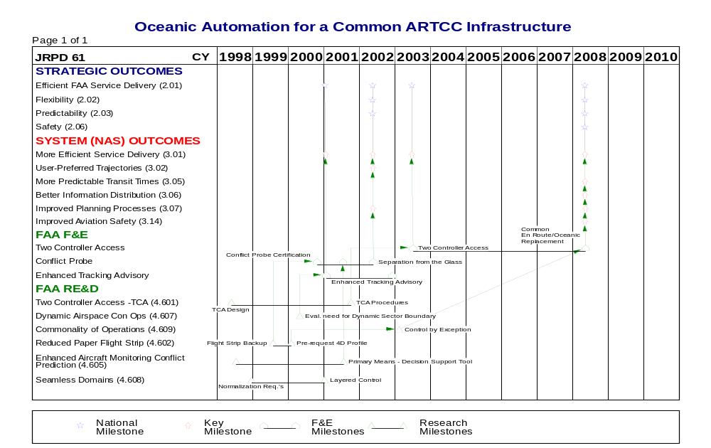

Schedule 6-1 Oceanic ATM Performance Goals/Key Milestones, Cont.

Common Separation Methods and Standards
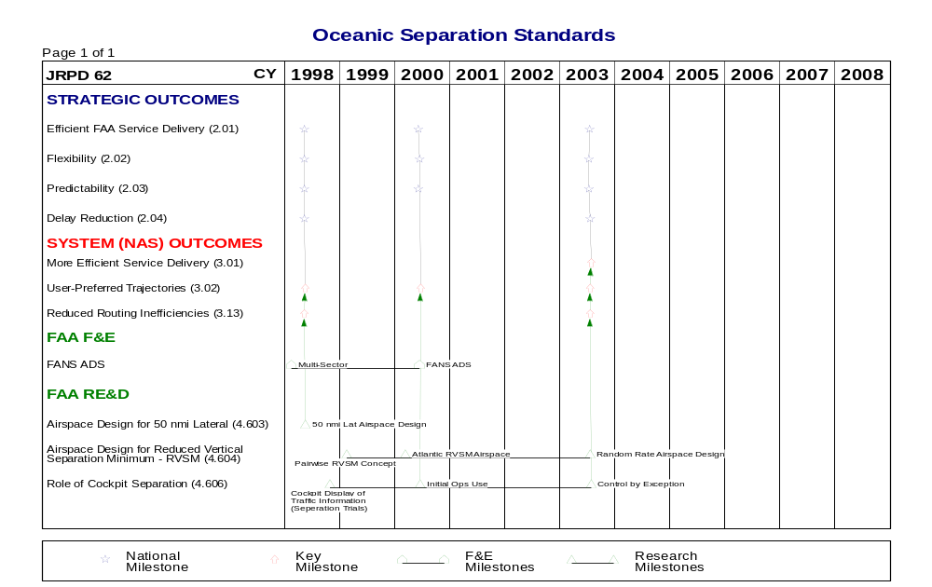

6.2 NAS 2005 Environment
Oceanic service providers will benefit from new decision support tools and procedures that will help the controller provide those user benefits, while maintaining an acceptable level of controller workload. In the NAS 2005 environment, this activity will result in the introduction of a common en route/oceanic ground infrastructure that includes a modern flight data processor and improved controller tools.
Changes in control techniques and traffic flow management will include: 1) the design for decision support tools that could be certified as primary means in procedural separation determinations, 2) design and procedures for ground-based 4-D requests, 3) procedures that would transfer responsibility to the cockpit for special maneuvers, and 4) the design of decision support tools that would allow user-preferred routes and trajectories to be assimilated to determine the routes and corridors to be used and to arbitrate reservations. It is through these events that flexibility and predictability will be most directly effected.

6.3 Operations and Services
ATM research and technology will not only help to determine the best way to implement specific technologies and procedures, but will also provide significant feedback on the feasibility of the operational concept to achieve the Oceanic vision. Under the existing NAS 2005 Concept of Operations, improvements in navigation, communication, and the use of surveillance are paramount enablers of capacity enhancements in oceanic airspace. Additionally, procedural reductions in separation standards are facilitated through the improved infrastructure. Automation and procedural changes help service providers to be strategic in solving potential conflicts, traffic congestion, and demand for user-preferred trajectories. Oceanic separation minima are massively reduced, allowing a corresponding increase in traffic demand, due to the following improvements:
- Satellite navigation systems, and datalink allow more accurate and frequent traffic position updates; datalink and expanded radio coverage provide direct air-to-ground communications (both digital and voice);
- Automated dependent surveillance data and continuously updated trajectory projections, in conjunction with certified DSS tools, allow procedural separation from the display and elimination of flight strips in Oceanic airspace;
- Timely delivery of clearances by the service providers, and responses by the flight deck, are achieved through increasingly common use of datalink;
- NAS Oceanic airspace is standardized to other NAS-International Civil Aviation Organization (ICAO) oceanic systems. Data are presented to service providers in all oceanic systems in a similar format, thus minimizing translation by the provider; and,
- Route and airspace flexibility is achieved as Oceanic airspace is integrated into the global grid of named locations. This flexibility is maximized through seamless coordination within and between facilities.

6.4 Needs and Joint Research Projects
The following table correlates Oceanic Area needs, extracted from A Concept of Operations for the National Airspace System in 2005, dated September 30, 1997, and identified in Volume 1, Section 4, of the Integrated Plan, with individual joint research projects. The JRPD information includes the project number, the specific product that addresses the need, and the product identification number. Appendix C contains additional JRPD information.
2005 Needs | JRPD#/Product/Product ID#
Accurate aircraft position updates - Direct air-to-ground communications | J61/Seamless Domains/4.608
Real time updating of trajectory predictions | J61/Enhanced Aircraft Monitoring & Conflict Prediction/4.605
Rapid delivery of clearances | J61/Seamless Domains/4.608
Seamless coordination within/between facilities | J61/Seamless Domains/4.608  J61/Commonality of Operations/4.609
Standard flight data formats | J61/Seamless Domains/4.608
Tools for balancing/reducing controller workload | J61/Dynamic Airspace Con Ops/4.607  J61/Two Controller Access/4.601  J62/Role of Cockpit Separation/4.606

6.5 Mature Free Flight Environment
The mature Oceanic environment is similar to the 2005 time frame but has expanded capabilities available to all aircraft and in all airspace. For example, further reductions in vertical, lateral, and longitudinal separation will increase airspace capacity. In the Mature Free Flight environment, operational concepts will be developed that will increase the controller’s ability to handle more aircraft and more complex situations and move oceanic operations closer to free flight.

6.6 Project Summaries
    - JRPD J61 - Advanced Oceanic Automation System Development (Work on Hold Pending
Purchase or Lease Decision for Oceanic Automation System)
Technical Overview/Abstract
This program focuses on enhancements to the oceanic air traffic system to increase controller productivity and increase the efficiency of flight operations. Advancements in the automation will focus first on controller workload with the major milestones establishing a design and procedures for shared responsibility between the controller team, the design and procedures for reduced dependence on flight strips, and the backup system for the elimination of flight strips. This research will also provide decision papers to determine the remaining need for dynamic airspace definition capabilities.
This activity in part is intended to increase the commonality between the oceanic and en route infrastructure and operations. This research will include: 1) assessments of the procedures and concept exploration to determine the extent to which commonality between domains is beneficial, 2) procedures and design for two controller access, and 3) the system solution and procedures for procedural separation in the absence of paper flight strips. The result will be a design and procedures for seamless ATM across the oceanic-en route and oceanic-terminal transition airspace. These procedures will account for random routing. These changes are intended to improve FAA productivity and form the basis for an environment that is more predictable, with higher likelihood of granting user-preferred profiles.

Program Responsibilities
The FAA is responsible for all of the Oceanic outcomes including:
- Balance controller duties in accordance with traffic demand to allow the system to handle 70 percent more oceanic traffic in the NAS 2005 environment, with today’s resource constraints;
- Leverage changes in the environment to increase the predictability of an aircraft flying its preferred route, so that a majority of the flights are granted their preferred profile;
- Share conflict advisory information with the cockpit and involve flight crews in the resolution in order to increase the ability of the FAA to allow user-preferred profiles; and,
- Transition to pre-planned altitude profiles to achieve a reduction in required fuel reserves through increased predictability in granting climbs.

For the complete Joint Research Project Description, see page C-99 in Appendix C.

6.6.2 JRPD J62 - Common Separation Methods and Standards
Technical Overview/Abstract
This program focuses on identifying the techniques and separation standards that will best support the traffic demand given the available accuracy of positional information. Changes in concept of operations including required procedures and airspace designs will be researched to improve the ability to grant user-preferred profiles. Research will culminate in airspace design for the application of 50 nmi lateral separation and reduced vertical separation accounting for the need to accommodate non-equipped aircraft. Also, developing the means for dynamically rerouting individual flights or groups in high density airspace and providing in general more flexible airspace will be a significant milestone. These changes are intended to increase the likelihood of granting user profiles, allowing users to fly closer to the wind route and altitude. One collateral effect will be domestic reduced vertical separation.

Program Responsibilities
The FAA is responsible for all of the Oceanic outcomes including:
- Modify the separation methods and standards to allow a majority of the oceanic airspace users to fly closer to the wind route and altitude;
- Modify the separation methods and standards to allow a 50 percent reduction in volume induced ground delay for oceanic airspace users; and
- Improved efficiency of operations.

For the complete Joint Research Project Description, see page C-105 in Appendix C.

6.7 Integration and Risk Management

Products | Risks | Mitigation Strategy
All | Multiple agencies and multiple organizations within the agencies need to collaborate, but there are differing goals and changing priorities among government collaborators and industry stakeholders | Setup mechanisms for communication and resolution of differences between the government and industry groups
All | Inadequate funding and funding stability | Provide ATM performance documentation to support agency return on investment prioritization.
(J61) Reduced dependence on paper flight strips | Controller/unions acceptance | Conduct joint application design’s, and prototyping to fully involve controller workforce and human factors personnel

- Acronyms and Abbreviations
AATT | Advanced Air Transportation Technologies Project
A/C | Aircraft
ACE | Aviation Capacity Enhancement
ADS | Automatic Dependent Surveillance
ADS-B | Automatic Dependent Surveillance - Broadcast
AERA | Automated En Route Air Traffic Control
aFAST | Active Final Approach Spacing Tool
AFSS | Automated Flight Service Station
A/G | Air/Ground
AMASS | Airport Movement Area Safety System
AOC | Airline Operation Center
ARC | Ames Research Center (NASA)
ARTCC | Air Route Traffic Control Center
ARTS | Automated Radar Terminal System
ASD | Aircraft Situational Display
ASDE | Airport Surface Detection Equipment
ASDI | Aircraft Situational Display to Industry
AST | Advanced Subsonic Technology
ATC | Air Traffic Control
ATCSCC | Air Traffic Control System Command Center
ATCT | Airport Traffic Control Tower
ATIDS | Airport Traffic Information Display System
ATIS | Automatic Terminal Information Service
ATM | Air Traffic Management
ATS | Air Traffic Services
AVOSS | Aircraft Vortex-Spacing System
AWT | Area Work Team
CAA | Civil Aviation Authority
CAASD | Center for Advanced Aviation System Development
CAP | Collaborative Arrival Planner
CBA | Cost-Benefit Analysis
CBD | Commerce Business Daily
CCLD | Core Capability Limited Deployment
CD | Concept Development
CDM | Collaborative Decision Making
CDS | Collaborative Departure Scheduling
CDST | Collaborative Departure Scheduling Tool
CDTI | Cockpit Display of Traffic Information
CE | Concept Exploration
CHI | Computer-Human Interface
CNS | Communications, Navigation, and Surveillance
COE | Center of Excellence
CONOPS | Concept of Operations
COTS | Commercial Off-The-Shelf
CP | Conflict Probe
CPDLC | Controller-Pilot Datalink Communications
CRCT | Collaborative Routing Coordination Tools
CSC | Computer Sciences Corporation
CTAS | Center TRACON Automation System
CY | Calendar Year
DA | Descent Advisor
DARP | Dynamic Aircraft Route Planning
DDTC | Digital Delivery of Taxi Clearances
DFW | Dallas-Ft. Worth Airport
DoD | Department of Defense
DOT | Department of Transportation
DROM | Dynamic Runway Occupancy Management
DSB | Dynamic Sector Boundary
DSEDM | Departure Sequencing Engineering Development Model
DSR | Display System Replacement
DSS | Decision Support System
DST | Decision Support Tool
ECC | Eurocontrol Experimental Center
E/DA | En Route Descent Advisor
EDP | Expedite Departure Path
ELT | Emergency Locator Transmitter
ERATMDST | En Route Air Traffic Management Decision Support Tool
ESC | Executive Steering Committee (NASA)
ETMS | Enhanced Traffic Management System
F&E | Facilities and Equipment
FAA | Federal Aviation Administration
FANG | Flight Management System-Air Traffic Management Next Generation
FANS | Future Air Navigation System
FAST | Final Approach Spacing Tool
FFP1 | Free Flight Phase 1
FFRDC | Federally-Funded Research and Development Center
FFSC | Free Flight Steering Committee
FIR | Flight Information Region
FIS | Flight Information Service
FMS | Flight Management System
4-D | Four-Dimensional
FSD | Full-Scale Development
FY | Fiscal Year
GA | General Aviation
GDPE | Ground Delay Program Enhancements
GNSS | Global Navigation Satellite System
GPRA | Government Performance and Results Act of 1993
GPS | Global Positioning System
HARS/R | High-Altitude Route System Replacement
HCI | Human-Computer Interface
HF | High Frequency
HMI | Human-Machine Interface
IAIMT | Interagency (FAA/NASA) ATM Integrated Management Team
IAIPT | Interagency (FAA/NASA) ATM Integrated Product Team
ICAO | International Civil Aviation Organization
ICD | Interface Control Document
ID | Identification
IFR | Instrument Flight Rules
I²F | Integration and Interoperability Facility
IMC | Instrument Meteorological Condition
IOC | Initial Operational Capability
IPLT | Integrated Product Leadership Team
IPT | Integrated Product Team
IRD | Interface Requirement Document
ITWS | Integrated Terminal Weather System
JAD | Joint Applications Designs
JRC | Joint Resources Council
JRPD | Joint Research Project Description
LAAS | Local Area Augmentation System
LaRC | Langley Research Center (NASA)
LVLASO | Low Visibility Landing and Surface Operations
MAMS | Military Use Airspace Management System
MDCRS | Meteorological Data Collection and Reporting System
MITLL | MIT Lincoln Laboratory
MoA | Memorandum of Agreement
MOPS | Minimum Operational Performance Standard
MoU | Memorandum of Understanding
NARIM | National Research Investment Model
NAS | National Airspace System
NASA | National Aeronautics and Space Administration
NCAR | National Center for Atmospheric Research
NEXCOM | Next Generation Air-to-Ground Communication System
NEXTOR | National Center of Excellence in ATM and Operations Research
nmi | Nautical Mile
NOAA | National Oceanic and Atmospheric Administration
NOTAM | Notice to Airmen
NPR | National Performance Review
NRP | National Route Program
NTSB | National Transportation Safety Board
ODID | Operational Display and Input Development
OT&E | Operational Test and Evaluation
O&M | Operations and Maintenance
PD | Prototype Development
pFAST | Passive Final Approach Spacing Tool
POET | Post Operational Evaluation Tool
PRM | Precision Runway Monitor
R&D | Research and Development
R,E&D | Research, Engineering and Development
RNAV | Area Navigation
ROM | Rough Order of Magnitude
RSO | Regional Sector Office
R&T | Research and Technology
RTCA | RTCA, Inc. (formerly Radio Technical Commission for Aeronautics)
RVSM | Reduced Vertical Separation Minimum
SAMS | Special Use Airspace Management System
SAR | Search and Rescue
SDTF | Surface Development and Test Facility
SMA | Surface Movement Advisor
SMS | Surface Management System
STARS | Standard Terminal Automation Replacement System
SUA | Special Use Airspace
SY | Staff Year
TAC | Technical Assistance Contractor
TAP | Terminal Area Productivity Project
TCA | Two Controller Access
TCAS | Traffic Alert and Collision Avoidance System
TDLS | Tower Data Link Services
TFM | Traffic Flow Management
3-D | Three-Dimensional
TMA | Traffic Management Advisor
TMU | Traffic Management Unit
TNCP | Test NAS Change Proposal
TRACON | Terminal Radar Approach Control
TWIP | Terminal Weather Information for Pilots
UPT | User-Preferred Trajectories
URET | User Request Evaluation Tool
UPR | User-preferred Routing
U.S. | United States
VDL | Very-High Frequency Digital Link
VFR | Visual Flight Rules
VMC | Visual Meteorological Condition
VNTSC | Volpe National Transportation Systems Center
WAAS | Wide Area Augmentation System
WATRS | Western Atlantic Track Route System
WJHTC | William J. Hughes Technical Center (formerly FAA Technical Center)
WV | Wake Vortex

{This Page Intentionally Blank.}

Appendix A

ATM Performance Outcomes and Outputs for ATM Research
and Technology Development

The ATM performance formulation exists in the form of a database in which each record corresponds to a different outcome or product. Table A.1 shows the information that is available in each record of the database. A complete listing of all outcomes and products (Levels 1 through 4) follows in Figure A.1.

NAME | DESCRIPTION
ID | An identification formed by concatenation of the LEVEL and the NO. items. For example, LEVEL 3 and No. 4 would have ID = 3.04.
NAME | Short name for the item.
UPLINK1 | The item on the next highest level to which the item contributes in the most significant way.
UPLINK2 | The item on the next highest level to which the item contributes in the second most significant way.
UPLINK3 | The item on the next highest level to which the item contributes in the third most significant way.
TEXT | A short (one paragraph) description of the item.
JRPD | ID(s) of the Joint Project Description(s) within which the work is described.
Table A.1 ATM Performance Database Listing

[[Figure A.1 provides a data base print-out - one record for each outcome and product Levels 1 - 4.]]

Appendix B

Definition of an IAIPT Key Milestone for
ATM Research and Technology Development

{This Page Intentionally Blank.}

Definition of an IAIPT Key Milestone

An IAIPT Key Milestone, as defined by the IAIMT, is as follows:
- A well-defined event that clearly signals the completion of a discrete work effort for which there is an objective basis for evaluating cost, schedule, and technical status.
- Relates to a JRPD output/product, i.e., a specific product that comprises hardware, software, procedures, data, technical or programmatic decisions or recommendations, and/or some other tangible item that satisfies a predefined set of objective, quantitative (i.e., “testable”) technical and/or programmatic requirements.
- Represents one or more of the following, strategic-level “events” in the life cycle of a JRPD output/ product:
- Delivery to the ATM operators or users;
- A point at which there is a major shift of management or financial responsibility, e.g.,
- From NASA to FAA
- From MITRE CAASD to FAA
- From FAA R,E&D funding to FAA F&E funding;
- A point at which there is a major “process” shift, e.g.,
- Transition from Concept Exploration to Concept Development
- Transition from Concept Development to Prototype Development or Full-Scale Development;
- An intermediate decision point at which the future scope, schedule, and/or functional requirements of the JRPD output are decided; or,
- A point at which the JRPD output has pre-planned visibility outside the managing or integrating organizations (i.e., FAA, NASA, MITRE CAASD, IAIPT), e.g., installation at a field site, or in significant presentations or interactions with other Agencies, the NAS Users, the Congress, and the like.

The transition points in the generic schedule on the next page indicate candidate Key Milestones:

“Generic” ATM Performance Goals/Key Milestones Schedule
JRPD Name
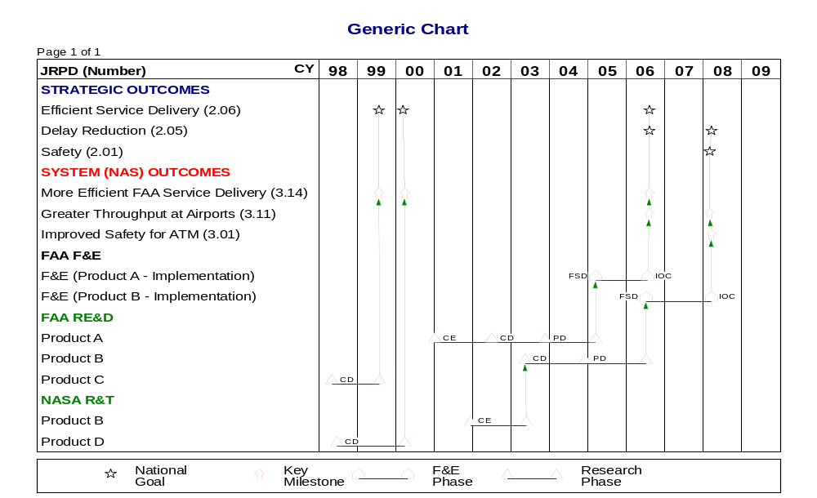

Air Traffic Service Plan 1996-2001, May, 1997.
Government/Industry Operational Concept for the Evolution of Free Flight, dated TBD.
A Key Milestone can represent an aggregate of several closely-related JRPD outputs/products.

