
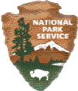
National Park Service
U.S. Department of Interior

Crater Lake National Park
Crater Lake, Oregon

Rehabilitation of the Stuart Falls Trail
Crater Lake National Park
Oregon

Chapter 1 - Purpose and Need

1.1 Introduction

Crater Lake National Park is located in southwestern Oregon on the divide of the Cascade Range. It lies in an area with a long history of volcanic and glacial activity, extending from Lassen Peak in northern California northward into Canada. Crater Lake occupies the collapsed caldera of the once majestic Mount Mazama.

Crater Lake is four and one-half to six miles across, has twenty-four miles of shoreline, a surface area of 13,192 acres, and a depth of 1,943 at its deepest point. It is the deepest lake in the United States. The landscape surrounding the rim of the caldera slopes downward and outward toward the boundaries of the park and is covered by glacial detritus and volcanic debris of various ages. Streams originating on the slopes of the caldera form headwaters of the Rogue River to the west or join the Klamath River drainage to the south and east.

The park surrounding the lake comprises approximately 183,224 acres and represents a varied topography, which rises from 3,937 feet in Red Blanket Canyon on the park’s southwest corner to 8,926 feet at the summit of Mount Scott. Other topographic high points are Union Peak, Hillman Peak, and Timber Crater. There are numerous scoria cones in the park, which were fed from vents radiating outward from Mount Mazama. The park is heavily forested, except for a number of treeless and pumice-covered flats. There is little under-story of trees or brush and the terrain is open except in the southeastern portion where one finds thick stands of Douglas snowbrush (Ceanothus velutinus). Steep-walled canyons cut in pumice, such as at Annie, Castle, and Sun Creeks, contribute to the ruggedness of the terrain.

The park is surrounded on the north, south, and east by the Winema National Forest; on the north by the Umpqua National Forest; on the east by Sun Pass State Forest; on the north and west by the Rogue River National Forest. In addition, a small area of private land borders the southeast corner of the park.

The basic purpose of the park is defined by the congressional act, signed by President Theodore Roosevelt on May 22, 1902 (32 Stat. 202), which established Crater Lake National Park:

"... an area of two hundred and forty-nine square miles ... dedicated and set apart forever as a public (park) or pleasure ground for the benefit of the people of the United States, to be known as "Crater Lake National Park.”

The act further states:

"That the reservation established by this act shall be under the control of the Secretary of the Interior, whose duty it shall be to establish rules and regulations and cause adequate measures to be taken for the preservation of the natural objects within said park,...”

The act requires that adequate measures shall be taken for

"... the preservation of the natural objects ... the protection of the timber ... the preservation of all kinds of game and fish..." and “that said reservation shall be open...to all... scientists, excursionists, and pleasure seekers."

Subsequent legislation, including the National Park Service (NPS) Organic Act of 1916 and the Redwood Act, emphasize the protection, preservation and interpretation of the natural and historic objects, scenery, and wild life of all national parks including Crater Lake. In meeting such mandates, park resources are to be managed in such a way as to maintain them in an unimpaired condition for the enjoyment of present and future generations.

Crater Lake National Park is required to have a comprehensive management plan called the General Management Plan (GMP). These plans set broad management direction for the National Parks. The last GMP for the park was completed in 1977. Much has changed in the park since that time and as a result the park began to revise its GMP two years ago. The new GMP is almost complete and examines four alternatives for managing the national park for the next 15 to 20 years. The alternative selected will provide the context in which all management actions will conform. The preferred alternative identified has several elements that relate to trails and backcountry use in the park.

The preferred alternative identifies the area around the Stuart Falls Trail as backcountry which includes most of the lands identified in the 1974 wilderness recommendation for the park. Management for this zone would preserve the park’s pristine landscape and provide visitor opportunities for solitude and primitive experience. Primitive trails and designated campsites are identified as appropriate facilities in the backcountry zone. The GMP also provides mitigating measures to be applied to all projects. Those that apply to the Stuart Falls Trail include:

- Facilities will be located to avoid known or suspected archeological resources.
- Soil erosion will be minimized.
- Areas used by visitors will be monitored for signs of native vegetation disturbance and the introduction of non-native species.
- Revegetation plans will be developed for areas impacted by construction.
- Restoration of native vegetation communities will rely on natural regeneration and succession as well as active measures.
- Surveys will be conducted for special status species before implementing any action that might affect these species.
- Crater Lake National Park will strive to incorporate the principles of sustainable design and development into all facilities.

1.2 Purpose and Need

Crater Lake National Park started in 1999 to rehabilitate the park’s numerous wilderness trails that were originally constructed in the 1930s as fire access roads. Many of these trails continue to show attributes of an old roadbed, such as two tracks. These wilderness trails are considered to be a part of the Pacific Crest Trail (PCT) system, because their direct connection with the PCT allows PCT hikers to access many popular destinations within the park. Park managers are encouraged to manage them to the same standards set for the actual Pacific Crest Trail. Park management’s intention for rehabilitating these trails was to help accelerate the natural recovery processes that have slowly been taking place during the last thirty years. The Stuart Falls Trail is currently scheduled for rehabilitation as part of this effort to improve the park’s backcountry use and wilderness experience.

It became apparent during a 2003 field survey that traditional maintenance methods, such as constructing different types of erosion control structures (water bars, check dams, etc); replacing the soil that had eroded from the tread surfaces; placing debris in one of the wheel tracks; utilizing small realignments, have been attempted numerous times in the past twenty years on this trail. The survey indicated that these past efforts have not been successful in achieving trail maintenance goals. Areas along the trail are continuing to erode and vegetation has not successfully been reestablished in the old wheel tracks. This continues to allow the visitor to clearly observe the road corridor. Further effort is needed to avoid unsightly trail sections, lower maintenance requirements for the future, and make the trail more in keeping with the standards for the Pacific Crest Trail.

The goal of this project is to lessen the road-like quality of the existing trail and to enhance its wilderness character while providing a well-designed and constructed trail that could be easily maintained. This goal is consistent with the Pacific Crest National Scenic Trail Comprehensive Management Plan and Memorandum of Understanding between the U. S. Forest Service, National Park Service, and the Pacific Crest Trail Association.

1.3 Project Location

The proposed project area (all alternatives) is located entirely within Crater Lake National Park boundaries and lies within the park’s recommended wilderness area. All proposed project work would end at the park’s southern boundary, which lies adjacent to the Sky Lake Wilderness managed by the U.S. Forest Service.

The Stuart Falls Trail begins at the Stuart Falls/Pumice Flat/Pacific Crest Trail junction. This junction is located approximately 4.1 miles from the Pacific Crest Trailhead at West Highway 62 and 2.9 miles from the Pumice Flat Trailhead on South Highway 62. The current Stuart Falls Trail runs approximately 2.0 miles from this junction to the south park boundary, beyond which it is another half mile to the actual falls.

Figure1 located on the next page shows the general location of the project area.

Figure 1 – Project Area
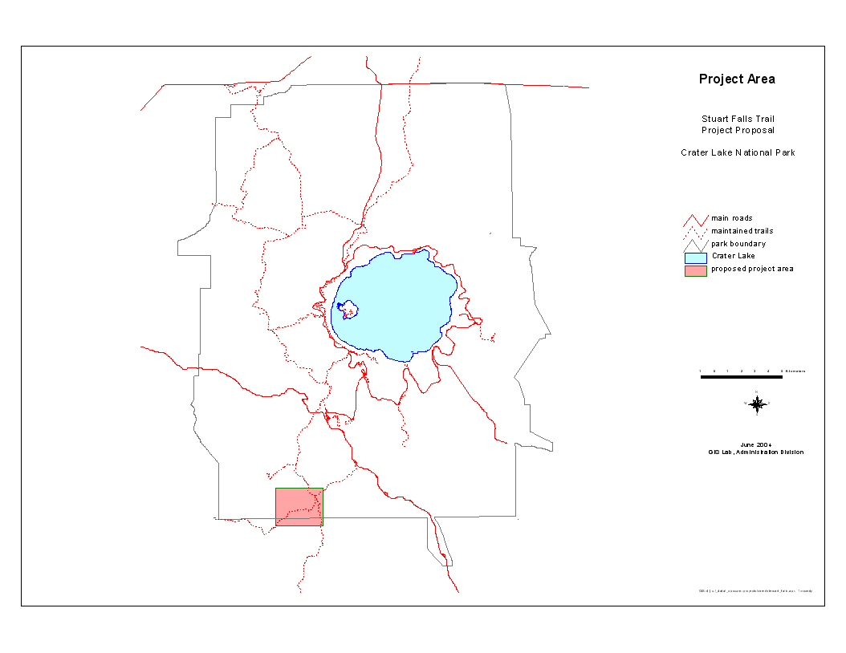
  - Project Objectives:

- Improve the visual quality of the trail by removing the appearance of the road corridor and providing a one track trail.

- Improve the wilderness values by mitigating evidence of past fire access roads.

- Provide a well designed/constructed trail to minimize annual maintenance.

- Enhance visitors’ wilderness experience by insuring that the wilderness provides opportunities for solitude and/or primitive, unconfined recreation.

- Reduce unfunded backlogged trail maintenance projects.

- Improve the Pacific Crest Trail and connecting trails to standards set in the Pacific Crest National Scenic Trail Comprehensive Management Plan.

  - Scoping Issues and Impact Topics

NPS Director’s Order (an agency guideline) on Environmental Compliance (DO 12) requires that all proposed projects be screened against a list of standard impact categories. Park management used an interdisciplinary review process to determine which resources could be affected by this project.

In addition, on February 26, 2004 the park sent out scoping letters to potentially interested parties to solicit any additional concerns about this project. Letters were sent to Pacific Crest Trail Association, Winema National Forest, Rogue River National Forest, US Fish and Wildlife Service, Klamath Tribes, High Desert Trail Riders, Jackson County Horsemen, and the Oregon Chapter of the Sierra Club. A letter asking for concurrence with the recommended finding of no effect on cultural resources was sent to the State Historic Preservation Office on February 2, 2004. As of May 11, 2004 no comments identifying any additional concerns have been received.

The following issues were identified by the park’s interdisciplinary review as the Impact Categories by which each of the project alternatives are evaluated.

Wilderness Values
All alternatives have been identified as being completely confined within the park’s proposed wilderness area. Although the legislative process has not been completed for the park’s wilderness designation proposal, it is the National Park Service policy to “…take no action that would diminish the wilderness suitability of an area possessing wilderness characteristics until the legislative process has been completed” (2001 NPS Management Policies, Chapter 6: Wilderness Preservation and Management). This policy also applies to any potential wilderness, requiring it to be managed as wilderness, until the legislative process has been completed.

Cultural Resources
The National Historic Preservation Act (16 USC 470 et seq.), NEPA, National Park Service Organic Act, NPS Management Policies (2001), Director’s Order – 12: Conversation Planning, Environmental Impact Analysis and Decision-making (2001) and Director’s Order – 28: Cultural Resources Management Guideline require the consideration of impacts on cultural resources. Cultural resources include archeological resources, cultural landscapes, historic structures, districts and ethnographic resources. Although Crater Lake is known primarily as a natural park area, it does have significant cultural resources.

Native American Sacred Sites or Tribal Land Use
National Park Service management Policies call for consideration of ethnographic resources. In the NPS Cultural Resource Management Guideline, an ethnographic resource is defined as any “site, structure, object, landscape, or natural resource feature assigned traditional legendary, religious, subsistence, or other significance in the cultural system of a group of traditionally associated with it.

Soils (Soil Erosion and Hydrology)
National Park Service (NPS) policy is to maintain all the components and processes of naturally evolving park ecosystems. Soil properties are integral components of determining the species diversity, productivity, and regenerative capacity of vegetation communities. Soil erosion can be caused by the natural hydrology flows in areas. The project alternatives identified the potential for ground-disturbing activities on previously undisturbed ground.

Vegetation
Ecological integrity of plants is considered to be an important component of naturally occurring biotic communities, which is covered by the NPS policy to maintain evolving park ecosystems. The project alternatives identified the potential for ground-disturbing activities on previously undisturbed ground.

Threatened or Endangered Species
The Endangered Species Act (1973), as amended, as well as National Park Service policy, requires an examination of impacts on all federally listed threatened or endangered species. This examination was accomplished by utilizing updated species lists of federally threatened, endangered and proposed species that may be present on or in the vicinity of Crater Lake National Park, provided by the U.S. Fish and Wildlife Service, Klamath Basin Field Office.

Species of Special Concern
National Park Service policy requires examination of the impacts on federal candidate species, as well as state-listed threatened, endangered, candidate, rare, declining, and sensitive species. An assessment of potential species that could be impacted was completed based on information provided in an updated U.S. Fish and Wildlife Service species list (March 2003), habitat analysis, and type of work proposed in each alternative.

Visitor Experience
Providing for visitor enjoyment is one of the primary purposes of the National Park Service, according to the 1916 Organic Act and NPS Management Policies. Furthermore, the Crater Lake National Park’s enabling legislation stipulates that visitors should have opportunities to enjoy the park in ways that leave park resources unimpaired for future generations.

Chapter 2 - Alternatives

  - Alternatives Considered and Analyzed in this Environmental Assessment.

Alternative 1 - Maintain Trail in Current Location (No Action)

Under this alternative no action would be taken to change the trail location or provide any improvements except during annual routine maintenance (Figure 2). Park staff would perform the annual maintenance on this trail. This routine maintenance consists of removing downed trees from the trail tread, constructing and maintaining water bars and other devices to lessen ongoing erosion, filling in the tread that erodes away and placing downed trees in one of the wheel tracks to disguise it. The trail segments would remain principally in the established road corridor. Rehabilitation efforts would be scheduled as funding allows during regular maintenance season. No crew camps would be stationed near the Stuart Falls Trail.

Figure 2: Alternative 1- Map
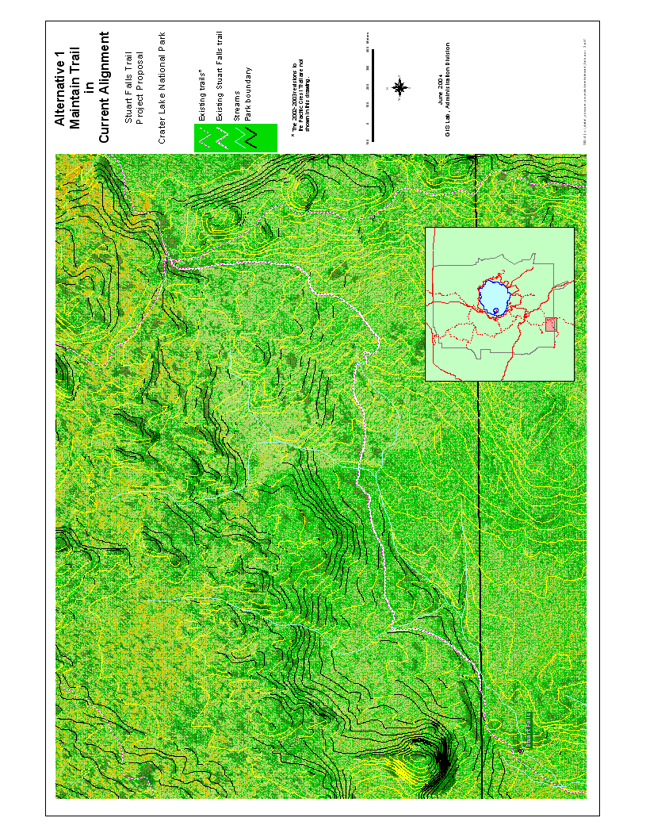
Alternative 2 – Rehabilitate Trail within Current Alignment.

This alternative would actively rehabilitate the existing roadbeds using traditional maintenance methods and minor reroutes (Figure 3). The reroutes developed would be less than a quarter mile so the trail would remain essentially on the current alignment. Minor reroutes may be identified in different locations to lessen areas that currently have steep grades or to avoid areas that have considerable damage from erosion because of the alignment. Reroutes would add approximately 0.9 additional miles to the current total length of the trail. Traditional methods to correct problems would include placement of erosion control devices such as water bars, check dams, etc. One of the wheel tracks would be physically scarified and disguised with debris. Soils would be placed in eroded tread. Cutbanks and berms would be removed, shaped and/or contoured to narrow the trail width as well as provide a more natural appearance. This re-contouring would return the natural landscape to the original topography to allow the water to sheet across rather than direct down the trail tread. Vegetation would be pruned or thinned. Some disturbed vegetation would be salvaged and/or native seed collected to replant in one of the wheel tracks and other disturbed areas to hasten restoration. This alternative would require crews to camp throughout the project area for the project duration.

Figure 3: Alternative 2 - Map
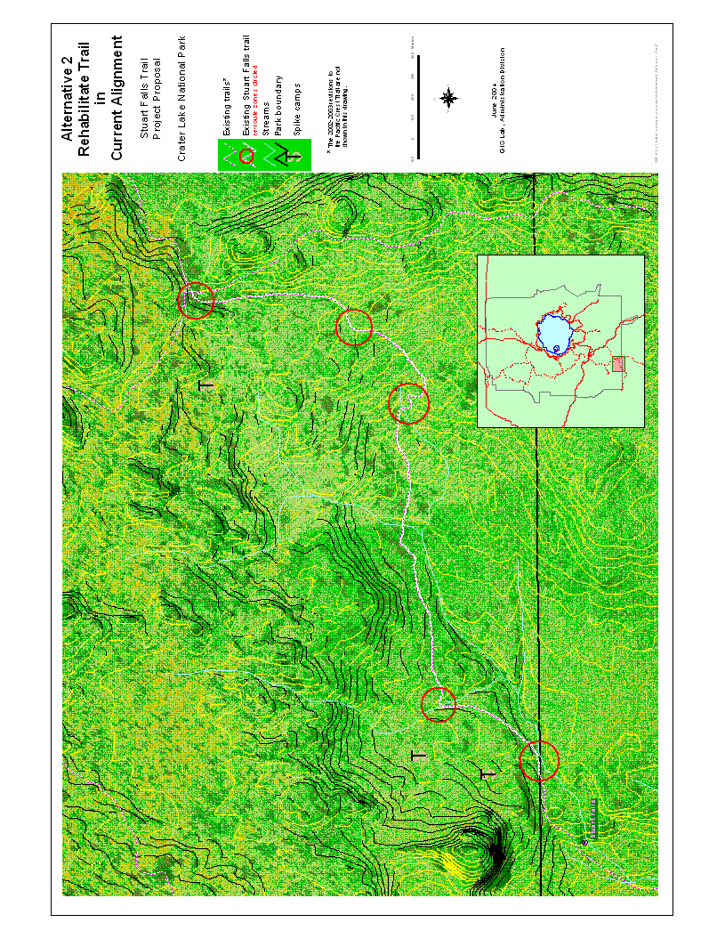
Alternative 3 - Reconstruct Trail Outside of Road Corridor Alignment (Preferred Action).

This alternative would relocate the entire Stuart Falls Trail section (see Figure 4). The route was selected to provide comfortable hiking grades, views, and to follow the standards set for the Pacific Crest Trail. The route would traverse along a ridge that lies to the west of the existing trail. Trail construction would follow the contours of the land and remain at a 10% or less grade. The travel way would be cleared of limbs, brush and other debris to a minimum clearance. This clearance would be 8 foot width by 10 foot height to accommodate the allowed horse usage on the trail. After duff removal, the surface would be dug to provide an adequate tread area. The newly constructed tread would be 18 to 30 inches wide. The trail would have a 3 – 5% cross slope where necessary. These tread standards would vary due to changing terrain. Approximately 2.7 miles of new trail would be constructed. Some existing trail sections would be rehabilitated using the same techniques as outlined in Alternative 2. This alternative would require crews to camp throughout the project area for the project duration.

Figure 4: Alternative 3 – Map

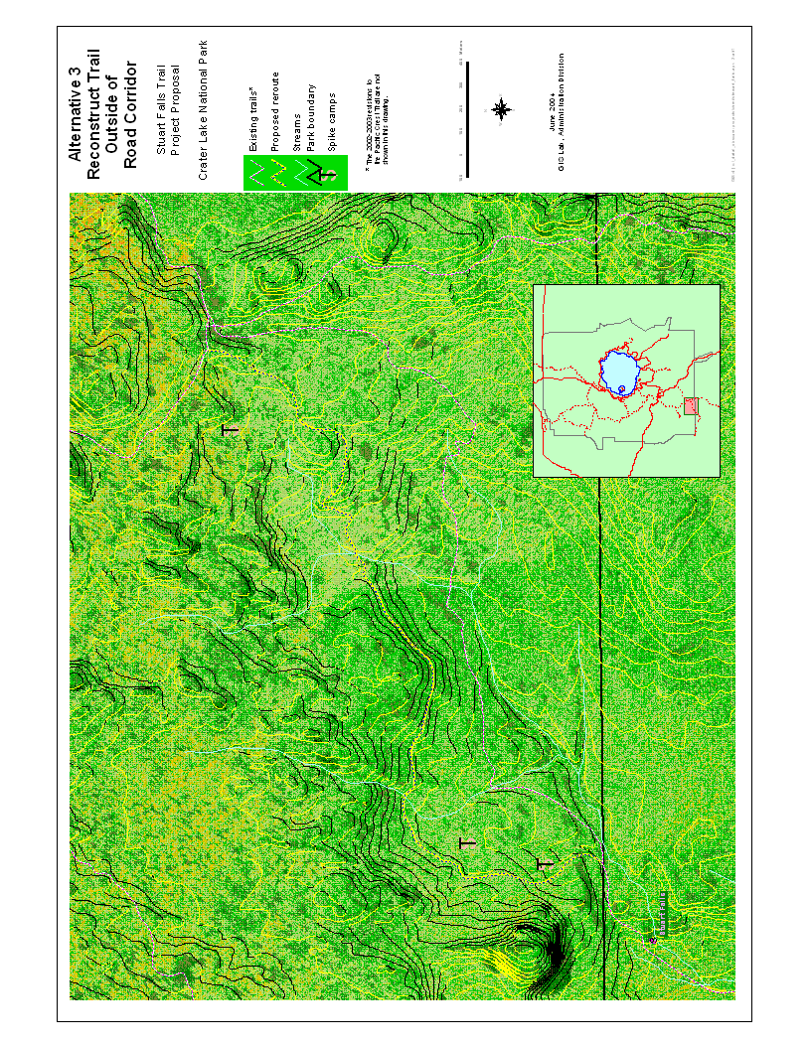
2.2 Alternatives Considered but Dismissed from Further Analysis

In addition to the three alternatives identified and evaluated in this document, one other alternative for restoring the Stuart Falls Trail was considered and dismissed. This alternative was to limit work to existing trail and utilizing heavy power equipment for rehabilitation. This alternative was dismissed from further consideration based on deficiencies associated with a number of factors including: 1) protection of natural resources: The location is 3 -5 miles to nearest roadway and would require enhancing the Pumice Flat trail to accommodate the equipment needed for the project or utilizing a helicopter to fly equipment to the project area. Usage of a helicopter would require building heli-spots; building access from heli-spot to existing trail alignment and enhancing current trail alignment to accommodate equipment usage to boundary (3 miles). Existing soils would have increased compaction due to the weight of heavy equipment. This would reverse the thirty-five years of healing that has taken place. Compaction decreases permeability, alters soil moisture content and diminishes water storage capacity. Natural soil processes would be restored in the rehabilitated areas only over the very long term, as the soil structure slowly returned to a more natural condition. 2) Protection of wilderness values: Crater Lake National Park currently follows management guidelines considering wilderness values. Consideration was also given to neighboring agency (Sky Lakes Wilderness policies, USFS) wilderness policies; 3) Successful recovery of previous areas rehabilitated by hand crews on other trail projects and 4) Budget costs: Higher costs from utilizing helicopters and heavy equipment. These costs would rise from helicopter, equipment rentals, unanticipated repairs, which could be more expensive and additional costs from previously unplanned ground disturbances (heli-spots, additional disturbed mileage necessary to move equipment to and from project site). Hand crews would still be needed to finalize disturbed areas and for any re-vegetation efforts.

2.3 Environmentally Preferred Alternative

The National Park Service is required to identify the environmentally preferred alternative(s) for any of its proposed projects. That alternative is the alternative that will promote the national environmental policy expressed in NEPA (The National Environmental Policy Act Section 101 (b)). This includes alternatives that:

1) fulfill the responsibilities of each generation as trustee of the environment for succeeding generations;

2) ensure for all Americans safe, healthful, productive, and esthetically and culturally pleasing surroundings;

3) attain the widest range of beneficial uses of the environment without degradation, risk of health or safety, or other undesirable and unintended consequences;

4) preserve important historic, cultural, and natural aspects of our national heritage and maintain, wherever possible, an environment that supports diversity and variety of individual choice;

5) achieve a balance between population and resource use that will permit high standards of living and a wide sharing of life’s amenities; and

6) enhance the quality of renewable resources and approach the maximum attainable recycling of depleted resources.

In essence, the environmentally preferred alternative would be the one(s) that “causes the least damage to the biological and physical environment; it also means the alternative which best protects, preserves, and enhances historic, cultural, and natural resources” (DOI, 2001a).

The no-action alternative meets only criterion number 4, preserving important natural and cultural resources. Alternative 2 provides more value than alternative 1 by meeting NEPA criterion 1, 2, and 4. This alternative would a) mitigate impacts from past manipulations and b) help repair native vegetation.

In this case, Alternative 3 (Preferred Action) is the environmentally preferred alternative for Crater Lake National Park since it meets goals 1, 2, 3, 4 and 6 described above. Under this alternative, trail management activities would provide a solution for a larger amount of the existing problems as compared to Alternative 2. These include: a) improve the visual quality; b) enhance visitors’ experience; c) mitigate impacts from past manipulations for the selected trail; d) improve operations efficiency by lower future maintenance needs; e) improve the PCT trail system connections; f) help repair native vegetation along these trails; g) prevent loss of soil from erosion. Alternative 2 provides solutions for a) mitigation of impacts from past manipulations; b) help with repair of native vegetation and c) prevent loss of soil.

This alternative fulfills park managers’ responsibility to current and future generations by ensuring safe, esthetically and culturally pleasing surroundings; by minimizing degradation of the environment; protecting and helping to preserve the historic, cultural, and natural resources in the park.

Chapter 3 - Environmental Analysis

3.1 Methodology

Impact analyses and conclusions are based on the review of existing literature and park studies, information provided by park staff, field surveys, professional judgments and insights of other agencies and officials, and input from interested local tribes and the public. Definitions used to evaluate context, intensity, duration, and cumulative nature of impacts associated with this project’s alternatives are discussed below.

Context is the setting within which impacts are analyzed such as the affected region, society as a whole, the affected interests, and/or a locality. In this environmental assessment, the intensity of impacts is evaluated within a local (i.e., project area) context, while the intensity of the contribution of effects to cumulative impacts is evaluated in a regional (i.e., park-wide) context.

Duration is the time period for which the impacts are evident. Short-term impacts are those that are noticeable during the project and six months thereafter. Long-term impacts are those that are evident for periods longer than one year after the project has been completed.

For this analysis, impact intensity or severity is defined as follows:

Wilderness Values
- Negligible – could have a temporary or small, non measurable effects on the wilderness values and/or solitude.
- Minor – could have a slight and localized effect on wilderness values and/or solitude.
- Moderate – would have measurable or readily apparent adverse effect on the wilderness values and/or solitude.
- Major – would have a substantial adverse effect or apparent permanent change to the wilderness value and/or solitude.

Cultural Resources/Native American Sacred Sites or Tribal Land Use
- Negligible – impact(s) at the lowest levels of detection. The determination under Section 106 of the National Historic Preservation Act (NHPA) would be no effect.
- Minor – disturbance of a site(s) results in little loss of significance or integrity to maintenance and preservation of a site(s). The determination under Section 106 of the NHPA would be no adverse effect.
- Moderate - disturbance of a site(s) diminishes the site(s) significance or integrity to the extent that its National Register of Historic Places (NRHP) eligibility is jeopardized. The determination under Section 106 of the NHPA would be adverse effect.
- Major – disturbance of site(s) has diminished the site(s) significance or integrity to the extent that it is no longer eligible to be listed in the NRHP. The determination under Section 106 of the NHPA would be adverse effect.

Soils (Soil Erosion and Hydrology)/Vegetation
- Negligible - an action that could cause small changes that would not be measurable or perceptible consequence.
- Minor – an action that could cause a slight and localized change with few measurable consequences.
- Moderate – an action that would result in readily apparent changes to soil with measurable consequences.
- Major – a substantial adverse or beneficial change to soil would result.

Threatened or endangered species/Species of Special Concern
- No effect – when the alternative would not affect a listed species or designated critical habitat.
- Not likely to adversely affect – when the effects of the alternative are expected to be discountable or insignificant.
- May effect – when the alternative may pose any effect on listed species or desired habitat.
- Likely to adversely affect – any adverse effect to the species that may occur as a direct or indirect result of the alternative and the effect is not discountable, insignificant, or beneficial.

Visitor Experience
- Negligible - could have an small affect on visitor experience that would not be measurable and/or would affect few people
- Minor – could have a slight and localized effect on visitor experience with few measurable results and/or would affect some people
- Moderate – would affect visitor use in a readily apparent adverse change and/or would affect a large number of people.
- Major – would have a substantial adverse effect on visitor experience and/or affect the large majority of people.

Cumulative impacts are defined as the impacts on the environment from the alternatives when added to other past, present, and reasonably foreseeable future actions. Cumulative impacts are considered for all alternatives. Past projects identified that contribute to cumulative impacts are the Union Peak/PCT trail rehabilitation/relocation. Present and future actions in conjunction with this project that may have the potential to cumulatively impact resources include:
- Planned prescribed burns under the park’s Fire Management Plan
- Reconstruction of the Rim Village parking lot
- Replacement of the Munson Springs/Garfield waterline replacement
- Rehabilitation of the Munson Valley sewage lagoons
- Rehabilitation of Highway 62 West

Chapter 4 – Environmental Consequences

4.1 Wilderness Values

Affected Environment

Lands within Crater Lake National Park have been and continue to be evaluated for their suitability for inclusion to the National Wilderness Preservation System. All proposed alternatives lie totally within a recommended wilderness area. National Park Service policies direct park mangers to “take no action that would diminish the wilderness suitability of an area possessing wilderness characteristics until the legislative process of wilderness designation has been completed.” The policy also states that “Until that time, management decisions pertaining to lands qualifying as wilderness will be made in expectation of eventual wilderness designation.”

Environmental Impacts

Alternative 1 - Maintain Trail in Current Location (No Action)

With no change in current management, much of the current trail alignment would remain in old roadbeds. Although the second track of the roadbed would, to the degree possible, be disguised under this alternative, a road-like corridor would still be evident and the wilderness traveler would still have the feeling of traveling along a road for the foreseeable future. Natural recovery and re-vegetation of the dual track is probable only in the very long-term, which would cause long-term minor impacts.

Alternative 2 - Rehabilitate Trail within Current Alignment

Under this alternative the dual road track would be proactively rehabilitated to accelerate its recovery and restoration of the wilderness character of the trail. Although no motorized equipment would be utilized, there would be some short-term negligible impacts to wilderness values such as solitude and natural quiet due to the increased presence of work crews during the summer season. In the long-term, restoration and re-vegetation would be accelerated enhancing the wilderness quality of the trails.

Alternative 3 - Reconstruct Trail Outside of Road Corridor Alignment (Preferred Action)

Under this alternative approximately 2.7 miles of new trail would be constructed. No motorized equipment would be utilized during construction. Short-term, negligible impacts to wilderness values such as solitude and natural quiet would result due to the summer long presence of work crews concentrated in the vicinity of the trail. In the long-term, however, crew presence would diminish as a result of decreased maintenance requirements which would result in negligible, ongoing impacts to wilderness values. Abandoned road segments would receive rehabilitation and/or re-vegetation, which would accelerate the improvement of their wilderness character. Wilderness visitors would have an enhanced experience by hiking along a designed trail rather than a converted roadway.

Cumulative Impacts

Past, present, and reasonably foreseeable future actions identified that may contribute to cumulative, localized, short or long-term impacts on wilderness environment with this proposed project, include prescribed burning and construction projects related to waterlines, road rehabilitation, and lagoons. Alternative 2 and 3 effects would be temporary, non-measurable and would not add cumulatively to any long-term impacts on wilderness values. Alternative 1 would add minor, long-term effect to the cumulative effects of park-wide projects.

Conclusions

Alternative 1 would continue to present some minor short and long-term impacts to wilderness characteristics and values due to the continued, albeit disguised, presence of an old roadway. Alternatives 2 and 3 would increase negligible short-term impact on wilderness values such as solitude and natural quiet due to an increased presence of work crews in the project area throughout the summer season. In the long term, however, the wilderness experience would be enhanced by these alternatives due to partial or complete rehabilitation of the old roadbed. Although negligible short-term impacts are probable, they would be temporary and limited in area. None of the alternatives identified would result in impairment to the wilderness characteristics and values.

4.2 Cultural Resources

Affected Environment

An environmental model of human use in prehistoric times was developed to predict archeological site locations at Crater Lake National Park (Mairs et al. 1994). This model correlates environmental factors with site types. Areas containing certain environmental criteria, such as water, level terrain, accessibility, and animal and plant resources are considered to be correlated with a relatively high probability for archeological sites. The project area exhibits two probability factors: areas of flat-to-moderate slope, and the presence of game. Artifacts that could be expected within the project area might include lithic scatters and/or isolated tools. These resources are associated with travel routes, campsites, and hunting. This model indicates that the project area has a relatively low to moderate probability for prehistoric archeological sites (defined as ten or more artifacts) and/or isolated finds. The park area is generally characterized by low site density.

Environmental Impacts

Alternative 1 - Maintain Trail in Current Location (No Action)

Alternative 1 proposes no ground disturbing activities outside of the currently disturbed roadbed. Therefore there would be no effect to cultural resources from this project or continued routine trail maintenance.

Alternative 2 - Rehabilitate Trail within Current Alignment

Alternative 2 involves potentially ground-disturbing activities in its current alignment. Because of the potential for impacts to cultural resources a survey was conducted to detect the presence of any cultural resources (Kritzer 2001). This survey of the Stuart Falls Trail resulted in the recording of one historic isolated find. There could possibly be a minor effect on this historic cultural resource, if this area was openly identified and not protected from disturbance. In order to meet the project’s objectives, some disturbance in this location would be required; however this low level of disturbance would result in a barely detectable impact to the find, resulting in a Section 106 determination of no effect. No other documented finds or sites (historic or pre-historic) lie within the project area. The archeological survey report recommends that surface artifacts should be avoided and any if new finds are discovered, work shall be halted and the appropriate personnel notified.

Alternative 3 - Reconstruct Trail Outside of Road Corridor Alignment (Preferred Action)

Alternative 3 involves potentially ground-disturbing activities and hence the potential for impacts to cultural resources. The proposed trail alignment was surveyed (Kritzer 2003) and no new finds or sites were found during this survey. All other isolated finds and sites on the Pacific Crest Trail and Stuart Falls Trail lie outside area of proposed construction, so they would not be impacted during construction activities. All work would be halted if any new finds are discovered during work activities and the appropriate personnel notified. Therefore, there would be no effect to any isolated finds and/or sites from this alternative.

Cumulative Impacts

In conjunction with the cumulative impacts of past, present and foreseeable future actions on cultural resources including past trail rehabilitation and relocation, reconstruction of the Rim Village parking lot, waterline replacement and rehabilitation of Highway West 62, these alternatives would not contribute to the cumulative impacts on cultural resources, because these alternatives would result in no impact to any known cultural resource.

Conclusions

Alternatives 1 would have no effect to cultural resources. Alternative 2 could possibly have a negligible impact on the one isolated find, a Section 106 of the National Historic Preservation Act determination would be no effect. Alternative 3 would have no effect on any isolated finds or sites. There would be no impairment to cultural resources from any of the alternatives.

4.3 Native American Sacred Sites or Tribal Land Use

Affected Environment

Information on the specific traditional uses of the proposed project area by the Klamath/Modoc, Upland Takelma, or Molalla Indians is not documented. Information on nearby locations and the general use of the Cascades, however, provides a context for potential use and interest within the project area. For example, the Cascades were traveled for trade and resource procurement in both pre and post- contact periods. The Klamath/Modoc, Upland Takelma, Umpqua, and Molalla exploited the Cascade uplands during the warmer months for roots, berries, and large game (Mairs et al. 1994). In addition, previous ethnographic research notes that many Klamath living at Klamath Marsh, east of the project area, traveled to Huckleberry Mountain for berries (Spier 1930:146). Huckleberry Mountain lies approximately 4 miles (6.4 kilometers) due west of the project area (Spier 1930:146)

Additionally, the rim of Crater Lake, as well as many nearby peaks, was used for spiritual purposes among the Klamath and Upland Takelma. A quest for power, vision, or spirit often occurred on mountains and included activities such as rock piling. Rock piles or cairns are found on several of the peaks in Crater Lake National Park today. Ethnographers have noted locations where people climbed up and piled rocks and archeologists have since recorded several such sites. The project area lies well south of any such finds.

Environmental Impacts

Alternative 1 - Maintain Trail in Current Location (No Action)

Alternative 1 does not propose ground disturbing work outside of the current roadbed, therefore this alternative would not affect Native American Sacred Sites or Tribal Land Use issues. There is a general absence of plants having ethnobotanical significance within the existing trail corridor. There would no effect to any sacred site and/or tribal land use issues.

Alternative 2 - Rehabilitate Trail within Current Alignment

Alternative 2 does not propose work outside of the current alignment. The only recorded historic-period site (Kritzer 2001) that may be of interest to the tribe lies outside the project area and would not be impacted. There is an absence of plants with ethnobotanical significance within the existing trail corridor. The archeological survey report recommends that surface artifacts should be avoided and during ground disturbing activities the discovery of any new archeological finds, work shall be halted and the appropriate personnel notified. Following these recommendations there would be no effect resulting from the rehabilitation work.

Alternative 3 - Reconstruct Trail Outside of Road Corridor Alignment (Preferred Action)

No sites or isolated finds are located within the proposed alignment; there is an absence of significant ethnobotanical plants within this proposed trail corridor and by following the recommendations listed in Alternative 2 there would be no effect on sacred sites and/or tribal land use issues.

Cumulative Impacts

Implementation of this project, when combined with the impacts of implementing the recommendations of other past, present and reasonably foreseeable proposed actions (i.e., past trail rehabilitation/relocation, Rim Village parking reconstruction, prescribed fire) within the park, would add no cumulative impacts on sacred sites or tribal land use issues as all alternatives for this project would result in no impact to any sacred sites or tribal land use issues.
.
Conclusions

No known sacred sites within the park are located within or near the project area. There is an absence of plants with ethnobotanical significance within the existing trail corridor and in the proposed trail alignment. Therefore, there would be no long or short term effects to tribal sacred sites or cultural resources of tribal concern from any of the alternatives. There would be no impairment to any Native American Sacred Sites or Tribal Land Use from any of the alternatives.

4.4 Soils (Soil Erosion and Hydrology)

Affected Environment

Five major soil series are found within Crater Lake National Park (USDA 2002). Of the five, two of the major soil series are generally found in this location. These are the Llaorock and Castlecrest. A small area of Cleetwood-Castlecrest-Llaorock complex exists in a meadow area located at the Stuart Falls/PCT/Pumice Flat junction. The intention of this project is to avoid this meadow area as the current alignment channels and accelerates the water flow through it.

Llaorock soil is composed of volcanic ash and bedrock fragments and is typically 60 inches in depth. The surface layer of this soil type is a dry, brown, very stony ashy sandy loam. The subsurface is dry, extremely stony medial sandy loam, light brown with fifty percent rock fragments.

Parent materials that compose the Castlecrest soil series is volcanic ash and pumice. The surface layer of this soil is grayish brown, ashy, loamy sand, while the subsurface is a dark grayish brown to a light yellowish brown, ashy sand, ashy loamy sand or ashy coarse sand.

Llaorock-Castlecrest complexes (0 to 15% & 15 to 30%) are found on side slopes of mountains and ridges. These soil series have rapid soil permeability with slow runoff, which results in little erosion where soils are protected by forest cover and sheet flow is not interrupted.

Environmental Impacts

Alternative 1 - Maintain Trail in Current Location (No Action)

Under this alternative, NPS would take no immediate action to improve the quality of the trail, so no short-term impacts would occur from work activities associated with this current project work. Long-term minor impacts would be expected. The existing trail suffers from loss of topsoil due to erosion problems. The natural water flows from spring snow melt and seasonal streams to the current trail tread from the western and northwestern slopes. The trail location lies within a natural drainage area. The soil erosion is increased in these areas due to a poorly aligned trail bed. This alignment allows spring snow melt and heavy fall rain showers to become channeled on the existing trail tread. Often the surrounding ground lies above the trail tread preventing traditional trail maintenance from working as they should in these areas. Many of the problem areas have been treated in the past with traditional trail maintenance methods (waterbars, check dams along with re-grading the tread and/or small realignments etc.) and have not shown stabilization or improvement because of this problem. As a system of old roads, the alignment is often not conducive to traditional trail maintenance methods to cure erosion problems. In certain areas, such as the meadow area at the Stuart Falls/Pumice Flat/PCT, the problem has increased even though the Cleetwood-Castlecrest-Llaorock soil complexes existing in these areas have rapid and excessively draining properties. These erosion problems may become even greater in future years; trail sections would require more expensive and uncertain reconstruction efforts.

Alternative 2 - Rehabilitate Trail within Current Alignment

Under this alternative, minor short-term impacts would be expected. In order to remove evidence of the road corridor, soil in one wheel track would be scarified, road berms would be removed from one or both trail sides and the cutbanks would be reshaped. Approximately 2.42 acres of soil would be disturbed by these actions. Although all the soils complexes in found in this project area have a rapid permeability with excessive drainage properties, channeling fast, high volumes of water over these areas has increased the erosion, especially to the meadow areas (Cleetwood-Castlecrest-Llaorock complexes) located at the beginning and end of this trail. These areas would require relocation with special attention applied to contouring the landscape to the original topography to allow the water to sheet cross and to ensuring successful re-vegetation. Re-vegetation efforts would be utilized to help minimize any long-term impacts by providing protection for the soils. The trail sections would need to be monitored, after work is accomplished, on an annual or bi-annual basis. This would be required due to the sparse amounts of vegetation found within the project area. Efforts may need to be repeated in areas if erosion continues or if plants failed to establish due to the extremely small growing season found in this region.

Alternative 3 - Reconstruct Trail Outside of Road Corridor Alignment (Preferred Action)

Under this alternative, minor short-term impacts would be expected. Approximately 0.65 acres of soil would be disturbed with the tread construction. The new alignment would require grades of travel at 10% or less through the route. The alignment would “fit” the trail to the ground, which means it would follow the contours of the land and maintain a uniform outslope (3-5%) to the tread. By utilizing this method, it is anticipated that erosion problems would be eliminated because the trail would not intercept the sheet flow. The trail would thus not become the water channel and would allow the water to utilize the natural characteristics found in the soils of the project area. These soils characteristics have a rapid permeability and are found to excessively drain due to the material make up of these soils (pumice/ash/some bedrock fragments). No long-term impacts would be expected because disturbances would remain at the site of the tread excavation. Any vegetation found along the trail tread sides would not be disturbed and would remain to provide protection to the soils surrounding the trail tread. Continuous erosion problems on the existing trail would be corrected by providing by applying natural erosion checks; re-contouring necessary sections to improve natural water sheet flow; providing additional protection by re-vegetating selected areas and preventing the continued usage by visitors.

Cumulative Impacts

The proposed actions from these alternatives would contribute a negligible and localized increment to the total cumulative past, present and reasonably foreseeable future actions (i.e. Garfield waterline replacement, lagoon project, rehabilitation of Highway 62 West, previous trail rehabilitation projects) within the park.

Conclusions

Under Alternative 1 there would be no additional short-term impacts to soils from work activity, but over time, long-term moderate impacts would be expected due to unresolved erosion problems. There would be short-term minor impacts to soils from rehabilitation and/or new trail construction under alternatives 2 and 3. Long-term impacts from these alternatives would be minimal or non-existent. None of the alternatives would result in impairment to soils.

  - Vegetation

Affected Environment

The biotic plant communities found throughout the Stuart Falls Trail project area varies according to canopy cover, topography, seral stage and available moisture. In this mixed confer forest, the common tree species found are Mountain Hemlock (Tsuga mertensiana); Shasta Red Fir (Abies x shastensis); White Fir (Abies concolor x grandis); Lodgepole Pine (Pinus contorta); and occasional Western White Pine (Pinus monticola) with little vegetation in the understory. The common vegetation is Anderson’s lupine (Lupinus andersonii) and Sedge species (Carex sp.) in the sparsely covered herbaceous layer. Periodically found in open rock outcroppings are Pinemat manzanita (Arctostaphylos nevadensis) and Littleleaf huckleberry (Vaccinium scoparium).

Environmental Impacts

Alternative 1 – Maintain Trail in Current Location (No Action)

Alternative 1 proposes no ground disturbing activities outside of the currently disturbed roadbed. Therefore there would be no effect to any vegetation located in the project area.

Alternative 2 – Rehabilitate Trail within Current Alignment

This alternative would actively rehabilitate the existing roadbeds. Under this alternative, vegetation would experience moderate short-term impacts from methods used to cure current problems. These rehabilitation methods would include developing small minor reroutes to lessen steep grades along the existing trail and to avoid channeling water along the trail tread; removal, re-shaping and contouring landscape (cutbanks, berms etc) to the natural topography; vegetation would be pruned or thinned and providing a cross-slope of five percent or less to encourage natural water sheet flow. All crew camps would be located in areas of no vegetation; crews would utilize leave no trace approaches to camping; campsites would change weekly and use a varied non-vegetated route to and from camp to work sites. Vegetation would be salvaged, seeds collected to actively rehabilitate disturbed areas. These efforts would require monitoring over time to insure success.

Alternative 3 – Reconstruct Trail Outside of Road Corridor Alignment (Preferred Action)

This alternative relocated the trail to a new area. Vegetation would experience minor impacts in the area of tread construction. Vegetation would not be disturbed outside of the 18” – 30” tread expansion. Due to the maturity of the confer forest; very little vegetation found in the understory; and because the reroute placement avoided areas of large biotic plant communities, it is expected that only a small amount of native, common plants would disturbed. An increase in disturbance would take place in the rehabilitated areas in the current trail. These disturbances would be similar to Alternative 2 due to the same methods would be applied. All crew camps would be located in areas of no vegetation; crews would utilize leave no trace approaches to camping; campsites would change weekly and use a varied non-vegetated route to and from camp to work sites. Vegetation would be salvaged, seeds collected to actively rehabilitate disturbed areas. These efforts would require monitoring over time to insure success.

Cumulative Impacts

Past, present and reasonable foreseeable future actions identified that may contribute to the cumulative effects on vegetation include past trail projects, reconstruction of Rim Village parking, Garfield water line project and rehabilitation of Highway 62 West. Alternative 2 and 3 would be localized temporary, non-measurable and would not add cumulatively to any long-term impacts to vegetation. Alternative 1 would not add to cumulative long/short term impacts of park-wide projects.

Conclusions

Alternative 1 proposes no ground disturbing activities. Therefore there would no impact to vegetation in the long or short term. There would be short-term minor to moderate impacts to vegetation expected from alternatives 2 and 3. No long-term impacts would be expected from these alternatives due to the rehabilitation, re-vegetation and monitoring efforts. There would be no impairment of vegetation by any alternative.

4.6 Threatened or Endangered Species

Affected Environment

A large variety of wildlife exists within the boundaries of Crater Lake National Park. Elk, deer, black bear and many rodent species may be seen throughout the project area. The U.S. Fish and Wildlife Service have identified species that are classified as either federally threatened or endangered that may occur in Crater Lake National Park. These include Canada lynx (Lynx canadensis), Bald eagle (Haliaeetus leucocephalus), Northern spotted owl (Strix occidentalis caurina), Shortnose sucker (Chasmistes brevirostris), Lost River sucker (Deltistes luxatus), and Bulltrout (Salvelinus confluentus). Of these listed species only three (Bald eagle, Northern spotted owl, bulltrout) are known or likely to reside within Crater Lake National Park. The project area is, however, located within the potential habitat of two of these species: the Bald eagle and the threatened Northern spotted owl. The project is also located in potential habitat for the threatened Canada lynx (Lynx canadensis) though their presence has not been confirmed.

Bald eagles are known to occasionally nest near Crater Lake and use it as a feeding area, but no known eagle sites are documented to show their usage for nesting or roosting within this project area.

The northern spotted owl is an old-growth dependent species and potential habitat is found in patches throughout the project area. Ten years of survey have recorded nesting areas and activity centers of Northern spotted owls in the park and though potential habitat exists in this project area, no active sites have been identified within it. The nearest known owl activity center is 1.93 miles away.

Park-wide surveys conducted for three years (1999-2001) failed to detect the presence of Canada lynx within the park boundaries. As a result, scientists have concluded that it is unlikely that a viable population of Canada lynx resides in or near the park.

Environmental Impacts

Alternative 1 - Maintain Trail in Current Location (No Action)

Since Alternative 1 describes no action beyond what is currently done to maintain trails, the alternative would have no effect on any listed threatened or endangered species or any wildlife species found within project boundaries

Alternative 2 - Rehabilitate Trail within Current Alignment

Noise and human presence would be expected during summer trail construction. The project’s location to the nearest spotted owl activity center is 1.93 miles away. Since this distance is well outside the recommended protection buffer of 1.2 miles, there would be no direct effect to spotted owls from noise. Scientists have concluded that it is unlikely that a viable population of Canada lynx resides in or near the park thus there would be no direct effect to the lynx. No known bald eagle nests are located within the project area, so there would be no direct effect to bald eagles. No major alteration (no removal of trees larger than 12 inches in diameter) would occur to potential habitat; therefore no effect to spotted owl, bald eagle or lynx habitats would be expected. Some temporary displacement of other wildlife may occur however, no long term impacts are expected to other wildlife species or their habitats from the work proposed in this alternative.

Alternative 3 - Reconstruct Trail Outside of Road Corridor Alignment (Preferred Action)

The proposed actions would result in noise and human presence during summer trail construction. The nearest northern spotted owl activity center is 1.93 miles away from the project area. This distance is well outside the recommended protection buffer of 1.2 miles for this species, there would be no direct effect on the Northern spotted owl from noise or human presence. Scientists have concluded that it is unlikely that a viable population of Canada lynx resides in or near the park thus there would be no direct effect to the lynx. No known bald eagle nests are located within the project area, so there would be no direct effect to bald eagles. No major damage (no removal of trees larger than 12 inches in diameter) would occur to potential habitat; therefore no effect to spotted owl, bald eagle or lynx habitats. Some temporary displacement of other wildlife may occur however no impacts are expected to other wildlife species or their habitats from the work proposed in this alternative.

Cumulative Impacts

Past, present and reasonably foreseeable future actions that may contribute to an effect on threatened and endangered species include prescribed burning and construction projects to related waterlines and lagoons. These actions could result in short-term as well as some long-term effects on threatened and endangered species within a localized site. All alternatives for this project would result in no effect to listed species and hence would not contribute to the cumulative short and/or long-term effects on threatened, endangered species or their habitats from any past, present, and future actions.

Conclusions

As no current documentation exists to support the existence of the Canada lynx within park boundaries; potential habitat would not be damaged due to no larger diameter trees (>12 inches dbh) being removed while implementing this project; introduction of the human work force is temporary; no active sites for either Bald eagle or Northern spotted owl are documented within the project area; no impacts are expected to other wildlife found in the park boundaries; none of the alternatives described would effect any federally listed threatened/endangered species; or their habitats; or to any other wildlife species. None of the alternatives would cause impairment to federally listed threatened/endangered species or other wildlife species.

4.7 Species of Special Concern

Affected Environment

Crater Lake National Park is home to a number of documented plant and animal species of special concern. These sensitive species have potential to be impacted by in-park development and land management activities on the park boundary.

Within the area surrounding the project, several animal species that are listed as a State or Federal species of concern have been documented by visitor observations. These observations included a Northern goshawk, a Lewis’ woodpecker, a Black-backed woodpecker, American martin and a Cascade frog.

The wolverine (Gulo gulo) is a low-density species that occupies isolated montane coniferous forests and talus slopes above the tree line, where human presence and activities are minimal. Old-growth forest structure is an important habitat characteristic for wolverine habitat. This potential habitat exists for the state-listed species wolverine within the project area. Annual survey efforts, both aerial and ground-based also have failed to produce evidence to confirm the wolverine’s presence within the park boundaries or adjacent to the park.

Plant surveys of the project areas were conducted along the Pacific Crest trail system, which includes the existing Stuart Falls Trail, and Alternative 3 reroute selection (Jones 2001; Coleman 2003). Surveyors searched for any plant species listed by the U. S. Fish and Wildlife Service as being threatened or endangered and plant species considered endangered by Oregon State, as well as the existence of any exotic plants.

Environmental Impacts

Alternative 1 - Maintain Trail in Current Location (No Action)

As no specific project work is proposed in this alternative other than routine maintenance in currently disturbed areas, no impact would be expected to habitat suitable for listed sensitive species. Therefore, there would not be impacts to any Species of Concern.

Alternative 2 - Rehabilitate Trail within Current Alignment

This alternative would not damage any habitat suitable for listed sensitive animal species. There would be no removal of large old-growth trees and only minor damage to the limited under-story vegetation would be expected. The 2001 plant survey found the existence of a species of concern Broad-Seeded rockcress (Arabis platysperma var. platysperm) along the southern Pacific Crest Trail complexes which includes the current Stuart Falls trail. This species is listed as rare, but not immediately imperiled. By avoiding it, there would not likely be any adverse affect. No other sensitive plant species were observed along the trail. Thus, there would be no effect to any sensitive plant species.

Alternative 3 - Reconstruct Trail Outside of Road Corridor Alignment (Preferred Action)

This alternative would not affect any habitat suitable for listed sensitive animal species. There would be no removal of large old-growth diameter trees and only minor damage to the under story vegetation would be expected. No sensitive plant species were observed along the selected reroute during the surveys. Therefore, there would be no effect to any sensitive plant species.

Cumulative Impacts

Past, present and reasonably foreseeable future actions that may have a cumulative, localized effect on sensitive species of concern include prescribed burning and construction projects related to waterlines, rehabilitating roadways and lagoons. Because the work activities described in these alternatives would have no effect on sensitive species of concern, this project would not contribute to the cumulative effects of these projects.

Conclusions

Annual survey efforts have failed to produce evidence confirming the wolverine’s presence within the park boundaries or adjacent to the park, and no major alteration or damage would be expected to potential habitat during implementation of the project alternatives. Therefore, there would be no effect on existing or potential wolverine habitat. No major alteration or damage would occur while implementing this project to other sensitive species habitats. There would no effect to rare species by avoiding any sensitive plant species location along the current trail alignment and with no expected damage occurring to potential habitat. None of the alternatives would cause impairment to sensitive species or their habitats.

4.8 Visitor Experience

Affected Environment

Many of the visitors at Crater Lake National Park stop at the park as part of a north-south trip to various scenic areas in Oregon and northern California. Less than 15 percent of the park’s visitors remain overnight, with less than 5 percent stay two or more nights in park boundaries and less than 1 percent is recorded as backcountry users. The percentage of park visitors obtaining outside lodging or campsites and returning to the park for day-use is unknown. The park’s trail system contains 95 miles of maintained trails, including 33 miles of the Pacific Crest Trail. Summer use of the park’s trails is sporadic, with most use occurring along the Pacific Crest Trail (NPS 1995). The Stuart Falls Trail is utilized by both stock user and hikers. Although no designated wilderness camps are located in this area, visitors utilize the trail for day and overnight trips. Stuart Falls is a popular destination spot for both park and Sky Lakes Wilderness visitors. This trail is heavily used by PCT hikers due to the lack of water on the official PCT route. Visitors will need to have water for an additional 8 -10 miles of PCT hike from in the southern boundary park. Winter use such as skiing, and snowshoeing are allowed during winter months.

Environmental Impacts

Alternative 1 - Maintain Trail in Current Location (No Action)

Under this alternative the trail section would remain in the old roadbed. The road alignment travels a route laid out for vehicles. This leaves visitors on an old roadbed through terrain that provide few views and with steeper grades than are comfortable for hikers. The feeling of traveling along a road would not be conducive to a wilderness or backcountry experience; some visitors may nevertheless enjoy the added trail width and expanded road corridor that this alternative would provide. Winter visitors would continue to use this marked ski trail to access Stuart Falls.

Alternative 2 - Rehabilitate Trail within Current Alignment

The trail would remain on its existing alignment and rehabilitation efforts would be applied to particular areas of serious erosion problems. Since this alternative follows predominately the alignment of Alternative 1, most of the associated impacts would occur there. For example, visitors on the Pacific Crest Trail would travel along a lower terrain that provides few views. The trail would identify numerous minor realignments to lower the grade to 10% or less. Reducing grades would help with the erosion problems and provide a more comfortable hike. These minor reroutes would lengthen the distance the visitor would currently travel in reaching their destination. Winter visitors would continue to utilize this marked ski trail to gain access to Stuart Falls. Visitors would encounter trail crews working along the trail. The proposed work would not stop visitors (stock or hiker) from utilizing the trail and no temporary trail closures would be expected. Crew camps would be set away from the trail corridor for benefit of crews and visitors. This has allowed visitors to pass without awareness of crews camping in the vicinity of the hiking trail on past projects.

Alternative 3 - Reconstruct Trail Outside of Road Corridor Alignment (Preferred Action)

A proposed reroute in Alternative 3 would remove the trail from lying in its current drainage area. The route would traverse along a ridge that lies to the west of the existing trail. As the route travels along this ridge’s side slope, it would provide visitors with many views of the surrounding area. The view is a panorama of the Sky Lakes Wilderness, which includes Goose Nest, Goose Egg, Ruth, Ethel, Tom and Jerry mountains, but extends past to glimpses of Mount McLoughlin. Hikers would also encounter extensive views of Bald Top, as they travel through the route’s southern portion. The proposed trail alignment would give visitors a better wilderness experience by imparting a feeling that they are removed from human encroachment. Visitors would have the chance to see a section of the park that is seldom visited, as they experience moments of solitude and enjoy a magnificent vista. Winter visitors would continue to utilize the existing winter trail (current marking would remain) to gain access to Stuart Falls. Visitor would not encounter work crews as the reroute location is not near the existing trail. Trail construction on each end of the trail would be built as the last effort. This prevents visitors from becoming confused to their location and allows crew to work more efficiently. In past trail projects (Union Peak/PCT/Crater Peak/Dutton) at Crater Lake National Park, visitors were unaware of construction work as they passed through the wilderness. All efforts would be made to sign or prevent usage of the new section until the reroute is totally completed. Crew camps would be set away from the existing trail corridor for benefit of crews and visitors. This has allowed visitors to pass through the area without any awareness of crews camping in the vicinity of the hiking trail on past projects.

Cumulative Impacts

Past, present and reasonable foreseeable future actions identified that may contribute to cumulative effects on the visitor experience include past trail rehabilitation and relocation, reconstruction of Rim Village parking and rehabilitation of Highway 62 West. All of these actions are intended to improve the visitor experience in the park. Currently, no know similar work is being proposed by the USFS, Sky Lakes Wilderness. The proposed project would contribute localized, negligible short-term effects and localized, beneficial, long-term effects on visitor experience to these cumulative actions.

Conclusions

The current visitor experience would remain as it is currently if Alternative 1 is implemented. Current trail alignment would predominately follow existing roadbeds. Visitors would be required to climb grades originally designed for vehicles and there would continue to be the sense of hiking along a road. This sense would be mitigated somewhat in Alternative 2 by actively rehabilitating one track of the two-track road. Alternative 3 would provide an enhanced visitor experience by providing a trail designed for hiker and stock use. Travel along a roadbed would be eliminated and replaced with alternative route, one which would offer better viewpoints. The winter route would continue to be marked as a ski trail and would not inconvenience the winter user. Visitors would be allowed to continue with their planned hikes without interferences from work crews. None of the alternatives would result in impairment to the visitor experience.

Table 1.1 – Summary of Consequences
Crater Lake National Park Trail Project

Resource Issue | Environmental Consequences
Resource Issue | Alternative 1  No Action | Alternative 2  Rehabilitation Proposal | Alternative 3  Preferred Action
Wilderness Values | - Continued short-term & long-term negligible impacts due to continued presence of old roadbed  - No impairment | - Short-term negligible impacts due to work operations  - No Long-term impacts  - No impairment | - Short-term negligible impacts due to work operations  - No Long-term impacts  - No impairment
Cultural Resources | - No impact  - No impairment | - Could have a negligible impact on isolated find; no adverse effect.  - No impairment | - No impact  - No impairment
Sacred Indian Sites | - No impact  - No impairment | - No impact to any known sites or finds  - No impairment | - As no known sites or finds are located in proposed trail route, would be no adverse effect.  - No impairment
Soils (Soil Erosion and Hydrology) | - No short-term impacts  - Long-term impacts expected from continued erosion  - No impairment | - Short term impacts due to field work  - Long-term impacts minimal or non-existent  - No impairment | - Short term impacts due to field work  - Long-term impacts minimal or non-existent  - No impairment
Vegetation | - No short term impacts  - No long-term impacts  - No impairment | - Short-term impacts due to field work  - No long-term impacts  - No impairment | - Short-term impacts due to field work  - No long-term impacts  - No impairment
Threatened & Endangered Species | - No impact  - No impairment  - No effect | - No impact  - No impairment  - No effect | - No impact  - No impairment  - No effect
Species of Special Concern | - No impact  - No impairment | - No impact if rare plant populations avoided  - No impairment | - No impact  - No impairment
Visitor Experience | - No impact  - No impairment | - Short-term impacts due to work operations  - No Long-term impacts  - No impairment | - Short-term impacts due to work operations  - No Long-term impacts  - No impairment

Chapter 4 - Consultation and Coordination

The following individuals assisted with the preparation and consultation to provide ongoing review and technical input to the environmental analysis:

Mac Brock, Chief of Natural Resources Management, NPS
Cheri Killam-Bomhard, Trails Supervisor, NPS
Brian Long, Trail Specialist, NPS; Mike Snyder, Trail Specialist; NPS, Luke
Reinhardt, Trail Specialist; NPS, Gretchen Gunter Trail Specialist, NPS; Kristofer Gant Trail Specialist, NPS; Jennifer Gifford, Trail Specialist, NPS
Kathy Cushman, Botanist, USFS; Wendy Coleman, Botanist, NPS; Sandra
Klepadlo-Girdner, Botanist, NPS
Steve Mark, Historian, NPS
Mary Benterou, Curator, NPS
Kelly Kritzer, Archaeologist, NPS
Daniel Jacobs, District Wilderness Ranger, NPS
Michael Murray, Terrestrial Biologist
Phil Kelley, GIS Specialist, NPS
Dennis Griffin, State Archaeologist, State Historic Preservation Office
Gerald Skelton, Director, Klamath Tribes Culture and Heritage Department

Chapter 5 - References and Appendices

5.1 Selected References

Trail Design, Construction and Maintenance, (1981) by William Birchard Jr., and Robert Proudman, Appalachian Trail Conference,

Handbook on Trail Building and Maintenance, Sequoia and Kings Canyon National Park, 1996 by Stephen S. Griswold

Pacific Crest Trail Comprehensive Plan- Appendix C, Pacific Crest Trail Conference, January 1982, USDA Forest Service

Trail Handbook, California Department of Parks and Recreation,

The SCA Trail-Building and Maintenance Manual, 1996 Student Conservation Association, Inc.

Kritzer, Kelly N.
2001 Report on the Archeological Survey of the Pacific Crest Trail System Rehabilitation and Development Project, CRLA.
2003 Report on the Archeological Survey of the Proposed Stuart Falls Trail Realignment, Reports on file with USDI, National Park Service, Crater Lake National Park and State Historic Preservation Office

Mairs, John, Kathryn R. Winthrop and Robert H. Winthrop
1994 Archaeological and Ethnological Studies of Southwest Oregon and Crater Lake National Park: An Overview and Assessment. Prepared for USDI, National Park Service, Seattle, Washington.

Spier, Leslie
1930 Klamath Ethnography. University of California Publications in American Archaeology and Ethnology, 30. University of California Press, Berkeley.

Wilderness Designation of Crater Lake National Park (1974/1994 legislative proposal), Crater Lake National Park, Crater Lake, OR

National Park Service Director’s Order #41 and Reference Manual 41 – Wilderness Preservation and Management, USDI, National Park Service

National Park Service Director’s Order – 28 Cultural Resources Management Guideline, USDI, National Park Service

National Park Service Management Policies (2001), USDI, National Park Service

2002 Soil Survey of Crater Lake National Park, Oregon, United States Department of Agriculture, Natural Resource Conservation Service, in cooperation with United States Department of the Interior, National Park Service

2001 National Park Service Director’s Order #12 and Handbook Conservation Planning, Environmental Impact Analysis, and Decision-making USDI, National Park Service.

Jones Russell, Coleman, Wendy J
2001/2003 Threatened and endangered plant surveys for Stuart Falls Trail, Crater Lake National Park, Oregon. Report on file with USDI, National Park Service, Crater Lake National Park, Crater Lake, Oregon

Species List update, Memorandum Dated: March 2003, US Fish and Wildlife Service, Klamath Falls Fish and Wildlife Office, Klamath Falls, OR

5.2 Attachments

Appendix – A: Re-vegetation Plan
Appendix – B: Rare Species List
Figure – 1: Location Map

Appendix – A

REVEGETATION PLAN FOR FEE DEMONSTRATION TRAILS

Prepared by Sandra Klepadlo-Girdner
________________________________________________________________________________

REVEGETATION OBJECTIVES
The revegetation objectives for Trail Rehabilitation Project as stated within this plan are to screen the sections of trail that will be permanently closed off and to minimize the loss of natural vegetation and duff layer during scarification, berm removal, reroutes, and culvert removals. Revegetation efforts will primarily involve salvage and transplantation of vegetation as well as salvage and replacement of duff and coarse woody debris. Direct seeding will be implemented at a few, relatively small sites eligible for seeding.

REVEGETATION PLAN
Field surveys for revegetation needs focus on assessing what and where vegetation will be salvaged, where seed could be collected, what areas would need to be seeded, what vegetation should not be impacted, and what rare, vascular plant species exist.
Vegetation species and cover, duff layers, and proposed trail rehabilitation techniques vary among trail sections, therefore revegetation concerns and needs also vary among sections. In spite of this, the basic revegetation techniques required to remedy the impacts of trail work can be performed using the same general methods as discussed in the next section on task specifics
Task Specifics (re-vegetation techniques)
Duff Salvage.
Rake duff away and set it aside in a nearby safe location. Seed the area where duff was removed if deemed necessary or if timing is appropriate. Scatter duff onto the impacted area after seeding. If seed is unavailable at the time, go ahead and replace the duff.
In the reroute sections, rake duff away as necessary to perform trail work. Replace duff on the new trail bed to minimize erosion or transport duff to another area in need.
Vegetation Salvage.
In order to minimize vegetation stress, salvage vegetation on the day of or up to 3 days prior to any impact of an individual trail section. If salvage work must occur before the day of trail work, designate an appropriate holding site for the vegetation that is not far from the work site, shady, not damaging to other vegetation, and not visible to trail users. Vegetation should be dug up with as much soil and root wad intact as possible, placed in a plastic pot/tub or on black plastic lined with moist peat moss, and transported to the appropriate site. In some cases, the salvaged vegetation may be used in other sections of the trail. For example, the portions of trail that would be closed off would need to be masked from users. Trees and sedge clumps can be placed in these areas as seen feasible. Salvaged vegetation should be watered, at least at time of salvage and again upon transplantation.
Salvage only the vegetation that meets the following criteria:
- Sedge/rush/huckleberry clumps greater than 5 inches in diameter
- Shrubs less than 1 ft in diameter. All other shrubs should be left in place if possible
- Trees less than 8 -12 inches tall. All others may not survive transplantation and can therefore be sacrificed if necessary.
.
Riparian areas
Extra care should be taken when working in areas with moisture-loving (hydrophilic) vegetation. Impacts should be minimal (i.e. avoid trampling the vegetation outside of the work area). Follow the general techniques for vegetation salvage, as noted above. The vegetation at these sites requires more water upon salvage, transplant, and holding. Water should be obtained from streams or water bags.

Seeding and Seed Collection
Line of sight on the closed sections would require some seeding. Other areas on the abandoned sections maybe selected as well. Seed collection should be performed as follows. NOTE: No more than 50% of a collection area and no more than 80% of an individual plant should be harvested.
- Confirm species identification before removing seed from individual plants.
- Roughly clean the seed with a hand thresher.
- Bag the seed in large manila envelopes and properly label them with:
LOCATION COLLECTED; SPECIES; WEIGHT; COLLECTOR’S NAME; and DATE COLLECTED.
- Store in a dry, cool place until use.
Due to the timing of seed collection (late summer/fall), most sections in need of seed will not be seeded until trail work has been completed. Follow the steps below for seeding. If seed is not available as work is being performed, return to the site when seed is available.
- Mix seed for the site
- Rake duff away
- Broadcast seed at ~ 9-10 grams/ ft²
- Rake in lightly.
- Rescatter duff.

NO MATERIAL (DUFF, TRANSPLANTS, or SEEDS) SHALL BE RE-LOCATED MORE THAN 500’ FROM THE RESPECTIVE COLLECTION SITE. This ensures protection of ecological integrity.

Appendix C: Rare Species of Crater Lake NP
March 2003
Common Name | Scientific Name | Federal Listing | Federal Species of Concern | State Rank*
Animals
Northern spotted owl | Strix occidentalis caurina | Threatened |  | 1
Bull trout | Salvelinus confluentus | Threatened |  | 1
Crater Lake Newt | Taricha granulosa ssp.mazamae |  |  | 1
Bald Eagle | Haliaeetus leucocephalus | Threatened |  | 2
Tailed frog | Ascaphcs truei |  | Y | 2
Cascade frog | Rana cascadae |  | Y | 2
Northern goshawk | Accipiter gartilis |  | Y | 2
Peregrine falcon | Falco peregrinus anatcm |  |  | 2
Pacific fisher | Martes pennanti pacifica |  | Y | 2
California wolverine | Gulo gulo luteus |  |  | 2
Western Gray Squirrel | Sciurus griseus |  |  | 3
Yuma Myotis | Myotis yumanensis |  | Y | 4
Long-legged Myotis | Myotis volans |  | Y | 4
Long-eared Myotis | Myotis evotis |  | Y | 4
Silver-haired Bat | Lasionycteris noctivagans |  | Y | 4
Olive-sided Flycatcher | Contopus cooperi |  | Y | 4
Willow Flycatcher | Empidonax traillii |  | Y | 4
Lewis' Woodpecker | Melanerpes lewis |  | Y | 4
White-headed Woodpecker | Picoides albolarvatus |  | Y | 4
Northern Sagebrush Lizard | Sceloporus graciosus |  | Y | 4
Mountain Quail | Oreortyx pictus |  | Y | 4
American Marten | Martes americana |  |  | 4
Bufflehead | Bucephala albeola |  |  | 4
Barrow's Goldeneye | Bucephala islandica |  |  | 4
Black-backed Woodpecker | Picoides arcticus |  |  | 4
Three-toed Woodpecker | Picoides tridactylus |  |  | 4
Great Gray Owl | Strix nebulosa |  |  | 4
Ringtail | Bassariscus astutus |  |  | 4
Plants
Crater Lake Rockcress | Arabis suffrutescens horizontalis |  | Y | 1
Pumice Grapefern | Botrychium pumicola |  | Y | 1
Mt. Mazama Collomia | Collomia mazama |  | Y | 1
Shasta Arnica | Arnica viscosa |  |  | 2
Lance-Leaved or Triangle Moonwort | Botrychium lanceolatum var. lanceolatum |  |  | 2
Abrupt-Beaked Sedge | Carex abrupta |  |  | 2
Crawford’s Sedge | Carex crawfordii |  |  | 2
Lesser Bladderwort | Utricularia minor |  |  | 2
Swamp Willow-Herb | Epilobium palustre |  |  | 3
Greene’s Hawkweed | Hieracium greenei |  |  | 3
Shaggy Hawkweed | Hieracium horridum |  |  | 3
White Stem Gooseberry | Ribes inerme var. klamathense |  |  | 3
Few-Flowered Mannagrass | Torreyochloa erecta |  |  | 3
Bolander’s Bluegrass | Poa bolanderi |  |  | 3
Oarleaf Buckwheat | Eriogonum pyrolifolium var. pyrolifolium |  |  | 3
California Mountain Ash | Sorbus californica |  |  | 3
Pine Woods Cryptantha | Cryptantha simulans |  |  | 3
Bolander’s Hawkweed | Hieracium bolanderi |  |  | 4
*1=Threatened or Endangered Throughout Range, 2=Threatened, Endangered or Extirpated from Oregon but Secure Elsewhere, 3=In Review, 4=Watch List

