Preface

At the turn of the last century, the discovery of the electron, radioactivity, quantum theory and the theory of relativity opened up a new realm of physics that led to an explosive growth in Science and Technology in the twentieth century. Now at the dawn of this century and a new millennium new physics might be revealed again! Over the next decade or two, an impressive array of scientific instruments at the Tevatron, RHIC (Relativistic Heavy Ion Collider) and LHC (Large Hadron collider), LIGO (Laser Interferometer Gravitational Observatory) and SDSS (Sloan Digital Sky Survey), to name a few, will usher in the most comprehensive program of study of the fundamental forces of nature and the structure of the universe. Major discoveries are anticipated. But, it is our conviction that the pace of discoveries will be severely impeded unless a concerted effort is made to deploy and employ advanced computing techniques to handle, process and analyze the unprecedented amounts of data. It is against this backdrop that ACAT 2000, the VII International Workshop on “Advanced Computing and Analysis Techniques in Physics Research” was held at Fermilab during October 16-20, 2000.

The first workshop in the series was held in Lyon, France, in 1990 under the name “New Computing Techniques in Physics Research” and was organized by Denis Perret-Gallix (LAPP, Annecy). Following this, the workshop was held in Europe at approximately 18-month intervals. The ACAT 2000 workshop was the first to be held in the US with the updated name and with expanded scope. With the new name and acronym our intention was to emphasize the importance of the advanced analysis techniques in meeting the scientific challenges of the coming decade. The workshop also obtained a new logo which was inspired in part by the T-shirt Richard Feynman helped design for the Thinking Machines Inc. (Feynman worked on the Connection Machine at the Thinking Machines Inc. during the summer of 1983; Physics Today, February 1989).

The workshop followed four main tracks: Artificial Intelligence (neural networks and other adaptive multivariate methods); Innovative Software Algorithms and Tools; Symbolic Problem Solving and Very Large Scale Computing. The workshop covered applications in high energy physics, astrophysics, accelerator physics and nuclear physics. About 200 physicists and computer scientists from all over the world came together to present their work and to discuss new ideas and initiatives. Besides the plenary, parallel and poster sessions, the workshop included working group and panel discussion sessions focused on particular topics – uses of C++, Large Scale Simulations, Advanced Analysis Environments and Worldwide Computing. The working group and panel sessions allowed informal presentations and vigorous and stimulating discussions.
The recent revolution in computer hardware and software is not only transforming our everyday lives but also the way we do science. The key-note address by Dr. Ruzena Baczsy of the U.S. National Science Foundation focused on the transformation that Information Technology is bringing to our society and our lives. Dr. Michael Witherell, Director of Fermilab, in his opening remarks, noted that there is now growing recognition among physicists that we rely heavily on developments in advanced computing technology and that innovative scientists often recognize the need for a revolutionary development before the wider world understands what it is good for. A special Fermilab Colloquium by Dr.Stephen Wolfram gave glimpses of his work on “A New kind of Science,” dealing with cellular automata and the evolution of complex systems. Perhaps, Wolfram’s ideas could be part of a revolution in the making.

Intelligence on-line and off-line
High energy physics experimenters hope to discover the Higgs boson, Supersymmetry and/or other signals of new physics beyond the Standard Model. Finding signals of new physics may be the veritable case of “finding needles in a hay-stack”. Fully multivariate analyses and advanced statistical techniques are crucial to achieve the physics goals. The new generation of experiments will present daunting challenge in data handling at all stages. So, intelligent handling and analysis of data is required both in real-time applications and in off-line data analysis. Artificial intelligence sessions surveyed the progress in the development and applications of adaptive multivariate methods such as neural networks. Prof. John Moody gave a feature talk entitled “Knowledge Discovery through Machine Learning” where he discussed some powerful “learning” algorithms that have been used to discover solutions to difficult problems in a wide range of fields.

Innovation is the key!
The usual topic of Software Engineering was renamed Innovative Software Algorithms and Tools to focus attention on the need to innovate and to stay on the cutting-edge. A variety of algorithms and tools for data management, processing and analysis were discussed. The world-renowned computer scientist Dr. Bjarne Stroustup, the inventor of C++, gave a feature talk “Speaking C++ as a native” and also served as a panelist in discussions centred around the “Use of C++ in Scientific Computing”. His talk explained, by way of several simple but striking examples, how C++ can be used in a much more expressive manner than one commonly finds. Stroustrup, echoing the comments of Mike Witherell, noted that the world is slow to catch on to new ideas. He also emphasized the need for physicists to be involved in the C++ Standards Committees if they wish to influence the further development of that language.

Computations start with symbolism
Symbolic Algebra, which was re-christened Symbolic Problem Solving at this workshop, has, over the years, proved to be an effective approach to complex theoretical calculations. The Schoonship computer program, developed by one of the early pioneers, Martinus Veltman, helped him and Gerard ‘t Hooft to develop and verify calculational methods of non-Abelian gauge theory of electroweak interaction. The Schoonship program, using symbols, performed algebraic simplifications of the complicated quantum field theoretical expressions. (Veltman and ‘t Hooft won the 1999 Nobel Prize in physics for elucidating the quantum structure of the electroweak interaction.) The importance and efficacy of such symbolic, computer algebra programs to perform symbolic manipulations and precise calculations of physical quantities is now well recognized. There are now many high energy specific as well as commercial, general purpose software packages (such as Maple and Mathematica) available for symbolic calculations. The ACAT 2000 workshop included feature talks by Gaston Gonnet on “Computer Algebra” and Stephen Wolfram on “Mathematica” among others.

Grid for the global village!
The experimental investigations we are embarking on involve thousands of scientists from across the world. Mining the scientific treasures from these experiments, over national and international distances, will present new problems in data access, processing and distribution, and remote collaboration on a scale never encountered in the history of science. “Grid computing” is emerging as the infrastructure that will connect multiple regional and national computational centers, providing data access and creating a universal source of pervasive and dependable computing power. Grid computing was therefore the focus for a whole day at the workshop. Various champions of the grid projects “GriPhyN”, “Particle Physics Data Grid (PPDG)” and “European DataGrid”, such as Ian Foster (ANL), Paul Avery (Florida), Harvey Newman (Caltech), Miron Livny (Wisconsin), Luciano Barone (INFN), Fabrizio Galgliardi (CERN) and other pioneers of grid and world-wide computing contributed. These were augmented by other plenary, parallel and panel talks on very large scale computing and simulations. Robert Ryne spoke on accelerator physics, Alex Szalay on astrophysics, Paul Mackenzie on lattice QCD calculations and Aiichiro Nakano on molecular dynamics simulations.

Technology Show
A Technology Show was co-sponsored by SGI, Cisco Systems and Fermilab. The show featured the Reality Center for collaborative visualization, IP streaming video, IP telephony, wireless LAN by SGI and Cisco, and hardware and application software exhibits from Wolfram Research, Platform Computing, Objectivity, Kuck & Associates Inc. and Waterloo Maple.

Acknowledgments
We would like to thank Fermilab Director Michael Witherell, our sponsors, the U.S. Department of Energy and the National Science Foundation. We thank Cisco Systems and Silicon Graphics form co-sponsoring the workshop and the Technology show. We also thank the American Physical Society and the European Physical Society for endorsing the workshop. We would like to thank the local and international organizing committees and in particular Denis Perret-Gallix, Bruce Denby, Mark Fischler and Irwin Gaines for extraordinary help. Our special thanks are due to the Fermilab visual media services headed by Fred Ulrich for help with workshop poster and other graphics, photographs and video streaming. Last but not least, our secretarial staff did a fantastic job in the administrative organization of the workshop; we appreciate their efforts and thank Emily Pahlavan for co-ordinating the efforts and Mari Herrera for helping with the proceedings.

As a final note, we would like to inform the readers that the video-streamed plenary talks are available at the ACAT web site: http://conferences.fnal.gov/acat2000/.

Fermilab Pushpalatha Bhat
April 9, 2001 Matthias Kasemann

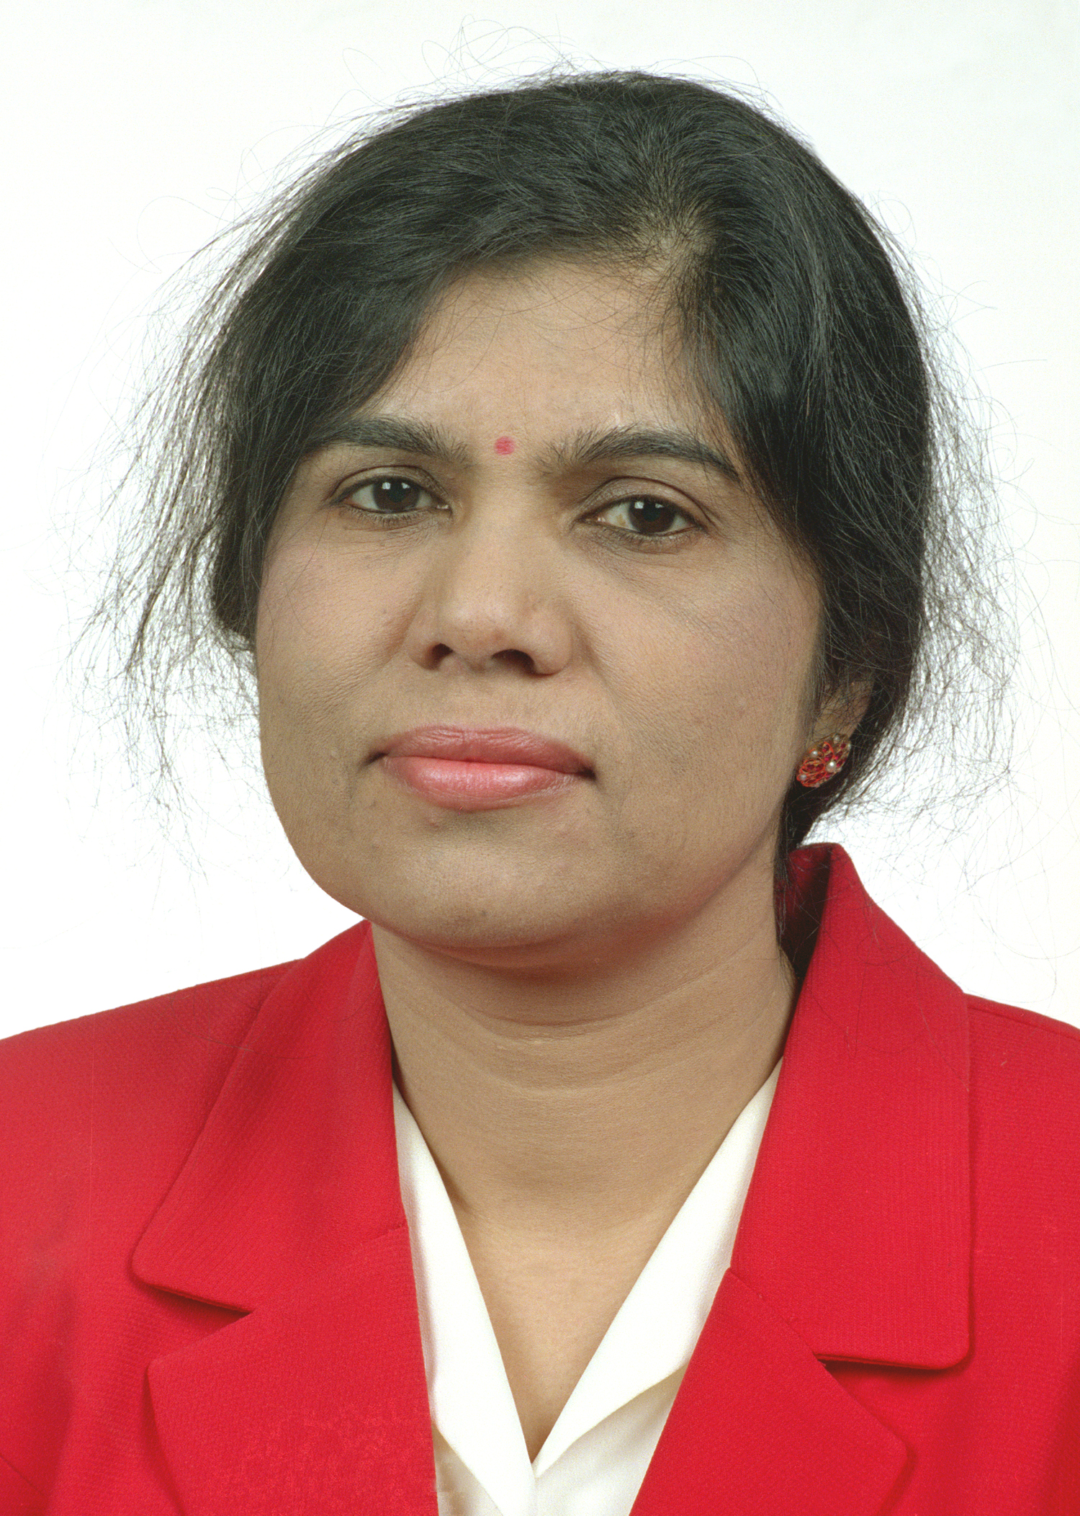
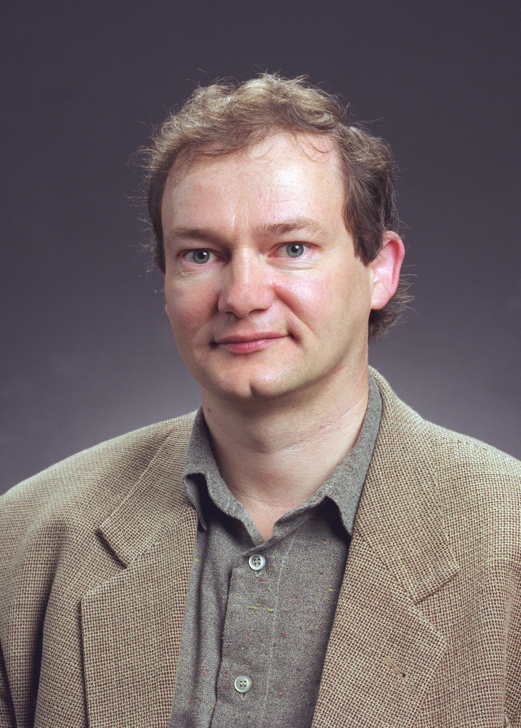
Pushpalatha Bhat
Matthias Kasemann

