Data Entry Procedures

Data Entry Overview
The Budget Execution Procedures perform the following functions:
Identify transactions and inquiry tables associated with the Budget Execution subsystem
Identify transactions and inquiry tables associated with tracking authority, commitments, obligations, and expenditures related to appropriated funds
Provide procedures to enter and process budget transactions

Data Entry Documents and Budget Levels
Funds are distributed in HUDCAPS by processing budget documents. Some levels require both an entry transaction and approval transaction prior to further distributing the funds. The following table lists the necessary transactions for each budget level.
HUDCAPS Budget Level | HUDCAPS Budget Term | Entry Document(s) | Approval Document
1 | Appropriation | Appropriation/ Apportionment(AA), and Appropriation Transfer (TA) | Appropriation Transfer Approval (TC)
2 | Apportionment | Appropriation/ Apportionment (AA) | Apportionment Approval (PA)
3 | Advice of Allotment | PAS Advice of Allotment (B4) or Budget Execution (BE) | - None -
4 | Distribution to Program/Object Class | PAS Distribution to Pgm/Obj Cls (B5) or Budget Execution (BE) | - None -
5 | Distribution to Program | PAS Distribution to Program (B6) or Budget Execution (BE) | - None -
6 | Assignment/Operating Budget (level 1) | Assignment/Operating Budget (SA) | - None -
7 | Assignment/ Operating Budget (level 2) | Assignment/Operating Budget (SA) | - None -
8 | Assignment/Operating Budget (level 3) | Assignment/Operating Budget (SA) | - None -

Use the Budget Execution Document (BE) for entry of the administrative funds.

Verify Fund Availability
Prior to processing a HUDCAPS budget document, fund availability should be verified by scanning the budget inquiry table which corresponds to the preceding budget level.
HUDCAPS Budget Level | HUDCAPS  Budget Term | HUDCAPS Table
1  2  3  4  5  6  7  8 | Appropriation  Apportionment  Advice of Allotment  Distribution to Program/Object Class  Distribution to Program  Assignment/Operating Budget (Level 1)  Assignment/Operating Budget (Level 2)  Assignment/Operating Budget (Level 3) | APPR  APOR  ALOC  SALC  ALLT  SASP  SASP  SASP

Note Users can not verify fund availability at the Appropriation level, as it is the first level of distribution.

Appropriation/Apportionment for No-Year and Multi-Year Funds

Appropriation/Apportionment (AA) Document for Appropriation of No-Year and Multi-Year Funds

Record Appropriation Amount to Master Fund Code With an AA Document

Perform the following steps to process an Appropriation/Apportionment (AA) document to record appropriation amount:

Select File from the Main menu.

Select New from the File menu.

From the Document drop-down list box, select Appropriation/Apportionment (AA).

Enter the Document ID.
Note All AA document IDs referencing a no-year or multi-year fund code include the allotment holder (ex: CFO, HSNG, CPD, PIH, etc.) in the first field. The last digit of the current fiscal year, the third and fourth digit of the fund code and the # sign are included in the second field (Example: CFO 0HA#). By entering the # sign, the system will assign the next available sequentail number for the document ID prefix entered.
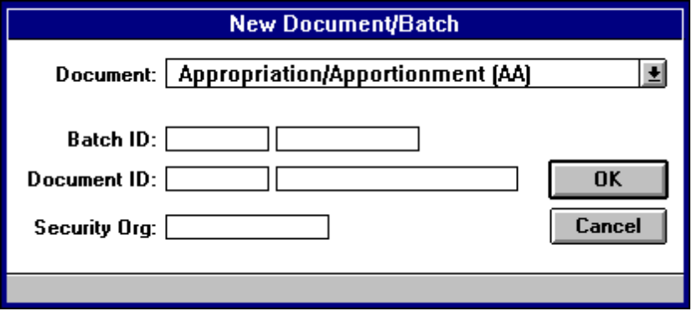

Select OK or press the Enter key.

Enter the following fields on the Appropriation tab:
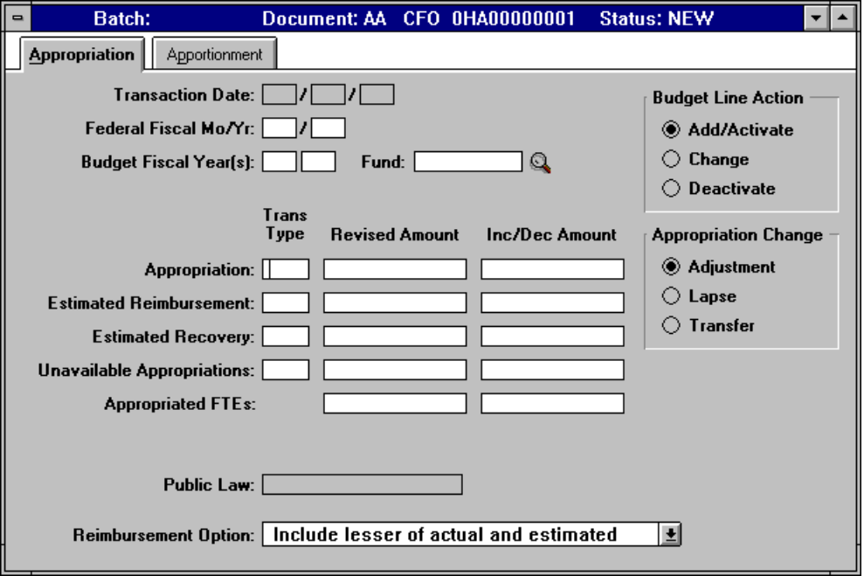

Field | Description
- Budget Fiscal Year(s) | For a no-year fund enter the last two digits of the Budget Fiscal Year. For a multi-year fund enter the last two digits of the Beginning Budget Fiscal Year and the Ending Budget Fiscal Year.
- Fund | Enter the appropriate master fund code for the no-year fund, or click on the search icon for a listing of valid fund codes.
- Budget Line Action | Select Add/Activate if this is the first AA document for the BFY/fund code, or select Change if previous AA documents have been processed for the BFY/fund code.
- Appropriation Trans Type | Enter 01 for an apportioned no-year fund.  Enter 03 for an inactive, unanticipated, unapportioned no-year fund.  Enter 04 for an unapportioned no-year fund.  Enter MY for an apportioned multi-year fund.
- Appropriation - Inc/Dec Amount | Enter the appropriation amount from the SF-132.

- Select Document from the Main menu.

- Select Edit from the Document menu.

- View the message area at the bottom of the window for warning or error messages and make the necessary changes.

Note If an error message occurs, use the Online Error Guide by double clicking on the error message. If unable to resolve the error with the Online Error Guide, call the HUDCAPS Help desk.
- Select Document from the Main menu.

- Select Process from the Document menu.

- When the message, “The document has been accepted, do you want to close the document?” appears, select Yes to close the document, or No to keep the document open.

Refer to Appendix A for examples of populated documents for a No-Year fund and a Multi-Year fund. See Example A-1.A.

Create Component Fund Record with an AA Document

Perform the following steps to process an Appropriation/Apportionment (AA) document to establish each of the Component funds:

Select File from the Main menu.

Select New from the File menu.

From the Document drop-down list box, select Appropriation/Apportionment (AA).

Enter the Document ID.
Note All AA document IDs referencing a no-year or multi-year fund code include the allotment holder (ex: CFO, HSNG, CPD, PIH, etc.) in the first field. The last digit of the current fiscal year, the third and fourth digit of the fund code and the # sign are included in the second field (Example: CFO 0HA#).

Select OK or press the Enter key.

Enter the following fields on the Appropriation tab:
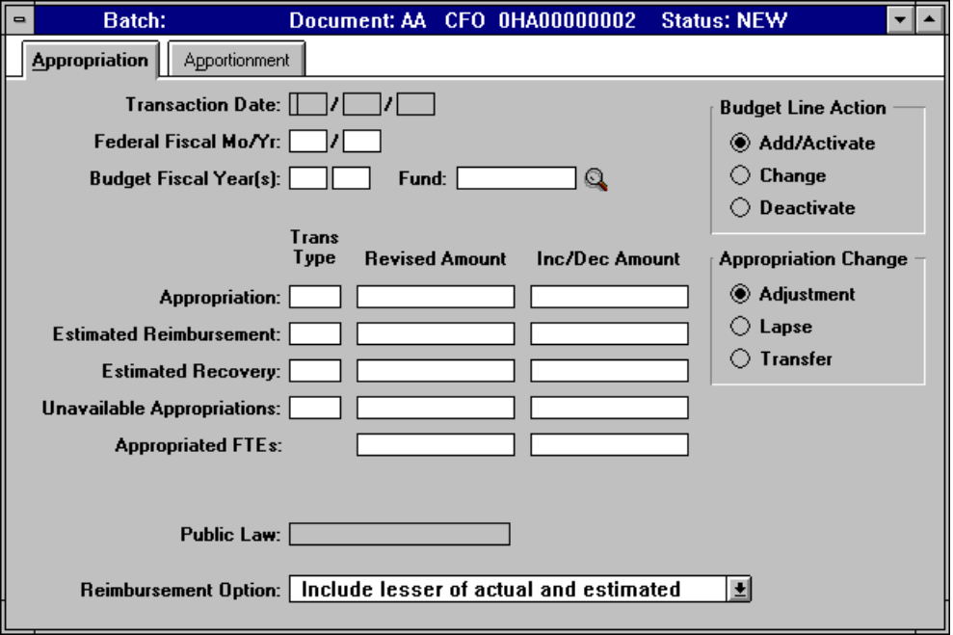

Field | Description
- Budget Fiscal Year(s) | For a no-year fund enter the last two digits of the Budget Fiscal Year. For a multi-year fund enter the last two digits of the Beginning Budget Fiscal Year and the Ending Budget Fiscal Year.
- Fund | Enter the component fund code, or click on the search icon for a listing of valid fund codes.
- Budget Line Action | Choose Add/Activate to add a new budget line.
- Appropriation Trans Type | Enter 01 for an apportioned no-year fund.  Enter 03 for an inactive, unanticipated, unapportioned no-year fund.  Enter 04 for an unapportioned no-year fund.  Enter MY for an apportioned multi-year fund.
- Inc/Dec Amount | Enter zero or leave blank (the system will interpret the Inc/Dec Amount as zero when this field is left blank).

Note No data needs to be entered on the Apportionment tab.
- Select Document from the Main menu.

- Select Edit from the Document menu.

- View the message area at the bottom of the window for warning or error messages and make the necessary changes.
Note If an error message occurs, use the Online Error Guide by double clicking on the error message. If unable to resolve the error with the Online Error Guide, call the HUDCAPS Help desk.
- Select Document from the Main menu.

- Select Process from the Document menu.

- When the message, “The document has been accepted, do you want to close the document?” appears, select Yes to close the document, or No to keep the document open.

Refer to Appendix A for examples of populated documents for a No-Year fund and a Multi-Year fund. See Example A-1.A.

Appropriation Transfer (TA) Document for Transfer from a Master Fund to a Component Fund

Transfer Funds from Master Fund to Component Fund(s) with a TA Document

Perform the following steps to process an Appropriation Transfer (TA) document to transfer funds from the Master fund to the Component fund(s) for no-year funds:

Select File from the Main menu.

Select New from the File menu.

From the Document drop-down list box, select Appropriation Transfer (TA).

Enter the Document ID.
Note All TA document IDs referencing a no-year or multi-year fund code include the allotment holder (ex: CFO, HSNG, CPD, PIH, etc.) in the first field. The last digit of the current fiscal year, the third and fourth digit of the fund code and the # sign are included in the second field (Example: CFO 0HA#).
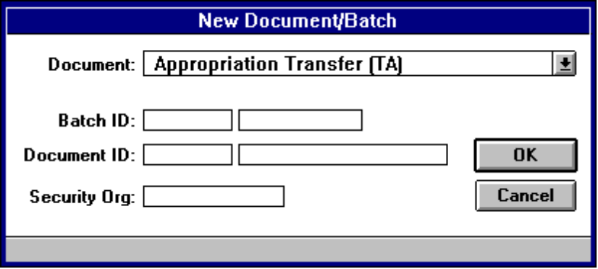

Select OK or press the Enter key.

Enter the following fields on the Main tab:
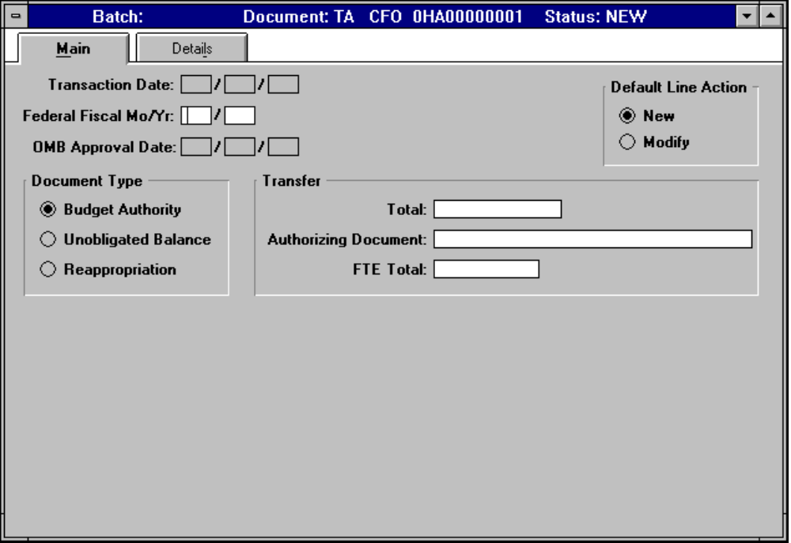

Field | Description
- Default Line Action | Select New.
- Document Type | Select Budget Authority.
- Transfer Total | Enter the amount to be transferred.
- Transfer Authorizing Document | Enter SF-132, appropriation symbol and approved date.

- Refer to Appendix A for example of populated document. See Example A-1.B.

Enter the following fields on the Details tab:
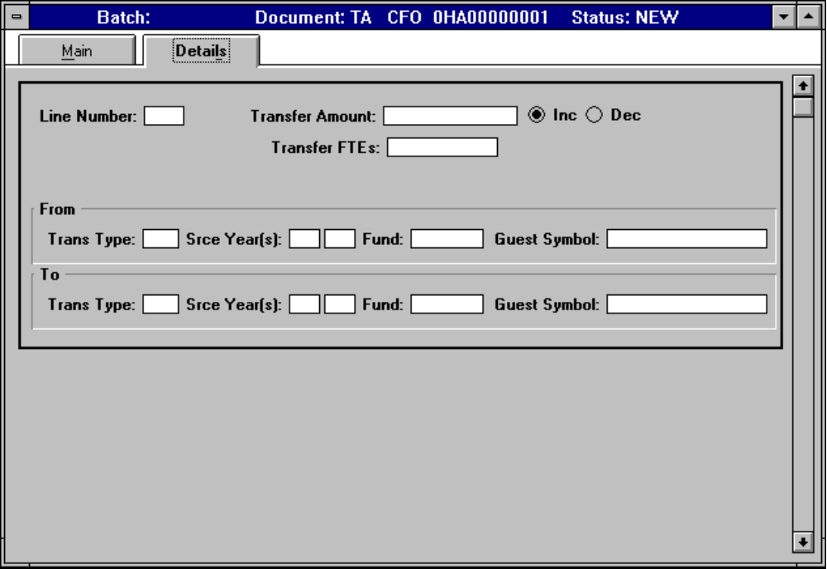

Field | Description
- Line Number | Enter the appropriate three digit line number (001 for the first line, 002 for the second line, etc.).
- Transfer Amount | Enter the dollar amount to transfer.
- Inc | Select the radio button to increase funds.
- From Trans Type | Enter the transaction type MC for current year funds.
- From Srce Year(s) | Enter the last two digits of the Budget Fiscal Year.
- From Fund | Enter the fund code of the Master fund from which the amount is being transferred.
- To Trans Type | Enter the transaction type MC for current year funds.
- To Srce Year(s) | Enter the last two digits of the Budget Fiscal Year.
- To Fund | Enter the fund code of the Component fund to which the amount is being transferred.

                - Select Document from the Main menu.

                - Select Edit from the Document menu.

                - View the message area at the bottom of the window for warning or error messages and make the necessary changes.
Note If an error message occurs, use the Online Error Guide by clicking on the error message. If unable to resolve the error with the Online Error Guide, call the HUDCAPS Help desk.
                - Select Document from the Main menu.

                - Select Process from the Document menu.

                - When the message, “The document has been accepted, do you want to close the document?” appears, select Yes to close the document, or No to keep the document open.

- Refer to Appendix A for example of populated document. See Example A-1.B.

Appropriation Transfer Approval (TC) Document

Approve Transfer with TC Document

Perform the following steps to process the Appropriation Transfer Approval (TC) Document:

Select File from the Main menu.

Select New from the File menu.

From the Document drop-down list box, select Appropriation Transfer Approval (TC).

Enter the Document ID.
Note All TC document IDs referencing a no-year or multi-year fund code include the allotment holder (ex: CFO, HSNG, CPD, PIH, etc.) in the first field. The last digit of the current fiscal year, the third and fourth digit of the fund code and the # sign are included in the second field (Example: CFO 0HA#). By entering the # sign, the system will assign the next available sequential number for the document ID prefix entered.
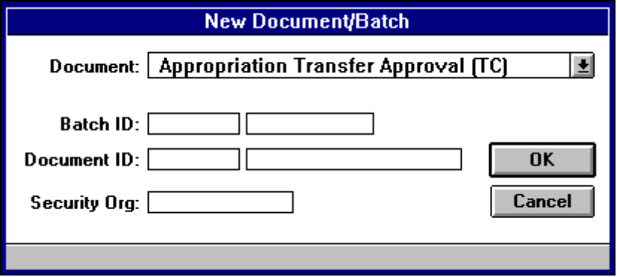

Select OK or press the Enter key.

Enter the following fields on an Appropriation Transfer Approval (TC) document:
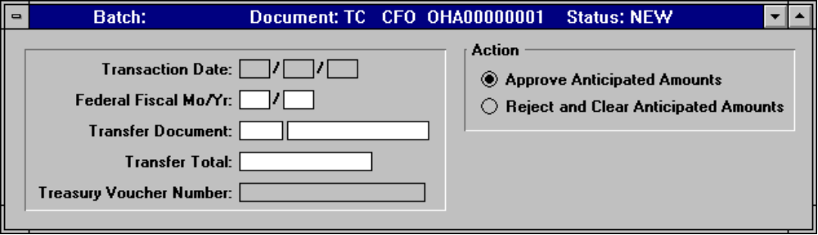

Field | Description
- Transfer Document | Enter the document ID of the Appropriation Transfer (TA) being approved. Enter TA in the first box and the Document ID in the second box.
- Transfer Total | Enter the total dollar amount to approve (as entered on the Main tab of the TA).
- Treasury Voucher Number | Enter SF-132.
- Action | Select Approve Anticipated Amounts or Reject and Clear Anticipated Amounts.

                - Select Document from the Main menu.

                - Select Edit from the Document menu.

                - View the message area at the bottom of the window for warning or error messages and make the necessary changes.

Note If an error message occurs, use the Online Error Guide by double clicking on the error message. If unable to resolve the error with the Online Error Guide, call the HUDCAPS Help desk.
                - Select Document from the Main menu.

                - Select Process from the Document menu.

                - When the message, “The document has been accepted, do you want to close the document?” appears, select Yes to close the document, or No to keep the document open.
- Refer to Appendix A for example of populated document. See Example A-1.C.

Appropriation/Apportionment (AA) Document for Apportionment of No-Year and Multi-Year Funds
Funds transferred from a master fund code to a component fund code must be apportioned by the component fund code. Funds are not apportioned by the master fund code. Apportionment of component fund codes cannot take place until funds have been transferred to the component fund code by an Appropriation Transfer (TA) Document, and have been approved of by an Appropriation Transfer Approval (TC) Document. Subsequently, an Appropriation/Apportionment (AA) Document is required to apportion funds transferred to component fund codes of no-year appropriations.

Verify Funds with APPR

The Appropriation Query (APPR) is displayed as follows:

Select Options from the Main menu.

Select Tables and Queries from the Options menu.

Click on the Category drop-down list and select Budget Execution.

Select the Appropriation Query (APPR).

Choose the OK button.
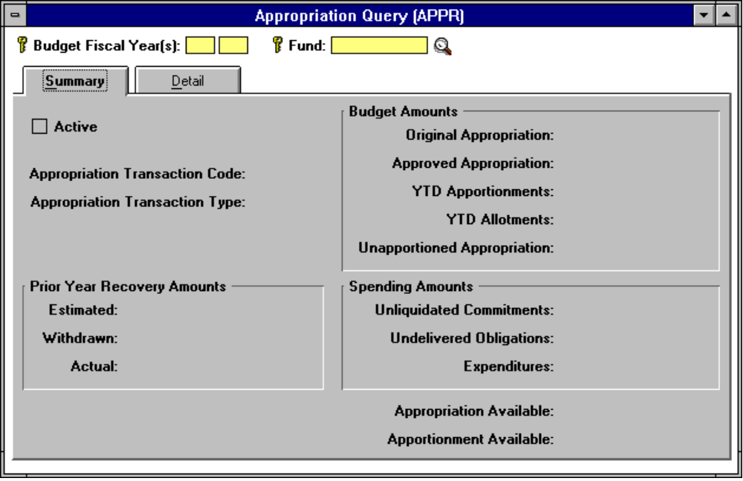

Enter the last two digits of the Budget Fiscal Year in the Budget Fiscal Year(s) field, and enter the fund code in the Fund field.

Select Actions from the Main menu.

Select Display from the Actions menu.

Verify funds available in the Unapportioned Appropriation field.
          - Refer to Appendix A for example of populated document. See Example A-8.A.

Apportion Funds with an AA Document

Perform the following steps to process an Appropriation/Apportionment (AA) document:

Select File from the Main menu.

Select New from the File menu.

From the Document drop-down list box, select Appropriation/Apportionment (AA).

Enter the Document ID.
Note All AA document IDs referencing a no-year or multi-year fund code include the allotment holder (ex: CFO, HSNG, CPD, PIH, etc.) in the first field. The last digit of the current fiscal year, the third and fourth digit of the fund code and the # sign are included in the second field (Example: CFO 0HA#). By entering the # sign, the system will assign the next available sequential number for the document ID prefix entered.

Select OK or press the Enter key.

Enter the following fields on the Appropriation tab:
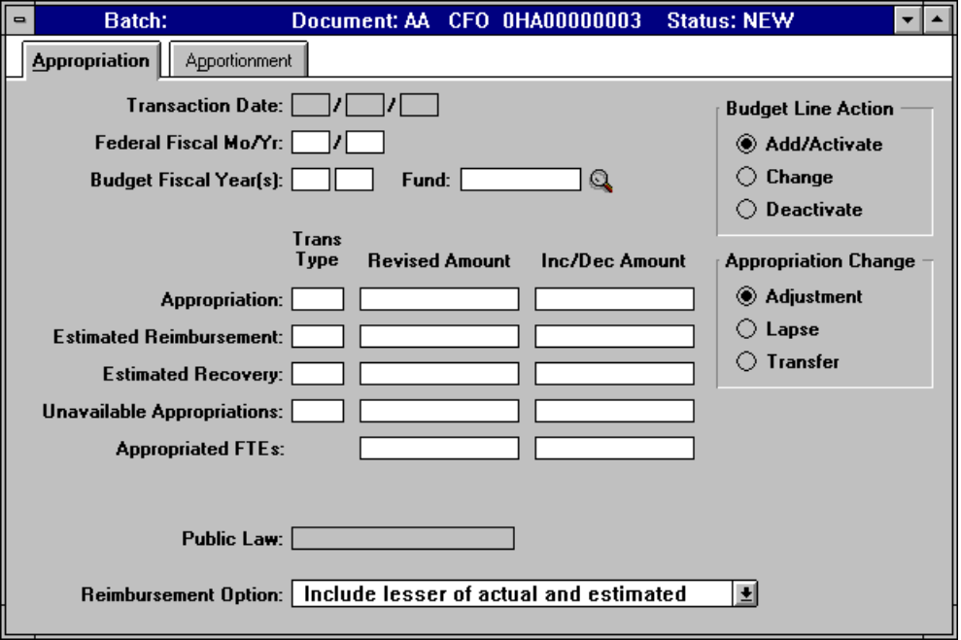

Field | Description
- Budget Fiscal Year(s) | Enter the last two digits of the Budget Fiscal Year.
- Fund | Enter the Component fund code.
- Budget Line Action | Defaults to Add/Activate. Select Change.

Note Do NOT enter any additional data on the Appropriation tab.
- Refer to Appendix A for example of populated documents for a No-Year fund and a Multi-Year fund. See Example A-1.D.

Select the Apportionment tab and enter the following fields:
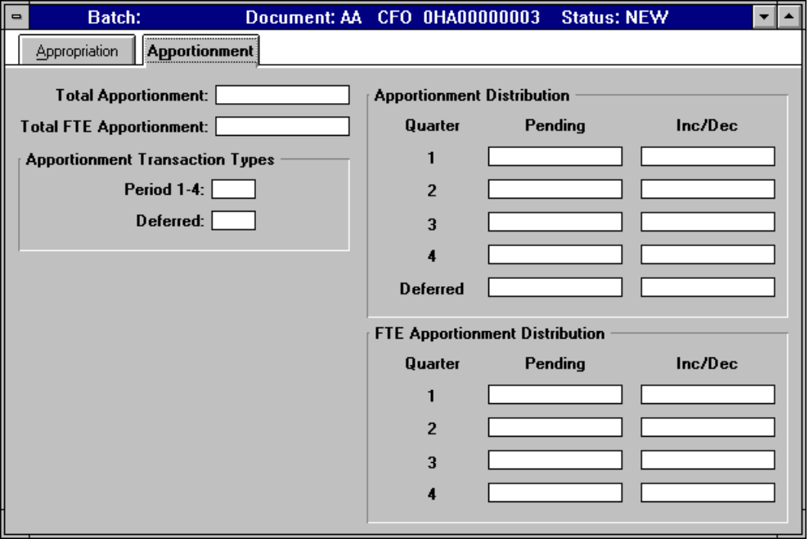

Field | Description
- Apportionment Transaction Types Period 1-4 | Enter PA (Pending Apportionment).
- Apportionment Distribution Inc/Dec | Enter the dollar amount of the transaction. The amount must include a decimal and cents (enter two zeros if it is an even dollar amount). Apportion all program funds in quarter 1, and distribute administrative funds by the applicable quarters.

                - Select Document from the Main menu.

                - Select Edit from the Document menu.

                - View the message area at the bottom of the window for warning or error messages and make the necessary changes.

                - Select Document from the Main menu.

                - Select Process from the Document menu.

                - When the message, “The document has been accepted, do you want to close the document?” appears, select Yes to close the document, or No to keep the document open.

- Refer to Appendix A for example of populated document. See Example A-1.D.

Apportionment Approval (PA) Document for No-Year and Multi-Year Funds

Approve Pending Apportionment with PA Document

Perform the following steps to process the Apportionment Approval (PA) document to approve and post pending apportionment amounts:

Select File from the Main menu.

Select New from the File menu.

From the Document drop-down list box, select Apportionment Approval (PA).

Enter the Document ID.
Note All PA document IDs referencing a no-year or multi-year fund code include the allotment holder (ex: CFO, HSNG, CPD, PIH, etc.) in the first field. The last digit of the current fiscal year, the third and fourth digit of the fund code and the # sign are included in the second field (Example: CFO 0HA#). By entering the # sign, the system will assign the next available sequential number for the document ID prefix entered.
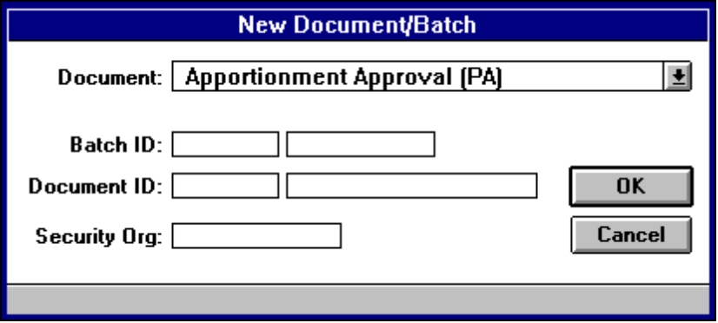

Select OK or press the Enter key.

Enter the following fields on the Apportionment Approval (PA) document:
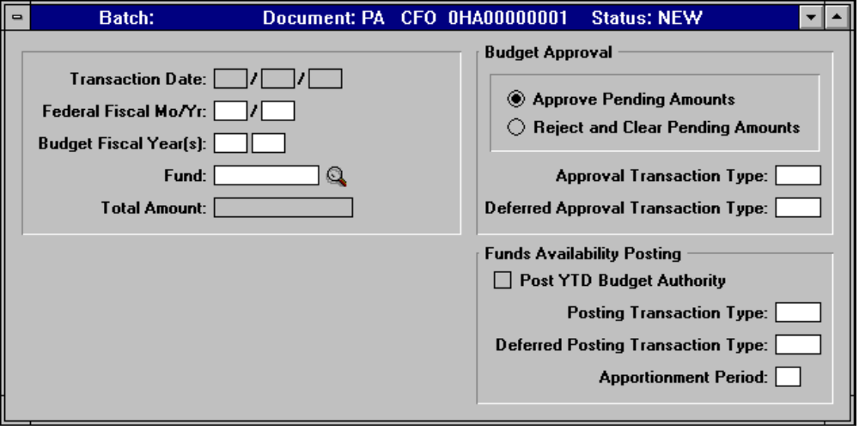

Field | Description
- Budget Fiscal Year(s) | Enter the last two digits of the Budget Fiscal Year.
- Fund | Enter the fund code, or click on the search icon for a listing of valid fund codes.
- Budget Approval | Defaults to Approve Pending Amounts. Must select Reject and Clear Pending Amounts to reject and clear pending amounts.
- Approval Transaction Type | Enter AP.
- Post YTD Budget Authority | Select the box (ensure that there is an x in the box).
- Posting Transaction Type | Enter 01.
- Apportionment Period | Enter the appropriate period through which you are posting authority. Valid values are 1, 2, 3, 4.

                - Select Document from the Main menu.

                - Select Edit from the Document menu.

                - View the message area at the bottom of the window for warning or error messages and make the necessary changes.

Note If an error message occurs, use the Online Error Guide by double clicking on the error message. If unable to resolve the error with the Online Error Guide, call the HUDCAPS Help desk.
                - Select Document from the Main menu.

                - Select Process from the Document menu.

                - When the message, “The document has been accepted, do you want to close the document?” appears, select Yes to close the document, or No to keep the document open.

- Refer to Appendix A for example of populated documents for a No-Year fund and a Multi-Year fund. See Example A-1.E.

Verify Approval with Apportionment Query (APOR)
The Apportionment Query (APOR) is used to review information about the status of an apportionment including the year-to-date apportioned, committed, obligated, and expended amounts.

The Apportionment Query (APOR) is displayed as follows:

Select Options from the Main menu.

Select Tables and Queries from the Options menu.

Click on the Category drop-down list and select Budget Execution.

Select the Apportionment Query (APOR).

Choose the OK button.
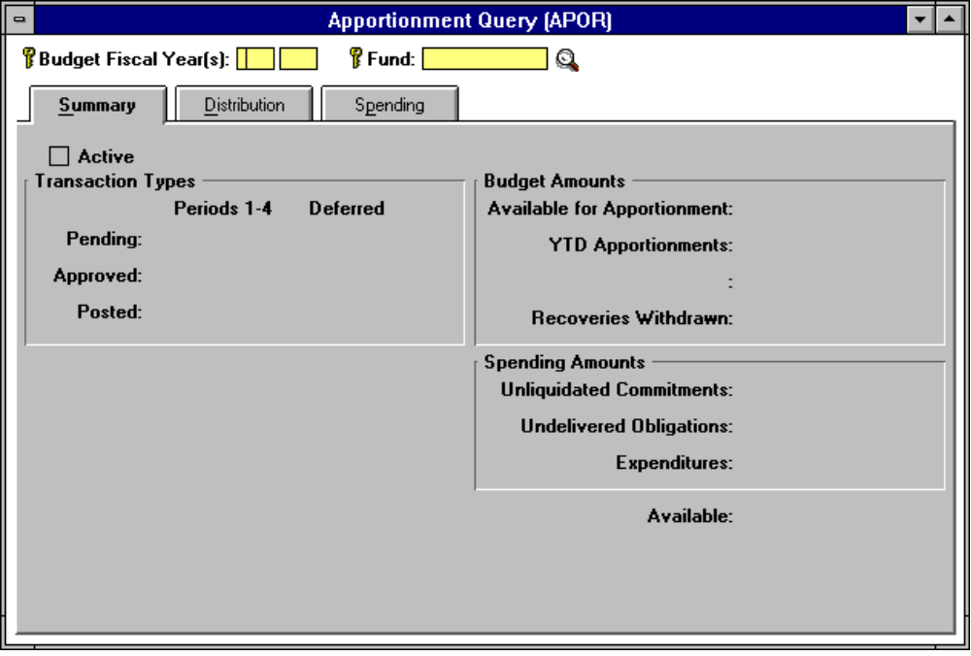

Enter the last two digits of the Budget Fiscal Year(s) in the Budget Fiscal Year(s) field (for a multi-year fund, enter the last two digits of the beginning year and the last two digits of the ending year), and enter the fund code in the Fund field.

Select Actions from the Main menu.

Select Display from the Actions menu.

- Refer to Appendix A for example of populated document. See Example A-9.A.

Click on the Distribution tab to view fund availability in the Quarterly Apportionments Approved field(s).
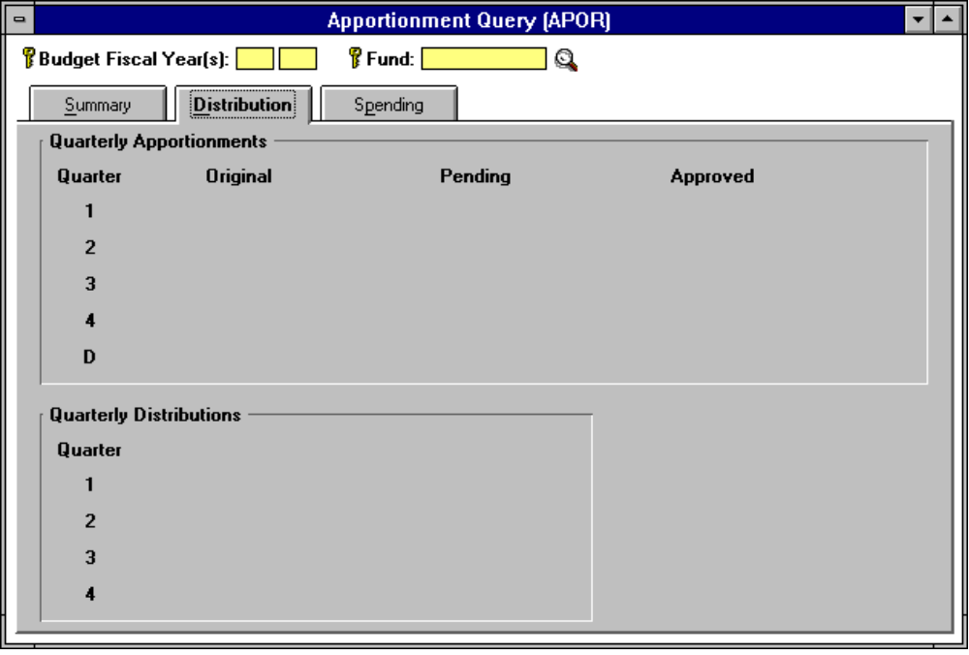

- Refer to Appendix A for example of populated document. See Example A-9.B.

Appropriation/Apportionment Annual Funds

Processing an Appropriation/Apportionment (AA) Document for Annual Funds

Record Appropriation Amount with an AA Document

Perform the following steps to process an Appropriation/Apportionment (AA) document to record appropriation amount:

Select File from the Main menu.

Select New from the File menu.

From the Document drop-down list box, select Appropriation/Apportionment (AA).

Enter the Document ID.
Note The AA Document ID referencing an annual fund includes the last digit of the current fiscal year, the last 4 digits of the Treasury symbol and the # sign in the second field (Example: CFO 00143#). By entering the # sign, the system will assign the next available sequential number for the document ID prefix entered.

Select OK or press the Enter key.

Enter the following fields on the Appropriation tab:
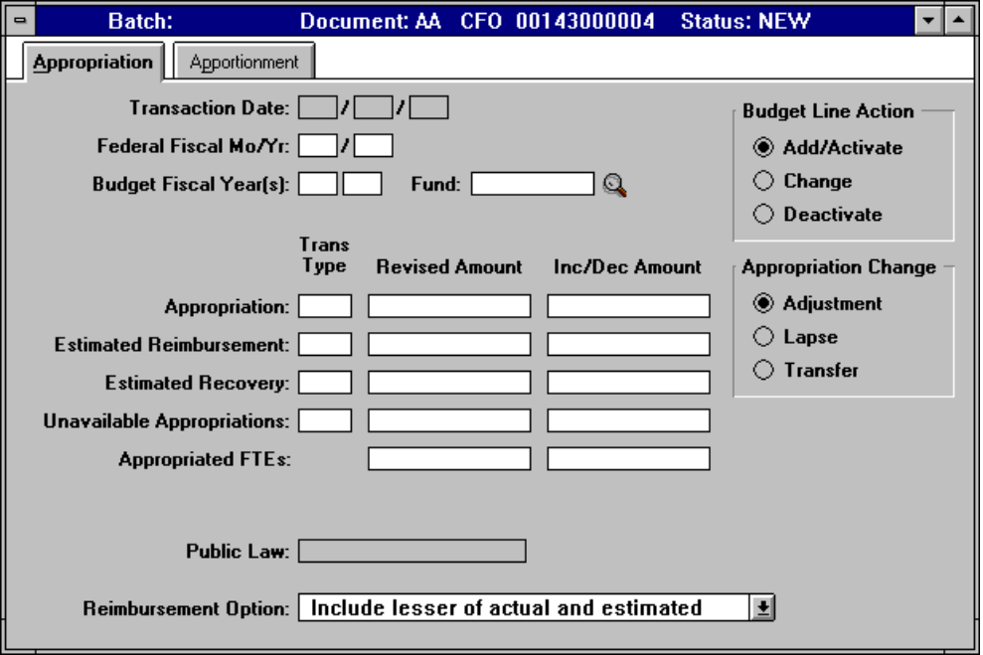

Field | Description
- Budget Fiscal Year(s) | Enter the last two digits of the Budget Fiscal Year(s).
- Fund | Enter the appropriate fund code for the annual fund, or click on the search icon for a listing or valid fund codes.
- Budget Line Action | Select Add/Activate if this is the first AA document for the BFY/fund code, or select Change if previous AA documents have been processed for the BFY/fund code.
- Appropriation Trans Type | Enter transaction type 01.
- Appropriation - Inc/Dec Amount | Enter the appropriation amount from the SF-132.

- Refer to Appendix A for example of populated document. See Example A-2.A.

Select the Apportionment tab and enter the following fields:
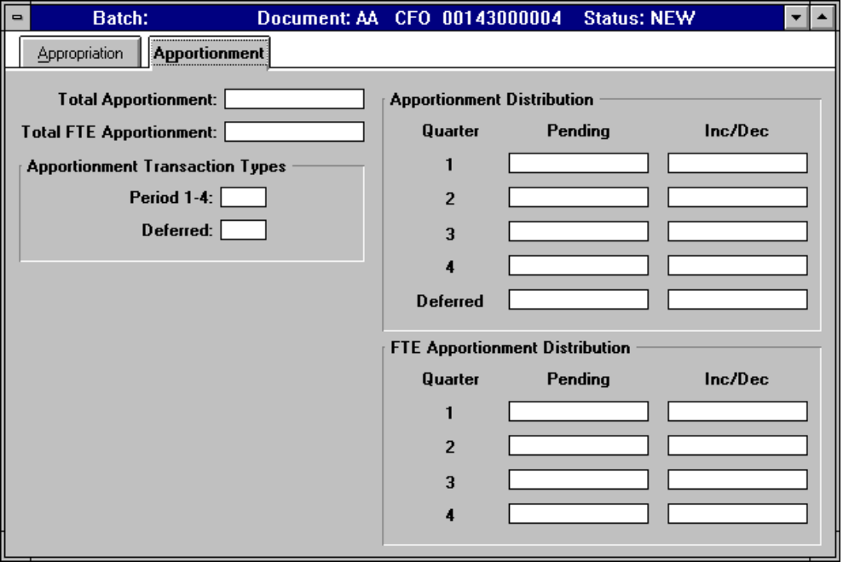

Field | Description
- Apportionment Transaction Types Period 1-4 | Enter PA (Pending Apportionment).
- Apportionment Distribution Inc/Dec | Enter the dollar amount of the transaction. The amount must include a decimal and cents (enter two zeros if it is an even dollar amount). Apportion all program funds in quarter 1, and distribute administrative funds by the applicable quarters.

                - Select Document from the Main menu.

                - Select Edit from the Document menu.

                - View the message area at the bottom of the window for warning or error messages and make the necessary changes.

                - Select Document from the Main menu.
                - Select Process from the Document menu.
                - When the message, “The document has been accepted, do you want to close the document?” appears, select Yes to close the document, or No to keep the document open.
- Refer to Appendix A for example of populated document. See Example A-2.A.

Apportionment Approval (PA) Document for Annual Funds

Approve Apportionment with PA Document

Perform the following steps to process the Apportionment Approval (PA) document to approve and post pending apportionment amounts:

Select File from the Main menu.

Select New from the File menu.

From the Document drop-down list box, select Apportionment Approval (PA).

Enter the Document ID.
Note The PA Document ID referencing an annual fund includes the last digit of the current fiscal year, the last 4 digits of the Treasury symbol and the # sign in the second field (Example: CFO 00143#). By entering the # sign, the system will assign the next available sequential number for the document ID prefix entered.

Select OK or press the Enter key.

Enter the following fields on the Apportionment Approval (PA) document:
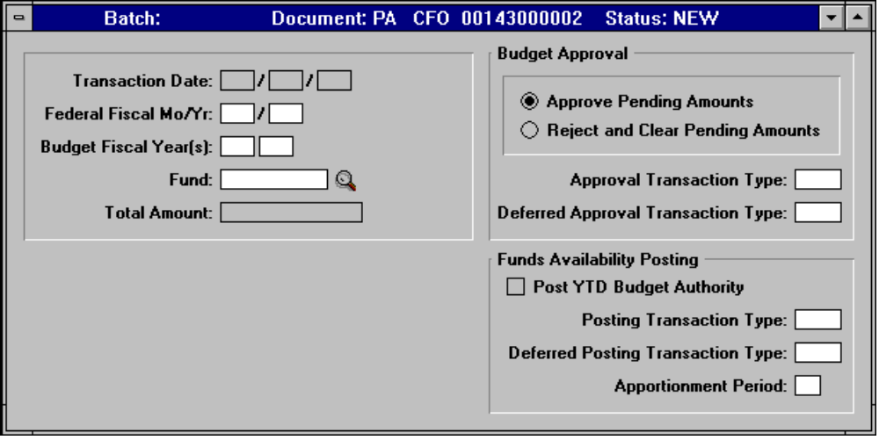

Field | Description
- Budget Fiscal Year(s) | Enter the last two digits of the Budget Fiscal Year(s).
- Fund | Enter the fund code, or click on the search icon for a listing of valid fund codes.
- Budget Approval | Defaults to Approve Pending Amounts. Must select Reject and Clear Pending Amounts to reject and clear pending amounts.
- Approval Transaction Type | Enter AP.
- Post YTD Budget Authority | Select the box (ensure that there is an x in the box).
- Posting Transaction Type | Enter 01.
- Apportionment Period | Enter the appropriate period through which you are posting authority. Valid values are 1, 2, 3, 4.

                - Select Document from the Main menu.

                - Select Edit from the Document menu.

                - View the message area at the bottom of the window for warning or error messages and make the necessary changes.
Note If an error message occurs, use the Online Error Guide by double clicking on the error message. If unable to resolve the error with the Online Error Guide, call the HUDCAPS Help desk.
                - Select Document from the Main menu.

                - Select Process from the Document menu.

                - When the message, “The document has been accepted, do you want to close the document?” appears, select Yes to close the document, or No to keep the document open.

- Refer to Appendix A for example of populated document. See Example A-2.B.

Verify Approval with Apportionment Query (APOR)
The Apportionment Query (APOR) is used to review information about the status of an apportionment including the year-to-date apportioned, committed, obligated, and expended amounts.

The Apportionment Query (APOR) is displayed as follows:

Select Options from the Main menu.

Select Tables and Queries from the Options menu.

Click on the Category drop-down list and select Budget Execution.

Select the Apportionment Query (APOR).

Choose the OK button.

Enter the last two digits of the Budget Fiscal Year(s) in the Budget Fiscal Year(s) field and enter the fund code in the Fund field.

Select Actions from the Main menu.

Select Display from the Actions menu.
          - Refer to Appendix A for example of populated document. See Example A-9.A.

Click on the Distribution tab to view fund availability in the Quarterly Apportionments Approved field(s).

- Refer to Appendix A for example of populated document. See Example A-9.B.

