Muon Acceleration
V. Lebedev
Jefferson Lab

MUTAC,
BNL, June 2000

Contents
- Machine layout and main parameters
- Linear preaccelerator
- First recirculator (RLA1)
  - 400 MHz versus 200 MHz for the second RLA
- Main recirculator (RLA2)
- Conclusions

1. Machine layout and main parameters

Basic MAD Parameters
Injection momentum / kinetic energy | 190/112 MeV
Final energy | 50 GeV
Initial rms normalized emittance | 1500 mm⋅mrad
Initial rms momentum spread / bunch length | 0.11 / 12 cm
Number of bunches per pulse | 30 ^{x} 4
Number of particles per bunch / per pulse | 10¹¹ / 3⋅10¹²
Bunch frequency / accelerating frequency | 200/200 MHz
Repetition rate | 15 Hz
Beam current in micropulse | 0.8 A
Beam power | 360 kW

Accelerator layout
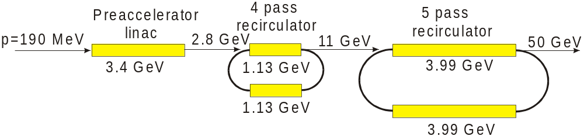

Major Points to be Addressed
- Is it possible to accelerate fast enough to prevent a decay of muons
- How to capture and accelerate a huge emittance and energy spread
  - Which energy is appropriate to start recirculation
  - Number of recirculation stages and number of passes per recirculator
  - Lattice type and chromaticity correction
  - Accelerating frequency
- Coherent beam stability

Muon Decay
  - Muon decay time - 2.2 μs
  - Accelerating gradient of 15 MV/m
    - Real estate accelerating gradient in linac – 8.2 MV/m
    - Real estate accelerating gradient in recirculators – 3 MV/m
  - 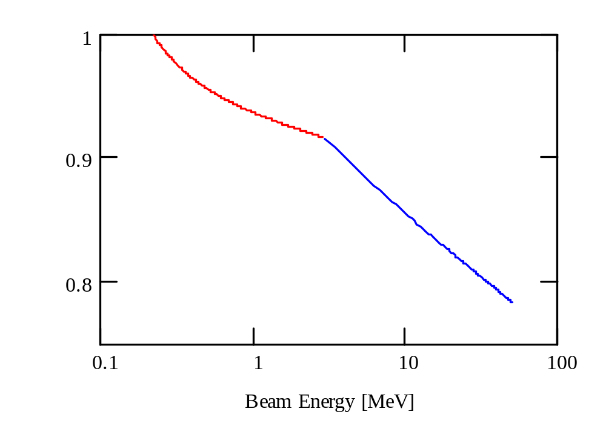Decay losses depend approximately linearly on the accelerating gradient
Red line – decay in linear accelerating part
Blue line – decay in recirculators

Linear Preaccelerator
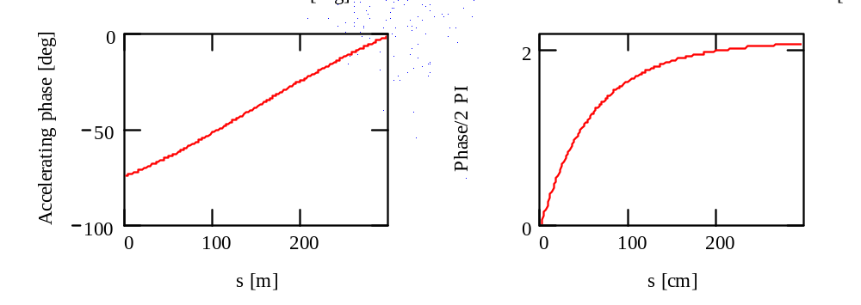
Accelerating phase along linac Synchrotron phase along the linac
- The final energy (2.8 GeV) is set by RF phase slip for higher passes
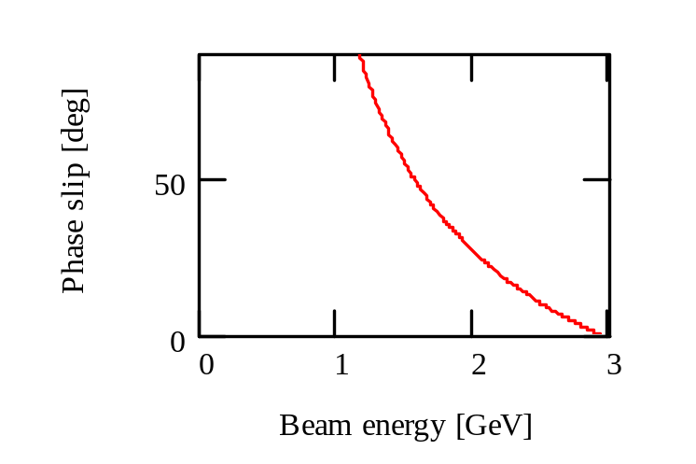
- Longitudinal (synchrotron) motion in the initial part
  - suppresses effect of non-linearities in the longitudinal phase space
  - allows to perform the beam bunching
  - reduces effective accelerating gradient (total voltage of 2.4 GV instead 1.9 GV)

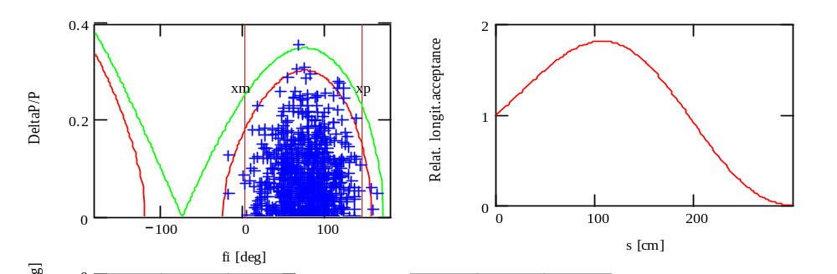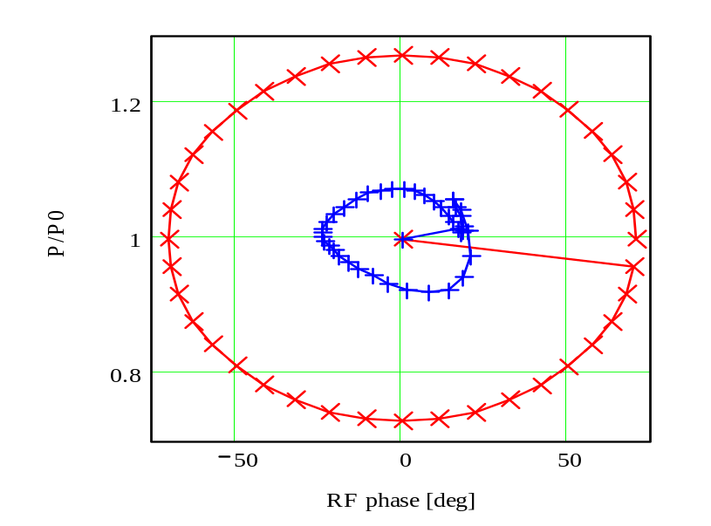
Figure 1. Separatrix size at the beginning of acceleration

Figure 2. Relative size of longitudinal acceptance along linac

Figure 3. Phase space before and after acceleration for particles at 2.5σ (95% of particles)
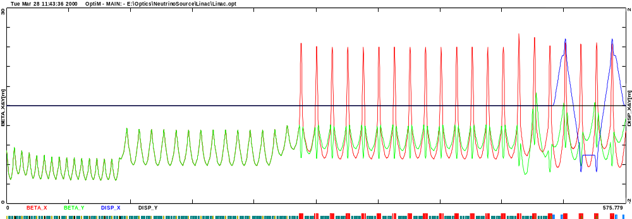
Beta-function in linear preaccelerator; acceleration from 112 MeV to 2856 MeV
Focusing
B₀= 7.5 kG (L=50 cm, 2a=40 cm)
B₁=10.5 kG (L=50 cm, 2a=40 cm)
…
B₂₁=49 kG (L=50 cm, 2a=20 cm)
G_{F27}=0.24 kG/cm (L=110 cm)
G_{D27}=-0.24 kG/cm *2 (L=60 cm)
…

RF
15 MV/m accelerating gradient
16 cryomodules of 5 m length
2 two-cell cavities per cryomodule
45 MV per cryomodule
30 cryomodules of 10 m length
4 two-cell cavities per cryomodule
90 MV per cryomodule
Maximum beam size in the cavity R=20 cm

Single Particle Tracking for the Linear Preaccelerator
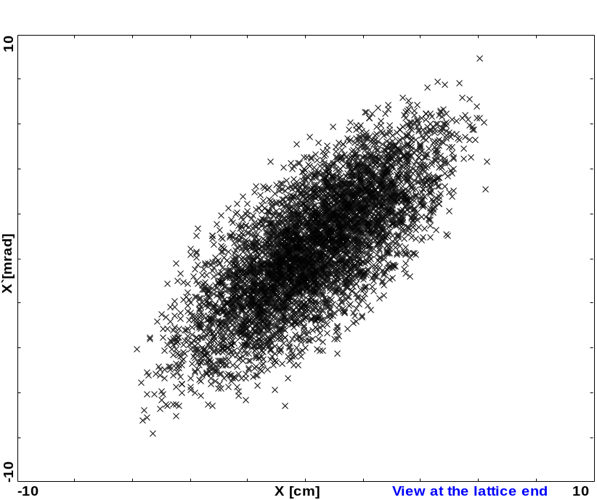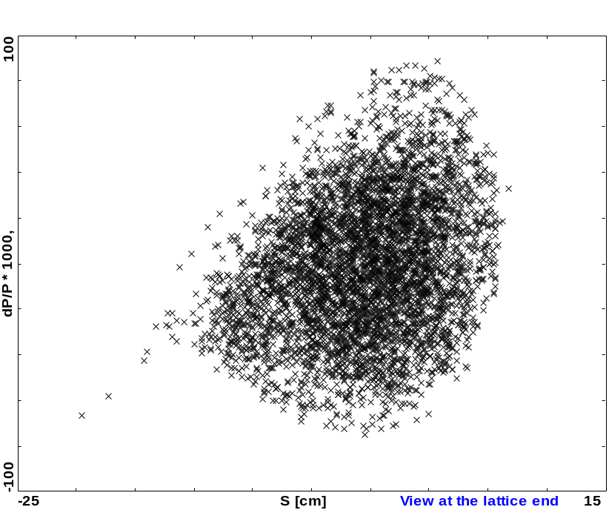

Horizontal and longitudinal phase spaces at the linac end
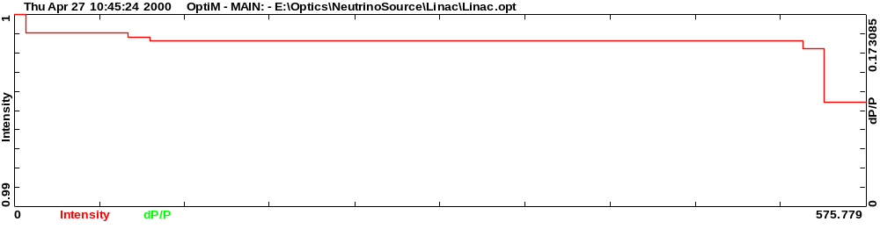
Beam losses along the linac
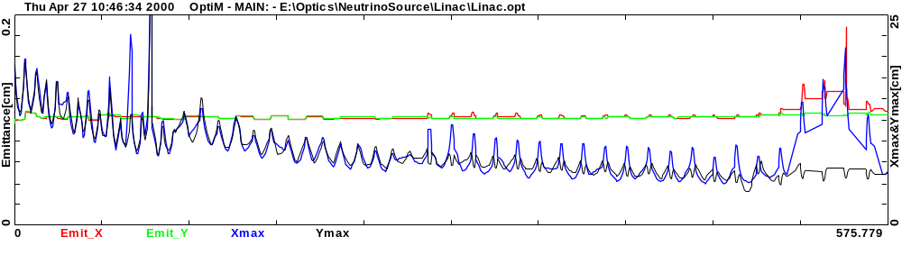
Rms emittance and maximum beam size (maximum particle displacement) along the linac. Rapid beam size decreases correspond to scraping of the particles with large amplitude

Tracking results for the Linear Preaccelerator
- Initial particle distribution
  - Gaussian distribution
    - Distribution truncated at 2.5 σ in 6D space
      - 30% of particles are cut from the distribution
    - Transverse rms emittance of 834 mm⋅mrad (1500 mm⋅rad normalized) is converted to 540 mm mrad after the truncation
    - Transverse acceptance of 5200 mm⋅mrad (9400 mm⋅rad normalized)
    - Rms bunch length - 12 cm
    - Rms energy spread - 0.11
- Less than 1% of particles are lost in the course of acceleration
  - transverse motion “instability” for off-momentum particles with large amplitudes
- No significant emittance growth
  - Final rms emittance - ε_{x} / ε_{y} = 40 / 39 mm⋅mrad
    - Horizontal emittance growth – 9% (Injection chicane)
    - Vertical emittance growth – 6%
  - Final rms energy spread - 0.03
- Output acceptance
  - Transverse acceptance - 430 mm⋅rad
  - Energy spread - ±0.083

First Recirculator (RLA1)

Main parameters for the RLA1

Initial energy | 2.856 GeV
Final energy | 11 GeV
Number of passes | 4
Total initial energy acceptance | ±6%
Total final energy acceptance | ±2 (4.1*) %
Initial transverse acceptance | 430 mm⋅rad
Final transverse acceptance !!! | 160 mm⋅rad ?
Emittance dilution (5% per arc) !!! | 40% ?
Total voltage per linac | 1.13 (1.23*)GV
Circumference | ~840 m

*400 MHz scenario

Longitudinal dynamics in the RLA1

Effect of the second RLA accelerating frequency on the design of the first RLA or 400 MHz versus 200 MHz for second RLA

Parameters for acceleration in the first recirculator
 | 200 MHz* |  |  | 400 MHz*
 | Kinetic energy [GeV] | Gang phase [deg] | Total energy spread, 2Δp/p [%] | Kinetic energy [GeV] | M₅₆ [cm] | Gang phase [deg] | Total energy spread, 2Δp/p [%]
Entrance | 2.89 | 5 | 11.9 | 2.89 |  | 6 | 11.7
Arc 1 | 4 | -26 | 9.3 | 4.11 | 60 | -22 | 9.0
Arc 2 | 5 | -26 | 8.7 | 5.25 | 60 | -25 | 9.9
Arc 3 | 6 | -26 | 7.5 | 6.36 | 60 | -29 | 9.8
Arc 4 | 7 | -26 | 7.5 | 7.43 | 60 | -38 | 9.2
Arc 5 | 8 | -26 | 6.9 | 8.40 | 50 | -45 | 9.6
Arc 6 | 9 | -26 | 6.1 | 9.26 | 50 | -45 | 9.9
Arc 7 | 10 | -26 | 5.1 | 10.13 | 50 | -45 | 9.5
Exit | 11 |  | 4.0 | 11 | 50 |  | 8.2
* M₅₆ = 1.1 m, Total voltage per linac = 1.113 GV at 200 MHz
** Total voltage per linac = 1.227 GV at 200 MHz
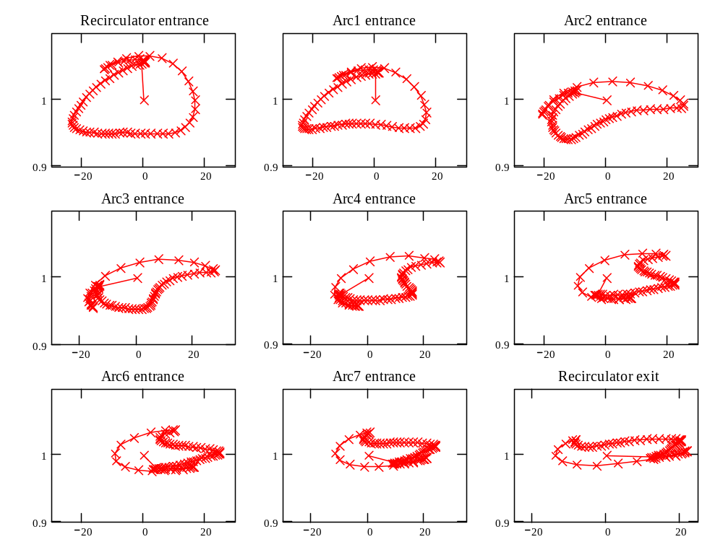
Longitudinal phase space in the first recirculator, 200 MHz scenario
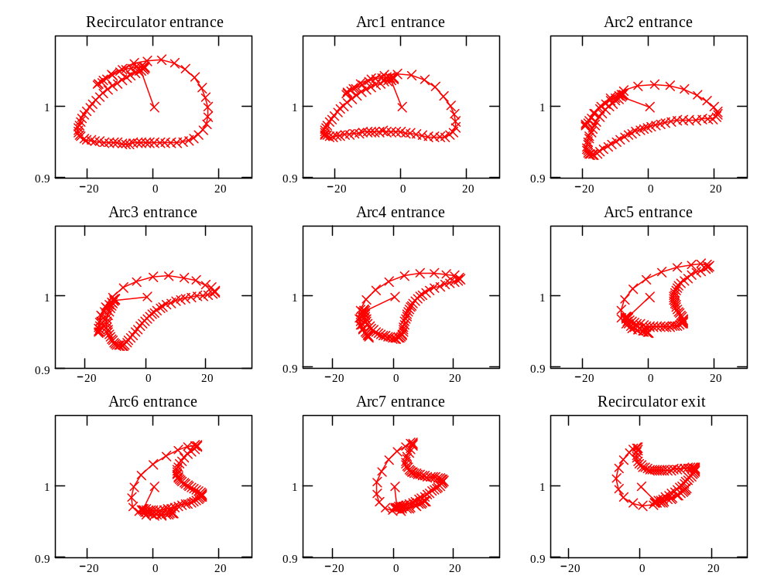
Longitudinal phase space in the first recirculator, 400 MHz scenario

Optics for RLA1
- General requirements for optics
  - Large energy spread
    - High symmetry lattice to accommodate large energy spread
  - Large acceptance
    - Small beta-functions
  - M₅₆ (~1 m)
  - It is a recirculator not a storage ring
    - Corrected chromaticity of the beam envelopes not tunes
        - A strategy for optics chromatic correction can be different
  - 2T dipoles for highest energy arc
- Spreaders and recombiners
  - Horizontal
  - Avoid dipoles with strongly separated beams

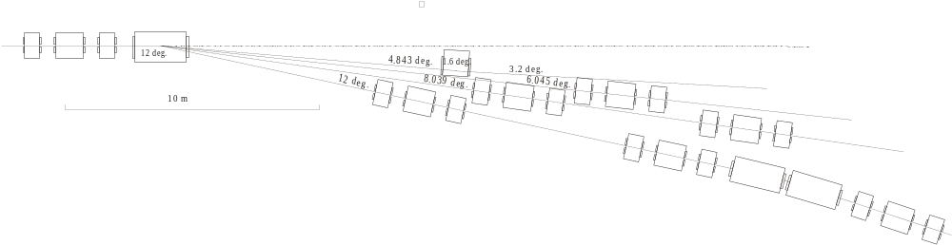

Choice of focusing structure
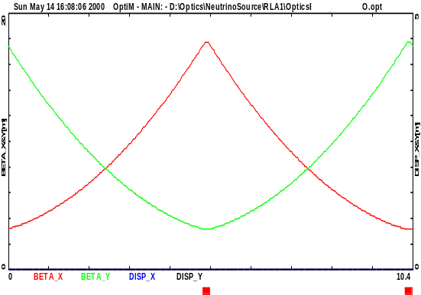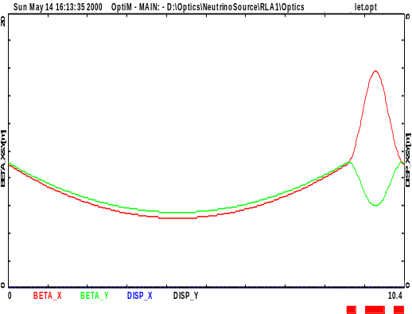
Advantages for FODO
- Smaller length of quads
- Easier chromaticity correction
- The same length
- The same phase advance per period. ν_{x}=ν_{y}=0.25 - effective chromaticity correction
Advantages for triplet focusing
- Longer straight sections
  - Possibility to use 10 m cryomodules
  - The only way to get simple beam spreaders
- Smaller vertical beta-function
  - Better vertical chromatic behavior (2 times smaller the vertical beam envelope chromaticity)

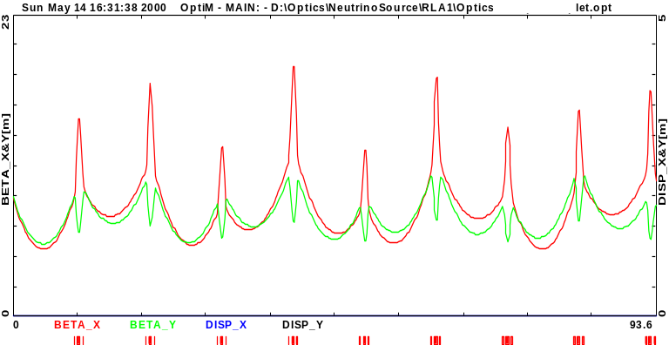
Beta-functions for momentum change of +10%
- Beam envelope oscillates but does not grow
FODO Triplet focusing
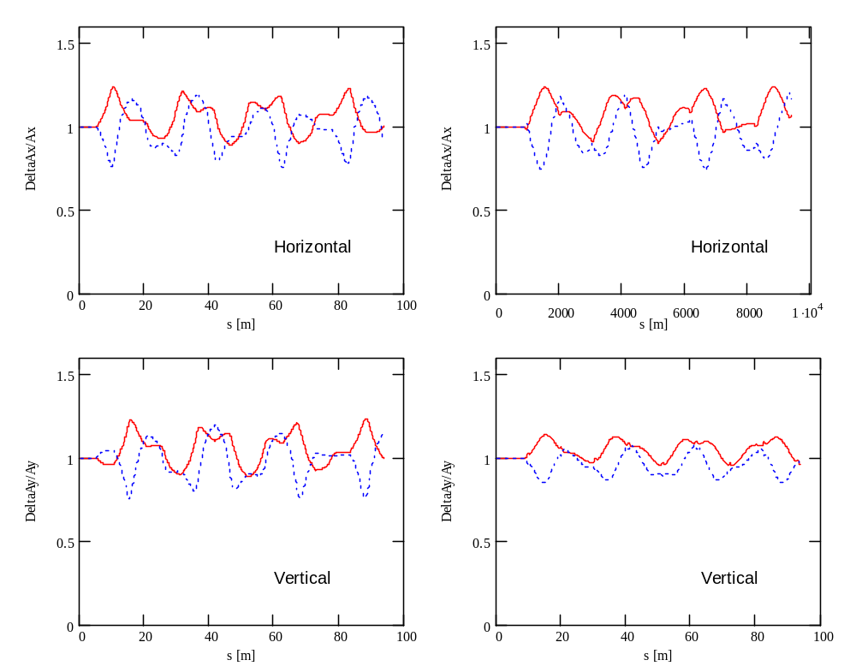

Relative beta-function change for ±10% momentum change β(p)/β(p₀)
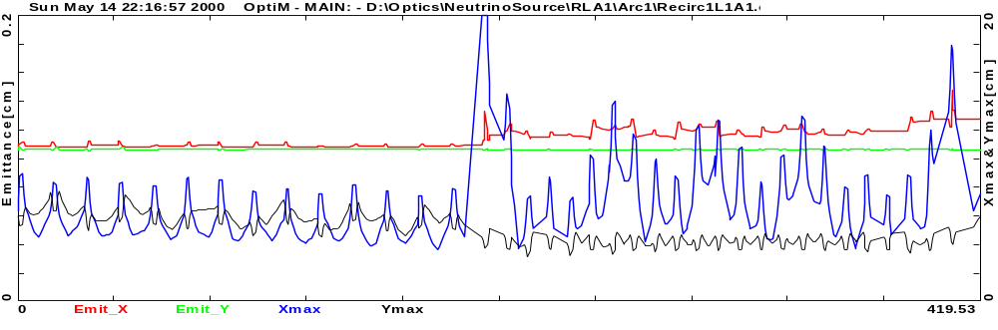
Beam emittance and beam envelopes with chromaticity correction in the spreader and recombiner only, particle loss 0.2%
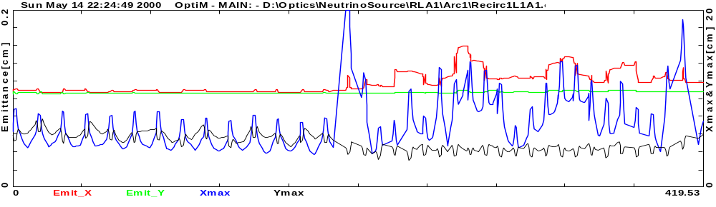
Beam emittance and beam envelopes with global chromaticity correction, particle loss 0.4%
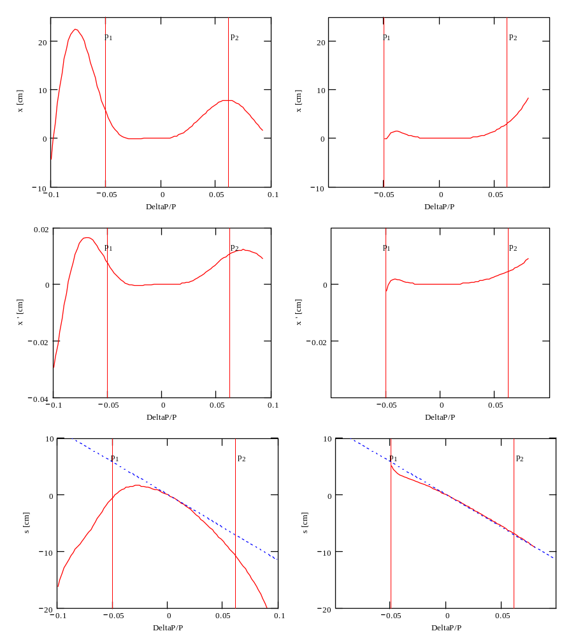

Chromaticity correction
for Arc 1

Non-linearity for
- Dispersion
- Dispersion-prime
- M₅₆
For the cases of
- no sextupole corrections
- 3 sextupole families
Non-linearity for
- Dispersion
- Dispersion-prime
- M56
for the cases of
- no sextuple corrections
3 sextupole families
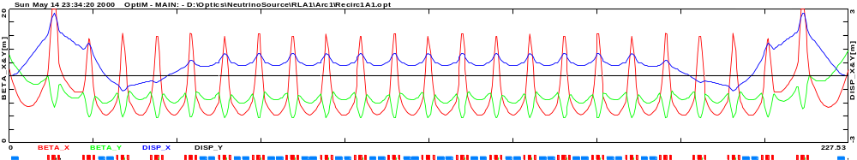

Scheme of sextupole correction (3 families of sextupoles)
Layout of magnets in the arcs
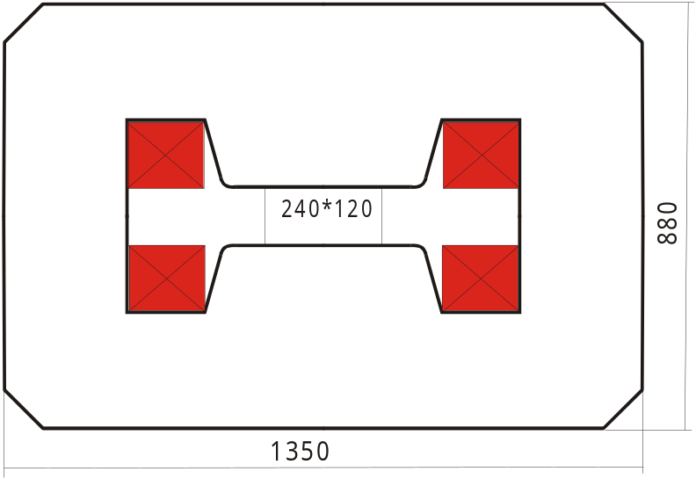

Each next arc is n*1.5 m longer
⇒Distance between arcs 3*1.5/π ≈ 1.5 m
⇒Total width for magnets in the tunnel
1.5*4 = 6 m

Cross-section for Arc1 dipole
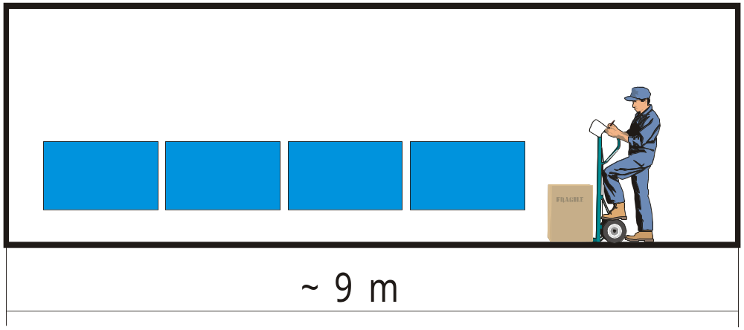

Main Recirculator - RLA2

Main parameters

Initial energy | 11 GeV
Final energy | 50 GeV
Number of passes | 5
Total initial energy acceptance | ±2.6%
Total final energy acceptance | ±0.7%
Initial transverse acceptance | 160 mm⋅rad
Final transverse acceptance | 55 mm⋅rad
Emittance dilution (5% per arc) | 55%
Total voltage per linac | 4 GV
Circumference | ~3 km

Parameters for acceleration in the RLA2

 | 200 MHz* |  |  | 400 MHz**
 | Kinetic energy [GeV] | Gang phase [deg] | Total energy spread, 2Δp/p [%] | Kinetic energy [GeV] | M₅₆ [cm] | Gang phase [deg] | Total energy spread, 2Δp/p [%]
Entrance | 11.00 | -5 | 4.0 | 11.00 | 200 | -7 | 8.2
Arc 1 | 14.96 | -16 | 4.0 | 15.22 | 200 | -30 | 6.3
Arc 2 | 18.79 | -16 | 3.9 | 18.9 | 200 | -17 | 6.3
Arc 3 | 22.63 | -16 | 3.5 | 22.96 | 200 | -30 | 6.4
Arc 4 | 26.47 | -16 | 2.9 | 26.64 | 200 | -30 | 5.4
Arc 5 | 30.31 | -16 | 2.7 | 30.32 | 200 | -30 | 4.5
Arc 6 | 34.15 | -7 | 2.4 | 34.00 | 200 | -30 | 4.1
Arc 7 | 38.11 | 0 | 1.9 | 37.68 | 260 | -11 | 4.3
Arc 8 | 42.10 | -6 | 1.7 | 41.85 | 260 | -16 | 3.7
Arc 9 | 46.07 | -10 | 1.5 | 45.94 | 260 | -17 | 2.5
Exit | 50.00 |  | 1.3 | 50.00 |  |  | 1.6
* Total voltage per linac = 3.992 GV at 200 MHz, M₅₆ = 2.2 m
**Total voltage per linac = 4.25 GV at 400 MHz

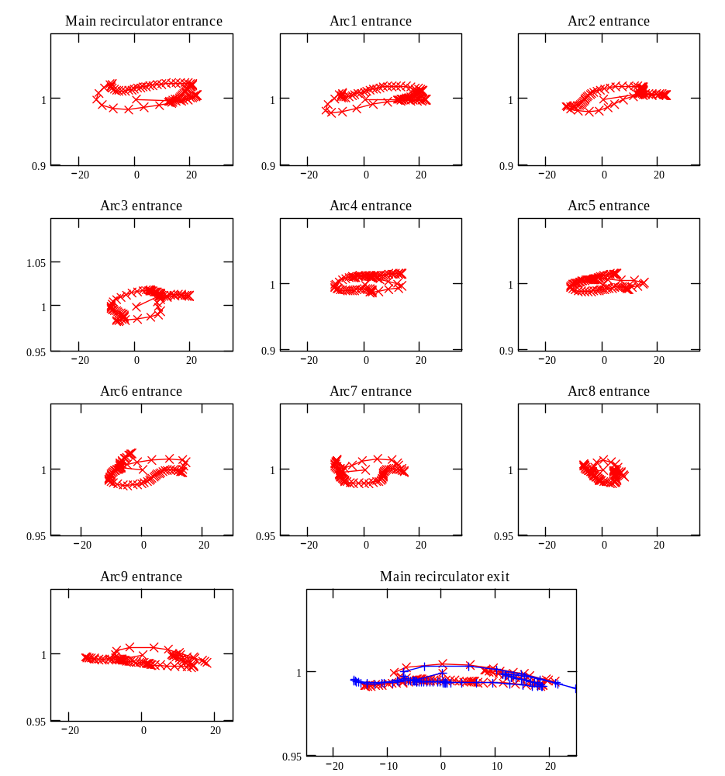
Longitudinal phase space in the RLA2. Blue line at the last slide shows longitudinal phase space for the last bunch of 3 10¹² particle train. The difference in comparison with the first bunch is related to the voltage droop (0.3% per pass for 200 MHz) in RF voltage due to beam loading.

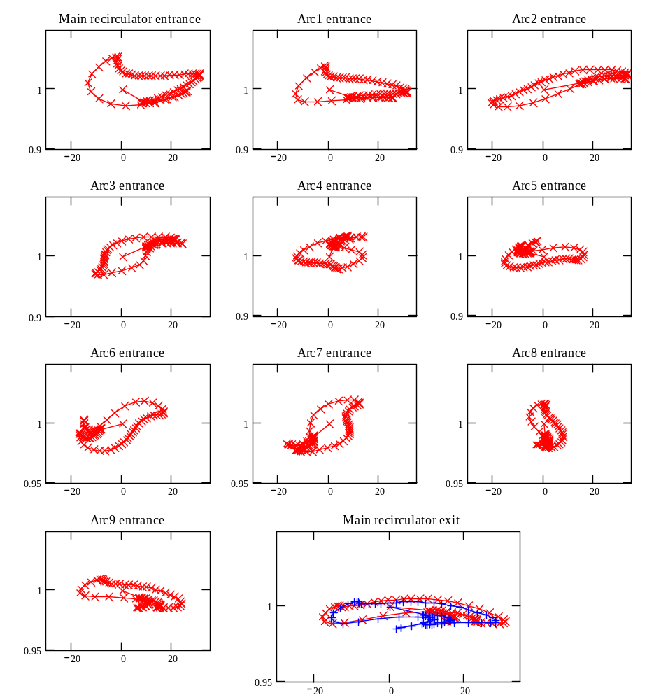
Longitudinal phase space in the RLA2. Blue line at the last slide shows longitudinal phase space for the last bunch of 3 10¹² particle train. The difference in comparison with the first bunch is related to the voltage droop (1.2% per pass for 400 MHz) in RF voltage due to beam loading.

Important Concerns

Why SC RF?
- Large apertures in the linear preaccelerator
- The only way to get required accelerating gradient (RF generator power limit)
- Smaller voltage droop than for NC RF with the same accelerating gradient
- Positive Jefferson Lab experience verify high reliability of the SC RF but
  - To reach high reliability a by-passing of cavities must be anticipated in the design

Voltage Droop due to Beam Loading
Cannot match RF generators to the beam power because there are no RF generators with sufficient power
⇒ voltage droop
RLA1 | RLA2
200 MHz 4 pass  ΔV/V = 0.3% per pass  ΔV/V = 1.2% for all 4 passes | 200 MHz 5 pass  ΔV/V = 0.3% per pass  ΔV/V = 1.5% for all 5 passes  400 MHz 5 pass  ΔV/V = 1.2% per pass  ΔV/V = 6% for all 5 passes
- Synchrotron motion due to non-zero M₅₆ prevents a loss of acceleration for the last bunch
- Dependence of beam orbit and optics on the beam current gas to be addressed in the design

400 or 200 MHz in the second RLA?
Advantages of 400 MHz | Disadvantages of 400 MHz
- Cheaper cavities  - Cheapper RF generators  - Smaller power consumption  - 2.5 MW versus 10 MW average RF power for RLA2  - Easier to achieve 15 MV/m | - Difficult to handle large energy spread in RLA1 at higher passes  - Larger energy droop for 400 MHz cavities

Possible layouts for recirculator

For RLA1
Linac : L=192 m

Racetrack
C=2*(192+197)=780 m
or linac takes 49% of C

Dog-bone
C=2*(192+462)=1310 m
or linac takes 29% of C
Arcs are 2.3 times longer
Total cost is smaller
RF power consumption is smaller
Muon decay 9.1% versus 5.5%
Optics & emittance growth ???

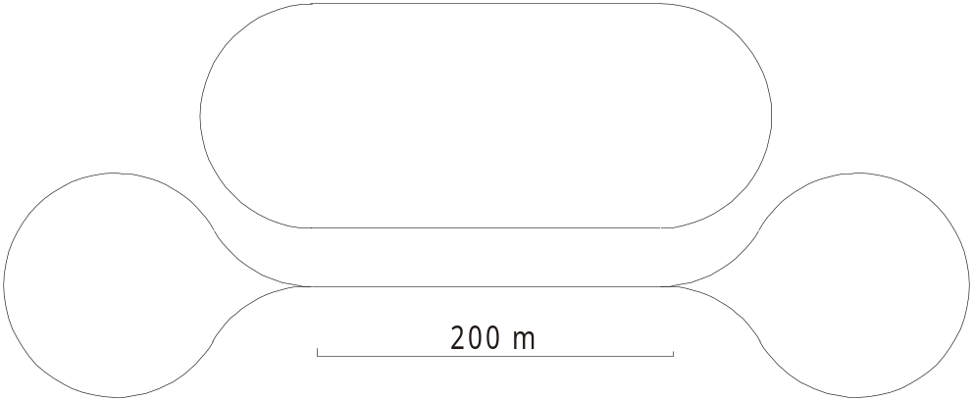

Conclusion and Required R&D
  - There are no principal physical and technical limitations to build an accelerator-recirculator for muons
  - 200 MHz accelerating frequency and SC RF look well justified
  - 400 MHz in second RLA is desirable but machine optics should be built to verify the possibility
  - R&D to get 15 MV/m at 200 MHz
  - Radiation effects on hardware (cavities, dipoles, etc.)
  - Beam instrumentation in hard radiation environment

