National Aeronautics and
Space Administration

John C. Stennis Space Center
SSC, Mississippi 39529–6000
Verification and Validation of NASA-Supported Enhancements to PECAD’s Decision Support Tools

Kenton Ross, Science Systems and Applications, Inc.
Rodney McKellip, NASA
John C. Stennis Space Center, Mississippi

Acknowledgments
This report has been authored by Science Systems and Applications, Inc., under Task Order NNS04AB54T with the National Aeronautics and Space Administration.

The authors appreciate the contributions of Roxzana Moore, Science Systems and Applications, Inc., and
Debbie Fendley, Computer Sciences Corporation, to the preparation of this report.

Trade names and trademarks are used in this report for identification only. Their usage does not constitute an official endorsement, either expressed or implied, by the National Aeronautics and Space Administration.
Table of Contents
Executive Summary v
1.0 Introduction 1
1.1 Systems Engineering Considerations 1
2.0 V&V of Application-Tailored MODIS Products 3
2.1 Calibration and Validation of MODIS Sensor and Standard Products 4
2.2 Characterization of the MODIS Application-Tailored Products 5
2.2.1 MODIS Product Accuracy 5
2.2.2 MODIS Product Delivery 6
2.2.3 MODIS Product Coverage 8
3.0 V&V of Global Reservoir and Lake Monitor Products 9
3.1 Calibration and Validation of TOPEX/Poseidon and Jason-1 Radar Altimeters 9
3.2 Characterization of the Global Reservoir and Lake Monitor 11
3.2.1 GRLM Accuracy 11
3.2.2 GRLM Delivery 13
3.2.3 GRLM Coverage 15
4.0 Conclusions and Recommendations 15
5.0 References 16
6.0 Acronyms 18

Tables
Table 1. PECAD accuracy, delivery, and coverage requirements for near-real-time imaging. 3
Table 2. PECAD accuracy, delivery, and coverage requirements for an NDVI database. 4
Table 3. PECAD accuracy, delivery, and coverage requirements for surface water level variation. 9
Table 4. Total error budget for lake height. 11
Table 5. Verified GRLM performance over select North American surface water bodies.* 12

Figures
Figure 1. Systems engineering approach. 2
Figure 2. Vegetation index time series for the Maize Triangle region of South Africa and for the Victoria wheat-growing region of eastern Australia. 5
Figure 3. July 2005 data interruption as reported on the MODIS Rapid Response System Status page. 6
Figure 4. Distribution of Crop Explorer MODIS Image Gallery delivery time lag from October 1, 2005, through October 15, 2005. 7
Figure 5. Variation of Crop Explorer MODIS Image Gallery delivery time lag by time of day (October 2005 observation period). 7
Figure 6. Geographic distribution of Crop Explorer MODIS Image Gallery delivery and lag times for Terra and Aqua (October 2005 observation period). 8
Figure 7. Comparison of Crop Explorer MODIS Image Gallery and MODIS NDVI Database geographical footprints as of October 2005. The footprints are overlaid on a global map of croplands as estimated in the 2001 MODIS Land Cover product (MOD12). 9
Figure 8. Gauge stations in the general vicinity of the Great Lakes. 13
Figure 9. Histogram of time to last estimated water level checked at the end of May 2004 and again at the end of May 2005. 14
Figure 10. Geographic distribution of time to last estimated water level at the end of May 2005. 15

Executive Summary
The NASA Applied Sciences Directorate, part of the Earth-Sun System Division of NASA’s Science Mission Directorate, has partnered with the U.S. Department of Agriculture (USDA) to enhance decision support in the area of agricultural efficiency—an application of national importance. Key components of national agricultural decision making are to understand the global context of crop conditions, to understand how those conditions affect food security, and to predict global crop production of key commodities. The Production Estimates and Crop Assessment Division (PECAD) of the USDA Foreign Agricultural Service (FAS) accepted the mandate to support national decision making with timely global crop intelligence. PECAD accomplishes its mission with a proven set of decision support tools that facilitates both its own internal analyses and its dissemination of relevant information to policy makers and other stakeholders.
This Verification and Validation (V&V) report is part of series that tracks the NASA/PECAD partnership through the systems engineering process. An Evaluation Report for PECAD was published in 2004 to document the decision support environment and to identify relevant NASA science assets that might improve the PECAD decision system. A Benchmarking Report was produced concurrent with this V&V report to measure the value of the initial NASA products that have been integrated into the PECAD system. This V&V report summarizes the Verification and Validation of the same enhancements covered in the Benchmarking Report:
- Near-real-time Moderate Resolution Imaging Spectroradiometer (MODIS) products through PECAD’s MODIS Image Gallery
- MODIS Normalized Difference Vegetation Index (NDVI) time series data through the USDA-FAS MODIS NDVI Database
- Jason-1 and TOPEX/Poseidon lake level estimates through PECAD’s Global Reservoir and Lake Monitor (GRLM)
Where possible, each enhanced product was characterized in terms of accuracy, timeliness, and coverage, and the characterized performance was compared to PECAD operational requirements (the operational requirements do not necessarily match performance requirements for projects as funded).
The accuracy of the MODIS Image Gallery NDVI product is being studied, but results are not yet available. The timeliness of the MODIS Image Gallery as measured by product latency was estimated to be 4.4 hours. Availability of MODIS Image Gallery products within the PECAD operational requirement of 6 hours was measured at 87 percent. In terms of coverage, the MODIS Image Gallery includes the great majority of crop production areas of economic importance but still lacks coverage in many areas where food security is a concern.
PECAD’s requires that MODIS NDVI time series be consistent with the legacy of the Advanced Very High Resolution Radiometer and SPOT VEGETATION measurements. Studies indicate that such consistency has been achieved, and ongoing work shows good agreement among products as well. The latency of the USDA-FAS MODIS NDVI Database appears to be several days longer than the 72-hour PECAD requirement. USDA-FAS MODIS NDVI Database coverage of crop production areas of economic importance was all but exhaustive.
The surface water level relative accuracy for the GRLM was estimated to be 5–7 cm over the Great Lakes, exceeding the 10-cm requirement established by PECAD. Some more challenging lakes (smaller lakes, reservoir in rugged terrain) did not meet the 10-cm requirement but still arguably provided valuable information. In 2005, GRLM latency was estimated to be 6 days, which was a 10-day improvement over 2004 performance. GRLM coverage was expanded, but because of challenges with current standard Jason-1 data processing, most of the new water bodies in the GRLM have few, if any, valid height estimates in the Jason-1 era. This leaves South America, south and east Asia, and Australia with very few near-real-time data points.
As of summer 2005, NASA-supported enhancements to the PECAD decision support tools have had varying degrees of success in meeting PECAD’s requirements. The MODIS Image Gallery and the GRLM are more mature and have achieved a semi-operational status, whereas the USDA-FAS MODIS NDVI Database is still evolving and should presently be considered developmental.
One overall recommendation resulting from the V&V process is that as NASA-supported enhancements become operational, regularly generated metrics should be introduced to track certain types of performance, such as delivery and coverage. While certain facets of decision support will require more careful analysis, the more routine aspects that relate to satisfaction of customer requirements should be amenable to simple self-monitoring that could be publicly available as product metadata.

Introduction
NASA partners with the U.S. Department of Agriculture (USDA) to bring about innovative uses of NASA Earth-Sun system science to inform and improve decision making for the sake of U.S. agricultural efficiency. In this partnership, NASA and the USDA seek to identify assessments, tools, and systems that impact decision making at a national scale and that are amenable to enhancement with NASA observations or predictions. One decision support system (DSS) that has been identified belongs to the Production Estimates and Crop Assessment Division (PECAD).
PECAD, a component of the USDA Foreign Agricultural Service (USDA-FAS), monitors global crop conditions, assesses how those conditions affect food security, and predicts crop yields for grains, oilseeds, and cotton. PECAD essentially performs an intelligence mission that affects U.S. government actions and global commodity markets. PECAD has several analysts who make crop assessments for certain regions of the globe. These analysts must make informed decisions about crop area, yield, and production. These decisions are supported by a framework of tools that bring together multiple, independent information sources in a spatial and temporal context. These tools include the Crop Assessment Data Retrieval and Evaluation (CADRE) geospatial data management system, which provides internal access to a wealth of remote sensing and weather information and to the Crop Explorer Web interface (USDA, 2005) which gives both internal and external users a portal to view remote sensing observations and model outputs for fixed geospatial subsets. Many of the Crop Explorer data streams are provided with near-real-time access.
More detailed information about PECAD’s DSS can be found in Decision Support Tools Evaluation Report for FAS/PECAD, Version 2.0 (NASA, 2004a). This report was part of a systems engineering approach to the USDA/NASA partnership supporting the enhancement of PECAD’s DSS. Three points of documentation are planned in this process: (1) DSS evaluation, (2) verification and validation of specific enhancement performance, and (3) benchmarking to show net effects of enhancements on the DSS performance as a whole. The systems engineering approach in its entirety is represented in Figure 1. This report documents the verification and validation (V&V) of implemented enhancements to PECAD’s DSS that are based on NASA Earth-Sun system science.
The implemented enhancements include application-tailored Moderate Resolution Imaging Spectroradiometer (MODIS) products and Global Reservoir and Lake Monitor (GRLM) products. The MODIS products are currently made available through two separate decision support tools: the MODIS Image Gallery and the USDA-FAS MODIS Normalized Difference Vegetation Index (NDVI) Database. Both the GRLM and the MODIS Image Gallery provide near-real-time products through PECAD’s Crop Explorer. This discussion will address two areas:
- Assessments of existing or previous NASA products on which these enhancements are based, and
- Characterizations of the performance of the newly implemented products.

Systems Engineering Considerations
While there is an overall thematic direction to the systems engineering process as defined in Figure 1, the process is not a simple sequence. For example, V&V and benchmarking for PECAD’s DSS have proceeded concurrently with the V&V effort coordinated by NASA Stennis Space Center’s Applied Sciences Directorate and benchmarking carried out by a joint team of scientists from the University of Arizona and the University of Missouri (Haithcoat et al., 2005; van Leeuwen et al., 2005).
Systems Engineering Approach

A systems engineering approach leads to scalable, systemic, and sustainable solutions and processes that contribute to the success of the mission, goals, and objectives of each National Application.
Evaluation
V&V
Benchmarking

Enhanced
DSS

DSS
Selection
Define Requirements & Specifications
Investigate Alternative NASA Inputs
Design
&
Implement
Verify
&
Validate
Benchmark
(Baseline &
Assess Performance)
Refine
Refine
Refine
Refine
Refine
Source: Adapted from Bahill and Gissing, 1998
Figure 1. Systems engineering approach.
V&V and benchmarking milestones’ being reached does not imply that the systems engineering process is complete. This certainly applies to the design and implementation stage. The projects currently delivering both MODIS and GRLM products are at various levels of maturity and are only meant to attain semi-operational or perhaps even demonstration status. Since the PECAD DSS certainly requires fully operational solutions, a transition to operational status is inferred. The manner and schedule of the operational transition is a matter of ongoing dialogue among DSS stakeholders.
The distinction between pre-operational and operational status has important consequences in the understanding of DSS requirements. This V&V report and its predecessor evaluation report (NASA, 2004a) consider the operational requirements of PECAD’s DSS. The projects implementing enhanced products are properly focused on their project performance requirements as defined in agreements with NASA and the USDA. Where a clear separation between operational and project performance requirements is known to exist, this separation is noted in the report.
Simply defining PECAD’s operational requirements has been a difficult process, and the process is ongoing. The challenges faced by PECAD’s analysts are diverse and resistant to simplification. Spatial scale ranges from small subsistence plots to the entire crop-producing area of the globe. Temporally, analysts must track multiyear means and must also be able to predict agronomic damage only hours after an event occurs. As a result, some requirements are a matter of continuing discussion between PECAD and NASA. Specifications for the spatial characteristics of Earth science inputs fall into this category. PECAD uses remote sensing data with ground sample distances (GSDs) ranging from less than a meter up to multiple kilometers. Teasing out spatial requirements for PECAD’s DSS would necessitate a careful breakdown of analysts’ typical tasks followed by a detailed sensitivity analysis for each task. Even then, trade studies would be required to balance spatial considerations with information technology and resource constraints and with temporal drivers.
The operational requirements suitable for attention in this report fall into three areas:
- Accuracy: measured uncertainty of a particular product’s parameter of interest
- Delivery:
  - Data time step, or frequency of product delivery
  - Latency, or mean lag time between original data acquisition and final product delivery
- Coverage: geographical area covered or spanned by the product
The requirements as specified for each product are taken from the earlier evaluation report (NASA, 2004a) unless otherwise noted.

V&V of Application-Tailored MODIS Products
As mentioned above, PECAD’s overall set of decision support tools are enhanced by the routine provision of two application-tailored MODIS products: the Crop Explorer MODIS Image Gallery and the USDA-FAS MODIS NDVI Database. Both products have been developed and implemented by the Global Agricultural Monitoring (GLAM) project, whose collaborators include NASA’s Goddard Space Flight Center (GSFC); USDA-FAS; Science Systems and Applications, Inc.; and the University of Maryland Department of Geography.
MODIS Image Gallery: The Crop Explorer MODIS Image Gallery is accessed through the Crop Explorer interface at the following USDA-FAS Web site: http://www.pecad.fas.usda.gov/cropexplorer/modis_summary/
The Crop Explorer MODIS Image Gallery provides near-real-time access to processed MODIS image subsets. This interface is actually a thin client linked to a selected set of the imagery available through GSFC’s MODIS Rapid Response System. For each image subset, the following images are provided in JPEG format: a natural color combination (Red, Green, Blue (RGB): MODIS bands 1, 4, and 3); a shortwave infrared/near infrared/red combination (RGB: MODIS bands 7, 2, and 1); and an NDVI. GeoTIFF format is provided at many locations and is planned for all image subsets as hardware improvements permit (Descloitres, personal communication, 2005). Each image type may be downloaded in 250 m, 500 m, and 1 km ground sample distances. Accuracy, delivery, and coverage requirements related to near-real-time MODIS images are detailed in Table 1.

Table 1. PECAD accuracy, delivery, and coverage requirements for near-real-time imaging.
Category | Requirement
Product accuracy | Undetermined
Data time step | 1 day
Latency | 6 hours or less
Coverage | All land regions important for crop production and food security
Source: NASA, 2004a
Further comment is called for in the case of product accuracy and coverage requirements. For product accuracy, a need for consistency with multiday composite products (such as the USDA-FAS MODIS NDVI Database) is implied, but no requirements or specifications have been established in discussions with PECAD. The MODIS Rapid Response team is studying the accuracy of the Rapid Response NDVI relative to other estimates, but results are not yet available (Descloitres, personal communication, 2005).
The coverage requirement is a case where operational and project performance requirements diverge. That PECAD needs imaging over “all land regions important for crop production and food security” (NASA, 2004a) is self-evident, but the MODIS Rapid Response contribution as originally proposed did not specify coverage. The project focus was on generating prototyping products (Justice et al., 2002). In early 2005, PECAD and the MODIS Rapid Response team agreed to bring the project performance requirement into alignment with PECAD’s quasi-global operational requirement. Contingent on the procurement and integration of new hardware to support this effort, the MODIS Rapid Response team expects to complete the increase in coverage by the end of the 2005 calendar year (Kendall and Schmalz, personal communication, 2005).
USDA-FAS MODIS NDVI Database: While the MODIS Image Gallery meets near-real-time needs, PECAD also requires a quasi-global NDVI image and time series database to observe crop trends. Multiday compositing is necessary for this product to reduce the affect of clouds, bidirectional reflectance distribution function effects, and other confounding factors. Through the USDA-FAS MODIS NDVI Database, users may display or download the archived NDVI data as single-date images or as chart time series of NDVI variation for selected points or areas. This database is currently maintained for PECAD at the following GSFC Web site: http://pekko.geog.umd.edu/usda/ndvi/
This product is still a beta version. The NDVI observations in this product are not produced by the GLAM project; they are NDVI estimates computed from standard Level 3, 16-day surface reflectance composites (MODIS MOD09 product) generated by the MODIS Data Production System (MODAPS). The USDA-FAS MODIS NDVI Database is developing tools for MODIS NDVI products that should play a similar role to Advanced Very High Resolution Radiometer (AVHRR) vegetation index information currently available to PECAD analysts through CADRE. The PECAD accuracy, delivery, and cover requirements for an NDVI database are summarized in Table 2.

Table 2. PECAD accuracy, delivery, and coverage requirements for an NDVI database.
Category | Requirement
Product accuracy | Must be consistent with existing NDVI database going back to 1981
Data time step | Maximum of 10 days (Doorn, 2004)
Latency | 24 hours or less measured from the end of the compositing period (Doorn, 2004)
Coverage | All land regions important for crop production and food security
Source: NASA, 2004a
The USDA-FAS MODIS NDVI Database contains points of difference between operational and project performance requirements. For the data time step, the product as proposed is limited to 16-day compositing periods, which are the minimum available through MODAPS. Similarly, the product is also limited in latency by the performance of MODAPS. The project’s original proposal suggested a nominal latency of 7 days.

Calibration and Validation of MODIS Sensor and Standard Products
The on-orbit calibration and validation of the MODIS sensor and standard MODIS products was dealt with comprehensively (for Terra MODIS) in a special issue of Remote Sensing of Environment in 2002, which characterized several intrinsic properties of interest to operational users. Wolfe et al. (2002) reported a geolocational accuracy of 50 m (1 σ) at nadir. For MODIS Bands 1 and 2 (the red and near-infrared bands used for PECAD tailored products), Rojas et al. (2002) found that the spatial response was consistent with pre-launch performance in the cross-track direction but was a bit degraded in the along-track direction. Huete et al. (2002) demonstrated that MODIS NDVI performed at higher fidelity than AVHRR NDVI. In a discussion of atmospheric correction for standard MODIS products, Vermote et al. (2002) showed a clear example of how not correcting for aerosol can dramatically affect the distribution of NDVI values throughout a scene.
Further work has been done regarding the cross validation of MODIS NDVI with other sensors. Gallo et al. (2004) found a linear relationship between AVHRR and MODIS 16-day composite time series with overall coefficient of variation (r²) above 0.9 (considering nine diverse land cover types). Working directly in support of the NASA/FAS partnership, the Global Inventory Monitoring and Modeling Studies (GIMMS) group at NASA GSFC has found similar results studying AVHRR, MODIS (MOD13 standard products), and SPOT VEGETATION (Justice, 2005). In Figure 2, NDVI time series are displayed from GIMMS estimates for one crop production region in South Africa and for another region in eastern Australia (the green line in each plot is MODIS Enhanced Vegetation Index, which is not used in current MODIS products tailored for PECAD). All of the NDVI time series have correlation coefficients above 0.9 relative to each other.
Maize Triangle ZA (mixed) VI  0.7  0.6  0.5  0.4  0.3  0.2  0.1  SPOT NDVI  MODIS EVI  MODIS NDVI  AVHRR VIg  Jan  00  Jan  01  Jan  02  Jan  03  Jan  04 | Victoria AU (wheat) VI  SPOT NDVI  MODIS EVI  MODIS NDVI  AVHRR VIg  Jan  00  Jan  01  Jan  02  Jan  03  Jan  04  0.7  0.6  0.5  0.4  0.3  0.2  0.1  0.8
Figure 2. Vegetation index time series for the Maize Triangle region of South Africa and for the Victoria wheat-growing region of eastern Australia.

Characterization of the MODIS Application-Tailored Products
The product characterizations in this report summarize quantifiable product performance in the areas of accuracy, delivery, and coverage as outlined in the systems engineering discussion (Section 1.1).

MODIS Product Accuracy
The only parameter of interest that has been clearly established for MODIS application-tailored products is NDVI. Given that PECAD’s accuracy requirement has been stated only in qualitative terms (observations should be “consistent” with the multiyear database), only a cross-comparison of the application-tailored products to standard products is needed.
A cross-comparison for the MODIS Rapid Response NDVI is not yet complete. The MODIS Rapid Response System team is currently undertaking a comparison with standard MODIS products (Descloitres, personal correspondence, 2005).
Because NDVI in the USDA-FAS MODIS NDVI Database is actually computed by MODAPS, it is assumed to be validated for the purposes of this report. It should be noted, however, that the USDA-FAS MODIS NDVI Database product is not the standard MOD13 NDVI; this NDVI product is computed in the MOD44C vegetation intermediate composite product. Although MOD44C is primarily an intermediate step in production of the MOD44A vegetation cover conversion product, its origins at the University of Maryland give the GLAM team greater creative control in support of PECAD. Both MOD13 and MOD44C take daily MOD09 surface reflectance as input and both use the standard equation ( 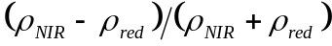 ) to compute NDVI, but the two slightly differ in their compositing schemes. MOD44C seeks the most cloud free, highest resolution data over the compositing period (USGS, 2005), and MOD13 has a similar approach called “constraint view angle maximum value compositing” which diverges in some details (Gao et al., 2003). Given the product similarities, previous studies regarding consistency of MODIS with legacy systems should be considered extensible to USDA-FAS MODIS NDVI Database estimates.

MODIS Product Delivery
The MODIS Rapid Response System product delivery was observed for two 15-day periods. The first period ran from June 23, 2005, (Julian day 173) through July 6, 2005 (Julian day 187). However, on July 2, 2005, an interruption of data lasted for more than 2 days. This problem affected all the data that was passed through the MODIS Rapid Response System to the Crop Explorer MODIS Image Gallery and was reported on the MODIS Rapid Response System Status page as shown in Figure 3.
Date | Description
2 July 2005  2005/183 | Some current data is not available due to hardware issues.
Source: http://rapidfire.sci.gsfc.nasa.gov/status/
Figure 3. July 2005 data interruption as reported on the MODIS Rapid Response System Status page.
Even 5 days after the July 2, 2005, interruption, the MODIS Rapid Response Delivery System delivery times were notably out of step with pre-interruption system performance. As a result, only the first 10 days of observation were used to estimate system performance. Based on the June-July observations, the estimated system latency for 59 tiles with an Aqua and a Terra delivery opportunity for each of 10 days (1180 distinct delivery opportunities) was 4.7 hours. The latency was computed as the mean lag time. All lag times greater than 24 hours were excluded on the assumption that these times represented anomalous problems that were not typical of system throughput. Just over 65 percent of the MODIS Rapid Response System information was available within the 6-hour requirement stated by PECAD and 80 percent of the information was available within 24 hours.
The second observation period ran from October 1, 2005, (Julian day 274) through October 15, 2005 (Julian day 288). Although 12 tiles were added to cover North Africa before the October observation period, these tiles were left out of this analysis to allow valid comparisons between the two periods. Based on the October observations, the estimated system latency for 59 tiles with an Aqua and a Terra delivery opportunity for each of 15 days (1770 distinct delivery opportunities) was 4.4 hours. About 87 percent of the MODIS Rapid Response System information was available within the 6-hour requirement stated by PECAD and 100 percent of the information was available within 24 hours.
Given the July data interruption, the October period should be considered more representative of expected operational system performance. Several distinct trends can be discerned in the October period. First, it should be noted that the lag times are heavy-tailed on the long side (Figure 4). The observed lag time data bears some resemblance to heavy-tailed distributions such as the inverse Gaussian and lognormal distributions. The implication is that for mature requirements it will be important to develop thresholds for both mean delivery and for some higher threshold with 90 percent delivery.
A systematic relationship existed between lag time and the time of day in which a particular subset-tile was acquired and processed. Figure 5 shows that the lag time trend reaches a minimum of about 3 hours near 6:00 AM – 12:00 AM (UTC) and then rises slowly through the course of a day, reaching a maximum of more than 4 hours between 6:00 PM and midnight (UTC). The geographic distributions of delivery and lag times for Terra and Aqua are shown in Figure 6.
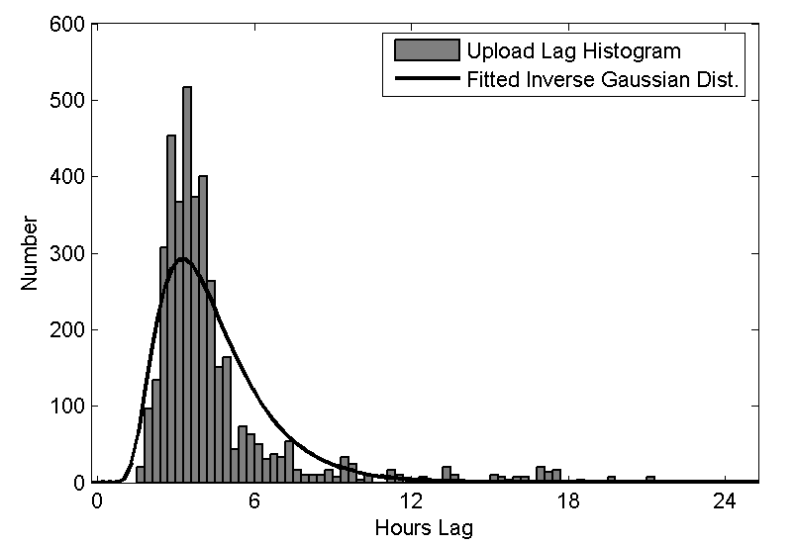
Figure 4. Distribution of Crop Explorer MODIS Image Gallery delivery time lag from October 1, 2005, through October 15, 2005.
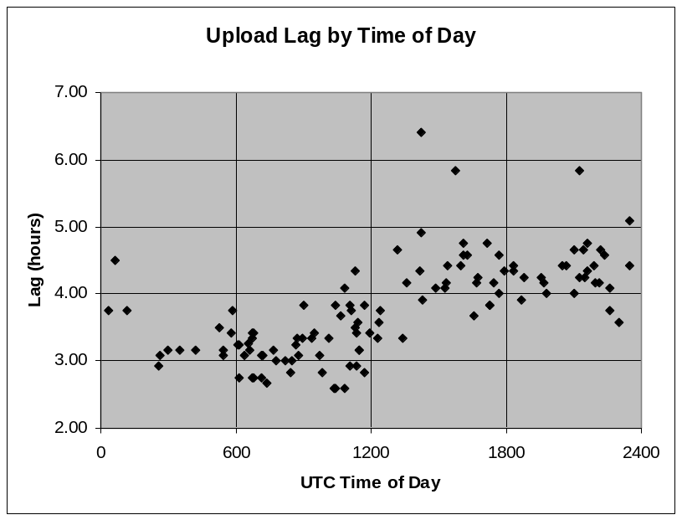
Figure 5. Variation of Crop Explorer MODIS Image Gallery delivery time lag by time of day (October 2005 observation period).
Taken as a whole, the Crop Explorer MODIS Image Gallery latency is meeting the stated PECAD requirement of 6 hours. Nominally, the data time step is being met, but lapses in availability (both identified and unidentified in the MODIS Rapid Response System Status page) are a cause for concern.
The USDA-FAS MODIS NDVI Database was not monitored in as careful a manner because it is more developmental in nature. However, it was observed that through June and July 2005, the shortest time lapse between end of compositing window and USDA-FAS MODIS NDVI Database timestamp was about 9.5 days. This latency has not yet met the project goal of 7 days nor the PECAD goal of 72 hours as stated in the DSS evaluation (NASA, 2004a). Given the 16-day time step and a latency of about 10 days (or more), the chance of PECAD analysts having more than one NDVI Database reading for the month leading to lock-up is small.

MODIS Product Coverage
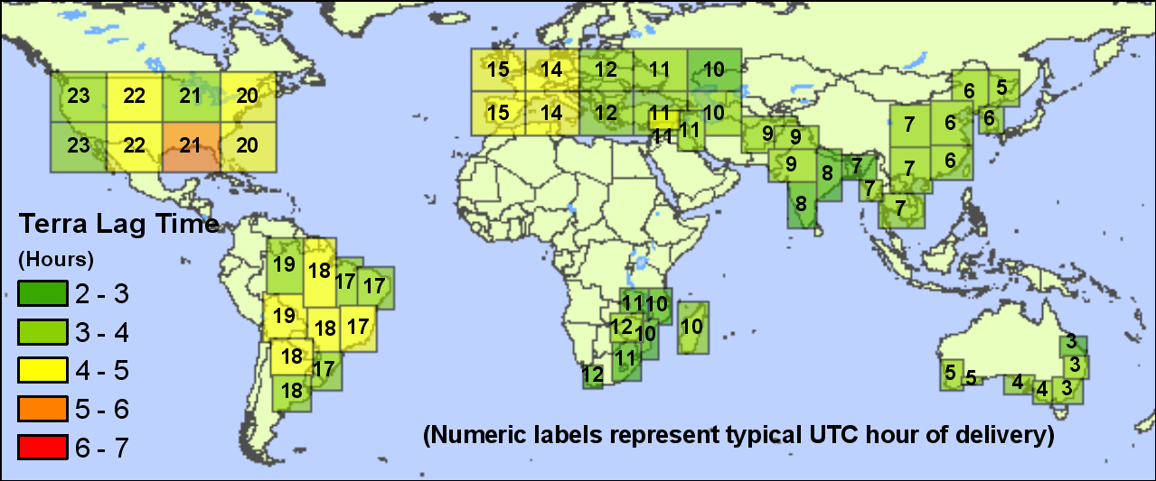
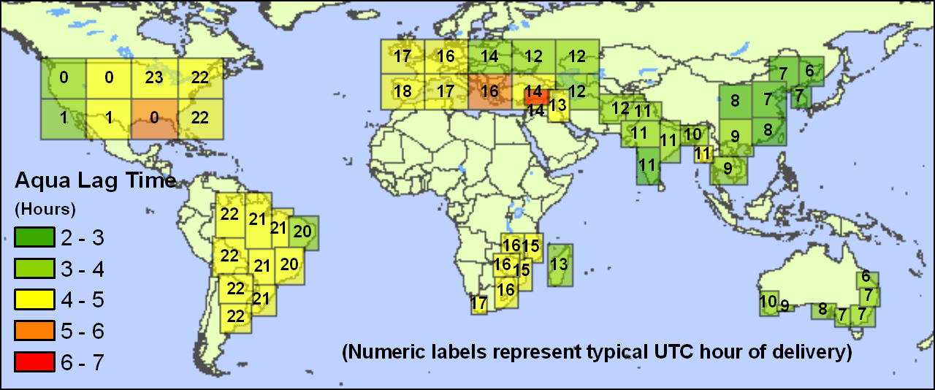
Figure 6. Geographic distribution of Crop Explorer MODIS Image Gallery delivery and lag times for Terra and Aqua (October 2005 observation period).
The global footprints of the Crop Explorer MODIS Image Gallery and the USDA-FAS MODIS NDVI Database are shown in Figure 7. Curiously, the Database omits Madagascar, even though Madagascar is available through the Crop Explorer MODIS Image Gallery. However, the USDA-FAS MODIS NDVI Database coverage limitations are strictly a result of the current system configuration since the MODAPS source data is essentially global in coverage.
The Crop Explorer MODIS Image Gallery omits a few crop production areas of some economic importance including Central America, parts of South America, the northernmost productive region of the Great Plains of North America, and parts of central Asia. Note the presence of the 12 northern Africa subset-tiles for the Crop Explorer MODIS Image gallery that were left out of the delivery time analysis.

Overall, the MODIS application-tailored products have nearly met the PECAD coverage requirements for economically important crop production, but important coverage gaps exist in the Crop Explorer MODIS Image Gallery in terms of PECAD’s food security mandate: notably Central America, northern South America, Indonesia, and the Philippines.
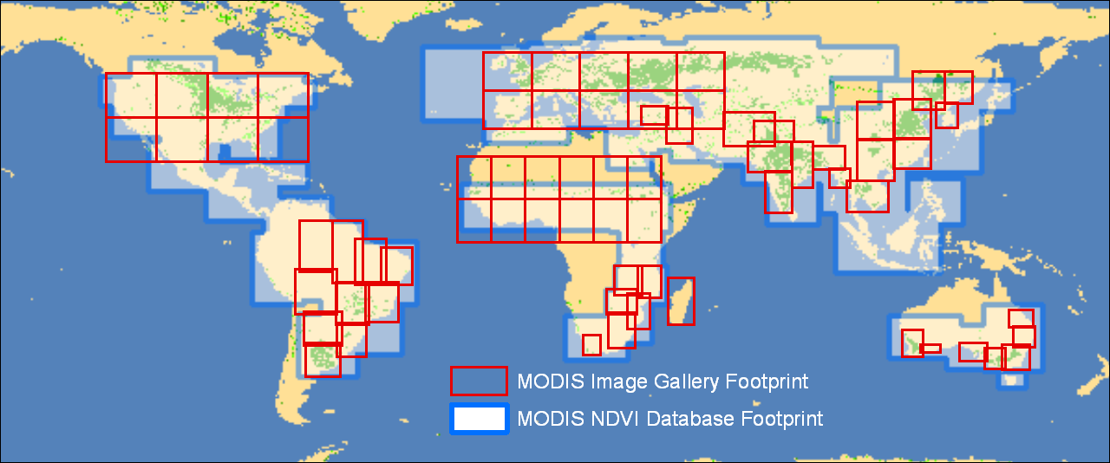
Figure 7. Comparison of Crop Explorer MODIS Image Gallery and MODIS NDVI Database geographical footprints as of October 2005. The footprints are overlaid on a global map of croplands as estimated in the 2001 MODIS Land Cover product (MOD12).

V&V of Global Reservoir and Lake Monitor Products
PECAD’s decision support requirements related to surface water level variation are detailed in Table 3.

Table 3. PECAD accuracy, delivery, and coverage requirements for surface water level variation.
Category | Requirement
Surface water level relative accuracy | 10 cm
Data time step | 10 days
Latency | 7–14 days
Coverage | Surface waters in all land regions important for crop production and food security
Source: NASA, 2004a

Calibration and Validation of TOPEX/Poseidon and Jason-1 Radar Altimeters
Global Reservoir and Lake Monitor products are based on measurements from radar altimeters onboard the Jason-1 and TOPEX/Poseidon satellites (USDA, 2004), which are joint missions between NASA and the French space agency, the Centre National d’Etudes Spatials (CNES). The primary purpose of these altimeters is to increase understanding of ocean surface topography. Their principal measurement is sea surface height (Ménard et al., 2003). The ranging approach for determining sea surface height differs in some particulars from the approach for determining surface water levels, but the two measurements are based on many common principles. Given that Jason-1 and TOPEX/Poseidon were designed for open sea measurements, the accuracy achieved by these instruments in measuring sea surface height sets the optimistic bound on accuracy that can be expected in measuring surface water levels.
After the launch of Jason-1 on December 7, 2001, about 10 months were dedicated to calibration of the new instrument and assessment of its performance. For much of that period, the Jason-1 and TOPEX/Poseidon satellites were operated in a common orbit with about one minute of separation between the two platforms, allowing an updated assessment of the TOPEX/Poseidon performance as well as a cross-validation between the two systems.
Three primary levels of distributed products were evaluated:
- Geophysical Data Record (GDR) – final product based on ground processing, available in 30 days;
- Interim Geophysical Data Record (IGDR) – intermediate products based on a preliminary orbit determination, available in three days; and
- Operational Sensor Data Record – near-real-time products based on onboard processing, available in 3–5 hours.
Of these products, the GDRs and IGDRs are relevant to the Global Reservoir and Lake Monitor. The GRLM used GDRs for TOPEX/Poseidon data to establish historical data going back to 1992 and used IGDRs for Jason-1 data to provide a near-real-time product with a latency period on the order of 10 days.
Ménard et al. (2003) summarized the Root-Sum-of-Squares estimates of Jason-1 sea surface height errors as 3.3 cm for the GDR product and as 3.9 cm for the IGDR products. Working in diverse locations, including the Harvest platform near California (Haines et al., 2003), Corsica (Bonnefond et al., 2003), and the Bass Strait on the north side of Tasmania (Watson et al., 2003), the individual calibration/validation teams commissioned by CNES and NASA all achieved sea-based results consistent with the overall estimates. Each of these studies also measured TOPEX/Poseidon errors and found them to be in the same 3-4 cm range. Chambers et al. (2003) cross-validated Jason-1 against TOPEX/Poseidon. The estimates of individual sensor error were similar among the analyses cited. The magnitude of the global bias between the sensors was found to be 14-15 cm. Residuals showed dependency on significant wave height, with local biases near coastlines. More placid waters had somewhat lower biases, and local biases in rougher waters were somewhat higher. This dependency on significant wave height accounts for some differences in bias estimates at the fixed sites, and it has implications for surface water level estimates since surface waters frequently have smaller wave heights than the open ocean.
Further highlighting the challenge of altimetry over surface waters, one Jason-1 calibration/validation effort studied sea surface height as measured over the Great Lakes with a special focus on a specific calibration site on the Ohio shore of Lake Erie (Shum et al., 2003). After accounting for instrument bias, the Jason-1 residuals with Great Lake tidal gauges ran between 3 and 5 cm, which is consistent with other results. However, the relative bias between Jason-1 and TOPEX/Poseidon was estimated to be about 8 cm, which is 6 cm less than the global bias. Only a small portion of the difference could be attributed to wave height effects. Ultimately, the study could not explain the difference.
An extensive evaluation of the capability of TOPEX/Poseidon to monitor lake/reservoir water level variation was carried out by Birkett (1995). Birkett’s study included an analysis of 68 lakes and developed an error budget for surface water level variation as detailed in Table 4. In this budget, two factors stood out as creating differences between large and small lakes: range precision and wet tropospheric correction.
Table 4. Total error budget for lake height.
Contribution | Root Mean Square (cm)
NASA orbit | 3.5*
Range precision | (variable)
Electromagnetic bias plus skewness | 2 + 1.2
Earth tide | 1
Dry troposphere | 0.7
Wet troposphere (TMR/ECMWF†) | 3/1.2
Ionosphere (DORIS‡/CNES) | 1.7
Minimum total (TMR/ECMWF) | 4.85/5.57
Source: adapted from Birkett, 1995
* The removal of geographically correlated orbit error components via the use of repeat track techniques may reduce this value.
†TOPEX Microwave Radiometer/European Centre for Medium-Range Weather Forecasts
‡Doppler Orbitography and Radiopositioning Integrated by Satellite
Range precision was significantly degraded by freezing of the lake surface. Also, range precision varied according to the number of data points collected across a lake. As the number of data points per pass () over a lake was increased, the impact of range precision error was reduced by a factor of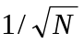. Birkett noted that the range precision error contribution was in the sub-centimeter range for large water bodies.
The wet tropospheric correction was based on the onboard microwave radiometer for open ocean readings. However, because of the large footprint of the radiometer (20–40 km), the corrections based on microwave radiometer readings near shore could not be used. Thus, larger lakes benefited from a better correction than the smaller lakes.
Aside from considerations related to the generalized error budget, Birkett also drew attention to several other conditions that could lead to error in estimation of surface water level variation. These conditions included unusually stormy or calm lake surfaces, unidirectional wind setup, and geoid surface slope error.
Birkett’s study performed a validation versus gauge data for Lake Superior, Lake Michigan, and Lake Ontario and, consistent with Shum et al. (2003), found accuracy in the 3–5 cm range.

Characterization of the Global Reservoir and Lake Monitor
An initial verification and validation effort for the GRLM decision support tool was carried out in 2004. Though somewhat early in the implementation phase for the tool, this effort touched on all the requirements mentioned in Table 3. The tool’s delivery and coverage have matured since this initial V&V effort ended, so requirements related to these properties were re-evaluated through the month of May 2005. As for the product accuracy requirement, the fundamental algorithm is essentially unchanged, so the results from the 2004 report are summarized below. For further detail, refer to the online version of the previous report, PECAD’s Global Reservoir and Lake Monitor: A Systems Engineering Report (NASA 2004b).

GRLM Accuracy
The GRLM root mean square accuracy estimates over several North American lakes are summarized in Table 5. These estimates are based on comparisons with water level gauges. The Great Lakes gauges were chosen from U.S. National Oceanic and Atmospheric Administration and Canadian Department of Fisheries and Oceans gauges to frame the Jason-1 pass used for GRLM estimates (Figure 8). Lake Winnebago and Lake of the Woods were each referenced to a single U.S. Geological Survey gauge. Lake Powell was monitored by the U.S. Bureau of Reclamation using a well-gauge built directly into the face of Glen Canyon Dam. Essentially, the Great Lakes can be considered representative of the larger water bodies in the GRLM. Great Lakes errors ran between 5 and 7 cm. Lake Winnebago and Lake of the Woods may be somewhat representative of smaller water bodies. Each estimate represents only a handful of potential readings per pass. Lake Winnebago error was calculated to be 27 cm and Lake of the Woods error was computed to be 26 cm. Lake Powell represents the most challenging type of lake or reservoir. The lake has very few potential readings per pass, and it is surrounded by mountainous terrain. Lake Powell error over the period assessed was about 140 cm.
Note the Great Lakes errors computed for the GRLM are somewhat larger than those reported by Shum et al. (2003). This discrepancy may be explained by the earlier study’s focus on the verification of sensor performance and by corrections for the sea surface height estimates being carefully tailored for the Great Lakes. The 2004 GRLM verification effort made no special corrections to the data because the focus of that study was the GRLM operational product accuracy.

Table 5. Verified GRLM performance over select North American surface water bodies.*
Water Body | Surface Area†  (km²) | σ  (outliers removed)  (cm) | Number Passes | Outlying Passes Removed | Number Gauges | Mean Pass-to-Gauge Distance  (km)
Lake Superior | 82,100 | 7.3 | 81 | 0 | 3 | 72
Lake Michigan | 57,800 | 5.3 | 75 | 0 | 3 | 51
Lake Huron | 59,600 | 6.2 | 80 | 2 | 4 | 55
Lake Erie | 25,700 | 6.5 | 73 | 1 | 4 | 29
Lake Ontario | 18,960 | 4.5 | 79 | 3 | 3 | 52
Lake Winnebago | 557 | 27.0 | 24 | 0 | 1 | 7
Lake of the Woods | 1,900 | 26.1 | 42 | 1 | 1 | 31
Lake Powell | 500 | 140.6 | 244 | 6 | 1 | 84
* All lakes and reservoirs were characterized using Jason-1 IGDR-based estimates with the exception of Lake Powell. No estimates based on Jason-1data existed for Lake Powell as of May 2004, so TOPEX/Poseidon GDR-based estimates were used.
† Surface areas from www.worldlake.org.
Note the Great Lakes errors computed for the GRLM are somewhat larger than those reported by Birkett (1995) or Shum et al. (2003). Much of the increased Great Lakes error is likely due to ice contamination, storms, or wind setup. The 2004 GRLM validation effort attempted to screen data only by removing a small number of statistical outliers and, in the case of Lake Winnebago and Lake of the Woods, by excluding completely frozen conditions. The goal was to represent the unvarnished operational product accuracy.
More problematic, perhaps, are the larger error figures for the three smaller water bodies: Lake Winnebago, Lake of the Woods, and Lake Powell. These error figures can be partially explained by less ideal reference data. As mentioned above, each of these three water bodies was referenced to only a single gauge. Lake Winnebago and Lake of the Woods estimates were based on fewer passes (24 and 42, respectively). The Lake Powell gauge would be expected to be markedly influenced by local draw-down associated with release events. Beyond reference issues, each of the three lakes had much less surface area than even the smallest of the Great Lakes. Consequently, the three lakes had fewer data points per pass and reduced range precision relative to the Great Lakes. The three lakes suffered from poorer estimation of the wet tropospheric correction. The steep terrain surrounding Lake Powell made it difficult for the altimeter sensors to “lock” on the water surface as the satellite crosses from land to water. “Loss of lock” can cause a loss of some or all data points for surface water bodies. No valid data points have been returned for Lake Powell since the transition from TOPEX/Poseidon to Jason-1.
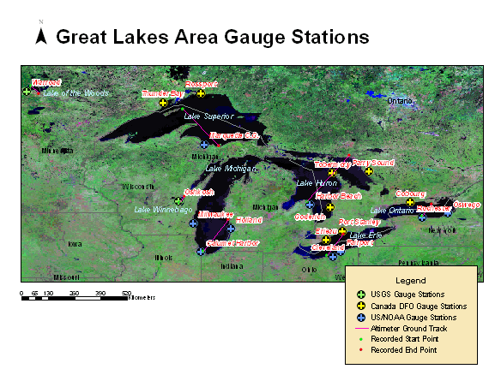
Figure 8. Gauge stations in the general vicinity of the Great Lakes.
While not all lakes appeared to meet the stated FAS accuracy requirement, perhaps the accuracy requirement should be revisited. For deep, narrow reservoirs, fairly large height uncertainty may be acceptable because the information regarding water volume is still readily discernable. For shallow, closed lakes (e.g., Lake Chad), the current standards are appropriate. Furthermore, FAS lake water height requirements should be developed in more detail to include a comprehensive listing of water bodies that FAS believes should be monitored.

GRLM Delivery
The latency of the GRLM products decreased from 10.3 days to 5.8 days between May 2004 and May 2005. Latency was defined as the mean lag time between data acquisition and GRLM product upload. The maximum lag time in May 2004 was 19.2 days, but in May 2005 the maximum lag time was reduced to 10.4 days. This dramatic improvement in delivery time was accomplished by reducing the average time between GRLM updates from 16 days to 6 days. This improvement clearly meets the stated FAS 10-day latency requirement for surface water level variation.
Once every 9.9 days (the Jason-1 orbital period), the GRLM adds a new data record for each monitored body of water, so the FAS 10-day time step requirement is nominally met. However, the Jason-1 standard product algorithms yield no height information for some passes, perhaps because of issues like “loss of lock” or other conditions that are screened in the standard algorithms to improve sea surface height estimates. For many instances in both 2004 and 2005, months to years passed between data acquisitions in which water levels were actually estimated. These dated sites have archival value, but they no longer provide information about current regional water availability. A breakdown of the time to last estimated water level is shown in Figure 9.
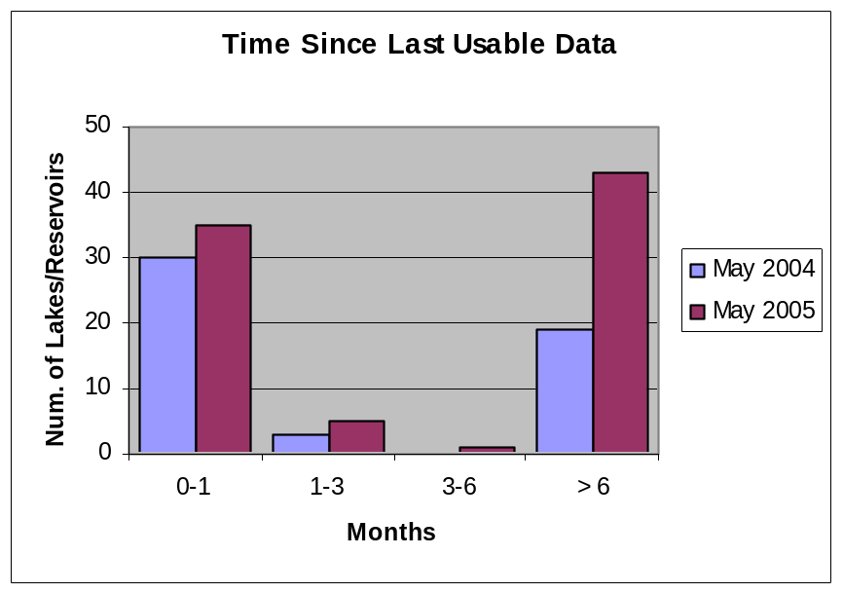
Figure 9. Histogram of time to last estimated water level checked at the end of May 2004 and again at the end of May 2005.
From May 2004 to May 2005, the number of lakes and reservoirs monitored increased from 52 to 84 – more than 60 percent. An incremental increase occurred in the number of water bodies with near-real-time monitoring, but most of the increase consisted of lakes and reservoirs that have had little or no valid data since Jason-1 became operational. The dearth of data for near-land sites results from the algorithms implemented for standard Jason-1 data processing. These algorithms filter out the near-land data. This issue was noted in the 2004 report (NASA, 2004b) with the indication that it was being addressed, but, as of this writing, no substantial improvement in processing near-land data was noted. The geographic distribution of more current and more out–of-date sites is shown in Figure 10.
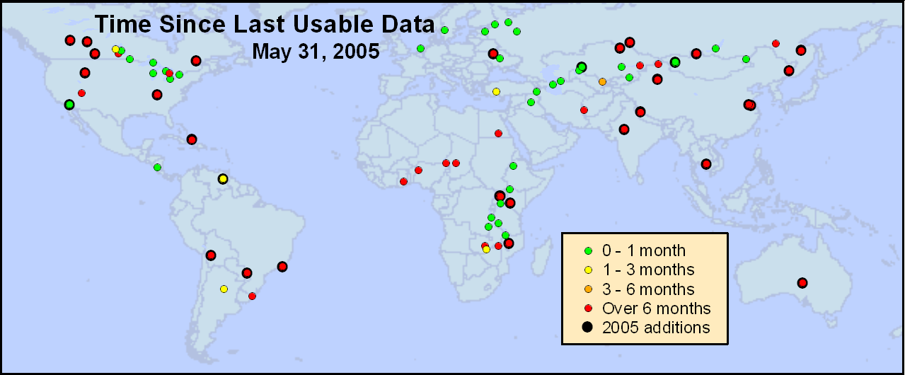
Figure 10. Geographic distribution of time to last estimated water level at the end of May 2005.

GRLM Coverage
In 2004, little coverage existed in South America, western North America, or eastern Asia. Australia had no monitored sites. As can be seen in Figure 10, through May 2005 sites have been added in all of these areas. Unfortunately, the overwhelming majority of the new sites are badly dated, so the near-real-time coverage has changed little.

Conclusions and Recommendations
As of summer 2005, NASA-supported enhancements to the decision support tools of PECAD have had varying degrees of success in meeting PECAD’s requirements. The MODIS Image Gallery and the Global Reservoir and Lake Monitor are more mature and have achieved a semi-operational status, whereas the USDA-FAS MODIS NDVI Database is still evolving and should presently be considered developmental.
Considering each decision support enhancement individually, their performances can be summarized according to product accuracy, delivery, and coverage. The MODIS Image Gallery has met delivery requirements with a latency of less than 5 hours and a time step of 1 day. Down time is a concern. Coverage is nearing sufficiency for economically important crop production regions, but some significant gaps remain in Central America, in parts of South America, in the northernmost productive region of the Great Plains of North America, and in parts of central Asia. Additional large coverage gaps for PECAD’s food security mission exist, notably in the Congo basin, in Indonesia, and in the Philippines.
Although the USDA FAS MODIS NDVI Database is less finished than the MODIS Image Gallery, the Database has already largely met its coverage requirement with fewer gaps than the MODIS Image Gallery. The principal exception is the Congo basin, where the Database does not seem to be meeting the 72-hour latency requirement. Cursory observations indicated latency of 9 days or more. The Database is being delivered on a 16-day time step, which is at the upper end of the range currently considered acceptable by PECAD. PECAD’s final time step requirement is a matter of ongoing discussion. The consistency of standard MODIS NDVI products with the AVHRR NDVI products has been established.
The Global Reservoir and Lake Monitor exceeded PECAD delivery requirement with a latency of less than 6 days and a time step of 10 days. Validation with water level gauges showed that the 10 cm PECAD surface water level relative accuracy requirement was being met in the Great Lakes. Results were not as good over smaller water bodies, which can be partially explained by less ideal reference data. While not all lakes appeared to meet the stated FAS accuracy requirement, perhaps the accuracy requirement should be revisited given that even “noisier” data often seemed to satisfy underlying information needs.
The amount of data that is not being processed by the standard Jason-1 algorithms was established as a matter of concern in 2004 and continues to be a problem. Coverage improved from 2004 to 2005, so that lakes and reservoirs being monitored are approaching quasi-global status, but the overwhelming majority of the added lakes have had no valid heights estimated because of the problems with the standard Jason-1 algorithms. Data dropouts should be reduced. At present, the source of science data for the GRLM is the “Archivage, Validation et Interprétation des données des Satellites Océanographiques” (AVISO) data center for CNES. If AVISO is unable to improve the data stream, perhaps a separate channel for providing appropriate sea surface height data should be engaged at the Jet Propulsion Laboratory’s Physical Oceanography Distributed Active Archive Center. If no action is forthcoming, then the need should be elevated to higher levels within NASA.
One overall recommendation resulting from the verification and validation process is that as NASA-supported enhancements become operational, regularly generated metrics should be introduced to track certain types of performance, such as delivery and coverage. While certain facets of decision support will require more careful analysis, the more routine aspects that relate to satisfaction of customer requirements should be amenable to simple self-monitoring that could be publicly available as product metadata.

References
Bahill, A.T., and B. Gissing, 1998. Re-evaluating systems engineering concepts using systems thinking. IEEE Transactions on Systems, Man and Cybernetics, Part C: Applications and Reviews, 28(4):516–527, doi:10.1109/5326.725338.
Birkett, C.M., 1995. The contribution of TOPEX/POSEIDON to the global monitoring of climatically sensitive lakes. Journal of Geophysical Research, 100(C12):25,179–25,204.
Bonnefond, P., P. Exertier, O. Laurain, Y. Ménard, A. Orsoni, G. Jan, and E. Jeansou, 2003. Absolute calibration of Jason-1 and TOPEX/Poseidon altimeters in Corsica. Marine Geodesy, Special Issue on Jason-1 Calibration/Validation, Part 1, 26(3-4):261–284.
Chambers, D.P., J.C. Ries, and T.J. Urban, 2003. Calibration and verification of Jason-1 using global along-track residuals with TOPEX. Marine Geodesy, Special Issue on Jason-1 Calibration/Validation, Part 1, 26(3-4):305–317.
Doorn, B., 2004. FAS Evaluation of Products and Expectations for FY05. Presentation for NASA/USDA-FAS project review at NASA Stennis Space Center, 30 June 2004.
Gallo, K., L. Ji, B. Reed, J. Dwyer, and J. Eidenshink, 2004. Comparison of MODIS and AVHRR 16-day normalized difference vegetation index composite data. Geophysical Research Letters, 31: L07502, doi:10.1029/2003GL019385.
Gao, X., A.R. Huete, and K. Didan, 2003. Multisensor comparisons and validation of MODIS vegetation indices at the semiarid Jornada experimental range. IEEE Transactions on Geoscience and Remote Sensing, 41(10):2368–2381, doi:0.1109/TGRS.2003.813840.
Haines, B.J., D. Dong, G.H. Born, and S.K. Gill, 2003. The Harvest experiment: Monitoring Jason-1 and TOPEX/POSEIDON from a California offshore platform. Marine Geodesy, Special Issue on Jason-1 Calibration/Validation, Part 1, 26(3-4):239–259.
Haithcoat, T., V. Likholetov, V. Kaupp, B. Doorn, D. Tralli, W. van Leeuwen, S. Drake, and C. Hutchinson, 2005. Benchmarking the performance of a decision support system. In Proceedings of 31st International Symposium on Remote Sensing of Environment: Global Monitoring for Sustainability and Security, International Society for Photogrammetry and Remote Sensing et al., St. Petersburg, Russian Federation, June 20–24, 2005; available online at http://www.isprs.org/publications/related/ISRSE/html/papers/1031.pdf (accessed January 1, 2006).
Huete, A., K. Didan, T. Miura, E.P. Rodriguez, X. Gao, and L.G. Ferreira, 2002. Overview of the radiometric and biophysical performance of the MODIS vegetation indices. In “The Moderate Resolution Imaging Spectroradiometer (MODIS): A new generation of land surface monitoring,” ed. C. Justice and J. Townshend, special issue, Remote Sensing of Environment, 83(1-2):195–213.
Justice, C., 2005. Support of Application of NASA EOS MODIS Data by USDA, annual report of the Global Agriculture Monitoring Project (a joint project between NASA, USDA/FAS, and University of Maryland) for the period from April 2004 through March 2005, 17 p.
Justice, C., A. Anyamba, C. Reynolds, J. Owens, S. Liang, and C.J. Tucker, 2002. Support of Application of NASA EOS MODIS Data by USDA Foreign Agriculture Service. Proposal submitted in response to CAN-02-OES-01: The Earth Science REASoN – Research, Education and Applications Solutions Network, 47 pp.
Ménard, Y., L.-L. Fu, P. Escudier, F. Parisot, J. Perbos, P. Vincent, S. Desai, B. Haines, and G. Kunstmann, 2003. The Jason-1 mission. Marine Geodesy, Special Issue on Jason-1 Calibration/Validation, Part 1, 26(3-4):131–146.
NASA, 2004a. Decision Support Tools Evaluation Report for FAS/PECAD, Version 2.0. Report commissioned by NASA/SSC Earth Science Applications Directorate, Agricultural Efficiency Integrated Product Team, 76 p. Available online at http://aiwg.gsfc.nasa.gov/esappdocs/evalreports/ pecad_dss_eval_rpt.doc (accessed July 24, 2005).
NASA, 2004b. PECAD’s Global Reservoir and Lake Monitor: A Systems Engineering Report. Report commissioned by NASA/SSC Applied Science Directorate, Agricultural Efficiency Integrated Product Team, 64 p. Available online at http://aiwg.gsfc.nasa.gov/esappdocs/benchmarks/ PECADGRLM.pdf (accessed July 24, 2005).
Rojas, F., R.A. Schowengerdt, and S.F. Biggar, 2002. Early results on the characterization of the Terra MODIS spatial response. In “The Moderate Resolution Imaging Spectroradiometer (MODIS): A new generation of land surface monitoring,” ed. C. Justice and J. Townshend, special issue, Remote Sensing of Environment, 83(1-2):50–61.
Shum, C., Y. Yi, K. Cheng, C. Kuo, A. Braun, S. Calmant, and D. Chambers, 2003. Calibration of JASON-1 altimeter over Lake Erie. Marine Geodesy, Special Issue on Jason-1 Calibration/Validation, Part 1, 26(3-4):335–354.
USDA, 2005. Crop Explorer. Production Estimates and Crop Assessment Division, Foreign Agricultural Service. http://www.pecad.fas.usda.gov/cropexplorer/ (accessed January 1, 2006).
USDA, 2004. Global Reservoir and Lake Monitor. Foreign Agricultural Service, Production Estimates and Crop Assessment Division, http://www.pecad.fas.usda.gov/cropexplorer/global_reservoir/ (accessed August 9, 2005).
USGS, 2005. MODIS/Terra Vegetation Cover Conversion 32-Day L3 Global 250m ISIN Grid (MOD44A). Land Processes Distributed Active Archive Center. National Center for Earth Resources Observation and Science. http://edcdaac.usgs.gov/modis/mod44a.asp, accessed January 1, 2006.
van Leeuwen, W., S. Drake, C. Hutchinson, B. Doorn, D. Tralli, V. Kaupp, T. Haithcoat, and V. Likholetov, 2005. Assimilating NASA data into a crop production estimation system: Risk management. In Proceedings of 31st International Symposium on Remote Sensing of Environment: Global Monitoring for Sustainability and Security, International Society for Photogrammetry and Remote Sensing et al., St. Petersburg, Russian Federation, June 20–24, 2005; available online at http://www.isprs.org/publications/related/ISRSE/html/papers/229.pdf (accessed January 1, 2006).
Vermote, E.F., N.Z. El Saleous, and C.O. Justice, 2002. Atmospheric correction of MODIS data in the visible to middle infrared: First results. In “The Moderate Resolution Imaging Spectroradiometer (MODIS): A new generation of land surface monitoring,” ed. C. Justice and J. Townshend, special issue, Remote Sensing of Environment, 83(1-2):97–111.
Watson, C., R. Coleman, N. White, J. Church, and R. Govind, 2003. Absolute calibration of TOPEX/Poseidon and Jason-1 using GPS buoys in Bass Strait, Australia. Marine Geodesy, Special Issue on Jason-1 Calibration/Validation, Part 1, 26(3-4):285–304.
Wolfe, R.E., M. Nishihama, A.J. Fleig, J.A. Kuyper, D.P. Roy, J.C. Storey, and F.S. Patt, 2002. Achieving sub-pixel geolocation accuracy in support of MODIS land science. In “The Moderate Resolution Imaging Spectroradiometer (MODIS): A new generation of land surface monitoring,” ed. C. Justice and J. Townshend, special issue, Remote Sensing of Environment, 83(1-2):31–49.

Acronyms
AVHRR Advanced Very High Resolution Radiometer
AVISO Archivage, Validation et Interprétation des données des Satellites Océanographiques (French data archive)
CADRE Crop Assessment Data Retrieval and Evaluation
CNES Centre National d’Etudes Spatials (the French space agency)
DORIS Doppler Orbitography and Radiopositioning Integrated by Satellite
DSS Decision Support System
ECMWF European Centre for Medium-Range Weather Forecasts
FAS Foreign Agricultural Service
GDR Geophysical Data Record
GIMMS Global Inventory Monitoring and Modeling Studies
GLAM Global Agricultural Monitoring
GRLM Global Reservoir and Lake Monitor
GSD ground sample distance
GSFC Goddard Space Flight Center
IGDR Interim Geophysical Data Record
MODAPS MODIS Data Production System
MODIS Moderate Resolution Imaging Spectroradiometer
NDVI Normalized Difference Vegetation Index
PECAD Production Estimates and Crop Assessment Division
RGB Red Green Blue
TMR TOPEX Microwave Radiometer
USDA U.S. Department of Agriculture
USDA-FAS USDA Foreign Agricultural Service
USGS U.S. Geological Survey
V&V Verification and Validation

