Abstract. The Toroidal Field (TF) coil of the National Spherical Torus Experiment (NSTX) [1] suffered a failure on February 14, 2003, after approximately 3 years of service and 7200 pulses. The failure occurred at an electrical joint connecting one of the radial flags to the inner leg bundle. Damage was extensive such that the coil could not be repaired. Analysis of the failure revealed structural design problems which have been addressed in the re-design effort described herein. Construction of a new TF coil is now underway.
NSTX TF Joint Failure and Re-Design
C. Neumeyer, A. Brooks, J. Chrzanowski, L. Dudek, P. Heitzenroeder, M. Kalish, M. Williams, I. Zatz
Princeton Plasma Physics Laboratory∗

INTRODUCTION
The NSTX is a spherical torus (ST) magnetic confinement fusion device which employs a de-mountable TF coil, meaning that the inner legs of the coil are bundled together into a single assembly which is separable from the outer legs. This feature is central to the ST concept, in which future reactors are envisioned to utilize a single turn central conductor carrying mega-amps of current to create the toroidal field. Although NSTX has a multi-turn TF coil, the low aspect ratio and low toroidal field of the ST configuration still lends itself to the grouping of the inner leg turns in to a bundle for convenience of manufacture, assembly, and maintenance. With the demountable configuration comes the challenge of an electrical joint, however, at high field. On NSTX, the TF inner leg bundle is threaded through an ohmic heating (OH) solenoid. Therefore, in order to preserve the ability to separate the OH and TF coils by sliding the OH coil over the TF bundle, the TF joint occurs at the radius of the inner leg bundle where the field is maximum.

TF Configuration
An isometric view of NSTX shown in Fig. 1, and a zoomed-in view of the upper TF joint region in Fig. 2. These views are of the original design, but the general features of the new design are similar. The TF inner leg bundle and OH coils are enclosed in a vacuum jacket and form the center stack, which is completely demountable from the rest of the machine. The TF coil has 36 water cooled copper turns connected in series, and produces 6kG at the major radius R₀=0.85m with 71.2kA per turn. The 36 turns are arranged in two layers, 12 on the inner layer and 24 on the outer. Radial flags are affixed to the inner leg conductors using long thru-bolts. Further out, L-shaped connectors join the flags to flexible links which in turn connect to the outer legs. A hub assembly consisting of several stainless steel disks structurally supports the radial flags. A torque collar attaches to the bundle below the elevation of the disks and transmits torque from the bundle to the hub.
In the original TF assembly, shown in Fig. 3, the fit-up and communication of loads from the radial flags to the hub disks, which were split into 180º segments, was accomplished by a set of G-10 wedges and manually selected shims.
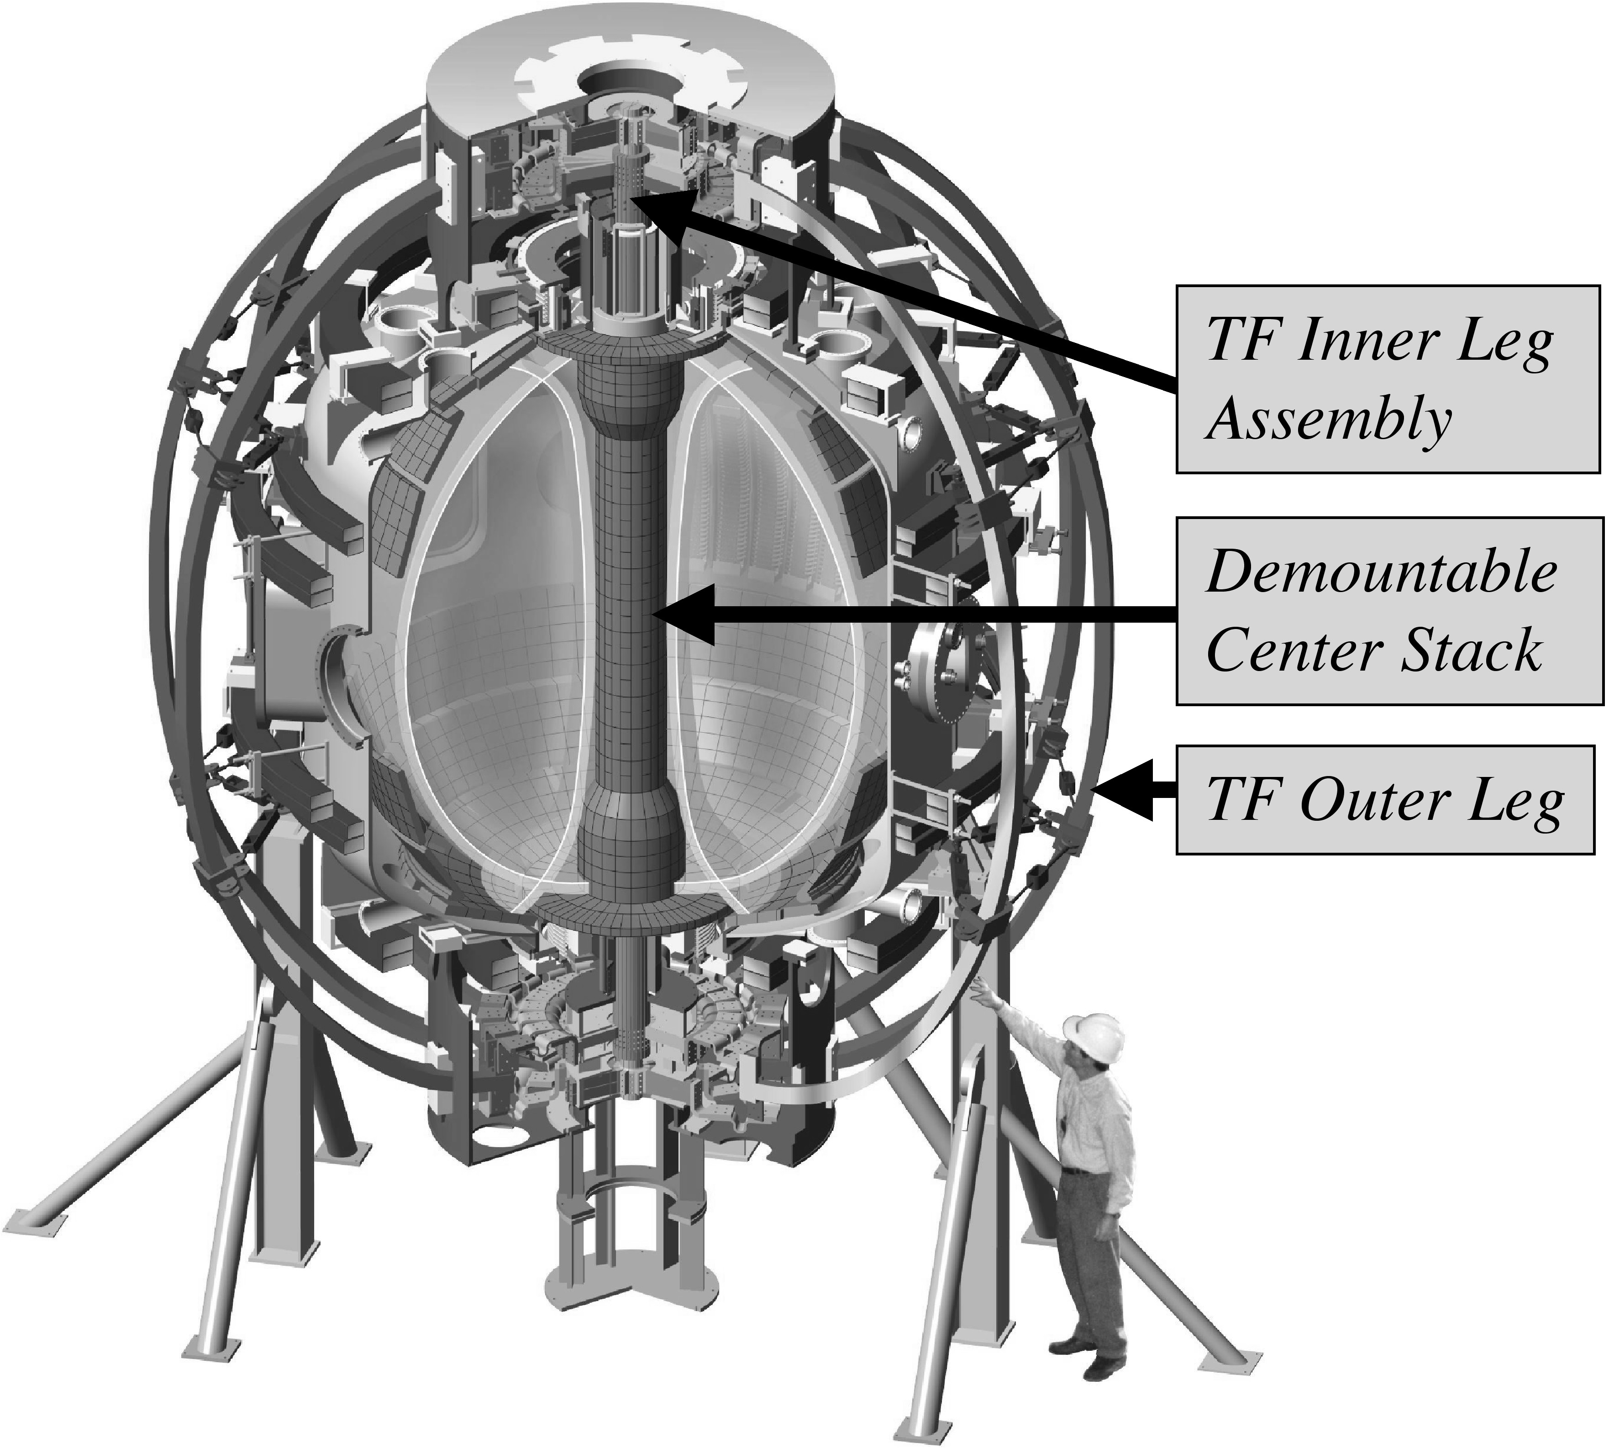Fig. 1. Isometric View of NSTX showing de-mountable TF/OH Center Stack.

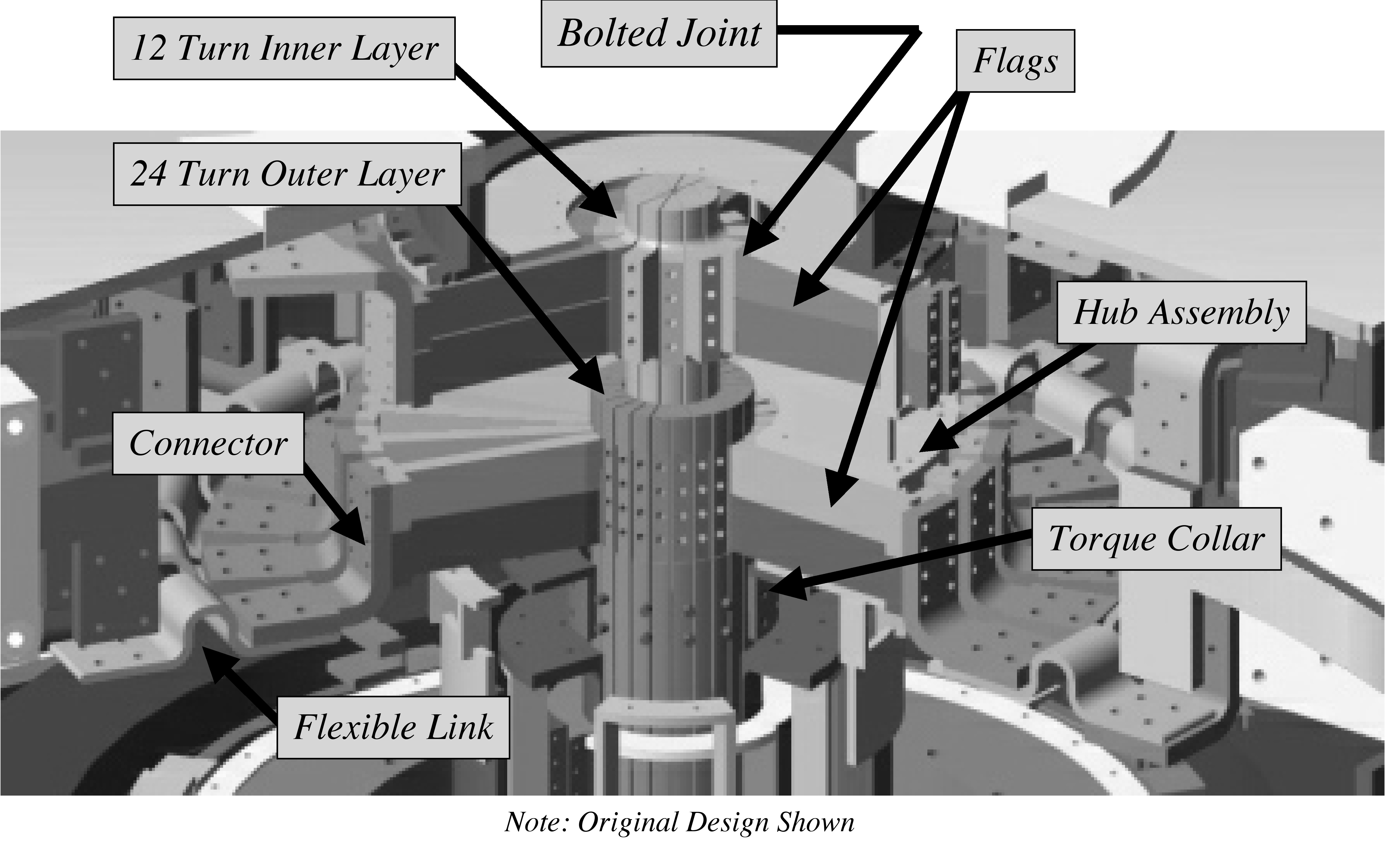
Fig. 2. Zoomed View showing Connections from Inner to Outer Leg

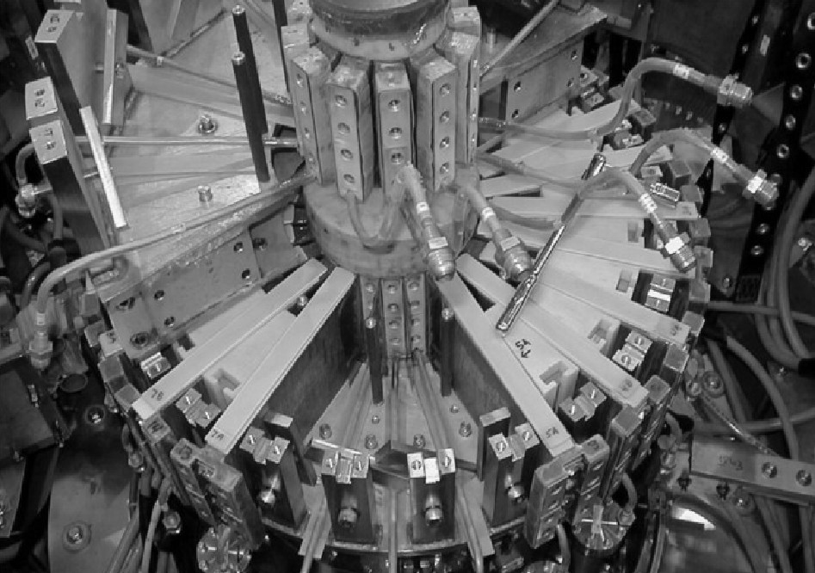
Fig. 3. G-10 Wedges and Shims of Original Assembly

These features proved to be the primary defects leading to the failure of the original design. The shimming was by nature imprecise, resulting in uncertain communication of EM loads from flags to hub disks. Second, the shimming allowed the flags and hub disks to slide radially with respect to one another. This, plus the non-toroidally continuous hub disks, led to a lack of stiffness against vertical loads and a tendency toward “dishing”. In the original finite element analysis (FEA) of NSTX, although G-10 properties were assumed in a layer of elements forming the interface between the flags and hub disks, the modeling did not allow sliding between the parts. This proved to be a major oversight because, without sliding, the flags would tend to act as the web of I-beams formed with the disks, which would be quite stiff. It resulted in a serious underestimate of the loads on the flag bolts which was likely the primary cause of the failure.

Failure of Original TF Assembly
On February 14, 2003, following the morning test shots, the first plasma attempt of the day resulted in a loud bang heard on the control room audio monitors followed by a plume of smoke visible on the control room video monitors. Waveforms of TF current during the last successful test shot and the faulty shot are shown in Fig. 4. The target flat top level was 53.4kA which produces Bt=4.5kG. The fault occurred just prior to flat top as the current passed 50kA. Several protective devices tripped and limited energy dissipation in the fault to 1.4MJ.

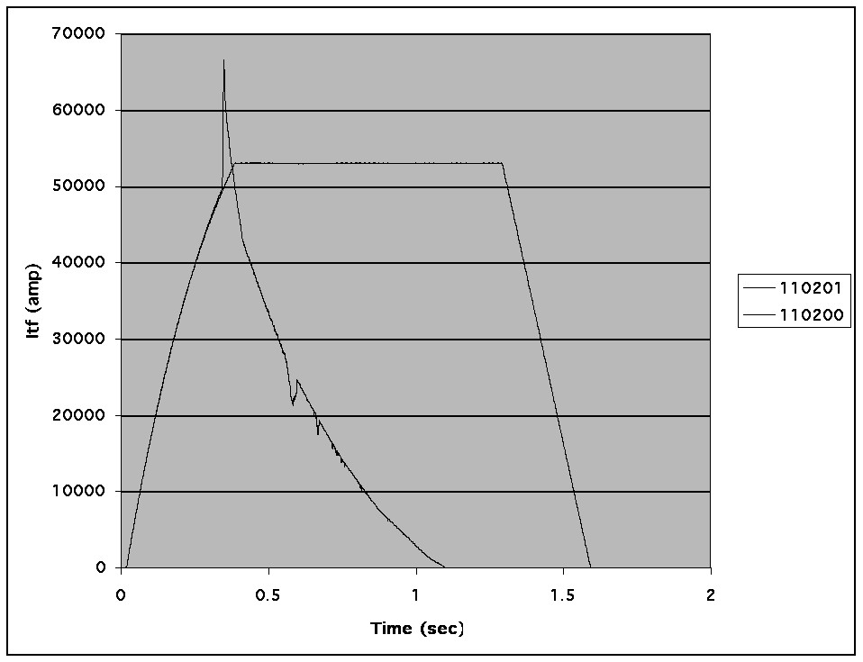
Fig. 4. TF Current Waveforms During Last Test Shot and Faulty Shot

Subsequent inspection of the coil revealed extensive melting and carbonization at one of the flag joints on the bottom of the machine. Voltage and current waveforms were analyzed and a fault sequence was developed as shown in Fig. 5.

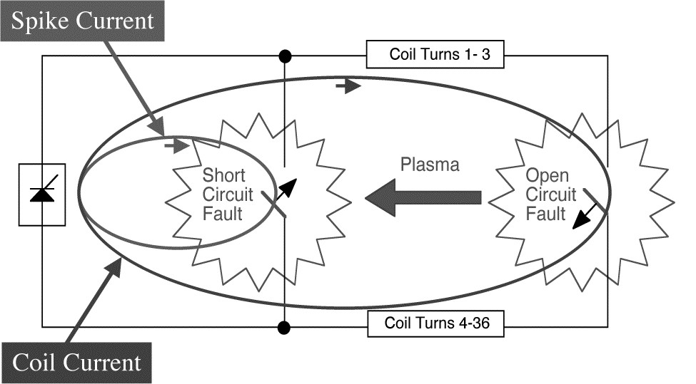

Fig. 5. TF Current Waveforms During Last Test Shot and Faulty Shot

An open circuit fault occurred initially at the flag joint of turn 3, which was located close to the start and finish leads of the coil, where the full 1kV terminal voltage was present. The resulting plasma then initiated a short circuit fault across the coil terminals, and the spike of fault current from the power supply led to the power supply trip and subsequent L/R decay. Thanks to the current spike the power supply tripped quickly. Had this not occurred, more energy would have been dissipated, leading to more extensive and perhaps collateral damage.

Following the event, more detailed FEA was undertaken and it became apparent that the mechanical support of the flat was inadequate. The cyclic vertical EM loads on the flags was causing excessive deflection and moment on the flag bolts, gradual loosening of the fasteners, loss of contact pressure, and high localized current density, eventually leading to failure.

Performance Requirements

Magnetic Field and Current
The TF is required to supply a long pulse at 3kG with 4.5 second flat top, and a short pulse at 6kG with a 0.6 second flat top. Although both pulse waveforms have the same prospective ∫I²(t)dt = 6.5x10⁹amp²-sec, the 6kG operation is clearly the most challenging because of the high force and the minimal time available for heat dissipated at the joint to diffuse to surrounding copper.

EM and Thermal Loads

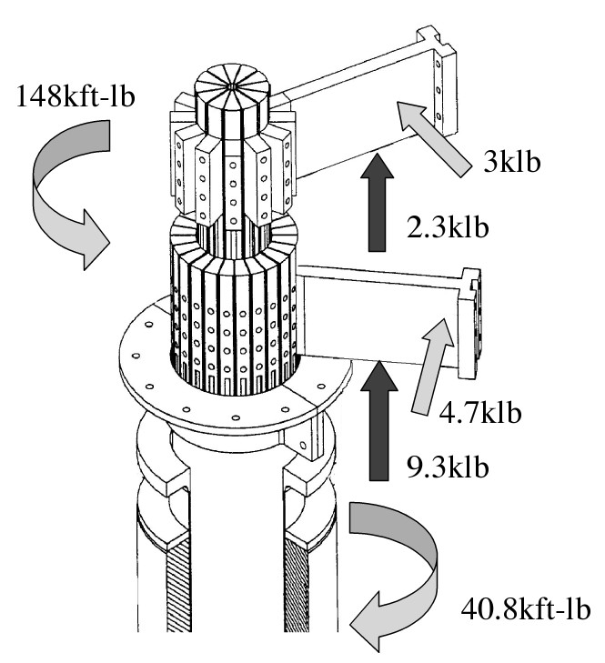
Fig. 6. Electromagnetic Loads on TF Flag Joint

EM loads are shown in Fig. 6. The in-plane loads are vertical and result from the magnetic pressure of the TF coil itself. The out-of-plane loads consist of torsion on the inner leg bundle and lateral loads on the flags. The torsional load results from the radial field at the end of the OH coil crossing the vertical TF current, when the lateral load results from the vertical fields from the OH and PF coils crossing the radial TF current.

Additional forces arise from thermal effects. The 80ºC temperature rise in the inner leg conductor causes an axial thermal expansion of 0.35” overall and, importantly, an increase in the length of the inner layer conductors as they extend beyond the outer layer, which amounts to an increased separation between the inner and outer layer flags. The radius of the bundle also increases by around 0.006” during a pulse.

Contact Resistance
Contact resistance is a key performance driver since it determines the heating of the joint. To characterize the achievable contact resistance using the machining and silver plating processes typical during TF coil manufacturing, tests were performed to quantify the relationship between contact pressure and contact resistivity as shown in Fig. 7.

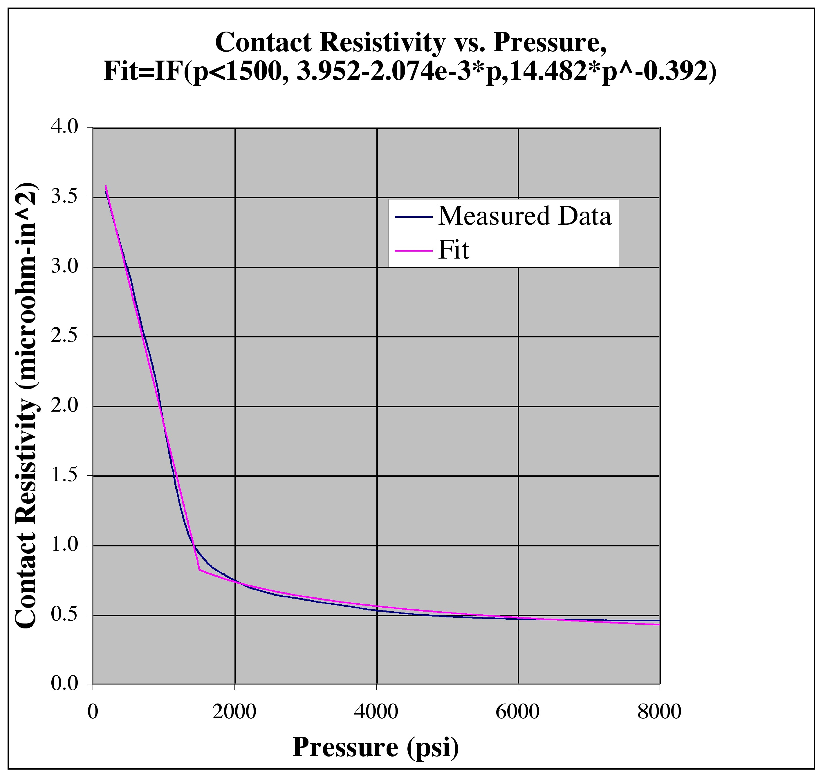
Fig. 7. Contact Resistivity vs. Pressure for Silver Plated Joint

To put perspective on Fig. 7, an FEA calculation of peak temperature, which is always located at the corner of the joint due to current bunching, shows that that an average contact resistivity of2.5μΩ-in² leads to a peak temperature of 120ºC. Although contact pressure typically varies across the joint, this finding suggests that contact pressures of 1ksi and above are sufficient.

New Design
The new TF joint design is shown in Fig. 8.

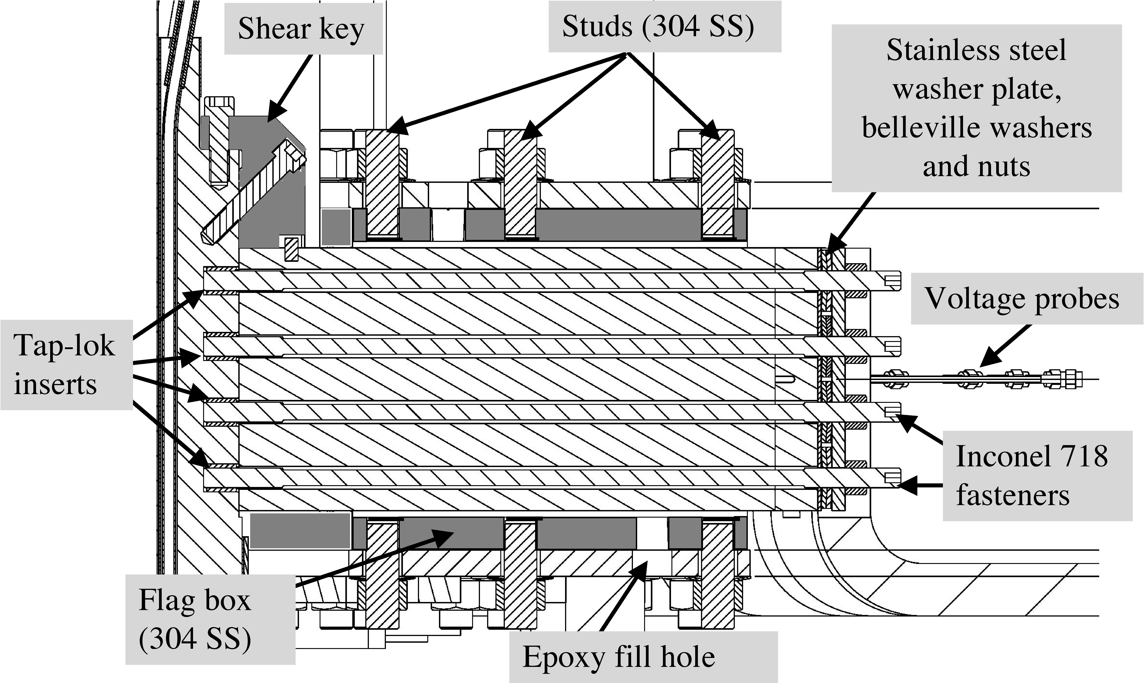 Fig. 8. New TF Flag Joint Design

The flags are potted with injected epoxy in boxes which are bolted to the hub disks. In this configuration, the flag boxes act like the webs of an I-beam, resulting in a very stiff structure. In addition, communication of the EM loads from the flags to the boxes via the potting is extremely efficient. A286 flag bolts are replaced by larger Inconel 718 studs at twice the preload. Spring loaded coaxial voltage probes are installed on all joints.
Key improvements over the old design are listed in Table I.

TABLE I
Improvements of New Design
 | Old Design | New Design
Hub Stiffness | Not adequate; lacking stiff linkages between disks because flags could slide w.r.t. disks | Very stiff. Boxes form webs with disks like I-beams.
Bolts/Studs | Shoulder engagement too small (4 bolts x 0.1 depth = .4 @ 1/2" dia, Area = 0.18 in^2) | Shear Shoe using two 3/8” dia bolts
 | Bolt 5/16” thread was necked down too far to 0.232" | Studs necked down to root dia of 3/8" bolt = 0.314"
 | 0.438” shank diameter was too large, bolt not compliant for thermal cycling | Neck down to root dia of 3/8" bolt = 0.314", Belleville washer
 | Torsion in long bolts during tightening, inaccurate tensioning | Studs with nuts used in place of long bolts, stud tensioner
 | Dual purpose bolts, combined tension and shear functions, tolerance issues, torque(tension) uncertainty | Loose fitting clearance holes for studs, separate shear shoes
 | Four 5/16" bolts @ 2500#, marginal friction to carry shear (4*2500=10000lbf applied vs. 9230lbs, requires mu ~1.0) | Four 3/8" studs @ 5000#, doubling of preload (4*5000=20000lbf)
 | Thin washers under bolt heads | 1/4" thick washer plate over Belleville washers at tee-ends
Inserts | Keensert type, marginal thread engagement | Taplok type, thread engagement > 0.5"
Shimming | Manually selected and inserted G10 shim stock | Hysol/glass tape potting in boxes, mold released to permit thermal growth
Out-of-Plane Load Path | Wedged G10 blocks with pusher bolts | Flags potted in boxes, boxes bolted to hub disks
Torque Collar | Two piece collar bolted directly to hub. Wet lay-up 0.25” thick Hysol RE2039 & HD3561. Holes in collar for epoxy outflow to enhance adhesion. | Three piece collar with sliding contact with hub for torsion-only connection. Wet lay-up 0.180” Hysol E-120HP. Serrations in collar to enhance adhesion.
Joint Resistance Measurement | 10A Biddle measurement via connection to two half flags on disassembled joint, resolution ~ 1μΩ | 200A precision measurement using voltage probes in situ, ~ 20x enhanced resolution

A simplified diagram of the in-plane force application and the elements available to react the load is given in Fig. 9. The four primary load paths are 1) the bolted joint friction, 2) the shear shoe, 3) the torque collar, and 4) the hub/spline/VV. At the joint, the radial pressure exerted by the fasteners results in a frictional response to vertical loads on the flag, depending on the coefficient of friction. In addition, the shear shoe, which is bolted on to the ends of the inner leg conductor, provides a vertical stop.

Fig. 9. Temperature Distribution at EOFT

The torque collar is attached to the inner leg bundle via a wet lay-up of room temperature cure epoxy. This collar serves to transmit the torque generated on the inner leg bundle to the hub assembly. The collar is connected to the hub at anchor points which are designed to transmit torque, but not vertical or radial load. The hub assembly takes the vertical moment generated on the flags. In addition, it communicates the torsional load from the collar and the lateral load on the flags out to the vacuum vessel by way of the spline. The spline is designed to transmit torque, but not vertical or radial load. It is intended to allow axial thermal displacement of the inner leg assembly with respect to the umbrella and vacuum vessel.

Analysis of New Design
Detailed FEA was performed using NASTRAN which includes non-linear effects, e.g. friction and sliding. Analysis was performed for Start of Flat Top (SOFT), End of Flat Top (EOFT) and End of Pulse (EOP) conditions. The FEA provided information concerning the peak stresses in the various components of the joint and, importantly, the contact pressure distribution over the joint. Using this contact pressure information with linear extrapolation between the time points, another FEA using ANSYS was used to simulate the temperature distribution during the pulse, including thermal diffusion and resistivity variation with temperature. Prior analyses showed that magnetic effects on current distribution were not significant. These results showed that peak temperatures occur at EOFT, and are located at the corner of the joint where the current bunches up. A typical result is shown in Fig. 10.
Cases were run at various off-normal conditions including friction coefficient and preload pressure. In all cases the temperature was less than 120ºC, which was established early on as a goal limit. It was found that reduction in contact pressure near the corner of the joint led simply to a redistribution of current to areas of higher pressure and lower resistivity.
Since large regions of the joint are at low current density under nominal conditions, a relatively high tolerance for pressure reduction exists. With this in mind, cases were run without the torque collar. It was found that peak temperatures were approximately 10ºC higher but still below 120ºC. Based on this result it has been decided to defer the implementation of the new torque collar, at least initially. During assembly and re-commissioning, using new voltage probes measuring the joint voltage drop along with fiber optic temperature and strain gauges, joint performance will be monitored and compared to the predictions of the analysis. If necessary to gain margin, the installation of the torque collar remains an option.

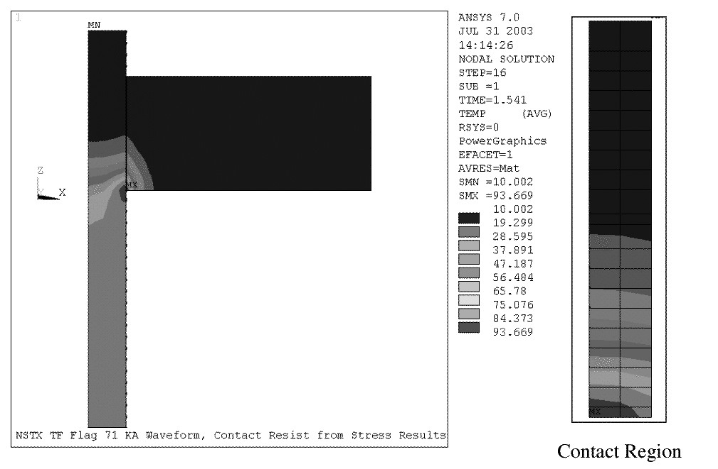
Fig. 10. Temperature Distribution at EOFT
.

Conclusions
The demountable TF coil is a central feature of the ST configuration. On NSTX, the demountable joints are based on a bolted configuration. The joint is located at the radius of the TF inner leg bundle, because of the desire to retain the ability to slide the OH coil over the bundle. As such it is located at peak magnetic field, and EM forces are maximal.
The original design utilized G-10 wedging and shimming which proved inadequate in terms of its ability to communicate the loads to the hub structure. The new design uses stainless steel boxes into which the flags are potted, for direct communication of the loads. The boxes are bolted to the hub assembly, forming a stiff I-beam like structure.
Detailed FEA shows that the structural support is adequate not only in terms of its ability to react the loads but also in maintaining high contact pressure on the joint, which is necessary for high electrical conductivity.
References
- C. Neumeyer, et al, “Engineering Design of the National Spherical Torus Experiment,” Fusion Engineering and Design. vol. 54, pp. 275-319, 2001.
- M. Kalish, et al, “NSTX Flag Joint Design, Testing, and Fatigue Analysis,” Proceedings of 20th SOFE

 

