Region 2: San Jose -San Francisco-Oakland, CA CSA

- Geographic Boundaries, Political Jurisdictions and Infrastructure
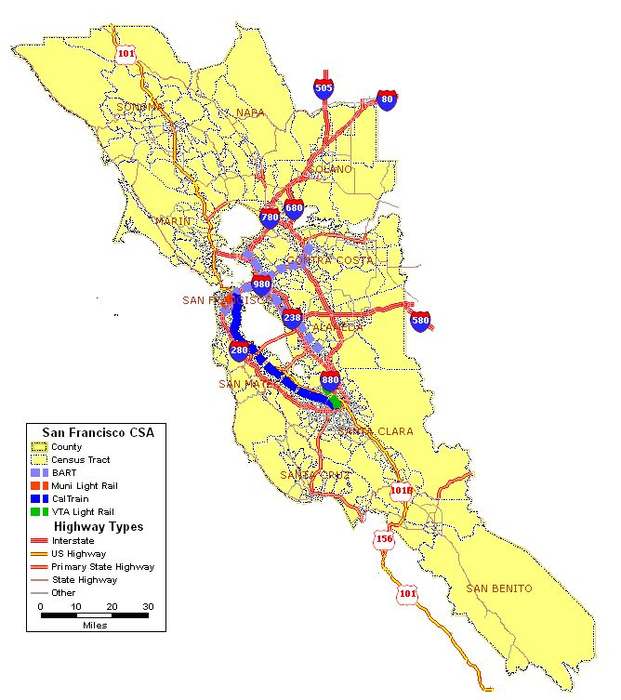

Map 2.1: San Jose-San Francisco-Oakland, CA CSA Major Highway and Fixed Guideway System

The San Jose-San Francisco-Oakland combined statistical area (CSA) consists of 11 counties surrounding the San Francisco Bay. As shown in Exhibit 2.1, the CSA is served by a number of Interstate, U.S. and State Highways as well as four local/regional rail systems. The CSA is 8,818 square miles and includes a population of more than 7 million people. The 2000 population of the state of CA was 33,871,648.

The northern and southern ends of the CSA include Sonoma County and San Benito County, respectively. It is bounded on the west by the Pacific Ocean and on the east by the Central Valley. The CSA includes such major cities as San Francisco, Oakland and San Jose as well as the smaller cities of Fremont, Santa Rosa and Hayward.

The region is served by number U.S. Interstates and U.S. Highways. Interstate 80 connects the region with the Sacramento region, which is to the east. Numerous beltways feeding the different cities in the region branch off of I-80. These include: I-980 serving downtown Oakland, I-880 connecting Oakland to San Jose along the east Bay, I-280 connecting San Francisco to San Jose along the west Bay, I-580 which connects Oakland to the Concord/Livermore area, and I-780 and I-680, which connect Oakland and the northern communities in Napa and Solano counties. Also, U.S. Highway 101, which runs the entire length of the State of California is a major north-south roadway which connects San Jose, San Francisco and the northern communities in Marin and Sonoma counties. Highway 101 spans the San Francisco Bay across the Golden Gate Bridge.

There are four fixed guideway systems: BART provides rapid rail service throughout the Bay Area; Muni provides light rail service in San Francsico; Cal Train provides commuter rail service between San Francisco and San Jose, and VTA provides light rail service in Santa Clara County.

A large portion of the CSA lies along the San Andreas fault, which runs 800 miles up the California coast from Riverside County in the south to Mendocino County in the north. The San Andreas also has three sister faults that run through the Bay area. Moving west to east these include the Hayward Fault, the Calaveras Fault and the Clayton-March Creek-Greenville Fault. The prevalence of these fault zones results in the frequent occurrence of earthquakes throughout the CSA.

The region has a dry summer subtropical climate, also known as a “Mediterranean” climate. Such climates are marked by wet winters and dry summers. The extremes in precipitation between the seasons can cause flash flooding and mudslide in winter and brush fires and drought in the summer.

- Agency Descriptions

Agency | Jurisdictions Served | Population Served | Operating Budget | Staff  Size
California DOT (CalTrans)  Districts 4 and 5 | Alameda, Contra Costa, Sonoma, Marin, San Francisco, San Mateo, Santa Clara, Napa,  Monterey, San Benito, San Luis Obispo, Santa Barbara, Santa Cruz | 7,088,410 | (a) | (a)
Metropolitan Transportation Commission (MTC) | San Francisco, Marin, Sonoma, Napa, Solano, Contra Costa, Alameda, San Mateo, and Santa Clara counties. | 6,783,760 | (a) | (a)
AC Transit | 13 cities and adjacent unincorporated areas in Alameda and Contra Costa counties | 1,500,000 | (a) | 2,224
Bay Area Rapid Transit | San Francisco, Alameda, Contra Cost and San Mateo counties | 2,968,262 | (a) | 3,490
San Francisco Municipal Railway | City of San Francisco |  | (a) | 3,828
San Mateo County (Sam Trans) | San Mateo County | 707,161 | (a) | 731
Santa Clara Valley Transit | Santa Clara County | 1,736,820 | $265,639,000 | 2,600
Golden Gate Transit | San Francisco and Marin counties, potions of Sonoma County | 1,300,000 | (a) | 822
County Connection | Central Contra Costa County | 491,700 | $27,503,819 | 300
WestCAT | Western Contra Costa County | 62,000 | $6,400,000 | 104
Tri Delta Transit | Eastern Contra Costa County | 217,591 | $15,740,000 | 169
Livermore/Amador Valley Transit | Dublin, Livermore, Pleasanton | 169,000 | (a) | 9
Sonoma County Transit | Sonoma County | (a) | (a) | (a)
Santa Rosa CityBus | City of Santa Rosa | (a) | (a) | (a)
Napa County TPA | Napa County and portions of Sonoma County | (a) | (a) | (a)
Vallejo Transit | Vallejo, San Francisco | (a) | (a) | (a)
Fairfield/Suisun Transit | Fairfield, Suisun City | 105,000 | (a) | 50
City of Petaluma | Petaluma | (a) | (a) | (a)
City of Vacaville | Vacaville | (a) | (a) | (a)
City of Union City | Union City | (a) | (a) | (a)
City of Benicia | Benicia | (a) | (a) | (a)
City of Healdsburg | Healdsburg | (a) | (a) | (a)
City of Dixon | Dixon | (a) | (a) | (a)
(a) Not available

Table 2.1: San Jose-San Francisco-Oakland CSA Transportation Agencies
- Transit Service Area: Fixed Guideway and Bus Service Area

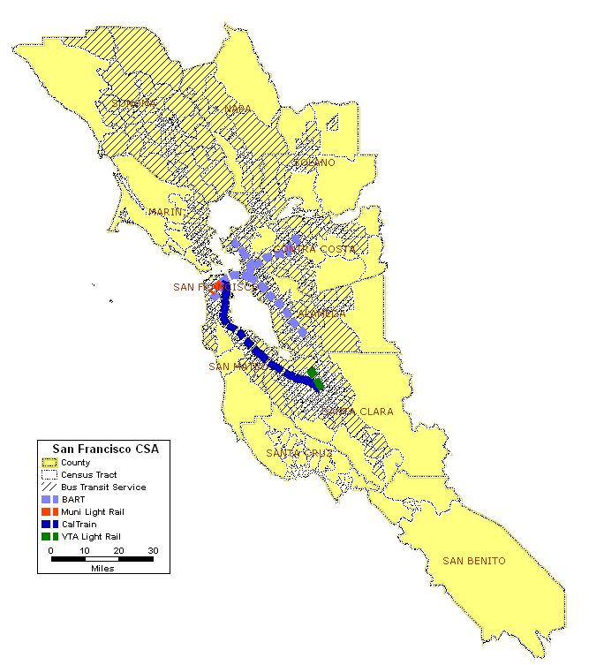
Map 2.2: San Jose-San Francisco-Oakland, CA CSA Transit Service Area

The transit systems that serve the CSA can be divided into three categories: large urban, medium urban, and small urban systems. Among the large urban systems are the following:

  - BART –BART provides rapid rail service within its three-County district and to Colma, Millbrae and the San Francisco International Airport in San Mateo County. The BART system consists of 104 miles of track and uses a fleet of 669 rail cars. There are 43 stations, including the BART-SFO extension that opened in June 2003. In FY2004, BART carried 97,545,611 passenger trips.

  - AC Transit - AC Transit’s service area is located on the eastern shore of the San Francisco Bay. The District operates two main types of service: East Bay service and Transbay/Express service. East Bay service is provided with 78 local all-day routes, 20 commute period-only routes (including two express routes), and six destination-based community routes. Transbay service consists of 27 routes that connect various points in the East Bay to the Transbay Terminal in San Francisco. AC Transit’s fixed-route service carried 64,663,431 according to NTD data.

  - Muni - Muni provides public transportation service within the City and County of San Francisco. Muni operates 80 lines in regular weekday service. Muni directly operates four modes of service: motor coach, trolley coach, light rail (Muni Metro and historic streetcars) and cable cars. There are four different route configurations: radial, cross-town, feeder and express. In addition, Muni runs late-night “owl service” between 1 a.m. and 5 a.m., available on two special routes and a number of regular routes. According to FY2004 NTD data, Muni’s ridership on each of its modes is as follows:

Cable Car | 7,869,197
Light Rail | 45,187,031
Motorbus | 87,471,668
Trolley Bus | 75,215,805
Total | 215,743,701

The medium urban category includes Golden Gate Transit, SamTrans, Santa Clara VTA, and County Connection. These systems mostly operate local and/or commuter bus services in their service areas. In addition to bus service, the Santa Clara VTA also operates a 42 mile light rail system and the Golden Gate Transit also operates ferry service from Sausalito and Larkspur to San Francisco.

The small urban category systems include Santa Rosa CityBus, Vallejo Transit, Livermore Amador Valley Transit Authority (LAVTA), Napa County Transportation Planning Agency, Sonoma County Transit, WestCAT and Tri-Delta operate mostly local urban and suburban bus services, some feeder service to BART and commuter bus services to Oakland and San Francisco. The only exception is Vallejo Transit, which also operates a Ferry service to San Francisco.
- Number and Proportion of Minority, Below Poverty and Limited English Proficient Populations in Relation to the Transit Service Area
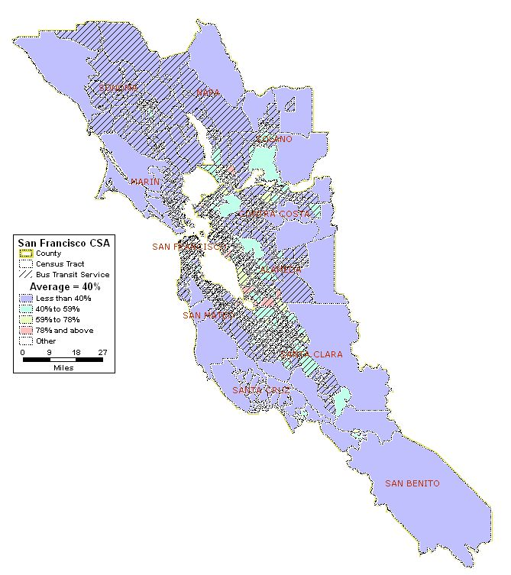
Map 2.3: San Jose-San Francisco-Oakland, CA CSA Minority Population

Total Number of Census Tracts in CSA 1,465
Total Population of CSA 7,088,410
Total Minority Population residing in CSA 2,923,892
Regional Average of Minority Population in the CSA 40%
Number (%) of Census Tracts with above average minority population 700 (48%)
Total Minority Population in the above average census tracts 2,119,066

The regional average minority population for the San Jose-San Francisco-Oakland CSA is 40 percent of the total population. As shown in Map 2.3, 700 of the 1465 tracts (47.8 percent) have minority populations that exceed the regional average. Many of these tracts are located in the San Francisco-Oakland areas (see Map 2.3A) and the San Jose area (see Map 2.3B). The total minority population of these 700 tracts is 2,119,066, or 30 percent of the total regional population.

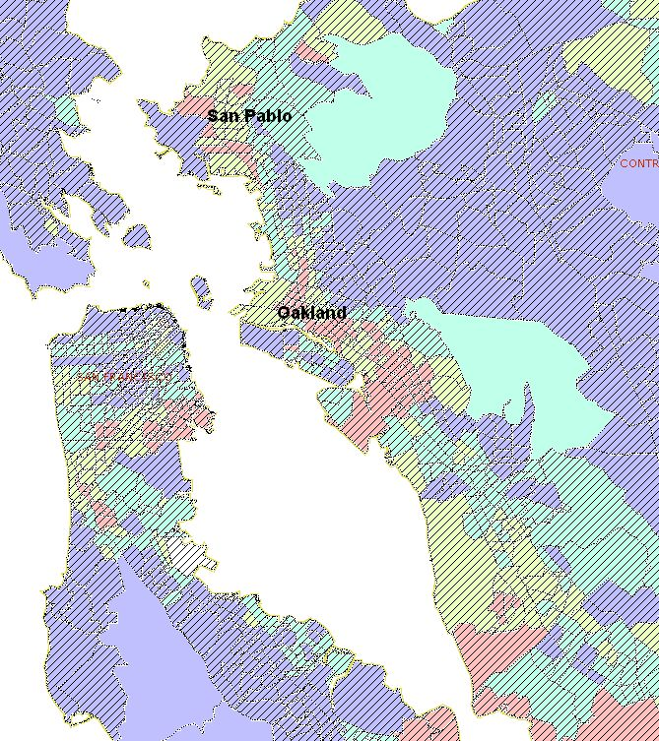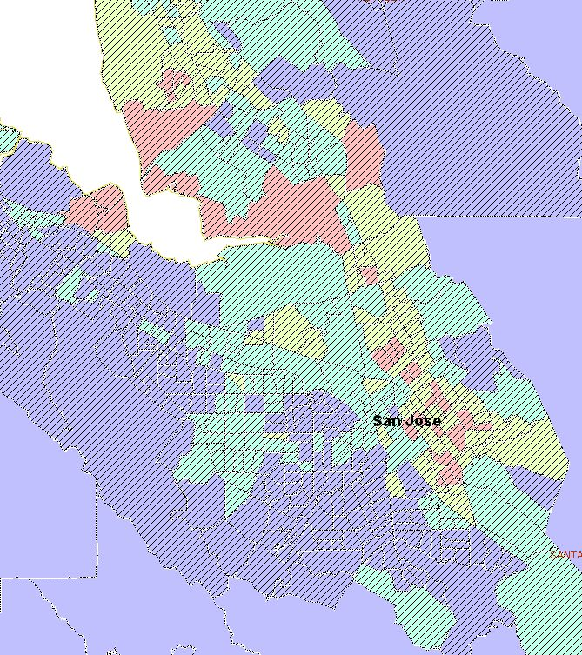
Map 2.3A: San Francisco-Oakland Minority Population Map 2.3B: San Jose Minority Population

Nearly all of the census tracts with higher than average concentrations of minorities are served by transit. Only 16 census tracts are not served by transit at all. However, these tracts have low population densities (less than 200 persons per square mile) versus the regional population density (800 persons per square mile) and represent only 1.4 percent (98,980 persons) of the total CSA population.

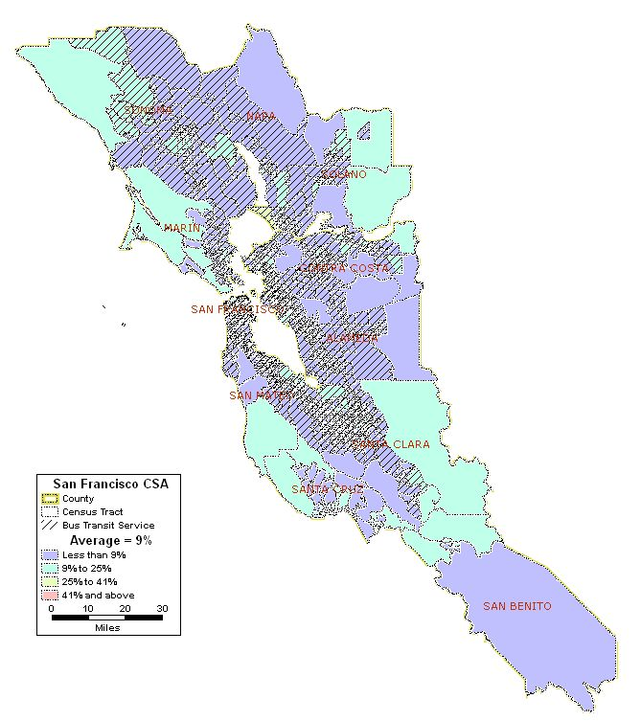
Map 2.4: San Jose-San Francisco-Oakland, CA CSA Below Poverty Population

Total Number of Census Tracts in CSA 1,465
Total Population of CSA 7,088,410
Total Below Poverty Population residing in CSA 607,698
Regional Average of Below Poverty Population in the CSA 9%
Number (%) of Census Tracts with above average Below Poverty pop. 509 (35%)
Total Below Poverty Population in the above average census tracts 384,074

Approximately nine percent (607,698 persons) of the regional population for the San Jose-San Francisco-Oakland CSA lives below the poverty level. As shown in Map 2.4, 509 of the census tracts (34.5 percent) have higher than average percentages of people living in poverty. These 509 census tracts account for 384,074 persons living below the poverty level. Thirty-six of these tracts are in the rural areas to the west (along the Pacific coast) and east (towards the Central Valley) of the urban centers. These rural census tracts are not well served by transit and represent 2.3 percent (163,651 persons) of the total CSA populations.

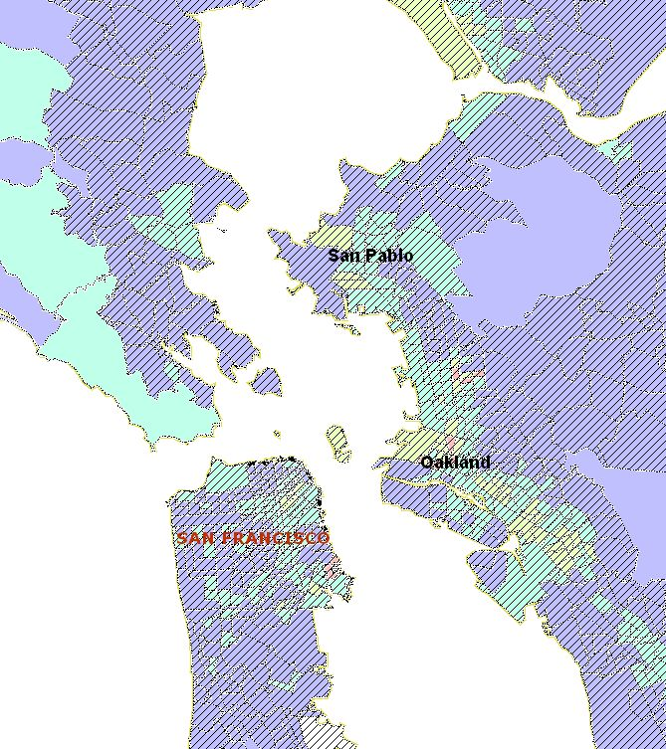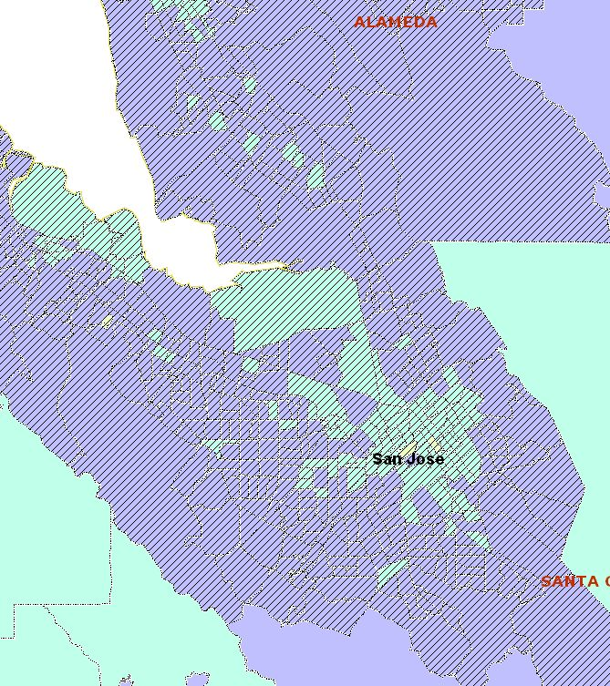
Map 2.4A: San Francisco-Oakland Below Poverty Population Map 2.4B: San Jose Below Poverty Population

Within the urbanized areas the highest concentrations of census tracts with higher than average percentages of persons living below the poverty level occur in the San Francisco-Oakland area and the San Jose area.

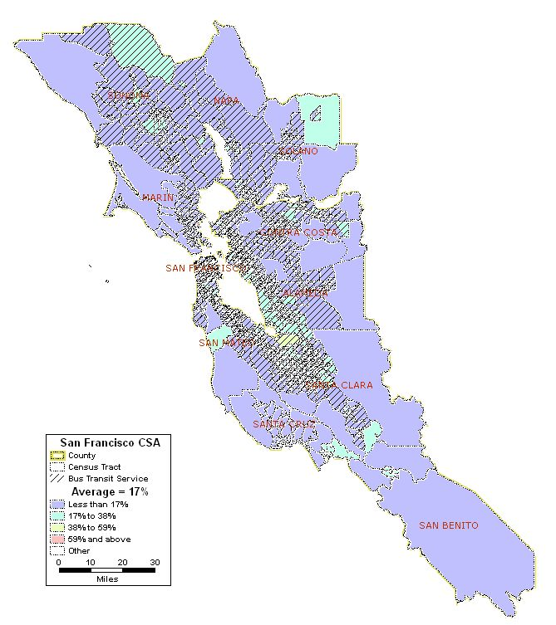
Map 2.5: San Jose-San Francisco-Oakland, CA CSA Limited English Proficient Population

Total Number of Census Tracts in CSA 1,465
Total Population of CSA 7,088,410
Total Population 5 years and older of CSA 6,636,216
Total LEP Population* residing in CSA 1,147,090
Regional Average of LEP Population* in the CSA 17%
Number (%) of Census Tracts with above average LEP population* 568 (39%)
Total LEP Population* in the above average census tracts 829,512

* LEP includes those 5 years of age and older

The San Jose-San Francisco-Oakland CSA has a population of 1.1 million people who have limited English proficiency (LEP). This represents 17 percent of the regional population. The concentrations of LEP persons is mostly in the urban areas of San Francisco-Oakland (see Map 2.5A) and San Jose (see Map 2.5B). Additionally, there are smaller concentrations of LEP persons in northern Sonoma County, eastern Solano County and southern Santa Clara County.

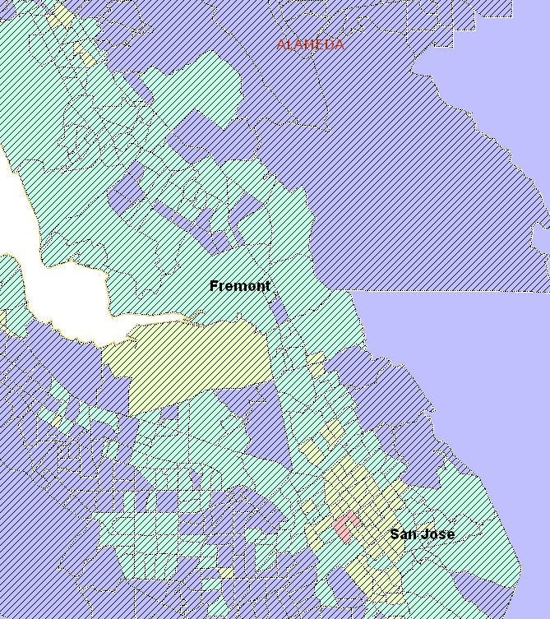
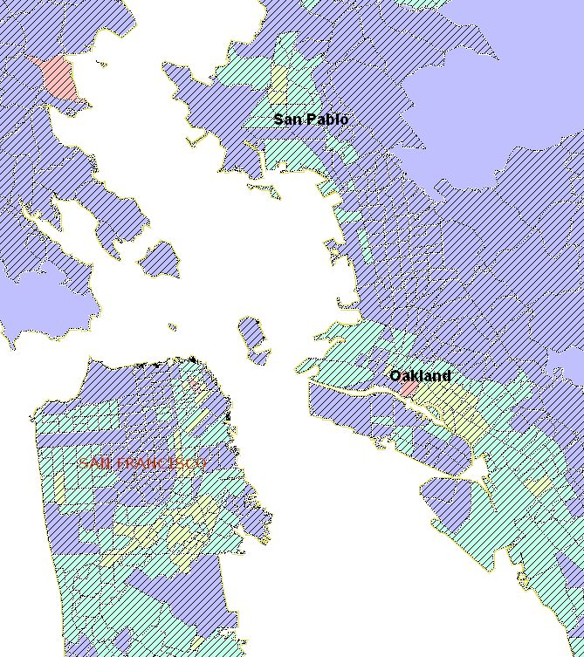
Map 2.5A: San Francisco-Oakland LEP Population Map 2.5B: San Jose LEP Population

The largest concentrations of LEP persons are in San Francisco, particularly Daly City to the south, and Oakland. Other areas of LEP concentrations include San Pablo and San Rafael, which is to the west across the bay. Proceeding south from Oakland, the areas around Hayward and Fremont also have higher than average concentrations of LEP persons. Finally, the areas around San Jose have the highest concentrations of census tracts with higher than average percentages of persons with limited English proficiency. There are 568 census tracts (38.8 percent) with a higher than average concentration of LEP persons. These 568 tracts account for 829,512 LEP persons in total. Eighteen of the 568 census tracts with higher than average LEP populations are not served by transit. These tracts account for only 1.5 percent (104,554 persons) of the total CSA population.

- Zero Car Households

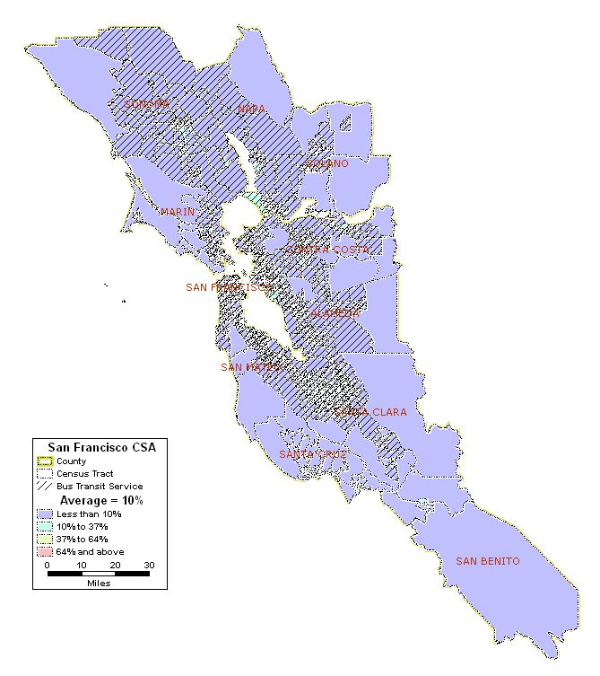
Map 2.6: San Jose-San Francisco-Oakland, CA CSA Zero Car Households

Total Number of Census Tracts in CSA 1,465
Total Households in the CSA 2,571,456
Total Zero Car Households in CSA 254,141
Regional Average of Zero Car Households in the CSA 10%
Number (%) of Census Tracts with above average Zero Car Households 437 (30%)
Total Zero Car Households in the above average census tracts 173,781

On average 10 percent of the households in the San Jose-San Francisco-Oakland CSA have no car available. There are 437 census tracts (29.8 percent) in which the number of zero car households exceeds the regional average. Every census tract in which the number of zero car households exceeds the regional average is within the transit service area. Most of the households with zero cars are within the urban areas, particularly San Francisco and Oakland. Only nine of the 437 census tracts with higher than average zero car households are located outside of the transit service area. These nine tracts account for less than one percent (49,302 persons) of the total CSA population.

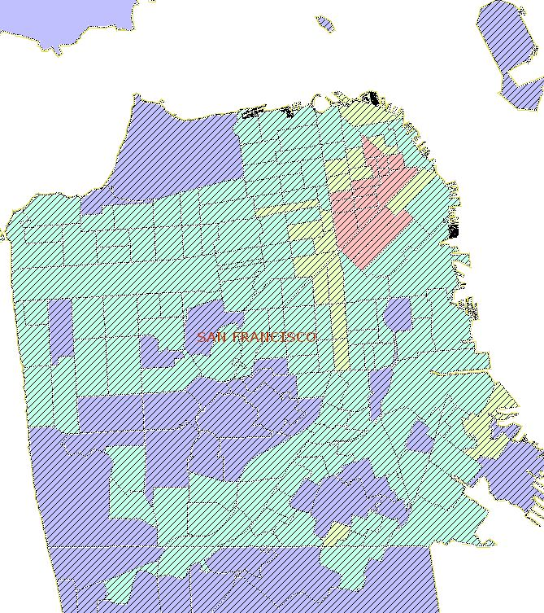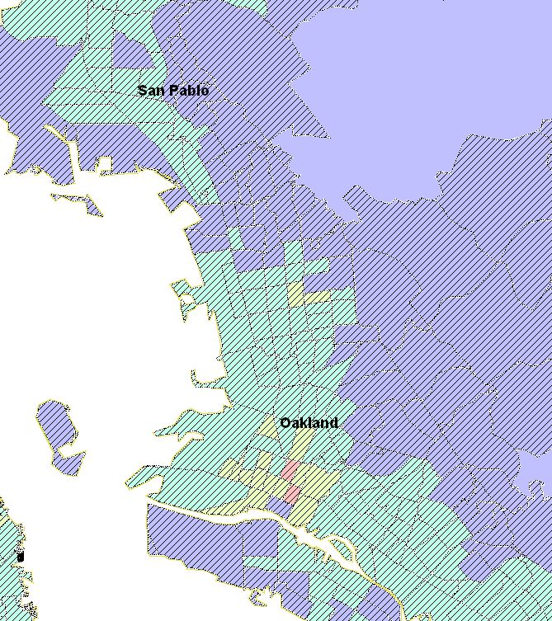
Map 2.6A: San Francisco Zero Car Households Map 2.6B: Oakland Zero Car Households

As shown in Maps 2.6A and 2.6B, the concentrations of zero car households are mostly in the downtown areas of San Francisco (see Map 2.6A) and Oakland (see Map 2.6B). The census tracts with the highest percentages of zero car households (64 percent and above) are exclusively in these two areas.
- Number and Proportion of Minority Population with Overlay of Below Poverty Population

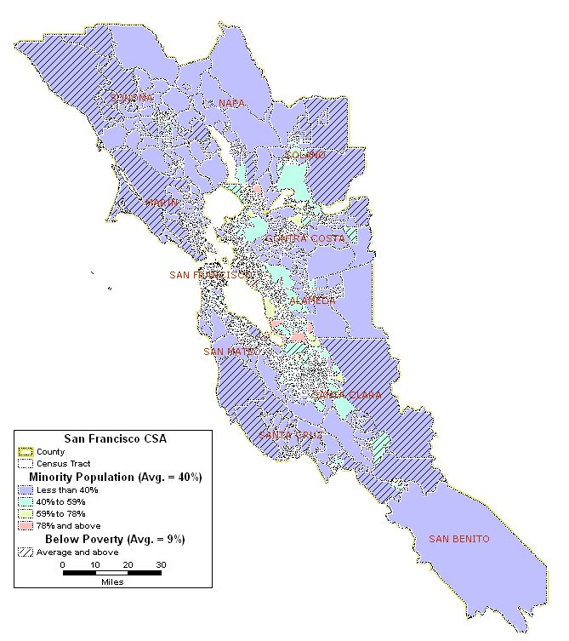

Map 2.7: San Jose-San Francisco-Oakland, CA CSA Minority Population with Overlay of Below Poverty Population

As shown in Map 2.7, there is some correspondence between the minority population and below poverty population in the San Jose-San Francisco-Oakland CSA. There are 376 census tracts (25.6 percent) in which the minority and below poverty populations both exceed the regional averages for these statistics, respectively. The areas in which minority and below poverty census tracts coincide most are the urban areas of San Francisco-Oakland (see Map 2.7A) and San Jose (see Map 2.7B). Although not all minority areas have an above average level of poverty, these maps indicate that the correlation is strongest in the urban cores of San Francisco, Oakland and San Jose.

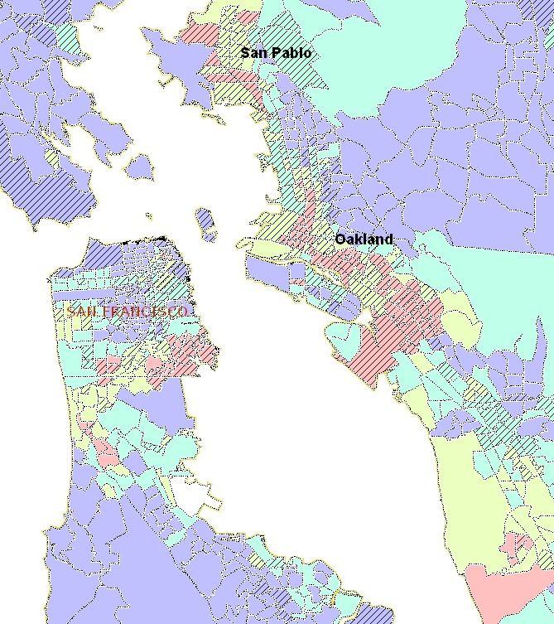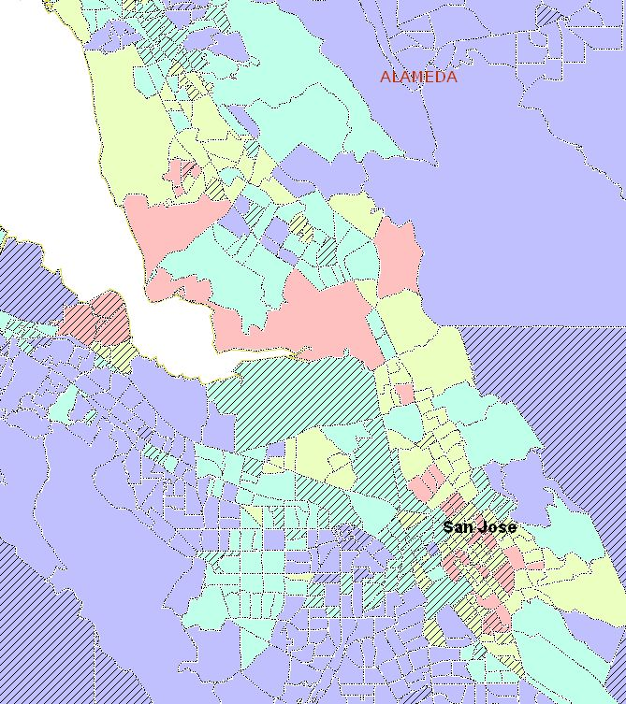
Map 2.7A: SF-Oakland Minority/Below Poverty Overlay Map 2.7B: San Jose Minority/Below Poverty Overlay

- Number and Proportion of Minority Population with Overlays of Below Poverty Population and Zero Car Households

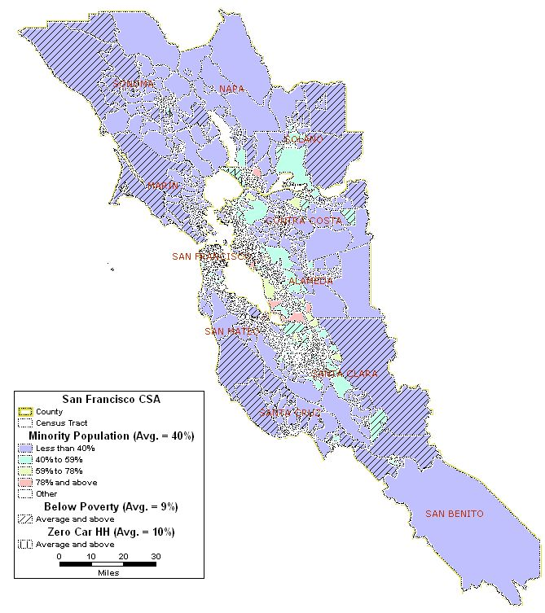
Map2.8: San Jose-San Francisco-Oakland, CA CSA Minority Population with Overlays of Below Poverty Population and Zero Car Households

There are 259 census tracts (17.7 percent) in which minority population, below poverty population and zero car households all exceed their respective regional averages. Similar to the overlay of minority and below poverty populations, the overlays of minority and below poverty populations with zero car households also show the strongest relationship in the urban core areas of San Francisco, Oakland, and San Jose. The details of these areas are shown in Maps 2.8A and 2.8B. As shown in these maps, the downtown areas of these three cities have the highest concentrations of census tracts in which the minority populations are coincident with above average poverty levels and above average number of zero car households.

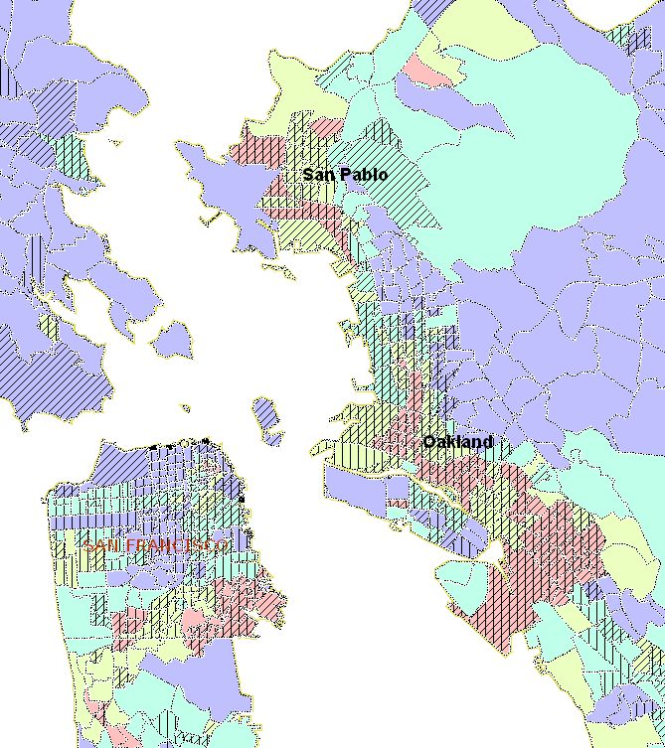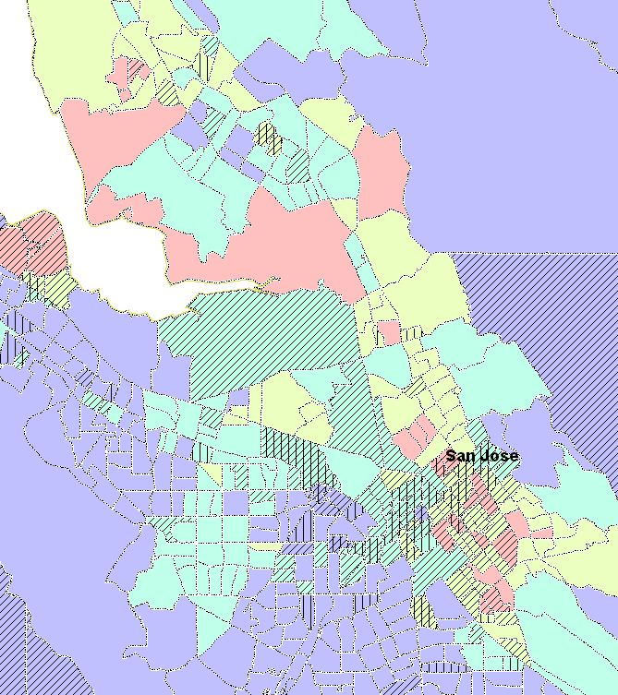
Map 2.8A: SF-Oakland Minority/Below Poverty/ Map 2.8B: San Jose Minority/Below Poverty/
Zero Car Overlay Zero Car Overlay

- Correlation Among Minority Population, Below Poverty Population, LEP Populations and Zero Car Households

 | Minority | Below Poverty | LEP | Zero Car HH
Minority | 1.00
Below Poverty | 0.51 | 1.00
LEP | 0.73 | 0.40 | 1.00
Zero Car HH | 0.37 | 0.63 | 0.36 | 1.00

Table 2.2: San Jose-San Francisco-Oakland CSA Correlation Coefficients

As shown in Table 2.2, there is a moderate positive correlation between minority and below poverty populations with a 0.51 correlation coefficient. There is an even stronger correlation between minority and LEP populations (0.73 correlation coefficient). The only other relationship in which there appears to be a strong correlation is between below poverty and zero car households, in which the correlation coefficient is 0.63.

- Natural Disasters

Event(s) | Date | Location | Human Impact | Financial Impact
Storms, Winds, Flooding, and Mudslides | February 1986 | Napa, Sonoma, Marin, Santa Clara, Solano, San Mateo, Alameda, Contra Costa | No deaths or serious injuries | $408 million
Fires (49er, Miller, and Fern) | September 1, 1988 | Solano County and other areas outside the Bay CSA | No deaths or serious injuries | $31 million
Loma Prieta Earthquake | October 1, 1989 | Alameda, San Mateo, Santa Clara, Santa Cruz, San Francisco, Contra Costa, Marin and Solano counties | 63 deaths  3,757 injuries | $5.9 billion
Freeze | January 1991 | San Mateo, Santa Clara, Solano, Sonoma (1/11/91); Alameda, Marin and Napa (1/18/91) | No deaths or serious injuries | $856 million
East Bay Hills Fire | October 20, 1991 | Alameda County | 25 deaths  150 injuries | $1.7 billion
Winter Storms | January 25, 1993 | Napa, Contra Costa, Sonoma counties | 20 deaths  10 injuries | $600 million
Winter Storms | January-February 1995 | Sonoma (1/9/95); Contra Costa, Napa, Santa Clara (1/10/95); San Mateo (1/11/95); Alameda, Marin (1/14/95); Solano (2/17/95) | 11 deaths | $741 million
Severe Storms/Flooding | January 4, 1997 | Alameda, San Francisco, Contra Costa, Marin, Napa, Solano, Sonoma, San Mateo and Santa Cruz counties | 8 deaths | $1.8 billion
El Nino-Severe Winter Storms and Flooding | February 2, 1999 | Alameda, Napa, San Mateo, Santa Clara, Santa Cruz, Solano, Sonoma counties | 17 deaths | $550 million
Earthquake | September 14, 2000 | Napa County | (a) | (a)
Severe Storms, Flooding, Mudslides, and Landslides | February 3, 2006 | Contra Costa, Marin, Napa, Solano, and Sonoma counties. | 1 death  1 injury | $816.6 million
Severe Storms, Flooding, Landslides, and Mudslides | June 1, 2006 | Alameda County and other counties outside the Bay Area. | 1 death  0 injuries | $144 million
(a) Not available

Table 2.3: 20-Year History of Natural Disasters in the San Jose-San Francisco-Oakland CSA (Source: FEMA and the California Office of Emergency Services)

The table above presents a snapshot of the naturals disasters that have affected the San Jose-San Francisco-Oakland CSA during the past 20 years. Although California is known as an earthquake hot zone, the table clearly shows that more damage has resulted from severe weather in the past 20 years than from earthquakes. The damage caused by these severe weather events is typically due to flooding, landslides and mudslides. In addition to earthquakes and severe weather, the region also is prone to wildfires. On a scale ranging from Moderate to High, to Very High Risk, the United States Geological Survey rates the state of California as having a Very High Risk of earthquakes.

- Manmade Disasters

The San Jose-San Francisco-Oakland CSA is home to a number of industries including shipping, high-technology, biotechnology and petrochemical. The region also has a number of sites that would be considered high profile targets for terrorism (e.g., the Department of Energy’s Lawrence Livermore National Laboratory, the Golden Gate Bridge, the Port of San Francisco, the Port of Oakland and the financial district in San Francisco). As such, there is potential for certain man-made disasters whether by accident or by intention. These include petroleum and chemical leaks or spills, radiological release and industrial sabotage to manufacturing plants, shipping facilities, and infrastructure.

In addition, the region is subject to other man-made disasters as any other major metropolitan area would be. Incidents such as building fires, aircraft accidents and major highway accidents could result in significant number of fatalities and/or casualties as well as property damage. 2005 data from the U.S. Department of Transportation on Hazardous Material Safety shows the state of California accounted for 8% of the hazardous materials incidents and 3% of related deaths for the year.

A review of information available through state and federal sources did not indicate that there have been any major man-made disasters in the region during the past 20 years.

