December 16, 2002

Dockets Management Branch
(HFA-305)
Food and Drug Administration
5630 Fishers Lane, Room 1061
Rockville, MD 20852

Re: Docket No. 94P-0036

Dear Sir or Madam:

The Institute of Shortening and Edible Oils (ISEO) appreciates the opportunity to comment on the Food and Drug Administration’s (FDA) amended proposed rule to require declaration of trans fatty acids in nutrition labeling. 67 Fed. Reg. 69171 (Nov. 15, 2002). ISEO strongly opposes the proposed footnote that would be required for foods containing trans fat.

ISEO is the national trade association representing the refiners of edible fats and oils in the United States. Its 21 members account for approximately 90 to 95 percent of all edible fats and oils produced domestically. Our members’ products are used in numerous foods including shortenings, cooking and salad oils, margarines and spreads, confections and toppings, as well as a wide variety of food ingredients.

ISEO strongly objects to the proposed footnote that would read “Intake of trans fat should be as low as possible.” We believe that this statement is potentially misleading, is based on questionable science, and conflicts with the agency’s desire to bring its labeling requirements into conformity with governing First Amendment law. Most importantly, the proposed footnote targeting trans fat has the potential to backfire, leading to higher consumption of saturated fat.

- The proposed footnote would be viewed as a de facto warning statement and would mislead consumers.

The proposed rule would require that any food that declares trans fat content (i.e., any food that contains 0.5 grams or more of trans fat per labeled serving size) must place an asterisk or other symbol in the Percent Daily Value (% DV) column for trans fat, referring to a similar symbol at the bottom of the Nutrition Facts box that is followed by the statement “Intake of trans fat should be as low as possible.”

Until now, FDA has made clear that its purpose is to encourage consumers to reduce consumption of the combined total of saturated fat and trans fat. In fact, FDA has indicated that saturated fat is the greater public health concern, because the average American consumes far more saturated fat than trans fat. In its original proposed rule on labeling of trans fat, FDA stated that, because the average American consumes five times more saturated fat than trans fat, it is essential that labeling of trans fat not divert consumer attention away from the risks associated with saturated fat. If labeling of trans fat were to cause industry to substitute saturated fat for trans fat in product formulations, or consumers to substitute saturated fat for trans fat in their diets, it would defeat its purpose of reducing the combined total of saturated fat and trans fat in the diet.

By now singling out trans fat in this way, FDA would convey a message that trans fat is uniquely bad for you. This message would inevitably divert consumer attention away from saturated fat and cause many consumers to replace trans fat with saturated fat.

  - The proposed footnote would effectively establish a Daily Value of zero for trans fat.

To most consumers, the recommendation that consumption of a nutrient “should be as low as possible” means that they should avoid that nutrient. Ideally, their intake of that nutrient should be zero. Although FDA states it is not proposing to establish a Daily Value for trans fat, the proposed footnote would effectively establish a Daily Value of zero.

The problem with this approach is that it conveys a misleading message about the relative significance of trans fat and saturated fat. In its original proposed rule, FDA proposed to apply the existing Daily Value for saturated fat to the combined total of saturated fat and trans fat. That approach would have given both industry and consumers an incentive to reduce the combined total of saturated fat and trans fat. Now, FDA is effectively proposing to retain the Daily Value of 20 grams (g) for saturated fat while setting a Daily Value of 0 g for trans fat.

The message would imply that a healthy diet may include up to 20 grams of saturated fat per day, but no trans fat whatsoever. In this way, the proposed footnote, read in conjunction with other aspects of the existing nutrition label, would convey a misleading message about the relative significance of trans fat and saturated fat.

  - In practice, the proposed footnote would lead to a substitution of saturated fat for trans fat in both food product formulation by industry and dietary patterns of consumers.

Inevitably, the proposed rule would lead to a return to saturated fat and would undermine the nutritional message about saturated fat that FDA and its sister agencies have worked so hard to convey to the public. By requiring a de facto warning statement on products containing trans fat, food manufacturers would be encouraged to substitute saturated fat for trans fat in product formulations. Similarly, consumers would be encouraged to substitute saturated for trans fat in their diets.

In predicting the impact of the proposed footnote, FDA must consider the real world formulation options of food manufacturers that currently use trans fat in their products. ISEO believes that FDA has made unrealistic assumptions about how manufacturers are likely to reformulate their products. For example, FDA has assumed that baked goods (e.g., breads, cakes, cookies, crackers) will be reformulated to remove trans fat without substituting saturated fat on a gram-for-gram basis. In the Regulatory Impact Analysis accompanying its original proposed rule, FDA assumed that 1 g of trans fat can be replaced with just 0.5 g of saturated fat. 64 Fed. Reg. at 62767.

This assumption is seriously flawed, because it does not consider the options available in the market or realistically expected in the near future. With a footnote highlighting trans fat, a manufacturer of baked goods would have a strong incentive to switch from a typical partially hydrogenated all-purpose shortening (APS) (3.5 g of saturated fat, 2.5 g of trans fat per serving) to a trans fat-free alternative APS. The alternatives include the following:

- A new low trans fat APS (36% saturated fat, 2% trans fat) that contains a blend of specialty canola oil and fully hardened soybean oil which is then interesterified.

The high cost of the specialty canola oil, coupled with high production costs, make this APS twice as expensive as the typical APS. Moreover, although low in trans fat, this new APS still contains enough trans fat that some baked products would still need to declare trans fat and carry the proposed footnote. In addition, baked goods made with this APS would not qualify for any nutrient content claims regarding saturated fat or trans fat content. Therefore, manufacturers would have little commercial incentive to use this product.

- An APS made with palm oil.

While using this APS eliminates trans fat, and thereby avoids the proposed footnote, the trans fat is replaced with saturated fat on nearly a gram-for-gram basis.

- Lard (6 g of saturated fat, 12 mg of cholesterol per serving).

Like the palm oil APS above, lard replaces trans fat with saturated fat on nearly a gram-for-gram basis.

Thus, given the APS products currently on the market, or reasonably foreseeable, it is not clear how baked goods can be reformulated to both avoid the proposed footnote and significantly reduce trans fat content. It is far more likely that most manufacturers of baked goods would choose to avoid the footnote by using an APS that replaces trans fat with saturated fat on nearly a gram-for-gram basis.

The proposed footnote is likely to have a similar effect on consumer purchasing decisions. For example, a consumer persuaded by the proposed footnote to avoid trans fat might choose butter (7 g of saturated fat, 31 mg of cholesterol per serving) over vegetable oil spread (2 g of saturated fat, 2 g of trans fat, no cholesterol per serving).

The end result is likely to be a return to higher consumption of saturated fat, precisely the result that FDA originally said it was trying to avoid.

  - The proposed footnote may confuse and frustrate many consumers.

One of the greatest virtues of the Nutrition Facts panel is its simplicity. By presenting information in a consistent manner in a relatively uncluttered format, the nutrition label can be read at a glance by the knowledgeable consumer. Currently the % Daily Value provides a uniform way to present information about the relative significance of a nutrient in the diet. The proposed rule would establish the cautionary footnote as another way to present this information. This requirement to present the same type of information in a different manner would undo the consistency of the label and add clutter. This increasing complexity could discourage consumers from reading the nutrition label.

- The proposed footnote is based on questionable science.

  - There is little, if any, evidence that trans fat has a greater adverse impact than saturated fat.

As FDA states in the preamble to the proposed rule, the proposed footnote is based on the Institute of Medicine of the National Academy of Sciences (IOM/NAS) report entitled “Dietary Reference Intakes for Energy, Carbohydrate, Fiber, Fat, Fatty Acids, Cholesterol, Protein and Amino Acids.” By recommending that intake of trans fat be “as low as possible,” the FDA has reversed the position taken by the agency in its original proposed rule.

In its original proposed rule, FDA reviewed the scientific evidence for an association between intake of trans fat and coronary heart disease (CHD) and concluded that “available studies do not provide a definitive answer to the question of whether trans fatty acids have an effect on LDL-C [LDL cholesterol] and CHD risk equivalent to saturated fats on a gram-for-gram basis.” 64 Fed. Reg. at 62753 (emphasis added).

Reviewing essentially the same evidence, the IOM/NAS panel reached a significantly different conclusion. Ignoring the absence of studies examining the effects of trans fat at low levels of intake, the IOM/NAS found “a positive linear trend between trans fatty acid intake and LDL cholesterol concentrations.” Moreover, the IOM/NAS also concluded that trans fat is worse than saturated fat, stating “the magnitude of this effect [on the LDL:HDL ratio] is greater for trans fatty acids compared to saturated fatty acids.”

The IOM/NAS conclusions are not supported by scientific studies. First, a preponderance of recent studies has shown that trans fat increases total and LDL cholesterol less than saturated fat. Examination of the 12 intervention studies comparing serum lipids, as cited by FDA in its 1999 proposal, reveals that 8 of these studies show that LDL cholesterol is significantly lower in subjects consuming trans fat diets when compared to saturated fat diets. The remaining 4 studies found no significant impact of trans fat on LDL cholesterol when compared to saturated fat (see Attachment A).

Second, the IOM/NAS report disregards the paucity of studies examining the effects of low levels of trans fat intake on serum total and LDL cholesterol. Very few well-controlled studies have been conducted using diets containing trans fat at conventional American intake levels of 2-3% energy. Therefore, extrapolation from existing studies to predict the effects on serum lipids of trans fat at lower intake levels more consistent with typical American diets is highly questionable. The IOM/NAS report's conclusion that there is a “positive linear trend” between trans fat intake and total and LDL cholesterol concentrations, and that trans fat has a more detrimental effect on the LDL:HDL ratio than saturated fat, appears to be based on a single
chart. This chart has very limited data for trans fat at low intake levels (i.e., less than 3 percent of energy). Moreover, the chart was originally published not in a peer-reviewed article, but in non-peer-reviewed correspondence . Moreover, the methodology for its construction was not explained, other than to say that it represents a best-fit regression of trans fat intake and LDL:HDL ratios. We believe that it would be unwise for FDA to base nutrition labeling policy on such a shaky foundation.

The difference between the FDA conclusion and the IOM/NAS conclusion is significant. While the IOM/NAS report is entitled to some deference, FDA as the regulatory agency with responsibility for food labeling should not automatically accept the judgment of an IOM/NAS panel for its own.

b. The IOM/NAS definition of “trans fat” differs from FDA’s proposed definition.

If FDA is accepting the IOM/NAS characterization of trans fat, does this also mean that FDA is adopting the IOM/NAS definition of “trans fatty acids”? In its 1999 proposed rule, FDA defined trans fat as "unsaturated fatty acids that contain one or more isolated (i.e., non-conjugated) double bonds in a trans configuration." 64 Fed. Reg. 62746, 62795 (Nov. 17, 1999). The IOM/NAS report defines trans fat as "unsaturated fatty acids that contain at least one double bond in the trans configuration." The inconsistency of these definitions could prove problematic for food labeling purposes. For example, conjugated linoleic acid (CLA) is included in the IOM/NAS definition of “trans fatty acids,” but not in the FDA definition. CLA has been found to have positive health attributes (e.g., anti-carcinogenicity, anti-atherogenicity, enhanced immune response, anti-diabetic properties). However, because it is a trans fatty acid under the IOM/NAS definition, the proposed footnote would advise consumers to avoid it and manufacturers would be encouraged to remove it from their products.

c. FDA should carefully review the DRIs as a whole before making any changes in the nutrition label based on the DRIs.

The proposed footnote would be the first change in Nutrition Facts made by FDA in response to the new Dietary Reference Intakes (DRIs). We believe this change is premature. The DRIs contain a large body of information and recommendations. If the nutrition label is to be revised to reflect the DRI recommendations, this should be done carefully and systematically. FDA should wait until all of the DRIs have been issued and should review the DRIs as a whole before incorporating any of the DRIs into its nutrition labeling regulations.

- The proposed footnote is legally flawed.

a. The proposed footnote is inconsistent with governing First Amendment precedents.

Under the First Amendment, government regulation of commercial speech must be carefully calibrated to advance a substantial government interest. Central Hudson Gas & Elec. Corp. v. Public Serv. Comm’n. of New York, 447 U.S. 557 (1980). Specifically, the regulatory agency must assert a substantial government interest, must show that its regulation directly advances the asserted interest, and must show that its regulation is not more extensive than is necessary to achieve its purpose. This standard applies to government regulations that compel commercial speech, as well as to those that restrict it. See, e.g., International Dairy Foods Association v. Amestoy, 92 F.3d 67, 73 (2d Cir. 1996) (state law requiring a label statement that was “the functional equivalent of a warning” struck down as unconstitutional).

The proposed footnote fails the Central Hudson test, because it does not directly advance a substantial government interest. As discussed above, the substantial government interest is to provide consumers with information about the presence and amounts of nutrients that may increase their risk of CHD (i.e., saturated fat, trans fat, and cholesterol). However, the proposed footnote would send a misleading message about the relative risks of saturated fat and trans fat. By targeting trans fat for a warning statement, the proposed footnote would divert consumers’ attention away from saturated fat and lead to substitution of saturated fat for trans fat.

b. If FDA intends to require the proposed footnote as a warning statement, that requirement should be promulgated in a separate rulemaking as part of 21 C.F.R. § 101.17, the section of FDA regulations devoted to warning statements.

The proposed footnote is a warning statement in all but name. In this context, it is worth noting that the proposed footnote does not accurately reflect the IOM/NAS report’s recommendation regarding trans fat intake. The report recommends that intake of trans fat “be as low as possible while consuming a nutritionally adequate diet” (emphasis added). By omitting the words “while consuming a nutritionally adequate diet,” the proposed footnote goes beyond the IOM/NAS recommendation and suggests no allowance for trans fat in a healthy diet. It tells consumers that they should avoid consuming a certain nutrient. If FDA is to require a warning statement regarding trans fat, the agency should propose it as an amendment to 21 C.F.R. § 101.17, the regulation designated for food labeling warning and notice statements. In that case, FDA should provide full notice-and-comment rulemaking in accordance with the Administrative Procedures Act, with at least a 60-day comment period.

- As it has for other nutrients that lack a Daily Value, FDA should require declaration of the amount of trans fat but leave the Percent Daily Value blank.

ISEO firmly believes that declaration of the amount of trans fat per serving as a separate line item in the Nutrition Facts box will be adequate to communicate the presence and significance of trans fat to consumers. We anticipate considerable “media hype” will accompany the addition of a new nutrient to the nutrition label, making the proposed footnote unnecessary. We therefore see no need for an additional footnote on the label which will likely confuse consumers.

ISEO therefore believes that the proposed footnote should be deleted from the proposed rule. FDA should require only declaration of the amount of trans fat per serving in Nutrition Facts. The nutrition label cannot, by itself, provide all the information consumers need to maintain healthy dietary practices, and it should not attempt to. The nutrition label is an essential tool, but the consumer must have some nutrition knowledge from other sources to be able to fully understand it. Attempting to use the nutrition label for warning purposes will lead to a cluttered and confusing label that will be less useful to consumers.

- Summary

In summary, ISEO believes that the proposed footnote would be viewed by consumers as a de facto warning statement. Read in the context of the existing nutrition label, the footnote would mislead consumers as to the relative health significance of trans fat and saturated fat.

Trans fats have not been shown to have a greater adverse impact on health than saturated fats and should not be uniquely referenced in that regard. ISEO suggests the proposed footnote be deleted and trans fats be identified only in regard to their amounts contained within the food serving.

Respectfully submitted,

Robert M. Reeves
President

RMR:dls
Enclosure (Attachment A)

ATTACHMENT A

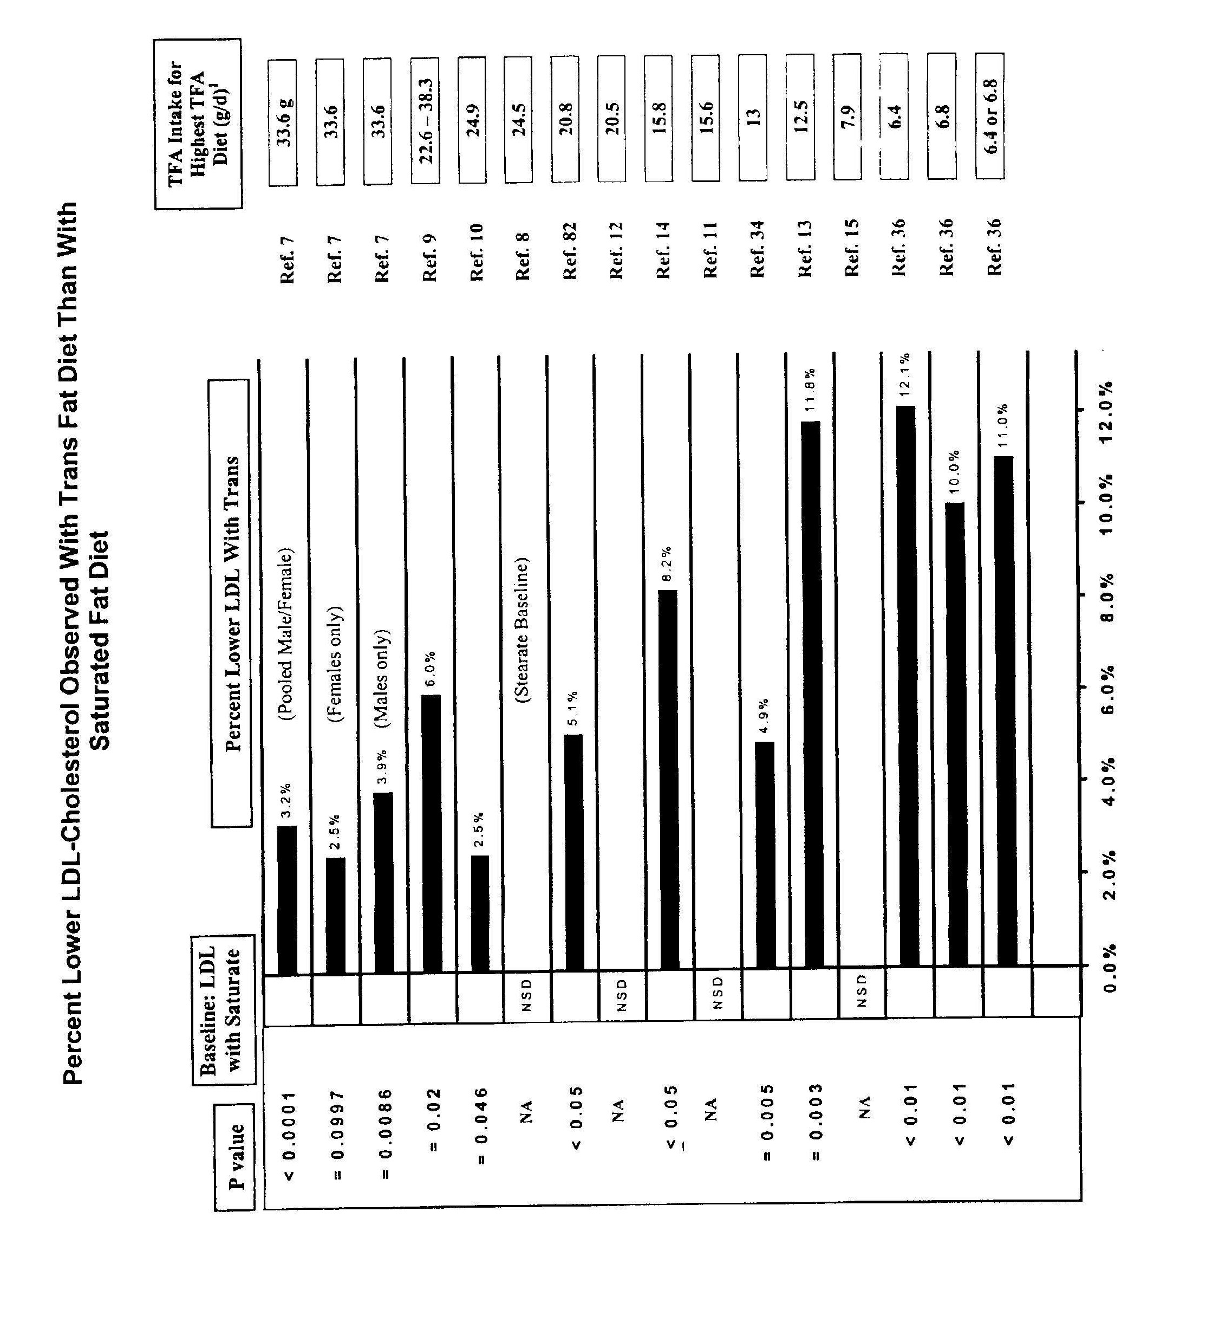

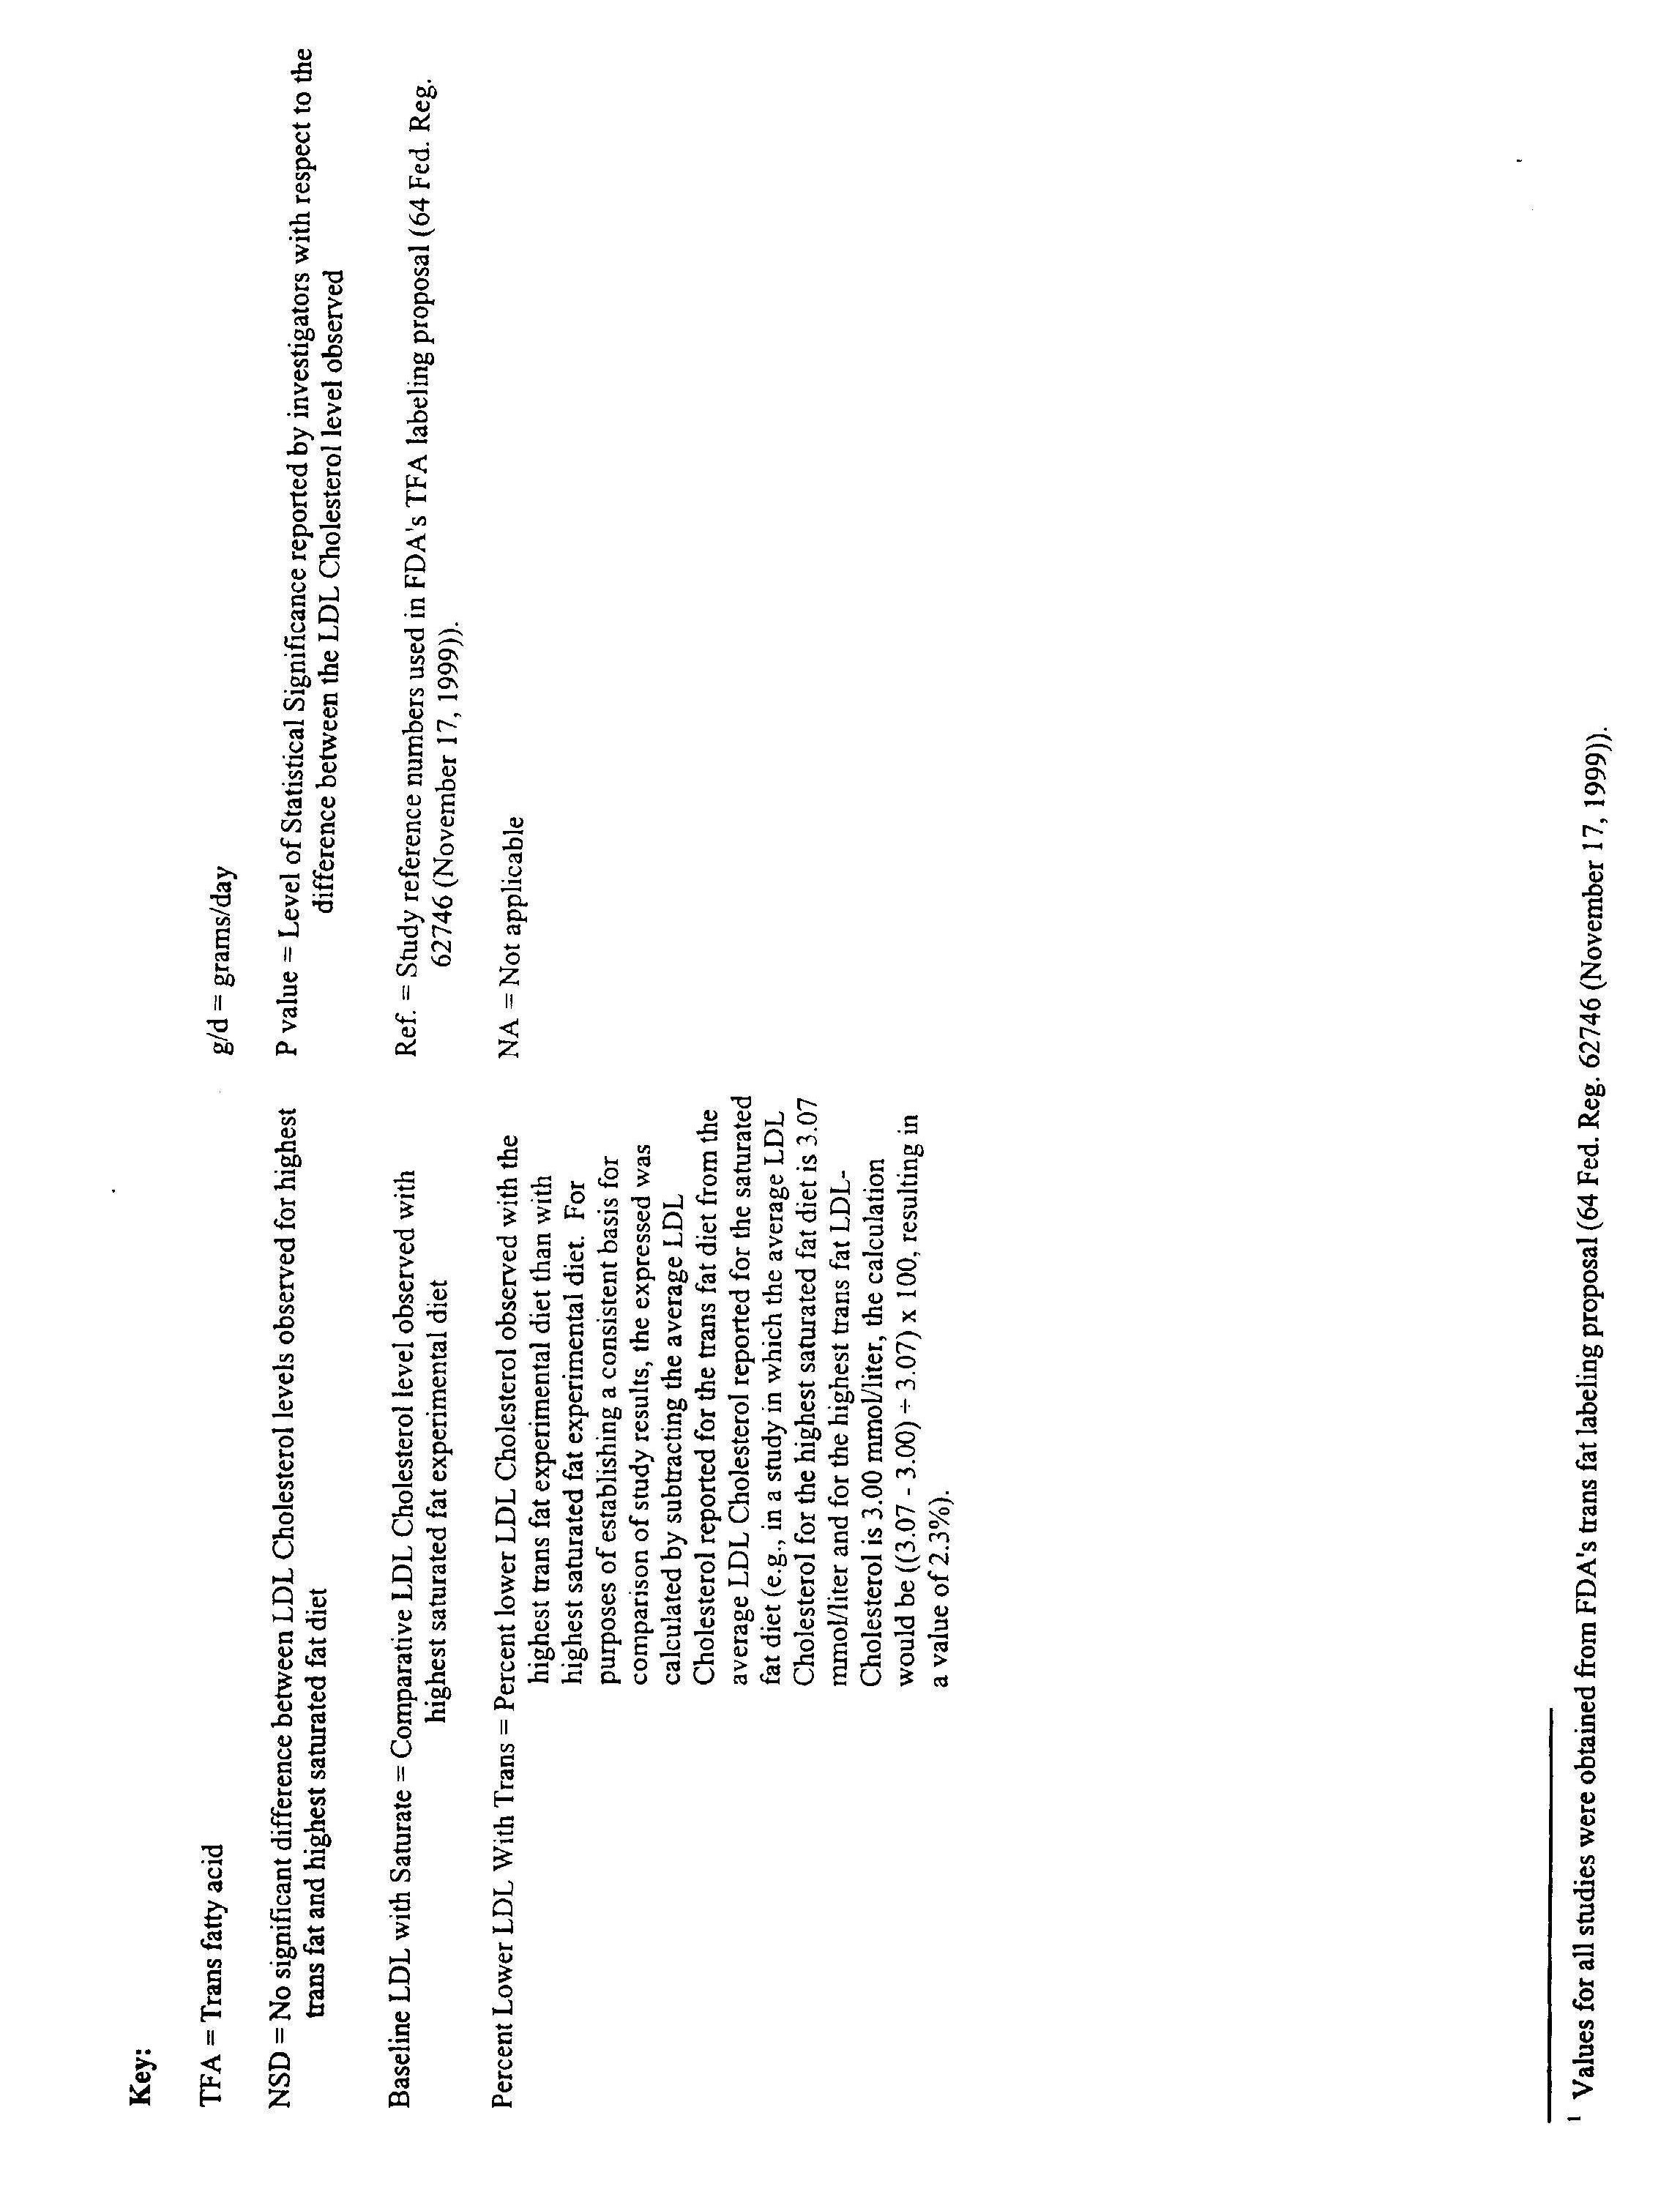

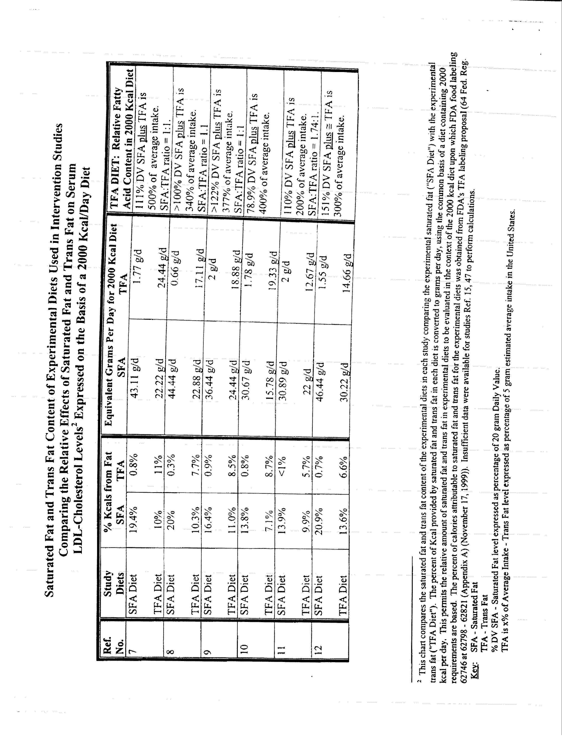

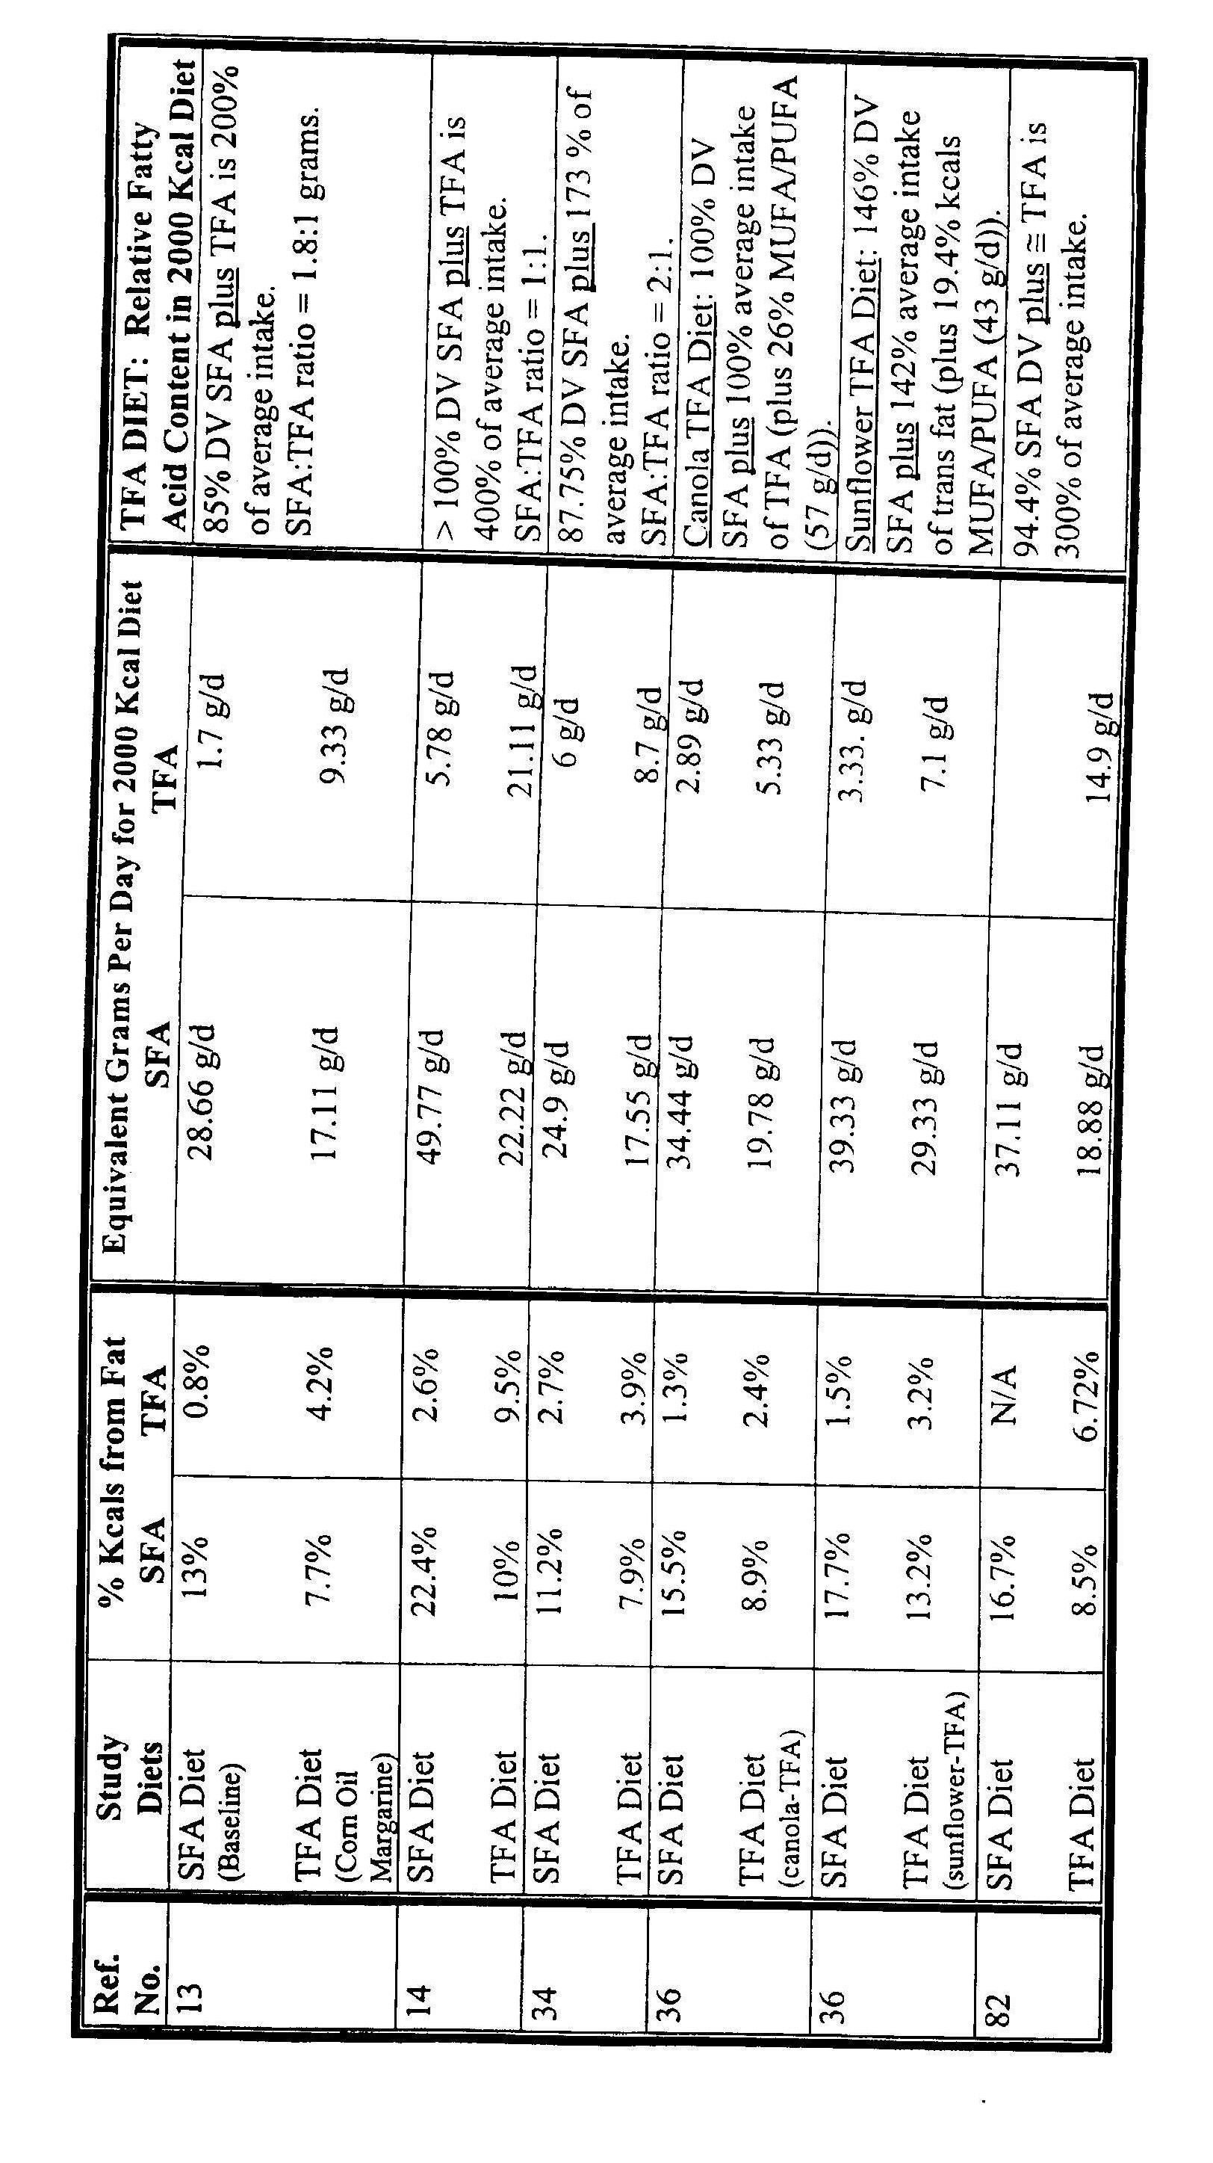

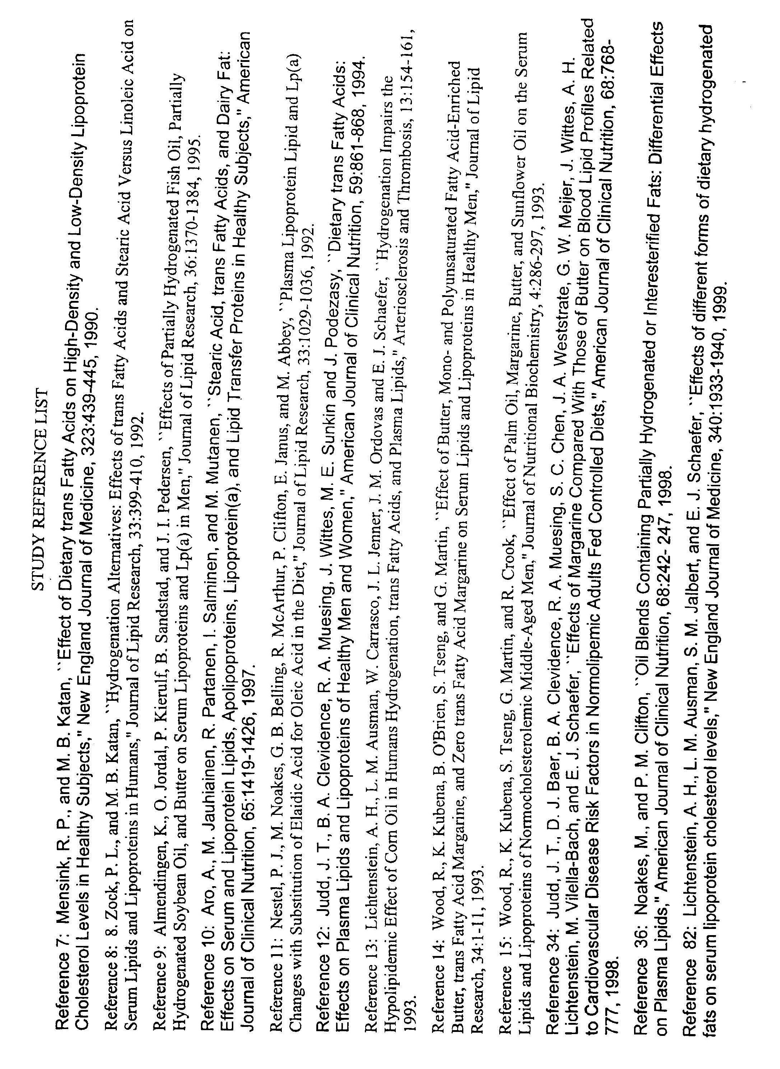

“FDA does not want to distract consumers from years of consumer education messages about saturated fat, especially because the average intake of saturated fat exceeds the average intake of trans fat by about fivefold (approximately 25 g versus 5 g/day, respectively).” 64 Fed. Reg. 62746, 62755 (Nov. 17, 1999).
Elsewhere, FDA stated “these studies do not conclusively show whether, on a gram-for-gram basis, the rise in LDL-C from trans fatty acids is as great as the rise that results from saturated fatty acids.” 64 Fed. Reg. at 62751.
IOM/NAS, “Letter Report on Dietary Reference Intakes for Trans Fatty Acids,” drawn from “Dietary Reference Intakes for Energy, Carbohydrate, Fiber, Fat, Fatty Acids, Cholesterol, Protein, and Amino Acids” (2002), at 14.
Id. at 6. This is in direct conflict with the FDA’s conclusion that the “magnitude of the effect of trans fatty acids on serum LDL-C compared to the increase resulting from consumption of diets containing saturated fat is not known.” 64 Fed. Reg. at 62754.
See, e.g., Judd et al. 1994. Dietary trans fatty acids: effects on plasma lipids and lipoproteins of healthy men and women, Am. J. Clin. Nutr., 59:861-868; Almendingen et al. 1995. Effects of partially hydrogenated fish oil, partially hydrogenated soybean oil, and butter on serum lipoproteins and Lp(a) in men, J. Lipid Research, 36:1370-1384; Judd et al. 1998. Effects of margarine compared with those of butter on blood lipid profiles related to cardiovascular disease risk factors in normolipemic adults fed controlled diets, Am. J. Clin. Nutr., 68:768-777.
See IOM/NAS, “Letter Report on Dietary Reference Intakes for Trans Fatty Acids,” at 6, Figure 1. The chart is a reprint of the Massachusetts Medical Society. It was originally published in correspondence, not in a peer-reviewed article, in the New England Journal of Medicine. Ascherio et al., “Trans fatty acids and coronary heart disease,” N. Engl. J. Med., 340:1994-1998, 1999 (letter).
In the preamble to its original nutrition labeling final rule, FDA declined to require a warning statement for high levels of total fat, saturated fat, cholesterol, or sodium in foods. According to FDA, “there are no generally recognized levels at which nutrients such as fat, saturated fat, cholesterol, or sodium in an individual food will pose an increased risk of disease.” 58 Fed. Reg. 2302, 2307 (Jan. 6, 1993). ISEO believes the same reasoning applies to trans fat.

