Improving Global Earthquake and Tsunami Monitoring: The USGS’s Response to a Presidential Initiative

D. McNamara, L. Gee, C. Hutt and H. Benz

Manuscript for the IRIS newsletter: June 2006

Introduction

In response to the December, 2004 disaster in the Indian Ocean region, the United States government committed $37.5 million to upgrade earthquake and tsunami monitoring systems operated by USGS and NOAA. The USGS received $13.5 million of this funding, which includes $8.1 million as part of an Emergency Supplemental in FY 2005, and a base increase of $5.4 million in FY 2006 appropriations. These funds are being used by the USGS in FY 2005-2006 to:
- upgrade communications at 37 Global Seismographic Network (GSN) stations;
- expand monitoring capabilities in the Caribbean with 9 new broadband stations;
- enhance National Earthquake Information Center (NEIC) monitoring systems;
- study tsunami hazard in the Caribbean, Atlantic, and Gulf of Mexico.

GSN Communications Upgrade

The Sumatra-Andaman Islands earthquake highlighted the contributions of the GSN to global earthquake monitoring. GSN data are critical to NEIC’s capabilities to detect, locate and fully characterize earthquakes around the world, contributing to USGS rapid earthquake information products. Given the importance of GSN contributions, adding or upgrading communications has been identified as a priority in the Emergency Supplemental funding.

Working with partners such as IRIS, UCSD, CTBTO, NOAA, AFTAC, and station operators, the USGS anticipates that 37 GSN stations will have new or improved communication links by September 30, 2006. In the past year, a total of 6 sites (CHTO, DAV, GRFO, KIEV, LCO, and PAB) have come online, one link has been upgraded (ADK), and the establishment of communications to FURI is anticipated this month. An award has been made to the University of California at San Diego (UCSD) (which operates and maintains one-third of the GSN stations) to enhance telemetry at five sites (SHEL, HOPE, MSEY, EFI, and RAYN). In addition, the CTBTO is in the process of upgrading their satellite bandwidth at 8 stations, providing additional bandwidth for GSN stations in the Pacific, Atlantic, Indian Ocean, and European regions. As part of the collaboration with NOAA, an ASL field engineer is currently on his way to Samoa to expand the Pacific satellite network. When complete, AFI, FUNA, PMG, and XMAS will have VSAT systems that link them to the PTWC. Communications to TARA and KANT will be added as these stations are installed later this year and JOHN will be returned to the system when the station is reinstalled at a future date.

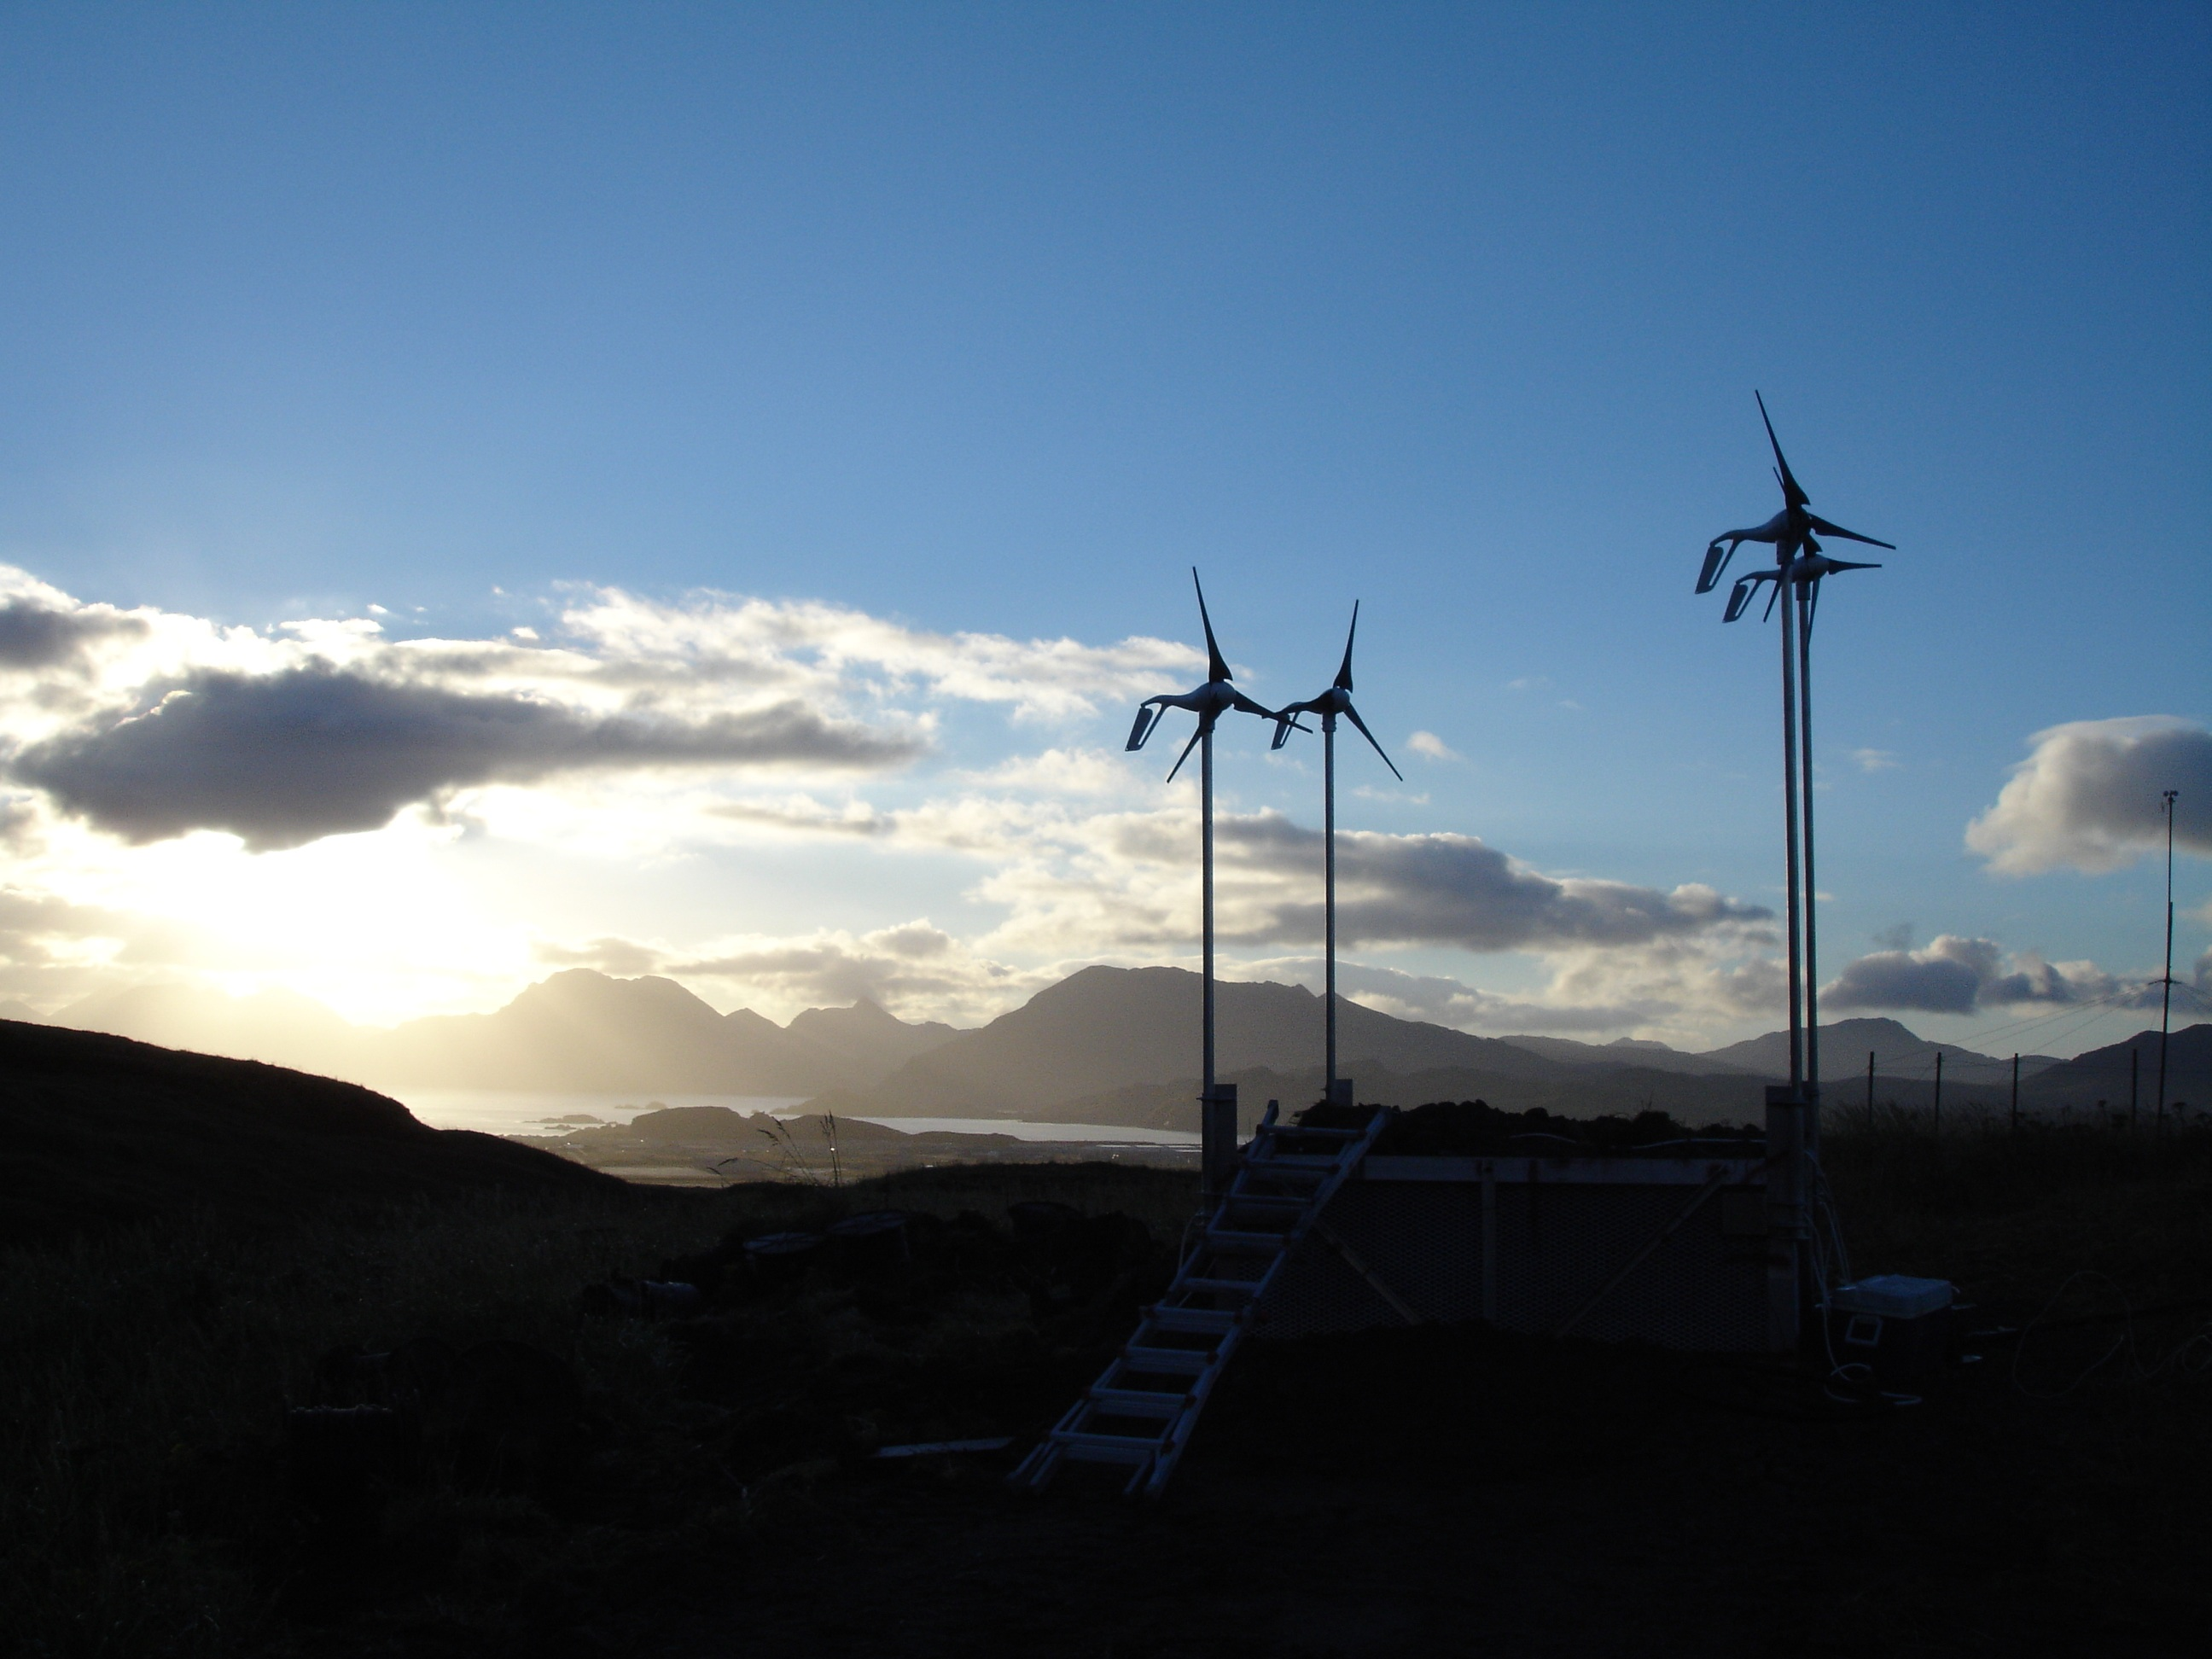

Figure 1: New wind generator at ADK, installed as part of the GSN telemetry upgrade. Photograph by Ted Kromer.

Improved Caribbean Monitoring

The second main project will enhance capabilities for rapid detection and notification of earthquakes in the Caribbean. The USGS is working with the University of Puerto Rico, the University of West Indies and eight host countries to install or upgrade seismic monitoring sites targeting earthquake source zones in the region. The new stations will be affiliated with the GSN, and long-term operation will be conducted by USGS in cooperation with partners from the host countries.

The nine planned stations are located in Antigua/Barbuda; Barbados; Cuba (U.S. Naval base at Guantanamo Bay); Dominican Republic; Jamaica; Honduras; Panama; Turks and Caicos; and Grenada (Figure 2). Efforts have focused on identifying and evaluating sites for each of these stations, obtaining Memoranda of Understanding/Agreement (MOU/MOA) and associated permits, and procuring equipment. In addition, USGS staff have worked closely with partners in host countries to identify station operators, plan data exchange, and conduct planning for both implementation and operation of these stations. Instrumentation will consist a Quanterra Q330 digitizer, a STS-2 seismometer, Episensor accelerometers, and real-time VSAT communications, consistent with the standards of the Advanced National Seismic System (ANSS) “backbone” network. Current discussions are underway to evaluate the feasibility of adding geodetic GPS installations to a subset of these stations in collaboration with UNAVCO. Satellite telemetry will transmit the data to NEIC, where the data will be redistributed to NOAA and other agencies.

In January 2006, Grenada became the first country to sign an MOU for the Caribbean network. The site preparation work was completed in February and the installation of the station will be completed in July 2006. In May 2006, a second MOU was signed between the USGS and the Smithsonian Tropical Research Institute (STRI) for a station on Barro Colorado Island (BCI) in Panama. We expect to build the site infrastructure and install instrumentation in July 2006. The USGS is currently awaiting permits or signed MOUs for the remaining seven sites.

The new 9 station seismic network is one branch of a system in the Caribbean that will also include 4 NOAA Deep-ocean Assessment and Reporting of Tsunami (DART II) bouys. The new monitoring system will greatly improve the region’s ability to respond to a damaging tsunami.

Figure 2: Improved earthquake and tsunami monitoring in the Caribbean. The map shows the seismicity and tectonic setting of the region as well as planned USGS and NOAA monitoring stations. The planned seismic stations will be affiliated with the Global Seismograph Network, which is operated jointly by NSF and the USGS.

Improved NEIC Operations and Enhanced Warnings

In parallel with efforts to upgrade and expand the seismic network infrastructure, the USGS is working to improve capabilities at the NEIC. This multi-faceted effort includes moving the NEIC to 24x7 operation and new software developments for the earthquake monitoring system. The USGS initiated 24x7 operations on January 8, 2006. Prior to this change, an off-hour on-call staff responded to earthquake emergencies and reviewed earthquake information was typically released 50-60 minutes after an earthquake occurred. With the new 24/7 staffing, 2 analysts are on duty at all hours and the response time for global earthquakes has been reduced by 50%.

Tsunami Hazard Studies

The final major component of the USGS effort under the Emergency Supplemental funding is to improve understanding of historical tsunamis and their effects in the Caribbean, Atlantic, and Gulf of Mexico. The tsunami hazards for coastlines in the region are complex in that practically all the known causes of tsunamis are present, including earthquakes, submarine landslides, and volcanoes. Efforts are under way to study potential tsunami sources south of Puerto Rico and the Virgin Islands, using multi-beam bathymetry mapping cruises and tsunami inundation modeling.

Conclusion

The magnitude-9.3 Sumatra-Andaman Islands Earthquake of December 26, 2004, increased the global awareness of the destructive hazard posed by earthquakes and tsunamis. With several hundred million people now living in coastal areas surrounding the Pacific and Atlantic Oceans and with major earthquakes occurring on average every 50 years, it is not a question of whether another destructive tsunami will occur but when. The USGS is working with partners such as NOAA, NSF, IRIS, CTBTO, and AFTAC to improve global earthquake and tsunami monitoring capabilities.

