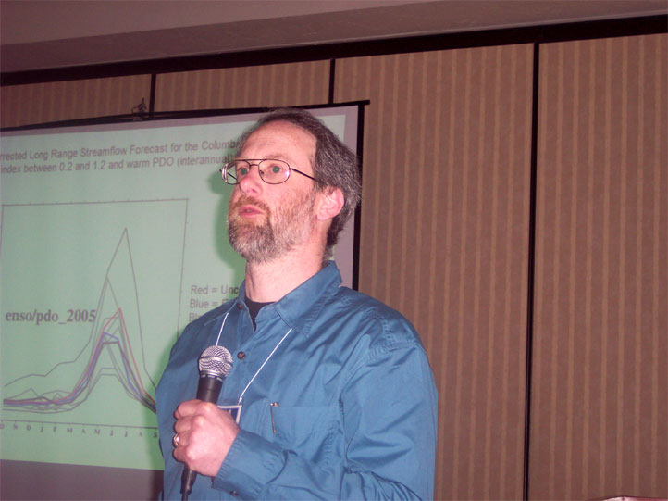
Update on West-Wide Hydrologic Forecasting at the University of Washington
Alan Hamlet
Andy Wood, Dennis P. Lettenmaier
Department of Civil and Environmental Engineering
University of Washington

1. Introduction: UW Experimental Hydrologic Forecasting System
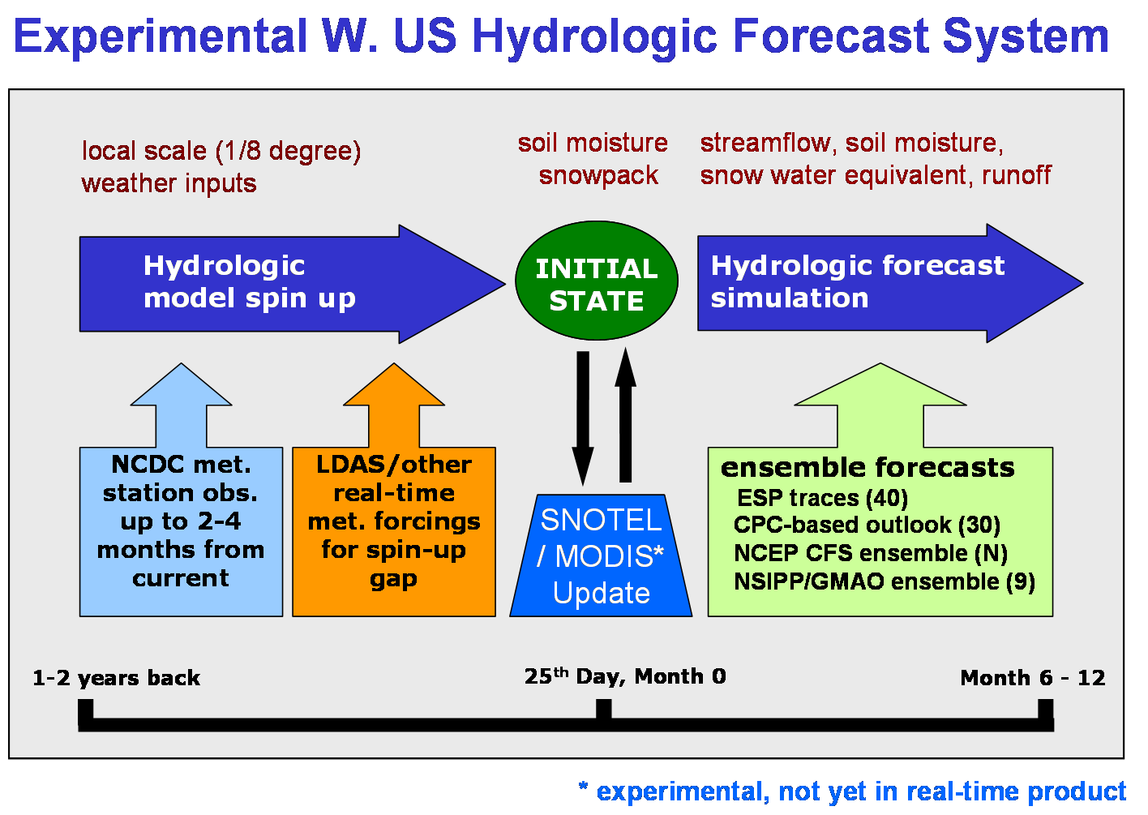
This just describes the framework for simulations – how the forecasts are made.
Note that the update cycle is typically monthly, with forecasts initialized on day 1 of the month, although we occasionally do twice monthly forecasts if changing conditions warrant.
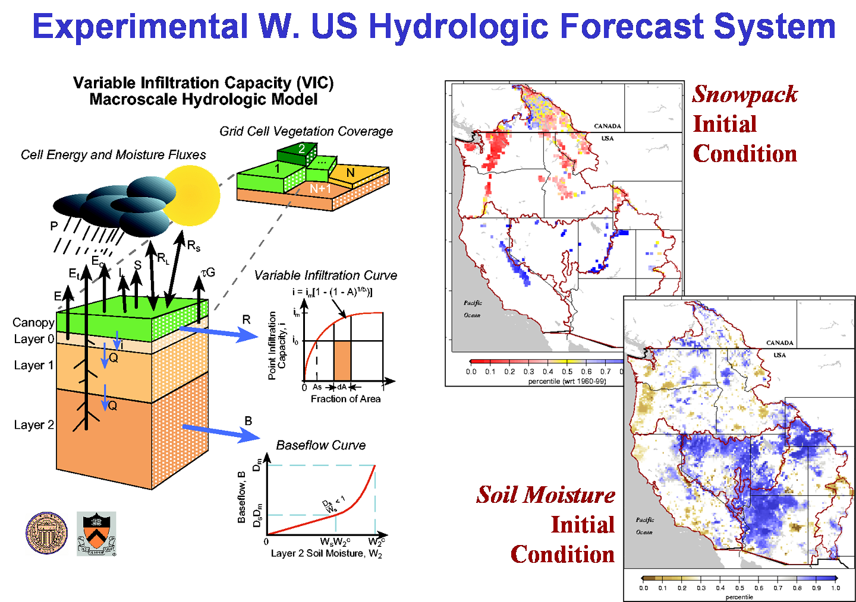
Here I typically say the system is implemented using VIC (wat/nrg balance model, etc.), and the spinup simulation produces an initial condition for snowpack and soil moisture over a domain of about 18,000 cells.

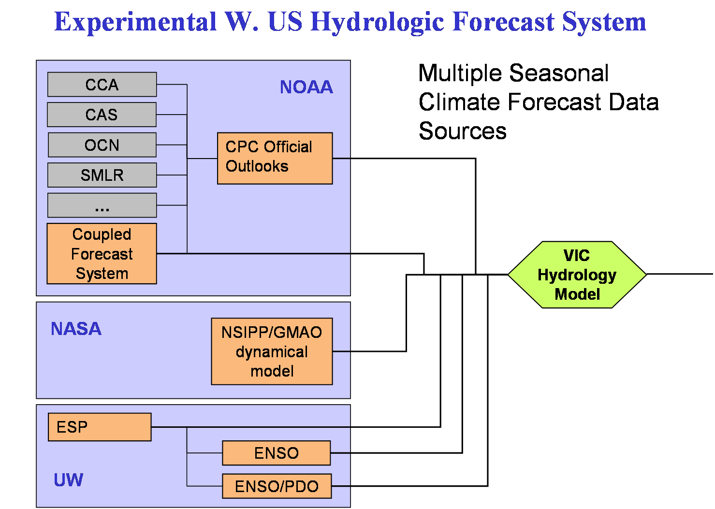
Our framework has allowed the use of climate forecast information from a number of sources – ESP & derivatives, climate model (NCEP/NSIPP), and CPC probabilistic outlooks. Currently we are re-implementing the climate model forecasts, and the CPC forecast approach is also evolving as we try to improve the temporal disaggregation step.
2. Water Year 2006: Current Conditions and Outlook
Now, we’ll just show a few slides showing current conditions and the streamflow outlook for this year.
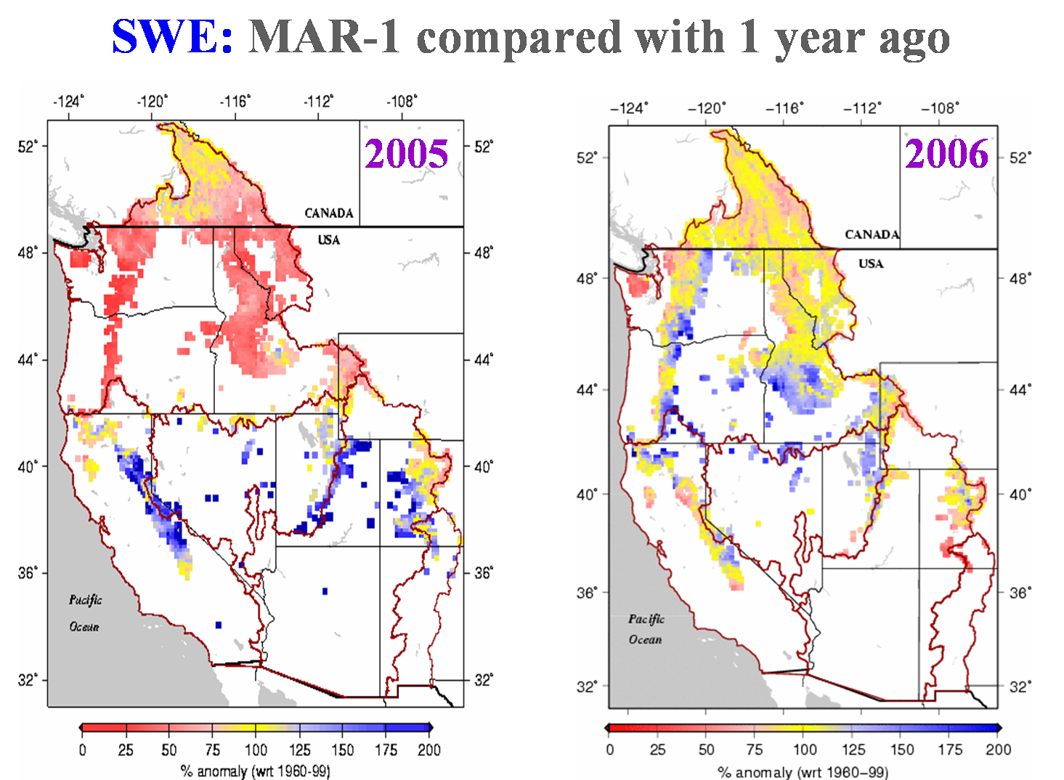
SWE also reflect this reverse of moisture gradient – last year was record setting, both dry in NW and wet in the SW, whereas this year is much nearer normal in the PNW, albeit with below avg snow at low elevations, and below avg in the SW (particularly rio grande).
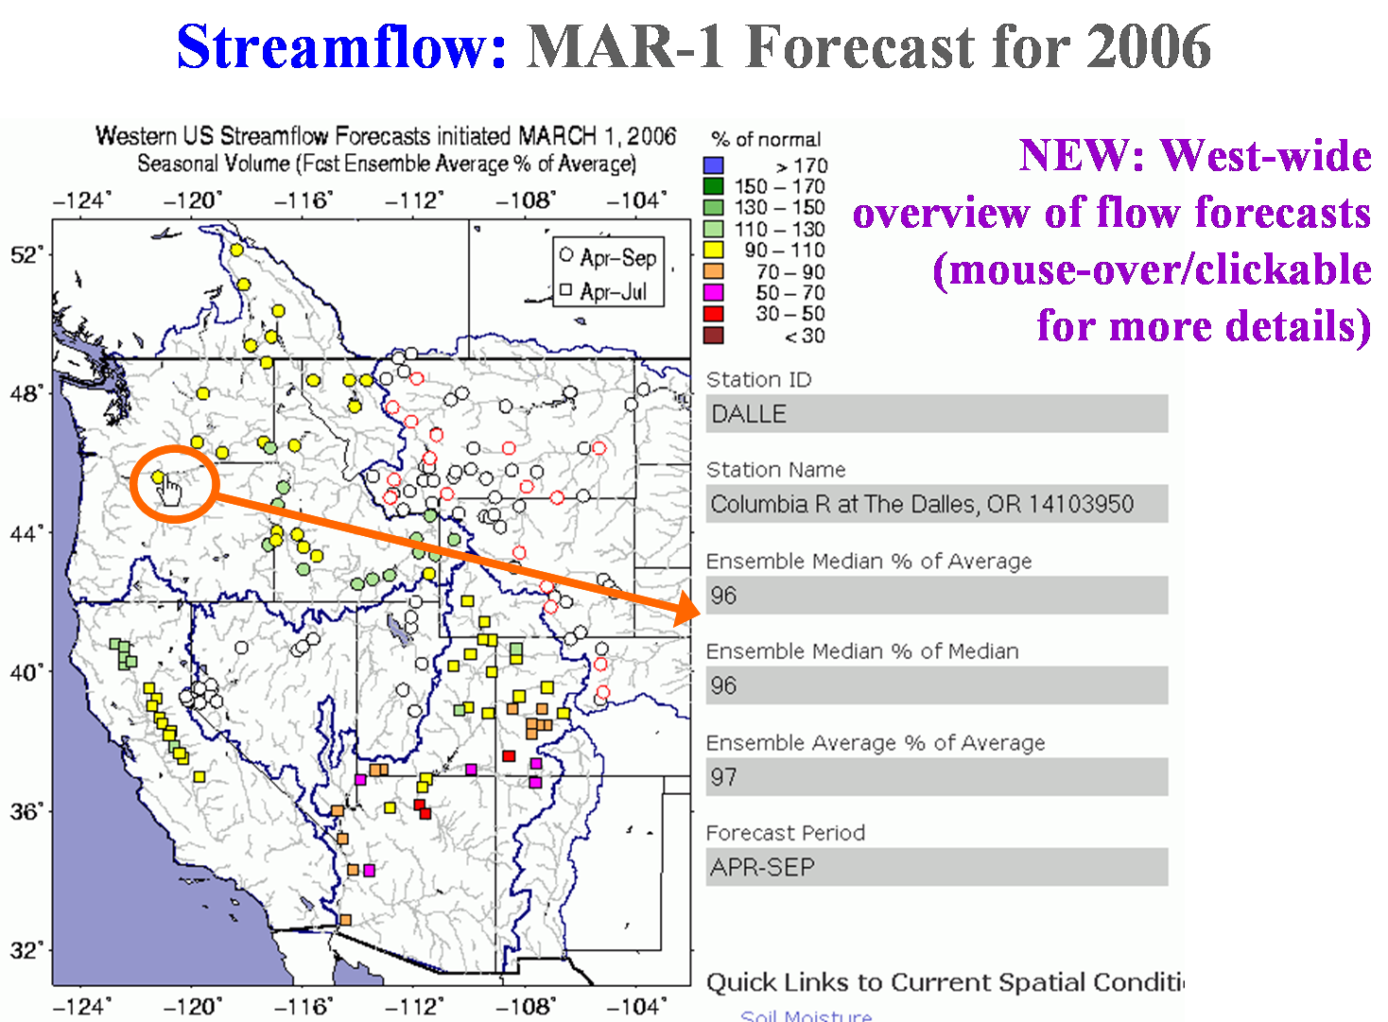
This bubble plot shows the streamflow outlook for summer runoff for about 90 locations in the domain. The anomalies are consistent with those shown in the spatial plots, with the lowest outlooks for the SW streams nearest that very low SM pattern we saw 2 slides back, and normal outlooks in the PNW.
Note, this west-at-a-glance display, with both mouse-overs that show various anomalies for the locations, and clickable points that launch more details, is something we have only recently added.
3. Current research activities:
Now that we’re talking about new features, we’ll continue with a quick summary of recent features or developments related to the west-wide system.
- Daily SWE observation west-wide roundup
- Multi-model forecast approach
- Daily nowcast update (from SW Monitor)
- Interaction with NRCS Water & Climate Center
- Basin-average water balance analyses
- Pilot basin operational efforts
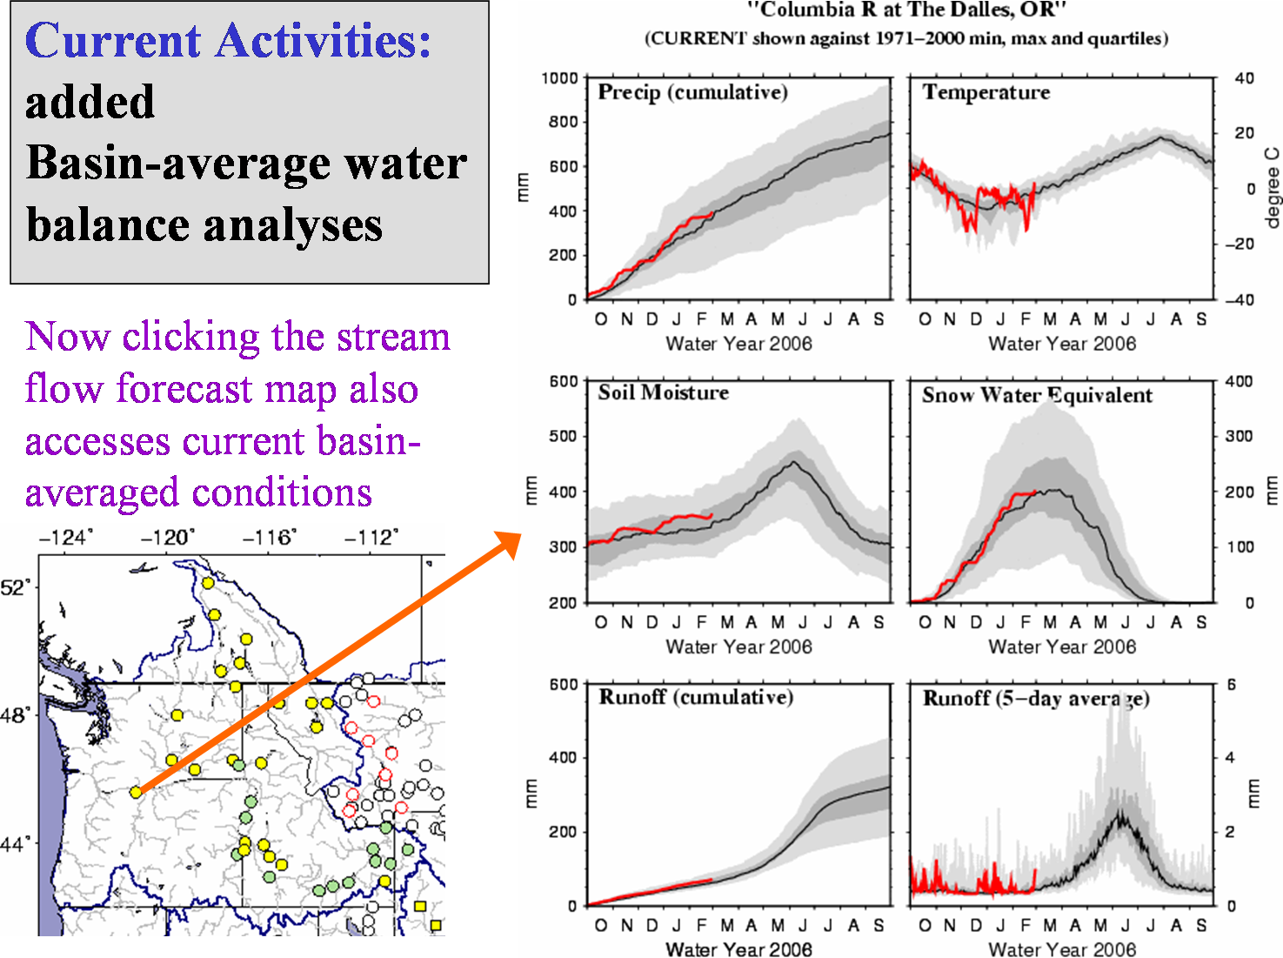

In addition to the streamflow hydrographs that we’ve had for a while, the clickable streamflow map now brings up the current water year conditions for P,T,SM,SWE, RO – which are helpful in showing where we are with respect to climatology. These are averaged over the drainage basin contributing to streamflow at each location.
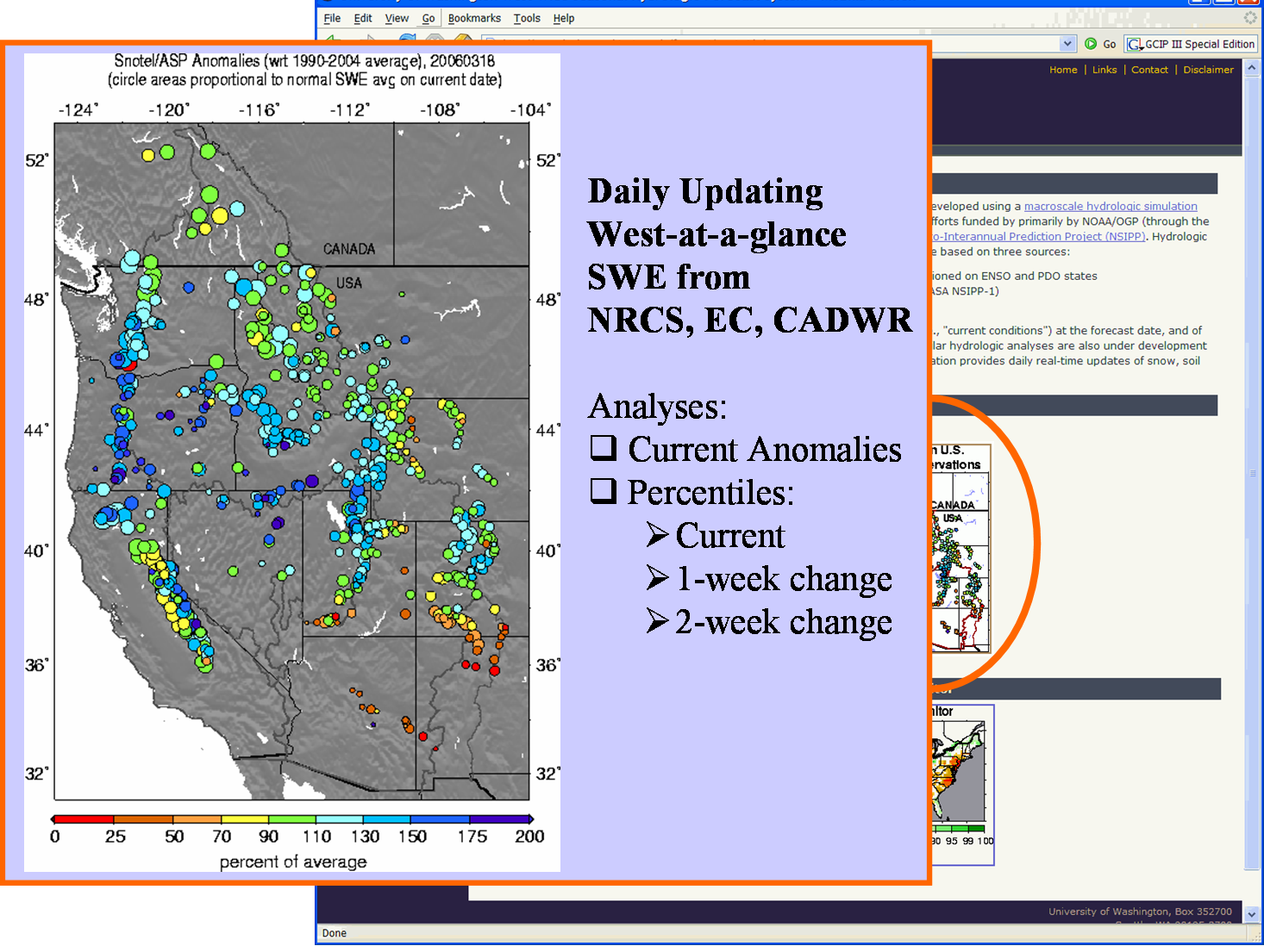

Another new feature is that we’re now plotting up several analyses of snow observations, and these update on a daily basis. We’ve been automatically downloading the data for a long time for use in our assimilation, and the goal here was to show the west-wide conditions at a single glance, something that’s hard to find elsewhere.
Note, in addition to the NRCS snotel points, we also have the California DWR snow pillows, and the Env. Canada snow pillows in the Columbia R. drainage.
There are about 5 plots – some of which are for changes during the last week or two.
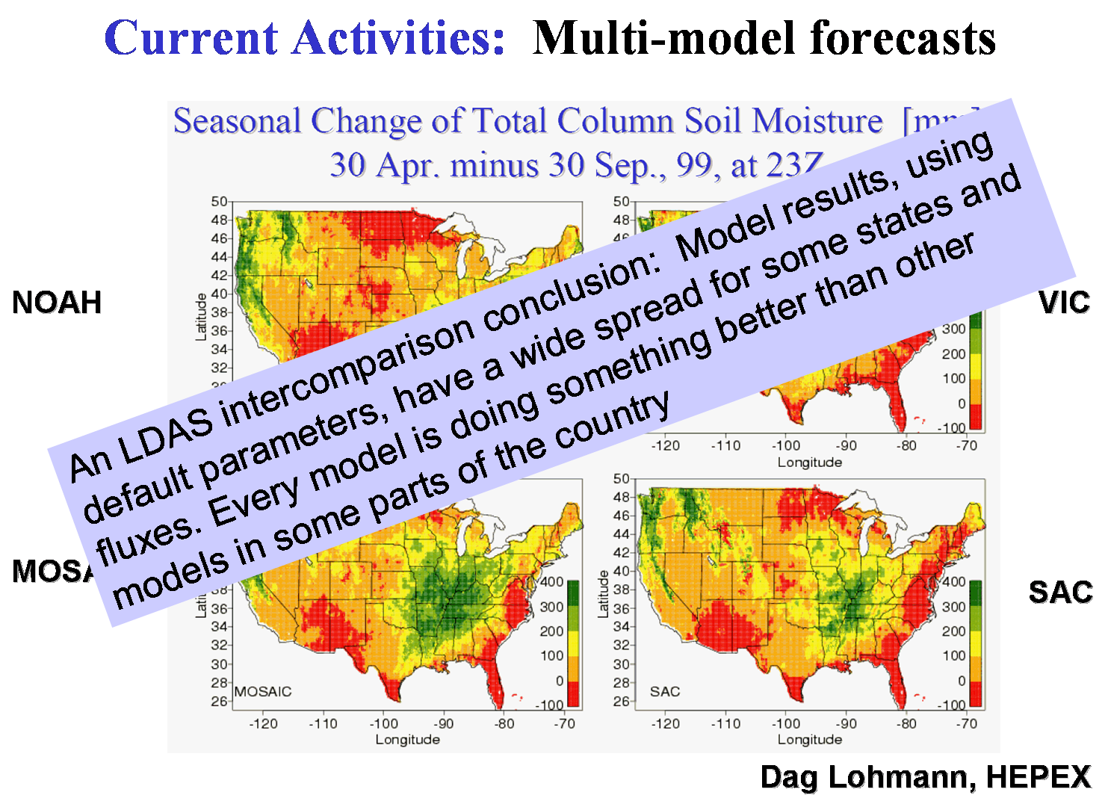

Another effort is related to evaluating a multi-model land surface ensemble. One of the conclusions of the LDAS initiative is that there might be some value to running algorithms from a number of models – see quote.
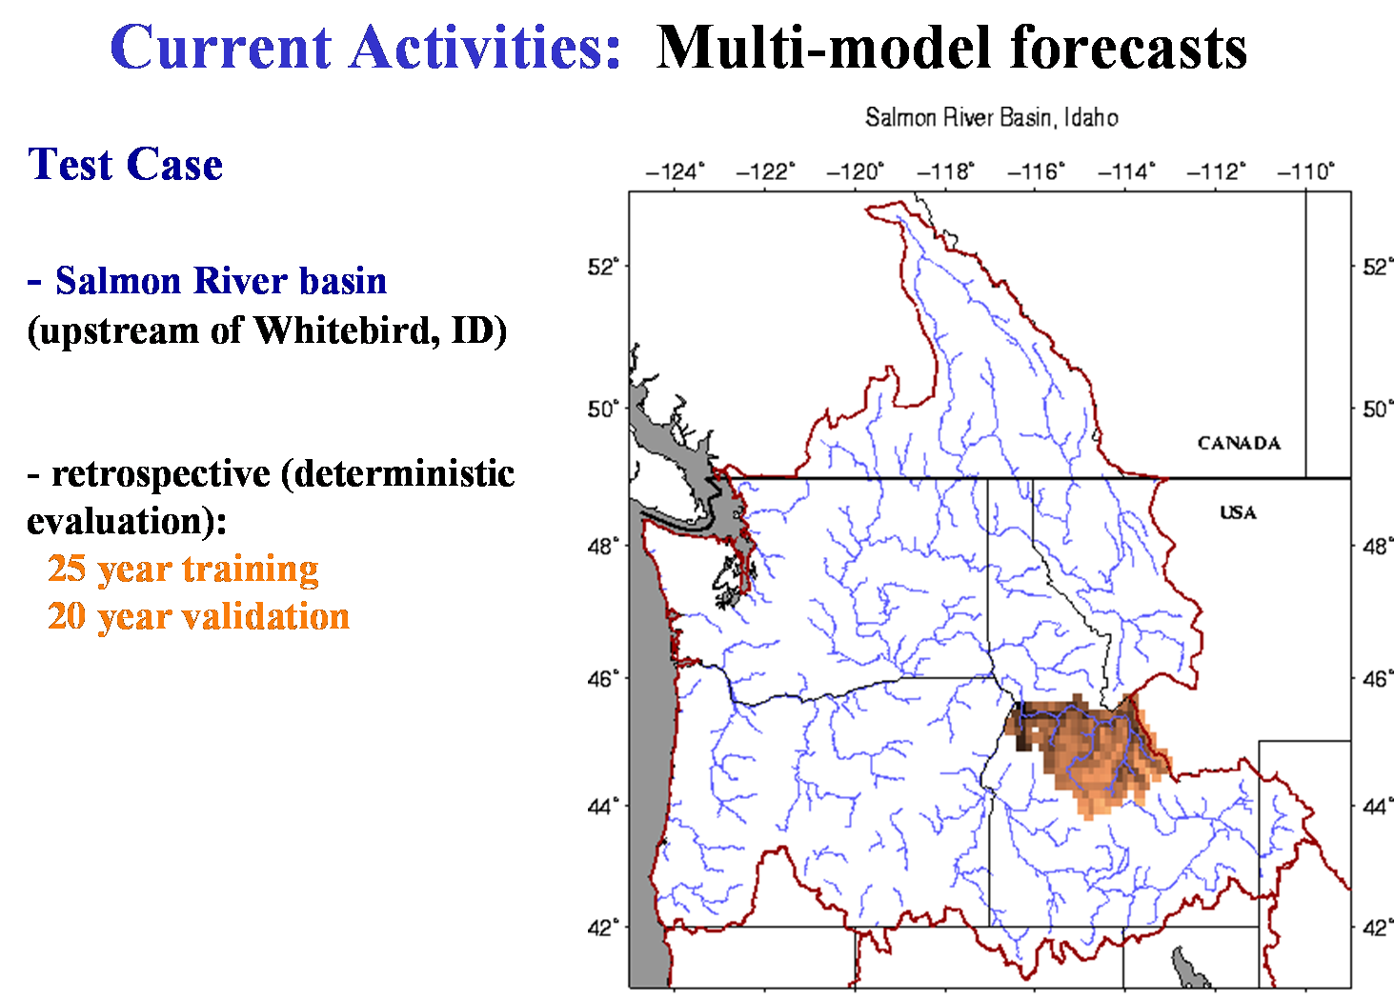
This is the test case in Idaho
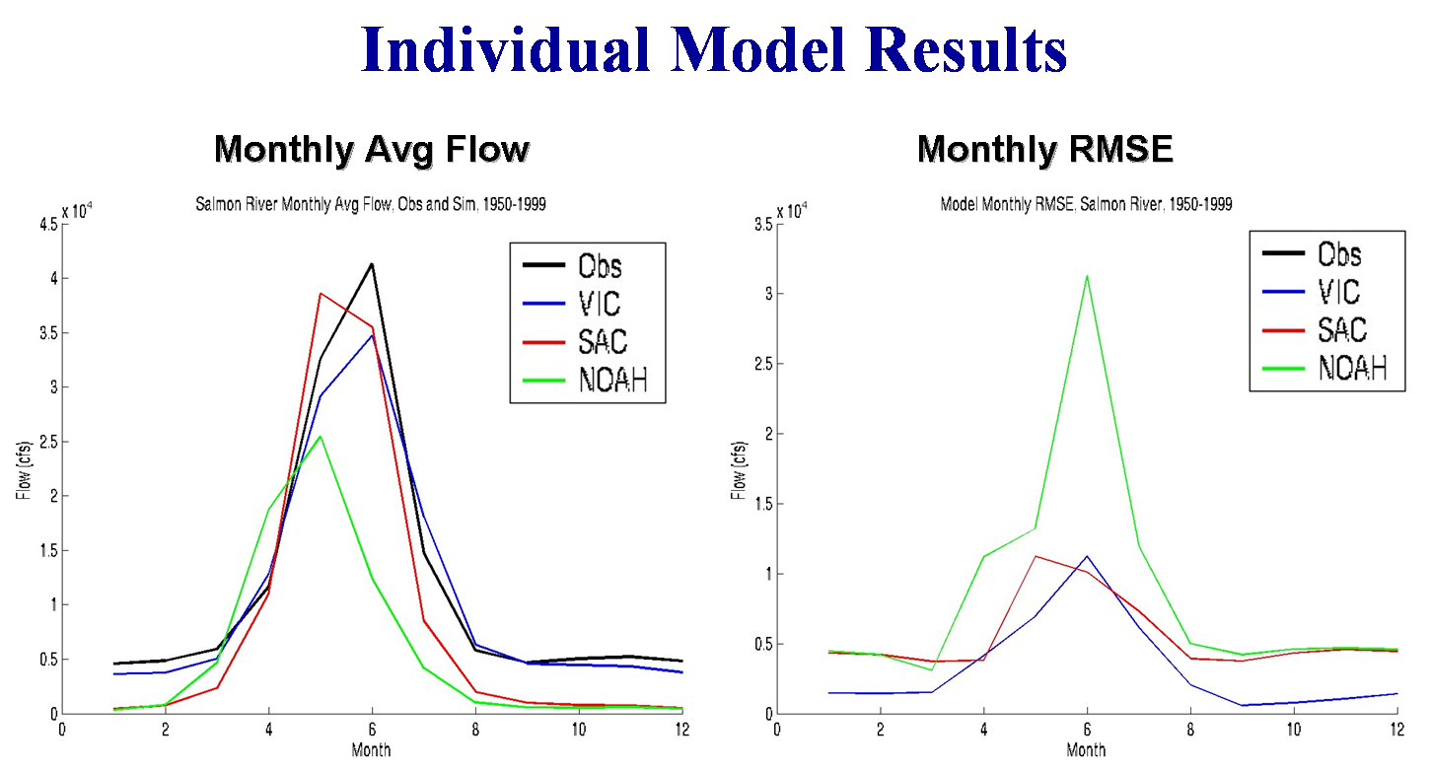

Here are the long term average results for the 3 models, none of which have been extensively calibrated. VIC is best, although the SAC model is not bad. The NOAH model has real problems with its snow simulation.
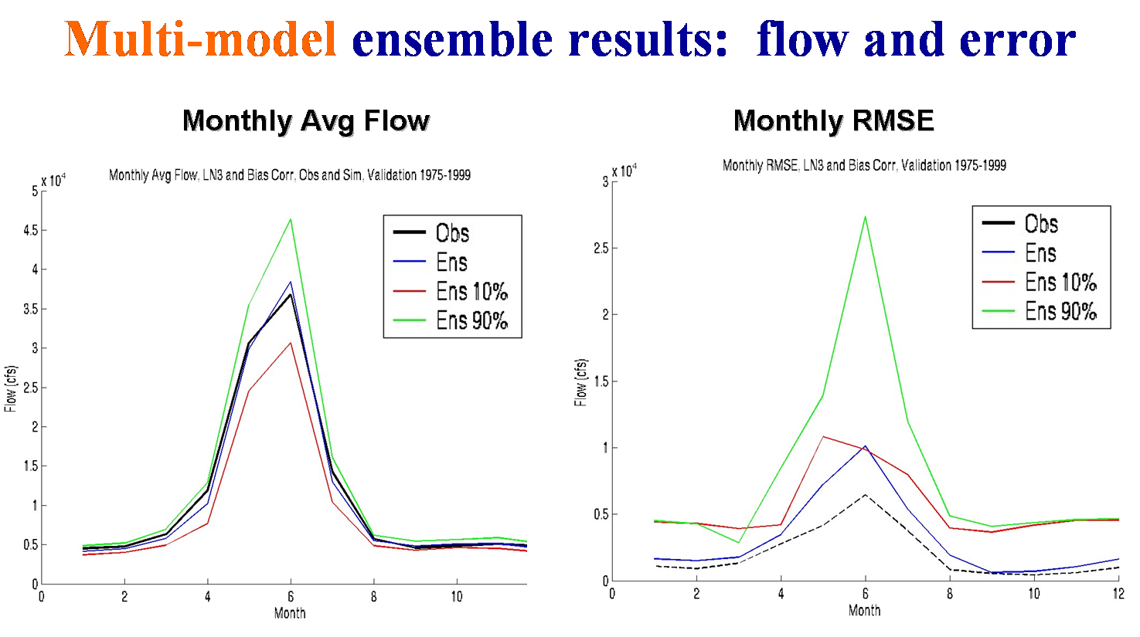

This is the result from a validation period for an ensemble combination of a single run of the each model. It’s clear that the model averaging process greatly reduces the error in the long term mean error & RMSE.
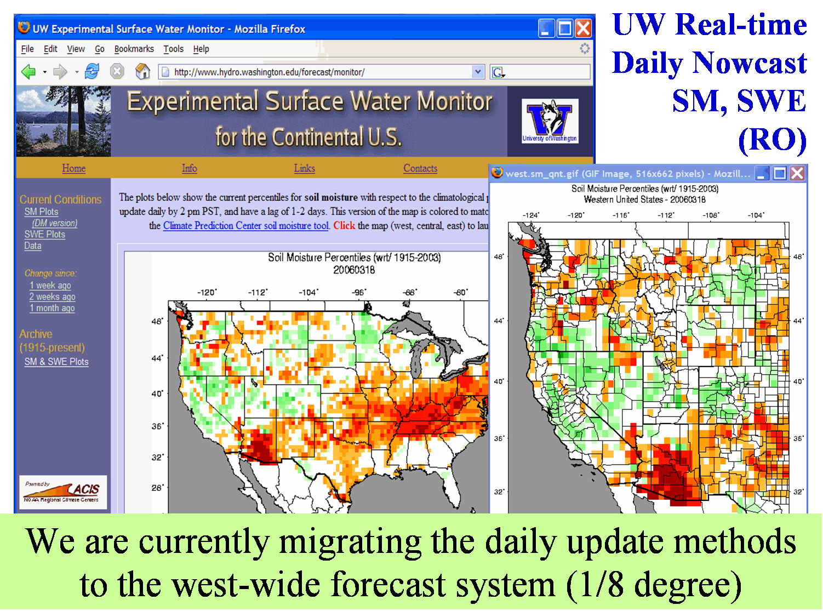

Another area of current research relates to the surface water monitor developed last year by A. Wood. This system, applied at coarse (1/2 degree) resolution over the entire CONUS, is completely automated (free-running) and updates every day. It’s just a prototype, demo project that have been unable to get funding to extend, and the main products are maps of current soil moisture & SWE, and an monthly archive that extends back to 1915, that also has SM & SWE maps.
Anyway, we are now adapting the daily update approach for use in the westwide forecast system, and should have the first basin (PNW) land surface conditions updating daily (at 1/8 degree) within the month. After that we’ll move on to other basins, and probably extend the 1/8 nowcast eastward to the Mississippi R.
Current Activities: Interaction with NRCS NWCC
Since last year, we have exchanged nowcast / forecast results with the NRCS National Water and Climate Center (head: Phil Pasteris)
- Under a Memorandum of Understanding between NRCS & UW:
- UW provides forecast results and data as NRCS requests
- NRCS provides access to stream flow and climate data (primarily via NOAA ACIS)
- NRCS has created a place for links to “experimental water supply forecasts” from its official website. Currently the UW is the only one, and they would like more!
- We generally attempt to schedule a “pre-forecast” conference call just prior to NRCS coordination of forecasts with NWS RFCs, in which we summarize our forecast outlooks and compare notes.
- In addition, there is a fair amount of informal exchange.
We also have an on-going interaction with the NWCC, and exchange results and comments on a routine basis during the forecast season. Credit Phil Pasteris, Tom Pagano, Tom Perkins, Jolyne Lea.
Note that NWCC is experimenting with a modeling capability based on the USGS PRMS model.
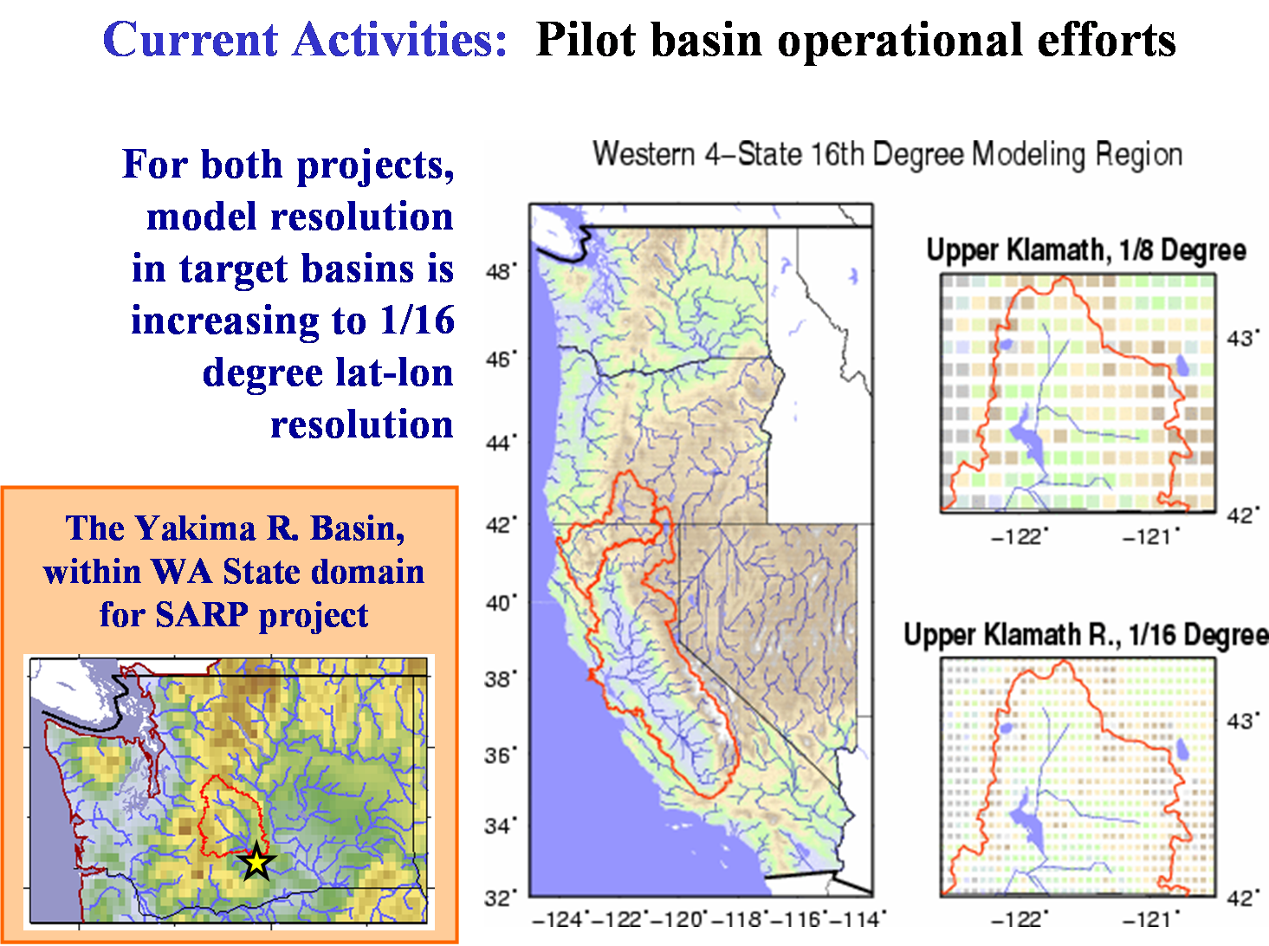
These are just the domains of the studies – for some of this 4 state area, we’re moving to a 1/16 of a degree resolution because the forecast points have smaller drainage areas than we’re comfortable with at 1/8 degree.
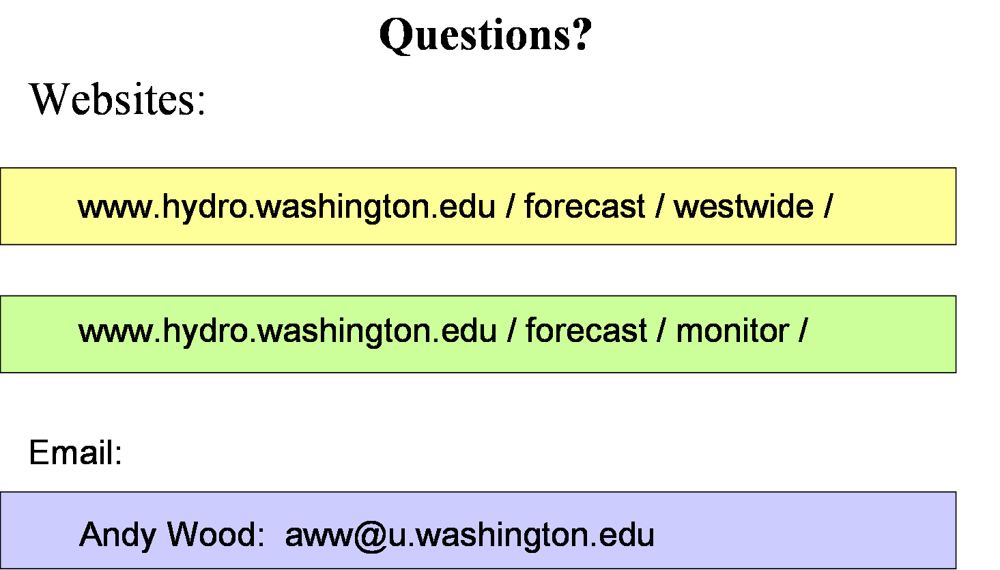

___________________________________________________
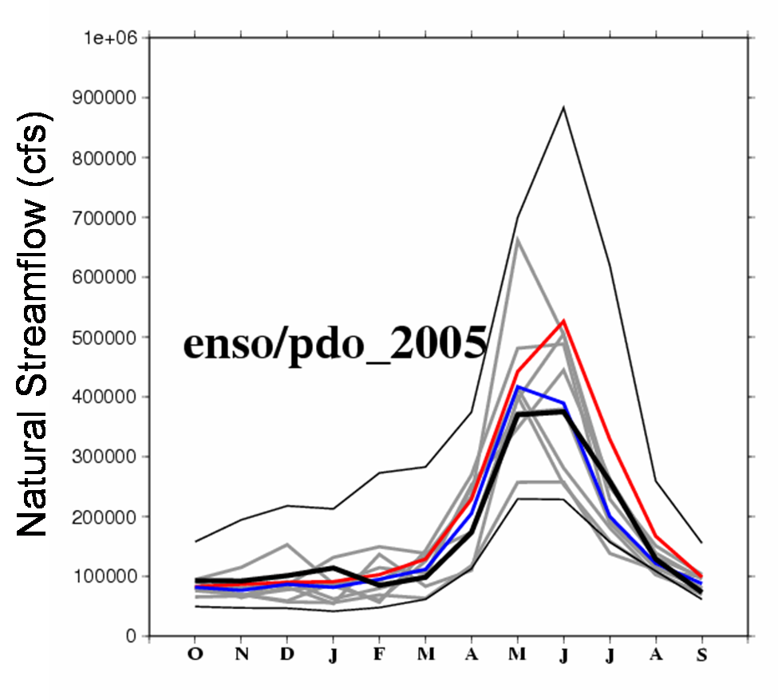

Bias Corrected Long Range Streamflow Forecast for the Columbia River at The Dalles
Nino3.4 index between 0.2 and 1.2 and warm PDO (interannual)
Red = Unconditional mean
Blue = Ensemble mean
Black = 2005 Observed

