The origin of gypsum-rich domes and cones in saline playa environment - the example from White Sands National Monument, New Mexico

Anna Szynkiewicz^{1*}, Lisa M. Pratt¹, Mihaela Gamoclija², David Bustos³

¹Department of Geological Sciences, Indiana University, 1001E 10th Street, Bloomington, IN 47408
²Geophysical Laboratory, Carnegie Institution of Washington, 5251 Broad Branch Road NW
20015 Washington, DC
³White Sands National Monument, P.O. Box 1086, Holloman Air Force Base, NM 88330
*corresponding author

Introduction
Continental playas represent saline mudflats where the capillary fringe intersects the landscape. They show various facies of evaporatic deposits and processes of solute transport that include surface runoff, meteoric and/or hydrothermal groundwaters. Modern continental playas contribute to salt deposits with thicknesses of more than hundred meters and areas measured in thousands of squares kilometers (Warren, 2006). In New Mexico, continental playas have developed in the closed-drainage basins formed by extentional tectonism of the Rio Grande Rift (Ref. ) where sediment deposition has been widely controlled by several abrupt changes of climate through the late Pleistocene and Holocene (e.g., Anderson et 2002).
The saline Alkali Flat from White Sands National Monument is a part of large continental playa with thick sequences of evaporatic salts, clays and silts preserved due to regional subsidence of the Tularosa Basin. The sediments are sulfate-rich that relates to dissolution of sulfate minerals (anhydrite, gypsum) by meteoric waters from large reservoir of Permian rocks surrounding the basin (e.g., LeMone, 1987). The intensive deflation of these sediments occurred at 7,000 and 4,000 years BP (Langford, 2003) that led to formation of large gypsum dune field in the eastern side and exposition of lacustrine sediments with dome and cone-like morphology abundant in sulfate mineralization on the west side of the Monument.
Here, we present the results of three field campaigns taken in 2007 combined with isotopic analysis (S, H) on gypsum-rich domes and local groundwater system together with studying of aerial images. The features of dome and cone-like morphology were detected in Martian surface for which many terrestrial analogs have been proposed such as cinder cones (e.g., Wood, 1979), rootless cones (Frey and Jarosewich, 1982), pingos, mud volcanos and evaporate deposition around geysers and/or springs (Farrand et al., 2005). As sulfates appear to be a significant part of rocks and regolith exposed at or near the surface of Mars, we believe that gypsum-rich domes from White Sands contribute important information about groundwater seepage in the surface of sulfate-dominated system leading to characteristic gypsum precipitation. Complex erosion driven by hydrological, aeolian and tectonic-related processes leave the dome- and conic-shaped features characterized by different albedo that is controlled by reflection of sunlight by gypsum crystals occurring on domes slopes.

Geological Background
White Sands National Monument is located in southern New Mexico (Fig. 1). Geographically belongs to the topographically closed basin of Tularosa. The exact thickness of basin fill is unknown but may vary from 300 to 2,500 m (pers. comm. Dave Love). The pluvial Lake Otero existed in the northern part of Tularosa Basin during the late-Pleistocene and left the evaporative sequences with laminated clays and silts, laminated gypsiferous marls, limestones, and massive silts containing large gypsum crystals; today, these sediments are exposed in gullies and incised by at least 20 playa lakes (e.g., Langford, 2003). The largest of the playas, Lake Lucero, consists of three sub-basins and is located in the southern part of White Sands National Monument. The aeolian processes are driven mainly by hydrological changes in groundwater table (e.g., Langford, 2003; Kocurek et al., 2006), but vegetation and surface cementation primarily acts to limit deflation as well (e.g., Schenk and Fryberger, 1988).
Gypsum-rich domes are located in the northwestern part of White Sands National Monument (Fig. 1), the area shared by the Monuments with the White Sands Missile Range. They appear close to the west edge of Alkali Flat being a part of old, re-exposed lacustrine clay sequence with reworked sheetwashed alluvium and aeolian sediments with an evaporatic crust developed on the surface. The underlying clay remains moist, most if not all of the time; the thickness of clay bed is unknown, however. Little is known about the age of lacustrine clay sequence with gypsum-rich domes. Based on radiodating of mammoth tracks found in that sequence, Spencer et al. (2006) suggest that tracks were made before 30,000 ¹⁴C yrs B.P. The overlaying sediments containing ostracodes valves, plant fragments, and charcoal have yielded four radiocarbon dates ranging from 22,800 to 19,430 ¹⁴C yrs B.P. (Spencer et al., 2006).

Methods
Field sampling
Three field campaigns were conducted on May, August and October 2007 and included sampling of selenite crystals from domes for sulfur and hydrogen isotopic analysis, measurements of strike and dip orientation of tilted layers of five domes. Samples for sulfur and hydrogen isotope analysis of dissolved sulfate and water were taken on May 2007 from surface water of Lake Lucero and 5 piezometers located inside the White Sand National Monument. Samples of water from the northeastern recharge zone of Tularosa Basin were taken from Crowford Spring and Three Rivers Campground.
A spatial occurrence of gypsum-rich domes were presented on aerial photographs being the digital orthophoto quads (DOQQs) released by Data Analysis Center (EDAC) at University of New Mexico in 2005.

Sulfur and hydrogen isotopes
For sulfur isotope analysis of dissolved sulfate in water, water samples were filtered, heated to 80-90ºC, acidified with HCl, and supplemented with 20 ml of 10 % BaCl₂ solution in order to precipitate BaSO₄. The precipitate was washed repeatedly with double-distilled water and isolated repeatedly by centrifugation as needed to remove chlorine prior to drying at 110 ºC. Sulfur isotopic compositions were determined using an EA1110 elemental analyzer coupled to a Finnigan Mat 252 isotope ratio mass spectrometer via a ConFlo II split interface (Studley et al. 2002). Isotopic data are reported with respect to VCDT (Vienna Cañon Diablo Troilite). The calibration was done based on laboratory standards calibrated relative to IAEA S-1 standard (δ³⁴S, -0.30 ‰). Analytical reproducibility was better than 0.2‰.
Hydrogen isotope composition was analyzed using a Hydrogen Device for water samples and a TC/EA elemental analser for gypsum crystallization water, both coupled to a ThermoFinnigan Delta Plus XP mass spectrometer. Sample of gypsum were freeze-dried overnight to remove contaminants of water moisture. Isotopic data are reported with respect to VSMOW (Vienna Standard Mean Ocean Water). The calibration was done based on laboratory standards calibrated relative to SLAP (δ²H= -428.00 ‰) and VSMOW standards (δ²H=0.00 ‰). Analytical reproducibility was better than +/-2 ‰ for δ²H.

Results and Discussion
Domes location and morphological features
Gypsum-rich domes show a varied size, shape and complex internal structure. Gypsum precipitation is marked by a variability of selenite including prismatic, lenticular and irregular crystals. At least three major morphologic types are recognized in the White Sands National Monument:
Type 1 - shows a layered internal structure with fine- to coarse-grained white selenite-rich beds and an amber selenite bed that is placed at the top of dome (Fig. 2). The amber selenite crystals are 10-20 cm long and preserved in vertical position. Type 1 is usually within 0.5-2.0 m in height. The white selenite-rich beds are best exposed in the northern side of each dome and show tilting toward the south. Both, the white selenite beds and amber selenite from the top show similar dip under the angle from 20 to 37º.
Type 2 - contains a white selenite breccia imbedded chaotically with large amber selenite blocks (Fig. 3). Those domes are the highest up to 3.0 m. Generally, Type 2 represents a disturbed sequence of Type 1 with poorly exposed white selenite-rich beds inside. Fragments of blocks with distinctive amber selenite layer are chaotically placed along the domes slopes. Many domes show a concentric pattern of bigger selenite growth that surrounding the selenite-rich beds. Around outer edges and within the rings, the selenite shows different size and color suggesting many generations of selenite crystals growth around the domes with no stratigraphic or crystal orientation. In the case of big domes within Types 1 and 2, more or less conic shape is preserved that is usually dependent on the position of large white and amber selenite crystals.
Type 3 - represents flat domes, with concentration of white coarse-grained selenite in the centre and surrounding big halo, even up to 8 m in diameter, built of fine-grained selenite, sand and clay sediments (Fig. 4). The halo parts of flat domes showed darker color on May and October 2007 in contrast to August 2007 when the surface temperatures were the highest and all surface of Alkali Flat dried out.

Type 1 suggests that an interior of gypsum-rich domes contain the remnants of layered lakebeds containing sulfate-rich evaporatic deposits. The lakebeds with white selenite and distinctive amber selenite layer in the top shows the example of gypsum crystals that are associated with evaporation/desiccation of the lake. These kinds of selenite are usually secondary in origin and grow in the media after the surrounding sediments are already deposited. Cody and Cody (1986) showed that different morphology of gypsum results from organic content within the clay and the temperature of crystallization. This infers a different depositional condition for a varied in size and shape selenite observed in domes.
In our opinion, Type 2 is a disturbed sequence of Type 1 due to advanced weathering. In most of cases, the amber selenite layer is located in the top of each dome, therefore, faster weathering of less coarse-grained gypsum-rich sediments leads to the re-orientation of this layer into lower parts of the domes. In White Sands, the weathering is mainly controlled by aeolian activity as the relatively high annual temperatures keep the area very dry. Nevertheless, a periodical flooding of the playa and further erosion by surface water might also increase temporally the weathering rates and enhance the downward moving of more resistant selenite beds from the top. Additionally, a downward moving seems to be promoted by tilting of domes sediments (Fig. 5). With time, a complex weathering driven by aeolian and hydrological processes led to the chaotic orientation of different selenite beds; that is what makes the complex internal structure inside the biggest domes of Type 2.
Flat domes of Type 3 distinctively differ in size and way of gypsum occurrence compared to Types 1 and 2. The changes in color within the halo (Fig. 6) seem to relate to seasonal variation in moisture content within the lacustrine clay sequence. Generally, water level was higher on May and October 2007 in the all area of White Sands National Monument. After the heavy monsoon season on 2006, the centre of a dune field and southwestern side of Alkali Flat was flooded from late August 2006 to late June 2007. The highest peak of flooding was observed for January 2007 (is it true David?), then the water level started to drop down and on May 2007 only ponds with remnant water were present on the surface. The halo around flat dome presented on Fig. 6 did not show surface water on May but the halo had more moisture compared to August when the relatively dry crust was observed and the darker area within the halo decreased in size. On October, the dark area of halo was the smallest but on the other hand the central part of the halo contained more moisture than it was observed on August; this probably relates to the summer 2007 abundant in precipitation that increased the water table in the all Monument. We also noted that on October the central part of this dome was a little higher suggesting its upward movement. Generally, evaporites in continantal playas grow by displacive crystal growth in the capilary zone or in immediately underlying brine-saturated muds. Ongoing growth of capillary salts above the water table pushes the playa surface up out of the capillary zone into the vadose zone (e.g., Warren, 2006). In our opinion this process is responsible for observed seasonal changes in the dome height presented on Fig. 6 and the way of gypsum occurrence within the Type 3. Further south, we found the flat dome that shows similar in size halo but with the central part pushed much higher above the surface (Fig. 4B). The close similarity in size and gypsum precipitation to the flat dome from Fig. 6 suggest more advanced stage of dome formation in this place.
The concentric patterns of gypsum growth within the Type 3 and circular features of moisture appearance suggest that Type 3 might relate to gypsum crystallization from groundwater discharging on the playa surface/subsurface. Rosen and Warren (1990) presented that gypsum precipitation in the playa sediments might result from groundwater saturated with respect to gypsum recharges around the playa margin. They named it as a groundwater seepage gypsum for which the negative δ²H values closely refer to the δ²H values of local groundwater system not affected by evaporation.
The circular patterns of gypsum growth are very common for Type 2, as well. Different size, color and way of selenite crystalization in Type 2 imply many generations of gypsum crystals. δ²H of white and amber selenite crystals taken randomly from several domes showed a consistent narrow range from -90 to -69 ‰ that is shifted toward negative values compared to δ²H value of groundwater (from -69 to -53 ‰) from piezomieters located inside the Monument. In contrast, the δ²H of surface water of Lake Lucero showed significantly positive values + 43 ‰ on May inferring the advanced evaporation of the playa lake. In fact, it was the last stage of lake evaporation and on August (or June/July? David put here your observation) there was no more surface water present on the surface of Lake Lucero. The groundwater from the piezometer located on the west shoreline of Lake Lucero showed lower δ²H values, -27, -28, and -29 ‰ on May, August and October, respectively, inferring that evaporation might affect strongly the isotopic composition of shallow groundwater in the subsurface of the playa.
The relatively low values of δ²H in all analyzed selenite crystals confirm that their formation might have taken place in several episodes of groundwater seepage on the playa surface/subsurface instead of crystallization from surface water or shallow groundwater undergoing consequent evaporation on the surface/subsurface of Alkali Flat.

Sulfur isotopes
Sulfur isotope measurements on lakebeds exposed in the southern part of Lake Lucero, large selenite from several domes and sulfate dissolved in modern groundwater system were carried out. Generally, sulfate from modern groundwater system in the White Sands area shows the lowest values of δ³⁴S ranging from 10.40 to 11.94 ‰, with mean value of 11.26 ‰ on May (Fig. 7). This is consistent with the δ³⁴S of dissolved sulfate observed for the surface water and groundwater of northeastern recharge zone that show values from 10.55 ‰ to 11.81 ‰ (mean 11.18 ‰) on May. Water/Acid-soluble sulfate from lakebeds exposed in the southern gullies of Lake Lucero showed the continuous increase of δ³⁴S values from 11.33 ‰ in the bottom to 14.27 ‰ at the top of profile (Fig. 8). Selenite from gypsum-rich domes showed δ34S values from 12.12 to 13.79 ‰ (mean 13.07 ‰, n=30). During gypsum precipitation, a small fractionation of sulfur isotopes takes place, within 0.3 to 0.8 ‰ (Ref. ), and gypsum is enriched in heavier isotopes relative to sulfate remaining in the solution (Ref. ). The δ³⁴S of the upper part of that profile and selenite from domes is much more shifted to higher values than it would be expected from sulfur isotope fractionation. Therefore, it may be suggested that younger sediments and selenite from domes were formed from sulfate characterized by higher values of δ³⁴S compared to modern groundwater system in this area.
Bacterial sulfate reduction would have caused the positive excursion of δ³⁴S value in sulfate (Ref. ) but in our opinion this process is/was negligible in the White Sands area. On May 2007, we detected small amount of H₂S in the piezometer located in the western side of Lake Lucero with negative δ³⁴S values (-38.08 ‰) indicating bacterial sulfate reduction. In spite of this, δ³⁴S value of dissolved sulfate (+10.57 ‰) was in the same range of δ³⁴S value noted for groundwater in the recharge zone showing that sulfate reduction does not influence on δ³⁴S value of sulfate. Generally, lake sediments from southern outcrops of Lake Lucero contain relatively small amount of organic carbon (from 0.04 to 0.21, with one clay-rich bed showing 0.37 %); this probably importantly limits the sulfate reduction rates in White Sands.
The other explanation for observed higher values of δ³⁴S is mixing the sulfate of different origin. The increase of δ³⁴S value follows the general increase of sulfate content observed for the lake sediments. Two different sequences of Permian evaporites are present in the Rio Grande rift, the ONE (rember to check the name) and Yeso formations. The ONE formation is exposed on the surface of the Tularosa Basin. Based on δ³⁴S values of sulfate in waters from the northeastern recharge zone of the Tularosa Basin, it might be suggested that ONE formation is characterized by δ³⁴S values for sulfate in the range from 10.55 ‰ to 11.81 ‰ (mean 11.18 ‰, n=2). Those values are consistent with δ³⁴S values of sulfate in modern groundwater system of White Sands. The Yeso formation is older in age and not exposed on the surface of Tularosa Basin. We analyzed δ³⁴S values of sulfate in shallow groundwater system of Estancia Basin in which Yeso formation is present on the surface. δ³⁴S values of sulfate for Yeso varied from 12.88 to 13.81 ‰ (mean 13.27 ‰, n=3) on May 2007 and well correspond to the range of δ³⁴S values obtained for the youngest sediments occurring in the gully profile from Lake Lucero outcrops (Fig. 7,8) and selenite from domes of Type 1 and 2 (from 12.12 to 13.79 ‰; mean 13.07 ‰). After the Last Maximum Glaciation in North America, the climate had been continuously changed toward increasing aridity and groundwater recharge had become dominant in the Tularosa Basin. Therefore, it may be expected that more water coming from deeper circulation had been entering the basin center because of limited surface run-off along that time. The general increase of δ³⁴S value in lake sediments may imply that groundwater was in contact with ONE formation and could have changed temporally sulfate isotope composition that is characteristic for shallow groundwater and surface run-off. During a time of sampling for this study, modern groundwater system in White Sands showed δ³⁴S values typical for ONE formation. This suggests that recharge from shallow groundwater system and/or surface run-off was dominant during that time.

Domes Crossing Alignment
Aerial photograph reveals that domes of type 1 and 2 are aligned along two cross-cutting trends (Fig. 9). Trend 1 extends NNE-SSW and contains four single domes. Trend 2 is located NW-SE with seven domes, five of them are gathered in a close proximity; we called them a Family Group. The Family Group contains many small domes (0.2-0.3 in height), barely visible on aerial photograph, that in most of cases represent transition between Type 1 and 2. Because of small size, Type 3 is not visible on aerial photographs, and usually those domes occur outside the Trend 1 and 2. However, similar to big domes, they are more or less linearly spread out across the Alkali Flat and are located in a close proximity to main crossing alignment observed for Type 1 and 2. Only one flat dome presented on Fig. 6 is within the main alignment, located about 1 m south from the first dome of Trend 1 (Fig. 9).
Generally, big domes show significant albedo differences relative to dark background of Alkali Flat (Fig. 9). It results mainly from high reflection of sunlight by selenite crystals that are placed around the domes. These selenites come from erosion of amber selenite layers being in the top of the dome and/or from selenite that was precipitating around the domes due to groundwater seepage (Fig. 3). The low albedo of Alkali Flat results from higher moisture and bigger content of fine grained material such as clays, fine gypsum precipitates and dust.
The evident alignment of Type 1 and 2 suggests that groundwater seepage may relate to local fractures conducting more water beneath the Alkali Flat. The western margin of the Tularosa Basin is, in fact, developed along the San Andres fault, the main Pleistocene tectonic dislocation in this area. Therefore, the domes alignment could be related to the local fractures originated from regional tectonic activity in the Tularosa Basin. Generally, little is known about development of fault system of this area because of limited access for the past 50 years relating to the military activity (Ref. ). In Fig. 1 we presented the localization of major faults that closely relate to domes appearance on the surface of Alkali Flats and orientation of strike and dip measured for tilted layers occurring in five domes. There is no offset in the adjacent lake beds exposed on gullies of the west edge of Alkali Flats that would correspond to the two-crossing domes alignment and the orientation of tilted layers in domes. This indicates that the fractures recorded by domes alignment were developed before deposition of sediments overlying the lacustrine clay sequence or the fractures relate to other synsedimentary processes that are not directly associated with the extentional tectonism of the Tularosa Basin.
It was shown, that aeolian activity in White Sands is dependent on the groundwater table and the moisture content in the evaporatic sediments. Because all domes are located on the surface of Alkali Flat that underwent an extensive deflation during Holocene, the groundwater seepage in the places where we see domes today could have prevented from their erosion during the final Holocen deflation. This might have resulted from better cementation by large selenite and bigger moisture content. The Type 3 suggests that groundwater seepage on the surface of Alkali Flat continuous until today.

Conclusions

Acknowledgments

References
Anderson, R.Y., Allen, B.D., Menking, K.M., 2002. Geomorphic expression of abrupt climate change in southwestern North America and the glacial termination. Quat. Res. 57, 371-381.
Cody, R.D., Cody, A.M., 1987. Gypsum nucleation and crystal morphology in analog saline terrestrial environments. J. Sediment. Petrol. 58, 247-255.
Farrand, W.H., Gaddis, L.R., Keszthelyi, L., 2005. Pitted cones and domes on Mars: observations in Acidalia Planitia and Cydonia Mensae using MOC, THEMIS, and TES data. J. Geophys. Res. 110, E05005.
Frey, H.M., Jarosewich, M., 1982. Subkilometer Martian volcanoes: properties and possible terrestrial analogs. J. Geophys. Res. 87, 9867-9879.
Kocurek, G., Carr, M., Ewing, R., Havholm, K.G., Nagar, Y.C., Singhvi, A.K., 2006. White Sands Dune Field, New Mexico: Age, dune dynamics and recent accumulations. Sediment. Geol. ….
Lemone, D.V., 1987. White Sands National Monument. Geological Society of America Contennial Field Guide – Rocky Mountain Section, 451-454.
Rosen, M.R., Warren, J.K., 1990. The origin and significance of groundwater-seepage gypsum from Bristol Dry Lake, California, USA. Sedimentol. 37, 983-996.
Spencer, G.L., Allen, B.D., Morgan, G.S., Myers, R.G., Love, D.W., Bustos, D., 2007. Mammoth footprints from the upper Pleistocene of the Tularosa Basin, Doña Ana County, New Mexico. In: Cenozoic vertebrate tracks and traces. Lucas, Spielmann and Lockley (Eds.) New Mexico Museum of Natural History and Science Bulletein 42, 149-154.
Warren, 2006. Evaporites …
Wood, C.A., 1979. Monogenetic volcanoes of the terrestrial planets. Proc. Lunar Planet. Sci. Conf. 10th, 2815-2840.

Fig. 2. Gypsum-rich dome showing the characteristic morphological features of Type 1.
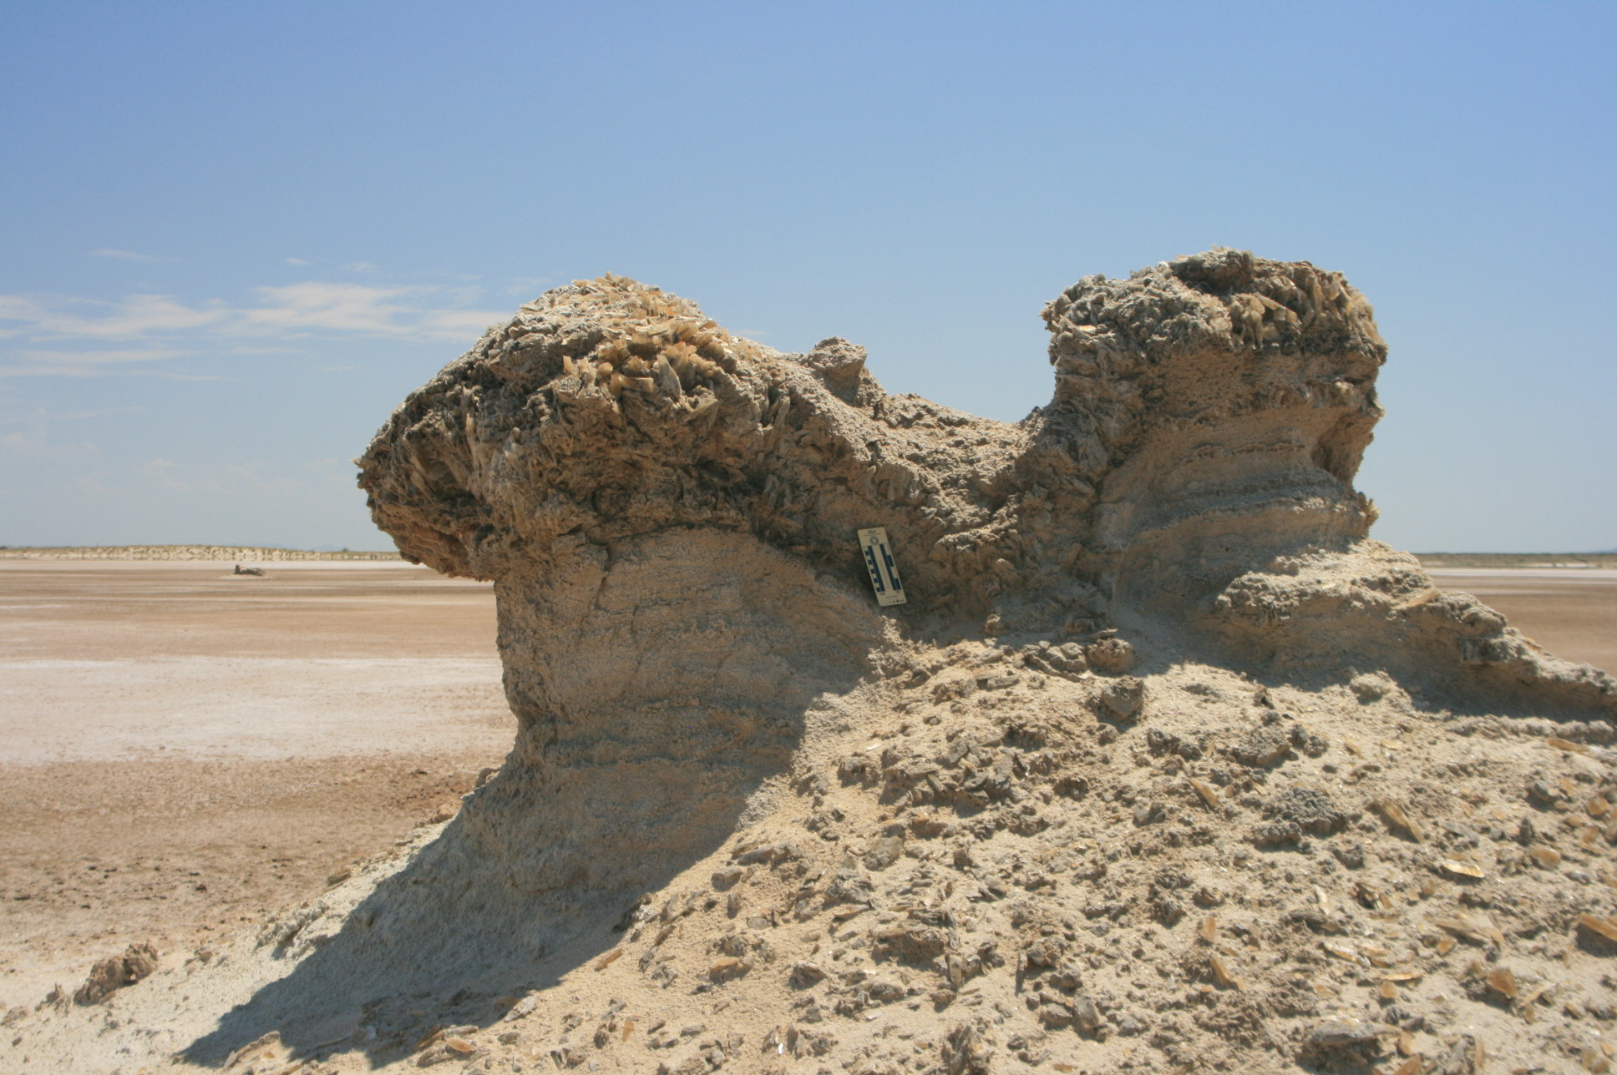
Layer with amber selenite
White selenite-rich lakebeds
Fig. 3. Gypsum-rich domes showing the characteristic features of Type 2.
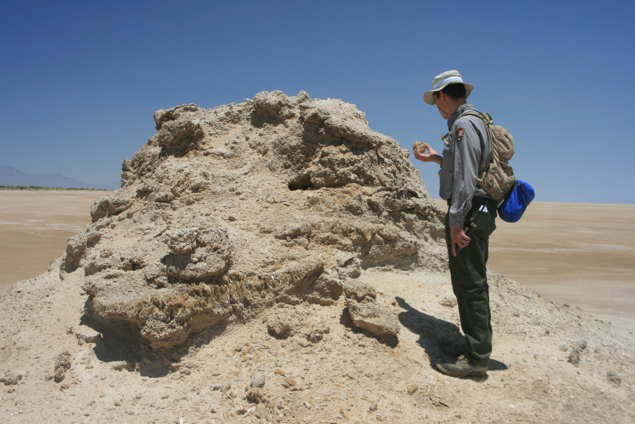
White selenite of
different size
Fragments with layers of amber selenite
different size
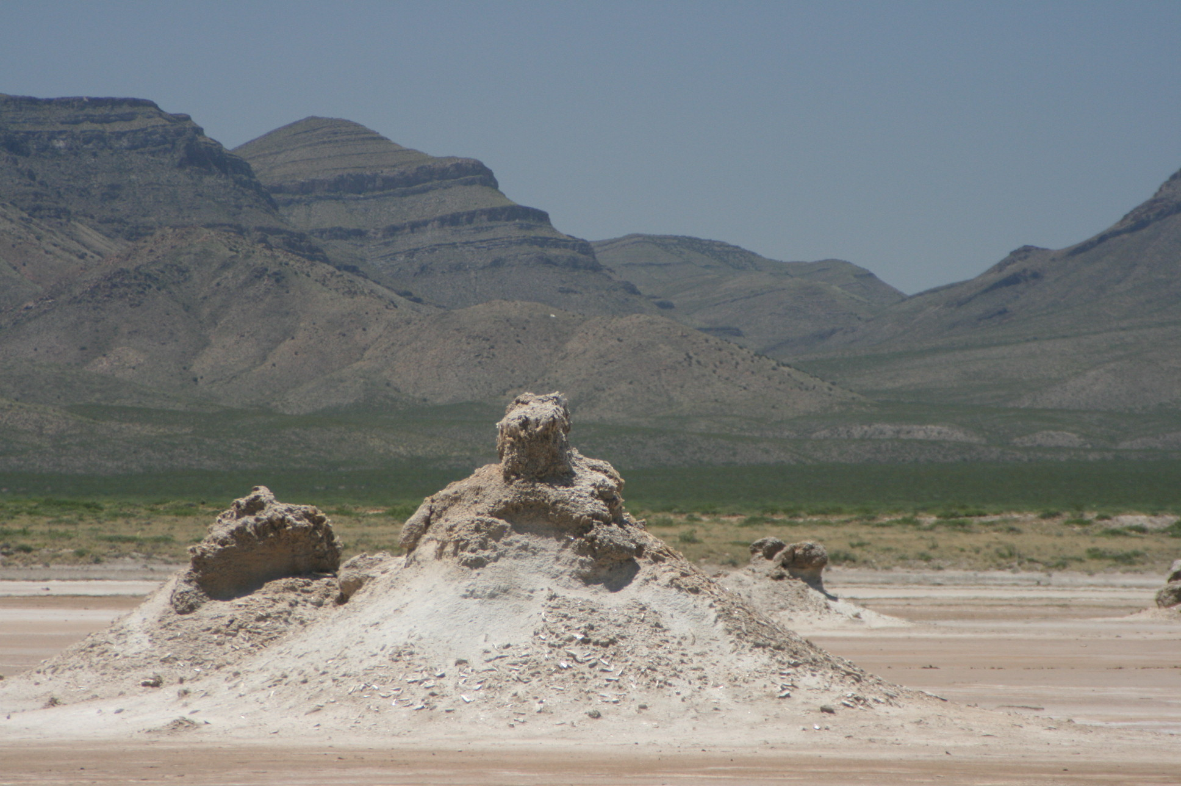
Layer with amber selenite
Type 1 from Fig. 1
White selenite-rich
lakebeds
White selenite of
different size
Eroded selenite
from the top causing high albedo

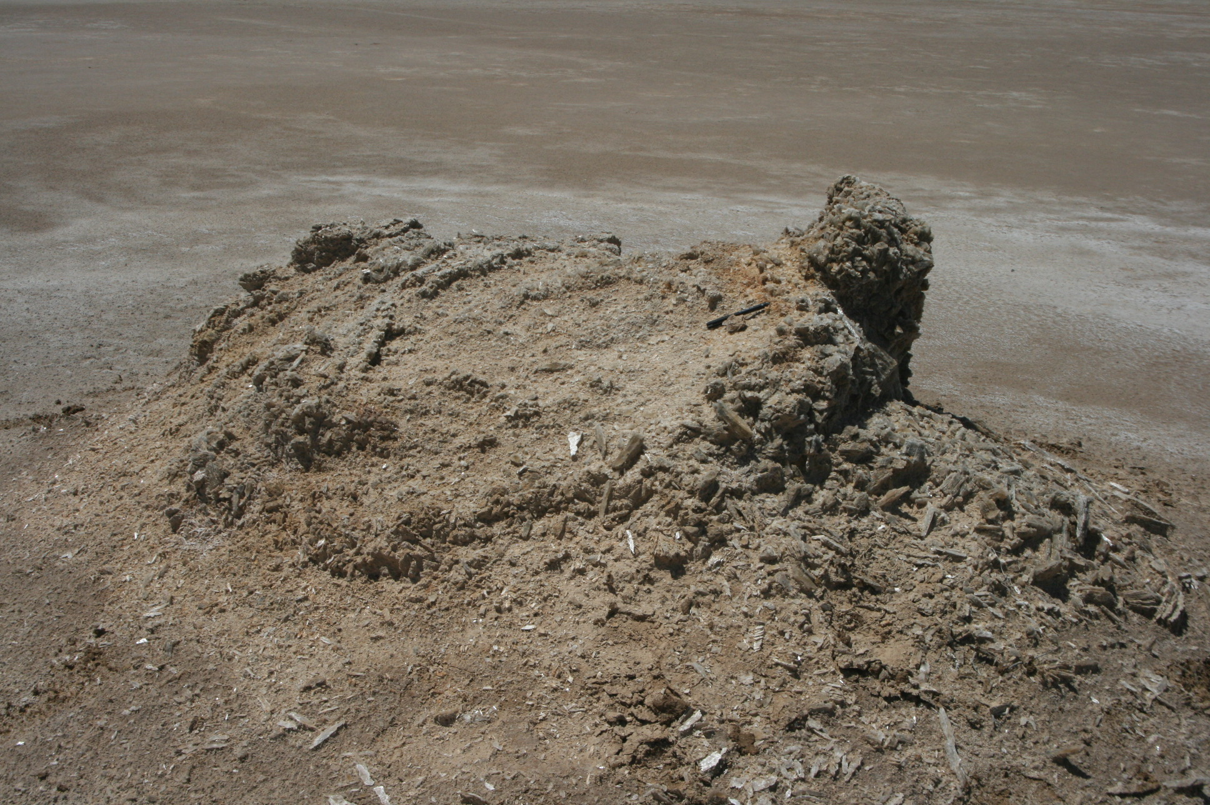
White selenite of
different size
Concentric patterns of selenite growth around
dome
White selenite-rich
lakebeds
Fig. 4. The examples of flat domes within the Type 3.
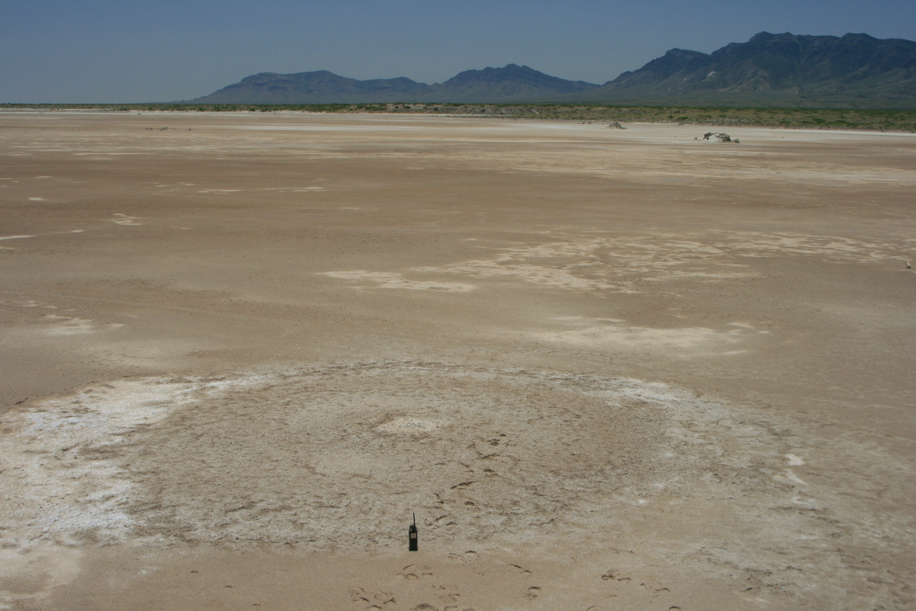 | 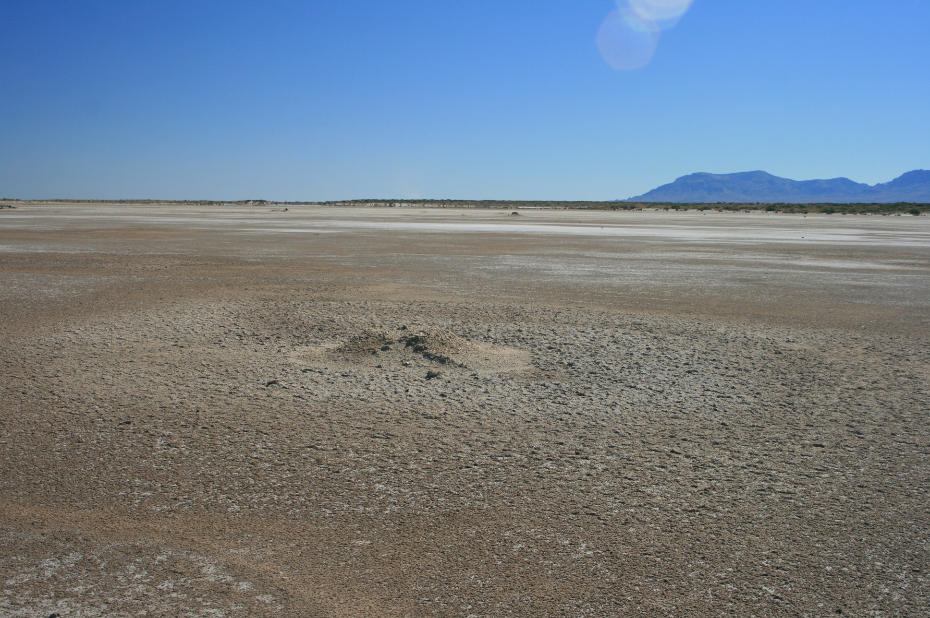 | 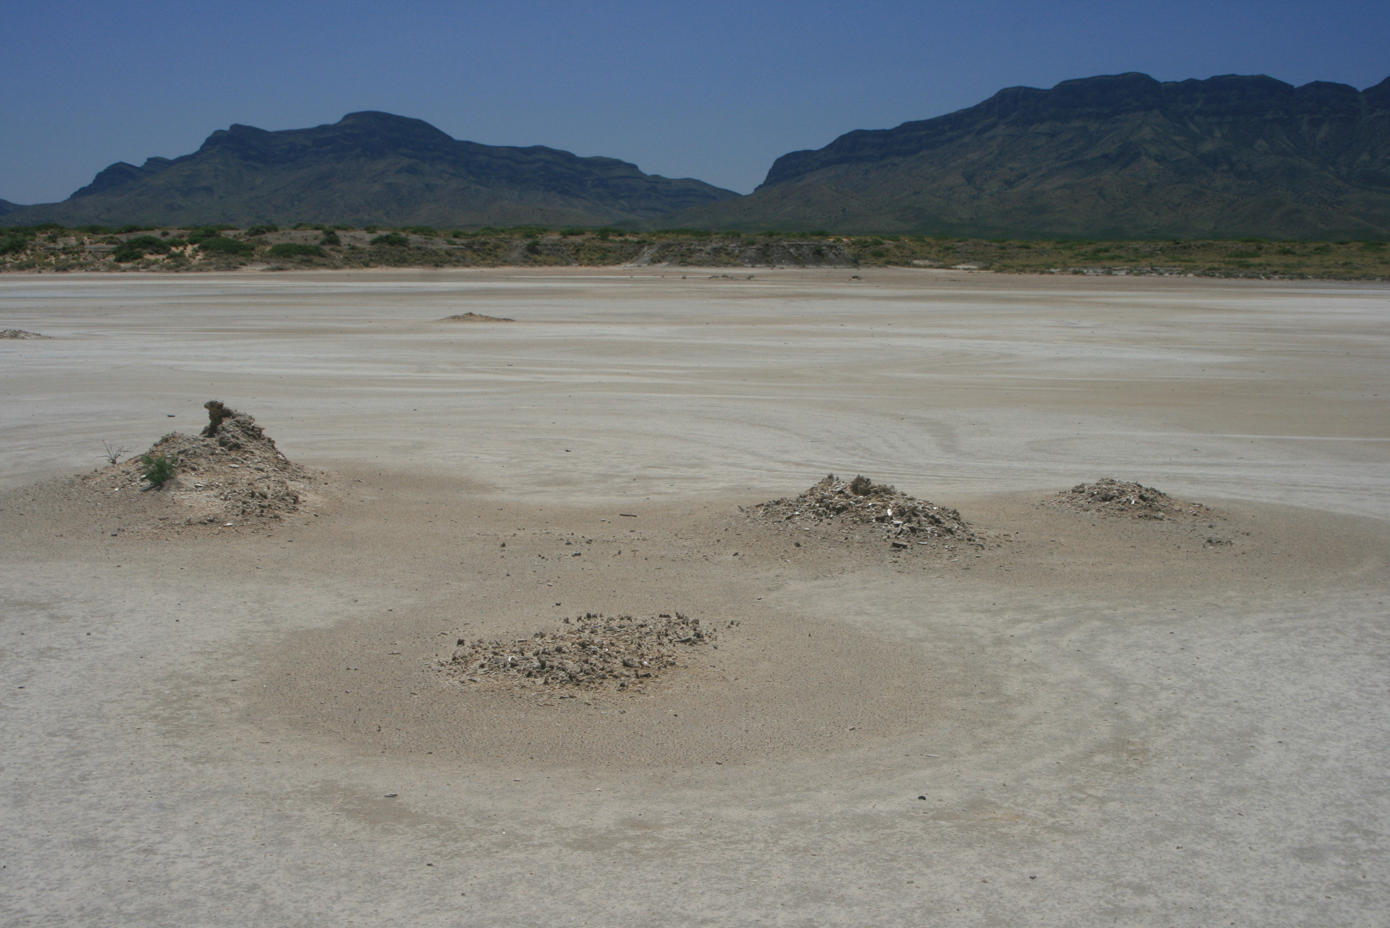

Fig. 5. The example of advanced erosion of dome of Type 2 showing downward movement of resistant selenite beds from the top.

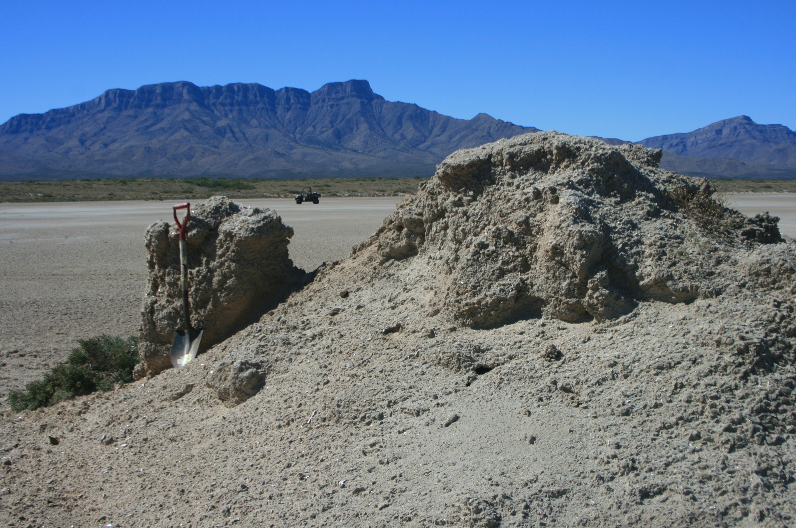
Dip direction of
lakebeds inside the dome
Resistant for weathering
fragment of selenite-rich
deposits

Fig. 6. Seasonal variations in moisture content within the halo area of flat dome belonging to Type 3.
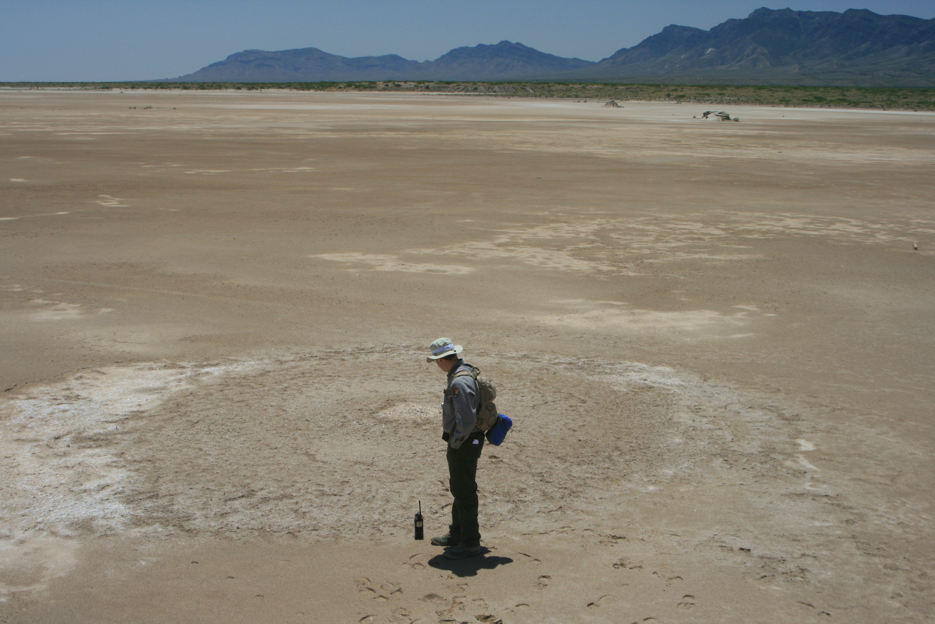 | 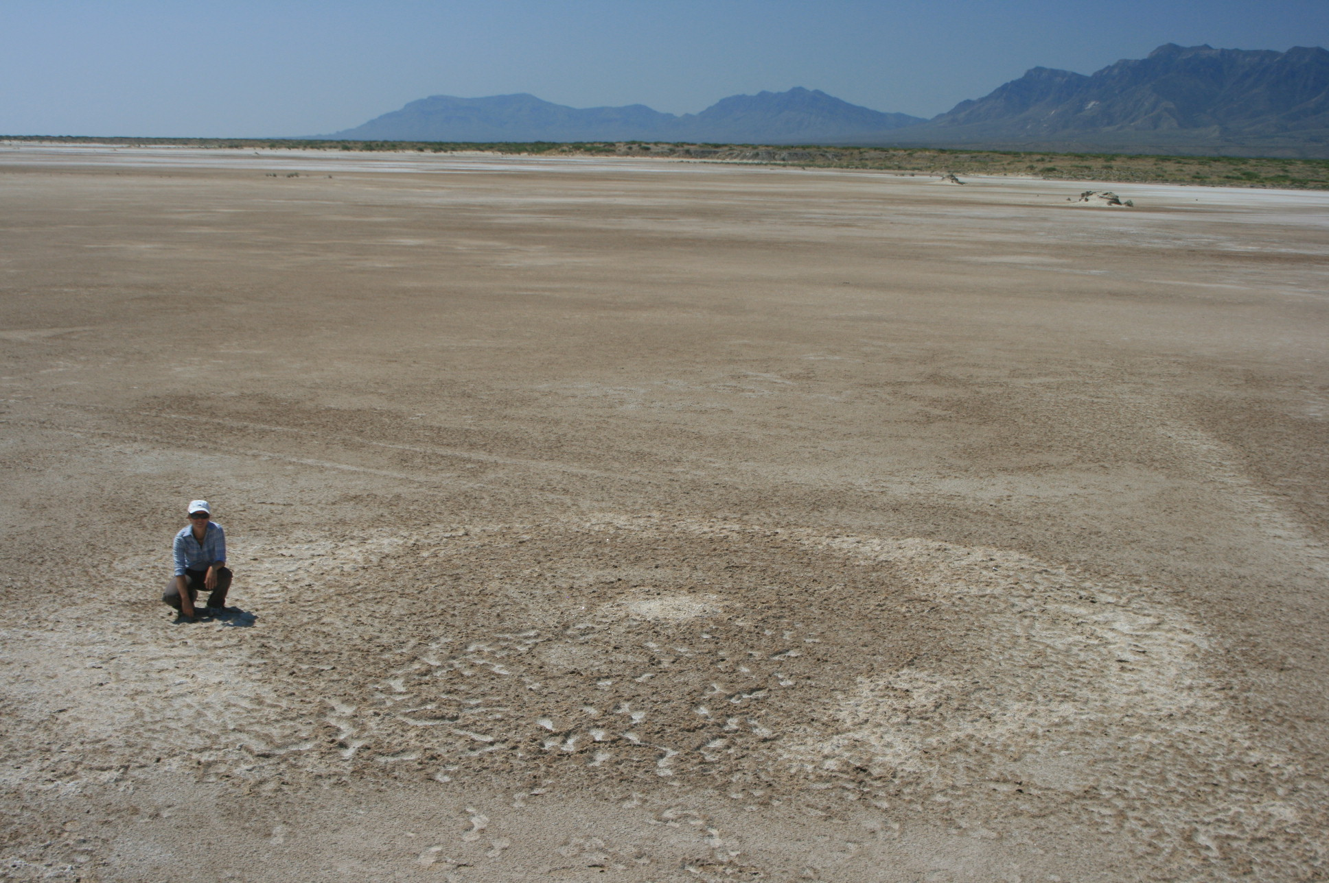 | 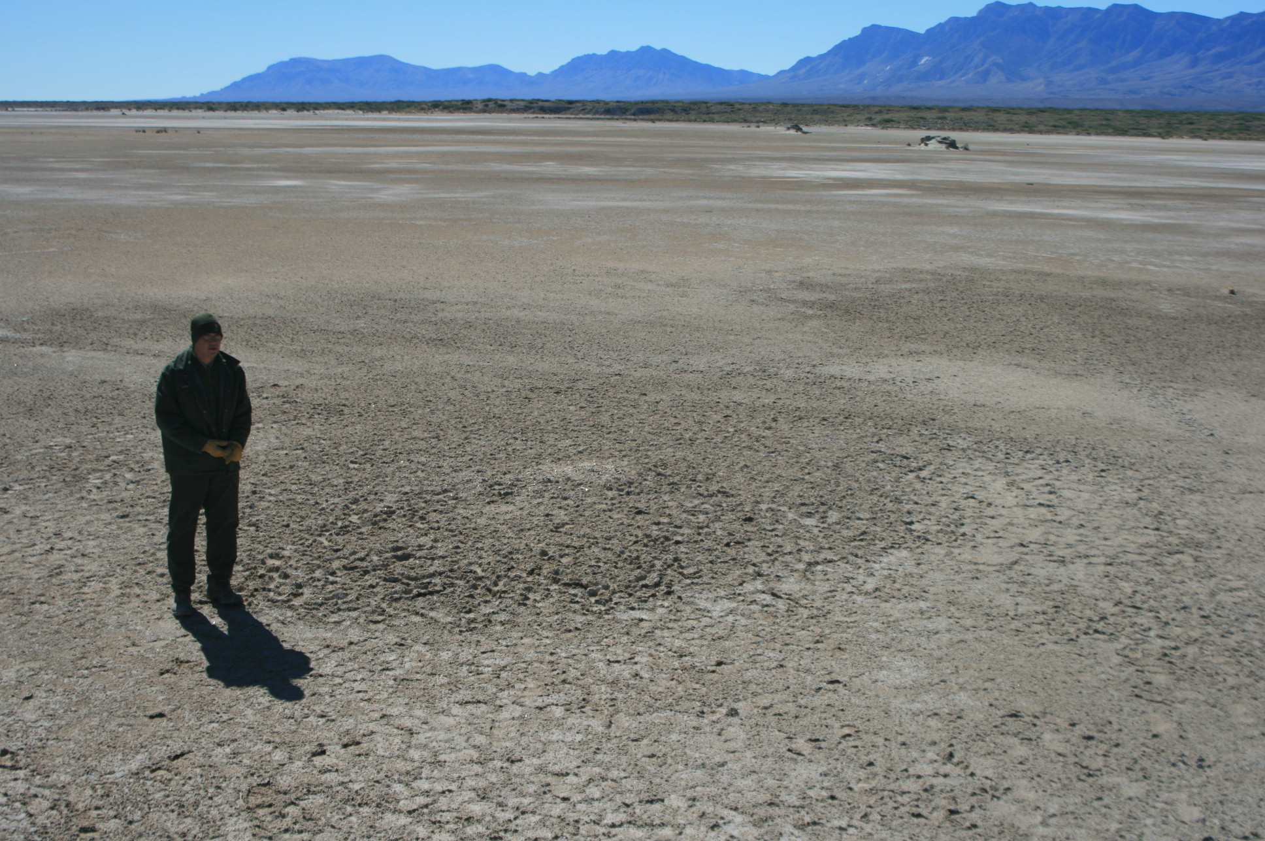
May 2007 | August 2007 | October 2007

Fig. 7. δ³⁴S values of gypsum in domes and lakebeds gully outcrops from Lake Lucero compared to δ³⁴S of sulfate in modern groundwater system.
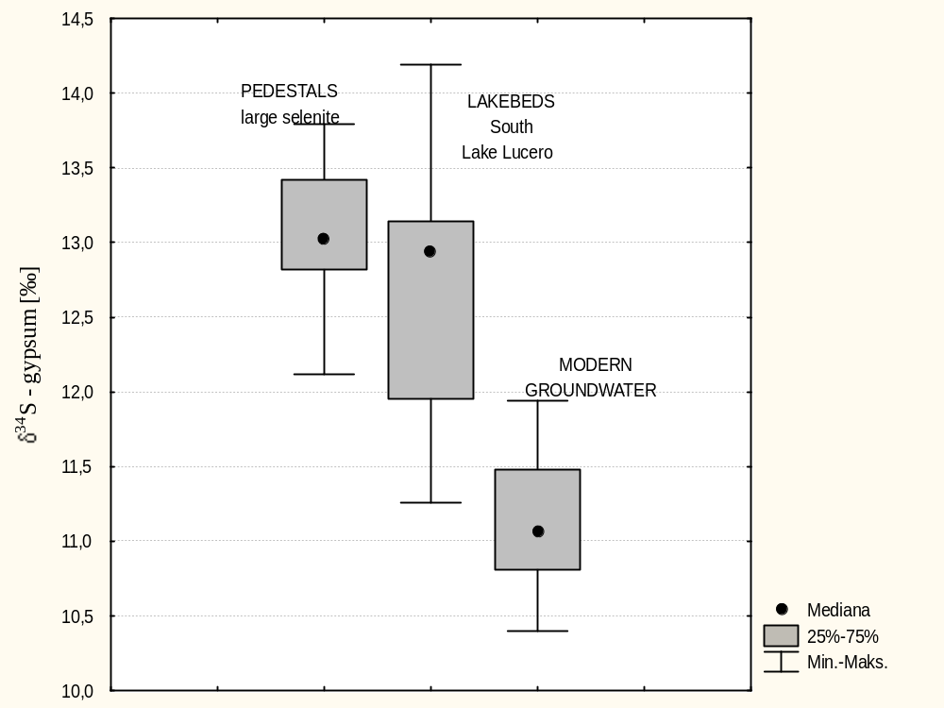

Fig. 8. δ³⁴S value of water/acid soluble sulfate in lakebeds for section LL-3.
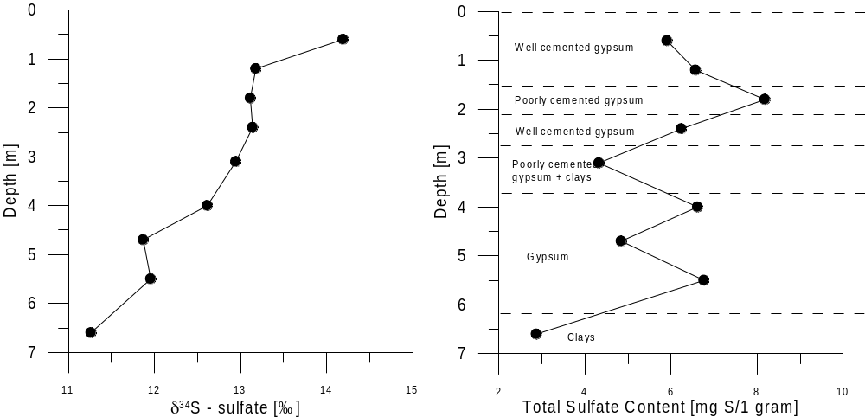

Fig. 9. Aerial photograph showing two-crossing alignment of Type 1 and 2.

