Center for Biologics Evaluation and Research
Office of Therapeutics Research and Review
Division of Clinical Trial Design and Analysis
Immunology and Infectious Diseases Branch

HFM-582

CLINICAL REVIEW

Abbott, Biologic Licensing Application

STN 125057

Adalimumab - for use in the treatment of rheumatoid arthritis

Scheldon Kress, M.D.

TABLE OF CONTENTS
I. Introduction
A. Background…………………………………………………………………………………………….3
B. Adalimumab Clinical Development Program…………………………………………………………4
C. Regulatory History………………………………………………………………………………….….5
II. Study DE 009
A. Clincal Trial Design…………………………………………………………………………………..10
B. Study conduct…………………………………………………………………………………………11
C. Efficacy Analysis……………………………………………………………………………… ….12
III. Study DE 011
A. Clincal Trial Design…………………………………………………………………………………..14
B. Study Conduct…………………………………………………………………………………..…….16
C. Efficacy Analyses
1. Efficacy Endpoints………………………………………………………………………...…….22
2. Efficacy Analysis………………………………………………………………………………..23
3. Summary of Efficacy Data……………………………………………………………………...29
IV. Study DE 019
A. Clincal Trial Design…………………………………………………………………………………..29
B. Study Conduct……………………………………………………………………………………...…32
C. Efficacy Analyses………………………………………………………………………………...….37
1. Primary Efficacy Endpoints……………………………………………………………………..37
a. ACR20 at Week 24………………………………….……………………………………..38
b. Modified Total Sharp Score (radiographic progression) at week 52………………………43
c. Disability Index (HAQ)……………………………………………………………………54
2. Secondary Efficacy Endpoints………………………………………………………………….55
3. Summary of Efficacy Data……………………………………………………………………...57
V. Study DE031
A. Clincal Trial Design……………………………………………………………………………….…58
B. Study Conduct………………………………………………………………………………………..61
C. Safety Analyses……………………………………………………………………………………...65
D. Efficacy Analysis……………………………………………………………………………………76
E. Summary of Analyses……………………………………………………………………………….79
VI. Integrated Safety Analysis
A. Safety Database………………………………………………………………………………………79
B. Treatment -Emergent Adverse Events………………………………………………………………..82
C. Other Adverse Events……………………………….………………………………………………..85
D. Deaths and Comparable Mortality Rates……………………………………………………………..86
E. Serious Adverse Events……………………………………………………………………………….90
F. Malignancies and Comparative Expected Incidence Rates…………………………………………..92
G. Serious Infections ……………………………………………………………………………………97
H. Tuberculosis and Other Opportunistic Infections…………………………………………………...102
I. ANA and Anti-dsDNA ……………………………………………………………………………...104
J. Lupus-Like Syndromes…………………………………………………………………………...…104
K. Immunologic Reactions……………………………………………………………………………..105
L. Demyelinating Disease……………………………………………………………………………...105
M. Adverse Events Leading to Withdrawal, Temporary Interruption, and Reduction of Study Drug....106
N. Laboratory Abnormalities……………………………………………………………………….…. .111
O. Immunogenicity……………………………………………………………………………………..114
P. Impact of Dose on Safety……………………………………………………………………………117
Q. Impact of Dose Intyerruption on Safety…………………………………………………………….118
R. Impact of Age on Safety…………………………………………………………………………….120
S. Impact of Concomitant Methotrexate on Safety…………………………………………………….122
VII. Financial Disclosure…………………………….….………………………….…...123
VIII.Overall Summary of Safety and Efficacy…………………………..………...….123

I. Introduction

A. Background

Rheumatoid arthritis (RA) is a chronic, inflammatory disorder of the joints with a female predominance. A prevalence of 1% has been reported in the adult population. The disease is characterized by a progressive inflammatory synovitis manifested by polyarticular joint swelling and tenderness. The synovitis results in erosion of articular cartilage and marginal bone with subsequent joint destruction. RA produces substantial morbidity and increased mortality. Studies of natural history of the disease indicate that within 2 years of diagnosis, patients usually experience moderate disability; after 10 years 30% are severely disabled. Assessment of the efficacy of any treatment for RA entails clinical, physical function, and laboratory measures i.e., a composite measure of disease activity improvement.

The FDA issued a Guidance Document for evaluating new treatments of RA in February 1999 (Clinical Development Programs for Drugs, Devices, and Biological Products Intended for the Treatment of Rheumatoid Arthritis). The guidance document recognized claims for efficacy based on improvement in signs and symptoms and a group of enhanced claims. For demonstration of efficacy, the standards set forth requires improvement in signs and symptoms of RA in a clinical trial of at least six months duration based on validated composite endpoints or indices of signs and symptoms such as the American College of Rheumatology (ACR) criteria for 20% improvement (the ACR20). Demonstration of effectiveness in inhibition of progression of structural damage, assessed via a method like the modified Sharp score, requires a clinical trial of at least twelve months duration. Since RA is a chronic disease, demonstration of durability of efficacy is also expected. For products with the potential to elicit antibody formation, assessment for durability is particularly important, since antibodies that develop over time may block effectiveness.

The enhanced claims recognized in the RA Guidance Document include the ability to achieve: a major clinical response, defined as an ACR70 for six consecutive months; a complete clinical response, defined using ACR criteria for remission and no radiographic progression for six consecutive months while receiving ongoing drug therapy; and a remission, defined as a remission by ACR criteria and no radiographic progression for six consecutive months while off all anti-rheumatic therapy. To encourage long-term trials, the claim of improvement in physical function requires a validated measure of improvement in disability such as the HAQ (Health Assessment Questionnaire), Arthritis Impact Measure Scale (AIMS), as well as evidence of improvement or, at least, no worsening in a measure of health related-quality of life such as the SF-36 for two to five years. The E1A ICH guidance document recommends that for chronically administered products, the minimum safety data-base requires at least 300-600 patients treated with the recommended dose for at least six months, at least 100 patients treated for at least twelve months, and a total of 1000 to 1500 patients treated overall. However, longer term data may be required if late developing AEs are observed or if AEs are observed that increase in severity or frequency over time. In addition, more data may be required if there are concerns based on preclinical toxicity testing, pharmacology, or inferences from similar agents.

Current drug therapy for RA includes non-steroidal anti-inflammatory drugs (NSAIDs) and corticosteroids to provide symptomatic relief. Some disease-modifying antirheumatic drugs (DMARDs) have been demonstrated to inhinit disease progression; some patients fail to achieve an adequate or sustained response to therapy due to lack of efficacy or toxicity.

The recent introduction of new classes of therapeutic agents has contributed to major advances in the treatment of RA. The first TNF-α blocking agents, infliximab and etanercept, were approved for improvement in signs and symptoms of RA. In addition, the TNF-α blockers have demonstrated inhibition of progression of structural joint damage among patients with RA. More recently anakinra, the first IL-1 blocking agent, has been approved for improvement in signs and symptoms of RA. All three of these agents are generally well tolerated, but have been associated with uncommon serious adverse events, primarily serious infections.

These newer novel biological agents inhibit the action of cytokines, hormone-like proteins that mediate communication between cells, and play critical roles in normal biologic processes, such as cell growth, inflammation, and immunity. Both tumor necrosis factor (TNF-α) and interleukin-1 (IL-1) have been implicated in the progression of inflammatory synovitis and articular matrix degradation. Being foreign proteins, these biologic agents are potentially immunogenic, and studies have been carried out to determine whether antibodies over time diminish clinical activity and increase the incidence of adverse events. Treatment with infliximab has been associated with antibody formation, particularly in patients receiving treatment without concurrent MTX. Antibody-positive patients were more likely to experience infusion reactions.

- Adalimumab Clinical Development Program

Adalimumab is a human-derived recombinant IgG1 monoclonal antibody engineered by gene technology. Adalimumab binds to TNF-α but not TNF-β and has a half-life of approximately 2 weeks. This antibody has been extensively studied in vitro as well as in vivo and no major toxicity was observed in animal studies. This submission presents data from three phase III clinical trials and assesses the efficacy and safety of adalimumab in the treatment of RA. Since TNF-α is an important cytokine affecting inflammation and immunity, patients were closely monitored and data were submitted for possible adverse events (AE), especially serious infections, malignancies, and immunogenic potential. In addition, the possible role of human antibodies to adalimumab on efficacy and safety was evaluated.

The adalimumab clinical development program includes 23 studies, 17 of which were conducted in RA patients, four of these studies (DE009, DE011, DE019, and DE031) represent controlled trials assessing the effectiveness of adalimumab, and four clinical pharmacology studies (DE015, DE024C, DE024J, and DE029) performed in healthy volunteers. Figure 1 depicts the overall group of studies in the adalimumab clinical development program. Table 1 lists the studies that are discussed and provides summary information on studies providing evidence of efficacy. Patients treated concomitantly with MTX participated in trials conducted almost entirely in North America. Patients not concomitantly treated with MTX participated in trials conducted almost entirely in Europe/Australia/Canada.

The proposed indication for Adalimumab is for “reducing signs and symptoms and inhibiting the progression of structural damage in adult patients with moderately to severely active RA who have had an inadequate response to one or more DMARDs.
Adalimumab can be used alone or in combination with MTX or other DMARDs.”

Safety data were provided in the BLA for approximately 2000 patients treated with adalimumab through August 31, 2001 for a median of 12 months, and were updated through August 31, 2002 for a median of 24 months.

C. Regulatory History

Shortly after the IND (#7627) for the study of D2E7 (adalimumab) became effective April 16, 1998, the sponsor submitted adverse event reports of cases of serious infections and deaths occurring in studies in Europe that had occurred prior to the time of the submission but were not provided to the FDA in the IND submission. The nine serious infectious adverse events (AEs) reported while patients were receiving adalimumab included: septic arthritis, post-operative wound infection, interstitial pneumonitis, miliary tuberculosis with pleural effusion, lymphatic tuberculosis, streptococcal pneumonia with empyema, gluteal abscess, forearm abscess, and multiple antibiotic resistant pneumonia combined with flaring of pre-existing SLE (systemic lupus erythematosus). By delaying the submission of these AEs to the Agency, the FDA was prevented from adequately assessing the risks to the subjects in the proposed clinical investigation. Based on the occurrence of these serious infections in Europe, all D2E7 clinical trials were placed on clinical hold on June 19, 1998, until these safety concerns could be adequately addressed.

Several explanations were provided by the sponsor including: the larger number of serious infections observed occurred among sicker patients, tuberculosis was more common in Europe, some subjects originally suspected of having infections had chronic infections at baseline or had no infections, and some of the subjects would have been excluded from US trials. In Study DE010 (adalimumab with MTX), which was similar to the proposed US Study in inclusion criteria, the incidence of serious infections was much lower. After intensive review of the explanations submitted by the sponsor, the sponsor was requested to initiate new precautions. On this basis, the clinical hold was removed on August 11, 1998 and the proposed study was allowed to proceed. In order to proceed, investigators were to be informed of the possibility of sepsis, to encourage early recognition and appropriate therapy and include information stating a potential increased risk of infections in the Informed Consent.

In December 1999, the Agency noted that eight cases of tuberculosis had been submitted as expedited safety reports. These tuberculosis cases occurred among 477 patients (1.7% incidence) administered adalimumab in Europe. The Agency requested the sponsor to provide additional information on these cases and determine whether actions could be taken to avoid further cases. Typically, the cases occurred among heavily–treated patients 58-70 years of age with long-standing RA, 4-6 months after initiating D2E7 therapy, and it was determined in retrospect that 80% of the patients had a baseline chest x-ray highly suspicious for prior tuberculosis. No cases of tuberculosis had been seen in US trials.

The sponsor agreed to proposed trial stopping rules, the appointment of a Data Safety Monitoring Board to review unblinded safety data, initiation of screening measures for pre-existing tuberculosis, prophylactic tuberculosis treatment when appropriate prior to administration of D2E7, and the early reporting of serious and unexpected SAEs to the Agency.
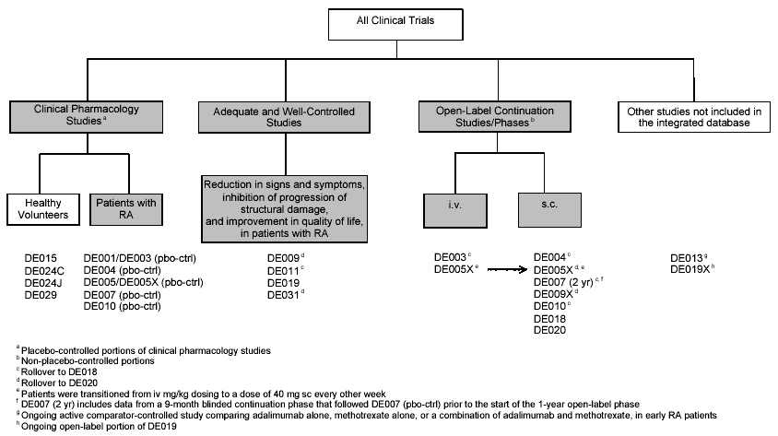

Figure 1: Study groupings for Integrated Summary of Effectiveness Data

Table 1 : Studies Providing Substantial Evidence of Efficacy
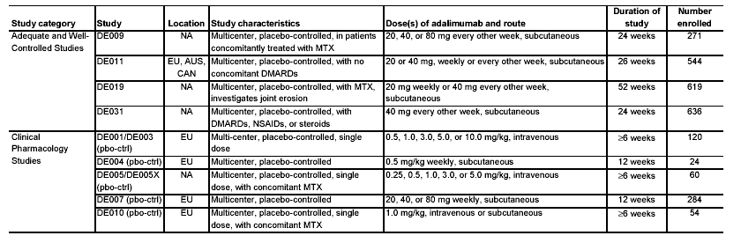
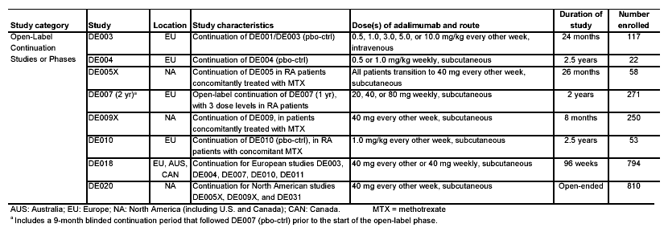

II. Study DE009 - Dose-Ranging Trial

A. Clinical Trial Design – DE009

Study DE009 is a phase II 24 week multicenter double blind randomized placebo-controlled dose-ranging trial to evaluate therapeutic effects, safety, tolerability, and immunogenicity of adalimumab administered subcutaneously every other week with concomitant MTX among patients with a confirmed diagnosis of rheumatoid arthritis. Patients were required to have insufficient efficacy or significant toxicity with MTX at weekly doses 12.5 to 25 mg. The dose of MTX had to be stable for at least 4 weeks before a patient could be screened. Patients receiving 10 to 12.5 mg MTX with documented intolerance to higher doses could also be enrolled. The dose of MTX was to remain constant during the 24-week study period. Patients must have been receiving MTX for at least 6 months before screening.

The study objective is to investigate whether every other week subcutaneous (sc) treatment with 20, 40, or 80 mg adalimumab for up to 24 weeks results in a significantly higher ACR20 response rate compared to treatment with placebo over the same treatment
period.

The primary efficacy endpoint of this study was the American College of Rheumatology 20% (ACR20) response as reported at Week 24. A patient was given the classification of “responder” to ACR20 if all of the following criteria were met:
- A   20% improvement in TJC (tender joint count).
- A  20% improvement in SJC (swollen joint count).
- A   20% improvement in three of the five remaining ACR core set measures:
1. Patient assessment of pain.
2. Patient global assessment of disease activity.
3. Physician global assessment of disease activity.
4. Patient self-assessed disability (disability index of the Health
Assessment Questionnaire [HAQ]).
5. Acute phase reactant (C-reactive protein [CRP]).

Patients who did not meet all of the above criteria, as well as those who withdrew from the study prior to Week 24 (i.e., prior to the end of the placebo-controlled period) were classified as “non-responders.” Each patient who withdrew from the study prior to Week 24 due to an AE was counted as a non-responder.

Secondary efficacy endpoints included ACR50 and ACR70, time to response for ACR20, ACR50, ACR70, ACR-N [defined as the least percent improvement (from baseline) in number of 1) tender and 2) swollen joints, and 3) the median percent improvement in a) pain assessment, b) physician and c) patient global assessment, d) physical function, and e) acute phase reactants, and incorporates all disease activity measures of the ACR response], AUC (area under the curve) for numeric ACR response [defined as the product of numeric ACR multiplied by the time a patient is at that level of improvement, which dynamically measures improvement over time (area under the curve of numeric ACR over time)], tender joint count (TJC) – an assessment of 68 joints or regions done by pressure or joint manipulation on physical examination, swollen joint count (SJC) – An assessment of 66 joints done by physical examination, assessment of pain, Patient Global Assessment of disease activity, Heath Status (Disability Index of the HAQ), Functional Assessment of Chronic Illness Therapy (FACIT), and serologic evaluations, which included cytokine levels (IL-1, IL-6, and TNF), rheumatoid factor (RF), and markers for cartilage destruction (proMMP-1 and proMMP-3).

B. Study Conduct – DE009

A total of 336 patients were screened, 271 patients were randomized, and 253 completed
the study (at least 16 weeks of treatment). Planned enrollment was for 268 patients. Due to the fact that one of the investigators was in the process of being debarred, the eleven (11) patients enrolled at his site were removed from the efficacy analysis. As a result, the efficacy analysis consisted of 260 patients and the demographic and safety analyses include 271 patients. A total of 209 patients received adalimumab and 62 patients received placebo. Figure 2 summarizes the planned conduct of the study.

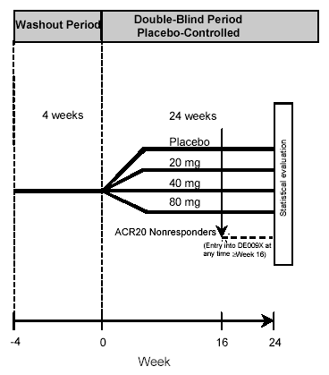
Figure 2 : Design of Study DE009

The Statistical Analysis Plan (SAP) consisted of an efficacy analysis on the intent-to-treat (ITT) population of all patients who were randomized, received at least one injection of double-blind study drug, and for whom any assessment of efficacy under double-blind conditions was available. The primary efficacy analysis consisted of a comparison of the change in ACR20 response rates at Week 24 compared to placebo on the intent-to-treat population. The ACR20 response rates of the three adalimumab groups were compared with the placebo group rates. Dunnett’s method, with an overall alpha level of 0.05, was used to adjust for the multiple comparisons of each active treatment group with a single control. Thus, statistical significance required demonstration of a proportionally greater level of efficacy for additional comparisons.

- Efficacy Analysis

The primary efficacy assessment was a comparison of the ACR20 response rates (using CRP as the acute phase reactant) between the individual adalimumab treatment groups (20, 40, and 80 mg subcutaneous every 2 weeks) and placebo at Week 24 utilizing Dunnett’s method to adjust for the multiple comparisons. After 24 weeks of treatment, each adalimumab treatment group (20, 40, and 80 mg) was statistically significantly superior (p ≤ 0.05) to placebo for the ACR20 response. The response at Week 24 was comparable between the 40 mg (67%) and 80 mg (66%) doses, was slightly lower for the 20 mg (48%) dose, and was significantly lower for the placebo (13%) (Table 2).

Table 2 : Study DE009: ACR20 response: Number (%) of patients responding over time by randomized treatment group (full analysis set, excluding Site #7)

 | Adalimumab |  |  | Placebo
 | 20 mg | 40 mg | 80 mg | Placebo
Time point | (N=67) | (N=63) | (N=70) | (N=60)
Week 24 (observed) | 32 (48%)ª | 42 (67%)ª | 46 (66%)ª | 8 (13%)
LOCF Week 24 | 34 (51%) ª | 42 (67%) ª | 46 (66%) ª | 8 (13%)
ª Statistically significantly different from placebo (p≤0.05).

As a secondary analysis provided for in the protocol, the last observation was also carried forward (LOCF) to Week 24 for patients who withdrew from the study for reasons other than AEs or those who went into open-label treatment prior to Week 24. Week 24 LOCF data demonstrated similar values between adalimumab and placebo relative to observed values (Table 2). In comparison, fewer placebo-treated patients showed improvement at Week 24.

Adalimumab-treated patients achieved higher ACR50, and ACR70 responses than placebo-treated patients (Table 3).

Table 3 : Study DE009 : ACR50 and ACR70 Responses By Randomized Treatment Group
 | Adalimumab |  |  | Placebo
 | 20 mg | 40 mg | 80 mg | Placebo
Time point | (N=67) | (N=63) | (N=70) | (N=60)

ACR50
Week 24 (observed) | 22 (33%) | 34 (54%) | 29 (41%) | 4 (7%)
LOCF Week 24 | 22 (32%) | 34 (54%) | 29 (41%) | 4 (7%)

ACR70
Week 24 (observed) | 7 (10%) | 15 (24%) | 13 (19%) | 2 (3%)
LOCF Week 24 | 7 (10%) | 15 (24%) | 13 (19%) | 2 (3%)
* Statistically significantly different from placebo (p≤0.05).

Adalimumab-treated patients achieved ACR20 responses faster and more often than placebo-treated patients. ACR20 responses are displayed graphically for the full analysis set of patients in Figure 3. Overall, the adalimumab treatment groups had a higher response at each time point compared to placebo. There is separation between adalimumab- and placebo-treated patients as early as Week 1, and the separation continues through Week 24.

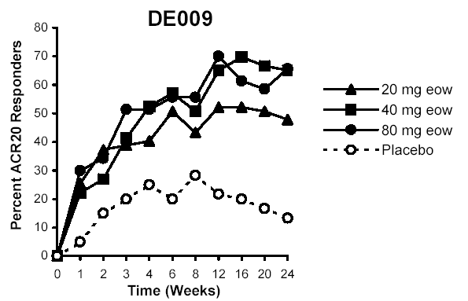

Figure 3 : Study DE009: Responder Rates to ACR20
III. Study DE011

  - Clinical Trial Design

Clinical trial DE011 is a Phase III 26 week adalimumab monotherapy trial to evaluate efficacy, safety, and immunogenicity of two doses (20 and 40 mg) and two dosing intervals (weekly and biweekly) administered subcutaneously in patients with rheumatoid arthritis with single DMARD failure. The doses of 20 and 40 mg adalimumab were selected based on results of a previous study (DE007). DE011 is a multicenter randomized placebo-controlled study comparing adalimumab vs. placebo with four periods: 1.) washout period, 2.) placebo-controlled treatment period, 3.) rescue period and 4.) post-study period (Figure 4). After the study entry screen visit, eligible patients entered a 4-week washout period in which all disease-modifying anti-rheumatic drugs (DMARDs) were discontinued. After the washout period, patients were randomized at the baseline visit to one of five treatment arms.

Patients who experienced an increase in disease activity or had less than 10% reduction in SJC and TJC compared to baseline, after at least 8 weeks of treatment, had the option to enter the rescue part of the study. During the rescue part double-blind treatment was stopped, and at the discretion of the treating physician higher doses of steroids, non-steroidal anti-inflammatory drugs (NSAIDs), or DMARDs were prescribed to cover the time until the end of the 26-week placebo-controlled treatment period.

The main criteria for inclusion are male and female patients ≥18 years of age with a confirmed diagnosis of RA (as defined by the 1987-revised ACR criteria), having failed one DMARD treatment, with at least 10 swollen joints (out of 66 assessed) and 12 tender joints (out of 68 assessed), and an erythrocyte sedimentation rate (ESR) ≥    28 mm/1st hour or C-reactive protein (CRP) ≥2 mg/dL.

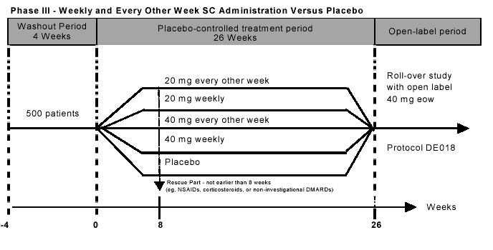
Figure 4: Design of Study DE011
The main exclusion criteria are evidence of cardiac, pulmonary, metabolic, renal, hepatic, gastrointestinal conditions, ongoing, recent, active, or latent infectious diseases, immune deficiency, history of lymphoma, leukemia or solid malignant tumor, history of tuberculosis or listeriosis, drug usage, recent joint surgery or injections, or having previously received any TNF antagonist (e.g., adalimumab, etanercept or infliximab)

Patients were prohibited from receiving any anti-rheumatic/anti-inflammatory drugs (i.e. DMARDs), except stable corticosteroids with a maximum daily dose equivalent to 10 mg of prednisolone, stable doses of NSAIDs prior to entering the rescue part of the study, and infrequent use of acetylsalicylic acid in recommended doses or equivalent treatments for mild pain (e.g., headache) as well as a regular intake of low-dose acetylsalicylic acid for prophylaxis of myocardial infarction.

Adalimumab or placebo was administered as a single sc injection (1.6 mL injectable solution in identical in appearance 2 mL. glass vials) every week or every other week for up to 26 weeks. Based on the randomization scheme, patients were to receive 20 or 40 mg of adalimumab per injection as a total body dose or placebo. Study drug was then injected under the skin of the abdomen or thigh in accordance with standard medical practice for sterile sc injection. The final concentrations of adalimumab were 20 mg/1.6 mL and 40 mg/1.6 mL. Placebo solution was a buffered vehicle of phosphate, citrate, and mannitol with 0.1% Tween 80. Each patient received a weekly injection of study drug or placebo to maintain the blinding.

The primary efficacy assessment was a comparison of the ACR20 response rates (using CRP as the acute phase reactant) between the individual adalimumab treatment groups (20, 40, and 80 mg subcutaneous every 2 weeks) and placebo at Week 24. Statistical methodology consists of Pearson’s chi-squared (χ²) test and analyses of covariance (ANCOVA) for treatment group differences between adalimumab and placebo during the placebo-controlled treatment period. Baseline homogeneity of demographic and baseline characteristics were checked using one-way analysis of variance (ANOVA), the Kruskal-Wallis test, or a Pearson’s χ² test, as appropriate. The primary efficacy analysis was a comparison of the response rates according to ACR20 in the intent-to-treat (ITT) population which was the same as the full analysis set of patients, and patients who did not complete the 26-week placebo-controlled period were counted as non-responders. Each of the four adalimumab dosage groups was tested for difference vs. placebo using a two-sided Pearson’s χ² test. The overall significance level was α=0.05. Multiplicity of testing (four tests) for the primary efficacy analysis was taken into account by applying the Bonferroni-Holm procedure, multiplying by a factor related to the number of comparisons and the degrees of freedom for the error mean square. Thus requiring a four-fold lower p-value in order to acquire statistical significance. All other statistical testing was unadjusted for multiple comparisons.

Analyses of the secondary efficacy endpoints included TJC, SJC, disability index of the HAQ, ACR50 response, ACR70 response, ACR-N response, time until ACR20, ACR50, and ACR70 responses, AUC of ACR-N, ACR20, ACR50, and ACR70 responses, patient and physician global assessments of disease activity, patient assessment of pain, duration of morning stiffness, CRP, ESR, SF-36 score, and modified DAS score. Statistical analyses of secondary efficacy variables (Pearson’s x² test for ACR50 and ACR70 response, ANCOVA for other secondary efficacy variables) were exploratory analyses.

  - Study Conduct

A total of 500 patients (100 per arm) were planned for enrollment in this study conducted at 52 sites in Europe, Australia, and Canada. Eight hundred twenty-seven (827) patients were screened, 544 patients were randomized, 481 patients completed the study, and data for 544 patients were analyzed (a larger number of patients than anticipated). Patients were randomized in blocks of five patients per block. Patient disposition is shown in Figure 5 and Table 4.

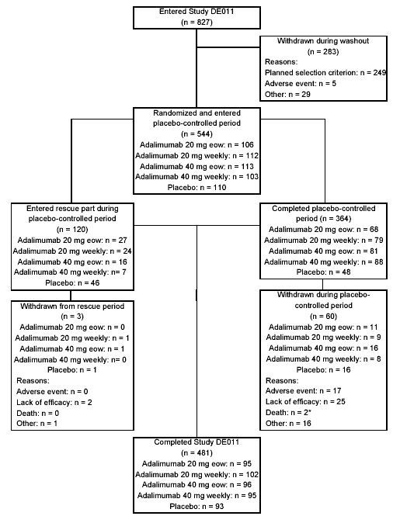

Figure 5 : Patient Disposition in Study DE011

Table 4 : Study DE011 Patient disposition (number [%]) by randomized treatment group (all patients who entered the study)

 | Adalimumab |  |  |  |  |  |  |  |  | Placebo
Treatment | 20 mg |  |  |  | 40 mg |  |  |  | All | Placebo
Treatment | Q2W |  | Weekly |  | Q2W |  | Weekly |  | All | Placebo
Treatment | N=106 | N=112 |  | N=113 |  | N=103 |  | N=434 |  | N=110
Completed study | 95 (90%) | 102 (91%) |  | 96 (85%) |  | 95 (92%) |  | 388 (90%) |  | 93  (85%)
Completed study on randomized therapy | 68 (64) | 79 (71) |  | 81 (72) |  | 88 (85) |  | 316 (73) |  | 48(44)
Completed study with rescue ≥ 8 weeks | 27 (26) | 23 (21) |  | 15 (13) |  | 7 (7) |  | 72 (17) |  | 45(41)
Withdrew early | 11 (10) | 10 (9) |  | 17 (15) |  | 8 (8) |  | 46 (11) |  | 17(16)
Withdrawals from study due to :
Adverse event | 4 (4) | 3 (3) |  | 6 (5) |  | 3 (3) |  | 16 (4) |  | 1 (1)
Lost to follow-up | 0 (0) | 0 (0) |  | 1 (1) |  | 0 (0) |  | 1 (0) |  | 1 (1)
Protocol violation | 2 (2) | 2 (2) |  | 2 (2) |  | 1 (1) |  | 7 (2) |  | 1 (1)
Death | 0 (0) | 0 (0) |  | 1 (1) |  | 0 (0) |  | 1 (0) |  | 1 (1)
Withdrawal of consent | 1 (1) | 1 (1) |  | 2 (2) |  | 1 (1) |  | 5 (1) |  | 2 (2)
Lack of efficacy/progression of disease | 4 (4) | 4 (4) |  | 5 (4) |  | 3 (3) |  | 16 (4) |  | 11(10)
Adverse event (at least possibly drug-related) | 3 (3) | 3 (3) |  | 4 (4) |  | 2 (2) |  | 12 (3) |  | 0

A total of 364 (67%) of 544 randomized patients completed the placebo-controlled
portion of the adalimumab monotherapy trial. Similar proportions of subjects completed the study in the drug and placebo arms. However, a higher percentage of adalimumab-treated patients completed the study (64 - 85%) on randomized therapy compared to placebo-treated patients (44%). A total of 120 patients (22%) entered the rescue part during the placebo-controlled period. However, three of the patients requiring rescue withdrew prematurely, and 117 patients requiring rescue completed the study. A higher percentage of placebo-treated patients (41%) than adalimumab-treated patients (17%) required rescue therapy after the 8th week.

A higher percentage of placebo-treated patients (16%) than adalimumab-treated patients (11%) withdrew from the study early. This difference is accounted for by a higher proportion of placebo-treated patients (10%) than adalimumab-treated patients (4%) withdrawing for lack of efficacy. Among the 46 adalimumab-treated patients who withdrew from the study, 16 ( 4% of those randomized) patients withdrew due to adverse events and 16 ( 4% of those randomized) withdrew due to lack of efficacy/progression of disease. Among the 17 (16% % of those randomized) placebo-treated patients who withdrew from the study, 11 (10% of those randomized), the majority, withdrew due to lack of efficacy/progression of study disease.

Adverse events, at least possibly drug-related, were observed in 3% (12/434) of adalimumab-treated patients and 0% of placebo-treated patients. Two deaths occurred in the trial, one among each group, the adalimumab-treated group and placebo-treated group. Deaths and adverse events will be reviewed in the Integrated Safety Analysis.

Protocol violations contributing to withdrawals occurred in 2% of adalimumab-treated patients and 1% of placebo-treated patients.

The demographic characteristics (see Table 5) by randomized treatment group for all patients who entered the study demonstrated that the majority were Caucasians and 80% were females with a median age of 54 years, similar to other RA clinical trials. The demographic characteristics in the various groups were comparable. Participants manifested long-standing disease (medians 8-10 years) and active rheumatoid arthritis, as manifested by high mean TJCs (means 34-36) and SJCs (means all approximately 20) (Table 6 ).

Table 5 : Study DE011 : Demographic characteristics by randomized treatment group (all patients who entered the study)

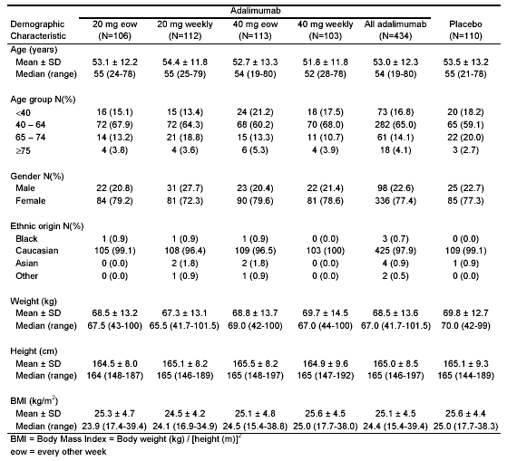

Table 6 : Study DE011 : Duration of RA and ACR components of disease activity at baseline by randomized treatment group (full-analysis set)

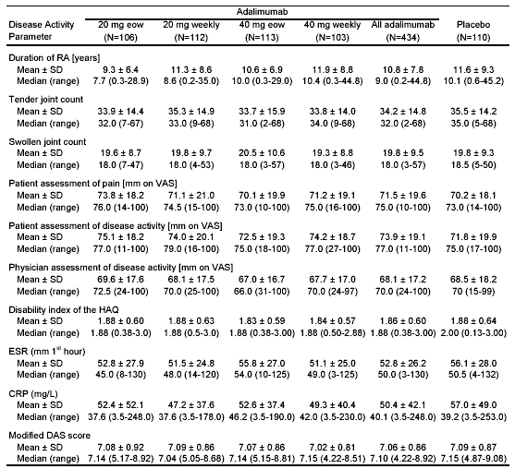

C. Efficacy Analysis

- Efficacy Endpoints

The primary efficacy endpoint was the ACR20 response at Week 26. Patients were classified as “responders” if all of the following criteria were met:
- A 20% improvement in tender joint count.
- A 20% improvement in swollen joint count.
- A 20% improvement in at least three of the five remaining ACR core set measures:
1. Patient assessment of pain.
2. Patient global assessment of disease activity.
3. Physician global assessment of disease activity.
4. Patient self-assessed disability (disability index of the Health
Assessment Questionnaire [HAQ]).
5. Acute phase reactant: ESR or C-Reactive Protein.

Patients were considered to be non-responders (efficacy failures) if they:
- failed to meet or improve beyond the American College of Rheumatology 20% (ACR20) improvement criteria at Week 26
- withdrew from the study prior to Weeks 26 (including ACR20 responders),
- switched to rescue medication

Rescue medication was permitted after 8 weeks if patients experienced an increase in disease activity or had less than 10% reduction in SJC and TJC compared to baseline. Leflunomide was the preferred rescue treatment if available in the site’s given country. Additional rescue medications permitted through the remainder of the 26-week placebo controlled treatment period included: higher doses of NSAIDs, corticosteroids, or DMARDs.

Secondary efficacy endpoints included changes in SJC, TJC, and disability index of the HAQ from baseline to Week 26; ACR50, ACR70, numeric ACR (ACR-N), disease activity score (DAS), patient and physician global assessments of disease activity, patient assessment of pain, morning stiffness, short form health survey (SF-36), erythrocyte sedimentation rate (ESR), C-reactive protein (CRP), rheumatoid factor (RF), and parameters derived from the variables mentioned above.

Serum adalimumab and human anti-human antibodies (HAHAs) concentrations were measured.

2. Efficacy Analysis

The full analysis set comprised all randomized patients who received at least one injection of study drug and for whom any assessment of efficacy under double-blind treatment was available. This was the case for a total of 544 patients enrolled in this study: 434 patients were administered adalimumab and 110 patients were administered placebo.

A dose response for ACR20 response rates was observed across the adalimumab treatment groups at Week 26, with the lowest response rate in the 20 mg q2w group (33%) and the highest observed in the 40 mg weekly group (54%). A summary of the efficacy parameters measured during the study period is included in Table 7. The ACR20 response at the dosage requested for adalimumab approval, 40 mg q2w, demonstrated statistically significant superiority over placebo, 43% for adalimumab compared to 20% for placebo (p ≤ 0.001). The 40 mg weekly treatment group showed a higher ACR20 response at Week 26 than the 20 mg q2w treatment group (nominal p=0.011) and the 20 mg weekly group (nominal p=0.038). All other between-group adalimumab comparisons were not statistically significantly different. It should be noted that these analyses, and all future presentations of between adalimumab group differences, are exploratory since the study was not designed to detect significant differences between adalimumab treatment groups.

The primary efficacy assessment for this study was a comparison of the ACR20 response rates (using CRP as the acute phase reactant) between each of the adalimumab treatment groups and placebo at Week 26. After 26 weeks of treatment, every adalimumab treatment group (weekly and q2week treatment with 20 or 40 mg) was statistically significantly superior (p  0.05) to placebo for the ACR20 response (20 mg q2w: p=0.006; 20 mg weekly: p  0.001; 40 mg q2w: p 0.001; 40 mg weekly: p0.001). These p-values are significant even when judged against the Bonferroni-Holm procedure.

Analyses of the secondary efficacy endpoints included TJC, SJC, disability index of the HAQ, ACR50 response, ACR70 response, ACR-N response, time until ACR20, ACR50, and ACR70 responses, AUC of ACR-N, ACR20, ACR50, and ACR70 responses, patient and physician global assessments of disease activity, patient assessment of pain, duration of morning stiffness, CRP, ESR, SF-36 score, and modified DAS score. Statistical analyses of secondary efficacy variables (Pearson’s x² test for ACR50 and ACR70 response, ANCOVA for other secondary efficacy variables) were exploratory analyses.

Table 7 : Study DE011 : Components of ACR 20 Response Index
(Median Percentage Improvement at Week 26 Compared to Baseline ª)
 | Adalimumab |  |  |  |  | Placebo
Efficacy Parameter | 20 mg |  |  | 40 mg
Efficacy Parameter | eow | weekly |  | Q2w | weekly
N =  ACR 20 response º | 106 | 112 |  | 113 | 103 | 110
N =  ACR 20 response º | (33%)* | (38%)** |  | (43%)*** | (54%)*** | (20%)
TJC mean percent change ^{c} | 42%* | 47%*** |  | 50%** | 57%*** | 13%
SJC mean percent change ^{c} | 33%* | 44% *** |  | 43% *** | 53%*** | 14%
1.Pain VAS ^{c} | 22 ^{ns} | 34 *** |  | 44 *** | 57 *** | 8
2. Patient global assessment ^{c} | 21 ^{ns} | 36 *** |  | 40 *** | 57 *** | 9
3. Physician global assessment ^{c} | 25 ** | 44 *** |  | 52 *** | 62 *** | 12
4. HAQ ^{c} | 10 ** | 15 *** |  | 13 *** | 27 *** | 0
5. Acute phase reactant ^{c}  CRP | 20 ^{ns} | 47 * |  | 49 *** | 55 *** | -2
Duration of morning stiffness | 50 ^{ns} | 67 ** | 75 *** |  | 88 *** |  | 33
Due to the multiple testing (four tests), the Bonferroni-Holm procedure was applied to keep the overall level of significance   =0.05 for the primary efficacy parameter..
* Comparison versus placebo (2-sided) p ≤ 0.05.
** Comparison versus placebo (2-sided) p ≤ 0.01.
*** Comparison versus placebo (2-sided) p ≤ 0.001.
^{ns} not significant
ª Negative values indicate worsening
º Observed values; non-responders imputation; comparisons vs placebo by Pearson’s chi-square test
^{c} LOCF; Median percentage improvement -comparisons vs placebo by ANCOVA with factor treatment group and baseline value as covariate Comparisons versus placebo (2-sided)

After 26 weeks of treatment, each adalimumab dose was associated with a greater median percentage improvement (negative change from baseline) in TJC, SJC, and the disability index (HAQ) than placebo. The TJC, SJC, pain (VAS), patient global assessment, physician global assessment, acute phase reactant, duration of morning stiffness, and the disability index of the HAQ responses at the dosage requested for adalimumab approval, 40 mg q2w, demonstrated statistically significant superiority for adalimumab compared to placebo (p ≤ 0.01).

Since rescue was allowed after Week 8 for patients experiencing lack of efficacy, it is informative to examine response rates at Week 8, when all subjects were still receiving assigned study drug. Table 8 compares the ACR20 response at Week 8 (the time period at which rescue medication was initially permitted) and Week 26 (the time period for appraisal of the primary efficacy endpoint). At Week 8, before rescue medication was allowed, the majority of the ACR20 responses to adalimumab at the proposed dosage of 40 mg biweekly had already been demonstrated, and only a few additional responses occur over the next 18 weeks.

Table 8 : Study DE011 : Comparison of ACR20 Response At Week 8 and Week 26

 | Adalimumab |  |  |  |  |  |  |  | Placebo
ACR 20 Responders at | 20 mg  q2w | 20 mg  weekly |  | 40 mg  q2w |  | 40 mg  weekly |  |  | Placebo
Week 8 | 43  (41%) |  | 46  (41%) |  | 46  (41%) |  | 45  (44%) | 16  (15%)
Week 26 | 38/106  (36%) |  | 44/112  (39%) |  | 52/113  (46%) |  | 55/103  (53%) | 21/110  (19%)

Figure 6 displays graphically the observed ACR20 responses over time for the full analysis set of patients. This figure demonstrates that the majority of responders had achieved an ACR20 response by the Week 2 study visit. In addition, the separation between adalimumab-treated patients and placebo-treated patients continues through Week 26.

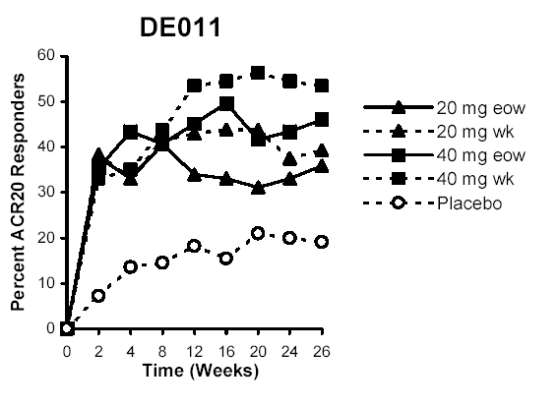
Figure 6 : Study DE011 : Responder rates according to ACR20 (observed values; full analysis set)

After 26 weeks of treatment, each of the four adalimumab treatment groups had higher ACR50, ACR70, and ACR-N responses than the placebo group. Statistically significant differences (p ≤ 0.05) were observed for the recommended dose of adalimumab, 40 mg q2w, compared to placebo for the ACR20, ACR50 ACR70, and ACR-N responses (Table 9).

Table 9 : Study DE011 : Summary of Major Efficacy Results at Week 26 – Number and Percentage of Patients Responding By Randomized Treatment Group (full analysis set)

 | Adalimumab |  |  |  | Placebo
 | N=106 | N=112 | N=113 | N=103 | N=110
Efficacy Parameter | 20 mg  eow | 20 mg  weekly | 40 mg  eow | 40 mg  weekly
ACR 20 response º | 38/106  (33%)ª | 44/112  (38%)ª | 52/113  (43%)ª | 55/103  (54%)^{abc} | 21/110  (20%)
ACR 50 response º | 20/106  (19%)ª | 23/112  (21%)ª | 25/113  (22%)ª | 36/103  (35%)^{abcd} | 9/110  (8%)
ACR 70 response º | 9/106  (9%)ª | 11/112  (10%)ª | 14/113  (12%)ª | 19/103  (18%)^{ab} | 2/110  (2%)
 | N  Mean ± SD | N  Mean ± SD | N  Mean ± SD | N  Mean ± SD | N  Mean ± SD
ACR-N response º | N=68 25.6±37.5^{a,f} | N=78  24.0±43.1^{f} | N=82 26.7±44.4^{a,f} | N=88  29.0±46.1^{a,f} | N=48  8.3±52.6
ª Statistically significant difference from placebo based on Pearson’s x² test (p<0.05)
^{b} Statistically significant difference from 20 mg q2w based on Pearson’s x² test (p<0.05)
^{c} Statistically significant difference from 20 mg weekly based on Pearson’s x² test (p<0.05)
^{d} Statistically significant difference from 40 mg q2w based on Pearson’s x² test (p<0.05)
^{f} Statistically significantly different from baseline based on 95% confidence intervals (p ≤ 0.05).
º Observed values, means

Study DE011 provides baseline and LOCF Week 26 HAHA (human anti-human antibody, i.e., anti-adalimumab antibody levels) data for 432 monotherapy adalimumab-treated patients (no concomitant MTX), the largest number of single study patients evaluated for HAHAs. Twelve percent of patients in this study developed HAHAs. Among the adalimumab-treated patients, the ACR20 response is lower (nominal p= 0.0048) among the HAHA positive adalimumab-treated patients (26%) than among all the HAHA negative adalimumab-treated patients (46%). The ACR20 response is also lower (nominal p=0.104) at the proposed dosage of 40 mg biweekly among the HAHA positive adalimumab-treated patients (30%) than among the HAHA negative adalimumab-treated patients (50%) (Table 10).

Table 10 : Study DE011: Relationship between HAHA and ACR20 Response at Week 26

 | HAHA Positive  N ACR20 (%) | HAHA Negative  N ACR20 (%) | P-value
All Patients  Adalimumab patients  20 mg biweekly  20 mg weekly  40 mg biweekly  40 mg weekly  Placebo | - 14 (26%)  54 14 (26%)  - 7 (37%)  11 1 (9%)  20 6 (30%)  4 0 (0%)  0 0 (0%) | - 196 (40%)  378 175 (46%)  - 31 (35%)  - 43 (43%)  92 46 (50%)  98 55 (56%)  110 21 (19%) | 0. 0416  0.0048  0.921  0.048  0.104  0.042  ----

Comparison of the dosing interval of adalimumab administration reveals a higher incidence of the development of HAHAs (nominal p = 0.0006) associated with biweekly administration (18%) compared to weekly administration (7%). To control for differences in overall dose, patients who received equal doses of adalimumab over a 2-week interval were compared, i.e. a weekly (20 mg qw) or a biweekly (40 mg q2w) injection. HAHAs were more common among the patients receiving the biweekly dosage(18%) than those receiving the weekly dosage (10%) (nominal p= 0.0816) (Table 11).

Table 11 : Study DE011 : Relationship of Dose and Dosing Interval of Adalimumab Administration and HAHA Development
 | N HAHA + (%) | P-value
All patients  Weekly  Biweekly  Subgroup  20 mg weekly  40 mg biweekly | 214 15 (7%)  218 39 (18%)  112 11 (10%)  112 20 (18%) | 0.0006  0.0816

- Summary of Efficacy Data

In this trial, the ACR20 response at Week 26, the primary efficacy parameter, was shown to be statistically superior to placebo for all four adalimumab treatment groups. A dose-response relationship was observed for ACR20 response rates across the adalimumab treatment groups at Week 26, with the lowest response rate for the 20 mg q2w group (33%), and the highest response rate for the 40 mg weekly group (54%). The ACR20 response rate at Week 26 for the adalimumab 40 mg q2w treatment group (43%), the proposed approval dosage, was statistically superior to the placebo-treated group (20%). The majority of responders had achieved an ACR20 response by the Week 2 study visit, and separation between adalimumab-treated patients and placebo-treated patients continued through Week 26.

Among adalimumab-treated patients, biweekly administration of adalimumab resulted in a higher incidence of HAHA-positivity than weekly administration, and HAHA-positivity was associated with a reduced frequency of ACR20 responses.

IV. Study DE019 – Adalimumab Plus Background Stable Dose Methotrexate Trial

A. Clinical Trial Design

Study DE019 is a multicenter double-blind, randomized, placebo-controlled 52 week phase III trial of adalimumab add-on therapy to background methotrexate (MTX) conducted to investigate the efficacy, safety, immunogenicity, and effect on immune response of subcutaneous (sc) injections of adalimumab (20 mg weekly or 40 mg biweekly [q2w]) compared to placebo weekly in patients with active RA treated concomitantly with MTX. A secondary objective was to investigate the retardation of disease progression at 52 weeks as detected by x-ray. The trial is composed of three parts: 1) a washout period and 2) a 52-week double-blind placebo-controlled period conducted at 89 sites in the United States and Canada (Figure 7), and 3) a 52-week open-label period. Patients without an ACR20 response by Week 16 could receive rescue medication if requested by the patient and permitted by the investigator-physician. After completing the 52-week placebo-controlled treatment period, patients could enter a 52-week open-label period with every other week 40 mg adalimumab treatment. Results from the double-blind placebo-controlled period of this study (1-year) are presented in this report. The doses of 20 mg weekly and 40 mg eow were determined from the 12-week double-blinded period results of Study DE007.

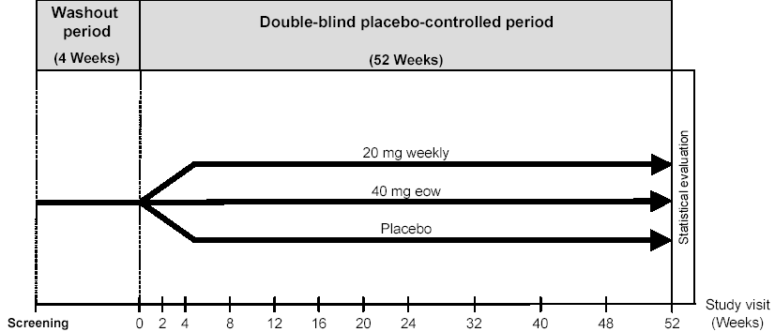
MTX R ACR
Stable Dose Rescue 20
permitted

Figure 7 : Study DE019: Study Design of the 52-Week Placebo-Controlled Study

The planned sample size was 600 randomized patients with RA (as defined by the 1987 ACR criteria) who had been treated concomitantly with MTX for a minimum of 3 months, prior to study entry. Patients were screened for study eligibility based on the inclusion/exclusion criteria. At the baseline visit patients were randomized to one of three equal groups of 200 patients to receive one of three study treatments consisting of either adalimumab or placebo via subcutaneous injection for up to 52 weeks:
1. Weekly 20 mg adalimumab
2. Biweekly 40 mg adalimumab and on alternate weeks placebo
3. Weekly placebo.
Adalimumab or placebo was self-administered (or given by a qualified person) as a single sc injection (1.6 mL injectable solution in identical in appearance 2 mL. glass vials) every week or every other week for up to 52 weeks. The concentrations of adalimumab solution were 20 mg/1.6 mL and 40 mg/1.6 mL. Placebo solution was a buffered vehicle with Tween 80. Patients returned for periodic examinations at Weeks 2, 4, 8, 12, 16, 20, 24, 32, 40, 48, and 52.

Eligibility consisted of RA patients with these inclusion criteria:
- Age 18 years and older, and for women of child-bearing potential demonstration of a negative pregnancy test (serum). .
- Met the ACR criteria for diagnosis of active RA and had at both the screening and baseline visits   6 swollen joints, 9 tender joints, and a C-reactive protein (CRP) 1 mg/dL, despite a minimum of 3 months of treatment with MTX.
- Taking a stable dose of MTX (oral, intramuscular, or sc) for at least 4 weeks prior to the screening visit with insufficient efficacy.
- Not taking DMARDs other than MTX (required a washout period during which all previous DMARDs [except MTX] were discontinued)
- Rheumatoid factor (RF) positivity or at least one joint erosion on x-ray. [Based on changes made in Amendment B, patients were eligible if they had both RF positivity and a CRP 1 mg/dL, or at least one joint erosion on x-ray.]
- Patients receiving stable daily glucocorticoids equivalent to 10 mg of prednisone
The dose of MTX was to remain constant during the 52-week double-blind period unless toxicity occurred.

The main exclusion criteria are evidence of cardiac, pulmonary, metabolic, renal, hepatic, gastrointestinal conditions, inflammatory joint or bowel disease, ongoing, recent, active, or latent infectious diseases, immune deficiency, history of lymphoma, leukemia or solid malignant tumor, history of tuberculosis or listeriosis, drug usage, alcohol abuse, recent joint surgery or injections, recent treatment with an investigational drug, laboratory values suggestive of possible MTX toxicity, having previously received any anti-TNF antagonist, pregnancy or breast-feeding.

At baseline and at every subsequent examination during the 52-week double-blind placebo-controlled period, joint assessments (tender and swollen joint counts) were performed by a blinded assessor, who was independent of the treating physician.

Study DE019 has three Primary Efficacy Endpoints:
1. Comparison of ACR20 response rates at week 24
2. Inhibition of radiographic progression at week 52
  - Disability index of HAQ at week 52

1) ACR20 response rates at Week 24 was the highest hierarchical primary efficacy outcome and was tested at the  = 0.05 level of significance, Comparisons of responder rates were performed using Pearson’s x² test per proposed analysis plan.

Observed data refers to patients with data available at the time point of analysis. Missing information for that time point, regardless of the reason, was not counted.

Observed data for ACR20 refers to patients with data available at the time point of analysis, but subjects were assessed as non- responder who:
- did not meet all of the ACR criteria on two consecutive visits at or after Week 12
- took additional DMARDs or increased MTX dose at or after the Week 16 assessments
- withdrew from the study prior to the measured time point (including ACR responders).

Comparisons were performed in sequence, using the closure principle to adjust for multiple comparisons. [the first comparison was between ACR20 responder rates for
all adalimumab-treated patients and placebo-treated patients, with subsequent comparisons between specific dose groups and placebo.]

2) Modified total Sharp x-ray score changes at Week 52 was the second hierarchical primary efficacy outcome. Radiographs of the hands/wrists and feet of each patient were obtained at screening and at Weeks 24, 52, and last visit for those who terminated early. The change in modified total Sharp x-ray score at Week 52 compared to baseline was designated as a primary endpoint. Digitized images of each radiograph were scored by two physicians (Dr. John Sharp and Dr. Carl Winalski). The assessors were blinded to study treatment and the chronological order of the images. Missing values were imputed using linear extrapolation from baseline and the last during-study evaluation. A secondary analysis was performed following the LOCF approach to impute missing values. The difference among all treatment groups was to be assessed using analysis of covariance (ANCOVA) with the baseline value as the covariate.

The protocol specified that a Shapiro-Wilk test would be performed on the data to assess normality. If the results of the Shapiro-Wilk test indicated a non-normal distribution with a p value of ≤ 0.05, the data were to be assessed using an analysis of ranks.

3) Disability index of the HAQ change at Week 52, the third primary efficacy endpoint was to be performed if the modified total Sharp x-ray score was significant at Week 52 (p ≤ 0.05). The difference among all treatment groups was to be assessed using ANCOVA with the baseline value as the covariate. If this was significant (p ≤ 0.05), pairwise comparisons between each active treatment group and placebo were to be evaluated using the same method.

Secondary efficacy variables consisted of classifying patients according to their level of improvement in disability index of the HAQ scores. Categories included an improvement of 0.22 (the minimally clinically significant change as defined by Goldsmith et al 1993) and 0.50 (considered a major improvement). This analysis utilizes LOCF approach for missing data.

Every effort was made to follow these patients and obtain x-rays even if they withdrew from the study.

B. Study Conduct

A total of 619 patients (approximately 200 per arm) were randomized and enrolled in the
double-blinded, placebo-controlled period of this study at 89 sites in the United States and Canada in equal proportions in the three study arms (Figure 8). Approximately three-quarters of the patients completed the 52 week study, with a somewhat higher proportion completing in the adalimumab groups (78%) than in the placebo group (70%). A higher percentage of placebo-treated patients (30%) than adalimumab-treated patients (22%) withdrew early from the 52 week study. A higher proportion of patients discontinued treatment due to adverse events among adalimumab-treated patients (10%) than among placebo-treated patients (7%) (Table 12).

.

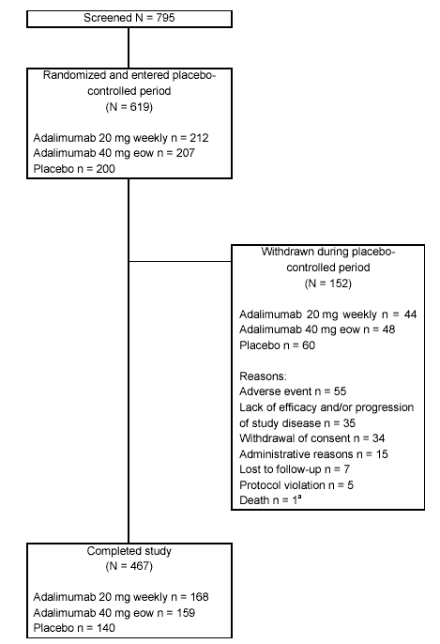

Figure 8 : Study DE019 : Patient Disposition

Table 12 : Study DE019 :Patient Disposition and Efficacy Assessment of Primary Endpoints At 24 and 52 Weeks
Planned enrollment N = 600 |  | Patients Screened N = 795
Enrolled & randomized | N = 619
Completed study (52 weeks) | N = 467
Withdrew early | N = 152
Treatment | Adalimumab
Treatment | 20 mg  Weekly  N=212 |  | 40 mg  Q2W  N=207 | All  Adalimumab  N=419 | Placebo  N=200
Completed study (24 weeks) | 181 (87%) |  | 173 (85%) | 354 (86%) | 155 (78%)
Withdrew early | 28 (13%) |  | 32 (15%) | 60 (14%) | 45 (23%)
Withdrawals from study:
Adverse event | 9 (4%) |  | 17 (8%) | 26 (6%) | 9 (5%)
Withdrawal of consent | 6 (3%) |  | 5 (2%) | 11 (3%) | 12 (6%)
Lack of efficacy/progression of study disease | 6 (3%) |  | 5 (2%) | 11 (3%) | 20 (10%)
Administrative reasons | 3 (1%) |  | 0 (0%) | 3 (1%) | 2 (1%)
Lost to follow-up | 3 (1%) |  | 2 (1%) | 3 (1%) | 2 (1%)
Protocol violation | 1 (<1%) |  | 2 (1%) | 3 (1%) | 0 (0%)
Death | 0 (0%) |  | 1 (<1%) | 1 (<1%) | 0 (0%)
Completed study (52 weeks) | 168 (79%) |  | 159 (77%) | 327 (78%) | 140 (70%)
Withdrew early | 44 (21%) |  | 48 (23%) | 92 (22%) | 60 (30%)
Withdrawals from study:
Adverse event | 16 ( 8%) |  | 26 (13%) | 42 (10%) | 13 (7%)
Withdrawal of consent | 11 (5%) |  | 8 (4%) | 19 (5%) | 15 (8%)
Lack of efficacy/progression of study disease | 6 (3%) |  | 6 (3%) | 12 (3%) | 23 (12%)
Administrative reasons | 5 (2%) |  | 3 (1%) | 8 (2%) | 7 (4%)
Lost to follow-up | 3 (1%) |  | 2 (1%) | 5 (1%) | 2 (1%)
Protocol violation | 3 (1%) |  | 2 (1%) | 5 (1%) | 0 (0%)
Death | 0 (0%) |  | 1 (1%) | 1 (0%) | 0 (0%)

The demographic characteristics by randomized treatment group for all patients who entered the study demonstrated that the majority were Caucasians and three-quarters were females with a median age of 56 years, similar to other RA clinical trials. The demographic characteristics in the various groups were comparable at baseline. Participants manifested long-standing disease (medians 11 years) and active rheumatoid arthritis, as manifested by high mean TJCs (means 28) and SJCs (means all approximately 20 ) Over 75% of participants were RF positive. Mean baseline total Sharp scores were >66 and the disability index of HAQ was approximately 1.4. (Table 13 and ).

Table 13 : Study DE019 : Demographic Characteristics
Treatment  N = 619 | Adalimumab
Treatment  N = 619 | 20 mg  Weekly  N=212 | 40 mg  Q2W  N=207 | All  Adalimumab  N=419 | Placebo  N=200
Demographics
Age (years) mean | 57.3 | 56.1 | 56.7 | 56.1
Gender (female %) | 76 | 76 | 76 | 73
Weight (Kg) mean | 79.0 | 77.4 | 78.2 | 80.1
Height (cm) mean | 166 | 165 | 165 | 166
Race (%)
Caucasian | 85 | 84 | 85 | 83
Hispanic | 7 | 6 | 6 | 8
Black | 6 | 7 | 6 | 7
Asian | 1 | 2 | 2 | 1
Other | 1 | 1 | 1 | 2

Table 14 : Study DE019 : Disease Activity Characteristics at Baseline
Treatment | Adalimumab
Treatment | 20 mg  Weekly  N=212 | 40 mg  Q2W  N=207 | All  Adalimumab  N=419 | Placebo  N=200
Completed study | 168 (79%) | 159 (77%) | 327 (78%) | 140 (70%)
Duration of RA (years) - mean | 11 | 11 | 11 | 11
Tender joint count - mean | 28 | 28 | 28 | 28
Swollen joint count - mean | 20 | 19 | 20 | 19
Total Sharp score - mean | 66.4 | 72.1 | 69.2 | 66.4
Erosion score - mean | 36.7 | 41.4 | 39.0 | 37.2
JS Narrowing score - mean | 29.7 | 30.7 | 30.2 | 29.2
RF positive – number (%) | 165 (78%) | 158 (76%) | 323 (77%) | 165 (83%)
RF levels - mean | 309 | 273 | 291 | 457
Disability index of HAQ-mean | 1.44 | 1.45 | 1.44 | 1.49
Duration of morning stiffness  minutes - mean | 114 | 111 | 113 | 112

Previous DMARD therapy was comparable at baseline. The median total weekly dose of MTX was 15 mg/kg for both adalimumab-treated patients and placebo-treated patients and two-thirds of both groups received their medication via the oral route and one-third by the parenteral route (Table 15).

Table 15 : Study DE019 :Previous DMARD Therapy for Rheumatoid Arthritis
Treatment | Adalimumab
Treatment | 20 mg  Weekly  N=212 | 40 mg  Q2W  N=207 | All  Adalimumab  N=419 | Placebo  N=200
Completed study | 168 (79%) | 159 (77%) | 327 (78%) | 140 (70%)

MTX Administration
Route %
Oral/ Parenteral | 68/33 | 66/34 | 67/33 | 69/31
Total weekly dose - mg/kg  (mean) | 16.3 | 16.7 | 16.5 | 16.7

Eighty percent of patients enrolled in this trial contributed to the Week 24 evaluation of the ACR20. Over 90% of all study patients contributed to the Week 52 evaluation of decreased radiographic progression, and approximately 75% of all study patients contributed to the Week 52 Disability Index (HAQ) evaluation. Assessment of the data contributing to the efficacy primary endpoints is shown in (Table 16). More patients in the placebo-treated group (30%) withdrew from the trial than patients in the adalimumab-treatment groups (22%).

Table 16 : Study DE019 : Patients With Data Contributing To The Efficacy Assessments (Primary Endpoints)
Treatment | Adalimumab
Treatment | 20 mg  Weekly  N=212 | 40 mg  Q2W  N=207 | All  Adalimumab  N=419 | Placebo  N=200
Completed study (52 weeks) | 168 (79%) | 159 (77%) | 327 (78%) | 140 (70%)
Withdrew early | 44 (21%) | 48 (23%) | 92 (22%) | 60 (30%)
ACR 20 at week 24 | 181 (85%) | 173(84%) | 354 (84%) | 155 (78%)

Radiographic regression

Sharp X-ray score changes
Baseline enrollment | N = 201 | N= 194 | N = 395 | N = 184
Scored at week 24 | 196 (98%) | 183 (94%) | 379 (96%) | 172 (93%)
Scored at week 52 | 196 (98%) | 183 (94%) | 379 (96%) | 172 (93%)
Disability Index (HAQ change)
Baseline enrollment | N = 212 | N = 206 | N =418 | N = 199
Observed score at week 52 | 168 (79%) | 160 (78%) | 328 (78%) | 140 (71%)

C. Efficacy Analyses

    - Primary Efficacy Endpoints

The primary efficacy endpoints were 1) ACR20 response at Week 24, 2) change in modified total Sharp x-ray score at Week 52, and 3) change in disability index (HAQ) at Week 52 (Table 17). Statistically significant changes are demonstrated for all three primary efficacy endpoints.

Table 17 : Study DE019 : Primary Efficacy Assessments
Treatment | Adalimumab
Treatment | 20 mg  Weekly  N=212 | 40 mg  Q2W  N=207 | All  Adalimumab  N=419 | Placebo  N=200
Completed study N = | 168 (79%) | 159 (77%) | 327 (78%) | 140 (70%)
Primary Efficacy Assessments
ACR20 Response at week 24 | 129 (61%)* | 131(63%)* | 260 (62%) | 59 (30%)
Radiographic progression -
Change in modified Sharp
X-ray score (erosions)
at week 52
N = at Week 52/Baseline | 196/201 | 183/194 | 379/395 | 172/184
Baseline
Mean + SD | 66 + 56 | 72 + 60 |  | 66 + 47
Change at Week 52
Mean + SD | 0.8 + 4.9 * | 0.1 + 4.8 * |  | 2.7 + 6.8

Disability Index of the HAQ
at week 52
Baseline N = | 212 | 206 | 418 | 199
Mean + SD | 1.44 + 0.64 | 1.45 + 0.63 |  | 1.48 + 0.59
Week 52 N = | 168 | 160 | 328 | 140
Change at week 52  + SD | -0.69  + 0.55* | -0.64  + 0.57* |  | -0.34  + 0.54
Additional Efficacy Assessment
ACR20 Response at week 52 | 116 (55%)* | 122 (59%)* | 238 (57%) | 48 (24%)
* Statistically significantly different from placebo (p< 0.001)

a. ACR20 Response at Week 24

An overall comparison of the change in ACR20 from baseline after 24 weeks of treatment revealed a statistically significant difference (p< 0.001) in each adalimumab treatment group (20 mg weekly [61%] and 40 mg q2w [63%]) compared to placebo [30%] (Table 17). The magnitude of the response at Week 24 was comparable between the 20 mg weekly and the 40 mg q2w treatments. Adalimumab-treated patients demonstrated statistically significant changes in all components of the ACR20 compared to placebo-treated patients (Table 18).

Table 18: Study DE019 :Components of ACR 20 Response Index (Percentage Change at Week 24 Compared to Baseline ª)

* Comparison versus placebo (2-sided) p ≤ 0.05.
Efficacy Parameter | Adalimumab  40 mg q2w  N = 207  (%) |  | Placebo  N = 200  (%)
ACR 20 response at  Week 24 º | 63% *** | 30%
TJC mean percent change ^{c} | 63% *** | 43%
SJC mean percent change ^{c} | 61% *** | 33%
1.Pain VAS ^{c} | 62% *** | 21%
2. Patient global assessment ^{c} | 62% *** | 23%
3. Physician global assessment ^{c} | 70% *** | 37%
4. HAQ Disability Index ^{c} | 45% *** | 16%
5. Acute phase reactant  (C Reactive protein) ^{c} | 50% *** | 0
Duration of morning stiffness  (minutes) ^{c} | 83% *** | 50%
** Comparison versus placebo (2-sided) p ≤ 0.01.
*** Comparison versus placebo (2-sided) p ≤ 0.001.
ª Negative values indicate worsening
º Observed values; non-responders imputation; comparisons vs placebo by Pearson’s chi-square test
^{c} LOCF; ; Median percentage improvement -comparisons vs placebo by ANCOVA with factor treatment group and baseline value as covariate comparisons versus placebo (2-sided)

Evaluation of time to onset of ACR20 response by treatment groups demonstrates that the onset of action of adalimumab occurs as early as Week 2 with both dosages (Figure 9), and the majority of the adalimumab-associated ACR20 responses occur within the first eight weeks. Additionally, if an adalimumab treatment response is not observed by Week 20, the data suggest that an ACR20 response is unlikely to occur.

Figure 9 : Study DE019: Time to First ACR20 Response By Treatment Group
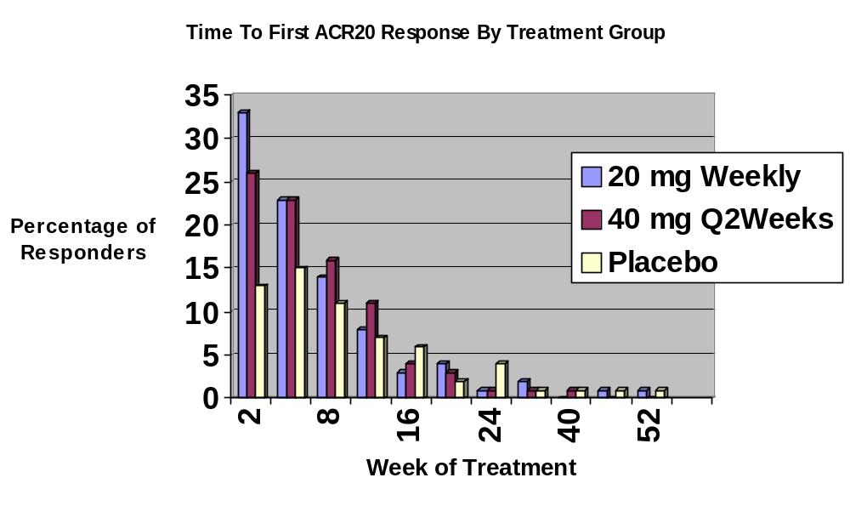
Overall, the adalimumab treatment groups had a higher response rate at each time point compared to placebo. Separation between adalimumab- and placebo-treated patients occurs as early as Week 2, is established by Week 4, and is maintained through Week 52 (Figure 10).
Figure 10 : Study DE019 : Percentage ACR20 Responders by Weeks 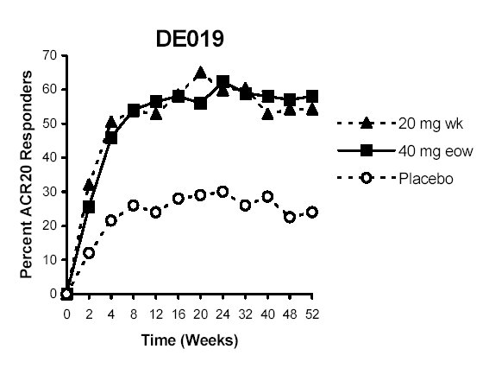

Evaluation of the maintenance of the ACR20 response at Week 52 (a secondary efficacy end-point) for adalimumab-treated patients who were responders at week 24, reveals that approximately 85% of early responders maintained their response through Week 52 compared to 63% for placebo-treated patients (Table 19).

Table 19 : Study DE019 : Maintenance of ACR20 Response at Week 52 For Patients Who Were Responders At Week 24 By Treatment Group
 | Responders
 | Adalimumab
 | 20 mg weekly | 40 mg q2w | Placebo
 | (N=212) | (N=207) | (N=200)
 | N (%) | N (%) | N (%)
ACR20 Response at Week 24 (Based on all randomized patients)
 | 129 (61%) | 131(63%) | 59 (30%)
ACR20 Response at Week 52 (Based on all randomized patients)
Total | 116 (55%) | 122 (59%) | 48 (25%)
Maintained from Week 24 | 107 (51%) | 117 (57%) | 37 (19%)
Not maintained  from Week 24 | 9 (4%) | 5 (2%) | 11 (6%)
Percentage of Responders Maintained from Week 24  Through Week 52 | 107/129  (83%) | 117/131  (89%) | 37/59  (63%)

The percentage of ACR20 responses by treatment subsets among 40 mg q2w adalimumab-treated patients at Week 24 was uniformly greater than among placebo-treated patients with a few exceptions, i.e. among Blacks and Hispanics. Among the adequate and well-controlled groups, the ACR20 response for Blacks at Week 24 (36%, 11/31) resembled that for placebo (34%, 11/32). However, ACR20 responses among Blacks were higher than for placebo at six time-points earlier than Week 24 (Week 2 [39% vs. 13%], Week 4 [42% vs. 19%], Week 8 [52% vs. 28%], Week 12 [45% vs. 25%], Week 16 [48% vs. 31%], and Week 20 [39% vs. 31%]). In addition, comparison of the change in TSS (radiologic progression) between adalimumab- and placebo-treated patients revealed the highest rate of progression among Black placebo-treated patients (7.7u/yr) and a markedly reduced rate of progression among Black adalimumab-treated patients (0.4 u/yr) [Table 22]. Therefore, the data indicate that Black patients did have a response to adalimumab treatment. Patients subsetted based on weight, RF positivity, and corticosteroid use had similar responses to adalimumab (approximately 60%) as the study population as a whole (Table 20).

Table 20 : Study DE019 : ACR20 Responders at Week 24 by Treatment Subsets

 | Adalimumab  40 mg Q2w |  | Placebo
 | N | % | N | %
Males | 35 | 71 | 18 | 33
Females | 96 | 61 | 41 | 28
Age
< 65 years | 93 | 66 | 48 | 31
≥ 65 years | 42 | 65 | 13 | 29
Race
White | 111 | 64 | 39 | 24
Black | 5 | 36 | 5 | 39
Asian | 4 | 80 | 1 | 50
Hispanic | 3 | 23 | 6 | 40
Other | 1 | 50 | 1 | 25
Weight
≤ 70 kg | 56 | 62 | 14 | 18
≥ 70 kg | 75 | 64 | 45 | 37
RF positive | 110 | 66 | 54 | 30
RF negative | 26 | 67 | 7 | 33
Corticosteroid use + | 56 | 62 | 31 | 31

b. Modified Total Sharp X-ray Score Changes at Week 52

The rate of radiographic progression was evaluated by calculating the change in modified total Sharp x-ray scores (TSS)(relative to baseline) at Weeks 24 and 52. Missing data were imputed by linear extrapolation to week 52. An overall comparison of the change from baseline in modified total Sharp x-ray scores to Week 52 revealed a statistically significant difference (p ≤ 0.001) across the treatment groups, and permitted pair-wise comparisons. Significance testing was to be done following the closure principle. The difference among all treatment groups was to be assessed using analysis of covariance (ANCOVA) with the baseline value as the covariate. Comparisons rates were performed using Pearson’s x² test. The magnitude of the change associated with each of the adalimumab treatment groups was smaller and was statistically significantly different (p ≤ 0.001 for both) from placebo (Table 21) indicating that adalimumab use was associated with a reduced rate of progression of structural damage.

Observed and LOCF (use of linear extrapolation to impute missing data) data demonstrated similar results. Similar results were observed when the data were analyzed using the per protocol set of patients. An overall comparison of the change from baseline in modified total Sharp x-ray scores to Week 52 for the per-protocol set revealed a statistically significant difference (p ≤  0.001) across the treatment groups, and permitted pair-wise comparisons. The magnitude of the change associated with each of the adalimumab treatment groups was smaller and was statistically significantly different (p ≤ 0.001 for both) from placebo. The mean modified total Sharp score for the proposed adalimumab dose of 40 mg q2w at Week 52 was 0.1 compared to 0.8 for 20 mg qw and 2.7 for the placebo-treated patients.

Normality was evaluated by applying the Shapiro-Wilk test procedure to the residuals from the parametric model. The resulting p-value was ≤ 0.05 indicating the normality assumption was violated. Therefore, the final analysis was performed following a non-parametric approach, ranking the results prior to fitting the model. Missing values were imputed using linear extrapolation from baseline and the last during-study evaluation.

Table 21 : Study DE019 : Modified Total Sharp X-Ray Score Changes (Extrapolated) At Weeks 24 and 52 By Treatment Group (full set analysis)

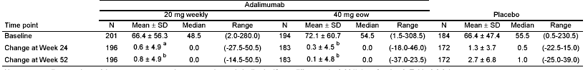
ª Statistically significantly different from placebo (p ≤ 0.01) based on median values.
^{b} Statistically significantly different from placebo (p ≤ 0.01) based on median values

Modified total Sharp x-ray score changes are presented by subgroups in Table 22. Comparison of the changes between adalimumab-treated patients and placebo-treated patients demonstrates a smaller increase in modified total Sharp x-ray scores with adalimumab compared to placebo in each of the subgroup analyses with the exception of patients >65 years of age. Among patients > 65 years of age receiving 20 mg weekly, the 12-month change in TSS was similar to placebo (2.7 vs. 3.2 u/yr). However, in the group receiving 40 mg q2w, the 12-month change in TSS was reduced compared to placebo (1.6 vs. 3.2 u/yr).

Of note, the largest increase in radiographic progression occurred among Blacks taking placebo. However, the rate of progression was reduced to a similar level among Black patients receiving adalimumab as for other groups. Rheumatoid factor positivity or negativity did not seem to influence the effect of adalimumab on radiographic progression.

Table 22: Study DE019 : Modified Sharp X-Ray Score (Observed) Changes At Week 52 By Age, Gender, Body Weight, Race, and RF Status
Treatment | Adalimumab
Treatment | 20 mg  Weekly  N=212 | 40 mg  Q2W  N=207 | All  Adalimumab  N=419 | Placebo  N=200
Completed study | 168 (79%) | 159 (77%) | 327 (78%) | 140 (70%)
Subgroup at Week 52 | N / Mean + SD
Age
< 65 years | 138  0.3 + 2.6 | 116  -0.5 + 4.8 | 254 | 128  2.7 + 7.1
> 65 years | 45  2.7 + 8.8 | 49  1.6 + 4.8 |  | 33  3.2 + 5.5
Gender (female) N=  Change at week 52 | 138  1.0 + 4.9 | 127  0.3 + 4.7 | 265 | 116  2.9 + 6.4
Body Weight
< 70 Kg at Baseline N=  Change at 52 weeks | 62  0.8 + 2.3 | 69  0.2 + 6.0 | 131 | 59  3.8 + 6.4
> 70 Kg at Baseline N=  Change at 52 weeks | 121  1.0 + 5.9 | 96  0.1+ 3.9 | 217 | 102  2.1+ 6.9
Race (%)
Caucasian | 156  1.0 + 5.4 | 143  0.1 + 5.1 | 299 | 138  2.6 + 6.9
Hispanic | 11  0.0 + 1.9 | 6  0.0 + 0.8 | 17 | 10  0.9 + 1.4
Black | 11  0.7 + 1.6 | 11  0.4 + 4.0 | 22 | 8  7.7 + 7.6
Asian | 2  1.8 + 1.1 | 4  0.3 + 0.3 | 6 | 2  3.8 + 5.3
Other | 3  0.0 + 0.0 | 1  -1.0 | 4 | 3  3.5 + 4.1

Rheumatoid Factor (positive)
Baseline N= | 165 | 158 | 323 | 165
 | 68 + 55.6 | 77.6 + 61.3 |  | 68.5 + 47.5
Change at Week 52 N= | 149 | 135 | 282 | 145
 | 0.9 + 5.2 | 0.0 + 5.3 |  | 2.7 + 6.4

Rheumatoid Factor (negative)
Baseline N= | 36 | 36 | 72 | 19
 | 58.9 + 59.6 | 48.0 + 52.6 |  | 48.2 + 43.3
Change at Week 52 N= | 34 | 30 | 64 | 16
 | 1.1 + 4.1 | 0.5 + 1.9 |  | 3.3 + 9.8

As expected, the baseline TSSs were progressively higher in patients with increasing duration of RA. The overall therapeutic effect of adalimumab was similar at all stages of the disease (Table 23)

Table 23 : Study DE019 : Modified Total Sharp X-Ray Score (Observed) Changes At Week 52 By Duration of RA
Treatment | Adalimumab
Treatment | 20 mg  Weekly  N=212 | 40 mg  Q2W  N=207 | All  Adalimumab  N=419 | Placebo  N=200
Completed study (52 weeks) | 168 (79%) | 159 (77%) | 327 (78%) | 140 (70%)
Withdrew early | 44 (21%) | 48 (23%) | 92 (22%) | 60 (30%)
Duration of RA
0 –2 years
Baseline N= | 28 | 24 | 52 | 18
 | 21.7 + 14.5 | 28.3 + 27.4 |  | 25.9 + 18.4
Change at Week 52 N= | 24 | 24 | 48 | 15
 | -0.0 + 1.2 | 0.4 + 4.1 |  | 4.7 + 6.3

>2 – 5 years
Baseline N= | 37 | 42 | 79 | 43
 | 44.5 + 38.1 | 36.3 + 31.5 |  | 44.3 + 37.1
Change at Week 52 N= | 34 | 36 | 70 | 38
 | 1.5 + 9.1 | 1.1 + 2.4 |  | 3.9 + 8.3
>5 – 10 years
Baseline N= | 48 | 42 | 90 | 41
 | 61.3 + 44.9 | 51.9 + 36.7 |  | 55.3 + 39.0
Change at Week 52 N= | 41 | 31 | 72 | 35
 | -0.3 + 3.4 | -0.3 + 3.9 |  | 2.3 + 5.9
> 10 years
Baseline N= | 87 | 86 | 173 | 82
 | 93.3 + 63.1 | 111.6 + 63.9 |  | 92.4 + 46.5
Change at Week 52 N= | 83 | 74 | 157 | 73
 | 1.6 + 3.9 | -0.3 + 6.2 |  | 2.0 + 6.3
Source of Data: Sponsor’s Table 25

The magnitude of the baseline TSSs did not have any apparent influence on the decrease in rate of progression of adalimumab-treated patients at the proposed dose compared to placebo-treated patients (Table 24).

Table 24 : Study DE019 : Modified Total Sharp X-Ray Score (Observed) Changes At Week 52 (Continued)
Treatment | Adalimumab
Treatment | 20 mg  Weekly  N=212 | 40 mg  Q2W  N=207 | All  Adalimumab  N=419 | Placebo  N=200
Completed study (52 weeks) | 168 (79%) | 159 (77%) | 327 (78%) | 140 (70%)
Withdrew early | 44 (21%) | 48 (23%) | 92 (22%) | 60 (30%)
Baseline Sharp score
Baseline score <30 N= | 59 | 59 | 118 | 51
 | 16.0 + 7.5 | 15.9 + 7.0 |  | 16.4 + 8.3
Change at Week 52 N= | 52 | 53 | 105 | 44
 | -0.0 + 1.4 | 0.5 + 2.9 |  | 1.5 + 3.3
Baseline score 30 – 90 N= | 91 | 81 | 172 | 75
 | 55.3 + 16.9 | 58.7 + 18.9 |  | 54.5 + 16.5
Change at Week 52 N= | 82 | 65 | 147 | 68
 | 1.2 + 3.5 | -0.2 + 5.4 |  | 4.1 + 7.6
Baseline score > 90 N= | 51 | 54 | 105 | 58
 | 144.4 + 51.6 | 153.6 + 47.8 |  | 125.7 + 28.2
Change at Week 52 N= | 49 | 47 | 96 | 49
 | 1.5 + 8.4 | 0.1 + 5.9 |  | 2.1 + 7.6

We performed analyses to determine what fraction of patients experienced no x-ray progression. At week 24, similar proportions of adalimumab-treated patients and placebo-treated patients manifested no new erosions. However at Week 52, 60% of the 40 mg q2w adalimumab-treated patients had no new erosions compared to baseline vs. 46% of placebo-treated patients (Table 25).

Table 25 : Study DE019 : Erosion Score: Patients with No New Erosions and Lower Erosion Scores at Weeks 24 and 52 by Randomized Treatment Group (full analysis set)

TimePoint | Adalimumab |  |  |  | Placebo
TimePoint | 20 mg weekly |  | 40 mg Q2w
 | N | % | N | % | N | %
Patients with no new erosions (=0 and <0)
Week 24 | 117 | 62 | 108 | 61 | 99 | 60
LOCF Week 24 | 119 | 62 | 119 | 62 | 103 | 58
Week 52 | 106 | 58ª | 102 | 62^{b} | 74 | 46
LOCF Week 52 | 119 | 59ª | 122 | 63^{c} | 85 | 46
Patients with lower erosion scores (<0)^{d}
Week 24 | 59 | 31 | 65 | 37ª | 41 | 25
LOCF Week 24 | 60 | 31 | 69 | 36ª | 41 | 23
Week 52 | 54 | 30ª | 63 | 38^{c} | 31 | 19
LOCF Week 52 | 57 | 28ª | 72 | 37^{c} | 35 | 19
a Statistically significantly different from placebo (p ≤  0.05).
b Statistically significantly different from placebo (p ≤ 0.01).
c Statistically significantly different from placebo (p ≤ 0.001).
d Comparison was done across three categories: <0, 0 and >0.

Erosion score changes were greater for placebo-treated patients than for 40 mg biweekly adalimumab-treated patients at both Week 24 and Week 52, and changes for 20 mg weekly adalimumab-treated patients were intermediate. LOCF data demonstrated similar results (Table 26).

Table 26 : Study DE019 : Erosion Score at Weeks 24 and Week 52 By Randomized Treatment Group – (full analysis set)

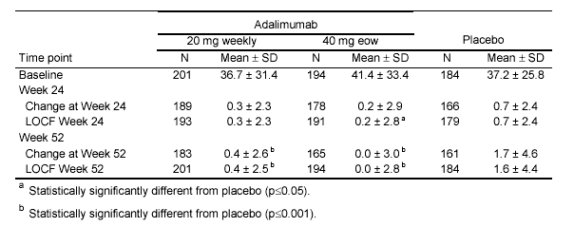

Adalimumab-treated patients demonstrated less of an increase in JSN scores than placebo at Weeks 24 and 52 (Table 27). The nominal p-values for these comparisons were <0.005.

Table 27 : Study DE019 : Joint Space Narrowing: Change in Joint Space Narrowing and Joint Space Narrowing Scores at Weeks 24 and 52 by Randomized Treatment Group (full analysis set)

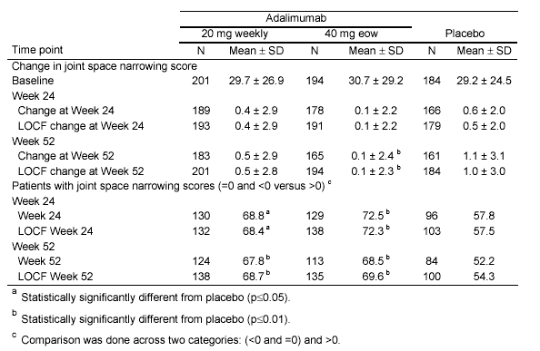
Table 28 presents the changes in TSS by quartiles and the 10th/90th percentiles. The 90th percentile for changes in TSS was 3 units for adalimumab-treated patients compared to 10 units for placebo.

Table 28: Study DE019 : Change from baseline at Week 52 in TSS*
--Repeat Sponsor’s primary analysis with additional quartiles of information
Group n mean std median q1 q3 p10 p90 min max
20 MG WEEKLY 196 0.79 4.94 0 -0.5 1.08 -2.0 3 -14.5 50.5
40 MG BIWEEKLY 183 0.09 4.77 0 -1.0 1.08 -2.5 3 -37.0 23.5
PLACEBO 172 2.67 6.76 1 0.0 4.00 -1.0 10 -25.0 39.0
*: Patients without baseline score or one score after baseline were excluded.
For patients without score at Week 52, their values were estimated using linear extrapolation method.

An analysis was performed to assess whether a linear imputation method or LOCF would be the best imputation technique for handling missing data. Table 29 demonstrates that
similar results are seen for the 12-month change in TSS using the two imputation techniques. This is not surprising given the small amount of missing data in the trial.

Table 29 : Study DE019 : Comparison of Statistical Inference Conclusions Based on Change from Baseline at Week 52 in TSS* Using Different Imputation Methods

Imputation Method | 40 MG BIWEEKLY (n=183)  Mean SD Median | PLACEBO (n=172)  Mean SD Median
Linear Extrapolation  LOCF | 0.09 4.77 0  0.13 4.70 0 | 2.67 6.76 1  2.63 6.61 1
*: Patients without baseline score or one score after baseline were excluded.

Table 30 uses data for patients who had baseline, Week 24 and Week 52 x-ray assessments, and displays the difference between the actual Week-52 value and that obtained by imputing Week-52 values from Week-24 values using linear extrapolation or LOCF. For untreated patients, linear extrapolation closely approximated Week-52 values (mean difference = 0.05), while LOCF values differed markedly (mean difference = 1.48). This analysis suggests that linear extrapolation is a more accurate imputation technique.

Table 30 : Study DE019 : Difference Between the Real and the Imputed Values at Week 52 in TSS*

Imputation Method | 40 MG BIWEEKLY (n=183)  Mean SD Median | PLACEBO (n=172)  Mean SD Median
Linear Extrapolation  LOCF | -0.53 9.21 0  -0.15 5.22 0 | 0.05 6.96 0  1.48 5.48 0.5
*: Patients without complete TSS score were excluded.

Table 31 presents additional sensitivity analyses to support the statistical findings of the primary analysis. Statistically significant differences between adalimumab and placebo remain when worse scores (75th percentile) are imputed for missing values with adalimumab and better scores (25th percentile) for placebo (Sensitivity Analysis III). A worse case scenario (Sensitivity Analysis IV) abrogates the treatment effect.

Table 31 : Study DE019 : Sensitivity Analyses Total Sharp Score

Sensitivity Analysis I

Assigning the worst change (50.5) to all patients with missing values
Group n mean std median q1 q3 min max P-value*
20 MG WEEKLY 212 4.54 13.99 0.5 -0.5 2.00 -14.5 50.5 <0.0001
40 MG BIWEEKLY 207 5.93 16.79 0.0 -1.0 2.00 -37.0 50.5 <0.0001
PLACEBO 200 9.37 17.78 1.5 0.0 8.25 -25.0 50.5
*: Adalimumab group vs. placebo group using Wilcoxon rank sum test.

Sensitivity Analysis II
Assigning the median change (0.5) to all patients with missing values
Group n mean std median q1 q3 min max P-value*
20 MG WEEKLY 212 0.76 4.75 0.5 -0.5 1.00 -14.5 50.5 <0.0001
40 MG BIWEEKLY 207 0.13 4.48 0.0 -1.0 1.00 -37.0 23.5 <0.0001
PLACEBO 200 2.37 6.31 0.5 0.0 3.25 -25.0 39.0
*: Adalimumab group vs. placebo group using Wilcoxon rank sum test.

Sensitivity Analysis III
Assigning the 75th percentile change (2.0) to patients with missing values treated with Adalimumab Assigning the 25th percentile change (-.5) to patients with missing values treated with placebo
Group n mean std median q1 q3 min max P-value*
20 MG WEEKLY 212 0.88 4.76 0.5 -0.5 2.00 -14.5 50.5 0.051
40 MG BIWEEKLY 207 0.31 4.52 0.0 -1.0 2.00 -37.0 23.5 0.0054
PLACEBO 200 2.23 6.36 0.5 -0.5 3.25 -25.0 39.0
*: Adalimumab group vs. placebo group using Wilcoxon rank sum test.

Sensitivity Analysis IV
Assigning the worst change (50.5) to patients with missing values treated with Adalimumab Assigning the best change (-37.0) to patients with missing values treated with placebo
Group n mean std median q1 q3 min max P-value*
20 MG WEEKLY 212 4.54 13.99 0.5 -0.5 2.00 -14.5 50.5 0.8896
40 MG BIWEEKLY 207 5.93 16.79 0.0 -1.0 2.00 -37.0 50.5 0.9669
PLACEBO 200 -2.88 15.16 0.5 -0.5 3.25 -37.0 39.0
*: Adalimumab group vs. placebo group using Wilcoxon rank sum test.

c. Disability Index of the HAQ at Week 52

An improvement in the disability index of the HAQ was represented by a negative mean change from baseline (i.e., assessed decrease in disease). After 52 weeks of treatment, both adalimumab dose groups (20 mg weekly and 40 mg q2w) were associated with statistically significant (p ≤ 0.001) improvements in observed disability index (HAQ) compared to placebo (Table 32).

The change in disability index of the HAQ scores at Week 52 for the adalimumab treatment groups in the per-protocol set were also statistically significantly superior (p<0.001) to placebo. The scores at Week 52 were comparable between 20 mg weekly and 40 mg eow treatment groups

Normality was evaluated by applying the Shapiro-Wilk test procedure to the residuals from the parametric model. The resulting p-value was >0.05 indicating the normality assumption was not violated. The final analysis was therefore performed following a parametric approach. ANCOVA statistical analyses was utilized for change in modified
change in disability index of the HAQ.

Table 32 : DE019 : Disability index of the HAQ at Week 52 by Randomized Treatment Group (full analysis set)

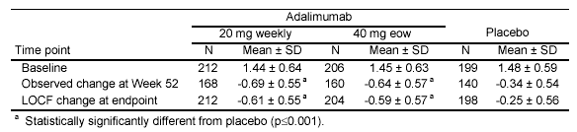

Among adalimumab-treated patients treated with 40 mg biweekly, 60% achieved HAQ (improvement) score reductions of > 0.22 and 46% achieved HAQ score reductions of
> 0.50 units at 52 weeks. Among placebo-treated patients 41% achieved HAQ score reductions of > 0.22 and 25% achieved HAQ score reductions of > 0.50 units.

2. Secondary Efficacy Endpoints

A substantial number of adalimumab-treated patients demonstrated ACR50 responses (40%) at both Week 24 and Week 52 compared to placebo (10%) (Table 33). [Continuous secondary efficacy variables were to be analyzed using ANCOVA, with baseline and treatment group as covariates. Pearson’s x² test was to be used for discrete data]

Table 33 : Study DE019 : ACR50 Response At Weeks 24 and 52: Number (%) of Patients Responding By Randomized Treatment Group

 | Adalimumab
Time point | 20 mg weekly | 40 mg q2w | Placebo
Week 24 | (N=212) | (N=207) | (N=200)
Week 24 | 87 (41) ª | 81 (39)ª | 19 (10)
Week 52 | 80 (38) ª | 86 (42) ª | 19 (10)
ª Statistically significantly different from placebo (p ≤0.001)

Over 20% of the 40 mg biweekly adalimumab-treated patients demonstrated ACR70 responses at both Week 24 and Week 52 (Table 34).

Table 34 : Study DE019 :ACR70 Response At Weeks 24 and 52: Numbers (%) of Patients Responding By Randomized Treatment Group

 | Adalimumab
 | 20 mg weekly | 40 mg q2w | Placebo
Time point | (N=212) | (N=207) | (N=200)
Week 24 | 37 (18) ª | 43 (21) ª | 5 (3)
Week 52 | 44 (21) ª | 48 (23) ª | 9 (5)
ª Statistically significantly different from placebo (p ≤0.001)
Source: sponsor’s Table 30

A significantly greater proportion of adalimumab-treated patients than placebo experienced a major clinical response at Week 52, a unique achievement for a RA therapeutic agent in a 1-year study. (Table 35)

Table 35 : Study DE019 : Major Clinical Response at Week 52 by Treatment Group
 | Adalimumab
 | 20 mg weekly | 40 mg q2w | Placebo
Major clinical responseª | (N=212) | (N=207) | (N=200)
Yes | 20 (9.4)^{b} | 18 (8.7)^{b} | 3 (1.5)
ª Defined as a continuous ACR70 over a 6 month period
^{b} Statistically significantly different from placebo (p ≤0.001)

The percentages of ACR50, ACR70 , and major clinical responses for adalimumab, all demonstrated statistical significance.

Table 36 demonstrates the higher number and percentage of placebo-treated patients compared to adalimumab-treated patients who were non-responders and required additional DMARDs.

Table 36 : Study DE019 : Number of Patients Using Additional DMARDs
Enrolled in study | N = 619
Treatment | Adalimumab
Treatment | 20 mg  Weekly  N=212 | 40 mg  Q2W  N=207 | All  Adalimumab  N=419 | Placebo  N=200
Completed study | 168 (79%) | 159 (77%) | 327 (78%) | 140 (70%)
Withdrew early | 44 (21%) | 48 (23%) | 92 (22%) | 60 (30%)
Number of patients using additional DMARDs
Week 24
ACR20 responder | 0 | 2 (1%) | 2 (1%) | 1 (1%)
ACR20 non-responder | 6 (3%) | 7 (3%) | 13 (3%) | 31 (16%)
Week 52
ACR20 responder | 0 | 0 | 0 | 0
ACR20 non-responder | 6 (3%) | 8 (4%) | 14 (3%) | 30 (15%)

3. Summary of Efficacy Data

In this trial, there were three primary efficacy endpoints: the ACR20 response rate at Week 24 was the highest hierarchical primary efficacy outcome, followed by comparisons of the modified total Sharp x-ray score changes at Week 52, and the third primary efficacy endpoint was the disability index of the HAQ change at Week 52. The ACR20 response at Week 24 for both adalimumab-treatment groups (20 mg weekly [61%] and 40 mg q2w [63%], the proposed approval dosage) was statistically superior to the placebo-treated group (30%). The separation between adalimumab- and placebo-treated patients occurred as early as Week 2, was established by Week 4, and maintained through Week 52. All subsets of patients examined demonstrated a treatment effect of adalimumab.

Comparison of the change from baseline in modified total Sharp x-ray scores to Week 52 revealed a statistically significant difference between adalimumab-treatment groups and the placebo-treated group. The smaller changes observed in patients treated with adalimumab was consistent with a slowing of the rate of progressions of structural damage.

The study demonstrated a greater degree of improvement in the HAQ scores from baseline to Week 52 for both adalimumab doses compared to placebo. While these data are consistent with an important clinical benefit, they do not meet the criteria outlined in the guidance document for a claim of improvement in physical function/prevention of disability. Demonstration of sustained improvement for 2 years is required for this claim.

V. Study DE031 - Adalimumab Plus Stable Dose DMARD

A. Clinical Trial Design

Study DE031 is a multicenter, randomized, double-blind, placebo-controlled, phase III 24 week trial in which adalimumab 40 mg is self-administered subcutaneously (sc) every other week to patients with RA whose disease was not adequately treated with their current anti-rheumatic therapies. The primary objective is to contrast the safety profile of adalimumab with placebo when both are administered with pre-existing rheumatologic care in patients with active RA. The secondary objective is to determine and compare the efficacy of adalimumab with placebo when both are administered with pre-existing rheumatologic care. Efficacy is measured by ACR20 response criteria and improvement in physical function and health-related quality of life as measured by the HAQ and SF-36.

Patients had a confirmed diagnosis of RA (as defined by the 1987-revised ACR criteria) for at least 3 months and were in ACR functional class I, II, or III. Patients were inadequately treated with their current anti-rheumatic therapies and had active RA. Doses of DMARDs, as well as concomitant prednisone (≤10 mg daily) and NSAIDs, were required to be stable for at least 28 days prior to screening. At the baseline visit, patients were randomized to adalimumab or placebo (randomly assigned in a 1:1 ratio) and this signified the start of the 24-week placebo-controlled period. Patients were examined at Weeks 2, 4, 8, 12, 16, 20 and 24 of the study. Patients who failed to meet or maintain an ACR20 response were allowed a single increase in dosage of their DMARD and/or steroid therapy, treatment with another DMARD after 3 months of study participation, or further dose adjustments following consultation with the medical monitor. Patients who prematurely withdrew for lack of efficacy received usual medical care. All patients who completed the placebo-controlled period were eligible for enrollment into the open label continuation Study DE031X .

Planned enrollment for this study was 400 patients. However, based on changes made in Amendment B, the planned sample size was increased to 600 patients (Figure 11). Ultimately, 636 patients were analyzed, 318 in each treatment group, the adalimumab-treatment group and the placebo-treated group .

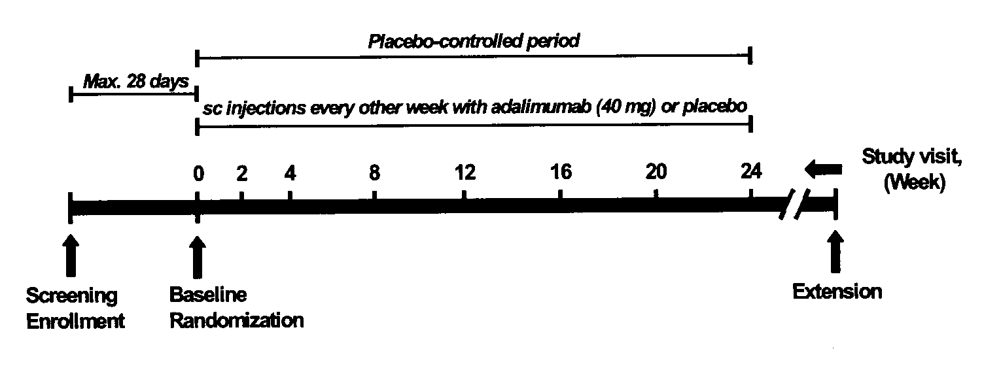
Figure 11: Study DE031 : Study Design

This study was designed to evaluate the safety and efficacy of adalimumab compared to a placebo control in patients with RA who were not adequately responding to other anti-rheumatic therapies and reflect the safety and efficacy that will be experienced post approval within usual current clinical practice. The study design reflected standard clinical practice, and therefore allowed adjunctive treatments and dose adjustments. A washout period for azathioprine and cyclosporine was chosen to decrease the potential for immunosuppression during the study.

Clinical adverse events (AEs), infections, immune reactions, malignancies, injection site reactions, changes in physical examinations, laboratory evaluations and vital signs were monitored. Chest x-rays and electrocardiograms (ECG) were done at study entry; an additional chest x-ray was performed at Week 12 in patients with positive tuberculin purified protein derivative (PPD) skin tests.

Eligibility consisted of RA patients with:

Inclusion criteria – major criteria for patients

- Patients were 18 years of age or older. Female patients of child-bearing potential had negative pregnancy test at screen.
- ACR criteria of active RA for at least 3 months (≥ 6 swollen joints and ≥9 tender joints)
- Receiving glucocorticoids equivalent to  ≥10 mg of prednisone daily
- DMARD dose was required to remain unchanged for at least 28 days
- All males and females of reproductive potential used a reliable method of contraception.

Exclusion criteria – major criteria for patients

- Who had received previous treatment with total lymphoid irradiation, monoclonal antibodies, alkylating agents, any TNF antagonist, intravenous (iv) immunoglobulin or any investigational agent
- History of cancer, lymphoproliferative disease, or positive HIV status.
- History of or current acute inflammatory joint disease other than RA
- History of unstable, persistent, or chronic medical conditions, infection, active tuberculosis or listeriosis, iv antibiotics within 30 days, or oral antibiotics within 14 days prior to screening
- Pregnant or breast-feeding.
- History of clinically significant drug or alcohol abuse, drug abuse, having received intra-articular, intramuscular, or iv administration of corticosteroids within 4 weeks evaluation,
- Joint surgery within 2 months prior to the screening evaluation.
- Abnormal laboratory values: hematological, hepatic or renal

Concomitant therapy

All concomitant therapies, including over-the-counter preparations, taken by the patient during the study were recorded on the CRF. Patients were allowed to continue drug therapies including antirheumatic therapies during the study except for azathioprine and/or cyclosporine. Patients continued to receive their pre-study dose of anti-rheumatic therapies. Anti-rheumatic therapies permitted for use during the study included DMARDs (hydroxychloroquine, leflunomide, methotrexate, parenteral gold, oral gold and sulfasalazine, or any combination of these or other DMARDs), NSAIDs and oral or intra-articular steroids. Doses of these DMARDs as well as concomitant prednisone (≤10 mg daily) and NSAIDs must have been stable for at least 28 days prior to screening. All efforts were made to keep the patient in the study during the 24-week placebo-controlled period.

Since this protocol was designed to reflect current clinical practice, the following adjunctive treatments and dose adjustments were allowed:
- Maximum of three intra-articular steroid injections were permitted during the first 3 months of the study (injected joint(s) were not assessed during joint examinations for 28 days following each injection).
- Dose of background DMARD, steroid, or NSAID therapies could be adjusted once during the study; further dose adjustments were instituted only after consultation with the medical monitor.

Secondary efficacy assessment - ACR20 response

The efficacy analysis was performed on the “full analysis set” of patients defined by the intent-to-treat principle. The full analysis set was defined as all patients who were randomized and received at least one injection of study drug and had at least one post-dose efficacy assessment. The ACR20 response at Week 24 (change from baseline) (using CRP as the acute phase reactant) was defined as the efficacy variable. All patients with missing visits or who withdrew from the study prematurely were counted as non-responders at the missing visits or from the time point of premature discontinuation onwards.

ACR20 response rates of the adalimumab and placebo-treated groups were compared using Pearson’s χ² test with a two-sided level of significance of α=0.05. All other efficacy variables were summarized descriptively (statistical characteristics, frequencies, percentages, confidence intervals) and analyzed by exploratory two-sided statistical tests. For categorical data, Pearson’s χ² test was used. For continuous data, an analysis of covariance (ANCOVA) model was used that included the treatment group as a factor and the respective baseline value as a covariate. In case of baseline imbalances between the treatment groups, further covariates could be added to the model.

A total of 400 patients were planned to be equally allocated to the two treatment groups, adalimumab 40 mg every other week and placebo. This sample size was chosen in order to increase the total number of patients exposed to adalimumab to approximately 300, thus allowing the study to be powered to show one adverse event with an incidence of 1% with at least 95% probability and with an incidence of 0.4% with at least 70% probability. Analysis of this enlarged safety database was intended for evaluation of any differences in AEs between patients treated with adalimumab versus standard rheumatologic care.

B. Study Conduct

Planned enrollment for this study was increased to 600 patients. Over 700 patients enrolled, 318 patients were randomized to each of the two treatment arms (adalimumab and placebo), and 91% of patients randomized to each treatment arm completed the study (Table 37). Dropouts occurred equally in both groups (9%). However, the number of dropouts due to lack of efficacy and/or progression of disease was higher in the placebo-treated group than in the adalimumab-treatment group. No increased incidence of withdrawals due to AEs was observed in the adalimumab-treatment group compared to the placebo-treated group.

A summary of patient disposition (all randomized patients) is presented in Figure 12 and
Table 37. Due to the fact that one of the investigators (Dr. DeAbate; Site #7) was undergoing proceedings to be debarred, patients enrolled at his site (6 patients) were removed from the efficacy analysis. All randomized patients are included in the demographic and safety analyses.

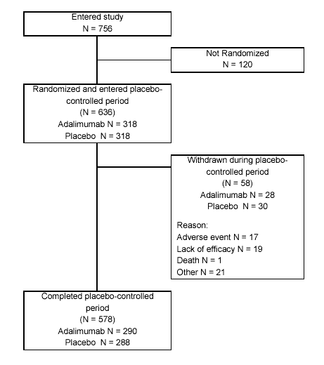

Figure 12 : StudyDE031 : Patient Disposition

Table 37 : Study DE031 : Patient Disposition (Number [%] of Patients) by Randomized Treatment Group (all randomized patients)

 | Treatment group
 | Adalimumab | Placebo | Total
Result | (N=318) | (N=318) | (N=636)
Completed study | 290 (91) | 288 (91) | 578 (91)
Early discontinuation | 28 (9) | 30 (9) | 58 (9)
Early withdrawals due to:
Adverse event | 9 (3) | 8 (3) | 17 (3)
Lost to follow-up | 2 (1) | 0 (0) | 2 (0)
Protocol deviations | 5 (2) | 3 (1) | 8 (1)
Death | 1 (0) | 0 (0) | 1 (0)
Lack of efficacy and/or  progression of disease | 5 (2) | 14 (4) | 19 (3)
Administrative reasons | 6 (2) | 5 (2) | 11 (2)

Table 38 : Study DE031 : Demographic characteristics at baseline by randomized treatment group (all randomized patients)

 | Adalimumab | Placebo
Demographic characteristic | (N=318) | (N=318)
Mean Age (years) | 55 | 56
Female (%) | 80 | 79
Ethnicity
Caucasian (%) | 89 | 86
Black (%) | 4 | 6
Hispanic (%) | 5 | 6
Mean Weight (kg) | 78 | 76
Mean RA duration (years) | 9 | 12
Rheumatoid Factor positive (%) | 63 | 62
RA-relevant previous disease  (at least one) (%) | 56 | 59
Tender joint count (median) | 25 | 25
Swollen joint count (median) | 18 | 19
Patient global assessment of disease activity (mm on VAS) | 53 | 52
Patient assessment of pain  (mm on VAS) | 57 | 58
Disability index (HAQ) | 1.38 | 1.38
CRP (mg/dL) (mean) | 1.5 | 1.5
FACIT Fatigue scale (median) | 30 | 30
DMARD therapy
DMARD discontinued prior (%) | 56 | 56
Concomitant RA-specific DMARD therapy (%) | 82 | 85
Concomitant RA-specific non-DMARD therapy (%) | 99 | 96
Increase in DMARD dose (%) | 2 | 4
Initiation of DMARD (%) | 1 | 3
Increase in steroid dose (%) | 4 | 6
Tuberculin PPD at baseline
(N/%)
PPD Positive | 7/2 | 4/1
PPD Positive-on prophylaxis | 4/1 | 3/1
PPD not stated-on prophylaxis | 1/0 | 1/0

  - Safety Analysis

Comparable percentages of patients in the adalimumab and placebo treatment groups reported one or more treatment-emergent AEs during the study. The percentage of patients with AEs considered to be at least possibly related to study drug according to the investigator’s assessment was higher in the adalimumab group than in the placebo group. Injection site reaction was significantly greater in patients receiving adalimumab than in patients receiving placebo. Neither the incidence of SAEs nor severe or life-threatening AEs was higher in the adalimumab-treated group. One death due to an AE was reported during the study. Patient #15106, treated with adalimumab, died following a SAE of herpes zoster, complicated by streptococcal superinfection (necrotizing fasciitis). No significant differences in the incidences of severe or life-threatening AEs, SAEs, or deaths were observed between the two treatment groups (Table 39). Summarization of all safety issues will be provide in the Integrated Safety Analysis.

Table 39 : Study DE031 : Overview of Patients with Treatment-Emergent AEs (safety set)
 | Adalimumab |  | Placebo |  | Adalimumab
 | (N = 318) |  | (N = 318) |  | vs.
 | (141.2 pt-yrs) |  | (139.9 pt-yrs) |  | Placebo
Patients with anyª | N (%) | N/100 pt-yrs^{b} | N (%) | N/100 pt-yrs^{b} | p<0.05^{c}
AE | 275 (87) | 194.8 | 263 (83) | 188.0 | -
AE leading to death | 1 (0) | 0.7 | 0 (0) | 0.0 | -
SAE | 17 (5) | 12.0 | 22 (7) | 15.7 | -
AE resulting in withdrawal | 9 (3) | 6.4 | 7 (2) | 5.0 | -
AE resulting in dose interruption | 38 (12) | 26.9 | 27 (9) | 19.3 | -
Severe or life-threatening AE | 38 (12) | 26.9 | 49 (15) | 35.0 | -
At least possibly drug-related AE | 147 (46) | 104.1 | 111 (35) | 79.3 | Yes
Infection | 166 (52) | 117.6 | 157 (49) | 112.2 | -
Serious infection | 4 (1) | 2.8 | 6 (2) | 4.3 | -
Malignancy | 4 (1) | 2.8 | 0 (0) | 0.0 | Yes
Immunologic reaction | 1 (0) | 0.7 | 1 (0) | 0.7 | -
AE except injection site reaction | 270 (85) | 191.2 | 258 (81) | 184.4 | -
At least possibly drug-related AE except injection site reaction | 117 (37) | 82.9 | 89 (28) | 63.6 | Yes
ª More than one AE per patient possible.
^{b} Number of patients with AEs per 100 patient-years.
^{c} Pearson’s ² test.

The numbers of patients reporting serious infections, malignancies, or immunologic reactions during this study were very small. The incidence of infections was similar for patients in the adalimumab and placebo treatment groups. A higher proportion of serious infections were reported in patients in the placebo-treated group (6 cases, 2%) compared to the adalimumab-treated group (4 cases, 1%). A higher proportion of patients in the adalimumab-treated group experienced malignancies (4 cases, 1%) compared to the placebo-treated patients (0 cases). The malignancies observed in the adalimumab-treated patients were 3 cases of basal cell carcinoma of the skin and one case of T-cell lymphoma. Patient 11601 was noted to have enlarged lymph nodes after three doses of study drug, was subsequently biopsied, and diagnosed with a T-cell lymphoma. The nominal p-value for the incidence of malignancies was <0.05. However, this does not take into account the multiple comparisons.

The mean duration and total number of injections of study drug were comparable in patients who received adalimumab or placebo. The mean total dose of adalimumab administered during the study was 481.4 mg.

A total of 9 (3%) of 318 adalimumab-treated patients and 7 (2%) of 318 placebo-treated patients withdrew from the study due to one or more treatment-emergent AEs. A summary of all patients who experienced AEs resulting in withdrawal is provided in Table 40. There were two cases of rashes and two cases of infections (infected foot and herpes zoster) among the adalimumab-treated patients leading to discontinuation from the study.
Table 40 : Study DE031 Patients Withdrawn Due to Treatment-Emergent AEs (safety set)
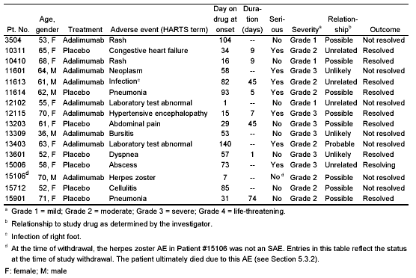
Comparison of the AEs subsetted by concomitant DMARD subgroups is summarized in
Table 41. A higher rate of certain categories of associated AEs with certain concomitant DMARDs was seen. AEs resulted in a higher incidence of dose interruption when leflunomide was combined with adalimumab (8 cases, 19%) compared to placebo (1 case, 2%). In addition, AEs at least possibly adalimumab-related were more frequent when adalimumab was given concomitantly with MTX, leflunomide, and other DMARDs, but not with antimalarials and sulfasalazine. A higher rate of SAEs was seen among placebo-treated patients than adalimumab-treated patients when given concomitantly with MTX and antimalarials.

Comparison of the number (percentage) of patients with the most frequently reported treatment-related AEs subsetted by number of concomitant DMARDs, shows a higher incidence of AEs that were considered drug-related when adalimumab is given alone or with one additional DMARD compared to placebo. There was no clear pattern of an increase in AEs overall among patients receiving adalimumab along with two or three additional DMARDs (Table 42).

Comparison of the number (percentage) of patients with the most frequently reported treatment-related AEs by concomitant DMARD therapy does not demonstrate a higher frequency of adalimumab-related AEs (Table 43). Comparison of the number (percentage) of patients with the most frequently reported treatment-related AEs corrected for frequency per 100 patient years reveals that rash, injection site reaction, and back pain were seen more frequently among adalimumab-treated patients \than placebo-treated patients with a nominal p value of < 0.05.

Table 41 : Study DE031 : Overview of Treatment-Emergent AEs by Concomitant DMARD Therapyª (safety set)

 | Methotrexate |  | Antimalarials |  | Leflunomide |  | Sulfasalazine |  | Other DMARDs
 | Adalimumab | Placebo | Adalimumab | Placebo | Adalimumab | Placebo | Adalimumab | Placebo | Adalimumab | Placebo
 | (N=178) | (N=199) | (N=75) | (N=82) | (N=42) | (N=46) | (N=29) | (N=33) | (N=25) | (N=25)
Patients with anyª | N (%) | N (%) | N (%) | N (%) | N (%) | N (%) | N (%) | N (%) | N (%) | N (%)
Adverse Event | 153 (86) | 161 (81) | 63 (84) | 74 (90) | 39 (93) | 39 (85) | 23 (80) | 28 (85) | 23 (92) | 19 (76)
AE leading to death | 1 (1) | 0 (0) | 0 (0) | 0 (0) | 0 (0) | 0 (0) | 0 (0) | 0 (0) | 0 (0) | 0 (0)
SAE | 8 (5) | 17 (9) | 4 (5) | 7 (9) | 3 (7) | 2 (4) | 2 (7) | 1 (3) | 0 (0) | 0 (0)
AE resulting in withdrawal | 5 (3) | 4 (2) | 0 (0) | 2 (2) | 2 (5) | 1 (2) | 0 (0) | 0 (0) | 0 (0) | 0 (0)
AE resulting in dose interruption | 16 (9) | 13 (7) | 7 (9) | 6 (7) | 8 (19) | 1 (2) | 2 (7) | 4 (12) | 1 (4) | 3 (12)
Severe or life-threatening AE | 19 (11) | 28 (14) | 7 (9) | 13 (16) | 8 (19) | 8 (17) | 5 (17) | 5 (15) | 1 (4) | 2 (8)
At least possibly drug-related AE | 78 (44) | 67 (34) | 37 (49) | 40 (49) | 23 (55) | 18 (39) | 14 (48) | 14 (42) | 14 (56) | 9 (36)
Infection | 100 (56) | 96 (48) | 34 (45) | 48 (59) | 24 (57) | 21 (46) | 13 (45) | 15 (46) | 14 (56) | 15 (60)
Serious infection | 4 (2) | 4 (2) | 1 (1) | 3 (4) | 0 (0) | 2 (4) | 1 (3) | 0 (0) | 0 (0) | 0 (0)
Malignancy | 2 (1) | 0 (0) | 0 (0) | 0 (0) | 0 (0) | 0 (0) | 0 (0) | 0 (0) | 0 (0) | 0 (0)
Immunologic reaction | 0 (0) | 1 (1) | 0 (0) | 1 (1) | 0 (0) | 0 (0) | 1 (3) | 0 (0) | 0 (0) | 0 (0)
ª .More than one AE per patient possible.

Table 42 : Study DE031 : Overview of Treatment-Emergent AEs by Number of Concomitant DMARD Therapies (safety set)

Number of concomitant DMARDs | 0 |  |  | 1 |  | 2 |  | 3
 | Adalimumab | Placebo |  | Adalimumab | Placebo | Adalimumab | Placebo | Adalimumab | Placebo
 | (N=57) | (N=48) |  | (N=184) | (N=172) | (N=66) | (N=84) | (N=11) | (N=14)
Patients with anyª | N (%) | N (%) |  | N (%) | N (%) | N (%) | N (%) | N (%) | N (%)
AE | 46 (81) | 36 (75) |  | 166 (90) | 145 (84) | 54 (82) | 72 (86) | 9 (82) | 10 (71)
AE leading to death | 0 (0) | 0 (0) |  | 1 (1) | 0 (0) | 0 (0) | 0 (0) | 0 (0) | 0 (0)
SAE | 3 (5) | 2 (4) |  | 12 (7) | 13 (8) | 1 (2) | 7 (8) | 1 (9) | 0 (0)
AE resulting in withdrawal | 2 (4) | 1 (2) |  | 7 (4) | 5 (3) | 0 (0) | 1 (1) | 0 (0) | 0 (0)
AE resulting in dose interruption | 10 (18) | 4 (8) |  | 22 (12) | 19 (11) | 6 (9) | 4 (5) | 0 (0) | 0 (0)
Severe or life-threatening AE | 7 (12) | 7 (15) |  | 23 (13) | 30 (17) | 7 (11) | 10 (12) | 1 (9) | 2 (14)
At least possibly drug-related AE | 22 (39) | 11 (23) |  | 90 (49) | 60 (35) | 29 (44) | 33 (39) | 6 (55) | 7 (50)
Infection | 28 (49) | 17 (35) | 99 (54) |  | 93 (54) | 31 (47) | 41 (49) | 8 (73) | 6 (43)
Serious infection | 0 (0) | 0 (0) |  | 3 (2) | 3 (2) | 0 (0) | 3 (4) | 1 (9) | 0 (0)
Malignancy | 2 (4) | 0 (0) |  | 2 (1) | 0 (0) | 0 (0) | 0 (0) | 0 (0) | 0 (0)
Immunologic reaction | 0 (0) | 0 (0) |  | 1 (1) | 0 (0) | 0 (0) | 1 (1) | 0 (0) | 0 (0)
ª More than one AE per patient possible.

Table 43: Study DE031: Number (%) of Patients with The Most Frequently Reported Treatment-Emergent AEs by Concomitant DMARD Therapy (safety set)

AEs^{c} | Methotrexate |  | Antimalarials |  | Leflunomide |  | Sulfasalazine |  | Other
 | Adalimumab | Placebo | Adalimumab | Placebo | Adalimumab | Placebo | Adalimumab | Placebo | Adalimumab | Placebo
 | (N=178) | (N=199) | (N=75) | (N=82) | (N=42) | (N=46) | (N=29) | (N=33) | (N=25) | (N=25)
 | N (%) | N (%) | N (%) | N (%) | N (%) | N (%) | N (%) | N (%) | N (%) | N (%)
Upper respiratory infection | 32 (18) | 28 (14) | 16 (21) | 18 (22) | 7 (17) | 8 (17) | 6 (21) | 5 (15) | 9 (36) | 5 (20)
Injection site pain | 20 (11) | 22 (11) | 10 (13) | 12 (15) | 6 (14) | 7 (15) | 2 (7) | 2 (6) | 3 (12) | 1 (4)
Rash | 16 (9) | 8 (4) | 3 (4) | 4 (5) | 5 (12) | 3 (7) | 3 (10) | 2 (6) | 2 (8) | 3 (12)
Injection site reaction | 13 (7) | 2 (1) | 8 (11) | 2 (24) | 4 (10) | 0 (0) | 3 (10) | 1 (3) | 2 (8) | 0 (0)
Nausea | 16 (9) | 11 (6) | 10 (13) | 4 (5) | 6 (14) | 3 (7) | 3 (10) | 2 (6) | 1 (4) | 0 (0)
Urinary tract infection | 21 (12) | 10 (5) | 6 (8) | 7 (9) | 5 (12) | 1 (2) | 0 (0) | 2 (6) | 1 (4) | 2 (8)
Headache | 13 (7) | 13 (7) | 12 (16) | 9 (11) | 3 (7) | 2 (4) | 3 (10) | 3 (9) | 0 (0) | 1 (4)
Sinusitis | 16 (9) | 13 (7) | 9 (12) | 9 (11) | 2( 5) | 2 (4) | 0 (0) | 2 (6) | 0 (0) | 4 (16)
Flu syndrome | 13 (7) | 7 (4) | 5 (7) | 3 (4) | 2 (5) | 2 (4) | 2 (7) | 1 (3) | 2 (8) | 3 (12)
Accidental injury | 16 (9) | 11 (6) | 6 (8) | 9 (11) | 3 (7) | 4 (9) | 3 (10) | 3 (9) | 1 (4) | 2 (8)
Abdominal pain | 9 (5) | 9 (5) | 2 (3) | 5 (6) | 2 (5) | 1 (2) | 3 (10) | 1 (3) | 0 (0) | 0 (0)
Rhinitis | 17 (10) | 24 (12) | 5 (7) | 9 (11) | 2 (5) | 6 (13) | 3 (10) | 3 (9) | 2 (8) | 1 (4)
Diarrhea | 14 (8) | 12 (6) | 6 (8) | 7 (9) | 3 (7) | 7 (15) | 1 (3) | 2 (6) | 1 (4) | 0 (0)
Clinical flare reaction | 8 (5) | 10 (5) | 3 (4) | 5 (6) | 3 (7) | 3 (7) | 4 (14) | 2 (6) | 1 (4) | 2 (8)
Back pain | 11 (6) | 3 (2) | 2 (3) | 1 (1) | 4 (10) | 1 (2) | 3 (10) | 2 (6) | 4 (16) | 0 (0)
Surgery | 8 (5) | 6 (3) | 5 (7) | 3 (4) | 3 (7) | 0 (0) | 0 (0) | 1 (3) | 1 (4) | 0 (0)
ª Occurring in 5% of patients in any treatment group.
^{b} MTX = methotrexate; Antimal = antimalarials (eg, HCG, chloroquine); Leflu = leflunomide; Sulfasal = sulfasalazine; Other = other DMARDs.
^{c} More than one AE per patient possible.

Table 44 lists all the patients in Trial DE031 with SAEs. Eighteen occurred among adalimumab-treated patients and 22 occurred among placebo-treated patients. There was no clear pattern of SAEs among adalimumab-treated patients.

Table 44 : Study DE031 : Patients with SAEs (safety set)
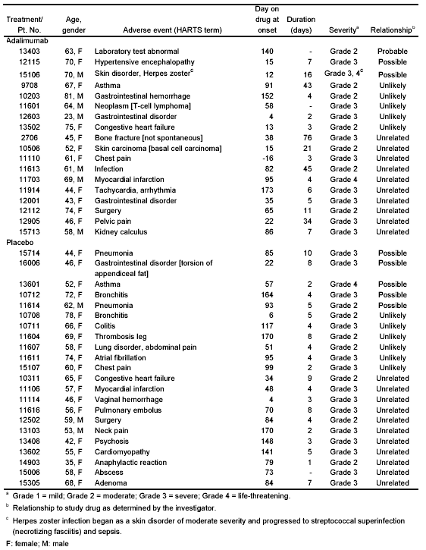

One adalimumab-treated patient (Patient #15106) died during the study (Table 45). This patient developed herpes zoster 12 days after the first injection of adalimumab, which then progressed into a streptococcal group A superinfection at the site of the herpes lesions. This progressed to necrotizing fasciitis and sepsis. The patient was admitted to the hospital and underwent surgical debridement of the lesion. The patient never recovered and died 16 days after the appearance of the herpetic lesions. This adalimumab-treated patient was also taking prednisone and methotrexate for control of RA.

Table 45 : Study DE031 Patient with fatal AE (safety set)

Patient  number | Age Gender | Treatment | Adverse event  (HARTS term) | Day on drug  at onset | Duration  (days) | Severity | Relationshipª
 |  |  | Skin disorder
15106 | 70  Male | Adalimumab | Herpes zoster^{b} | 12 | 16 | Grade  3, 4^{b} | Possible
ª Relationship to study drug as determined by the investigator.
^{b} Herpes zoster infection began as a skin disorder of moderate severity and progressed to streptococcal superinfection (necrotizing fasciitis) and sepsis.

Serious infectious AEs were reported in ten study patients, 4 (1.3% of 318) adalimumab-treated patients and 6 (1.9% of 318) placebo-treated patients (Table 46). Among the adalimumab-treated patients, there were 2 cases of gastrointestinal disorder (appendicitis), 1 case of herpes zoster, and 1 case of foot infection. Approximately 50% of both adalimumab-treated and placebo-treated patients reported one or more non-serious infectious AEs after study drug administration.

Table 46 : Study DE031 : Patients with serious infections (safety set)

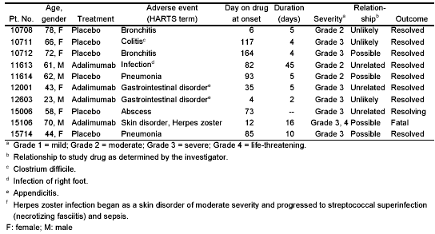

The six most frequently reported infectious AEs (upper respiratory infection, rhinitis, sinusitis, urinary tract infection, flu syndrome, and cough increased) are presented by concomitant DMARDs subgroups (with and without methotrexate, antimalarials, leflunomide, sulfasalazine, or other DMARDs) in Table 47 and summarized by the number of concomitant DMARDs in Table 48. There was no clear pattern of an increase in any particular type of infection beyond the fluctuations expected when large numbers of comparisons are considered.

Although there were individual subgroups where the incidence of particular infections was somewhat higher in adalimumab-treated patients than in controls, there was no overall pattern of more frequent infections associated with concomitant use of higher numbers of DMARDs (Table 48).
Table 47: Study DE031 Frequent infectious adverse events by concomitant DMARD therapy (safety set)

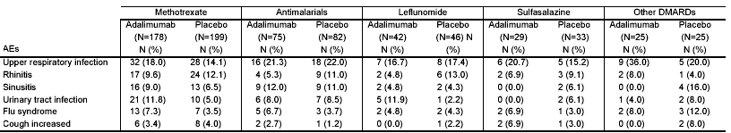

Table 48: Study DE031:Frequency of the most commonly reported infectious adverse events by number of concomitant DMARD therapies (safety set)

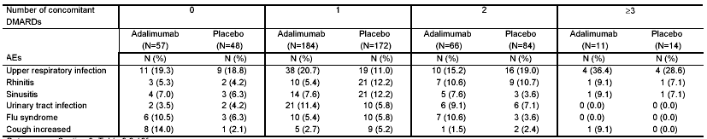

Similar numbers of adalimumab-treated patients and placebo-treated patients withdrew from the study due to one or more treatment-emergent AEs.

A higher percentage of adalimumab-treated patients converted from negative to positive ANA than placebo-treated patients during this trial. The percentage was notably higher at Week 24 than at Week 12 (Table 49 ).

Table 49 : Study DE031 : Patients who changed from positive to negative or negative to positive ANA until Week 12 or Week 24 ª (safety set)

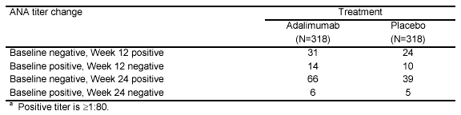

Likewise, a higher percentage of adalimumab-treated patients converted from negative to positive anti-dsDNA than placebo-treated patients during this trial. The percentage was much higher at Week 24 (Table 50 ). One patient with rising ANA and anti-dsDNA titers was discontinued from the study. No clinical manifestations of lupus-like syndrome were observed among patients who became positive for autoantibodies.

Table 50: Study DE031 : Patients who changed from positive to negative or negative to positive anti-dsDNA until Week 12 or Week 24 ª (safety set)

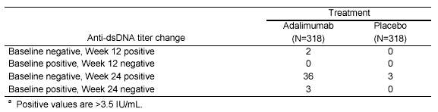

D. Efficacy Analysis

Clinical trial DE031 was designed to study the safety and efficacy of adding adalimumab to DMARD regimens encountered in a typical clinical practice. Adalimumab was given alone or in combination with other DMARDs that patients were already receiving. The study assessed the efficacy of adalimumab (40 mg) administered subcutaneously every other week for up to 24 weeks in patients with RA whose disease was not adequately treated with their current antirheumatic therapies. The efficacy assessment was a comparison of the ACR20 response rates (using CRP as the acute phase reactant) between adalimumab and placebo treatments. Adalimumab demonstrated a greater degree of improvement (53%) than placebo (35%) for the observed ACR20 response rate at Week 24 (Table 51).

Table 51 : Study DE031 :ACR20 response rate: number (%) of patients responding over time by randomized treatment group (full analysis set)

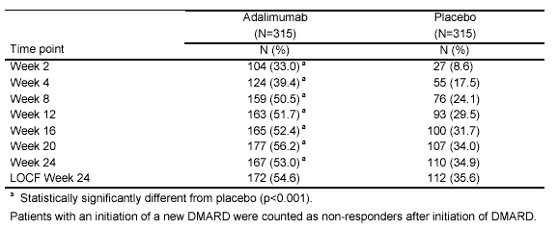

Since this study was designed to approximate usual clinical practice, use of intra-articular injections and the ability to adjustment of DMARD and corticosteroid doses were permitted. The frequency of increases in DMARD and corticosteroid dosing was higher in the placebo group (Table 53) which would tend to increase the placebo response rate disproportionately. This may have contributed to the relatively high 35% ACR20 response rate at Week 24 (the highest ACR20 placebo response observed in the clinical development program, when compared to the placebo responses in trials DE009 [13%], DE011 [19%], and DE019 [30%]).

ACR20 response rates are displayed graphically over the 24 week time course for adalimumab-treated patients and placebo-treated patients in Figure 13. The onset of this response was rapid and sustained.

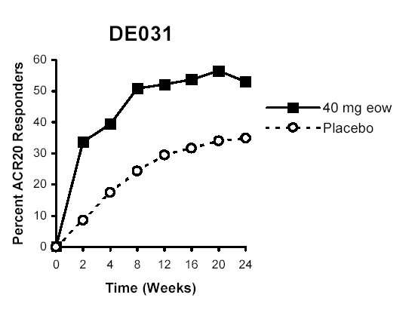
Figure 13 : Study DE031 :Time course of ACR20 responses by randomized treatment group

Adalimumab-treated patients taking concomitant methotrexate, antimalarial treatments, or sulfasalazine demonstrated a higher ACR20 response rate than placebo patients taking similar DMARDs. However, adalimumab patients taking concomitant leflunomide had a similar ACR20 response rate to placebo at Week 24 (33% and 37%, respectively) (Table 52). The patients receiving concomitant leflunomide were examined in more detail to determine whether there was a reduced treatment effect of adalimumab when added to leflunomide. First, earlier responses than Week 24 were examined. At Week 12, the ACR20 response rate for the adalimumab patients taking concomitant leflunomide was 41%, and for placebo plus leflunomide was 17%.

The lower response rate at Week 24 for adalimumab patients treated with leflunomide may have been influenced by a number of factors:

1). The higher number of patient withdrawals in the adalimumab plus concomitant leflunomide group. Of the patients receiving concomitant leflunomide, 7 of 42 (17%) adalimumab-treated patients but only 3 of 46 (7%) placebo-treated patients were withdrawn from the study prematurely. There was no pattern of reasons for withdrawal in either group. Of note, three of the adalimumab-treated early withdrawal patients had demonstrated ACR20 responses prior to being withdrawn, compared to one of the placebo-treated early withdrawal patients.

2). Patients treated with placebo plus concomitant leflunomide had an increase in ACR20 response from Week 12 to 24 probably due to the greater use of rescue steroids in this group (30%) compared to adalimumab plus concomitant leflunomide (14%). Among patients taking concomitant leflunomide, 5 of 46 (11%) placebo patients but only 1 of 42 (2%) adalimumab-treated patients received rescue steroid treatment before reaching ACR20 criteria.

Furthermore, thirty-five of the placebo plus leflunomide patients in this study rolled over into DE020, an open-label adalimumab 40 mg biweekly study. Their ACR20 response rate increased from 23% at study entry to 54% at Week 12.

Thus, the early withdrawals may have decreased the overall adalimumab-treated patient response, and the higher ACR20 response rate demonstrated by the placebo-treated patients in this study could be attributed to the greater rescue initiation of DMARDs, increased dosages of DMARDs and steroids, and intra-articular injections (Table 53). Data detailing the frequency and medications utilized for intra-articular injections were not provided.

Table 52: Study DE031 : Concomitant Medication at Week 24 for ACR20

 | ACR 20
 | Adalimumab |  | Placebo
Concomitant medication | Total N | % Response | Total N | % Response
Methotrexate | 178 | 57 | 199 | 35
Antimalarial | 75 | 51 | 82 | 33
Leflunomide | 42 | 33 | 46 | 37
Sulfasalazine | 29 | 59 | 33 | 24
Other DMARDs | 25 | 52 | 25 | 44
No DMARD | 54 | 50 | 45 | 33
One DMARD | 184 | 55 | 172 | 38
Two DMARDs | 66 | 50 | 84 | 30
Three or more DMARDs | 11 | 46 | 14 | 36
Antimalarial (e.g., HCG, chloroquine)

Table 53: Study DE031 : Incidence of DMARD or Steroid Therapy Change
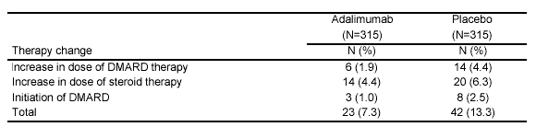
E. Summary of Analyses for Study DE031

This trial was designed to mimic typical clinical practice where adalimumab would be given alone or in combination with other DMARDs. The study assessed the efficacy of adalimumab administered 40 mg subcutaneously every other week for up to 24 weeks to patients with RA whose disease was not adequately treated with their current antirheumatic therapies. The efficacy assessment, a comparison of the ACR20 responses, demonstrated a greater degree of improvement in the adalimumab-treated patients (53%) than placebo (35%) at 24 weeks. Similar efficacy was seen for adalimumab regardless of the background DMARD regimen

Comparable percentages of patients in the adalimumab and placebo treatment groups reported one or more treatment-emergent AEs during the study. However AEs considered to be at least possibly related to study drug were more frequent in the adalimumab group than in the placebo group. Injection site reaction was seen more frequently in patients receiving adalimumab than in patients receiving placebo. The incidence of infections was similar for patients in the adalimumab and placebo treatment groups. The proportion of adalimumab-treated patients experiencing serious infections was similar to placebo-treated controls. However, there was one death in the adalimumab-treatment group in a patient with herpes zoster complicated by streptococcal superinfection (necrotizing fasciitis). No pattern of an increase in AEs or SAEs was seen when adalimumab was combined with any specific DMARD or combination of DMARDs.

A higher proportion of patients in the adalimumab-treated group experienced malignancies compared to the placebo–treated patients. The malignancies observed in the adalimumab-treated patients were three cases of basal cell carcinoma and one case of T-cell lymphoma. The rate of malignancies in patients receiving adalimumab will be considered further in the Integrated Safety Analysis

A higher percentage of adalimumab-treated patients converted from negative to positive ANA and positive anti-dsDNA than placebo-treated patients during this trial. No clinical autoimmune disease was observed. The evidence of auto antibodies and autoimmune disease will be discussed further in the Integrated Safety Analysis.

VI. Integrated Safety Analysis

A. Safety Database

Safety data from all US and non-US (Europe, Australia, and Canada) sources that were available as of August 31, 2001 were integrated within this integrated summary of safety information (hereafter referred to as the ‘ISS’) to provide a comprehensive safety profile for adalimumab in this patient population. Safety data related to deaths, malignancies, serious adverse events, and serious infections were up-dated as of August 31, 2002. A total of 20 clinical trials completed during the adalimumab clinical development program are included in the integrated safety database (Table 54).
Table 54: ISS : Studies contributing safety information to the adalimumab integrated safety database
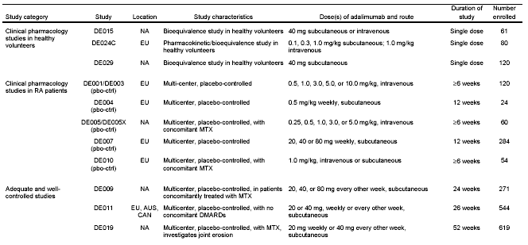
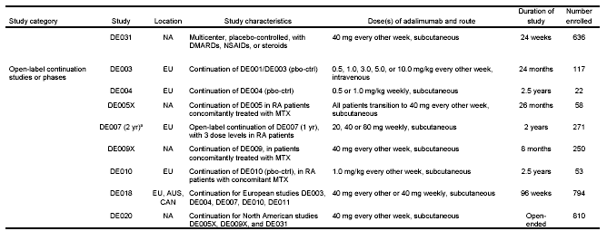
Source of data: sponsor’s ISS Table 1
AUS: Australia ; EU: Europe ; NA : North America (including U.S. and Canada) ; CAN : Canada
MTX = methotrexate ; pbo-ctrl = placebo-controlled
ª Includes a 9-month blinded continuation period that followed DE017
The overall body of adalimumab safety data presented in this section evaluates safety concerns
related to:

- The short- and long-term safety and tolerability of adalimumab.
- Safety of adalimumab when used alone or in combination with methotrexate or other DMARDs.
- Safety of adalimumab when administered subcutaneously at the recommended dose of 40 mg every other week, and at the higher dose of 40 mg weekly.
- Adverse events (AEs) experienced by RA patients treated with adalimumab, frequency and severity.
- Incidences and types of serious infections, malignancies, autoimmune disorders, and deaths associated with adalimumab treatment, particularly in patients exposed to higher than recommended doses.
- Incidence and effects of elevated anti-nuclear antibodies (ANAs), anti-double stranded
deoxyribonucleic acid (anti-dsDNA) titers, and human anti-human antibodies (HAHAs) observed in some RA patients treated with adalimumab.
- Any apparent effect on the safety profile of adalimumab by the development of HAHAs
or by prolonged dose interruptions.

Overall, the mean age of the patients treated with adalimumab was 55 years. Most adalimumab-treated patients (77%) were female, and the majority of adalimumab-treated patients (91%) were Caucasian. The mean duration of RA was 131 months and 80% of subjects were RF positive at baseline. Many of the patients were receiving DMARDs at baseline and during the studies. Concomitant medications included MTX in 49% of all patients and corticosteroids in 57%. With regard to co-morbid conditions among patients, hypertension was reported in 27%, diabetes in 6%, COPD in 4%, and CHF in 1% of patients.

A total of approximately 1600 patients received treatment with adalimumab at the proposed dosage of 40 mg biweekly for ≥ 6 months and approximately 800 patients received treatment at that dose for ≥ 12 months (Table 55). The supplemental safety update provided safety data for approximately 2400 adalimumab-treated patients.

Table 55: ISS : Summary of the Duration of Exposure to Adalimumab by Treatment Received in all RA Patients

 | Adalimumab
 | 20 mg  Q2w sc  (N=175) | 20 mg  wk sc  (N=397) | 40 mg  Q2w sc  (N=1903) | 40 mg  wk sc  (N=466) | All  sc doses^{b}  (N=2263) | All  iv doses^{c}  (N=197) | All  adalimumab  (N=2334)
Duration of
exposureª
Duration of  exposureª | N (%) | N (%) | N (%) | N (%) | N (%) | N (%) | N (%)
<3 month | 23 (13) | 39 (10) | 117 (6) | 55 (12) | 95 (4) | 31 (16) | 109 (5)
3-<6 months | 41 (23) | 49 (12) | 193 (10) | 78 (17) | 139 (6) | 17 (9) | 152 (7)
6-<12 months | 111 (63) | 108 (27) | 798 (42) | 151 (32) | 593 (26) | 14 (7) | 576 (25)
12-<18 months | 0 (0) | 200 (50) | 669 (35) | 88 (19) | 945 (42) | 46 (23) | 908 (39)
18-<24 months | 0 (0) | 0 (0) | 122 (6) | 48 (10) | 214 (10) | 9 (5) | 195 (8)
24-<36 months | 0 (0) | 1 (0) | 4 (0) | 46 (10) | 195 (9) | 32 (16) | 241 (10)
36-<48 months | 0 (0) | 0 (0) | 0 (0) | 0 (0) | 82 (4) | 48 (24) | 108 (5)
48 months | 0 (0) | 0 (0) | 0 (0) | 0 (0) | 0 (0) | 0 (0) | 45 (2)
wk = weekly Q2w = every other week sc = subcutaneous iv = intravenous
ª The duration intervals are defined as follows: <3 months = 1-90 days; 3-<6 months = 91-163 days;
6-<12 months = 164-344 days; 12-<18 months = 345-527 days; 18-<24 months = 528-709 days;
24-<36 months = 710-1074 days; 36-<48 months = 1075-1439 days; 48 months = 1440 days.
^{b} includes 80 (1.0 mg/kg) eow or wk.
^{c} 0.25, 0.50, 1.0, 3.0, 5.0, 10.0 mg/kg eow or wk.

B. Treatment-Emergent Adverse Events

Table 56 presents an overview of adverse events observed during the adequate and well-controlled trials. Because patients receiving different regimens had widely varying duration of exposure, rates are calculated as events per 100 patient-years to provide a common metric. Four categories of events of special interest were observed to occur among patients at a higher frequency per 100 patient-years in the adalimumab-treatment groups compared to placebo: deaths, drug-related AEs, deaths, malignancies, and infections (serious and non-serious). These will be described in more detail.

Table 56 : ISS : Overview of number (number/100 patient years) of patients with treatment-emergent AEs during the placebo-controlled period, by randomized treatment – adequate and well-controlled studies (safety set)

 | Adalimumab
 | 20 mg Q2w sc  (N=175) |  | 20 mg wk sc  (N=324) |  | 40 mg Q2w sc  (N=705) |  | 40 mg wk sc  (N=103) |  | 80 mg Q2w sc  (N=73) |  | All adalimumab  (N=1380) |  | Placebo  (N=690)
Patients with any ª  AE | N (N/100PY) |  | N (N/100PY) |  | N (N/100PY) |  | N (N/100PY) |  | N (N/100PY) |  | N (N/100PY) |  | N (N/100PY)
Patients with any ª  AE | 170 | (238) | 312 | (132) | 638 | (160) | 102 | (211) | 64 | (205) | 1286 | (164) | 598 |  | (165)
Clinical AE | 165 | (231) | 298 | (126) | 620 | (156) | 97 | (201) | 64 | (205) | 1244 | (158) | 573 |  | (158)
Laboratory AE | 106 | (148) | 152 | (64) | 216 | (54) | 89 | (184) | 6 | (19) | 569 | (72) | 178 |  | (49)
Fatal AE | 0 | (0.0) | 1 | (0.4) | 5 | (1.3) | 1 | (2.1) | 0 | (0) | 7 | (0.9) | 1 |  | (0.3)
SAE | 17 | (24) | 53 | (23) | 61 | (15) | 14 | (29) | 6 | (19) | 151 | (19) | 60 |  | (17)
AE leading to withdrawal | 11 | (15) | 27 | (11) | 45 | (11) | 5 | (10) | 3 | (10) | 91 | (12) | 29 |  | (8)
AE leading to dose interruption | 16 | (22) | 74 | (31) | 103 | (26) | 17 | (35) | 14 | (45) | 224 | (29) | 86 |  | (24)
AE leading to dose reduction | 0 | (0.0) | 1 | (0) | 0 | (0) | 0 | (0) | 0 | (0) | 1 | (0) | 0 |  | (0)
Severe or life-threatening/intractable AE | 45 | (63) | 83 | (35) | 113 | (28) | 22 | (46) | 7 | (22) | 270 | (34) | 114 |  | (32)
At least possibly drug-related AE | 112 | (156.7) | 198 | (84.0) | 376 | (94) | 71 | (146.9) | 35 | (112.0) | 792 | (100.8) | 280 |  | (77)
Infection (serious and non-serious) | 93 | (130.1) | 196 | (83.1) | 398 | (100) | 51 | (105.5) | 45 | (144.1) | 783 | (99.7) | 334 |  | (92)
Serious infection | 2 | (2.8) | 10 | (4.2) | 18 | (4.5) | 3 | (6.2) | 1 | (3.2) | 34 | (4.3) | 7 |  | (1.9)
Malignancy | 2 | (2.8) | 5 | (2.1) | 10 | (2.5) | 1 | (2.1) | 1 | (3.2) | 19 | (2.4) | 2 |  | (<1)
Immunologic reaction | 1 | (1.4) | 2 | (0.8) | 6 | (1.5) | 1 | (2.1) | 0 | (0) | 10 | (1.3) | 4 |  | (1.1)
wk = weekly Q2w = every other week sc = subcutaneous
ª More than one AE per patient possible.

The most frequently observed adverse drug reactions were injection site reactions, rhinitis, upper respiratory infection, abnormal laboratory test, and rash.

The rate of adverse events was approximately one AE per year and one serious event per 4 to 5 years among adalimumab-treated and placebo-treated patients. Adalimumab-treated patients experienced a higher incidence of laboratory AEs and serious infections (Table 57).

Table 57 : ISS :Overview of number (%) of patients with treatment-emergent AEs in patients treated with adalimumab during placebo-controlled and non-placebo-controlled periods, by treatment received – all studies in RA patients (safety set)

 | Adalimumab  40 mg Q2w sc  (N=1903) |  |  |  | All adalimumab doses sc and iv  (N=2334) |  |  |  | Placebo-Treated Patients from the Adequate and  Well-Controlled Studies  (N=690)
Patients with anyª | N (%) |  | E (E/100  pt-yrs) |  | N (%) |  | E (E/100  pt-yrs) |  | N (%) |  | E (E/100  pt-yrs)
AE | 1765 | (93) | 12172 | (786) | 2221 | (95) | 30775 | (1042) | 589 | (87) | 3304 | (912)
Clinical AE | 1675 | (88) | 9003 | (582) | 2180 | (93) | 19699 | (667) | 573 | (83) | 2769 | (764)
Laboratory AE | 886 | (47) | 3169 | (205) | 1201 | (52) | 11076 | (375) | 178 | (26) | 535 | (148)
Fatal AE^{b} | 9 | (1) | 16 | (1) | 22 | (1) | 41 | (1) | 1 | (0) | 3 | (1)
SAE | 294 | (15) | 404 | (26) | 575 | (25) | 1022 | (35) | 60 | (9) | 75 | (21)
AE leading to withdrawal | 114 | (6) | 162 | (11) | 252 | (11) | 353 | (12) | 29 | (4) | 39 | (11)
AE leading to dose interruption | 340 | (18) | 522 | (34) | 614 | (26) | 1106 | (37) | 86 | (13) | 124 | (34)
AE leading to dose reduction | 2 | (0) | 2 | (0) | 23 | (1) | 43 | (2) | 0 | (0) | 0 | (0)
Severe or life-threatening/intractable AE | 372 | (20) | 610 | (39) | 734 | (31) | 1482 | (50) | 114 | (17) | 220 | (61)
At least possibly drug-related AE | 984 | (52) | 3214 | (208) | 1550 | (66) | 8620 | (292) | 280 | (41) | 850 | (235)
Infection (serious and non-serious) | 1061 | (56) | 2209 | (143) | 1573 | (67) | 4507 | (153) | 334 | (48) | 591 | (163)
Serious infection | 56 | (3) | 61 | (4) | 129 | (6) | 146 | (5) | 7 | (1) | 7 | (2)
Malignancy | 29 | (2) | 30 | (2) | 52 | (2) | 53 | (2) | 2 | (0) | 2 | (1)
Immunologic reaction | 16 | (1) | 19 | (1) | 38 | (2) | 49 | (2) | 4 | (1) | 4 | (1)
Q2w = every other week sc = subcutaneous iv = intravenous
ª More than one AE per patient possible.
^{b} Can include more than one AE ongoing at time of death.

Increasing age among adalimumab-treated patients is associated with an increased frequency of occurrence of malignancies, SAEs, and AEs resulting in dose interruption (Table 58). These percentages increased as age increased over 65 and even higher over age 75 in both those patients treated with adalimumab and those receiving placebo. The percentage of patients with fatal AEs, which only occurred in the adalimumab–treated group, also increased in frequency with advancing age.

Table 58 : ISS : Overview of number (%) of patients with treatment-emergent AEs, by age - adequate and well controlled studies (safety set)

 | Adalimumab  40 mg Q2w sc |  |  |  |  |  | Placebo
 | <65  (N=526) |  | 65  (N=179) |  | 75  (N=42) |  | <65  (N=520) |  | 65  (N=170) |  |  75  (N=34)
Patients with anyª AE | N | % | N | % | N | % | N | % | N | % | N | %
Patients with anyª AE | 475 | (90) | 163 | (91) | 39 | (93) | 457 | (88) | 141 | (83) | 25 | (74)
Clinical AE | 461 | (88) | 159 | (89) | 39 | (93) | 435 | (84) | 138 | (81) | 24 | (71)
Laboratory AE | 167 | (32) | 49 | (27) | 13 | (31) | 141 | (27) | 37 | (22) | 5 | (15)
Fatal AE | 0 | ( 0) | 5 | ( 3) | 3 | ( 7) | 0 | ( 0) | 1 | ( 1) | 0 | ( 0)
SAE | 31 | ( 6) | 30 | (17) | 9 | (21) | 40 | ( 8) | 20 | (12) | 5 | (15)
AE leading to withdrawal | 23 | ( 4) | 22 | (12) | 5 | (12) | 18 | ( 4) | 11 | ( 7) | 4 | (12)
AE leading to dose interruption | 67 | (13) | 36 | (20) | 11 | (26) | 64 | (12) | 22 | (13) | 6 | (18)
AE leading to dose reduction | 0 | ( 0) | 0 | ( 0) | 0 | ( 0) | 0 | ( 0) | 0 | ( 0) | 0 | (.0)
Severe or life-threatening/intractable AE | 67 | (13) | 46 | (26) | 7 | (17) | 78 | (15) | 36 | (21) | 7 | (21)
At least possibly drug-related AE | 282 | (54) | 94 | (53) | 17 | (41) | 223 | (43) | 57 | (34) | 8 | (24)
Infection (serious and non-serious) | 303 | (58) | 95 | (53) | 21 | (50) | 258 | (50) | 76 | (45) | 14 | (41)
Serious infection | 7 | (1) | 11 | ( 6) | 2 | ( 5) | 4 | ( 1) | 3 | ( 2) | 1 | (3)
Malignancy | 7 | ( 1) | 3 | ( 2) | 2 | ( 5) | 1 | ( 0) | 1 | ( 1) | 0 | ( 0)
Immunologic reaction | 5 | ( 1) | 1 | (1) | 0 | ( 0) | 4 | ( 1) | 0 | ( 0) | 0 | ( 0)
Q2w = every other week sc = subcutaneous
ª More than one AE per patient possible.

- Other Adverse Events

Table 59 demonstrates the most frequently reported treatment-emergent AEs, irrespective of relation to study drug, in patients treated with adalimumab during placebo-controlled and non-placebo-controlled study periods, by treatment received.

Table 59: ISS : Number (%) of patients with the most frequently reported treatment-emergent AEs, irrespective of relation to study drug, in patients treated with adalimumab during placebo-controlled and non-placebo-controlled study periods, by treatment received – all studies in RA patients
 | Adalimumab 40 mg Q2w sc  (N=1903) |  | All adalimumab doses, sc and iv  (N=2334) |  | Placebo-Treated Patients from the Adequate and Well-Controlled Studies (N=690)
Body system/AE^{b} | N (%) | E (E/100  pt-yrs) | N (%) | E (E/100  pt-yrs) | N (%) | E (E/100  pt-yrs)
Abdominal pain | 111 (6) | 130 (8) | 222 (10) | 276 (9) | 30 (4) | 32 (9)
Accidental Injury | 183 (10) | 221 (14) | 309 (13) | 396 (13) | 56 (8) | 59 (16)
Asthenia | 104 (6) | 114 (7) | 224 (10) | 269 (9) | 40 (6) | 41 (11)
Back pain | 128 (7) | 140 (9) | 244 (11) | 325 (11) | 25 (4) | 29 (8)
Clinical flare reaction | 248 (13) | 306 (20) | 406 (17) | 600 (20) | 75 (11) | 89 (25)
Fever | 42 (2) | 48 (3) | 164 (7) | 239 (8) | 17 (3) | 18 (5)
Flu syndrome | 132 (7) | 148 (10) | 279 (12) | 392 (13) | 41 (6) | 43 (12)
Infection | 62 (3) | 63 (4) | 131 (6) | 145 (5) | 13 (2) | 14 (4)
Surgery | 108 (6) | 122 (8) | 208 (9) | 270 (9) | 23 (3) | 25 (7)
Hypertension | 99 (5) | 106 (7) | 218 (9) | 287 (10) | 18 (3) | 18 (5)
Diarrhea | 132 (7) | 163 (11) | 257 (11) | 350 (12) | 66 (10) | 86 (24)
Nausea | 134 (7) | 158 (10) | 265 (11) | 350 (12) | 54 (8) | 63 (17)
Sore throat | 98 (5) | 124 (8) | 190 (8) | 244 (8) | 39 (6) | 45 (14)
Decreased hemoglobin | 191 (10) | 238 (15) | 524 (23) | 1077 (37) | 44 (6) | 49 (14)
Injection site pain | 122 (6) | 388 (25) | 250 (11) | 726 (25) | 85 (12) | 330 (91)
Injection site reaction | 104 (6) | 210 (14) | 195 (8) | 373 (13) | 8 (1) | 9 (3)
BUN increased | 150 (8) | 194 (13) | 274 (12) | 532 (18) | 23 (3) | 32 (9)
Peripheral edema | 83 (4) | 97 (6) | 144 (6) | 176 (6) | 24 (4) | 27 (8)
Arthralgia | 84 (4) | 92 (6) | 185 (8) | 228 (8) | 43 (6) | 48 (13)
Joint disorder | 100 (5) | 114 (7) | 201 (9) | 250 (9) | 40 (6) | 43 (12)
Dizziness | 75 (4) | 91 (6) | 159 (7) | 228 (8) | 32 (5) | 36 (10)
Headache | 175 (9) | 245 (16) | 387 (17) | 646 (22) | 53 (8) | 67 (19)
Depression | 70 (4) | 74 (5) | 116 (5) | 129 (4) | 22 (3) | 27 (8)
Bronchitis | 116 (6.1) | 133 (9) | 242 (10) | 324 (11) | 35 (5) | 42 (12)
Cough increased | 109 (5.7) | 127 (8) | 242 (10) | 294 (10) | 42 (6) | 45 (12)
Rhinitis | 280 (15) | 376 (24) | 533 (23) | 858 (29) | 93 (14) | 106 (29)
Sinusitis | 178 (9) | 234 (15) | 275 (12) | 389 (13) | 61 (9) | 78 (22)
Upper respiratory infection | 294 (15) | 373 (24) | 430 (18) | 585 (20) | 86 (13) | 96 (27)
Herpes simplex | 65 (3) | 77 (5) | 131 (6) | 183 (6) | 15 (2) | 21 (6)
Pruritus | 72 (4) | 80 (5) | 237 (10) | 310 (11) | 10 (1) | 11 (3)
Rash | 205 (11) | 237 (15) | 432 (19) | 600 (20) | 43 (6) | 49 (14)
Skin disorder | 77 (4) | 86 (6) | 172 (7) | 215 (7) | 20 (3) | 23 (6)
Hematuria | 47 (3) | 58 (4) | 241 (10) | 424 (14) | 28 (4) | 41 (11)
Urinary tract infection | 129 (7) | 160 (10) | 195 (8) | 251 (9) | 36 (5) | 50 (14)
Q2w = every other week sc = subcutaneous iv = intravenous
ª Occurring in 5% of patients in the “all adalimumab” treatment group.

- Deaths and Comparable Mortality Rates

Eight patients, 7 treated with adalimumab and 1 treated with placebo died, as a result of AEs during the adequate and well-controlled studies; the primary AE leading to death is presented by patient in Table 60. Deaths occurred at a rate of 0.3/100 patient-years (CI, 0.26, 0.82) among placebo-treated patients, 0.9/100 patient-years (CI, 0.23, 1.55) among all adalimumab-treated patients, and 1.3/100 patient-years (CI, 0.16, 2.35) among patients receiving the proposed recommended dose. Two additional deaths among adalimumab-treated patients (total of 9) are provided in supplementary final safety updates: 1.) diverticulitis with secondary sepsis and 2.) hepatic necrosis. The most frequent causes of death were sepsis (3) and malignancy (3) [carcinoma (2) and lymphoma (1)]. Two deaths related to infection are described in greater detail in Table 61.

Table 60 : ISS : Patients with fatal AEs – Adequate and Well-Controlled Studies
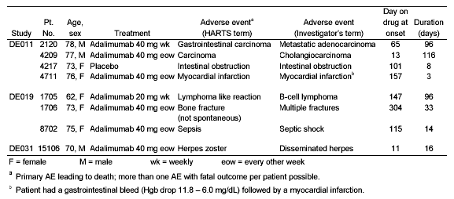

Table 61 : Deaths Related to Infections
Patient Number | Adverse Event | Relevant Medical History
8702 | Urosepsis & septic shock | Onset fatigue and disturbance of equilibrium (incoordination), patient was withdrawn from study, and event resolved. Patient became febrile with urinary incontinence and a week later developed a urinary tract infection and a upper respiratory infection. Urosepsis (E. coli) was followed by septic shock and pancytopenia, cardiac arrest and death.
15106 | Herpes zoster, dissemination, superinfection | Herpes zoster with dissemination, necrotizing fasciitis of upper extremity, superinfection with Group A streptococcus and death.

Table 62 lists all 22 fatal adverse events from among all patients treated with adalimumab in the clinical development program. Two additional deaths (total of 24), one each from diverticulitis with associated sepsis and hepatic necrosis are not shown on this table. Even though the majority (77%) of patients enrolled in these studies were females, the majority of deaths occurred in male subjects (58% [14/24]). The major categories for the deaths include cardiovascular (7), malignancy (6), infections (5), and gastrointestinal (3), [including the additional death from diverticulitis and associated sepsis not shown on this Table].
Table 62 : ISS : List of fatal adverse events during treatment with adalimumab. All patients treated with adalimumab. Study group: all studies in patients with RA (DE001/3, 004, 005/X, 010, 007, 009/X, 011, 019, 031, 018, 020).
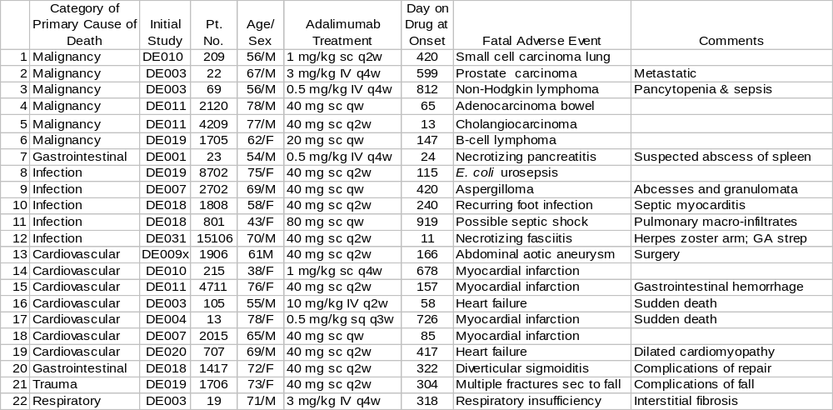

Because the adalimumab safety database includes a significant number of older patients, including a substantial portion aged 65 to 75 (22%) and over age 75 (5%), some deaths are expected. In addition, mortality has been reported to be increased in RA patients. To determine whether the death rate was higher than expected, the observed rate was compared to that expected among various populations (Table 63). Standardized Mortality Rate (SMR - ratio of observed death rate compared to age adjusted expected frequency) was 0.72 for all adalimumab-treated subjects (C.I., 0.46, 1.05), 1.38 for males (C.I., 0.72, 2.44) and 0.45 for females (C.I., 0.22, 0.83). The confidence interval for the male deaths overlaps ‘one,’ implying that the mortality rate observed was within the expected range. The mortality rate for the females was lower than expected. The SMR for adalimumab-treated patients did not exceed that observed in a variety of epidemiologic studies of RA patients

Table 63 : ISS : Comparable Mortality Rates Among RA Patients

Study | Population Base | SMR*  (95% CI)
Wolfe et al (1994) | Tertiary referral center  (North America | 1.98 - 3.08
Wolfe et al (1994) | Community-based (North America) | 1.98
Symmons et al (1998) | Hospital-based referral center (England) | 2.7  (2.4, 3.1)
Gabriel et al (1999) | RA patients (All Rochester) | 1.38  (1.22, 1.55)
Krause et al (2000) | Methotrexate responders | 1.47
Krause et al (2000) | Methotrexate non-responders | 4.11
Adalimumab  clinical  development  program | Calculation using WHO mortality rates  (22 adalimumab-treated patients  that died) | 0.72  (0.46, 1.05)
Adalimumab  clinical  development  program | Males (13) | 1.38  (0.72, 2.44)
Adalimumab  clinical  development  program | Females (9) | 0.45  (0.22, 0.83)
* Standardized Mortality Rate
Highest mortality rates associated with increased age, male sex, RF positivity, and continued signs of active inflammation

E. Serious Adverse Events

Overall the rate of SAEs was not higher among adalimumab-treated patients compared to placebo controls at the proposed recommended dose (Table 56). However, a higher rate of SAEs was observed among patients receiving 40 mg weekly.

To explore why SAEs were more frequent among patients receiving 40 mg weekly, the individual studies were examined. All 103 patients receiving that dose were in study DE011, the European monotherapy study. In that study, the rate of SAEs was lower among patients receiving adalimumab 40 mg weekly (22.6/100 patient–years) or adalimumab 40 mg biweekly (26.0/100 patient–years) than those receiving placebo (39.7/100 patient–years) [Table 64]. Thus, the rate of SAEs does not appear to be increased in patients receiving adalimumab 40 mg weekly.

For both adalimumab- and placebo-treated patients, the percentage of patients reporting SAEs was higher among patients 65 years of age than among patients <65 years of age, and higher still among the small group of patients 75 years of age (Table 95). Within each age group the overall percentage of SAEs was slightly higher among adalimumab-treated patients than among controls. DDuring the double-blin, placebo-controlled periods of the adequate and well-controlled studies, 151 adalimumab-treated patients (11% of 1380; 19 patient /100 pt-yrs) and 60 placebo-treated patients (9% of 690 ; 17 patients/100 pt-yrs) experienced one or more SAEs. SAEs reported slightly more frequently by adalimumab-treated patients included surgery, clinical flare reaction, bone fracture, and pneumonia.

The most commonly reported SAE was surgery, a HARTS term that encompassed arthroplasty and arthrodesis procedures (18 events in 17 patients), tendon repair, hernia repair, aneurysm repair, uterine prolapse repair, removal of fibroids, cholecystectomy, pacer placement revision, prostatectomy, and removal of a basal cell carcinoma (one patient each). Each of the five most commonly reported SAEs occurred more often among all adalimumab- than among placebo-treated patients. Ten percent of adalimumab-treated patients and 8 % of placebo-treated patients experiencd one or more SAEs other than planned surgeries

For both adalimumab- and placebo-treated patients, the percentage of patients reporting SAEs was not higher among patients taking corticosteroids at baseline than among patients not taking corticosteroids at baseline, and was not higher among patients taking concomitant MTX than among patients who were not (Table 97).

Table 64 : Study DE011 : Overview of number (%) of patients with treatment-emergent AEs (safety set)

 | Adalimumab |  |  |  | Placebo
 | 40 mg Q2w |  | 40 mg Q2w
 | 50.07 pt-yrs |  | 48.61 pt-yrs |  | 40.34 pt-yrs
 | (N=113) |  | (N=103) |  | (N=110)
 | N (%) | N/100  pt-yrs | N (%) | N/100  pt-yrs | N (%) | N/100  pt-yrs
Patients with any AE ª | 112 (99.1) | 223.7 | 102  (99.0) | 209.9 | 105  (95.5) | 260.3
Serious AE (SAE) | 13  (11.5) | 26.0 | 11  (10.7) | 22.6 | 16  (14.5) | 39.7
Severe or life-threatening/intractable AE | 27  (23.9) | 53.9 | 21  (20.4) | 43.2 | 25  (22.7) | 62.0
At least possibly drug- related AE | 74  (65.5) | 147.8 | 69  (67.0) | 142.0 | 49  (44.5) | 121.5
AE leading to death | 2  (1.8) | 4.0 | 1  (1.0) | 2.1 | 1  (0.9) | 2.5
AE leading to permanent withdrawal | 7  (6.2) | 14.0 | 5  (4.9) | 10.3 | 3  (2.7) | 7.4
AE leading to temporary withdrawal | 15  (13.3) | 30.0 | 15  (14.6) | 30.9 | 4  (3.6) | 9.9
AE leading to dose reduction | 0  (0.0) | 0.0 | 0  (0.0) | 0.0 | 0  (0.0) | 0.0
AE leading to dose increase | 0  (0.0) | 0.0 | 0  (0.0) | 0.0 | 0  (0.0) | 0.0
AE leading to switch to rescue period | 4  (3.5) | 8.0 | 0  (0.0) | 0.0 | 11  (10.0) | 27.3
Infection | 56  (49.6) | 111.8 | 50  (48.5) | 102.9 | 43  (39.1) | 106.6
Serious infection | 1  (0.9) | 2.0 | 2  (1.9) | 4.1 | 0  (0.0) | 0.0
Malignancy | 2  (1.8) | 4.0 | 1  (1.0) | 2.1 | 1  (0.9) | 2.5
Immunologic reaction | 1  (0.9) | 2.0 | 1  (1.0) | 2.1 | 0  (0.0) | 0.0
ª More than one AE per patient possible.

F. Malignancies and Comparative Expected Incidence Rates

Eight malignancies (excluding non-melanoma skin cancers) were observed in adalimumab-treated patients within the adequate and well controlled studies, and none were observed among placebo-treated patients. Thirty malignancies (excluding non-melanoma skin cancers) were observed in adalimumab-treated patients within the clinical development program, and none were observed among placebo-treated patients (Table 65). Six patients died of their malignancies. Adalimumab-treated patients had approximately an eight-fold greater safety observational exposure in the studies than did placebo-treated patients. Matching the data from the SEER database to the age and sex distribution seen in all patients treated with adalimumab, the expected number of2 cancers dwas 22.

In the clinical development program, based on this smaller initial database, a higher SIR rate for malignancies was suggested (Table 65).

Table 65 : ISS : Malignancies in the Clinical Development Program

 | Malignancy incidence |  | SIR (Standardized Incidence Ratio)  [95% CI] | Exposure  (patient-years)
 | Observed incidence | Expected  Incidence ¹ | SIR (Standardized Incidence Ratio)  [95% CI] | Exposure  (patient-years)
Adequate and Well-Controlled Studies

Malignancies in adalimumab-treated | 8 | 6
Malignancies in placebo-treated | 0 | 0.8
Clinical Development Program

Malignancies in adalimumab-treated | 30 | 22 | 1.33  [0.9, 1.9] | 2,954
Malignancies in placebo-treated | 0 | 2.9 |  | 385
¹ Matching data from NCI SEER database to calculate expected age-matched malignancy rate
for US population (SEER Program Public-Use Data 1973-1998)
These thirty malignancies (excluding non-melanoma skin cancers) were observed among 2334 adalimumab-treated patients over a median of 12 months during the clinical development program and were submitted with the BLA. The most frequently seen malignancies were breast (4), prostate (4), gastrointestinal (4), non-Hodgkin’s lymphoma (4), uterine/endometrial (3), and melanoma (2) [Table 66].

Thirty-six non-melanoma skin cancers and 48 malignancies of various types were observed in 2468 RA patients treated in clinical trials with adalimumab for a median of 24 months and were submitted with the final safety update through August 31, 2002. The malignancies observed during use of adalimumab were neoplasms of the immune system (9), breast (7), colon-rectum (6), uterine-cervical (5), prostate (5), melanoma (3), gallbladder-bile ducts (2), and other carcinomas.

Table 66 : ISS : Cancer Incidence Analysis in Clinical Development Program
Cancer Site | Observed in BLA ¹ | Observed in  Interim  Safety Update ² | Observed in  Final Safety Update ³
Exposure | 2334 patients  median  12 months | 2467 patients  median  19.3 months | 2468 patients  median  24 months
All Sites | 30 | 38 | 48
All lymphomas | 4 | 8 | 10
NHL |  | 7
Hodgkin’s D |  | 1
Breast | 4 | 5 | 7
Colon – rectum | 3 | 4 | 6
Cervix – Uteri | 3 | 3 | 5
Prostate | 4 | 4 | 5
Melanoma | 2 | 2 | 3
Gallbladder –  bile ducts | 1 |  | 2
Adenocarcinoma  (unknown origin) | 2 |  | 2
Other | 7 | 11 | 8
Non-melanoma skin cancers | 24 | 32 | 36
Basal cell |  | 23
Squamous cell |  | 9

1 Data available through August 31, 2001
2 Data available through March 29, 2002
³ Data available through August 31, 2002

Based on 46 of the 48 malignancies observed in the final safety update, for which data was available to up-date the observed Standardized Incidence Ratio (SIR), the observed SIR (ratio of observed rate to age-adjusted expected frequency) for malignancies was 1.00 (95% CI, 0.7, 1.3)] [Table 67], implying that the observed frequency of malignancies among adalimumab-treated patients was within the expected incidence range.

Table 67: ISS : Comparative Expected Cancer Incidence Rates In the Adalimumab Clinical Development Program Through August 31, 2002

Cancer Type * | Observed | Expected | SIR | 95% CI
All Sites | 46 | 45.82 | 1.00 | (0.7 – 1.3)
All Lymphomas | 10 | 1.85 | 5.42 | (2.6 – 10.0)
NHL | 9 | 1.70 | 5.28 | (2.4 –10.0)
Hodgkin’s Disease | 1 | 0.14 | 7.09 | (0.1 – 39.5)
Breast | 7 | 11.15 | 0.63 | (0.3 – 1.3)
Colon | 5 | 4.75 | 1.05 | (0.3 – 2.5)
Lung | 1 | 6.67 | 0.15 | (0.0 – 0.8)
Melanoma | 3 | 1.53 | 1.97 | (0.4 – 5.7)
Prostate | 5 | 4.45 | 1.12 | (0.4 – 2.6)
Uterine | 4 | 2.30 | 1.74 | (0.5 – 4.4)
Other sites | 11 | 13.12 | 0.84 | (0.4 – 1.5)

Non-Melanoma Skin Cancers **
Basal Cell | 23 | 20.12 | 1.14 | (0.7 – 1.7)
Squamous Cell | 9 | 3.79 | 2.37 | (1.1 – 4.5)

* Cancer rates used were 1992-1999 SEER rates
** Skin cancer rates used were 1977-1978 NCI study rates

A total of ten lymphomas, primarily Non Hodgkin’s lymphoma, were observed in patients treated with adalimumab. Based on these patients, the observed SIR (ratio of observed rate to age-adjusted expected frequency) for all lymphomas was 5.4 (95% CI, 2.6, 10.0). The wide confidence interval seen for Non Hodgkin’s lymphoma did not allow an accurate determination of whether its frequency was greater than expected. An attempt was made to correlate the onset of the lymphomas and the duration of therapy with adalimumab. Analysis of the exposure interval between initiation of adalimumab treatment and time-to-onset of lymphoma did not provide clear evidence of a relationship between longer duration-of-therapy and incidence of lymphoma (Table 68).

Table 68 : ISS : Lymphoma Incidence Rates by Duration of Treatment with Adalimumab

Exposure Interval Until  Time of Event - Months | Number/Total (%) | N(N/100 patient-years)
0 - < 6 | 2/2468 (0.08) | 2 (0.2)
6 -< 12 | 1/2216 (0.05) | 1 (0.1)
12 - <18 | 1/1867 (0.05) | 1 (0.1)
18 - < 24 | 2/1395 (0.14) | 2 (0.4)
24 - < 30 | 1/619 (0.16) | 1 (0.4)
30 - < 36 | 0/375 (0.00) | 0 (0.0)
36 - < 42 | 0/321 (0.31) | 1 (0.8)

Table 69 summarizes the cases of lymphoma observed during the adalimumab clinical development program by type and concomitant therapy. Lymphomas that have occurred in the setting of impaired immune function have most often been large B cell, Non Hodgkin’s lymphomas. Similarly, the lymphoma type most often reported in this clinical development program was the large B cell, Non Hodgkin’s lymphoma. Ninety percent of the lymphoma patients had received MTX (seven were receiving concomitant MTX and two had received prior MTX), and 80% were receiving concomitant corticosteroids.

Table 69 : ISS : Summary of Lymphoma Cases By Type and Concomitant Therapy
Subject/Study | Type of Lymphoma | Family History | Concomitant Therapy
Subject/Study | Type of Lymphoma | Family History | Azathioprine/  Cyclophosphamide | MTX | CSTD
2204/DE007 | Mantle zone B cell | Sister-leukemia |  | X | X
69/DE001 | Diffuse Large B cell |  |  | X ^{P}
1414/DE011 | MALT cell B cell |  | X ^{P} | X ^{P} | X
8911/DE019 | Follicular B cell |  |  | X
10509?DE031 | Large B cell |  |  |  | X
1705/De019 | Mixed small and large B cell |  |  | X
11601/DE031 | T cell |  |  | X | X
8208/DE019 | Small and large B cell |  |  | X | X
14605/DE031 | Large B cell |  |  | X | X
4404/DE019 | Hodgkin’s |  |  | X | X
Total = 10 |  | 1 | 1 | 9 | 8
P = previous
Among non- melanoma skin cancers, squamous cell carcinomas also occurred at a frequency greater than expected (Table 67). However, the data used to establish the expected rate were from 1977-1978, leading to some uncertainty of the comparison.

The Kaplan Meier plot in Figure 14 shows that the rate of detection of new malignancies (based on the August 31, 2001 data) was constant over the observation period for all patients treated with adalimumab. The plot does not support an association between increased development of malignancy and longer duration of exposure to adalimumab. If the risk had increased over time, the slope of the curve would become increasingly negative with time. Longer duration of observation will be required to determine whether exposure beyond 2 to 3 years is associated with a higher risk of malignancy.

Figure 14 : ISS : Kaplan Meier curve of time to first malignancy during treatment with adalimumab in all patients treated with adalimumab

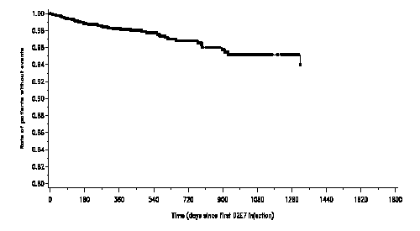
In this clinical development program malignancies were observed at frequency rates approximating the expected rate, except for neoplasms of the immune system which were observed at a greater rate than expected. Since the introduction of TNF blocking agents which affect host defenses by modulating cellular immune responses, a major concern of the Agency has been the possibility of an increased risk of development of lymphomas among patients treated with TNF blocking agents. Published literature suggests that RA patients with highly active disease have a greater risk of lymphomas. Two published epidemiologic studies of 11,683 and 1,767 patients observed an approximately 4 to 5 fold increased incidence of lymphoma in patients with moderately active RA. The RA patients who participated in this clinical development program all had moderate to severe RA with mean duration of disease above 10 years.
Available data are insufficient to determine whether adalimumab increases the incidence of lymphomas above that expected in this patient population. Continued monitoring of adalimumab-treated patients is necessary to quantify the role of adalimumab, if any, in contributing to the high observed incidence of lymphomas.

G. Serious Infections

Since the introduction of TNF blocking agents like adalimumab that modulate cellular immunity, development of serious infections among patients treated with anti-TNF agents has been a major concern of the Agency. In the adalimumab clinical development program, serious infections were defined as infections associated with hospitalization or with use of parenteral antibiotics. Forty-one patients (34 [3%] of 1380 adalimumab-treated patients [4.3 patients/100 pt-yrs] and 7 [1%] of 690 placebo-treated patients [1.9 patients/100 pt-yrs]) experienced serious infections, as provided in the BLA data available through Aug 31, 2001. Four adalimumab-treated patients experienced two serious infections each; the remaining 37 patients experienced a single serious infection. Two patients died of infectious AEs, and 13 patients withdrew from the studies as a result of serious infections. The most common organs involved in the infections were the respiratory, skin, musculoskeletal, gastrointestinal, and genitourinary (Table 70).

Table 70 : ISS : Organ involvement for serious infections excluding tuberculosis and
Opportunistic infections – (Data Available through August 31, 2001)

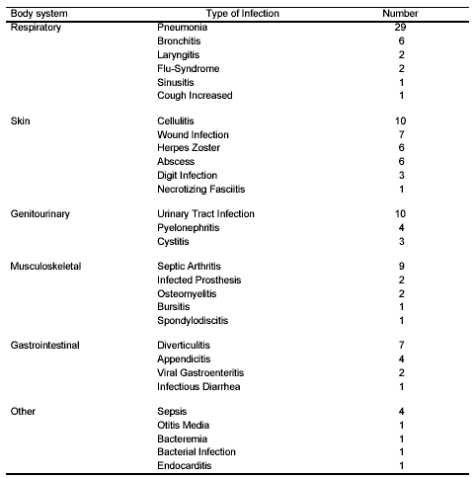

Table 71 presents the different kinds of serious infections observed during the adequate and well-controlled studies.

Table 71 : ISS : Patients with serious infections – adequate and well-controlled studies

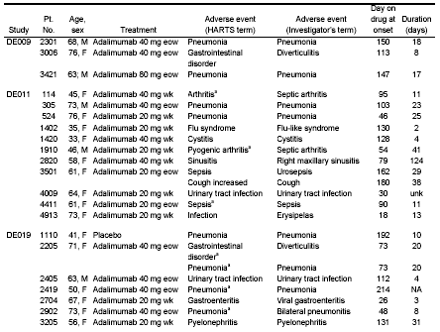
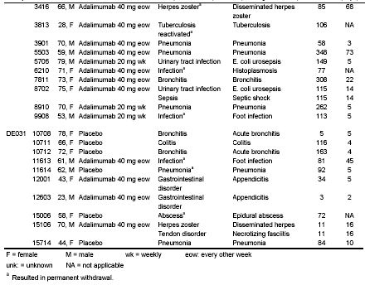

Infections that were associated with sepsis during the clinical development program are listed in Table 72. Skin, musculoskeletal and urinary infections were among those infections most frequently associated with sepsis.

Table 72 : ISS : Infections Associated with Sepsis During the Adalimumab Clinical Development Program

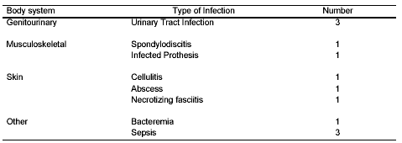

Table 73 summarizes all patients who experienced serious infections, including the 4-month interim and final safety up-dates.

Table 73 : ISS : Overview of Serious Infections of Clinical Interest As Reported in the ISS, Interim 4-Month Safety Update, and Final Safety Update
Patients with Any | Safety Data and Up-Dates |  |  | Total
Patients with Any | ISS  BLA Submission ¹ | 4-Month Interim  Up-Date ² | Final  Up-Date ³ | Total
SAE | 575 | 241 | 160 | 976
Serious infection | 129 | 35 | 38 | 202
Tuberculosis | 9 | 1 | 3 | 13
Opportunistic Infection | 2 | 1 | 3 | 6
¹ The ISS reported safety data through 31-Aug-2001 included in the original submission
² The 4-month safety update data from 31-Aug-2001 through 29-March-2002 and data that had not been reported in the original submission
³ This safety update reported data from 29-March-2002 through 31-Aug-2002

A total of 202 adalimumab-treated patients (includes the final safety up-date of 31-Aug-2002) experienced serious infections during the clinical development program. Review of information provided on 186 subjects with serious infections, revealed a wide assortment of serious infections. Based on this larger safety database, the order of frequency remains similar; the serious infections observed were pulmonary, musculoskeletal (including post-surgical), skin, gastrointestinal, and genitourinary.
Representative serious pulmonary infections included various pneumonias, some with empyema; musculoskeletal infections included septic arthritis, post-surgical infections, and infected prostheses; infections of the skin included erysipelas, cellulitis, and disseminated herpes zoster; gastrointestinal infections included diverticulitis, appendicitis, and diarrhea; genitourinary infections included pyelonephritis, and chronic pyelonephritis.

Table 74 compares the serious infection incidence rates among RA patients within the adalimumab clinical development program and comparable population bases from published studies. There is considerable variation in the reported rates for SAEs per 100 patient years, varying from 3.1 to 9.5 events per 100 patient years. The incidence rate for adalimumab-treated patients at the proposed dosage of 40 mg biweekly is at the lower end of that range, but is higher than the rate for placebo-treated patients.

Table 74 : ISS : Comparable Serious Infection Incidence Rates Among RA Patients

Study/Publication | Population Base | Events/  100 patient-yrs
Doran (2000) | Mayo Clinic | 3.1-9.5
Singh (1999) | ARAMIS database
Adalimumab clinical development program |  | 4.9
Adalimumab 40 mg q2w treatment group |  | 3.9
Adalimumab Trials (AWC) |  | Adalimumab | Placebo
 |  | 4.8 | 1.9

For both adalimumab- and placebo-treated patients, the rate of serious infections was lower among patients <65 years of age than for older patients. (See Table 95 and Table 96.) Both of the patients who died of serious infections were > 65 years of age (70 and 75 years), and both patients with herpes zoster infections were > 65 years of age (66 and 70 years). Of note, both patients with fatal infections and both patients with herpes zoster infections were among the patients taking concomitant MTX.

H. Tuberculosis and Other Opportunistic Infections

Nine cases of tuberculosis were observed during the clinical development program (Table 76), five of which occurred among patients over age 65. An additional four cases were provided with the Safety Update of August 31, 2002, yielding a total of thirteen cases. Infections included miliary, lymphatic, peritoneal, and pulmonary tuberculosis. Most of the cases of tuberculosis occurred within the first few months after initiation of therapy and may reflect recrudescence of latent disease.

Occurrence of seven cases of tuberculosis out of 542 patients treated (1.7%) early in the clinical trials prompted discussions between the Agency and the sponsor and consideration of placing the clinical program on hold. Thorough analysis of those 7 cases determined that ¾ of the cases had baseline chest x-rays consistent with tuberculosis, suggesting that screening might be an effective way to identify patients at risk. At the recommendation of the FDA, the sponsor instituted measures for screening and prophylaxis for all patients prior to enrollment. The sponsor adopted screening procedures consisting of chest x-ray in Europe and PPD plus chest x-ray in the U.S. and initiation of appropriate prophylactic tuberculosis treatment in accordance with the CDC Guidelines (Table 75).

The incidence of cases of reactivation tuberculosis promptly decreased after initiation of this program, and the proposed labeling supports these recommendations.

Six cases of invasive opportunistic infections caused by histoplasma, aspergillus, and nocardia were also reported in clinical trials.

Table 75 : ISS : Screening prophylaxis methodology employed and maximum dose administered during the adalimumab clinical development program

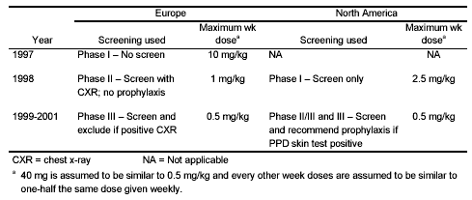

Continued monitoring of adalimumab-treated patients for additional examples of serious and opportunistic infections is needed.
Table 76 : ISS : Listing of tuberculosis cases observed in the adalimumab clinical development program

Study grouping | Initial  Study | Patient  number | Sex | Country | Age  (yrs) | Day on  drug at  onset | Dose and  schedule at onset | Protocol requires  screeningª/  exclusion | Comments
Open-label  continuation studies | DE001 | 114 | F | Germany | 67 | 100 | 10 mg/kg q4wk iv | No/No  No screening done ^{c} | Recovered.
Open-label  continuation studies | DE004 | 16 | F | Germany | 71 | 116 | 1 mg/kg wk sc | No/No  No screening done ^{c} | Recovered.
Open-label  continuation studies | DE001 | 111 | F | Germany | 67 | 202 | 5 mg/kg q4wk iv | No/No  No screening done ^{c} | Recovered.
Open-label  continuation studies | DE010 | 305 | M | Germany | 63 | 183 | 1 mg/kg eow sc | No/No  No screening done ^{c} | Recovered.
Open-label  continuation studies | DE011 | 3511 | F | Germany | 67 | 351 | 40 mg eow sc | Yes/Yes  PPD-not done  Chest X-ray neg | Recovered. Case entered into database after clinical cut-off of 31- Aug-01.
Open-label  continuation studies | DE001 | 106 | F | Germany | 45 | 431 | 3 mg/kg q4wk iv | No/No  No screening done ^{c} | Recovered.
Open-label  continuation studies | DE007 | 2110 | F | UK | 68 | 219 | 40 mg wk sc | Yes/No  No screening done ^{c} | Recovered.
Open-label  continuation studies | DE007 | 2506 | F | Spain | 57 | 241 | 80 mg wk sc | Yes/No  No screening done ^{c} | Recovered.
Adequate and well-  controlled studies | DE019 | 3813 | F | US | 28 | 106 | 40 mg eow sc | Yes/No^{b}  PPD- neg  Chest X-ray neg | Not resolved. Primary case. Patient had recent family exposure to tuberculosis.
Long-term post-  study follow-up | DE011 | 4801 | M | Italy | 45 | -- | Post-study | Yes/Yes  PPD-not done  Chest X-ray neg | Off adalimumab for 4 months.
Long-term post-  study follow-up | DE011 | 3408 | F | Germany | 28 | -- | Placebo | Yes/Yes  PPD-not done  Chest X-ray neg | Placebo-treated patient (ie, did not receive adalimumab).
Long-term post-  study follow-up | DE007 | 1507 | F | Germany | 70 | 184 | Post-study | Yes/No  No screening done ^{c} | Recovered. Seventy (70) days post adalimumab treatment. Prior treatment was 40 mg weekly.
F = female M = male wk = weekly eow = every other week q4wk = every 4 weeks sc = subcutaneous iv = intravenous
ª Screening by chest x-ray in EU/Australia and PPD skin test in US/Canada
^{b} Prophylaxis recommended but not mandatory
^{c} For the eight patients that had no screening tests performed, retrospective review of previous chest x-rays by two radiologists revealed that 6 of the 8 patients had some finding consistent with possible old tuberculosis infection

I. ANA and Anti-dsDNA

In the controlled trials, increases in ANA and anti-dsDNA titers were observed more frequently in adalimumab-treated patients than in placebo-treated patients. At Week 24, 12% of adalimumab-treated patients and 7% of placebo-treated patients shifted from ANA negative at baseline to positive (Table 77).

Table 77 : ISS : ANA Shift – Baseline To LOCF Weeks 12 and 24 ª –
Adequate and well-Controlled Studies by randomized treatment (safety set)
 | 20 mg  q2w | 20 mg  qw |  |  | 40 mg  q2w |  | 40 mg qw | 80 mg  q2w | All  adalimumab  N = 1289 |  | Placebo N =640
 | Baseline negative patients
 |  |  |  |  |  | % ¹ |  |  |  | % ¹ |  | % ¹
Baseline negative/ negative at Week 12 | 124 |  | 221 | 475 |  | 86 | 72 | 42 | 934 | 88 | 484 | 90
Baseline negative/ negative at Week 24 ^{b} | 127 |  | 213 | 455 |  | 82 | 76 | 43 | 914 | 86 | 493 | 92
Baseline negative/ positive at Week 12 | 13 |  | 25 | 51 |  | 9 | 15 | 0 | 104 | 10 | 42 | 8
Baseline negative/ positive at Week 24 ^{b} | 11 |  | 33 | 77 |  | 14 | 11 | 0 | 132 | 12 | 39 | 7
¹ Percentage of maximal number of observations among patients with negative ANA at baseline
ª Data from Study De031 reports maximum ANA at Weeks 12 and 24 instead of LOCF Week 12 and 24; baseline positive to Week 12 or 24 positive determined by subtraction.
^{b} Data from Study De011 substitutes Week 26 for Week 24.

J. Lupus-Like Syndromes

A few cases of lupus-like syndromes with skin rash, serositis, and positive serologies were seen (Table 78). One patient treated with adalimumab developed clinical signs suggestive of new-onset lupus-like syndrome. The patient improved following discontinuation of therapy.

A worldwide search of the safety database (reported November 26, 2002) revealed 4 cases of pleural effusion, 3 cases of pericarditis, and 1 case of pericarditis and pleuritis among adalimumab-treated patients. Information on these cases is still sketchy. Therefore, the role of adalimumab usage in the occurrence of these cases is currently unclear. One case of pleuritis was attributed to be manifestations of the underlying rheumatoid arthritis by biopsy, and one case of pleural effusion was later attributed to tuberculosis. Several of these cases were evaluated for drug-induced lupus erythematosus, but no evidence was found.

The impact of long-term treatment with adalimumab on the development of autoimmune diseases is unknown

Table 78 : ISS : Listing of the lupus-like cases observed during the adalimumab clinical development program
Initial study | Patient  number | Sex | Age  (yrs) | Day on  drug at  onset | Dose and  schedule at  onset | Comments
DE001 | 94 | F | 48 | 1428 | 40 mg q2w sc | Skin rash and positive serologies
DE007 | 1526 | F | 70 | 168 | 40 mg wk sc | Serositis and positive serologies
DE010 | 103 | F | 49 | 418 | 1 mg/kg q2w sc | Undocumented serositis and positive serologies
DE011 | 113 | F | 45 | 107 | 20 mg wk sc | Probable lupus before study,  exacerbation with neutropenia and elevated serologies
F = female wk = weekly q2w = every other week sc = subcutaneous

K. Immunologic Reactions

Table 79 lists the immunologic reactions observed during the clinical development program. They were primarily allergic rashes (14), infusion reactions (7), urticarial reactions (6), and anaphylactic reactions (4).

L. Demyelinating Disease

Table 80 lists the three cases of possible demyelinating disease observed during the clinical development program of adalimumab. Demyelinating disease has been observed in studies of many TNF blockers, including etanercept, infliximab, and lenercept. Of note, one normal volunteer developed demyelinating disease after a single dose of adalimumab. Two of the 3 patients had complete recovery, the other has residual leg numbness.
.

M. AEs Leading to Withdrawal, Interruption, and Reduction of Study Drug

The most frequent reasons for withdrawal were adverse events, lack of efficacy, and withdrawal of consent. At the recommended dose (40 mg biweekly), AEs among adalimumab-treated patients leading to temporary withdrawal occurred in 18% and permanent withdrawal in 6% of adalimumab-treated patients. The most common adverse events leading to discontinuation of adalimumab were clinical flare reaction (0.7%), rash (0.3%) and pneumonia (0.3%). The incidence of temporary withdrawal was higher with weekly dosing and intravenous administration (Table 81).
Table 79 : ISS :Listing of the immunologic reactions observed during the adalimumab clinical development program

Type | Initial study | Patient  number | Sex | Age  (yrs) | Day on  drug at  onset | Dose and  schedule at onset | SAE  Yes/No | Comments
Infusion reaction | DE001 | 28 | F | 48 | 27 | 1 mg/kg Q4wk iv | Yes | Repeat administration at slower rate.
 | DE001 | 43 | F | 63 | 27 | 1 mg/kg Q4wk iv | No | Repeat administration at slower rate.
 | DE001 | 21 | F | 26 | 43 | 1 mg/kg Q4wk iv | Yes | Discontinued from study.
 | DE001 | 53ª | F | 24 | 296 | 3 mg/kg eow iv | Yes | Vasovagal event. Discontinued from study.
 | DE001 | 82 | F | 76 | 857 | 3 mg/kg eow iv | No | No comments.
 | DE001 | 85 | F | 47 | 143 | 3 mg/kg eow iv | No | Two episodes. Discontinued from study.
 | DE001 | 123 | F | 45 | 265 | 3 mg/kg Q4wk iv | Yes | No comments.
Anaphylactoid reaction | DE007 | 2201 | F | 36 | 407 | 40 mg wk sc | No | No comments.
 | DE007 | 2415 | M | 53 | 315 | 80 mg wk sc | No | No comments.
 | DE007 | 2423 | F | 51 | 21 | 20 mg wk sc | No | Flu-symptoms, three episodes.
 | DE019 | 9903 | F | 39 | 22 | 20 mg wk sc | No | No comments.
 |  |  |  |  |  |  |  | No comments.
Other systemic reaction | DE007 | 1526 | F | 70 | 168 | 40 mg wk sc | Yes | Lupus-like illness.
 | DE019 | 4814 | M | 65 | 118 | 40 mg eow sc | Yes | Immunosuppression.
Allergic rash | DE001 | 95 | F | 40 | 14 | 5 mg/kg q4w iv | No | No comments.
 | DE007 | 414 | F | 64 | 518 | 40 mg wk sc | No | No comments.
 | DE007 | 1610 | M | 67 | 84 | 80 mg wk sc | No | No comments.
 | DE007 | 1701 | F | 58 | 79 | 80 mg wk sc | No | No comments.
 | DE007 | 2205 | F | 67 | 797 | 40 mg eow sc | No | No comments.
 | DE007 | 2208 | F | 46 | 957 | 40 mg eow sc | No | No comments.
 | DE007 | 2325 | F | 71 | 962 | 40 mg eow sc | No | No comments.
 | DE010 | 109 | F | 67 | 1322 | 40 mg eow sc | No | No comments.
 | DE011 | 1404 | F | 36 | 101 | 40 mg eow sc | No | Two episodes.
 | DE011 | 3020 | F | 50 | 103 | 20 mg wk sc | No | No comments.

Type | Initial study | Patient  number | Sex | Age  (yrs) | Day on  drug at  onset | Dose and  schedule at onset | SAE  Yes/No |  | Comments
 | DE011 | 3809 | F | 37 | 10 | 20 mg eow sc | No | Two episodes,  232 days apart.
 | DE011 | 3816 | F | 54 | 11 | 40 mg eow sc | No | No comments.
 | DE011 | 4401 | F | 70 | 314 | 40 mg wk sc | No | No comments.
 | DE011 | 5031 | F | 58 | 14 | 40 mg wk sc | No | No comments.
Urticaria-type reactions | DE007 | 2101 | F | 62 | 733 | 40 mg q6w sc | No | No comments.
 | DE019 | 5904 | F | 50 | 14 | 40 mg eow sc | No | Two episodes.
 | DE019 | 9305 | F | 43 | 20 | 40 mg eow sc | No | No comments.
 | DE019 | 9604 | F | 49 | 56 | 40 mg eow sc | No | No comments.
 | DE031 | 11908 | F | 61 | 265 | 40 mg eow sc | No | Two episodes.
 | DE031 | 12810 | F | 68 | 57 | 40 mg eow sc | No | No comments.
Fixed drug eruption | DE001 | 53ª | F | 24 | 28 | 3 mg/kg q4w iv | No | No comments.
 | DE031 | 9003 | F | 24 | 86 | 40 mg eow sc | No | No comments.
Lupus-skin reaction | DE010 | 103 | F | 49 | 418 | 1 mg/kg eow sc | Yes | No systemic symptoms.
Allergic reaction | DE001 | 7 | F | 27 | 41 | 1 mg/kg q4w iv | No | No comments.
unspecified | DE007 | 2507 | M | 53 | 880 | 40 mg eow sc | No | No comments.
 | DE009 | 802 | F | 60 | 340 | 40 mg eow sc | No | No comments.
F = female M = male
wk = weekly
eow = every other week
qxwk = every x weeks
sc = subcutaneous
iv = intravenous
ª This patient had two different and separate allergic type reactions

Table 80 : ISS : Listing of cases of possible demyelinating disease observed in the adalimumab clinical

development program

Initial  study | Patient  number | Sex | Age  (yrs) | Day on  drug at  onset | Dose and  schedule at onset | Comments | Post Study Follow-up
DE009 | 2508 | F | 50 | 243 | 40 mg eow sc | Optic neuritis and subsequent positive MRI. | Patient treated acutely for optic neuritis with high dose corticosteroids, improved and continued on adalimumab. MRI consistent with demyelinating disease. The patient remains asymptomatic and has stopped taking adalimumab
DE024C | 77 | M | 30 | 8 | 1 mg/kg iv | Paresthesias in healthy volunteer. | Patient had mild to moderate paresthesias of the upper and lower extremities. MRI consistent with old demyelinating disease (no lesions enhanced with contrast material). Treated with high dose corticosteroids and has recovered off any medications.
DE019 | 9710 | F | 52 | 28 | 20 mg wk sc | Paresthesias treated with Copaxone. | Patient had episodes of lower extremity numbness. MRI consistent with demyelinating disease. Treated with glatiramer acetate and improved. Jan-02 the glatirarner acetate was discontinued secondary to headaches and the patient was placed on interferon beta-1b. The interferon beta-1b was discontinued in May-02. At this time the patient has intermittent right leg numbness and is able to perform all activities of daily living.
F = female M = male wk = weekly eow = every other week
sc = subcutaneous iv = intravenous

Table 81 : ISS : Adverse Events Leading to Withdrawal, Temporary Interruption , and Reduction of Study Drug

 | Adalimumab
 | 20 mg sc q2w |  | 20 mg sc qw |  | 40 mg sc q2w |  | 40 mg sc qw |  | All sc |  | All IV |  | All Adalimumab
 | N= 175 |  | N=397 |  | N=1903 |  | N=466 |  | N=2263 |  | N=197 |  | N=2334
Any adverse event | N | % | N | % | N | % | N | % | N | % | N | % | N | %
AEs leading to permanent withdrawal ¹ | 11 | 6 | 29 | 7 | 114 | 6 | 29 | 6 | 211 | 9 | 42 | 21 | 252 | 11
AEs leading to temporary interruption ² | 16 | 9 | 91 | 23 | 340 | 18 | 103 | 22 | 576 | 26 | 53 | 27 | 614 | 26
AEs leading to dose reduction ³ | 0 | 0 | 2 | 1 | 2 | <1 | 1 | <1 | 7 | <1 | 16 | 8 | 23 | 1
Reviewer’s Table
1 Source of data: sponsor’s Table 5.3.11
2 Source of data: sponsor’s Table 5.3.12
3 Source of data: sponsor’s Table 5.3.13

N. Laboratory Abnormalities

1. Hematologic Changes

Adalimumab-treated patients demonstrated elevations of red blood cells, hemoglobin, and hematocrit levels and reductions in leucocytes, primarily neutrophils (Table 82). To a great extent this represents normalization of abnormal deviations associated with their chronic disease.

Table 82 : ISS : Hematology Changes From Baseline in Adequate and Well-Controlled Studies by Randomized Treatment

 | Adalimumab-Treated  Patients |  |  | Placebo-Treated Patients
Hematological Parameter | Mean change  LOCF Week 24 | Comment |  | Mean change  LOCF Week 24
Hemoglobin | ↑4.2 g/L * | Changes greater with higher doses |  | ↑0.7 g/L
WBC | ↓0.6 x 10⁹/L * | Neutaphils decreased ; lymphocytes increased |  | ↑0.1 x 10⁹/L
WBC↓0.8x 10⁹/L *
Neutrophils ↓8%
Lymphocytes ↑ 7%
Basophils | Mean changes in percentages  were very small
Eosinophils
Monocytes
Platelet count | ↓33.2 x 10⁹/L |  | Changes greater with higher doses | ↑3.3 x 10⁹/L
 | ↓33.5 x 10⁹/L
Hematocrit | Similar to hemoglobin
RBC
* p ≤ 0.001

2. Laboratory Changes

Many subjects (5% to 13 %) had uric acid levels higher than the upper limit of normal (ULN) at baseline. Hyperuricemia was only graded as 1 (>ULN to ≤ 10 mg/DL) or 4 (≥10 mg/DL) with no grading in-between. Adalimumab-treated patients demonstrated a higher frequency of Grade 4 hyperuricemia than placebo-treated patients during the clinical trials (Table 83). However, nineteen of these twenty subjects demonstrated elevation of uric acid at baseline (10 had Grade 1, and 9 had Grade 4). One adalimumab-treated patient developed an episode of gout and another an episode of nephrolithiasis.

Table 83 : ISS : CTC Grade 3 and 4 Laboratory Changes from Baseline Recorded During Clinical Development Program

Study Group & Test Abnormality | Adalimumab-Treated |  |  | Placebo-Treated
Clinical Pharmacology HV | Grade 3 | Grade 4 | Total/  N | Grade  3 | Grade  4 | Total/N
Hypophosphatemia | 5 |  | 5/176
Hyperuricemia |  | 1 | 1/235 |  |  | 20
Clinical Pharmacology RA
Hypercholesterolemia | 3
Hyponatremia | 1 |  |  | 3
Hypokalemia | 1 |  |  | 1
Hyperkalemia | 1 | 3 |  | 2 | 2
Hyperuricemia |  | 2
Hypercreatinine | 1
Hypophosphatemia |  |  |  |  | 1

Adequate and Well-controlled
Low hemoglobin | 8 |  |  | 1
Leukopenia | 3 |  |  | 1
Lymphocytopenia | 15 |  |  | 12
Neutropenia |  | 1 |  |  | 1
AST elevation | 1 |  |  | 2
ALT elevation | 1 |  |  | 2
CK elevation | 2 |  |  | 1
Hypercholesterolemia
Hyponatremia |  | 1
Hypernatremia |  | 1
Hypokalemia
Hyperkalemia |  | 1
Hyperuricemia |  | 20 * |  |  | 7 *
Hypercreatinine
Hypophosphatemia

* Among these 27 patients with hyperuricemia, 12 patients had grade 1 hyperuricemia (>ULN – ≤10 mg/dl) and 13 had grade 4 hyperuricemia (≥10 mg/dl) at screening or baseline. Six patients had hyperuricemia classified as an adverse event. One patient had an episode of gout and one patient had a kidney stone possibly related to hyperuricemia. There was no grade 3 hyperuricemia.

3. Liver Enzymes

During the adequate and well-controlled studies, sixteen patients (nine treated with adalimumab and seven treated with placebo) developed AST and ALT liver enzyme elevations greater than twice the ULN. Overall between one and four percent of adalimumab-treated patients developed > 2 fold elevation of liver enzymes. This was similar to the percent of placebo-treated patients with liver enzyme elevations (Table 84; Table 85).

Four patients with these elevations did not return to normal by the end of the study or during the open-label continuation studies. Bilirubin levels were always within normal range and albumin and GGT levels were not determined for these patients. In two patients, ALT and AST elevations returned to normal ranges during follow-up periods (one was taking concomitant MTX). In a third patient, taking concomitant MTX, these liver enzymes were elevated at baseline and remained elevated. The fourth patient was eventually diagnosed with primary biliary cirrhosis. None of these four patients received leflunomide.

One patient with a history of fatty liver developed hepatic necrosis and died while receiving adalimumab. This patient never had elevation of AST or ALT. Given the history of liver disease, it is uncertain whether adalimumab was contributory. Nonetheless, vigilance for additional cases of hepatotoxicity is warranted.

Table 84 : ISS : Percentage of Patients with AST Elevation Greater Than Two Times ULN on At Least One Occasion

 |  | Adalimumab Dosage
Study | Placebo | 20 mg q2w | 20 mg  qw | 40 mg q2w | 40 mg  qw | 80 mg q2w
DE009 ¹ | 0 | 3 |  | 3 |  | 1
DE011 ² | 1 | 4 | 3 | 2 | 0
DE019 ³ | 4 |  | 2 | 3
DE031 ⁴ | 3 |  |  | 4
¹ In this study, all patients were on concomitant MTX.
² In this study, all patients were on no concomitant DMARDs.
³ In this study, all patients were on concomitant MTX.
⁴ In this study, all patients were on concomitant standard of care which could include any combination of DMARDs.

Table 85 : ISS : Percentage of Patients with ALT Elevation Greater Than Two Times ULN on At Least One Occasion

 |  | Adalimumab Dosage
Study | Placebo | 20 mg q2w | 20 mg  qw | 40 mg q2w | 40 mg  qw | 80 mg q2w
DE009 ¹ | 2 | 1 |  | 8 |  | 4
DE011 ² | 2 | 1 | 2 | 3 | 2
DE019 ³ | 7 |  | 5 | 3
DE031 ⁴ | 2 |  |  | 6
¹ In this study, all patients were on concomitant MTX.
² In this study, all patients were on no concomitant DMARDs.
³ In this study, all patients were on concomitant MTX.
⁴ In this study, all patients were on concomitant standard of care which could include any combination of DMARDs.

O. Immunogenicity

Concern has been raised about the ability of HAHAs (human anti-human antibody) to reduce the beneficial effects of biological therapeutic agents, as well as increase the likelihood of adverse effects. Therefore, patients were tested at multiple time-points for antibodies to adalimumab during the 6 to 12 month period of the trials (Table 86). Six percent of adalimumab-treated patients and less than one percent of placebo-treated patients developed low-titer neutralizing HAHAs at titers > 20 ng/ml at least once during treatment.

Table 86 : ISS : Development of HAHAs by randomized treatment in the adequate and well-controlled studies with (DE009, DE019) and without (DE011) background MTX
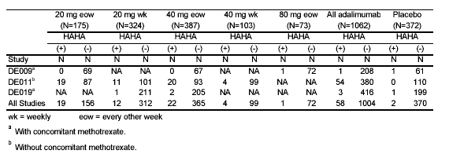

Patients receiving biweekly dosing developed antibodies more frequently than those receiving weekly dosing (Table 87).

Table 87 : ISS : Relationship of HAHA Positivity Status to Adalimumab Frequency
 | Adalimumab Administration Frequency |  |  |  |  |  | Placebo  N =372
 | Weekly  N = 427 |  | Q2 weeks  N = 635 |  | All  N =1062
 | n | % | n | % | n | % | n | %
HAHA (+) | 16 | 4 | 42 | 7 | 58 | 5 | 2 | 0.5
HAHA (+) | 20 mg | 4 | 20 mg | 11
HAHA (+) | 40 mg | 4 | 40 mg | 6

Patients treated with concomitant methotrexate had a lower rate of antibody development than patients on adalimumab monotherapy (1% versus 12%) (Table 88).

Table 88 : ISS : Relationship of HAHA Positivity Status to Adalimumab Concomitant MTX Therapy
 | Adalimumab |  |  |  |  |  | Placebo  N =372
 | Monotherapy  N = 434 |  | With MTX  N = 628 |  | All  N =1062
 | n | % | n | % | n | % | n | %
HAHA (+) | 54 | 12 | 4 | 1 | 58 | 5 | 2 | 1

HAHA-positivity was higher among patients treated biweekly with adalimumab at 20 mg than at 40 mg (Table 89). The long-term immunogenicity of adalimumab is unknown.

Table 89 : ISS : Relationship of HAHA Positivity Status to Adalimumab dosage
 | Adalimumab Dosage
 | 20 mg  N = 499 |  | 40 mg  N = 490 |  | 80 mg  N = 73 |  | All  N =1062 |  | Placebo  N =372
 | n | % | n | % | n | % | n | % | n | %
HAHA (+) | 31 | 6 | 26 | 5 | 1 | 1 | 58 | 5 | 2 | 0.5
HAHA (+) | Qw | 4 | Qw | 4
HAHA (+) | Q2w | 11 | Q2w | 6

At the proposed dosage of 40 mg the ACR 20 response was lower among antibody-positive patients (30%) than among antibody-negative patients (50%).

Seven percent (4/58) of HAHA-positive adalimumab-treated patients withdrew prematurely from Studies DE009, DE011, and DE019 (Table 90). One of these four patients withdrew due to an AE. The other patients withdrew due to lack of efficacy (2 patients) and withdrawal of consent (1 patient). There is no evidence for an increase in incidence of withdrawals related to the occurrence of HAHA-positivity

Table 90 : ISS : Withdrawal by reason in Studies DE009, DE011 and DE019 by randomized treatment and HAHA status (101)
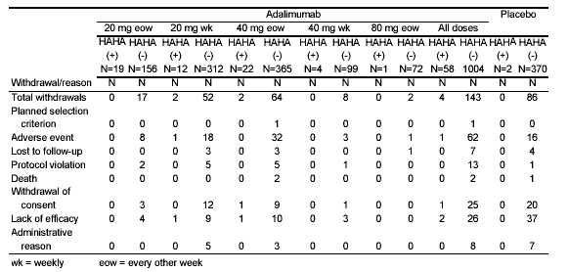

Treatment-emergent AEs were reported in    5% of all adalimumab-treated patients during Study DE011 (Table 91). HAHA-positivity occurred more frequently in this monotherapy study without concomitant MTX, but HAHA-positivity was not associated with clinically meaningful differences in the incidence of treatment-emergent AEs.

Table 91 : ISS : Overview of treatment-emergent adverse events by HAHA status in Study DE011
 | All Adalimumab |  | Placebo  (N=110)
 | HAHA (+)  (N=54) | HAHA (-)  (N=380) | Placebo  (N=110)
Patients with any | N (%) | N (%) | N (%)
AE | 53 (98) | 376 (99) | 105 (96)
Clinical AE | 47 (87) | 350 (92) | 92 (84)
Laboratory AE | 49 (91) | 342 (90) | 98 (89)
Fatal AE | 0 (0) | 3 (1) | 1 (1)
SAE | 8 (15) | 54 (14) | 18 (16)
Planned surgery | 5 (9) | 11 (3) | 3 (3)
SAE except planned surgeries | 4 (7) | 47 (12) | 15 (14)
AE leading to withdrawal | 2 (4) | 25 (7) | 3 (3)
AE leading to dose interruption | 6 (11) | 55 (15) | 6 (6)
AE leading to dose reduction | 1 (2) | 0 (0) | 0 (0)
At least severe AE | 13 (24) | 96 (25) | 25 (23)
At least possibly drug-related AE | 36 (67) | 257 (68) | 50 (46)
Infection | 29 (54) | 178 (47) | 43 (39)
Serious infection | 0 (0) | 11 (3) | 0 (0)
Malignancy | 0 (0) | 5 (1) | 1 (1)
Immunologic reaction | 1 (2) | 3 (1) | 0 (0)

P. Impact of Dose on Safety

Based on data from Study DE011, the monotherapy trial, adalimumab 40 mg administered weekly showed a higher ACR20 than when administered biweekly, 54% compared to 47%, respectively. The AE rate observed with the two interim dosing schedules did not show an increased adverse event rate in patients treated weekly compared to those treated every other week ().

Table 92 : ISS : Overview of number (Percentage) of patients with treatment-emergent AEs Subsetted by Dosage (safety set)

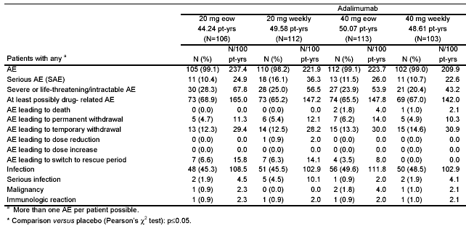

Q. Impact of Dose Interruption on Safety

The impact of dose interruption on loss of efficacy and safety was evaluated in a small group of patients who had single dose interruptions of either >70 to ≤ 140 days or > 140 days (Table 93). The majority of patients demonstrating an ACR20 prior to an interruption for >70 to ≤ 140 days maintained their ACR20-response. With only four cases with interruption of > 140 days, the numbers are too small to draw any definite conclusion.

Table 93 : ISS : Impact of Dose Interruption on Efficacy

Duration of Dose Interruption  During Therapy  in Days | ACR20 Response in Relation to Interruption
Duration of Dose Interruption  During Therapy  in Days | Response Prior to Interruption |  | Response Within First Two Time points After Restarting
Duration of Dose Interruption  During Therapy  in Days | Negative | Positive | Positive | Negative
Dose Interruptions During Therapy - Single
>70 to ≤ 140 ª  (N with data=101) |  | 40 |  | 6 (15%)
>70 to ≤ 140 ª  (N with data=101) |  | 40 | 34 (85%)
>70 to ≤ 140 ª  (N with data=101) | 61 |  | 21 (34%)
>70 to ≤ 140 ª  (N with data=101) | 61 |  |  | 40 ( 66%)
>140 ^{b}  (N with data=20) |  | 4 |  | 2 (50%)
>140 ^{b}  (N with data=20) |  | 4 | 2 (50%)
>140 ^{b}  (N with data=20) | 16 |  | 9 (56%)
>140 ^{b}  (N with data=20) | 16 |  |  | 7 (44%)
ª approximately 5 to 10 half-lives
^{b} approximately 10 half-lives

The types of AEs that occurred before and after dose interruption appeared to be comparable. In the intravenous portion of the clinical development program, two patients had systemic infusion reactions associated with dose interruptions of >70 to ≤140 days (Table 94). Of 20 Patients having longer dose interruptions (i.e. >140 days), both in the intravenous portion and subcutaneous portions of the clinical development program, they did not have systemic immunologic reactions.

Table 94 : ISS : Impact of Dose Interruption on Safety

Patients | `  Type of Immunologic Reaction  (Systemic Anaphylactoid Reaction or Urticaria)
 | Before Interruption | After Interruption

Intravenous Portion of Clinical Development Program

Interruption >70 to ≤ 140 Days
Patient # 53 | Fixed drug reaction | Two separate infusion reactions  Patient remained on study drug
Patient # 85 |  | Two infusion reactions on days 143 and 380. Following second reaction study drug was discontinued.

Intravenous Portion of Clinical Development Program

Interruption >140 Days

None

Subcutaneous Portion of Clinical Development Program
None

R. Impact of Age on Safety

In the AWC studies, the exposure-weighted frequency of AEs increased with increasing age among the elderly in both adalimumab- and placebo-treated groups (Table 95; Table 96). The rate of SAEs, AEs leading to withdrawal, AEs leading to dose interruption, severe or life-threatening/intractable AEs, and serious infections were higher among patients over age 65 compared to patients under 65 in both the adalimumab– and placebo-treatment groups. However, the frequency of patients with serious infections was highest among adalimumab–treated patients over age 65. The frequency of patients with malignancies and fatal AEs, which mainly occurred in the adalimumab-treated group, also increased with increasing age. Due to the relatively small number of patients involved, firm conclusions cannot be reached regarding whether adalimumab increases the relative risk of older patients for these events.

Table 95: ISS - Overview of Number (Number/100 Patient Years) of Patients with Treatment –Emergent AEs Subsetted By Age – Adequate and Well-Controlled Studies (Safety Set)

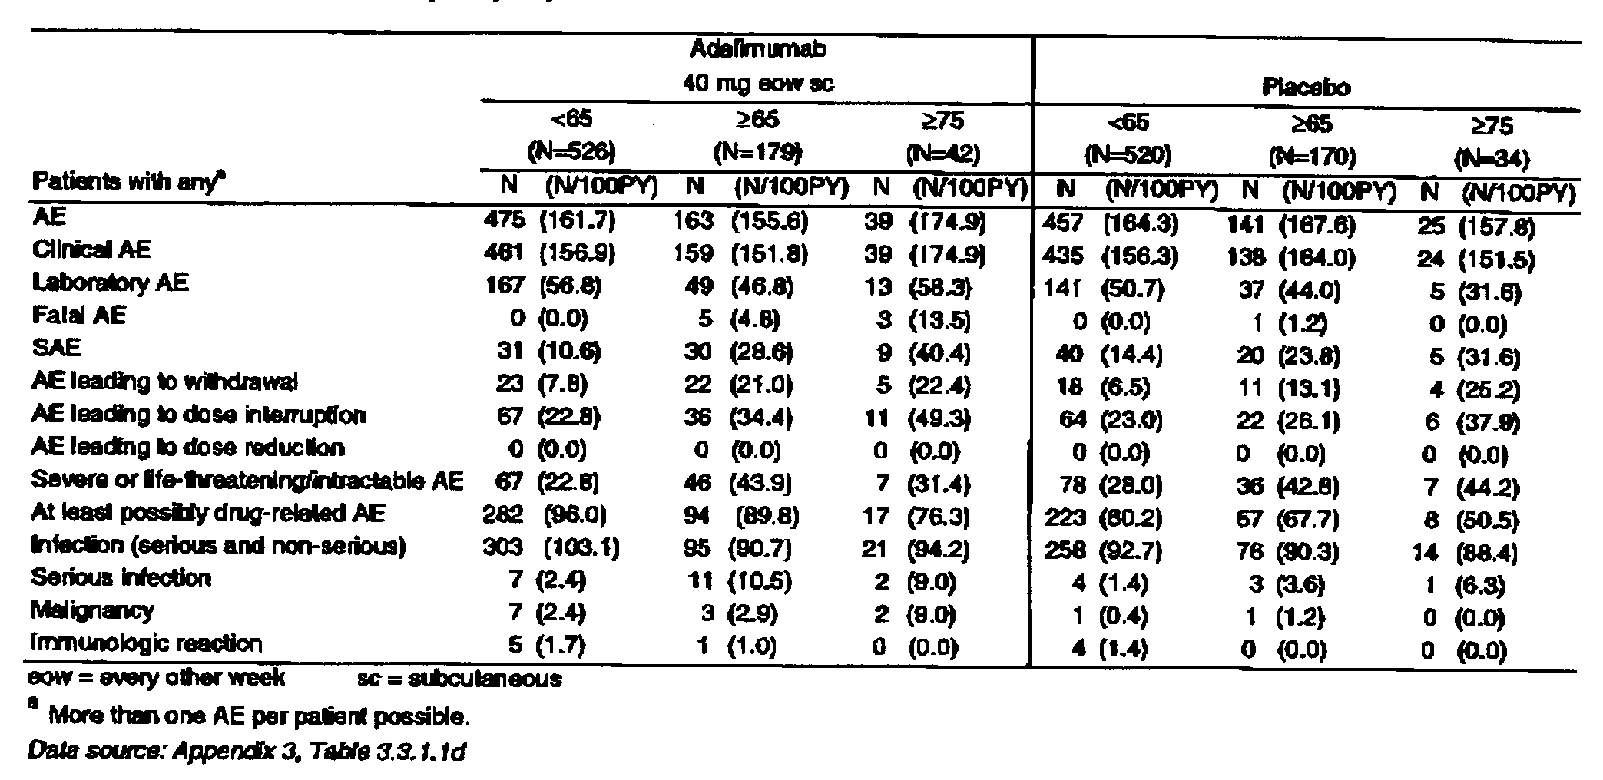

Table 96 : ISS : Overview of Number (Number of Events/100 Patient Years) of Patients with Treatment –Emergent AEs Subsetted By Age – Adequate and Well-Controlled Studies (Safety Set)

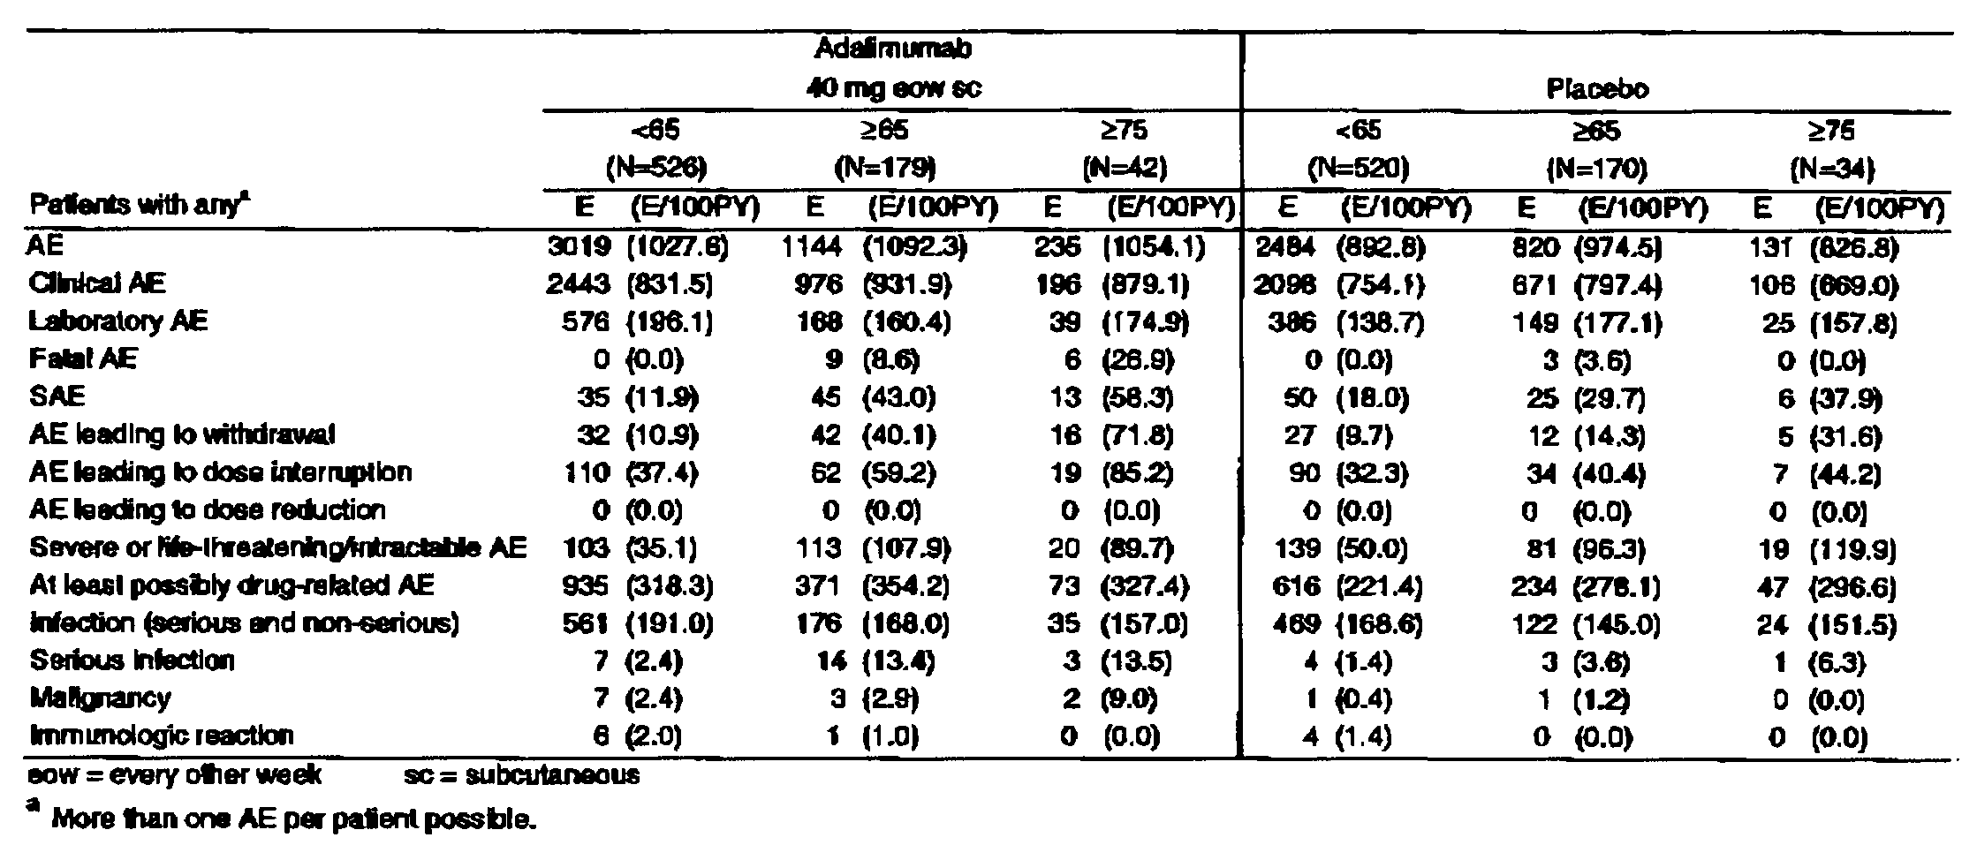

S. Impact of Concomitant Methotrexate on Safety

In order to determine whether concomitant MTX would increase the incidence of AEs associated with adalimumab, a comparison was made of the incidence of AEs with and without concomitant MTX (Table 97). At the proposed adalimumab dosage of 40 mg biweekly, concomitant MTX did not appear to increase the incidence of AEs, SAEs, serious infections, infections, malignancies, or laboratory AEs. However, caution should be used in interpreting these figures since many of the patients treated with concomitant MTX were from different trials than the patients not receiving concomitant MTX. The monotherapy trials were performed in Europe and the MTX combination trials were performed in the US. Differences in the overall incidence of adverse events in the different trials could influence the relative rates shown in Table 97.

Table 97 : ISS : Overview of Adverse Events During Treatment With 40 mg Every Other Week Adalimumab With and Without MTX (All studies in patients with RA through March 29, 2002)
 | Adalimumab 40 mg Every Other Week
 | With MTX  N=1195 |  |  | Without MTX  N=1005
Patients with Any | N | % | N/100PY | N | % | N/100PY
AE | 1092 | 91 | 89 | 972 | 97 | 96
Clinical AE | 1080 | 90 | 88 | 918 | 91 | 91
Laboratory AE | 292 | 24 | 19 | 730 | 73 | 72
Fatal AE | 8 | 1 | 1 | 7 | 1 | 1
SAE | 208 | 17 | 13 | 245 | 24 | 24
AE leading to withdrawal | 81 | 7 | 5 | 78 | 8 | 8
AE leading to interruption | 258 | 22 | 16 | 242 | 24 | 24
AE leading to dose reduction | 3 | <1 | <1 | 1 | <1 | <1
Severe/Life-threatening/Intractable AE | 250 | 21 | 16 | 306 | 30 | 30
At least possibly drug-related AE | 585 | 49 | 37 | 615 | 61 | 61
Infections (serious and non-serious) | 754 | 53 | 48 | 601 | 60 | 59
Serious infections | 45 | 4 | 3 | 38 | 4 | 4
Malignancy | 32 | 3 | 2 | 21 | 2 | 2
Immunologic reaction | 8 | 1 | 1 | 12 | 1 | 1

VII. Financial Disclosure

The effect of potential financial conflicts of interest on clinical study results was assessed. Analysis of the financial disclosure forms provided by sponsor listed no participation in financial arrangements or financial interests by clinical investigators of adalimumab in the following clinical studies: DEOO1, DEOO3, DEOO4, DEOO5, DE005X, DEOO7, DEOO9, DEOO9X, DEO11, DEOI5, DEO18, DEOI9, DEO20, DEO24, DEO29 and DE031. In conclusion, results of these studies did not appear to be influenced by potential financial conflicts of interest.

VIII. Overall Summary of Efficacy and Safety

The clinical development of adalimumab focused on establishing the therapeutic indications of 1) reducing the signs and symptoms, 2) inhibiting the progression of structural damage, and 3) improving health-related quality of life and reducing disability in adult patients with moderately to severely active RA who have had an incomplete response to one or more DMARDs. Adalimumab was evaluated in four clinical studies: DE009, a dose ranging trial, DE011, a monotherapy trial, DE019, a background MTX trial, and DE031, a background DMARDs trial (use in a setting comparable to standard rheumatologic care). The results of the randomized efficacy studies are consistent in showing efficacy of adalimumab in reducing the signs and symptoms of rheumatoid arthritis as measured by the ACR20 response. Efficacy of adalimumab was observed in all patient subsets based on baseline demographics, baseline disease activity and baseline prognostic factors. ACR50 and ACR70 responses higher than with placebo were also achieved.

Efficacy of adalimumab was seen both for monotherapy (study DE011), combination therapy with MTX (study DE019), and combination with a variety of other DMARDs that patients were already receiving (study DE031). The optimal dose of adalimumab is 40 mg sc every other week when given in combination with MTX. Higher doses were not more effective (study DE009). In contrast, for monotherapy, although adalimumab 40 mg every other week was effective (43% ACR20 responses at 6 months), 40 mg weekly was associated with higher response rates (54% ACR20 responses at 6 months) (study DE011). Of note, the point estimates of the response rates for adalimumab 40 mg every other week with MTX were higher (63% ACR20 responses at 6 months – study DE019) than with monotherapy (46 % ACR20 responses at 6 months – study DE011). Although comparing results between studies must be done with caution, the higher responses with the adalimumab-MTX combination may be due to inhibition of anti-adalimumab antibody formation by MTX.

Improvement was seen on all the components of the ACR response criteria. Separation between the responses of adalimumab- and placebo-treated patients occurred as early as Week 2 and was maintained through Week 52. In study DE019, adalimumab-treated patients experienced a lower rate of progression in structural damage as measured by the modified Sharpe score than placebo-treated patients. In addition, adalimumab-treated patients experienced improvement in physical function as measured by the disability index of the HAQ compared to placebo over 52 weeks. However, as stated in the RA Guidance Document, attaining a claim of Improvement in Physical Function requires data demonstrating sustained improvement in the HAQ out to 2 years.

Overall, the short- and long-term safety and tolerability of adalimumab has been demonstrated in a large database of RA patients exposed to the drug for up to 4 years. Adalimumab, at the proposed dosage of 40 mg biweekly, was generally well tolerated, except for the increased occurrence of injection site reactions and pain, upper respiratory infections, abnormal laboratory tests, and rashes. Three categories of events of special interest were observed to occur at a higher frequency among adalimumab-treated patients compared to placebo: deaths, lymphomas, and infections (serious and non-serious).

Twenty-four deaths were observed among the adalimumab-treated patients in the clinical development program. Since the trials included a significant number of older patients, 22% age 65 to 75 and 5% over age 75, some deaths were expected Even though the majority of patients enrolled in these studies were females, the majority of the deaths occurred in male subjects. The most frequent categories of death were cardiovascular, malignancy, infections, and gastrointestinal.

Since most of the patient exposure was from open-label extension studies, there are no concurrent controls for comparison. To provide an estimate as to whether` the mortality rate is higher than expected, the mortality rate was compared to that predicted based on sex and age-matched rates in the general US population.

Determination of the Standardized Mortality Rate (SMR) for comparison of the observed death rate to the age-adjusted expected frequency of deaths for this population suggested that the death rate for males was higher (SMR 1.38 [CI, 0.72,2.44]) and the death rate for females was lower than expected (SMR 0.45 [CI, 0.22, 0.83]). Whereas the confidence interval for male deaths overlapped ‘one,’ the male mortality rate and overall mortality rate were within the expected range. The SMR for the whole group of adalimumab-treated patients was 0.72 [CI, 0.46, 1.05]. These data do not indicate a higher death rate with adalimumab treatment. Collection of additional data with longer-term exposure is warranted, particularly for male patients.

A total of ten lymphomas, primarily Non Hodgkin’s lymphoma, was observed in patients treated with adalimumab. The observed SIR (ratio of observed rate to age-adjusted expected frequency) for all lymphomas was 5.4 (95% CI, 2.6, 10.0) compared to the general population. The increased incidence of lymphomas observed among these adalimumab-treated patients has raised concerns about whether adalimumab increases the risk of development of lymphomas. Published literature suggests that RA patients have an approximately 2-fold higher risk of lymphoma than the general population. Furthermore, RA patients with highly active disease have an even greater risk of lymphomas, irrespective of their treatment, in the same range as the SIR reported for adalimumab-treated patients. Analysis of the time-to-onset of the cases of lymphoma seen with adalimumab did not provide evidence of a relationship to duration of adalimumab therapy. Available data are insufficient to determine whether adalimumab increases the incidence of lymphomas. Continued monitoring of adalimumab-treated patients is necessary to quantify the role of adalimumab, if any, in contributing to the observed higher incidence of lymphomas than in the general population.

Since the introduction of TNF blocking agents, which affect host defenses by modulating cellular immune responses, the Agency has been concerned about an increased risk of serious infections among anti-TNF-treated patients. Patients treated with adalimumab experienced more frequent serious infections than did placebo-treated patients (4.2 vs. 1.9 per 100 patient-years). The most common organs affected by serious infections among adalimumab-treated patients were pulmonary, musculoskeletal, skin, gastrointestinal, and genitourinary. Two patients died and 13 patients withdrew from studies as a result of serious infections. In addition, thirteen cases of tuberculosis (TB) and six cases of invasive opportunistic fungal infections were observed. Implementation of pre-treatment screening with intradermal PPD in the US, chest x-rays in Europe, and appropriate prophylactic anti-tuberculosis treatment in accordance with CDC Guidelines was associated with a reduction in the rate of active TB. However, other variables may have also contributed to the lower rate of TB later in the clinical development program, including less exposure to higher doses of adalimumab and possibly recruitment of fewer patients at high risk of latent TB infection.

For both adalimumab- and placebo-treated patients, the rate of serious infections and deaths due to serious infections were lower among patients <65 years of age. Increasing age among adalimumab-treated patients was associated with an increased occurrence of malignancies, SAEs, AEs leading to withdrawals, and AEs resulting in dose interruption compared to age-matched placebo-treated patients. The percentage of patients with fatal AEs, which only occurred in the adalimumab–treated group, was also higher with advancing age.

In summary, adalimumab treatment has demonstrated substantial efficacy, both for signs and symptoms as well as for progression of structural damage to joints and for improvement in disability for up to 12 months. Uncommon, but serious adverse events were observed in adalimumab-treated patients. Overall, adalimumab has shown a favorable benefit to risk profile when administered subcutaneously at the recommended dose of 40 mg every other week, and the higher dose of 40 mg weekly, either alone or in combination with methotrexate or other DMARDs.

Wolfe, F, Sibley TJ, et al. The mortality of rheumatoid arthritis. Arthritis Rheum. 1994; 37: 481-494.
Symmons DPM, Jones MA, Scott DL, Prior P. Long-term mortality outcome in patients with RA: rarly presenters continue to do well. J Rheumatol. 1998; 25: 1072-7.
Gabriel AE, Crowson CS, O’Fallon WM. Mortality in rheumatoid arthritis: have we made an impact in four decades. J Rheumatol. 1999; 25: 2529-2533.
Krause D, Schleusser B, Herborn G, Rau R. Response to methotrxate treatment is associated with reduced mortality in patients with severe RA. Arthritis Rheum. 2000; 43: 14-21.
Brown SL, Greene MH, Gershon SK, Edwards ET, Braun MM. Tumor necrosis factor antagonist therapy and lymphoma development: twenty-six cases reported to the FDA. Arthritis and Rheumatism 2002;46: 3151-3158
Baecklund E, Ekbom A, Sparen P, Feltelius N, Klareskog L. Disease activity and risk of lymphoma in patients with rheumatoid arthritis : nested case-control study. BMJ 1998; 517: 180-1
Abstract. Wolfe F. Inflammatory activity, but not methotrexate or prednisone use predicts Non-Hodgkin’s lymphoma in rheumatoid arthritis: a 25-year study of 1,767 RA patients. ACR Plenary II 1998: 931
Abstract. Doran MF, Crowson CS, O’Fallon WM, Gabriel SE. Infections in rheumatoid arthritis. Arthritis Rheum. 2000; 43, No. 9 (suppl) 606.
Abstract. Singh G, Ramey DRUG-RELATED, Rausch PL, Schettler JD. Serious infections in rheumatoid arthritis: Relationship to immunosuppressive use. Arthritis Rheum. 1999; 42, No 9 (suppl) 1029.
Mohan N, Edwards ET, Cupps TR, Oliverio PJ, Crayton H, Rickert JR, Siegel JN. Demyelination occurring during anti-tumor necrosis factor α therapy for inflammatory arthritis. Arthritis & Rheumatism 2001; 44: 2862-2869.

