CONCEPT: Fundamentals of the CAP Flying Safety Program

APROXIMATE TIME: 1 Hour

OBJECTIVES:

1. Discuss the importance of CRM and how it becomes a crucial element to effective cockpit communication and operations
2. Discuss the importance of ORM in preflight planning and techniques for implementation
3. Discuss how CRM and ORM are instrumental to safe flight
4. Discuss the essential elements of a flight safety program
5. Discuss reporting procedures and the importance for rapid notification of local safety offices and NHQ CAP.

SUGGESTED MATERIALS: Additional materials are: CAP Regulation 62-2, Mishap Reporting and Investigation, The Sentinel, Jul 98 Special Edition; Any recent articles on CRM or ORM in aviation magazines (i.e. Flying Safety and Mobility Forum. Check the local library or on-line WEB sites): Flying Safety Magazine: http://www.afsc.saia.af.mil/magazine/htdocs/fsmfirst.htm,Mobility Forum Magazine: http://www.AMC-Ser@scott.af.mil. Refer to the instructor information link in the user’s guide for the basic materials to teach the class.

INTRODUCTION:
Safety is paramount in the Civil Air Patrol. This lesson focuses on flight safety, but many of its techniques and procedures are applicable to ground safety as well. Crew Resource Management and Operational Risk Management are important training tools that enable aviators to effectively utilize all available resources and minimize the risk associated with flying. Additionally, maintaining a dynamic flight safety program is essential to safe flight operations.

PURPOSE/RATIONALE:
This lesson will provide basic techniques and procedures for establishing basic CRM and ORM programs. It will also cover critical elements of a commanders safety program. This will ensure that every precaution is taken to minimize the risk associated with flight.

MAIN POINTS:
1. The basics of Crew Resource Management.
2. The basics of Operational Risk Management.
3. The essential elements of the CAP flight safety program.
4. Reporting requirements and procedures for aircraft mishaps

Lesson Presentation:

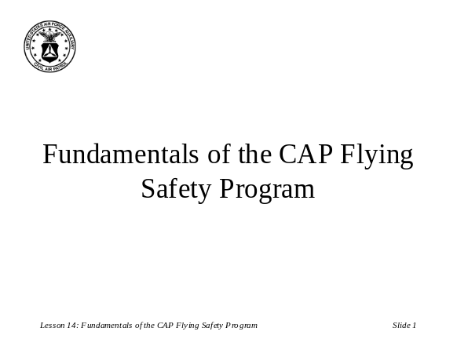Attention Step: (Slide 1) Welcome students to the class. Introduce the course and describe how this will discuss tools that could save their lives.

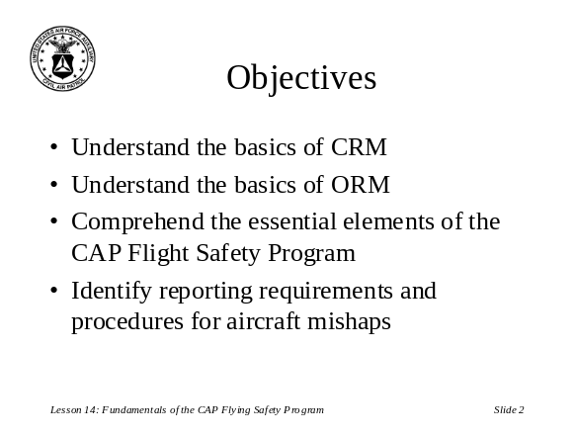Lesson Overview: (Slide 2) Give students an overview of what you will be discussing, what the objectives are and what you hope the student will take away from this course.

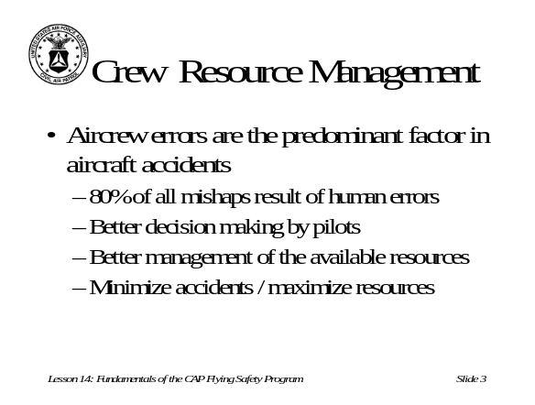Main Point 1: (Slide 3) Discuss how aircrew errors are the predominant factors in aircraft mishaps. Describe how good decision making and maximizing the use of all available resources can reduce mishaps.

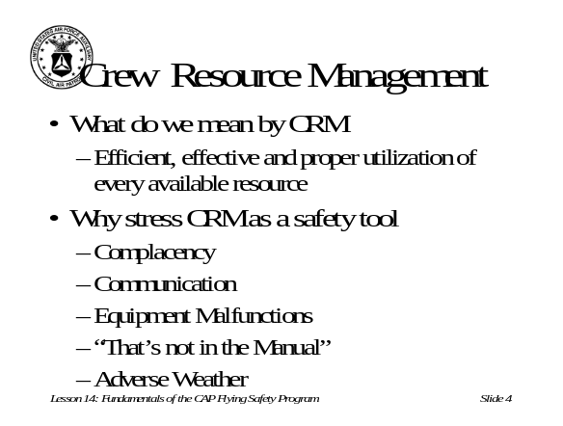Main Point 1: (Slide 4) Elaborate on what CRM is and why we stress CRM training. Explain where CRM can be most effective and in what situations.

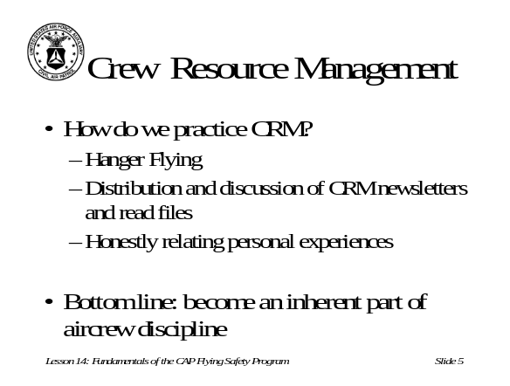Main Point 1: (Slide 5) Explain how practicing CRM will make it second nature. Talk about where CRM information can be found and discuss the benefits of talking about CRM and lessons learned from personal experiences. Stress that CRM must become an inherent part of flight operations.

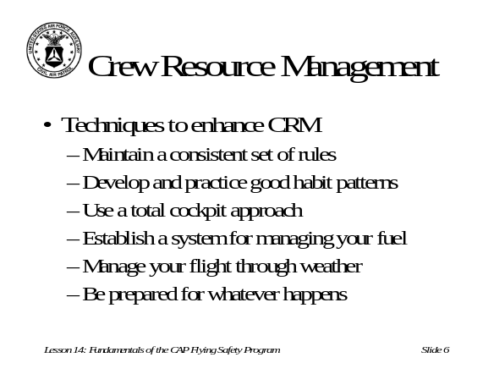Main Point 1: (Slide 6) Discuss techniques to enhance CRM. Solicit inputs from students and be sure to emphasize how CRM is dynamic and changes with experience.

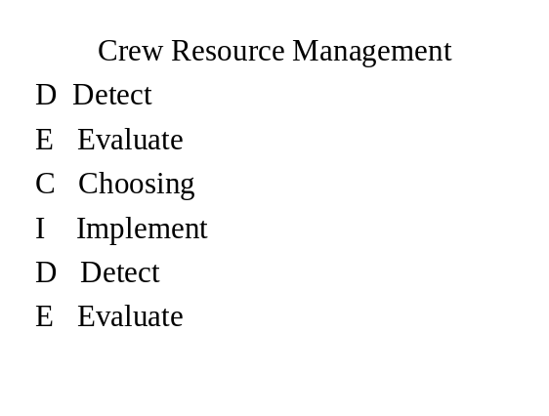Main Point 1: (Slide 7) Present the memory aid DECIDE as a tool to help pilots properly evaluate an emergency situation.

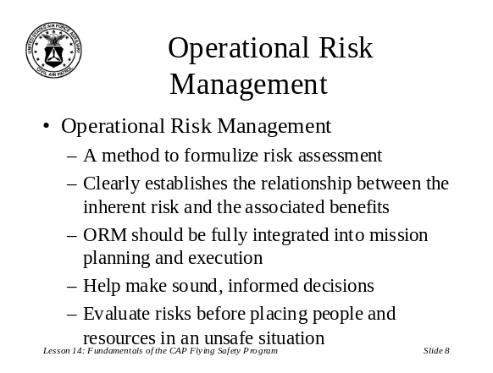Main Point 2: (Slide 8) Describe what ORM is and how it is a cost benefit analysis. Fully integrating ORM into the mission planning process is crucial. Explain how it helps make the correct decisions and helps to determine when a mission is not worth the risk.

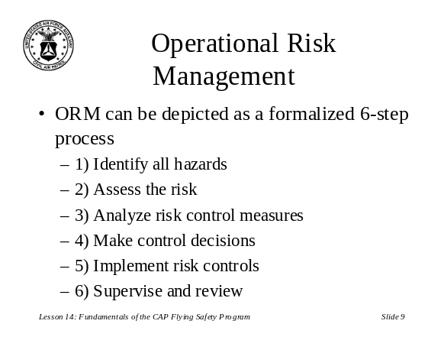Main Point 2: (Slide 9) Discuss the formalized 6 step process, expanding on each step to be sure the students understand how they integrate into the ORM process.

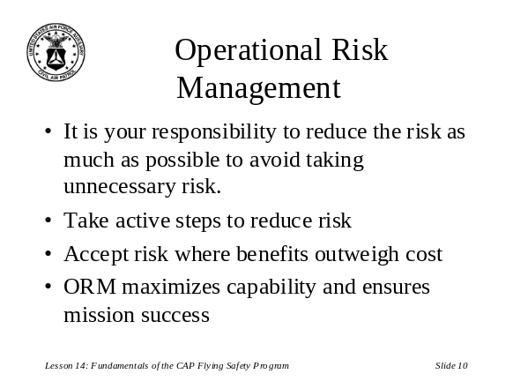Main Point 2: (Slide 10) Explain how each pilot is responsible for minimizing risk and actively taking steps to avoid taking unnecessary risk. However, stress that the mission still needs to be done and some risk is always present. ORM simply defines the risk and presents actions to take minimizing that risk.

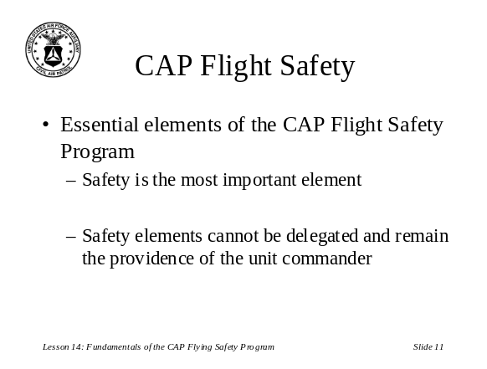Main Point 3: (Slide 11) Emphasize that safety is always a priority and everyone is responsible for safe operations. Safety remains the commanders program.

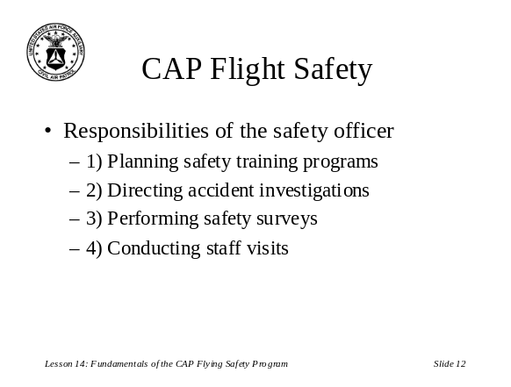Main Point 3: (Slide 12) Discuss the responsibilities of the safety officer. Extrapolate on each area and be sure students understand the basics of the sub areas.

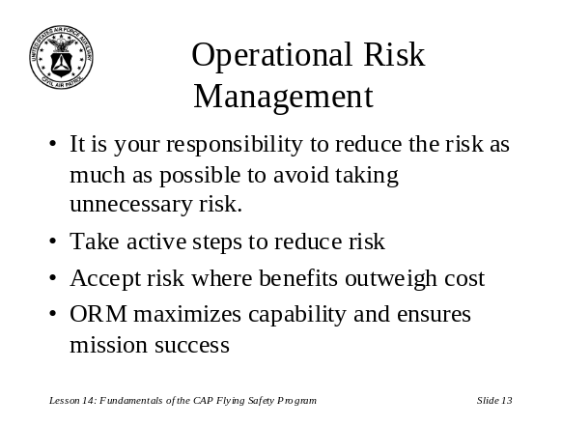Main Point 3: (Slide 13) Same as slide 12

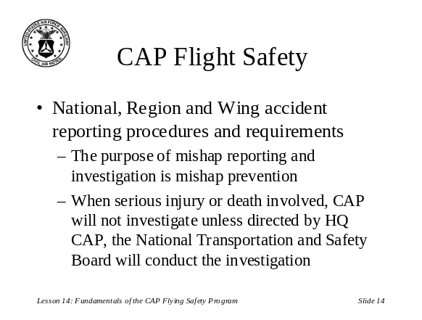Main Point 4: (Slide 14) Describe reporting procedures for accidents and mishaps. Be sure to emphasize when to contact National, Regional and Wing commanders.

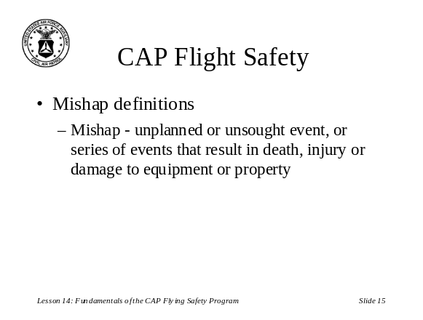Main Point 4: (Slide 15) Define the definition of a mishap. Explain how this may impact reporting procedures.

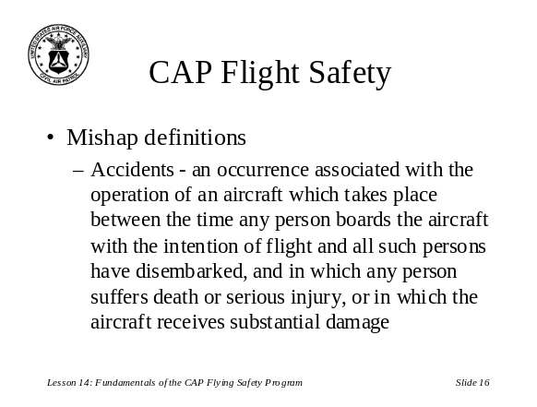Main Point 4: (Slide 16) Define the definition of an accident. Explain how this may impact reporting procedures.

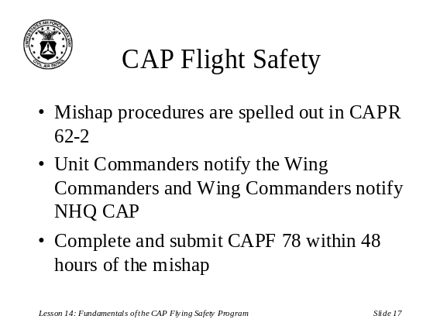Main Point 4: (Slide 17) Describe CAPR 62-2 and applicable reporting procedures. If available, distribute copies of a blank CAP Form 78 and have students go through and fill out an example mishap report.

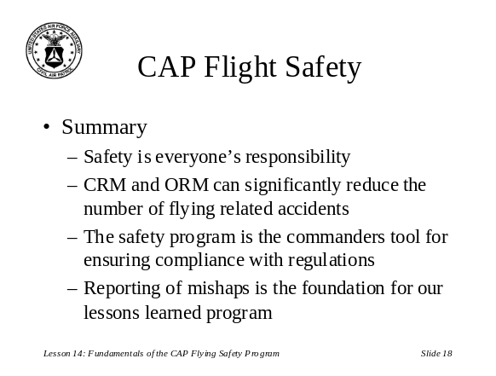Summary: (Slide 18) Recap the main objectives and stress that safety is everyone’s responsibility. Ask for questions and clarify any problem areas.

