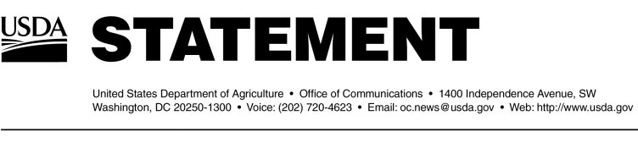
Release No. 0501.04
by Andrea Morgan
Associate Deputy Administrator
Animal and Plant Health Inspection Service
U.S. Department of Agriculture

November 18, 2004

“Early this morning, we were notified that an inconclusive BSE test result was received on a rapid screening test used as part of our enhanced BSE surveillance program.
“The inconclusive result does not mean we have found another case of BSE in this country. Inconclusive results are a normal component of screening tests, which are designed to be extremely sensitive so they will detect any sample that could possibly be positive.
“Tissue samples are now being sent to USDA’s National Veterinary Services Laboratories—the national BSE reference lab—which will run confirmatory testing.

“Because this test is only an inconclusive test result, we are not disclosing details specific to this test at this time.

“APHIS has begun internal steps to begin initial tracebacks, if further testing were to return a positive result. However, it is important to note, that this animal did not enter the food or feed chain.

“Confirmatory results are expected back from NVSL within the next 4 to 7 days. If the test comes back positive for BSE, we will provide additional information about the animal and its origin.
“USDA remains confident in the safety of the U.S. beef supply. Our ban on specified risk materials from the human food chain provides the protection to public health, should another case of BSE ever be detected in the United States.

“Screening tests are often used in both human and animal health and inconclusives are not unexpected. These tests cast a very wide net and many end up negative during further testing.

“And some subset of these animals may even turn out to be positive for BSE. While none of us wants to see that happen, that is not unexpected either. Our surveillance program is designed to test as many animals as we can in the populations that are considered to be at high risk for BSE.
“Additional measures to strengthen public health safeguards include the longstanding ban on imports of live cattle, other ruminants, and most ruminant products from high-risk countries; FDA's 1997 prohibition on the use of most mammalian protein in cattle feed; an aggressive surveillance program that has been in place for more than a decade; the banning of non-ambulatory cattle from the human food chain; the process control requirement for establishments using advanced meat recovery (AMR) systems; prohibiting the air-injection stunning of cattle; and, if an animal presented for slaughter is sampled for BSE, holding the carcass until the test results have been confirmed negative.
#

