

Indian Health Service
FY 2005 Performance Plan
FY 2004 Revised Final Performance Plan
and FY 2003 Performance Report
January 26, 2004
This seventh Congressional Justification Submission of the Indian Health Service Fiscal Year (FY) 2005Performance Plan, FY 2004-Revised Final Performance Plan, and FY 2003 Performance Report reflects the commitment and determination of the Indian Health Service (IHS) to make a positive difference in the health status of American Indians and Alaska Natives.

This document is provided in accordance with the Government Performance and Results Act (GPRA) of 1993. The principles and values underlying this Act have been part of the IHS culture for some time. The IHS and its stakeholders have always considered the GPRA and its requirements as a natural extension of the public health model the Agency has used effectively for almost a half century to make significant improvements in the health status of Indian people.

The FY 2005 Performance Plan portion of this document also defines the Agency's concerted effort in response to the President's Management Agenda, the One Department initiative of the Secretary of Health and Human Services (HHS), and the Healthy People 2010 goals of achieving equivalent and improved health status for all Americans over the next decade. The long-term projected outcome of the FY 2005 Performance Plan has been enhanced this year to incorporate revisions to the IHS Strategic Plan and the new HHS Strategic Plan. For example, a roadmap table shows individual GPRA annual performance measures linked to specific long-term health outcome goals developed for the IHS Strategic Plan.

Achieving both the short- and long-term health goals in the face of increasing health status disparities experienced by American Indian and Alaska Native people represents a formidable challenge for the IHS, particularly for the local IHS, Tribal, and Urban Indian health programs. To meet this challenge, the FY 2005 Performance Plan is designed to use available resources effectively, and balance the investment in treatment and prevention priorities with the development of a critical infrastructure along with the capacity to evaluate program effectiveness.

As the FY 2004 Revised Final Performance Plan and the FY 2003 Performance Report portions of the document show, the Indian health system is up to the challenge of improving health services and programs as well as meeting the emerging health needs of an aging population. Furthermore, we are pilot testing promising new technologies through collaborative efforts with other HHS partners. Indeed, achieving the elimination of health disparities between the general and the American Indian and Alaska Native populations will require the best efforts of One Department. We continue to be optimistic that the future holds forth better health care services, programs, and outcomes that will result in the improved health status of American Indian and Alaska Native people.

Charles W. Grim, D.D.S., M.H.S.A.
Assistant Surgeon General
Interim Director

Executive Summary

MISSION:
The mission of the Indian Health Service, in partnership with American Indian and Alaska Native people, is to raise their physical, mental, social, and spiritual health to the highest level.

GOAL:
To assure that comprehensive, culturally acceptable personal and public health services are available and accessible to American Indian and Alaska Native people.

FOUNDATION:
To uphold the Federal Government’s obligation to promote healthy American Indian and Alaska Native people, communities, and cultures and to honor and protect the inherent sovereign rights of Tribes.

The Indian Health Service (IHS) is the Operating Division (OPDIV) within the Department of Health and Human Services (HHS) that carries out the federal government’s trust responsibility to provide health care services to eligible American Indian and Alaska Native (AI/AN) people. IHS provides these health services through a network of 594 healthcare facilities, including 49 hospitals, 231 ambulatory clinics, 309 health stations, 15 school-based clinics, and numerous Alaskan village clinics. These facilities provide direct health care services to over 1.6 million AI/AN people. Many of these people live in isolated areas where there is no access to health care services other than those offered by IHS or tribally operated programs. Until the mid 1990s, IHS operated most of these facilities and programs as federal programs. Currently, over 50% of the Indian health system is operated directly by tribal governments through contracts or compacts. In addition to these tribally operated programs, IHS contracts with 34 urban Indian organizations to provide services to eligible AI/AN people who reside in large metropolitan areas.
Since 1955, IHS has demonstrated the ability to utilize limited resources to improve the health status of the AI/AN people by focusing on preventive and primary care services. The development and implementation of a community-based, public health system has lead to significant improvements in the health status of AI/AN people. Examples can be seen in the dramatic decreases in mortality rates for certain health problems between 1972-74 and 1997-99:
- Maternal mortality reduced 79% (31.6 to 6.7 per 100,000);
- Tuberculosis mortality reduced 86% (10.7 to 1.5 per 100,000);
- Gastrointestinal disease mortality reduced 72% (6.7 to 1.9 per 100,000);
- Infant mortality reduced 65% (25.0 to 8.8 per 1,000 live births); and
- Unintentional injuries mortality reduced 54% (206.7 to 95.1 per 100,000).
These changes are even more significant when one considers that IHS achieved these improved outcomes despite the following:
- IHS receives lower per capita funding than the average Medicaid patient;
- IHS has higher costs for health care due to increased disease burden and lack of access;
- Provider recruitment and retention problems limit the availability of providers (e.g., half the physicians and nurses per capita as the general population);
- Facilities are lacking or inadequate in numerous locations (i.e., the average age of IHS facilities is 32 years in comparison to 9 years for the private sector); and
- High unemployment, poverty, lack of education, substandard housing, and other social determinants of health lead to poor health status

Our current FY 05 performance plan includes 39 performance measures, including outcome measures, output measures, and efficiency measures. Within this document, the initial FY 2005 and revised final FY 2004 Performance Plans have merged with the FY 2003 Performance Report consistent with the required format developed with the Department of Health and Human Services. In 2005, there are 39 GPRA indicators; we have eliminated two indicators and changed an additional three indicators from the FY 04 plan. These changes were made in conjunction with clinicians and tribal input that was obtained over the course of the last 12 months. In FY 2003, the IHS GPRA plan included 41 measures. In 2003, 30 target measures were met; eight targets were not met, and three are not currently reported. In FY 04, 2 measures have been modified to achieve an increased number of outcome measures. Modification of FY 03 measures to include outcomes will enable us to assess the impact of improved clinical quality on outcome. Changed measures include or will include obesity, fetal alcohol prevention, cardiovascular disease prevention, domestic violence prevention, and pregnant HIV transmission prevention. IHS is also pegging performance targets to HP 2010 goals, as well as HEDIS goals. Additionally, performance goals continue to be integrated into the PART reviews, as well as the IHS Strategic Plan.

Performance successes included our ability to continue to meet our diabetic indicators, despite an increasing diabetic population throughout Indian country. In addition, IHS continues to display improvement in immunization rates and injury prevention initiatives. Ongoing challenges to improving clinical quality continue to confront our Agency, as we face an increasing population, as well as significantly increasing disease burdens. Ongoing health disparities exist throughout the majority of AI/AN communities, and will require additional comprehensive, community-oriented interventions for significant impact.

While the IHS public health model has been effective in eliminating certain infectious diseases, improving maternal and child health, and increasing access to clean water and sanitation, the problems facing AI/AN people and communities today are very different from those that existed historically. The health problems in AI/AN communities today mirror the health problems confronting U.S. All Races. These problems include obesity, substance abuse, and lack of exercise, tobacco dependence, and violence. The impact of these conditions in AI/AN populations is reflected in increased disease burden and decreased life expectancy. These often lead to the development of chronic diseases that require costly long-term treatment such as cardiovascular disease, diabetes (including kidney disease, dialysis, and blindness), liver disease, cancer, and injuries.

In addition, the recent fully analyzed and racially adjusted mortality data (FY 1999) available from the National Center for Health Statistics documents an overall 4.5% increase in death rate for AI/AN people from 698.4 per 100,000 population for the period 1994 to 1996 to 730.1 per 100,000 population for the period 1997 to 1999. See Table 1 on page 7 for disease specific information.

Community based, public health oriented program provided a cost effective positive impact on health status when health problems were more clearly linked to disease processes prevalent many years ago. However, this model has yet to be adapted to the more recent behavioral and lifestyle issues that face IHS today. Implementing appropriate prevention and patient education programs while continuing to provide high quality medical services to AI/AN communities will require additional resources that are not currently available to IHS.

The current plan presents a strategic set of performance indicators intended to approach the growing health disparities between the American Indian and Alaska Native population and the rest of the US population (see chart below). However, achieving these performance targets will be insufficient in reversing the worsening health status of American Indian and Alaska Native people. Health disparities between American Indian and Alaska Native’s and the US population in general are unlikely to improve unless additional resources become available to target these ongoing disparities.

IHS GPRA Contact:

Theresa Cullen, MD, MS
Planning and Evaluation
Office of Program Support/Office of Public Health
Phone: (301) 443-1549
Fax: (301) 443-0114

Table 1: Mortality Rate Disparities Continue Among AI/AN and All Races
in the IHS Service Area
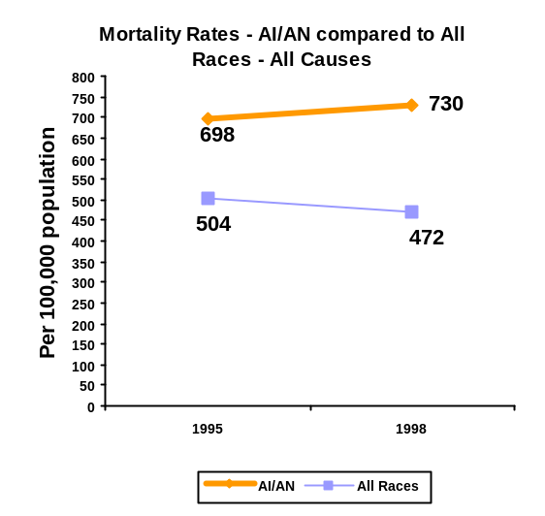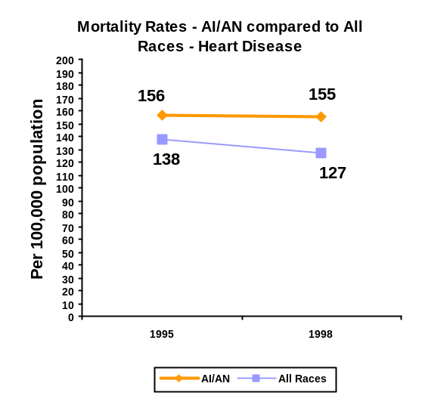
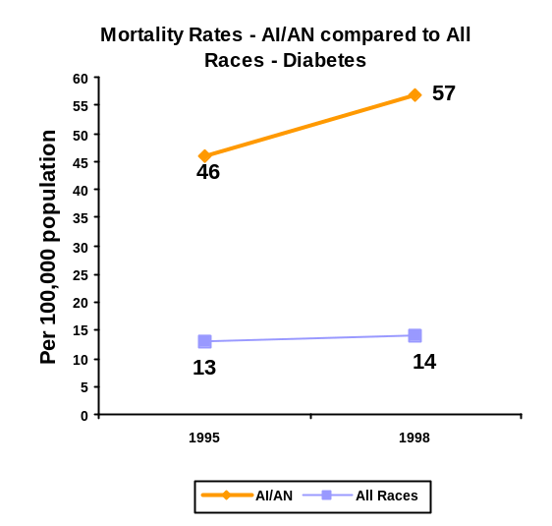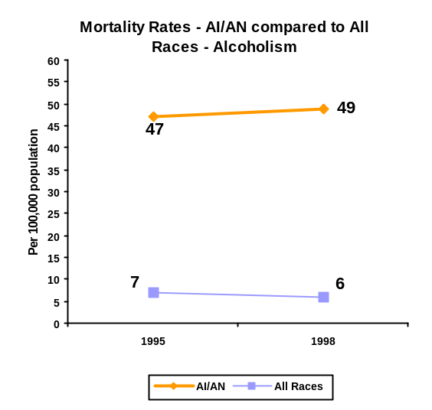
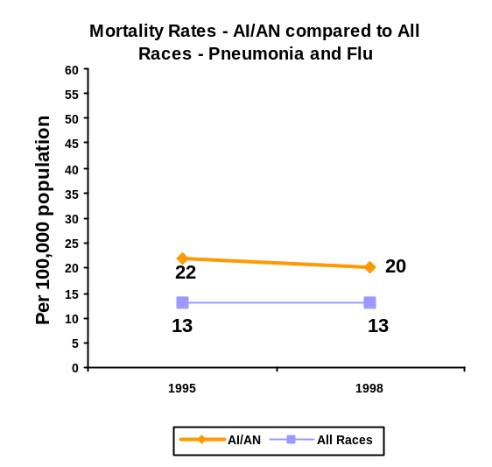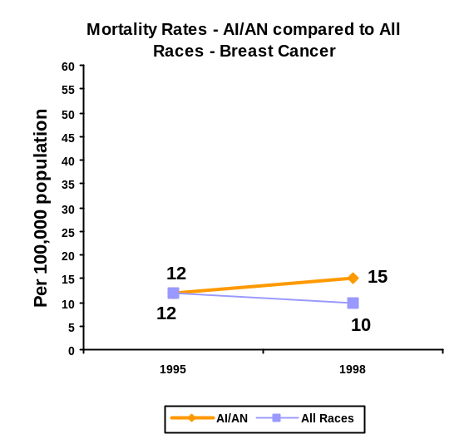

TABLE OF CONTENTS
Executive Summary iii
1.0 PERFORMANCE plan and Report 1-1
1.1 Treatment Performance Measures 1-5
1.1.1 Diabetes Group 1-5
1.1.2 Oral Health Group 1-5
1.2 Prevention Performance Measures 1-6
1.2.1 Developmental Prevention Group 1-6
1.3 Consultation, Partnerships, Core Functions, and Advocacy Performance Measures 1-6
1.4 Information Technology Development and GPRA 1-6
1.5 Key External Factors Influencing Success 1-7
1.5.1 The Role of Poverty 1-7
1.5.2 A Lack of Cost-Effective Interventions for Chronic Diseases 1-7
1.5.3 Third Party Collections 1-7
1.5.4 Recruitment and Retention of Health Care Providers 1-7
1.6 Budget and Program Aggregation 1-10
Performance Analysis 1-16
Treatment and Prevention Categories 1-16
1.6.1 Program Description and Context 1-16
1.6.2 Treatment Aggregation 1-16
1.6.3 Prevention Aggregation 1-17
1.6.4 Treatment Indicators 1-18
Performance Budget Integration 1-29
1.6.4.1 Diabetes Group: 1-29
1.6.4.1 Cancer Screening Group: 1-38
1.6.4.2 Substance Abuse Treatment Group: 1-40
1.6.4.3 Oral Health Group: 1-42
1.6.4.4 Family Violence, Abuse, or Neglect Indicator: 1-47
1.6.4.5 Information Technology Development Group: 1-48
1.6.4.6 Quality of Care Indicator Group: 1-51
1.6.5 Prevention Indicators 1-54
Performance Budget Integration 1-60
1.6.5.1 Public Health Nursing Indicator: 1-60
1.6.5.1 Immunization Group: 1-62
1.6.5.2 Injury Prevention Group: 1-66
1.6.5.3 Suicide Prevention Indicator: 1-68
1.6.5.4 Developmental Prevention and Treatment Group: 1-69
1.6.5.5 HIV/AIDS Indicator: 1-72
1.6.5.6 Environmental Surveillance Indicator: 1-74
1.7 Capital Programming/Infrastructure Category 1-75
1.7.1 Program Description and Context 1-75
1.7.2 Capital Programming /Infrastructure: Performance Indicators 1-75
1.7.3 Capital Programming/Infrastructure Indicators 1-76
1.7.3.1 Capital Programming /Infrastructure Group: 1-78
1.8 Partnerships, Consultation, Core Functions, and Advocacy Category 1-82
1.8.1 Program Description and Context 1-82
1.8.2 Performance Indicators 1-82
1.8.3 Partnerships, Consultation, Core Functions, and Advocacy Indicators 1-83
Performance Budget Integration 1-86
1.8.3.1 Consultation Improvement Indicator: 1-86
1.8.3.2 Administrative Efficiency, Effectiveness, and Accountability Group: 1-87
1.8.3.3 Managing Human Capital Indicator: 1-92
2.0 APPENDIX 1: Linkage to HHS and Agency Strategic PlanS 2-1
3.0 Appendix 2: CHANGES anD Improvements 3-1
3.1 FY 2005 Performance Plan 3-1
3.2 Revisions to FY 2004 Performance Plan 3-1
4.0 APPENDIX 3: PARTNERSHIPS AND COORDINATION 4-1
4.1 Program Coordination By Partners Within DHHS 4-1
Food and Drug Administration 4-3
Centers for Medicare and Medicaid Services 4-3
Health Resources and Services Administration 4-4
National Institutes of Health 4-4
HHS Office of Women's Health 4-4
Substance Abuse and Mental Health Services Administration 4-5
4.2 Collaboration With Other Federal Agencies 4-5
Department of Interior/Bureau of Indian Affairs 4-5
Department of Justice 4-5
Department of Veterans Affairs 4-5
4.3 Injury Prevention 4-5
5.0 Appendix 4: Data Verification and Validation 5-1
5.1 Data Sources to Describe the American Indian and Alaska Native Population 5-1
5.2 IHS Automated Data Systems 5-2
5.3 IHS Diabetes Care and Outcomes Audit 5-3
6.0 Appendix 5: Performance Measurement Linkages 6-1
6.1 Performance Measurement Linkages with Budget 6-1
6.2 Cost Accounting 6-1
6.3 Human Resources 6-2
6.4 Capital Planning 6-3
6.5 Program Evaluation 6-3
6.6 Summary of Select Evaluations Activities 6-4
6.7 New Directions for Evaluation 6-5
7.0 APPENDIX 6: SUMMARY FULL COST OF PERFORMANCE PROGRAM AREAS 7-5
7.1 Performance Program Summary Table 7-5

PERFORMANCE plan and Report
- INTRODUCTION

MISSION:
The mission of the Indian Health Service, in partnership with American Indian and Alaska Native people, is to raise their physical, mental, social, and spiritual health to the highest level.

GOAL:
To assure that comprehensive, culturally acceptable personal and public health services are available and accessible to American Indian and Alaska Native people.

FOUNDATION:
To uphold the Federal Government’s obligation to promote healthy American Indian and Alaska Native people, communities, and cultures and to honor and protect the inherent sovereign rights of Tribes.

The Indian Health Service (IHS) is the Operating Division (OPDIV) within the Department of Health and Human Services (HHS) that carries out the federal government’s trust responsibility to provide health care services to eligible American Indian and Alaska Native people. IHS provides these health services through a network of 594 healthcare facilities, including 49 hospitals, 219 ambulatory clinics, 309 health stations, 15 school-based clinics and numerous Alaskan village clinics. These facilities provide direct health care services to over 1.4 million American Indian and Alaska Native people; many of these people live in isolated areas where there is no access to health services other than those offered by IHS or tribally operated programs. Until the mid 1990s, IHS operated most of these facilities and programs as federal programs. However, IHS has long advocated for and supported the federal policy of Indian self-determination. Because of this commitment, currently over 50% of the Indian health system is operated directly by tribal governments. In addition to these tribally operated programs, IHS has contracts with 34 urban Indian organizations to provide services to eligible Indian people who reside in large metropolitan areas.
This performance plan outlines the incremental steps necessary to achieve our Strategic Goals and our Mission. The Strategic Goals provide the framework for key long-term outcome goals that are reflected through the performance indicators in this plan. The performance indicators in turn address the most significant health problems facing the American Indian and Alaska Native population as identified by representatives of the local I/T/U programs as well as management areas of the President's Management Agenda.
Strategic Goal 1 is to Build Healthy Communities. Health care is significantly determined at the community level; lifestyles established at that level profoundly influence health. The application of collaborative public health models remains critical to the development of healthy communities. These public health models can help empower communities to identify their own health problems as well as actively involve them in developing the solutions.
Strategic Goal 2 is to Achieve Parity in Access by 2010. Achieving parity in access to essential health care services is essential. This requires a focused advocacy effort coordinated across an expanded Indian health network. It also requires improving efficiencies, increasing collections, and tapping alternative revenue streams across I/T/Us. It requires appropriate organizational capacity and expertise within the Indian Health System.
Strategic Goal 3 is to Provide Compassionate, Quality Health Care. Improving the quality, safety, effectiveness, and acceptability of comprehensive, culturally appropriate health care for American Indian and Alaska Natives remains a management priority. An adequate information technology infrastructure helps ensure access to safe, evidence-based standards of care as well as health information to providers and consumers.
Strategic Goal 4 is to Embrace Innovation. The IHS can only achieve the previous three goals by embracing innovation. The IHS must develop a more a proactive and entrepreneurial corporate culture, and expand partnerships and coalitions to expand the Indian health network. This requires the IHS to improve its coordination and communications capacity and support the development of new structures, which can assist the Indian health network advocacy efforts in multiple dimensions.
Table 2: Program Performance Report Summary Table
FY | Measures in Plan by Budget Category | Efficiency | Outcome  Measures | Output Measures | Results Reported | Results Met  Completely | Unreported
1999 | Treatment - 17 |  |  |  | 17 | 12
1999 | Prevention - 3 |  |  |  | 3 | 1
1999 | Capital Programming/ Infrastructure- 3 |  |  |  | 3 | 2
1999 | Consultation, Partnerships, Core Functions, Advocacy - 4 |  |  |  | 4 | 3
1999 | Total - 27 | 2 | 9 | 16 | 27 | 18 | 0
2000 | Treatment - 18 |  |  |  | 18 | 13
2000 | Prevention - 8 |  |  |  | 8 | 5
2000 | Capital Programming/ Infrastructure - 3 |  |  |  | 3 | 2
2000 | Consultation, Partnerships, Core Functions, Advocacy - 5 |  |  |  | 5 | 4
2000 | Total - 34 | 3 | 12 | 19 | 34 | 24
2001 | Treatment - 19 |  |  |  | 19 | 13
2001 | Prevention - 11 |  |  |  | 10 | 6 | 1
2001 | Capital Programming/ Infrastructure - 3 |  |  |  | 3 | 2
2001 | Consultation, Partnerships, Core Functions, Advocacy - 5 |  |  |  | 5 | 4
2001 | Total - 38 | 3 | 13 | 22 | 37 | 25 | 1
2002 | Treatment - 21 |  |  |  | 21 | 18 | 0
2002 | Prevention - 12 |  |  |  | 11 | 9 | 1
2002 | Capital Programming/ Infrastructure - 2 |  |  |  | 2 | 2 | 0
2002 | Consultation, Partnerships, Core Functions, Advocacy - 5 |  |  |  | 4 | 2 | 1
2002 | Total - 40 | 3 | 15 | 22 | 38 | 31 | 2
2003 | Treatment - 21 |  |  |  | 20 | 15 | 1
2003 | Prevention - 12 |  |  |  | 11 | 10 | 1
2003 | Capital Programming/ Infrastructure - 2 |  |  |  | 2 | 2 | 0
2003 | Consultation, Partnerships, Core Functions, Advocacy - 6 |  |  |  | 5 | 4 | 1
2003 | Total - 41 | 3 | 17 | 21 | 38 | 30 | 3
2004 | Treatment – 21
2004 | Prevention - 12
2004 | Capital Programming/ Infrastructure - 2
2004 | Consultation, Partnerships, Core Functions, Advocacy - 4
2004 | Total - 39 | 3 | 18 | 20
2005 | Treatment – 21
2005 | Prevention - 12
2005 | Capital Programming/ Infrastructure - 2
2005 | Consultation, Partnerships, Core Functions, Advocacy - 4
2005 | Total - 39 | 4 | 21 | 15

The FY 2003 performance report highlights several noteworthy accomplishments as well as conveys the challenges and difficulties faced by the I/T/U programs in achieving these measures. A few are presented here as representative of the overall report.

Treatment Performance Measures

Diabetes Group
IHS has been cited as a model of community involvement and program effectiveness for the use of the IHS Diabetes Care and Outcome Audit to measure diabetes care in American Indian and Alaska Native communities. The Diabetes Care Audit assesses diabetes care and education for approximately 85,000 IHS diabetes patients. These measures reflect the National Council on Quality Assurance/American Diabetes Association proposal for national performance benchmarks for diabetes care.
IHS chose seven (including dental) of these audit measures as GPRA performance goals for 2005. Trends from the 2003 audit data indicate a continued improvement in these indicators. The IHS National Diabetes Program attributes these clinical improvements to the extensive commitment that IHS and local communities have made to improve diabetes control. The IHS National Diabetes Program is encouraging programs to use the new diabetes funding to continue to enhance their clinical care programs as well as their prevention projects. In addition, in FY 2003, our data source switched from the diabetic audit to GPRA+ data, which is obtained from the local RPMS databases. Our diabetic audit data mirrors our GPRA+ data, even though there may be occasional absolute differences.

Oral Health Group
Dental indicators provide a measure of three aspects of the dental program that collectively have the potential to affect oral health outcomes. Access to dental care is strongly associated with oral health. Periodic examinations allow for the detection and treatment of dental disease. Addressing overall access to dental care remains the dental programs greatest challenge. It is worth noting that the national average for access to dental has stood at just over 60% for several years. Access remains a continued priority for the IHS.
The benefits of water fluoridation and dental sealants in reducing the prevalence and severity of tooth decay are well supported in the scientific literature and access to dental services has been associated with better oral health status. In 2003, the IHS surpassed its performance targets for maintaining access to dental care and applying dental sealants but came up slightly short of reaching its target for expanding coverage of water fluoridation. As a result, the Office of Environmental Health and the Headquarters Division of Oral Health are implementing a new centralized effort to promote fluoridation in Indian communities.

Prevention Performance Measures

Developmental Prevention Group
Cardiovascular disease, obesity and tobacco are GPRA indicators that are dependent upon pilot projects with tribes and outside organizations to address these prevention issues. All targets were achieved in 2003. For FY 2004 and beyond, the indicators addressing prevention of cardiovascular diseases, obesity and tobacco use have evolved into global IHS-wide efforts. Effective programs that address these problems are critical to effective prevention and improved health status in American Indian and Alaska Native communities.

Consultation, Partnerships, Core Functions, and Advocacy Performance Measures
For FY 2003, accomplishments included meeting four of these five indicators; data for one indicator is still pending.. These all represent critical internal management functions that significantly contribute to our Mission.

Information Technology Development and GPRA
The IHS health information system provides user-friendly tools to facilitate tracking and improving direct patient care at the local sites; they also facilitate health data aggregation that is transparent to the end user. Reporting on GPRA indicators is dependent upon this reliable health information system. This system, RPMS (Resource Patient Management System), supports and facilitates the integration of clinical, administrative, and financial data at more than 80% of Indian healthcare facilities. The Patient Care Component of the RPMS is an automated system for the collection, storage, and output of data gathered at the point of patient contact in the outpatient, inpatient, and field visit settings. The National Patient Information Resource System (NPIRS) database includes data from both facilities using RPMS as well as those using other Health Information systems.
Indian Health Service has developed and deployed a software application (GPRA+ Clinical Performance Indicator System) designed to extract GPRA clinical indicator information from the RPMS system. This application facilitates local, as well as regional, compilation of clinical GPRA indicator results. The application allows a provider to track its’ own performance based upon the GPRA clinical indicators (similar to the use of HEDIS by individual providers) based upon site-specific times. GPRA+ also allows us to report on active clinical users, as opposed to all facility users. These results are used to report the FY 03 data.
IHS obtained data for most clinical indicators using electronic queries on current FY 2003 local health information databases. Automating extraction of data in this way allows IHS to add new performance measures in the most cost-effective way, without imposing additional data collection burdens on health care staff. A data warehouse is being developed to ensure accurate user population information as well as clinical data.

Key External Factors Influencing Success

The Role of Poverty
Socioeconomic determinants of health for both acute and chronic conditions are documented worldwide. In fact, many of the racial and ethnic disparities in health status disappear when analyses control for education and socioeconomic status. While increasing access to comprehensive health services over time will reduce both mortality and morbidity to some degree in American Indian and Alaska Native communities, health services alone are not likely to eliminate the huge health disparity gap that now exists, unless the other complex factors contributing to poverty are addressed. Poor health status should be viewed as both a cause and an effect of poverty.

A Lack of Cost-Effective Interventions for Chronic Diseases
Prevention, diagnosis and treatment of diseases such as obesity, alcoholism, diabetes, and cancer are extremely costly. The IHS is funded at approximately $1400 per person per year with Medicare/Medicaid; private insurance collections and out of pocket expenditures adding an estimated $500-700 more. Thus, health care for American Indian and Alaska Native people is funded at approximately $2000 per person annually compared to almost $4500 for the U.S.general population. In communities where the diabetes prevalence is approaching 40-50 percent, the entire available per capita funding is used to treat acute medical problems, leaving no resources for other critical health prevention and disease management.

Third Party Collections
The IHS is committed to the identification of available alternate resources and full optimization of third party collections for delivery of health care services. IHS has significantly increased its third party collections, because of higher negotiated Medicare and Medicaid rates, new authority to bill under CHIP and more efficient business management practices involving patient eligibility determination, documentation of services and processing of claims. These increases have been critical to the I/T/Us ability to meet increasingly demanding accreditation and quality standards and maintain access to services in the face of growing health demands driven by population growth and increasing health disparities. Third-party collections contribute to many performance measures and are considered in a general way in setting performance targets.

Recruitment and Retention of Health Care Providers
Vacancy rates for some health care providers are at the highest level in IHS history and relate directly to difficulties in recruitment and retention of these providers. External factors include the growing debt levels for health professionals leaving school, and relative shortages of certain health professionals. Internal factors include isolation, lack of amenities in many reservation settings, limited spousal employment opportunities, as well as limited access to consultants and diminished professional support from IHS Headquarters. Collectively these trends and associated reductions in career development and training opportunities have resulted in ongoing issues with recruitment and retention.
B. Discussion and Performance analysis
Program Description and Context:
Table 3 outlines the relationship between the IHS Strategic Plan’s four broad Strategic Goals, their supporting long-term outcome goals, and the FY 2005 performance indicators. Annual performance indicators contribute to the realization of the long-term outcome goals that serve as the progress measures for the IHS Strategic Goals.
Table 3:
Roadmap of Relationship of IHS Strategic Goals, Long Term Outcome Goals,
and Annual Performance Indicators
IHS Strategic Goals | Long Term Outcome Goals | Annual Performance Indicators | Budget Category
GOAL 1: BUILD HEALTHY COMMUNITIES | By 2010 we will decrease years of productive life lost (YPLL) by 20% over the 2002 level. | - Indicator 1:Poor blood Sugar Control  - Indicator 2: Good Diabetic Blood Sugar Control  - Indicator 3: Diabetic Blood Pressure Control  - Indicator 4: Diabetic Lipid Screening  - Indicator 5: Diabetic Kidney Disease Screening  - Indicator 7: Pap Screening  - Indicator 8: Mammography Screening  - Indicator 15: Domestic Violence | Treatment
GOAL 1: BUILD HEALTHY COMMUNITIES |  | - Indicator 22: Public Health Nursing visits  - Indicator 23: Children’s Immunizations  - Indicator 24: Adult Influenza Immunizations  - Indicator 25: Adult Pneumococcal Immunizations  - Indicator 26: Injury Prevention Projects  - Indicator 27: Reduce Unintentional Injury Mortality Rates  - Indicator 28: Suicide Surveillance System  - Indicator 29: Screen patients for lipids  - Indicator 31: Screen patients for tobacco use | Prevention
GOAL 1: BUILD HEALTHY COMMUNITIES | By 2010 we will decrease obesity rates for children by 10% over the 2002 rate. | - Indicator 30: Screen patients for obesity | Prevention
GOAL 1: BUILD HEALTHY COMMUNITIES |  | Other Annual Milestones for Strategic Goal 1:  - Indicator 9: Youth Regional Treatment Centers  - Indicator 10: Screen Potential Mothers for Substance Abuse  - Indicator 11: Water Fluoridation | Treatment
GOAL 1: BUILD HEALTHY COMMUNITIES |  | - Indicator 34: Environmental Health Surveillance Systems | Prevention
GOAL 1: BUILD HEALTHY COMMUNITIES |  | - Indicator 39: Assess Public Health Infrastructure | Consultation, Partnerships, Core Functions, and Advocacy
GOAL 2: ACHIEVE PARITY IN ACCESS BY 2010 | By 2010 we will assure 70% of AI/AN children receive dental sealants. | - Indicator 13: Dental Sealants | Treatment
GOAL 2: ACHIEVE PARITY IN ACCESS BY 2010 | By 2010 we will increase childhood immunization rates to 95%. | - Indicator 23: Childhood Immunizations | Prevention
GOAL 2: ACHIEVE PARITY IN ACCESS BY 2010 | By 2010 we will assure that 40% of AI/AN diabetics achieve "ideal" blood sugar control. | - Indicator 2: Diabetic Blood Sugar Control | Treatment
GOAL 2: ACHIEVE PARITY IN ACCESS BY 2010 | By 2010 we will assure that 94% of AI/AN homes have safe and adequate sanitation facilities. | - Indicator 35: Sanitation Facilities | Capital Programming/ Infrastructure
GOAL 2: ACHIEVE PARITY IN ACCESS BY 2010 |  | Other Annual Milestones for Strategic Goal 2:  - Indicator 12: Access to Dental Services  - Indicator 14: Diabetic Access to Dental Services | Treatment
GOAL 2: ACHIEVE PARITY IN ACCESS BY 2010 |  | - Indicator 22: Public Health Nursing Services | Prevention
GOAL 2: ACHIEVE PARITY IN ACCESS BY 2010 |  | - Indicator 36: Construction of Health Care Facilities | Capital Programming/ Infrastructure
GOAL 2: ACHIEVE PARITY IN ACCESS BY 2010 |  | - Indicator 38: CHS Rate Agreements  - Indicator 42: Placement of Healthcare Scholarship Recipients | Consultation, Partnerships, Core Functions, and Advocacy
GOAL 3: PROVIDE COMPASSIONATE, QUALITY HEALTH CARE | By 2010 we will assure that at least 90% of the AI/AN consumers receiving health care in IHS facilities perceive it to be good, very good, or excellent while maintaining 100% accreditation. | - Indicator 19: Accreditation of Facilities  - Indicator 21: Consumer Satisfaction | Treatment
GOAL 3: PROVIDE COMPASSIONATE, QUALITY HEALTH CARE |  | Other Annual Milestones for Strategic Goal 3:  - Indicator 6: Diabetic Retinopathy Screening  - Indicator 16: Local Data Quality  - Indicator 17: Expand Use of Behavioral Health Data System  - Indicator 18: Urban Common Data Set  - Indicator 20: Implement Medication Error Reporting System | Treatment
GOAL 3: PROVIDE COMPASSIONATE, QUALITY HEALTH CARE |  | - Indicator 33: HIV/AIDS Prevention Education at Prenatal Evaluations | Prevention
GOAL 4: EMBRACE INNOVATION | By 2010, the work of the Indian health network will result in the per capita funding available for health care for AI/AN people to be comparable to the US All Races level. | - Indicator 37: Satisfaction with Consultation Policy | Consultation, Partnerships, Core Functions, and Advocacy
NOTE: Indicators 9, 33, 36, 42, and 45 have been discontinued for FY 2005.

Budget and Program Aggregation
Table 3 above relates our performance measures to our budget. We have selected four functional areas for the aggregation of the 24 budget categories identified in the IHS Detail of Changes Table: 1) Treatment, 2) Prevention, 3) Capital Programming/Infrastructure, and 4) Consultation, Partnerships, Core Functions, and Advocacy.
Most chronic diseases such as diabetes, obesity, injuries, and family violence require multidisciplinary interventions to be successful. In such cases, there may be several providers, as well as health programs and funding categories, simultaneously addressing these health problems. Moreover, tribal programs, which now manage over 50% of the total IHS budget, have the legal flexibility to reprogram funding categories to meet their identified health priorities and likewise use an accounting system tailored to their needs and preferences. As a result, with the exception of the facilities construction category, tribes tend to use resources based on individual tribal priorities; consequently, the link between named categories in the IHS budget and how the funds actually are used in tribal programs may not be highly correlated.
For IHS managed programs, aggregation of budget categories that splits out activities and funding sources and facilitates a valid cost accounting link to health outcomes cannot be provided at this time. Despite these limitations, specific calculations for the four functional budget areas are included within this plan.
The estimate for treatment costs have been calculated based upon known health care costs in published medical literature, clinical user population, and level of need funded. If no external cost data is available, costs are calculated based upon percentage of provider time as a part of Medicare reimbursement rates. Specific line item budgets determine costs for indicators that have line item budgets. (e.g. dental, public health nursing)

The estimate for prevention costs have been calculated based upon known health care costs in published medical literature, clinical user population, and level of need funded as well. Once again, specific line item budgets determine costs for indicators that have line item budgets (e.g. dental, public health nursing). Many of the prevention indicators are tracking indicators; for these, we have included costs of tracking, and NOT the cost of the interventions.

The estimate for capital programming and infrastructure include the costs of building new facilities, as well as new and improved sanitation costs. However, these estimates do not include the costs of supporting and updating old facilities, equipment, and environmental costs.

The estimate for consultation, partnerships, core functions, and advocacy includes the cost of supporting these programs (as the measures are output measures), and not the cost of providing these services. The actual costs for most of these services (e.g. Contract Health Costs; Scholarships) are embedded in the other three budget categories.

Current FY 05 performance indicator budget aggregation accounts for approximately two billion of the budget submission. However, many of our projected indicator costs do not include the actual cost of services. For instance, our Contract Health Service indicator cost is based upon the cost of assessing the current number of contracts; it does not include the basis for these costs—which is the CHS line item budget within the treatment budget. The CHS budget amount accounts for 16% of the treatment budget category. If IHS included the costs of providing the service in each of our projected performance evaluation costs, as well as the cost of the evaluation, budget performance linkages would exist for approximately 2.6 billion of our proposed budget.

IHS is working towards a set of sentinel indicators that will reflect the majority of our budget. For instance, cardiovascular disease (CVD) is the number one cause of AI/ AN death. At the current time, due to data system and clinical constraints, IHS has only one performance indicator that addresses only one aspect of CVD treatment and prevention. Development of additional data systems, as well as outcome monitoring, should enable us to develop a more comprehensive CVD indicator—and allow us to monitor appropriate and effective utilization of additional treatment and prevention dollars.

Table 4 below shows the relationship between the funding categories in IHS Detail of Changes Table and the appendix of the “Budget of the United States” and our GPRA aggregation.
Table 4:
Budget Category Aggregation
INDIAN HEALTH SERVICE  Detail of Change Table |  |  |  | APPENDIX  Budget of the United States  items from left column |  |  | GPRA AGGREGATION  items from left column
SERVICES: |  |  |  | SERVICES:
1 | Hospitals & Health Clinics
2 | Dental Services |  |  |  |  |  | 1. | Treatment (1,2,3,4,5,10,11,12,14,15)
3 | Mental Health
4 | Alcohol & Substance Abuse |  |  |  |  |  | 2. | Prevention (6,7,8,9,19b)*
5 | Contract Health Services
 | Total, Clinical Services |  |  | 1 | Clinical Services (1-5) |  | 3. | Capital Programming/  Infrastructure (16-20)**
6 | Public Health Nursing
7 | Health Education |  |  |  |  |  | 4. | Partnerships, Consultation,  Core Functions, and Advocacy (13,19a-c)***
8 | Comm. Health Reps
9 | Immunization AK
 | Total, Prev Hlth |  |  | 2 | Preventive Health (6-9) |  |  | *The Prevention category includes 35% of Environmental Health Support (19b) activities.
10 | Urban Health |  |  | 3 | Urban Health (10)
11 | Indian Health Professions |  |  | 4 | Indian Health Professions (11) |  |  | **The Capital Programming/Infrastructure category includes 80% of Facilities Support (19a), 60% of Environmental Health Support (19b), and 20% of OEHE Support (19c) activities.
12 | Tribal Management |  |  | 5 | Tribal Management (12)
13 | Direct Operations |  |  | 6 | Direct Operations (13)
14 | Self Governance |  |  | 7 | Self Governance (14) |  |  | ***The Partnerships, Consultation, Core Functions, and Advocacy category includes 20% of Facilities Support (19a), 5% of Environmental Health Support (19b), and 80% of OEHE Support (19c) activities.
15 | Contract Support Costs |  |  | 8 | Contract Support Costs (15)
 | Total, Services |  |  |  | Total, Services
FACILITIES: |  |  |  | FACILITIES:
16 |  | Maint. & Improvement |  | 9 | Maint. & Improvement (16)
17 |  | Sanit. Facil. Constr.
18 |  | Hlth Care Facs. Constr. |  | 10 | Hlth Care Facs. Constr. (17-18)
19 |  | Facility & Envir. Hlth Support |  | 11 | Facil. & Envir. Hlth Sup (19a-c)
19a |  | Facility Support
19b |  | Env. Health Support
19c |  | OEHE Support
20 |  | Equipment |  | 12 | Equipment (20)
 |  | Total, Facilities |  |  | Total, Facilities
(20) Total, IHS |  |  |  | (12) Total, IHS |  |  | (4) Total, IHS
Budget Category Aggregation
Table 5: Crosswalk to FY 2005 Budget Request
 | Category/Sub-sub activity | FY 2005 Request
 | TREATMENT
1 | Hospitals & Health Clinics | $1,228,096,000
2 | Dental Services * | 109,013,000
3 | Mental Health | 55,780,000
4 | Alcohol and Substance Abuse | 143,571,000
5 | Contract Health Services | 495,203,000
10 | Urban Health | 32,371,000
11 | Indian Health Professions | 35,472,000
12 | Tribal Management | 2,406,000
14 | Self-Governance | 10,308,000
15 | Contract Support Costs | 271,734,000
 | M/M and PI Collections (85%) | 477,462,000
 | Diabetes | 150,000,000
 | Total | $3,011,416,000
 | PREVENTION
6 | Public Health Nursing * | $ 45,091,000
7 | Health Education | 12,371,000
8 | Community Health Representatives | 53,022,000
9 | Immunization AK | 1,623,000
19b | Environmental Health Support (35%) | 20,306,000
 | Total | $132,413,000
 | CAPITAL PROGRAMMING/INFRASTRUCTURE
16 | Maintenance & Improvement | $ 47,331,000
17 | Sanitation Facilities | 114,382,000
18 | Health Care Facilities Construction | 70,947,000
19a | Facilities Support (80%) | 59,578,000
19b | Environmental Health Support (60%) | 34,811,000
19c | OEHE Support (20%) | 2,349,000
20 | Equipment | 16,294,000
 | M/M and PI Collections (15%) | 84,258,000
 | Quarters | 5,900,000
 | Total | $435,850,000
 | PARTNERSHIPS, CONSULTATION, CORE FUNCTIONS, AND ADVOCACY
13 | Direct Operations | $ 58,205,000
19a | Facilities Support (20%) | 14,894,000
19b | Environmental Health Support (5%) | 2,901,000
19c | OEHE Support (80%) | 9,396,000
 | Total | $85,396,000
* The Dental and Public Health Nursing performance measures are evaluated in a disaggregated way from the Treatment and Prevention categories in an effort to explore a closer budget/performance linkage for these programs.

Performance Analysis

Treatment and Prevention Categories

Program Description and Context
Treatment and Prevention indicators are combined in this section. These indicators are based on specific selection criteria that include but are not limited to the following:
- critical health problems to our population;
- identified priority areas in terms of addressing health problems;
- existence of passive data sources;
- no rewards exist for under reporting of conditions; and
- evidenced-based and supportive of recognized standards of care.
For many indicators, a measurable change in the ultimate outcome is unlikely to be seen in the one-year time span of the performance plan. Indeed, the one-year target indicators may not be related to funding levels in a simple linear relationship within that one-year period.
The data that support the treatment and prevention indicators comes primarily from the IHS automated information system (Resource and Patient Management System). A discussion of data validation processes relative to this system is on Appendix 1 of page 4-1.
Ultimately, our performance in treatment and prevention activities will determine our level of success in improving the health of the American Indian and Alaska Native population. However, the proposed IHS funding for FY 2005 does not allow for target level increases over FY 2004 for many of these indicators. Our commitment to continue to meet these targets, given the population growth of over 1.7% annually and the rising cost of providing services, is challenging.

Treatment Aggregation
Hospitals and Clinics - supports inpatient and ambulatory care and support services such as nursing, pharmacy, laboratory, nutrition, medical records, etc (see page IHS-29 in FY 2004 budget document).
Dental Services - supports the provision of dental care through clinic based treatment and prevention services and community oral health promotion and disease prevention activities including water fluoridation and dental sealants (see page IHS-37 in FY 2005 budget document).
Mental Health - supports community oriented clinical and preventive mental health and social services programs (see page IHS-41 in FY 2005 budget document).
Alcohol and Substance Abuse - supports the efforts of tribes in the provision of holistic alcoholism and other drug dependency treatment, rehabilitation, and preventive services for individuals and families (see page IHS-49 in FY 2005 budget document).
Urban Indian Health - supports contracts and grants to 34 urban health programs funded under Title V of the Indian Health Care Improvement Act (see page IHS-93 in FY 2005 budget document).
Indian Health Professions - supports self-determination and access to health care through efforts to enable American Indian and Alaska Native to enter health professions, and effective recruitment of health staff by providing scholarships, loan repayment, temporary employment, and health professions recruitment (see page IHS-99 in FY 2005 budget document).
Self-Governance - supports the Office of Tribal Self-Governance and Self-Governance Planning and Negotiating grants. (see page IHS-113 in FY 2005 budget document).
Contract Support - provides administrative costs for tribal managed programs in addition to what would have been provided under the direct provision of the program as authorized under Section 106(a) (2) of P.L. 93-638, the Indian Self-Determination Act, as amended (see page IHS-121 in FY 2005 budget document).

Prevention Aggregation
Public Health Nursing - supports the community-based Public Health Nursing program that provides treatment, counseling, health education, and referral activities carried out in such setting as homes, schools, jails, bars, and community centers in conjunction with a diversity of other health care providers (see page IHS-75 in FY 2005 budget document).
Health Education - supports activities directed towards promoting healthy lifestyles, community capacity building, and the appropriate use of health services through public health education targeted at school health, employee health promotion, community health, and patient education (see page IHS-79 in FY 2005 budget document).
Community Health Representative - supports the tribally administered program of training American Indian and Alaska Native community members in basic disease control and prevention. These activities include serving as outreach workers with the knowledge and cultural sensitivity to effect change in community acceptance and utilization of health care resources and use community-based networks to enhance health promotion/disease prevention (see page IHS-83 in FY 2005 budget document).
Alaska Immunization Program - supports the Alaska immunizations program to address hepatitis and haemophilous influenza through collaboration with the CDC (see page IHS-87 in FY 2005 budget document).
Environmental Health Support - supports the IHS injury prevention program that coordinates and provides grants for primary preventive community-based collaborative programs using defined problem identification and evaluation methods (see page IHF-37 in FY 2005 budget document).

Treatment Indicators

Table 6: Treatment Indicators Performance Summary
Performance Indicator | FY Targets | Actual Performance | Reference
Diabetes Group
Indicator 1: Assure that the proportion of patients with diagnosed diabetes that have poor glycemic control (outcome)does not increase  Aggregated Indicator 1-5  full cost ( in millions)  FY 05: 820.8  FY 04: 817.5  FY 03: 814.2 | FY 05: assess proportion of patients with poor diagnosed control  FY 04: establish the baseline of patients with diagnosed diabetes that have poor glycemic control.  Prevalence of Diabetes  FY 04: maintain database  FY 03: maintain database  FY 02: maintain database  FY 01: maintain database  FY 00: maintain database  FY 99: establish baseline | FY 05:  FY 04:  FY 03: 2/04  FY 02: database maintained  FY 01: database maintained  FY 00: database maintained  FY 99: baseline established | P: p. 3-11  B: p. IHS-29  - IHS-127  3  HP 2010  * indicates revised FY 2004 measure. See summary of Changes Table 10 on page 5-1
Indicator 2: Address the proportion of patients with diagnosed diabetes that have demonstrated improved glycemic control. [outcome]  Full cost ( included in cost of indicator 1-5) | Ideal Glycemic Control  FY 05: maintain at FY 04 level  FY 04: +1% over FY 03 level*  FY 03: maintain at FY 02 level  FY 02: improve from FY 01  1FY 01: improved from FY 00  FY 00: improved from FY 99  FY 99: 25%  Good Glycemic Control  FY 99: 38% | FY 05:  FY 04:  FY 03: 28***  FY 02: 30%/25%***  FY 01: 29% **  FY 00: 26%  FY 99: 24%  FY 98: 22%  FY 97: 25%  FY 99: 35%  FY 98: 35%  FY 97: 25% | P: p. 3-12  B: p. IHS-29  p. IHS-127  3, 5  HP 2010  * indicates revised FY 2004 measure. See Summary of Changes Table 10 on page 5-1.  ** revised 8/03  *** GPRA+ data
Indicator 3: Address the proportion of patients with diagnosed diabetes that have achieved blood pressure. [outcome]  See # 1 for full cost | Ideal Hypertension Control  FY 05: maintain at FY 04 level  FY 04: +1% over FY 03 level*  FY 03: maintain at FY 02 level  FY 02: maintain at FY 01 level*  FY 01: improve from FY 00  FY 00: improve from FY 99  FY 99: 41% | FY 05:  FY 04:  FY 03: 37% ***  FY 02: 34/7%** /36%**  FY 01: 36%**  FY 00: 35%  FY 99: 36%  FY 98: 38%  FY 97: 27% | P: p. 3-13  B: p. IHS-29  p. IHS-127  3, 5  HP 2010  * indicates revised FY 2004 measure. See Summary of Changes Table 10 on page 5-1.  *** GPRA+ data  **revised 1/04
Indicator 4: Address the proportion of patients with diagnosed diabetes assessed for dyslipidemia. [outcome]  See # 1 for full cost | LDL Cholesterol  FY 05: maintain at FY 04 level  FY 04: +1% over FY 03 level*  FY 03: maintain at FY 02 level  FY 02: improve from FY 01  FY 01: improve from FY 00  FY 00: improve from FY 99  FY 99: 32%  Total Cholesterol  FY 99: 82% | FY 05:  FY 04:  FY 03: 48%***  FY 02: 64%/ 44%***  FY 01: 60%  FY 00: 54%  FY 99: 46%  FY 98: 29%  FY 99: 72%  FY 98: 79%  FY 97: 83% | P: p. 3-14  B: p. IHS-29  p. IHS-127  3, 5  *** GPRA+ data  HP 2010  * indicates revised FY 2004 measure. See Summary of Changes Table 10 on page 5-1.
Indicator 5: Address the proportion of patients with diagnosed diabetes assessed for nephropathy. [outcome]  See # 1 for full cost | FY 05: maintain at FY 04 level  FY 04: +1% over FY 03 level*  FY 03: maintain at FY 02 level  FY 02: improve from FY 01  FY 01: improve from FY 00  FY 00: improve from FY 99  FY 99: 36% | FY 05:  FY 04:  FY 03: 36%***  FY 02: 56%/35%***  FY 01: 54%  FY 00: 41%  FY 99: 36%  FY 98: 33%  FY 97: 36% | P: p. 3-15  B: p. IHS-29  p. IHS-127  3, 5  ***GPRA+ data  HP 2010  * indicates revised FY 2004 measure. See Summary of Changes Table 10 on page 5-1.
Indicator 6: Address the proportion of patients with diagnosed diabetes who receive an annual diabetic retinal examination at designated sites. [outcome]  full cost  FY 05: 1.8 M  FY 04: 1.7 M  FY 03: 1.6 M | FY 05: maintain at 04 level  FY 04: +3% over FY 03 level  FY 03: +3% over FY 02 level  FY 02: no indicator | FY 05:  FY 04:  FY 03: 58%***  FY 02: 55%*** | P: p. 3-16  B: p. IHS-29  p. IHS-127  3, 5  ***GPRA+ data  HP 2010
Cancer Screening Group
Indicator 7: Address the proportion of eligible women patients who have had a Pap screen within the previous three years. [outcome]  full cost for # 7 &8  FY 05: 12.5 M  FY 04: 12.1 M  FY 03: 11.6 M | Pap Screening  FY 05: maintain FY 04 level  FY 04: maintain FY 03 level  FY 03: maintain FY 02 level  FY 02: +2% over FY 01 level  FY 01: +3% over FY 00 level  FY 00: +3% over FY 99 level  FY 99: no indicator  Cervical Cancer  FY 99: determine incidence of cervical cancer | FY 05:  FY 04:  FY 03: 61%***  FY 02: 43.2% w/in 3 years (+1.3% over FY 2001)/62%***  FY 01: 21% w/in 1 year , 42% w/in 3 years  FY 00: 12% w/in 1 year, 18% w/in 3 years  FY 99: baseline not adequate  FY 99: 8-10 per 100,000 based on 40% of AI/AN | P: p. 3-18  B: p. IHS-29  3, 5  ***GPRA+ data  HP 2010
Indicator 8: Address the proportion of eligible women patients who have had mammography screening within the last 2 years. [outcome]  See # 7 | FY 05: maintain the FY 04 level  FY 04: maintain FY 03 level  FY 03: maintain FY 02 level  FY 02: +2% over FY 01 level  FY 01: +2% over FY 00 level  FY 00: +3% over FY 99 baseline  FY 99: establish baseline | F.Y 05:  FY 04:  FY 03: 41%***  FY 02: 24.7% w/in 2 years (+3.7% over FY 2002)/42%***  FY 01: 21% w/in 2 years  FY 00: 15% w/in 2 years  FY 99: baseline not adequate | P: p. 3-19  B: p. IHS-29  3, 5  ***GPRA+ data  HP 2010
Alcohol and Substance Abuse
Indicator 9: Assure quality and effectiveness of Youth Regional Treatment Centers. ( outcome)  full cost  FY 05: 19.5 M  FY 04: 19.0 M  FY 03: 18.9 M | RTC Accreditation:  FY 05: ensure 100% accreditation  RTC Assessment Criteria  FY 04: +2% over FY 03 for 4 criterion  FY 03: +5% over FY 02 for 4 criterion  FY 02: establish RTC baseline for 4 criterion  Follow-up Rates  FY 04: no indicator  FY 03: no indicator  FY 02: no indicator  FY 01: FY 00 level or higher  FY 00: 45% (+10% over FY 99 for 3 follow-ups by 12 months post discharge)  FY 99: establish baseline  Abstinence  FY 04: no indicator  FY 03: no indicator  FY 02: no indictor  FY 01: +5% over FY 00  FY 00: no indicator | FY 05:  FY 04:  FY 03: +4% over FY 02 for modifiable criteria  FY 02: baseline established  FY 03: no indicator  FY 02: no indicator  FY 01: 60%  FY 00: 48% % -12 mos (+17%)  FY 99: 40.9%  FY 03: no indicator  FY 02: no indicator  FY 01: no reliable data source  FY 00: no reliable data source | P: p. 3-23  B: p. IHS-49  1, 3, 5
Indicator 10: Address alcohol use in female patients of childbearing age. [outcome]  full cost  FY 05: 1.6 M  FY 04: 1.6 M  FY 03: 1.6 M | Provide Alcohol Screening  FY 05: increase screening over  FY 04: During FY 2004, establish the screening rate for alcohol use in women of childbearing age.  Implement Screening Protocol  FY 04: No indicator  FY 03: Maintain FY 02 level  FY 02: + 2% over FY 01  FY 01: + 10% over FY 00  FY 00: +5% over FY 99  FY 99: establish baseline | FY 05:  FY 04:  FY 03: 95%  FY 02: 90.5% (increase of 5.5% over FY 01)  FY 01: 85% (decrease of 2.6%)  FY 00: 87.6% (+9.2% over FY 99)  FY 99: 78.4% | P: p. 3-24  B: p. IHS-29  1, 3, 5  HP 2010
Oral Health Group
Indicator 11: Address access to optimally fluoridated water for the AI/AN population. [outcome]  full cost ( indicator 11-14)  FY 05: 92.7 M  FY 04: 90.9 M  FY 03: 89.4 M | FY 05: 0.5% over FY 04 pop. receiving flour. water  FY 04: 1% over FY 03 for pop. receiving fluor. water  FY 03: 1% over FY 02 for pop. receiving fluor. water  FY 02: 5% over FY 01 for AI/AN pop. receiving fluor. water  FY 01: 10% over FY 00 for demo Areas  5% over FY 00 for other Areas  FY 00: 15% over FY 99 for demo Areas  FY 99: no indicator | FY 05:  FY 04:  FY 03: +0.37%  FY 02: +1% for pop  FY 01: 28% over FY 00 for demo Areas  Same % FY 00 for other Areas  FY 00: 18 systems in compliance (38% increase)  FY 99: 13 systems in compliance for demo Areas or 2% | P: p. 3-26  B: p. IHS-37  3  HP 2010
Indicator 12: Address the proportion patients who obtain access to dental services. [outcome]  full cost (see # 11)  EFFICIENCY MEASURE | FY 05: maintain at FY 04 level  FY 04: maintain at FY 03 level  FY 03: maintain at FY 02 level  FY 02: 1% over FY 01  FY 01: 27%  FY 00: 23%  FY 99: 21% | FY 05:  FY 04:  FY 03: 28.1% ( increase)  FY 02: 27.35% (+1% over FY 01)  FY 01: 26.3%  FY 00: 25.1%  FY 99: 25.1%  FY 98: 24.5%  FY 97: 22% | P: p. 3-28  B: p. IHS-37  3, 5  HP 2010
Indicator 13: Address the number of sealants placed per year in AI/AN children. [outcome]  full cost (see # 11) | Total Sealants Placed  FY 05: at F.Y 04 levels  FY 04: at FY 03 level  FY 03: at FY 02 level  FY 02: +2.5% over FY 01 total sealants placed | FY 05:  FY 04:  FY 03: 243,499  FY 02: 227,945 (+7.2% over FY 01)  FY 01: 212,617 | P: p. 3-30  B: p. IHS-37  3, 5  HP 2010
Indicator 14: Address the proportion of patients diagnosed with diabetes who obtain access to dental services.  [outcome]  full cost (see #11) | FY 05: maintain at FY 04 level  FY 04: 1% increase over FY 03  FY 03: 2% increase over FY 02  FY 02: 2% increase over FY 01  FY 01: no indicator  FY 00: no indicator  FY 99: no indicator | FY 05:  FY 04:  FY 03: 36%***  FY 02: 36%***  FY 01: 32%  FY 00: no indicator  FY 99: no indicator | P: p. 3-31  B: p. IHS-37  3, 5  ***GPRA+ data  HP 2010
Family Abuse, Violence, and Neglect Indicator
Indicator 15: Address the proportion of women who are screened for domestic violence at health care facilities. [outcome]  full cost  FY 05: 1.9 M  FY 04: 1.8 M  FY 03: 1.4 M | Screening  FY 05: maintain FY 04 level  FY 04:at least 15% screened  FY 03: no indicator  FY 02: no indicator  FY 01: no indicator  FY 00: no indicator  FY 99: no indicator  Staff Training  FY 04: no indicator  FY 03: 60%  FY 02: 56%  FY 01: no indicator  FY 00: no indicator  FY 99: no indicator  Policies and Procedures  FY 04: no indicator  FY 03: 85%  FY 02: 82%  FY 01: 80%  FY 00: 70%  FY 99: 60%  Data Code  FY 04: codes implement in RPMS  FY 03: develop standard data code  FY 02: no indicator  FY 01: no indicator  FY 00: no indicator  FY 99: no indicator | FY 05:  FY 04:  FY 03: no indicator  FY 02: no indicator  FY 03: 60%  FY 02: 70%  FY 01: no indicator  FY 00: 54% (baseline)  FY 04:  FY 03: 84%  FY 02: 85%  FY 01: 82%  FY 00: 72%  FY 99: 64%  FY 04:  FY 03: standard data code established  FY 02: no indicator | P: p. 3-32  B: p. IHS-41  p. IHS-29  1, 3  HP 2010

Performance Indicator | FY Targets | Actual Performance | Reference
Information Technology Development Group
Indicator 16: Expand the automated extraction of GPRA clinical performance measures and improve data quality.  full cost ( measures 16-18)  FY 05: 8.2 M  FY 04: 6.7 M  FY 03: 6.5 M | FY 05: add 2 new measures of automated data quality assessment  FY 04: a. Implement quality training in all Areas  b. +2 new measures to automated data quality assessment “package”  FY 03: a. complete baseline of initial measures  b. automate new measures  c. distribute automated mapping tools to all I/T/Us  FY 02: assess 5 sites for 5 performance measures  FY 01: setup 5 sites for testing 5 performance measures  FY 00: no indicator  FY 99: no indicator | FY 05:  FY 04:  FY 03: complete baseline of initial measures; new measures automated; automated mapping tools distributed to all I/T/U sites  FY 02: 5 sites assessed for performance measures  FY 01: 5 sites for testing 5 performance measures established | P: p. 3-34  B: p. IHS-63  3, 5  
Indicator 17: Expand the Behavioral Health Data System by assuring an additional 5% of the programs will report minimum agreed-to behavioral health-related data into the national data warehouse.  full cost ( see # 16) | Expand MH/SS Use  FY 05: increase by 5%  FY 04: +5% use over FY 03  FY 03: +3% use over FY 02  FY 02: +5% use over FY 01  FY 01: +10% use over FY 00  FY 00: +10% use over FY 99  FY 99: 50% reported  Submit Minimum Data Set  FY 04: 55% submit minimum data  FY 03: 50% submit minimum data  FY 02: no indicator | FY 05:  FY 04:  FY 03: 3% increase  FY 02: 5% increase  FY 01: +12.1% increase  FY 00: +24.7% increase  FY 99: 51% reported  FY 98: 40-45% baseline est.  FY 03: 50%  FY 02: no accepted data set | P: p. 3-36  B: p. IHS-41  p. IHS-49  3, 5  
Indicator 18: Expand Urban Indian Health Program capacity for securing mutually compatible automated information system that captures health status, and patient care data for the Indian health system.  full cost ( see# 16) | I/T/U IT Enhancement  FY 04: no indicator*  FY 03: no indicator  Urban IT Enhancement  FY 05: implement C&G language  FY 04: develop language*  FY 03: +2 sites over FY 02 level  FY 02: +2 sites over FY 01 level  FY 01: implemented in 30% of urban programs  FY 00: test in at least one site  FY 99: develop specs and plan | FY 05:  FY 04:  FY 04:  FY 03: 5 sites added  FY 02: 2 sites added  FY 01: 32% (11 of 34) urban programs  FY 00: tested in several sites  FY 99: accomplished 8/99 | P: p. 3-37  B: p. IHS-63  3, 5    * indicates revised FY 2004 measure. See Summary of Changes Table 10 on page 5-1.
Quality of Care Group
Indicator 19: Maintain 100% accreditation of all IHS hospitals and outpatient clinics.  % of full cost  FY 05: 16%  FY 04: 16%  FY 03: 15% | FY 05: 100%  FY 04: 100%  FY 03: 100%  FY 02: 100%  FY 01: 100%  FY 00: 100%  FY 99: 100% | FY 05:  FY 04:  FY 03: 100%  FY 02: 100%  FY 01: 100%  FY 00: 100%  FY 99: 100%  FY 98: 100% (baseline) | P: p. 3-38  B: p. IHS-29  p. IHF-9  3, 5
Indicator 20: Address medication errors by developing a reporting system to reduce medication error. [outcome]  full cost  FY 05: 6.0 M  FY 04: 3.0 M  FY 03: 0.3 M | FY 05: all direct care facilities shall be using the NCCMERP nationally recognized medication error definition, and shall have a non-punitive multi-disciplinary medication error reporting system in place.  FY 04: establish baseline data for medication error reporting for all IHS Areas  b. pilot test standardized medication error reporting system in two additional areas  FY 03: assess baseline and establish pilot sites  FY 02: assess current systems for 3 elements | FY 04:  FY 03: baseline assessed and pilot sites established;  FY 02: 3 elements assessed | P: p. 3-38  B: p. IHS-29  3,
Indicator 21: Assess consumer satisfaction with the acceptability and accessibility of health care  full cost  FY 05: 0.2 M  FY 04: 0.2 M  FY 03: 0.2 M | FY 05: improve by 1% over FY 04  FY 04: improve 3% over FY 03  FY 03: establish baseline  FY 02: secure OMB clearance  FY 01: secure OMB clearance  FY 00: Federal clearance and establish baseline  FY 99: develop instrument and protocol | FY 05:  FY 04:  FY 03: baseline established  FY 02: OMB clearance secured  FY 01: waiting final OMB approval  FY 00: submitted but clearance not completed  FY 99: instrument and protocol complete | P: p. 3-39  B: p. IHS-29  3  5
Total Treatment Funding: | FY 05: $3,011,416,000*  FY 04: $2,964,983,000*  FY 03: $2,907,957,000  FY 02: $2,746,954,000  FY 01: $2,117,008,000  FY 00: $1,931,326,000  FY 99: $1,811,951,000  FY 98: $1,711,018,000  *includes 85% of M/M and PI collections and Diabetes |  | P: page # in perform. plan  B: page # in budget justif.

Performance Budget Integration
These 21 indicators account for approximately 59% of this budget category. Additional indicators within the Partnerships/ Consultation budget category account for approximately 17% more of the performance budget (contract health services; scholarships). If the costs of these services (not solely the oversight of these programs) were included in this category, these performance indicators would reflect 69% of the proposed treatment budget for FY 05.

1.6.4.1 Diabetes Group:
The following six indicators address the ongoing monitoring and treatment of diabetes in the American Indian and Alaska Native population. Diabetes continues to be a growing problem in American Indian and Alaska Native communities with rates increasing rapidly in the majority of IHS Areas. The age at diagnosis is occurring younger, with no signs of decline in any IHS Area. The treatment indicators (1-6) were selected because of their proven benefits in reducing the morbidity and mortality associated with diabetes. We have changed indicator 1 to focus on improving diabetic control; we will continue to collect prevalence data, and report the diabetic indicators within the context of this information.
While two-thirds of the Special Diabetes Program for Indians (SDPI) grantees are focusing significant efforts on primary prevention of type 2 diabetes, one third are focusing resources on secondary and tertiary prevention geared at reducing diabetes complications. The IHS National Diabetes Program has developed an infrastructure and methodology to track both clinical treatment and prevention efforts carried on by the SDPI grantees. The grantees are evaluated on clinical care through the Annual IHS Diabetes Care and Outcomes Audit. We expect performance to remain unchanged in grant programs focused on primary prevention. This is because their target audience is those at risk for diabetes and not patients who already have the disease. We hope to see improvement in the GPRA indicators at sites that are focused on improving clinical care, and will report data on this group separately in FY 05.
The IHS Diabetes Program conducts a yearly medical record review (either electronically or by manual chart audit) of a random sample of over 19,000 medical records in I/T/U facilities in order to assess compliance with the IHS Standards of Care for Diabetes. This record review uses a strict protocol to assure statistical integrity and comparability of both process and outcome measures over time. In addition, GPRA+, our RPMS GPRA extraction software, enables us to track these trends at local facilities running RPMS. GPRA+ data has been used for the GPRA report for FY 2003. . Trends over time for I/T/U facilities, service units, Areas, and IHS-wide( using both diabetic audit data and GPRA+ data) are also constructed for indicators 1-6.
Performance targets for the FY 2005 indicators 1-6 are set at a maintenance level over the FY 2004 level due to projected increase in the diabetic population, as well as known costs and budget projections.
Indicator 1: During FY 2005, assure that the proportion of patients with diagnosed diabetes that have poor glycemic control does not increase over FY 2004 level.
During FY 2004, establish the baseline of patients with diagnosed diabetes that have poor glycemic control.
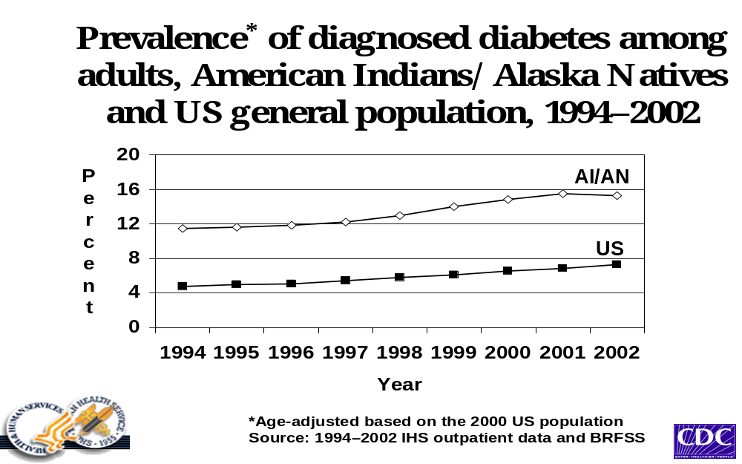
*Age-adjusted based on the 2000 U.S.population.
Source: FY 01 IHS APC file. Excludes data from 39 service units (7% of the IHS user population).
Area age-specific diabetes prevalence rates have been prepared for the American Indian and Alaska Native population based on patients diagnosed with, treated for diabetes, and having at least one outpatient visit during FY 2002. This information is the contextual basis for our series of diabetic indicators.
Rationale: This indicator is directed at reducing diabetic complications through improved blood sugar control by decreasing the percentage of patients with poor glycemic control

Approach: Glycemic control is measured with a test called the Hemoglobin A1C (HgbA1c) that measures the average blood sugar over the last 1-2 months. The IHS Diabetes Care and Outcomes Audit divides these control levels into “Ideal” ; “Good” ; “Fair” ; “Poor”; and “Very Poor” based on national diabetes care standards.
Data Source: Diabetes registries, yearly IHS Diabetes Care and Outcomes Audit. Achievement of this indicator will be determined by calculating the mean HgbA1c of the entire diabetic population for a given audit year as well as dividing these data into the categories of "ideal", "good," "fair," "poor," and "very poor."
Those sites that have chosen to focus on the problem by applying the best practices associated with glycemic control will be assessed as a defined group using the IHS Diabetes Care and Outcomes Audit. In FY 2004, the mean HgA1c of this group and categories of glycemic control will be reported as a baseline and compared with the performance of the I/T/U system as a whole. Then, in subsequent years, the performance of this group will be followed and compared to the larger group, with results for both being reported in the GPRA reports. Further analysis of their specific activities related to glycemic control may provide guidance and answers to other sites hoping to address this problem in the future.
Program Performance: IHS met this indicator in 2002. 2003 data is still pending. This indicator was to monitor the prevalence of diabetes. Current FY 2003 data is being evaluated. Results are expected to be reported in February 2004, though preliminary analysis indicates that there is a continued epidemic of diabetes in American Indian/ Alaska Native communities.

Indicator 2: During FY 2005, maintain the proportion of patients with diagnosed diabetes that have demonstrated improved glycemic control (defined as ideal control) at the FY 2004 level.

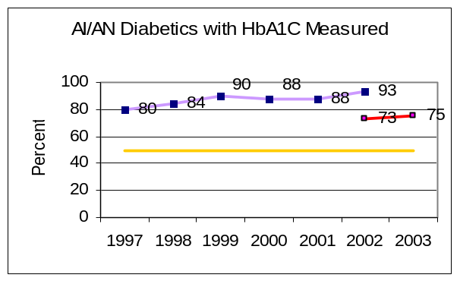
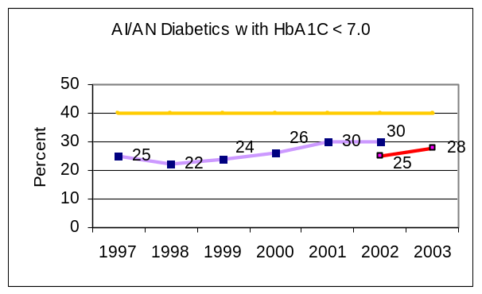
Purple - Diabetic Audit Data Source
Red - GPRA+ Data Source
Gold - HP 2010 or IHS Goal

Rationale: This indicator is directed at reducing diabetic complications through improved blood sugar control.

Approach: Glycemic control is measured with a test called the Hemoglobin A1C (HgbA1c) that measures the average blood sugar over the last 1-2 months. The IHS Diabetes Care and Outcomes Audit divides these control levels into “Ideal” (<7%); “Good” (7.0-7.9%); “Fair” (8.0-9.5%); “Poor” (9.5-11.9%); and “Very Poor” (>12%) based on national diabetes care standards. The current guidelines recommend the use of HgbA1c cutoffs that determine control at the "Ideal" level.
Data Source: Diabetes registries, yearly IHS Diabetes Care and Outcomes Audit, GPRA+ data from local RPMS.
Those sites that have chosen to focus on the problem by applying the best practices associated with glycemic control will be assessed as a defined group using the IHS Diabetes Care and Outcomes Audit. Starting in FY 2004, the mean HgA1c of this group and categories of glycemic control will be reported as a baseline and compared with the performance of the I/T/U system as a whole.
Program Performance: IHS met this indicator in FY 2002 and 2003. The FY 2003 Indicator was to maintain the proportion of I/T/U clients with diagnosed diabetes who have improved their glycemic control (defined by ideal control) at the FY 2002 level. Our current rates of measuring HgA1c values far surpass the Healthy People 2010 target. Our baseline of ideal control, established in FY 98, was 22%, with increases as noted above, even though the definition of ideal control has become stricter. GPRA+ data, used to report clinical indicators starting in FY 2003, mirrors the trends previously established in the diabetic audit. The difference in absolute percentages is due to the use of the diabetic audit versus a solely electronic audit for GPRA+ data.

Indicator 3: During FY 2005, maintain the proportion of patients with diagnosed diabetes who have achieved blood pressure control at the 2004 level.
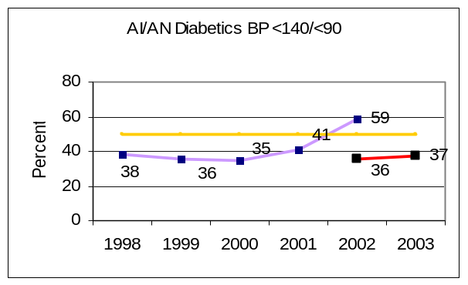
Purple - Diabetic Audit Data Source
Red - GPRA+ Data Source
Gold - IHS 2010 Goal

Rationale: This indicator is directed at reducing complications of diabetes. Large clinical studies have demonstrated that blood pressure control significantly reduces the incidence of complications related to diabetes, most notably heart disease, strokes and kidney disease.
Approach: National standards recommend that the ideal goal of diabetic blood pressure control should be 130/80. For the GPRA process, the “ideal” control is defined as 130/80, though this will change as clinical care guidelines are modified.
Data Source: Diabetes registries and yearly IHS Diabetes Care and Outcome Audits, GPRA+ data from local RPMS. This indicator is determined by calculating the proportion of clients with diabetes who have “ideal” blood pressure control (defined as systolic BP<130 and diastolic BP<80) and the proportion who fall into the “controlled” category (defined as systolic BP<140 and diastolic BP<90) in the current audit year. The current year mean systolic and diastolic blood pressures of the “ideal” category are compared to that of the previous year to determine if improvements were maintained for this fiscal year.
Program Performance: IHS did not met this indicator in FY 2002; IHS did met this indicator in FY 2003. The FY 2003 indicator was to maintain the proportion of I/T/U clients with diagnosed diabetes who have achieved blood pressure control at the FY 2002 level.
In FY 2002, 34.7% of clients falling into the “ideal BP control” category based on the diabetic audit; in FY 2003, 37% of patients were in control using GPRA+ electronic data. This improvement, which mirrors the diabetic audit data from a trend perspective, occurred in spite of the fact that we “tightened” our definition of “ideal control” (lowering the acceptable diastolic BP from 85mm Hg to 80 mm Hg) in response to new National Guidelines on Blood Pressure Control in people with diabetes.

Indicator 4: During FY 2005, maintain the proportion of patients with diagnosed diabetes assessed for dyslipidemia (LDL cholesterol) at the FY 04 levels.
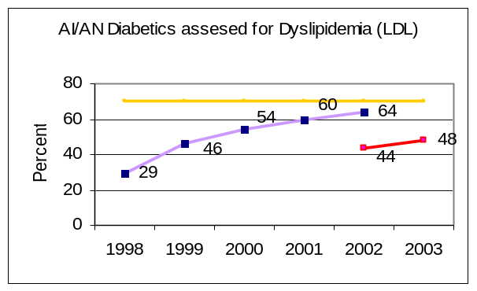
Purple - Diabetic Audit Data Source
Red - GPRA+ Data Source
Gold - IHS 2010 Goal

Rationale: This indicator is directed at reducing diabetic complications from heart disease through lowering of serum LDL cholesterol.
Approach: This indicator will measure screening of LDL in diabetic patients. The diabetes grant programs choosing to focus on cardiovascular risk reduction, of which treatment of dyslipidemia is a large, will be tracked separately to see if their overall performance is better than the group as a whole. Trends over time for I/T/U facilities, service units, Areas and IHS-wide are constructed for selected indicators.
Data Source: Diabetes registries, yearly IHS Diabetes Care and Outcomes Audit; GPRA+ data. Achievement of this indicator is determined by calculating the proportion of patients with diabetes who have had LDL cholesterol performed in the past year. The current year’s data is compared to that of the previous year to determine if improvements were maintained for this fiscal year.
Program Performance: IHS met this indicator in both FY 2002 and FY 2003. The FY 2003 Indicator was to maintain the proportion of I/T/U clients with diagnosed diabetes assessed for LDL cholesterol at the FY 2002 level. The proportion of I/T/U clients diagnosed with diabetes assessed for LDL cholesterol increased from 46% for FY 1999 to 64% in FY 2003. GPRA+ data showed an increase from 44% to 48%, mirroring the trend from the diabetes audit data. This improvement in performance is due to better awareness in both providers and patients through the National Cholesterol Education Program efforts and increased I/T/U provider awareness of the growing problem of heart disease in AI/AN through Diabetes Program (and others) efforts to publicize results of the Strong Heart Study showing that the rate of heart disease in AI/AN is increasing.

Indicator 5: During FY 2005, maintain the proportion of patients with diagnosed diabetes assessed for nephropathy at the FY 2003 level.
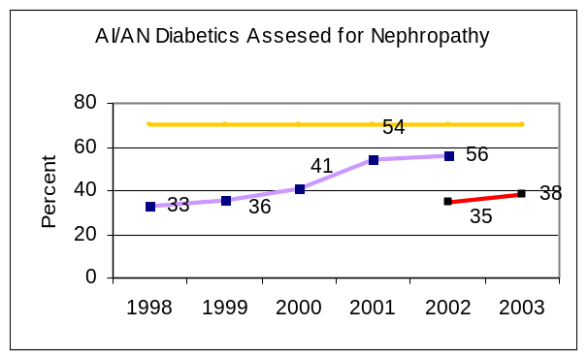

Purple - Diabetic Audit Data Source
Red - GPRA+ Data Source
Gold – IHS 2010 Goal

Rationale: This indicator is directed at reducing diabetic complications. End stage renal disease (ESRD), or diabetic kidney disease, is a significant and growing problem in Indian communities. The assessment of proteinuria not only indicates who is at risk for ESRD, but is an independent predictor of cardiovascular risk, which is the number one killer of American Indian and Alaska Native adults.
Approach: The benefits of aggressive interventions to lower blood pressure in diabetics relative to kidney health have been well described in the literature and numerous practice guidelines and standards exist. The use of appropriated diabetes funding enhancements will improve the performance of this indicator with grants /cooperative agreements for special activities aimed at targeted diabetes-related treatment and prevention areas.
A special sub-report of the IHS Diabetes Care and Outcomes Audit, called the Kidney Health Profile, generated annually, assesses screening and treatment for kidney health in a community. Each year’s reported rate will be used to provide trend analysis.
Data Source: Diabetes registries, yearly IHS Diabetes Care and Outcomes Audit, and GPRA+ data from local RPMS systems.
Achievement of this indicator is determined by calculating the proportion of patients with diabetes and a normal proteinuria screen who have had a test for microalbuminuria performed in the past year. The present year’s data is compared to that of the previous year to determine if the level of assessments were maintained.
Program Performance: IHS met this indicator in both FY 2002 and FY 2003. The FY 2003 Indicator was to maintain the proportion of I/T/U clients with diagnosed diabetes assessed for nephropathy at the FY 2002 level and was met. Screening for microalbuminuria to assess early diabetic nephropathy increased from 33% in 1998 to 56% in FY 2002 using the diabetic audit, and from 35-38% (from 2002 to 2003), using GPRA+ reports on local RPMS data.

Indicator 6: During FY 2005, maintain the proportion of patients with diabetes who receive an annual diabetic retinal examination at designated sites at the FY 2004 rate.
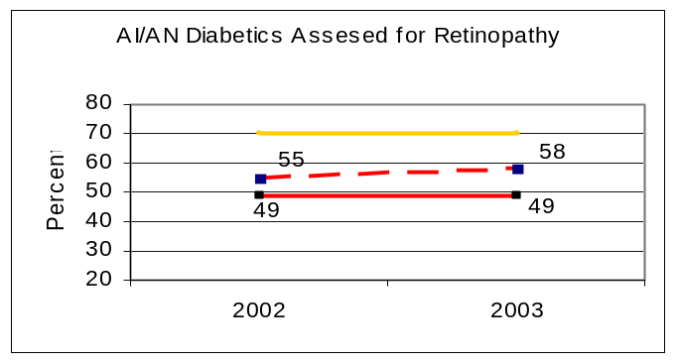
Gold – 2010 Goal
Dashed Red – Telemed Project Data
Solid Red – GPRA Data
Rationale: The purpose of this indicator is to reduce the level of vision loss from diabetic retinopathy in the American Indian and Alaska Native population. According to the Early Treatment of Diabetic Retinopathy Study (ETDRS) timely laser, treatment of diabetic retinopathy nearly eliminates severe vision loss due to diabetes. It is estimated that the benefits of treatment include a net savings of almost $500,000,000 and almost 100,000 person years of sight across the USA.
Approach: Early detection and timely treatment is necessary to minimize or prevent vision loss due to diabetic retinopathy. The Indian Health Service began tracking the rate of annual eye exams many years ago, documenting the perennial rate of annual diabetic eye exams/retinal screenings consistently at between and 53-56%. An improved strategy will be implemented in three phases. The first phase involves facilities that have telemedicine projects in place designed to screen diabetics for diabetic retinopathy. Those facilities participating in phase one are: Phoenix Indian Medical Center, Pine Ridge Hospital, Tuba City Medical Center, Fairbanks Health Center, Sells Hospital and Carl Albert Indian Health Facility
Data Source: The calculation of annual dilated retinal exams on diabetics is obtained from GPRA+ run on local RPMS databases.
Program Performance: IHS met this indicator for FY 2003. The FY 2003 indicator was to increase the proportion of patients with diagnosed diabetes who receive an annual diabetic retinal examination at designated sites by 3%. Many barriers that exist within the IHS system prevent significant improvement in the diabetic eye screening rates. The implementation of diabetic retinopathy screening programs utilizing telemedicine may be one method to decrease some of these barriers. With the renewal of funding for the Special Diabetes Program for Indians (SDPI), it is expected that more sites will implement solutions such as this in an effort to reach the IHS 2010 goal of 70%.

Cancer Screening Group:
These two indicators are directed at increasing the coverage of women receiving screening for breast and cervical cancer.
Indicator 7: During FY 2005, maintain the proportion of eligible women who have had a Pap screen within the previous three years at the FY 2004 levels.
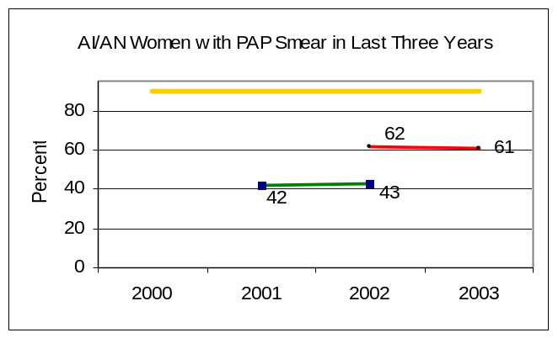
Green – NPIRS Data Source
Red - GPRA+ Data Source
Gold - HP 2010 or IHS Goal

Rationale: The purpose of this indicator is to reduce the mortality and morbidity of cervical cancer, which occurs at higher rates among American Indian and Alaska Native women than in the general U. S. population. The long-range goal is to reduce both cervical cancer incidence and death rates to achieve parity with the U.S. all-races rate by 2010.
Approach: The IHS Office of Public Health is responsible for overall coordination of efforts to achieve these indicators.
Data Source: The total number of women age18 through 64 who have had at least one Papanicolaou screening test performed (cervical cytology or Pap smear) in the previous three years will be determined from IHS Laboratory reports and PCC electronic patient records. The baseline for this measure as reported in FY 2000 performance report is 18%.
Program Performance: IHS did not meet this indicator for FY 2003 The FY 2003 indicator was to maintain the proportion of women 18 and older that had a Pap in 2003 at the FY 2002 level.
The IHS performance for 2003 was determined from electronic medical record queries using GPRA+ at the local sites. Even though we were unable to show an increase over FY 2002, we were able to show a significant increase using local data derived from the local health information system. IHS believes that our current screening rate of 61% is a major achievement in our cancer prevention strategy. During FY 2003, funding remained stable for Pap screening and cancer prevention in general. IHS did not increase overall expenditures for women’s health, and CDC did not fund any additional Tribal screening projects. Problems with recruitment and retention of providers continue to exist.
IHS plans to renew our focus on cancer screening. This will include providing feedback to providers on their individual and local facility pap screening rates.
Indicator 8: During FY 2005, maintain the proportion of eligible women who have had mammography screening at the FY 2004 rate.
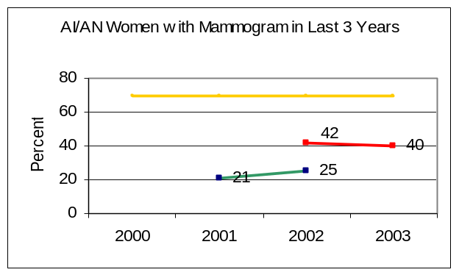
Green – NPIRS Data Source
Red - GPRA+ Data Source
Gold - HP 2010 or IHS Goal

Rationale: The purpose of this indicator is to reduce the mortality and morbidity of breast cancer among American Indian and Alaska Native women.
Approach: Mammography screening is provided to American Indian and Alaska Native women directly by IHS facilities, by mobile mammography units supported either by CDC funds, or through contract health arrangements with private radiology groups. The IHS Office of Public Health performs the overall coordination of this effort. Linkages with CDC and State screening programs are critical to success. CDC has funded the National Indian Women’s Health Support Center to provide technical assistance to Tribal mammography programs.
Data Source: IHS electronic medical records are the principal data source. The numerator is the total number of women age 50 through 64 who have had at least one mammogram performed in the previous two years. We have increased the lower age limit from 40 to 52, because considerable controversy remains about the efficacy of mammography for women under 50. We set an upper age limit of 64 to have rates that are comparable with CDC reporting, and because women over 65 are Medicare eligible and therefore more likely to have mammograms performed by outside facilities that do not report to IHS.
Program Performance: IHS did not meet this indicator for FY 2003. This indicator committed to maintaining the proportion of American Indian and Alaska Native women who received clinically indicated screening mammography in the previous 2 years.
In FY 2003, 41%of American Indian and Alaska Native women had a mammogram during the previous 2 years. The graph illustrates the increase in overall screening rates when data is derived from local health information systems using GPRA+. This increase in screening reflects better data collection and capture of mammography at the local level.
IHS plans to increase mammography rates by providing electronic reminders as well as feedback to individual providers.

Substance Abuse Treatment Group:
These two indicators address substance abuse treatment. The first targets improved residential treatment of adolescents with alcohol/substance abuse problems. The second addresses prevention of fetal alcohol syndrome.
Indicator 9: During FY 2005, the Youth Regional Treatment Centers that have been in operation for 18 months or more will achieve 100 % accreditation through either CARF, or a comparable accreditation process.

Rationale: This indicator is intended to evaluate youth regional treatment centers, and ensure that these programs are appropriately managed. Successful completion of residential treatment can help reduce drug and alcohol use relapse in youths.
Approach: Accreditation by JCAHO, CARF, or comparable state accrediting bodies ensures that the Youth Regional Treatment Centers met acceptable standards of treatment care. This indicator has changed to focus on accreditation, as the components of the previous indicator are met and surpassed with accredited facilities.
Data Source: Data for this indicator are collected from the YRTCs. The Division of Behavioral Health, Office of Public Health will be responsible for coordinating data collection from the Regional Treatment Centers.
Program Performance: In 2003, IHS met the intent of this indicator. The FY 2003 performance measure was to improve baseline YRTC data for the following measures by 5%
- Percent of youths who successfully completed alcohol/substance abuse treatment at IHS funded YRTCs. (Stable at 63% from 62.6%)
- Percent of youth (that completed treatment) who developed an aftercare plan with their appropriate aftercare agency (99.6% from 99.0%)
- Percent of youth who have this after care plan communicated to the responsible follow-up agency; documentation of this communication must be in the youth YRTC record (99.5% from 89.5%)
- Percent of YRTC programs that have a family week opportunity for youth that participate in the YRTCs (100% from 100%)
All YRTC’s have reported data on these measures. Completion of treatment, established aftercare, and an established family week are known factors in predicting success. Improvement in after care communication, as well as youth with aftercare plans, and family week opportunities are essential to improving outcomes. IHS believes that we met the spirit of this measure, as we say marked improvement in the communication of after care plans. However, we were unable to increase the percentage of youth who have completed treatment, as this is multifactorial.We will continue to track this indicator in FY 2004, prior to the change to accreditation in FY 2005.
Indicator 10: During FY 2005, increase the screening rate for alcohol use in women of childbearing age over the FY 04 rate.
During FY 2004, establish the screening rate for alcohol use in women of childbearing age.
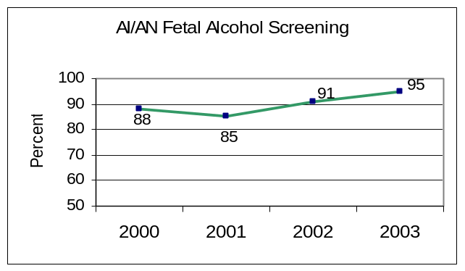
Rationale: The purpose of this indicator is a reduction in the incidence of Fetal Alcohol Syndrome (FAS). Surveillance conducted at two IHS Areas indicated FAS rates greatly exceed general population rates. Thus, the purpose of this indicator is to assure that providers consistently screen and make appropriate referrals for women at risk. Indian Health Service had implemented screening and case management protocols at the majority of our facilities by 2002.
Approach: The Division of Behavioral Health works with facilities to educate establish and increase the rates of screening for alcohol use in this age cohort. In addition, RPMS Health Summary ensures that there is an automatic health care reminder for alcohol screening. This reminder is visible to the end health care provider at the time of the provider visit.
Data Source: RPMS data extraction
Program Performance: IHS met this indicator. The FY 2003 indicator committed to maintaining the proportion of I/T/U prenatal clinics utilizing a recognized screening and case management protocol(s) for pregnant substance abusing women at the FY 2002 level For FY 2002, 209 out of 231 clinics had implemented such protocols for a rate of 90.5%. In FY 2003, 95% of clinics met this indicator.IHS is changing this indicator in FY 2004 to reflect the desire to move towards an outcome indicator.

Oral Health Group:
Oral conditions of American Indian and Alaska Native participants are far worse than the U.S. general population. These poor oral conditions profoundly influence their quality of life, including their ability to attend school, work, and sleep, eat, and socialize.
The 1999/2000 IHS Oral Health Survey of American Indian and Alaska Native dental patients underscored the significant disparities in oral health that continue to exist between native and non-native Americans. Key findings concerning the Native American population examined include:
- Native American patients experience roughly three times the amount of tooth decay and periodontal disease as compared to the general U.S. population;
- Very young Native Americans experience tooth decay at rates significantly greater than general U.S. population children;
- The use of tobacco is strongly associated with both oral cancer and periodontal disease. The prevalence of tobacco use starts at about 13 years of age among Native Americans and steadily increases with age; and
- Most Native American adults and elders have lost teeth because of dental disease or oral trauma.
Indicator 11: During FY 2005, increase the proportion of American Indian and Alaska Native population receiving optimally fluoridated water by 0.5 % over FY 2004 levels for all IHS Areas.
Rationale: Fluoridation is one of the most cost effective public health measures for reducing the prevalence of dental decay in all age groups. However, despite the known benefits of fluoridation, the number of fluoridated water systems in Indian country has declined by 68% during the 1990’s because of more rigorous monitoring standards developed by the Center for Disease Control. The FY 2005 fluoridation objective is formulated as a 0.5 % increase in the number of individuals having access to fluoridated water. The tribal utilities yet to be fluoridated are the relatively small ones. The average number of individuals served by tribal utilities that remain unfluoridated is approximately 300. A proposed 0.5 % increase at first glance might appear quite modest. However, it will take the fluoridation of approximately 25 individual utilities to achieve this goal. This reasonable objective postulates a smaller increase in fluoridation coverage than previous objectives for recent years. This is in recognition of a number of factors:
- The successes documented at our pilot sites in previous years have proven to be less exportable than originally envisioned.
- Remaining utilities yet to be fluoridated are relatively small. Efforts similar to those made in recent years will yield diminishing returns in the future, as in general it takes a similar level of effort and resources to start up fluoridation at an individual utility regardless of size or number of individuals served.
- Significant positive outcomes from reorganizing and centralizing fluoridation coordination are not expected until FY 2005.
- Relying upon Area Offices to provide fluoridation data has introduced variability into our annual assessments. A primary thrust of national efforts during both FY 2003 and FY 2005 will be to establish a consistent national database with which to monitor future efforts toward fluoridation.
Approach: The IHS Dental Program, Office of Environmental Health and Engineering Branch, and the Centers for Disease Control and Prevention’s Division of Oral Health entered into an interagency agreement in FY 2000 to support a demonstration fluoridation project in the Albuquerque and Phoenix Areas.
This indicator expanded to address all IHS Areas in FY 2001, because of earmarked recurring funding of $500,000 in FY 2001 to support water fluoridation IHS-wide. Each Area will submit an annual plan of action and an annual report of activities and outcomes. Because of the very limited success Area dental programs have had with respect to fluoridation in recent years, Headquarters Office of Environmental Health and Engineering and Headquarters Division of Oral Health are initiating a new effort to promote fluoridation.
Date Sources: (1) Water Fluoridation Reporting System (WFRS) and database maintained by CDC. The FY 2002 level will provide the comparison or baseline for assessing the annual gain. (2) Reports from IHS Area fluoridation coordinators and Area Dental Officers. Individual Area reports continue to be solicited for two reasons: (1) WFRS lacks the detail and the personal observations that can be provided by field personnel; and (2) few tribal utilities have chosen to use WFRS.
Program Performance: IHS did not meet this indicator. The FY 2003 indicator committed to a 1%increase in the number of American Indian and Alaska Native people benefiting from fluoridated drinking water. However, an increase of 0.37% was achieved and documented. .
Individual reports from IHS Areas other than the two demonstration sites make it clear that significant progress has been made in most Areas with respect to water fluoridation, but the final objective of all the efforts, successful fluoridation, has not yet occurred. As noted above, the Headquarters Office of Environmental Health and Engineering and Headquarters Division of Oral Health are initiating a new centralized effort to promote fluoridation across the IHS.

Indicator 12: During FY 2005, maintain the proportion of patients who obtain access to dental services at the FY 2004 level.
During FY 2004, maintain the proportion of patients who obtain access to dental access at the FY 2003 level.
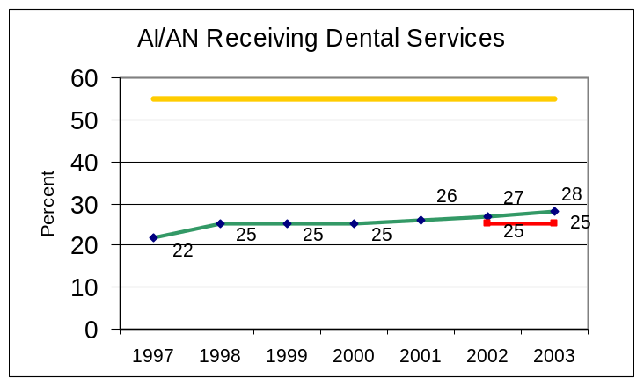
Green – NPIRS Data Source
Red - GPRA+ Data Source
Gold - HP 2010 or IHS Goal

Rationale: This indicator is directed at improving the oral health status of the American Indian and Alaska Native population. There has been almost a 10% reduction in the percent of the American Indian and Alaska Native population annually receiving dental services in recent years. The proposed FY 2005 indicator supports the capacity to maintain dental access at 100% of the FY 2004 level.
Approach: Access to dental services in FY 2005 will be maintained at 100% of the FY 2004 level through a combination of strategies that include:
- Increasing the I/T/U dental workforce.
- Increasing retention and productivity of dental providers.
- Updating and simplify the automated dental record keeping system.
- Expanding essential dental specialty services through contracts with the private sector.
- Targeting specific populations.
The vacancy rate for dental providers, which has fluctuated slightly between approximately 18% and 22%, is a key determinant in limiting access to care. The current vacancy rate of approximately 20% has remained relatively stable over the last few years despite increased emphasis upon recruiting. This suggests that additional efforts toward retention of dental providers will be necessary to ensure stabilizing this indicator.
Data Source: IHS Dental Data System component of the RPMS; GPRA+ data from local RPMS.
Program Performance: IHS met this indicator. The FY 2003 indicator committed to maintaining the proportion of the American Indian and Alaska Native population having access to dental care compared to FY 2002. 28.1% of the user population received dental care in FY 2003 compared to 27.35% receiving care in FY 2002. GPRA+ data is also stable at 25% for FY 2002 and FY 2003.
Indicator 13: During FY 2005, maintain the number of dental sealants placed per year in American Indian and Alaska Native patients at the FY 2004 level.
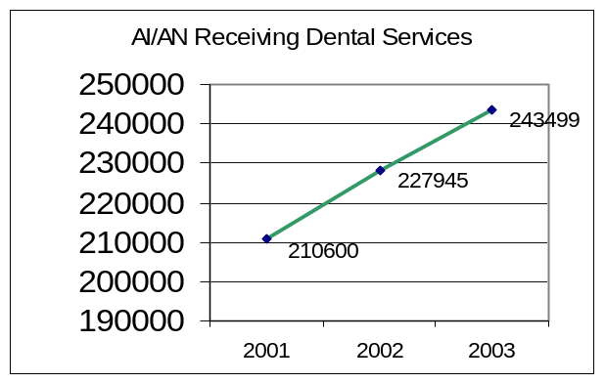

Rationale: Dental sealants, a recognized standard in preventive dental care, are an effective measure for reducing dental decay rates and can be effectively applied by dental auxiliaries at relatively low cost. Because surveys of American Indian and Alaska Native children have consistently identified them as having significantly higher decay rates than the general U.S. population, sealants are essential to reduce both the ravages and costs of treating dental decay.
The intent of this indicator is to reduce dental decay by increasing both the number of patients with dental sealants (the prevalence of sealants in the population) and the number of sealants per patient (the intensity of coverage per individual
Approach: Local dental clinics are responsible for implementing/maintaining effective and efficient sealant programs that are either school-based or school-linked and targeted for children ages 6-14 years (to coincide with the eruption of first and second permanent molar teeth). In order to maintain the number of sealants placed on the posterior teeth of Indian patients in FY 2005, an innovative approach will be required. One option involves the use of contract 4-handed dental sealant teams hired from the private sector. Dental Community Health Aides may be trained to assist dental hygienists and dental assistants in placing sealants. Additional portable equipment to be used in the schools is an efficient way to make use of lack of clinic space and going to where the children are – the schools.
Data Source: IHS Dental Data System component of the RPMS. This revision of data collection is expected to result in significantly larger data sets and data that are more reliable. In contrast to the previous measure, these data will provide an estimate of both prevalence of sealants and intensity of care, by providing an estimate of the number of sealants placed per patient.
Program Performance: IHS met this indicator. In FY 2002, 227,945 sealants were placed in the IHS dental program. In FY 2003, 243,499 sealants were placed in patients of all ages. This represents an increase over sealants placed in FY 2002.

Indicator 14: During FY 2005, maintain the proportion of patients diagnosed with diabetes who obtain access to dental services at the FY 2004 level.
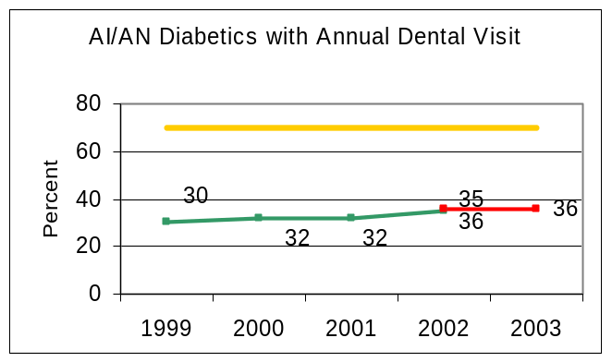
Green – NPIRS Data Source
Red - GPRA+ Data Source
Gold - HP 2010 or IHS Goal

Rationale: The purpose of this indicator is to improve both oral health status and diabetic control for American Indian and Alaska Native diabetics. Restoring access to both primary and secondary treatment and preventive services for diabetics can lessen periodontal disease progression and the subsequent effects on diabetes and overall health. Improving access and thus increasing utilization of dental services can also result in less costly care, improved health status, and quality of life.
Approach: Individual I/T/U hospitals and clinics provide access to care for diabetic patients in a wide variety of ways. At a minimum, a yearly examination provides an educational opportunity to enlighten the diabetic patient on their oral health status and proper home care to reduce periodontal disease and its effect on diabetic control. Those programs with additional time and resources can provide anything from extraction of teeth that are severely involved with periodontal disease to comprehensive periodontal therapy and dentures. The proposed FY 2005 IHS budget will support the capacity to maintain access at the FY 2003 level in the face of population growth and rising costs of treatment.
Data Source: Diabetes registries, yearly IHS Diabetes Care and Outcomes Audit.
Program Performance: IHS did not meet this indicator in FY 2003. IHS did meet this indicator in FY 2002. This indicator was to increase access to dental services at 2% over FY 2002 level. Ongoing shortages of dental professionals make this aggressive target difficult to reach. Our ability to maintain services is remarkable, given the increasing diabetic population that needs to access limited services.

Family Violence, Abuse, or Neglect Indicator:
Indicator 15: During FY 2005 the IHS will ensure that 15% of women between the ages of 15 and 40 are screened for domestic violence.
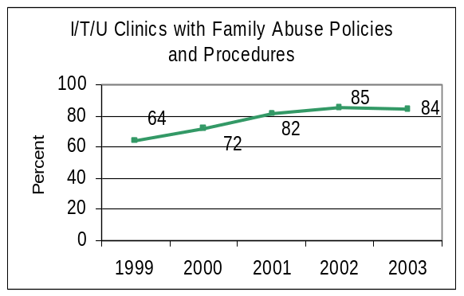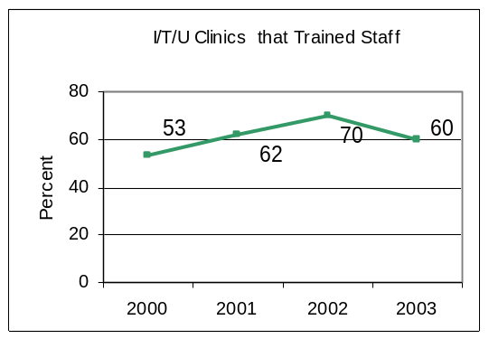

Rationale: This indicator is designed to help ascertain, evaluate and reduce the prevalence of family violence, abuse and neglect in American Indian and Alaska Native communities. Rates of intimate partner violence are double for American Indian and Alaska Native people compared to whites, and 1½ times greater than U.S. all races. (MMWR)
Approach: IHS has developed training materials that are specific for American Indian and Alaska Native communities. IHS has entered into a collaborative agreement with the Family Violence Prevention Fund as well as ACF, DHHS. This agreement facilitated the development of our teaching materials as well as the implementation and evaluation of a multifaceted systems approach to screening at clinical facilities throughout American Indian and Alaska Native communities.
Data Source: RPMS data will be used to obtain and aggregate domestic violence screening rates.
Program Performance: IHS did not meet this indicator. The FY 2003 indicator was to assure that at least 85% of I/T/U medical facilities who provide direct clinical care have written policies and procedures for routinely identifying, treating, and/or referring victims of domestic violence, abuse or neglect as well as child abuse/neglect and elder abuse/neglect.
In addition, 60% of sites needed to provide staff training to their direct clinical staff on these policies. The aggregate rate for policies and procedures for FY 2003 was 84%. 60% of sites provided training in these policies and procedures. A code for screening for domestic violence was developed and integrated into our health information system; this will facilitate our ability to report on the screening for domestic violence in high-risk female populations starting in FY 2004. IN FY 2004, this indicator changes to an outcome indicator.

Information Technology Development Group:
The following three indicators address the development of improved automated data capabilities that support clinical care and performance measurement.
Indicator 16: During FY 2005, implement a national program to improve the quality, accuracy and timeliness of Resource Patient Management System (RPMS) Patient Care Component (PCC) clinical data to support the Agency’s GPRA clinical measures by expanding the current automated data quality assessment “package” to include two new additional clinical measures.
Rationale: This indicator is part of an on-going effort to improve the overall accuracy, completeness and timeliness of clinical data from the Agency’s primary clinical data repository - Resource Patient Management System (RPMS) Patient Care Component (PCC) used for GPRA clinical measures. The goal of this indicator is to improve the overall quality of clinical data including completeness, timeliness, accuracy and movement of data to the national programs for future national electronic GPRA reporting.
Approach: The I/T/Us are responsible for managing local RPMS clinical applications including data quality. The agency will provide an expanded data quality application that will allow individual sites to assess electronically collected clinical data received at the national program level with patient “medical records” maintained at the local health facility.
Data Source: Local programs export RPMS clinical data to the national programs.
Program Performance: IHS met this indicator. For FY 2003 this indicator committed to:
- Automate new performance measures
- Complete baseline for any performance measures where electronic data collection was implemented during this FY;
- Distribute automated mapping tools for LOINC to all I/T/U’s
This serves as part of a long-term effort to expand the IHS capacity to derive GPRA performance data directly from clinical automated information systems, including the Resource and Patient Management System (RPMS). This allows IHS to add new performance measures in the most cost-effective way and efficient way. The majority of the GPRA clinical indicators are reported in FY 03 using GPRA+ data. Finally, a LOINC software patch was distributed to all I/T/U sites that were interested in deploying this enhancement.
Indicator 17: During FY 2005, improve the Behavioral Health (BH) Data System by assuring at least an additional 5% of the I/T/U programs will report minimum agreed-to behavioral health-related data to the national data warehouse.
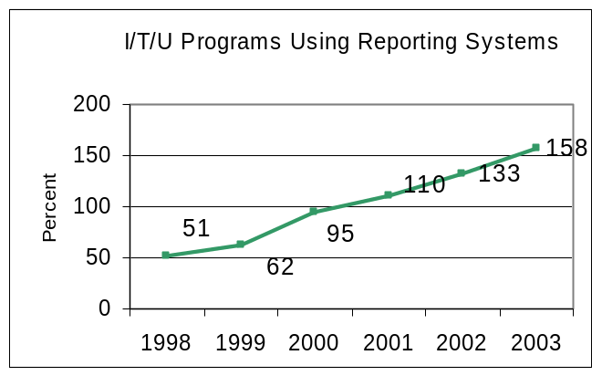
Rationale: The purpose of this indicator is to collect data in order to track and evaluate improvements in the behavioral health status of American Indian and Alaska Native people. Better BH data collection and analysis will improve planning, implementation and evaluation of mental health, alcohol and substance abuse, and social services efforts across I/T/U programs.
Approach: Improving behavioral health outcomes relies on two important activities: data collection as close to point of care as possible, and data reporting in a standardized way that can be understood across the Indian health system. Standardized data reporting can be achieved by providing a usable, provider-driven and provider friendly computerized application to I/T/U sites.
A key activity that began in FY 2002 was the design and implementation of an integrated Behavioral Health system. The behavioral health Interim Solution, deployed during FY 2003, helped address the need for incremental improvements in existing RPMS systems, as well as facilitated a standardized suicide data collection system within the RPMS package.
The IHS Indian Health Performance Evaluation System (IHPES) has also developed a national Mental Health SAS database.
Data Source: RPMS, the Mental Health Database, and appropriate surveys.
Program Performance: IHS met this indicator. The FY 2003 performance measure was to increase the percent of I/T/Us that have implemented the use of the Mental Health/Social Services (MH/SS) data reporting system by 3% over the FY 2001 level. In FY 2003, an additional 25 sites began to collect and share data.
The FY 2003 totals for this indicator were taken directly from the national data center. “Actual” data was exported and received from all included I/T/U programs by the national data center. This comparative data was based upon data sent to the national database since 1990.
Indicator 18: During FY 05, IHS will have in place contract and grant requirements for all urban Indian programs to provide a specified data set in a standard format.
FY 2004 indicator: During FY 04, IHS will develop a specific minimum data set as well as appropriate language for the urban C&G.
Rationale: The urban health programs are currently capturing data for the Urban Indian Health Program Common Reporting Requirement (UCRR). However, a minimum data set needs to be developed to address additional urban data needs, including GPRA reporting.
Approach: The urban program will facilitate a data workgroup to develop this minimum data set. This group will develop this minimum data set by during FY 04. Mandatory reporting on this data set will be included as part of the C&G language starting in FY 05.
Data Source: Review of Urban Program Contracts and Grants language
Program Performance: IHS met this indicator for FY 2003. The FY 2003 performance measure was to increase by 5% (+2 sites over FY 02 level), the proportion of Urban Indian health care programs that have implemented mutually compatible automated information systems that capture health status and patient care data over the FY 2002 level. The intent of the measure is to 1) build Urban Indian Health Program (UIHP) information technology and data collection infrastructure capacity, 2) create a system which allows standardized data collection, data reporting and data sharing, 3) provide centralized technical support to UIHPs and to share programmatic knowledge among UIHPs, and 4) create a resource for developing advocacy data.

IHS met this indicator with the installation of the IHS Resource and Patient Management System (RPMS) at five new sites. The new sites, located within the state of Montana, Billings Area Office, are Billings, Butte, Great Falls, Helena and Missoula.

The measure was surpassed through the collective efforts of the Urban Indian Health Program (UIHP) contractors and grantees, the Urban Indian Health Program Branch office and the Indian Health Performance Evaluation System (IHPES) staff in developing the urban Indian health care data mart within the IHS data warehouse and with the establishment of an UIHP data workgroup that has begun to develop the minimum data set needed to address additional urban data needs.

Adequate health status and health services data are essential for the effective planning and management of any health care delivery system. Urban data must eventually reach parity with that collected by tribal and IHS facilities to allow for a more accurate portrayal of the needs and services available to American Indians and Alaska Natives (AI/AN) residing in urban areas, the existing disparities in health status that afflict them, and supporting local health program needs as well as provide data for the larger IHS requirements, including GPRA. The UIHPs advocate for the considerable health care need of the AI/AN people residing in urban areas and to meet the Healthy People 2010 goal of achieving equivalent and improved health status for all Americans.

Quality of Care Indicator Group:
The following indicators address the quality of health care provided in IHS settings from both the perspective of accreditation, medication errors, and consumer satisfaction.
Indicator 19: During FY 2005, maintain 100% accreditation of all IHS hospitals and outpatient clinics.
Rationale: The accreditation of IHS hospitals and clinics represents the most objective and respected measure of health care quality. In addition, accreditation is essential for maximizing third-party collections, and contributes both directly and indirectly to many other indicators presented in this plan.
Approach: The local I/T/U multidisciplinary team approach to accreditation and ongoing quality management has been the mainstay of success in this important activity. Additional support and guidance from Areas and Headquarters staff will continue to support this indicator. This is one of the most demanding indicators to meet, given the growing clinical quality of care assessments that are required as well as issues related to health facilities maintenance, improvement, and renovation that are critical to accreditation. The accrediting body used for hospitals and some ambulatory health centers is the Joint Commission on the Accreditation of Health Care Organizations (JCAHO). However, there was an increase in the ambulatory health centers that obtained accreditation from the American Association of Ambulatory Health Centers (AAAHC).
Data Source: IHS compiled a database generated from accreditation reports submitted by IHS Area Quality Assurance coordinators.
Program Performance: IHS met this indicator in FY 2003. The FY 2003 committed to maintaining 100% accreditation of all IHS hospitals and outpatient clinics and was achieved. During FY 2003, fifteen IHS hospitals were evaluated by JCAHO and all fifteen maintained full accreditation. In addition, 13 ambulatory health centers participated in accreditation visits from JCAHO and AAAHC and all were accredited.

Indicator 20: During FY 2005, all direct care facilities shall be using the NCCMERP nationally recognized medication error definition, and shall have a non-punitive multi-disciplinary medication error reporting system in place.
Rationale: The intent of this indicator is to improve patient safety by reducing medication errors. The current system in place does not require national reporting. Many sites still have punitive systems in place that discourage reporting of medication errors. By developing a national anonymous reporting system, IHS will be able to determine a more accurate medication error rate and identify frequent problems throughout our health care system.
Approach: The IHS examines the many different medication error reporting processes and training used throughout the I/T/U, as well as other health networks. IHS works with Areas to establish baseline data for medication error reporting.
Data Source: In FY 2005, baseline medication error reporting data is obtained from sites using in place local systems including reports to Risk Management Officers and data entered into the Resource and Patient Management System (RPMS).
Program Performance: IHS met this indicator. The FY 2003 performance indicator was that the IHS would assess the current processes in place in I/T/Us that affect medication error reporting, and:
- establish pilot sites
- assess baseline at the initial sites
The two sections of the indicator related to Medication Error Reporting were met. Med Marx, the web based medication error reporting system, was pilot tested for one year at all of IHS and most tribal sites in the Phoenix and Albuquerque areas. Results of the pilot test were favorable and other areas were encouraged to adopt Med Marx or another standardized medication error reporting system. To date, 55 facilities in the Alaska, Aberdeen, Bemidji, Oklahoma, and Phoenix areas are using Memorex.

The second part of the Medication Error Reporting indicator related to assessing baseline data for reported errors. The Phoenix area was the pilot and established an area-wide baseline both prior to and after implementation of the Med Marx reporting system. In September 2003, Med Marx rolled out a Multi-Facility Module that will allow for tracking and trending of medication errors at the regional and national level. IHS has purchased this module and expects to have out first national data available in the second quarter of FY 2004

Indicator 21: By the end of FY 2005, maintain consumer satisfaction rates at the FY 2004 level.
Rationale: The intent of this indicator is to maintain consumer satisfaction. Assessing consumer satisfaction is fundamental to health care quality, and is one of the Institute of Medicines cornerstones of health care quality. Improved consumer satisfaction is also associated with higher consumer compliance levels with provider health recommendations, which can result in improved health outcomes.
Approach: In FY 1999, the IHS developed a comprehensive culturally sensitive consumer satisfaction survey instrument that was based on a tested and validated instrument from the private sector. Clearance was obtained in late FY 2002, and baseline data was obtained during FY 02. Additional assessments have been undertaken in FY 2003, with a follow-up survey to determine improvement scheduled to be completed in FY 2004.
The responsible parties for implementation are the local service sites with assistance from the IHS Area office staff. The local staff is part of the local quality assurance program and the aggregate staff will be part of the IHS epidemiology centers/program.
Data Source: IHS Consumer Satisfaction Survey
Program Performance: IHS met this indicator. The FY 2003 indicator committed to establishing a baseline for consumer satisfaction using the OMB approved instrument. instrument, which was obtained in late FY 02. Use of the survey instrument began in late FY 2002, and a baseline was established by the end of FY 2003.

Prevention Indicators
Table 7: Prevention Indicators Performance Summary
 | Performance Indicator |  |  | FY Targets |  | Actual  Performance |  | Reference
 | Public Health Nursing Indicator
 | Indicator 22: Address the number of public health nursing services (primary and secondary treatment and preventive services) provided by public health nursing  EFFICIENCY MEASURE  full cost  FY 05: 46.5 M  FY 04: 43.1 M  FY 03: 39.6 M |  |  | Total Visits  FY 05: maintain FY 04 levels  FY 04: maintain FY 03 level  FY 03: maintain FY 02 level  FY 02: +2% over FY 01  FY 01: +3% over FY 00  FY 00: 7% over 97 or 363,033  FY 99: no indicator  Home Visits  FY 05: no indicator  FY 04: maintain FY 03 level  FY 03: +2% over FY 02  FY 02: +2% over FY 01  FY 01: +3% over FY 00  FY 00: 7% over 97 or 127,846  FY 99: no indicator |  | FY 05:  FY 04:  FY 03:359,089 ***  FY 02: 400,347/343,844***  FY 01: 383,436 (+3.1%)  FY 00: 371,548 (9.5 % over FY97)  FY 99: 336,134  FY 97: 339,283 baseline  FY 05: no indicator  FY 04:  FY 03: 160,650***  FY 02: 151,370/156263***  FY 01: 153,852 (+20%)  FY 00: 127,873 (7% over 97)  FY 99: 111,836  FY 97: 119,482 baseline |  | P: p. 3-46  B: p. IHS-75  1, 3, 5  ***GPRA+ data
 | Immunization Group
 | Indicator 23: Address rates for recommended immunizations for AI/AN children patients 19-35 months. [outcome]  full cost ( # 23-25 )  FY 05: 8.6 M  FY 04: 7.9 M  FY 03: 7.0 M |  |  | FY 05: maintain FY 04 level  FY 04: +2% over FY 03  FY 03: at FY 02 level  FY 02: +1% over FY 01 level  FY 01: +1% over FY 00 level  FY 00: +2% over FY 99 level  FY 99: 91% |  | FY 05:  FY 04:  FY 03: 80%  FY 02: 80%  FY 01: 83% 12 of 12 Areas (-3%)  FY 00: 86% 12 of 12 Areas (-3%)  FY 99: 89% 12 of 12 Areas  87% 11 of 12 Areas  FY 98: 88% (baseline 11 of 12 Areas)  * previously reported at 78% |  | P: p. 3-47  B: p. IHS-29  p. IHS-75  p. IHS-83  p. IHS-87  1, 3  HP 2010
 | Indicator 24: Address influenza vaccination rates among non-institutionalized adult patients aged 65 years and older. [outcome]  full cost ( see # 23) |  |  | Influenza  FY 05: at FY 04 levels  FY 04: at FY 03 level  FY 03: at FY 02 level  FY 02: +1% over FY 01 level  FY 01: +1% over FY 00 level  FY 00: 65%  FY 99: no indicator  Pneumococcal  FY 04:  FY 03: moved to # 25 below  FY 02: no indicator  FY 01: secure electronic baseline  FY 00: 65%  FY 99: no indicator |  | FY 05:  FY 04:  FY 03: 51% ***  FY 02: 31%/51%***  FY 01: 34.8%  FY 00: 30.7%  FY 03: moved to # 25 below  FY 02: no indicator  FY 01: data not available  FY 00: data source inadequate |  | P: p. 3-48  B: p. IHS-29  p. IHS-75  p. IHS-83  1, 3, 5  HP 2010  ***GPRA+
 | Indicator 25: Address pneumococcal vaccination rates among non-institutionalized adult patients age 65 years and older  [outcome]  full cost ( see # 25) |  |  | FY 05: maintain at FY 04 levels  FY 04: at FY 03 level  FY 03: at FY 02 level  FY 02: no indicator  FY 01: secure electronic baseline  FY 00: 65%  FY 99: no indicator |  | FY 05:  FY 04:  FY 03: 65%***  FY 02: 17%/ 64%***  FY 01: 11.2%  FY 00: data source inadequate |  | P: p. 3-49  B: p. IHS-29  p. IHS-75  p. IHS-83  1, 3, 5  HP 2010  ***GPRA+
 | Injury Prevention Group
Indicator 26: Support community-based injury prevention programs.  full cost ( # 26-27)  FY 05: 40.5 M  FY 04: 38.6 M  FY 03: 37.8 M |  | Web Based Reporting:  FY 05:  IP Intervention Projects  FY 04: maintain at least 36 injury prevention projects.  FY 03: implement at least 36 injury prevention projects.  # of Comprehensive IP Progs  FY 03: no indicator  FY 02: maintain at least 25 sites*  FY 01: no indicator  FY 00: no indicator |  |  | FY 05:  FY 04:  FY 03: 36 injury prevention projects implemented  FY 03: no indicator  FY 02: 25 sites  FY 01: 25 sites  FY 00: baseline 25 sites |  | P: p. 3-50  B: p. IHF-37  1, 3  .
Indicator 27: Address the number of unintentional injuries for AI/AN people. [outcome]  full cost ( see # 26) |  | Deaths  FY 05: maintain or reduce FY 04  FY 04: maintain or reduce FY 03  FY 03: maintain or reduce FY 02 rate  FY 02: at FY 01 rate, or less  FY 01: no indicator  FY 00: no indicator  FY 99: 93/100,000 (ICD-9)  95.84/100,000 (ICD-10)  Hospitalizations  FY 01: 70 per 10,000  FY 00: 71.5 per 10,000 |  |  | FY 05:  FY 04:  FY 03: Available December 2006  FY 02: Available December 2005  FY 01: Available February 2004  FY 00: Available February 2004  FY 99: 95.5/100,000  FY 96-98: 94.7/100,000 deaths  FY 94-96: 92.6/100,000 deaths  FY 92-94: 95.0/100,000 deaths  FY 01: data not available  FY 00: data not available  FY 98: 72.5 /10,000 hosp.  FY 96: 74.7/10,000 hosp. |  | P: p. 3-50  B: p. IHF-37  1, 5  HP 2010

Suicide Prevention Indicator
Indicator 28:  Support suicide prevention programs.  full cost  FY 05: 28.0 M  FY 04: 26.0 M  FY 03: 24.0 M |  | FY 05: establish baseline data  FY 04: implement national reporting plan  FY 03: + 5% over FY 02 level  FY 02: + 10% over FY 01 level  FY 01: 50% of I/T/Us implem.  FY 00: no indicator  FY 99: no indicator |  |  | FY 05:  FY 04:  FY 03: increased by 30%  FY 02: 22% of I/T/Us implem. (+10% over FY 01)  FY 01: 12% of I/T/Us implem.  FY 00:  FY 99:  FY 98: estimated 25% |  | P: p. 3-52  B: p. IHS-41  P. IHS-49  3, 5  HP 2010
 | Developmental Prevention and Treatment
 | Indicator 29: Support clinical and community-based cardiovascular disease prevention initiatives.  [outcome]  full cost ( #29-30)  FY 05: 12.5 M  FY 04:2.7 M  FY03:1.5 M |  |  | FY 05: baseline number of eligible patients screened for lipids  FY 04: Evaluation implemented and 1 site added  FY 03: Evaluation implemented and 1 site added  FY 02: 3 sites implementing interventions  FY 01: 3 sites with intervention plans  FY 00: no indicator  FY 99: no indicator |  | FY 05:  FY 04:  FY 03: 4 sites implementing  Intervention plans  FY 02: 3 sites implemented intervention plans  FY 01: 3 sites with intervention plans |  | P: p. 3-53  B: p. IHS-79  p. IHS-29  1, 3  HP 2010
 | Indicator 30: Support clinical and community-based obesity prevention initiatives. [outcome]  full cost ( see # 29) |  | BMI measured  FY 05: increase % of patients with BMI measured  FY 04: establish baseline BMI measured*  Develop Model Pilot Sites  FY 03: implement a 3-element obesity prevent. /treat. plan  FY 02: develop a 3-element obesity preventtreat. plan*  FY 01: implement obesity prevention program and monitor pilots and comparisons sites  FY 00: establish five pilot sites  FY 99: develop approach and baselines |  |  | FY 05:  FY 04:  FY 03: 3 element obesity prevention /treatment plan implemented  FY 02: 3 element obesity prevent/ treatment plan developed  FY 01: implementation and monitoring commenced at sites  FY 00: pilot sites established  FY 99: approach and baseline accomplished |  | P: p. 3-54  B: p. IHS-29  1, 3  * indicates revised FY 2004 measure. See Summary of Changes Table HP 201010 on page 5-1
Indicator 31: Support local level initiatives directed at reducing tobacco usage. [outcome]  full cost  FY 05: 5.0 M  FY 04: 1.5 M  FY 03: 0 |  |  | Determine Screening Rates  F.Y 05: maintain screening at FY 04 levels  FY 04 :secure baseline screening rates*  Pilot Test Strategies  FY 03: develop 5-year tobacco control plan for IHS  FY 02: commence all prescribed control activities in 5 sites  FY 01: establish 5 tobacco control centers  FY 00: establish baseline rates for tobacco usage  FY 99: no indicator |  |  | Y 05:  FY 04:  FY 03: 5 year tobacco control plan for IHS developed  FY 02: commence all prescribed control activities in 5 sites  FY 01: 7 tobacco control centers established  FY 00: baseline rates established |  | P: p. 3-55  B: p. IHS-29  1, 3  * indicates revised FY 2004 measure. See Summary of Changes Table 0 on page 5-1  HP 2010
 | HIV/AIDS Group
Indicator 32:  Reduce the incident of HIV in AI/ AN communities  full cost ( #32-33)  FY 05: 3.6 M  FY 04: 3.0 M  FY 03: 3.0 M |  | FY 05; baseline screening of pregnant women for HIV  FY 04: no indicator  FY 03: no indicator  FY 02: 3 Areas assessed  FY 01: one Area assessed  FY 00: establish baseline rates  FY 99: no indicator |  |  | FY 05:  FY 04: no indicator  FY 03: no indicator  FY 02: 3 areas assessed  FY 01: Area baseline partially established  FY 00: partially established |  | P: p. 3-56  B: p. IHS-29  p. IHS-59  HP 2010
 | Indicator 33: Maintain the percentage of high-risk sexually active persons who know their HIV status and have received risk reduction counseling. [ outcome]  full cost ( see # 32) |  | FY 05: no indicator  FY 04: +10 Sites  FY 03: +5% over FY 02  FY 02: secure baseline in 3 new Areas  FY 01: Establish baseline  FY 00: no indicator  FY 99: no indicator |  |  | FY 04:  FY 03: .1 % over baseline  FY 02: baseline in 3 areas  FY 01: baseline for limited sites  FY 00: no baseline |  | P: p. 3-56  B: p. IHS-29  p. IHS-59  1,HP 2010 3
 | Environmental Surveillance Indicator
Indicator 34: Implement automated web-based environmental health surveillance data collection system in tribal systems.  full cost  FY 05: 0.3 M  FY 04: 0.2 M  FY 03: 0.2 M |  | FY 05: +15% over FY 04 level  FY 04: +15% over FY 03 level  FY 03: +15% over FY 02 level  FY 02: implement in at least 10 sites  FY 01: 15% of communities assessed  FY 00: develop surveillance protocol and plan  FY 99: no indicator |  |  | FY 04:  FY 03: +16% over FY 02 level (from 19 to 22 sites)  FY 02: implemented in 19 more sites  FY 01: automated system distributed to all IHS field sites  FY 00: protocol and plan partially completed  FY 99: no surveillance systems in place |  | P: p. 3-57  B: p. IHF-37  3, 4
Total Prevention Funding : |  | FY 05: $132,413,000  FY 04: $128,083,000  FY 03: $125,387,000  FY 02: $118,224,000  FY 01: $113,558,000  FY 00: $109,216,000  FY 99: $102,712,000  FY 98: $99,647,000 |  |  |  |  | P: page # in perform. plan  B: page # in budget justif.

Performance Budget Integration
These 13 indicators account for approximately 74 % of this budget category. This includes 33% for public health nursing (inclusion of their line item budget), as well as an estimated 30 % for unintentional injury prevention. Unintentional injuries are an ongoing cause of decreased life expectancy in AI/AN populations. Resources are spent on health education, community health representatives and environmental support to address this issue.

1.6.5.1 Public Health Nursing Indicator:
Indicator 22: During FY 2005, maintain the total number of public health nursing services (primary and secondary treatment and preventive services) provided to neonates, infants, and elders in all setting at the FY 2004 workload levels.

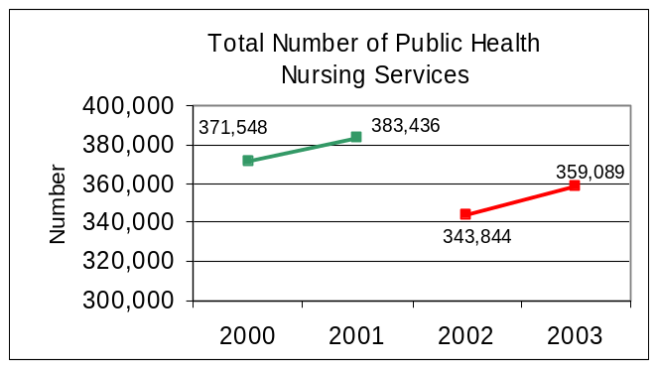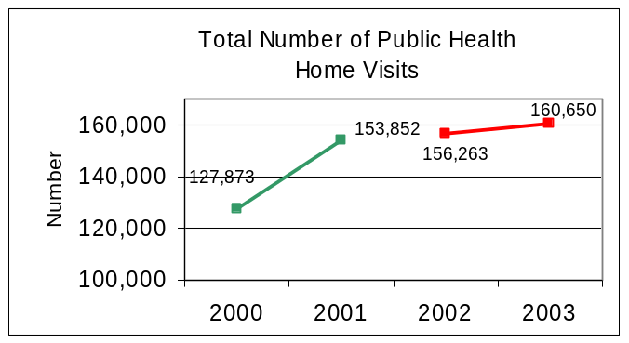
Green – NPIRS Data Source
Red - GPRA+ Data Source

Rationale: The purpose of this indicator is to improve the health status of American Indian and Alaska Native people through maintaining access to services associated with improved health outcomes. Many of the successes in Indian health such as a decrease in infant mortality, high immunization rates, and increased prenatal care are attributed to the efforts of public health nursing.
Public Health Nursing is a unique service because individual and group health promotion and disease prevention activities are provided in the home and in the community setting. Public Health Nursing Programs are a crucial link between health care services and the community. Public Health Nursing Programs strive to improve the quality of care provided to the community. .The unique quality of Public Health Nursing (PHN) service is that care can be provided in any setting where the patient is accessible. This is especially effective for high-risk patients and families. Therefore, public health nursing workload, especially community based visits, is used as measure of program effectiveness and an overall indicator of health status of the community.
Approach: The population base for public health nursing services is the IHS user population residing within the official boundaries of the Area. However, in some service units, the user population is greater than the reported census population. In these cases, the Indian user population is used as an estimate of the service population to reflect PHN service to both stable communities and transient populations.
Data Sources: IHS PCC, GPRA+ , and written reports submitted by Tribes using non-RPMS systems.
Program Performance: The IHS met this indicator in FY 2003. The FY 2003 performance indicator committed to maintaining the total number of Public Health Nurse visits to the American Indian and Alaska Native population at the 2002 level, and increasing the number of home visits by 2%. The FY 2003 Public Health Nurse report reflects that 359,089 visits compared to 343,844 visits in FY 2002 total Public Health Nurse visits were provided and 3% more home visits (compared to in FY 2002- ) were provided over FY 2002 data. The combination of community-based and home-based primary, secondary, and tertiary prevention efforts and improved documentation practices by I/T/U PHN Programs may reflect in the increase of visits overall, but also with the increase in home visits.

Immunization Group:
The following three indicators support immunization coverage in children and adults at high risk for preventable diseases and represent perhaps the most efficacious "impact" interventions known to public health.
Indicator 23: During FY 2005, maintain baseline rates for recommended immunizations for American Indian and Alaska Native children 19-35 months compared to FY 04.
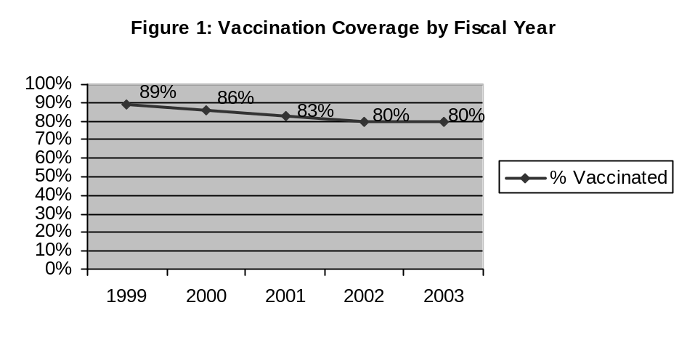
Rationale: The National Immunization Survey, which is used to estimate immunization coverage for each state and for the U.S., collects information on children 19 - 35 months. In addition, the Healthy People 2010 goal is 90% coverage with routine immunizations for children 19 - 35 months. IHS will establish baseline data on children 19 - 35 months in FY 04. We will continue to assess our performance using the 19 - 35 month indicator rather than the 3 - 27 month indicator.
Approach: The purpose of this indicator is to increase age appropriate immunization coverage for American Indian and Alaska Native children. Immunizations are one of the most cost-effective public health measures available for improving health outcomes in children and are a recognized standard of care and a standard of public health.
Data Source: Quarterly immunization reports are based on IHS patient care records and public health nursing records of children who receive immunizations at an IHS facility. IHS will be primarily responsible for completing the reports. Comparison data for the 19 – 35 month rate are available from the National Immunization Survey reported by CDC.
Program Performance: IHS MET this indicator. The FY 2003 performance indicator # 23 was to reduce the incidence of preventable disease by maintaining the FY 2002 proportion of AI/AN children who have completed all recommended immunizations for ages 3-27 months (as recommended by Advisory Committee on Immunization Practices) during FY 2003.

Data is collected on a quarterly basis. Because the same child may be eligible for immunization in each quarter as they move through the age cohort, the totals for the year do not represent individual children. We can, however, determine the number of vaccination opportunities in FY 2003, and the number of vaccination opportunities that were realized. “Immunization opportunities” are defined as the number of times in FY 2003 that children were eligible to receive a vaccine. “Realized immunization opportunities,” means the child received the required vaccination.

The percent of immunization opportunities for children 3 – 27 months that were realized in FY 2002 was 80%. The FY 2003 goal was to maintain 80%. Based on quarterly reports from all 12 IHS areas from July 1st, 2002 – June 30th, 2003, there were 113,962 immunization opportunities for AI/AN children 3 – 27 months. Of those, 90,890 or 80% were realized; the FY 2003 performance measure of 80% was achieved

Challenges in meeting the FY 2003 performance indicator include:

- Vaccine Shortages - Throughout FY 2001 and 2002 there were extensive shortages for 6 of the routinely recommended childhood vaccinations, including DTaP, some hepatitis B/Hib combination vaccines, and MMR. Shortages led to the suspension of routinely recommended doses in some states (such as the 4th DTaP), so that many children were not up-to-date with their vaccines. While the shortages were resolved in FY 2003, there may have been delays in catching children up that would have affected vaccine coverage levels for FY 2003.
- Vacancies in positions essential for the delivery, tracking and reporting of immunizations (i.e. public health nurses, medical records staff)
- IHS Immunization software package is not fully utilized at many local facilities
- An increasingly complex immunization schedule as new vaccines are added
- Incomplete tracking due to the multiple sources of health care (many non-IHS)

Steps taken to address challenges:
- IHS is working with CDC and state immunization programs to prioritize limited vaccine supply to ensure the highest risk and most vulnerable children receive priority
- Data quality initiatives are on-going and will likely result in lower immunization coverage levels initially. Improved data, however, will also allow IHS to identify low-performing areas to target for intervention.
- IHS is addressing agency-wide recruitment and retention problems
- A contract is in place to update the RPMS Immunization software package and to provide training in its use to facilitate its implementation in all clinics
- IHS is currently involved in a pilot data exchange project with three state immunization registries that should result in improved tracking.

Indicator 24: In FY 2005, maintain the FY 2004 rate for influenza vaccination levels among non-institutionalized adult patients age 65 years and older.
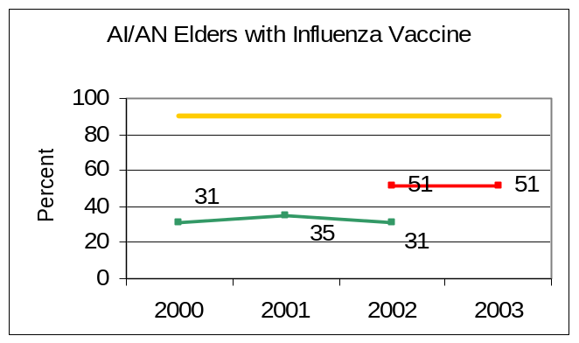
Green – NPIRS Data Source
Red - GPRA+ Data Source
Gold - HP 2010 or IHS Goal

Rationale: The purpose of this indicator is to reduce morbidity and mortality due to influenza among adults. Improving immunization coverage rates for influenza among adults will reduce the incidence of this disease.
Approach: IHS clinics are encouraged to provide influenza vaccine to adults 65 years of age during clinic visits and during mass immunization clinics. Educating patients is a part of the strategy to ensure influenza vaccine is provided. The proposed FY 2005 IHS budget will support the capacity for sites to continue existing strategies and maintain current immunization coverage levels in the face of population growth.
Data Source: RPMS data system; GPRA+ Influenza vaccination rates are based on having received vaccination within the prior 12 months.
Program Performance: IHS met this indicator. This indicator was to maintain the percentage of adults 65 years old and older that receive influenza vaccine at the FY 2002 level.
The percent of adults 65 years and older that received influenza vaccine in FY 2003 was 51%, which was equal to the same percentage in FY 2002 using GPRA+ data.
IHS continues to addressing this issue by changing the data system to ensure that historical data is available, and working with CDC to ensure equitable distribution of influenza vaccine. In addition, there is a continued emphasis on electronic healthcare reminders as well as individual electronic provider feedback.
Indicator 25: In FY 2003, maintain the FY 20042 rate for pneumococcal vaccination levels among non-institutionalized adult patients age 65 years and older.
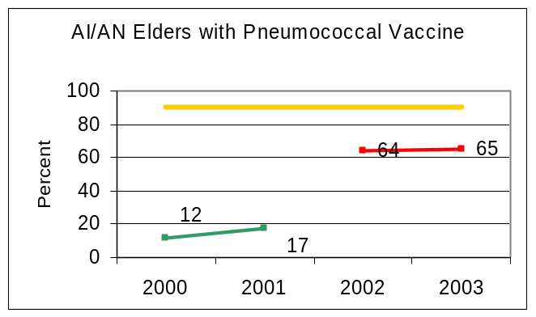
Green – NPIRS Data Source
Red - GPRA+ Data Source
Gold - HP 2010 or IHS Goal

Rationale: The purpose of this indicator is to reduce morbidity and mortality due to pneumococcal disease among adults. Improving immunization coverage rates for pneumococcal disease among adults will reduce the incidence of these diseases.
Approach: IHS clinics are encouraged to provide pneumococcal vaccine to adults 65 years of age during clinic visits. The proposed FY 2005 IHS budget will support the capacity for sites to continue existing strategies and maintain current immunization coverage levels in the face of population growth.
Data Source: RPMS data system and GPRA+. Pneumococcal vaccination rates are based on clinically appropriate patients having ever received the pneumococcal vaccine.
Program Performance: IHS met this indicator. IHS developed an approach to obtain the needed data for this indicator and in FY 2003; we were able to show an increase of almost 2% in this vaccination. IHS achieved this increase in this immunization rate by focusing on improving Pneumococcal immunization rates at the local facilities. IHS continues to focus on improved pneumococcal vaccine rates through increasing electronic healthcare reminders to providers.

Injury Prevention Group:
The following two indicators address the process and outcome of comprehensive community-based injury prevention efforts across I/T/U settings.

Indicator 26: During FY 2005, develop a web-based data collection system to report injury prevention projects.

Rationale: The purpose of this indicator is to reduce injury rates in the American Indian and Alaska Native communities through the implementation of proven injury intervention strategies across I/T/U settings. This indicator builds on the work conducted by the IHS Injury Prevention Program and documents initiatives and strategies initiated through the Injury Prevention Program 5-year Plan.
Proven injury prevention interventions are projects that address a specific identified injury problem; employ a multiple-strategy approach; are based on a proven effective, evaluated injury prevention strategy; or are epidemiologically identified from local data and designed on a proven prevention approach. Examples of projects include Sleep Safe Project sites, national IHS Part II Injury Infrastructure Grants, and Injury Prevention Specialist Fellowship.
Approach: Since the mid-1980's IHS has developed the capacity of IHS staff and tribes to epidemiologically assess the injury hazards and risk factors in communities and develop intervention strategies. Injury intervention projects are underway through I/T/U settings to reduce the burden of injury experienced. This measure will report on the community specific initiatives underway throughout IHS.
Data Sources: Data to report on this indicator is compiled and reported by Area Injury Prevention Specialists.
Program Performance: IHS met this indicator. The FY 2003 indicator committed to implementing at least 36 community prevention projects. This objective was met in FY 2003.

Indicator 27: During FY 2005, reduce deaths caused by unintentional injuries to no higher than the FY 2004 level.
Rationale: Injuries are a leading cause of hospitalization for American Indian and Alaska Native people. Annually, forty six percent (46%) of the Years of Potential Life Lost (YPLL) for American Indian and Alaska Native people are the result of injuries. Furthermore, injuries are the number one cause of mortality for American Indian and Alaska Native people for ages 1-44 years and third for overall death rates. The single largest expenditure of contract medical care funds is for the treatment of injuries. The systematic implementation of prevention strategies through partnerships with tribes and outside agencies has demonstrated significant improvements in injury rates across American Indian and Alaska Native.
Approach: The IHS has assigned an Injury Prevention Program Manager, who coordinates activities and resources with specially trained Injury Prevention Specialists at the Area, District, Service Unit and tribal levels. IHS maintains a broad base Injury Prevention program that includes a $1.475 million Infrastructure Grant Program, an internationally recognized training program, community-based epidemiologic assessment, and partnerships with other agencies to fund and implement proven intervention projects in communities.
Data Source: In its original form in the FY 1999 performance plan, this indicator targeted injury mortality as the performance measure. However, efforts to apply this approach in FY 2000 and FY 2001 revealed that the hospitalization data do not accurately reflect the number of unintentional injury cases that are hospitalized in IHS or tribal hospitals. Coding omissions have resulted in injury codes frequently not being noted. For FY 2002, the IHS will again depend on adjusted death rates generated from the official injury mortality data from the NCHS.
Program Performance: No data is currently available to report on this indicator. IHS expects that we will be able to report on this indicator by 2005.
The FY 1999 indicator committed to reduce deaths by unintentional injuries for American Indian and Alaska Native people to no more than 93 per 100,000 people. The Healthy People 2010 target is 17.5 deaths/100,000 population. IHS has determined that the indicator was met for 1999. The 1999 unintentional injury rate of 93/100,000 indicator was established using the International Classification of Disease, 9th edition (ICD-9). The IHS reported rate of 95.5/100,000 used the newer ICD-10 classification system.
The two versions of the classification system are not directly comparable. In the September 21, 2001 edition of "National Vital Statistic" (Deaths: Final Data for 1999), the National Center for Health Statistics published comparability ratios to adjust and compare ICD-9 and ICD-10 data.
When the performance target of 93/100,000 is adjusted for ICD-10, using the adjustment ration of 1.0305 for unintentional injuries, the rate is 95.84/100,000. The rate IHS reported was 95.5/100,000, based on ICD-10.

Suicide Prevention Indicator:
Indicator 28: During FY 2005, establish baseline data on suicide from the new suicide reporting system.
In FY 2004, implement the national suicide reporting system
Rationale: This indicator is part of an expanding systematic effort at reducing the prevalence of suicide in the American Indian and Alaska Native population. The suicide death rate for the American Indian and Alaska Native population has actually increased in the 1990s and is currently 72% greater than the national average. However, IHS has known that our data is incomplete, as many attempted suicides and completed suicides are not currently recorded in our data system. The Division of Behavioral Health, along with the Information Technology Support Center, has developed a comprehensive suicide data reporting system.
Approach: Programs are responsible for implementing a national suicide reporting system. A suicide surveillance system is being encouraged for use at clinical facilities to assure that routine suicide screenings and case management are nationally consistent, but also tailored to the needs and resources of each site. This suicide surveillance instrument is integrated into the interim behavioral health software application
Data Source: Local programs send reports to the national ITSC with identified data sources linked with RPMS as appropriate. Aggregated data is used to assess current rates. Effective deployment of the new interim behavioral health application ensures that the national suicide reporting system is being utilized.
Program Performance: IHS met this indicator. The 2003 indicator committed to reducing suicide rates by assuring that by the end of FY 2003, there would be at least a 5 % increase in the number of I/T/U programs that have implemented a suicide surveillance system to monitor the incidence and prevalence rates of suicidal acts (attempts, and completions). This surveillance system is coupled with assuring that those at risk receive appropriate services, and that appropriate population-based prevention interventions are implemented. At the current time, 60 I/T/U programs are reporting suicide data, including attempts and completions. This represents an increase of over 35% over the number of programs reporting in FY 02. In 2004, this indicator changes to focus on the implementation of the new Behavioral Health package that includes a suicide reporting form.

Developmental Prevention and Treatment Group:
The following three indicators represent efforts to identify and disseminate the finding and learning from research and demonstration projects addressing significant chronic diseases afflicting American Indian and Alaska Native people. These measures target the development and implementation of effective prevention and treatment programs to address cardiovascular disease, diabetes and tobacco use.
Indicator 29: During FY 2005, establish the number of adult patients that receive appropriate screening for blood lipids.
Rationale: Cardiovascular disease represents the single largest cause of death for American Indian and Alaska Native people above the age of 45.
Approach: This indicator focuses on evaluating screening and prevention for CV disease in adult patients.
Data Source: RPMS, GPRA+
Program Performance: IHS met this indicator. During FY 2003, the three Tribal programs:
- continued to implement their Community Action Plan;
- did actual tracking of the Cardiovascular Disease Clinical Indicators selected by the three Tribes (lipids, cholesterol, body mass index, tobacco cessation rates, and exercise education) through GPRA+ software designed especially to track CVD; and
- assessed their communities through evaluating community knowledge, behaviors, and risks of CVD.
In addition, another site initiated a culturally sensitive community-directed pilot cardiovascular disease prevention program.
Activities for FY 2005 include the establishment of a baseline of the number of adult patients that received appropriate screening for blood lipids. This data will be evaluated by using the RPMS GPRA+ software application.
Indicator 30: During FY 2005, each area will increase the number of patients for whom BMI data can be measured by 5% percent.
In 2004, establish baseline rates for BMI on children and adults.
Rationale: This indicator is part of a comprehensive long-term effort to identify effective interventions to prevent and reduce obesity in American Indian and Alaska Native people. IHS must blaze a new trail into unknown territory in order to address the escalating obesity and diabetes rates. In FY 2004 and 2005, IHS is committed to establishing the obesity rates for the communities that we serve. This will enable IHS to track the impact of interventions that have been developed by the Obesity Control Projects.
Approach: The approach to this revised indicator for FY 2004 and 2005 includes developing an increased data capacity for BMI data evaluation.

Data Source: IHS RPMS system, IHS/ITCA national pediatric height weight survey; GPRA+ data from local facilities
Program Performance: IHS met this indicator. This FY 2003 indicator committed to implementing a 3-element obesity prevention and treatment plan throughout IHS. IHS implemented this three-element plan in conjunction with tribes and local facilities.
Indicator 31: During 2005, rates of screening for tobacco use will be maintained at FY 04 rates.
During FY 2004, IHS will establish rates of screening for tobacco use.

Rationale: The use of tobacco represents the second largest cause of preventable deaths for American Indian and Alaska Native people. Smoking rates in many American Indian and Alaska Native communities are almost twice the national average. The Indian Health Service has not yet addressed the tobacco problem with a specific action plan or budget request. Because tobacco has a unique status among many American Indian and Alaska Native tribes as a sacred plant, any plan for control activities must have significant input from American Indian and Alaska Native community leaders.
Screening for tobacco use is essential to identifying patients at risk for complications of tobacco abuse. IHS plans on tracking these rates of screening, as well as rates of intervention for those patients are at risk for complications from tobacco abuse.
Approach: The changed 2004 indicator calls for the IHS to establish rates of screening for tobacco use. In FY 2005, IHS will maintain these screening rates. During FY 2003, recommendations made by the tobacco workgroup were presented to IHS senior leadership and to the National Indian leadership organizations.
Data Source: IHS Program records; GPRA+ data from local facilities
Program Performance: IHS met this indicator. The FY 2003 indicator committed to developing a 5-year tobacco control plan. The IHS strategy for tobacco control involves two distinct approaches: 1) clinical cessation; and 2) community-based prevention programs. A workgroup of staff from IHS HQ, Areas, and clinics was formed to address clinical cessation issues. This workgroup has developed a framework for clinic-based tobacco cessation efforts that will guide IHS and Tribal health programs as they build capacity for tobacco control. Plans were also developed to monitor clinical data on tobacco education and use through the GPRA+ software. In a separate process, the seven CDC-funded Tribal Tobacco Control Centers met with IHS to provide input on the community-based component of our tobacco control and prevention effort. The resulting Plan will be used by the Centers to guide their activities in youth tobacco prevention, and will be disseminated to other AI/AN communities and health programs. These organizations are currently in their second year of a five-year funding project from the Office on Smoking and Health, Centers for Disease Control. Their purpose is to build capacity and infrastructure at the tribal level for tobacco control and prevention. Thus far, the assistance provided to tribes includes: training and technical assistance, partnership building, education/awareness, and policy development.

HIV/AIDS Indicator:
The following indicator addresses implementation of risk reduction counseling for high-risk sexually active individuals with the long-term goal of reducing the spread of HIV infection in the American Indian and Alaska Native population.
Indicator 32: No FY 2003 or FY 2004 indicator
Indicator 32: FY 05: Establish the baseline for number of pregnant women screened for HIV in pregnancy.
Rationale: The purpose of this indicator is to reduce the spread of HIV infection in American Indian and Alaska Native communities. Identification of HIV in pregnancy can result in decreased transmission of HIV.
Approach: A baseline of HIV screening in pregnancy will be established in FY 05. RPMS will be used for documentation of screening and/ or patient education
Data Source: RPMS database
Program Performance: New indicator in FY 05
Indicator 33: FY 05 – No Indicator
During FY 2004, Determine the percentage of high-risk sexually active persons who have been tested for HIV at an additional 10 sites.
Rationale: The purpose of this indicator is to reduce the spread of HIV infection in American Indian and Alaska Native communities. The Indian Health Service is working to increase availability and access to voluntary and confidential HIV diagnostic testing by constituents who do not know their HIV status, link them to care and prevention services, and assist them in adhering to treatment regimens and in sustaining risk reduction behavior. The FY 2002 indicator was designed to obtain baseline measures in at least 3 areas. The FY 2005 indicator is designed to measure the expansion of obtaining HIV testing data in high-risk sexually active patients in additional sites throughout IHS.
Approach: A baseline was established in FY 2002. In FY 2004, RPMS will once again be queried for documentation of completed HIV testing for this defined high-risk population.
Data Source: RPMS database and chart reviews
Program Performance: IHS did not meet this indicator. The FY 2003 performance indicator was committed to increasing the percentage of high-risk sexually active persons (defined as people who have a positive test for gonorrhea, Chlamydia and/or syphilis) who have been screened for HIV by 5%. .
IHS was able to increase screening rates for HIV in high risk patients by approximately 1%, but was unable to reach the goal of a 5% increase. This inability to increase screening rates reflects a myriad number of reasons, including patient refusal as well as concerns about confidentiality and anonymity. IHS is working with tribes and communities on education and anonymity issues.

Environmental Surveillance Indicator:

Environmental Surveillance Indicator:

Indicator 34: During FY 2005, the IHS will increase the number of active tribal user accounts for the automated Web-based environmental health reporting system by 15% over the FY 2004 level for American Indian and Alaska Native tribes not currently receiving direct environmental health services.

Rationale: This indicator is directed at reducing environmental threats to health by collecting community information for decision-making. Community environmental health status has traditionally been determined by completing environmental health surveys of individual facilities listed on the Facility Data System (FDS) inventory. Current changes in data collection methodology and technological advances will support more consistent assessment of community environmental health services by building a more comprehensive dataset to analyze and use to determine direction. Ultimately this change will support setting specific targets for reducing environmental threats across I/T/U settings. In order to collect a more complete set of data it is necessary to have the participation of American Indian and Alaska Native tribes to add to the data and verify the accuracy of FDS elements that are not part of the Indian Health Service.

Approach: The Environmental Health Services program utilizes the Web-based Environmental Health Reporting System (WebEHRS) in conjunction with Tribal partners to collect community and facility information to be used for ongoing surveillance. At the regional level, this project is coordinated with the IHS Area Environmental Health Officers in partnership with the tribes and local IHS Environmental Health Services programs.
Data Source: Data is gathered using the current Web-based Environmental Health Reporting System (WebEHRS) developed in FY 2000 and implemented in IHS in FY 2001.

Program Performance: IHS MET THIS INDICATOR. The FY 2003 indicator committed to achieve a 15% increase in active tribal user accounts receiving direct environmental health services to the WebEHRS. 3 additional sites began using WebEHRS by the end of the reporting period, for an increase of 15%.
The Division of Environmental Health developed and implemented WebEHRS, webehrs.hqe.ihs.gov, a web-based bottom up driven environmental health data and field support system. The data fields consist of environmental health related facilities and services found in American Indian and Alaskan Native communities. WebEHRS database is maintained on an IHS HQ-based server. The data and associated files are aggregated and available for analysis and reporting by users on successively higher levels.

Capital Programming/Infrastructure Category
Performance Budget Integration

These 2 indicators account for approximately 43% of this budget category. Ongoing maintenance, repairs and equipment are not covered with a performance indicator at this time.

Program Description and Context
Capital Programming/Infrastructure indicators represent the physical infrastructure that contributes to a healthy environment by assuring safe water and sewage facilities, medical facilities where health services can be adequately provided, and the ability to maintain the medical facilities that are critical to our mission.
Sanitation Facilities Construction – supports the construction of water, sewage, and solid waste systems (see page IHF-13 in FY 2005 budget document).
Health Care Facilities Construction – supports the construction of new or replacement health care facilities (see page IHF-19 in FY 2005 budget document).
Maintenance and Improvement – supports ongoing health care facility maintenance, alteration, and repair (see page IHF-9 in FY 2005 budget document).

Capital Programming /Infrastructure: Performance Indicators
These indicators are selected and based on the following criteria:
- supports components of the Indian Health Facilities Appropriation and funding priorities of I/T/Us identified in the budget formulation process;
- supports existing data systems that record the need for physical infrastructure or improvements to the existing infrastructure;
- follows the formula-based prioritization of each project's relative need; and
- has demonstrable link to improved access to health services or healthier living environments.
Data is recorded at the local level where projects are conceptualized based on strict protocols and formulas. These data are compiled at the Area and Headquarters level and reviewed for accuracy and then compared against similar projects. The validation and verification of this information is essential to the facilities program; it is used to distribute resources as well as measure performance. The link between funding levels and our ability to accomplish these indicators is relatively direct and supported by well-quantified and validated planning formulas.
These indicators support many of the Departmental and IHS areas of focus by providing a foundation where health services are effectively delivered and objectives reached. Without a healthy living environment, access to safe medical facilities, and proper maintenance, most of the objectives could not be met.

Capital Programming/Infrastructure Indicators
Table 8: Capital Programming/Infrastructure Performance Summary
Performance Indicator | FY Targets | Actual  Performance | Reference
Capital Programming/Infrastructure Group
Indicator 35: Provide sanitation facilities to new or like-new homes and existing Indian homes. [outcome]  EFFICIENCY MEASURE  full cost  FY 05: 123.3 M  FY 04: 120.9 M  FY 03: 98.6 M | FY 05: 22,000 homes  FY 04: 20, 000 homes  FY 03: 15,255 homes  FY 02: 2,528 New/L. New  12,727 Existing  Total 15,255  FY 01: 3,800 New/L. New  10,930 Existing  Total 14,730  FY 00: 3,740 New/L. New  11,035 Existing  Total 14,775  FY 99: 5,900 New/L. New  9,330 Existing  Total 15,230 | FY 05:  FY 04:  FY 03: 22,750 homes  FY 02: 3,342 New/L.  17,883 Existing  Total: 21,225  FY 01: 3,551 New/L. New  14,451 Existing  Total 18,002  FY 00: 3,886 New/L. New  14,490 Existing  Total 18,376  FY 99: 3,557 New/L. New  13,014 Existing  Total 16,571 | P: p. 3-61  B: p. IHF-13  3  HP 2010
Indicator 36: Improve access to health care by construction of the approved new health care facilities.  [outcome]  full cost  FY 05: 76.3 M  FY 04: 74.0 M  FY 03: 86.3 M | FY 05: complete scheduled phase of construction of appropriated facilities  FY 04: complete scheduled phase of construction of appropriated facilities  FY 03: complete scheduled phase of construction of appropriated facilities  FY 02: complete scheduled phase of construction of appropriated facilities  FY 01: complete scheduled phase of construction of appropriated facilities  FY 00: complete scheduled phase of construction of appropriated facilities  FY 99: complete scheduled phase of construction of appropriated facilities | FY 05:  FY 04:  FY 03: phases for 12 of 12 projects completed on schedule  FY 02: phases for 10 of 10 projects completed on scheduled , plus phases for 2 projects not completed the previous year were completed  FY 01: Phases for 5 of 7 projects completed on schedule, plus phase for one project not completed the previous year was completed.  FY 00: phases for 5 of 6 projects completed on schedule  FY 99: phases for ad projects completed on schedule | P: p. 3-62  B: p. IHF-19  3
Total Capital Programming/ Infrastructure Funding: | FY 05: $435,850,000**  FY 04: $431,293,000**  FY 03: $411,630,000  FY 02: $357,034,000  FY 01: $322,377,000  FY 00: $277,303,000  FY 99: $255,953,000  FY 98: $221,009,000  ** includes 15% of M/M and PI Collections and Quarters Collections |  | P: page # in perform. plan  B: page # in budget justif.

Capital Programming /Infrastructure Group:

Indicator 35: During FY 2005, provide sanitation facilities projects to 22,000 Indian homes with water, sewage disposal, and/or solid waste facilities.
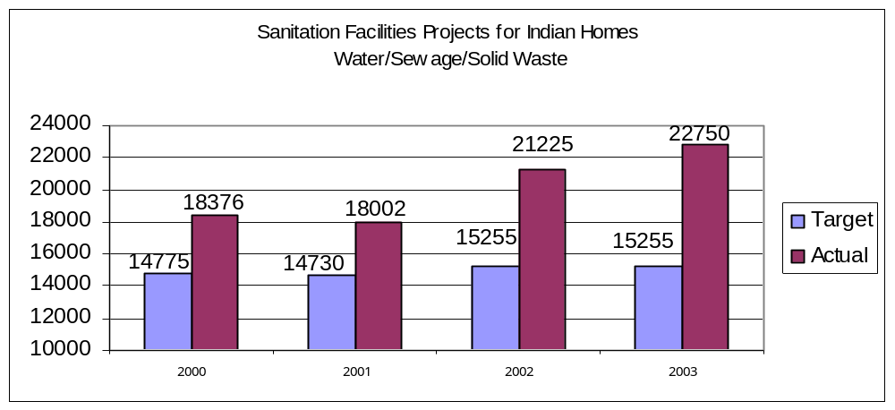
Rationale: This indicator directly supports improved environmental health for American Indian and Alaska Native people. The IHS Sanitation Facilities Construction Program has carried out those authorities since 1960 using funds appropriated for Sanitation Facilities Construction and contributed funds from Tribes and other Federal agencies to provide potable water and waste disposal facilities for American Indian and Alaska Native people. This work is recognized as a significant factor contributing to a reduction in the rates for infant mortality, gastroenteritis morbidity, and other environmentally related diseases by as much as 80 percent since 1973. American Indian and Alaska Native homes are still seven times more likely to be without clean water than homes in the broader U.S. with most of these homes located in geographically isolated areas.
Approach: This program regularly updates the needs for sanitation facilities based on the Indian Health Care Improvement Amendments (Title II, Section 302(g) 1 and 2 of P.L. 100-713). Based on the end-of-year FY 2002 estimates, the cost of technically and economically feasible projects to correct these needs for existing homes was $900 million out of a total need of $1.578 billion. It is considered feasible to provide sanitation facilities for between 95 and 98 percent of all existing Indian homes.
Data Source: The SFC Sanitation Deficiency System (SDS), and Project Data System
Program Performance: IHS met this indicator. The FY 2003 performance measure to provide sanitation facilities to 15,255 homes by the end of FY 2003.was met. moreover, exceeded. IHS provided this service to 22,750 homes during FY 2003. This measure indicates the number of homes served with water, sewer and solid waste facilities. This significant increase in existing homes was the result of funding more projects to upgrade existing community sanitation facilities infrastructure. IHS has received between $30 million to $44 million annually from outside contributors since FY 1996. IHS will continue to work cooperatively with tribes to attract funds from outside IHS to construct needed sanitation facilities.
1.7.3.3 Indicator 36: During FY 2005, increase the modern health care delivery system to improve access and efficiency of health care by assuring the timely phasing of construction of the following health care facilities:
a. Red Mesa, AZ – complete construction of a new health center, including supporting staff quarters.
b. Sisseton, SD – complete construction of a replacement health center, including supporting staff quarters.
c. Zuni, NM – complete design and construction of staff quarters project.
d. Wagner, SD – design-build staff quarters project.
Rationale: This indicator supports the replacement of health care facilities to increase access to medical services supported by the IHS. These medical services are comparable to medical services available to the general population (appointments to see primary care physicians, nurses, dentists, etc.). Efficient space for health care delivery allows for more appointments, and for patients to see more health care providers in one trip. Although accessible is synonymous in this usage with obtainable health care services, the IHS can demonstrate that workloads have increased or services that are more comprehensive are provided in new facilities.
Modern facilities help recruit and retain health care providers, which, in turn, can result in improved access and continuity of health care. Once a replacement facility has been completed and fully staffed, the IHS has experienced an average increase in patient visits of approximately 60% over the old facility. Where private sector housing is not available for the increased staffing levels, additional staff quarters are needed for non-local staff in support of the identified IHS health care facilities.
Approach: The IHS developed the Health Facilities Construction Priority System (HFCPS) methodology in response to Congressional directive to identify planning, design, construction, and renovation needs for the 10 top-priority inpatient care facilities and the 10 top-priority outpatient care facilities and to submit those needs through the President to the Congress. Under the three-phase HFCPS process, the IHS Headquarters solicits proposals for facility construction from the IHS Area Offices and ranks them according to their relative need for construction. Responding to Congressional language accompanying the FY 2000 appropriations, the IHS, in consultation with the tribes, currently is reviewing the HFCPS for possible revision to reflect a methodology that will reflect appropriate factors in determining the relative need for all IHS health care facilities construction.
Current factors used to determine relative need are workload, existing facility age, isolation (availability of alternatives sources of care), and existing space data. The IHS uses the current HFCPS methodology to review proposals and determine which will be considered during a more intensive Phase II review. The IHS examines these Phase II proposals in detail and applies the methodology to determine the proposals that will be considered during Phase III. During Phase III, applicable IHS Area Offices prepare a Program Justification Document (PJD) for review by IHS Headquarters. If the PJD justifies construction, it is approved and the project is placed on the appropriate priority list below those already on the list.

The IHS has developed the Quarters Construction Priority System (QCPS) to identify staff quarters projects to support existing health care facilities. (Note staff quarters associated with replacement health care facilities is part of those projects and are not processed under the QCPS.) Like the HFCPS, quarters projects are processed through three phases and new staff quarters projects are added to the Quarters Priority List as Program Justification Documents for Staff Quarters (PJDQ) are approved.
Proposed projects that have been approved and placed on the respective priority lists remain on the lists until they have been fully funded by Congressional appropriations or other funding mechanism. After projects are placed on the Priority Lists, IHS updates its five-year planned construction budget. That budget is updated yearly and is used as the basis for funding requests.
Data Source: The HFCPS and QCPS generate projects that are reflected in a five-year funding plan in the Health Care Facilities Planned Construction Budget. The IHS Inpatient, Outpatient and Quarters Priority Lists are used to show the needed construction priorities.
Program Performance: IHS met this indicator. The FY 2003 indicator was accomplished with the timely phased construction of the following health care facilities as outlined below and will lead to enhance access to care for the American Indian and Alaska Native population.
Ft. Defiance, AZ: For the replacement, hospital that was completed in June 2002, and opened for service on August 1, 2002, the replacement and additional staff quarter’s portion of the project proceeded on schedule under a design-build contract, with 46 units being completed and turned-over for use. This portion of the project continues with a scheduled 3rd quarter FY 2004 completion.
Winnebago, NE: Construction continued for the replacement hospital, with a 2nd quarter FY 2004 completion scheduled for this portion of the project. The modification of the Drug Dependency Unit is scheduled for 1st quarter FY 2005 completion, which will complete this project.
Pinon, AZ: Construction continued for the new health center and staff quarters project, with a scheduled 3rd quarter FY 2005 project completion.
Red Mesa, AZ: Funding to date is being used for the first phase of construction. Using funding appropriated in FY 2004 and that being requested in FY 2005, the project could be scheduled for 2nd quarter FY 2006 completion.
Pawnee, OK: Construction by the Pawnee Tribe, under a Public Law (P.L.) 93-638 Subpart J contract is scheduled for 2ne quarters FY 2004 completion.
St. Paul, AK: Project is proceeding and is scheduled for 4th quarter FY 2006 completion.
Metlakatla, AK: Project is proceeding and is scheduled for 4th quarter FY 2005 completion.
Sisseton, SD: Project is proceeding. The Tribe will develop the site for the IHS under a P.L. 93-638 Subpart J construction contract. Using funding appropriated in FY 2004 and that being requested in FY 2005, the project could be scheduled for 3rd quarter FY 2006 completion.
Clinton, OK: Funding for project design was provided in FY 2004. Using funding anticipated in FY 2006, the project could be scheduled for 1st quarter FY 2008 completion.
Bethel, AK: Funding provided in FY 2004 will be used to complete this project, which is being provided by the Yukon-Kuskokwin Health Corporation through a design-build contract under an agreement with the IHS. The project is scheduled for a 2nd quarter FY 2005 completion.
Small Ambulatory Program: For the FY 2001 Small Ambulatory Program (SAP), tribes have received awards for nine projects, and two projects have been completed. For the FY 2002 SAP, tribes have received awards for eight projects. For the FY 2003 SAP, awards are anticipated for four projects, two in the 1st quarter and two in the 2nd quarter of FY 2004. Uncompleted projects are either in design or under construction by the tribes.
Dental Facilities Program: Two additional projects are being processed for design and construction under this program. As additional funding is appropriated, additional dental units are provided by the IHS.

Partnerships, Consultation, Core Functions, and Advocacy Category

Program Description and Context
The Partnerships, Consultation, Core Functions, and Advocacy aggregation encompasses the IHS administrative and management functions, relationships with stakeholders and consumers, and strategies for collaboration in pursuit of the IHS mission. Data for these indicators come from recognized sources including budget reports and audits, a HHS survey, and a survey of the universe of stakeholders using recognized social survey methods. The two components of this aggregation are:
- Direct Operations - supports management and administrative functions for Area and Headquarters staff including policy development, budget formulation, health program support, and accountability requirements (see page IHS-107 in FY 2005 budget document).
- Facilities and Environmental Health Support - provides administrative and management support for the construction, maintenance, and operation of health care facilities, staff housing, and sanitation facilities (see page IHF-29 in FY 2005 budget document).

Performance Indicators
The choice of indicators for this aggregation category is based on the following criteria:
- Supports and encourages tribal sovereignty, the government to government relationship between tribes and the Federal government, and tribal self-determination;
- supports and encourages collaboration with stakeholders, agencies, and organizations directed toward improving the health of American Indian and Alaska Native people; and
- supports and encourages sound management practices.
Achieving these performance indicators, as well as the overall coordination of the GPRA and other Federal accountability requirements, represent a significant challenge for the IHS and its reduced management and public health infrastructure. The reorganization of Headquarters and many Area offices has resulted in flatter organizational structures, less specialization in function, and greater use of self-directed teams in order to increase efficiency. However, it has become increasingly clear that, coupled with improved data management capacity, there are two functions that must be supported to assure overall program success and these are:
- Assuring that continued and expanded opportunities for tribal consultation and participation in IHS endeavors is supported;
- Assuring effective recruitment of needed health disciplines is achieved and that orientation, training, and support are available to enhance the retention these staff. The scholarship program is one effective tool available for ongoing recruitment and retention.

Partnerships, Consultation, Core Functions, and Advocacy Indicators
Table 9: Consultation, Partnerships, Core Functions, and Advocacy Indicators Performance Summary
Performance Indicator | FY Targets | Actual  Performance | Reference
Consultation Improvement Indicator
Indicator 37: Improve the level of satisfaction with the processes for consultation and participation provided by the IHS, as measured by a survey of I/T/Us.  full cost  FY 05: 0.1 M  FY 04: 0.1 M  FY 03: 0.1 M | FY 05: meet or exceed FY 04  FY 04: 3% increase over FY 03  FY 03: establish baseline satisfaction rate*  FY 02: secure OMB clearance for instrument and baseline  FY 01: implement policy and submit instrument  FY 00: revise policy and instrument  FY 99: establish policy and collect baseline | F.Y 05:  Y 04:  FY 03: baseline rate established  FY 02:secured clearance; no baseline  FY 01: policy implemented and instrument submitted  FY 00: revised policy proposed and instrument developed  FY 99: policy established but baseline delayed | P: p. 3-69  B: p. IHS-107  3  * indicates lack of adjustment in not meeting FY 02 measure. See Summary of Changes Table 10 on page 5-1
Administrative Efficiency, Effectiveness, and Accountability Group
Indicator 38: Improve the level of Contract Health Service (CHS) procurement of inpatient and outpatient hospital services for routinely used providers under contracts or rate quote agreements at the IHS-wide reporting level.  full cost  FY 05: 3.7 M  FY 04: 3.3 M  FY 03: 3.0 M | F.Y 05: TBD  FY 04: +1% over FY 03  FY 03: +1% over FY 02  FY 02: 88%  FY 01: 79%  FY 00: no indicador  FY 99: no indicador | FY 05:  FY 04:  FY 03: Available Sept 2004  FY 02: 89%  FY 01: 80%  FY 00: no indicator  FY 99: 86%  FY 97: 74% | P: p. 3-70  B: p. IHS-55  3, 8  
Indicator 39: Assure appropriate administrative and public health infrastructure is in place in response to agency reorganization and accountability requirements.  full cost  FY 05: 0.1 M  FY 04: 0.1 M  FY 03: 0.1 M | FY 05: assess pub health infrastructure in additional 3 area offices  FY 04: assess pub. health infrastructure in one additional Area Offices*  FY 03: assess pub. health infrastructure for HQ and 6 Areas  FY 02: no indicador  FY 01: no indicator  FY 00: 1876 FTE or less  FY 99: at least 10% under FY 97 level or 1876 FTE | FY 05:  FY 04:  FY 03: PH infrastructure assessed for HQ and 3 areas ( not 6 areas)  FY 02: no indicator  FY 01: no indicator  FY 00: 1,569 FTE  FY 99: -22% (1,619 FTE)  FY 97: 2085 FTE baseline | P: p. 3-71  B: p. IHS-107  2  3    * indicates revised FY 2004 measure. See Summary of Changes Table 10 on page 5-1
Indicator 40: Increase the proportion of I/T/Us who have implemented Hospital and Clinic Compliance Plans to assure that claims meet the rules, regulations, and medical necessity guidance for Medicare and Medicaid payment.  full cost  FY 03: 0.4 M | F.Y 05: no indicator  FY 04: no indicator*  FY 03: improve 10% over FY 02 baseline  FY 02: no indicator  FY 01: no indicator | FY 05: no indicator  FY 04: no indicator  FY 03: 100% compliance  FY 02: no indicator  FY 01: no indicator | P: p. 3-72  B: p. IHS-107  3    * indicates revised FY 2004 measure. See Summary of Changes Table 10 on page 5-1
Indicator 41: Support Tribal Self-Determination through technical assistance  full cost  FY 05: 1.0 M  FY 04: 1.0 M  FY 03: 1.0 M | Technical Assistance  FY 05: No indicator  FY 04: No indicator*  FY 03: 100% of new tribes  FY 02: tribal approval of protocol  FY 01: develop protocol  Contract Support Cost Review  FY 05: No indicator  FY 04: No indicator*  FY 03: 100% use of protocol for new tribes  FY 02: secure tribal acceptance  FY 01: develop protocol  FY 00: no indicator  FY 99: no indicator | FY 05 :  FY 04:  FY 03: 100% of new tribes  FY 02: tribal approval  FY 01: protocol developed  FY 04:  FY 03: 10/03  FY 02: tribal acceptance  FY 01: protocol developed | P: p. 3-73  B: p. IHS-121  3    * indicates revised FY 2004 measure. See Summary of Changes Table 10 on page 5-1
Quality of Work Life and Staff Retention Group
Indicator 42:  Assess scholarship program for placement and efficiency  EFFICIENCY MEASURE.  full cost  FY 05: 0.7 M  FY 04: 0.7 M  FY 03: 1.0 M | Placement Scholarship Recipients  FY 05: improve placement rate by 2%  FY 04: Secure baseline rate for placement of scholarship recipients*  Nurse Retention  FY 03: identify nurse retention problems and develop plan  FY 02: no indicator  FY 01: no indicator | FY 05  FY 04:  FY 03: nurse retention assessed and plan developed  FY 02: no indicator  FY 01: no indicator | P: p. 3-75  B: p. IHS-29  3  8    * indicates revised FY 2004 measure. See Summary of Changes Table 10 on page 5-1
Total Consultation, Partnerships, Core Functions, and Advocacy Funding: | FY 05: $85,396,000  FY 04: $82,923,000  FY 03: $89,907,000  FY 02: $89,282,000  FY 01: $75,823,000  FY 00: $72,884,000  FY 99: $69,729,000  FY 98: $67,038,000 |  | P: page # in perform. plan  B: page # in budget justify.

Performance Budget Integration
These five indicators account for approximately 4% of this budget category. All of these measures are output measures at the current time; the cost of these measures is based upon the fiscal requirements to monitor these outcomes, not the cost of the intervention itself.

Consultation Improvement Indicator:

Indicator 37: During FY 2005, the IHS will maintain stakeholder satisfaction with the agency’s consultation process at the FY 2004 level

Rationale: The purpose of this indicator is to improve the consultation process with IHS stakeholders. Given the number and diversity of I/T/Us, formal policies are essential to assure broad input, a rational and equitable approach to making timely decisions, and the highest possible buy-in across I/T/Us. Equally important is securing the data to assess how well the processes are actually working, and then improving them. Finally, the IHS encourages opportunities for local I/T/Us to evaluate the agency’s progress in enhancing the consultation process and supporting recommended changes.

Approach: A partnership is essential to ensure that resources are effectively and efficiently utilized to maximize the positive impact health programs have on the target I/T/U populations. Partnerships already exist with such tribal entities as the National Indian Health Board (NIHB), the Tribal Self-Governance Advisory Committee (TSGAC) and the National Congress of American Indians (NCAI). A survey was developed to collect baseline data and identify the weaknesses in the implementation of the consultation policy by the headquarters and area offices. The information collected by the survey instrument will be used by management and staff to establish baseline data, identify consultative strengths and weaknesses, design improvements, and provide feedback to local IHS, Tribal and Urban health officials, health boards, and community members regarding stakeholder satisfaction with the Agency’s tribal consultation process.

Data Source: Consultation and Participation Policy Survey.

Type of Indicator: Process and Balance Scorecard: internal perspective

Linkages: This indicator supports the DHHS Strategic Plan, Objective 6: Increase customer satisfaction, Objective 10, Maximize collaboration with HHS stakeholders. It also underpins the IHS’ commitment supporting the Self-Determination process and AI/AN community empowerment.

Program Performance: IHS met this indicator in FY 03. In FY 03, IHS conducted a nation-wide survey to establish baseline data to assess the level of satisfaction ITUs have with IHS's consultation process. The survey instrument was mailed to representatives of 584 federally recognized tribes, 39 urban programs and 13 tribal health boards. Survey responses were received and are being analyzed by the Agency.

Administrative Efficiency, Effectiveness, and Accountability Group:
This group of indicators addresses the improvement of administrative functions that support the improvement of health care efficiency and effectiveness, as well as improved agency accountability.
Indicator 38: During the FY 2005 reporting period, the IHS will have improved the level of Contract Health Services (CHS) procurement of inpatient and outpatient hospital services for routinely used providers to at least 1% over the FY 2004 level of the total dollars paid to contract providers or rate quote agreements at the IHS-wide reporting level.
Rationale: The CHS regulations require the use of medical priorities to assure that persons with the most urgent need receive services and that alternate resources pay prior to IHS expending funds. We are seeking to ensure that contracts or rate quote agreements are in place that provides reduced rates to IHS and its patients with routinely used hospitals. It should be noted that IHS might never be able to reach 100 percent because the majority of our facilities are in rural settings. Many times, there is only one hospital in the vicinity and they are unwilling to offer discounted rates to the IHS. The 90% level of procuring inpatient and outpatient facility services to routinely used providers of the total dollars paid to contract providers will be maintained in future years.
Approach: IHS is primarily interested in obtaining contracts or rate quote agreements with frequently used providers. As providers determine that agreements are feasible with the IHS, the percentage of facilities on contract should increase.
Frequently used hospitals are defined as those facilities to which IHS paid more than $50,000 for inpatient services per year and/or more than $10,000 in outpatient services per year. Not all hospitals meet both criteria, and inpatient and outpatient service contracts and rate quotes will be tracked separately.
Data Source: The IHS contracts with Blue Cross and Blue Shield of New Mexico for Fiscal Intermediary (FI) services. The FI collects the claims data and maintains the IHS/CHS database. The IHS will use FY 1999 claims paid data as the baseline because data for this year are 99 percent complete. The IHS is the payer of last resort, which means any alternate resource available to the patient must be billed first. It typically takes 2 years for claims data to become complete for a fiscal year. As the FY data becomes complete, the percent of providers under contract within the thresholds stated above will be updated in the GPRA Performance Report annually. Listed below are some of the assumptions made in analyzing the data:
- All inpatient and outpatient claims for hospital services, processed by the FI for the reporting year, defined as the Purchase Order Fiscal Year (POFY), are eligible.
- Providers are considered under contract if there is a number in the contract field and an effective date for appropriate reporting year. This includes regular contracts and Rate Quotes.
- Payments were defined as contract or open market at a claim level. If any charge on a claim was paid at a contract rate, the claim is considered a contract payment. If all charges on a claim were paid at open market (i.e., paid at billed charges), the claim is considered open market.
- The provider number used to determine the total paid for the POFY is defined as the provider’s base EIN. This is a 9-digit provider EIN/TIN, and includes all suffixes assigned to that EIN.
- Under IHS regulations, certain catastrophic cases are eligible for Catastrophic Health Emergency Fund (CHEF). These cases often involve emergencies or the need for specialized providers, which may be out of the area. The area may have little control over which providers these patients see. The CHEF threshold is $21,700 for an episode of care for FY 2002. To target inpatient claims that could be CHEF eligible, data was run excluding any inpatient claim where IHS paid $21,700 or more.
- Outpatient providers were included if they were paid $10,000 or more under contract and/or open market. Inpatient providers were included if they were paid $50,000 or more under contract and/or open market.
The percent of dollars paid under contract is calculated as follows:
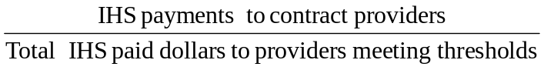
Program Performance: This data will be available in September 2004. Purchase Order Fiscal Year 2002 claims data is used in the calculation and is only 89% complete as of December 2002. Typically, it takes 2 years for claims data to complete processing through the Fiscal Intermediary (FI). It is estimated that FY 2002 data will become complete by September 30, 2003. The CHS indicator for FY 2002 was targeted at 88% of frequently used providers will have medical contracts in place. This indicator was fully met.
Indicator 39: By the end of FY 2005, the IHS will have completed a systematic assessment of the public health infrastructure for Headquarters in an additional three Area Offices.
Rationale: The purpose of this indicator is to assure that a systematic and rational process is utilized to assess public health performance. This new indicator commits IHS to evaluate our current delivery of essential public health and related administrative services to American Indian and Alaska Native populations.
IHS believes that it is prudent to assess systematically the delivery of public health services to its client population using established assessment tools. This approach can provide a rational basis for public health planning, including workforce and organizational changes in the IHS.
Approach: IHS will use instruments developed by CDC's National Public Health Performance Standards Program (NPHPSP), based on the nationally recognized “Ten Essential Services of Public Health” The NPHPSP has tested and validated the assessment process with state and local public health programs; this tool is now considered by many to be the best available approach to benchmarking public health programs.
Data Source: The data for determining this indicator will be derived from the adapted survey instruments that assess public health and administrative infrastructure at IHS Headquarters and Area Offices (including Tribal Epidemiology Centers). The indicator will be considered accomplished if IHS Headquarters and all 12 Area Offices are formally assessed, using the adapted protocol and instruments, by the end of FY 2005.
Program Performance: IHS did not meet this indicator in FY 2003. IHS was unable to assess infrastructure at six sites; only four sites have been completed. This indicator changes in FY 04 to reflect our current performance. Our performance reflects lack of national resources to conduct this work at the current time.
Indicator 40: No indicator for FY 04 or FY 05.
Indicator 40: By the end of FY 2003, the IHS will increase by 10% over the FY 2002 level the proportion of IHS facilities that have implemented Hospital and Clinic Compliance Plans to assure that claims meet the rules, regulations, and medical necessity guidance for Medicare and Medicaid payment.
Rationale: By law, IHS has been given the authority to bill and collect reimbursement from the Medicare and Medicaid (M&M) programs, per Title XXVIII and XIX of the Social Security Act. In order to receive payments for services rendered, bills must be submitted to M&M fiscal intermediaries. All bills must be supported by medical record provider documentation, as well as medical necessity; they must be accurately coded in order to comply with the rules and regulations of the M&M programs. Hospital and Clinic Compliance Plans set up policy and procedures that help insure that claims that are generated by our facilities meet these guidelines for payment purposes. These policies and procedures work to prevent fraud, waste and abuse so prevalent in the health care industry.
Approach: A survey will be provided to Areas asking how many of their facilities have compliance plans adopted by their respective Governing Boards and which facilities have draft plans. In addition, Areas and Service Unit hospital and clinics will be required to submit copies of audits and corrective actions plans for further HQs analysis. Key criteria include status of plan development and implementation and analysis of any external third party audits on compliance with the rules and regulations of Medicare and Medicaid for reimbursement.
Data Source: The data source will be a survey provided by HQs to the SUs through the Area Office. This information will be tabulated by HQs and shared with Areas/SUs through its management control tracking system.
Program Performance: IHS met this indicator. IHS was able to achieve 100% compliance with implemented Hospital and Clinical Compliance Plans in 2003. Due to this, this indicator will be discontinued after FY 2003.
Indicator 41: FY 05- No Indicator
FY 04- No Indicator

Rationale: Funding appropriated for contract support costs has grown to approximately $270 million over the last five years. The Congress and the Office of Management and Budget have requested that the Indian Health Service review. the soundness of allocation policies concerning contract support costs and to take steps to assure that contract support costs provided to tribes are reasonable and do not duplicate other funding provided to tribes by the IHS under self-determination agreements. Technical assistance provided to tribes, and the review of Contract Support Cost requests that are consistent with the IHS contract Support Cost Policy and the Indian Self-Determination Act.
Approach: By the end of first quarter of FY 2003, the IHS had met with tribal representatives complete the development of review standards and obtain acceptance by the Director, IHS. These standards are now utilized in the review of contract support cost requests from contracting and compacting tribes. Verification is documented in the Annual Funding Agreements that are approved and signed by tribes and the IHS. In FY 2005, the IHS will provide technical assistance to each tribe submitting proposals or letters of intent based on identified areas of need and with specific technical assistance in the area of calculating contract support costs.
Data Source: CSC Requests and Signed Annual Funding Agreements.
Program Performance: IHS met this indicator. The FY 2003 performance indicator committed to support the efficient, effective and equitable transfer of management of health programs to tribes submitting proposals or letters of intent to contract or compact IHS programs under the Indian Self-Determination Act by 100% use of tribes using the new protocol, and 100% of tribes receiving technical assistance. Since this is a federal mandate, we are electing to drop this indicator for the future.

Managing Human Capital Indicator:
This indicator addresses improving the recruitment and retention of health care providers at local I/T/Us through the efficient use of the IHS Scholarship Program.

Indicator 42: During FY 2005, the IHS will increase its efficiency in placing Health Profession Scholarship recipients in Indian health settings within 90 days of graduation by 2% over the established FY 2004 baseline.
Indicator 42: By the end of FY 2004, IHS will establish a baseline for the proportion of Health Professions Scholarship recipients that are placed in I/T/U programs within 90 days of graduation from their health/allied health discipline program.

Rationale: The purpose of this indicator is to increase the efficiency in placing Health Profession Scholarship recipients in Indian health settings and ultimately increase access to critical health services for AI/AN people. It has replaced the previous indicator that addressed the attrition of nurses because it represents a valid efficiency measure and addresses a specific IHS budget line item.

The Indian Health Care Improvement Act (IHCIA), P.L. 94-437, as amended, authorizes IHS to conduct three interrelated scholarship programs to train the health professional personnel necessary to staff IHS, tribal, and urban health programs serving American Indians and Alaska Natives. During the 2002/2003 academic year, 376 students were funded for the various health/allied health professions through section 104. Of that number, 128 will graduate in 2003, with 27 students (Medicine, Clinical Psychology, etc.) being placed in a deferment status while they complete an internship, residency, or other advanced clinical training that is required for the practice of their health profession.

Approach: The IHS will utilize Area Office staff, IHS Headquarters health professionals, IHS website, mailings to tribes and urban facilities for announcement of students who will be completing their degree programs. Specific activities will include:

a. Identify a staff person at each Area Office to assume the responsibility of an IHS Area Scholarship Coordinator.
b. Provide IHS, Tribal, and urban recruiter’s information on students who are graduating from their degree programs for recruitment purposes.
c. Maintain a comprehensive database to track students during their award year in order to provide information on students by date of graduation and health/allied health professions.

Data Source: During FY 2003, the IHS Scholarship program implemented a new data system to monitor the status of scholarship recipients and their placement in I/T/U settings. For FY 2004 a baseline rate for placing these recipients will be established and the system will be used to monitor progress in improving the efficiency in placing them in succeeding years.

Program Performance: The IHS MET this indicator. The FY 2003 indicator was evaluating nurse recruitment issues. The purpose of this indicator was to reduce nursing vacancy and attrition rates at the local I/T/U clinical setting and ultimately improve the quality of care. The current number of nurse positions in I/T/U programs is approximately 4000. The average vacancy rate for nurses during FY 2003 was 11%, though some areas have an 18% rate. The attrition rate improved by 3% with the implementation of Title 38 special pay authority. It is estimated that the recruitment, relocation, orientation, education, and training cost of hiring a new registered nurse is $40,000. A nation-wide nursing shortage continues to exist, especially in the nurse specialty categories of ICU, ER, OR, OB, and Certified Registered Nurse Anesthetists (the CRNA vacancy rate is approximately 33%). The current nursing shortage makes it even more imperative that we retain the nurses we currently employ, providing a potential for significant cost savings and improved quality of nursing and overall health care.

APPENDIX 1: Linkage to HHS and Agency Strategic PlanS
The IHS FY 2005 GPRA Performance Plan is a supportive and interdependent extension of the HHS Strategic Plan and the new IHS Strategic Plan. In Table 3 on page 2-1 of this plan, we have shown the relationship between the four broad Strategic Goals of the IHS Strategic Plan and the FY 2005 performance indicators. Every indicator selected for our performance plan directly or indirectly supports Objective 3.6 Increase access to health services for American Indians and Alaska Natives and Objective 3.4 Eliminate racial and ethnic health disparities. In addition, many IHS indicators address other components of the HHS plan and include:
1. Cardiovascular Disease Prevention Indicator 30 and Obesity Prevention Indicator 31 directly support HHS Objective 1.1 Reduce behavioral and other factors that contribute to the development of chronic diseases.
2. HIV Indicator 34 directly supports HHS Objective 1.2 Reduce the incidence of sexually transmitted diseases and unintended pregnancies.
3. Immunization Indicators 23 and 24 directly support HHS Objective 1.3 Increase immunization rates among adults and children.
4. Substance Abuse Indicators 10 and 11 directly support HHS Objective 1.4 Reduce substance abuse.
5. Tobacco Indicator 32 directly supports HHS Objective 1.5 Reduce tobacco use, especially among youth.
6. Injury Prevention Indicators 27 and 28 and Domestic Violence Indicator 16 directly support HHS Objective 1.6 Reduce the incidence and consequences of injuries and violence.
7. Public Health Infrastructure Indicator 41directly supports HHS Objective 2.1 Build the capacity of the health care system to respond to public health threats in a more timely and effective manner, especially Bioterrorism threats
8. Medication Error Indicator 21 directly supports HHS Objective 5.1 Reduce medication errors.
9. Accreditation Indicator 20 directly supports HHS Objective 5.4 Improve consumer and patient protections.
10. IT Development Indicators 17 and 18 directly support HHS Objective 5.5 Accelerate the development and use of an electronic health information infrastructure.
11. Staff Retention Indicator 46 directly supports HHS Objective 8.2 Improve the strategic management of human capital.
12. Contract Health Care Indicator 40 directly supports HHS Objective 8.3 Enhance the efficiency and effectiveness of competitive sourcing
13. IT Development Indicators 17 and 18 directly support HHS Objective 8.6 Enhance the use of electronic commerce in service delivery and record keeping.
In a similar vein, there is considerable consistency of focus between the new IHS Strategic Plan and the current version of the HHS Strategic Plan. While this is not surprising relative to health care specific areas that could fill pages, we would offer the following associations between objectives from HHS Goal 8 Achieving Excellence in Management Practices and selected Action Performance Goals from the IHS Strategic Plan:
HHS Objective 8.2 Improve the Management of Human Capital
- Increase the percentage of IHS Area and Headquarters staff meeting recommended training and experience standards for their respective positions.
- Increase the number of people completing Executive Leadership Development Program training annually.
- Increase the relative annual amount of training provided to I/T/U staff by non-IHS resources.
- Increase the number of I/T/U staff funded through IHS completing long-term training annually.
- Increase the number of partnerships with universities or other organizations to help train Indian people.
HHS Objective 8.3 Enhance the Efficiency and Effectiveness of Competitive Sourcing
- Increase the number and scope of negotiated contracts with health care providers.
HHS Objective 8.4 Improve Financial Management
- Increase the percentage of I/T/U sites with a comprehensive IT system that allows for aggregation and export (sharing) of clinical, financial and administrative data.
- Increase the percentage of I/T/U sites developing managerial cost accounting capacity.
- Increase the percentage of I/T/U sites developing business plans with identified service/product lines.
HHS Objective 8.5 Enhance the use of Electronic Commerce in Service Delivery and Record Keeping
- Increase the percentage of I/T/U sites with a comprehensive IT system that allows for aggregation and export (sharing) of clinical, financial and administrative data.
- Increase the percentage of I/T/U site able to extract clinical data on lifestyle components (tobacco use, alcohol us, seat belts use, etc).
HHS Objective 8.6 Achieve Integration of Budget and Financial Performance Information
- Increase the percentage of I/T/U sites with a comprehensive IT system that allows for aggregation and export (sharing) of clinical, financial and administrative data.

Appendix 2: CHANGES anD Improvements

FY 2005 Performance Plan
The FY 2005 Performance Plan represents our ongoing effort to link annual performance indicators to the long-term health outcome goals from the recently revised IHS Strategic Plan. This plan and it performance targets are based on updates in baseline data and other data related issues, the ability to address key external factors influencing success, the level of attainment of related FY 2003 performance indicators, and the most current proposed funding level.
In FY 05, the IHS has decreased the number of performance indicators from FY 03 by two, and has increased the number of efficiency measures by one. In addition, IHS has increased the number of outcome measures by three. Over 60% of our performance measures in FY 05 are either efficiency and/ or outcome measures.

Revisions to FY 2004 Performance Plan
The iterative process of developing the FY 1999-FY 2003 performance plans and drafting the FY 2005 performance report continues to be a significant learning process for the IHS. It requires the auditing of many different data sets to assess current access to health services and baseline rates of various conditions. This iterative process continues to point to needed changes in the performance evaluation process. The table that follows summarizes the significant changes in content or magnitude to FY 2004 indicators originally submitted with the FY 2004 budget.
Table 10: Summary of Changes to the FY 2004 IHS Performance Indicators
Original FY 2004 Indicator | Revised FY 2004 Indicator | Rationale for Change
Indicator 1: Maintain information on the prevalence of diabetes | Indicator 1: Address the proportion of patients with diagnosed diabetes that have poor glycemic control | This indicator will allow us to add an additional outcome measure- the percentage of diabetic patients who are in poor control. We will still report on the diabetic prevalence data; this data will serve as the background for indicators 1-6.
Indicator 2: During FY 2004, increase the proportion of I/T/U clients with diagnosed diabetes that have demonstrated improved glycemic control by 2% over FY 2003. | Indicator 2: During FY 2004, increase the proportion of I/T/U clients with diagnosed diabetes that have demonstrated improved glycemic control by 1% over FY 2003. | The diabetic population continues to increase .The goal for ideal glycemic control has become more difficult to achieve as national standards continue to be tightened. IHS recognizes increasing difficulty in continuing to meet these goals.
Indicator 3: During FY 2004, increase the proportion of I/T/U clients with diagnosed diabetes who have achieved blood pressure control by 2% over the FY 2003 level. | Indicator 3: During FY 2004, increase the proportion of I/T/U clients with diagnosed diabetes who have achieved blood pressure control by 1% over the FY 2003 level. | The diabetic population continues to increase. The goal for ideal diabetic blood pressure control has become more difficult to achieve as national standards continue to be tightened. IHS recognizes increasing difficulty in continuing to meet these goals.
Indicator 4: During FY 2004, increase the proportion of I/T/U clients with diagnosed diabetes assessed for dyslipidemia (i. e. LDL cholesterol) by 2% over the FY 2003 level. | Indicator 4: During FY 2004, increase the proportion of I/T/U clients with diagnosed diabetes assessed for dyslipidemia (i.e., LDL cholesterol) by 1% over the FY 2003 level. | The diabetic population continues to increase. This increase affects our ability to improve by 2%.
Indicator 5: During FY 2004, increase the proportion of I/T/U clients with diagnosed diabetes assessed for nephropathy by 2% over the FY 2003 level. | Indicator 5: During FY 2004, increase the proportion of I/T/U clients with diagnosed diabetes assessed for nephropathy by 1% over the FY 2003 level. | The diabetic population continues to increase. This increase affects our ability to improve by 2 %.
Indicator 18: No FY 2004 indicator | Indicator 18: During FY 2004, IHS will develop a specific minimum data set as well as appropriate language for the urban C&G | The recent urban PART review resulted in a renewed focus on Urban program IT development.
Indicator 28: During FY 2004, increase by 3% over the FY 2002 level, the proportion of I/T/Us that have implemented systematic suicide evaluation and referral systems that include:  a. Monitoring the incidence and prevalence rates of suicidal acts (attempts and completions);  b. assuring appropriate population-based prevention and interventions are available and services are made accessible to individuals identified at risk;  c. establishing baseline rates for adolescent suicide (12-19 year olds). | Indicator 28: During FY 2004, implement national reporting plan to support national performance management of AI/AN suicide. | Indian Health Service developed and deployed the new Behavioral Health System throughout the I/T/U communities. Because of this new software application, that includes a robust suicide reporting form; IHS has modified this indicator to reflect our new comprehensive ability to facilitate suicide national reporting.
Indicator 30: During FY 2004, continue the incremental implementation of all components of the Indian Health Service Obesity Prevention and Control Plan that was developed in FY 2001. This includes IHS Area or regional planning meetings; staff development and IT development to monitor American Indian and Alaska Native BMI (height weight data); an infrastructure to collect, interpret, and diffuse the approaches from obesity related demonstration projects and studies to IHS Areas and I/T/Us.  a. Each IHS Area is responsible for implementation for an Area wide, long range, comprehensive Obesity Prevention and Control Plan  b. Each Area will decrease height and weight measurement omission rates and will report BMIs on children and adults.  c. Area Offices to host National and Area training(s) among I/T/U stakeholders that emphasize Area wide Obesity Prevention and Control Plan. | Indicator 30: In 2004, establish baseline omission rates for BMI on children and adults. | IHS is streamlining all indicators to have only one part. This indicator is part B of the former FY 04 indicator. We expect to continue to meet part A and part C of this indicator as part of our commitment to developing effective ways to combat obesity.
Indicator 31: By the end of 2004, the IHS and its stakeholders will have implemented the identified activities as specified by the five-year plan for tobacco control in American Indian and Alaska Native communities. | Indicator 31: By the end of 2004, the IHS and its stakeholders will have established rates of screening for tobacco use. | Tobacco control requires establishing appropriate rates of tobacco use. This activity is the foundation for the proposed tobacco control plan.
Indicator 37: During FY 2003, the IHS will improve the stakeholder satisfaction with the agency's consultation process by 5% over the FY 2002 level. | Indicator 37: During FY 2003, the IHS will secure a baseline rating of stakeholder satisfaction with the agency's consultation process. | Note, the FY 2004 measure is not being change but we are reporting that the IHS missed revising the FY 03 target in last year’s CJ submission in the face of not securing the baseline as set in our FY 02 target. By missing that target, as we clearly reported last year, it was not appropriate to secure both a baseline and an improved score in the same year. Thus, the target for FY 03 was intended to be changed to securing the baseline score. The FY 04 target remains unchanged and focused on documenting a measured improvement.
Indicator 39: By the end of FY 2004, the IHS will have completed a systematic assessment of the public health infrastructure for Headquarters in three additional Area Offices. | Indicator 39: By the end of FY 2004, the IHS will have completed the systematic assessment of the public health infrastructure for one additional Area Office. | IHS has changed this indicator, as IHS was unable to meet the indicator in FY 03 due to lack of resources to complete his evaluation. Due to this, IHS has modified this indicator in FY 04 to reflect FY 03 results
Indicator 40: By the end of FY 2004, the IHS will increase by 10% over the FY 2003 level the proportion of IHS facilities that have implemented Hospital and Clinic Compliance Plans to assure that claims meet the rules, regulations, and medical necessity guidance for Medicare and Medicaid payment. | No FY 2004 Indicator | IHS has previously met this indicator. In response to guidance to increased efficiency and outcome measures, and decrease process measures, IHS elected to drop this measure.
Indicator 41: During FY 2005, the IHS will support the efficient, effective and equitable transfer of management of health programs to tribes who submit proposals or letters of intent to contract or compact IHS programs under the Indian Self-Determination Act. IHS will do this by providing technical assistance to each tribe submitting proposals or letters of intent based on identified areas of need and with specific technical assistance in the area of calculating contract support costs. | No FY 2004 Indicator | IHS has consistently met this indicator, and must meet this due to Congressional mandates. Due to this, IHS will drop this indicator in FY 2004.
Indicator 42: During FY 2004, the IHS will systematically work to improve nurse attrition rates by:  a. Implementing the National Council of Nurses Recruitment and Retention Plan in all IHS Areas and Headquarters.  b. Assessing Area vacancy and attrition rates, on-line exit interviews, and job satisfaction surveys to include salary and benefits analysis to identify those locations where nursing vacancy and attrition rates are most problematic. | Indicator 46: During FY 2004, secure baseline rates for the placement of Health Professions Scholarship recipients in I/T/U setting within 90 days of graduation. | This indicator has been selected to replace the nursing attrition indicator because it more directly under the control of the IHS, directly linked to and IHS funding category, and less influenced by external market trends.

APPENDIX 3: PARTNERSHIPS AND COORDINATION
The magnitude of American Indian and Alaska Native health disparities and the resource demands require the IHS to identify and collaborate with secondary available outside organizations that have the capacity, capability, and interest to assist in addressing these diverse health problems. Our resolve to develop this crosscutting network is evident by the number and diversity of collaborative activities that are currently in place and described in this section.
The IHS has continued to develop and expand its crosscutting collaborations and partnership with other agencies and organizations to achieve common goals and objectives addressing health disparities of American Indians and Alaska Natives.

Program Coordination By Partners Within DHHS
Administration for Children and Families/Head Start Bureau
- training and technical assistance to 177 Head Start grantees, including a full-time health and safety specialist position and a computerized data system for the IHS Head Start program.
- monitor and develop programs to address the 0-5 age group of American Indian and Alaska Native in prevention. This is an intervention program to address rising trends in obesity in this age group.
- co-sponsor pilot projects to improve the health care response to domestic violence. (Indicator 16)
Agency for Healthcare Research and Quality
- supporting work to strengthen health services research; increasing opportunities for the Native American population into research; development of an Indian Primary Care Based Research Network; involvement of American Indian and Alaska Native in the Medical Expenditures Planning Survey; incorporation of IHS data into the Healthcare Utilization Project and strengthening the research infrastructure of American Indian and Alaska Native organizations.
- support evaluation of medication errors in the Indian health system (Indicator 21)
- IHS-AHRQ Electronic Health Record Evaluation
Centers for Disease Control and Prevention Umbrella Agreement
Annually develop a collaborative umbrella work plan that includes specific agreements with the following CDC entities:
- CDC/Agency for Toxic Substances and Disease Registry Tribal Liaison: strengthen inter-government response to tribal public health needs
- Epidemiology/Preventive Medicine Training: hosts CDC Epidemic Intelligence Service (EIS) Officers for their two-year field epidemiology training experience and Preventive Medicine Residents (PMRs) for a one-year field training.
- CDC/National Center for Chronic Disease Prevention and Health Promotion-Chronic Disease Annual Work plan: intra-agency agreement/work plan was developed in 1990:
  - Division of Cancer Prevention and Control (DCPC):
    - provide technical assistance/guidance for capacity building with state health departments, IHS tribes and tribal organizations.
    - provides funds for colposcopy training and other IHS cancer control activities.
    - direct technical assistance and consultation to tribes and tribal organizations through the National Breast and Cervical Cancer Early Detection Program (Indicator 7-8)
  - Health Promotion Activities for Older Adults: technical assistance in the design, implementation and analysis of surveys for health promotion activities for older adults.
  - Behavioral Surveillance Branch (BSB): uses the CDC Behavioral Risk Factor Surveillance Survey (BRFSS).
  - Cardiovascular Health: technical assistance in the design, implementation, and evaluation of cardiovascular risk factor prevention and intervention programs. (Indicator 30)
  - Division of Oral Health: develop, implement and promote water fluoridation in American Indian and Alaska Native communities for dental disease prevention. (Indicator 12)
  - Division of Diabetes Translation (DDT): providing technical consultation and assistance on public health surveillance of diabetes to define the burden of diabetes and diabetes-related complications among the Native population. (Indicators 1-6)
  - Gallup National Diabetes Prevention Center: provide national leadership to plan, develop, implement and evaluate the National Diabetes Prevention Center. (Indicators 1-6).
o Office on Smoking and Health (OSH): develop, establish, and maintain a community-based program for the prevention and control of tobacco use, and related health problems among American Indian and Alaska Native populations. (Indicator 32)
  - Division of Reproductive Health (DRH): address reproductive-related health problems in American Indian and Alaska Native, including Sudden Infant Death Syndrome, and to assist tribes in community health surveys.
- National Center for HIV, STD and TB Prevention (NCHSTP)
o Division of Sexually Transmitted Disease Prevention: planning, development and implementation of sexually transmitted disease control programs between American Indian and Alaska Native.
o Division of HIV/AIDS Prevention:
    - assist in the coordination of national surveillance, prevention, and control activities for HIV/AIDS and related opportunistic infections, STDs, and hepatitis B and C among American Indian and Alaska Native people. (Indicator 33)
    - provide HIV prevention program activities for the implementation and evaluation of HIV prevention education for American Indian and Alaska Native children and youth in schools on reservations, rural areas, and urban metropolitan areas. (Indicator 33)
- National Center for Infectious Diseases (NCID)
  - Division of Viral and Rickettsial Diseases, Hepatitis Branch: epidemiologist to assist in the planning development, and implementation of hepatitis prevention and control programs between American Indian and Alaska Natives.
  - Special Pathogens Branch: assist in the planning, development and implementation of Hantavirus prevention and control programs between American Indian and Alaska Natives.
- National Center for Injury Prevention and Control (NCIPC): reduce unintentional and intentional injuries between American Indian and Alaska Natives. The CDC has assisted IHS with pilot injury surveillance projects (Indicators 27-28 )
- National Immunization Program (NIP): Vaccine-Preventable Disease Control - assists in the planning, development and implementation of vaccine-preventable disease control programs among American Indian and Alaska Natives. (Indicators 24-26)

Food and Drug Administration
- reduce patient and occupational exposures; to promote principles of radiation protection, and to allow the FDA to monitor radiation protection for conformance with existing agency and Federal policies.
- support in the evaluation and use of medical radiologic equipment.

Centers for Medicare and Medicaid Services
The collaboration with the Centers for Medicare and Medicaid Services (CMS) covers an array of issues that critically impact operational issues related to the Indian health care system and the provision of services by the IHS to its stakeholders.
- The IHS and CMS Joint Indian Health Steering Committee includes:
  - Legislation Subcommittee: work on legislative issues, e.g., reauthorization of the Indian Health Care Improvement Act, using Medicare rates for CHS payments
  - Operations Subcommittee: work on program policy and operation issues such as reimbursement policies, outreach and education, and data sharing and other policy guidance.
  - Cost Reports Subcommittee: addresses short and long-range plans for development of hospital cost reports.
  - the National Medical Education program (NMEP) Task Force, which ensures that beneficiaries receive accurate, reliable information about their benefits, rights and health plan options; have the ability to access information needed to make informed choices.
- Home Health Care workgroup to develop draft regulations to implement the Prospective Payment System.
- HHS Value-Based Purchasing Work Group that is part of the Quality Interagency Coordination Council. They have pursued the national goal to reduce the number of medical errors in health care environments and to build a safer health system nationally.
- Input into the Prospective Payment System Minimum Data Sets that include current cost reports.
- New Medicare and Medicaid reimbursement rates for the IHS and IHS-funded tribal facilities.
- guidance and proposed regulations exempting American Indian and Alaska Native from any cost sharing provisions under CHIP for eligible children.
- Medicare enrollment data to provide more accurate information for assessing outreach to Medicare beneficiaries that are American Indian and Alaska Native to establish an accurate database for IHS.

Health Resources and Services Administration
- support for the PHS Primary Care Policy Fellowship program
- provide HIV/AIDS education and training to health care providers that provide health care services to American Indian and Alaska Native people (Indicator 33)
- share software enabling IHS to receive occupational health, environmental assessment and health information management support services

National Institutes of Health
- collaborating academic research institutions, Indian tribes or Indian community based organizations.
- development of treatment regimens for individuals with diabetes who also suffer from periodontal disease. (Indicator 15)
- conduct clinical research studies primarily in the areas of diabetes and digestive diseases

HHS Office of Women's Health
- conducting 11 surveys through Indian country to identify women's health issues

Substance Abuse and Mental Health Services Administration
- support several Native American collaborations addressing mental health and the "Indian Self Determination: Summit on Tribal Strategies to Reduce Alcohol, Substance Abuse and Violence."

Collaboration With Other Federal Agencies

Department of Interior/Bureau of Indian Affairs
- support several Native American collaborations addressing mental health, domestic violence abuse and neglect (Indicator 16)
- provide technical assistance and training for background checks of employees of tribal health programs.
- support of the IHS/BIA Annual Youth Conference reaching junior high and high school and college teens

Department of Justice
- support coordinated activities in mental health and community safety for American Indian and Alaska Native children, youth, and families.
- co-sponsor the "Indian Self Determination: Summit on Tribal Strategies to Reduce alcohol, Substance Abuse and Violence."

Department of Veterans Affairs
- collaborating with the VA on targeted data systems and credentialing
- develop an agreement targeting education and outreach of veteran beneficiaries who are underutilizing their benefits and services.
- develop care agreements and pharmaceutical supply agreements
- participates in the VA Pharmaceutical Prime Vendor Program

Injury Prevention
National Center for Injury Prevention and Control of the CDC. Present briefings on injury issues to staff from the Senate Select Subcommittee on Indian Affairs.

Appendix 4: Data Verification and Validation
Data Validation is the process for ensuring that data collected matches the intended area of performance.
Data Verification is the assessment of data completeness, accuracy, consistency and timeliness and related quality control practices.
The verification of clinically based performance indicators is supported by the IHS automated data system (RPMS), and/or the IHS Diabetes Care and Outcomes Audit.
For the Capital Programming/Infrastructure Indicators 34-36, the data are recorded at the local level where projects are conceptualized based on strict protocols and formulas. These data are compiled at the Area and Headquarters level and reviewed for accuracy and then compared against similar projects.
For indicators that survey our consumers (indicators 21 and 37), the required Paperwork Reduction Act clearance process effectively addresses both validation and verification process as required in submitting the instrument and collection protocol.
The remaining indicators in this plan are process measures for which verification is less formalized. They are based on the integrity of IHS reporting structures as well as our health information system –RPMS.

Data Sources to Describe the American Indian and Alaska Native Population
The IHS utilizes outside (non-IHS) and IHS data sources to manage its diverse programs and assess Indian health status. The two principal outside data sources are the Bureau of the Census and the Centers for Disease Control and Prevention, in particular, the National Center for Health Statistics (NCHS). The Census Bureau is the source of Indian population counts and social and economic data. However, reliable Indian census data at the county level are only available from the Decennial Census, once every 10 years. The IHS prepares American Indian and Alaska Native population estimates for years between the Censuses.
The NCHS provides IHS with natality and mortality files that contain all births and deaths for USA residents, including those identified as American Indian or Alaska Native. The NCHS obtains birth and death records from the State departments of health, based on information reported on official State birth and death certificates. The IHS receives these records with essentially the same basic demographic information as the records maintained by NCHS, but with names, addresses, and record identification numbers deleted as required by the Privacy Act. The NCHS does perform numerous edit checks and imputes values for non-responses. The IHS assigns IHS organizational (Area and service unit) identifiers to the birth and death records in setting up its Indian database. The IHS computer routines for accomplishing this have been thoroughly verified, and the results are continuously monitored. The IHS utilizes factors based on a National Death Index study to adjust Indian mortality rates for race miscoding. Because of significant time lags in obtaining mortality and natality data, IHS has chosen not to use mortality data for annual performance plan indicators except in special circumstances. The IHS will continue to use mortality data for tracking long-term trends in Indian health status and to make comparisons with other population groups.

IHS Automated Data Systems
The IHS has its own clinical information systems to collect data on the services provided by IHS and tribal direct and contract programs. The software used by IHS facilities and most tribal facilities is the Resource and Patient Management System (RPMS). It is estimated that the national RPMS data set accounts for approximately 90 percent of the IHS user-population and clinical visits.
The local RPMS system supports a robust clinical and administrative data set. The PCC component (patient care component) of RPMS facilitates the collection, aggregation, display, and utilization of patient specific information. The PCC component includes many different software applications that are pertinent to the electronic retrieval of GPRA data, including lab, patient education, purpose of visit, and referral information.
IHS applies a series of edits at the facility and central database levels to detect and correct invalid data. At the central database level, additional edit checks are applied to ensure that the validity of data sorts. Reports are also assessed for linearity (is the data consistent month to month) and completeness (how it compares to last year) prior to sending data for review and approval. Other data quality issues that cannot be detected by computer are identified through the monitoring for reasonableness that is performed in the field, and by Area and Headquarters health program staff.
Each facility that utilizes PCC has a facility-level database that contains the detailed PCC data collected at that site. A subset of the detailed PCC data (to meet the routine information needs of IHS Headquarters) is transmitted to the IHS central database. The PCC data are the source of most of IHS’ GPRA measures; these measures reflect prevention activities and morbidity and do not have the time lags described previously for mortality data. .
The IHS has developed and deployed a clinical software application, GPRA+. This software monitors the IHS GPRA clinical indicators at a local level, and ensures standard data queries (through specified data logic and data fields) at individual sites. This software facilitates ongoing local feedback on GPRA indicators based upon site-specified times, locations, and providers. This application enables sites to track performance in a timelier manner, and implement appropriate responses to their results.
Defining current user population is also critical to our data systems. New user population data reflects a process of eliminating duplicate patients. In addition, IHS has established a ‘clinical user population’, similar to the VHA definition. This ‘clinical user population’ is based on the traditional user population definition; however, in addition, patients are included in this population if they have had two or more visits to a set of pre-defined clinics within the last 3 years. By using this specific population, we are able to evaluate clinical care for AI/AN patients who are receiving some degree of ongoing care from our system.
IHS also supports an ongoing data quality integration project. This ensures that national clinical indicators, regardless of etiology, are developed in a similar manner, rely on specific data sets, and have well-defined data extract routines. The development of these processes supports our ongoing clinical quality improvement initiative.
Our information technology path is designed to increase quality data, as well as improve health care outcomes. Ensuring quality data for GPRA and performance indicators remains a major focus of our information technology development path, as does developing point of care order and data entry through a graphical user interface.
In the course of preparing this 2003 report, IHS identified issues that will be addressed in 2004 in order to further improve the quality of data for clinical indicators. Some of the actions that are planned include the following:

- Provide training for Area GPRA coordinators after the release of the next version of GPRA+ software. This training provides information and instructions about the software and will provide a forum to share best practices that have been identified during the analysis of the 2003 performance. In addition, coordinators discuss effective ways of using GPRA results to work with individual facilities.
- Provide local health program training within each Area to identify quality of care issues, barriers to access, and system problems that have a negative impact on performance. The training addresses issues that may cause under-reporting of results, such as backlogs in data entry, lack of procedures to enter lab results, or inadequate collection of patient information about prior history, especially immunizations. Coding issues may also result in underreporting of care and will be addressed. See GPRA checklist on page 27.
- Encourage those tribal facilities not running RPMS to either begin to use it or to develop or purchase software that is compatible with GPRA+. Require urban contractors to do the same.

IHS Diabetes Care and Outcomes Audit
A final important data set that underpins the diabetes treatment indicators 1-6 is the IHS Diabetes Care and Outcomes Audit. Since 1986 a yearly medical record review to assess diabetes care has been conducted in more than 75% of the IHS and tribal facilities, representing care to nearly 70,000 American Indian and Alaska Native people with diabetes. The medical staffs at participating facilities are encouraged to maintain active diabetes registries using uniform definitions. Each registry is maintained in the IHS medical record system and includes information about individuals with diagnosed diabetes who have been seen at least once in the past three years. Each year a systematic random sample is drawn from each facility's registry, using a sample size sufficient to provide estimates of +10% of the true rates of adherence for that facility with a confidence of >90%.
The medical record review measures selected clinical interventions, performance measures, and intermediate outcomes using the uniform set of definitions. The Area diabetes consultants conduct chart reviews and other professional staff trained by them in accordance with written instructions and definitions provided by the IHS Diabetes Program. The abstracted data are entered into a microcomputer-based epidemiologic software program. Summary reports are printed for immediate use by facility staff in their quality improvement and program planning activities. Regional and national rates are constructed for each item of the medical record review after data are aggregated from all participating sites.
During the period 1995-1999, approximately 150 sites submitted data to be compiled for the IHS total. Indian health facilities and tribally contracted facilities that do not provide direct patient services did not participate in the audit. Participation from each of the 12 IHS administrative regions varied by year and by federal or tribal management. All regions were represented in each year and approximately 2/3 of all the facilities contributed data in a given year. Tests of trend over the 3- year period were performed by the Mantel-Hanzel test except as noted in the text.
Our diabetic indicators are reported using diabetic audit data for FY 2002. However, due to the delay in obtaining this data, and the successful development and deployment of our GPRA+ software, GPRA+ data was used for the FY 2003 report. We anticipate that future data will be reported using GPRA+, as well as continuing to track the results of the manual diabetic audit. Our hope is the eventual synthesis of these two data sources into one report.

Appendix 5: Performance Measurement Linkages

Performance Measurement Linkages with Budget
For the first time, the 05 budget includes budgetary links to performance by positing costs for achieving specific indicator goals. These projections must be cautiously evaluated. IHS is unable to evaluate costs for many of our performance measures. The vast majority of our clinical measures rely on interdisciplinary approaches to the delivery of care. Consequently, we are unable to designate specific costs for each separate activity at the current time. The budget category narrative includes an overview into the development of the budget costs assigned to that category. We anticipate incremental improvement in this evaluation over the next few years. Our GPRA indicators are representative of our programs, but not a comprehensive reflection of our program portfolio.
Our agency health care funding is annually prioritized to the acute and chronic problems of greatest need and concern to our consumers. Health outcomes (i.e., mortality and morbidity) are well articulated annually in our publication Trends in Indian Health with 2-3 year old data. Our indicator set reflects these current and chronic problems.
Similarly, while performance targets for indicators addressing facilities construction are linked to funding levels in a linear way, this is often not the case for indicators addressing health care services when viewed through a one-year timeframe. In some cases, investments in the supportive infrastructure are the highest priority for long-term effectiveness but will do nothing in the short-run to increase access to services.
In addition, the American Indian and Alaska Native population increases over 1.7 percent annually. Thus, service capacity must be increased over 1.7 percent just to remain at the same level of coverage each year for the indicators that set a target for the percent of the population covered. Many health care related indicators have minimal target level increases or commit to the same level as FY 2004 due to this. Achieving these levels of care, however, are unlikely to reverse the downward trend in health status of the American Indian and Alaska Native population.

Cost Accounting
In 2002, we prepared Medicare cost reports for all inpatient facilities, both direct federal and tribal. There were 47 facility reports and 12 home office reports (10 are offices, Headquarters, and Alaska Native Tribal Health Consortium) for 50 separate reports. It is anticipated that we will continue to prepare a report for each inpatient facility each year/ The cost reports determine our billing rates (both inpatient and outpatient) for other Medicare and Medicaid with the exception of Medicare inpatient, which is paid via DRG.

Human Resources
The IHS is committed to human resource development (HRD) and work life improvements as an essential component of performance planning and performance management. Historically, we have invested in long- and short-term training for all staff to assure capable public health leaders, healthcare providers and administrative support. The current IHS Strategic Plan includes Objective 2.3 Expand and Maintain Organizational Capacity and Expertise that is support by a series of strategies and the following Action Performance Goals:
1. Increase the percentage of IHS Area and Headquarters staff meeting recommended training and experience standards for their respective positions.
2. Increase the number of people completing Executive Leadership Development Program training annually.
3. Increase the relative annual amount of training provided to I/T/U staff by non-IHS resources.
4. Increase the number of I/T/U staff funded through IHS completing long-term training annually.
5. Increase the number of partnerships with universities or other organizations to help train Indian people.
The requested FY 2005 IHS budget includes a renewed commitment to find cost-effective approaches to better meet HRD--including clinical, public health, management, information technology, and general organizational effectiveness training-- and work life needs. Through our human capital projects we are addressing succession planning; competency and development needs of direct health-care providers; developmental needs of managers, supervisors and leaders; state-of-the-art workplace practices such as flexible working hours and workplace; and communication of organizational and professional information to support performance. The IHS' approach to CCA implementation will follow the example of the Department in delegating responsibility and authority to the Area Directors for Area IT capital planning and investment control.
HHS information technology will be managed on an enterprise basis with a common infrastructure, rather than by many separate agencies. One of the efforts underway is a unified financial management system. Specifically, HHS will have one financial management system for the Centers for Medicare and Medicaid Systems and the Medicare contractors called HIGLAS, and another management system for the rest of the department. The purpose of this endeavor is to achieve greater economies of scale, eliminate duplication, and provide better service delivery. The unified financial management system will reduce costs, mitigate security risks and provide timely and accurate information for management purposes. With the unified system, IHS and the rest of the department will have uniform business rules, data standards and accounting policies and procedures and a more efficient implementation as administrative support functions are incorporated.

Capital Planning
The maintenance deficiencies for health care facilities are captured and presented to Congress in the Backlog of Essential Maintenance, Alteration, and Repair for IHS and participating tribal facilities. Sanitation Facilities Construction needs are identified and reported to Congress through the Sanitation Deficiency System. Capital asset planning for health care facilities construction is done in accordance with the IHS Health Care Facilities Priority System Methodology and submitted to OMB through Circular A-11, Preparation of Budget Estimates, and Section III for reporting capital assets. These activities are represented in this performance plan by the three Capital Programming/Infrastructure Indicators in section 3.2.3.

Program Evaluation
IHS recognizes the growing importance of evaluation in supporting the IHS Mission, Goal and GPRA performance planning. The IHS evaluation process seeks to include American Indians and Alaska Natives as primary stakeholders in defining the purpose, design, and execution of evaluations. The IHS has worked with it stakeholders in identifying and implementing principles of responsive evaluation practice and setting evaluation priorities.
The purposes of IHS evaluation efforts are:
- to advise the Director of the IHS on policy formulation; to conduct and manage program planning, operations research, program evaluation, health services researches, legislative affairs, and program statistics;
- to develop the long-range program and financial plan for the IHS in collaboration with appropriate agency staff;
- to coordinate with HHS, Indian Tribes, and organizations on matters that involve planning, evaluation, research and legislation; and
- to develop and implement long-range goals, objectives, and priorities for all activities related to resource planning and allocation methodologies and models.
The Office of Public Health (OPH) serves as the principal advisory office to the IHS on issues of national health policy and coordinates these four evaluation functions:
- Health Program Evaluations--Collect and analyze information useful for assisting IHS officials in determining the need for improving existing programs or creating new programs to address health needs;
- Policy Analysis--Conduct analyses when a change in the IHS health service delivery system must be considered, when issues emerge in an area where no policy currently exists, or when current policies are perceived as inappropriate or ineffective;
- Health Services Research--Undertake analyses of the organization, financing, administration, effects, and other aspects of the IHS; and
- Special Studies and Activities--Conduct studies and prepare special reports required by Congress in response to pending legislation or policies, often using a roundtable whenever an issue or a health problem requires immediate action and it is unclear what type of action should be taken.
The OPH meets part of the IHS evaluation needs with two major types of short-term studies: policy or program assessments and evaluation study. The policy study contributes to IHS decision-making about budget, legislation, and program modifications and includes background information to support IHS projects. Evaluation studies are carried out at the program level, or area offices, and focus on specific program goals.

Summary of Select Evaluations Activities
Several evaluation projects funded in FY 04 have significant direct and/or indirect implications for IHS performance planning and are thus summarized below:

An Evaluation of Influenza and Pneumoccocal Vaccination coverage in Adults
This project is designed to help the IHS to evaluate the accuracy of the NIPIRS data and to quantify the degree, if any, of under-estimation of influenza and Pneumoccocal vaccination coverage levels for each IHS Area. Once this is determined, the IHS and Area offices will be able to adjust the NPIRS-based rates and provide a more accurate measure of influenza and pneumoccocal coverage. This in turn will allow IHS to better identify possible barriers to immunization with influenza and pneumoccocal and develop strategies to improve coverage.
The Effects of Fluoridation on the Prevalence of Oral Disease in American Indian Youngsters
This project focuses on health program evaluation and health services research. It proposes an epidemiologic evaluation of the efficacy of water fluoridation in Indian Country. This evaluation will help identify the impact of water fluoridation on oral health.
Domestic Violence Pilot Project Evaluation
This project will strengthen the Indian, Tribal and Urban (I/T/U) facility responses to domestic violence through a “Health program Evaluation”. Recently funded IHS-ACF domestic violence pilot projects will be evaluated for efficacy. These results will be shared with other health care facilities throughout Indian country.
Cost Effectiveness of a Rural IHS Tele-medicine Consultation Services
Since 1999, an Indian Health Service Hospital, located in remote, South Dakota, has been using a clinical tele-medicine program to deliver a wide range of clinical specialist’s consultation and disease management services. Before 1999, these services required traditional face-to-face encounters between the patient and the specialist. This work-time; a high-risk of failed follow-through by the patient, weather delays a restricted range of services that fit Contract Health Services priority one definitions; and off-site care delivery which precluded revenue generation by the Service Unit. This study will evaluate the economic impact of this method of care delivery.

Suicide Data Collection and Surveillance For Prevention Program
The purpose of this project is to reduce the high rate of suicide completions and attempts among youth and young adults on an American Indian Reservation by increasing the tribe’s efforts to collect meaningful surveillance data to support the development of a comprehensive, evidence based on prevention program.

New Directions for Evaluation
The IHS is responding to dramatic changes taking place inside and outside the Government including greater involvement of tribal governments in the Indian health care system, technological innovations, the changing patterns of disease to more chronic conditions, and the transfer of many Federal programs and resources to individual States. IHS remains committed to comprehensively community-based, preventive, and culturally sensitive projects that empower tribes and communities to overcome health issues. In addition, IHS continues to embrace GPRA as a cornerstone of our ongoing commitment to clinical quality improvement.

APPENDIX 6: SUMMARY FULL COST OF PERFORMANCE PROGRAM AREAS

Performance Program Summary Table

Estimated Full Cost by Program
($ in Millions)

Performance Program Area | FY 2003 | FY 2004 | FY 2005
Treatment | $2,934.8 | $3,012.5 | $3,133.9
Prevention | $133.7 | $139.6 | $145.9
Capital Programming/Infrastructure | $439.0 | $452.3 | $469.3
Partnerships, Consultation, Core Functions, and Advocacy | $3.0 | $2.8 | $2.9
Total Full Cost of Performance Program Areas * | $3,510.5 | $3,607.2 | $3,752.0

IHS Total Program Level ** | $3,510.5 | $3,607.2 | $3,752.0

* Equals the sum of the full cost of each performance program area in Attachment 3
** Equals the total program level included in the tables for Attachment 1.

TREATMENT*
Request, Full Costs & Annual Measures  ($ in millions) | FY 2003 | FY 2004 | FY 2005
Budget Request (Program Level)  Estimated Full Cost | $2,882.4  $2,934.8 | $2,962.7  $3,012.5 | $3,082.6  $3,133.9
Group 1  Incorporates measures:  1-5 | $814.2 | $817.5 | $820.8
Group 2  Incorporates measure:  6 | $1.6 | $1.7 | $1.8
Group 3  Incorporates measures:  7-8 | $11.6 | $12.1 | $12.5
Group 4  Incorporates measure:  9 | $18.9 | $19.0 | $19.5
Group 5  Incorporates measure:  10 | Pending | $1.6 | $1.6
Group 6  Incorporates measures:  11-14 | $89.4 | $90.9 | $92.7
Group 7  Incorporates measure:  15 | $1.4 | $1.8 | $1.9
Group 8  Incorporates measures:  16-18 | $6.5 | $6.7 | $8.2
Group 9  Incorporates measure:  19 | $471.5 | $477.5 | $477.5
Group 10  Incorporates measure:  20 | $0.3 | $3.0 | $6.0
Group 11  Incorporates measure:  21 | $0.2 | $0.2 | $.2

* The distribution of full costs to performance measures may not equal the full cost of the performance program area.

PREVENTION*
Request, Full Costs & Annual Measures  ($ in millions) | FY 2003 | FY 2004 | FY 2005
Budget Request (Program Level)  Estimated Full Cost | $121.7  $133.7 | $128.1  $139.6 | $134.3  $145.9
Group 1  Incorporates measure:  22 | $39.6 | $43.1 | $46.5
Group 2  Incorporates measure:  23-25 | $7.0 | $7.9 | $8.6
Group 3  Incorporates measures:  26-27 | $37.8 | $38.6 | $40.5
Group 4  Incorporates measure:  28 | $24.0 | $26.0 | $28.0
Group 5  Incorporates measure:  29-30 | $1.5 | $2.7 | $12.5
Group 6  Incorporates measure:  31 | $.5 | $1.5 | $5.0
Group 7  Incorporates measures:  32-33 | $3.0 | $3.0 | $3.6
Group 8  Incorporates measure:  34 | $0.2 | $0.2 | $0.2

* The distribution of full costs to performance measures may not equal the full cost of the performance program area.

CAPITAL PROGRAMMING/INFRASTRUCTURE*
Request, Full Costs & Annual Measures  ($ in millions) | FY 2003 | FY 2004 | FY 2005
Budget Request (Program Level)  Estimated Full Cost | $418.7  $439.0 | $431.2  $452.3 | $447.0  $469.3
Group 1  Incorporates measure:  35 | $98.6 | $120.9 | $123.3
Group 2  Incorporates measure:  36 | $86.3 | $74.0 | $76.3

* The distribution of full costs to performance measures may not equal the full cost of the performance program area.

PARTNERSHIPS, CONSULTATION, CORE FUNCTIONS, AND ADVOCACY*
Request, Full Costs & Annual Measures  ($ in millions) | FY 2003 | FY 2004 | FY 2005
Budget Request (Program Level)  Estimated Full Cost | $0  $3.0 | $0  $2.8 | $0  $2.9
Group 1  Incorporates measure:  37 | $0.1 | $0.1 | $0.1
Group 2  Incorporates measure:  38 | $3.0 | $3.3 | $3.7
Group 3  Incorporates measure:  39 | $0.1 | $0.1 | $0.1
Group 4  Incorporates measure:  40 | $0.4 | N/A | N/A
Group 5  Incorporates measure:  41 | $1.0 | $1.0 | $1.0
Group 6  Incorporates measure:  42 | $1.0 | $0.7 | $0.7

* The distribution of full costs to performance measures may not equal the full cost of the performance program area.

Pneumococcal conjugate (PCV) and Varicella (VZV) vaccines were also in short supply, but are not included in the vaccine coverage calculations and therefore do not affect vaccination coverage levels.

