Wiki Searching Auto-complete Feature Instructions

- Setting up Auto-complete:
The auto-complete feature within search can be set up automatically (via my preferences) or it can be used at the time you wish to search.
  - To set it up via preferences, after you’ve logged in click on the My Preferences link (Figure 1).
  - In My Preferences, click the Misc tab (Figure 1).
  - Now check the box for Auto-triggered auto-completion (Figure 1).
  - Click the Save button to save your changes.

Figure1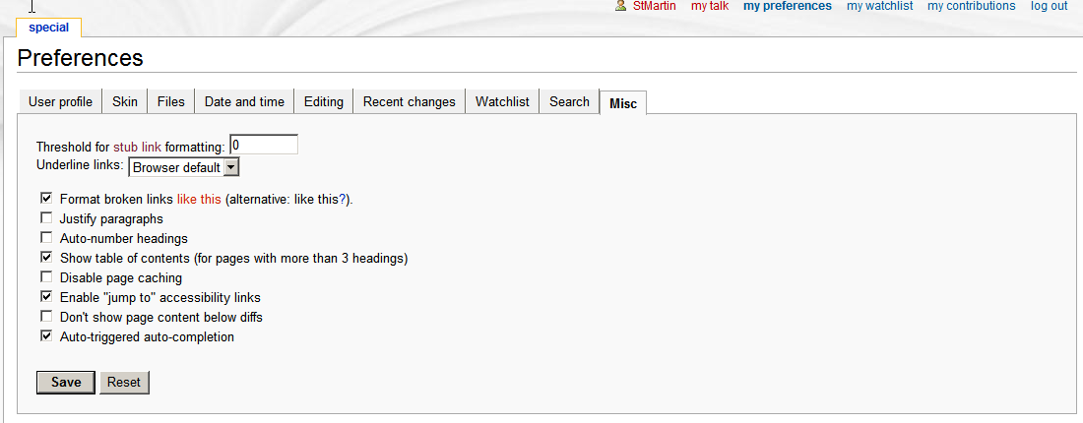

  - If you do not wish to set your preferences for the auto-complete feature you may type the word in the Search box and click CTRL-spacebar to activate auto-complete.

- Using Auto-complete
Note: Since the new CTCAE SOC is the coding scheme for the 2nd iteration, if you type in CTCAE SOC (does not have to be capitalized) and then your term it will allow you to find the AE term within this namespace.

  - Begin typing CTCAE SOC and then the AE term you wish to find (see below- example: Hypohidrosis).
  - If your auto-complete is auto-triggered you should see a red swirling circle, which signifies that the auto-complete is working to find your term.
  - You will then see a drop down box with a list of terms (see Figure 2).

Figure 2
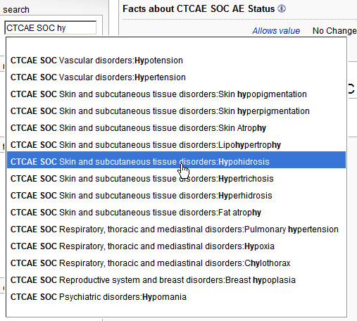

  - Choose your term from the list. This will place that name in the Search field (see Figure 3).

Figure 3
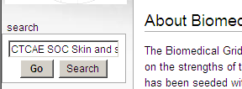

  - If you click the Go button, you will be directed to the AE term page (see Figure 4).

Figure 4
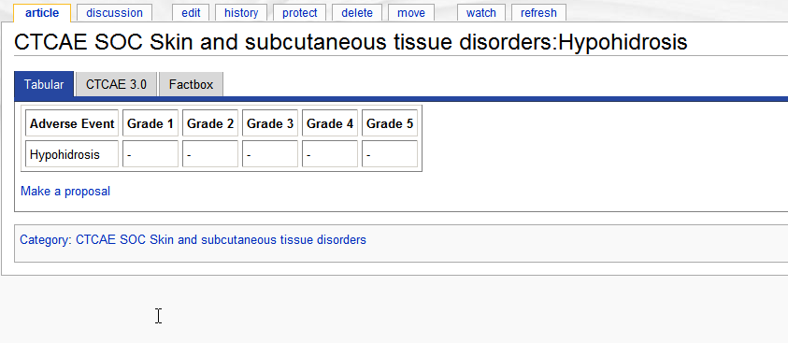

  - If you click the Search button, you will be directed to a Search results page (see Figure 5). At this page you can also click on the link for the AE page and be directed to that page.

Figure 5
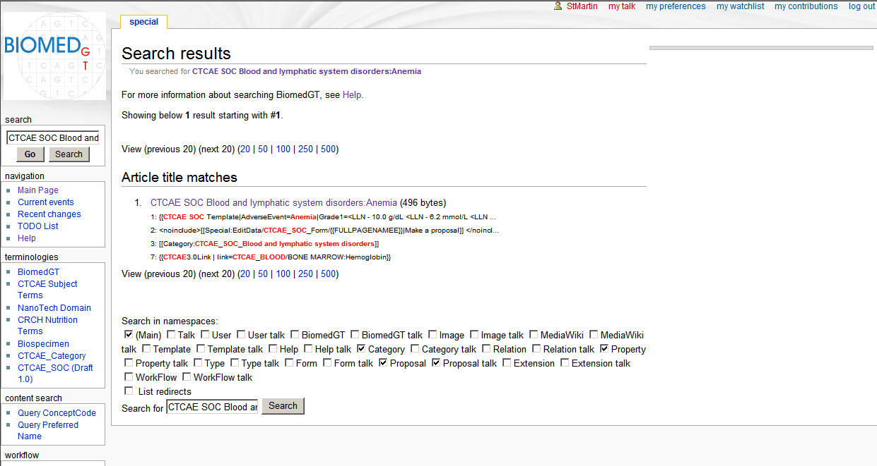

- Icons within Search:
  - Within the auto-complete search you may see icons next to search results drop-down box. These indicate whether the search result is a property (P), category (C), or Adverse event term (which has no icon).
    - For CTCAE purposes you may only need to search for the CTCAE SOC Adverse event name. Therefore please disregard the items with an icon next to them.

  - If you choose your search word (without an icon) and click Go, it will take you to that particular AE term page. From there you can either choose the Discussion tab or make a proposal.

- Troubleshooting
  - If you have problems searching for a word, try entering in just part of the word and then using the auto-complete. This should help you get a broader search range.
  - If you have any other problems with Search, please consult the Help link located on the main page.

