BRIEFING DOCUMENT
NONPRESCRIPTION DRUGS and REPRODUCTIVE HEALTH DRUGS ADVISORY COMMITTEE MEETING
16 DECEMBER 2003

PLAN B® (LEVONORGESTREL)
FOR EMERGENCY CONTRACEPTION
R_{x}-to-OTC SWITCH

14 November 2003

Women’s Capital Corporation
1990 M Street, NW
Suite 250
Washington, DC 20036

AVAILABLE FOR PUBLIC DISCLOSURE WITHOUT REDACTION

TABLE OF CONTENTS
LIST OF APPENDICES 7
1 Introduction and Background 8
1.1 Introduction 8
1.2 Executive Summary 8
1.2.1 Unintended Pregnancy 8
1.2.2 Emergency Contraception 9
1.2.2.1 Definition 9
1.2.2.2 Awareness 10
1.2.2.3 Emergency Contraception – History 11
1.2.2.4 Emergency Contraception – Worldwide Experience 12
1.2.2.5 Emergency Contraception – Access 13
1.2.2.6 Pharmacy Access Programs 15
1.2.2.7 Potential Impact of Expanded Access to Emergency Contraception 16
1.2.2.7.1 Condom Use 16
1.2.2.7.2 Sexually Transmitted Infections (STI) 19
1.2.2.7.3 Routine Birth Control Use 19
1.2.3 Plan B: Post-Marketing Safety Experience 20
1.2.3.1 Ectopic Pregnancy 25
1.2.4 Plan B: Rx-to-OTC Switch 26
2 CLINICAL Pharmacology of Levonorgestrel – MECHANISM OF ACTION 28
3 Well-Controlled, COMPARATIVE, Clinical STUDIES OF 0.75 MG LEVONORGESTREL for Emergency Contraception (NOT SPECIFICALLY DESIGNED TO SUPPORT AN Rx-to-OTC SWITCH) 32
3.1 Summary of Comparative Clinical Efficacy Studies of 0.75 mg Levonorgestrel for Emergency Contraception from NDA 21-045 32
3.2 Controlled Studies of the Plan B Levonorgestrel Regimen for Emergency Contraception Since the Submission of NDA 21-045 34
4 Studies Supporting the OTC Distribution of Plan B 34
4.1 Overview 34
4.2 Plan B OTC Label Comprehension Study 37
4.2.1 Overview and Study Design 37
4.2.2 Survey Overview 39
4.2.3 Survey Procedure 39
4.2.4 Study Population 40
4.2.5 Results – All Patients 44
4.2.5.1 Communication Objectives 44
4.2.5.2 Communication Objective 2 46
4.2.5.3 Communication Objective 4 47
4.2.5.4 Communication Objective 8 49
4.2.6 Results by Literacy Level (as assessed by the REALM test) 50
4.2.6.1 Overview 50
4.2.6.2 Results - Communication Objectives 53
4.2.7 Summary and Conclusions – Label Comprehension Study 54
4.3 Plan B OTC Actual Use Study 56
4.3.1 Overview and Study Design 56
4.3.2 Study Population 60
4.3.3 Analysis of Primary Outcome Variables of Plan B OTC Actual Use Study 64
4.3.3.1 Contraindicated Use 64
4.3.3.2 Incorrect Use 65
4.3.4 Analysis of Pregnancy During Plan B OTC Actual Use Study 66
4.3.5 Additional Results of the Plan B OTC Actual Use Study 68
4.3.6 Prior vs. Naïve Users 69
4.3.7 Safety Results for the Plan B OTC Actual Use Study: Adverse Events 70
4.3.8 Actual Use Study: Conclusion 72
5 benefit/risk overview of plan b as an otc emergency contraceptive 74
5.1 Overview 74
5.2 Risk Assessment of Plan B 74
5.3 Benefits of OTC Plan B 76
5.4 Discussion and Conclusions – Risks vs. Benefits 77
6 plan b: Convenient Access, Responsible Education Program 79
6.1 Introduction 79
6.2 CARESM Program Objectives 80
6.3 Labeling/Packaging 81
6.3.1 Core messages 82
6.3.2 Labeling refinements 82
6.3.3 Additional sources of information 83
6.4 Education 83
6.4.1 Educational Program to Healthcare Professionals. 83
6.4.2 Educational Campaign to Consumers 84
6.4.3 Media Coverage 85
6.5 Distribution 85
6.6 Monitoring 86
6.7 Summary and Conclusions 88
7 References 89

LIST OF TABLES

Table 1: Plan B Serious Adverse Events 28 July 2002 – 27 July 2003 22
Table 2: Summary of Adverse Events by Body System 24
Table 3: Well-Controlled Comparative Clinical Studies Previously Submitted in NDA 21-045 32
Table 4: Efficacy Results for Comparative Clinical Trials from NDA 21-045 (WHO #92908, WHO 1998b, Ho 1993) 33
Table 5: Sponsor Studies Supporting OTC Distribution of Plan B 35
Table 6: Socio-Demographic Characteristics of the Eligible Population in the Plan B OTC Label Comprehension Study 41
Table 7: Distribution of Eligible Subjects Seen at Mall and Clinic Settings, by Age Group 42
Table 8: Contraceptive History of the Eligible Population in the Plan B OTC Label Comprehension Study 43
Table 9: Percent of Subjects Who Understood Communication Objectives Related to Efficacy in the Plan B OTC Label Comprehension Study 45
Table 10: Correct Response Percentages for Questions 9, 21, 22, and 25 Making Up Communication Objective 2: Plan B is Intended as a Back Up Method and Should Not Be Used for Regular Birth Control 46
Table 11: Correct Response Percentages for Questions 10, 19, 20 and 29 Making Up Communication Objective 4: The First Pill Should Be Taken Within 72 Hours After Intercourse 48
Table 12: Correct Response Percentages for Question 15 Making Up Communication Objective 8: Plan B Should Not Be Used by Women with Unexplained Vaginal Bleeding 49
Table 13: Socio-Demographic Characteristics of the Subjects Administered the REALM Test in the Plan B OTC Label Comprehension Study 52
Table 14: Percent of REALM Subgroup Who Understood Communication Objectives Related to Efficacy in the Plan B OTC Label Comprehension Study 53
Table 15: Socio-Demographic Characteristics of Screened and Enrolled Cohorts in the Actual Use Study (% of each subset) 63
Table 16: Efficacy Results for Actual Use Study and NDA Pivotal Study 68
Table 17: Contraceptive Methods Used Before and After Receiving Plan B 68
Table 18: Contraindicated and Incorrect Use Among Prior and Naïve Users of Emergency Contraception 70
Table 19: Percent of Subjects Reporting Adverse Events in Actual Use Study (≥ 5% reported for at least one subset) 71
Table 20: Interval Between Pill Doses in Actual Use Study and NDA Pivotal Clinical Trial 73

LIST OF FIGURES

FIGURE 1: PROBABILITY OF CONCEPTION ON SPECIFIC DAYS NEAR THE DAY OF OVULATION (WILCOX 1995)……………………………………………………………………..29
Figure 2: Instructions for Use Printed on the Outside of the Plan B OTC Actual Use Study Label* 60
Figure 3: Pregnancy Analysis in Actual Use Study 67

LIST OF APPENDICES

APPENDIX 1: MECHANISMS OF ACTION
APPENDIX 2: LABEL COMPREHENSION QUESTIONS AND QUESTIONNAIRE
APPENDIX 3: LABEL COMPREHENSION STUDY LABEL
APPENDIX 4: ACTUAL USE STUDY LABEL
APPENDIX 5: PROPOSED OTC LABEL
APPENDIX 6: CATEGORIZATION OF VERBATIM TERMS FOR LABEL COMPREHENSION STUDY QUESTION #7
APPENDIX 7: PROPOSED PATIENT PACKAGE INSERT
APPENDIX 8: LABEL COMPREHENSION STUDY DATA TRANSCRIPTION CARD
1 Introduction and Background

1.1 Introduction
This briefing document summarizes information in support of the proposed Rx-to-over-the-counter (OTC) switch for the marketed emergency contraceptive, Plan B® and describes the proposed CARESM (Convenient Access Responsible Education) program intended to insure the appropriate and responsible use of Plan B. Women’s Capital Corporation (“the sponsor”) proposes that expanded access to Plan B, combined with a well defined marketing and educational program, will provide a fundamentally improved approach to satisfying an unmet medical need that will result in the reduction of unintended pregnancies.

Barr also contends that Plan B is an ideal OTC candidate. The unpredictable timing of the event leading to the need for emergency contraception, along with the following characteristics of Plan B strongly support the switch to OTC status:
- Early use of Plan B increases efficacy
- Plan B has an appropriate safety profile
- Plan B has a compelling risk/benefit assessment
- Plan B is not used chronically.

1.2 Executive Summary
1.2.1 Unintended Pregnancy

There are nearly three million unintended pregnancies each year in the United States, and about half of them end in abortion. Unintended pregnancy remains a major public health problem, affecting women in all reproductive age groups and socio-economic strata. Greater use of emergency contraception (EC) could theoretically prevent up to 70% of unintended pregnancies (Trussell 1992b). Use of emergency contraception by American women is still relatively rare for a number of reasons, including generally limited information that this therapeutic option exists and restrictions on availability that limit access.

In 1994, the last year for which complete data are available, 49% of all pregnancies in the U.S. are estimated to have been unintended and 54% of these pregnancies ended in abortion (Henshaw 1998). Abortion rates are highest among women who are aged 18-29, unmarried, low-income, and/or black or Hispanic. In addition, low-income women presenting for abortion are more likely to report problems accessing contraception (Jones 2002b). Based on 1994 data, Henshaw (1998) estimated that American women average 1.4 unintended pregnancies over their reproductive lifetime and that 43% of U.S. women will have an abortion by the time they reach 45 years of age (Henshaw 1998).

In addition, the incidence of contraceptive failures should not be underestimated. More than half (53.7%) of U.S. women presenting for elective abortion were using a method of contraception in the month they became pregnant; of those who were not using a method, most had used contraception in the recent past. Of note, only 1.3% reported using emergency contraception (Jones 2002b).

1.2.2 Emergency Contraception

1.2.2.1 Definition

Emergency contraception is a therapy for women who have had unprotected sexual intercourse, including sexual assault or a contraceptive failure. Pharmacologic methods of emergency contraception have included use of combination or progestin-only oral contraceptives, danazol, synthetic estrogens, conjugated estrogens, and antiprogestins.

1.2.2.2 Awareness

Levels of awareness regarding emergency contraception remain low, and few women are counseled about the method in advance by their doctors. A nationally representative survey found that just 68% of women aged 18-44 are aware that there is something they can do in the first few days after unprotected sex to prevent pregnancy (Kaiser 2003). A 2000 survey that probed deeper into women’s “awareness” of emergency contraception found that while 74% of women aged 18-44 surveyed claimed to have heard of the “morning-after” pill, just 27% percent claimed to have heard of “emergency contraceptive” pills. Furthermore, only 43% responded that emergency contraceptive pills were available in the United States, 30% knew that a prescription was required to obtain emergency contraception, and only 16% understood that emergency contraceptive pills needed to be taken within 72 hours after sexual intercourse (Kaiser 2000). Another survey of 293 active duty members of a U.S. Air Force base found that while 64% had heard of EC, only 15% knew the correct timeframe for use (van Royen 2000). A product that is so time dependent cannot be used effectively unless women are educated proactively. These studies demonstrate that awareness and comprehensive understanding of emergency contraception and its uses is currently inadequate to insure responsible and effective use.

These low levels of awareness and knowledge about emergency contraception may, in part, be due to the fact that only 25% of gynecologists and 14% of general practice physicians reported that they talk about this method “always” or “most” of the time (Kaiser 2003a). This may be due to physicians being too busy to discuss an event that may or may not be relevant for any given patient. The lack of knowledge about emergency contraception is likely to result in a number of preventable unintended pregnancies, as a recent survey of U.S. women (n=10,683 usable questionnaires) obtaining abortions in 2000-2001 found that just 1.3% of women reported taking emergency contraceptive pills to prevent the pregnancy (Jones 2002b). Despite the reported rates of unintended pregnancy, another survey from earlier this year found that only 6% of women aged 18-44 reported ever having used emergency contraception (Kaiser 2003b).

1.2.2.3 Emergency Contraception – History

Over the last several decades a variety of approaches to emergency contraception have been evaluated, including high-doses of estrogen, estrogen combined with progestin, progestin alone, antiprogestational agents and intrauterine devices (IUDs) (Van Look 1993; Glasier 1997). Ovral® (0.5 mg norgestrel/0.05 mg ethinyl estradiol), a high-dose combined oral contraceptive approved for use in 1968, was a standard product used for emergency contraception in the U.S. from the mid-1970s. Dosed as 2 tablets (total dose: 1.0 mg norgestrel/0.1 mg ethinyl estradiol) within 72 hours of unprotected sex, followed by another 2 tablets 12 hours after the first dose (total dose: 1.0 mg norgestrel/0.1 mg ethinyl estradiol) (generally referred to as the Yuzpe regimen after its Canadian developer), it was declared a safe and effective regimen by the FDA in 1997. A combination product based on the Yuzpe regimen, Preven®, was approved by the FDA in 1998. To date, all approved emergency contraceptive products are available by prescription only.

Beginning in the late 1980s, investigators recognized the potential of levonorgestrel as an emergency contraceptive in place of the standard Yuzpe regimen of combined high-dose oral contraceptives (containing estrogen and progestin). Levonorgestrel has a long history of use in combination oral contraceptives and there are substantial data to support the drug’s efficacy in pregnancy prevention, including the efficacy of elevated doses used postcoitally. Using levonorgestrel 0.75 mg tablets already marketed by Gedeon Richter, Ltd., the World Health Organization (WHO) sponsored two well-controlled studies of levonorgestrel for emergency contraception, both of which were published (Ho 1993, WHO 1998b). The first of these studies was a single-center, randomized trial of levonorgestrel compared with the Yuzpe regimen in women requesting emergency contraception within 48 hours of unprotected intercourse. In this study, levonorgestrel was found to be as effective in preventing pregnancy as the Yuzpe regimen.

WHO subsequently conducted a multi-center, randomized, double-blind study (WHO #92908) in order to confirm and expand the findings of Ho et al. (1993). In this study conducted in 14 countries, 1,998 women from a wide variety of racial and ethnic groups participated. Two separate doses of levonorgestrel 0.75 mg (taken 12 hours apart within 72 hours of unprotected sex) showed greater efficacy when compared with the Yuzpe regimen. The results indicated that Plan B is 89% effective if used as labeled within 72 hours of unprotected sex. Plan B reduced the risk of pregnancy following a single act of mid-cycle unprotected sexual intercourse from 8%, on average, to 1.1%. The regimen was demonstrated to be more effective if treatment is initiated soon after unprotected sex than if treatment is delayed. Taken within 24 hours of coitus, the regimen reduced the risk of pregnancy by 95%, from about 8% to 0.4%.

Plan B was approved by the U.S. Food and Drug Administration (FDA) in 1999 as a prescription product indicated for use following a contraceptive accident, failure to use a regular contraceptive method correctly or sexual intercourse without contraception, including cases of sexual assault.

1.2.2.4 Emergency Contraception – Worldwide Experience

Levonorgestrel has a 40-year history of safe use in combined and progestin-only contraceptives. In addition, there is a 30-year history of clinical research on elevated doses of levonorgestrel for postcoital contraception and 20 years of foreign marketing experience for the 0.75 mg tablet manufactured by Gedeon Richter Ltd., which provide ample evidence of the safety and efficacy of 0.75 mg levonorgestrel tablets in postcoital pregnancy prevention.

The extensive body of efficacy and safety data, from multiple studies by many different investigators, and covering a diverse population of women, provide considerable reassurance that Plan B should remain highly safe and effective in an OTC environment. The levonorgestrel regimen for emergency contraception is currently approved in 101 countries. In 33 of these countries it is currently sold without a prescription, by pharmacists, or OTC. In Israel, Norway and Sweden, levonorgestrol is available OTC. In 30 countries, including the UK and France, it is available directly from a pharmacist without a prescription. Of those countries where Plan B is currently sold without a prescription, the UK, Finland and Switzerland provide access to Plan B with age restrictions. Clinical trials, medical literature and post-marketing surveillance by regulatory agencies indicate no clinically significant safety problems. An evaluation of international post-marketing adverse events also shows that “real-life” usage of emergency contraception does not pose any safety concerns.

1.2.2.5 Emergency Contraception – Access

Since the efficacy of emergency contraception has been found to be significantly affected by the amount of time between the unprotected sex-act and using emergency contraception, rapid access to the method is of critical importance to maximize efficacy. A pooling of the results for the Yuzpe regimen (estrogen and progestin) of emergency contraception combined with Plan B found that each 12 hours of delay reduces efficacy by about 50% (p=0.02) (Piaggio 1999). Treatment is completely ineffective once the process of implantation of a fertilized egg is underway, a process that begins within five to seven days after coitus (Grimes 2001, Raman-Wilms 1995, Bracken 1990).

The majority of American women who must seek a prescription from a private physician and then fill it at a pharmacy face even greater barriers to timely use than do clinic populations where emergency contraception is well understood and provided at the time of the visit. Even in the hospital and clinic setting, Shawe et al. (2001) found that only 4% of women accessing the method at a healthcare facility obtained it in the first 12 hours and only 37% did so in 12-24 hours. A review of eight other studies found that only 27% to 61% of women accessed the method within 24 hours, 23% to 33% in 24 to 48 hours, and 10% to 25% in 49 to 72 hours (Ashok 2002, Arowojolu 2002, WHO 2002, Roizen 2001, Nanthakumaran 1998, Tydén 1998, Evans 1996, Roberts 1995). Highlighting problems with access, a recent study from University of California, San Francisco (UCSF) found that 14% of 663 subjects reported wanting to use emergency contraception in the past but not doing so because of: inconvenience (17%), difficulty with the 72-hour limit (11%), the clinic was closed (7%), they did not know where to go (9%), and other reasons (15%) (UCSF 2003b).

Another aspect reflecting a logistical barrier to obtaining EC was recently published by Espey et al. An assessment was performed to determine the immediate availability of prescription emergency contraception (Plan B and Preven) at pharmacies in Albuquerque, New Mexico. A prescription for either Plan B or Preven was presented at 89 pharmacies and found that neither EC was immediately available at 89% of the pharmacies included in the study. At those pharmacies where EC was not immediately available, only 53% predicted that they could obtain the product for the patient within 24 hours. The authors concluded that “lack of availability at the pharmacy constitutes a major barrier to emergency contraception access.” (Espey, 2003) Thus, any program designed to maximize the efficacy of Plan B must include education about appropriate use of Plan B, education about where and how to obtain Plan B and finally a mechanism to insure availability of Plan B at the pharmacy level.

1.2.2.6 Pharmacy Access Programs

While emergency contraceptive pills are still prescription products in the United States, there are currently five states in the U.S. where a woman can walk in to a pharmacy and obtain emergency contraceptive pills without an advance prescription from a prescriber. These five states are Alaska, California, Hawaii, New Mexico, and Washington State. The changes made by each state relate to their existing pharmacy practice laws. Some states required legislative change, others required regulatory change, and one state, Washington, needed no formal change in law, but needed to bring about institutional acceptance for this new practice.

Pharmacy access to emergency contraception was initiated in 1997 in the United States:
- 1997 - Washington State initiated its pilot program, which became a self-sustaining program just two years later.
- 2000 - California initiated a pilot program with 70 pharmacies.
- 2002 - California legislation took effect allowing a statewide effort; Alaska approved its first collaborative protocols allowing pharmacists to dispense emergency contraception.
- 2003 - New Mexico approved a statewide protocol to allow for pharmacy access; Hawaii passed legislation that will allow women to access emergency contraception directly from a pharmacist as soon as a standardized protocol is developed.

A preliminary assessment of the first two months of the pharmacy access program in Washington State found that pharmacy access was key to greater utilization of emergency contraception: 42% of women (n=129) responding to a mail-in questionnaire indicated that without pharmacy access they would simply have waited to see if they became pregnant, and 16% said they did not know what they would have done (Wells 1998); among adolescents (aged 15-21, n=126), 22% would have waited to see if they got pregnant and 20% did not know what they would have done (Sucato 2001).

Additional data on adolescents accessing the services (n=126, aged 15-21), found that extended accessible hours to the regimen were utilized, as 45% obtained emergency contraception on the evening and/or the weekend. In addition, although prior use of the method was common, repeated prior use was not: 32% had used emergency contraception 1 or more prior times, with 10% using it 2 or more prior times, and just 6% using it 3 or more prior times (Sucato 2001).

In addition, adolescents did not represent a disproportionate share of consumers accessing emergency contraception directly from a pharmacist in Washington State, as the mean age of women seeking services was 24.5 years, with only 13% under 18 years of age. Timely access was met, as a review of 991 pharmacy records revealed that 70% of women received emergency contraception within 1 day of unprotected intercourse. It appears that barriers were also removed, which likely contributed to the timely access, as 20% of respondents reported that they went to a pharmacist because their physician’s office was closed, 7% reported that their regular clinic or physician didn’t prescribe emergency contraception, and 14.8% reported that they had no regular clinic or physician (Downing 2000).

1.2.2.7 Potential Impact of Expanded Access to Emergency Contraception

1.2.2.7.1 Condom Use
Easier access to emergency contraception does not appear to undermine condom use. Easier access to emergency contraception as a backup (i.e., in the event of condom breakage, slippage, or leakage) may, in fact, allow more women to rely on condoms for both birth control and disease prevention (WCC/FHI 2002, UCSF 2003b, Raine 2000).

A number of studies provide information about the effects of emergency contraception on condom use. In the Plan B® OTC Actual Use Study, 10.3% of subjects who reported no condom use before admission were using condoms at follow-up, compared to only 4.7% of condom users who had stopped using the method (WCC/FHI 2002). This result is consistent with the literature. At the three-month follow-up of 39 women given a Preven® emergency contraception kit to keep at home, 39% of those who had not reported condom use at last intercourse during enrollment did report condom use at last intercourse at the time of follow-up. Just 15% of those who had used a condom at last intercourse at enrollment were not using a condom after three months in the study, suggesting a net gain of 24% in condom use (Roye 2002, Roye 2001). In the 1994–1996 study in Scotland by Glasier et al. (1998) comparing women who received an off-label regimen of emergency contraception in advance with those who had to obtain it from the clinic, there was no difference between the two groups with respect to the use of condoms. A subsequent study of advanced provision by Raine et al. (2000), also using an off-label regimen, showed similar results among low-income minority adolescents and young adults in San Francisco. There was no difference between the advanced provision and clinic access groups with respect to the consistency of condom use at the four-month follow-up.

In the UCSF Emergency Contraception Access Study of Plan B (UCSF 2003b), the advanced provision and pharmacy access groups each showed a statistically significant decrease in rates of condom use at last sex from baseline to follow-up (p<0.007 and p<0.001, respectively), while the clinic access group remained relatively consistent over time (p<0.651). In this study, young women at high risk of unintended pregnancy and STI acquisition were given access to three free packages of Plan B. Condom use at last intercourse was lightly lower in the advance provision group (48.9%) and pharmacy access group (50.6%) than in the clinic access group (55.7%) (p<0.097). No differences were shown, however, in frequency of condom use or current use of condoms. Primary and secondary endpoints were compared for adolescents (15–17 years) and young adults (18–24 years). At follow-up interviews six months (to a year) after enrollment, there were no significant differences between the two age groups in condom use since entering the study (p<0.519), condom use at last intercourse (p<0.933) or current use of condoms (p<0.938). The impact on condom use was mixed, but adolescents appeared no more likely to modify their condom use than young adults. In the study by Belzer et al. (2003) of adolescent mothers aged 14-20, also conducted with Plan B, there was no difference in condom use between subjects given Plan B in advance or those who had to return to a clinic setting to receive the product.

These and other studies of advanced provision, in which women self-diagnosed their need for emergency contraception and used it without medical oversight—often many months after receiving counseling—provide further support that Plan B can be used safely, effectively and appropriately without medical supervision. As noted above, the UCSF results (UCSF 2003b) could suggest that in particularly vulnerable populations prone to risky sexual behavior, easy cost-free access to emergency contraception, through advanced provision or free pharmacy access may increase slightly some types of risk-taking.

It cannot be assumed that OTC sale of Plan B in retail pharmacies would have a similar impact, since users would be required to pay for the product. It is important to note that when compared to routine use of condoms or even oral contraceptives, Plan B is a very expensive form of “routine” birth control. The cost of repetitive use of Plan B is in and of itself a deterrent to repeated use for most of the population. The small decreases in consistent condom use observed in the recent UCSF Emergency Contraception Access Study (2003b) were not observed in the Glasier et al. (1998), Raine et al. (2000), or Belzer et al. (2003) studies. The explanation may be that in the Glasier, Raine, and Belzer studies, subjects were given only one course of treatment in advance, while in the UCSF study subjects were given three packages of Plan B in advance or a card allowing them access to up to three free packages at a pharmacy. Plan B is packaged in single-use packages. Women will need to consider cost when making their contraceptive choices. Finally, the CARESM program will actively encourage the use of routine birth control through the distribution of written materials to consumers as well as a hotline and website providing responsible and accurate information.

1.2.2.7.2 Sexually Transmitted Infections (STI)
In the UCSF Emergency Contraception Access Study (2003b) comparing advanced provision, pharmacy access and standard clinic access, there was no evidence of a difference in the acquisition of an STI during the study among the three groups. It is important to note that subjects were given access to three free packages of Plan B. In the study population as a whole, 22.3% of participants had a history of STIs. During the study, a total of 156 participants (16.7%) acquired an STI (self-reported or by laboratory tests), including: 47 (14.9%) in the advance provision group, 58 (18.5%) in the pharmacy access group and 51 (16.7%) in the clinic access group. The differences were not statistically significant. There were no differences among the three groups when controlling for baseline history of STIs (p<0.427). When primary and secondary endpoints were compared for adolescents (15-17 years) and young adults (18-24 years) at follow-up interviews six months (to a year) after enrollment, there were no significant differences between the two age groups in sexually transmitted disease acquisition (p<0.719).

1.2.2.7.3 Routine Birth Control Use
Studies also show that women with access to EC typically do not abandon regular contraception or use their chosen method less consistently. A growing body of literature suggests that women with easier access to EC are more likely to use EC following an occasional episode of unprotected sex than women who must visit a clinic or doctor’s office for a prescription (Glasier 1998c, Raine 2000, Belzer 2003, Jackson 2003, Ellertson 2001a), but they are generally not more likely to abandon regular contraception (Belzer 2003, Jackson 2003, UCSF 2003b). Women who use EC following a pregnancy scare may actually be more likely to use an effective ongoing contraceptive method afterwards (Riain 1998, Rowlands 2000). A number of studies also provided evidence that advanced provision did not increase the incidence of unprotected sex (Raine 2000, Belzer 2003, Jackson 2003).

The availability of Plan B in community pharmacies along with an appropriate and responsible education program will help raise awareness of emergency contraception and encourage its appropriate use. Once women are educated about emergency contraception in the context of providing a clear understanding of how it fits into a responsible contraceptive strategy, eliminating the need for a prescription provides for more direct and timely access in the event of a contraceptive emergency. Thus, the change to OTC availability of Plan B should not encourage the inappropriate use of this product but with responsibly designed educational and marketing programs, will maximize efficacy and thereby decrease the incidence of unintended pregnancies and potentially abortion.

1.2.3 Plan B: Post-Marketing Safety Experience

Plan B has been marketed as a prescription drug product in the U.S. since 1999. During the most recent reporting period, 28 July 2002 to 27 July 2003, WCC received 216 initial post-marketing Adverse Drug Experience (ADE) reports containing 327 adverse events. No deaths were reported. These 216 reports included 191 nonserious and/or labeled events from the U.S. and 25 serious adverse events from the U.S. and Chemical Works of Gedeon Richter, Ltd. (Gedeon Richter), which markets levonorgestrel tablets in 40 countries worldwide, the Canadian Adverse Drug Reaction Monitoring Program (CADRMP), and the published literature.

Table 1 lists the serious adverse event reports received during the reporting period. The 25 serious adverse event reports included 35 adverse events. Although the possibility of ectopic pregnancy is described under the warning section in the labeling for Plan B, ectopic pregnancies were considered serious adverse events and were reported to the FDA.
Table 1: Plan B Serious Adverse Events 28 July 2002 – 27 July 2003
Event Description | Preferred Term(s) | Date Submitted
Ectopic pregnancy | Ectopic pregnancy | 9/11/2002
Benign dermoid cyst, Ectopic pregnancy | Benign ovarian germ cell teratoma, Ectopic pregnancy | 9/11/2002
Ectopic pregnancy | Ectopic pregnancy | 9/11/2002
Ectopic pregnancy | Ectopic pregnancy | 10/9/2002
Ectopic pregnancy | Ectopic pregnancy | 11/12/2002
Ectopic pregnancy | Ectopic pregnancy | 11/12/2002
Congenital anomaly | Congenital anomaly | 12/9/2002
Itching, rash, hives | Itching, rash, hives | 2/19/2003
Ectopic pregnancy | Ectopic pregnancy | 3/6/2003
Unintended pregnancy, spontaneous abortion | Unintended pregnancy, abortion | 3/6/2003
Ectopic pregnancy | Ectopic pregnancy | 3/6/2003
Ectopic pregnancy | Ectopic pregnancy | 3/18/2003
Fetus detached from uterine wall | Abruptio placentae | 4/2/2003
Unintended pregnancy | Unintened pregnancy | 4/16/2003
Ectopic pregnancy | Ectopic pregnancy | 4/16/2003
Unintended pregnancy, hospitalization after spot bleeding, induced abortion | Unintended pregnancy, antepartum hemorrhage, induced abortion | 5/6/2003
Ruptured tubal pregnancy | Ruptured tubal pregnancy | 5/21/2003
Right ruptured tubal pregnancy | Ruptured tubal pregnancy, vaginal bleeding | 5/21/2003
Possibility of a right-sided ectopic pregnancy | Abdominal pain, nausea, right ectopic pregnancy | 5/21/2003
Unintended pregnancy, miscarriage | Unintended pregnancy, missed spontaneous abortion | 5/21/2003
Ectopic pregnancy, ovarian cystectomy | Ectopic pregnancy | 7/11/2003
Unintended pregnancy | Unintended pregnancy | 5/21/2003
Unintended pregnancy, premature rupture of membrane | Unintended pregnancy, caesarean section | 5/28/2003
Ectopic pregnancy | Ectopic pregnancy, laparotomy, salpingectomy | 5/28/2003
Ectopic pregnancy | Ectopic pregnancy | 7/14/2003
The adverse events received by WCC (362 events in 216 reports) and all the serious adverse events (numbering 35 events in 25 reports) are summarized in the following table by WCC Preferred term (Table 2).

Table 2: Summary of Adverse Events by Body System
Preferred Term | Non-serious Events |  | 15-Day Alert Events
Preferred Term | Number of Reported Events | Percentage of Total Events | 15-Day Alert Events
Body as a Whole
Fatigue/asthenia | 15 | 4.6
Cardiovascular System
Irregular rapid pulse | 1 | 0.3
Gastrointestinal System
Nausea | 34 | 10.4 | 1
Vomiting | 8 | 2.5
Diarrhea/loose stools | 7 | 2.1
Bloating/water retention | 5 | 1.5
Stomachache | 2 | 0.6
Metallic taste in mouth | 1 | 0.3
Appetite loss | 1 | 0.3
Neurological System
Headache | 11 | 3.4
Dizziness/lightheaded | 9 | 2.8
Emotional changes | 2 | 0.6
Irritability | 1 | 0.3
Shakiness in hands | 1 | 0.3
Twitching in right eye | 1 | 0.3
Blurred vision | 1 | 0.3
Respiratory System
Labored breathing | 1 | 0.3
Return of asthma symptoms | 1 | 0.3
Dermatological
Rash/hives | 3 | 0.9 | 1
Acne | 1 | 0.3
Itching | 3 | 0.9 | 1
Musculoskeletal System
Back pain | 2 | 0.6
Mylagia | 1 | 0.3
Genitourinary System
Menstrual irregularities | 98 | 30.0 | 1
Abdominal pain/cramping | 47 | 14.4 | 1
Unintended pregnancy | 30 | 9.2 | 6
Preferred Term | Nonserious Events |  | 15-Day Alert Events
Preferred Term | Number of Reported Events | Percentage of Total Events | 15-Day Alert Events
Breast tenderness/pain | 22 | 6.7
Ectopic pregnancy |  |  | 16
Vaginal discharge | 5 | 1.5
Vaginal pain | 2 | 0.6
Abortion |  |  | 3
Galoctorrhea | 1 | 0.3
Urinary frequency | 3 | 0.9
Hematuria | 2 | 0.6
Urinary urgency | 2 | 0.6
Congenital anomaly |  |  | 2
Ovarian cyst | 2 | 0.6 | 1
Dysuria | 1 | 0.3
Abruptio placentae |  |  | 1
Antepartum hemorrhage |  |  | 1
TOTAL: | 327 |  | 35

Post-marketing pharmacovigilance has not identified any unexpected adverse events. Most adverse events reported were not life-threatening. The only serious adverse event reported multiple times was ectopic pregnancy. Ectopic pregnancy is included in the warning section of the label but is not thought to be associated with the use of Plan B.

1.2.3.1 Ectopic Pregnancy

The incidence of ectopic pregnancy in the United States general population is 2% of all pregnancies. In routine (i.e., daily) users of progestin-only oral contraceptives, up to 10% of the pregnancies that occur are ectopic. This incidence is higher than with most other contraceptive methods (McCann and Potter 1994). Although the mechanism is uncertain, it may be due to the decreased activity of the fallopian tube cilia and changes in tubal motility that interfere with the transport of the ovum.

There does not appear to be an increased risk of ectopic pregnancy with use of
Plan B. In clinical studies including more than 11,000 women who used Plan B for postcoital contraception there were 3 reported ectopic pregnancies of a total 198 pregnancies giving an ectopic pregnancy rate of 1.5%.

Additional reports of ectopic pregnancy with use of Plan B have been received from the post-marketing setting. The number of ectopic pregnancies is high compared to the number of unintended pregnancies reported to pharmacovigilance authorities. This is probably due to less reporting of unintended pregnancy because it is not usually considered a serious or unexpected adverse event, but a product failure. Ectopic pregnancies are much more likely to be reported than intrauterine pregnancies, since they are abnormal and thus more likely to be considered an adverse event.

These data suggest no increased risk of ectopic pregnancy for levonorgestrel emergency contraception. In addition, the proposed Plan B OTC label cautions women to be alert for symptoms of associated with ectopic pregnancy and to see their healthcare professional should any of these symptoms arise.

In summary, post-marketing surveillance data support the safety and efficacy of Plan B as a prescription drug product. Most adverse events were nonserious and not life-threatening. Based on exposure, the incidence of ectopic pregnancy should not be expected to exceed that seen in the general population. Based on existing safety data, the change from prescription to OTC availability for Plan B is not anticipated to have an adverse impact on the safety profile.

1.2.4 Plan B: Rx-to-OTC Switch

On 16 April 2003, Women’s Capital Corporation (WCC) submitted a Supplemental New Drug Application (sNDA) to change the status of Plan B from prescription only to OTC. Two studies to support an Rx-to-OTC switch were developed through a highly interactive process with the FDA OTC Division. The OTC Label Comprehension Study was undertaken to evaluate the ability of women to understand the instructions for use after reviewing a prototype OTC label (Appendix 3). Since the dose and dosing regimen in the sNDA proposed labeling are identical to the approved prescription-only labeling, the goal of this study was to determine whether the proposed OTC labeling could be understood by the patient without medical screening or counseling from a healthcare professional.

The second study supporting the Rx-to-OTC sNDA was the OTC Actual Use Study, designed to provide information on the ability of the target population to self-select and appropriately use Plan B when labeled for OTC distribution. The primary objective was to estimate the frequency of contraindicated and incorrect uses of Plan B when dispensed under simulated OTC conditions. Repeat and prior use of emergency contraception, the impact of emergency contraception on regular contraceptive use, pregnancy and pregnancy outcome, and reports of adverse events were also evaluated in this study.

These two studies conducted to support the R_{x}-to-OTC switch provide substantial evidence that women (1) can self-diagnose their need for emergency contraception; (2) can understand the directions for use of an emergency contraceptive product; and (3) can self-administer the product in a manner likely to be safe and efficacious without medical screening or counseling from a healthcare professional
(see Section 4).

Plan B’s Rx-to-OTC switch is supported by leading U.S. medical organizations who agree that the current prescription requirement creates a major barrier to timely access and who agree that the levonorgestrel regimen is safe, easy to use and, if used quickly, highly effective in preventing pregnancy. In addition, there is no evidence that levonorgestrel would harm a pregnant woman or a developing fetus if the product is taken accidentally during early pregnancy (Grimes 2001, Raman-Wilms 1995, Bracken 1990). A number of organizations have passed resolutions in support of OTC status, including the American College of Obstetricians and Gynecologists, the American Academy of Family Physicians, the American College of Nurse-Midwives, the American Medical Association, the Association of Reproductive Health Professionals, the National Medical Association, and Physicians for Reproductive Choice and Health. In addition, over 70 organizations have petitioned FDA to remove the prescription requirement for emergency contraception (CRLP 2001).

Barr proposes to support the OTC distribution of Plan B with the CARESM Program (Convenient Availability Responsible Education, see Section 6). This program focuses on education at all levels in concert with increased availability at the pharmacy level. This program has several major components intended to increase awareness about the appropriate and responsible use of Plan B, while insuring availability of Plan B at the pharmacy. Education programs will be targeted to healthcare providers and consumers through their healthcare provider. Barr recognizes that in order to responsibly sell and market this product, it is essential to provide education and increase availability without encouraging risky behavior. Thus, the intent of the CARESM program is to insure that women are aware of Plan B, know how and when to use it, and understand how to easily obtain it in the most expeditious manner. More detail is provided on the CARESM program in Section 6.

2 CLINICAL Pharmacology of Levonorgestrel – MECHANISM OF ACTION

It is likely that levonorgestrel emergency contraception, like other systemic methods of contraception, works in several different ways, depending on the cycle day of unprotected sex and the cycle day of treatment (Croxatto 2002d, see Appendix 1). The only mechanism of action that has been clearly demonstrated to prevent pregnancy is the impact of emergency contraception on the ovulatory process (Croxatto 2002d, Müller 2002, Croxatto 2002b, Trussell 2002, 2003c). In addition to suppressing or delaying ovulation, the drug may compromise the ovulatory process to the degree that fertilization is not possible, or interfere with sperm migration and function (Croxatto 2002d, Yeung 2002).

There are only six fertile days in the menstrual cycle – that is, days in which an act of sexual intercourse can give rise to pregnancy. These are the day of ovulation and the five preceding days (Figure 1, Wilcox 1995). Thus, in most cases spermatozoa spend one to five days in the female genital tract before encountering the ovum. This interval provides an opportunity to interfere with the migration and function of the sperm and/or with the process of ovulation. Emergency contraceptive pills may prevent the encounter of spermatozoa with the ovum; and, even if the two gametes do come in contact, fertilization may not proceed to completion. (Croxatto, 2002d)
Figure 1: Probability of Conception on Specific Days Near the Day of Ovulation (Wilcox 1995)
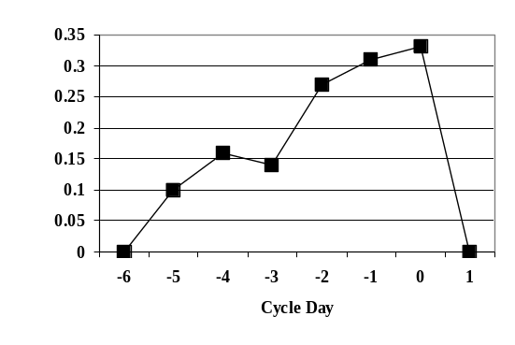

In human beings, fertilization is not very efficient: in ideal circumstances, when intercourse takes place during the most fertile days, the chance that fertilization will take place does not exceed 50%. On average, in couples not using any method of birth control, the chance of conception during any one cycle is approximately
25-30%. Even with daily intercourse, most ovulatory menstrual cycles may be incapable of producing a conception (Wilcox 1995), as other factors (such as age) apparently have a strong role in determining fertility. It is plausible that even minor alterations in reproductive processes will greatly lessen the likelihood of pregnancy. This possibility has been explored experimentally in a few studies, and emergency contraceptive pills have been shown to interfere with pre-fertilization events (Croxatto 2002d).
The only mechanism of action that has been clearly demonstrated to prevent pregnancy is the impact of emergency contraception on the ovulatory process (Croxatto 2002d, Müller 2002, Croxatto 2002b, Trussell 2002, 2003c). Current understanding of ovulation is that a mid-cycle surge of luteinizing hormone from the pituitary acts on a follicle in the ovary, setting into motion a series of coordinated events, and resulting in release of an oocyte and transformation of the empty follicle into the corpus luteum. When the normal luteinizing hormone surge or any of the subsequent events is altered, the result can be ovulatory dysfunction and compromised fertilization. Depending on the timing of the administration relative to the luteinizing hormone surge, levonorgestrel inhibits or postpones this luteinizing hormone surge, inhibits or postpones rupture of the follicle, interferes with the formation of the corpus luteum, or has no effect on these indices. (Croxatto 2002d)

Through the above mechanisms, levonorgestrel emergency contraception pills given during the preovulatory phase of the menstrual cycle have the capacity to interfere with the ovulatory process by suppressing or delaying ovulation. Additionally, even if ovulation does occur, the drug may compromise the ovulatory process to the degree that fertilization is not possible. Another mechanism by which levonorgestrel may work is by interfering with sperm migration and function. Interference with the fertilization process has not been directly demonstrated for levonorgestrel emergency contraception (Croxatto 2002d, Yeung 2002).

Sperm migration in women occurs in two phases. In the first phase, a few minutes after insemination some spermatozoa, aided by propulsive contractions of the genital tract, reach the fallopian tube. In the second phase, over several days, spermatozoa that have been stored in the crypts of the uterine cervix migrate in successive cohorts towards the fallopian tube. Only those from the second phase have the ability to fertilize. Administration of levonorgestrel 3-10 hours after sexual intercourse has been shown to affect sperm migration between 3 and 9 hours after treatment. It reduced the number of spermatozoa recovered from the uterine cavity, increased the pH of the uterine fluid (which immobilized spermatozoa), and increased the viscosity of cervical mucus (which impeded further passage of sperm cells into the uterine cavity) (Kesserii 1974). Although the dose of levonorgestrel in this study was only 57% of the current levonorgestrel dosage, these results are highly relevant to the actions of levonorgestrel when administered as an emergency contraceptive. If ovulation occurs after a woman has taken levonorgestrel, interference with the sustained phase of sperm migration could well reduce or eliminate the probability of fertilization. (Croxatto 2002d)

Levonorgestrel alters the endometrium to varying degrees depending on dose. The impact of these endometrial changes on implantation is unclear. There is little direct evidence that prevention of implantation is a mechanism of action for levonorgestrel emergency contraception (Croxatto 2002d, Ugocsai 2002, Kahlenborn 2002). Alterations in endometrial receptivity that could interfere with implantation have been investigated, but only indirectly. Some studies have found alterations in endometrial morphology or in the expression of certain progesterone-dependent molecules. Whether such changes have a deleterious effect on endometrial receptivity is questionable. Other studies have found either negligible alterations or none, and in the case of levonorgestrel, existing evidence does not support the hypothesis that it alters endometrial receptivity or impedes implantation. (Croxatto 2002d)

Overall, the available data suggest that the primary mechanisms of action likely interfere with the ovulatory process. Since most of the risk of pregnancy is concentrated in the days leading up to and including the day of ovulation and since a direct effect on the process of ovulation has been demonstrated, it is likely that Plan B works primarily and perhaps exclusively prior to fertilization. The fact that emergency contraception is more effective the sooner it is used would also argue against important post-fertilization modes of action (Trussell 2003c, Croxatto 2002d).

3 Well-Controlled, COMPARATIVE, Clinical STUDIES OF 0.75 MG LEVONORGESTREL for Emergency Contraception (NOT SPECIFICALLY DESIGNED TO SUPPORT AN Rx-to-OTC SWITCH)

3.1 Summary of Comparative Clinical Efficacy Studies of 0.75 mg Levonorgestrel for Emergency Contraception from NDA 21-045

Two well-controlled studies were presented and summarized in NDA 21-045 (approved in July 1999). These randomized trials evaluated a two-dose regimen of levonorgestrel 0.75 mg tablets compared to the older Yuzpe regimen of combined high-dose oral contraceptives (Table 3) — the standard for emergency contraception at the time.

Table 3: Well-Controlled Comparative Clinical Studies Previously Submitted in NDA 21-045
Study | Regimens | Number of Subjects Included in Analysis | Design*
WHO #92908  (WHO 1998b) | - Two doses of 0.75 mg LNG 12 h apart  - Two doses of EE 0.05 mg + NG 0.50 mg 12 h apart (Yuzpe) | 976  979 | AC, DB, MC, R
Ho et al.  (1993) | - Two doses of 0.75 mg LNG 12 h apart  - Two doses of EE 0.05 mg + NG 0.50 mg 12 h apart (Yuzpe) | 410  424 | AC, R, SC

* Abbreviations used in this table: AC=Active Control, DB=Double-Blind, EE= Ethinyl Estradiol, LNG=Levonorgestrel, MC= Multi-Center, NG=Norgestrol, R=Randomized, SC=Single-Center

The pivotal Plan B clinical study for NDA 21-045 was designed, coordinated, monitored and analyzed by the WHO Special Programme of Research, Development and Research Training in Human Reproduction (WHO #92908, WHO 1998b). It was conducted between 1995 and 1997 at 21 clinical sites in 14 countries on five continents. The earlier Ho et al. (1993) study was conducted at the Family Planning Association of Hong Kong.

In the pivotal multi-center study, 31 women (3.2% of the efficacy population) became pregnant in the Yuzpe group and 11 (1.1% of the efficacy population) became pregnant in the levonorgestrel group (Table 4). The crude relative risk of pregnancy (levonorgestrel/Yuzpe) was 0.36 (95% confidence intervals: 0.18–0.70). The Breslow-Day test of homogeneity across centers provided no evidence of a difference in ratios between centers. Since the upper one-sided 95% confidence bound levonorgestrel/Yuzpe was 0.70, which is less than 1, the levonorgestrel regimen was deemed to be more effective than the standard Yuzpe regimen.

Table 4: Efficacy Results for Comparative Clinical Trials from NDA 21-045 (WHO #92908, WHO 1998b, Ho 1993)
 | WHO #92908  (WHO 1998b) | Ho et al.  (1993)
Levonorgestrel Group
Number of women | 976 | 410
Number of pregnancies | 11 | 12
Pregnancy rate in % | 1.1 | 2.9
Number of observed/expected pregnancies§ | 11/76.3 | 8/19.8*
Prevented fraction in % | 86 | 60
Yuzpe Group
Number of women | 979 | 424
Number of pregnancies | 31 | 15
Pregnancy rate in %, (95% CI)** | 3.2 (2.2, 4.5) | 3.5
Number of observed/expected pregnancies§ | 31/74.2 | 9/22.0*
Prevented fraction in %, (95% CI)** | 58 (41, 72) | 59*
Comparison of Levonorgestrel to Yuzpe
Relative risk levonorgestrel/Yuzpe, (95% CI)** | 0.36 (0.18–0.70) | --

§ Expected pregnancies calculated using Dixon’s expected probabilities of pregnancy by cycle day.
* Among 331 women (levonorgestrel group) and 341 women (Yuzpe group) who had reliable menstrual dates.
** Abbreviation used in this table: CI=Confidence Interval

Significantly higher pregnancy rates were noted among women who delayed taking the treatment for two or three days after intercourse when the results from both the levonorgestrel and Yuzpe arms were combined (Piaggio 1999). This finding is biologically plausible: the longer the treatment is delayed, the more likely it is that the woman would have become pregnant at which time treatment is ineffective. These studies provide evidence of the high efficacy of Plan B, taken according to the currently approved labeling.
3.2 Controlled Studies of the Plan B Levonorgestrel Regimen for Emergency Contraception Since the Submission of NDA 21-045

Three other studies of the Plan B levonorgestrel regimen for emergency contraception have been completed since the submission of NDA 21-045 and a fourth study is undergoing final analysis:
- The Wu et al. (1999) study comparing the efficacy of two doses of 0.75 mg levonorgestrel with one 10 mg dose of mifepristone in 1,276 women
- The Arowojolu et al. (2002) study comparing the efficacy of two 0.75 mg doses with a single dose of 1.5 mg in 1,118 women at two sites in Nigeria
- The WHO (2002) multi-center study comparing the efficacy of two 0.75 mg doses with a single dose of 1.5 mg and a single dose of 10 mg mifepristone in 4,071 women at 15 sites in 10 countries

Two of the three studies, Arowojolu et al. (2002) and the multi-center international study conducted by WHO (2002) were designed, in part, to test alternate dosing regimens. The new studies completed since the submission of NDA 21-045 support the high efficacy of levonorgestrel for emergency contraception.

4 Studies Supporting the OTC Distribution of Plan B

4.1 Overview

Plan B was approved by the FDA for marketing as a prescription product on 28 July 1999. The proposed change in this supplement to the NDA is a prescription (Rx) to OTC switch for the use of Plan B as emergency contraception. The dosage and instructions for use will remain the same, although the package and package insert have been modified to suit an OTC environment.

The two OTC studies sponsored by WCC -- the Plan B OTC Label Comprehension Study and the Plan B OTC Actual Use Study (Table 5) -- were designed, coordinated and monitored by Family Health International (FHI). These studies were designed to evaluate whether Plan B can be used safely and effectively without oversight by a licensed medical practitioner. The Label Comprehension Study was conducted first to evaluate an OTC label prototype and women’s ability to understand the instructions for use (WCC/FHI 2001). The study was recently published (Raymond 2002a). The ensuing modified label prototype was used for the Actual Use Study.

Table 5: Sponsor Studies Supporting OTC Distribution of Plan B
Study | Rationale | Number of Subjects  Recruited | Design*
Plan B OTC Label Comprehension Study  (WCC/FHI 2001; Raymond 2002a) | This study was designed to evaluate comprehension of the prototype OTC package label for Plan B. | 663  (656 in analysis) | MC, OL
Plan B OTC Actual Use Study  (WCC/FHI 2002) | This study was designed to provide information on the ability of the target population to self-select and appropriately use Plan B when labeled for OTC use. The primary objective was to estimate the frequency of contraindicated and incorrect uses of Plan B when dispensed under simulated OTC conditions. Secondary objectives were to estimate the incidence of repeat use, pregnancy and adverse events. | 665  (540 in efficacy analysis) | MC, OL

* Abbreviations used in this table: MC=Multi-Center, OL = Open Label, OTC = Over-The-Counter

As agreed upon at the meeting held on 5 February 2001 with the FDA Division of Reproductive and Urologic Drug Products (DRUDP), the Division of Over-the-Counter Drug Products and representatives of WCC, the Plan B OTC Actual Use Study was considered the pivotal study and its results are the primary source of data to support the Rx-to-OTC switch. When used according to instructions, the approved dosage and regimen have been judged safe and effective by the FDA. Therefore, the Actual Use Study was designed primarily to show that women could use the product appropriately and according to directions, without counseling or medical oversight. (A discussion of the study design can be found in Section 4.3.1 below).

The proposed OTC product labeling was developed according to current FDA content and formatting requirements (21 CFR 201.60–201.66) and was written to be understood by women of low literacy. Important efficacy information from the prescription product labeling is addressed in the proposed OTC labeling.
The OTC label used in the Label Comprehension Study was revised based on the results of that study, and the revised label was then used in the Actual Use Study (see Appendix 4). The Actual Use Study OTC label was then submitted as part of
the sNDA.

On 15 October 2003, WCC submitted an amendment to the R_{x}-to-OTC sNDA application in response to an oral request from FDA made on 26 September 2003. At that time, FDA requested a copy of the OTC prototype labeling from the Label Comprehension Study, the Actual Use Study, and the proposed commercial labeling. These labels appear in Appendices 3, 4, and 5, respectively.

Changes between the Actual Use Study prototype and the proposed OTC commercial labeling were:
- The percentages listed for the incidence of side effects were removed, consistent with other OTC labeling.

- The statement on unusual vaginal bleeding appeared in the Warning section of the Plan B package for the Label Comprehension and Actual Use studies and in the proposed OTC product package. A second statement concerning unusual vaginal bleeding was moved from the contraindications to the side effect section of the proposed OTC product package.

The package proposed in the sNDA is a 3¼″ × 3″ package (see Appendix 5). Although the changes described above were made to the proposed OTC package, the size of the package studied was identical in both the Label Comprehension and Actual Use studies to that proposed for marketing in the sNDA.

The sponsor is now proposing to insert this 3¼″ × 3″ package into a larger outer package. The larger outer package will have identical labeling to the smaller inner package but in a larger and thus more legible font. A package insert will also be included in the larger package. Additional consumer-tested information will also be enclosed in the larger package. Information on Plan B, its appropriate use, sexually transmitted diseases, and routine forms of birth control are proposed for inclusion. Rough drafts of some of this additional information (not yet studied in the target population) appear in Appendix 7. In addition, a card designed for the patient to record the time of the first dose and the projected time of the second dose will be provided.

4.2 Plan B OTC Label Comprehension Study

4.2.1 Overview and Study Design

Prototype labeling for the Plan B OTC product was evaluated in the Label Comprehension Study (WCC/FHI 2001). The study took place in malls and family planning clinics in eight geographically representative U.S. cities between 18 June and 12 July 2001. Every effort was made – including the use of enrollment quotas based on demographics – to enroll a target population that was highly diverse and adequate for subgroup analyses among all groups in the general population likely to be represented in the OTC population of Plan B users. The focus of this study was to determine the proportion of subjects who demonstrated “understanding” of eleven prospectively defined communication objectives developed with the FDA that were thought to be important for safe and effective use of Plan B. These objectives addressed indications for use, contraindications, instructions, possible side effects, and management of serious complications of use. All eleven communication objectives were defined prior to study initiation. The results of the study were published (Raymond 2002a).

The eleven communication objectives were developed by consensus of WCC, FHI, and consultants. The FDA had many comments and suggestions, particularly on the individual questions; most were incorporated. Results of informal and formal pretests of the questionnaire were also considered in the finalization of the questions.

The table that follows summarizes the definition used to define each communication objective.
Communication Objective | Responses that operationally define comprehension of the objective
- Plan B® is indicated for prevention of pregnancy after unprotected sex. | at least two of the following: 7, 14, 16, 19
- Plan B® is intended as a back up method and should not be used for regular contraception. | at least three of the following: 9, 21, 22, 25
- Plan B® does not prevent sexually transmitted diseases or HIV/AIDS. | 13 and 27
- The first pill should be taken within 72 hours after intercourse. | at least two of the following: 10 (if response mentions 72 hours or 3 days), 29, (19 and 20)
- The first pill should be taken as soon as possible after intercourse. | 10 (if response mentions as soon as possible) or 26
- The second pill should be taken 12 hours after the first. | 30
- Plan B® should not be used by women who are already pregnant (because it will not be effective). | 11 or 17
- Plan B® should not be used by women with unexplained vaginal bleeding | 15
- Plan B® should not be used by women with allergy to any ingredient in the product. | 18
- Side effects of Plan B® include nausea and vomiting. | (32 and 34) or nausea/vomiting mentioned in answer to 37, unless she answered "yes" to all of 32-36
- If severe abdominal pain develops, the user should seek medical care immediately. | 31

A total of 663 interviews were conducted in the Label Comprehension Study. To be eligible, subjects had to self-report that they were able to read English well enough to read an OTC product label. They also could not have a marketing or healthcare background or have previously participated in this study. Of those interviewed, 656 women between the ages of 12 and 50 met the inclusion criteria and were included in the analysis. Of the seven women not considered eligible, 3 were more than 50 years old, 2 did not read English, one had a healthcare/marketing background, and one provided missing data for all of the five questions regarding eligibility. This resulting number of eligible subjects exceeded the target sample size of 575. The target sample size was established to make possible the determination of the proportion of women who understood each communication objective with a 95% confidence interval (conservatively assuming that the proportion would be 50%). The target also reflected advice from the FDA on the usefulness of subgroup analyses. Most subjects (582; 89% of the total eligible subjects) were enrolled at malls. The other 73 (11%) were enrolled at clinics. Clinics were included because the ethics board of FHI required that minors enrolled at malls have parental consent to participate in the study. This requirement was waived at clinics because minors can receive clinical services in that setting without parental consent.

4.2.2 Survey Overview

A standardized questionnaire was used to precisely guide conduct of the survey for each subject (see Appendix 2). As described in detail below, a series of standardized questions were asked in a specific order after the subject had the opportunity to inspect or refer to various portions of the prototype OTC Plan B package
(see Appendix 2). Answers to all open-ended questions were recorded verbatim and subsequently categorized (e.g., see Appendix 6). Correct answers were prospectively defined. At the suggestion of the FDA, “acceptable” answers to some questions were also defined (see Appendix 2). Verbatim responses were categorized as acceptable before tabulation of results.

4.2.3 Survey Procedure

For the survey, each subject was given a prototype OTC Plan B package (see Appendix 3). Each woman was instructed first to look at the outside of the package (i.e., Appendix 3, Panels 1 and 13) as if she were thinking about whether to purchase the product in a pharmacy. The subject was instructed to “take as much or as little time as you normally would in a drugstore.” The package was retrieved, and the interviewer asked the subject to respond from memory to the following question “Without looking at the label, tell me what Plan B is used for?” (Question 7, see Appendix 2).

The package was then returned to the subject, and she was permitted to inspect the outside (i.e., Appendix 3, Panels 1 and 13), while the interviewer asked Questions 8-12 (see Appendix 2).

The subject was then told to open the package and review it as if she were about to use the product at home. She was permitted to refer to the entire label while the reviewer asked Questions 13-37 (see Appendix 2). The questions were both multiple choice and open-ended. After completing the product questionnaire, the interviewer recorded demographic information about the subject. Finally, the subject was asked to complete a self-administered questionnaire about her sexual and contraceptive history.

4.2.4 Study Population

The socio-demographic characteristics of the 656 subjects who were analyzed in the Label Comprehension Study are summarized in Table 6. Statistics are presented alongside the comparable distribution of women in the U.S. population. Enrollment quotas were set to ensure that the study population included representative numbers of women with characteristics of particular interest (e.g., 17-25 years old). These quotas were based on a review of census data on the demographic characteristics of U.S. women of reproductive age and the desire to include sufficient women for subgroup analyses.

Table 6: Socio-Demographic Characteristics of the Eligible Population in the Plan B OTC Label Comprehension Study
Demographic Breakdown | Label Comprehension Study Number of Women (%) | U.S. Women (Age 12-50)*
Age (years)
12-16 | 76 (11.6) | 12.3%
17-25 | 355 (54.1) | 21.4%
26-50 | 225 (34.3) | 66.3%
Race
Asian or Pacific Islander | 30 (4.6) | 4.4%
American Indian or Alaska Native | 6 (0.9) | 1.0%
Black | 155 (23.6) | 13.5%
White | 324 (49.4) | 72.8%
Other | 115 (17.5) | ⎯
Refused/Missing | 26 (4.0) | ⎯
Marital Status
Single | 487 (74.2) | ⎯
Married | 143 (21.8) | ⎯
Divorced | 17 (2.6) | ⎯
Widowed | 8 (1.2) | ⎯
Refused/Missing | 1 (0.2) | ⎯
Ethnicity
Hispanic | 154 (23.5) | 13.1%
Not Hispanic | 500 (76.2) | 86.9%
Refused/Missing | 2 (0.3) | ⎯
Highest Level of Education**
6th Grade or less | 4 (0.6) | 2%
7th - 8th Grade | 26 (4.0) | 3%
9th - 12th Grade (not completed high school) | 148 (22.6) | 14%
Completed high school or GED | 199 (30.3) | 28%
Vocation/Techical school | 18 (2.7) | ND
Less than 4 years of college | 117 (17.8) | 29%
Completed college | 105 (16.0) | 17%
Graduate school | 37 (5.6) | 2%
Refused/Missing | 2 (0.3) | ND

* Data is from the U.S. Census 2000.
** Data from U.S. population include women age 15-54
ND = Not Done

Almost 12% of participants were between the ages of 12 and 16 years, a figure comparable to their proportion in the U.S. population of women, aged 12–50. Consistent with the aims of the Label Comprehension Study to enroll a sample of subjects most consistent with the primary target population expected to use Plan B, the proportion of women in the study age 17-25 was more than twice the proportion in that age group who make up the U.S. population. Black and Hispanic women were also over-represented relative to the general American population in an effort to ensure a study sample that reflected a heterogeneous cross-section of ethnicity. The study also included overall a higher proportion of women with lower education than the general population.

Subjects were seen at four clinics (N=73 subjects) and eight shopping malls (N=583 subjects). Table 7 summarizes the distribution of subjects by age group who were seen in mall and clinic settings:

Table 7: Distribution of Eligible Subjects Seen at Mall and Clinic Settings, by Age Group
 | Age Group (in Years)
Study Setting | 12-13 | 14-16 | 17-25 | 26-50
Mall (N=583) | 2.7% | 9.4% | 51.3% | 36.5%
Clinic (N=73) | 1.4% | 5.5% | 76.7% | 16.4%

As expected, subjects 17-25 years of age were represented to a larger proportion (76.7%) at clinics than at malls (51.3%). This was almost certainly a result of the fact that women coming to clinics tended, in general, to be in 17-25 year old age group, as many of the clinics were situated near college campuses and this is the age group that clinics tend to draw from. Note that the percentages associated with each distribution in the table above should be viewed with some caution, as the number of subjects seen at clinics is just 11% of the total number of eligible subjects seen in the Label Comprehension Study.

Study participants were likely users of an OTC product for emergency contraception given their sexual and contraceptive history (Table 8). More than three-quarters (79%) of the women who responded to the sexual history questionnaire were sexually experienced; and, of these, most (71%) had experienced unprotected intercourse despite a desire not to become pregnant. More than two-thirds had worried about an unintended pregnancy at some time in the past (70%). More than half of subjects who had used oral contraceptive pills reported having missed taking pills and 40% of those who had used condoms had experienced a condom break. However, only 32 (6%) of the sexually experienced subjects had ever previously used emergency contraceptive pills.

Table 8: Contraceptive History of the Eligible Population in the Plan B OTC Label Comprehension Study
Sexual and Contraceptive History | Number (%)* Who Responded
Ever had sex | 474 (79)
Had sex in past 3 months | 383 (82)
Ever used ECPs | 32 (6)
Ever used condom | 410 (89)
Ever had condom break (of those who ever used a condom) | 155 (40)
Ever used oral contraceptive pills | 284 (61)
Ever missed oral contraceptive pill (of those who ever used oral contraceptive pills) | 159 (57)
Ever used spermicide | 89 (18)
Ever used injectable | 83 (17)
Ever used withdrawal | 204 (43)
Ever used rhythm | 40 (8)
Ever used other method | 54 (11)
Ever had unprotected sex but did not want pregnancy | 314 (71)
Ever worried about unwanted pregnancy | 315 (70)
Any pregnancy scare (condom break, missed pills, unprotected sex, worry about unwanted pregnancy) | 390 (82)

* Percentages here are expressed as % of those who responded. The number of respondents varies by question with those providing conflicting responses or missing responses excluded.

In summary, demographic results suggest that the target population for the Label Comprehension Study was well represented and consistent with the study’s aim to enroll a representative, diverse group of subjects that would 1) include a significant contingent of the target population most likely to use Plan B, 2) include a representative group of subjects considered at greatest risk of failure to understand the labeled instructions for product use, and 3) not be biased by the inclusion of subjects with educational levels too high to obtain a fair assessment of label comprehension using proposed OTC label language.

4.2.5 Results – All Patients

4.2.5.1 Communication Objectives

Results for the 11 prospectively defined communication objectives were tabulated based on assessment of the survey questions comprising the definition of each objective.

Table 9 summarizes the results associated with the percentage of correct responses obtained for each communication objectives. In addition to presenting results for the entire 656 eligible subject sample, summary data have also been stratified by age grouping (12-16, 17-25, 26-50 years old), and setting (mall, clinic).

Table 9: Percent of Subjects Who Understood Communication Objectives Related to Efficacy in the Plan B OTC Label Comprehension Study
Objective | Age Group |  |  | Setting |  | Total  (N=656)
Objective | 12-16  (n=76) | 17-25  (n=355) | 26-50  (n=225) | Mall  (n=583) | Clinic  (n=73) | Total  (N=656)
1 Plan B is indicated for prevention of pregnancy after unprotected sex.* | 86.8 | 93.5 | 95.6 | 93.5 | 93.2 | 93.4
2 Plan B is intended as a back up method and should not be used for regular contraception. | 57.9 | 67.6 | 71.6 | 68.6 | 61.6 | 67.8
3 Plan B does not prevent sexually transmitted diseases or HIV/ AIDS. | 93.4 | 96.6 | 92.0 | 94.3 | 97.3 | 94.7
4 The first pill should be taken within 72 hours after intercourse. | 77.6 | 86.5 | 87.1 | 85.4 | 87.7 | 85.7
5 The first pill should be taken as soon as possible after intercourse. | 84.2 | 83.7 | 81.3 | 83.4 | 79.5 | 82.9
6 The second pill should be taken 12 hours after the first.** | 77.6 | 90.1 | 81.8 | 85.2 | 90.4 | 85.8
7 Plan B should not be used by women who are already pregnant. | 97.4 | 99.4 | 97.8 | 98.6 | 98.6 | 98.6
8 Plan B should not be used by women with unexplained vaginal bleeding. | 72.4 | 77.2 | 74.7 | 75.6 | 76.7 | 75.8
9 Plan B should not be used by women with allergy to any ingredient in the product. | 90.8 | 91.5 | 91.1 | 91.1 | 93.2 | 91.3
10 Side effects of Plan B include nausea and vomiting. | 90.8 | 93.0 | 84.0 | 88.5 | 98.6 | 89.6
11 If severe abdominal pain develops, the user should seek medical care immediately. | 81.6 | 84.2 | 77.3 | 81.3 | 83.6 | 81.6
* Using an acceptable definition for question 7 from the full study report (WCC/FHI 2001)
** Using an acceptable definition for question 30 from the full study report (WCC/FHI 2001)

Subjects in the clinic and mall settings provided very similar correct response rates to the 11 objectives. Thus, setting does not appear to have influenced the outcome.

Overall, consistent responses for each communication objective were observed across both age and study setting groupings. For Objectives 2 and 8, the correct response rates were somewhat lower than for the other nine objectives across all subgroups. Additional analysis of these findings led to the observation that one or more questions making-up the objective may have either been ambiguous or otherwise problematic for the subject to satisfactorily answer. Objective 4 will also be addressed since the 12-16 age group demonstrated slightly lower correct response rates than the other subgroups evaluated.

4.2.5.2 Communication Objective 2

Communication Objective 2 focused on use of Plan B as a back up method that should not be used for regular contraception. Correct response to at least three of the four questions comprising Communication Objective 2 operationally defined correct comprehension of this objective. Low response percentages for Communication Objective 2 were seen for all subgroups (see Table 10).

Table 10: Correct Response Percentages for Questions 9, 21, 22, and 25 Making Up Communication Objective 2: Plan B is Intended as a Back Up Method and Should Not Be Used for Regular Birth Control
Age Group (Yrs)
Questions |  | 12-16  (N=76) | 17-25  (N=355) | 26-50  (N=225) | Total  (N=656)
Overall Results, Correct Response for Objective 2: (correct response for at least 3 of the questions) |  | 57.9% | 67.6% | 71.6% | 67.8%
9: | According to the label, should Plan B be used as regular birth control? (NO) | 77.6% | 87.0% | 85.3% | 85.4%
21: | A woman is planning to have sex tonight. She usually uses condoms to prevent pregnancy. This time she plans to use Plan B instead because her husband complains about using condoms. Is this a correct use of Plan B ? (NO) | 50.0% | 49.6% | 40.9% | 46.6%
22: | A woman used Plan B every day instead of her usual birth control pills. Was this a correct use of Plan B ? (NO) | 90.8% | 91.0% | 89.8% | 90.5%
25: | A woman and her husband do not like using condoms, and the woman does not want to take birth control pills. They decide to use Plan B as their main contraceptive method. Is this a correct use of Plan B? (NO) | 59.2% | 65.6% | 75.6% | 68.3%

It is clear from this presentation that questions 21 and 25 presented more of a challenge to the women surveyed. For the 12-16 year old group, 77.6% were able to correctly answer that Plan B was not a regular birth control method (Question 9); over 90% of them understood the scenario described in Question 22 to correctly answer that Plan B was not an “every day”, “regular” birth control method. It could be speculated that the two younger age groups, particularly the youngest one, had an easier understanding of the proper use of Plan B when presented with a scenario that they could evaluate, rather than simply responding to a direct question. In order to strengthen the message about appropriate use, however, the message that Plan B is not a substitute for regular contraception now appears in bold print within the current, proposed OTC label. The sponsor is proposing to include additional information in the package discussing more effective and appropriate methods of birth control.

It is also interesting that, for Question 21, the correct response rate for the 26-50 year old age group (40.9%) is discernibly lower than for the two younger age groups (50.0% and 49.6%, respectively), and that this finding appears to be independent of education level. It is possible that a greater number of older subjects are married or in long-term relationships and are more practical when it comes to sex. These subjects may also be having sex less often than their younger counterparts. As a result, older subjects may have seen Plan B as effective contraception for a “planned emergency”. Although the product is not indicated for this use, it may shed some light into the perception that subjects have regarding whether an “emergency” is literally that or a “prevention” of an emergency (like keeping a fire extinguisher on hand in the unlikely event of fire).

4.2.5.3 Communication Objective 4

Table 11 displays the proportion of all subjects giving the correct answer to each question related to Communication Objective 4 for all subject and for each age group indicated.

Table 11: Correct Response Percentages for Questions 10, 19, 20 and 29 Making Up Communication Objective 4: The First Pill Should Be Taken Within 72 Hours After Intercourse
Age Group (Yrs)
Question |  | 12-16  (N=76) | 17-25  (N=355) | 26-50  (N=225) | Total  (N=656)
Overall Results,Correct Response for  Objective 4: (at least 2 of the following: Question 10 (72 hours/3days), 29, (19 & 20)) |  | 77.6% | 86.5% | 87.1% | 85.7%
10: | After unprotected sex, when is the best time to take the first tablet? (ASAP AND WITHIN 72 HRS OR 3 DAYS) | 38.2%¹  13.2%²  25.0%³ | 60.0%¹  25.1%²  34.9%³ | 50.6%¹  24.4%²  26.2%³ | 54.3%¹  23.5%²  30.8%³
19: | A woman had unprotected sex 2 days ago and then used Plan B to prevent pregnancy. Was this a correct use of Plan B? (YES) | 82.9% | 86.2% | 88.9% | 86.7%
20: | A woman had unprotected sex a week ago and then used Plan B to prevent pregnancy. Was this a correct use of Plan B? (NO) | 94.7% | 94.6% | 94.2% | 94.5%
29: | How many days does the label say is the longest after sex a woman should wait before taking the first Plan B tablet [hours]? (3 DAYS OR 72 HOURS) | 85.5% | 91.8% | 92.4% | 91.3%
¹ Correct or acceptable (ASAP and within 72hours/3days or 72hours/3days)
² Correct (ASAP and within 72hours/3days)
³ Acceptable (within 72hours/3days)

Communication Objective 4 focused on proper use of Plan B within 72 hours after unprotected intercourse. It is clear from the correct response rates that Question 10 had a disproportionately low correct response rate. Correct responses to this question included only responses that contained a specific reference to the 72-hour window. This meant that if a subject responded that the best time to take the first tablet was “as soon as possible”, the response was considered not to be correct. Given the open-ended nature of this question (this question was not a multiple-choice question), it is understandable that a subject could have answered “as soon as possible” and not known that a specific time window was needed to “correctly” answer the question. The other questions making-up this objective (19, 20 and 29) all have response rates well over 80% suggesting that subjects clearly understood the need to take the first tablet within the 72-hour window. In conclusion, it appears that the low correct response rate to this objective is not a result of lack of understanding of the objective by subjects, but merely a result of the definition used to define a “correct” response to Question 10.

In response to this finding, in addition to the statement included in the Drug Facts panel of the Label Comprehension label (Panel 13, see Appendix 4), the sponsor added a second statement to reinforce the importance of taking the first tablet of
Plan B within 72 hours of unprotected sex to Panel 8 of the Actual Use Study label.

4.2.5.4 Communication Objective 8

Table 12 displays the proportion of all subjects giving the correct answer to Question 15 the sole question for Communication Objective 8 for all subject and for each age group indicated.

Table 12: Correct Response Percentages for Question 15 Making Up Communication Objective 8: Plan B Should Not Be Used by Women with Unexplained Vaginal Bleeding
Age Group (Yrs)
Question |  | 12-16  (N=76) |  | 17-25  (N=355) | 26-50  (N=225) | Total  (N=656)
15: | A woman had unusual vaginal bleeding during the past week. She had unprotected sex and then she took Plan B to prevent pregnancy. Was this a correct use of Plan B? (NO) |  | 72.4% | 77.2% | 74.7% | 75.8%

It is unclear as to why unusual vaginal bleeding is considered a contraindication to use of Plan B in the current prescription label. Current oral contraceptive labeling includes undiagnosed abnormal vaginal bleeding as a contraindication. Clearly, in an OTC setting a potential user cannot be expected to be able to evaluate whether or not her unusual vaginal bleeding is undiagnosed or abnormal. Given the results of the responses to this question, unusual vaginal bleeding does appear in the warning section as well as the side effect section of the proposed OTC label. In addition, the additional materials contained in the proposed package for the OTC use of Plan B will be modified to clarify this concern.

Some other changes were made to the label prior to initiation of the Actual Use Study based on the findings for Objectives 6 and 11. For Objective 6, the slightly lower response rate for the youngest age group led to putting the message that the second Plan B tablet should be taken 12 hours after the first Plan B tablet into bold face type for the label used in the Actual Use Study. A similar finding among subjects in the 26-50 year-old age group for Objective 11 led to putting the fact that ectopic pregnancy is a serious medical issue into bold face type for the label used in the Actual Use Study.

4.2.6 Results by Literacy Level (as assessed by the REALM test)

4.2.6.1 Overview

Literacy was assessed in the subgroup of OTC Label Comprehension Study participants who were 18 years of age or older and who had not completed college. The instrument used to evaluate literacy was the REALM test (Rapid Estimate of Adult Literacy in Medicine, Davis et al. 1993). The REALM test was comprised of a list of 66 words specified in the Label Comprehension Study questionnaire. The subject was asked to pronounce each word for the interviewer. The words chosen encompassed those related to the conditions of use and side effects that might be associated with a contraceptive product, with the addition of terms related to women’s health and general medical conditions. The words chosen for the REALM were also considered to be at the literacy level for which the OTC label was written. The raw REALM score for each subject was then categorized as follows:

REALM Raw Score | Grade Range Estimate
0-18 | Third Grade and Below
19-44 | Fourth to Sixth Grade
45-60 | Seventh to Eight Grade
61-66 | Ninth Grade and Above

Although the REALM score provides some information about the consistency of a subject’s reported level of education and her ability to read, the developers of the instrument point out that the REALM is an estimate of literacy and not a grade-equivalent determinant. In addition, its role in evaluating the Label Comprehension Study is considered somewhat limited because only a subset of subjects participating in the study were tested. Thus, survey results for those administered the REALM test were analyzed separately.

A total of 395 subjects were given the REALM test. Their socio-demographic characteristics are given in Table 13 in total and as subgroups for those with REALM scores suggesting a literacy level of < 8th grade (N=139) or > 8th grade (N=254).
Table 13: Socio-Demographic Characteristics of the Subjects Administered the REALM Test in the Plan B OTC Label Comprehension Study
Demographic Breakdown | Number of Women (%)
Demographic Breakdown | < 8th Grade  N = 139 | > 8th Grade  N = 254 | Total*  N = 395
Literacy Level
3rd Grade or less | 1 (0.7) | ⎯ | 1 (0.3)
4th – 6th Grade | 17 (12.2) | ⎯ | 17 (4.3)
7th – 8th Grade | 121 (87.1) | ⎯ | 121 (30.6)
High school | ⎯ | 254 (100.0) | 254 (64.3)
Missing | ⎯ | ⎯ | 2 (0.5)
Setting
Mall | 123 (88.5) | 219 (86.2) | 344 (87.1)
Clinic | 16 (11.5) | 35 (13.8) | 51 (12.9)
Age (years)
17-25 | 92 (66.2) | 182 (71.7) | 275 (69.6)
26-50 | 47 (33.8) | 72 (28.3) | 120 (30.4)
Race
Asian or Pacific Islander | 4 (2.9) | 11 (4.3) | 15 (3.8)
American Indian or Alaska Native | 1 (0.7) | 1 (0.4) | 2 (0.5)
Black | 48 (34.5) | 59 (23.2) | 108 (27.3)
White | 46 (33.1) | 125 (49.2) | 172 (43.5)
Other | 34 (24.5) | 48 (18.9) | 82 (20.8)
Refused/Missing | 6 (4.3) | 10 (3.9) | 16 (4.1)
Ethnicity
Hispanic | 46 (33.1) | 61 (24.0) | 107 (27.1)
Not Hispanic | 93 (66.9) | 193 (76.0) | 288 (72.9)
Refused/Missing | 8 (5.8) | 8 (3.1) | 16 (4.1)
Marital Status
Single | 106 (76.3) | 194 (76.4) | 301 (76.2)
Married | 25 (18.0) | 51 (20.1) | 76 (19.2)
Divorced | 4 (2.9) | 6 (2.4) | 10 (2.5)
Widowed | 3 (2.2) | 3 (1.2) | 7 (1.8)
Refused/Missing | 1 (0.7) | 0 | 1 (0.3)
Highest Level of Education Completed
6th Grade or less | 0 | 0 | 0
7th - 8th Grade | 3 (2.2) | 0 | 3 (0.8)
9th - 12th Grade (not completed high school) | 35 (25.2) | 36 (14.2) | 73 (18.5)
Completed high school or GED | 66 (47.5) | 120 (47.2) | 186 (47.1)
Vocation/Techical school | 8 (5.8) | 10 (3.9) | 18 (4.6)
Less than 4 years of college | 27 (19.4) | 88 (34.6) | 115 (29.1)

* Total includes 2 subjects who were missing REALM results.

4.2.6.2 Results - Communication Objectives

Table 14 summarizes the results associated with the percentage of correct responses obtained for the 11 prospectively defined communication objectives for those patients who took the REALM test. In addition to presenting results for the entire 395 subject sample who participated in the REALM test, summary data have also been included for the overall 12-16 age group as well as those subjects who completed college or graduate school.

Table 14: Percent of REALM Subgroup Who Understood Communication Objectives Related to Efficacy in the Plan B OTC Label Comprehension Study
Objective | Age Group  12-16 Years  (N=76) | REALM Category  < 8th Grade  (N=139) | REALM Category  > 8th Grade  (N=254) | Completed College or Grad. School (N=142) | Total  (N=656)
1 Plan B is indicated for prevention of pregnancy after unprotected sex. | 86.8 | 84.2 | 96.9 | 100.0 | 93.4
2 Plan B is intended as a back up method and should not be used for regular contraception. | 57.9 | 46.0 | 78.7 | 78.2 | 67.8
3 Plan B does not prevent sexually transmitted diseases or HIV/ AIDS. | 93.4 | 84.2 | 99.2 | 97.9 | 94.7
4 The first pill should be taken within 72 hours after intercourse. | 77.6 | 71.9 | 90.2 | 96.5 | 85.7
5 The first pill should be taken as soon as possible after intercourse. | 84.2 | 84.2 | 83.5 | 82.4 | 82.9
6 The second pill should be taken 12 hours after the first. | 77.6 | 82.0 | 92.5 | 82.4 | 85.8
7 Plan B should not be used by women who are already pregnant. | 97.4 | 95.7 | 99.6 | 100.0 | 98.6
8 Plan B should not be used by women with unexplained vaginal bleeding. | 72.4 | 69.1 | 81.9 | 75.4 | 75.8
9 Plan B should not be used by women with allergy to any ingredient in the product. | 90.8 | 82.0 | 95.7 | 94.4 | 91.3
10 Side effects of Plan B include nausea and vomiting. | 90.8 | 84.9 | 96.5 | 82.4 | 89.6
11 If severe abdominal pain develops, the user should seek medical care immediately. | 81.6 | 81.3 | 83.1 | 77.5 | 81.6

Similar to the results seen for all treated patients, satisfactory response rates were seen for nine of the 11 communication objectives. As seen in the analysis for all treated subjects, lower correct response rates were seen for Objectives 2 and 8. In particular, subjects with a REALM literacy category < 8th grade had an appreciably lower response to Objective 2 than either “high literacy” subjects or those who completed college or graduate school. In fact, the < 8th grade REALM subgroup had the lowest response rate. In an effort to insure that as many potential users of Plan B can adequately comprehend the proper use of Plan B, particularly adults with a low literacy level, the sponsor has proposed to include additional information that addresses the fact that Plan B is not intended to be used as a routine form of birth control. These materials will be tested in a population with diverse levels of literacy and will consider the use of graphics and/or pictorials that do not require intense information processing. However, it is important to note that the overwhelming majority of all subjects in the Label Comprehension Study understood and were able to communicate the intent for the use of Plan B.

For Objective 8, the < 8th grade REALM subjects responded within the same range as both the youngest age group and those who had completed college or graduate school. Also, as discussed for the analysis of all treated patients, this objective presented challenges to all subgroups evaluated and resulted in a revision of the label.

As stated in Section 4.2.4.3, communication objective 4 is disproportionately impacted by the definition of “correct” response for Question 10. When this is taken into consideration, the < 8th grade literacy subgroup demonstrates an adequate level of comprehension for this objective.

4.2.7 Summary and Conclusions – Label Comprehension Study

The Plan B OTC Label Comprehension Study was designed to evaluate the first OTC label prototype for switching Plan B from R_{x} to OTC status. A diverse, heterogeneous sample of subjects of all races and between the ages of 12 and 50 years were interviewed. Questions were asked regarding the proposed OTC product package and the label. Consistent with conditions that would be commensurate with OTC use, no screening or counseling by any clinician, pharmacist, or any other healthcare professional was conducted.

Overall, the 656 subjects studied demonstrated an adequate understanding of the 11 communication objectives prospectively defined to represent a satisfactory understanding of the Plan B OTC label used in this study. However, a lower correct response rate was obtained for Objectives 2, 4 and 8.

The results obtained for Objective 4 may be attributed to the strict definition used to define the “correct” response to Question 10. However, the high correct response rate to Question 29 demonstrates that subjects clearly understood that the longest one should wait before taking the first Plan B tablet is 3 days or 72 hours after unprotected sex. Although subjects understood that the first Plan B tablet should be taken within 72 hours of unprotected sex, an additional statement concerning the importance of taking the first tablet within 72 hours of unprotected sex was added to Panel 8 of the label used in the Actual Use Study (Appendix 4).

The results for Objective 2 suggest that some women were unable to demonstrate adequate understanding that Plan B is a back-up method only and should not be used as a routine form of birth control. Although these results may be attributed to the ambiguity of some of the questions, given the significance of this objective and the importance of understanding the need for routine birth control, the sponsor bolded this statement in the label for the Actual Use Study and in the proposed Plan B OTC label now being reviewed by the FDA. The sponsor has also designed an education and outreach program called CARESM (see Section 6). Specifically with regard to Objective 2, CARESM proposes inclusion of information, tested in a low-literacy population, that clearly communicates the fact that Plan B is not intended to be used as a method for routine birth control and provides information on alternative birth control methods.

Responses to Objective 8 also suggest that subjects participating in the study may not have understood that unusual vaginal bleeding was a contraindication to use of
Plan B. It is presumed that the contraindication included in the current prescription label is an effort to insure that women who are experiencing undiagnosed abnormal vaginal bleeding (as stated in the class labeling for oral contraceptives) will seek medical attention. Although this is important to the patient’s long-term well-being, it does not predispose them to any additional adverse events if Plan B is used. However, to provide additional support for this communication objective, an additional statement has been added to Panel 4 in the proposed Plan B OTC label now being reviewed by the FDA (see Appendix 5).

Although not highlighted above, it is important to note that the overwhelming majority of subjects demonstrated comprehension of the communication objective related to STIs and HIV/AIDs (Objective 3). Over 90% of the overall study population answered these questions correctly – including the subset of subjects
aged 12-16.

In conclusion, subjects participating in the study demonstrated appropriate comprehension of the Plan B OTC label. Several areas were identified where improvement was thought to be warranted. Modifications were made to the label in advance of the Actual Use study. Additional changes to the label and the package
have been proposed in order to maximize the benefits of Plan B for OTC use.

4.3 Plan B OTC Actual Use Study

4.3.1 Overview and Study Design

The Plan B OTC Actual Use Study was a non-comparative case series designed to provide information on whether women seeking emergency contraception could self-select and use the product appropriately and safely when it is labeled for OTC distribution. Since efficacy had already been demonstrated in the controlled trials supporting the NDA and the dose and regimen are identical to the R_{x} product, the objective of this study was to estimate the frequency of contraindicated and incorrect use of Plan B when dispensed under OTC-like conditions (without medical oversight).

The study took place between November 5, 2001 and April 11, 2002 at five affiliates of Planned Parenthood Federation of America throughout the United States as well as five Longs Drugs pharmacies located in the Seattle, WA area where women were already accustomed to receiving confidential emergency contraceptive services directly from the pharmacist. At the time, Washington State was the only state in the country with a well-established pharmacy access program, so it was not possible to select a more diverse sample of pharmacy sites. The choice of sites with well-established emergency contraception services was justified by the confidential nature of the product and by the current low level of awareness of emergency contraception in the general public. It would not have been feasible to conduct the Actual Use Study in a retail setting using overt advertising to attract study participants. Recruitment in such a setting would have been extremely difficult both because few of the women exposed to the advertising in a retail setting would have actually needed emergency contraception at the time and because those who did need it might be embarrassed to show an interest in the product, given the setting.

The study procedures simulated anticipated Plan B OTC distribution in that women received no medical screening or counseling prior to receiving the product and no counseling on the product’s use unless they sought help from a healthcare professional. In an attempt to more closely mimic an OTC population, the admission criteria intentionally did not exclude women who had contraindications for the product or women who had previously used any type of emergency contraception.

Women were required to self-select (identify themselves as needing emergency contraception and enter the study site requesting it) and self-administer the product (women received no counseling or instruction outside of what was contained on and in the package). Although, in the initial screening, women were told briefly about the study, no information was provided about the product or its use. The prototype product sample was sealed, as it would be in the OTC environment, so that women had access only to the Drug Facts panel (Figure 2 and Appendix 4) while making their decision to receive or not receive the product. (Note: This limited amount of information was also the basis of the Label Comprehension Study’s first question regarding what Plan B is used for). If a woman was eligible and chose to receive the product after looking at it, she was given further information about the study (not about the product) and asked to sign an informed consent form. If she consented, she was asked to record additional background information. The study product was then provided to her, along with a Study Data Card (see Appendix 8) that she was asked to complete after she used the product. Information regarding the timing of the sex act and the ingestion of the two doses of Plan B were recorded on the Data Card. All interactions with a healthcare professional at the time of enrollment and subsequent to that time were noted, including the nature of the questions asked.

Subjects who received the study product were contacted by phone or in-person at the study site one week after receiving the product and again after four weeks. Each woman was questioned about use of the product, side effects and pregnancy. The information received by phone was considered the principal source of information for the analysis. Supplemental contacts were made if the subject’s pregnancy status was unclear, if she had unresolved adverse events at the last contact or if she had used the product within the week before the last contact. At the first contact following use of the product, the subject was asked to mail the completed Study Data Card (see Appendix 8) to the study site. After both contacts had been completed, the site provided compensation to the subject ($40 at the clinics; $45 at the pharmacies). Pregnant subjects were invited to call a WCC established pregnancy registry. This registry was established solely for this study.

The results of the Label Comprehension Study showed that overall subjects could adequately understand the language of the proposed OTC label. The labeling of the study product used in the Actual Use Study was nearly identical to the prototype product tested in the Plan B Label Comprehension Study (see Appendix 4).

In an effort to evaluate repeat use, the study design did not limit the number of times a woman could receive the product. Women were allowed to enroll in the study as many times as they presented to the clinic or pharmacy during the enrollment period. The enrollment period at each site ranged from 35 to 95 days. At each re-enrollment, the subject followed the same procedures as at the initial enrollment. Women were not offered multiple packages at enrollment. However, as in an OTC setting women were not prohibited from obtaining multiple packages upon request. Women requesting emergency contraception for future use were not excluded. To simulate OTC distribution, participants were required to pay for the product.

Figure 2: Instructions for Use Printed on the Outside of the Plan B OTC Actual Use Study Label*
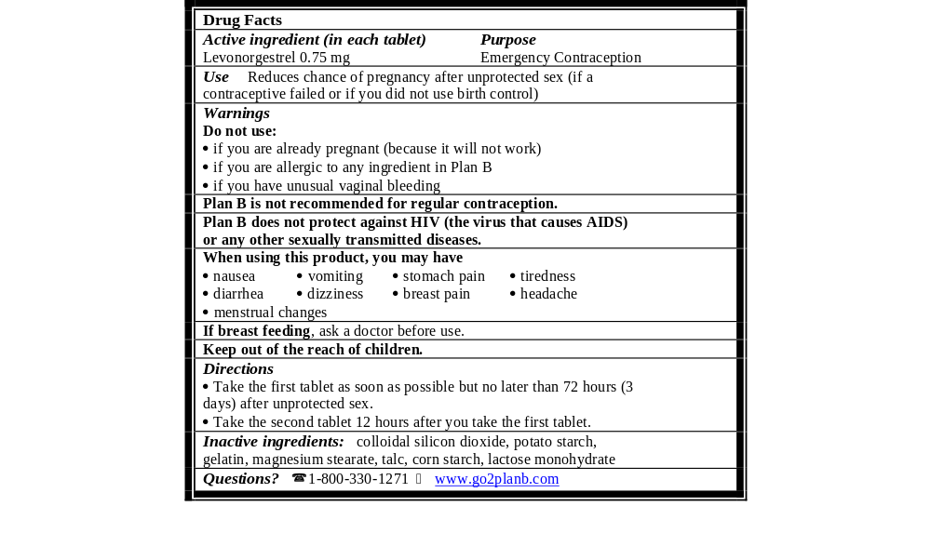
* Actual Size of the Label

4.3.2 Study Population
The sample size for the Actual Use Study was estimated to be 256 subjects who used Plan B. It was calculated to estimate the frequency of the two primary study outcomes (contraindicated use and incorrect use) with confidence intervals ± 5%. In these calculations, it was assumed that both true proportions were 15%. To account for multiple confidence interval estimations, the Bonferroni adjustment was applied, so that the 97.5% confidence limits were estimated rather than the traditional 95% limits. The Bonferroni adjustment was appropriate because of the lack of evidence for a correlation between the two behaviors of contraindicated use and incorrect use. This calculation was conservative because it was expected that the proportions of contraindicated and incorrect use would be lower than 15%. In that case, to achieve the same level of precision (± 5%), fewer subjects would have been required. To ensure diversity of the study population and allow for subgroup analyses, target enrollment was at least 450 subjects who each used Plan B at least one time.

The analysis populations in the Actual Use Study were defined as follows:
- Screened Cohort: Includes all subjects screened in the study, with no exclusions (665 women).
- Enrolled Cohort: Subset of the screened cohort, including only the subjects who received study product (585 women).
- Per-Protocol Cohort: Subset of the enrolled cohort, excluding subjects who were enrolled with violations of any of the study admission criteria listed in the protocol (576 women).
- Lost to Follow-up Cohort: Subset of the enrolled cohort, including all subjects for whom no follow-up information was provided (42 women).

Of the 665 women screened, 585 (88%) were enrolled in the study (i.e., left the study site with study product). Of the 80 women who were not enrolled, 69 were not offered or declined to sign the written informed consent, 3 did not want to be contacted during the study, 2 did not want to participate, 1 changed her mind about even wanting to receive Plan B, 2 thought that the study was too long a duration, for 1 the information was unknown and 2 others were deemed ineligible after they had already signed the informed consent form (e.g., both stated they were not sure they should receive emergency contraception). Of the 585 enrolled women, 576 (98%) were eligible to participate (Per-Protocol Cohort) and 9 were enrolled into the study without the site realizing they were ineligible (8 stated they were not sure they should receive emergency contraception, and 1 did not come into the clinic to receive emergency contraception) but have been retained in the enrolled cohort (they were excluded from the per-protocol cohort).

Among the 585 women in the enrolled cohort, 542 (93%) completed at least one follow-up contact, and one additional subject provided only her Data Card
(Appendix 8). The 42 subjects (7.4% of the Enrolled Cohort) who did not provide any follow-up information constituted the lost to follow-up cohort. A total of 513 (87.7% of the Enrolled Cohort) had at least two follow-up contacts. The median time to first contact was 8 days (mean = 11.6 days). In the case of the second contact, 93% of those occurred 28 days or longer after enrollment with median time of 30 days (the specified time for the one-month contact). In addition, a total of 336 study participants mailed in their Data Cards.

The 585 women enrolled in this study represent a broad spectrum of socio-demographic characteristics and were very similar to the expected OTC population (Table 15). The median age was 21 years with 5% aged 16 or younger. This compares with the estimated 6% of women of reproductive age (14-44) who are in the 14 to 16 year age bracket (VHS 1997, U.S. Census 2000, MMWR 2002). Racial/ethnic characteristics were as follows: 76% classified themselves as white, 10% as black or African-American, and 14% classified themselves as Hispanic. These numbers are representative of the racial/ethnic diversity of women of reproductive age in the U.S. population. Note these are not mutually exclusive racial/ethnic categories, the participants were given the opportunity to classify themselves into multiple racial/ethnic categories, e.g., a subject could call herself white, African American and/or Hispanic.

Of the women enrolled in the study, 13% had less than a high-school education. The majority of study participants (65%) reported incomes of less than $35,000 a year, consistent with the young age distribution. Barr expects that the population that eventually will purchase Plan B OTC will differ from the general U.S. population in that it will likely include fewer minority group women, low-income women, and young adolescents since these women may be less aware of emergency contraception as an option and may have less discretionary income with which to purchase Plan B. Barr expects family planning clinics to continue to be a major source of Plan B for women who need free subsidized services.
Table 15: Socio-Demographic Characteristics of Screened and Enrolled Cohorts in the Actual Use Study (% of each subset)
Demographic Breakdown | Screened Cohort  (n=665) | Enrolled Cohort  (n=585) | % U.S. Women  (Aged 14-44)*
Age (years)
14-16 | 4.8 | 5.0 | 9.2
17-25 | 75.9 | 74.4 | 26.8
26-30 | 12.8 | 14.0 | 15.5
31-35 | 4.1 | 4.1 | 16.2
36-44 | 2.4 | 2.6 | 32.2
Missing | 0 | 0 | --
Race
Asian | 6.5 | 6.3 | 4.3
American Indian/Alaskan Native | 1.8 | 1.7 | 1.0
Black or African American | 10.2 | 9.9 | 13.7
Native Hawaiian or other Pacific Islander | 1.7 | 1.7 | 0.2
White | 74.6 | 76.4 | 72.0
Missing | 8.0 | 6.7 | --
Marital Status
Single | 89.5 | 89.1 | --
Married | 5.6 | 5.6 | --
Divorced | 2.6 | 2.9 | --
Separated | 2.1 | 2.2 | --
Missing | 0.3 | 0.2 | --
Reported Highest Level of Education Completed
8th grade or less | 0.5 | 0.3 | --
9th to 11th grade | 13.8 | 13.0 | --
High school/GED | 14.0 | 13.2 | --
Technical school | 1.7 | 1.5 | --
Some college | 48.3 | 49.6 | --
Finished college | 15.9 | 16.2 | --
Graduate school | 5.7 | 6.2 | --
Missing | 0.2 | 0 | --
Household Income
0-15,000 | 38.0 | 39.5 | --
15,001-25,000 | 13.2 | 13.2 | --
25,001-35,000 | 12.3 | 12.5 | --
35,001-45,000 | 7.2 | 7.7 | --
>45,001 | 10.7 | 10.6 | --
Missing | 18.5 | 16.6 | --

* Data is from U.S. Census 2000.

The participant characteristics of the 585 subjects who were enrolled in the study (Enrolled Cohort) were almost identical to those of the screened cohort. The per-protocol cohort also had similar characteristics. Approximately 68% of the enrolled cohort had never been pregnant before their first screening and more than 80% had no living children. Forty percent had previously used emergency contraception; 13.8% had used it more than once. A total of 536 subjects (92% of the Enrolled Cohort) reported having used a contraceptive method in the month before admission into the study. Sixty percent indicated that they had had sex without contraception at least once in that month (including the act that prompted the subject’s use of emergency contraceptive pills). About 16% of the enrolled cohort reported irregular menstrual cycles. Where information was provided, the median cycle length was 28 days.

Only 16% of the subjects who received the study product spoke with the clinician or pharmacist at the study site after making their self-selection. Most of the questions asked could have been answered in an OTC setting by a pharmacist reading the
Plan B label and/or proposed patient brochure. The most common questions related to the safety of the product, including side effects and contraindications, instructions for use, whether or not to take it with food, or other questions about Plan B or other methods of contraception.

4.3.3 Analysis of Primary Outcome Variables of Plan B OTC Actual Use Study
4.3.3.1 Contraindicated Use

Contraindicated use was defined as having occurred if the subject took the pills contrary to any of the three warnings specified on the outer package label:

Warnings
Do not use:
- If you are already pregnant (because it will not work)
- If you are allergic to any ingredient in Plan B
- If you have unusual vaginal bleeding
When the product was provided using a simulated OTC approach, the incidence of contraindicated use was extremely low (1.3%, 7 out of 523 classifiable cases). One subject was considered to have been pregnant at the time of product use and 6 subjects had unexplained vaginal bleeding before use of Plan B. None of the women reported that she had recognized these situations prior to use of the product; therefore, none of the contraindicated uses was determined to be deliberate. Only one of the contraindicated uses (unexplained vaginal bleeding) occurred in a woman under the age of 17. She was also the only contraindicated user with less than a High School education. Three of the contraindicated uses (all unexplained vaginal bleeding) occurred in women who had used emergency contraception before. Of all six women who had unexplained vaginal bleeding before using Plan B, one reported vaginal bleeding as an adverse event after taking Plan B. Her vaginal bleeding ended two days after she took Plan B.

4.3.3.2 Incorrect Use

Incorrect use was defined as having occurred if the subject took the pills contrary to the following dosing schedule indicated on the inner and outer labels:

Directions
- Take the first tablet as soon as possible but no later than 72 hours (3 days) after unprotected sex.
- Take the second tablet 12 hours after you take the first tablet.

In the primary analysis of incorrect use, this schedule for correct use was interpreted strictly: that is, if the first tablet was taken more than 72 hours after the unprotected sex act, or if the second tablet was not taken exactly 12 hours after the first tablet, the use was considered incorrect. However, this definition may be unrealistically strict in that it allows NO variation at all in the interval between the two doses of medication, i.e., to be classified as having used the product correctly, the subject would have had to report that she took the second tablet exactly 12 hours after the first tablet, indicated by recorded tablet ingestion times that were exactly 12 hours apart.

A total of 98% percent of the subjects (499 of the 509 who provided usable information for the timing of both the sex act and the ingestion of the first pill) reported taking their first pill no more than 72 hours following the sex act, with a median time of 36 hours. A total of 506 patients provided information on the timing of the sex act, timing of ingestion of the first pill and timing of ingestion of the second pill. Of these, 366 patients (72%) took both pills within timeframes recommended by the label.

Further, in patients who recorded the timing of ingestion of both pills, 73.8% (398/540 with available data) of subjects recorded a time of exactly 12 hours, 85.9% (464 subjects) recorded a time of between 11.5 and 12.5 hours, and 94.2% (508 subjects) recorded a time between 10 and 14 hours following the first dose.

4.3.4 Analysis of Pregnancy During Plan B OTC Actual Use Study
Since the dose and regimen proposed for OTC use are identical to the R_{x} product, assessing the efficacy of Plan B was not a primary goal of the Actual Use Study; however, pregnancies were analyzed to determine the proportion of failures. Of the 540 subjects who were enrolled and were confirmed to have taken Plan B during the study, it was determined that 10 of them became pregnant after product use
(Figure 3). No information on the pregnancy status was available for an additional 14 subjects. Thus, the effective denominator of the number of subjects at risk for pregnancy was 526. The proportion of women who may have become pregnant after first use is 10 of 526 or 1.9% (95% confidence interval 0.92%, 3.47%). These figures may represent a conservative estimate of the failure rate of Plan B, as some of these women may have become pregnant from coital acts before or after the act that prompted use of the product.

All of the subjects who became pregnant took the first pill within 72 hours of having sex and the second 12 to 13 hours after the first. None of these 10 participants took the study product more than once. Of the ten pregnancies reported in this study, four ended in elective abortion while the outcomes of the other six are unknown. Only one subject called into the Pregnancy Registry. She reported an elective pregnancy termination.

Figure 3: Pregnancy Analysis in Actual Use Study

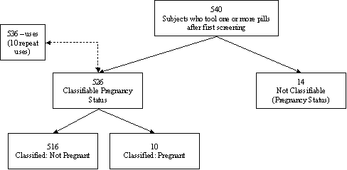

The proportion of subjects who became pregnant in the Actual Use Study (1.9%) is not substantially higher than the proportion in the levonorgestrel group of the WHO (#92908) pivotal clinical study (1.1%). However, a direct comparison (Table 16) of pregnancy rates in the two trials is complicated by differences in study designs and population behaviors:
- In the WHO #92908 study, pregnancy tests were performed if menses following product use were delayed, whereas in the Actual Use Study, no pregnancy tests were performed except by the subjects themselves at their own discretion.
- The WHO #92908 study enrolled women who had had only one unprotected sex act, and the women were advised to not have additional sex in the enrollment cycle after admission; whereas the Actual Use Study did not have this restriction.
- The WHO #92908 study excluded women who had recently used hormonal contraception, whereas about one quarter of the Actual Use Study subjects did so.

Table 16: Efficacy Results for Actual Use Study and NDA Pivotal Study
 | Actual Use Study  (WCC/FHI 2002) | WHO #92908  (WHO 1998b)
Number of women | 526 | 976
Number of pregnancies | 10 | 11
Pregnancy rate (%) | 1.9 | 1.1
Number of observed/expected pregnancies | -- | 11/76.3
Prevented fraction (%) | -- | 86

4.3.5 Additional Results of the Plan B OTC Actual Use Study

Of the 543 subjects who provided follow-up data after the first screening, all reported that they had had sex in the month before the first screening. Most (92% of the Enrolled Cohort) claimed to have use some method of contraception in that month (Table 17): condoms (79%), withdrawal (28%), oral contraceptive pills (22%) and/or spermicides (9%). Sixty percent (60%) claimed to have had at least one sex act in the month without contraception before enrollment.

A total of 336 (62%) of the 543 women who provided follow-up data indicated that they had had sex after receiving study drug, only 20% of whom reported to have a sex act without using any method of contraception. The methods most commonly used during the follow-up period were condoms (90%), oral contraceptive pills (21%), spermicide (11%) and withdrawal (10%).

Table 17: Contraceptive Methods Used Before and After Receiving Plan B
Subjects who: | Provided follow-up information | Indicated they had sex after receiving drug
 | N = 543 | N = 336/543 (62%)
Contraceptive Method(s) Used:
Condoms | 79% | 90%
Withdrawal | 28% | 10%
Oral Contraceptives | 22% | 21%
Spermicide | 9% | 11%

Analysis of the reported methods of contraception in the month prior to enrollment and between enrollment and the last follow-up contact for those who had sex in both intervals, slightly more (11%) of women started using a more effective method compared with 8% who stopped using a more effective method during at least some portion of these intervals. Ten percent (10%) initiated condom use after receiving the product, whereas only 5% used a condom at least once in the month before enrollment, but not in the follow-up period after enrollment. Younger subjects and those with less than high school education were more likely to switch from a less to a more effective method after screening.

Only 6% of subjects consulted with a healthcare professional at a later date. The most common reason for consulting a healthcare provider was simply to inform him or her about product use. Other reasons included medical problems or side effects, ongoing contraception, a positive pregnancy test, questions about Plan B, repeat need for emergency contraception or for a routine appointment.

Eight subjects used the product twice, and two used it three times during the course of the study. The reason for each repeat use was consistent with the indications for use described on the product label.

4.3.6 Prior vs. Naïve Users

The relatively large number of prior users in the Actual Use Study allowed useful comparisons between prior users of emergency contraception and naive/never users. The analyses showed that women who had been counseled and screened by a medical practitioner in the past and those who presented for emergency contraception without the benefit of such counseling (naïve users) did not differ significantly with respect to contraindicated or incorrect use (Table 18), use of regular contraception, or most other variables.

Table 18: Contraindicated and Incorrect Use Among Prior and Naïve Users of Emergency Contraception
 | Prior User | Naïve Users | Total*
Total Uses | N=213 | N=327 | N=540
Contraindicated Use | 1.4% | 1.2% | 1.3%
Incorrect Use | 29.6% | 23.5% | 25.9%
Deliberate | 1.9% | 0.9% | 1.3%
Unintentional | 27.7% | 22.6% | 24.6%
Correct Use | 66.7% | 68.5% | 67.8%
Following Instructions
1st pill < 72 hrs. after sex | 95.3% | 90.5% | 92.4%
2nd pill exactly 12 hrs after the 1st | 68.5% | 73.7% | 71.7%

* Denominator includes subjects both with and without data available

4.3.7 Safety Results for the Plan B OTC Actual Use Study: Adverse Events

Adverse events among subjects in the enrolled cohort were tabulated (Table 19). Adverse events include all medical problems reported at subject contacts or on Study Data Cards (see Appendix 8) after use of the study product. For events reported at subject contacts, information on various characteristics of the event was collected: including: severity (mild, moderate or severe), seriousness (not serious or serious), relationship to study drug (yes or no), specific complaint (COSTART preferred term) and body system class. Study Data Cards (Appendix 8) did not collect this information. Frequencies of adverse events were also calculated for subgroups of subjects who used the study product in a contraindicated or incorrect fashion.

Of the 540 subjects who used the current regimen of levonorgestrel 0.75 mg in the Actual Use Study, 46% (246 subjects) reported at least one adverse event at either follow-up contact or on the Study Data Card (Appendix 8). As seen in Table 19 abdominal pain was reported by 14.3% (77 subjects), nausea and/or vomiting by 13.7% (74 subjects), headache by 11.3% (61 subjects), and asthenia by 8.0% of women (43 subjects).

Subjects with contraindicated or incorrect use did not notably differ from the enrolled cohort in frequency or nature of reported adverse events. Three of the women whose use of the product was contraindicated did not report any adverse events. For women who took the product incorrectly, by the primary definition, 44% experienced an adverse event, compared to 46% of the total enrolled cohort. Only four types of adverse events were reported by more than 5% of those subjects with incorrect use of Plan B: abdominal pain (12.7%), asthenia (8.5%), headache (9.2%) and nausea and/or vomiting (12.0%).

Table 19: Percent of Subjects Reporting Adverse Events in Actual Use Study (≥ 5% reported for at least one subset)
Adverse Events | Total*  (n=246) | Subjects With Contraindicated Use  (n=7) | Subjects With Incorrect Use  (n=142)
Abdominal pain | 14.3 | 14.3 | 12.7
Acne | 0.6 | 14.3 | 0.7
Asthenia | 8.0 | 0 | 8.5
Breast pain | 2.8 | 14.3 | 4.2
Headache | 11.3 | 28.6 | 9.2
Nausea and/or vomiting | 13.7 | 14.3 | 12.0
Menstrual disorder | 6.6§ | 0 | 0.7
Pharyngitis | 2.6 | 14.3 | 2.1
Any adverse event | 45.6 | 57.1 | 43.7

* Reported at follow-up contact or on Study Data Card.
** Reported at follow-up contact. Only events reported at follow-up contact were classified as being related to the product, or not.
§ Menstrual disorder includes: lighter menstrual bleeding, menorrhagia, menstrual disorder and metrorrhagia.

At subject contact, product users reported a total of 412 adverse events. Of these, 352 (85%) were considered to be mild, and the rest were moderate. None met the FDA definition of a serious adverse event (see 21 C.F.R. §314.80(a)). One third (135 of 412 adverse events) were treated with concomitant medication, either prescription or OTC. Only 8 subjects stated that their adverse events (hematuria, urinary incontinence, urinary urgency, headache, abdominal pain, and vomiting) could or might stop them from using the product in the future.

Of the 540 subjects who used the study product, 513 (95%) had a menstrual period before the end of their study participation. The first menstrual period of those who had periods started a median of seven days after ingestion of the product (range 0–49 days). This pattern was not substantially different in the subset of 22 subjects who were age 16 or younger.

4.3.8 Actual Use Study: Conclusion

The Plan B OTC Actual Use Study was designed to provide information on whether women seeking emergency contraception could self-select and use the product appropriately and safely when it is labeled for OTC distribution. The sample consisted of subjects of all races between the ages of 14 and 44 years who would be likely to use Plan B in the OTC setting. Subjects were asked to review the proposed Plan B package and decide whether or not to receive the product, with no unsolicited screening or counseling by a healthcare professional prior to using Plan B.

Results in the Actual Use Study were consistent across all subgroups examined. Potentially vulnerable groups such as less educated women and minors were not substantially more likely to use the product in an incorrect or contraindicated manner. In fact, incorrect use was lower among subjects aged 16 years and younger than those aged 17 years and older. These vulnerable groups also did not have higher risks of pregnancy in this study.

When the findings of this study are compared to those of the pivotal clinical trial for Plan B conducted by WHO (#92908), results are remarkably similar. The distribution of reported intervals between doses was almost identical (Table 20). In addition, the proportion of subjects who became pregnant was similar.

Table 20: Interval Between Pill Doses in Actual Use Study and NDA Pivotal Clinical Trial
 | Actual Use Study  (WCC/FHI 2002) | WHO #92908  (Levonorgestrel group)*
 | n=523 | n=974
Interval between doses:
Less than 12 hours | 52 (10%) | 88 (9%)
Exactly 12 hours | 387 (74%) | 720 (74%)
More than 12 through 16 hours | 63 (12%) | 127 (13%)
More than 16 hours | 21 (4%) | 49 (5%)

*Source: FHI reanalysis of data submitted in approved NDA 21-045 for Plan B (levonorgestrel) for emergency contraception. Numbers do not add to 100% due to rounding.

Women were allowed to enroll in the study as many times as they presented to the clinic or pharmacy, although repeat use of the study product was rare. Eight subjects used the study product twice over the course of the study and two received it three times. Considering that 7.5% of sexually active U.S. women at risk of pregnancy who do not desire to become pregnant use no contraception (Trussell 1998d), the repeated need for the product in this study by 10 of 585 women (1.7%) does not suggest any patterns of abuse. Although 40% of the Enrolled Population reported prior use of emergency contraception, only 8% reported use within the last three months and only 2% reported use within the last month.

It would appear, therefore, that the results in the Actual Use Study not only demonstrated that the subjects could adequately follow the stated directions for use of Plan B as an emergency contraceptive but also that they followed a pattern of use in a simulated OTC setting that mirrored the pattern of use observed in the original NDA controlled study. The value of the Actual Use Study is that it was conducted in a population representative of women in the United States who would be among the most identifiable target for access to Plan B as an OTC emergency contraceptive.

5 benefit/risk overview of plan b as an otc emergency contraceptive

5.1 Overview

Levonorgestrel has a more than 30-year history of use in contraception, and its safety profile has been well characterized in the clinical literature. The levonorgestrel regimen for emergency contraception is currently approved in 101 countries. In 33 of these countries it is currently sold without a prescription, by pharmacists, or over the counter. A Gedeon Richter, Ltd. 0.75 mg levonorgestrel tablet, manufactured since 1980 with only minor formulation changes, is currently marketed in 70 countries. Clinical trials, medical literature, and post-marketing surveillance by pharmacovigilance agencies have provided a well-characterized safety profile. A substantial body of evidence indicates that the safety profile of Plan B for use as emergency contraception appears to pose no untoward safety concerns. Experience with the prescription product since 1999 in the United States has demonstrated a high level of safety. An evaluation of international post-marketing adverse events also shows that “real-life” usage of emergency contraception does not pose safety concerns.

5.2 Risk Assessment of Plan B

The following have been identified by the sponsor as the major sources of risk potentially associated with the use of OTC Plan B for emergency contraception:

- The first tablet is not taken within 72 hours of unprotected sex. The result would be a reduced probability of effectiveness. The recommended dosing regimen is to take the first tablet within 72 hours after the sexual encounter to maximize efficacy. However, easier access to emergency contraception would be expected to optimize the ability to take the pills as soon as possible after unprotected intercourse
- The second tablet is taken simultaneously with the first, or is taken at some point after the first tablet is taken but less than 12 hours after. Evidence from clinical trials suggests that although such use is not approved and is not supported by the data, in the New Drug Application, taking the second tablet simultaneously with the first or in advance of 12 hours would not adversely affect the efficacy of the product. (WHO 2002).
- The second tablet is not taken at all, or is taken at some point beyond 12 hours after the first tablet. The result could be a reduced probability of effectiveness. Evidence from clinical trials does not show any safety risk to the patient if the second tablet is not taken at all, or is taken more than 12 hours after the first. Indeed, substantial efficacy was still obtained in earlier trials involving the use of a single 0.75 mg levonorgestrel tablet (WHO 1987, He 1991, WHO 2000a).
- The patient could suffer some labeled adverse event such as nausea, stomach pain, headache, and dizziness or breast tenderness. However, these adverse events are safer than a potential unintended pregnancy or abortion.
- Plan B is contraindicated in patients who are pregnant, are having unexplained vaginal bleeding, or are allergic to levonorgestrel or any other ingredients in
Plan B. However, each of these contraindications should be easy for the consumer to self-identify. In addition, there is no evidence that Plan B would harm a pregnant woman or a developing fetus if the product is taken accidentally during early pregnancy (Grimes 2001, Bracken 1990). Regarding unexplained vaginal bleeding, there are no known conditions that cause vaginal bleeding that will be worsened in the short term by the use of combined oral contraceptives, so there should be even less concern with a progestin-only method (WHO 2000b).
- Plan B could be used on a regular basis in place of a method of contraception indicated for regular use. Plan B is intended only as an emergency contraceptive. It is not intended for regular use. However, the safety of repeat or frequent use of 0.75 mg levonorgestrel tablets has been investigated in several studies. These studies have shown that repeated use, even in a single menstrual cycle, is not associated with serious or lasting side effects (WHO 2000a, He 1991, Bhattacharjee 1987).
- Plan B could be used “too” frequently. What constitutes “too” frequently is subjective. The indication for Plan B implicitly includes repeated use if unprotected sex is repeated. If unprotected sex occurs frequently, however, the appropriate course is adoption of a method of contraception indicated for regular use, not adoption of Plan B for regular use.
- Consumers may believe that Plan B can protect against HIV or other Sexually Transmitted Infections “STIs”, and as a result may abandon the use of condoms or use them less regularly. The data for the Plan B Label Comprehension Study, however, show that very high percentages of consumers, from all demographic groups, who have read a Plan B OTC prototype label understand that it does not protect against transmission of HIV/AIDS or other STIs.

- The OTC availability of, and education around, Plan B as an emergency contraceptive could lead to increased risky behavior (i.e., unprotected sex) by consumers who believe that Plan B can protect them from unwanted pregnancy without having to use a regular contraceptive. However, a large, randomized, controlled trial in Great Britain demonstrated that education about emergency contraception did not increase sexual activity among young people (Graham 2002). In addition, many studies provide evidence that advanced provision of emergency contraception does not increase the incidence of unprotected sex (Raine 2000, Belzer 2003, Jackson 2003). Finally, the Plan B Actual Use Study actually showed a decrease in the proportion of the Enrolled Population who had at least one sex act without contraception, from 60% in the month before the first screening to just 20% after the first screening (WCC/FHI 2002).

5.3 Benefits of OTC Plan B

The following have been identified by the sponsor as the major potential benefits associated with the use of OTC Plan B for emergency contraception:

- There are 3 million unintended pregnancies in the U.S. each year, with about half ending in abortion. Awareness and access to Plan B should greatly decrease the numbers of unintended pregnancies, and subsequent abortions.
- Plan B is effective in reducing the incidence of unwanted pregnancy after a single act of unprotected mid-cycle coitus from 8% to 1%, a reduction of 89%.
- Plan B needs to be used within 72 hours of unprotected sex. In addition, a combined analysis of the Yuzpe and Plan B regimens found that each 12 hours of delay reduced efficacy by about 50% (p=0.02) (Piaggio 1999). OTC access will allow women to acquire Plan B most expeditiously.
- Plan B is associated with a limited number of side effects, all of which are self-limited and not life threatening when compared to the risks associated with pregnancy or surgical abortion.
- Plan B does not adversely impact a pregnancy once the process of implantation has begun.
- If Plan B is ineffective, the long-term outcome is no different than if it had not been used at all.
- Based on the data presented in the sNDA, women were able to self diagnose, administer the product properly, and seek follow-up when needed.
- Easier access to emergency contraception would be expected to optimize the ability to take the pills as soon as possible after unprotected intercourse. With OTC access, women will not have to first contact a healthcare provider for a prescription.
- OTC availability, along with increased awareness, will most effectively reduce the number of unintended pregnancies and abortions—important public health goals.
- Women will not have to discuss what may be an embarrassing situation with a third party.
- More than 50% of U.S. women presenting for elective abortion were using a method of contraception in the month they became pregnant, and only 1.3% reported using EC (Jones 2002b).
- Trussell et al. (1992b) estimate that wider use of EC could in theory reduce the number of unintended pregnancies and could reduce the overall number of abortions.

5.4 Discussion and Conclusions – Risks vs. Benefits

Removing the prescription requirement for Plan B coupled with increasing awareness of emergency contraception will help ensure that Plan B plays a larger role in the reduction of unintended pregnancy and interruption of pregnancy — important public health goals. OTC sale of Plan B presents no serious safety issues. Efficacy of the product is likely to be the same, or better given more timely access to the product. Based on the results of the OTC studies conducted by the sponsor, a growing body of literature, and foreign marketing experience, the risk of unintended health consequences also appears to be minimal. There is no evidence to suggest that American women will abuse Plan B as an OTC product.

In the sponsor’s OTC studies, women were able to understand the proposed labeling regardless of age, race, ethnicity, educational attainment or medical literacy. Contraindicated use and repeat use were both low. No negative impact was observed on regular contraceptive use. Other supporting studies in which women self-diagnosed their need for emergency contraception and used it without medical oversight -- often many months after receiving counseling -- provide further evidence that Plan B can be used safely, effectively and appropriately without medical supervision. The results also suggest that most women do not abandon regular contraception or engage in more risky sexual behavior if emergency contraception is readily at hand. The UCSF results (UCSF 2003b) could suggest that in particularly vulnerable populations prone to risky sexual behavior, easy cost-free access to emergency contraception may marginally increase some types of risk-taking. It cannot be assumed that OTC sale of Plan B in retail pharmacies would have a similar impact, however, since users would be required to pay for the product and Plan B would be at least as expensive (i.e., the proposed single-use package) as routine forms of birth control. Pragmatically, condoms and even oral contraceptives are a cheaper alternative. The small increases in unprotected sex and consistent condom use observed in the UCSF Emergency Contraception study (2003b), were not observed in the Glasier et al. (1998c), Raine et al. (2000), or Belzer et al. (2003) studies. All of the studies confirm that easier access to the method increases the likelihood of use following unprotected sex.

Plan B is in every respect an appropriate candidate for OTC sale. It meets or exceeds the safety and efficacy standards required of other OTC pharmaceutical products:

- The drug product is very safe. There are no reports of deaths and few reports of serious adverse events in over 20 years of use for regular postcoital contraception and emergency contraception.
- There is no evidence that Plan B would harm a pregnant woman or would harm a developing fetus if the product is accidentally taken during early pregnancy.
- Side effects of Plan B are well-characterized, generally mild or moderate and self-resolving. Side effects rarely require medical intervention.
- Plan B has few contraindications, all of which should be easy for the consumer to identify. Contraindicated use is unlikely to raise any safety problems.
- Use by adolescents, including young adolescents raises no safety concerns.
- Plan B is not addictive.
- Overdosing is unlikely, since Plan B is packaged as a single course of treatment.
- Instructions for use of Plan B are simple, and all users follow exactly the same regimen.
- Incorrect use would not present any safety problems.
- To date, there is no evidence that occasional use of Plan B increases the risk of ectopic pregnancy, even though chronic use of progestin-only contraceptives does appear to increase the risk. There is no reason to expect chronic use of Plan B.
- No medical screening is required to use Plan B as the indication for use and the contraindications are easily recognized by a woman herself, without the need for a provider.
- Medical screening by a healthcare provider does not typically identify women more likely to experience side effects, and does not prevent any side effects from occurring. It does not increase the safety of the regimen.

6 plan b: Convenient Access, Responsible Education Program

6.1 Introduction
Barr has carefully constructed the CARESM (Convenient Access, Responsible Education) Program to help ensure that Plan B will be used responsibly and appropriately as outlined in the proposed OTC labeling. Although Plan B is under consideration as an OTC product (meaning that it can be used safely and effectively without professional intervention), the sales and marketing plan has been designed to limit the availability of Plan B, to the extent practical, to pharmacies and clinics, and to educate healthcare professionals and consumers regarding the availability and responsible use of Plan B. The need to take Plan B in as timely a manner as possible dictates that any responsible marketing program not only address healthcare professionals but also include extensive consumer education and direct access components. Thus, the CARESM program contains elements that include an appropriate consumer education component. In addition, the sponsor will work closely with chain pharmacies to ensure that they will carry Plan B and provide access to it in a responsible manner. Data suggests that there are several critical issues currently limiting access to Plan B:

- The prescription requirement delays timely access to Plan B;
- Pharmacies may not routinely stock Plan B;
- Awareness of the availability of Plan B is lacking among healthcare professionals as well as women of childbearing age, and
- Access to accurate sources of information about the product is limited.

The CARESM program is intended to address these issues by providing sources of accurate and responsible information to both healthcare providers and consumers. It is also designed to provide a framework for pharmacies to ensure availability of Plan B when sought by knowledgeable consumers.

Four core elements of CARESM contribute to the achievement of program objectives.
- Labeling/Packaging/Informational toll free number (to provide essential information to consumers in an accessible, easily-understood format),
- Education (to provide information intended to educate physicians, pharmacists and nurse practitioners and to provide healthcare practitioners with educational materials that they can supply to their patients to stimulate discussion.),
- Distribution (to ensure, to the extent practical, that Plan B will be available only in retail operations with pharmacy services and clinics and in a manner which allows easy access by the consumer to a pharmacist or other healthcare professional should questions arise), and
- Monitoring (to evaluate the effectiveness of the program and make adjustments as appropriate)

6.2 CARESM Program Objectives

The CARESM program is designed to promote appropriate and responsible use of Plan B by achieving the following objectives:
- To ensure that consumers and healthcare professionals understand what emergency contraception is and when it can and should be used safely and effectively.
- To ensure that consumers and healthcare professionals understand how to obtain Plan B in a timely manner.
- To clearly communicate that Plan B is for use only as an emergency contraceptive, and that it should not to be used as a routine form of contraception.
- To encourage the responsible use of Plan B and to encourage ongoing dialogue between healthcare professionals and consumers regarding responsible behaviors relating to contraception.
- To provide consumers with information needed to decide whether their use of Plan B would be appropriate.
- To provide additional resources to assist populations with special needs, such as low literacy populations, to make this decision correctly.
- To provide healthcare professionals with the information they need to guide their patients in purchasing and using the product, and encourage dialogue when appropriate.
- To provide retailers with the necessary information for both pharmacists and consumers, product packaging and labeling to merchandise Plan B at point of purchase to facilitate the provision of information without impeding access.

6.3 Labeling/Packaging

The Plan B labeling is being developed to provide clear and comprehensive communication of the key messages outlined above, and to make known additional sources of information. Plan B is packaged as a single course of therapy (two tablets) and will be priced in a manner that reinforces appropriate usage as an emergency contraceptive. Plan B packaging is being designed to improve readability, ease of use and compliance. Packaging will include information designed for the consumer, including those with low-literacy, on the need to use routine forms of birth control. Materials will also continue to inform women clearly about the lack of effectiveness against STI/HIV.

6.3.1 Core messages

The Plan B labeling has been designed and tested to ensure that it communicates the basic messages related to appropriateness and responsible use, outlined in the objectives above:

- Plan B is to be used only by women of childbearing potential
- Plan B is intended only for emergency contraception
- Plan B does not substitute for a regular form of contraception
- Plan B does not protect against sexually transmitted diseases
- Plan B must be started as soon as possible within 72 hours of unprotected sexual intercourse
- Following the directions for use enhances Plan B’s effectiveness
- Plan B will not be effective if you are already pregnant
6.3.2 Labeling refinements

Based on the results of the Label Comprehension Study, the sponsor has proposed several refinements to enhance communication of these key messages in the most recent version of the OTC labeling (Appendix 5). In addition, the sponsor will add the following features to the labeling and packaging as part of the CARESM program:

- A larger outer package will be developed. Except for size, this package will be identical to the OTC package proposed in the sNDA (Appendix 5). This change will allow an increase in the font size throughout the labeling to improve readability and make the information more inviting.
- A card will be included in the package to allow women to record the time of the initial dose and the projected time of the second dose. Doing so will encourage appropriate dosing, with the second tablet to be taken 12 hours after the first.
- The labeling will direct users to a 24 hour toll free number staffed by a healthcare professional if they have any questions or concerns.
- The labeling will direct users to a website for additional information.
- Information will be provided reminding women that Plan B is not a routine form of birth control.
- Clarifying information will be included in a patient leaflet insert, which will also provide information about contraceptive choices and STI’s. The user will be encouraged to consult her healthcare professional for assistance in choosing a routine contraceptive method.

6.3.3 Additional sources of information

Information will be available at any time during the purchase and product use cycle. A toll-free number, staffed by healthcare professionals 24 hours a day will be available. The Plan B website will also provide information to more information while maintaining consumer privacy. The phone number and website address will be clearly identified on both the outside of the package and the interior labeling.

6.4 Education

Given the very low levels of awareness of the availability of emergency contraception, the CARESM Program provides for an intensively educational approach to the introduction of Plan B as an OTC product. Barr is proposing an educational program that will initially focus on healthcare professionals. The program will assist healthcare providers in developing an adequate knowledge base so that they can provide responsible and accurate counseling to patients.

Efforts directed to raising consumer awareness of the product and its appropriate use will follow appropriate professional education programs. The educational materials will address not only Plan B but will encourage healthcare professionals to urge users to adopt routine forms of contraception and avoid reliance on Plan B as their primary form of birth control.

6.4.1 Educational Program to Healthcare Professionals.

Plan B will be introduced and explained to healthcare professionals to raise awareness and knowledge levels as to emergency contraception. Given the current lack of understanding of emergency contraception, this program is intended to ensure that healthcare professionals are prepared to support their patient populations.
- Physicians, physician assistants, nurse practitioners, and their staffs, and pharmacists are the primary audiences for this educational program. Pharmacists are especially important because they will need to be prepared to answer questions at the point of purchase. Programs will include continuing education by certified professionals and educational materials (including websites and toll free numbers) that can be accessed easily and at anytime. The sponsor will make available to the state boards of pharmacy continuing education programs for use at annual meetings and other regional programs. The sponsor will also encourage state boards of pharmacy to provide information to their members regarding the availability and appropriate use of Plan B.
- The sponsor’s sales force for female healthcare products consisting of approximately 250 sales representatives will visit the offices of approximately 30,000 physicians, mostly Ob/Gyn’s. The sales representatives will provide materials targeted for consumers. Physicians, physician assistants and nurse practitioners will be asked to distribute the materials to patients. Materials will encourage patients to discuss any questions they have about emergency contraception or the specific use of Plan B with their physician or the nurse practitioner. Efforts to reach healthcare professionals to reinforce these messages will continue indefinitely as part of the sponsor’s ongoing professional communications program. The sponsor also will work with the relevant healthcare professional associations to provide programming and materials to reach those healthcare providers who will not be reached personally.
- All materials for consumers and healthcare providers will be tested through research and field testing to ensure communication objectives are met.
6.4.2 Educational Campaign to Consumers

An information campaign to consumers will commence once the healthcare professional audience has been introduced to the product. This consumer education campaign is anticipated to begin about six months following product launch.
- The campaign will be designed to convey critical awareness and educational messages as well as information about product availability. The intent will be to make consumers aware of the availability of emergency contraception and its appropriate use.

- The campaign will be designed to appeal to women age 17 to 44.
  - The language and visuals used will be appropriate and of interest to this age group. New promotional materials will be provided for comment to FDA during the development process and will be tested to ensure appropriate communication according to current practices.

  - Media placements that appeal to teen/adolescent audiences will not be used.

6.4.3 Media Coverage

The sponsor is anticipating the potential for media coverage of the December advisory panel meeting and the FDA’s subsequent decision on the sNDA. The sponsor will develop comprehensive media briefing materials that emphasize the appropriate and responsible use of emergency contraception. Company spokespersons will be media trained to ensure strong and consistent communication of the appropriate messages, consistent with the commitments above related to the tone and approach to be taken with consumers.

6.5 Distribution

The sponsor believes that in the interest of responsible usage (and in recognition of the circumstances of the need for emergency contraception), Plan B should be available in those retail outlets that typically sell a broad range of OTC medications and that have pharmacy services staffed with pharmacists (or, in the case of clinics, other healthcare professionals) during normal business hours to answer questions.

- The sponsor will sell Plan B directly to drug wholesalers, clinics, or retail chains and stores with valid pharmacy or drug wholesaler licenses. The sponsor will recommend, but cannot legally require, that Plan B be sold only in retail pharmacies, or other stores with a pharmacy on-site, such as food super stores and mass merchandisers. The sponsor will also recommend that Plan B is put on shelves near the pharmacy or within the line of sight of the pharmacist. Upon request, the sponsor will also make available for retail use. Product information to be placed in merchandising display units.
- The sponsor will recommend to all customers who purchase the product directly from the sponsor that they limit secondary distribution to consumers in clinics and retail outlets that have a pharmacy
- Plan B will continue to be made available to clinics (Planned Parenthood and government clinics). Doing so will enable the clinic population to obtain the product in an environment that provides easy access to professional contact and counseling.

6.6 Monitoring

The sponsor intends to monitor trends in the use of emergency contraception to evaluate the effectiveness of the CARESM program, will make adjustments as appropriate. Monitoring will be accomplished in several ways, with information gathered from both healthcare professionals and consumers.

Monitoring actual use of Plan B is complex due to the difficulties inherent in identifying women who have purchased the product and in gathering useful, generalizable information. Consequently, the monitoring component will rely on a variety of sources intended to provide trend data, observational data, and signals of program effectiveness and potential problems. Monitoring components will include the following:

1. A survey or surveys of a subset of healthcare professionals (e.g. OB/GYN, family practice, pharmacists, nurses, family planning and health clinic personnel) annually to determine:

    - Attitudes toward and experience with patients’ usage of Plan B
    - Trends among emergency contraception users within their patient population (especially source of awareness, repeat use, use instead of more effective forms of contraception, acquisition of STIs, etc.)
    - Nature of interactions with Plan B users (Does the contact with the healthcare professional occur prior to product usage? after usage? Are the women in search of contraceptive counseling? What types of side effects are being seen in use?)
    - Areas where additional information is needed in the marketplace, as identified by the questions raised by the users

2. Through collaboration with established professional groups and pharmacy boards, other audiences may be surveyed to gather information that could help evaluate the CARESM program and provide signals of problems associated with patients’ understanding of the purpose and proper use of Plan B:

- College student health clinics
- Sex education teachers and counselors
- Reproductive health professionals

The information derived from these audiences is anticipated to be based on a small number of reliable contacts and therefore will need to be interpreted with care.

- Using relevant survey data regularly collected by others (e.g. CDC BRFSS, YRBSS, NGO surveys) the sponsor will monitor for potential indicators that Plan B is being used in an inappropriate manner. Where existing surveys do not include relevant data, the sponsor will seek inclusion of appropriate questions. Potential areas of analysis include evaluating possible correlations between:

  - increases in STIs in areas with high Plan B sales;
  - increases in pregnancy and/or abortion rates in areas with high Plan B sales
  - The sponsor recognizes that the use of these sources may not give timely enough data to evaluate the CARESM program in the short term. However, the commitment to monitoring extends beyond the initial stages of product introduction, and working with data sources to enhance collection of data relevant to use of Plan B will be ongoing.

4. Gathering data from actual users of Plan B is difficult because the number of users will be relatively small and because the decision to use emergency contraception is a private and emotional one. Women choosing to use the product are expected to wish to remain anonymous and are entitled to maintain their privacy. Nevertheless, the sponsor will work with a variety of sources in an effort to obtain and analyze consumer data to assess the effectiveness of the CARESM program elements. The primary focus of this component will be:

- Foundations and Nongovernmental Organizations (NGOs) that conduct surveys on reproductive health issues. It is hoped that these studies can provide a sufficient base of Plan B users to determine and evaluate what impact, if any, the OTC availability of Plan B has on trends in the data (i.e. pregnancy rate, Plan B usage, abortion rate, acquisition of STIs, etc.)

The sponsor will work with the FDA to establish reporting formats and schedules in order to ensure that data and information on program effectiveness and changes are available on a timely basis.

6.7 Summary and Conclusions

The sponsor recognizes that in order for Plan B to make a contribution to the public health through OTC status, it is essential that the product be marketed responsibly and used appropriately. The sponsor has designed the CARESM Program to help achieve these objectives. Through CARE’s combination of education, distribution and marketing features, Plan B will be substantially more accessible to those women for whom its use is indicated, while monitoring will help the sponsor and the FDA assess the impact of the program and take steps to improve it where appropriate. The packaging and labeling, together with strong relationships with healthcare professionals, professional organizations and the FDA, will provide further reinforcement for the safe and effective use of Plan B. The avoidance of inappropriate messages and media placements will help ensure appropriate and consistent information. Consumer information about product use and the importance of contraceptive choices will help preclude the need for Plan B. The CARESM program is a unique approach to OTC marketing and the sponsor looks forward to working with the FDA to finalize key components and establish reporting guidelines.

7 References

- Arowojolu AO, Okewole IA, Adekunle AO. Comparative evaluation of the effectiveness and safety of two regimens of levonorgestrel for emergency contraception in Nigerians. Contraception. 2002;66:269-273.

- Belzer M, Yoshida E, Tejirian T, Tucker D, Chung K, Sanchez K. Advanced supply of emergency contraception for adolescent mothers increased utilization without reducing condom or primary contraception use. Research Presentations. J of Adolesc Health. 2003;32:122-123.

- CRLP. Center for Reproductive Law and Policy. Citizen's Petition. Submitted to the FDA on February 14, 2001. http://www.crlp.org/pdf/EC_petition.pdf Accessed on November 12, 2003.

- Croxatto H. Progress report to CONRAD Collaborative Center for Clinical Research. Report CIG-00-62. September 2002b.

- Croxatto HB, Fuentealba B, Brache V, et al. Effects of the Yuzpe regimen, given during the follicular phase, on ovarian function. Contraception. 2002c;65:121-128.

- Croxatto HB. Emergency contraception pills: how do they work? IPPF Medical Bulletin 2002d;36:1-2.

- Ellertson C, Ambardekar S, Hedley A, Coyaji K, Trussell J, Blanchard K. Emergency contraception: randomized comparison of advance provision and information only. Obstet Gynecol. 2001a;98:570-575.

- Glasier A, Baird D. The effects of self-administering emergency contraception. New Engl J Med. 1998c;339:1-4.

- Glasier A. Emergency postcoital contraception. New Engl J Med. 1997;337: 1058-1064.

- Grimes DA, Raymond EG, Scott Jones B. Emergency contraception over-the-counter: the medical and legal imperatives. Obstet Gynecol. 2001;98:151-155.

- Ho PC, Kwan MS. A prospective randomized comparison of levonorgestrel with the Yuzpe regimen in post-coital contraception. Hum Reprod. 1993;8:389-392.

- Jones RK, Darroch JE, Henshaw SE. Contraceptive use among U.S. women having abortions in 2000-2001. Perspec Sexual Reprod Health. 2002b;34:294-303.

- Kahlenborn C, Stanford JB, Larimore WL. Postfertilization effect of hormonal emergency contraception. Ann Pharmacother. 2002;36:465-70.

- Kaiser Family Foundation. A national survey of women about their sexual health. Self Magazine. Summer 2003a.

- Kaiser Family Foundation. National survey of women’s health care providers on reproductive health: emergency contraception. June 2003b.

- Kaiser Family Foundation. Lifetime Television, Vital Signs Inde No. 2: Emergency contraception (selected findings). November 2000.

- Kook K, Gabelnick H, Duncan G. Pharmacokinetics of levonorgestrel 0.75 mg tablets. Contraception. 2002;66:73-76.

- McCann MF, Potter LS. Progestin-only oral contraception: a comprehensive review. Ectopic pregnancies. Contraception. 1994;50(Suppl 1):S44-49.

- MMWR. Youth Risk Behavior Surveillance – United States, 2001. MMWR Morbid Mortal Wkly Rep. June 28, 2002; 51(SS04);1-64.

- Müller AL, Llados CM, Croxatto HB. Postcoital treatment with levonorgestrel does not disrupt postfertilization events in the rat. Contraception. 2003;67:415-419.

- ní Riain A. Increasing the effectiveness of contraceptive usage in university students. Eur J Contracept Reprod Health Care. 1998;3:124-128.

- Peterson LS. Contraceptive use in the United States: 1982-90. Vital and Health Statistics of the Centers for Disease Control and Prevention. Advance Data. 1995;260:1-15.

- Piaggio G, von Hertzen H, Grimes DA, Van Look PF. Timing of emergency contraception with levonorgestrel or the Yuzpe regimen [letter]. Lancet. 1999; 353:721.

- Raine T, Harper C, Leon K, Darney P. Emergency Contraception: Advance provision in a young, high-risk clinic population. Obstet Gynecol. 2000;96:1-7.

- Raymond EG, Dalebout SM, Camp SI. Comprehension of a prototype over-the-counter label for an emergency contraceptive pill product. Obstet Gynecol. 2002a; 100:342-349.

- Roye CF, Johnsen JRM. Adolescent and emergency contraception. J Pediatr Health Care. 2002;16:3-9.

- Roye CF. Routine provision of emergency contraception to teens and subsequent condom use: a preliminary study [letter]. J Pediatr Health Care. 2001;28:165-166.

- Sucato GS, Gardner JS, Koepsell TD. Adolescents’ use of emergency contraception provided by Washington state pharmacists. J Pediatr Adolesc Gynecol. 2001;14:163-169.

- Trussell J, Stewart F, Guest F, Hatcher RA. Emergency contraceptive pills: a simple proposal to reduce unintended pregnancies. Fam Plann Perspect. 1992b; 24:269-273.

- Trussell J, Ellertson C, Dorflinger L. Effectiveness of the Yuzpe regimen of emergency contraception by cycle day of intercourse: implications for mechanism of action. Contraception. 2003c;67:167-171. (Preprint Trussell 2002)

- UCSF. University of California, San Francisco. Results of the analysis of provision of emergency contraception to women enrolled in the study prior to December 31, 2001: Pharmacy access and advance distribution evaluation. Study #H9738-18501-02. Report prepared by PinneyAssociates. January 30, 2003b.

- Ugocsai G, Rózsa M, Ugocsai P. Scanning electron microscopic (SEM) changes of the endometrium in women taking high doses of levonorgestrel as emergency postcoital contraception. Contraception. 2002;66:433-437.

- United States Census Bureau. U.S. Summary: 2000. Census 2000 Profile. Issued July 2002.

- Van Look PFA, von Hertzen H. Emergency contraception. Br Med Bull. 1993;49: 158-170.

- van Royen AR, Calvin CK, Lightner CR. Knowledge and attitudes about emergency contraception in a military population. Obstet Gynecol. 2000;96:921-925.

- VHS. Fertility, Family Planning, and Women's Health: New Data From the 1995 National Survey of Family Growth. Vital and Health Statistics. Series 23. No. 19. May 1997. Available at: http://www.cdc.gov/nchs/data/series/sr_23/sr23_019.pdf. Accessed November 12, 2003.

- WCC/FHI, Women’s Capital Corporation and Family Health International. Plan B® Over-the-Counter Label Comprehension Study Report. FHI Study #9728. Final Study Report. November 5, 2001.

- WCC/FHI,Women’s Capital Corporation and Family Health International. Plan B® OTC Actual Use Study. Phase 3. Non-comparative case series study of Plan B® levonorgestrel emergency contraceptive pills provided using a simulated over-the-counter approach. FHI Study #9727. Final Study Report. 2002. (Updated 2003)

- Wells ES, Hutchings J, Gardner JS, et al. Using pharmacists in Washington State to expand access to emergency contraception. Fam Plann Perspect. 1998;30:288-290.

- WHO #92908. Report of the pivotal study: A prospective, randomized, multi-center study to compare the Yuzpe regimen with levonorgestrel in emergency postcoital contraception. November 15, 1998. Published. Task Force on Postovulatory Methods of Fertility Regulation. Randomised controlled trial of levonorgestrel versus the Yuzpe regimen of combined oral contraceptives for emergency contraception. Lancet 1998b;352:428-433.

- WHO Task Force on Post-Ovulatory Methods for Fertility Regulation. United Nations Development Programme/ United Nations Population Fund/World Health Organization/World Bank Special Programme of Research, Development and Research Training in Human Reproduction. Efficacy and side effects of immediate postcoital levonorgestrel used repeatedly for contraception. Contraception 2000a; 61: 303-308.

- WHO Research Group on Post-ovulatory Methods of Fertility Regulation. Published. von Hertzen H, Piaggio G, Ding J, et al. Low dose mifepristone and two regimens of levonorgestrel for emergency contraception: a WHO multicentre randomised trial. Lancet. 2002; 360:1803-1810.

- Wilcox AJ, Weinberg CR, Baird DD. Timing of sexual intercourse in relation to ovulation: effects on the probability of contraception, survival of the pregnancy, and sex of the baby. New Engl J Med. 1995;333:1517-1521.

- Wu S, Wang C, Wang Y. [A randomized, double-blind, multicentre study on comparing levonorgestrel and mifepristone for emergency contraception] [Chinese]. Zhonghua Fu Chan Ke Za Zhi. 1999;34:327-330. [Full text in Chinese available upon request]

- Yeung WSB, Chiu PCN, Wang CH, Yao YQ, Ho P-C. The effects of levonorgestrel on various sperm functions. Contraception. 2002;66:453-457.

- Downing D. Pharmacist prescribing of emergency contraception: the Washington State experience. Emergency contraception the pharmacist’s role. APhA Special Report. Available at: http://www.pharmacist.com/pdf/emer_ contra.pdf Accessed on November 12, 2003

APPENDIX 1: Mechanism of Action
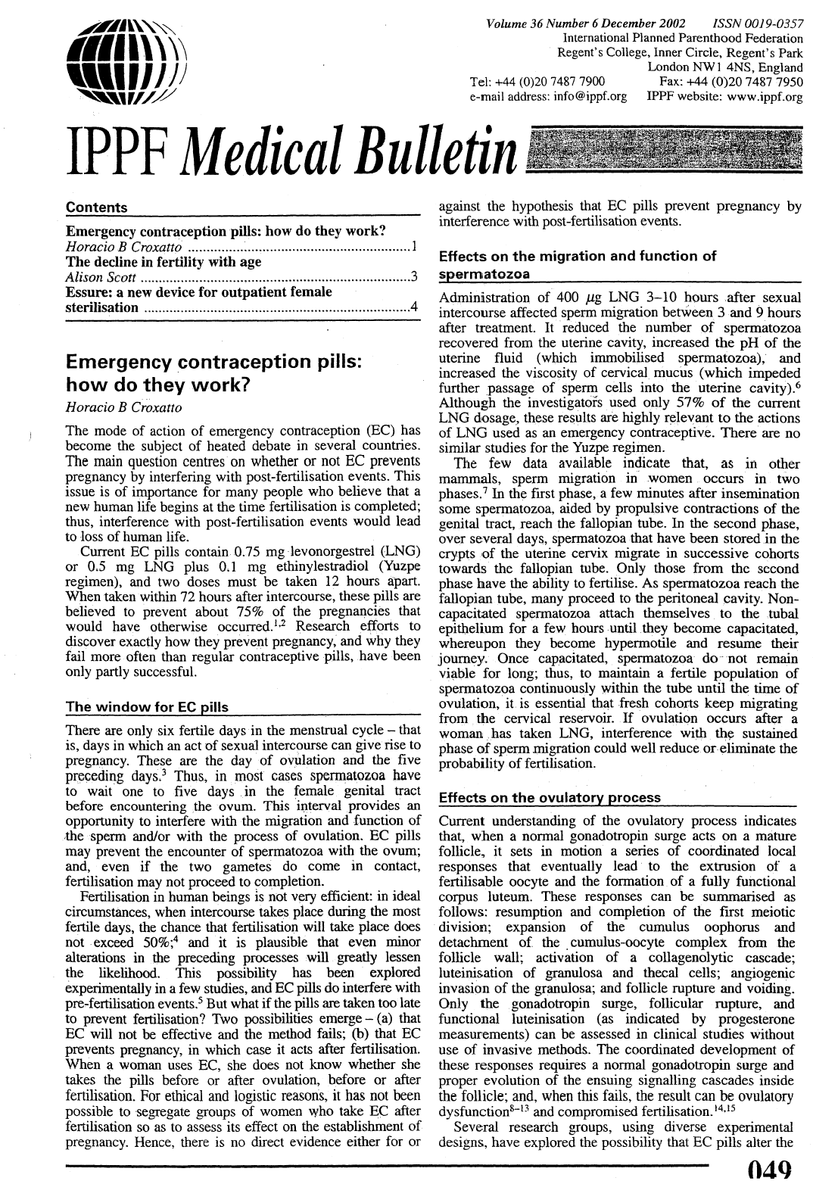

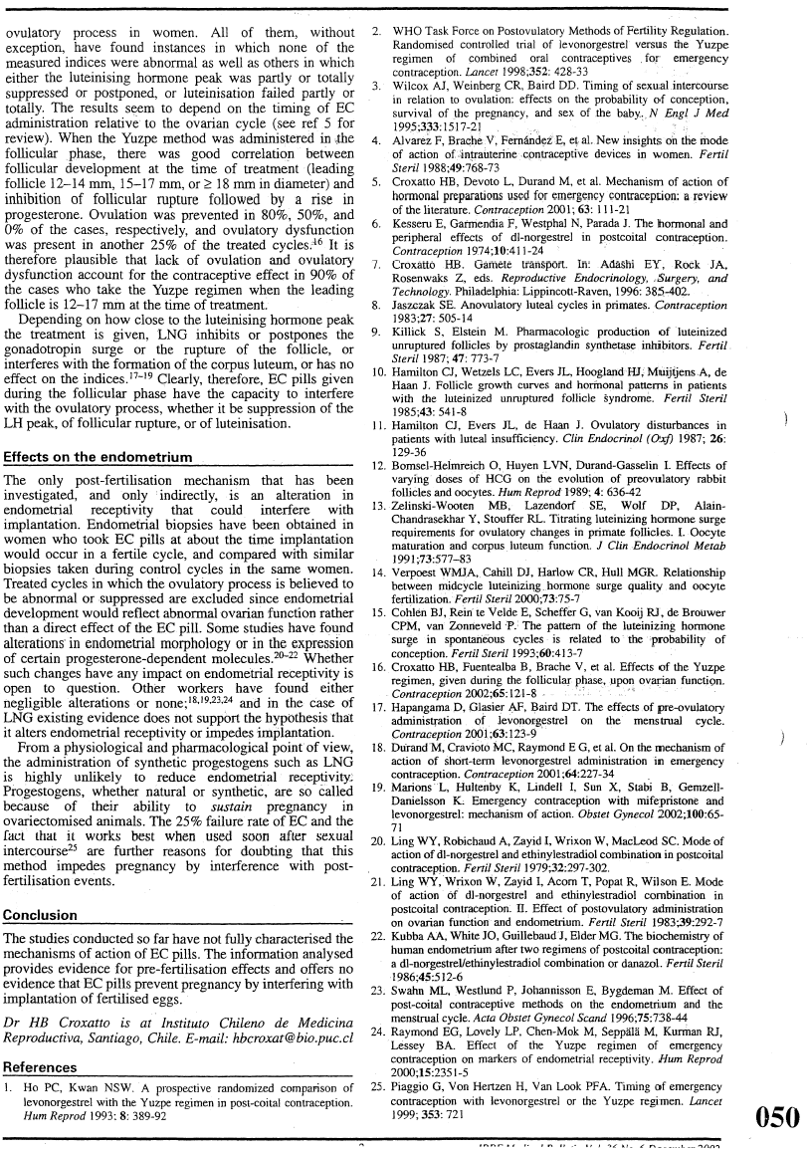
APPENDIX 2: Label Comprehension Questions/Questionnaire

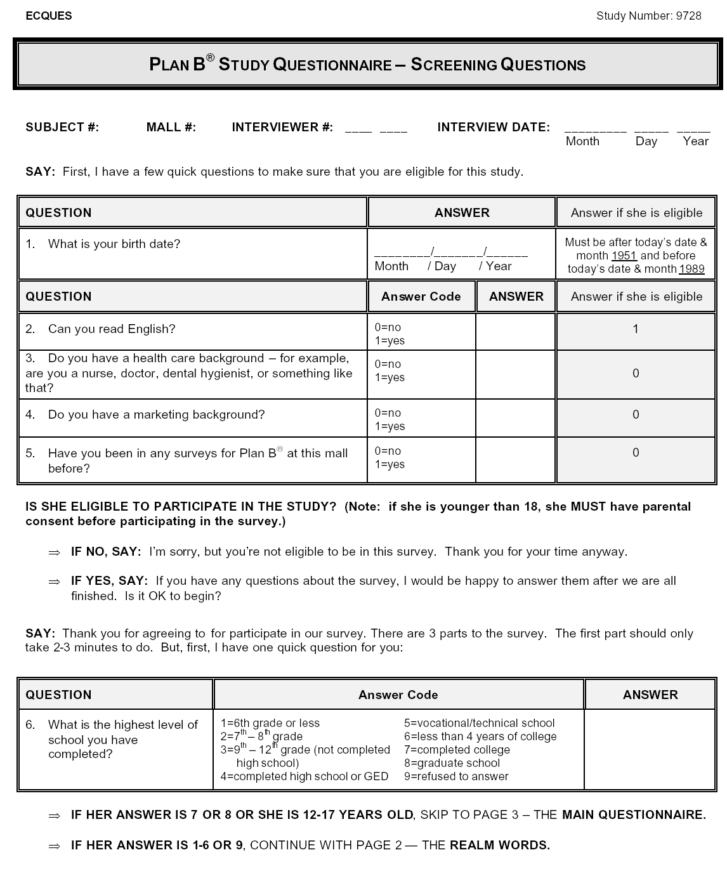
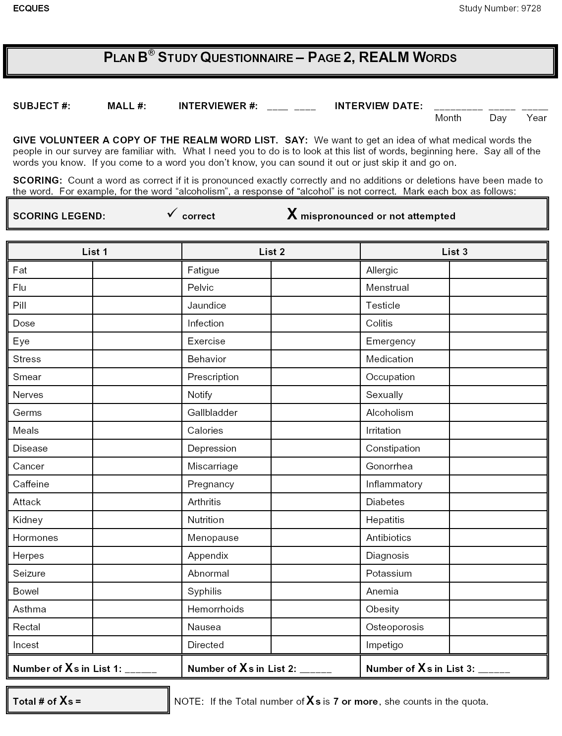
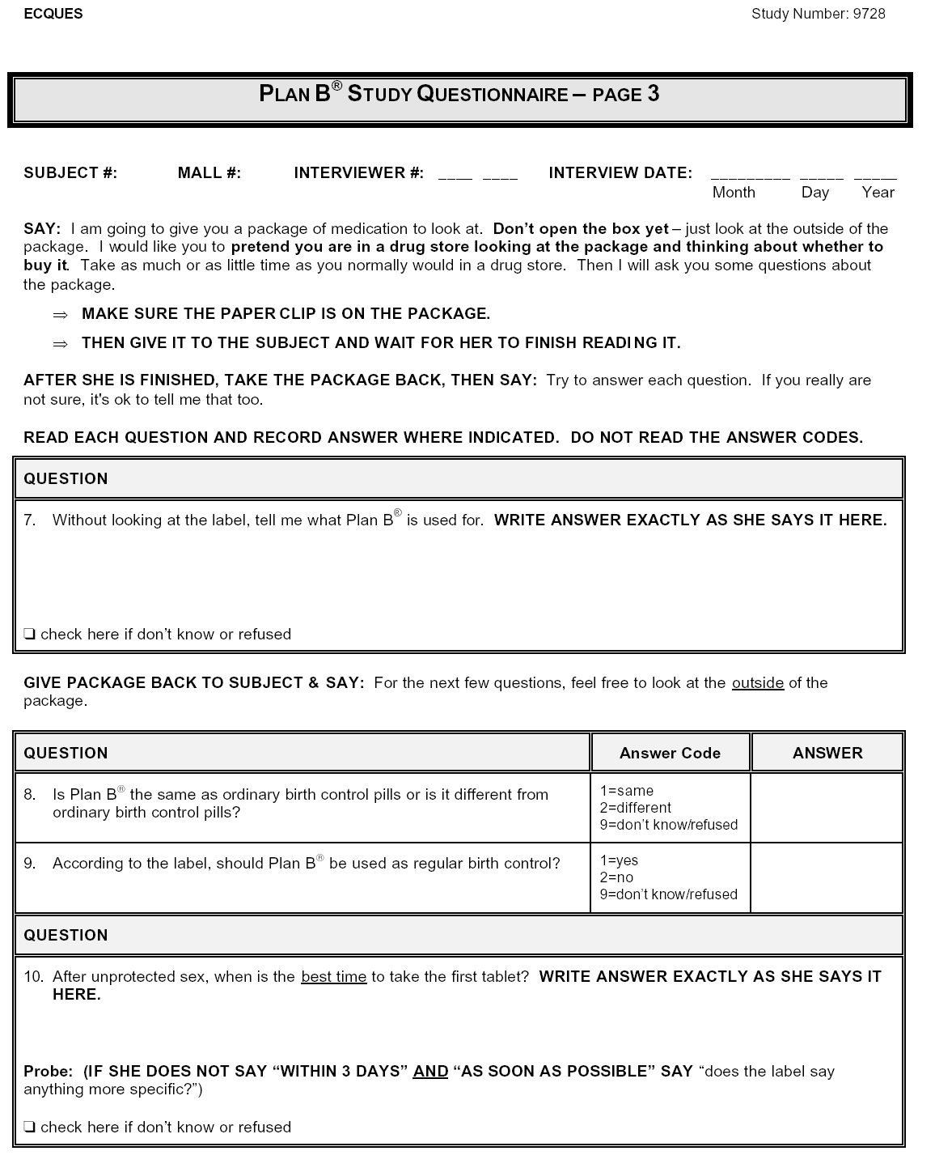
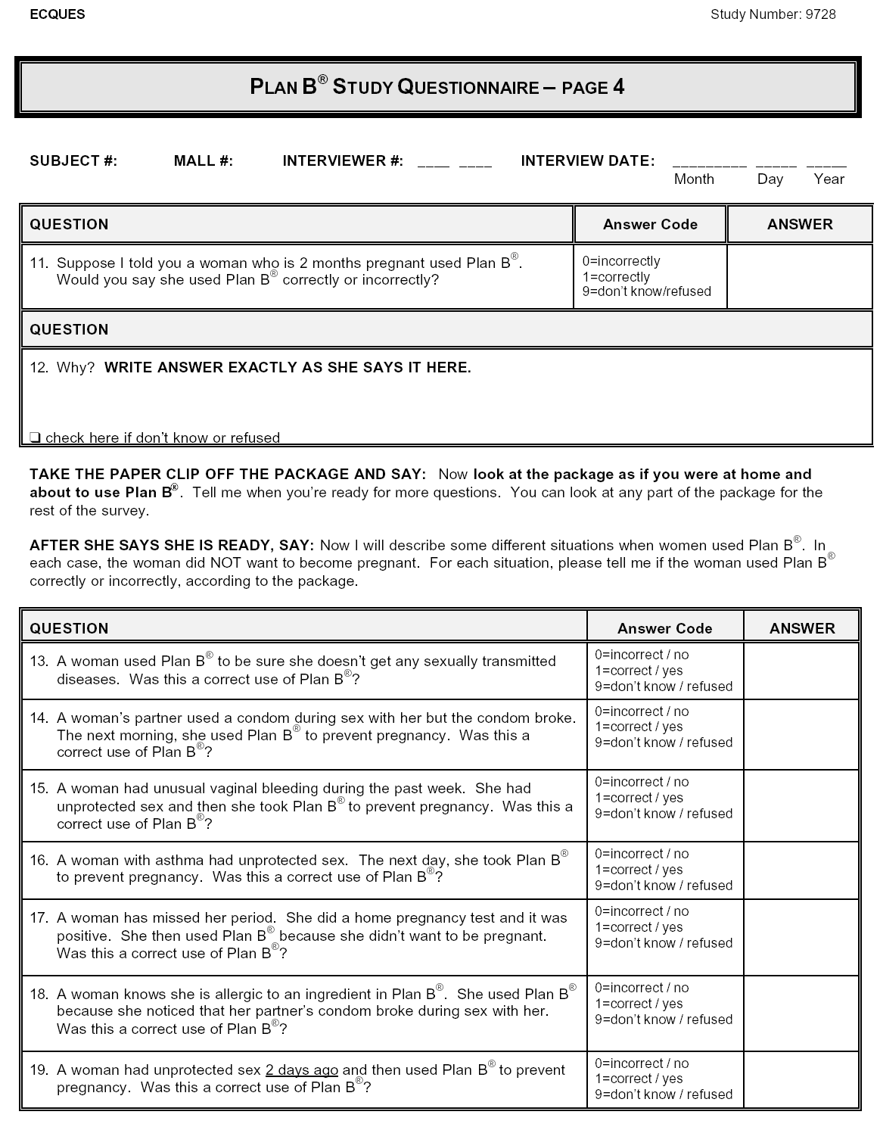
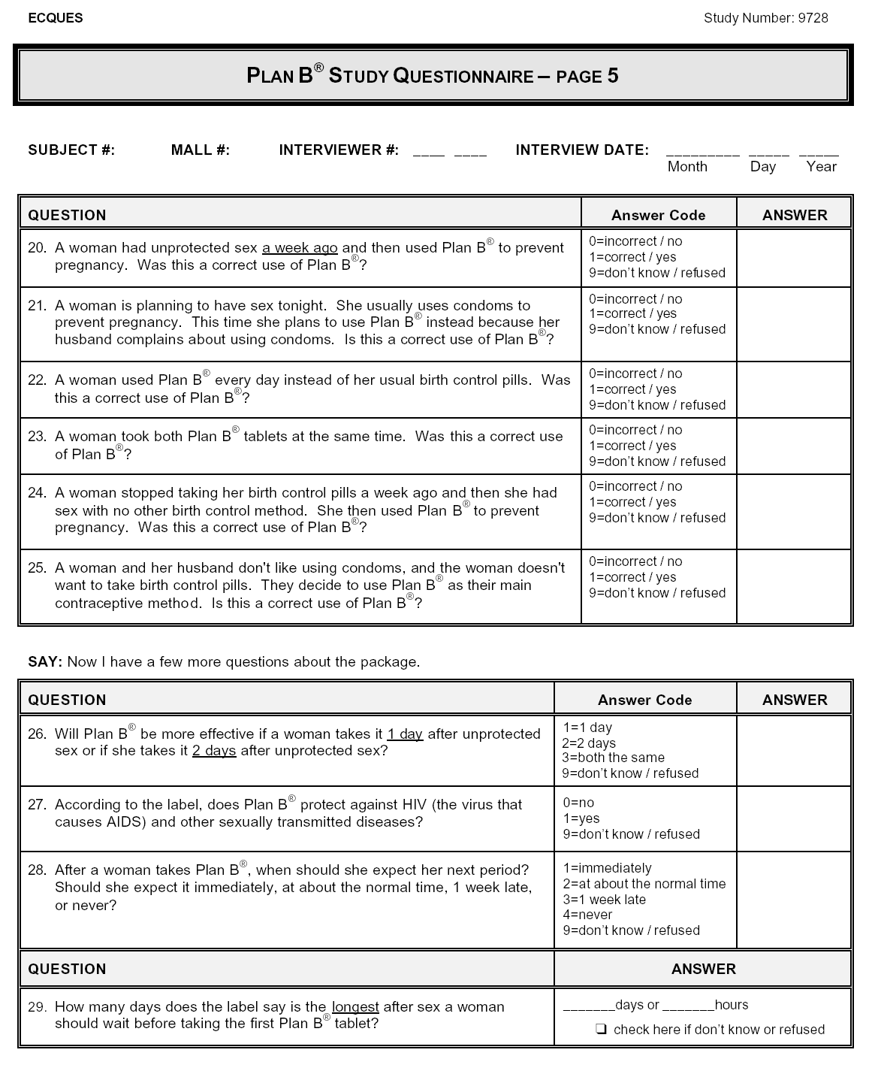
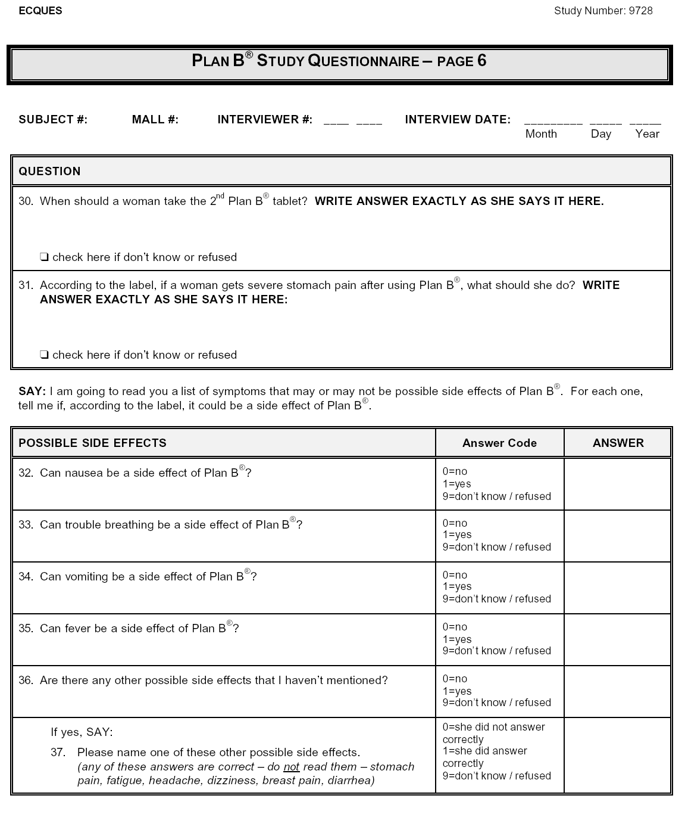
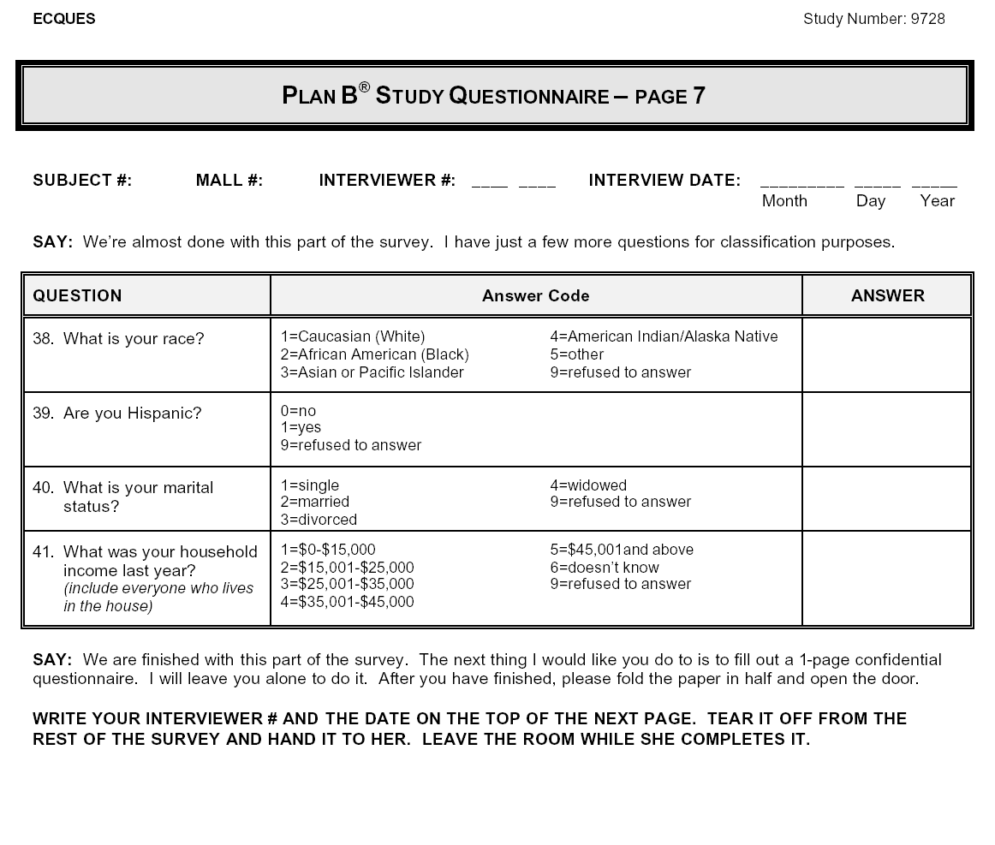
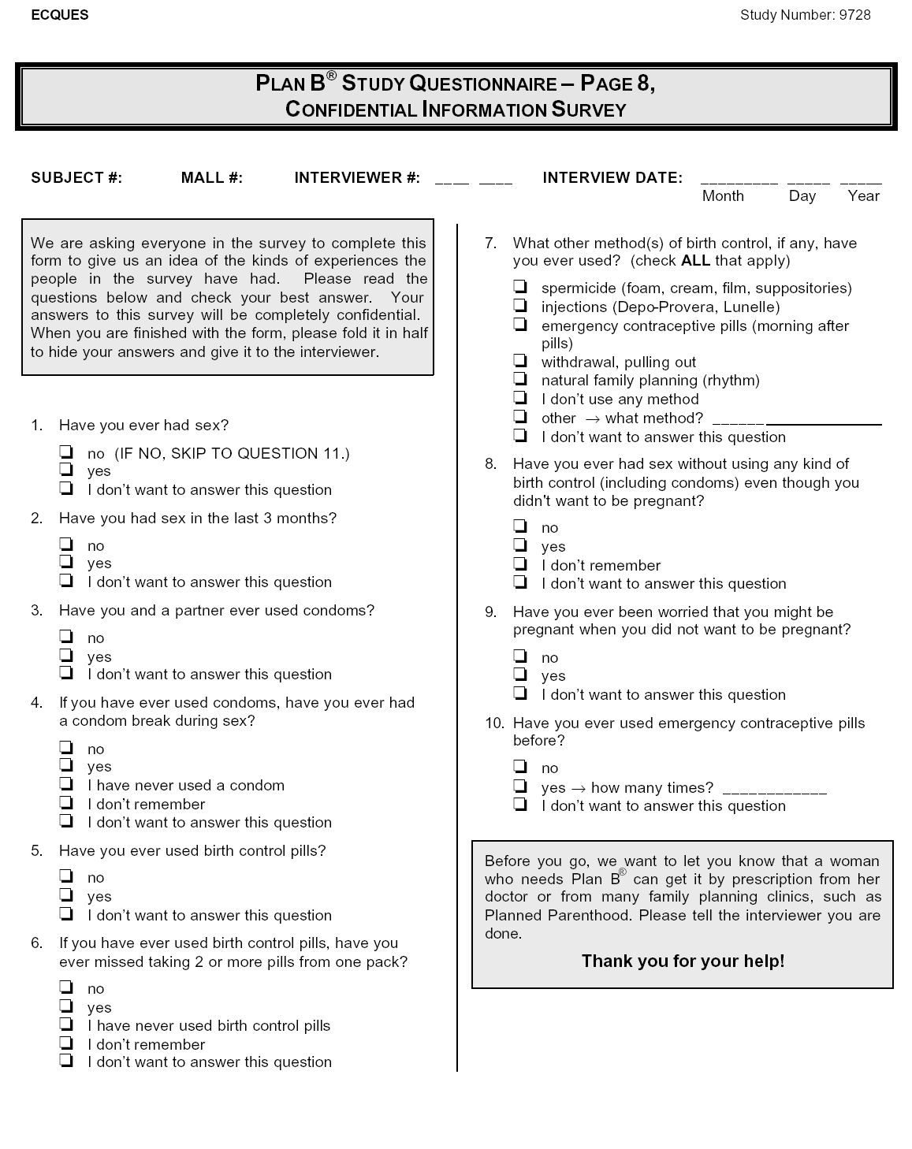

Results of Individual Question Responses from the Label Comprehension Study Questionnaire by Age Group (All 656 Eligible Subjects)

Question |  | 12-16 Years  (N=76) | 17-25 Years  (N=355) | 26-50 Years  (N=225) | Total  (N=656)
7: | Without looking at the label, tell me what Plan B is used for? | 71.1** | 83.4** | 89.3** | 84.0**
 | Contraception After Sex* (Correct) | 28.9 | 47.6 | 46.7 | 45.1
 | Contraception (Acceptable) | 42.1 | 35.8 | 42.7 | 38.9
8: | Is Plan B the same as ordinary birth control pills or is it different from ordinary birth control pills? (DIFFERENT) | 73.7 | 81.1 | 85.3 | 81.7
9: | According to the label, should Plan B be used as regular birth control? (NO) | 77.6 | 87.0 | 85.3 | 85.4
10: | After unprotected sex, when is the best time to take the first tablet? | 82.9** | 82.3** | 77.3** | 80.6**
 | ASAP and w/in 72 hrs/3days (Correct) | 13.2 | 25.1 | 24.4 | 23.5
 | ASAP (Acceptable) | 44.7 | 22.3 | 26.7 | 26.4
 | Within 72 hours or 3 days (Acceptable) | 25.0 | 34.9 | 26.2 | 30.8
11: | Suppose I told you a woman who is 2 months pregnant used Plan B. Would you say she used Plan B correctly or incorrectly? (NO) | 93.4 | 92.1 | 90.2 | 91.6
12: | From verbatim answer given in Question 11 - Why is this correct/incorrect? (Because she was already pregnant, it won't work, it's too late) | 92.1 | 95.2 | 91.6 | 93.6
13: | A woman used Plan B to be sure she does not get any sexually transmitted diseases. Was this a correct use of Plan B? (NO) | 94.7 | 97.5 | 93.8 | 95.9
14: | A woman's partner used a condom during sex with her but the condom broke. The next morning, she used Plan B to prevent pregnancy. Was this a correct use of Plan B? (YES) | 78.9 | 91.8 | 92.9 | 90.7
15: | A woman had unusual vaginal bleeding during the past week. She had unprotected sex and then she took Plan B to prevent pregnancy. Was this a correct use of Plan B? (NO) | 72.4 | 77.2 | 74.7 | 75.8
16: | A woman with asthma had unprotected sex. The next day, she took Plan B to prevent pregnancy. Was this a correct use of Plan B? (YES) | 55.3 | 64.5 | 62.7 | 62.8
17: | A woman has missed her period. She did a home pregnancy test and it was positive. She then used Plan B because she didn't want to be pregnant. Was this a correct use of Plan B? (NO) | 86.8 | 90.1 | 89.3 | 89.5
18: | A woman knows she is allergic to an ingredient in Plan B. She used Plan B because she noticed that her partner's condom broke during sex with her. Was this a correct use of Plan B? (NO) | 90.8 | 91.5 | 91.1 | 91.3
19: | A woman had unprotected sex 2 days ago and then used Plan B to prevent pregnancy. Was this a correct use of Plan B? (YES) | 82.9 | 86.2 | 88.9 | 86.7
20: | A woman had unprotected sex a week ago and then used Plan B to prevent pregnancy. Was this a correct use of Plan B? (NO) | 94.7 | 94.6 | 94.2 | 94.5
21: | A woman is planning to have sex tonight. She usually uses condoms to prevent pregnancy. This time she plans to use Plan B instead because her husband complains about using condoms. Is this a correct use of Plan B? (NO) | 50.0 | 49.6 | 40.9 | 46.6
22: | A woman used Plan B every day instead of her usual birth control pills. Was this a correct use of Plan B? (NO) | 90.8 | 91.0 | 89.8 | 90.5
23: | A woman took both Plan B tablets at the same time. Was this a correct use of Plan B? (NO) | 93.4 | 96.3 | 96.4 | 96.0
24: | A woman stopped taking her birth control pills a week ago then she had sex with no other birth control method. She then used Plan B to prevent pregnancy. Was this a correct use of Plan B? (YES) | 60.5 | 67.6 | 72.4 | 68.4
25: | A woman and her husband don't like using condoms and the woman doesn't want to take birth control pills. They decide to use Plan B as their main contraceptive method. Is this a correct use of Plan B? (NO) | 59.2 | 65.6 | 75.6 | 68.3
26: | Will Plan B be more effective if a woman takes it 1 day after unprotected sex or if she takes it 2 days after unprotected sex? (1 day) | 76.3 | 74.6 | 64.0 | 71.2
27: | According to the label, does Plan B protect against HIV (the virus that causes AIDS) and other sexually transmitted diseases? (NO) | 97.4 | 98.6 | 96.9 | 97.9
28: | After a woman takes Plan B, when should she expect her next period? | 84.2* | 89.0* | 89.8* | 88.7*
 | ABOUT NORMAL TIME (Correct) | 71.1 | 78.6 | 81.3 | 78.7
 | ONE WEEK LATE (Acceptable) | 13.2 | 10.4 | 8.4 | 10.1
29: | How many days does the label say is the longest after sex a woman should wait before taking the first Plan B tablet? (3 days or 72 hours) | 85.5 | 91.8 | 92.4 | 91.3
30: | When should a woman take the 2nd Plan B tablet? | 77.6 | 90.1 | 81.8 | 85.8
 | 12 HOURS AFTER FIRST TAB (Correct) | 55.3 | 75.2 | 64.0 | 69.1
 | OTHER[12 HOURS MENTIONED] (Acceptable) | 22.4 | 14.9 | 17.8 | 16.8
31: | According to the label, if a woman gets severe stomach pain after using Plan B, what should she do? | 81.6* | 84.2* | 77.3* | 81.6*
 | MD [no time] (Correct) | 72.4 | 72.7 | 66.2 | 70.4
 | MD immediately (Acceptable) | 9.2 | 11.5 | 11.1 | 11.1
32: | Can nausea be a side effect of Plan B? (YES) | 100.0 | 99.2 | 98.7 | 99.1
33: | Can trouble breathing be a side effect of Plan B? (NO) | 85.5 | 88.2 | 75.1 | 83.4
34: | Can vomiting be a side effect of Plan B? (YES) | 94.7 | 97.2 | 92.9 | 95.4
35: | Can fever be a side effect of Plan B? (NO) | 81.6 | 78.6 | 81.3 | 79.9
36: | Are there any other possible side effects that I have not mentioned? (YES) | 96.1 | 93.8 | 93.3 | 93.9
37: | Name other side effects (LISTED ON LABEL) | 85.5 | 89.3 | 84.9 | 87.3

APPENDIX 3: Proposed Commercial Prototype Label

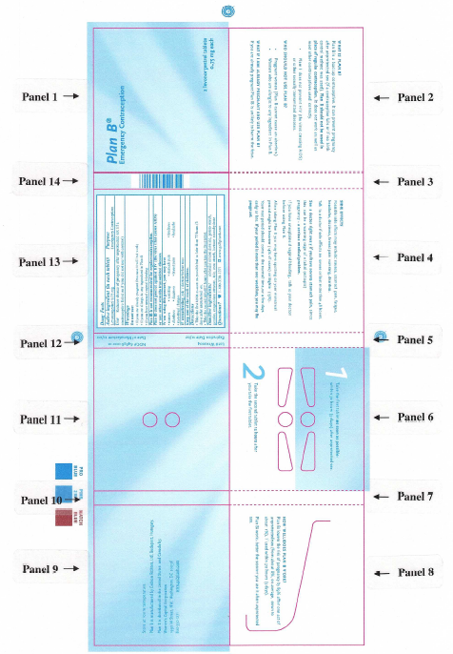

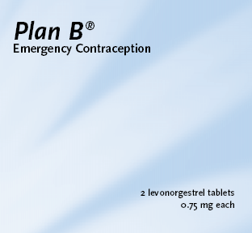
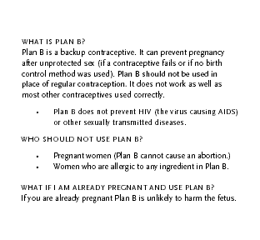

Panel 1 Panel 2

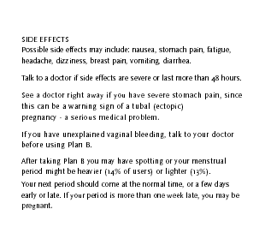
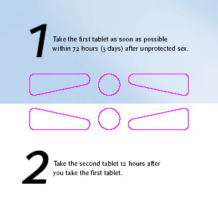

Panel 4 Panel 6

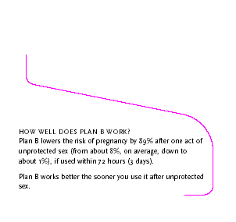


Panel 8 Panel 9

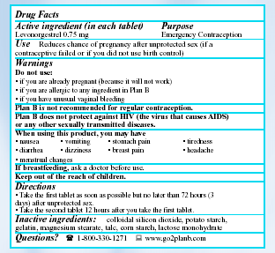


Panel 11 Panel 13

APPENDIX 4: Actual Use Study Label

Panel Number(s) | Item(s) Changing | Label Comprehension to Actual Use Study | Actual Use Study to Proposed OTC Commercial Labeling
1 | “2 levonorgestrel tablets” and “0.75 mg each” | Moved from upper left-hand corner to lower right-hand corner | No change
1 | “Emergency Contraception” | Enlarged font one point size | No change
2 | “Plan B should not be used in place of regular contraception.” | Bolded | No change
2 | “ · Women who have unusual vaginal bleeding.” | No change | See Panel 4, dealt with under “warnings” section
2 & 4 | “WHAT IF I AM ALREADY PREGNANT AND USE PLAN B? If you are already pregnant Plan B is unlikely to harm the fetus.” | Moved from Panel 4 to Panel 2 | No change
3 | NO CHANGES
4 | Percentages after listing of side effects | No change | Removed
4 | Listing of side effects | No change | Changed to sentence format, instead of bullets
4 | “If you have unexplained vaginal bleeding, talk to your doctor before using Plan B.” | Not included in either version under warnings | Addition of this text between ectopic pregnancy and menstrual changes warnings
4 | …“serious medical problem.” | Bolded | No change
4 & 8 | “After taking Plan B you may have spotting or your menstrual period might be heavier (14% of users) or lighter (13%). Your next period should come at the normal time, or a few days early or late. If your period is more than one week late, you may be pregnant.” | Moved from Panel 8 to Panel 4 | No change
5 | NO CHANGES
6 | “12 hours” | Bolded | No change
7 | NO CHANGES
8 & 9 | “HOW WELL DOES PLAN B WORK?  Plan B lowers the risk of pregnancy by 89% after one act of unprotected sex (from about 8%, on average, down to about 1%), if used within 72 hours (3 days).  Plan B works better the sooner you use it after unprotected sex.” | Moved from Panel 9 to Panel 8 | No change
9 | “, if used within 72 hours (3 days).” | Added to text at the end of the first sentence on Panel 9, which was moved to Panel 8 (see line above) | No change
9 | “Do not take more than 2 tablets in 24 hours.” | Removed | No change
9 & 11 | “Store at room temperature.  Plan B is manufactured by Gedeon Richter, Ltd, Budapest, Hungary.  Plan B is distributed in the United States and Canada by:  Women’s Capital Corporation  1990 M Street, NW, Washington, DC 20036  800-330-1271 www.go2planb.com” | Moved from Panel 11 to Panel 9 and centered from top and bottom margins | No change at this time
10 | NO CHANGES
12 | NO CHANGES TO PERMANENT TEXT, PERIODIC CHANGES TO ACTUAL LOT#, EXPIRATION DATE, AND/OR DATE OF MANUFACTURE
13 | “contraception” under Use section | Changed to “birth control” | No change
14 | NO CHANGES

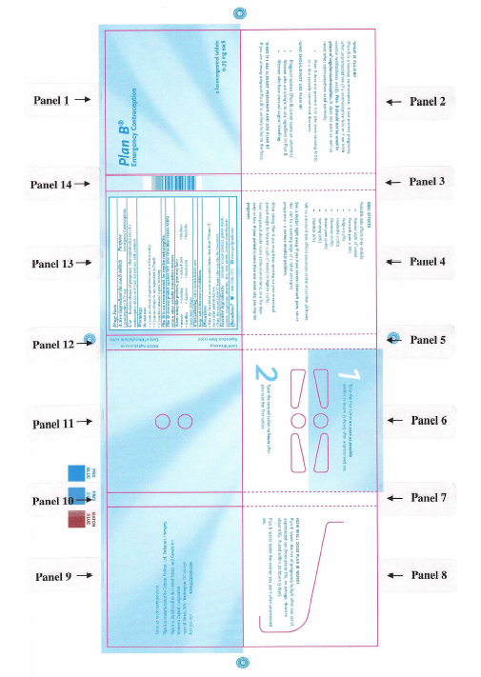

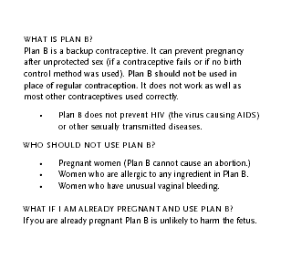

Panel 1 Panel 2

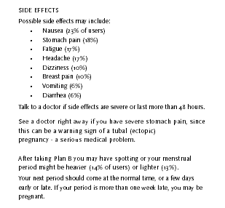

Panel 4 Panel 6

Panel 8 Panel 9



Panel 11 Panel 13

APPENDIX 5: Label Comprehension Study Label

Prescription Package Insert | Proposed OTC Product Label
Contraindications | Who should not use Plan B/Warnings
Known or suspected pregnancy | Pregnant women (Plan B cannot cause an abortion)
Hypersensitivity to any component of the product | Women who are allergic to any ingredient in Plan B
Undiagnosed abnormal genital bleeding | Rewritten in the Warnings section as “Do not use if you have unusual vaginal bleeding”
Warnings
Plan B is not recommended for routine use as a contraceptive. | Plan B is not recommended for regular contraception.
Plan B is not effective in terminating an existing pregnancy. | Do not use if you are already pregnant (because it will not work)
Effects on Menses  Menstrual bleeding patterns are often irregular among women using progestin-only oral contraceptives and in clinical studies of levonorgestrel for postcoital and emergency contraceptive use. Some women may experience spotting a few days after taking Plan B. At the time of expected menses, approximately 75% of women using Plan B had vaginal bleeding similar to their normal menses, 12-13% bled more than usual, and 12% bled less than usual. The majority of women (87%) had their next menstrual period at the expected time or within ± 7 days, while 13% had a delay of more than 7 days beyond the anticipated onset of menses. If there is a delay in the onset of menses beyond 1 week, the possibility of pregnancy should be considered. | After taking Plan B you may have spotting or your menstrual period might be heavier (14% of users) or lighter (13%). Your next period should come at the normal time, or a few days early or late. If your period is more than one week late, you may be pregnant.
Ectopic Pregnancy  Ectopic pregnancies account for approximately 2% of reported pregnancies (19.7 per 1000 reported pregnancies). Up to 10% of pregnancies reported in clinical studies of routine use of progestin-only contraceptives are ectopic. A history of ectopic pregnancy need not be considered a contraindication to use of this emergency contraceptive method. Health providers, however, should be alert to the possibility of an ectopic pregnancy in women who become pregnant or complain of lower abdominal pain after taking  Plan B. | See a doctor right away if you have severe stomach pain, since this can be a warning sign of tubal (ectopic) pregnancy – a serious medical problem.

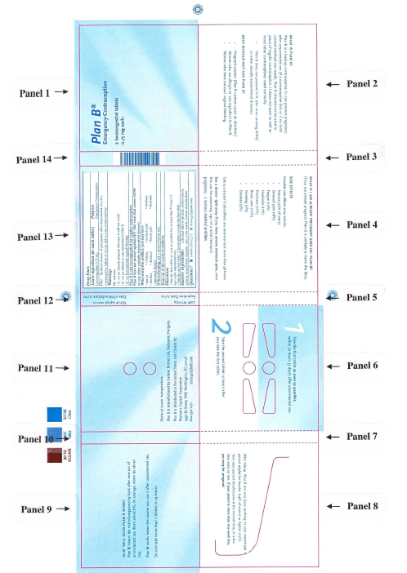

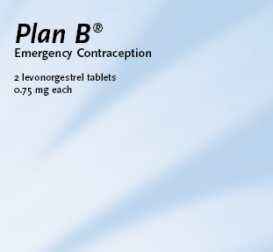
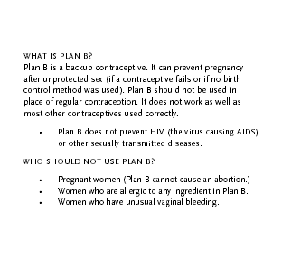

Panel 1 Panel 2

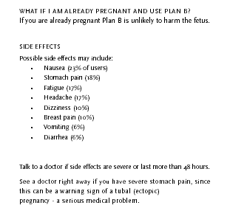

Panel 4 Panel 6
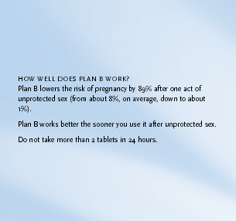
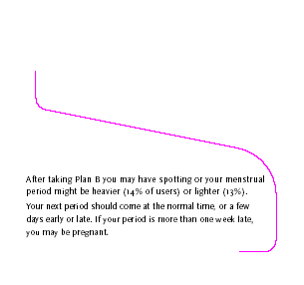

Panel 8 Panel 9
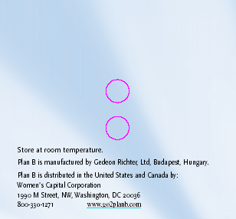
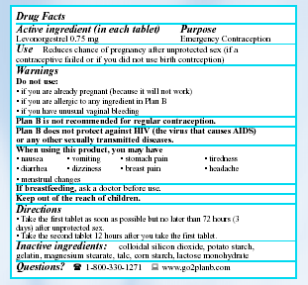

Panel 11 Panel 13

APPENDIX 6: Categorization of Verbatim Terms for Label Comprehension Study Question #7

Question 7: Without looking at the label, tell me what Plan B is used for.

1=CONTRACEPTION AFTER SEX (correct and acceptable)
a day after contraceptive
a emergencey contraception
a emergency contraception
a emergency contraceptive
a emergency contracteption
a morning after pill
a morning after tablet or pill
a morning after type product
abortion
abortion drug
abortion pill
after have unprotected sex take it under 72 hours if you don't want to get preg
after having sex if you are afraid of...didn't use contraception
after sex not to get pregnant
after unprotected sex a contraceptive
after unprotected sex it's a drug used to protect against pregnancy
after unprotected sex to avoid pregnancy
after unprotected sex to prevent from pregnancy
after you have unprotected sex and you don't want to get pregnant take the pill
after you have unprotected sex you take it to prevent pregnancy
an abortion type of thing if you think you are pregnant
an abortion type thing for the day after
an emergency contraception
an emergency contraceptive
an emergency contraceptive for birth control after sex
an emergency contraceptive morning after pill
an emergency pill to use if you think you're pregnant
as a form of emergency birth control
as emergency birth control i believe
birth control after unprotected sex
birth control like a morning after pill
birth control to use the next day
contracepted after unprotect sex
contraception after having sex
contraception after unprotected sex
contraception reduces a pregnant chance after unprotected sex
contraceptive emergency
contraceptive if you didn't use one or if it broke
day after intercourse to make sure you are not pregnant
day after pill
day after pill so you dont get pregnant
day after pill to get rid of pregnancy 72 hours after you have unprotected sex
emer birth control
emerg birth control
emergency after pill
emergency after sex pill
emergency backup pill for not getting pregnant
emergency birth control
emergency birth control pill
emergency birth control pills
emergency compensation
emergency conception
emergency con-something
emergency contraceptave
emergency contraception
emergency contraception (pregnacy)
emergency contraception if you got raped condem broke forgot birth control pill
emergency contraception incase you get pregnant
emergency contraception morning after pill
emergency contraception or morning after pill
emergency contraception pill
emergency contraception to help stop pregnancy
emergency contraception within 72 hours if not already pregnant
emergency contraception within 72 hours of having sex
emergency contraceptive
emergency contraceptive like the morning after pill
emergency contraceptive use up to 3 days after unprotected sex or if cont fail
emergency contraceptives
emergency contreceptive
emergency contriceptive the morning after pill
emergency pills
emergency pills to keep you from being pregnant
emergency prevention of pregnancy
for emergency contraception
for if you have sex and you didn't take birth control or use a condom
for unprotected sex so you won't come out pregnant
for unprotected sex to prevent pregnancy
had unprotected sex would take it within 72 to prevent pregnancy
helps prevent pregnancy if your contraceptive fails you
if you have sex without a condom or any other birth control
if you have unprotected sex and don't want to be pregnant
if you have unprotected sex its supposed to kill the sperm
if you use it after you have unprotected sex you won't get pregnant
if your contreception failed or if one was not used
in case you had unprotected sex it stops pregnancy
it has 2 emergency contraceptive birth control pills
it is a emergencey contraception
it is a emergency contraception
it is a emergency contraception after having sex for not getting pregnant
it is a emergency pill and probably take it every day for birth control
it is a pill you take after you have unprotected sex
it is a type of contraception to be used in an emergency situation
it is a type of emergency contraception
it is an emergency contraception
it is emergency contraception
it kills sperm right after sex
it looks like its used for emergency contraception
its a birth control pill for emergencies a day after pill
its a morning after pill
its an emergency birth control pill
its an emergency contraceptive
its emergency contraception to be taken 72 hours after unprotected sex
its emergency contraceptives
its for contraception after you have sex
it's like a after pill in case your contraception won't work
it's like a day after pill
its like a morning after pill
it's says it's not or too avoid pregnancy after intercourse
it's the morning after pill
its the morning after pill, reduce your chances of getting pregnant after
its used to prevent pregnancy after unprotected sex
it's used to stop pregnancy after you have had sex
like a morning after pill or something
like the day after pill you take after having sex so you won't get pregnant
like the morning after pill kinda
morning after pill
morning after pill after unprotected sex
morning after pill have sex and don't use protection can take it within 72 hrs
morning after unprotected sex
not to get pregnant after unprotected sex
oral emergency contreceptive
plan b is something you take after sex to keep you from getting pregnant
preven u from getting pregnant so if you have unprotected sex you get a chance
prevent pregnancy after unprotected sex
preventing pregnancy after unprotected sex
preventing pregnancy after unprotected sex or failed contraceptives
prevents you from getting pregnant after having sex
reduced the chance of pregnancy for unprotected sex
reduces chance of pregnancy after unplanned sex
so that if you have unprotected sex you will not get pregnant
so you won't be pregnant after unprotected sex
something similar to the morning after pill i think but not sure
something you take for you not to get pregnant after unprotected sex
stops you from being knocked up if the rubber breaks
take it after unprotected sex to stop you from getting pregnant
take it after you have unprotected sex
that morning after drug for unprotected sex
the after morning pill
the day after pill
the morning after pill
the morning after pill i think
to keep you from being pregnant when you don't use protection or it fails on u
to kill the firtilized egg
to prevent pregnancy after having unprotected sex
to prevent pregnancy after unprotected sex
to prevent pregnancy contraception in case of an emerge
to prevent pregnancy if there is a chance you may be pregnant
to reduce chance of pregnancy if contraceptive wasn't used during sex
to take care pregnancy after unprotected sex
unprotected sex it reduces the risk of pregnancy
unprotected to reduce pregnancy after unprotected sex
well the outside said emergency contraceptive
when having unprotected sex so you don't get pregnant
when your contraception fails it's a back up plan
you won't get pregnant day after program

2=contraception (acceptable)
"cuts down the chance of getting pregnant"
"it's birth control"
a birth control pill
a conceptative
a contraceptive
a contraceptive birth control
a form of birth control
a method of birth control
a pill not to get pregnant
a pill you take when you dont want to get pregnant
a pregnancy contraception a form of birth control
a type of birth control
a type of birth control pill
a type of contraceptive
alt. contraceptive
alternative contraceptive
an form of contreceptive
avoid pregnancy
back up birth control
back up contraception
back up contraception pills
back up pills
back up plan for when your other birth control fails
backup birth control
birth contraceptive
birth control
birth control contraceptive
birth control i guess
birth control or something
birth control pill
birth control pills
birth control/contraceptive
birth controll
birthcontrol
conceptrative
constraception
conterception
contraception
contraception it says
contraception to stop pregnancy
contraceptive
contraceptive birth control
contraceptive pills prevent pregnancy
contraceptives
contraceptives just in case
contreception to prevent unwanted pregnancy
contreceptive
for contraceptive
for contrecepting
for pregnancy to prevent it
for the prevention of pregnancy
girls who don't want to be pregnant
helps prevent unplanned pregnancy from occuring
helps you so you don't get pregnant
I guess, I don't know, birth control, protection
if case you are worried in getting pregnant
if you don't want to be pregnant
if your not pregnant it's to keep from getting pregnant
i'm guessing birth control
i'm not quite sure maybe pills to prevent conception
i'm not sure but probably preventing pregnancy
i'm not sure some kind of pregnacy preventer maybe
it is a contreaceptive
it is a pill you take so you wont become pregnant
it is to used to keep you from getting pregnant
it is used to help prevent you from having a baby
it is used to prevent pregnancy
it is used to prevent pregnency
it is used to prevent you from having a child
it is used to whatchmacallit to prevent getting pregnant
it may be for some kind of birth control
its a contraceptive
it's a contraceptive
it's a contraceptive to keep you from getting pregnant
it's a pill that is used for not getting pregnant
it's a pill used for not getting pregnant
it's a type of birth control
it's for a protection for sex a contraception
its for birth control
its for to not get pregnant its like for birth control
it's kinda a form of birth control but not really it prevents pregnancy
it's probably to prevent pregnancy
it's the "i don't want to be pregnant" pill
it's used for preventing pregnancy
keeps you from getting pregnant
like a birth control pill
like the pill
not to be pregnant
not to get pregnant
not to get pregnant and if you are pregnant don't take it
plan b is a type of birth control
plan b is for preventing pregnancy
plan b is used for birth control pills
pregnancy control pill
pregnancy pil so you won't get pregnant
pregnancy prevention
pregnancy prevention pill
pregnancy to prevent pregnancy
prevent from getting pregnant
prevent of pregnancy
prevent pregency
prevent pregnancies
prevent pregnancy
prevent you from getting pregnant
preventing pregnancy
preventing unwated conception
prevention of pregnancy
prevents unwanted pregnancy
protection prevent from getting pregnant
reduce chance of pregnancy
reduce the chance of getting pregnant
reduces the chance of getting pregnant
so you can't get pregnant
so you don't get pregnant
so you wont get pregnant
so you won't get pregnant
some type of pregnancy pill-birth control
something to prevent pregnancy
stop pregnancy
stops you from being pregnant
there used for birth control
to avoid pregnancy
to help prevent pregnancy
to help you not get pregnant
to keep you from being pregnant
to keep you from getting pregnant
to make sure you dont get pregnant
to minimize the chances of getting pregnant
to not get pregnant
to prevent conception
to prevent not getting pregnant
to prevent pregnancy
to prevent use from pregnancy i guess
to prevent you from getting pregnant
to protect you from having kids
to reduce risk of pregnancy
to reduce the chance of getting pregnant
to reduce the chance of pregnacy
to stop pregnancy
type of birth control
type of contreceptive pill
well i would have to say in place of a condom like the morning after pill

3=emergency, sex not mentioned (incorrect and not acceptable)
emergencies
emergency medication
emergency pregnancy pill
emergency situations
emergenies
for emergency pain, sex

4=STI/HIV (incorrect and not acceptable)
for hiv (w) pregnancy (w) aids (w)it
hiv
hiv-aids
if you have HIV
prevent against stds
protect against hiv
protect hiv
sexually transmitted diseases

5=after sex, purpose unspecified
after having unprotected sex
after sex pills
after sex the emergency thing
after unprotected sex
after you already had sex and you kind of screwed up
after you have sex you can use that afterward
for after you've had unprotected sex
for unprotected sex
for when you have unprotected sex
if you have unprotected sex
in case you had unprotected sex or a condom broke or something like that
in case you have unprotected sex
it's for if you've had unprotected sex
they are tablets for if you didn't have protected sex
to protect yourself from unprotected sex
to use after unproted sex
unprotected sex
used for unprotected sex

6=other
a pregnancey test or something
conception
for no mistaking regular things constipation
for pregnancy
for protection of sex
for sexually active stuff
for when you have headaches
headaches?
i think pregnancy
it looks like allergy pills
medication
miscarry babies not miscarry but get it out
nausea pain
pains
pregnancy
probably having sex
protection for sex
second choice
sex
something having to do with being pregnant
something to do with a cold or allergies
take for percautions
to find out if your pregnant if you are don't use it
to get rid of a mistake
unwanted pregnancy

9=don't know/refused
don't know or refused
i did not look at that
i don't think i looked that closely
i have no idea
i have no idea i forgot already
i wouldn't know that
i'm not sure
maybe like a...a kind of birth control or to kill an infection I'm not sure
not sure

APPENDIX 7: PROPOSED PATIENT PACKAGE INSERT

What you should know about Plan B®

Plan B® is a backup method of birth control.

Plan B® is emergency contraception, a backup method of birth control. Plan B® can reduce your risk of pregnancy if you have unprotected sex (if your regular birth control method fails or if you have sex without birth control).

Plan B® contains a concentrated dose of levonorgestrel, a synthetic hormone used in birth control pills for over 35 years.

Because Plan B® prevents pregnancy before if begins, it is not the same as abortion.

You can use Plan B® if you had unprotected sex one or more times in the last three days (72 hours), and you don’t want to become pregnant.

Plan B® is not as effective as using a regular birth control method correctly and consistently. It can be used as a backup method if:
- Your regular birth control failed (your partner’s condom broke or slipped)
- You made a mistake with your regular method (you missed several birth control pills)
- You did not use any birth control method

Plan B® works better the sooner you use it.

Your only have a few days to prevent pregnancy after unprotected sex. Plan B® works better the sooner you use it. Take the first Plan B® tablet as soon as possible within three days (72 hours) of unprotected sex. Take the second tablet 12 hours later.

Plan B® can reduce the risk of pregnancy to about 1 percent, if you use it within the first three days of a single act of unprotected sex. Your risk of pregnancy ranges from 0 to 35 percent, depending on the day of your menstrual cycle.

Plan B® works like other birth control pills.

Plan B® can prevent pregnancy by stopping the release of an egg from the ovary (ovulation), or it may prevent the union of sperm and egg (fertilization). You are at most risk of pregnancy just before ovulation and on the day of ovulation.

If fertilization does occur, Plan B® may prevent a fertilized egg from attaching to the womb (implantation). Plan B® will not work after implantation of a fertilized egg.

Plan B® is not the same as the early abortion pill, Mifeprez® (RU486). Plan B® cannot disrupt an established pregnancy.

Some women experience short-term side effects?

Plan B® has no serious or lasting medical side effects. Some women will experience non-serious side effects, such as nausea, stomach pain, headache, dizziness, or breast tenderness. These are similar to the side effects of regular birth control pills. Some women have menstrual changes such as spotting or bleeding before their next period. Some women may have a heavier or lighter next period, or a period that is early or late. If your period is more than a week late, you should get a pregnancy test.

Plan B® will not harm an established pregnancy?

Plan B® should not have any effect on an established pregnancy. If you take it accidentally after you are already pregnant, or if it does not work, it is not likely to cause any harm to you or your pregnancy. Studies of women who took birth control pills by mistake after they were already pregnant showed no increased risk of birth defect.

Warnings

If you become pregnant after using Plan B®, and you have sever stomach pain, contact a doctor immediately. This may be a sign of an ectopic pregnancy (a pregnancy growing in your fallopian tube).

Keep this and all drugs out of the reach of children. In case of accidental ingestion, call a Poison Control Center, emergency medical facility, or a doctor immediately.

Each Plan B® package is sealed in plastic wrap. If the wrap is missing or torn, return the package to your pharmacy.

Questions or Comments
Call 1-800-330-1271 or visit www.go2planb.com
Choosing a Regular Method of Birth Control

Plan B® is a safe and effective emergency contraceptive for use when you need a backup method of birth control.

Plan B® is not a substitute for regular contraception. Using a regular contraceptive correctly and consistently would be more effective and may be less expensive. Plan B® does not protect you against sexually transmitted infections, including HIV/AIDS.

If you are sexually active but you are not using a regular birth control method, or if you are having trouble using your method, you should talk with a healthcare professional. Women who are sexually active and use no birth control method for a year have an 85% risk of becoming pregnant.

Listed below are birth control choices that you may want to discuss with your healthcare provider. In some cases, Plan B® may be a good backup for the method you choose.

Abstinence
Sexual abstinence is the most effective way to avoid both unintended pregnancy and sexually transmitted infections, including HIV/AIDS. Sexual abstinence requires commitment and self-control on the part of both partners in a relationship. For women practicing abstinence, Plan B® can be useful back-up method, if unplanned sex does occur.

Birth Control Pill
Most birth control pills contain progestin and estrogen. These active ingredients are synthetic versions of naturally occurring female hormones. Progestin-only pills are available for women who should not take estrogen because of cardiovascular or other risk factors. All birth control pills currently require a prescription. Birth control pills are highly effective if they are used correctly and consistently. Because women sometimes forget to take their pills, the typical pregnancy rate in the first year of use is about 8%. Advantages of the pill include more regular periods, less menstrual bleeding, decreased menstrual cramps, and a reduction in the risk of endometrial and ovarian cancer. Side effects may include nausea, breast tenderness, and headaches, but these symptoms often decrease after the first few months of pill use. Birth control pills provide no protection against sexually transmitted infections or HIV/AIDS. Plan B® can be used as a backup contraceptive if you miss two or more pills in a row or if you start a new cycle of pills late. You can start taking your pills again as soon as you finish your Plan B®.

Condom
Many different types of condoms for men are available in pharmacies without a prescription. Condoms can prevent pregnancy and can also reduce the risk of getting HIV/AIDS or other sexually transmitted infections. To be most effective, condoms must be used correctly and consistently. Condoms break or slip 3% to 5% of the time. As a result of condom accidents and inconsistent use, the typical risk of pregnancy is about 15% in the first year of use. A polyurethane female condom, worn inside the vagina, is also available without a prescription. The female condom can prevent both pregnancy and sexually transmitted infections, including HIV/AIDS. The risk of pregnancy is about 21% in the first year of typical use. Couples depending on male or female condoms for birth control may find it useful to keep Plan B® in the nightstand in case of a condom accident or if unprotected sex occurs.

Diaphragm, Cervical Cap and Sponge (Female Barrier Methods)
Female barrier methods prevent pregnancy by stopping sperm from reaching the uterus. The diaphragm and cap are used with a spermicide; the sponge contains a spermicide. (See “Spermicides” below). These methods do not require a prescription. Plan B® can be a useful backup method when a diaphragm or cervical cap moves out of place during sex, or if unprotected sex occurs.

Implant (Contraceptive Implant)
New contraceptive implants, lasting two to three years, are available in Europe and should be available soon in the United States. Implants allow the steady release of low doses of progestin, a synthetic version of a naturally occurring female hormone. Implants are highly effective and convenient for women who want long-term contraception. Pregnancy rates are less than 0.5% in the first year if typical use. Like other progestin-only methods, implants can cause irregular menstrual bleeding, including spotting and less frequent periods. Implants must be inserted under the skin and surgically removed by a healthcare professional.

Injectable Contraceptive
Injectable contraceptives (birth control shots) are highly effective and more convenient for some women than daily pills. Only 3% of users typically get pregnant in the first year of use. The shots generally work in the same way as birth control pills. There are two types available in the United States. Both require a prescription. Plan B® can be used as a backup if you are late getting your contraceptive injection.

Intrauterine Device (IUD)
IUDs are contraceptive devices that are inserted into the uterus. They can work for ten years or more, but they must be inserted and removed by a healthcare professional. IUDs provide no protection against sexually transmitted infections, including HIV/AIDS. They are not recommended for women who may be exposed to sexually transmitted infections, such as women with more than one sexual partner. Plan B® can be a useful backup method on those rare occasions when an IUD becomes dislodged or expelled.

Natural Family Planning (Periodic Sexual Abstinence)
Natural family planning (sometimes called “fertility awareness” or “periodic sexual abstinence”) generally involves abstaining from vaginal sex during fertile days of the menstrual cycle. There are a number of different methods. Most couples need some months of training in order to use the method effectively. Typical pregnancy rates in the first year of use are about 25%. Natural family planning methods provide no protection against sexually transmitted infections, including HIV/AIDS. Plan B® can be used as a backup for natural family planning if, for example, a women realizes after sex that she has miscalculated the fertile period.

Patch (Transdermal Patch)
One of the newest methods of birth control is a patch that releases low doses of estrogen and progestin, synthetic versions of naturally occurring female hormones. Women use one patch per week for three weeks, followed by a break of one week. The patch is worn on the abdomen, buttocks, upper arm or upper torso (except on the breasts). The patch prevents pregnancy in the same way birth control pills do, but may be more convenient for some women. The patch has many of the same advantages and disadvantages as the birth control pill. Side effects and pregnancy rates in the first year are expected to be similar to that of the pill. The patch requires a prescription. Plan B® can be a useful backup method if you apply a new patch late.

Spermicide
Spermicides are often used with female barrier methods, such as diaphragms, but may also be used alone. Spermicides work by attacking sperm. They are available without a prescription, but must be used each time you have sex. Used alone, they have a typical first year pregnancy rate of 29%. Their main advantage is that they are widely available in pharmacies and can be used without a male partner’s cooperation. They do not protect against HIV/AIDS. For women who rely solely on spermicides alone or with a barrier method, Plan B® may be a useful backup if unprotected sex occurs.

Vaginal Ring
Another new method of birth control is the vaginal ring. The ring releases low levels of estrogen and progestin, synthetic versions of naturally occurring female hormones. The ring is worn inside the vagina continuously for three weeks, followed by a break for one week. It does not need to be removed during sexual intercourse. It works the same way as birth control pills and has many of the same advantages and disadvantages. Side effects and failure rates are expected to be similar. The ring requires a prescription. Plan B® can be a useful backup method if you insert a new vaginal ring late.

Voluntary Sterilization
Contraceptive sterilization for women involves blocking off the fallopian tubes by a variety of means to prevent the passage of eggs and sperm. Male sterilization blocks the passage of sperm. Sterilization is highly effective, with a typical first year pregnancy rate of 0.5% for female sterilization and 0.15% for male sterilization. Advantages of female sterilization may include decreased risk of ovarian cancer. Disadvantages may include risk of ectopic pregnancy in the event of failure. Neither male nor female sterilization provide any protection against sexually transmitted infections, including HIV/AIDS. Most methods of sterilization involve minor surgery. Sterilization is a permanent method and should be considered only by women and men who are certain they want no more children.

Sources:
1. Hatcher RA, Nelson MA, Zieman M et al. A Pocket Guide to Managing Contraception. Tiger, Georgia: Bridging the Gap Foundation, 2002.
http://www.managingcontraception.com/images/pds/managing.pdf

2. Trussell J. Contraceptive failure. In Hatcher RA, Trussell J, Stewart F, et al. Contraceptive Technology: Eighteenth Revided Edition. New York NY: Ardent Media, 2004.
APPENDIX 8: Label Comprehension Study Data Transcription Card

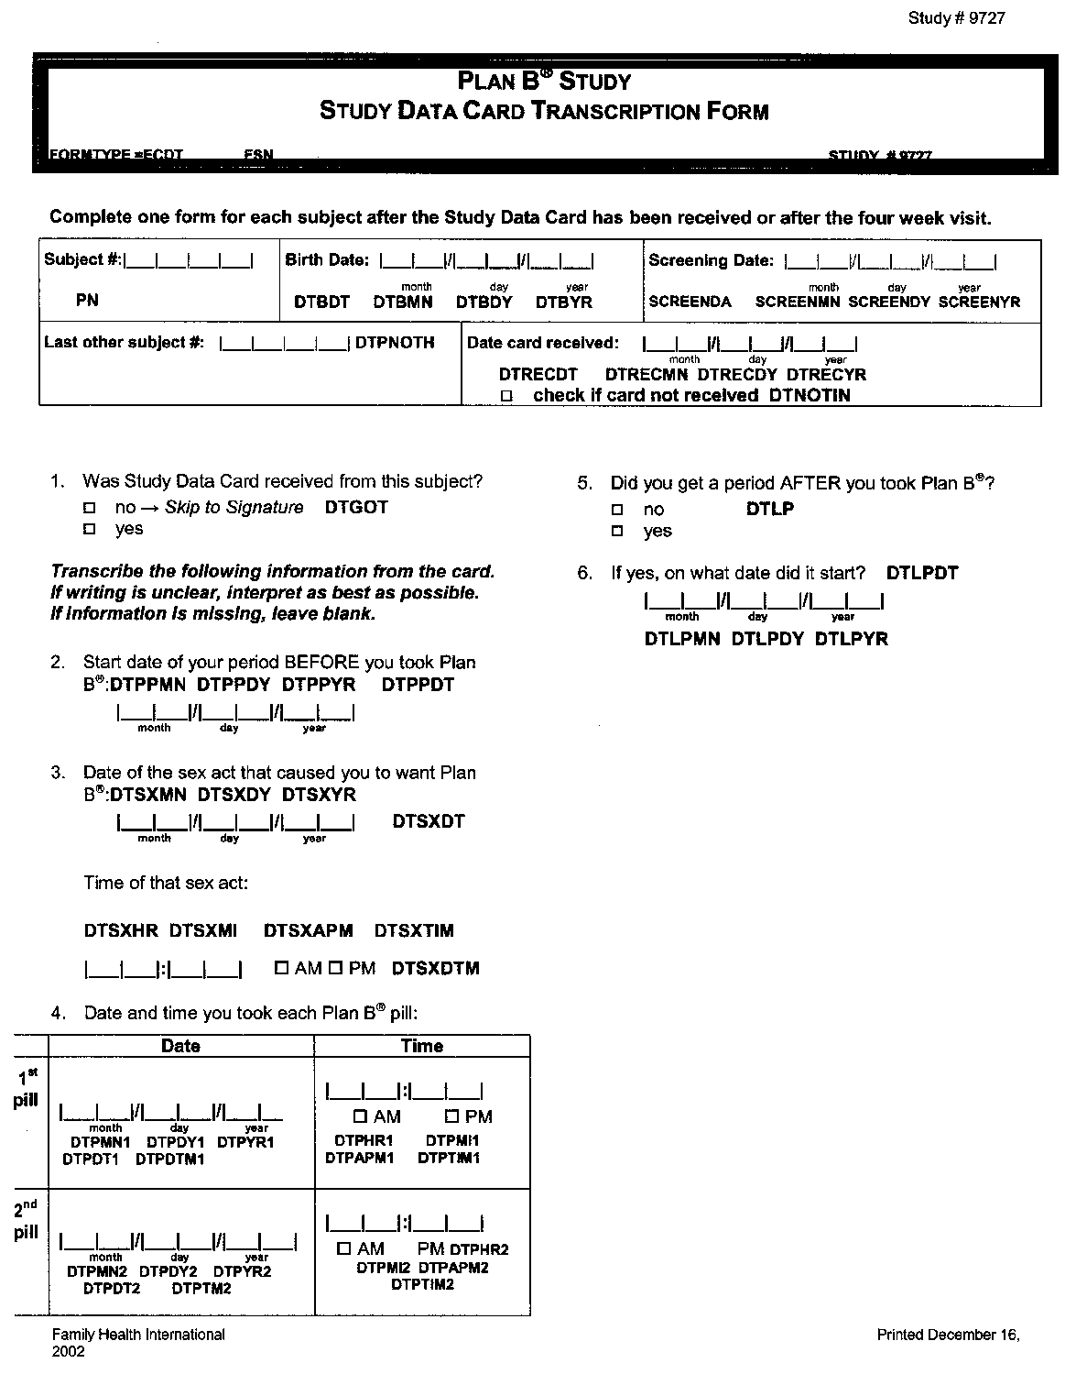
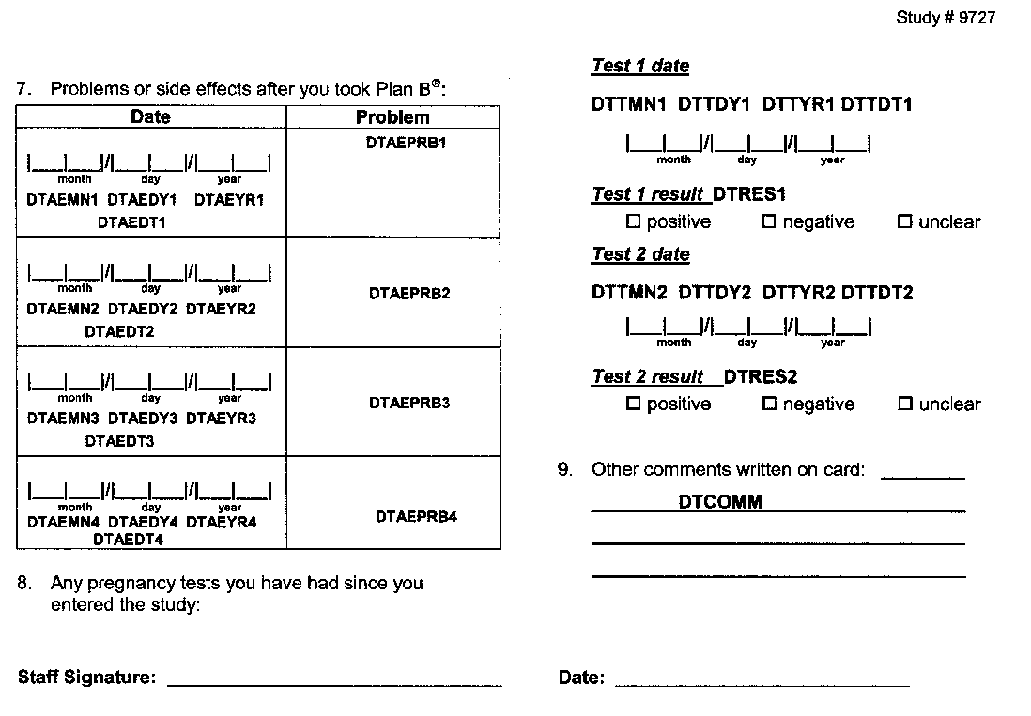

Albania, Belgium, Benin, Cameroon, Congo, Denmark, Dominican Republic, Finland, France, French Polynesia, Gabon, Guinea-Conakry, India, Ivory Coast, Madagascar, Mali, Mauritius, Namibia, New Zealand, Niger, Portugal, Senegal, South Africa, Sri Lanka, Switzerland, Togo, (Trinidad & Tobago), Tunisia, Uganda, United Kingdom
Eligibility requirements included: emergency contraception was requested for personal use, no previous participation in the Plan B OTC Label Comprehension Study, ability to read English (according to women’s own judgment), no previous screening for contraindications to emergency contraceptive pills by clinic or pharmacy staff before arriving at the clinic or pharmacy, willingness to complete questionnaires and be contacted or return to the study site in 1 and 4 weeks for follow-up, and indication that the woman wanted the study product after reading the text on the outside of the study package label.
The subjects were reimbursed a standard amount for their time in completing the study. However, subjects were not told about the reimbursement until after they had reviewed the study package and indicated their decision as to whether they should received study drug.
It should be noted when looking at this table that the percentages for the contraindicated and incorrect use of the product were for the total of those reported; they were not separated into product-related or nonproduct-related. In addition, the total number of women who used the product in a contraindicated fashion was only 7, so the percentages that are given have wide margins of error.

