Biographical Summaries

Jeff Lillycrop – U.S. Army Corps of Engineers (USACE)
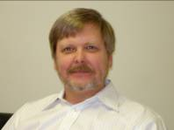
Jeff Lillycrop is Technical Director for Navigation, Coastal and Hydraulics Laboratory (CHL), Engineering Research and Development Center (ERDC), U.S. Army Corps of Engineers. He is the USACE representative and Co-Chair of the Interagency Working Group – Ocean and Coastal Mapping (IWG-OCM). As Chief of the Spatial Data Branch, Operations Division, at the Mobile District from 1996 to 2007, he was responsible for four programs and teams: (1) the USACE National Coastal Mapping Program as Director of the Joint Airborne Lidar Bathymetry Technical Center of Expertise (JALBTCX), a partnership between USACE, the U.S. Naval Meteorology and Oceanography Command, and the National Ocean Service; (2) the Silent Inspector National Support Center; (3) the Geographic Information System (GIS) support team for the Mobile District and support for others; and (4) contract collection and analysis of spatial data.

Jeff holds an M.S. in coastal and oceanographic engineering from the University of Florida. He has published over 50 papers related to airborne lidar surveying and mapping, sediment management, and other topics related to navigation and coastal engineering.

Roger L. Parsons – National Oceanic and Atmospheric Administration (NOAA)

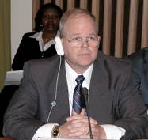
Roger Parsons serves as a coordinator for Integrated Ocean and Coastal Mapping (IOCM). He is responsible for coordinating mapping activities within NOAA and between NOAA and other federal mapping agencies. Parsons, a captain, retired from the NOAA Commissioned Corps in June 2006 following 31 years of active service. During his last three years, he served as director for the Office of Coast Survey and a U.S. national hydrographer.

As director of the Office of Coast Survey, Roger was responsible for managing all aspects of the nation’s nautical charting, hydrographic surveying, and nautical data collection and information programs. His operational and managerial experience with numerous programs throughout NOAA included service aboard six NOAA hydrographic survey and research vessels. He has conducted hydrographic survey operations along the U.S. Atlantic and Gulf Coasts, the Caribbean, and in Central America. His command tour aboard the Ronald H. Brown included a yearlong, around-the-world oceanographic and climate research cruise. Roger also served in the following positions: commanding officer for the NOAA Officer Training Center; chief of operations for the Atlantic Marine Center; NOAA liaison to the U.S. Naval Oceanography Command; acting chief of NOAA’s Hazardous Materials Response Division; executive officer of NOAA’s Office of Response and Restoration; and director of the NOAA Commissioned Personnel Center.

Roger earned a B.S. in oceanography and meteorology from the State University of New York Maritime College, an M.S. in public administration from the University of Southern Mississippi, and completed graduate studies in hydrography and oceanography at the U.S. Naval Postgraduate School.

John Haines – U.S. Geological Survey (USGS)

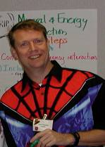
John Haines is the program coordinator for coastal and marine programs in the USGS and works at USGS headquarters in Reston, VA. His responsibilities include the following activities: program planning and implementation for the USGS Coastal and Marine Geology Program; coordination of broad USGS science activities in coastal and marine systems; and acting as the primary bureau representative in interagency activities leading to the development of coordinated coastal and marine programs. In the final role, he represents the USGS on the Joint Subcommittee on Ocean Science and Technology (JSOST) and its various working groups, and he co-chairs the JSOST Interagency Working Group on Ocean and Coastal Mapping (IWG-OCM). He also represents the USGS on the Interagency Task Force for the Extended Continental Shelf.

Prior to assuming his current responsibilities, John was a research oceanographer in the USGS Coastal and Marine Geology Science Center in St. Petersburg, FL. He led or participated in research programs that included regional studies of coastal erosion in the Great Lakes, hurricane impacts throughout the nation, and multi-agency investigations of wave and sediment transport processes on beaches. John has a Ph.D. in physical oceanography from Dalhousie University and joined USGS following a post-doctoral position with the Bedford Institute of Oceanography.

With one totally negligible exception, John has not been an active “mapper.” However, a substantial portion of his current efforts are directed at supporting and enhancing cooperative programs to provide comprehensive mapping products in coastal and marine systems.

Steve Kopach – Minerals Management Service (MMS)

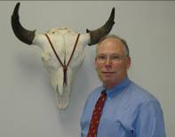
Steve Kopach is currently the chief of the Mapping and Boundary Branch of the MMS, Offshore Energy and Minerals Management, Division of Leasing. The Mapping and Boundary Branch (www.mms.gov/ld/Maps.htm) develops the marine cadastre, which includes the lease block grids and various offshore boundaries for MMS. This information provides the base for nearly all MMS offshore maps and leasing processes and gives MMS the means to define, describe, analyze, and account for every acre or hectare of Federal Offshore Submerged Lands. Steve is also currently a co-chair of the IWG-OCM, as well as co-chair of the FGDC Marine Boundary Working Group (MBWG). www.csc.noaa.gov/mbwg/

As part of Steve’s current responsibilities, he is working toward developing a Multipurpose Marine Cadastre (MMC) through the MBWG. The MMC is envisioned as a system to enable the boundaries of marine rights, responsibilities, restrictions, and interests to be recorded, spatially administered and managed, and physically defined in relationship to the boundaries of other neighboring or underlying rights and interests.

Before coming to MMS, Steve worked for the Bureau of Land Management and the USFWS, specializing in cadastral surveys and riparian boundary determinations. Steve is a licensed land surveyor in Indiana, Arizona, and Virginia, and he is a certified photogrammetrist.

Larry Mayer – Center for Coastal and Ocean Mapping

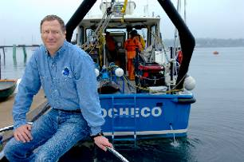
Dr. Larry Mayer has a broad-based background in marine geology and geophysics. He graduated magna cum laude with an Honors degree in geology from the University of Rhode Island and received a Ph.D. in Marine Geophysics from the Scripps Institution of Oceanography. At Scripps his schizophrenic future was determined as he worked with the Marine Physical Laboratory’s Deep-Tow Geophysical package, but applied this sophisticated acoustic sensor to problems of the history of climate. After being selected as an astronaut candidate finalist for NASA’s first class of mission specialists, Larry went on to a Post-Doc at the School of Oceanography at the University of Rhode Island where he worked on the early development of the Chirp Sonar and problems of deep-sea sediment transport and paleoceanography of the equatorial Pacific. In 1982 he became an Assistant Professor in the Dept. of Oceanography at Dalhousie University, continuing to work on problems of paleoceanography and the development of the Chirp Sonar. In 1991 he moved to the University of New Brunswick to take up the NSERC Industrial Research Chair in Ocean Mapping. In 2000 Larry became the founding director of the Center for Coastal and Ocean Mapping at the University of New Hampshire and the co-director of the NOAA/UNH Joint Hydrographic Center.

Larry has participated in more than 60 cruises (over 50 months at sea!) during the last 20 years and has been chief or co-chief scientist of numerous expeditions, including two legs of the Ocean Drilling Program. He has served on, or chaired, far too many international panels and committees and has the requisite large number of publications on a variety of topics in marine geology and geophysics. He is the recipient of the Keen Medal for Marine Geology and an Honorary Degree from the University of Stockholm. He was a member of the President’s Panel on Ocean Exploration and chaired a National Academy of Science Committee on national needs for coastal mapping and charting. He is co-chair of NOAA’s Ocean Exploration Advisory Working Group and a member of the National Science Foundation’s Advisory Committee for the Geosciences. Larry’s present research deals with sonar imaging and remote characterization of the seafloor as well as advanced applications of 3-D visualization to ocean mapping problems.

Sheila Semans – California State Coastal Conservancy

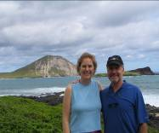
Sheila Semans has over seventeen years of experience working in environmental conservation, and has spent the last seven years at the California Coastal Conservancy most recently focusing on ocean management. As staff to the California Ocean Protection Council, Sheila is the program manager for the California Seafloor Mapping Program, and oversees over $19 million in state funds and grants devoted to mapping the territorial seas.

Sheila also manages the Coastal Ocean Currents Monitoring Program, the state’s $21 million investment in ocean observing infrastructure. In that role, Sheila has helped develop Ocean Science Applications, a state-led entity whose mission is to assure California has an integrated ocean-observing program that addresses the state’s management priorities. Sheila’s experience developing these highly collaborative programs has enabled her to work with all the marine labs throughout the state, universities, NGOs, and with local, state and federal agencies.

Anthony Wilbur – Massachusetts Office of Coastal Zone Management

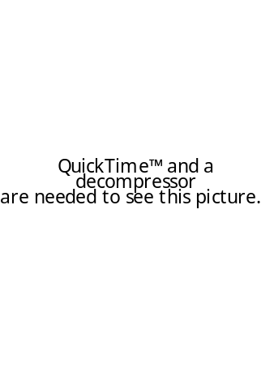
Anthony Wilbur is a marine ecologist for the Massachusetts Office of Coastal Zone Management (CZM). Since 2003, Anthony managed the CZM – US Geological Survey Seafloor Mapping Cooperative. The mapping cooperative mapped nearly 1,300km² of the seafloor environment in state territory from the New Hampshire border to Cape Cod Bay. CZM, USGS and other partners are now planning new mapping south of Cape Cod (e.g., Buzzards Bay and Vineyard Sound). The seafloor mapping cooperative is a successful partnership that leverages state, federal and private resources to achieve the goal of accomplishing geophysical mapping of all state waters. See http://woodshole.er.usgs.gov/project-pages/coastal_mass/ for updates.

Tony also serves as a member of the Gulf of Maine Mapping Initiative (http://www.gulfofmaine.org/gommi/). The Gulf of Maine Mapping Initiative (GOMMI) is a US-Canadian partnership of government and non-government organizations to conduct comprehensive seafloor imaging, mapping, and biological and geological surveys in the Gulf of Maine.

In addition to planning and implementing seafloor mapping surveys, CZM and GOMMI publish outreach material on the applications of seafloor mapping data to ocean resources management and promote a greater understanding of the ocean environment.

Steven Wolfe – Florida Department of Environmental Protection

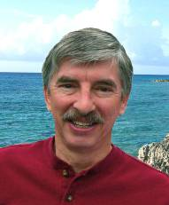
Steve Wolfe is a Program Administrator with the Florida Dept. of Environmental Protection (FDEP), Monitoring Coordinator for Florida’s Coastal Monitoring effort, and Liaison to the Florida Water Resources Monitoring Council. He is also the Water Quality Team lead for the Gulf of Mexico Alliance and Florida’s representative to the southeastern states/Department of Defense SERPPAS marine mapping team. Mr. Wolfe’s interests include coordination of coastal mapping, monitoring, and modeling in the waters around Florida and the Gulf of Mexico. Toward this end he co-chaired a workshop sponsored by FDEP, USGS, and SERPPAS in February 2007 to examine marine mapping efforts in Florida and establish priorities for mapping of Florida’s coastal waters.

Past lives include Liaison to the Florida Oceans and Coastal Council, Administrator of the FDEP Central Biology Laboratory, and stints in ecotoxicology, aquaculture, and boatbuilding. Steve has degrees in marine biology and biological oceanography from Florida State University.

Douglas L. Vandegraft – U.S. Fish and Wildlife Service


Doug Vandegraft is the chief cartographer for the U.S. Fish and Wildlife Service’s National Wildlife Refuge System in the Division of Realty in Arlington, VA. Doug received a B.A. in Geography and a minor in Cartography from Northern Arizona University, and he also received an associate’s degree in surveying and mapping science from University of Alaska-Anchorage. Doug previously worked as a cartographic technician for the Bureau of Land Management before transferring to the USFWS in Anchorage, Alaska in 1986. He became supervisor of the cartographic unit in 1990, and in 2000 Doug became chief cartographer at USFWS headquarters in Washington, D.C.

Doug currently represents USFWS on several multi-agency geospatial data coordinating bodies: the U.S. Board on Geographic Names; U.S. Baseline Committee; FGDC, as a member of the coordination group; subcommittee on cadastral data; and charter member of the Marine Boundary Working Group. He also belongs to the International Cartographic Association and the Interagency Cadastral Coordinating Council.

Other memberships include the American Congress on Surveying and Mapping (where Doug served as immediate past president of the Cartography and Geographic Information Society and a webmaster for their Web site) and Toastmasters International.

Jennifer Wozencraft – U.S. Army Corps of Engineers

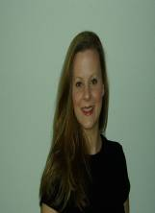
Jennifer Wozencraft is Director of the Joint Airborne Lidar Bathymetry Technical Center of Expertise (JALBTCX). She has worked for the U.S. Army Corps of Engineers (USACE) in the field of airborne lidar bathymetry and related technologies for the past 11 years. USACE Headquarters funds JALBTCX to execute its National Coastal Mapping Program (NCMP). This program is designed to provide regional coastal data, at engineering scales and on a recurring basis, to support regional sediment management and other USACE activities in the coastal zone. Since its inception in 2004, NCMP has collected airborne lidar topo/bathy and imagery data along the U.S. Gulf of Mexico, Atlantic, Great Lakes shorelines. GIS products generated from these data include topo/bathy DEMs, bare earth DEMs, vector shoreline, bottom reflectance images, and RGB and hyperspectral image mosaics. These data are available to the public through the NOAA CSC LDART website.

Jennifer earned her B.S. in Mathematics and Dance at the University of Alabama and her M.S. in Marine Sciences at the University of South Alabama. She is currently pursuing a Ph.D. in Marine Sciences at the University of Southern Mississippi.

Steven Rohmann – National Oceanic and Atmospheric Administration

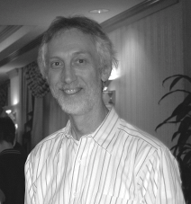
Dr. Steven Rohmann has been involved in the study and characterization of coastal ecosystems for over 30 years. His graduate research investigated the accumulation and migration of pesticides through a coastal watershed in southern Mississippi. He then led a project to characterize the types and amounts of pollution entering the Hudson River watershed. Since joining NOAA in 1988, Dr. Rohmann has been involved in assessing the impact of non-point sources of pollution to U.S. estuaries, developing several NOAA digital data products, including a GIS-based, Coastal Assessment Framework and Medium-resolution Vector Shoreline, and, since 1994, maps of U.S. shallow-water coral ecosystems. Steve currently leads NOAA’s effort to produce a map of approximately 13,000 sq km of southern Florida’s coral ecosystems. He has been involved in the production of similar maps in the U.S. Virgin Islands, Puerto Rico, Hawaii (including the Northwestern Hawaiian Islands), Guam, the Northern Marianas, American Samoa, and the Republic of Palau, and has developed a plan to map the Federated States of Micronesia and the Republic of the Marshall Islands. Dr. Rohmann has extensive experience in the use of remote sensing technologies to characterize the marine environment, including aerial photography and satellite imagery, LiDAR sensors, ocean color sensors, and acoustic sensors.

Steve holds a B.S. in Biology from Virginia Tech; an M.S. in Limnology from Tulane University; and a Ph.D. in Fisheries and Stream Ecology, also from Tulane University.

Bill Schwab – U.S. Geological Survey
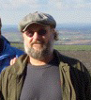
Dr. Schwab has over 30 years of experience as a research marine geologist/geophysicist with the U.S. Geological Survey (USGS). His research interests have included submarine slope stability and mobility of submarine mass movements, the formative processes of deep-sea fans, exploration of mid-ocean ridge neovolcanic zones, sedimentologic environment of central Pacific seamounts in relation to marine minerals research, and sedimentary processes in coastal and marine environments controlling coastal evolution. He led the development of the USGS Woods Hole Sea-Floor Mapping Group and currently serves as Chief Scientist, USGS Woods Hole Science Center, Woods Hole, MA. He is responsible for supervision of research and technical staff, coordination and integration of scientific projects with USGS directives and line management, and serves as USGS spokesperson in matters concerning coastal and marine geology, sea floor mapping technology, and scientific programs.

Bill received a B.A. in Geology from SUNY, Oswego; an M.S. in Geology/Geophysics from the University of Rhode Island; and a Ph.D. in Marine Geology from Duke University.

Stephen K. Brown – National Oceanic and Atmospheric Administration

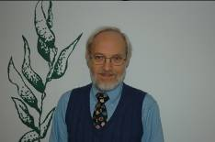
Dr. Stephen K. Brown is chief of the Assessment and Monitoring Division in the NOAA/National Marine Fisheries Service (NMFS), Office of Science and Technology. He received his Ph.D. in Ecology from Rutgers University, and conducted post-doctoral research on coastal ecology at Stanford University and fisheries at the University of Washington. His career at NOAA began with the National Ocean Service’s Biogeography Program in 1990, and he has been with the NMFS Office of Science and Technology since 1998. He has published reports and journal articles on habitat mapping and modeling, Essential Fish Habitat (EFH), and fish communities, primarily for the northwestern Atlantic.

The NMFS has numerous mandated responsibilities for managing the Nation’s living marine resources (LMRs), including fisheries managed under the Magnuson-Stevens Fishery Conservation and Management Act, and species protected under the Endangered Species Act (ESA) and the Marine Mammal Protection Act. The agency provides a wide range of scientific advice for management decision making, primarily focusing on the abundance and population dynamics of LMRs.

Information on habitat is an important component of the NMFS science program. The NMFS science centers are actively engaged in identifying and describing EFH and Critical Habitat for ESA-listed species, and in restoring habitat that has been damaged by anthropogenic or natural impacts. These activities require an understanding of species-habitat relationships, and quantitative analyses of the amount and condition of available habitat. Most of the geospatial data used in these analyses are developed through partnerships with other agencies or universities.

James E. Walker, Jr. – US Army Corp of Engineers

Jim Walker serves as the Navigation Branch Chief in Operations Division, HQUSACE, beginning this assignment in January 2007. Responsibilities include management of Inland and Coastal Navigation programs with an annual budget of just over $2B for studies, construction, operation and maintenance.
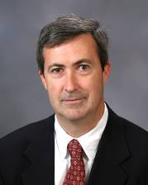
Prior to this assignment Jim served in the Corps of Engineers Mobile District as Assistant Chief of Operations Division where he helped manage one of the largest and most diverse Operations and Maintenance programs in the Corps.

Mr. Walker began his career with the Corps in 1976 as a college co-op student at the Mobile Area Office performing hydrographic surveys using lead lines and incrementally marked steel cables tied to pine poles. He has followed hydrographic survey developments and lidar based survey operations as well.

Mr. Walker holds a Bachelor of Science degree from the University of South Alabama and a Master of Science degree in Civil Engineering from Colorado State University. He is a graduate of the Army Management Staff College and is a registered Professional Engineer in the State of Alabama.

Barbara Reed – Naval Oceanographic Office
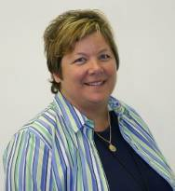
Barbara is the Director of Production Management at the Naval Oceanographic Office (NAVO) at Stennis Space Center, MS. Production at NAVO encompasses ocean and acoustic measurement, modeling and forecasting, bathymetry, hydrography, and numerous specialized geospatial production efforts in support of global naval operations provided on strategic, operational, and tactical timelines.

While the Navy’s mission is primarily global rather than national, partnerships and leveraging in technology, processes, standards, training, and policy for ocean and coastal mapping issues are extremely important to effectively use the limited resources of all participants. Examples such as our participation in Homeland Defense surveys and production, Joint Airborne Lidar program, as well as developing standards for various national and international scientific committees are a few of the ways we participate and contribute on a national level. As a past Hydrography Department director and Director of Oceanographic Operations for Navigation, her interest and experience in ocean and coastal mapping fits well with this venue.

Barb has a Bachelor of Science degree from Florida Institute of Technology and a graduate degree in Geophysical Engineering from the Colorado School of Mines. She has 25 years experience at the Naval Oceanographic Office managing, collecting, processing, and validating geophysical, hydrographic and oceanographic data and products.

Renee Orr – Minerals Management Service
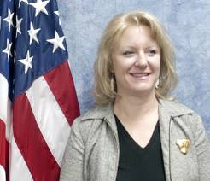
Ms. Orr has been Chief of the Department of the Interior’s Minerals Management Service Leasing Division since 2002. The Leasing Division develops and implements the Nation's Outer Continental Shelf (OCS) oil and gas leasing programs to achieve national economic and energy policy goals, manages the OCS Marine Mineral Program, and maintains the various maps, legal descriptions, and measurements defining U.S. offshore boundaries.

Ms. Orr has B.A. degrees in History and Economics from the Metropolitan State College of Denver. She began her career with MMS in the Minerals Revenue Management Program and has worked in MMS’s Policy and Management Improvement office as well as the Office of International Activities and Marine Minerals.

Christopher Fox – National Oceanic and Atmospheric Administration

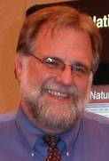
Dr. Christopher Fox has served as Director of NOAA’s National Geophysical Data Center (NGDC) in Boulder, Colorado since April 2004, after serving as Acting Director beginning December 2002. NGDC is the national repository for marine geology and geophysics data, global bathymetry, and NOAA hydrographic products, with additional responsibilities in space physics, satellite data processing, whole earth modeling, and large-scale data management systems. Since arriving at NGDC, Dr. Fox has overseen the move of NOAA's Comprehensive Large-Array data Stewardship System (CLASS) operational site to NGDC, a significant expansion in tsunami-related data activities following the December 26, 2004 disaster in the Indian Ocean, the adoption of responsibilities for the Nation's magnetic field modeling, the establishment of a dual site for GPS-CORS observing system collection, and the revitalization of other areas of NOAA's mission especially ionosphere characterization and bathymetric/hydrographic support. NGDC is also home to four World Data Centers and the International Hydrographic Organization Data Centre for Digital Bathymetry (IHO-DCDB).

Before joining NGDC, Dr. Fox served as a Principal Investigator within the VENTS Program of NOAA's Pacific Marine Environmental Laboratory from June 1985 to April 2004. He led a diversified program in marine mapping, geophysics, and underwater acoustics. Dr. Fox also held an appointment as an Associate Professor (Courtesy) at Oregon State University's College of Oceanic and Atmospheric Sciences. Prior to his service with NOAA, Dr. Fox worked for the U.S. Naval Oceanographic Office in Bay St. Louis, Mississippi, where he participated in a wide variety of studies including the numerical modeling of seafloor microtopographic roughness and the development of automated cartographic mapping from multibeam sonar systems. Prior to joining NAVOCEANO, Dr. Fox worked within the U.S. Geological Survey developing numerical simulations of geothermal reservoir dynamics. He holds a Ph.D. in Marine Geophysics from Columbia University’s Lamont Doherty Earth Observatory.

John McDonough – National Oceanic and Atmospheric Administration
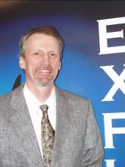
John McDonough served as a physical scientist with NOAA’s National Ocean Service from 1989 to 2002, where he developed data and geographic information systems related to coastal and marine environments, and applied that information to help prepare management plans for marine protected areas. From 1998 to 2002, John was the project manager for large-scale undersea research expeditions using a variety of tools and techniques, including manned and unmanned submersibles. Specific efforts include the Sustainable Seas Expeditions, a joint endeavor between NOAA and the National Geographic Society to explore the system of National Marine Sanctuaries managed by NOAA’s National Ocean Service. Mr. McDonough initially joined the NOAA Office of Ocean Exploration as the Operations Coordinator in January 2003, and has been the office's Deputy Director since 2005. He is committed to exploring and learning more about natural systems in marine and coastal areas, and providing the data and information required for effective ecosystem-based management.
John received his master’s in Environmental Science and Policy from the Johns Hopkins University in Baltimore, MD in 1998, and a B.S. in Coastal Geomorphology from the University of Maryland in 1989.
Roger Johnson - National Park Service (NPS)

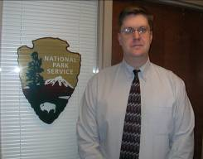
Roger Johnson is the Chief Cartographer for the Land Resources Division (LRD) of NPS. He is responsible for coordinating all land status and acquisition mapping activities within NPS. Beyond nationwide cartographic services Roger manages the digital data development, distribution, and archiving of all LRD's ownership and boundary information. Additionally, Roger maintains an online archive of the legal documentation associated with every NPS unit including legislation, deeds, legal descriptions, and metadata. As a result of these activities Roger often serves as the NPS representative on interagency committees and government working groups whose goals are the coordination, standardization, and integration of geospatial data.

Prior to coming to NPS Roger served for eight years with NOAA's Office of Coast Survey. Beginning his career as a production cartographer, Roger was fortunate to have the opportunity to develop several of the tools used by the Marine Charting Division in the production of their raster and electronic nautical charts. He also played a primary role in the design, creation, and public testing of prototype and new concept nautical charts. As a result of these activities, Roger ended his tenure with NOAA managing the Coast Survey Development Laboratories, Cartographic and Geospatial Technology Program.

Roger holds degrees in Geography and Physical Science from California State University as well as professional certifications from numerous industry leading software vendors including ERSI, Autodesk, ERDAS, MicroStation, and Microsoft.

Margaret A. Davidson – National Oceanic and Atmospheric Administration

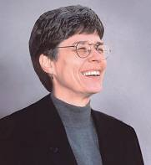
Margaret A. Davidson has served since 1996 as the Director of NOAA’s Coastal Services Center, a national enterprise established to accelerate access to the science and technology capabilities of NOAA and its partners to improve coastal and ocean resource management as practiced at state and local levels. From August 2000 to October 2002, Margaret also served as the Acting Assistant Administrator of NOAA for Ocean Services and Coastal Zone Management. Before coming to NOAA, Margaret served sixteen years with the South Carolina Sea Grant Consortium, thirteen as the Executive Director. She began her coastal career as an Assistant Attorney General and Special Counsel for the Louisiana Department of Justice.

Ms. Davidson holds a MMA from the University of Rhode Island and a JD from Louisiana State University. She has served in positions of leadership for several national and professional organizations, regularly teaches a graduate level multi-disciplinary course, and is frequently requested to serve as a facilitator and presenter for civic and professional organizations.

Her professional interests include climate and weather variability and its impact on coastal resources, integrated coastal management, and aquaculture and fisheries management. She was a Fulbright Scholar for coastal resource management at Prince of Songkhla University, Thailand in 1992-93.

Brian Midson – National Science Foundation

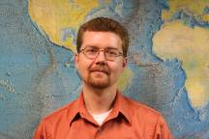
Brian Midson is an Assistant Program Director at the National Science Foundation (NSF), in the Division of Ocean Sciences. He received his B.S. in Oceanography from the University of Washington in 1991, and his M.S. in Oceanography from the University of Hawaii in 1999.

Before coming to NSF, Brian was the manager of the Data Department for the Hawaii Undersea Research Laboratory at the University of Hawaii, Manoa. His duties included coordination of science activities for the $3M/yr. program and participating in the Loihi submarine volcano research project. Brian has been at NSF since 2001, when he joined the Marine Geology and Geophysics Program. Since 2004 Brian has been working directly with the Ocean Sciences Division Director fulfilling the needs of various programs across the division. Most recently, Brian rejoined the MGG program, assuming the duties of the lead program director for a nine-month detail. In the future, Brian will be heavily involved with managing the National Deep Submergence Laboratory, whose assets include the human occupied vehicle, Alvin, and the remotely operated vehicle, Jason-II, as well as other towed and autonomous mapping instruments.

NSF supports Ocean and Coastal mapping efforts through grants to individual investigators to conduct basic science. The mapping products include bathymetry, sub-bottom profiling using a variety of geophysical techniques, and many water column properties. The preponderance of mapping efforts at NSF are funded through the Division of Ocean Science; however, the Division of Earth Science, other Directorates, and the Office of Polar Programs support some mapping efforts as well.

Samuel Y. Johnson – U. S. Geological Survey

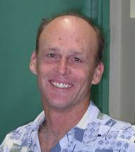
Sam Johnson is the Chief Scientist of the U.S. Geological Survey Western and Coastal and Marine Geology Team (WCMG). WCMG consists of approximately 110 staff members located in Santa Cruz and Menlo Park, CA, conducting multidisciplinary geological research in marine and coastal environments in the US Western Region (California, Oregon, Washington, Hawaii, Alaska). Active WCMG work involves seafloor and benthic habitat mapping, geologic framework, ecosystem function and restoration, sediment and contaminant budgets and transport, coastal evolution, coastal erosion, earthquake and tsunami hazards, coral reef health, coastal and marine climate-change impacts, coastal groundwater, marine energy and mineral resources, and related topics. WCMG staff has been active in helping organize and conduct State Waters Mapping efforts for California, Washington and Oregon.

Sam earned a B.A. in Earth Sciences from the University of California, Santa Cruz, and M.S. and Ph.D. in Geological Sciences from the University of Washington. He joined the USGS in 1984 after serving as Assistant Professor at Washington State University. Prior to his current position, he conducted research on sedimentology, basin analysis, and earthquake hazards, and managed the USGS Evolution of Sedimentary Basins Program.

William (Quin) Robertson – American Shore and Beach Preservation Association

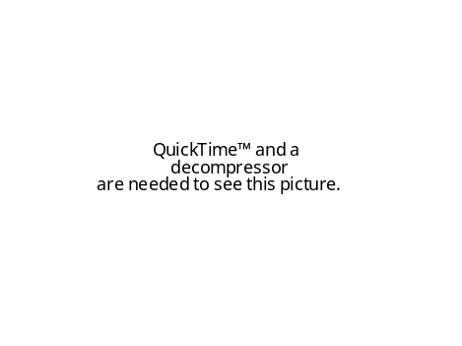
William “Quin” Robertson is a Coastal Geologist with Coastal Planning & Engineering, a corporate member of the American Shore and Beach Preservation Association (ASBPA). Dr. Robertson’s research focuses on using land based and remote sensing data to quantify change in coastal morphology and develop models from these results using geographic information systems to aid in coastal mitigation. Recent studies include extracting shorelines from LIDAR data, investigating the relationships between shoreline migration and volume change, using airborne laser bathymetry to locate the depth of closure, and analyzing shallow-water seismic data to identify sand resources.

Since 1926, ASBPA has represented the scientific, technical, and political interests along the coast in an effort to shape national coastal research and policies that promote responsible stewardship of America’s coastal resources. ASBPA’s members rely on numerous coastal data sets to answer scientific questions that lead to solutions on how to protect and sustain America’s coastlines. There is significant need for continuous coastal monitoring along with a central source to house the vast coastal data sets that have been collected and those data that will be collected in the future.

Anthony Niles – Army Corps of Engineers
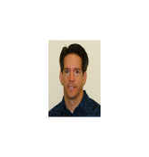
Anthony Niles has worked at the U.S. Army Topographic Engineering Center in the Engineer Research and Development Center since 1985, and is currently a senior program manager in the Geospatial Applications Branch. He has conducted research and development projects in mapping and geospatial database management in support of the Corps of Engineers Civil Works mission. Currently, Tony is directing web-based mapping initiatives for Corps Headquarters to disseminate information on Corps civil works projects, the National Inventory of Dams, and is coordinating the Corps initiative to develop and produce Electronic Navigational Chart Data on all navigable inland, coastal, and Great Lakes waterways of the U.S.

Tony has a B.S. in Mechanical Engineering from Old Dominion University, and an M.S. in Mechanical Engineering – Computer Aided Design from George Washington University.

Steven R. Barnum – National Oceanic and Atmospheric Administration

Captain Steven R. Barnum, NOAA, is the Director of the Office of Coast Survey (OCS) of the U.S. National Oceanic and Atmospheric Administration (NOAA) and the official U.S. National Hydrographer. In this position Captain Barnum heads the oldest government scientific organization in the United States, having its foundation as far back as 1807 when President Thomas Jefferson established the Survey of the Coast. Today, Coast Survey carries on this proud tradition by continuing to produce the navigational products that are required for the safe and efficient maritime commerce in and out of our Nation's ports.

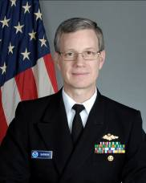
Captain Barnum began his career with NOAA in 1980 when he was commissioned as an Ensign in the NOAA Corps. He has specialized in Coast Survey mission objectives for the most part, including more than eight years of hydrographic field operations aboard five NOAA ships. His ship assignments include Commanding Officer of the NOAA Ship THOMAS JEFFERSON; Commanding Officer of the NOAA Ship WHITING, which conducted numerous Homeland Security surveys for the U.S. Navy in the wake of the September 11, 2001 attacks; Executive Officer of the NOAA Ship WHITING, Operations Officer of the NOAA Ship DAVIDSON and Operations Officer of the NOAA Ships RUDE and HECK. His shore assignments include Chief of the Navigation Services Division; Navigation Manager for the northeast United States; Executive Director, NOAA Marine and Aircraft Operations; Chief, Electronic Engineering Branch; and Chief of the Computer Support Branch for NOAA Commissioned Personnel where he oversaw the development and integration of an Oracle-based personnel system with image archiving.

Captain Barnum was raised in New Orleans, Louisiana, and holds a B.S. in Electrical Engineering from Louisiana Tech University; a B.S. in computer Science from University of Maryland; and an M.S. in Software Engineering from Johns Hopkins University. Captain Barnum has received numerous awards including two United States Department of Commerce Silver Medals, the NOAA Corps Commendation Medal, the United States Coast Guard Achievement Medal, and several NOAA Sustained Superior Achievement Medals.

Nicholas (Miki) Schmidt – National Oceanic and Atmospheric Administration
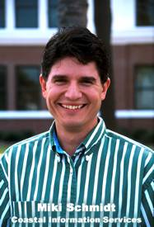
Miki Schmidt began his career at the NOAA Coastal Services Center in 1996. After serving as a manager of the Center's geographic information systems (GIS) program for four years, Schmidt became deputy branch chief of the Coastal Geospatial Services branch, which leads the Center's GIS, remote sensing, habitat, and hazards activities. In 2004, he was named chief of the branch.
An expert in geospatial technologies, Schmidt has had a long career with the federal government. From 1988 to 1991, he served as a civilian remote sensing scientist for the U.S. Army's Strategic Defense Command. He then worked for NASA's remote sensing program until 1996, working with the private industry to develop remote sensing products.
Schmidt holds a master's degree in Geography and a bachelor's degree in Marine Science, both from the University of South Carolina.

David B. Zilkoski – National Oceanic and Atmospheric Administration

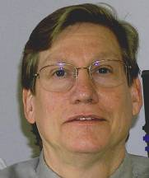
David B. Zilkoski received a B.S. in Forest Engineering from the College of Environmental Science and Forestry at Syracuse University and an M.S. degree in geodetic science from The Ohio State University. He has been employed by NOAA since 1974. He is currently the Director, Office of the National Geodetic Survey.

Under the auspices of the Federal Geodetic Control Subcommittee, Dave evaluates new leveling instrumentation, e.g., electronic digital bar code leveling systems. Based on instrument testing, he develops and verifies new specifications and procedures to estimate classically-derived, as well as GPS-derived, orthometric heights. Under his leadership, NGS has developed and transferred new positioning technologies such as the Shallow Water Positioning System (SWaPS) for monitoring underwater features, GPS-equipped buoys, the incorporation of geodetic data and procedures into restoration projects for determining accurate elevation models, and the use of new geodetic and remote sensing technology such as GPS, LIDAR, and IFSAR to generate shoreline and other coastal information for managers.

Dave has authored a number of publications on coastal subsidence, surveying, and vertical datum including a chapter in The DEM Users Manual (2001, The American Society for Photogrammetry and Remote Sensing, Bethesda, MD, David F. Maune, ed.). He is also a guest lecturer at the University of California at Riverside. He is Chair of the MTS Marine Geodetic Information System Committee; a past President of the American Association for Geodetic Surveying; a member of the American Geophysical Union, Maryland Society of Surveyors; and a fellow of the American Congress on Surveying and Mapping and the International Association of Geodesy.

John Brock – U.S. Geological Survey

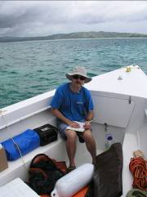
John Brock is a USGS scientist stationed in St. Petersburg, Florida and attached to the Coastal and Marine Geology Program. His research is focused on the physical structure, biological - ecological functioning, and processes of temporal change within diverse coastal ecosystems, including coral reef tracts, barrier islands, and wetlands. His work emphasizes the use of aircraft lidar and multi-spectral imaging to study ecosystem geomorphology, topographic complexity, and habitats at spatial scales fine enough to capture community structure. Through partnerships with NASA and the NPS, these capabilities have been applied to undertake detailed benthic characterizations of portions of the Florida reef tract within Biscayne National Park, the Florida Keys National Marine Sanctuary, Dry Tortugas National Park, and the U.S. Virgin Islands Coral Reef National Park and a number of other coastal ecosystems. His USGS projects are developing and applying new coastal remote sensing, mapping and site monitoring tools that constitute an integrated package of instrumentation and software in support of decision-making by management authorities aimed at the conservation and the sensible use of coastal ecosystems.

John received a B.S./B.A. in Geology and Psychology from the University of Delaware; an M.S. in Geology from the University of Georgia; and a Ph.D. in Geological Sciences from the University of Colorado.
Bill Sargent – Florida Fish and Wildlife Conservation Commission

Bill Sargent is a Florida Fish and Wildlife Conservation Commission (FWC) research scientist who has been mapping and assessing Florida coastal systems since the early 1980's. The mission of the FWC is managing fish and wildlife resources for their long-term well-being and the benefit of Florida’s citizens and visitors. The FWC strives to use the best science and information available in addressing fish and wildlife issues, habitat issues, and the complex human dimension aspects of conservation. The FWC has a long history of pioneering geographic information systems in the management of ocean and coastal resources.
The Geospatial Assessment of Marine Ecosystems (GAME) program is a data cataloging effort that serves as a foundation for a spatial data framework supporting ecosystem-based management through regulatory, planning, and intergovernmental coordination activities. GAME was initiated in collaboration with the Florida Department of Environmental Protection and is now being implemented in collaboration with the U.S. Environmental Protection Agency and the Florida Institute of Oceanography. GAME directly addresses needs identified by the U.S. Commission on Ocean Policy, supports objectives of the U.S. Environmental Protection Agency’s Strategic Plan, is being implemented as part of the Gulf of Mexico Alliance/ Governor’s Action Plan, and is coordinating with the USACE, USGS, and NOAA partnership implementing the Priority Habitat Information System (PHINS). GAME provides PHINS with access to metadata describing current and historic state, federal and local projects in the Gulf of Mexico and throughout Florida.

Jonathan E. Westcott – Federal Emergency Management Agency FEMA)


The National Flood Insurance Program (NFIP) was created by Congress to lessen the negative effects of floods on the Nations’ population. The Federal Emergency Management Agency’s (FEMA’s) Mitigation Directorate administers the NFIP and is committed to reducing the loss of life and property through a three pronged approach to hazard mitigation: Risk Analysis, Risk Reduction, and Risk Insurance. One of the Risk Analysis Division’s responsibilities is the identification and mapping of flood hazards nationwide, including coastal flood hazards.

Jonathan E. Westcott, P.E., is a Program Specialist in FEMA’s Mitigation Directorate, Risk Analysis Division, Engineering Management Branch. Jon has been working for the NFIP for 8 years as both a contractor and a Federal employee. He has been with FEMA since July 2006.

Michael P. Ouimet – Texas Department of Information Resources
(Representing National States Geographic Information Council – NSGIC)


Michael (Mike) Ouimet has worked professionally more than 23 years in a variety of positions in GIS technology, city planning and transportation planning. Mike is the Texas State GIS Coordinator (1997 – present). He is employed by the Texas Department of Information Resources, and works for the Chief Technology Officer of Texas. Mike has managed numerous GIS projects in that role. As State GIS Coordinator Mike is a member of the Texas Geographic Information Council (TGIC) and is the Administrative Chair of TGIC.

Mike is also a member of the National States Geographic Information Council (NSGIC) whose membership focus is State GIS Coordinators and State GIS Coordination Councils. Over the past several years NSGIC and NOAA have been actively engaged in efforts to coordinate state GIS activities with NOAA programs. Mike has been actively involved in several NSGIC committees and functions including
The NSGIC Board of Directors, Board Treasurer, Finance Committee, and NSGIC Geospatial Emergency Preparedness Committee.

Prior to working as Texas State GIS Coordinator, Mike was employed by the City of Austin, Texas (1985-1990) in three positions as a GIS/IT analyst, city planner, and senior transportation planner working on the city’s long-range comprehensive plan and land development issues. From 1990 to 1997, Mike worked as the Principal Planner for the Capital Metropolitan Transportation Authority where he was the program lead for a variety of projects including light rail system planning, transit corridor planning, capital facilities development, long-range planning, and the GIS and statistics group. Mike led the team that installed the agency’s first GIS that was used extensively for analyzing corridor demographics and land use characteristics for light rail transit service.

Mike holds an M.S. in Community and Regional Planning from the University of Texas and a B.A. in Geography / City Planning from Northern Michigan University.

John M. Palatiello – Management Association for Private Photogrammetric Surveyors (MAPPS)

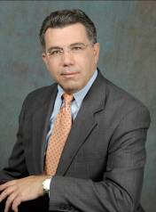
John M. Palatiello is Executive Director of the Management Association for Private Photogrammetric Surveyors – MAPPS (www.mapps.org), an association of private firms in the geospatial field. He is also President of the firm of John M. Palatiello & Associates, Inc. (www.jmpa.us), a public affairs consulting firm located in Reston, Virginia, providing government affairs and association management services to firms and organizations in the geospatial, engineering and mapping related fields. He serves as Administrator of the Council on Federal Procurement of Architectural-Engineering Services (COFPAES, www.cofpaes.org), a coalition of the nation’s leading design professional societies.

In 2008, Interior Secretary Dirk Kempthorne appointed Mr. Palatiello to the National Geospatial Advisory Committee.

John has long been involved in public policy issues affecting the geospatial community. He was the first Joint Government Affairs Director of the American Congress on Surveying and Mapping (ACSM) and the American Society for Photogrammetry and Remote Sensing (ASPRS) and was Assistant Executive Director of ACSM. He was appointed to an advisory committee to the Virginia state legislature to create the Virginia Geographic Information Network (VGIN), and was a member of a study committee on licensing of Photogrammetrists that made recommendations to the Virginia Board of Architects, Professional Engineers, Land Surveyors, Certified Interior Designers and Landscape Architects (APELSCIDLA). He is also a member of the Board of the Institute for Geographic Information Systems Studies (IGISS), a non-profit education and research institution.

A Connecticut native, John has a degree in political science from The American University in Washington, DC. He served for eight years as a Congressional staff assistant, including service as an aide to former Congressman John Myers (R-IN) and former Congressman Bill Hendon (R-NC). John has served as Chairman of the Procurement and Privatization Council of the U.S. Chamber of Commerce, and currently serves on the Chamber’s Small Business Council. He was also Chairman of the Business Coalition for Fair Competition, an organization of more than two dozen associations that promote policies and legislation that seek to focus government on its core mission, while curbing government commercial activities. He is a member of the American Society of Association Executives (ASAE), on which he has served on its Government Relations Section board of directors.

Krista Collier — Federal Emergency Management Agency (Contractor)


Krista Collier is a Coastal Technical Specialist for Michael Baker Jr Inc., the National Service Provider for the Federal Emergency Management Agency’s (FEMA’s) National Flood Insurance Program (NFIP). She performs and conducts reviews of coastal engineering analyses related to flood insurance studies, has led efforts to update to FEMA’s Coastal Guidelines and Specifications for flood studies for the Atlantic Ocean and Gulf of Mexico and Great Lake coasts and has consulted on coastal flood hazard mapping projects. Krista is experienced with coastal flood hazard analyses including dune evaluation and erosion, wave height, and wave runup, and is knowledgeable of NFIP policies and regulations.

Krista is a member of the Association of State Floodplain Managers (ASFPM) and has assisted FEMA in the presentation of new coastal methodologies and guidelines at the ASFPM annual conference. Krista obtained her M.S. in Marine Sciences, with a focus on Geological Oceanography, from Stony Brook University.

Charles (Charly) Alexander – National Oceanic and Atmospheric Association

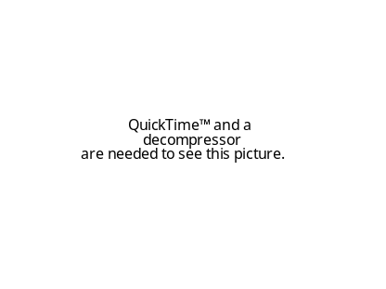
Charles (Charly) Alexander is currently the Operations Division Chief at NOAA’s new Integrated Ocean Observing System (IOOS) Program Office in Silver Spring, Maryland. His job is to manage the technical coordination and execution of IOOS within and across NOAA and in collaboration with regional IOOS partners. His principal focus is managing the IOOS Data Integration Framework – a three-year project to test the hypothesis that integrated and interoperable data can make a measurable difference when the data are applied in a decision-making context such as a forecast model. He also chairs the Program’s Integrated Products Team – a 40+ member, cross-NOAA team of technical experts on data management, transport, and integration.

In 1985 Charly joined NOAA as a Presidential Management Intern from Louisiana State University after he completed a joint master’s program in Marine Science and Public Administration. Before joining the IOOS Program he served in a variety of technical and management positions, including almost a decade with NOAA’s National Marine Sanctuary Program, where he managed an interdisciplinary division to support the 14 sanctuary sites. Charly’s work on GIS and mapping in the Sanctuary Program included detailed work on marine boundaries, GIS data standards, and close collaboration with NOAA Coast Survey and others to better define and map the sanctuaries. Through this work he also participated with NOAA colleagues to frame the foundations of NOAA’s priorities and requirements for Integrated Ocean and Coastal Mapping.

Charly was a NOAA Sea Grant Fellow from LSU in 1983 when he worked as a Legislative Assistant to then-Congressman John Breaux (D-LA) on Capitol Hill. He received his BA in Biology-Geology from Whitman College in Walla Walla, WA where he was selected as a Thomas J. Watson Fellow for a year of independent study and research his senior year.

Carol Jeffords – LEAD Alliance, Inc.


Carol Jeffords serves as the editor and administrative assistant for LEAD Alliance, a business that provides organizational development, consulting, and facilitation services. She provides editing and and and proofreading services for LEAD Alliance clients as well as for any internal documents – including proposals, letters, and summaries – that go out to customers. Carol also provides administrative support for meetings, focus groups, workshops, and conferences. That administrative support may include scheduling, meeting planning, and development of tools and materials, as well as on-site logistical support.

Carol holds a B.A. in History from Washington State University. She has worked as an intelligence analyst at CIA, and in the training offices of MITRE Corporation and TRW. She has over eight years of experience in providing administrative and logistical support for LEAD Alliance clients and projects.

Carol is a fan of mystery novels, college football and basketball, and working out at the gym. She is also an enthusiastic international traveler who has adopted the motto you can’t have a favorite place until you’ve seen them all.

Tricia Gibbons – LEAD Alliance, Inc.

Tricia Gibbons is President of LEAD Alliance, Inc., a small woman-owned business celebrating its 15th Anniversary. Tricia has over 25 years of experience in the private, education, and federal sectors designing and facilitating organization and team development interventions. She works with organizations in planning, organizing and facilitating professional conferences and workshops.

Tricia has facilitated initiatives focusing on strategic visioning, tactical work plan development, public policy mediation, problem solving, customer service strategy, and organization transformation. She works collaboratively with her clients to design and facilitate stakeholder outreach sessions as well as community meetings. Her facilitated sessions are characterized by the climate she creates for collaboration and by her innovative approach to process facilitation.

Tricia earned a B.A. from SUNY at Oswego and a M.Ed. from Northeastern University in Boston. She holds Certificates in Training and Development as well as Organization Development and Change Management from Georgetown University. Recent client engagements include: IWG – Ocean and Coastal Mapping Technical Workshop, DOI Information Technology Management Council, Abrupt Climate Change FACA Committee, FGDC Future Directions Initiative, and USGS Science Information Management Workshop.

Tricia enjoys playing golf, walking or reading on the beach, and working out at the gym. Favorite escapes include Florida in the winter, Cape Cod in the summer and Italy any time of the year.

