Plating of Transformation Stocks Protocol

Version Number: 4.2
Production Start Date: 03/11/03
Version 4.2 Date: 06/01/04
Author: Damon Tighe, Tijana Glavina
Reviewed/Revised by: Lena Philip

Summary
Upon receiving transformation stocks from the Library Creation group, the transformation stocks are plated onto 254 x 254mm dry bioassay agar plates using glass beads. The plates are then incubated for 18 hours in preparation for colony picking on the QPix instruments.

Materials & Reagents

Materials/Reagents/Equipment  Disposables  6mm Glass Beads, Soda Lime  15-ml Centrifuge Tube  50-ml Centrifuge Tube  10-ml Serological Pipet  Safe-Lock 2.0-ml Microcentrifuge Tubes  Reagents  LB Amp 100 X-gal plates (254mm)  LB Chlor 20 X-gal plates (254mm)  LB Chlor 12.5 X-gal plates (254mm)  LB Kan 30 X-gal plates (254mm)  SOC medium, 20ml/vial  Pure Bright Germicidal Bleach  100% Ethanol (200 Proof)  Milli-Q Water  Equipment  EDP3 Electronic Pipette  Easypet | Vendor  Fisher  Corning/VWR  Corning/VWR  Falcon  Eppendorf  Teknova  Teknova  Teknova  Teknova  Teknova  Monahan Paper Company  AAPER Alcohol (LBNL)  Millipore Milli-Q System  Rainin  Eppendorf | Stock Number  11312D  430052  430290  357551  22363395  L4902  L4415  L4908  L4013  S1625  775011  6810-13289  -  -  -

Procedure
NOTE 1: Your supervisor will notify you by email on which Libraries you will be plating.
NOTE 2: Always clean surfaces with 70% ethanol before placing the bioassays on them.

1. Using the Database to Select Libraries
  - In the Venonat database, click on Libraries DB → select Choose Plating Queue (Step 4-Plating- in Library Support Database)→ select what type of Library you will be plating (i.e. Whole genome, Evolutionary genomics, All others) → click on SUBMIT.
  - Upon submitting the queue, a new window titled Select Libraries for Plating will open that contains all of the libraries possible to plate in that Library type (Refer to Figure 1 in Appendix A).
  - You will select which libraries to plate and how many based upon the number of 384-well plates that are needed by each library. Generally, each bioassay produces two and a half 384-well destination plates.
  - As you select what libraries you are going to plate, fill in your initials and the number of barcodes needed (corresponding to the number of bioassays).
  - Once you have a sum of 20 – 40 bioassays worth of libraries to plate, highlight your library selections using the cursor → go to FILE → PRINT → SELECTION → PRINT.
NOTE: This page will be helpful as you search for your libraries in the freezer as well as with the following steps. Put this copy in your lab notebook.
  - Click on SUBMIT.
NOTE: Print this page. This page will give you the following information: library name, antibiotic, vector, total plates needed, total plates created, additional plates needed, total suspension volume, plating stock volume and SOC volume.
  - The next screen will have a link to print off your barcodes, select this link. On the barcode printing page, select SATO 4 as your barcode printer and submit (SATO 4 is on counter I of Rm139). Put the barcodes on your lab bench, you will be affixing them to dry bioassays later.
NOTE: If the barcodes did not already print, press the Online button of the machine. Once your barcodes have printed press Online again to take the machine off line and then Feed in order to give enough barcodes that you can tear the strip off. If you do not take the barcode printer offline before pressing Feed, the printer will print multiple copies of your last barcode. The barcodes should have the library name and bioassay number on them.

2. Drying Bioassays
NOTE: When transporting the bioassays on a cart, make sure to wipe the cart down with a 70% ethanol and a paper towel.
  - Remove the desired number of sleeves of bioassays containing the correct antibiotic from the 4ºC deli.
NOTE: For pUC18 and pMCL200 libraries, plate 1 bioassay per 2.5 destination plates needed. For example, if a library needs 6 destination plates, you will only need to plate 3 bioassays (approx. 1:2.5 ratio). For pcc1Fos libraries, plate 1 bioassay per destination plate (1:1 ratio).
  - Check expiration dates on each sleeve. Use the oldest ones first. Do not use anything that has expired.
  - Wearing gloves, slice open each sleeve on a clean workspace.
  - Examine plates for contamination and irregularities (Irregularities: agar cracked, uneven agar levels, too much or too little agar on plate etc.). Refer to Figure 2 in Appendix A. If the plates are unusable, fail the plates out of the system and pass them to QC for further testing.
NOTE: To fail the plates by lot number go to Venonat → Libraries DB → Enter Failed/Not Used Bioassay Barcodes and Lots. Enter in operator, failure mode, lot #, and additional comments. Bring the bioassay to QC once it has been failed.
  - Dry the outside of the plates with a paper towel and tilt the plates on their side and drain any excess liquid from the plate into the trash.
  - Place the plates with their lids down and ajar in the three “Drying Only” 37ºC incubators located in Rms139 and 146, so that as the plate warms, moisture can escape.
Important! Do not place any of the plates against the back of the incubator where hot air is blown out of vents. Placing plates in the back will cause them to dry non-uniformly and can affect the flatness of the agar surface making them difficult for the QPix machines to image.
NOTE 1: If you use LB Chlor 20 X-gal plates and/or LB Chlor 12.5 X-gal plates, label the sides of the bioassays in order to differentiate between the two different types.

NOTE 2: The bioassays should be stacked 3 per shelf and 13-14 per incubator.
  - Check the incubators every 15 minutes to see which bioassay plates are dry (plates dry at different rates, based on their location in the incubator).
NOTE: Drying time can take approximately 1-2 hours.
  - Take out all of the plates that do not contain droplets of moisture on the agar surface. If any plates still have liquid on their surface, leave them in the incubator for further drying.
Important! The bioassays you plate must be completely dry, otherwise the extra moisture will prevent the proper absorption of the plating mix and make the plates unpickable. Be careful not to over dry the plates - over drying may interfere with proper spreading of colonies as well. Examine each bioassay carefully for irregularities or contamination before use.
  - Once you have all of your bioassays, stack them into sets of 20 with their lids down.
  - Place the plates upside down with the antibiotic label facing you. Affix the barcodes to the right side of the plate.
3. Finding your transformation stock
NOTE 1: The following steps can be performed while the bioassays are drying.
NOTE 2: If more than one transformation stock is needed, the stocks must come from the same transformation event and date.
  - Transformation stocks are found in the -80ºC freezer at the end of bay BC in Rm139. Bring an insulated bucket full of ice in which to put your transformation stocks.
  - Using the Select Libraries for Plating sheet printed out in step 1.2 and the column labeled Location, look for the box containing your transformation stock. Inside each box are multiple transformation stocks with their library name on the cap and you will need to hunt through them to find your libraries:
NOTE: It is easier to pull out a rack and set it on the countertop than to shuffle through the freezer with the door open. Sometimes the boxes get stuck in the racks and need to be tapped out using a blunt tool.
    - “Human” and “All Others” libraries can be found in racks labeled with an appropriate number only.
    - “Microbial” libraries can be found in racks labeled with the letter “M”.
    - “Whole genomes” are in racks labeled “WG”.
  - As you remove your transformation stocks from their boxes, immediately place them on ice.
NOTE: Transformation stocks will take approximately 15-30 minutes to thaw on ice. You can periodically roll the tube in your hand to thaw and mix it.
  - If you cannot find your transformation stock, go back and repeat section 1 to make up the number of bioassays you would have plated for the missing stock. Also, alert your supervisor about the missing transformation stock.

4. Plating Using Glass Beads
NOTE 1: Most of the time the plater will plate one whole genome library at a time in order to prevent any potential mix ups of different plating stocks. In the event of plating more then one whole genome library in a plating event, the plater needs to separate all of the preparation of the plating stock as well as the actual plating of the library.
NOTE 2: For BAC libraries, the plater can process a maximum of 10 libraries at a time.
  - Preparing the plating mix:
    - For libraries that require one bioassay plated you will need to use 2-ml tubes, “shooters”, for each sample.
    - You will need to plate 2ml of the plating mix (SOC media plus transformation plating stock) onto each bioassay. Refer to the Preparing Mix Calculations Template to determine the transformation and SOC media volumes needed for the plating mix. These are general guidelines you should follow:
      - If the plating volume is less than 10μl, you can add the plating volume on top of the 2ml of SOC for each bioassay (no need to subtract).
      - If plating 5 or more bioassays per library and the plating volume is larger than 10μl, subtract the plating volume from 2ml to calculate out how much SOC to add to your mix.
      - If the plating volume is 100μl or greater, you should always subtract it from 2ml of SOC per plate.
      - For libraries requiring multiple bioassays, you may set up your plating mix in a 15-ml or 50-ml centrifuge tube or in a small glass bottle (100-ml), depending on the number of bioassays you need to plate. Using a measuring cylinder, add the total volume of SOC broth needed to plate all the bioassays for the particular library.
    - Using barrier tips, aliquot the recommended plating volume, found on the sheet printed from step 1.7 (Select Libraries for Plating), into your plating mix tubes and immediately place the original stocks back into the -80ºC freezer.
    - Cap the tubes or bottle and label the cap with the library name of the stock.
    - Mix by gently inverting the tube several times and place it on ice.
    - Discard any leftover SOC broth. Use a fresh bottle of SOC daily.
  - Make a collection container for your dirty beads by pouring 250ml of 10% bleach into a 500-ml beaker.
NOTE: More than 250ml may be needed to completely submerge the beads in the 10% bleach solution.
  - Set up the hood area where you will be plating (Refer to Figure 3 in Appendix A):
    - Spray and wipe down the hood down with 10% bleach and then 70% ethanol.
    - Put your two stacks of dry plates in the far left corner, your dirty bead beaker in the left front corner along with a 500-ml beaker to put your empty “shooters” centrifuge tubes in and your 250-ml beaker full of clean glass beads.
    - Transfer your “shooters” from ice to a centrifuge tube rack, gently invert the entire rack a few times and place them in the front center area of the hood.
  - Plating with the glass beads:
    - Remove 3-4 plates (set 1) from the stack and flip them so their lids are up. The number of plates you pull out depends on how many you can hold in a stack at one time.
    - To each plate, add approximately 10-15 beads.
NOTE: If too many beads are added by accident, excess beads should be dumped into the bleach beaker.
    - Mix your shooter or tube containing the plating mix immediately before dispensing.
    - For plating single bioassay per library, lift the first lid ajar and dump the contents of the shooter, which corresponds to that bioassay (make sure to shake it to get all possible liquid out).
    - For plating many bioassays of the same library, use a 10-ml pipet to draw up 8ml of the mix for 4 bioassays (6ml for 3 bioassays, 4ml for 2 bioassays, 2ml for 1 bioassay), dispensing 2ml of the plating mix onto each bioassay.
NOTE: Pour any leftover plating mix onto the last bioassay for that particular library.
    - Close the lid of the plate and set it to your right with the lid facing up. Continue this process with the other three plates and then pick up the stack of 4 plates (set 1) and shake them for 15 seconds or until the solution is well distributed over the plate.
NOTE: If the bioassays are still somewhat wet, the first shake might take up to a minute.
Important! The shaking should be done thoroughly yet gently. When shaking, you should make as many irregular but gentle motions as possible to ensure that the beads are not taking the same path across the plate, otherwise the distribution of colonies will be poor. Make sure your feet are firmly on the ground and that you are holding the stack of bioassays close to your body while you shake it. You can also turn your back towards the hood door and lean on it slightly to gain back support. This is to prevent a back injury that may result from improper posture while plating.
    - Place the stack of 4 plates (set 1) to the far right side of the hood and begin adding beads to another stack of 4 plates (set 2).
    - Once all of the beads have been added to set 2, return to set 1 and shake the plates again for 15 seconds or until the plate no longer looks wet. If the bioassay appears dry after the 1st shake, you can do only a brief 2nd shake.
    - Add your “shooters” to set 2 and shake for 15 seconds or until the solution is well distributed over the plate. Place the plates to the side.

    - Take each plate in set 1 and individually shake it briefly (2 seconds) and then turn it vertically with one edge down over the dirty bead beaker and open the lid letting all of the beads fall into the beaker.
CAUTION! Be careful not to splash bleach onto the plate.
    - Place the beadless plates in the far right corner of the hood with the bioassays facing right side up. Finish the other three plates of set 1 and then move on to shaking set 2.
    - Grab another set of four (set 3) and begin to add the beads.
    - Continue with this process until you have plated transformation stocks onto all of the bioassays and you have a large stack of finished plates on your right.
NOTE: Sometimes, some bioassays are particularly wet and have to sit in the hood for a long time before beads can be removed. You can leave those ones sitting on beads a few minutes longer and discard the beads when the bioassay appears dry.
  - Once all of the plates have been beaded, stack them upside down with their lids ajar and in a staggered fashion in the hood to let them dry. This drying should take about 15 minutes.
  - During the 15 minutes, you can empty the waste beaker and clean up other miscellaneous items. After 15 minutes, check the surface of each plate for visible drops of liquid. If all of the plates are dry, close lids and leave the plates in a stack with their lids facing down.

5. Cleanup
  - The centrifuge tube and 10-ml pipet tips used for plating should be placed in the autoclave waste.
  - Clean the hood with 10% bleach followed by 70% ethanol.
  - Cleaning the Beads (only when the bead waste container is full):
    - Place parafilm over the top of the beaker and shake the beads in the bleach for 10 seconds.
    - Empty the bleach into the sink.
    - Fill the beaker with tap water, empty, and repeat two more times.
    - Fill the beaker with Milli-Q water once, shake, and empty into the sink.
    - Fill the beaker with 70% ethanol, shake, and empty into another beaker. Repeat this step one more time.
NOTE: Do not pour the ethanol into the sink. Pour the ethanol into another beaker, so it will be easy to carry to the hazardous waste container. Let the leftover ethanol evaporate off of the beads in the hood for 10 minutes.
    - Dispose of the ethanol in the red hazardous waste container.
    - Let the beads dry in the fume hood.
    - Place foil on top of the beaker and give it to autoclaving in Rm143.
    - When beads have been autoclaved, pour into bead waste container for glass recycling.

6. Incubation and “In Plating” Database
  - Place the bioassays upside down in stacks of five into one of the “incubation only” 37ºC incubators for 18 hours. Place a maximum of five stacks of five plates per shelf of the incubator. On the very top shelf, place only two stacks of five plates.
  - Record your initials, the number of bioassays, the date, and the time in, and the time out (18 hours later) on the Bioassay Incubation sheet on the outside of the incubator
NOTE: 18 hours is an approximation since colonies generally grow in 18 hours but some will require more or less time in the incubator to reach adequate size. The pickers will make sure the colonies are of good size before the plates are pulled out of the incubators.
  - In the Venonat database, click on Libraries DB → select In Plating → on the next page are rows that tell you information about what you have plated, including how many bioassays you have made and the number of destination 384-well plates that were requested.
  - You will need to fill out the Next Step column on libraries you have plate using the drop down list in each cell.
NOTE: The 4 dropdown menu options are Plating Complete – Stock Left, Plating Complete – No Stock Left, Some Plating – Return for More Plating, Did not plate – Return for plating.
  - If you select Plating Complete – No Stock Left, notify your supervisor that the stock is empty.
  - Click on SUBMIT.
  - The next day after plating, the pickers will remove the plates from the incubator and put them in the deli of Rm147, where unpicked plates are kept. You will need to examine your plates and look for anything irregular, such as large colonies, discolored colonies, and colony smearing due to liquid. Make note of any irregularities in your notebook and anything that may have caused them. Alert the supervisor, if necessary.
NOTE: If the plates are unusable, fail the plates out of the system. To fail the plates with barcodes go to Venonat → Libraries DB → Enter Failed/Not Used Bioassay Barcodes and Lots. Enter in operator, failure mode, lot #, barcode, and additional comments. Bring the bioassay to QC once it has been failed.
  - Each plater is responsible to keep track of their colony counts daily and keep track of them in their notebook. Report to supervisor if you notice any irregularities.

Reagent/Stock Preparation

10% Bleach
In a 2-L bottle: Add 200ml bleach to 1800ml Milli-Q water. Mix well. Label: 10% Bleach, date, and your initials.

70% Ethanol
In a 100-ml bottle, add 70ml 100% ethanol to 30ml Milli-Q water. Mix well. Label: 70% Ethanol, date, and your initials.

Troubleshooting
If, after the barcodes have already been printed, you notice that there is a contaminated bioassay or you will be unable to finish plating the transformation stocks for that day, go to the Venonat database, click on Libraries DB → select Scan Bioassays Failed or Unused → scan in the failed or unused barcodes.

SOP Approval
DEPARTMENT | APPROVED BY | DATE
Lab Supervisor
Research & Development
Instrumentation
QC
Purchasing
EH & S
Informatics
Seq Assessment & Analysis
Dept Head of Prod Seq

Appendix A
Figure 1. Select Libraries for Plating Window. Each row describes a different library. The rows are color coded to tell you what type of antibiotic each library needs to be plated on. In the top left corner of the window is the key for antibiotic and row colors.
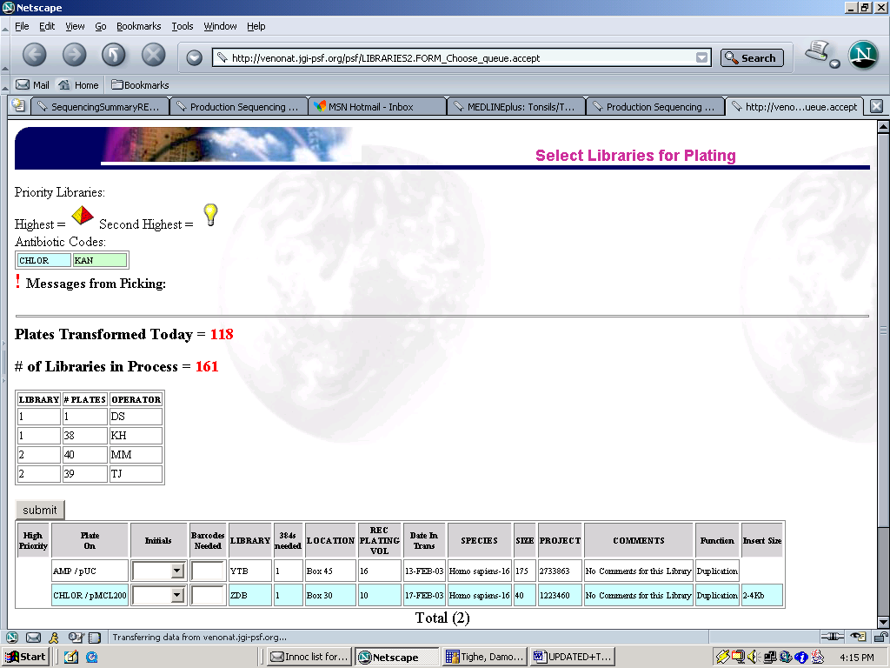
This is how many bioassays of this library you will be plating. Assume 1 bioassay is 2.5 384–well plates

Put your initials here
Recommended plating Volume is the amount of transformation stock you should use for this library when plating.
Number of 384 plates requested .
Select Libraries for Plating

Figure 2. Examining bioassays for contamination or irregularities.

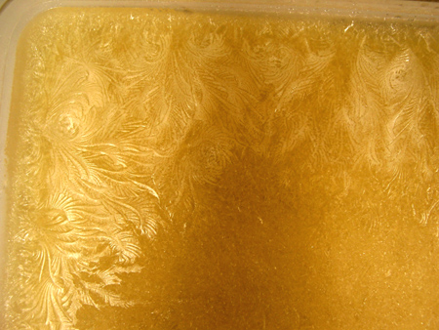
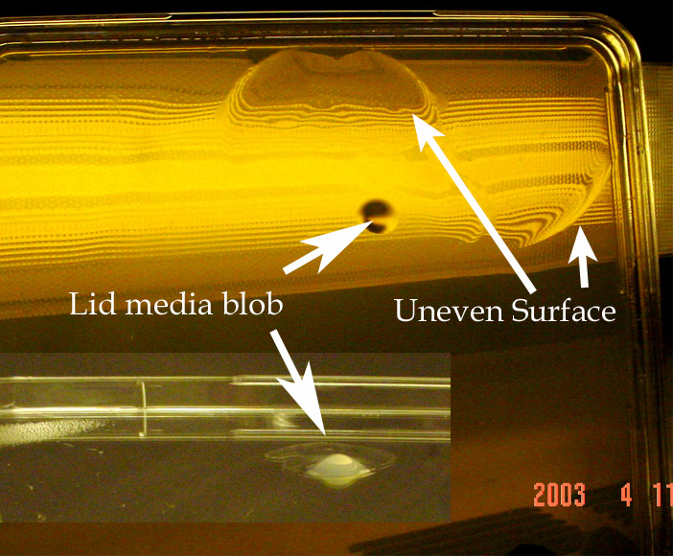
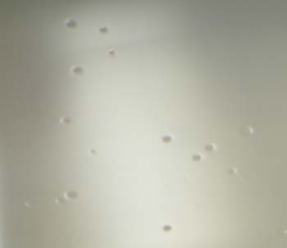
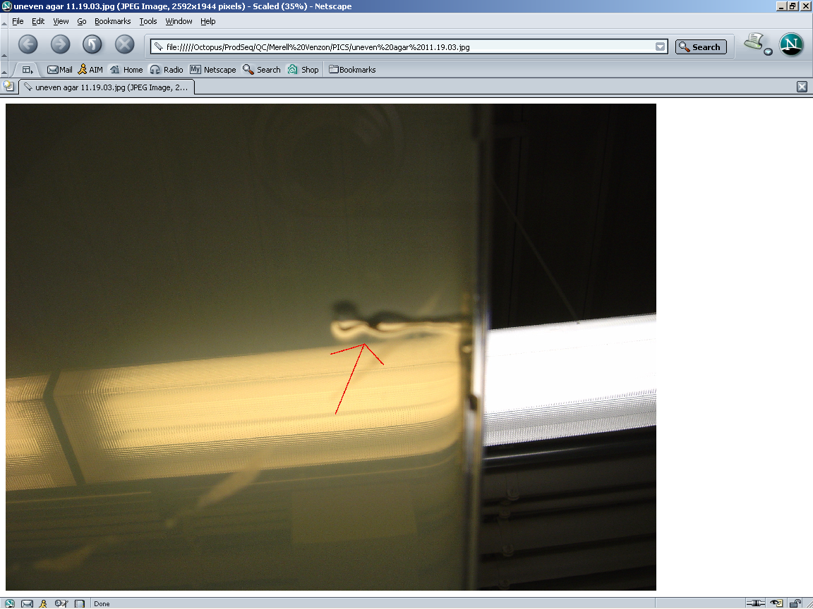
Bubble-pox: caused by bubbles in surface of agar when agar is setting.
Agar Channel: caused by water condensing and dropping into agar when agar is setting.
Frozen Agar: feather like anomalies on surface caused by agar being frozen and then thawed.
Agar Blobs: may appear on lid or agar surface, caused by sloppy agar pouring.

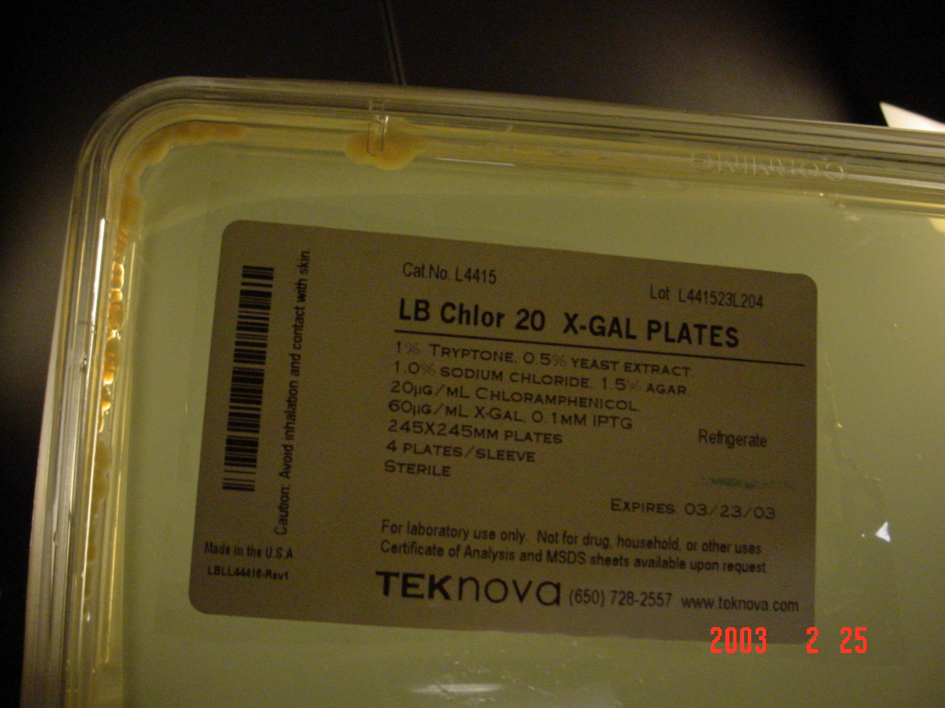
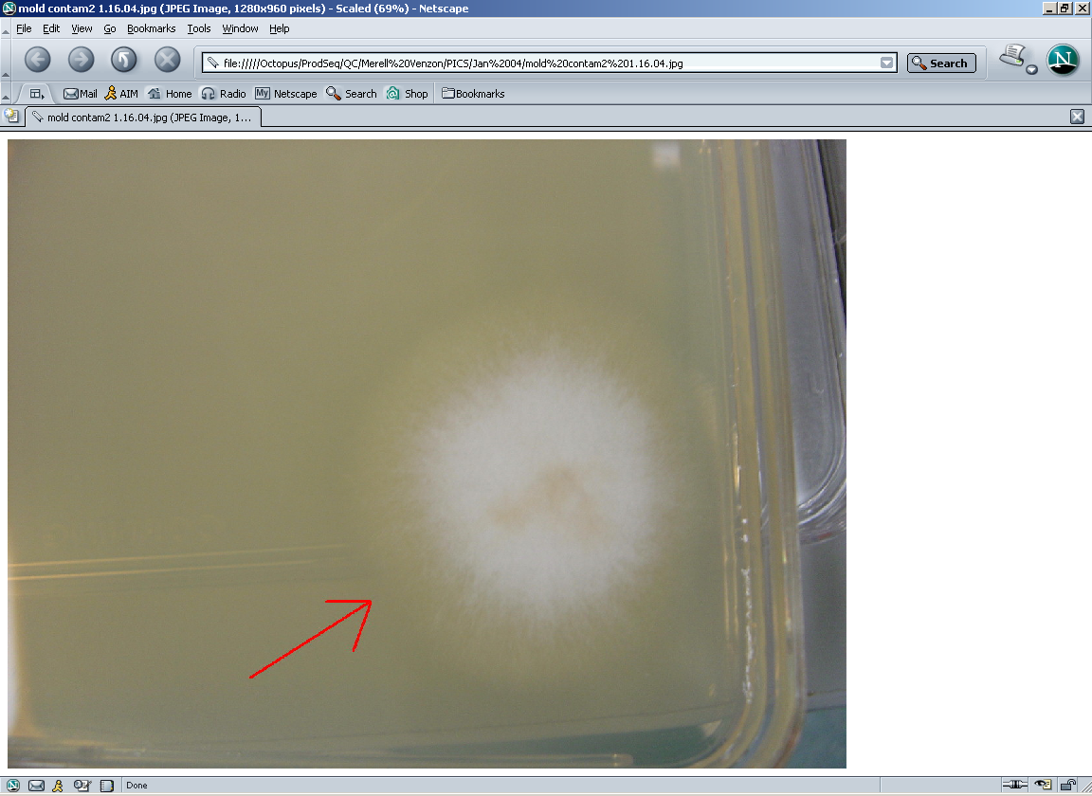
Bacterial Growth: usually occurs around rim of plate, pungent odor
Fungal growth: may be dime size to the entire plate, sometimes no odor

Figure 3. Fume hood setup for plating with glass beads.
Dry Plates
Spread plates
Clean Beads
shooters
waste
Dirty beads
Set 2
Set 1
Dry Plates
Spread Plates
Clean Beads
Shooters
WASTE
Dirty beads
Set 2
Set 1

Appendix B

AUDIT TRACKING
5/26/04 – Christine Lansang and Chris Daum performed an audit between 9:15AM – 1:40PM. The user was Miranda Harmon-Smith. Changes incorporated into protocol on 8/25/04.

