ANNUAL REPORT
to
National Renewable Energy Laboratory

“THIN-FILM PHOTOVOLTAICS PARNERSHIP PROGRAM”

Contract NO. RDJ-2-30630-20
Deliverable D.2.6

PROJECT TITLE: “Research Leading to High Throughput Manufacturing of Thin-Film CdTe PV Modules”

NAME OF ORGANIZATION: First Solar, LLC

PRINCIPAL INVESTIGATOR: Dr. Rick C. Powell

ADDRESS: First Solar, LLC
28101 Cedar Park Blvd.
Perrysburg, OH 43551

PHONE: 419-662-7549
FAX: 419-662-8525
e-mail: rcpowell@firstsolar.com

CATEGORY: Technology Partner

27 September 2004

Table of Contents

Abstract ii
Acknowledgements iv
1. Introduction 1
2. Advanced Front Contact and Window Layers (AFCW) 2
2.1 Zinc Stannate (ZTO) Deposition 3
2.2 Oxygenated Amorphous CdS (a-CdS:O) Deposition 3
2.3 AFCW Device Optimization 4
3. CdS/CdTe Deposition Reactor Development 7
3.1 Distributor Development 7
3.1.1 Alternative Distributors 9
3.1.2 Distributor Modeling 12
3.2 Process Control 14
3.3 Film Characterization 15
3.3.1 Device Analysis 15
3.3.2 IV Mapping 16
3.3.3 Non-uniformity loss estimates 17
3.3.4 Chemical Analysis 18
4. Accelerated Life Testing Development 19
4.1 Development of predictive ALT Protocols 19
4.2 Stress-Induced Change Mechanisms 19
4.2.1 CdCl₂ treatments 20
4.2.2 Back Contact Processing 22
4.2.3 Humidity effects during device processing 22
5. Environmental, Health and Safety Improvements 23
5.1 Updated Safety Program 23
5.2 Ongoing Monitoring 24
5.3 Material recovery 24
6. Future Plans 26
List of Figures 27
Glossary of Abbreviations 28
References 29

Abstract

First Solar is actively commercializing CdTe-based thin film photovoltaics. During the past year major additions of production capability have been completed as well as process improvements to achieve higher throughput and efficiency and greater durability. This report presents the results of phase II of the subcontract entitled “Research Leading to High Throughput Manufacturing of Thin-Film CdTe PV Modules”. The subcontract supports several important aspects needed to for high volume manufacturing of high efficiency modules including exploration of large area advanced front contact window layers, improvements of the semiconductor deposition system, advancement in understanding of post deposition processing steps and accelerated life testing methods, and progress to the environmental, health and safety programs.

Advanced front contact and window layers (AFCW) are believed to be necessary for efficiency improvements, particularly when using very thin CdS window layers. Tasks in this area were added to the statement of work in Phase 2. Adaptation of laboratory deposition processes to large area and initial tests on full scale modules were completed. The benefits of the AFCW have not yet been realized in full modules.

Progress continued in the development of the vapor transport deposition (VTD) system. A number of advanced system designs, designated as VTD-2, with improved operational characteristics were demonstrated. One design in particular has been selected for future concentration. The improved system results in better film uniformity and material utilization while also opening new regions of parameter space for coating optimization. We continued to improve and characterize a new CdS powder feed system that will be increasingly important for high efficiency modules which employ very thin CdS window layers. We have documented the superiority of the new system, but further optimization is underway. We expect to introduce the improved powder metering system in concert with an improved VTD-2 deposition system for CdS.

Significant progress has also been made on a numerical model of mass and heat flow within the semiconductor deposition system. The sophistication of the model has grown to include details of particle injection, particle sublimation, and vapor transport. Attention is now focused on modeling the film growth process. Validation with experimental data is ongoing as many experimental observations can now be semi-quantitatively predicted.

Progress was made in understanding several steps in module processing. Improvements in back contact formation and understanding of the influence of humidity on device processing advanced.

A new faster accelerated life test has been shown to be equivalent to and in some respects better than our old 8 week test. This new procedure is being implemented in our standard quality assurance program and work continues to determine how the new test correlates with field data.

Our Environmental, Health and Safety program has increased to include all aspects of the factory expansion. New engineering controls have further reduced worker exposure risk within the factory from already low levels. We also continued to progress in methods to handle our waste streams.

Work under this subcontract contributes to the overall manufacturing operation. During phase II, average module efficiency (total area) on the production line was improved from 7.9 to 8.6% due primarily to process optimization. At the same time production volume for commercial sale increased from 2.5 MW in 2003 to an estimated 6 MW in 2004. Much of the new 25 MW/yr production line has been qualified and production volume is steadily increasing.

Acknowledgements

Many people at First Solar contributed to the success of the Phase 2 work. We gratefully acknowledge the contributions of Anke Abken, Dave Berger, Eugene Bykov, John Christiansen, Todd Coleman, Nelson DeVoe, Tony Draper, Andy Gray, Roger Green, Upali Jayamaha, Peter Meyers, Anne Moser, Mike Steele, and Syed Zafar, as well as personnel from First Solar production, engineering and management.

We are also grateful for the support that we have received from National Renewable Energy Laboratory staff, including D. Albin, S. Asher, T. Gessert, T. McMahon, H. Ullal, S. Wei, X. Wu, and K. Zweibel. Contributions from S. Hegedus and B. McCandless of Institute of Energy Conversion; J. Sites, K. Barth and A. Enzenroth of Colorado State University; A. Fahrenbruch of ALF; A. Compaan, V. Karpov, and D. Shvydka of University of Toledo; S. Feldman, S. Gilmore, V. Kaydanov and T. Ohno of Colorado School of Mines; and C. Ferekides of University of South Florida are gratefully acknowledged.

Two lower-tier subcontracts are directly contributing to this work. The first project, titled “Direct Integration of Solid-Prescursor Powders into Chemical Vapor Deposition Systems”, involves modeling of the heat and mass transfer in the deposition reactor. This work is being conducted by J.P. Delplanque, R. Kee, and M. Pavol of Colorado School of Mines. The second project, titled “Nonuniformity Loss in Photovoltaics”, involves the modeling of performance loss due to spatial variation. This work was performed by V. Karpov and D. Shvydka at University of Toledo.

1. Introduction

First Solar (FS) has developed proprietary thin-film PV module technology and is rapidly transitioning this technology into a significant manufacturing capability. Production volume has increased substantially in the last several years from 1.5 MW in 2002 to 2.5 MW in 2003. Approximately 6 MW will be produced in 2004. The production facility has been expanded to 131,000 ft² and an upgraded and fully automated production line with an expected capacity of 25 MW/yr is currently being installed and qualified. Full production on this new line is expected in 2005.

Concurrent with the increase in production volume, average module performance (total area) has increased from 7.9% in 2003 to 8.6% in 2004. Our current champion module has an NREL-confirmed performance of 9.4% (10.2% aperture area).

In addition, quality assurance procedures within the factory have been developed and documented. ISO 9001 certification was achieved in May 2004. The module testing program has been greatly expanded and now includes indoor accelerated light soaking and durability testing using a number of protocols as well as field testing. We are currently closely tracking ~1,800 modules at 3 locations.

Market development has kept pace with the production volume increase. Our basic market strategy remains the production of high-quality, high-volume, best-value solar modules for large field installations. Market opportunities in Europe justified the establishment of a German subsidiary in June 2003 to better serve customers. More information can be found at our website www.firstsolar.com.

The support of First Solar through the Thin Film Photovoltaic Partnership Program (TFPPP) has been instrumental in the progress over the past several years. Phase 2 of the present contract (RDJ-2-30630-20) has assisted in 1) exploration of production-compatible front contact window layers, 2) continued development of our unique high-rate vapor transport deposition (VTD) process for the semiconductor layers, 3) optimization of post-deposition processing, 4) improvements in accelerated life testing, and 5) progress in environmental, health and safety (EH&S) programs.

Advanced front contact and window layers (AFCW) are believed to be necessary for efficiency improvements, particularly when using very thin CdS window layers. An expanded program in this area was added into the contract statement of work. Specifically the work includes the adaptation of demonstrated laboratory deposition processes to large area and the evaluation of AFCW layers when incorporated into our module manufacturing process.

Motivation for continued development of our high-rate VTD process stems from the fact that VTD is a relatively immature process used to form the main junction and the thickest layer in the device. The VTD system is required to continuously and consistently produce uniform films for long durations.

ALT testing is critical to assure the 20+ year performance that underlies the economics of PV systems. Continued development of rapid tests which differentiate the stability of experimental devices and which can be correlated to long term performance is essential. Further understanding of degradation mechanisms is also vital.

Large scale manufacturing of a product that contains cadmium, a regulated material, requires development of procedures for further reduction in emissions and solid wastes. This includes further identification, characterization, monitoring and reduction of cadmium emissions and improvements in module recycling.

2. Advanced Front Contact and Window Layers (AFCW)

During Phase 2 we added to the statement of work tasks related to the development of advanced front contact and window layers (AFCW). AFCW layers are believed to be central to improving device efficiency and are an integral part of the record efficiency CdS/CdTe small area devices. The purpose of AFCW layers is to reduce the optical losses incurred in the front contact and the CdS window layer. Optical losses can be cut by thinning inactive absorbing layers or by making those inactive layers more transparent. In CdS/CdTe solar cells the CdS is an absorbing inactive layer. CdS is inactive in the sense that the collection of photogenerated carriers within it is very inefficient. When CdS is thinned below a certain critical thickness, although the current increases as expected due to reduced optical losses, no net gain in efficiency is observed because of the loss in open circuit voltage (Voc) and fill factor (FF). Inclusion of a suitable buffer layer between the transparent conducting oxide (TCO) and the CdS has been a way to overcome this problem. Modification of the CdS layer to decrease its absorption is also possible.

The goal of our AFCW work is to establish methods to form AFCW layers on full size plates using techniques which could be transferred to production and to demonstrate the benefit of these layers on the module scale in our overall process.

Our approach has been to start with the front contact process developed at NREL by Dr. Wu for record efficiency small area devices and to adapt elements of it for large area production use. The NREL process employs a transparent conductive layer of cadmium stannate (Cd₂SnO₄), a buffer layer of zinc stannate (Zn₂SnO₄ abbreviated as ZTO), and an n-layer of amorphous oxygenated CdS (a-CdS:O) [1, 2]. All layers in the NREL process are sputtered. The ZTO is believed to be a strong candidate for the buffer layer and a-CdS:O has been shown to be more transparent potentially lowering optical losses. Rather than tackle all three layers used in the NREL process, we began by investigating only the ZTO buffer layer and the a-CdS:O layer using our normal commercially-available SnO₂ as the transparent conductor.

Thus during Phase 2 we investigated the two AFCW combinations:
- SnO₂:F /sputtered ZTO/sputtered a-CdS:O
- SnO₂:F /sputtered ZTO/VTD-CdS .

2.1 Zinc Stannate (ZTO) Deposition

The NREL process uses rf-sputtering from a compound target to form the ZTO layers. It is difficult to use rf-sputtering to deposit uniform large area films at high rates. Instead we chose to deposit films using an A/B pulsed DC sputter mode.

ZTO films were deposited onto 60cm x 120 cm full size plates using sputtering from a compound target. The ZTO deposition rates were low due in part to the large fraction of oxygen used in the sputter gas. The deposition rates are adequate for thin buffer layers. ZTO films were characterized using optical absorption/reflection and resistivity measurements. The ZTO films undergo drastic changes during the high temperature device fabrication process. To understand the electro optical properties of ZTO films within a high efficiency device, single layer ZTO films are annealed at 570ºC for 2 minutes in the presence of CdS to simulate the changes that undergo during the device fabrication. For ZTO films to act as a good buffer layer the resistivity of the annealed films should be within a specific range and the optical absorption should be low.

In order to optimize the large area deposition process, we deposited several sample films on Corning 1737 glass substrates at various sputtering pressures and gas mixtures. The results are shown in Table 1. The sample ZTO-15 had properties similar to those considered optimal for high efficiency NREL devices.

Table 1. Optical and electrical properties of ZTO films before and after anneal. Measurements and annealing provided by Dr. Wu at NREL.
Sample | Eg *  (eV) | Eg †  (eV) | Sheet R *  (Ohm/sq) | Resistivity †  (Ohm-cm) | Absorption at 400 nm †  (%)
ZTO-7 |  |  |  | High
ZTO-12 | 3.46 | 3.51 | 5x10⁸ | 0.05 | 15
ZTO-14 | 3.57 | 3.47 | >10⁹ | 0.29 | 25
ZTO-15 | 3.70 | 3.64 | >10⁹ | 1.4 | <10
* as grown film † annealed at 570ºC for 2 minutes in the presence of CdS

The inherent thermal annealing of ZTO buffer layers within the FS semiconductor deposition process may differ from the simulated anneals. Thus the above deposition condition for optimal in-device ZTO properties is only a starting point.

2.2 Oxygenated Amorphous CdS (a-CdS:O) Deposition

We also deposited a-CdS:O films on full size plates using the pulsed sputter mode. The a-CdS:O deposition rates were comparable to metal deposition rates in the same system. The uniformity of one of the early films was measured on our in-house CdS thickness mapping system and the standard deviation in thickness over the full plate was ~4%. We expect uniformity to improve as the sputtering target is conditioned over time.

In order to get desired film properties the deposition pressure and the oxygen/argon ratio of the process gas was varied systematically. Films were characterized at First Solar and NREL using optical transmission/reflection, dark and photo conductivity and XRD measurements. Although lower sputtering pressures are desired from a manufacturing point of view, films grown at lower sputtering pressures had undesirable optical properties (see Figure 1a).

(a)  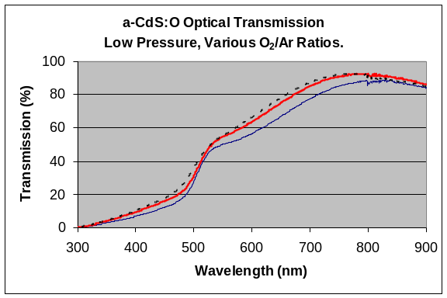 | (b)  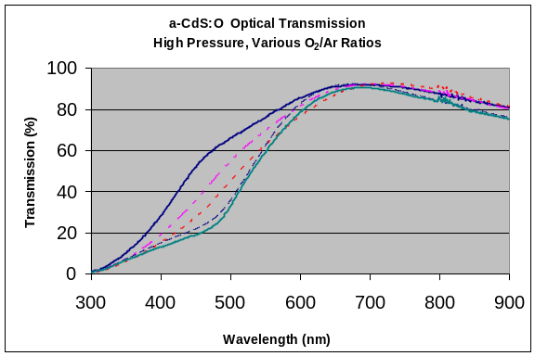
Figure 1. Optical absorption curves of a-CdS:O films.

Films grown at a higher deposition pressures had better optical properties (see Figure 1b). Further characterization of films was done using XRD and dark/photo conductivity measurements at NREL by Dr. Wu. As indicated by XRD patterns, film grown without oxygen exhibits a polycrystalline structure with the preferential orientation along the (002) axis. The intensity of the (002) peak is reduced progressively as the oxygen/argon gas ratio is increased as the films become amorphous. The optical band gap of the amorphous material is about 2.53eV. The ratio of photo/dark conductivity of the amorphous films was also quite high which is an indication that this material is suitable as a window layer for CdTe based solar cells.

2.3 AFCW Device Optimization

To date two tests have been run using the SnO₂:F/ZTO/a-CdS:O front contact structure. In the first test, fourteen plates were coated with six different combinations of ZTO/a-CdS:O. CdTe deposited by VTD in the production system. Dot cells were made on several plates while the rest were processed through our standard production stream to make modules. Although the device efficiencies were somewhat lower than that produced using our optimized standard process, this very first attempt proved that that the room temperature sputtered ZTO/a-CdS:O layers are basically compatible with our VTD coating and module fabrication process. Representative device results are shown in Table 2.

Table 2. Summary Results from SnO₂:F/ZTO/a-CdS:O AFCW structure.
Type | Total Area  Efficiency  (%) | Voc  (mV/cell) | Jsc  (mA/cm²) | FF  (%) | Roc  (ohm-cm²) | Rsc  (ohm-cm²)
Condition 2, Test 1  Cell average | 10.7 | 811 | 20.3 | 64.7 | 6.8 | 1180
Condition 2, Test1  Best Cell | 11.4 | 824 | 21.0 | 65.6 | 6.5 | 1020
Best Module Test 1  E03230670 | 8.4 | 772 | 21.1 | 60.9 | 7.5 | 811
Best Module Test 2  E07140274 | 8.8 | 804 | 23.0 | 56.0 | 9.5 | 588

One of the sub-modules (E03230670) with the SnO₂:F/ZTO/a-CdS:O AFCW structure underwent our standard 56 day light soak. The stability of that module was comparable to standard product.

A second, more elaborate experiment based on Taguchi methodology of optimization was conducted. For this test 54 plates were made using various processing condition for ZTO, a-CdS:O, CdTe, and subsequent processing . I-V parameters of the best sub-module are shown in Table 2.

Two experiments with the SnO₂:F/ZTO/VTD-CdS AFCW structure have also been completed. For the preliminary test, CdS and CdTe films were deposited by VTD in the production system onto fifteen SnO₂:F plates coated with ZTO films. Device results are shown in Table 3.

Again a second more comprehensive designed experiment involving 54 plates and variations in ZTO, CdS/CdTe and subsequent processing was conducted. I-V parameters of the best module are shown in Table 3.

Table 3. Summary Results from SnO₂:F/ZTO/VTD-CdS AFCW structure.
Type | Total Area  Efficiency  (%) | Voc  (mV/cell) | Jsc  (mA/cm²) | FF  (%) | Roc  (ohm-cm²) | Rsc  (ohm-cm²)
Best condition Test 1  Cell average | 11.5 | 794 | 21.9 | 66.3 | 6.3 | 870
Best condition Test 1,  Best Cell | 12.0 | 817 | 21.9 | 67.3 | 6.0 | 19800
Best Module Test 1  E04210171 | 8.3 | 731 | 22.5 | 59.7 | 9.2 | 746
Best Module Test 2  E07230523 | 9.2 | 793 | 22.6 | 60.4 | 8.5 | 778

While good modules have been made with both AFCW structures, on balance the SnO₂:F/ZTO/VTD-CdS sequence seems to be more compatible with our process at the present time. This sequence is also simpler as it involves the addition of only one layer into our device. Thus we are concentrating on this AFCW structure and have already run a third test.

Without a buffer layer, thinning the CdS increases efficiency and photocurrent until the photocurrent reaches about 23 mA/cm². Further reductions in CdS thickness yield higher photocurrent but reduced efficiency due to loss in Voc and FF (see Figure 2). The use of a buffer layer has been shown to extend the maximum photocurrent limit to >25 mA/cm².

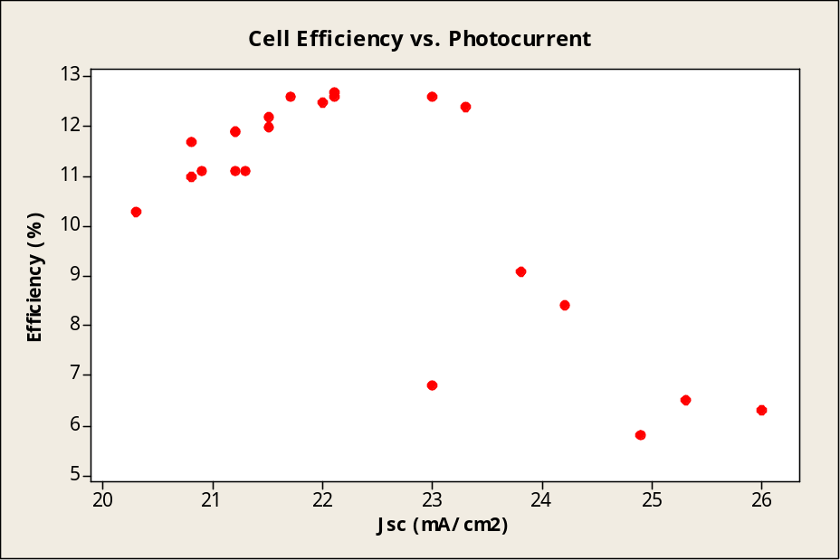
Figure 2. Efficiency as a function of photocurrent for a set of dot cells made on a graded CdS thickness plate without a buffer layer.

Figure 3 shows the results of the comprehensive module level test using the SnO₂:F/ZTO/VTD-CdS AFCW structure with CdS in the range of 500-900Å. We expect a range of results for the plates which have the ZTO buffer layer because a wide variety of conditions were used. Nevertheless we also expect to see some evidence of an increase in the maximum photocurrent before the efficiency falls off. Figure 3 does not show such evidence. Thus although we have made reasonably good modules using the ZTO buffer layer, we have not yet shown that it provides any benefit.

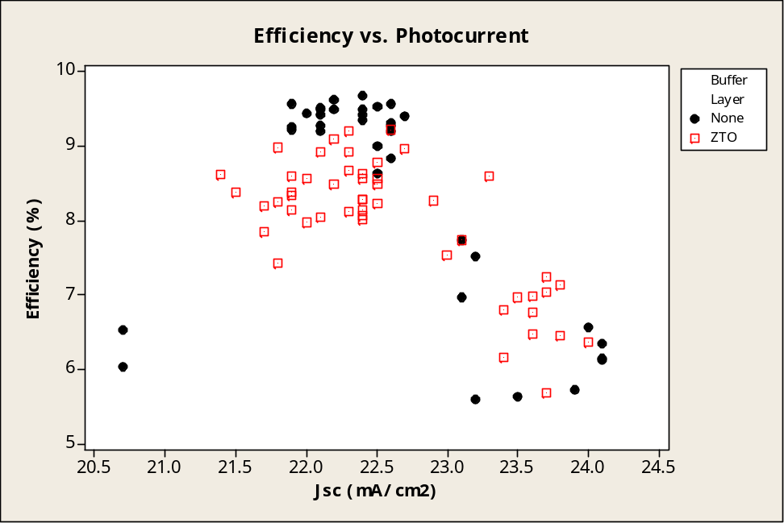
Figure 3. Efficiency as a function of photocurrent for modules made with and without ZTO buffer layer.

3. CdS/CdTe Deposition Reactor Development

3.1 Distributor Development

At the heart of the First Solar manufacturing technology is the semiconductor coater. CdS and CdTe are deposited sequentially in the same piece of equipment using the vapor transport deposition (VTD) method. VTD is a high-throughput, large- area coating technique pioneered and patented by First Solar [3, 4]. The system capitalizes on the ease with which CdS and CdTe can be vaporized and on the rapid rates at which quality films can be formed from re-condensing vapors. Essentially the method utilizes flash-sublimation of injected semiconductor powders in an inert carrier gas stream to create a dense vapor cloud in a modest vacuum (~5 Torr). The inert carrier gas flow directs and controls the dense vapor cloud. The semiconductor films are formed on glass substrates at temperatures between 500 and 600 ºC at high rates. The inert carrier gas and some vapors not deposited are then exhausted from the chamber.

Since the VTD deposition rates are rapid, the length of the deposition zones needed to form the relatively thick (2-5µm) absorber layer at production line speeds of is relatively short. These compact high temperature deposition zones are ideal from a manufacturing equipment perspective as short deposition chambers can be used (lower capital equipment costs) and small critical areas are easier to manage. The production vapor generator and vapor distributor system in use today is relatively simple, robust, and durable.

The film formation process must be integrated with the control of glass properties. The extremely high deposition rates of the VTD method require high substrate temperatures. From the glass perspective, the VTD system heats low-strength, annealed glass to temperatures in excess of the glass softening point. Quenching during venting of the vacuum exit load lock strengthens the glass. The quenching process must be closely coordinated with overall system thermal management in order to achieve glass flatness and strength uniformity. Glass strength is required for field deployment and glass flatness is needed for consistent laser scribing and module lamination.

The core component of the VTD method is the vaporizer/distributor system. The design, materials, and methods of operation of the distributor system fundamentally control film formation including uniformity of thickness, microstructure and junction properties. The distributor serves three main functions. First, the input powder must be vaporized. Second, a uniform cross-web† distribution of mass flow must be achieved in order to form films of uniform thickness. Third, presentation of the deposition flux to the glass controls film nucleation and growth and thereby microstructure.

The base distributor system is simple both mechanically and thermally and can consistently produce films with adequate thickness uniformity (±10%). However, film thickness and microstructure uniformity depend on carrier gas flow and the details of feed injection. Normally carrier gas flow is adjusted to produce the best possible film thickness uniformity and cannot be altered to change dilution, to improve input powder transport, or to adjust film microstructure. In addition, optimum operating parameters vary between nominally identical distributors, and adjustments must be made over the life of the distributor.

Spatial variation in microstructure leads to spatial variation in device performance and is thus undesirable. The effect of microstructure non-uniformity can be accentuated by operation in an asymmetric mode. In this mode, film thickness is nearly uniform, but a clear asymmetry in film growth is observed (see Figure 4). Reflection characteristics can be used to give a rapid indication of surface microstructure. Figure 5 shows a map of the surface roughness determined from the specular and scattered infrared reflection.

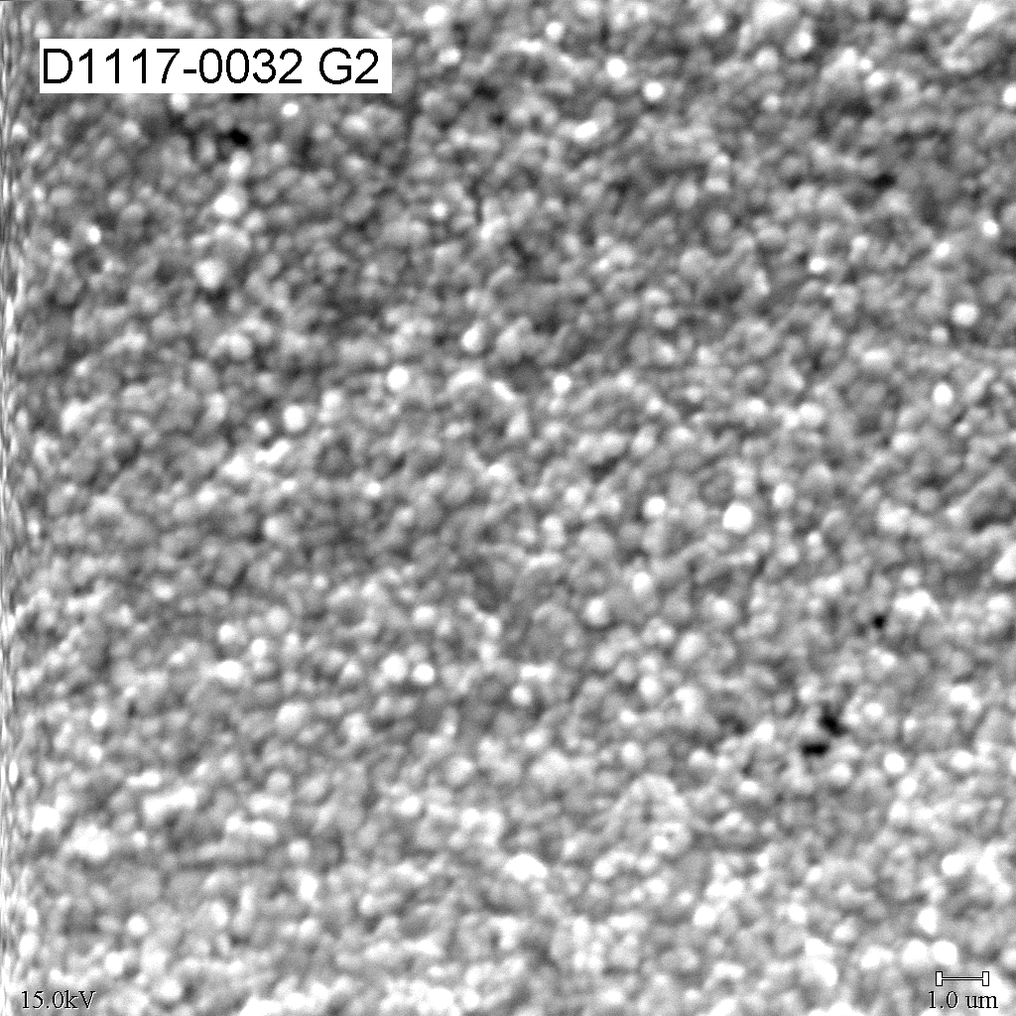 | 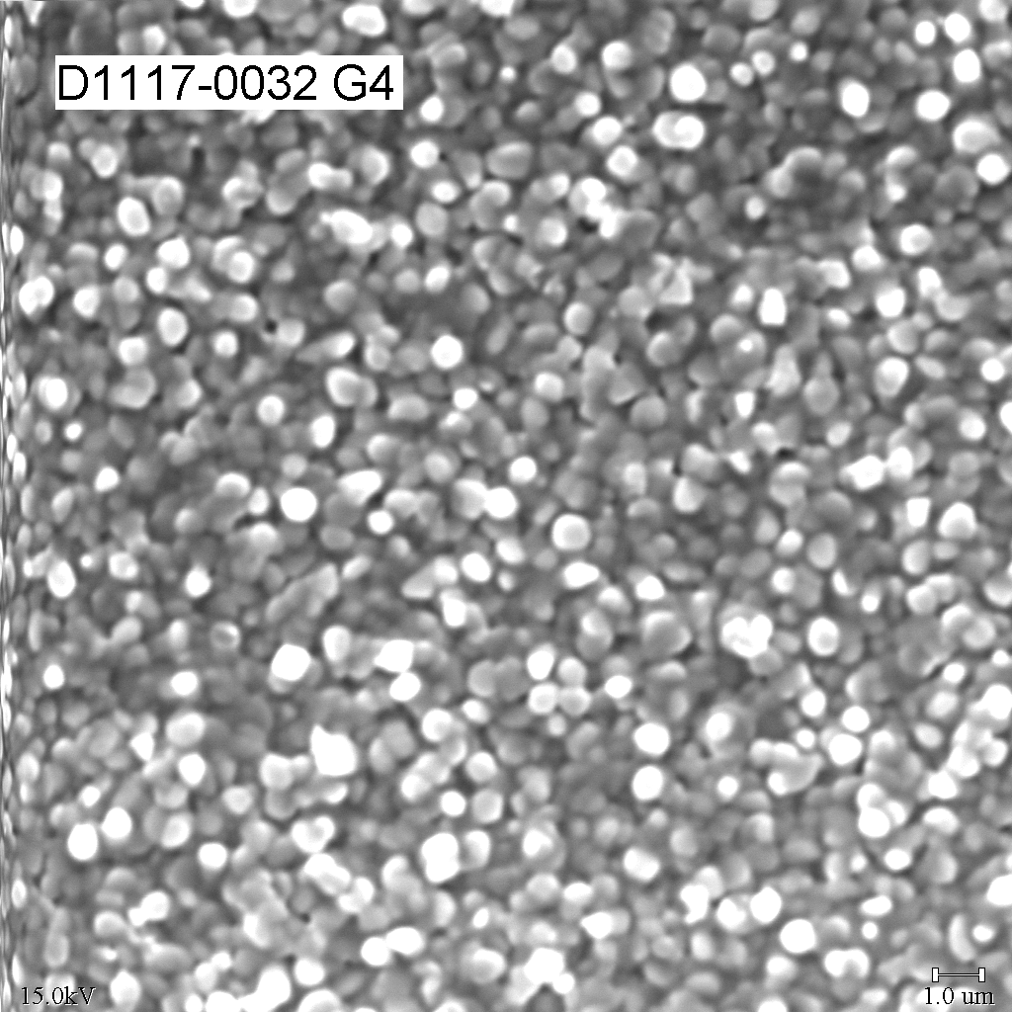 | 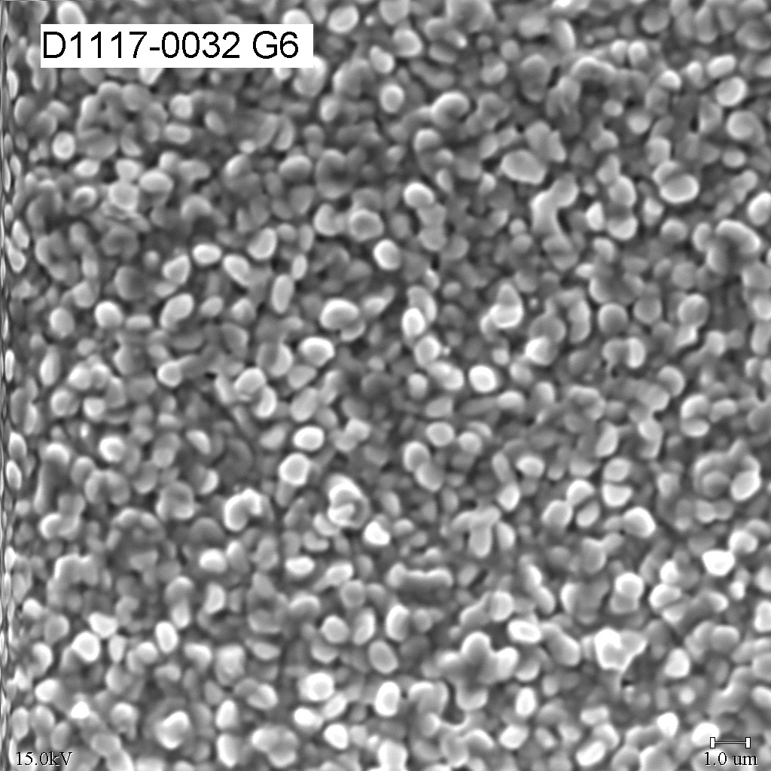
Figure 4. SEM micrographs showing variation in CdTe film microstructure across a plate deposited using a standard distributor operated in an asymmetric mode. The G2 and G6 positions correspond to locations x=60, y=20 and x=60, y=-20 respectively in Figure 5.

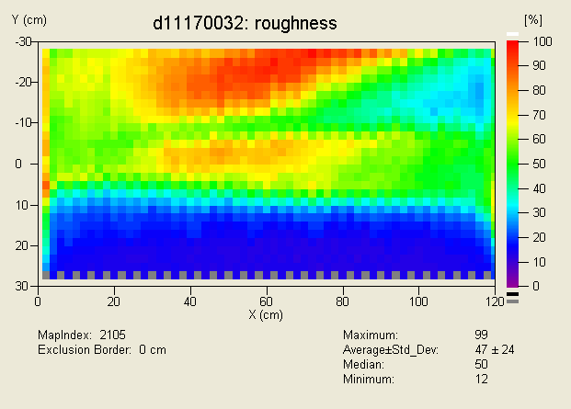
Figure 5. Color contour map of surface roughness determined from reflection characteristics for a film deposited with a standard distributor operated in an asymmetric mode. Note that Y is the cross-web dimension, i.e. the direction of motion of the plate is in the X direction.

To compensate for the underlying variation in microstructure, standard distributors with deposition zones significantly wider than the glass are normally used. In other words, to avoid edge effects the stream of glass is passed through only the central region of vapor deposition zone. Obviously there is consequent lower material utilization.

3.1.1 Alternative Distributors

During this contract period, we have focused on one basic alternative distributor concept that will be designated as VTD-2. In this concept, the spatial non-uniformity problems that can arise in a low-pressure, three component gas system are effectively circumvented. Several different configurations of the VTD-2 idea have been tested and we have now selected one version (designated as the G3 distributor) for future concentration. While the VTD-2 concept resolves most of the problems of the VTD-1 systems, the VTD-2 distributors are mechanically and thermally more complex.

A recent test (ETA 807) clearly demonstrates the improved uniformity of the G3 system for CdTe. In this test operating parameters of the G3 distributor were varied to explore the range of CdTe films possible and their suitability for devices. Film thickness uniformity was excellent and was independent of operating parameters. In other words the geometry of the G3 distributor controlled the film thickness uniformity. Figure 6 shows that films made with the G3 distributor are significantly more uniform in thickness than films made with the standard distributor. This result was achieved while simultaneously reducing the width of the deposition zone dramatically which led to a 40% reduction in the source material requirements.

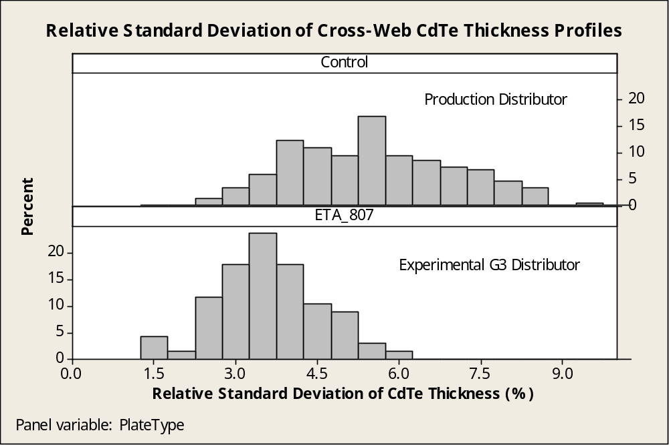
Figure 6. Reduction in CdTe thickness variation cross web for G3 distributor. On average there is a 37% reduction in cross-web variation using the G3 system.

The intentional variation in operating parameters in the ETA 807 experiment did lead to significant variation in film microstructure. Figure 7 shows a representative sampling of the as-deposited film grain structures.

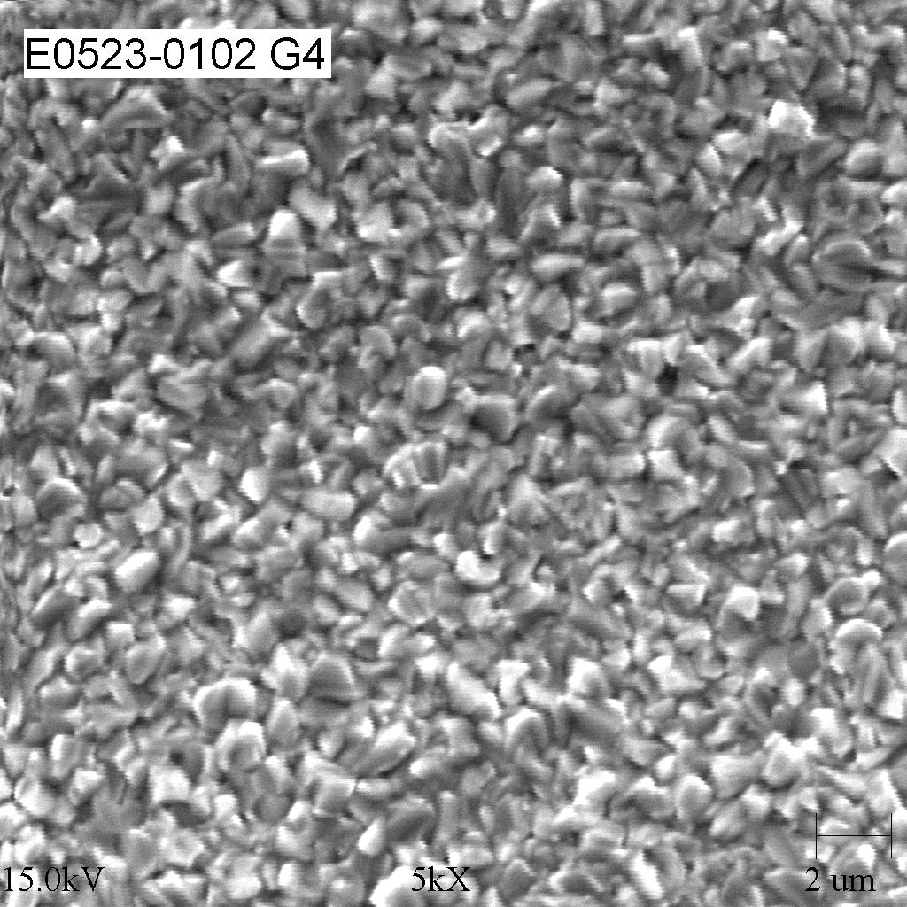 | 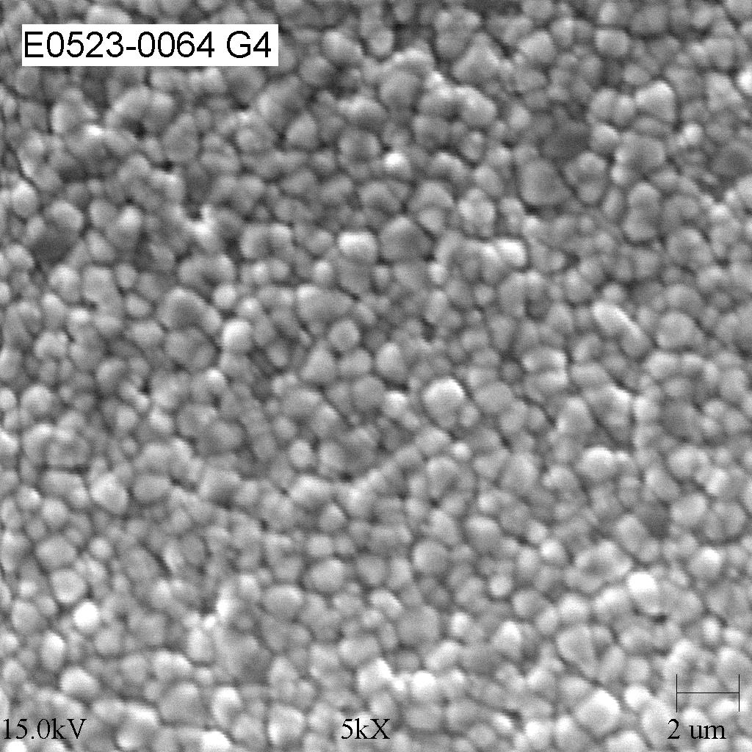
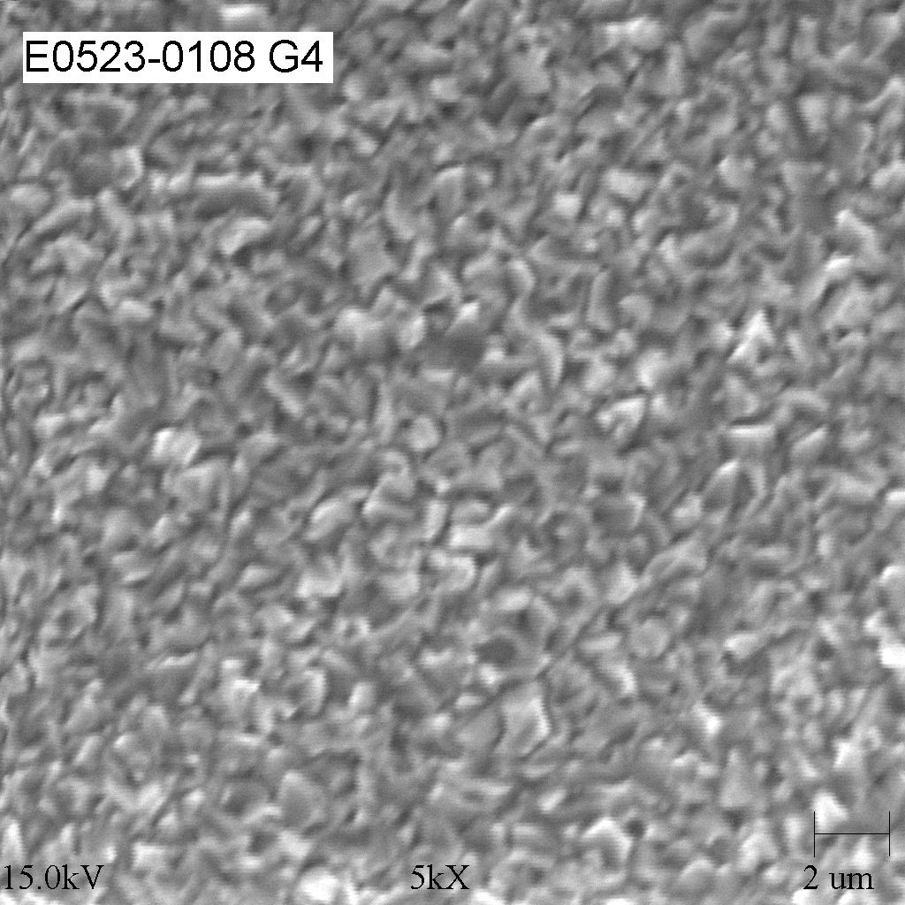 | 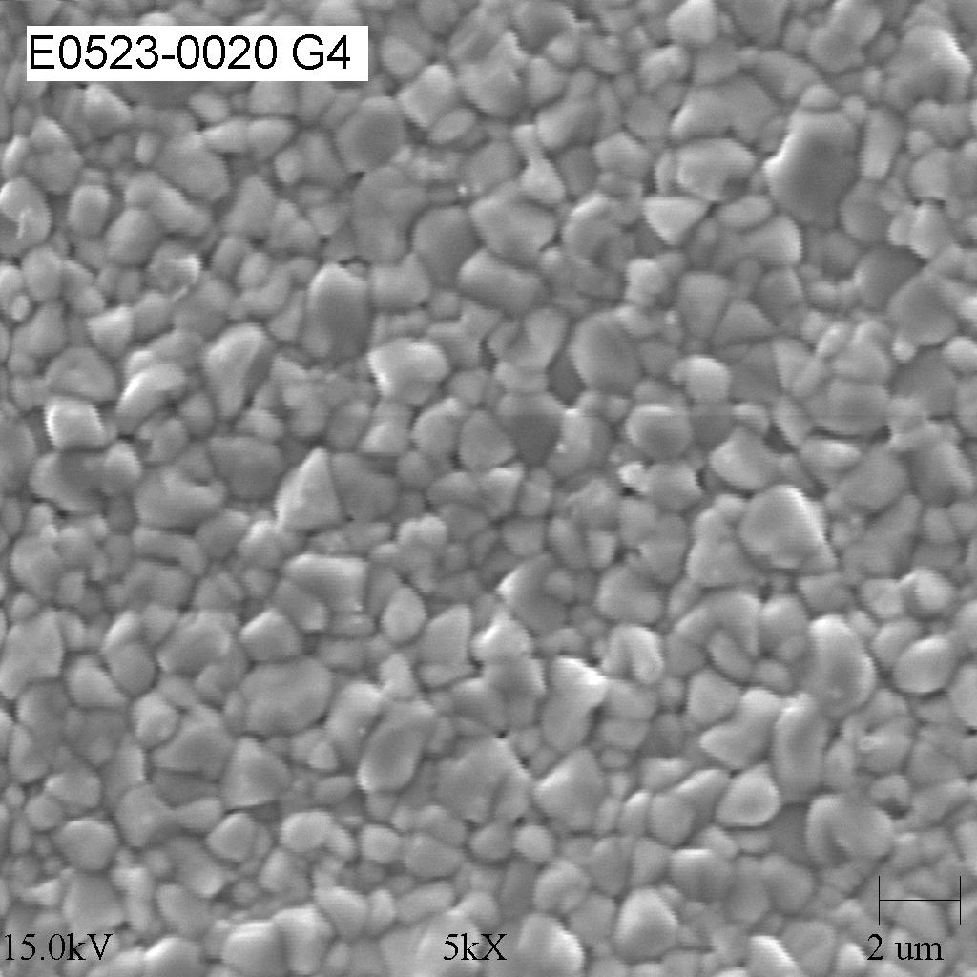
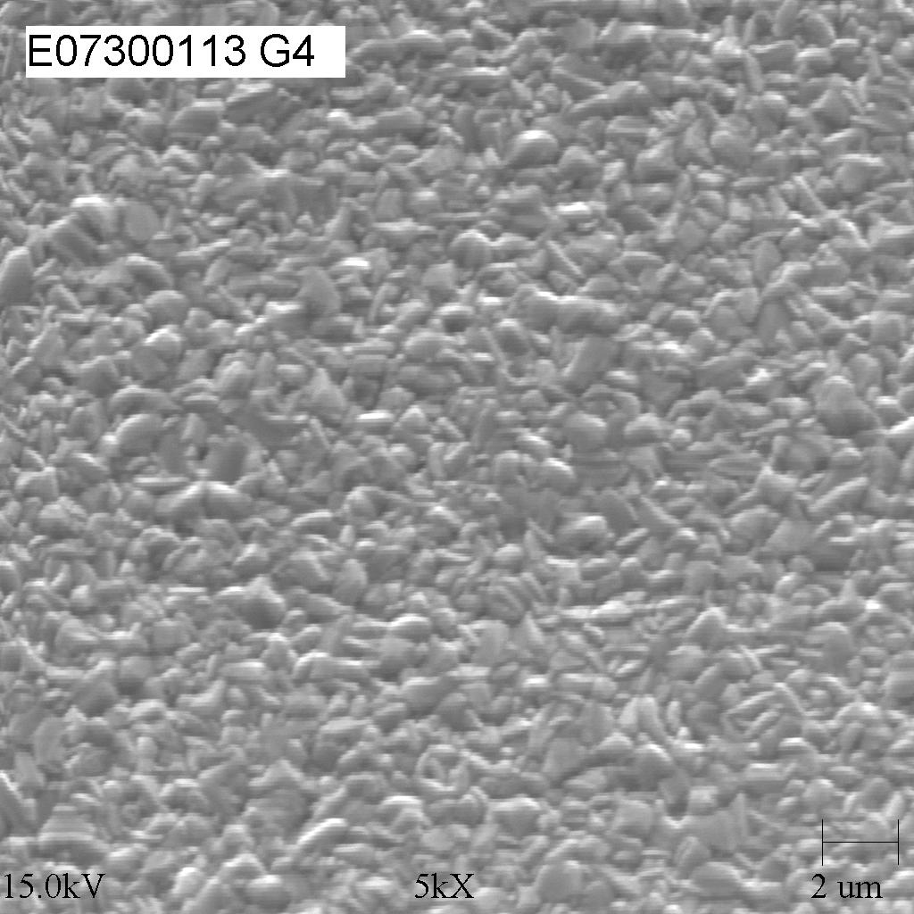 | 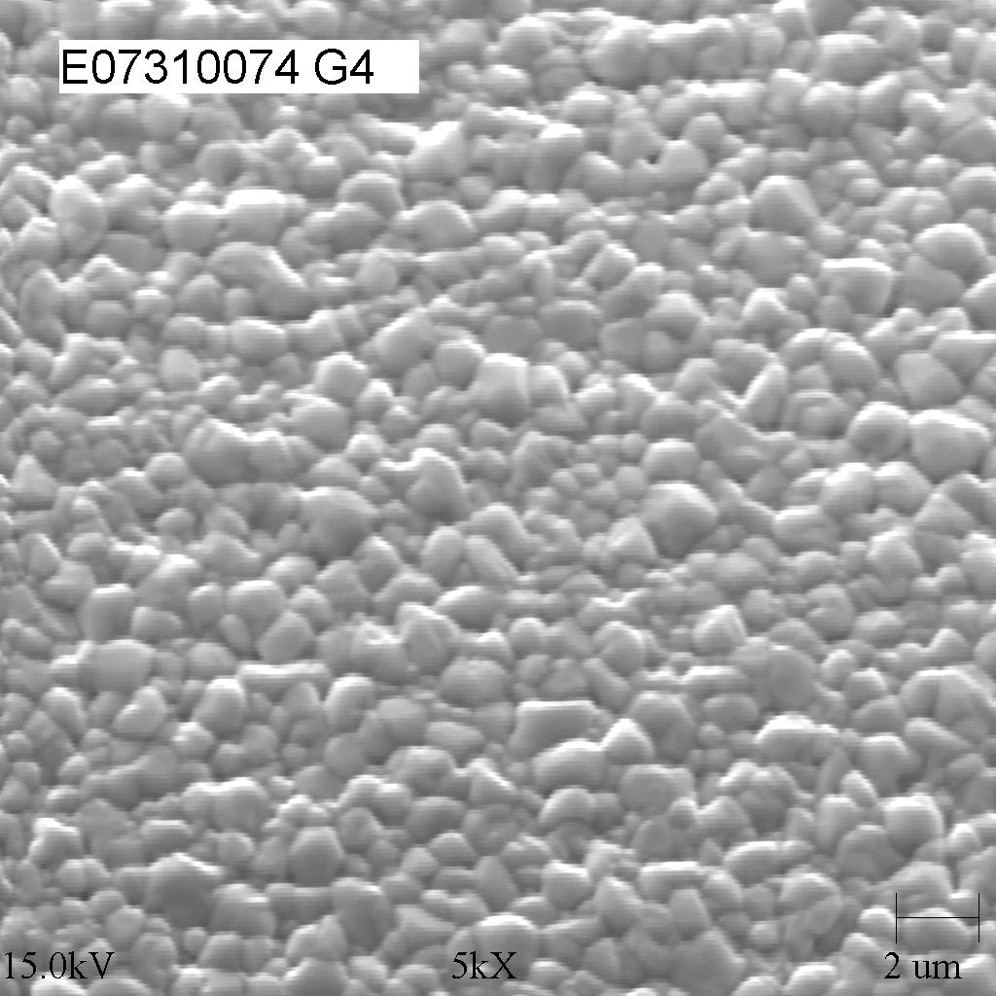
Figure 7. SEM micrographs of films deposited using the G3 distributor. A variety of microstructures can be formed. These micrographs are from centered locations but in general the G3 distributor produces films with uniform structure. All micrographs 5000x magnification.

In addition to the variety of microstructures that can be formed, the spatial uniformity of the microstructure has also improved. Using the standard deviation in cross-web surface roughness profiles as an indicator, Figure 8 shows that despite the wide variety of experimental conditions explored in ETA 807 nearly all films are more uniform across the web than those produced with the standard distributor.

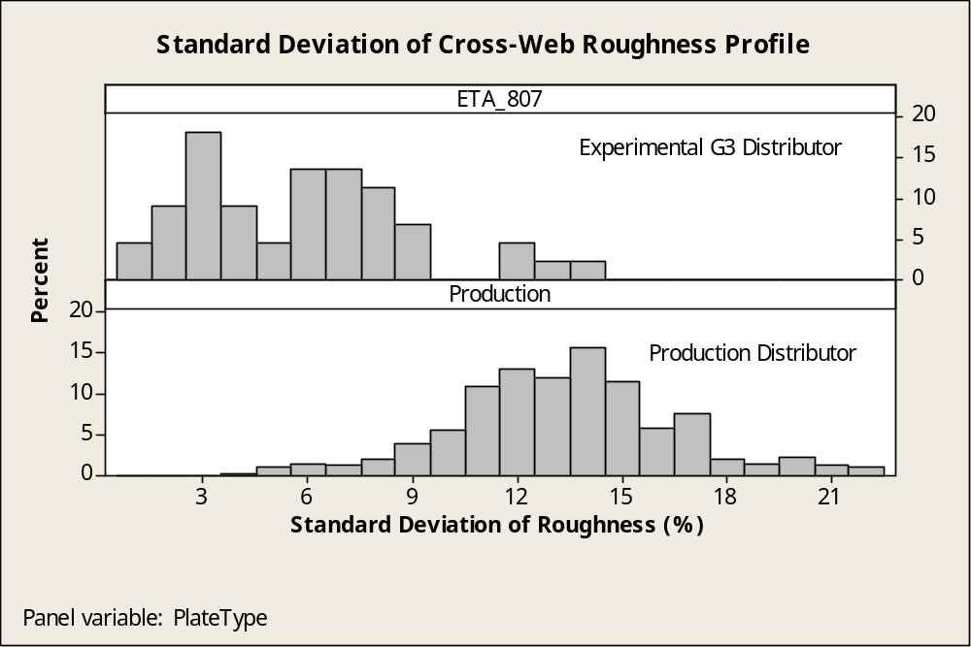
Figure 8. Reduction in cross-web roughness variation for G3 distributor.

Devices have been made from CdTe films produced with the G3 distributor. Not surprisingly the different microstructure films require different post-deposition processing to produce the best device. We are now in the process of determining which deposition parameters and post deposition conditions produce the most efficient and stable devices.

We believe that the G3 system will also work well for CdS and improvements in thickness uniformity are expected to facilitate fabrication of devices with very thin CdS.

3.1.2 Distributor Modeling

Despite the simplicity of the basic VTD system, the heat and mass transport processes that occur within it are complex. Conducting experimental trials using production equipment is becoming increasingly difficult and inferring physical mechanisms operating within the distributor based on resulting film characteristics is very tricky. Therefore a program to provide a solid theoretical understanding of the distributor operation was begun in collaboration with a group from Colorado School of Mines (CSM) in Phase I. The goal of this effort is to guide the experimental work of distributor design and operation.

The CSM team made significant progress on a numerical model of mass and heat flow within the semiconductor deposition system. The sophistication of the model has grown to include details of particle injection, particle sublimation, and vapor transport.

Within the distributor flow field calculations are coupled to the particles by way of mass, momentum, and energy. Convective sublimation is approximated using the extended film model, which describes the particle mass loss and the heat required by the sublimation process. This sublimation model is connected to a model for tracking particle motion through a specified flow field. Distributions of input particle sizes can be tracked as they enter the distributor and sublime. The model is now fully coupled. It accounts for physical motion of the powders, radiative and convective heat transfer, and powder sublimation. The sublimed vapor significantly alters the pressure, velocity and composition of the gas phase which in turn affects the motion of the injected powder.

The model demonstrates that non-uniformity can arise due to how particles are injected and vaporized and due to mass transport in the vapor phase. Attention is now being directed towards modeling the film growth process. A figure of merit or growth factor that can be related to the film growth rate is being developed. Validation with experimental data is ongoing and many experimental observations can now be semi-quantitatively predicted. For example, Figure 9 shows the comparison of experimental and modeled data from a standard distributor operated in a mode that yields non-uniform thickness films.

(a)  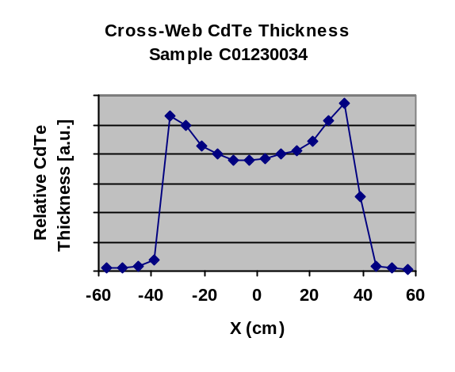 | (b)  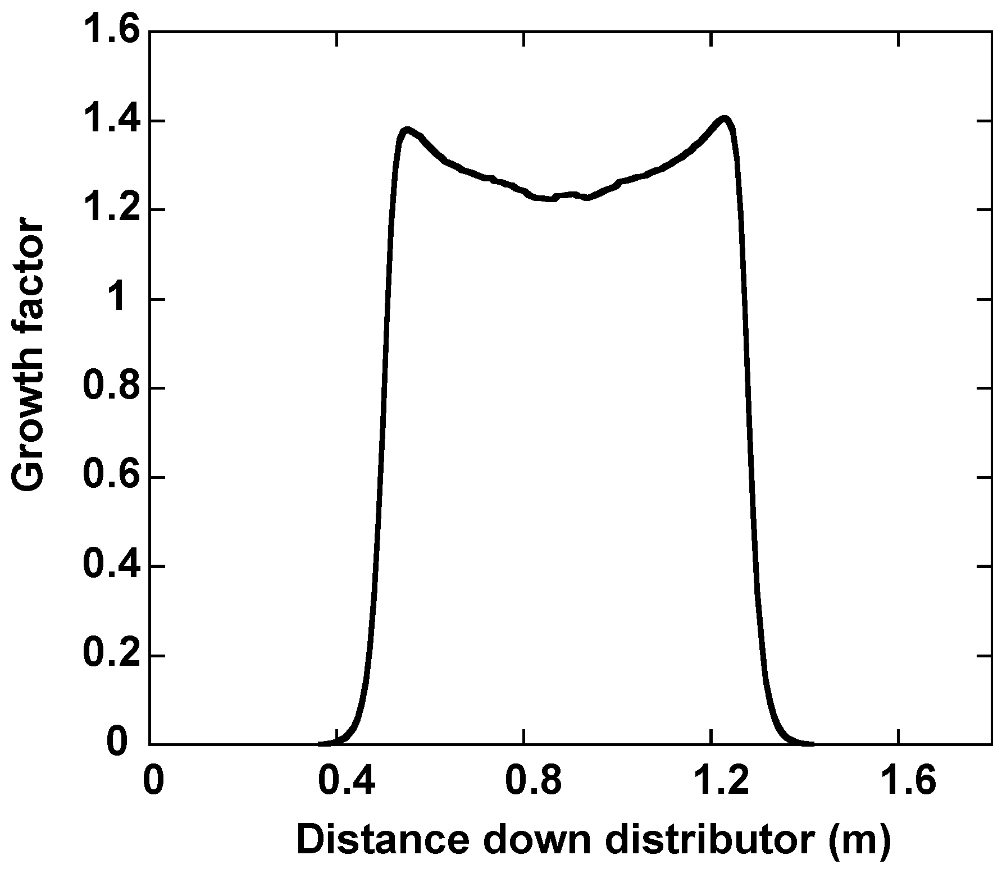
Figure 9. Cross-web CdTe thickness profile from a standard distributor operated in a non-uniform mode (a) experimental data, (b) modeled case.

The modeling effort is currently focused on the base VTD system. Once the growth factor is more refined, we plan to optimize the base distributor with respect to distributor geometry and thermal operating conditions using the overall numeric model and a partial factorial designed experiment. This should allow us to quantify the sensitivity of non-uniformity to various design parameters that would be impractical to test experimentally. We envision this numeric optimization project to help translate the results of a complicated theoretical model into practical use.

While the newer VTD-2 systems are geometrically more complex, the modeling of these systems is expected to be easier due to their innate improved uniformity characteristics. Thus the extension of the numeric model to alternative distributors is predicted to be very straightforward and to yield higher confidence results.

3.2 Process Control

The use of thinner CdS films is a well-known path to improve device efficiency. Consistently controlling CdS thickness is thus an essential task. The cross-web uniformity of VTD films is primarily controlled by the distributor while the average thickness and the consistency of thickness over time (i.e. down-web) are primarily determined by the input powder feed rate. At the present time approximately half of the variation within a plate is due to down web fluctuations.

In Phase I we developed a new feed system that was shown to reduce variation in CdS thickness on a single plate. However the data suggested that feed rate fluctuations over longer time scales were present. During Phase II we continued to refine this feed system and focused on characterization of the feed systems in bench tests rather than via CdS film thickness maps.

Figure 10 shows some typical results of feeder bench tests comparing the feed system in production use (the best commercially available system that we have found) and the new feeder equipment over the course of several hours. As in the earlier tests using CdS thickness maps, the new feed system appears to give less fluctuation. However, the feed rate variation in the new system is still significant and day to day reproducibility in both feed systems remains a concern. Consequently we have made some physical changes in the new feed system and are conducting optimization tests aimed at reducing variation and increasing feed rate resolution.

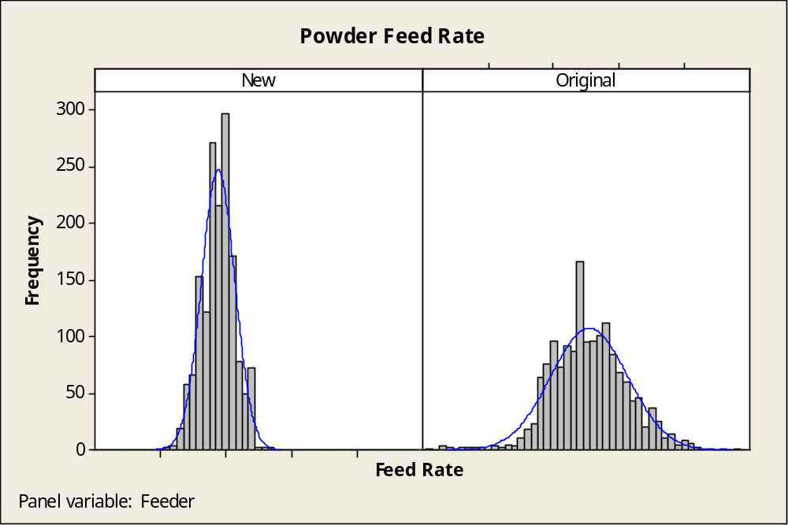
Figure 10. Performance comparison of powder feed systems for test duration of several hours. A 56% reduction in distribution width was achieved with the new system.

3.3 Film Characterization

Film characterization is the essential component of the development of high-throughput CdS/CdTe deposition reactor. Film measurements that have been established previously include automated CdS thickness mapping, automated CdTe roughness mapping, and manual CdTe thickness. During Phase 2 we completed final debugging of an automated IV mapping system and began to utilize the system for understanding spatial variation in modules.

3.3.1 Device Analysis

During Phase 2 work continued on expanding the use of current-voltage-temperatures (IVT), capacitance-voltage (CV) and quantum efficiency (QE) measurements. Ideally these measurements would aid in the determination of loss mechanisms and related process steps.

Traditionally “equivalent circuit” parameters are extracted from IVT data since these parameters can be related to standard semiconductor junction models. We attempted to gain insight into loss mechanisms by analyzing the IVT behavior of several well-differentiated device sets. We consulted with a number of the CdTe team members including UT, CSU, USF, ALF, and IEC. Generally the group concluded that the IVT signature of current First Solar devices is problematic for conventional analysis and thus extraction of equivalent circuit parameters is unreliable. We continue to use these measurements for qualitative comparisons.

3.3.2 IV Mapping

The IV mapping system allows spatial variation in device performance to be determined. Any un-encapsulated module can be divided into an array of small area cells using additional laser scribes. The cells can then be probed automatically making use of the monolithic interconnect via. We have used this system to identify processing problems and to assess non-uniformity losses. For example, during the start up of a new piece of equipment, some modules had poor performance, using the IV mapping system we found that a consistent non-uniformity was due to the setup of the new equipment (see Figure 11). Figure 12 shows a plate with non-uniformity related to a wet processing step. In each case, the IV mapping system allows us to quantitatively understand patterns of variation within a module and is invaluable in locating the process the source of the non-uniformity.

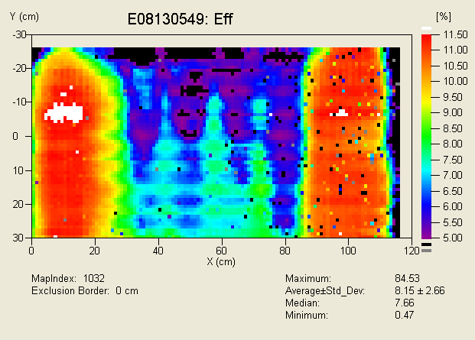
Figure 11. IV map from a poor performing module produced during start-up of a new piece of equipment.

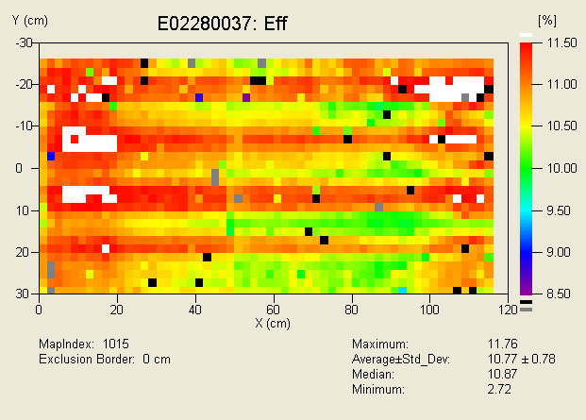
Figure 12. IV map of a plate with non-uniformity caused in a wet processing step.

3.3.3 Non-uniformity loss estimates

Work on understanding non-uniformity losses has progressed on both the experimental and theoretical fronts. Experimentally we have been monitoring non-uniformity in thin CdS modules by mapping IV parameters in select modules that are laser scribed into an array of isolated cells. For example, Figure 13 shows efficiency and Jsc maps from a moderate efficiency module. Some structure is apparent in both the X and Y directions. We believe that the variations are from known sources. For example in this case the vertical bands are caused by variations in CdS thickness due to feeder pulses. A series of modules that exhibited a range of spatial variations were carefully measured for power loss analysis. This set included modules that were processed well off optimum and thus some very poor modules are included. The goal of this analysis was to quantify the amount of loss due to cell mismatch. In other words how much loss can be attributed to the fact that local areas in an interconnected module are not operating at their maximum power point. Figure 14 shows the comparison between average active area cell efficiency and the active area efficiency of the module before division into isolated cells. The difference between the two is the mismatch loss. Contrary to expectations, Figure 14 shows that the mismatch loss is quite minimal in this set of modules. Consequently at the present time, the magnitude of the improvement possible by improved uniformity can only be attributed to the difference between the average cell and the best cell on a plate.

On the theoretical side, the PSPICE simulation software developed at UT is now operational. The basic results to date suggest that the mismatch loss is small (<10%) given the rather large values of series resistance. Moreover the simulation suggests that the geometric pattern does not much matter except for a few severe cases. This result is puzzling and more work is needed to explicitly validate the PSPICE simulation. Nonetheless, it appears that mismatch will not be a large contributor until the average fill factor (series resistance) of the underlying devices is improved.

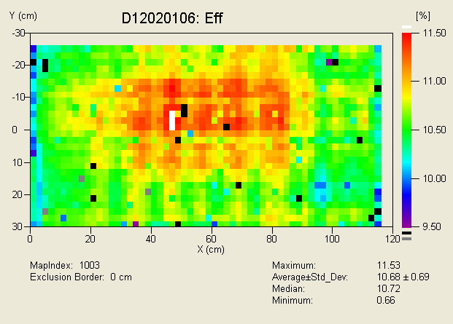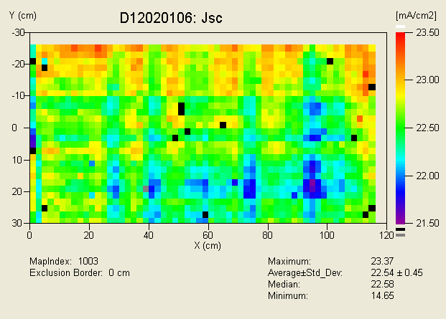
Figure 13. Data from IV maps.

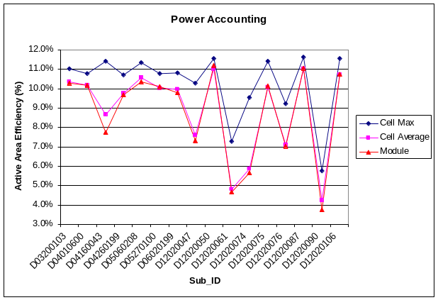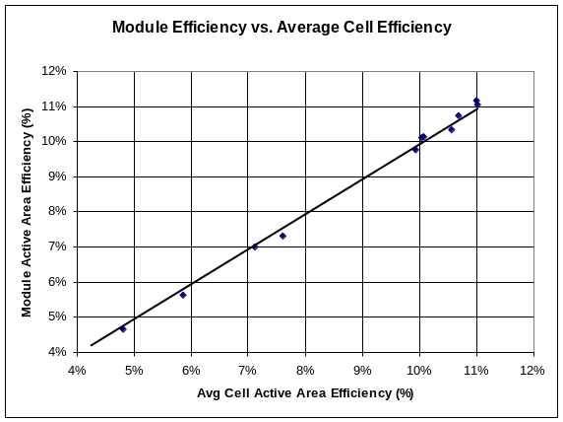
Figure 14. Power loss analysis. Mismatch loss is the difference between module and average cell efficiency.

3.3.4 Chemical Analysis

A used inductively coupled plasma atomic emission spectrometer (ICP-AES) has been acquired and refurbished. The ICP is now used for analysis of trace impurities that influence initial and long-term device performance. The ICP will also be used in defining specifications and developing procedures for quality control of in-coming raw materials such as CdS, CdTe, and CdCl₂. Special emphasis has been focused on monitoring the dopant added during back-contact preparation.

4. Accelerated Life Testing Development

Stable, predictable performance of PV modules is essential for achievement of cost-effective solar electric fields. This requires the development of predictive accelerated life testing (ALT) protocols and increased understanding of mechanisms of stress-induced changes in devices.

4.1 Development of predictive ALT Protocols
First Solar has done considerable research on accelerated life and field testing of CdTe thin-film PV. Potential failure modes for thin-film PV are generally thought to be associated with loss of encapsulation integrity or exposure to combinations of light, heat, bias, and time. In the present ALT protocol we focus on the changes due to exposure to combinations of light, heat, bias, and time.

Ideally ALT would be quantitatively predictive of field performance. Correlation of fast ALT protocols with field data is a formidable task especially in an environment of continuous fabrication process change. We are currently closely tracking ~1800 modules at 3 outdoor locations. An equally important goal of ALT is to rapidly differentiate any device stability differences due to process changes.

To these ends, during Phase 2 we continued to build the correlation between the current 56 day ALT procedure and a more rapid test. The new ALT test provides much more timely information and allows a much greater number of samples to be tested for a given area of test bed.

The rapid test consists of subjecting devices to continuous illumination at higher temperature and frequently recording IV measurements in-situ. The normal multi-vapor metal halide lamps used in the standard light soak stations provide the illumination. Data analysis consists of correcting for illumination fluctuation including 60Hz flicker and extracting a saturated efficiency value from a fitted decay curve. The technique has been applied to cells, module segments, and both un-encapsulated and finished modules.

The correlation of the new ALT protocol with the 56 day ALT is quite good. In many ways the new test is a better indicator of stability than the longer test as the more frequent sampling leads to higher confidence in how efficiency changes with time. The new test also has more tightly controlled module temperature and much better intensity measurements. We have begun to build additional stations to perform the new protocol on a greater number of samples. We have found that the ALT protocol for encapsulated modules must be altered slightly to avoid an unrealistic failure mode related to overheating the EVA. Thus the required test duration is somewhat longer for finished modules.

4.2 Stress-Induced Change Mechanisms

During Phase 1 we had a concentrated effort on finding markers and mechanisms for stress induced changes in the device. In that work a clear marker did not emerge and thus we took a more pragmatic approach during Phase 2. This practical approach addressed important questions regarding the CdCl2 heat treatment and environmental effects.

4.2.1 CdCl₂ treatments

Alternative CdCl₂ treatment methods, most notably vapor CdCl₂, have been frequently studied. To ensure that the best possible method be used for production VTD films, a joint experiment with members of the National CdTe team was undertaken. The objective of this experiment was a comparison between wet and vapor CdCl₂ activation treatments. Each of the participating groups received a series of production VTD as-deposited CdS/CdTe film stacks from FS. Samples with two different CdS thicknesses were provided. Each group performed CdCl₂ wet and vapor activation treatments following procedures and techniques established at their facilities. The participants completed devices with their specific back-contact technologies. Basic device characterization was performed. CdCl₂ activated material was also returned to FS for device completion using the FS back-contact method. FS tested the devices for long-term performance under OC light soaking at 65°C. Results of the joint experiment were presented at the National CdTe Team Meeting in February 2004. At FS, wet and close spaced sublimation (CSS) vapor CdCl₂ treatments were performed. The CSS-vapor CdCl₂ apparatus operates at atmospheric pressure with the source and substrate isothermal. In general, small area devices with efficiencies >12% were obtained using both wet and vapor CdCl₂ methods. Small area devices made from material with thinner CdS often showed lower values for the open-circuit voltage V_{OC} and fill factor FF, which may be caused by the local consumption of CdS. Small differences in the JV-performance of devices that received a wet or a vapor CdCl₂ treatment were noted (see Table 4), but a clear advantage of the vapor treatment method was not found.

Table 4. JV-parameter for small-area devices processed with wet and vapor CdCl₂ treatments.
Device ID | CdS  Thickness | CdCl₂  method | Efficiency  (%) | Voc  (mV) | Jsc  (mA/cm²) | FF  (%) | Rsc  (Ohm-cm²) | Roc  (Ohm-cm²)
D10300182 I4 52 | standard | wet | 12.08 | 800 | 23.2 | 65.0 | 1064 | 5.6
D10300180 B4 52 | thinner | wet | 12.21 | 800 | 23.8 | 64.3 | 1550 | 6.1
D06270138 G4 52 | standard | vapor | 12.73 | 831 | 23.1 | 66.2 | 840 | 5.8
D10300179 F3 52 | thinner | vapor | 12.40 | 813 | 23.8 | 64.2 | 832 | 6.6

Residues left behind by the CdCl₂ activation treatment have to be removed prior to back-contact application. The chemical nature and amounts of residues depend on treatment temperature, CdCl₂/O₂ ratio and the humidity level of the ambient during the treatment.

(a)  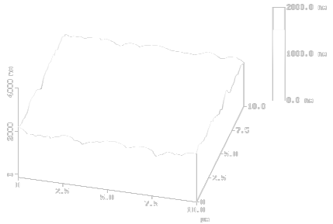  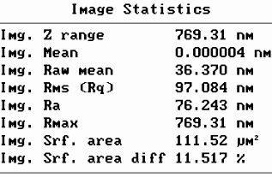 | 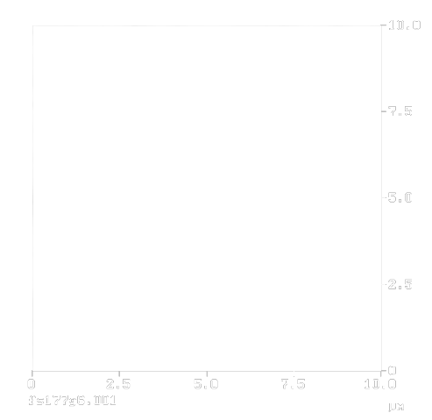
(b)  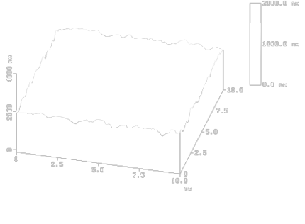  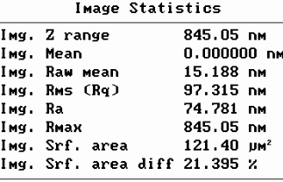 | 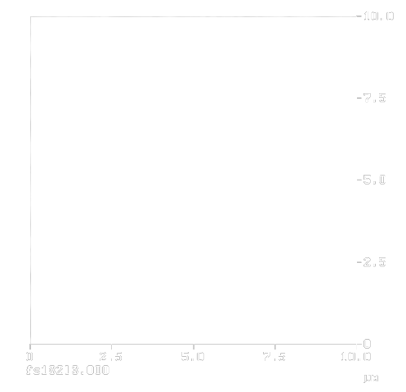
Figure 15. AFM micrographs of CdTe surface after: a) wet CdCl₂ treatment and rinsing, b) CSS-vapor CdCl₂ treatment in room ambient without rinsing. AFM measurements provided by IEC.

For wet CdCl₂ treatments the appearance of CdTeO₃ as the main surface residue was identified by XRD-measurements; CSS-vapor CdCl₂ treatments leave CdO and CdTeO₃ on the CdTe surface behind (XRD measurements supported by IEC). Adequate etching procedures to remove these oxides and to alter the CdTe surface prior to back-contact application are still under investigation.

In general, it appears that none of the methods for CdCl₂ treatments (wet & vapor) used by other team members is clearly superior to the method we use in production. The CdTe sub-team “Chlorine Issues” that was formed to address this question has been formally dissolved.

4.2.2 Back Contact Processing

During Phase 2 the Process Engineering group identified an important back contact process parameter. Modest and simple changes to this variable result in dramatic and reproducible improvements in device performance and a significant reduction in performance fluctuation. Figure 16 shows the effect for a significant population of modules. A significant amount of effort has been devoted to understanding the physical mechanism of this and surrounding process steps. We believe that this work may help advance the understanding of stress-induced changes.

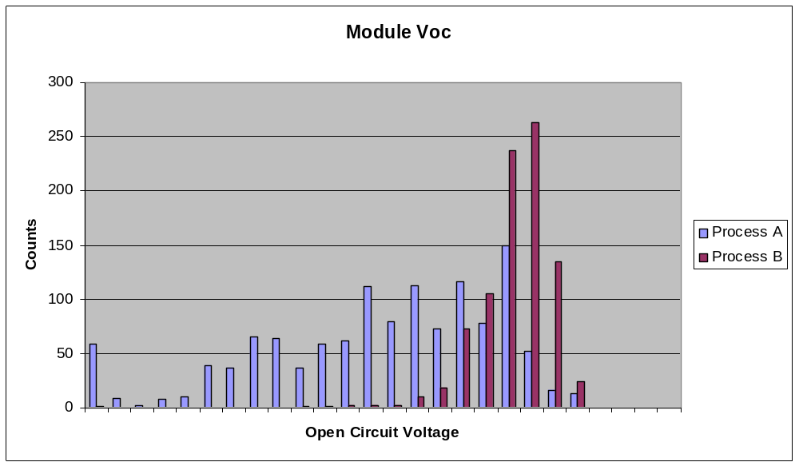
Figure 16. Effect of newly identified back contact process parameter.

4.2.3 Humidity effects during device processing

Part of the effort to understand the improved back contact method focused on the influence of humidity during several process steps. As has been reported by others, the ambient during the high-temperature CdCl₂ annealing step affects device properties. Typically the best devices are produced when the activation process is conducted in dry air with humidity exposure resulting in poorer open circuit voltage V_{OC} and fill factor FF. High humidity levels during CdCl₂ processing increase the thickness and the amounts of oxide residues on the CdTe surface (XRD measurements supported by IEC).

Humidity exposure at other stages during back contact formation was also found to influence device performance in tests involving small area devices. In general, humidity caused reduction in open circuit voltage and fill factor. The worst cases involve a large amount of “roll-over” and a significant efficiency loss. The changes persisted during further light soak stress. In the exploratory tests, the humidity levels and delay times used were extreme; however actual production line effects have also been noted. Currently the production line has a number of delay points and tests for each of these were conducted. In the new production line, there will only be a few points where accumulators can delay process flow, and thus concentration on these points is underway.

We experimented with process factors with the aim of reducing the sensitivity of device performance to ambient variation. Using extreme humidity levels for experiments on small area devices, we found that humidity exposure can cause “roll-over” and high efficiency losses. We also found that there were indeed process factors downstream from the CdCl2 step that reduced the sensitivity to ambient humidity. Optimized devices did not develop any “roll-over” in open-circuit light-soaking experiments: they showed the typical long-term performance comparable to devices, which had not seen any humidity exposure during processing (see Figure 17). In addition, slight improvements in device performance could be achieved.

a)  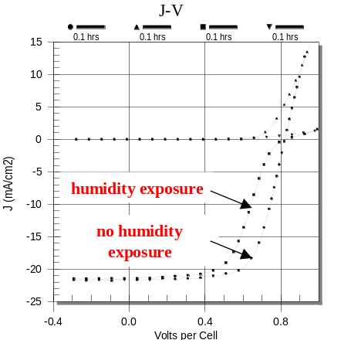 | b)  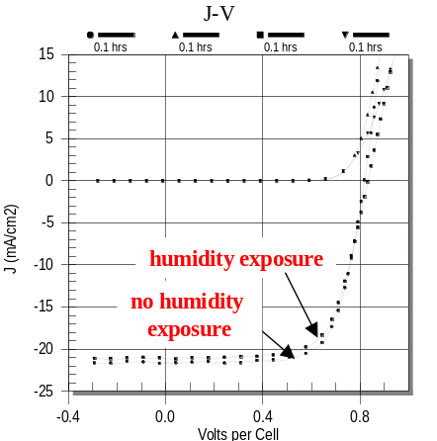
Figure 17. JV-curves of small-area devices a) standard devices with and without extreme humidity exposure during processing, b) improved devices with and without extreme humidity exposure during processing.

, pp. 749-756, 1995.

5. Environmental, Health and Safety Improvements

First Solar is committed to producing a safe product and to operating a safe factory. Thus Environmental, Health, and Safety (EH&S) programs are a top priority. Three main efforts were conducted during Phase 2: updating the safety program to accommodate the factory expansion, ongoing monitoring, and continued efforts for hazardous waste reduction and processing.

5.1 Updated Safety Program

With the factory expansion, much of the EH&S effort during Phase 2 was devoted to updating our current safety program to include the new production equipment. Safety inspections, review of standard operating and lockout/tagout procedures for all new equipment, as well as air sampling and sound monitoring has been conducted.

Training is a key element of operating a safe workplace. Increased staff to handle the increase in production means increased training needs. During Phase 2 we completed the conversion of all our training materials to electronic format for easier management. These materials are now in use for new employee training and ongoing recertification and include Hazard Communication, Cadmium Compliance, Lockout Tagout, and Forklift Operation, Radiation Quality Assurance Plan, Department of Transportation Awareness Training, and Department of Transportation Function Specific Training.

5.2 Ongoing Monitoring

Air sampling is frequently performed. Air monitoring includes fixed location sampling, mobile sampling attached to individuals, and performance assessment of HEPA filtration units. During Phase 1, we studied the effectiveness of HEPA filters and uncovered deficiencies in commercially available units and installation methods. We have worked on improved methods to alert us to any HEPA filter problems. However, we continue to primarily rely on air sampling and biannual system performance assessment by a consultant.

Previously we had three areas within the factory where operators were required to wear respirators due to air sampling results. The three associated process steps were CdTe material removal from the sunny-side, CdCl₂ heat treating, and edge delete prior to lamination. Engineering controls were added to these processes as part of their production upgrade for the automated factory. Two of the processes have now been qualified for production without the need for respirator protection and the third process is also expected to meet this goal once the new automated equipment becomes operational.

5.3 Material recovery

Large scale manufacturing of CdTe-based photovoltaic modules involves handling a significant amount of material that contains cadmium. The largest amount of material that must be handled is scrap plates and off-spec modules.

Previously we have used a wet process that consists of crushing the modules, etching off the CdS/CdTe, precipitating the metals and forming a concentrated filter cake. The filter cake can be disposed of as hazardous waste or can be blended into other larger-volume industrial recovery streams. The filter cake contains copper from busbar ribbons and lead wires and typically is the material of interest. In other words, the filter cake can be blended into copper recycling streams. The clean glass is recycled as glass cullet. The waste also contains tellurium which has some value. We continue to investigate pathways to separate the Te and thus access this value.

During Phase 2 we found several return avenues for dry, as-crushed modules including the glass. This would greatly simplify our internal operation.

Two different companies can blend our crushed scrap in with their existing secondary feedstocks for copper smelting. The copper contained in the scrap is the main target. The glass is an effective substitute for silica sand, which smelters add in quantity for slag conditioning and thus poses no problem as a feedstock component. Since cadmium and tellurium are co-products of copper production, these materials rejoin normal production streams and again become commodities. Cadmium and tellurium are only acceptable since they occur in small quantities in our input stream which is then blended with other material recovery streams.

We are also working with a company that is developing a process for handling electric arc furnace (EAF) dust. EAF dust is a hazardous waste produced in very large quantities which contains large amounts of iron, zinc, and cadmium, and other metals. The new proprietary pyrometallurgical process melts the EAF dust at very high temperatures driving off the volatile metals including zinc and cadmium which are then collected as a dust in a baghouse. The baghouse dust is rich in zinc and will be sent to a zinc smelter or processor for refinement. Since nearly all cadmium is derived as a byproduct of zinc production, cadmium in the zinc stream is normal. The other outputs from the EAF dust process are pig iron which is returned for steel and a slag that is used in road construction as it has some unusual friction characteristics.

Crushed photovoltaic scrap (primarily glass) could be added to the EAF dust melt as a slag conditioner, similar to copper smelting above, offsetting silica sand use. Our cadmium would join the zinc material stream where it is a normal component and end up back as a normal cadmium commodity.

6. Future Plans

First Solar is committed to commercializing CdTe-based thin film photovoltaics. This commercialization effort centers on bringing a 25MW automated production facility on line in the next few months. Process improvements to achieve higher efficiency and greater durability will also continue. The following activities are planned for phase 3 of this subcontract.

- Continued work on large area AFCW layers to allow the use of thinner CdS for higher efficiency.
- Continued work on VTD-2 type distributors
- Equipment and process improvements to allow for consistent formation of thinner VTD CdS layers.
- Use of numeric modeling to improve distributor designs and understanding of VTD process.
- Expanded testing of devices using rapid ALT procedures and correlation of rapid ALT results with field data.
- Continued investigation into post deposition processing, degradation mechanisms, and in-process measurements.
- Continued vigilance in training and monitoring the safety program. Added work on ergonomic practices.
- Continued investigations into material recovery options.

List of Figures

Figure 1. Optical absorption curves of a-CdS:O films. 4
Figure 2. Efficiency as a function of photocurrent for a set of dot cells made on a graded CdS thickness plate without a buffer layer. 6
Figure 3. Efficiency as a function of photocurrent for modules made with and without ZTO buffer layer. 7
Figure 4. SEM micrographs showing variation in CdTe film microstructure across a plate deposited using a standard distributor operated in an asymmetric mode. The G2 and G6 positions correspond to locations x=60, y=20 and x=60, y=-20 respectively in Figure 5. 8
Figure 5. Color contour map of surface roughness determined from reflection characteristics for a film deposited with a standard distributor operated in an asymmetric mode. Note that Y is the cross-web dimension, i.e. the direction of motion of the plate is in the X direction. 9
Figure 6. Reduction in CdTe thickness variation cross web for G3 distributor. On average there is a 37% reduction in cross-web variation using the G3 system. 10
Figure 7. SEM micrographs of films deposited using the G3 distributor. A variety of microstructures can be formed. These micrographs are from centered locations but in general the G3 distributor produces films with uniform structure. All micrographs 5000x magnification. 11
Figure 8. Reduction in cross-web roughness variation for G3 distributor. 12
Figure 9. Cross-web CdTe thickness profile from a standard distributor operated in a non-uniform mode (a) experimental data, (b) modeled case. 13
Figure 10. Performance comparison of powder feed systems for test duration of several hours. A 56% reduction in distribution width was achieved with the new system. 15
Figure 11. IV map from a poor performing module produced during start-up of a new piece of equipment. 16
Figure 12. IV map of a plate with non-uniformity caused in a wet processing step. 17
Figure 13. Data from IV maps. 18
Figure 14. Power loss analysis. Mismatch loss is the difference between module and average cell efficiency. 18
Figure 15. AFM micrographs of CdTe surface after: a) wet CdCl₂ treatment and rinsing, b) CSS-vapor CdCl₂ treatment in room ambient without rinsing. AFM measurements provided by IEC. 21
Figure 16. Effect of newly identified back contact process parameter. 22
Figure 17. JV-curves of small-area devices a) standard devices with and without extreme humidity exposure during processing, b) improved devices with and without extreme humidity exposure during processing. 23

Glossary of Abbreviations

AFM Atomic Force Microscopy
ALF Alan Farhenbruch consulting
ALT Accelerated Life Test
CdS Cadmium Sulfide
CdTe Cadmium Telluride
CSM Colorado School of Mines
CSU Colorado State University
CV Capacitance-Voltage measurement
DAP Donor-Acceptor Pair
EH&S Environmental, Health and Safety
FF Fill Factor
FS First Solar, LLC.
IEC Institute of Energy Conversion at the University of Delaware
I-V Current-Voltage measurement
IVT Current-Voltage measurements as a function of temperature
J_{sc} Short circuit current density
NREL National Renewable Energy Laboratory
OC Open Circuit
PL Photoluminescence
PV Photovoltaics
Roc Dynamic resistance at open circuit
Rsc Dynamic resistance at short circuit
SC Short Circuit
TCO Transparent conducting oxide
USF University of South Florida
UT University of Toledo
V_{Cd} Cadmium vacancy
V_{oc} Open circuit voltage
VTD Vapor Transport Deposition

References

[1] X. Wu and P. Sheldon, "Novel Manufacturing Process for Fabricating CdS/CdTe Polycrystalline Thin-Film Solar Cells," presented at Sixteenth European Photovoltaic Solar Energy Conference, Glasgow, United Kingdom, 2000.
[2] X. Wu, R. G. Dhere, Y. Yan, M. J. Romero, Y. Zhang, J. Zhou, C. DeHart, A. Duda, C. Perkins, and B. To, "High-Efficiency Polycrystalline CdTe Thin-Film Solar Cells with an Oxygenated Amorphous CdS (a-CdS:O) Window Layer," presented at Twenty-Ninth IEEE Photovoltaic Specialists Conference, New Orleans, Louisiana, 2002.
[3] R. Powell, G. Dorer, N. Reiter, H. McMaster, S. Cox, and T. Kahle, "Apparatus and method for depositing a material on a substrate, U.S. Patent # 5,945,163." U.S.: First Solar, LLC., 1999.
[4] R. Powell, G. Dorer, N. Reiter, H. McMaster, S. Cox, and T. Kahle, "Apparatus and method for depositing a semiconductor material, U.S. Patent #6,037,241." U.S.: First Solar, LLC, 2000.

† Cross-web denotes transverse to the direction of motion in the deposition system and down-web refers to in the direction of motion in the deposition system.

