TECHNICAL NOTES
USDA-Natural Resources Conservation Service
Boise, Idaho

TN AGRONOMY NO. 43 May 20, 1983

Prepared by Floyd G. Bailey, State Conservation Agronomist

STANDARD METHODS OF MEASURING
CROP VEGETATION RESIDUES, YIELDS

As greater emphasis is placed on conservation tillage, crop residue use and stubble mulching in soil erosion control systems, soil conservationists need to have available acceptable methods for measuring and estimating amounts of crop residues. This technical note contains instructions on the commonly used methods of measuring and estimating crop residues. Its objective is to encourage improved sampling procedures and accuracy in crop residue measurements.

The Hand Clipping Method

This method consists of hand clipping and weighing crop residues. It requires a fixed guide consisting of a square or ring containing 9.6 square feet inside the frame. A square with 37.2 inches per side or a ring having a 42-inch inside diameter is used to get a 9.6 square feet template. Measurements are made in grams for easy conversion to pounds per acre. To use, place the ring or square on the ground and collect all visible parts of plant vegetation or residue above the ground within the ring or square. Clip off all attached or partially buried vegetation at the soil surface. Materials such as weeds should be included when the sample is for erosion control purposes. When the sample area contains small pieces of vegetation that are difficult to pick up, the soil conservationist should estimate the amount (in grams) remaining on the soil surface. Do not include soil particles in the sample.

Weigh all samples in an air-dry condition. When samples are wet, they should be air-dried under natural weather conditions or oven-dried at approximately 700 C. until the weight has become stable. Use a gram scale to weigh the sample. To convert the sample weight to pounds per acre, multiply the sample gram weight by 10.

A minimum of four samples per field should be collected using a random method of sampling. When the field contains chaff or straw rows, one of the four samples should include the chaff row.

The Line and Point Method

This method requires crop residues to be flattened and uniformly distributed across the field.
The line consists of a cord 50 feet long with 100 knots or beads spaced 6 inches apart. Lines can be easily made from a piece of 1/8 or 3/16 inch nylon rope about 70 feet long and two metal pegs or stakes. Overhand knots are tied in the rope on 6 inch centers. The end product is a 50 foot cord with 100 points on it. The two metal pegs are attached to the ends of the rope. They are used to stake the line out.

In the field, the line is stretched out across the field at about a 45 degree angle to the crop rows. Both end pegs are pushed into the soil to hold the line straight.

To estimate residue on the soil, walk along the line and count the number of knots that lie on top of a piece of crop residue. Ignore small pieces of residue that will decay before the critical erosion period or are not large enough to intercept a raindrop. The number of knots directly over residue will tell the percentage of the surface covered with residue. Tables 1 and 2 can be used to convert percent cover to pounds of cover per acre.

To improve accuracy, three or more randomly selected samples should be taken and results averaged.

The Weight Estimate System

The weight estimate system is similar to the hand clipping method. It is faster but less accurate; however, it is accurate enough for planning purposes.

This system uses a 9.6 square foot or ring. The square or ring is placed on the ground. Then the soil conservationist selects a handful of the same type of material located outside the square or ring. This sample should be large enough to weigh, but not too much to easily handle in one hand. Holding the sample in one hand, the soil conservationist uses the other hand to estimate the number of “like handfuls” of residue contained within the square or ring by grasping handfuls inside the template. The hand sample is then weighed in grams and the weight multiplied by the number of “like handfuls” to determine the estimated weight of the residues within the square or ring. The weight in grams is multiplied by 10 to give pounds per acre.

This procedure should be randomly repeated over the field to get a proper representation of the field. Weight estimates should periodically be checked against actual clipping weights to maintain accuracy.

Row-Length Method

Where row crops are grown, it is often desirable to use the row-length method to measure residue. This is accomplished by measuring the row spacing and marking off the row length required to give the proper size sample. The sample area should be a minimum of 1 square yard for small grains and grasses and a minimum of 2 square yards for corn. The following table is used to determine row length needed when the row spacing is known.

Row spacing center-to-center | Length of row to make 2  square yards | Length of row to make 1  square yard
Inches | Feet | Feet
20 | 11 | 5.5
24 | 9 | 4.5
30 | 7 | 3.5
36 | 7 | 3.0
42 | 5 | 2.5

All above ground vegetation or residue is collected and weighed. Samples are weighed air-dry. Sufficient samples should be measured to get a good representation of the field. Sample weights are averaged to gain the weight of the average 1 square yard sample. When the weight is in grams, multiply average sample weight by 10.66 to convert to pounds per acre.

Rod Row Sampling

This method consists of cutting a measured length of drill row and weighing the grain or straw yield. Any length of row can be cut, but the following row lengths are recommended because they produce an easily-managed bundle or sheath, and the data is easily converted to pounds or bushels per acre.

1. On 14-inch drill row spacing - Cut two adjacent rows in 9 feet 4 inches long. To convert yield to pounds per acre, multiply results by 2000.

2. On a 7-inch drill row spacing - Cut two adjacent rows 9 feet 4 inches long. To convert yield to pounds per acre, multiply results by 4000.

3. On a 6-inch drill row spacing - Cut two adjacent rows 8 feet 8½ inches long. To convert yield to pounds per acre, multiply results by 5000.

Cutting two adjacent drill rows is better than cutting only a single row because drill skips in the row are usually compensated for by heavier tillering in the adjacent row.

Photo Comparisons

Photographs of different amounts of crop residue can be compared to field situations to estimate the amount of crop residues on the field. This method is accurate enough for general planning purposes, but should not be used for certifying practice compliance. Soil conservationists using photo-comparison should frequently check themselves by clipping samples using the square or ring method to maintain accuracy at a high level.

The attached photographs can be used for making photo comparisons.

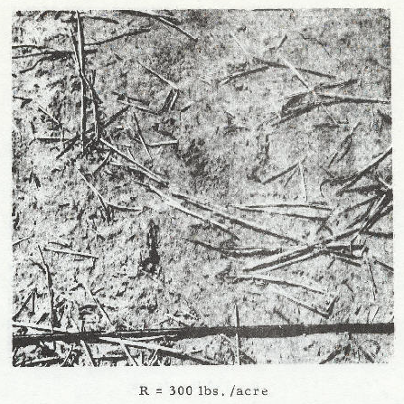

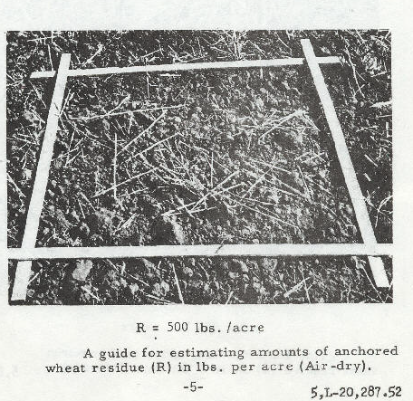

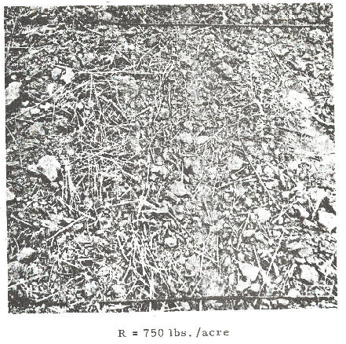
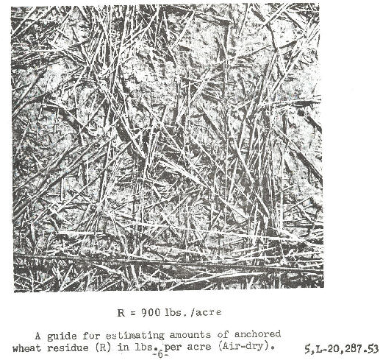

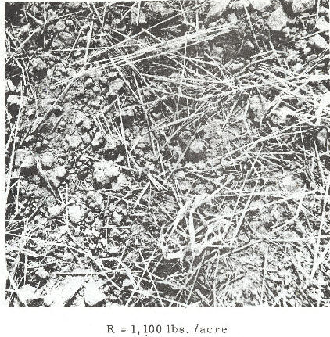

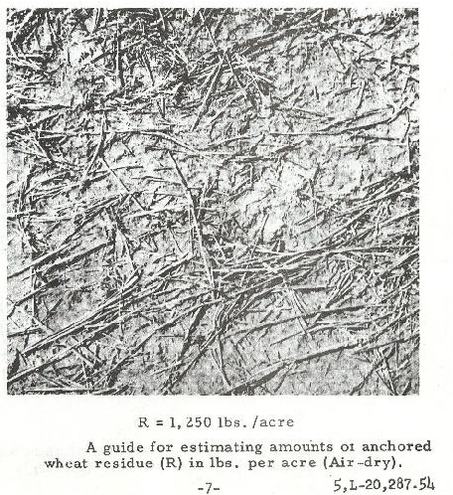

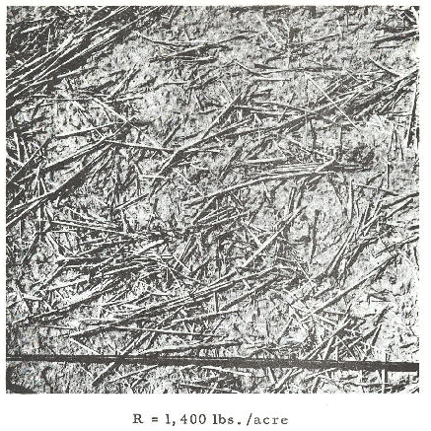

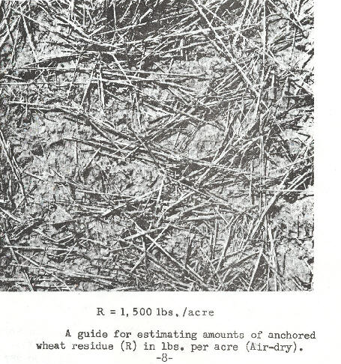

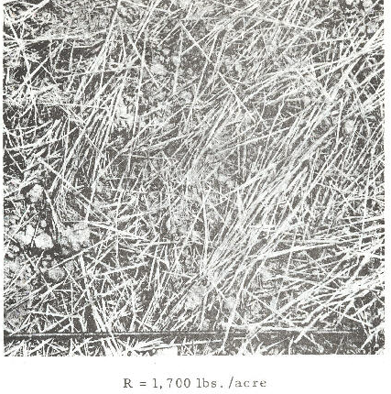

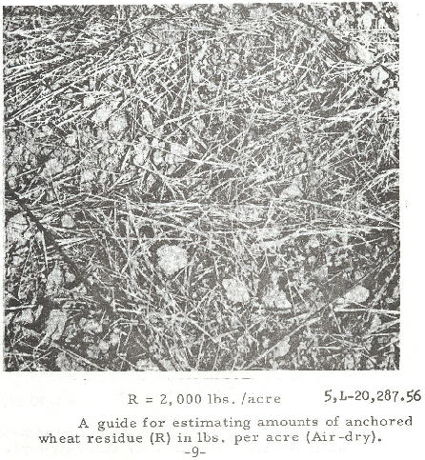
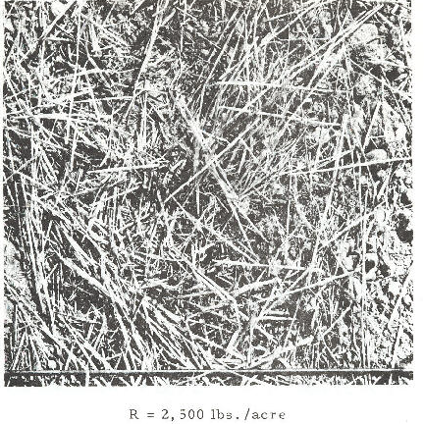

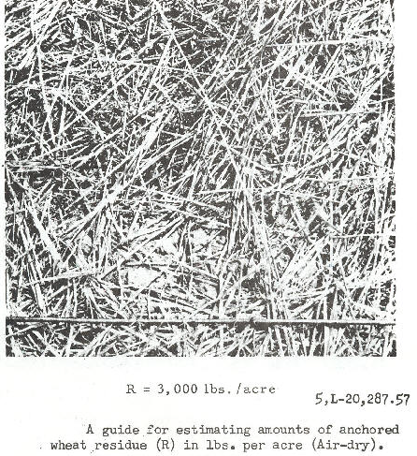

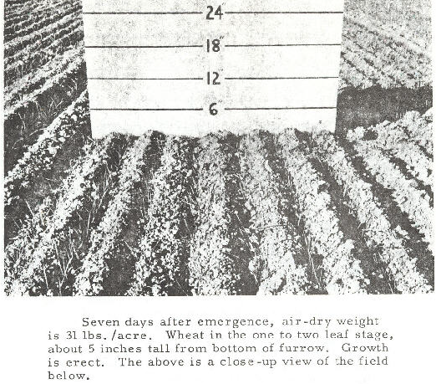

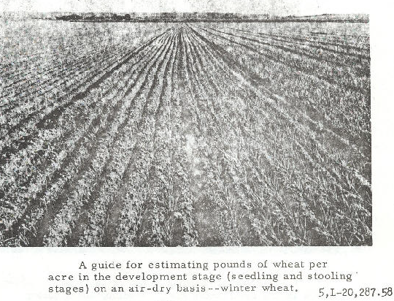
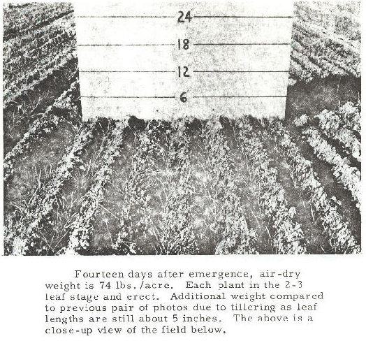
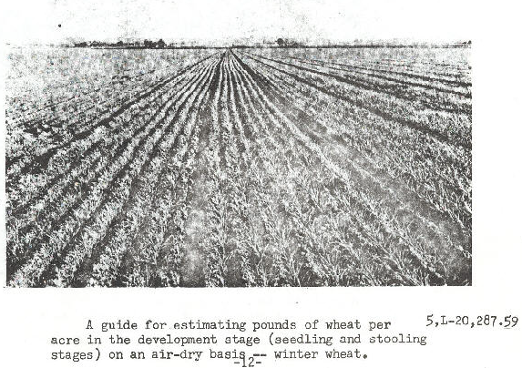
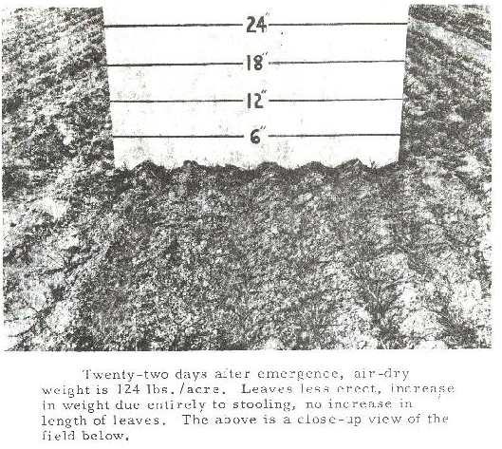

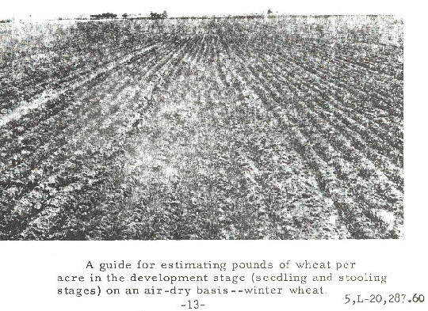

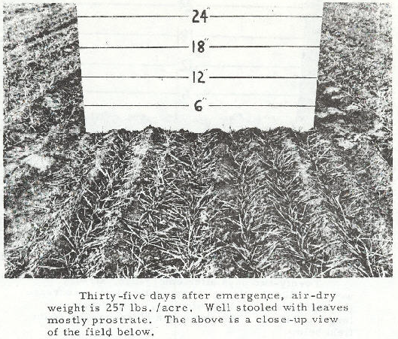

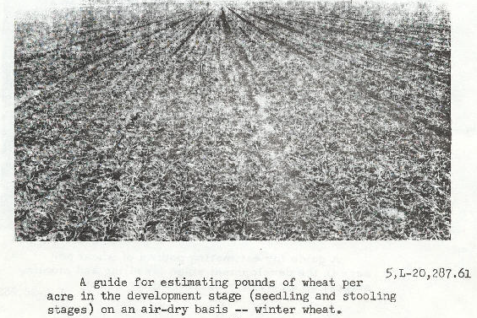

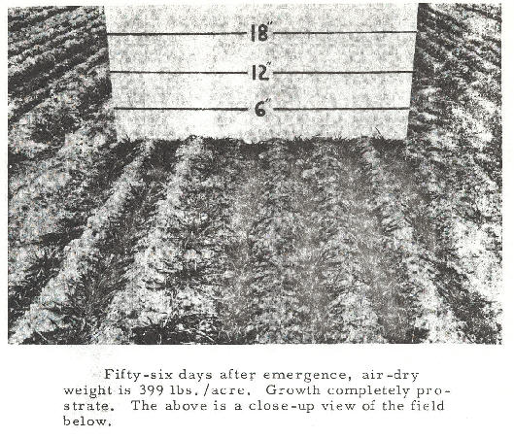

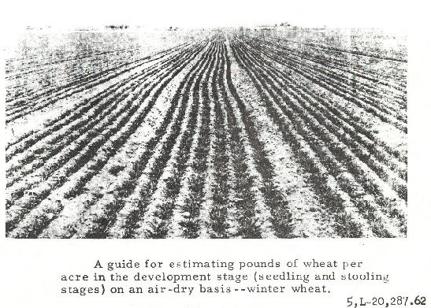

TABLE 1 Cover/Residue Table for Wheat, Barley, Oats, Soybeans or Similar Small Diameter Stalk

Percent Cover | Pounds of Residue/Acre | Percent Cover | Pounds of Residue/Acre
1 | 16 | 51 | 1107
2 | 31 | 52 | 1139
3 | 47 | 53 | 1172
4 | 63 | 54 | 1205
5 | 80 | 55 | 1233
6 | 96 | 56 | 1274
7 | 113 | 57 | 1310
8 | 129 | 58 | 1346
9 | 146 | 59 | 1384
10 | 164 | 60 | 1422
11 | 181 | 61 | 1461
12 | 198 | 62 | 1502
13 | 216 | 63 | 1543
14 | 234 | 64 | 1586
15 | 252 | 65 | 1629
16 | 271 | 66 | 1674
17 | 289 | 67 | 1721
18 | 308 | 68 | 1768
19 | 327 | 69 | 1818
20 | 346 | 70 | 1868
21 | 366 | 71 | 1921
22 | 386 | 72 | 1976
23 | 406 | 73 | 2032
24 | 426 | 74 | 2091
25 | 446 | 75 | 2151
26 | 467 | 76 | 2215
27 | 488 | 77 | 2281
28 | 510 | 78 | 2350
29 | 532 | 79 | 2422
30 | 554 | 80 | 2498
31 | 576 | 81 | 2577
32 | 599 | 82 | 2661
33 | 622 | 83 | 2750
34 | 645 | 84 | 2844
35 | 669 | 85 | 2944
36 | 693 | 86 | 3051
37 | 717 | 87 | 3166
38 | 742 | 88 | 3291
39 | 767 | 89 | 3426
40 | 793 | 90 | 3573
41 | 819 | 91 | 3737
42 | 845 | 92 | 3920
43 | 872 | 93 | 4127
44 | 900 | 94 | 4366
45 | 928 | 95 | 4649
46 | 956 | 96 | 4995
47 | 985 | 97 | 5442
48 | 1015 | 98 | 6071
49 | 1045 | 99 | 7147
50 | 1076 | 100 | 9999
TABLE 2 Relation of Percentage of Surface Cover to Mulch Rate

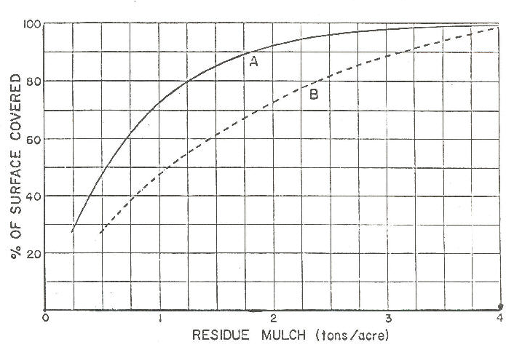

Curve A is for small-grain straw. Curve B is for chopped cornstalks.

Acknowledgements

This material was developed from the following references:

“A Standardized Procedure for Residue Sampling.” USDA-ARS 41-68.

‘‘Methods of Measuring or Estimating Amounts of Crop Residue Per Acre.” WTSC Agronomy Note No. 23, November 1965 by J.W. Turelle.

“Weight-Estimate System of Sampling Crop Residues.” (unpublished) by Evan L. Murray.

“Predicting Rainfall Erosion Losses, A Guide to Conservation Planning.” USDA Handbook No. 537, prepared by Science and Education Administration (ARS), 1978.

Plant Science Handbook, Washington State University.

“Measuring Crop Residue Cover.” Laflen, J.M. et al, Journal of Soil and Water Conservation, November-December 1981.

