The Jason 2 Mission:
Monitoring Ocean Surface Topography from Space
Yves Menard ⁽¹⁾, Lee Fu⁽²⁾, François Parisot⁽¹⁾, Said Kaki⁽²⁾,
Alain Ratier⁽³⁾, Robert Cheney⁽⁴⁾
(1) CNES, 18 Ave. Ed. Belin, 31401, Toulouse cedex, France
(2) JPL, 4800 Oak Grove Drive, Pasadena, CA 91109, USA
(3) EUMETSAT, Am Kavalleriesand 31, D-64295 Darmstadt, Germany
(4) NOAA, 1315 East-West Highway, Silver Spring, MD 20910, USA

September 16, 2002
Presentation to EUMETSAT Scientific and Technical Group

- Contributing to the Space-Based Ocean Observatory
The oceans are a fundamental element in our planet's climatic system. We should be able to monitor their conditions at all times, to describe them, to understand them and forecast their changes. The climatic upsets we have experienced in recent years—like those related to "El Niño" and "La Niña" events—gave us a sudden wake-up call to try to better understand the « ocean machine » and its interaction with the atmosphere. Scientists need in particular to examine the causes, consequences, and "predictability" of oceanic changes because it is now accepted that the ocean has a fundamental disruptive and regulating role in the Earth's climate.
Our limited view of the ocean has become much sharper over the last thirty years. Just a few decades ago, the thought that we could have a continuous, real-time global view of the ocean seemed unrealistic; at that time, only partial and intermittent in-situ data were available. This is no longer the case, thanks to the many satellites that monitor the Earth and its oceans, flying over the entire surface of the planet in just a few days and measuring, with unparalleled accuracy, surface temperatures, ocean color, wind speed and direction, and sea surface topography.
The Franco-American satellite TOPEX/Poseidon (T/P) was launched in 1992 as a follow-up to SEASAT (1978) and GEOSAT (1985). Together with ERS-1 and ERS-2 (1991, 1995) and Geosat Follow-On (1998) it showed the wide range of oceanographic applications that can be obtained from space. Using very powerful radar altimetry technology, the sharp eye of this satellite detects the slightest variation in sea level and provides quick, synoptic, global, and regular measurements of ocean surface topography (Chelton et al., 2001). Data gathered by T/P over all the Earth's oceans every 10 days allow scientists to regularly draw up charts of sea surface currents, follow their intra-seasonal to seasonal variations, and observe the oceanic signatures of major climatic anomalies, such as the 1997-99 El Niño/La Niña phenomena. This is helping scientists better understand and describe the complex mechanisms and interactions among the oceans' different variability modes.
On December 7, 2001, the Jason-1 satellite was launched from the Vandenberg site in USA to take over the T/P mission. This new satellite, jointly developed by CNES and NASA as the previous one, was declared operational 2 months after the launch and since then is delivering geophysical data at a level of performance identical to T/P. Placed in the same orbit as T/P, Jason-1 is working in tandem with its companion T/P, still operational after 10 years of a brilliant career. On March 1, 2002, the ENVISAT satellite from ESA was launched by an Ariane 5 rocket from Kourou. Onboard this multi-mission satellite, a radar altimeter is running (Benveniste, 2002) to take over the ERS-2 altimetric mission (still in operation). The orbit repeating at 35 days (instead of 10 days for Jason and T/P) is sampling the ocean at a shorter spatial scale, complementing the large scale vision of T/P.
With T/P and previous missions living up to expectations, satellite altimetry has become an indispensable discipline in the development of a new challenge, that of operational oceanography. In this regard, Jason-1 and ENVISAT are considered as precursors with the implementation of new near-real time capabilities (for instance, Jason-1 delivers data to users within 3 hours of observation). This challenge has been spurred on by the success and interest generated by these altimetric missions in research programs like WOCE (World Ocean Circulation Experiment), TOGA-COARE (observing climatic anomalies in the tropical Pacific region), and more recently CLIVAR (Climate Variability and Predictability).
Progressing from research to applications and operational services is always delicate. It demands first a permanent dialogue between researchers and teams involved in operational system developments. This close relation is essential to implement and update models and assimilation tools in the operational centers. Another strong requirement is to increase and maintain in a consistent way the satellite based and in-situ observation networks and the data access systems. The Global Ocean Data Assimilation Experiment (GODAE) represents an international effort to address these different issues (N. Smith, 2002). Several pilot experiments are already running in various countries to prepare the demonstration phase of GODAE over 2003-2005. High resolution 3D global description and forecast of the ocean will be then routinely released by different centers around the world. The MERCATOR and FOAM projects in Europe (Bahurel et al., 2002; Bell et al., 2002), the ECCO project in US (Fukumori et al., 2002) are few examples of such pilot experiments. Climate seasonal forecasts, ship routing, ecosystem management, and coastal area activities, will widely benefit from these new oceanic products. In the meantime, oceanic models will reach increasing levels of performance and the global in-situ observation network will be enhanced and maintained. The international ARGO program will support around 3000 profiling floats over all the oceans by 2005 (Roemmich et al., 2002).
The satellite based observation systems also need to be maintained and developed (Ratier, 2001; Kawamura, 2002). In this regard, spaceborne altimetry programs are key elements of the global observation network (Mitchum et al., 2001). They have to be consistent with the global and long term observation strategy required for the GODAE objectives (Smith and Koblinsky, 2001). In this regard, new altimetric missions have to be decided soon in order to replace the current missions by 2006. In late 2001 CNES, NASA, Eumetsat, and NOAA exchanged letters indicating that they intend to work together on a “Jason-2”mission (a new name for this mission is currently under discussion; is it known generically in the U.S. as the Ocean Surface Topography Mission, or OSTM, but in this paper we will use the term Jason-2.)

2. Jason-2 to take over the Jason-1 mission
The main objectives of Jason-2 include the continuation of the T/P and Jason-1 missions, based on the science and pre-operational returns of these two missions (Menard and Fu, 2001) and the support in a timely manner to the global and regional operational applications. As its predecessors, Jason-2 will be placed onto a 66° orbit, at an altitude of 1336 km.. It will follow the same reference ground tracks, repeating these tracks every 10 days. Performance and data delivery latency will be the same as Jason-1 (Menard et al., 2000). Even if the operational application objectives of the Jason-2 mission will take a growing place with respect to previous missions, the research part will be still very intense.
2.1. Research topics cover many different fields.
Description of the mean circulation using altimetric sea level measurements is essential to better understand its interaction with the time-varying components and the involved mechanisms. It is also important for initializing ocean models. The large accumulation of altimetric data from the early missions through Jason-2 and follow-on, along with high resolution marine geoid derived from space-borne gravimetric measurements (CHAMP in 2000, GRACE in 2002, GOCE in 2005) will provide significant contributions to a better understanding of this “mean” ocean.
The ocean exhibits variability at different scales in time and space, affecting significantly mass and heat transport, exchanges with the atmosphere, and consequently the climate. Sea surface topography as measured by altimetry has proven its usefulness to understand the physics behind this variability (e.g. Fu and Chelton, 2001; Picaut and Busalacchi, 2001). Model parameterization has been improved thanks to these new findings. But there is still more to do. Apart from the seasonal cycle, which leads to an increase or decrease in sea level in each hemisphere, exceeding 15 cm in some areas, there are significant variations from one year to the next which are not yet well understood. The El Nino event, the North Atlantic Oscillation, the Pacific Decadal Oscillation, the planetary waves crossing the oceans over periods of months are among the mechanisms which need to be better characterized. Because of the long period of these phenomena, very long time series of altimetric observations are needed, requiring Jason-2 and follow-on missions.
Mesoscale ocean variability is associated with shorter time and space scales (typically 1 month/30 km) but it impacts significantly the energy balance with the atmosphere. Western boundary turbulent currents and the energetic whirlpools which they form play an essential role in moving heat from low to high latitudes. But eddies are travelling over all the oceans interacting with the lower frequency modes as well as with the coastal currents, coast line, continental shelf, and bathymetry. This eddy activity is now quite well characterized statistically, thanks to the multi-year accumulation of altimetric data (Le Traon and Morrow, 2001). But we need to go one step further to decode this complicated turbulent physics and to transcribe it better in the eddy resolving open ocean and coastal models. Jason-2 (as Jason-1 and T/P) will provide spatial resolution not optimized for such investigations (320 km at the equator), but its contribution along with complementary missions (e.g. ENVISAT and follow-on) will be essential.
At the other end of the ocean variability spectrum, the secular mean sea level trend is a pertinent indicator of global warming. The unique accuracy of T/P sea level measurements has demonstrated an unexpected capability of recovering a global trend of about 2 mm/year (Nerem and Mitchum, 2001). Nevertheless, this parameter has an extremely small variation, at the limit of what can be observed even with systems as efficient and accurate as T/P and Jason-1. Only long term time series over several decades will decrease the error bar at a level consistent with the small amplitude of the signal. The continuation of Jason type missions is a unique way to fulfill this objective of great importance and of general interest.
In the domain of tide modeling significant progress has been made thanks to the altimetry, in particular T/P data (Le Provost, 2001). Several models now are able to predict the main diurnal and semi-diurnal components of ocean tides with an exceptional precision of 2 cm rms. But investigations are continuing to track more subtle tide signals, including long period components, coastal interactions, internal waves generated by the tides, and tidal energy dissipation. All these issues need absolutely the continuation of altimetric missions, including Jason-2, to provide the appropriate space and time sampling of the sea level.
Other domains will benefit from the Jason-2 mission. Estimates of wave height and wind speed derived from the radar altimeter echos are two parameters which are of great value for marine meteorology nd climatology studies as well as operational sea-state forecasts (Lefevre and Cotton, 2001). Investigations in the field of earth sciences, such as research on marine geoid (Tapley and Kim, 2001), tectonics (Cazenave and Royer, 2001), hydrology, ice (Zwally and Brenner, 2001), closed seas, great lakes, and desert regions, will also greatly profit from the continuation and the merging of high precision Jason-2 altimetric measurements with other data sets.
2.2 Operational Applications, predicting the ocean weather
One of the major objective of the Jason-2 mission (~2006 launch) will be to support the transition from the ocean operational system demonstration phase (the 2003-2006 GODAE time frame) to the ocean routine operations. Operational activities can be divided into two categories depending on the time-scale: the short range ocean forecast (in which we can include coastal aspects) and the seasonal to long term range ocean forecast.
The seasonal ocean forecasting is one of the most demanding and ambitious objectives. Information on these time scales provided by altimetry to the ocean models is essential, because the role of currents is not yet well understood and well parameterized. Even if progress in the related physics is expected within the next years, the near-real time ocean state estimates derived from altimetric data and assimilated continuously with other data sets into models is of great value (Rienecker at al., 2002). This assimilation leads to a description and a prediction of oceanic currents, temperatures, and salinity with a level of precision that has never before been obtained. The question of longer term predictions (interannual to decadal) is of importance, but research in this field is just starting, so long term routine ocean forecasts will not emerge in the near future. As mentioned previously, long time series of accurate altimetric data (Jason-2 and follow-on) will help in understanding this ocean long-period variability and its interaction with short term modes (participating thus in the improvement of seasonal forecasts).
One example of seasonal ocean forecast operated on a routine basis is the one provided by NOAA. Since 1996, T/P sea level anomalies have been assimilated each week in the NCEP Pacific Ocean model used to predict ENSO (Miller et al., 2002). This processing is done in near-real time thanks to the 2-day latency delivery of T/P interim geophysical data (figure 1). In the meantime several groups around the world are working on the coupling of ocean with atmosphere to develop seasonal climate forecasting models. Such models will use as inputs the ocean analysis and predictions released by ocean operational centers.
The short range ocean prediction has many applications of great interest. Several global and regional models have been developed and run in an experimental or pre-operational configuration, before entering the operational phase (e.g. MERCATOR, FOAM, ECCO...) (figure 2). They provide high resolution, high frequency 3D products which depict and forecast a few weeks in advance the very short scale nature of the ocean signal, including current positions and intensity, position and scales of eddies and thermal fronts (Hurlburt et al., 20002; Bahurel et al., 2002; Bell et al, 2002; Pinardi et al., 2002). One issue which is especially challenging is understanding the connection of the open ocean with the coastal ocean and development of models capable of recovering the sharpest details (Thompson et al., 2002). Because of the highly turbulent characteristics of this short range signal and its non-linear evolution, it is absolutely necessary to take advantage of global, dense, and accurate observations. Altimetry is especially powerful for monitoring in near-real time the mesoscale signal and adjusting regularly the models. The derived products satisfy many applications (e.g. marine safety, marine pollution, ship routing, navy needs, oil drilling, coastal forecasts, fish stock management...).
For instance, based on these products, links can be observed between the marine environment, the rate of marine species reproduction, and their life cycle (Griffin et al., 2002). Consequently, this is helpful to better manage variations in fishing resources according to fishing campaigns. Fishing industry management is a promising market for short range mesoscale products (e.g. CLS CATSAT project, NOAA fishery service forecasts). The offshore drilling oil industry is also interested in those products because petrol companies are going further from the coast and into deep water. Oil is brought to the surface through flexible umbilicals to barges anchored above the site, and tankers then remove the oil from these barges. Knowing the currents at the surface but also at a depth of several hundred meters is very useful for this type of operation sensitive to destructive eddies and fronts (Evensen, communication at GODAE symposium, 2002). Navy forces need also for their own needs specific forecasting and analysis of short range oceanic state. Water masses, temperatures, currents, eddies, and the position of fronts are essential information to help both surface and underwater navigation (Jourdan et al., 2002; Smedstad et al., 2002).
Another field of activity is that concerning coastal areas where there are many problems related to risk prevention and coastal development. High resolution models require as an input high accuracy products in the coastal band but also at the deep ocean boundary. One example is the prevention of storm surges. They generate an abnormal increase in sea level (up to few meters) caused by low pressure together with high winds blowing from the sea toward land (amplified during hurricane situations) which can be particularly devastating to the shoreline. Another example is the trajectory monitoring and forecasting of drifting polluted waters, ships, and objects lost at sea. The drift is a result of the combined actions of a current pushed by the wind, tide, and coastal currents and large-scale oceanic circulation. Its forecast is based on dedicated oceanic models coupled with models describing the behavior and changes of the drifting materials. In this domain too, altimetry products have a key role to assess and to constrain frequently the models, improving thus the forecasts (Daniel et al., 2002) (figure 3).
Meteorological centers run sea state forecast models to anticipate the evolution of waves and swells, which are superimposed, on all parts of the Earth, providing sailors and workers at sea with regular forecasts and special weather updates when weather conditions deteriorate. Such models (e.g. VAG at Météo-France, WAM at the ECMWF European Center) benefit undoubtedly from real-time wave-height and wind speed altimetry products such as those issued within 3 hours from ERS2, Jason-1, and ENVISAT (Lefevre and Cotton, 2002).
3. The Jason-2 System
The Jason-2 mission will be conducted within a partnership extended to four: the CNES and NASA space agencies, and the EUMETSAT and NOAA operational agencies. This new program organization will reinforce the transition of the Jason-2 mission towards operational applications. Indeed, EUMETSAT and NOAA will be involved in the ground operations, while CNES and NASA will have the project development responsibility. CNES participation is placed within a national effort of developing the operational oceanography. On the NASA side, this new project is part of its EOS program. NOAA participation is linked to its existing satellite ground system and its ocean applications programs. EUMETSAT will be engaged through its first optional program to be approved mid-2003.
On a technical point of view, Jason-2 satellite (figure 4) will be as identical as possible to Jason-1 (Escudier et al., 2000). Even if not yet finalized, the organization should be close to the following:
CNES providing:
- A new version of the PROTEUS multi-mission platform taking into account the
experience return of the past missions and the evolution of the electronic components,
- The dual-frequency radar altimeter Poseidon 3 adapted to new electronic components
and new engineering developments
- The Precise Orbit Determination System DORIS, a second generation miniaturized
version
NASA providing:
- A GPS receiver to contribute in the precise determination of the orbit of the satellite
- A laser retro-reflector to complete the orbit tracking of the satellite
- A new generation radiometer to measure the water vapor content in the troposhere and
derive the appropriate radar path delay correction
As with Jason-1, Jason-2 should be launched by NASA using a Delta 2 Boeing rocket from the Vandenberg launch site in California. The ground system will benefit from the T/P and Jason-1 heritage. In CNES, the data processing, archiving and distribution will be part of the SALP (Precise Localization and Altimetry Service) project.
NOAA has proposed to provide Earth terminals, the satellite operations control center, and near real time data processing, archiving, and distribution.
EUMETSAT should provide an Earth teminal and should be responsible for near real time product processing, distribution, and user interface support.
A science team selected by the four agencies will assist the project in science algorithm development and further calibration and validation activities.
In addition to this nominal payload (similar to Jason-1), NASA/JPL has proposed to embark as a technological demonstration passenger, a new radar altimeter imager called the Wide Swath Ocean Altimeter (WSOA). This new concept of instrument uses two antennas separated by a 7-meter mast and the interferometric technique to map directly under the satellite and over a 200 km swath the dynamic sea surface topography (Pollard et al., 2002). Because of its full coverage and high resolution, such an instrument looks very promising for the users, especially with regard to mesoscale and short scale applications. But first, the technological feasibility and the performances need to be assessed in orbit. Jason-2 may be an opportunity for such a demonstration, assuming WSOA is compatible with the PROTEUS platform and does not imply any additional risk to the core mission. Consequences of this option for the nominal Jason-2 mission are presently being evaluated by CNES and JPL project teams. The final decision about this option will be taken by the four partners, mid-2003, after a careful evaluation of the technical, budget and schedule impacts on the core mission.
4. Performances and Products
The unique error budget of the T/P sea level measurements and derived products explains for a large part the exceptional science return of this mission. This high level performance has been due mainly to a thorough optimization of the mission design, including a high technology payload and satellite, and the choice of an orbit perfectly adapted to the objectives of the mission. The T/P mission was quickly considered as a reference for the whole users community. In particular for data centers merging altimetric data sets issued from different satellites, the contribution of T/P data set is essentially its high accuracy (Le Traon et al., 2002). Soon after the launch of T/P, the scientists recommended strongly to continue for the long term such a reference mission. This is why Jason-1 and the next Jason-2 missions are designed to have at least the same level of performances as T/P and the same orbit, revisiting the same reference tracks. The first Jason-1 calibration/validation results presented at the 2002 Biarritz Science Team meeting (Jason SWT, 2002) show that the final error budget should be even better than the pre-launch specifications (table I).
Based on the heritage of the T/P and Jason-1 geophysical products (Blanc et al., 2002; Benada et al., 2002), three types of Jason-2 products will be delivered (table I):
- As for Jason-1, the Operational Sensor Records (OSDR) will be the faster product delivered to the users. These products take advantage of the DORIS navigator and of the on-board processing capabilities to provide in a short delay of 3-5 hours the geophysical data, including the radar range, the wind speed, wave-height, the orbit, and the radiometer measurements. This product is essentially dedicated to marine meteorology applications. But, thanks to the exceptional performances of the DORIS navigator and further improvements in the on-board processing, applications in other domains, like short range ocean circulation monitoring, are expected.
- The Interim Geophysical Data records (IGDR) are delivered within 3 days to satisfy the near real time requirements of ocean prediction systems. Based on ground processing, they contain all the information needed to compute a sea level height as accurate as 5 cm at 1 Hz sampling along the track of the satellite. In the near future, the quality of the OSDR could be improved at a level of performances similar to IGDR which would allow production of a single OSDR/IGDR product in a delay of 3-5 hours.
- The Geophysical Data Records are the final fully validated products offering the ultimate accuracy in the measurements of sea level, wave-height and wind speed. The present GDR Jason-1 error budget is expected to be improved thanks to up-coming adjustments in the processing algorithms which would benefit also to Jason-2 GDR products.

5. Schedule
On a programmatic point of view, first discussions between the four agencies started early in 2000, resulting in a co-signed letter for a preliminary agreement on the Jason-2 program. The Memorandum of Understanding is now being prepared for a program decision and an expected signature in 2003. In the meantime, technical discussions are going on to define in more detail the project components and the respective contributions of each agency. Anticipated procurements and studies on Poseidon, DORIS altimeter, and PROTEUS platform have been initiated by CNES in order to meet the starting of the phase B development end of 2002 and the starting of phase C/D mid 2003, and consequently the targeted launch date, end of 2006. The satellite will be designed for a 5 years mission.
Table I. JASON-1 PerformanceS AS A FUNCTION OF LATENCY and products.
(This is for 1 Hz sampling along the satellite track)
Measurement | 3 hours (OSDR) | 3 days (IGDR) | 30 days (GDR) | 30 days (goal)
Range to surface (cm, corrected) | 4.5 | 3.3 | 3.3 | 2.3
Radial orbit height (cm) | < 30 | 4.0 (2.5*) | 2.5 (2.0*) | 1.0
Sea-surface height (cm) | N/A | 5.0 (4.1*) | 4.2 (3.8*) | 2.5
Significant wave height (cm) | 50 | 50 | 50 | 25
Wind speed (m/s) | 2 | 1.7 | 1.7 | 1.5
* Revised error, based on preliminary Jason-1 Cal/Val results (TBC)

References
Bahurel P., P. De Mey, C. Le Provost, P.Y. Le Traon, and the Mercator project, A GODAE Prototype system with applications – Example of the MERCATOR system, « En Route to GODAE » International Symposium, Proceedings, CNES Ed, 2002
Bell M., A. Hines, P. Holland, M. Martin, M. McCulloch, D. Storkey, An overview of the FOAM System for Deep Ocean Forecasting, « En Route to GODAE » International Symposium, Proceedings, CNES Ed, 2002
Benada R., K. Case and D. Collins, Jason Science Data Distribution at JPL PODAAC, « En Route to GODAE » International Symposium, Proceedings, CNES Ed., 2002
Benveniste J., The ENVISAT altimetry mission contribution to GODAE, « En Route to GODAE » International Symposium, Proceedings, CNES Ed, 2002
Blanc F., K. Case, N. Picot and V. Rosmorduc, Altimetry Products for Oceanography, « En Route to GODAE » International Symposium, Proceedings, CNES Ed., 2002
Cazenave A. and J.Y. Royer, Applications to Marine Geophysics, in “Satellite Altimetry and Earth Sciences”, L.L Fu and A. Cazenave (Eds), Academic Press, 2001

Chelton D., J. Ries, B. Haines, L. Fu and P. Callahan, Satellite Altimetry, in “Satellite Altimetry and Earth Sciences”, L.L Fu and A. Cazenave (Eds), Academic Press, 2001
Daniel P., F. Marty, P. Josse, Improvement of existing Operational Oil Spill and Object Drift Prediction System in Western Mediterranean Sea, « En Route to GODAE », International Symposium, Proceedings, CNES Ed., 2002
Escudier P., G. Kunstmann, F. Parisot, R. Boain, T. Lafon, P. Hoze, S. Kaki, Jason System Overview and Status, in « Watching the Ocean from Space », AVISO Newsletter n°7, AVISO Altimetry Edition, 2000
Fu L.L. and D. Chelton, Large Scale Ocean Circulation, in “Satellite Altimetry and Earth Sciences”, L.L Fu and A. Cazenave (Eds), Academic Press, 2001

Fukumori I., T. Lee, D. Menemenlis, L.L. Fu, A routine global ocean data assimilation system: ECCO-2, « En Route to GODAE »,International Symposium, Proceedings, CNES Ed., 2002
Griffin D., A. Hobday and J. Wilkin, Fisheries Applications, « En Route to GODAE », International Symposium, Proceedings, 2002
Hurlburt H., M. Bell, G. Evensen, C. Barron, A. Hines, O.M. Smedstad, D. Storkey, Operational Global Ocean Prediction Systems, « En Route to GODAE » International Symposium, Proceedings, CNES Ed., 2002
Jason-1 Science Working Team, Minutes of the Jason-1 and T/P SWT Meeting, Menard Y. (Ed.), Biarritz, June 2002
Jourdan D., E. Duporte, L. Kerleguer, The SOAP Products : from « What for ? » to « Why not ? », « En Route to GODAE », International Symposium, Proceedings, CNES Ed., 2002
Kawamura H., Space-based Ocean Observations for GODAE, « En Route to GODAE » International Symposium, Proceedings, CNES Ed., 2002
Lefevre J.M. and D. Cotton, Ocean Surface Waves, in “Satellite Altimetry and Earth Sciences”, L.L Fu and A. Cazenave (Eds), Academic Press, 2001
Le Provost C., Ocean Tides, in “Satellite Altimetry and Earth Sciences”, L.L Fu and A. Cazenave (Eds), Academic Press, 2001
Le Traon P.Y. and R. Morrow, Ocean Currents and Eddies, in “Satellite Altimetry and Earth Sciences”, L.L Fu and A. Cazenave (Eds), Academic Press, 2001
Le Traon P.Y., G. Dibarboure, J. Dorandeu, SSALTO/DUACS and Operational Altimetry: En Route to GODAE, « En Route to GODAE » International Symposium, Proceedings, CNES Ed., 2002
Menard Y. and L. Fu, Jason-1 Mission, in Jason-1 Science Plan, AVISO newsletter 8, AVISO altimetry Edition, 2001
Menard Y., P. Escudier, L. Fu and G. Kunstmann, Cruising the Ocean from Space with Jason-1, in EOS, Transactions, American Geophysical Union, Vol. 81, N° 34, 2000
Miller L., R. Cheney, D. Behringer and C. Maes, Assessing the Impact of Satellite Altimeter Data on the NOAA/NCEP Operational Ocean Analysis, « En Route to GODAE » International Symposium, Proceedings, CNES Ed., 2002
Mitchum G., R. Cheney, L.L. Fu, C. Le Provost, Y. Menard and P. Woodworth, The future of Sea Surface Height Observations, , in «Observing he Oceans in the 21st Century, C.J. Koblinsky and N.R. Smith (Eds), GODAE and Bureau of Meteorology, Melbourne, 2001
Nerem S. and G. Mitchum, Sea Level Change, in “Satellite Altimetry and Earth Sciences”, L.L Fu and A. Cazenave (Eds), Academic Press, 2001
Picaut J. and A.J. Busalacchi, Tropical Ocean Variability, in “Satellite Altimetry and Earth Sciences”, L.L Fu and A. Cazenave (Eds), Academic Press, 2001

Pinardi N., E. Demirov, P. De Mey, G. Kallos, A. Lascaratos, P.Y. Le Traon, G. Manzella, P.M. Poulain, L. Petit de la Villeon, F. Raicich, U. Send, G. Triantafyllou, C. Tziavos, M. Zavatarelli, G. Zodiatis, The Mediterranean Ocean Forecasting System: first (1998-2001) and second (2002-2005) phase of implementaion, « En Route to GODAE », International Symposium, Proceedings, CNES Ed., 2002
Pollard B., E. Rodriguez, L. Veilleux, T. Akins, P. Brown, A. Kitiyakara, M. Zawadski, S. Datthanasombat and A. Prata, The Wide Swath Ocean Altimeter : Radar Interferometry for Global Ocean Mapping with Centimetric Accuracy, IEEEAC paper n° 068, IEE, 2002
Ratier A., Space-based Observations in the Global Ocean Observing System : The Operational Transition Issue, in «Observing he Oceans in the 21st Century, C.J. Koblinsky and N.R. Smith (Eds), GODAE and Bureau of Meteorology, Melbourne, 2001
Rienecker M., O. Alves, D. Anderson, D. Behringer, M. Ishii, Ocean Data Assimilation for Seasonal-to-Interannual Analysis and Prediction, « En Route to GODAE » International Symposium, Proceedings, CNES Ed., 2002
Roemmich D. and the Argo science team, Implementing Argo, the global Profiling float Array, « En Route to GODAE » International Symposium, Proceedings, CNES Ed., 2002
Smedstad O.M., H. Hurlburt, E. Metzger, R. Rhodes, J. Schriver, A. Wallcraft, A. Birol Cara, An Operational Real-time Eddy Resolving 1/16° Global Ocean Nowcat/Forecast System, « En Route to GODAE », International Symposium, Proceedings, CNES Ed., 2002
Smith N.R. and C.J. Koblinsky, The Ocean Observing System for the 21st Century : A Consensus Statement, , in «Observing he Oceans in the 21st Century, C.J. Koblinsky and N.R. Smith (Eds), GODAE and Bureau of Meteorology, Melbourne, 2001
Smith N., En Route to GODAE, « En Route to GODAE » International Symposium, Proceedings, CNES Ed., 2002
Tapley B. and M.C. Kim, Applications to Geodesy, in “Satellite Altimetry and Earth Sciences”, L.L Fu and A. Cazenave (Eds), Academic Press, 2001
Thompson K., H. Kawamura, T. Malone, M. Fogarty, M. Depledge, J. Cullen, H. Shuval and N. Pinardi, Coastal Prediction, Coastal GOSS and GODAE, « En Route to GODAE », International Symposium, Proceedings, CNES Ed., 2002
Zwally H.J. and A. Brenner, Ice Sheet Dynamics and Mass Balance, in “Satellite Altimetry and Earth Sciences”, L.L Fu and A. Cazenave (Eds), Academic Press, 2001
Relevant Web sites
http://www-aviso.cnes.fr
http://sealevel.jpl.nasa.gov
http://www.mercator.com.fr

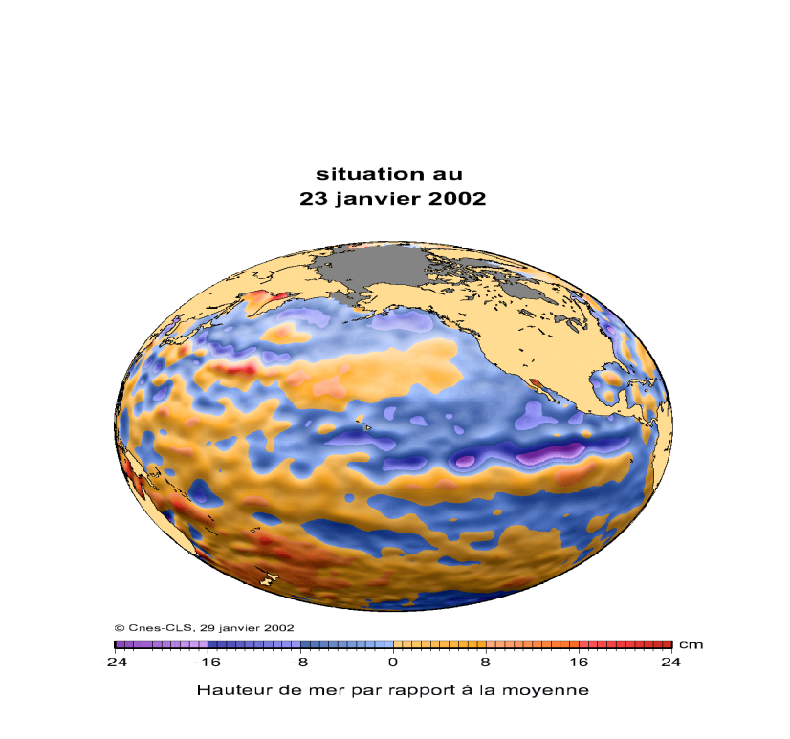

Figure 1: T/P and Jason-1 are watching permanently
the tropical Pacific, detecting any sea level
anomaly which may be due to ENSO starting

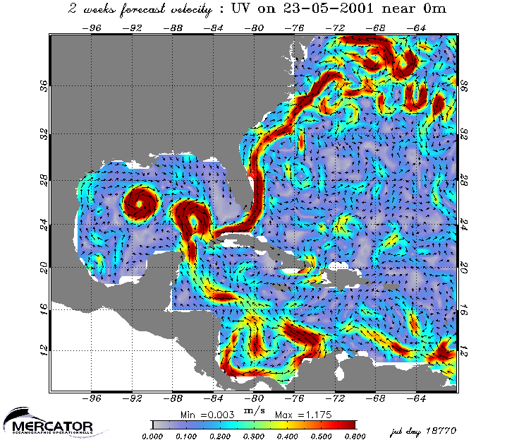

Figure 2: The MERCATOR system fed by T/P and Jason-1 data
provides since January 2001, routine high resolution
2 weeks forecast of the North Atlantic circulation

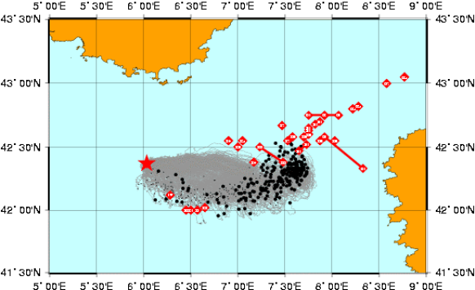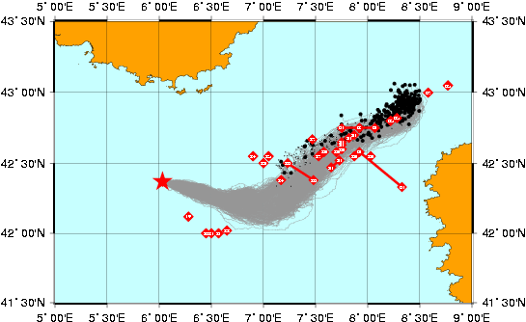
Figure 3: Three weeks forecast of the Lyria pollution in the Mediterranean Sea (1993), by the Meteo-France MOTHY polluant drift model (red star is the starting point, red diamonds are observations)
on the right: with assimilation of MERCATOR yearly circulation and of ERS1 and T/P data
on the left: without assimilation (from Daniel et al., 2002)

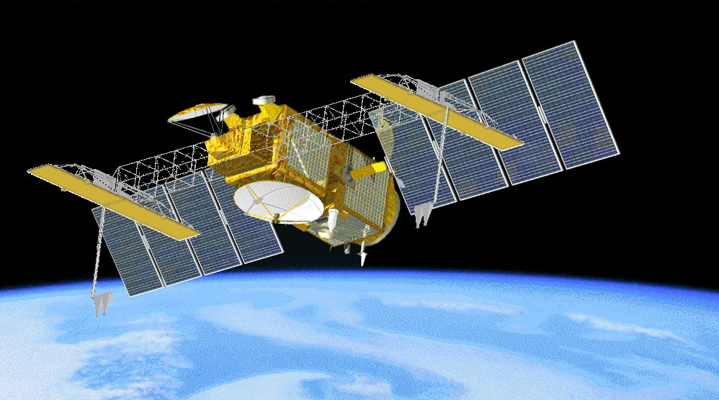
Figure 4: The Jason-2/OSTM satellite i

