UNITED STATES MARINE, INC. CATALOG

This Catalog includes the following USMI products, standard equipment and optional packages. Please click on the page number of the product you wish to view.

11 METER RIGID INFLATABLE BOAT 5
33’ SECURITY OPERATIONS CRAFT RIVERINE (SOCR) 12
82’ MKV Special Operations Craft (MKV-SOC) ………………….23

Drawings, design concepts, calculations and specifications for all USMI products listed on GSA are considered to be the property of USMI and, if provided, are furnished on a confidential basis with an expressed understanding that they will not be copied in any manner, used for manufacture, sold, transferred, nor used to the detriment of said firm without written permission. It shall be further understood that recipients are not to disclose this proprietary information to any other parties, except for those specific purposes for which the material is issued. Furthermore, any uses of information contained in the released documentation, other than those expressly for USMI, except by agreement in writing by and with appropriate compensation to United States Marine, Inc. is not permitted.

Please visit www.usmi.com to get more information about our company and to download a copy of our Commercial brochure which includes pictures of our products and accessories.

Standard Form 1449 – Solicitation/Contract/Order for Commercial Items Page 1B
United States Marine, Inc.
GS-07F-0202N

Pages 1B through 1D of this award reflect terms and conditions accepted at the time of award. As required in Clause I-
FSS-600, Contract Price Lists, the following information must also appear on the Cover Page Notices required by
the clause.

**************************************************************************************
GENERAL SERVICES ADMINISTRATION
FEDERAL SUPPLY SERVICE
AUTHORIZED FEDERAL SUPPLY SCHEDULE PRICELIST

On-line access to contract ordering information, terms and conditions, up-to-date pricing, and the option to create an electronic delivery order are available through GSA Advantage!™, a menu-driven database system. The INTERNET
address for GSA Advantage!™ is http://www.fss.gsa.gov.

Federal Supply Schedule 539 – Solutions & More
Marine Craft and Equipment, Inboard and Outboard Engines, Towable Bladders and Floating Marine Barriers, and Bouys
FSC Class: 1940
Contract Number: GS-07F-0202N
For more information on ordering from Federal Supply Schedules,
click on the FSS Schedules button at http:www.fss.gsa.gov.

Contract Period: 01/02/03 through 01/01/08

CONTRACTOR: United States Marine, Inc. Business Size: Small
19807 Chef Menteur Hwy
New Orleans, LA 70129
Ph: 504-254-4444 Contract Administration: Barry Dreyfus, Jr.
Fax: 505-254-2544

CUSTOMER INFORMATION:

1a. Awarded Special Item Numbers(s):

260-06 – Inflatable Boats

1b. Lowest Priced Model Number for each Awarded Special Item Number(s):

260-06: (Model Number and Price to be inserted by contractor prior to mailing)

1c. Hourly Rates: N/A

2. MAXIMUN ORDER GUIDELINE: $ 315,000 per SIN/Order 260-06

This maximum order is a dollar amount at which it is suggested that the ordering agency request higher discounts from the contractor before issuing the order. The contractor may: 1) Offer a new lower price, 2) Offer the lowest price available
under the contract, or 3) Decline the order within five (5) days. In accordance with the Maximun Order provisions
contained in the Schedule, a delivery order may be placed against the Schedule contract even though it exceeds the
maximum order.

Standard Form 1449 – Solicitation/Contract/Order for Commercial Items Page 1C
United States Marine, Inc.
GS-07F-0202N

3. MINIMUM ORDER LIMITATION: $100.00

4. GEOGRAPHIC COVERAGE: Domestic

5. POINTS OF PRODUCTION: New Orleans, LA 70129

6. BASIC DISCOUNT: 0%

7. QUANTITY DISCOUNT: 2% for 3-6 Craft
4% for 7+ Craft

8. PROMPT PAYMENT TERMS: Net 30 Days

9a. GOVERNMENT PURCHASE CARDS ARE ACCEPTED: YES

9a. NOTIFICATION WHETHER GOVERNMENT PURCHASE CARDS ARE ACCEPTED OR NOT ABOVE
THE MICROPURCHASE THRESHOLD. All Amounts

10. FOREIGN ITEMS: N/A

11a. TIME OF DELIVERY: 90 Days

11b. EXPEDITED DELIVERY: Negotiable

11c. OVERNIGHT/2-DAY DELIVERY: N/A

11d. URGENT REQUIREMENTS: N/A

12. FOB POINT: FOB Origin

13a. Ordering Address(es): Same as Contractor

13b. Ordering procedures: For supplies and services, the ordering procedures, information on Blanket Purchase Agreements (BPA’s) and a sample BPA can be found at the GSA/FSS Schedule homepage
(fss.gsa.gov/schedules)

14. PAYMENT ADDRESS: Same as Contractor

15. WARRANTY PROVISIONS: 5-Year Government Warranty

- EXPORT PACKING CHARGES, IF APPLICABLE: N/A

- TERMS AND CONDITIONS OF GOVERNMENT PURCHASE CARD ACCEPTANCE: All Amounts

- TERMS AND CONDITIONS OF Rental, maintenance, and repair: N/A

- TERMS AND CONDITIONS FO INSTALLATION (IF APPLICABLE): None

Standard Form 1449 – Solicitation/Contract/Order for Commercial Items Page 1D
United States Marine, Inc.
GS-07F-0202N

- TERMS AND CONDITIONS OF REPAIR PARTS INDICATING DATE OF PARTS PRICE LISTS AND ANY
DISCOUNTS FROM LIST PRICES (IF APPLICABLE).
20a. Terms and conditions for any other services (If Applicable). N/A

- LIST OF SERVICE AND DISTRIBUTION POINTS (IF APPLICABLE). None

- LIST OF PARTICIPATING DEALERS (IF APPLICABLE): None

- PREVENTIVE MAINTENCE (IF APPLICABLE):

24a. SPECIAL ATTRIBUTES SUCH AS ENVIRONMENTAL ATTRIBUTES (E.G., RECYCLED CONTENT, ENERGY EFFICIENCY, AND/OR REDUCED POLLUTANTS): N/A

24b. IF APPLICABLE, INDICATE THAT SECTION 508 COMPLIANCE INFORMATION IS AVAIBLE ON ELECTRONIC AND INFORMATION TECHNOLOGY (EIT) SUPPLIES AND SERVICES AND SHOW WHERE FULL DETAILS CAN BE FOUND (E.G. CONTRACTOR’S WEBSITE OR OTHER LOCATION) THE EIT STANDARDS CAN BE FOUND AT: WWW.SECTION 508.GOV/.

25. DATA UNIVERSAL NUMBER SYSTEM (DUNS) NUMBER: 145723656
26. NOTIFICATION REGARDING REGISTRATION IN CENTRAL CONTRACTOR REGISTRATION (CCR) DATABASE:

11 METER RIGID INFLATABLE BOAT

UNITED STATES MARINE, INC.

10011 LORRAINE ROAD

GULFPORT, MS 39503
TELEPHONE: (228) 679-1005 FAX: (228) 679-1010

SCHEDULE TITLE: | Federal Supply Schedule 084 - Total Solutions for Law Enforcement, Security, Facilities Management, Fire, Rescue, Clothing, Marine Craft and Emergency Disaster Response  FSC Group 19, Part I, FSC Class 1940
CONTRACT NUMBER: | GS-07F-0202N  For more information on ordering from Federal Supply Schedules – click on the FSS Schedules button at fss.gsa.gov.
CONTRACT PERIOD: | 1/03/03 through 12/31/08
CONTRACTOR: | United States Marine, Inc Points of Contact:  10011 Lorraine Road Barry Dreyfus, Jr. or Lynette Florane  Gulfport, MS 39503  (228) 679-1005 Fax: (228) 679-1010 website: www.usmi.com
CONTRACT ADMINISTRATION SOURCE: | Same as Contractor above
BUSINESS SIZE: | Small
1a. Table of Awarded Special Item Numbers with Appropriate cross-reference to page number(s) | Special Item Number  (SIN) 260-06 – Inflatable Boats
1b. Lowest Priced Model Number/Lowest Unit Price | 11 Meter Rigid Inflatable Boat (RIB) $262,095.34
1c. Hourly Rates | N/A
2. Maximum Order | $315,000 per SIN/Order 260-06
3. Minimum Order | $100
4. Geographic Coverage (delivery area) | US Domestic
5. Point of Production | New Orleans, Orleans Parish, Louisiana
6. Discount/Statement of Net Price | Government Prices for Boats and Accessories are Net as Per This Price List (discount deducted). Basic Discount – 4.76%
7. Quantity Discounts | 3 to 6 craft - 6 % off Commercial Price List  7 craft and above - 8% off Commercial Price list
8. Prompt Payment Terms | Net 30 Days
9. Government Purchase Cards | - Government Purchase Cards are Accepted  - Accepted above the Micro-Purchase Threshold for All Amounts
10. Foreign Items | N/A
11a. Time of Delivery | 90 Days
11b. Expedited Delivery | Negotiable
11c. Overnight and 2-Day Delivery | Not Available
11d. Urgent Requirements | Per Clause I-FSS-140-B, Contractor can be contacted to effect a faster delivery.
12. F.O.B. Point(s) | F.O.B. Origin
13. Order Address | a. Same as Contractor  b. Ordering Procedures: For supplies and services, the ordering procedures, information on Blanket Purchase Agreements (BPA’s) and a sample BPA can be found at the GSA/FSS Schedule homepage (fss.gsa.gov/schedules)
14. Payment Address | Same as Contractor
15. Warranty Provision | 5-Year Government Warranty
16. Export Packing Charges | Not Applicable
17. Terms/Conditions of Government Purchase Card Acceptance | All Amounts
18. Terms/Conditions of Rental, Maintenance and Repair | Not Applicable
19. Terms/Conditions of Installation | Not Applicable
20. Terms/Conditions of Repair Parts | Not Applicable
20a. Terms/Conditions for Other Services | Not Applicable
21. List of Service and Distribution Points | None
22. Participating Dealers | None
23. Preventative Maintenance | Not Applicable
24a. Special Attributes (i.e. Environmental  Attributes) | Not Applicable
24b. If applicable, indicate that Section 508 Compliance Information is Available on Electronic and Information Technology (EIT) Supplies and Services and Show Where Full Details Can be Found (e.g. Contractor’s Website or other Location) The EIT Standards can be found at www.section 508.gov/. | Not Applicable
25. Data Universal Number System (DUNS) Number | 14-5723656
26. Central Contractor Registration (CCR) | Contractor is Registered in CCR

USMI has over 10 years of experience in designing and constructing rigid inflatable boats (RIBs). As of mid-2002, United States Marine, Inc. has delivered over 100 of these craft to commercial and military customers, both domestic and international, including the 11 Meter Naval Special Warfare Rigid Inflatable Boat.

USMI offers the 11 Meter RIB in a base boat, with various option packages. The basic 11 Meter RIB consists of hull, sponson, (1) 3-man bolster, 24 volt electrical system and various other items. Several option packages are also available.

STANDARD 11 METER RIGID INFLATABLE BOAT

STANDARD EQUIPMENT

United States Marine, Inc.’s standard (base) 11 Meter Rigid Inflatable Boat consists of the following items:

- Hull and Structure
- Hull and Deck Laminate (consists of Kevlar/Eglass Hybrid fabric
and foam core with high elongation, surfacing and laminating resins
- Structure is foam cored (no wood is used in structure)
- Hull and Deck joint and bulkheads are bonded together with laminate
- Sponson, two part for ease of maintenance/removal
- Swim Platform
- 5 year warranty on workmanship of hull, deck and structure

- Propulsion
(NOTE: Available propulsion packages are listed under optional equipment.
- Engine Monitoring/Alarm Panel, with Gauges Installed
- Tachometer
- Oil Pressure
- Water Pressure
- Voltmeter
- Pyrometer
- TurboBoost
- Emergency Steering System
- 90 Gallon Fuel Bladder (2)
- Fuel Usage Monitoring System
- Racor Fuel Filter System
- Fuel Key and Pouch, (2) Fuel Fills (Port and Stbd), Fuel Vents
- Underwater Exhaust System
- Fuel Fills are custom made and are integral to the console

- Electrical
- Standard 24 Volt Electrical System
- Battery On/Off Switch
- Horn Circuit
- Battery Charger for All Battery Banks
- 24 to 12V Converter
- Shore Power Cable, 75’
- Shore Power Receptacle
- Perko Plug Receptacles

- Electrical (Cont’d)
- Lighting, Including
- Navigation Lights
- Anchor Light
- Engine Room/Jet Compartment Lighting
- Deck Lights
- Horn
- Compass

- Auxiliary Equipment
- Throttle Control w/Cables
- Waterjet and Gear Controls w/Cables
- Sea Water Strainer System
- High Speed Reverse Control (HSRC) System, w/electronic and manual monitoring
- Fast Lube Oil Change System (FLOCS) Pump
- Bilge Pumps, Including
- (2) 24VDC 1200 GPH Submersible (Forward)
- (2) 24VDC 3550 GPH Submersible (Aft)
- (1) Manual
- Trim Tabs
- Helm Unit
- Drain Plugs

- Outfitting Equipment
- 1st Row 3-Man Bolster
- Console and Console Access Hatch
- Forward Stowage Hatch
- Mid-Forward Stowage Hatch
- Engine Hatches w/Air Intakes and Gas Springs
- Waterjet Access Hatches
- (6) Self Bailing Deck Scuppers
- Tiedown Fittings (1 bow, 2 stern)

- Outfitting Equipment (Cont’d)
- (8) Cargo Tiedowns - Sail Tracks w/Sailcars
- Handrails; (2) on Console, (1) on 1st Row Bolster
- Anchor and Anchor/Towline
- Mooring Lines
- Mooring Cleats (2 Aft)
- Boat Hook
- Aggressive Non-Skid Surface
- Fire Extinguishing Equipment (3)
- Ring Buoy
- Flag
- Towing Pendant - 9’

USMI has an in-house Upholstery Dept., which has the capability of providing custom items for customers. The following standard custom upholstery items are provided with USMI’s 11 Meter Rigid Inflatable Boat.

- Covers/Upholstery Equipment Bags
- Console Cover and Bag
- Equipment Bags, including Stowage (2), Navigation (2) and FLOCS Pump
- Throttle Linkage Bag (1 small and 1 large)
- Wall Cargo Nets (2)
- Oil Coolant Bag and Straps
- Engine Hatch Straps
- Dock Line Bags (2)

11 Meter Rigid Inflatable Boat (FSS Price List)

 |  |  | GSA (US $)
DESCRIPTION |  | PART NO. | 11 METER RIB
Base Boat
11 Meter Rigid Inflatable Boat (without Propulsion System) |  | 11M583-000 | $ 262,095.34
EQUIPMENT OPTIONS
Hull Equipment Options
Swim Platform |  | 11M140-001 | STD
Sponson |  | 11M166-001 | STD
Propulsion Equipment Options
Caterpillar 3126 420HP (Qty 2) |  | 11M230-001 | $ 110,122.48
Caterpillar 3126 470 HP ( Qty 2 |  | 11M230-002 | $ 144,920.05
Caterpillar HEUI 450 HP (Qty 2) |  | 11M230-003 | $ 127,647.05
Caterpillar HEUI 500 HP (Qty 2) |  | 11M230-004 | $ 138,887.59
Hamilton Waterjet Model 322 w/ZF Drives (Qty 2) |  | 11M230-005 | $ 63,051.99
Rolls Royce/KaMeWa Waterjet Model FF280 w/ZF Drives (Qty 2) |  | 11M230-006 | $ 75,419.62
Engine Monitoring/Alarm Panel, with Gauges Installed |  | 11M436-001 | STD
Emergency Steering System |  | 11M561-001 | STD
90 Gallon Fuel Bladder (2) |  | 11M540-001 | STD
Fuel Key and Pouch, (2) Fuel Fills (Port & Std) and Fuel Vents |  | 11M540-002 | STD
Electrical Equipment Options
Shorepower/Battery Charger (Portable) Model RM2405 (24 Volt) |  | 11M313-001 | STD
Lighting, including: Navigation Lighting, Anchor Light , Engine Room/Waterjet Compartment Light and Deck Lights |  | 11M330-001 | STD
Lighting, RAM |  | 11M330-002 | $ 925.12
Spotlight, with bag (2), Candle Power 45,000 each |  | 11M330-003 | $ 3,343.57
Standard 24V Electrical System |  | 11M300-001 | STD
Engine Room Blowers |  | 11M425-001 | STD
Bilge System (See Note (2) below for components) |  | 11M503-001 | STD
Electronic Equipment Options
Compass (Ritchie SS5000), w/Light Assembly |  | 11M422-001 | STD
Communications & Navigation Complete (See (1) below for list of components) |  | 11M400-001 | $ 39,195.06
Radar Arch with GPS and Radar w/Scanner and Flap Cover |  | 11M400-002 | $ 15,666.88
Auxiliary Equipment Options
Seawater Strainer System |  | 11M524-001 | STD
Self Cleaning Seawater Strainer System |  | 11M524-002 | $ 8,599.02
HSRC System |  | 11M568-001 | STD
Keel Guard |  | 11M565-002 | $ 3,446.77
Trim Tabs |  | 11M565-001 | STD
Fast Lube Oil Change System (FLOCS) Pump |  | 11M260-001 | STD
Outfit and Furnishing Equipment Options
Console and Console Access Hatch |  | 11M167-001 | STD
3-man Bolster Frame & Seat s(1st row) |  | 11M131-001 | STD
Seats (2nd row) |  | 11M131-002 | $ 2,871.55
3-man Bolster Frame and Seats (3rd row) |  | 11M131-003 | $ 6,882.49
3-man Bolster Frame and Seats (4th row) |  | 11M131-004 | $ 7,004.48
4-man Bolster Frame and Seats (3rd row) |  | 11M131-005 | $ 7,579.88
4-man Bolster Frame and Seats (4th row) |  | 11M131-006 | $8,178.59
Forward Stowage Hatch |  | 11M670-001 | STD
Mid-Forward Stowage Hatch |  | 11M670-002 | STD
Engine Hatches with Air Intakes |  | 11M167-002 | STD
Waterjet Access Hatches |  | 11M167-003 | STD
Self Bailing Deck Scuppers (6) |  | 11M526-001 | STD
Swim Platform Ladder – Roll Up and Straps |  | 11M623-001 | $ 991.19
Non-Skid Surface – Aggressive Non-Skid |  | 11M634-001 | STD
Non-Skid Surface – Treadmaster & Ensolite Form |  | 11M634-002 | $ 6,034.66
On Board Tools (See Note (3) below for contents) |  | 11M665-001 | $ 735.09
Fire Extinguishing Equipment ( 1-Chemical and 2-CO2, with bags) |  | 11M555-001 | STD
Outfit and Furnishing Equipment Options (Cont'd)
King Post – Removable |  | 11M172-001 | $ 1,108.99
Tow Post (Aft for Swim Platform) |  | 11M582-001 | $ 1,523.91
Wind Screen Assembly |  | 11M428-001 | $ 482.87
Forward Weapon Mount |  | 11M187-001 | $ 1,558.69
Cargo Tiedowns, Sail Tracks with Sailcars (8) |  | 11M611-001 | STD
Additional Cargo Tiedowns Package, Sail Tracks with Sailcars (20) |  | 11M611-002 | $ 1,315.18
Tiedown Fittings (1 bow, 2 stern) |  | 11M611-003 | STD
Handrails including: (2) on Console and (1) on 1st Row Bolster |  | 11M612-001 | STD
Anchor Marine, Aluminum and Anchor/Towline |  | 11M581-001 | STD
Mooring Lines |  | 11M582-001 | STD
Mooring Cleats (2 Aft) |  | 11M611-004 | STD
Hook, Boat, 3 1/2' TO 8' Deluxe |  | 11M582-003 | STD
U.S Flag (16” x 24”) |  | 11M600-001 | STD
Horn (Compact Twin, 12V 2AMP) |  | 11M443-001 | STD
Ring Buoy, Unicellular, 20"D Type IV |  | 11M583-001 | STD
Covers/Equipment Bags
Equipment Bags – Misc. Stowage (Port and Stbd) |  | 11M613-002 | STD
Equipment Bags – Navigation (Port and Stbd) |  | 11M613-003 | STD
Equipment Bags - FLOCS Pump (Fuel Stripping Bag) |  | 11M613-004 | STD
Throttle Linkage Bag (1 small and 1 large) |  | 11M613-005 | STD
Boat Cover/Canvas (Mooring and Mooring Cover Bag) |  | 11M613-006 | $ 5,067.01
Boat Cover/Canvas (Adjustable Road) |  | 11M613-007 | $ 6,114.62
Console Cover and Console Cover Bag |  | 11M613-008 | STD
Chain Bag |  | 11M613-009 | STD
Wall Cargo Nets (Port and Stbd) |  | 11M613-010 | STD
Oil Coolant Bag and Straps |  | 11M613-011 | STD
Engine Hatch Straps |  | 11M613-012 | STD
Dock Line Bags (2) |  | 11M613-013 | STD
Rear Bolster Splash Guard |  | 11M613-001 | $ 245.32
Console Curtain (Clear) |  | 11M613-014 | $ 296.18
Transport/Air Transport Options
Single Point Lift Fitting | 11M611-004 |  | $ 2,829.03
Trailer – Air Transportable | 11M854-001 |  | $ 44,001.31
Trailer – Non-Tilting | 11M854-002 |  | $ 21,145.94
Air Transport Tiedowns (8) | 11M611-005 |  | $ 2,113.70
Portable Mobility Enhancement System (PMES) | 11M854-002 |  | $ 15,383.73
(NOTE:) Spare Parts Available (See Attached Catalog)

NOTES:

- Communications and Navigation Complete consists of:

Radar Arch, Radome, Navigation Lighting, Compass, GPS, Radar w/Scanner and flap cover, HF Tuner, VHF and UHF antennas, VHF Radio, Variable IR Strobe Light and Bag, Radar Arch Sleeves, and a Drop In Communications Package Box ready to accept GFE TRS package, IFF ready capability.

- Bilge System includes the following pumps:

(2) – 24VDC Automatic Submersible Lovett 3164-1200AM24, (1)-Manual Gusher Urchin, (2) 24V 3550GPH Submersible JABSCO 30250-2024, (1) Full Stroke JABSCO 337450000

- On Board Tools consists of:

Item Description | Qty |  | Item Description | Qty
Wrench Set, 11pc Combination | 1 |  | Wrench, Adjustable, 8" | 1
Wrench Set, 11pc Metric Combination | 1 |  | Pliers, Arc-Joint, 12" | 1
Hammer, 16oz 14-1/4" Ball Pein | 1 |  | Cutter, Diagonal, 4" W/Insulated Handles | 1
Screwdriver Set, Professional | 1 |  | Pliers, Needle Nose 6" W/Ins Handles | 1
Pliers, Vise Grip, 10" | 1 |  | Equipment Case, 1550 Pelican Orange | 1
Pliers, Lineman's, 8" | 1 |  | Can, Jerry, Plastic 5gal | 2
Grease Gun, W/O Grease Cartridge | 1 |  | Can, Jerry, Plastic 1gal | 1
Screwdriver Set, 29pc Majestic | 1 |  | Bucket, Super, 8-Quart | 1
Socket Set, 18pc 12pt 3/8" Drive | 1 |  | Screwdriver, #1 Phillips, 3/16" X 3" | 1
Tool, Driver Set W/Interchangeable Blades | 1 |  | Socket Set, 12pc 12pt Deep 3/8" Drive | 1
 |  |  | Adapter | 1

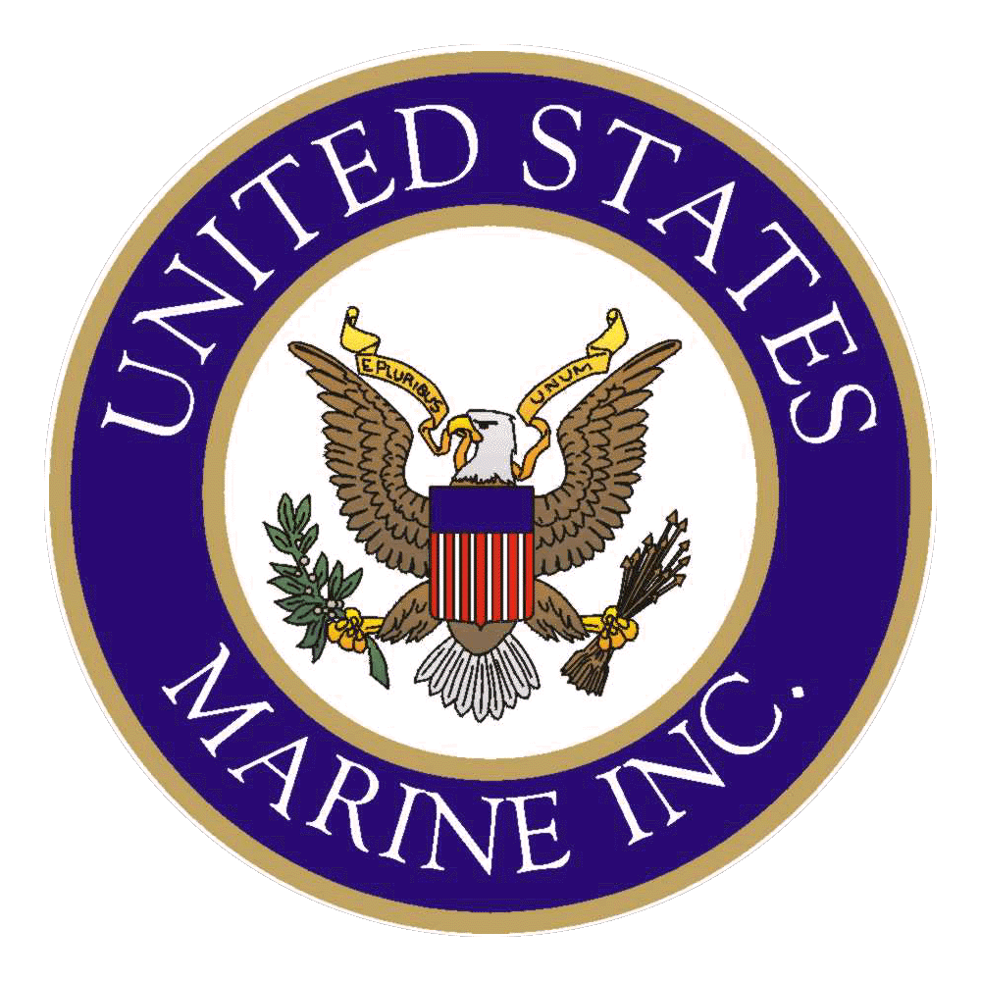
GENERAL SERVICES ADMINISTRATION OFFICE

OF FEDERAL SUPPLY AND SERVICES
Authorized Federal Supply Schedule Price List

2008 GSA Prices

33’ SECURITY OPERATIONS CRAFT RIVERINE (SOCR)

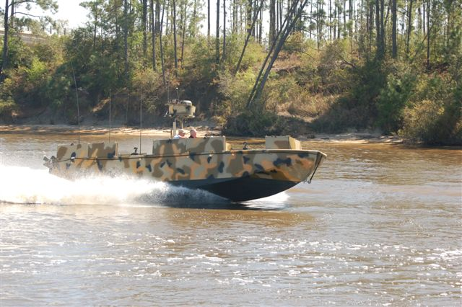

UNITED STATES MARINE, INC.

10011 LORRAINE ROAD

GULFPORT, MISSISSIPPI 39503
TELEPHONE: (228) 679-1005 FAX: (228) 679-1469

SCHEDULE TITLE: | Small Craft and Marine Equipment  FSC Group 19, Part I, FSC Class 1940
CONTRACT NUMBER: | GS-07F-0202N  For more information on ordering from Federal Supply Schedules – click on the FSS Schedules button at fss.gsa.gov.
CONTRACT PERIOD: | 1/03/03 through 1/1/2013
CONTRACTOR: | United States Marine, Inc Points of Contact:  10011 Lorraine Road Barry Dreyfus, Jr./Lynette Florane  Gulfport, MS 39503  (228) 679-1005 Fax: (228) 679-1469 website: www.usmi.com
CONTRACT ADMINISTRATION SOURCE: | Same as Contractor above
BUSINESS SIZE: | Small
1a. Table of Awarded Special Item Numbers with Appropriate cross-reference to page number(s) | Special Item Number  (SIN) 260-01 Security Operations Craft Riverine (SOCR)
1b. Lowest Priced Model Number/Lowest Unit Price | Security Operations Craft Riverine (SOCR) $585537.05
1c. Hourly Rates | N/A
2. Maximum Order | $315,000 per SIN/Order 260-01
3. Minimum Order | $100
4. Geographic Coverage (delivery area) | US Domestic
5. Point of Production | Gulfport, Harrison County, Mississippi
6. Discount/Statement of Net Price | Government Prices for Boats and Accessories are Net as Per This Price List (discount deducted and IFF added). Basic Discount – 5.712% 1-2 Craft
7. Quantity Discounts | 6% 3-6 Craft  8% 7Craft and Above
8. Prompt Payment Terms | Net 30 Days
9. Government Purchase Cards | - Government Purchase Cards are Accepted  - Accepted above the Micro-Purchase Threshold for All Amounts
10. Foreign Items | N/A
11a. Time of Delivery | 90 Days
11b. Expedited Delivery | Negotiable
11c. Overnight and 2-Day Delivery | Not Available
11d. Urgent Requirements | Per Clause I-FSS-140-B, Contractor can be contacted to effect a faster delivery.
12. F.O.B. Point(s) | F.O.B. Origin
13. Order Address | a. Same as Contractor  b. Ordering Procedures: For supplies and services, the ordering procedures, information on Blanket Purchase Agreements (BPA’s) and a sample BPA can be found at the GSA/FSS Schedule homepage (fss.gsa.gov/schedules)
14. Payment Address | Same as Contractor
15. Warranty Provision | 5 Yr. Government Warranty on Workmanship of Hull and Deck
16. Export Packing Charges | Not Applicable
17. Terms/Conditions of Government Purchase Card Acceptance | All Amounts
18. Terms/Conditions of Rental, Maintenance and Repair | Not Applicable
19. Terms/Conditions of Installation | Not Applicable
20. Terms/Conditions of Repair Parts | Not Applicable
20a. Terms/Conditions for Other Services | Not Applicable
21. List of Service and Distribution Points | None
22. Participating Dealers | None
23. Preventative Maintenance | Not Applicable
24a. Special Attributes (i.e. Environmental  Attributes) | Not Applicable
24b. If applicable, indicate that Section 508 Compliance Information is Available on Electronic and Information Technology (EIT) Supplies and Services and Show Where Full Details Can be Found (e.g. Contractor’s Website or other Location) The EIT Standards can be found at www.section 508.gov/. | Not Applicable
25. Data Universal Number System (DUNS) Number | 14-5723656
26. Central Contractor Registration (CCR) | Contractor is Registered in CCR
On-line access to contract ordering information, terms and conditions, up-to-date pricing, and the option to create an electronic delivery order are available through GSA Advantage!, a menu-driven database system. The INTERNET address DSA Advantage! is: GSAAdvantage.gov.

STANDARD EQUIPMENT

United States Marine, Inc.’s standard (base) 33’ SOCR consists of the following items:

- Hull and Structure
- Hull and Deck
- Hull structure is aluminum and deck is carbon fiber composite
- Swim Platform
- Flotation Foam
- 5 year warranty on workmanship of hull, deck and structure

- Propulsion
(NOTE: Available propulsion packages are listed under optional equipment.
- Engine Monitoring/Alarm Panel, with Gauges Installed
- Tachometer
- Oil Pressure
- Water Pressure
- Voltmeter
- Pyrometer
- TurboBoost
- Emergency Steering System
- 250 Gallon Integral Fuel Tank
- Fuel Usage Monitoring System
- Racor Fuel Filter System
- Fuel Key and Pouch, (2) Fuel Fills (Port and Stbd), Fuel Vents
- Underwater Exhaust System

- Electrical
- Standard 24 Volt Electrical System
- Battery On/Off Switch
- Horn Circuit
- 24 to 12V Converter
- Shore Power Receptacle
- Perko Plug Receptacles

- Lighting, Including
- Navigation Lights
- Anchor Light
- Engine Room/Jet Compartment Lighting
- Deck Lights
- Horn
- Compass

- Auxiliary Equipment
- Throttle Control w/Cables
- Waterjet and Gear Controls w/Cables
- High Speed Reverse Control (HSRC) System, w/Electronic
and Manual Monitoring
- Bilge Pumps, Including
- (6) 24VDC 3700 GPH Submersible
- (2) Submersible - Manual
- Trim Tabs
- Helm Unit
- Drain Plugs

- Outfitting Equipment
- Coxswain Seat
- Console and Console Access Hatch
- Forward Stowage Hatch
- Mid-Forward Stowage Hatch
- Engine Hatches, Armor Protected, w/Air Intakes
- Waterjet Access Hatches
- (4) Self Bailing Deck Scuppers
- Boat Tiedown Fittings (1 bow, 2 stern)

- Outfitting Equipment (Cont’d)
- (8) Cargo Folding Padeyes
- Handrails; (2) on Console, (1) Forward of Transom, Forward and
- Aft of Engine Box, Port and Starboard of Engine Box
- Mooring Pockets (2 Fwd and 2 Aft)
- Boat Hook
- Aggressive Non-Skid Surface
- Fire Extinguishing Equipment (1-Chemical; 2-CO2)
- Ring Buoy
- Flag

USMI has an in-house Upholstery Dept., which has the capability of providing custom items for customers. The following standard custom upholstery items are provided with USMI’s 33’ SOCR.

- Covers/Upholstery Equipment Bags
- Console Cover and Bag
- Equipment Bags, including Gear (2), and FLOCS Pump
- Throttle Linkage Bag
- Oil Coolant Bag and Straps
- Waterjet Hatch Straps
- Dock Line Bags (6)

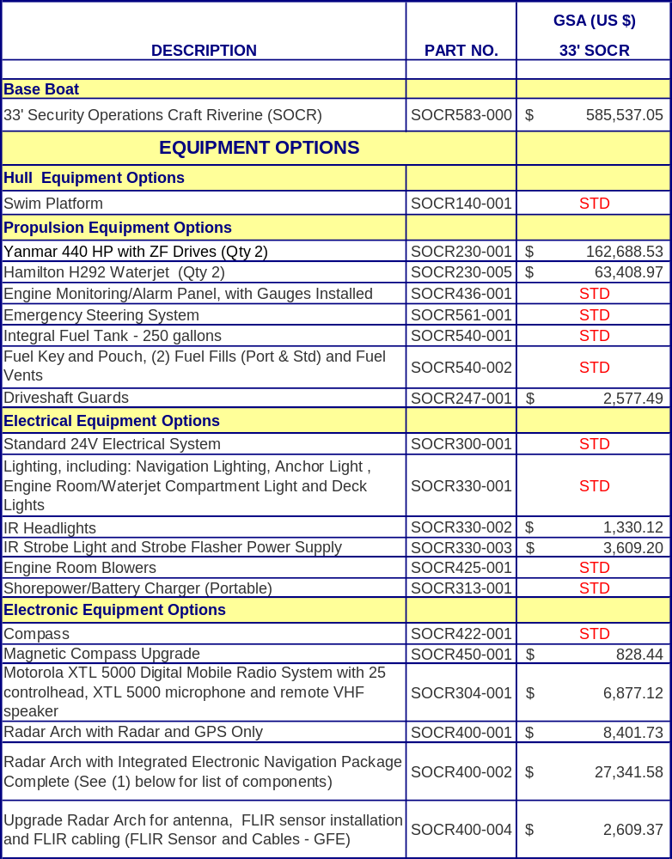

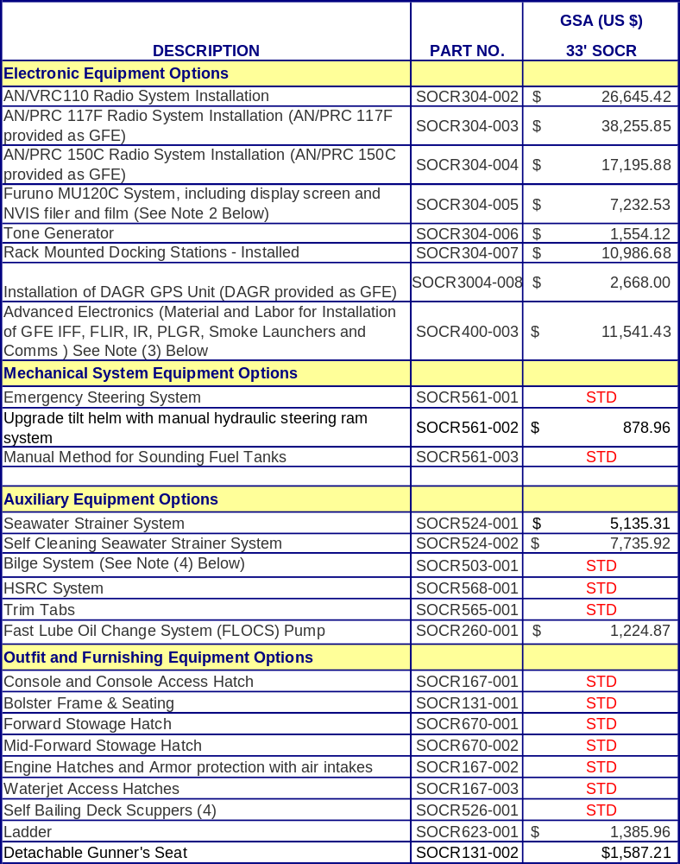

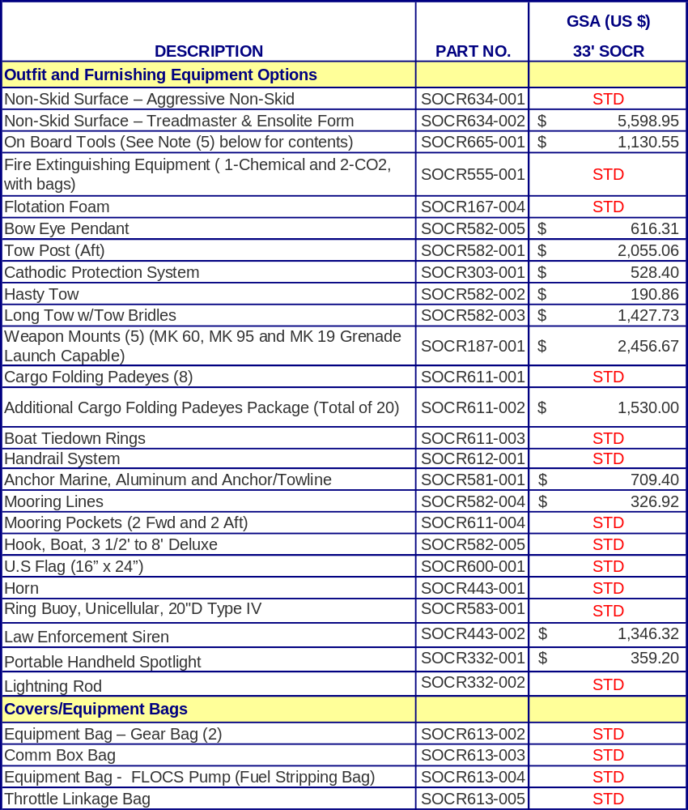

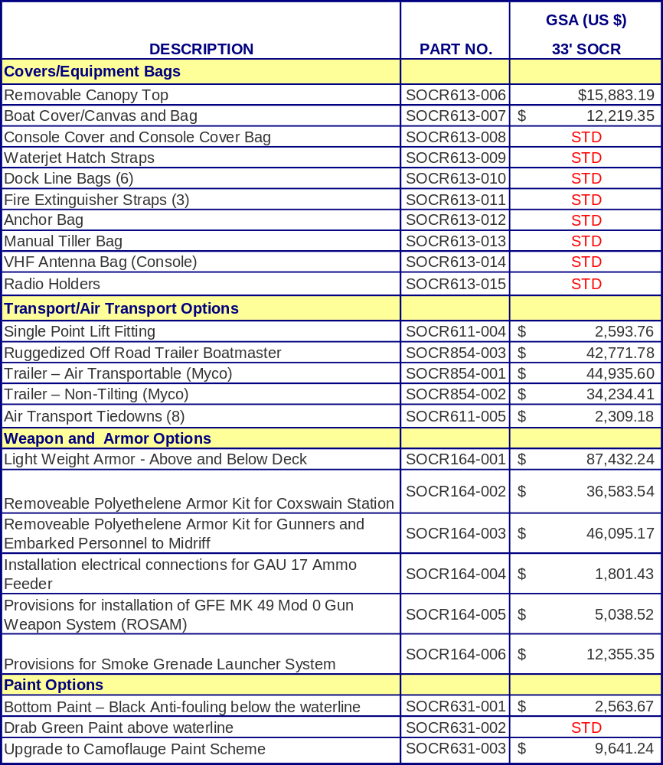

NOTES:
(1) Radar Arch w/Navigation consists of:
- Furuno 1834C Chart Plotter Series, 10" CRT NAVNET Radar
- Furuno Integrated Heading Sensor Compass
- Furuno Video Interface Kit
- Furuno BBFF1 Network Sounder
- Furuno Transducer 520-PLD
(2) Furuno MU120C System
- This option can be added with the Radar Arch with Integrated Electronic
Navigation Package Option
(3) Advanced Electronics
- Installation of wiring and power hookups for GFE IFF, IR, PLGR, Smoke Launcher and Comms
(4) Bilge System consists of:
- Manual Submersible Bilge Pumps (Qty 2)
- Little Pal Multi-Purpose Hand Pump (Qty 1)
- 3700 GPH Submersible Bilge Pumps (Qty 6)
(5) Onboard Tools consists of:
- 11 Pc Combination Wrench Set
- 11 Pc Metric Combination Wrench Set
- 10" Vise Grip Pliers
- Grease Gun, w/o Grease Cartridge
- 1550 Pelican Protector Equipment Case (Black)
- 29 Pc Majestic Screwdriver Set
- 18 Pc 12Pt 3/8" Drive Socket Set
- Driver Set w/Inter. Blades and Sockets
- 8" Adjustable Wrench
- 12" Arc-Joint Pliers
- 4" Diagonal Cutter w/Insulated Handles
- Lever Gun
- 6" Needle Nose Pliers, w/Insulated Handles
- Combination Crimping-Wire Cutter/Strip Tool
- 5 Gal Plastic Jerry Can (Qty 2)
- 8-Quart Super Bucket
- 12 Pc 12 Pt Deep 3/8" Premium Quality Metric Socket Set
- 3/8 Drive Universal Joint
- 4" Curved Jaw Locking Pliers
- 3/8 Drive 3 Extension
- 3/8 Drive 6 Extension
- 3/8 Drive 8 Extension
- 3/8 Drive 12 Extension
- 3/8" Drive 10 Pc Metric Socket
- 3/8 Drive 9 1/2 HDL FLX
- 20 oz Rubber Mallet
- 2 1/4 Inspect Circle Mirror
- Flex Retriever/Holder
- 16 3/4 Telescopic Retriever Mag
- 7 pc Metric Drive Flex Socket
- 3/8" Drive 6 Pt 17 mm Universal Socket

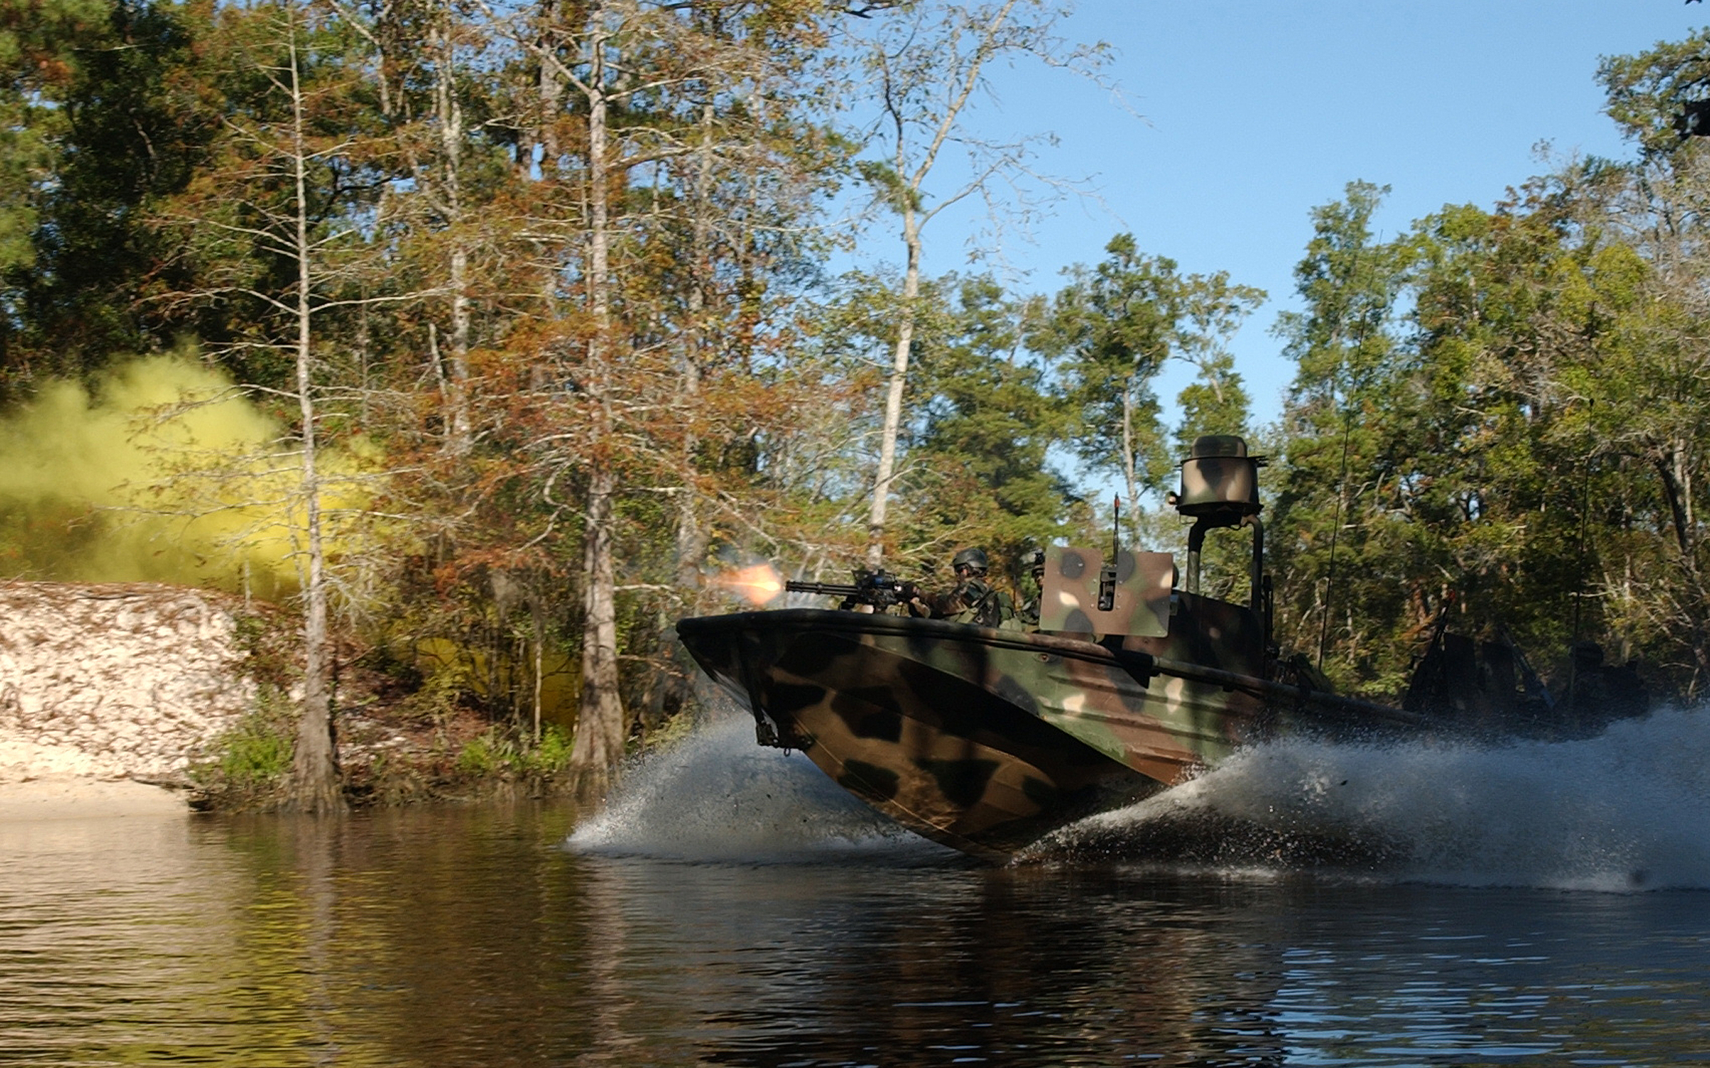

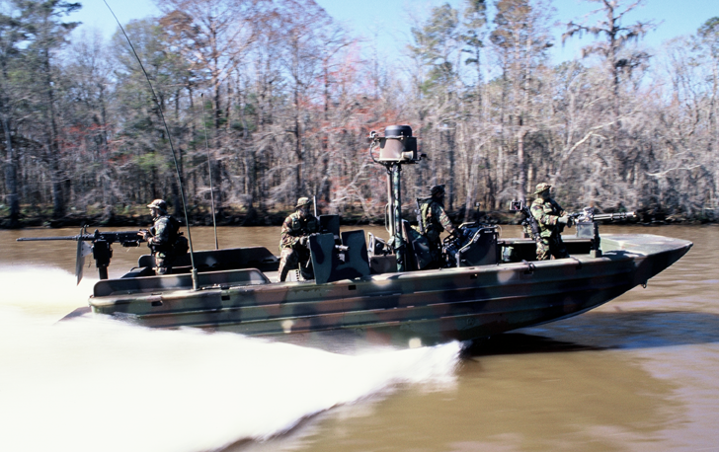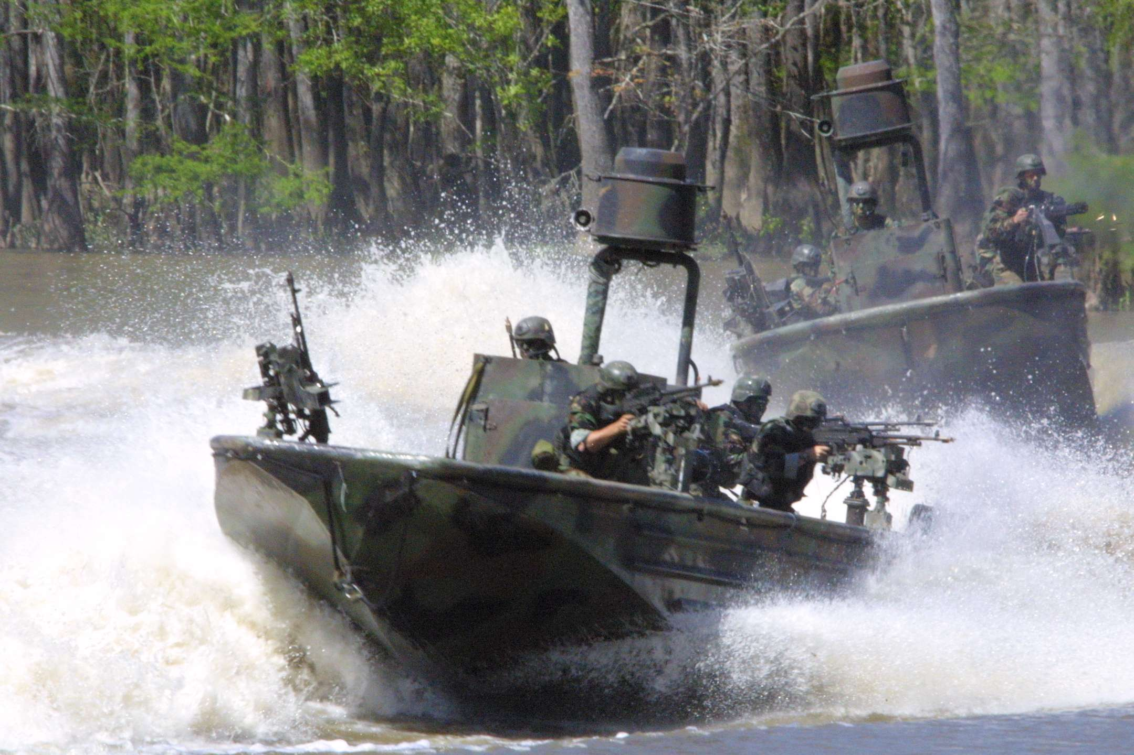

GENERAL SERVICES ADMINISTRATION OFFICE
OF FEDERAL SUPPLY AND SERVICES
Authorized Federal Supply Schedule Price List

2007 GSA Prices

82’ MKV Special Operations Craft (MKV-SOC)

UNITED STATES MARINE, INC.

10011 LORRAINE ROAD

GULFPORT, MISSISSIPPI 39503
TELEPHONE: (228) 679-1005 FAX: (228) 679-1469

SCHEDULE TITLE: | Small Craft and Marine Equipment  FSC Group 19, Part I, FSC Class 1940
CONTRACT NUMBER: | GS-07F-0202N  For more information on ordering from Federal Supply Schedules – click on the FSS Schedules button at fss.gsa.gov.
CONTRACT PERIOD: | 1/03/03 through 12/31/08
CONTRACTOR: | United States Marine, Inc Points of Contact:  10011 Lorraine Road Barry Dreyfus, Jr./Lynette Florane  Gulfport, MS 39503  (228) 679-1005 Fax: (228) 679-1469 website: www.usmi.com
CONTRACT ADMINISTRATION SOURCE: | Same as Contractor above
BUSINESS SIZE: | Small
1a. Table of Awarded Special Item Numbers with Appropriate cross-reference to page number(s) | Special Item Number  (SIN) 260-01 MKV Special Operations Craft (MKV-SOC)
1b. Lowest Priced Model Number/Lowest Unit Price | MKV Special Operations Craft (MKV-SOC) $5,798,879.29
1c. Hourly Rates | N/A
2. Maximum Order | $315,000 per SIN/Order 260-01
3. Minimum Order | $100
4. Geographic Coverage (delivery area) | US Domestic
5. Point of Production | Gulfport, Harrison County, Mississippi
6. Discount/Statement of Net Price | Government Prices for Boats and Accessories are Net as Per This Price List (discount deducted and IFF added). Basic Discount – 4.76% 1-2 Craft
7. Quantity Discounts | 2% 3 or above Craft
8. Prompt Payment Terms | Net 30 Days
9. Government Purchase Cards | - Government Purchase Cards are Accepted  - Accepted above the Micro-Purchase Threshold for All Amounts
10. Foreign Items | N/A
11a. Time of Delivery | 90 Days
11b. Expedited Delivery | Negotiable
11c. Overnight and 2-Day Delivery | Not Available
11d. Urgent Requirements | Per Clause I-FSS-140-B, Contractor can be contacted to effect a faster delivery.
12. F.O.B. Point(s) | F.O.B. Origin
13. Order Address | a. Same as Contractor  b. Ordering Procedures: For supplies and services, the ordering procedures, information on Blanket Purchase Agreements (BPA’s) and a sample BPA can be found at the GSA/FSS Schedule homepage (fss.gsa.gov/schedules)
14. Payment Address | Same as Contractor
15. Warranty Provision | 1 Yr. Government Warranty on Workmanship of Hull and Deck
16. Export Packing Charges | Not Applicable
17. Terms/Conditions of Government Purchase Card Acceptance | All Amounts
18. Terms/Conditions of Rental, Maintenance and Repair | Not Applicable
19. Terms/Conditions of Installation | Not Applicable
20. Terms/Conditions of Repair Parts | Not Applicable
20a. Terms/Conditions for Other Services | Not Applicable
21. List of Service and Distribution Points | None
22. Participating Dealers | None
23. Preventative Maintenance | Not Applicable
24a. Special Attributes (i.e. Environmental  Attributes) | Not Applicable
24b. If applicable, indicate that Section 508 Compliance Information is Available on Electronic and Information Technology (EIT) Supplies and Services and Show Where Full Details Can be Found (e.g. Contractor’s Website or other Location) The EIT Standards can be found at www.section 508.gov/. | Not Applicable
25. Data Universal Number System (DUNS) Number | 14-5723656
26. Central Contractor Registration (CCR) | Contractor is Registered in CCR

On-line access to contract ordering information, terms and conditions, up-to-date pricing, and the option to create an electronic delivery order are available through GSA Advantage!, a menu-driven database system. The INTERNET address DSA Advantage! is: GSAAdvantage.gov.

Note: USMI did not have an existing catalog/price list for the 82’ MKV-SOC. This catalog/price list has been printed for this GSA solicitation, and will also be used as USMI’s commercial catalog/price list in the future. The price list was constructed using current 82’ MKV-SOC pricing.

USMI offers the 82’ MKV Special Operations Craft (MKV-SOC) with option packages. The basic 82’ MK-V consists of aluminum hull and deck, shock mitigation seating, 24 VDC electrical system, 16 kW AC Gen Set and various other items listed on the following pages.

PRINCIPAL CHARACTERISTICS OF BASE BOAT

Length Overall 82 ft
Beam, Max. 17.5 ft
Draft (Max Static) 5 ft
Displacement Approximately 57 Tons
Fuel Capacity 2,600 Gallons
Accommodations Seating for 5 Crew and
Up to 16 Passengers
Cruise Speed (SS3) 25-35 knots
Range at Cruise 550+ nautical miles
Max. Speed (SS2) 47 + knots
Range at Max Speed 500+ nautical miles
Payload (variable) 6,500 lbs+

STANDARD EQUIPMENT

United States Marine, Inc.’s standard (base) 82’ MKV-SOC consists of the following items:

- Hull and Structure
- Hull and Deck constructed of aluminum
- 1 year warranty on workmanship of hull, deck and structure

- Propulsion Support Systems
  - 2,600 Gallon Integral Fuel Tank
  - (2) Fuel Fills, Fuel Vents
  - Underwater Exhaust System
  - Raw Water Cooling System
  - Electric Starting System

- Electrical
- Standard 24 Volt Electrical System
- Battery On/Off Switch
- Horn Circuit
- 24 to 12V Converter
- Shore Power Receptacle
- Plug Receptacles
- Lighting, Including
- Navigation Lights
- Anchor Light
- Engine Room/Jet Compartment Lighting
- Deck Lights
- Below Deck Area Lighting
- Handheld Search Light
- Horn

- Auxiliary Equipment
- Throttle Control w/Cables
- Waterjet and Gear Controls w/Cables
- 16 KW Generator
- High Speed Reverse Control (HSRC) System, w/Electronic
and Manual Monitoring
- Bilge Pumps, Including
- (5) Electric
- (2) Manual
- Joystick Steering
- Drain Plugs

- Outfitting Equipment
- Shock Mitigating Seats for Crew and Passengers
- Console and Console Access Hatch
- Stowage Hatch
- Mid-Forward Stowage Hatch
- Removable Engine Hatches
- Removable Waterjet Access Hatches
- Tempered Glass Windshield, with Wipers
- Tempered Glass Windows, including Slider Windows Port and Starboard
- Canvas Canopies and Cover
- Tiedown Fittings
- Cargo Folding Padeyes
- Handrails
- Mooring Pockets
- Non-Skid Surface
- Safety Equipment, including:
- Fire Extinguishing Equipment, including Pyrogen in Engine Room
- Ring Buoy
- 10-Man Inflatable Life Raft
- Life Preservers

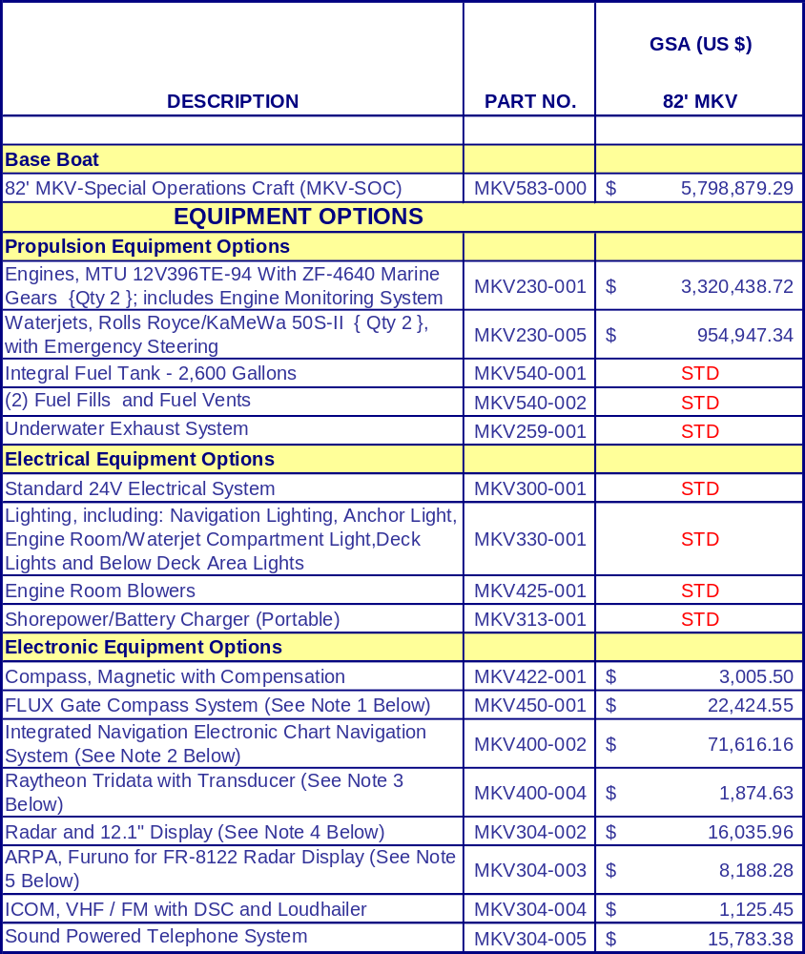

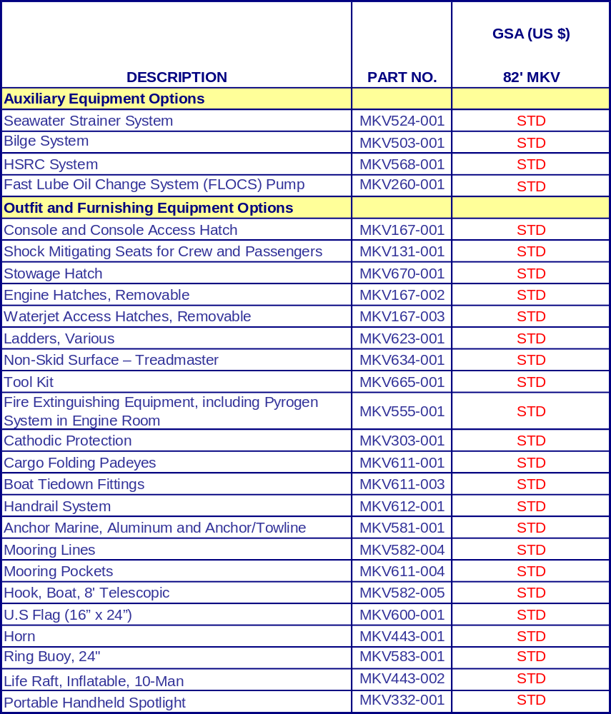

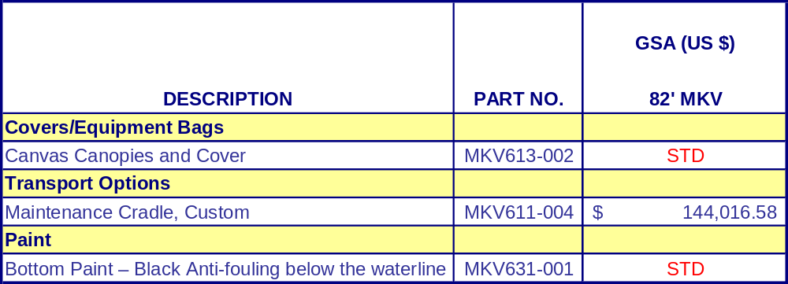

NOTES:
(1) This is a military-standard fluxgate marine compass system with a backlit LCD display and a fully automatic sensor that calibrates itself and requires no maintenance
(2) Integrated Navigation Electronic Chart Navigation System With Radar Overlay, Automatic Chart Loading, Alarms And Generation Of SAR Operation Patterns, includes a Master and (2) Slave Stations
(3) The Tridata system combines depth, speed and temperature all on one easy to read display
(4) An X-Band 12KW radar with a 12.1” display, 4’ foot antenna for excellent performance and Mini-ARPA for automatic target tracking.
(5) ARPA provides capability for automatic target tracking

UNITED STATES MARINE, INC.
10011 LORRAINE ROAD
GULFPORT, MS 39503 USA
(228) 679-1005 FAX (228) 679-1010
WWW.USMI.COM

